ZOIKOSUITE
Data, Search, Analytics & AI
Detailed Service Specifications
DATA-01 through DATA-07 • AI-01 through AI-05

Field | Value
Document ID | ZS-SVC-N-001
Version | 1.0 — Build-Ready Data & AI Baseline
Date | August 24, 2026
Status | Engineering baseline — controlled decisions remain before production activation
Owner | ZoikoSuite Product / Data Platform / AI Engineering
Applies to | Engineering, Data, AI/ML, Product, Security, Privacy, Finance Controls, QA, Operations
Language | American English
Executive doctrine — Data and AI services may ingest, assess, derive, index, reconcile, retrieve, summarize, classify, detect anomalies or propose. They do not silently become the authority for accounting, tax, payment, legal, payroll, reporting, authorization, or other governed business outcomes.

1. Executive Architecture & Scope
This pack instantiates the canonical DATA-01 through DATA-07 and AI-01 through AI-05 capabilities from ZS-SVC-SPEC-001 into build-ready service contracts.
The domain sits downstream of authoritative business services and upstream of analytics, search, reconciliation, user assistance and AI-enabled workflows. It therefore carries unusually high risk of becoming a hidden second source of truth if boundaries are weak.
A "service" remains a logical bounded capability. This pack does not mandate twelve independently deployed microservices.
Critical boundary — DATA-01 is governed analytical/data-pipeline ingestion. INT-06 remains the controlled path for authoritative business-data import. DATA-02 can detect defects but the owning business domain corrects authoritative facts. DATA-04/05/06 are projections. DATA-07 proves control assertions but never edits a ledger. AI-01..05 are advisory unless a downstream deterministic/human validation contract explicitly converts a proposal into a governed business command.
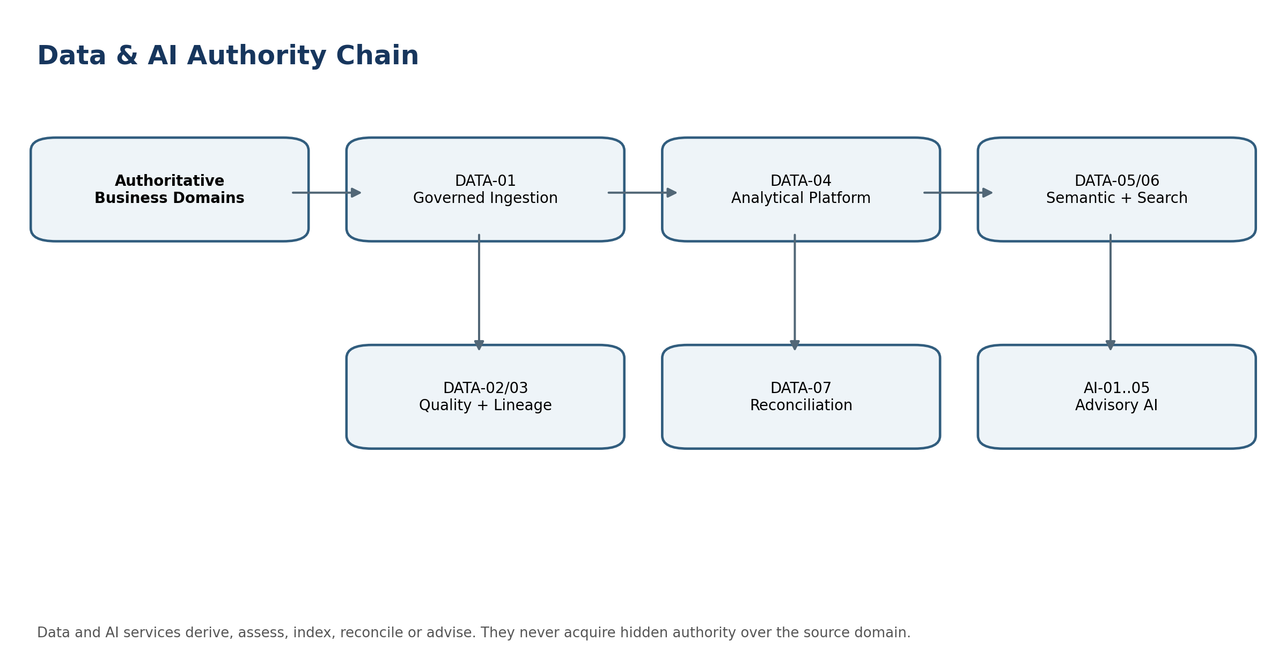
Figure 1 — Data & AI authority chain

2. Non-Bypassable Data & AI Invariants
- Authoritative business facts remain owned by their source domain; analytical copies, indexes, embeddings, features and AI outputs are derived artifacts.
- Every material derived record retains source lineage, transformation/version identity and effective data classification.
- Tenant, legal-entity, residency and purpose context must survive end-to-end through ingestion, analytics, search and AI processing.
- Search, RAG and analytics apply authorization before retrieval or computation where feasible; post-generation filtering alone is insufficient.
- No index, vector store, cache, feature store or analytical zone may weaken the source object’s row/field access restrictions.
- Deletion, restriction, legal hold, retention and residency policies propagate to derived copies, embeddings, indexes and AI evidence according to ZS-DATA-GOV-001.
- Data quality detection does not grant authority to repair source records outside the owning domain.
- Lineage metadata is evidence of derivation, not an alternative copy of the business fact.
- Certified financial and statutory reporting never uses an unlabelled analytical projection as authoritative actuals.
- Reconciliation uses frozen/reproducible populations, versioned rules, tolerances and materiality; matching totals alone are insufficient.
- AI-generated numerics never replace deterministic financial, tax, payroll, statutory or regulatory calculation engines.
- AI may propose classifications, extraction candidates, anomalies, drivers or explanations; protected actions remain governed commands.
- Original source documents/evidence are preserved when AI extracts or summarizes them.
- Every material AI output retains model/provider version, prompt/template version, retrieval/source references, safety policy and evaluation/release identity where applicable.
- Model/provider upgrades are governed releases with evaluation gates, canary/rollback and change evidence; silent model switching is prohibited for material workflows.
- Provider data use, training rights, retention and geographic processing must be contractually and technically controlled; customer data is not available for third-party model training by default.
- Prompt injection and retrieved-content instructions are treated as untrusted data, not platform commands.
- AI tool calls cannot bypass normal API authorization, SoD, workflow, idempotency or accounting/tax/payment controls.
- Anomaly scores or AI confidence cannot alone trigger adverse, irreversible or material financial actions.
- AI failures degrade safely to no answer, deterministic workflow or human review rather than fabricated authority.
- Sensitive prompts and outputs are minimized in telemetry; secrets and regulated data are never logged casually.
- RAG answers expose source citations/links where the user experience permits, and unsupported material claims are withheld or clearly qualified.
- Analytical freshness and assurance state are visible to downstream consumers.
- Derived data cannot cross residency boundaries merely because an analytics or AI provider is globally available.
- All services expose evidence sufficient for replay, investigation, certification and incident response without requiring hidden model reasoning.

3. Shared Service Contract
Contract Dimension | Required Behavior
Trusted context | tenant_id, subject/workload identity, legal_entity_scope where applicable, residency region, data classification, purpose, request/trace ID, policy/version context.
Authorization | RBAC/ABAC/relationship checks plus dataset/index/model/tool-specific policy. AI tool calls re-authorize at the target command.
Data provenance | Source IDs, source versions/watermarks, transformation code/version, schema version, producer, timestamps and integrity digest where material.
Derived assurance | Every analytical/search/AI output declares freshness, source class and assurance state: certified, controlled projection, provisional, advisory or unknown.
Idempotency | Material ingestion, evaluation, export and provider/model operations use stable request/run IDs and replay-safe writes.
Concurrency | Version protected configuration/model/prompt/rule changes; stale approvals or evaluation baselines are rejected.
Residency | Storage, vectorization, inference, logs, backups, analytics and support access must satisfy the resolved residency policy.
Retention/hold | Derived artifacts inherit or resolve retention/hold obligations; deletion is propagated through governed disposition jobs.
Observability | Business-correctness metrics, freshness, lineage coverage, DQ failures, search leakage probes, model/evaluation drift, token/cost usage and provider health.
Evidence | Immutable run/result metadata sufficient to reproduce deterministic transformations and audit AI provenance without storing prohibited hidden chain-of-thought.

4. Detailed Service Specifications

DATA-01 — Data Ingestion
Purpose. Ingest approved source/domain data into governed analytical pipelines and projections.
Specification Field | Build-Ready Requirement
Authoritative ownership | IngestionRun, SourceCheckpoint, LandingObject, QuarantineItem
Explicit non-ownership | Direct authoritative business writes; source-domain validation ownership; connector credentials.
Required source inputs | approved domain events/extracts, schema, source watermark, classification, residency policy
Server-resolved context | tenant, subject/workload, legal entity/scope where applicable, residency, purpose, classification, policy/model/rule versions, trace/request ID.
Named commands | StartIngestion, CommitBatch, QuarantineBatch, ReplayFromCheckpoint, CloseRun
Read/query surfaces | get run/status/checkpoint; preview quarantined items; lineage lookup
Lifecycle/state | Draft → Running → PartiallyQuarantined → Completed / Failed / Superseded
Permissions / SoD | Purpose-scoped least privilege. Configuration/model/prompt/rule publication separated from evaluation/release approval. Protected downstream actions are re-authorized by their owning domain.
Events | DATA.IngestionCompleted, DATA.BatchQuarantined, DATA.CheckpointAdvanced
Dependencies | INT-02/03, DATA-02, DATA-03, DATA-04, GOV-02, ZS-DATA-GOV
Idempotency / concurrency | Stable run/request IDs; replay-safe result persistence; optimistic version checks on configuration, model, prompt, rule and certification changes.
Failure semantics | Fail closed for tenant/residency/authz or material provenance gaps; quarantine malformed data; AI returns blocked/no-answer/review-required rather than fabricated authority.
Evidence / lineage | Source IDs/versions, transformation/model/prompt release, timestamps, hashes/watermarks, decision/evaluation evidence and downstream references sufficient for replay/investigation.
NFR / recovery | Residency-aware recovery, bounded queue/backpressure, resource isolation, provider/cost limits, freshness and correctness SLIs, defined RPO/RTO by criticality.
Core controls | At-least-once source consumption, deterministic deduplication, no cross-residency landing; backpressure and bounded retry; source-to-target count/hash evidence.
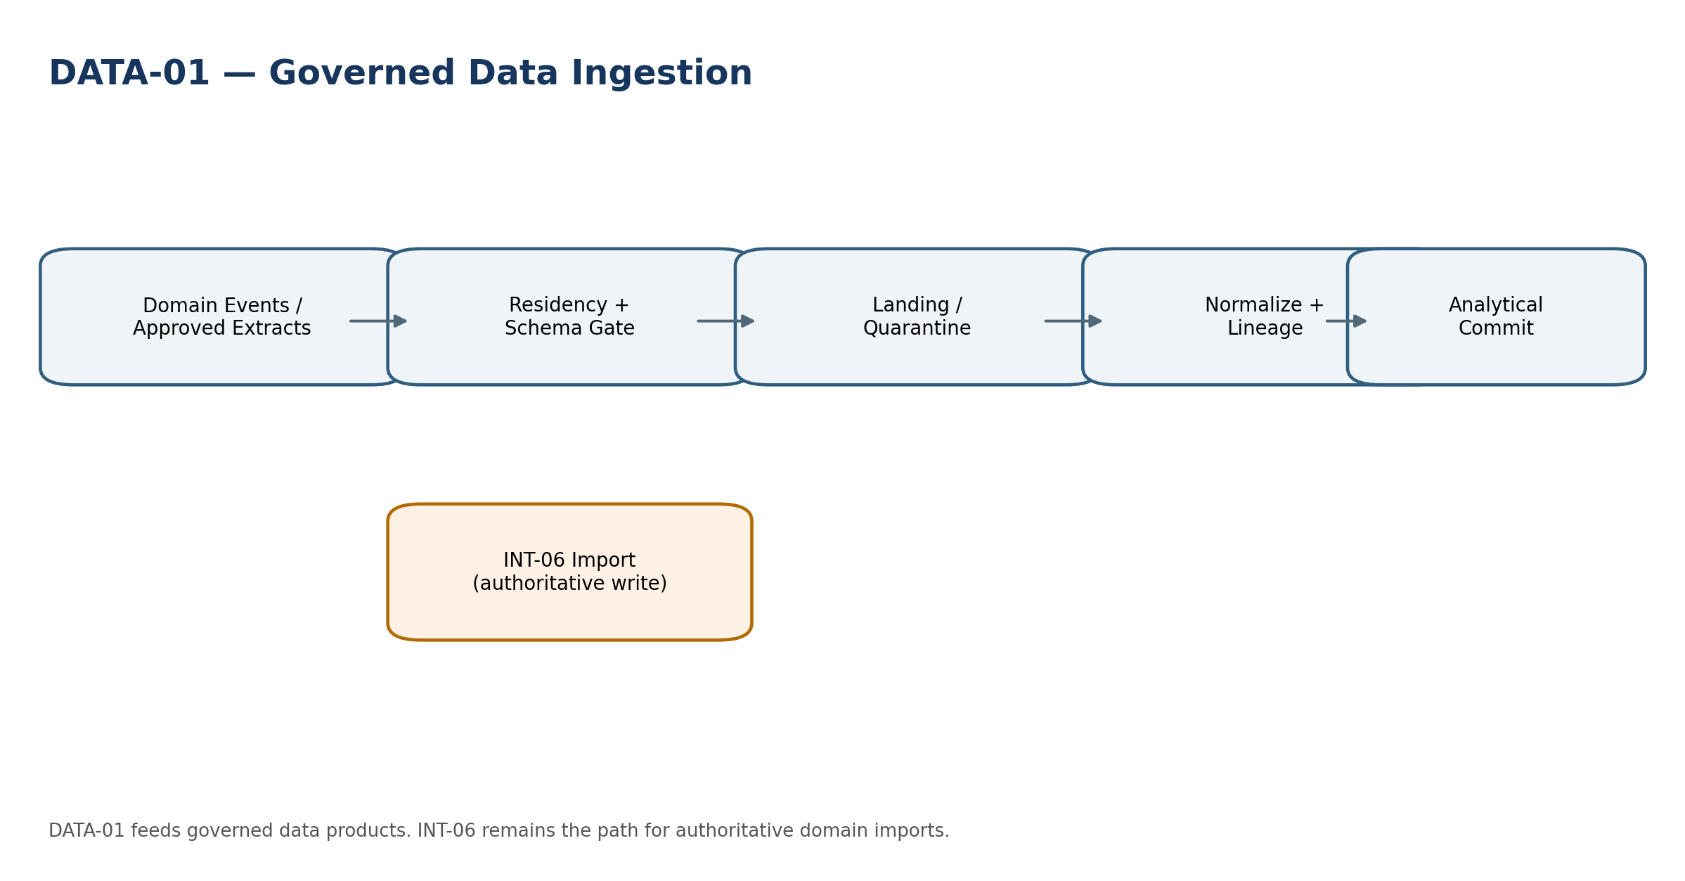
Engineering view — DATA-01 Data Ingestion

Minimum service-specific acceptance tests:
- Duplicate source event does not duplicate analytical facts.
- Wrong-region batch is blocked before landing.
- Schema-incompatible batch quarantines without partial silent coercion.

DATA-02 — Data Quality
Purpose. Evaluate schema, completeness, reference, consistency and reasonableness controls over governed populations.
Specification Field | Build-Ready Requirement
Authoritative ownership | DQRuleSet, DQRun, DQResult, DQIssue, DQCertification
Explicit non-ownership | Editing source records; redefining domain validity without owner approval.
Required source inputs | frozen population, rule-set version, materiality/severity profile, expected references
Server-resolved context | tenant, subject/workload, legal entity/scope where applicable, residency, purpose, classification, policy/model/rule versions, trace/request ID.
Named commands | RunDQ, RaiseIssue, AssignIssue, Reperform, CertifyDQ
Read/query surfaces | results by rule/dimension; issue backlog; trend/failure heatmap
Lifecycle/state | Planned → Running → ExceptionsOpen → Reperformed → Certified / Failed
Permissions / SoD | Purpose-scoped least privilege. Configuration/model/prompt/rule publication separated from evaluation/release approval. Protected downstream actions are re-authorized by their owning domain.
Events | DATA.DQFailed, DATA.DQIssueRaised, DATA.DQCertified
Dependencies | DATA-01/03/04, owning domains, ZS-CONTROL, ZS-QA
Idempotency / concurrency | Stable run/request IDs; replay-safe result persistence; optimistic version checks on configuration, model, prompt, rule and certification changes.
Failure semantics | Fail closed for tenant/residency/authz or material provenance gaps; quarantine malformed data; AI returns blocked/no-answer/review-required rather than fabricated authority.
Evidence / lineage | Source IDs/versions, transformation/model/prompt release, timestamps, hashes/watermarks, decision/evaluation evidence and downstream references sufficient for replay/investigation.
NFR / recovery | Residency-aware recovery, bounded queue/backpressure, resource isolation, provider/cost limits, freshness and correctness SLIs, defined RPO/RTO by criticality.
Core controls | Quality dimensions and measures are versioned; remediation remains in source domain; certification references exact population.
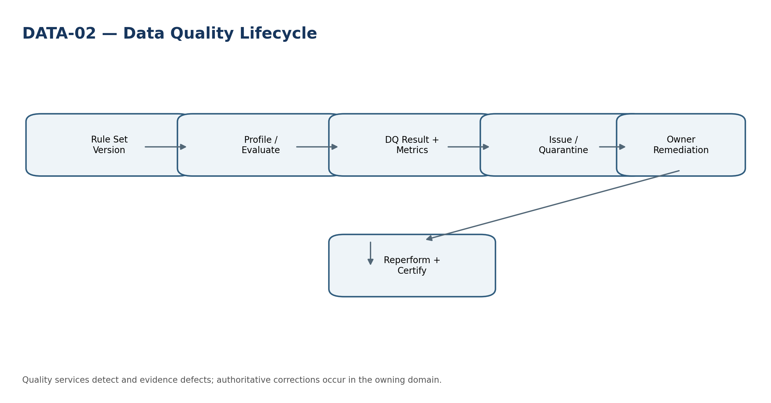
Engineering view — DATA-02 Data Quality

Minimum service-specific acceptance tests:
- DQ rule-set change creates a new run/version.
- Operator cannot mark a source defect fixed without source-domain evidence.
- Aggregate materiality catches many individually small failures.

DATA-03 — Data Lineage
Purpose. Maintain source-to-derived provenance and transformation lineage across data, reports, search and AI.
Specification Field | Build-Ready Requirement
Authoritative ownership | LineageEntity, LineageActivity, LineageEdge, TransformationVersion, ProvenanceManifest
Explicit non-ownership | Authoritative business storage; mutable business history.
Required source inputs | source/derived IDs, activity version, agent/service, timestamps, digests, data classification
Server-resolved context | tenant, subject/workload, legal entity/scope where applicable, residency, purpose, classification, policy/model/rule versions, trace/request ID.
Named commands | RecordDerivation, SealManifest, SupersedeLineage, AttachEvidence
Read/query surfaces | upstream/downstream impact; as-of lineage; source-to-report path
Lifecycle/state | Open → Sealed → Superseded
Permissions / SoD | Purpose-scoped least privilege. Configuration/model/prompt/rule publication separated from evaluation/release approval. Protected downstream actions are re-authorized by their owning domain.
Events | DATA.LineageRecorded, DATA.LineageGapDetected
Dependencies | all domains, DATA-01/04/05/06, AI-01..05, REP, ZS-DATA-GOV
Idempotency / concurrency | Stable run/request IDs; replay-safe result persistence; optimistic version checks on configuration, model, prompt, rule and certification changes.
Failure semantics | Fail closed for tenant/residency/authz or material provenance gaps; quarantine malformed data; AI returns blocked/no-answer/review-required rather than fabricated authority.
Evidence / lineage | Source IDs/versions, transformation/model/prompt release, timestamps, hashes/watermarks, decision/evaluation evidence and downstream references sufficient for replay/investigation.
NFR / recovery | Residency-aware recovery, bounded queue/backpressure, resource isolation, provider/cost limits, freshness and correctness SLIs, defined RPO/RTO by criticality.
Core controls | Lineage is append/supersede, not destructive edit; gaps in material source-to-report/AI provenance are operational defects.
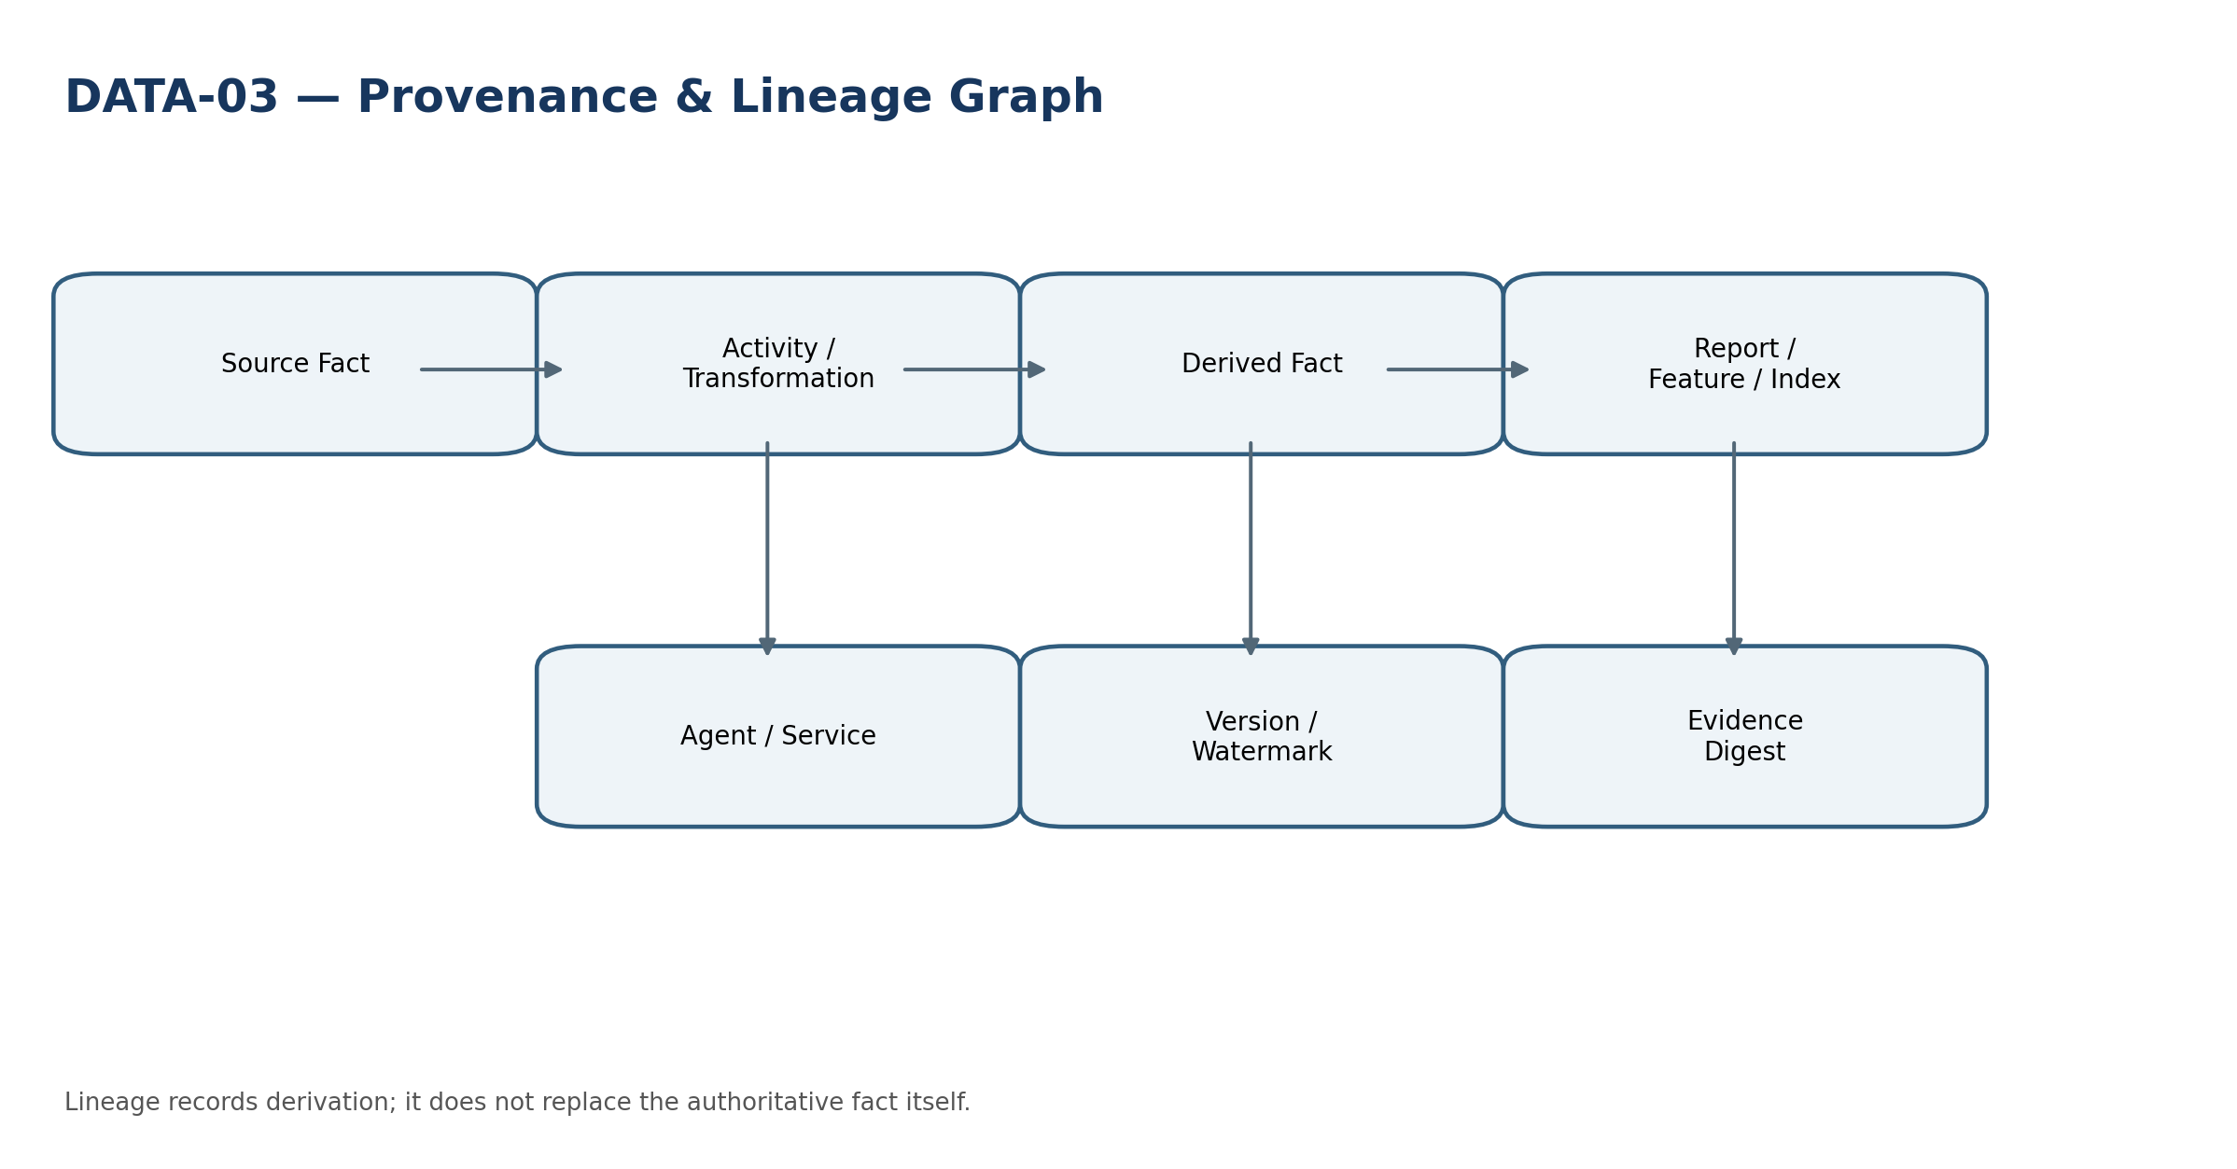
Engineering view — DATA-03 Data Lineage

Minimum service-specific acceptance tests:
- Missing transformation version blocks material lineage certification.
- Superseded lineage remains historically queryable.
- Cross-tenant lineage graph traversal is denied.

DATA-04 — Analytical Data Platform
Purpose. Create governed analytical snapshots, curated datasets and query-ready projections.
Specification Field | Build-Ready Requirement
Authoritative ownership | AnalyticalDataset, DatasetVersion, Snapshot, Partition, DataProductCertification
Explicit non-ownership | Systems of record; authoritative posting/tax/payment state.
Required source inputs | certified/governed sources, checkpoint/watermark, transformation version, residency/classification policy
Server-resolved context | tenant, subject/workload, legal entity/scope where applicable, residency, purpose, classification, policy/model/rule versions, trace/request ID.
Named commands | BuildSnapshot, PublishDatasetVersion, DeprecateDataset, RebuildPartition
Read/query surfaces | dataset catalog; freshness; partition status; assurance state
Lifecycle/state | Draft → Building → Validated → Published → Deprecated / Quarantined
Permissions / SoD | Purpose-scoped least privilege. Configuration/model/prompt/rule publication separated from evaluation/release approval. Protected downstream actions are re-authorized by their owning domain.
Events | DATA.DatasetPublished, DATA.DatasetFreshnessBreached
Dependencies | DATA-01/02/03, DATA-05/06, FIN, REP, GOV-02, ZS-SEC
Idempotency / concurrency | Stable run/request IDs; replay-safe result persistence; optimistic version checks on configuration, model, prompt, rule and certification changes.
Failure semantics | Fail closed for tenant/residency/authz or material provenance gaps; quarantine malformed data; AI returns blocked/no-answer/review-required rather than fabricated authority.
Evidence / lineage | Source IDs/versions, transformation/model/prompt release, timestamps, hashes/watermarks, decision/evaluation evidence and downstream references sufficient for replay/investigation.
NFR / recovery | Residency-aware recovery, bounded queue/backpressure, resource isolation, provider/cost limits, freshness and correctness SLIs, defined RPO/RTO by criticality.
Core controls | Tenant/region isolation, bounded staleness, immutable published versions, cost/resource isolation and reproducible rebuild.
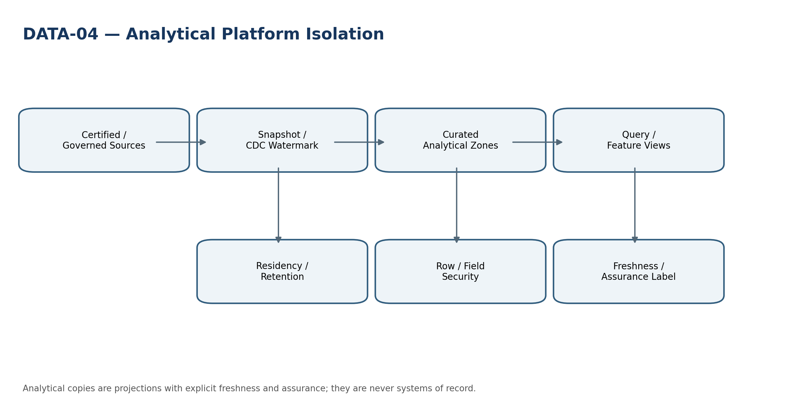
Engineering view — DATA-04 Analytical Data Platform

Minimum service-specific acceptance tests:
- Published dataset cannot be silently rebuilt in place.
- Stale dataset declares freshness breach.
- Cross-tenant query/resource pool does not leak rows or metadata.

DATA-05 — Semantic Model
Purpose. Define governed reusable metrics, dimensions, joins and calculation plans over analytical data.
Specification Field | Build-Ready Requirement
Authoritative ownership | SemanticModel, MetricBinding, DimensionBinding, CalculationPlan, SemanticVersion
Explicit non-ownership | Changing FIN-05 KPI authority; accounting/tax rules; raw SQL access to source-of-record.
Required source inputs | approved KPI/metric definitions, dataset versions, units/currency/aggregation semantics
Server-resolved context | tenant, subject/workload, legal entity/scope where applicable, residency, purpose, classification, policy/model/rule versions, trace/request ID.
Named commands | PublishSemanticVersion, RetireMetricBinding, ValidateCalculationPlan
Read/query surfaces | metric definitions; dependency graph; version comparison
Lifecycle/state | Draft → Validating → Published → Deprecated
Permissions / SoD | Purpose-scoped least privilege. Configuration/model/prompt/rule publication separated from evaluation/release approval. Protected downstream actions are re-authorized by their owning domain.
Events | DATA.SemanticVersionPublished, DATA.SemanticConflictDetected
Dependencies | DATA-04, FIN-05, REP-04/05, DATA-03
Idempotency / concurrency | Stable run/request IDs; replay-safe result persistence; optimistic version checks on configuration, model, prompt, rule and certification changes.
Failure semantics | Fail closed for tenant/residency/authz or material provenance gaps; quarantine malformed data; AI returns blocked/no-answer/review-required rather than fabricated authority.
Evidence / lineage | Source IDs/versions, transformation/model/prompt release, timestamps, hashes/watermarks, decision/evaluation evidence and downstream references sufficient for replay/investigation.
NFR / recovery | Residency-aware recovery, bounded queue/backpressure, resource isolation, provider/cost limits, freshness and correctness SLIs, defined RPO/RTO by criticality.
Core controls | Metric collisions block publish; units/currency/sign/aggregation are explicit; published versions immutable.
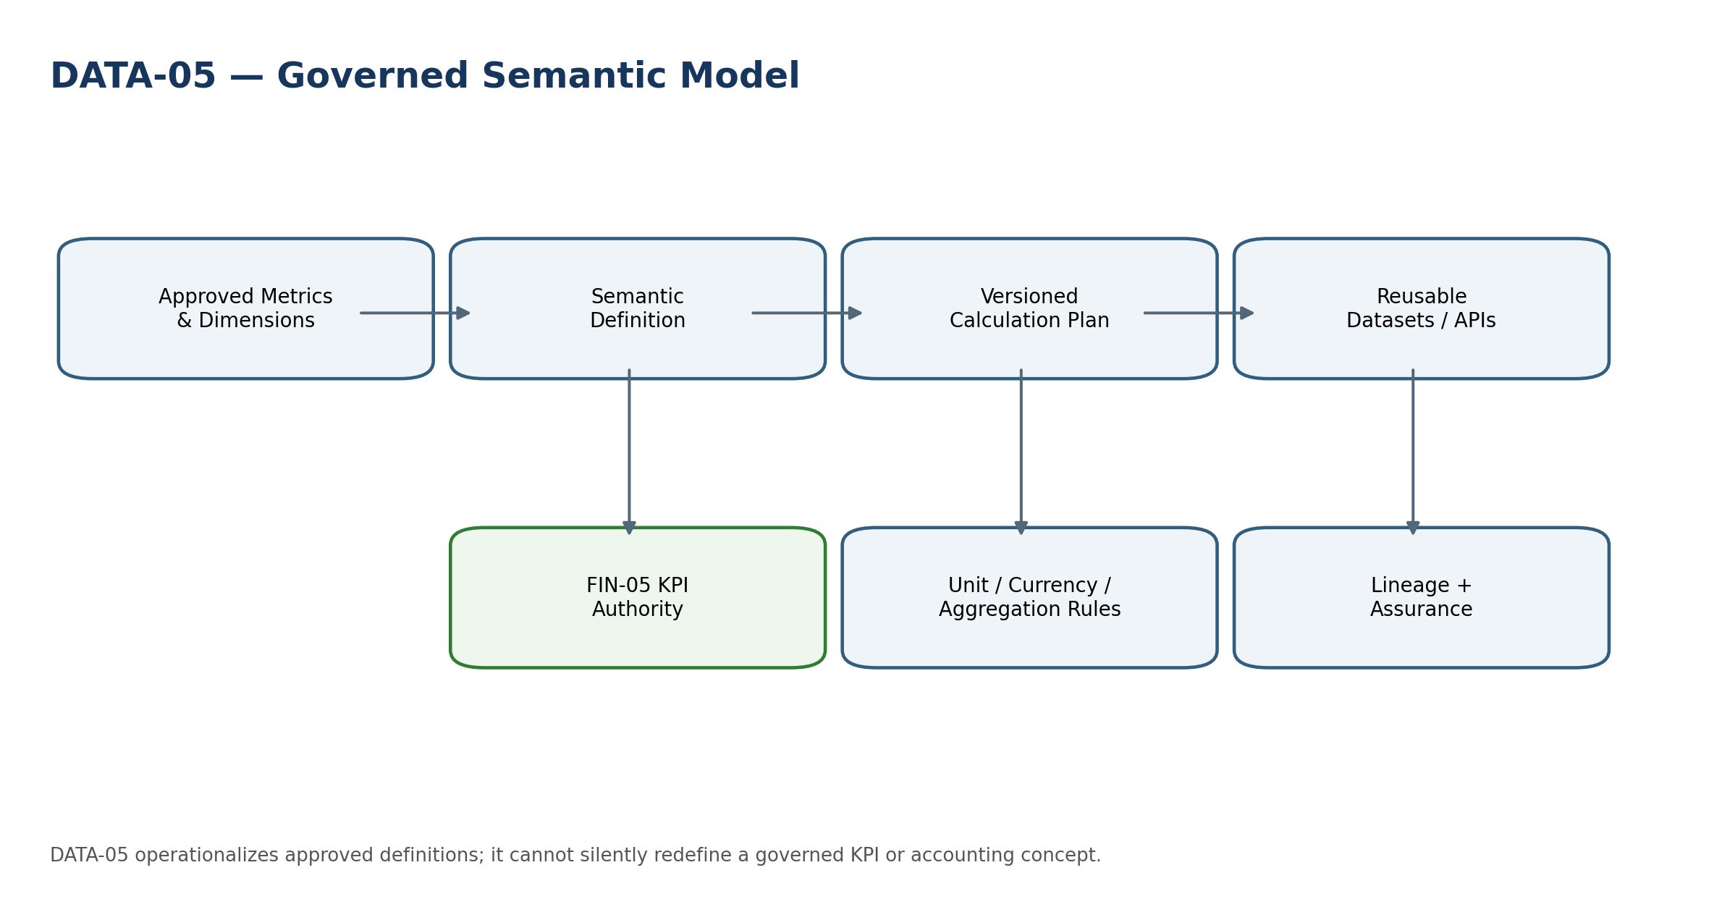
Engineering view — DATA-05 Semantic Model

Minimum service-specific acceptance tests:
- Conflicting KPI/metric semantics block publish.
- Dimension hierarchy change does not rewrite prior semantic version.
- Unauthorized raw SQL/source-store binding is rejected.

DATA-06 — Global Search
Purpose. Search permitted business objects and evidence without leaking unauthorized existence, counts or snippets.
Specification Field | Build-Ready Requirement
Authoritative ownership | SearchIndex, IndexDocument, SearchPolicy, SearchResultEvidence
Explicit non-ownership | Authoritative records; permission decisions; semantic KPI definition.
Required source inputs | authorized source projections, object ACL/scope, tenant/entity context, freshness and classification
Server-resolved context | tenant, subject/workload, legal entity/scope where applicable, residency, purpose, classification, policy/model/rule versions, trace/request ID.
Named commands | ReindexScope, PurgeIndexObject, RebuildIndex, ValidateSearchPolicy
Read/query surfaces | search; explain source/freshness; index health
Lifecycle/state | Indexing → Available → Degraded / Rebuilding
Permissions / SoD | Purpose-scoped least privilege. Configuration/model/prompt/rule publication separated from evaluation/release approval. Protected downstream actions are re-authorized by their owning domain.
Events | DATA.SearchIndexUpdated, DATA.SearchLeakageProbeFailed
Dependencies | DATA-03/04, GOV-03/04, ZS-SEC, source domains
Idempotency / concurrency | Stable run/request IDs; replay-safe result persistence; optimistic version checks on configuration, model, prompt, rule and certification changes.
Failure semantics | Fail closed for tenant/residency/authz or material provenance gaps; quarantine malformed data; AI returns blocked/no-answer/review-required rather than fabricated authority.
Evidence / lineage | Source IDs/versions, transformation/model/prompt release, timestamps, hashes/watermarks, decision/evaluation evidence and downstream references sufficient for replay/investigation.
NFR / recovery | Residency-aware recovery, bounded queue/backpressure, resource isolation, provider/cost limits, freshness and correctness SLIs, defined RPO/RTO by criticality.
Core controls | Authorization-before-retrieval, no cross-tenant cache keys, deletion/hold propagation, anti-enumeration controls and stale-index disclosure.
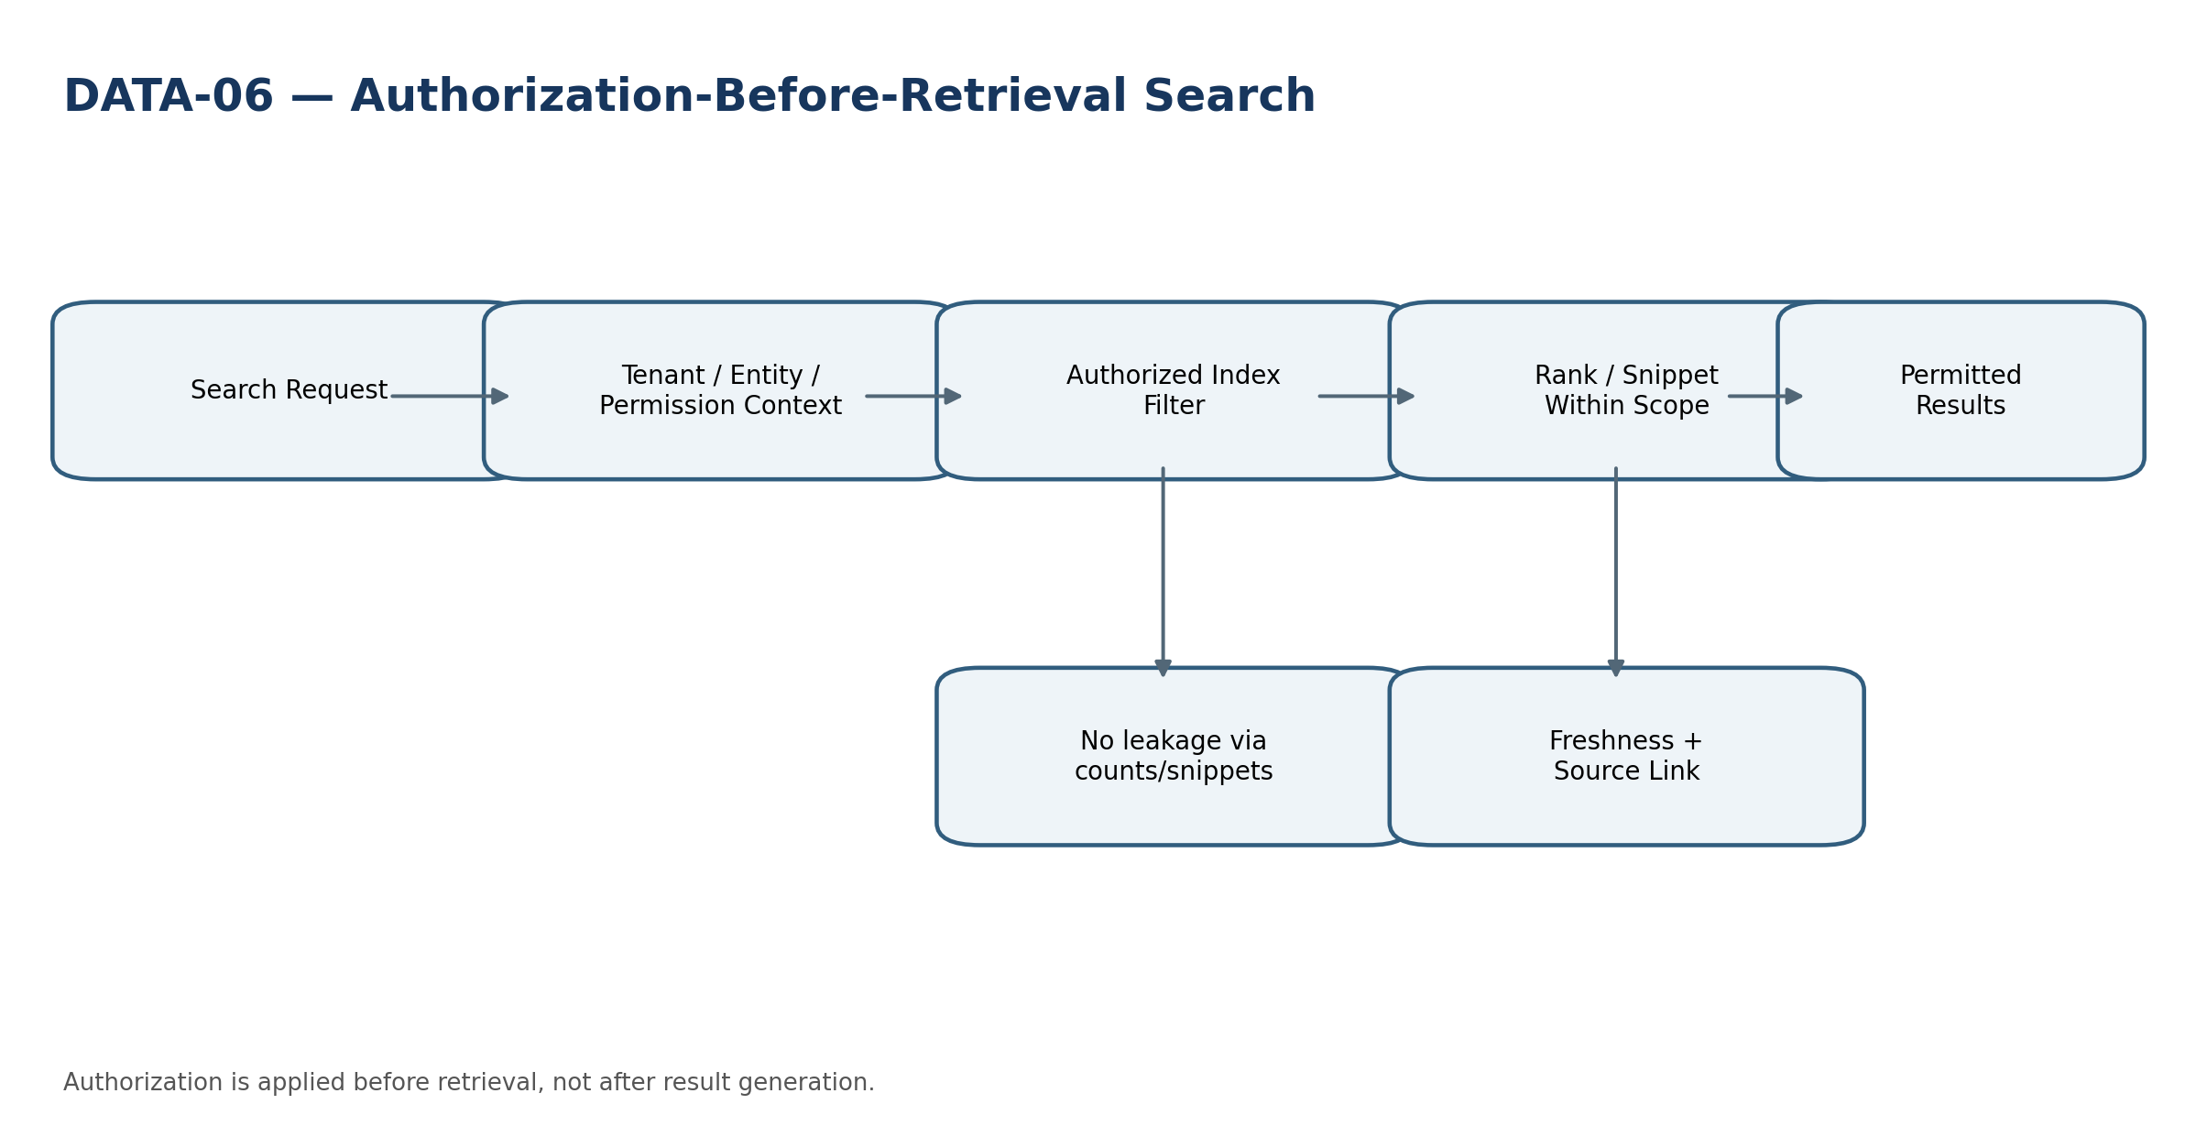
Engineering view — DATA-06 Global Search

Minimum service-specific acceptance tests:
- Unauthorized object does not leak via count/snippet/autocomplete.
- Purged/restricted object is removed from index under disposition policy.
- Stale index returns freshness indication or blocks protected use.

DATA-07 — Reconciliation Engine
Purpose. Compare controlled datasets/populations under explicit match, tolerance, materiality and exception rules.
Specification Field | Build-Ready Requirement
Authoritative ownership | ReconciliationDefinition, ReconciliationRun, PopulationSnapshot, MatchResult, ReconciliationException, Certification
Explicit non-ownership | Editing ledger/subledger/source records; inventing corrective journals.
Required source inputs | two or more frozen populations, rules/version, tolerance, materiality, expected assertions
Server-resolved context | tenant, subject/workload, legal entity/scope where applicable, residency, purpose, classification, policy/model/rule versions, trace/request ID.
Named commands | StartRun, Match, RaiseException, Reperform, Certify, SupersedeRun
Read/query surfaces | run status; unmatched/exceptions; assertion outcomes
Lifecycle/state | Planned → Running → ExceptionsOpen → Reperformed → Certified / Failed
Permissions / SoD | Purpose-scoped least privilege. Configuration/model/prompt/rule publication separated from evaluation/release approval. Protected downstream actions are re-authorized by their owning domain.
Events | CONTROL.ReconciliationCompleted, CONTROL.ExceptionRaised, CONTROL.Certified
Dependencies | ZS-CONTROL, Accounting/AR/AP/BNK/TAX/Assets/Payroll, DATA-03
Idempotency / concurrency | Stable run/request IDs; replay-safe result persistence; optimistic version checks on configuration, model, prompt, rule and certification changes.
Failure semantics | Fail closed for tenant/residency/authz or material provenance gaps; quarantine malformed data; AI returns blocked/no-answer/review-required rather than fabricated authority.
Evidence / lineage | Source IDs/versions, transformation/model/prompt release, timestamps, hashes/watermarks, decision/evaluation evidence and downstream references sufficient for replay/investigation.
NFR / recovery | Residency-aware recovery, bounded queue/backpressure, resource isolation, provider/cost limits, freshness and correctness SLIs, defined RPO/RTO by criticality.
Core controls | Frozen populations, aggregation materiality, controlled manual matches, certified runs immutable, remediation through owning domain.
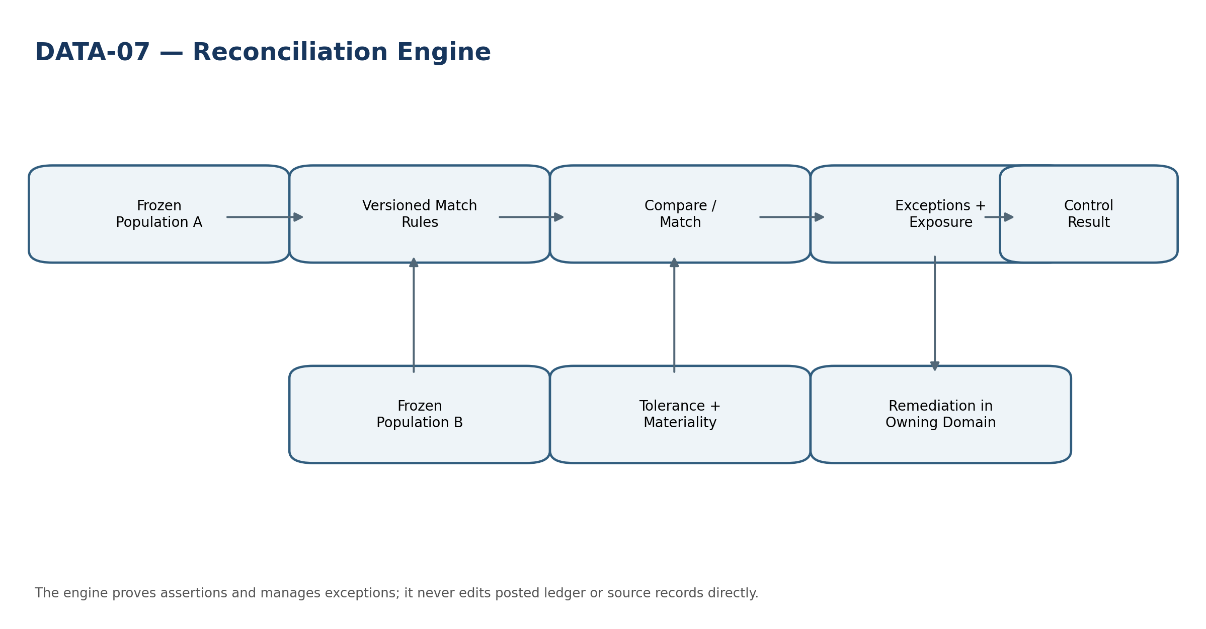
Engineering view — DATA-07 Reconciliation Engine

Minimum service-specific acceptance tests:
- Equal totals with different composition still surface exceptions.
- Tolerance cannot be widened during a certified run.
- Manual match requires reason/authority and remains auditable.

AI-01 — Document Extraction
Purpose. Extract structured candidate fields from documents while preserving original evidence and validation path.
Specification Field | Build-Ready Requirement
Authoritative ownership | ExtractionJob, ExtractionCandidate, EvidenceSpan, ExtractionDecision, ModelInvocation
Explicit non-ownership | Authoritative invoice/tax/payroll/legal facts; document deletion; final approvals.
Required source inputs | authorized document, document hash/version, extraction schema, model/provider profile, prompt version, classification/residency
Server-resolved context | tenant, subject/workload, legal entity/scope where applicable, residency, purpose, classification, policy/model/rule versions, trace/request ID.
Named commands | ExtractDocument, AcceptCandidate, RejectCandidate, ReprocessWithVersion
Read/query surfaces | candidate fields; evidence spans; confidence; invocation provenance
Lifecycle/state | Queued → Running → ReviewRequired → Accepted / Rejected / Failed
Permissions / SoD | Purpose-scoped least privilege. Configuration/model/prompt/rule publication separated from evaluation/release approval. Protected downstream actions are re-authorized by their owning domain.
Events | AI.ExtractionCompleted, AI.CandidateAccepted, AI.ExtractionFailed
Dependencies | INT-06, document stores, source domains, DATA-03, AI governance
Idempotency / concurrency | Stable run/request IDs; replay-safe result persistence; optimistic version checks on configuration, model, prompt, rule and certification changes.
Failure semantics | Fail closed for tenant/residency/authz or material provenance gaps; quarantine malformed data; AI returns blocked/no-answer/review-required rather than fabricated authority.
Evidence / lineage | Source IDs/versions, transformation/model/prompt release, timestamps, hashes/watermarks, decision/evaluation evidence and downstream references sufficient for replay/investigation.
NFR / recovery | Residency-aware recovery, bounded queue/backpressure, resource isolation, provider/cost limits, freshness and correctness SLIs, defined RPO/RTO by criticality.
Core controls | Original evidence immutable; low confidence/ambiguous fields require review; accepted candidate still enters owning domain through normal command validation.
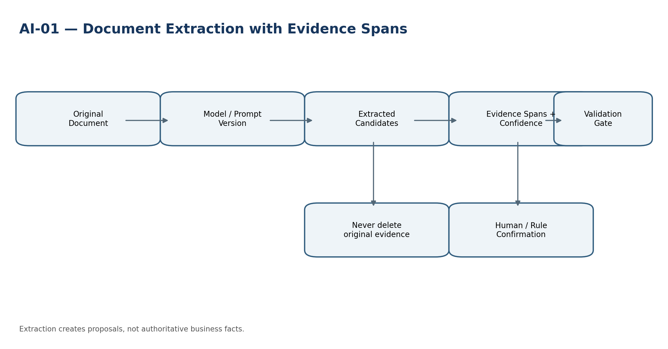
Engineering view — AI-01 Document Extraction

Minimum service-specific acceptance tests:
- Prompt/model upgrade cannot silently change accepted extraction workflow.
- Low-confidence protected field requires validation.
- Original document remains available after candidate rejection.

AI-02 — Classification
Purpose. Suggest transaction, document or category classifications with evidence and confidence.
Specification Field | Build-Ready Requirement
Authoritative ownership | ClassificationJob, ClassificationCandidate, FeatureSnapshot, ClassificationDecision
Explicit non-ownership | Direct posting/tax/category authority where material; hidden policy decisions.
Required source inputs | authorized object/features, approved label taxonomy, model/version, evaluation release
Server-resolved context | tenant, subject/workload, legal entity/scope where applicable, residency, purpose, classification, policy/model/rule versions, trace/request ID.
Named commands | Classify, AcceptSuggestion, RejectSuggestion, OverrideWithReason
Read/query surfaces | suggestions, confidence, explanations, model/eval version
Lifecycle/state | Queued → Scored → ReviewRequired → Accepted / Rejected
Permissions / SoD | Purpose-scoped least privilege. Configuration/model/prompt/rule publication separated from evaluation/release approval. Protected downstream actions are re-authorized by their owning domain.
Events | AI.ClassificationSuggested, AI.ClassificationAccepted
Dependencies | source domains, DATA-03/04, GOV policy, AI governance
Idempotency / concurrency | Stable run/request IDs; replay-safe result persistence; optimistic version checks on configuration, model, prompt, rule and certification changes.
Failure semantics | Fail closed for tenant/residency/authz or material provenance gaps; quarantine malformed data; AI returns blocked/no-answer/review-required rather than fabricated authority.
Evidence / lineage | Source IDs/versions, transformation/model/prompt release, timestamps, hashes/watermarks, decision/evaluation evidence and downstream references sufficient for replay/investigation.
NFR / recovery | Residency-aware recovery, bounded queue/backpressure, resource isolation, provider/cost limits, freshness and correctness SLIs, defined RPO/RTO by criticality.
Core controls | Thresholds are use-case-specific; confidence does not bypass review/SoD; drift and class distribution monitored.
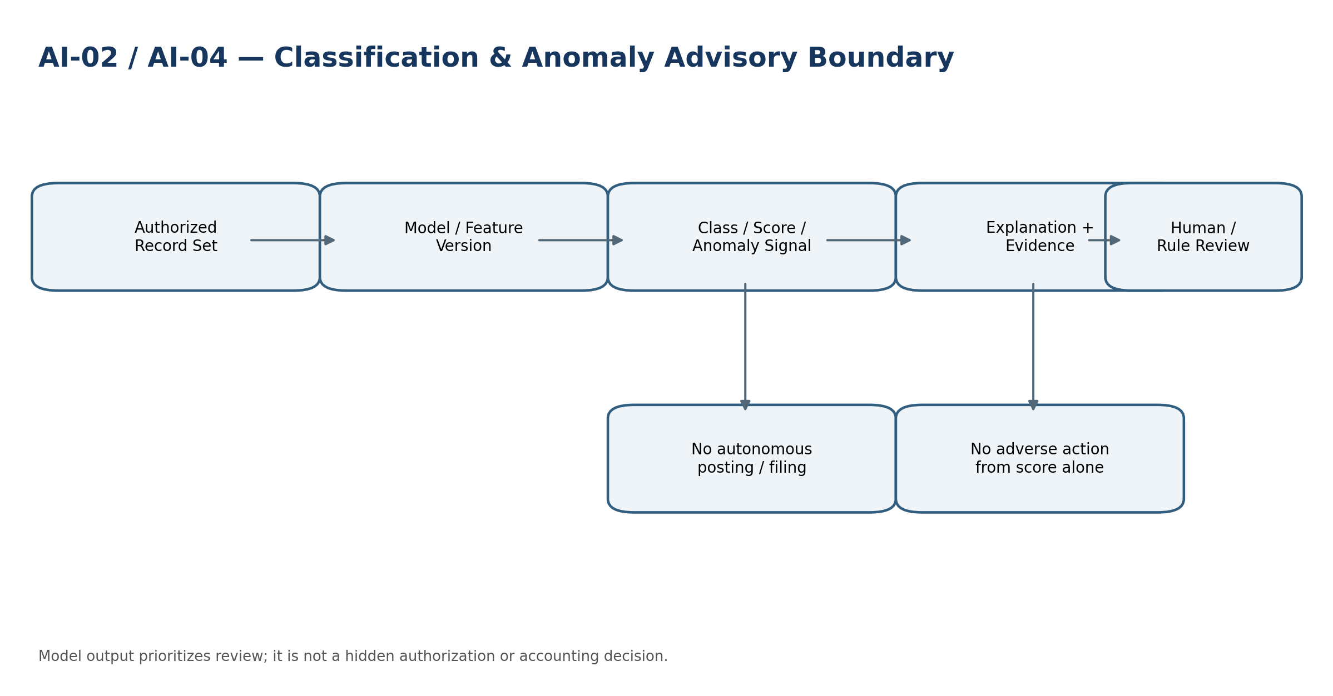
Engineering view — AI-02 Classification

Minimum service-specific acceptance tests:
- High confidence does not bypass protected review.
- Model drift beyond threshold blocks release or escalates.
- Rejected suggestion cannot be reapplied invisibly by replay.

AI-03 — ZoikoSuite Assistant / RAG
Purpose. Answer permitted questions from authorized source evidence and invoke approved tools through normal domain commands.
Specification Field | Build-Ready Requirement
Authoritative ownership | AssistantSession, RetrievalSet, PromptExecution, CitationSet, ToolProposal, AIResponseEvidence
Explicit non-ownership | Hidden business authority; unrestricted database access; direct privileged writes; chain-of-thought retention.
Required source inputs | user/workload auth context, purpose, query, retrieval policies, model/provider profile, prompt/tool policy, residency
Server-resolved context | tenant, subject/workload, legal entity/scope where applicable, residency, purpose, classification, policy/model/rule versions, trace/request ID.
Named commands | Ask, Retrieve, ProposeToolCall, ExecuteApprovedToolCall, EndSession
Read/query surfaces | conversation/session state; citations; tool history; source evidence
Lifecycle/state | Active → Completed / Blocked / Escalated
Permissions / SoD | Purpose-scoped least privilege. Configuration/model/prompt/rule publication separated from evaluation/release approval. Protected downstream actions are re-authorized by their owning domain.
Events | AI.AnswerGenerated, AI.ToolCallProposed, AI.ToolCallExecuted, AI.PolicyBlocked
Dependencies | DATA-06/03/04, GOV-03/04/05, INT-01, all tool target domains, ZS-SEC
Idempotency / concurrency | Stable run/request IDs; replay-safe result persistence; optimistic version checks on configuration, model, prompt, rule and certification changes.
Failure semantics | Fail closed for tenant/residency/authz or material provenance gaps; quarantine malformed data; AI returns blocked/no-answer/review-required rather than fabricated authority.
Evidence / lineage | Source IDs/versions, transformation/model/prompt release, timestamps, hashes/watermarks, decision/evaluation evidence and downstream references sufficient for replay/investigation.
NFR / recovery | Residency-aware recovery, bounded queue/backpressure, resource isolation, provider/cost limits, freshness and correctness SLIs, defined RPO/RTO by criticality.
Core controls | Authorization before retrieval, prompt-injection defense, source citations, no secret leakage, tool re-authorization, model/provider fail-safe and transparent AI interaction where required.
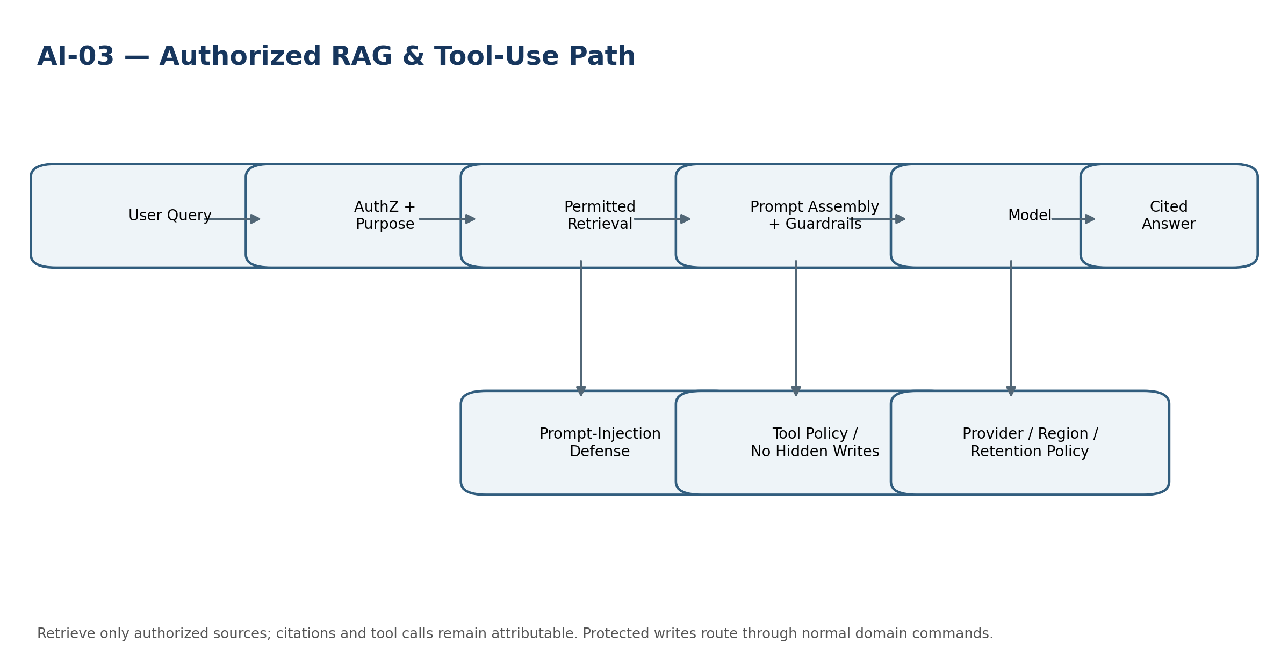
Engineering view — AI-03 ZoikoSuite Assistant / RAG

Minimum service-specific acceptance tests:
- RAG cannot retrieve unauthorized source before generation.
- Retrieved prompt injection cannot invoke a protected tool.
- Tool call re-authorizes and respects idempotency/SoD at target domain.

AI-04 — Anomaly / Exception Detection
Purpose. Surface unusual records, behaviors or control exceptions for review.
Specification Field | Build-Ready Requirement
Authoritative ownership | AnomalyModel, DetectionRun, AnomalySignal, ReviewDisposition
Explicit non-ownership | Autonomous adverse action, fraud accusation, write-off, blocking payment without governed rule/human decision.
Required source inputs | authorized feature set, baseline/model version, review threshold, business context
Server-resolved context | tenant, subject/workload, legal entity/scope where applicable, residency, purpose, classification, policy/model/rule versions, trace/request ID.
Named commands | RunDetection, AcknowledgeSignal, EscalateForReview, CloseSignal
Read/query surfaces | signals by severity/source/model; drift metrics; dispositions
Lifecycle/state | Detected → ReviewPending → Confirmed / Dismissed / Escalated
Permissions / SoD | Purpose-scoped least privilege. Configuration/model/prompt/rule publication separated from evaluation/release approval. Protected downstream actions are re-authorized by their owning domain.
Events | AI.AnomalyDetected, AI.AnomalyDispositioned
Dependencies | DATA-04/03, source domains, CONTROL, AI governance
Idempotency / concurrency | Stable run/request IDs; replay-safe result persistence; optimistic version checks on configuration, model, prompt, rule and certification changes.
Failure semantics | Fail closed for tenant/residency/authz or material provenance gaps; quarantine malformed data; AI returns blocked/no-answer/review-required rather than fabricated authority.
Evidence / lineage | Source IDs/versions, transformation/model/prompt release, timestamps, hashes/watermarks, decision/evaluation evidence and downstream references sufficient for replay/investigation.
NFR / recovery | Residency-aware recovery, bounded queue/backpressure, resource isolation, provider/cost limits, freshness and correctness SLIs, defined RPO/RTO by criticality.
Core controls | Signals retain model/feature version; false-positive/false-negative feedback monitored; protected actions require separate governed commands.

Engineering view — AI-04 Anomaly / Exception Detection

Minimum service-specific acceptance tests:
- Anomaly score alone cannot freeze payment/write off balance.
- Feature/model version is retained with each signal.
- Dismissed signal remains evidence for evaluation and drift review.

AI-05 — Forecast Assist
Purpose. Assist FIN-02/03 with driver, range, narrative and scenario suggestions while preserving explicit planning assumptions.
Specification Field | Build-Ready Requirement
Authoritative ownership | ForecastAssistJob, SuggestedDriver, SuggestedRange, EvidenceReference, PlannerDecision
Explicit non-ownership | Approved forecast values; accounting actuals; direct scenario promotion.
Required source inputs | approved FIN context, plan/forecast versions, source evidence, model/provider profile, planning purpose
Server-resolved context | tenant, subject/workload, legal entity/scope where applicable, residency, purpose, classification, policy/model/rule versions, trace/request ID.
Named commands | SuggestDrivers, SuggestRange, GenerateNarrative, AcceptSuggestion, RejectSuggestion
Read/query surfaces | suggestions and evidence; uncertainty; provenance
Lifecycle/state | Queued → Generated → PlannerReview → Accepted / Rejected
Permissions / SoD | Purpose-scoped least privilege. Configuration/model/prompt/rule publication separated from evaluation/release approval. Protected downstream actions are re-authorized by their owning domain.
Events | AI.ForecastSuggestionGenerated, AI.ForecastSuggestionAccepted
Dependencies | FIN-02/03/04, DATA-04/05, DATA-03, AI governance
Idempotency / concurrency | Stable run/request IDs; replay-safe result persistence; optimistic version checks on configuration, model, prompt, rule and certification changes.
Failure semantics | Fail closed for tenant/residency/authz or material provenance gaps; quarantine malformed data; AI returns blocked/no-answer/review-required rather than fabricated authority.
Evidence / lineage | Source IDs/versions, transformation/model/prompt release, timestamps, hashes/watermarks, decision/evaluation evidence and downstream references sufficient for replay/investigation.
NFR / recovery | Residency-aware recovery, bounded queue/backpressure, resource isolation, provider/cost limits, freshness and correctness SLIs, defined RPO/RTO by criticality.
Core controls | No direct write to approved forecasts; explicit uncertainty and source basis; accepted suggestions create normal FIN candidates, never accounting entries.
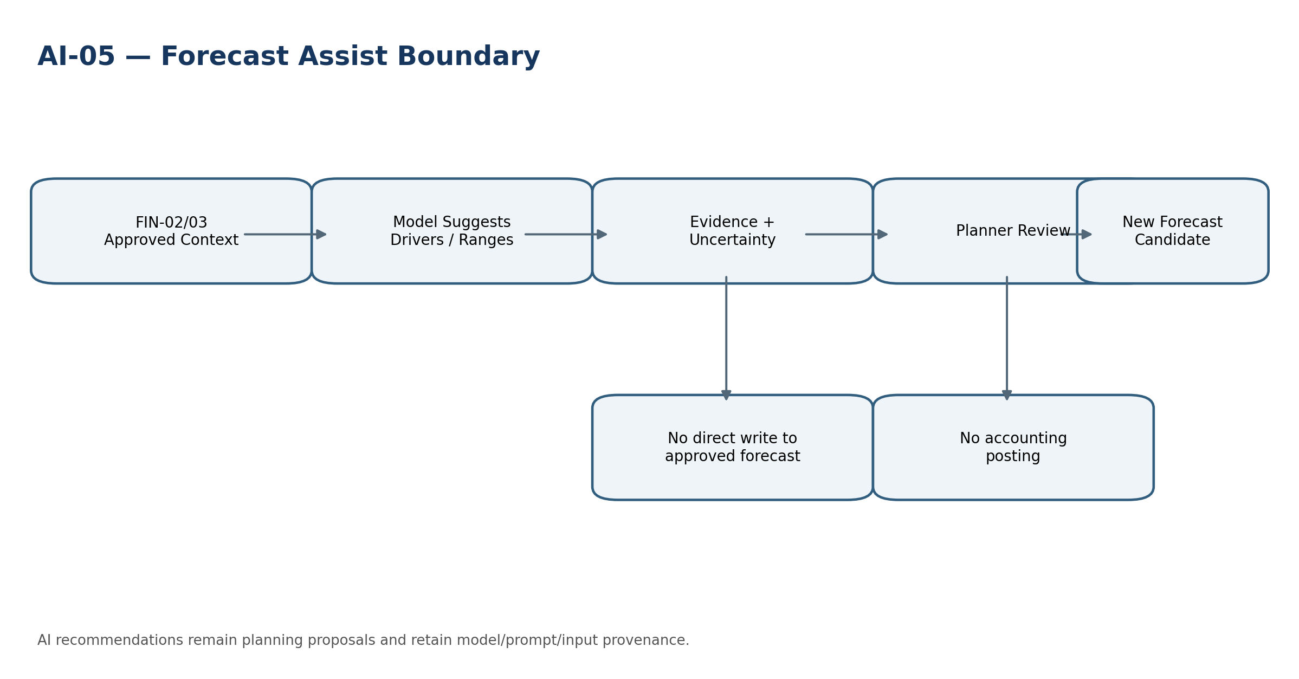
Engineering view — AI-05 Forecast Assist

Minimum service-specific acceptance tests:
- Suggestion cannot mutate approved FIN forecast.
- Planning suggestion cannot create journal entry.
- Model/provider change requires evaluation before material use.

5. Cross-Cutting Data Architecture
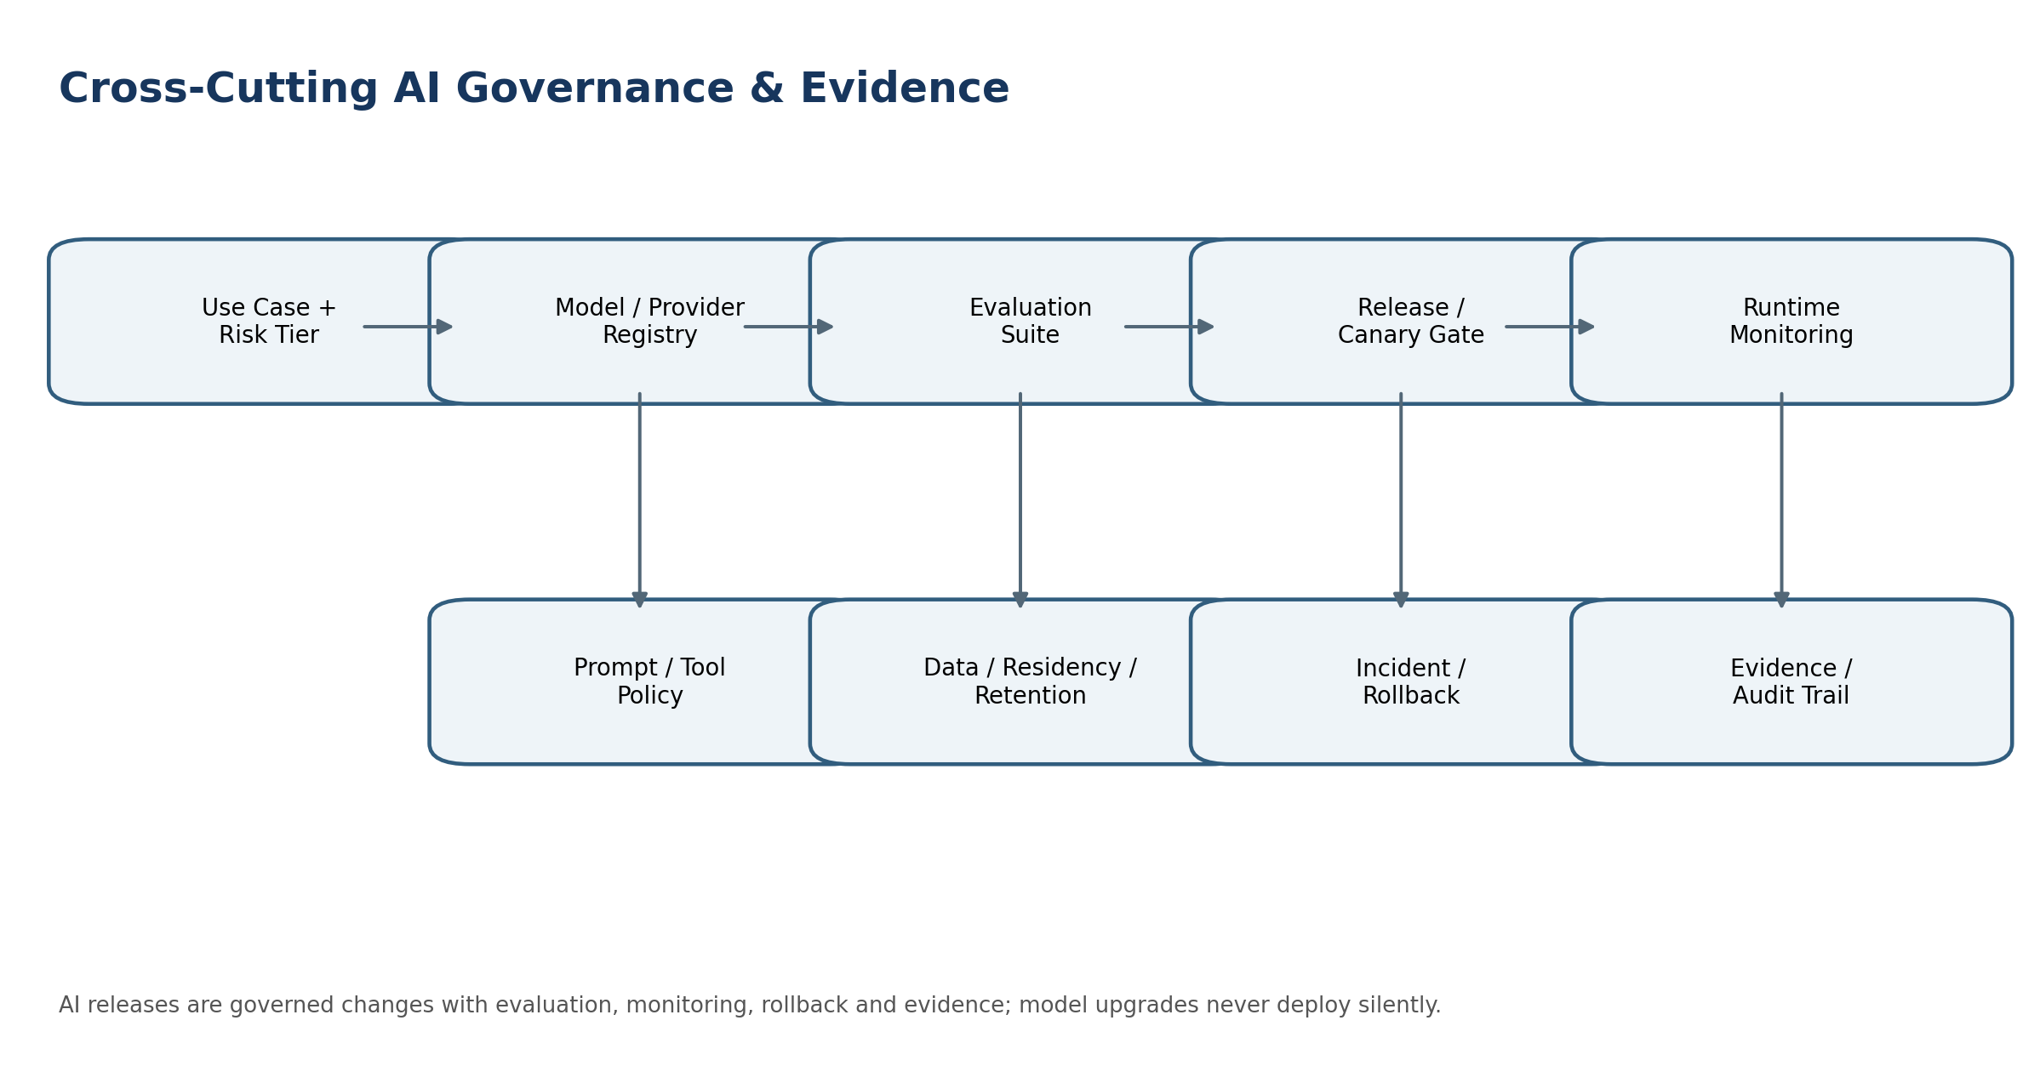
Figure — Cross-cutting AI governance and evidence
Layer | Canonical Responsibility | Prohibited Shortcut
Source-of-record | Authoritative domain services own business facts. | Analytics/search/vector stores treated as source.
Ingestion | Controlled analytical/event ingestion and checkpointing. | Direct authoritative writes through DATA-01.
Quality | Versioned rules, metrics, issues and certification. | Editing source data from DQ UI.
Lineage | Source-to-derived/report/AI provenance. | Inferred undocumented lineage after the fact.
Analytics | Governed snapshots and curated data products. | Unlabelled stale data used as certified actuals.
Semantic | Reusable metrics/dimensions over approved data. | Local dashboard formulas redefining governed KPIs.
Search | Authorized indexing/retrieval with source links. | Post-generation filtering of unauthorized results.
Reconciliation | Frozen populations, assertions, exceptions, certification. | Changing source/ledger to make totals match.
AI | Advisory extraction/classification/RAG/anomaly/forecast assist. | Hidden autonomous authority over protected outcomes.

6. AI Governance, Model Registry & Evaluation
Control Area | Required Engineering Contract
Use-case registration | Every AI capability has owner, purpose, allowed users, data classes, jurisdictions, risk tier, prohibited outcomes, human/deterministic validation path and lifecycle state.
Model/provider registry | Provider, model/version, hosting mode, region, data-use/training terms, retention, security posture, supported context/tool features, cost limits and approved use cases.
Prompt/tool registry | System prompt/template version, retrieval policy, tool allowlist, output schema, refusal rules, safety policies and change history.
Evaluation suite | Task accuracy, groundedness/citation, leakage, prompt injection, tool misuse, refusal correctness, protected-domain numerics, hallucination, latency/cost and fairness/impact where relevant.
Release gate | No material AI release without baseline comparison, blocking thresholds, reviewer approval, canary/ring deployment and rollback target.
Runtime monitoring | Quality/drift indicators, unsupported-answer rate, tool denial/failure, leakage probes, prompt attacks, provider changes, token/cost, latency and incident signals.
Evidence | Invocation metadata and source references sufficient for audit, without storing or exposing hidden chain-of-thought.
Fallback | No answer, deterministic workflow, human review or prior approved model; silent downgrade to unapproved provider/model prohibited.
Provider change | Contract/API/model alias changes treated as controlled change; pinned model IDs where supported; re-evaluation required when behavior can materially change.
Training/fine-tuning | Separate governance for training datasets, rights, consent/purpose, de-identification, evaluation, model artifacts and retention. Customer content is excluded from third-party training by default.

7. Derived Data, Search, Embeddings & Privacy/Residency
- Embeddings and vector representations are treated as derived data that may retain information about their source. They inherit classification, tenant scope, residency and disposition obligations unless a documented assessment proves otherwise.
- Search indexes, analytical tables, caches, feature stores and vector stores must support deletion/restriction propagation and legal-hold-aware retention under ZS-DATA-GOV-001.
- RAG retrieval uses tenant/entity/user/purpose filters before candidate passages are exposed to the model. The model must never receive documents the user is not entitled to retrieve.
- Cross-border AI inference is a data transfer decision. Provider region, transient processing, logs, abuse monitoring and support access all fall under residency review.
- AI telemetry follows minimization: do not log secrets, full financial documents, payroll details, tax identifiers or sensitive prompts merely for debugging convenience.
- Synthetic, masked or de-identified datasets should be preferred for evaluation where production-identifying content is unnecessary.

8. Canonical Data & AI Control Catalogue
ID | Control | Required Outcome
DA-CTRL-001 | Source authority preserved | Derived stores cannot become authoritative business source.
DA-CTRL-002 | Tenant isolation | All analytical/search/AI stores and caches enforce tenant context.
DA-CTRL-003 | Residency propagation | Derived processing/storage inherits residency policy.
DA-CTRL-004 | Classification propagation | Derived objects retain data-classification metadata.
DA-CTRL-005 | Retention/hold propagation | Disposition and legal hold reach indexes, analytics and embeddings.
DA-CTRL-006 | Lineage completeness | Material derived facts have source/transformation lineage.
DA-CTRL-007 | Freshness labeling | Analytical outputs expose watermark/freshness.
DA-CTRL-008 | Assurance labeling | Certified/provisional/advisory states are explicit.
DA-CTRL-009 | DQ rule versioning | Quality results bind to exact rule version and population.
DA-CTRL-010 | DQ remediation authority | Source correction remains in owning domain.
DA-CTRL-011 | Analytical immutability | Published dataset versions are immutable/superseded.
DA-CTRL-012 | Semantic conflict gate | Conflicting governed metric definitions block publication.
DA-CTRL-013 | Search pre-authorization | Authorization occurs before retrieval/snippet generation.
DA-CTRL-014 | Search anti-enumeration | Counts/autocomplete/errors cannot leak unauthorized existence.
DA-CTRL-015 | Reconciliation frozen populations | Certified runs use reproducible populations.
DA-CTRL-016 | Tolerance governance | Tolerance/materiality cannot change mid-run.
DA-CTRL-017 | Manual match evidence | Manual matches require authority/reason and remain auditable.
DA-CTRL-018 | AI use-case registration | Every AI use case has explicit purpose/risk/authority boundary.
DA-CTRL-019 | Model/provider registry | Only approved model/provider profiles may run protected workloads.
DA-CTRL-020 | Prompt/tool versioning | Material prompt/tool policies are versioned and approved.
DA-CTRL-021 | AI release evaluation | Blocking evaluation suite passes before material release.
DA-CTRL-022 | Model change control | Provider/model behavior changes trigger reassessment.
DA-CTRL-023 | Original evidence preservation | AI extraction never replaces source document.
DA-CTRL-024 | AI numerics boundary | Authoritative financial/tax/payroll numerics stay deterministic.
DA-CTRL-025 | RAG source authorization | Unauthorized passages never enter model context.
DA-CTRL-026 | Prompt injection defense | Retrieved content cannot become privileged instructions.
DA-CTRL-027 | Tool re-authorization | AI tool calls pass normal domain auth/SoD/workflow.
DA-CTRL-028 | Citations/grounding | Material RAG answers retain source references or are withheld/qualified.
DA-CTRL-029 | No hidden chain-of-thought dependency | Audit evidence uses inputs, outputs, sources, policies and decisions—not private reasoning text.
DA-CTRL-030 | Anomaly advisory boundary | Anomaly score alone cannot trigger irreversible action.
DA-CTRL-031 | Forecast assist boundary | AI cannot mutate approved forecast or accounting actuals.
DA-CTRL-032 | Data-use/training restriction | Customer data excluded from third-party training by default.
DA-CTRL-033 | AI telemetry minimization | Sensitive prompts/outputs are minimized and protected.
DA-CTRL-034 | Provider failure safe mode | Unapproved fallback/provider switching prohibited.
DA-CTRL-035 | AI incident rollback | Model/prompt release has known rollback and incident procedure.
DA-CTRL-036 | Evaluation data governance | Evaluation datasets are rights-, privacy- and residency-controlled.
DA-CTRL-037 | Feature drift monitoring | Feature/label drift is measured for relevant models.
DA-CTRL-038 | Cost/resource guardrails | Token/query/compute budgets prevent tenant or provider runaway.
DA-CTRL-039 | AI transparency | Interactive AI disclosure applied where policy/law requires.
DA-CTRL-040 | Evidence retention | AI/data run evidence follows approved retention/legal-hold rules.

9. Canonical Commands, APIs & Events
Surface | Examples | Contract Rule
Data commands | StartIngestion, RunDQ, PublishDatasetVersion, PublishSemanticVersion, StartReconciliation | Named commands; idempotent; expected version where mutable config is involved.
Search/query | Search, ExplainResult, GetLineage, QueryDataset | Read-only, authorization-scoped, freshness/assurance metadata returned.
AI commands | ExtractDocument, Classify, Ask, RunDetection, SuggestDrivers | Provider/model/prompt release pinned or resolved server-side; use-case policy enforced.
AI tool calls | ProposeToolCall → ExecuteApprovedToolCall | Target domain receives a normal authenticated/authorized command; AI is not a privileged backchannel.
Events | DATA.DatasetPublished, CONTROL.Certified, AI.AnswerGenerated, AI.PolicyBlocked | CloudEvents-aligned event envelope under ZS-EVENT-001; evidence IDs and trace/cause included.

10. Negative-Path Certification Suite
Test | Failure Mode | Expected Control Outcome
N-01 | Cross-tenant analytical row appears in query | Block; P0 tenant isolation incident.
N-02 | Forged tenant header on ingestion/search | Resolve tenant server-side; reject mismatch.
N-03 | Wrong-region analytical batch | Block before landing; evidence residency decision.
N-04 | Search snippet reveals unauthorized object | Fail leakage test; disable affected index/path.
N-05 | Autocomplete reveals unauthorized supplier name | No result/existence leakage.
N-06 | Deleted/restricted source remains in search index | Disposition convergence failure; block relevant search until corrected.
N-07 | Held source is destroyed in vector store | Legal-hold violation; prevent destruction and raise incident.
N-08 | Analytical dataset stale beyond protected-use threshold | Mark stale/block protected use.
N-09 | Published dataset rebuilt in place | Reject; create new version.
N-10 | Missing transformation version | Block lineage certification/material downstream use.
N-11 | DQ operator edits authoritative source from DQ UI | Reject; remediation through owner domain.
N-12 | DQ threshold widened after failures | New rule version and rerun required.
N-13 | Reconciliation totals equal but records differ | Surface unmatched/composition exceptions.
N-14 | Reconciliation tolerance widened mid-run | Reject and invalidate certification.
N-15 | Manual match without authority/reason | Reject.
N-16 | AI extraction writes invoice directly | Reject; candidate must pass AR/AP domain command.
N-17 | AI extraction loses original document | Fail evidence invariant.
N-18 | AI classifies high confidence and auto-posts | Reject hidden authority.
N-19 | AI anomaly score freezes payment | Reject; protected action requires Banking/AP/GOV workflow.
N-20 | Forecast Assist edits approved forecast | Reject; create planner-reviewed candidate.
N-21 | AI generates authoritative tax amount | Block use; TAX engine required.
N-22 | RAG retrieves unauthorized payroll record | Block before model context.
N-23 | Prompt injection in retrieved invoice requests tool execution | Treat as data; no instruction authority.
N-24 | Assistant tool call attempts direct DB write | Reject; only approved domain command interfaces.
N-25 | Tool call bypasses SoD | Target domain rejects.
N-26 | Model alias changes provider behavior silently | Release gate detects/unpins; re-evaluation required.
N-27 | Unapproved fallback provider used after outage | Block/fail safely.
N-28 | Provider stores customer prompts for training contrary to policy | Provider/use case prohibited; incident/contract control.
N-29 | Sensitive prompt logged in plaintext | Telemetry policy violation; redact/contain.
N-30 | AI answer has unsupported financial claim without citation | Withhold/qualify; fail groundedness control.
N-31 | AI citation points to stale superseded source | Expose current/supersession state or block.
N-32 | Embedding copied to prohibited region | Block replication/processing.
N-33 | Model evaluation dataset contains production PII without approved purpose | Reject dataset/use.
N-34 | Evaluation passes average score but fails protected numeric invariant | Release blocked.
N-35 | Prompt change after approval | New version/evaluation required.
N-36 | AI tool permission cache remains after revocation | Revocation must take effect within policy window; stale tool call denied.
N-37 | Anomaly model drift exceeds threshold | Escalate/degrade/disable per model policy.
N-38 | Feature store serves wrong period/entity feature | Reject via scope/version controls.
N-39 | Semantic model changes KPI sign convention silently | Publication conflict blocked.
N-40 | Search index contains secret field not intended for indexing | Block indexing; purge and incident review.
N-41 | RAG response attempts to reveal system prompt/secrets | Refuse/redact; no secret exposure.
N-42 | User asks assistant to override policy | Assistant cannot change policy; explain/route to authorized process.
N-43 | AI output used after model release revoked | Runtime policy blocks revoked release.
N-44 | Provider timeout during AI request | Return controlled error/no-answer; no fabricated output.
N-45 | RAG citation source under legal hold but user lacks access | Hold does not grant access; deny retrieval.
N-46 | Cross-tenant cache key collision | Prevent by tenant-scoped keys; P0 if leakage.
N-47 | Data-quality certification lacks population watermark | Certification blocked.
N-48 | Reconciliation remediation tries to edit posted journal | Reject; accounting correction command required.
N-49 | AI-generated narrative exported as certified statutory disclosure without review | Block; Reporting governance required.
N-50 | Interactive assistant subject to AI disclosure policy lacks disclosure | Release blocked in affected jurisdiction/use case.

11. Definition of Ready
- Service owner and authoritative/non-authoritative boundary approved.
- Tenant/entity/residency/data-classification/purpose requirements defined.
- Canonical data model, schema/event/API contracts and lineage obligations defined.
- For AI: use-case risk tier, model/provider profile, prompt/tool policy, evaluation suite, prohibited authority and fallback behavior approved.
- Retention/legal hold/deletion behavior for derived stores, indexes, embeddings and evidence defined.
- SLO/RPO/RTO, capacity/cost limits, observability and runbooks defined.
- Negative-path acceptance tests mapped to ZS-QA-001 and security/privacy tests mapped to ZS-SEC-001.

12. Definition of Done
- Contracts implemented and versioned; no undocumented direct source-store access.
- Tenant isolation, residency, retention/hold propagation and authorization-before-retrieval tests pass.
- Lineage, freshness, assurance and evidence are observable for material outputs.
- DQ/reconciliation controls prove frozen population reproducibility.
- AI release evaluation passes blocking thresholds and model/prompt/provider versions are registered.
- Protected tool calls re-authorize through target domains and cannot bypass SoD/workflow.
- Runbooks, rollback/fallback, incident signals and cost/capacity controls are production-ready.
- Release certificate under ZS-QA-001 is approved with no unresolved mandatory controls.

13. Engineering Implementation Sequence
Wave | Scope
Wave 1 | Data/AI governance registry, authority boundaries, context/residency/classification contracts.
Wave 2 | DATA-01 ingestion + DATA-03 lineage + base DQ controls.
Wave 3 | DATA-04 analytical platform + DATA-05 semantic model.
Wave 4 | DATA-06 global search with authorization-before-retrieval and disposition convergence.
Wave 5 | DATA-07 reconciliation integration with ZS-CONTROL-001.
Wave 6 | AI-01 extraction + AI-02 classification with evidence/human validation.
Wave 7 | AI-03 Assistant/RAG with tool policy, prompt-injection defense and citations.
Wave 8 | AI-04 anomaly detection + AI-05 Forecast Assist with drift/evaluation controls.
Wave 9 | Cross-domain certification, red-team/abuse testing, regional failover, cost/capacity, production rollout.

14. Controlled Decisions Before Production
- Approved analytical storage/search/vector technologies by residency region and data class.
- Maximum staleness/freshness targets by dataset and protected use case.
- AI use-case risk tier taxonomy and required approvers/evaluation thresholds.
- Approved model/provider profiles by jurisdiction, data classification and use case.
- Prompt/output retention defaults and model-provider data-use contractual terms.
- Tool allowlists and maximum autonomous scope for non-material administrative actions, if any.
- Search snippet/autocomplete policy for restricted and sensitive objects.
- Embedding deletion/hold convergence SLO and proof mechanism.
- AI disclosure/transparency policy by jurisdiction/use case, including EU Article 50 applicability assessment.
- Evaluation dataset ownership, privacy basis, synthetic-data strategy and release cadence.

15. Prohibited Architecture Anti-Patterns
Anti-Pattern | Why Prohibited
Second source of truth | Treating warehouse/search/vector/feature data as authoritative business record.
Post-filter RAG | Retrieving everything then trying to redact unauthorized material after model generation.
Magic confidence threshold | Allowing AI confidence to authorize protected transactions.
Silent model alias | Relying on a provider alias that can materially change behavior without release control.
Hidden training use | Allowing customer content to train external models by default.
Direct AI writes | Giving model/tool layer direct database or ledger mutation access.
Unversioned prompt logic | Treating prompt changes as informal copy edits rather than executable behavior changes.
Search enumeration | Leaking unauthorized object existence via counts, errors, snippets or autocomplete.
Mutable certified reconciliation | Editing a certified population/result to make the control pass.
DQ as repair authority | Letting data-quality tooling silently “fix” authoritative source records.
Embedding immunity | Assuming embeddings are non-sensitive and exempt from residency/retention/hold.
Chain-of-thought evidence | Depending on private model reasoning text as auditable control evidence.
AI generated numerics | Using LLM arithmetic as authoritative accounting, tax, payroll or regulatory calculation.
Narrative certification bypass | Publishing AI-generated management/statutory narrative without Reporting review.
Unbounded cost | Allowing tenant queries/model calls without query/token/compute budgets.

16. Current External Standards & Regulatory Baseline
Reference | Engineering Relevance | Official Source
NIST AI RMF 1.0 | Current published AI RMF remains 1.0; NIST states it is being revised. Use as risk-management baseline, not certification. | https://www.nist.gov/itl/ai-risk-management-framework
NIST AI 600-1 | Generative AI Profile published July 26, 2024 and updated on NIST site April 2026; informs GenAI risks/evaluations. | https://www.nist.gov/publications/artificial-intelligence-risk-management-framework-generative-artificial-intelligence
ISO/IEC 42001:2023 | Published AI management system standard for organizational governance of AI systems. | https://www.iso.org/standard/42001
ISO/IEC 23894:2023 | Published guidance for AI-specific risk management. | https://www.iso.org/standard/77304.html
ISO/IEC 5259 series | 2024/2025 series addresses data quality for analytics/ML, including measures, management and governance. | https://www.iso.org/standard/81088.html
W3C PROV-O | Stable provenance ontology used as conceptual alignment for Entity–Activity–Agent lineage. | https://www.w3.org/TR/prov-o/
EU AI Act | AI Act applies progressively. As of August 2, 2026, Commission enforcement powers and Article 50 transparency obligations apply to relevant systems; high-risk provisions have later dates. | https://digital-strategy.ec.europa.eu/en/policies/enforcement-ai-act
Scope note — This engineering standard does not determine whether a specific ZoikoSuite deployment/use case is legally classified as high-risk AI or subject to a particular jurisdictional obligation. Legal/compliance classification remains jurisdiction- and use-case-specific, while engineering must provide the controls and evidence needed to implement the approved classification.

Appendix A — Canonical Data & AI Objects
- IngestionRun • SourceCheckpoint • LandingObject • QuarantineItem
- DQRuleSet • DQRun • DQIssue • DQCertification
- LineageEntity • LineageActivity • LineageEdge • ProvenanceManifest
- AnalyticalDataset • DatasetVersion • Snapshot • DataProductCertification
- SemanticModel • MetricBinding • DimensionBinding • CalculationPlan
- SearchIndex • IndexDocument • SearchPolicy • ReconciliationDefinition
- ReconciliationRun • PopulationSnapshot • MatchResult • ReconciliationException
- AIUseCase • AIModelProfile • AIProviderProfile • PromptTemplateVersion
- ToolPolicyVersion • EvaluationSuite • EvaluationRun • ModelRelease
- ExtractionJob • ExtractionCandidate • EvidenceSpan • ClassificationCandidate
- AssistantSession • RetrievalSet • PromptExecution • CitationSet
- ToolProposal • AnomalySignal • ForecastAssistJob • AIResponseEvidence

