ZOIKOSUITE.
ENGINEERING VERIFICATION, CERTIFICATION
& ACCEPTANCE STANDARD
Detailed Engineering Wireframe & Global Quality Control Standard
Accounting • Finance • Taxation • Audit • Legal • Business Operations
EXECUTIVE QUALITY DOCTRINE
ZoikoSuite releases are certified from verifiable evidence, not confidence statements or dashboard percentages. Every material requirement and control must map to executable verification; every execution must preserve reproducible evidence; every failure must map to owned remediation and retest; and every release decision must be risk-weighted, independently authorized where required, and reconstructable after deployment.

Document control | Value
Document ID | ZS-QA-001
Version | 1.0 — Global Engineering Verification Baseline
Date | August 24, 2026
Status | Engineering verification baseline — subject to formal QA, architecture, security, finance/tax and release-governance approval before production
Owner | ZoikoSuite Platform Architecture / Engineering Quality
Prepared for | Engineering, QA, SRE, DevOps, Security, Data, Product, Accounting, Tax, Audit, Legal/Compliance and Operations
Language | American English

1. Critical Analysis & Refinement Decisions
The earlier architecture standards define what ZoikoSuite must do and which controls may not be bypassed. This document closes the remaining gap: how the engineering organization proves—repeatably and with evidence—that an implementation actually satisfies those standards before and after release.
Observed risk / ambiguity | Refined architecture decision
Pass-rate theater | No release may be certified solely from an aggregate pass percentage. Mandatory controls and unresolved blockers override headline statistics.
Coverage without traceability | Every material requirement/control receives a stable verification mapping to one or more executable tests and evidence artifacts.
Happy-path dominance | Negative-path, concurrency, replay, authorization, state-machine and failure-recovery tests are mandatory for Q0/Q1 capabilities.
Environment drift | Test environments, schemas, feature flags, jurisdiction packs and dependencies are versioned; results without environment identity are not certification evidence.
Non-reproducible financial tests | Financial/tax tests use fixed-precision values, explicit rounding, rule versions, seeded datasets and frozen source populations.
Self-certification | High-risk releases require independent sign-off appropriate to the risk: QA, finance/accounting, tax/regulatory, security or platform reliability.
Weak defect closure | A defect is not “closed” because code merged. Closure requires remediation evidence and successful retest of the failed assertion.
Uncontrolled production data in test | Synthetic or formally authorized/masked data only; production-derived test data inherits classification, residency, retention and access controls.
DR treated as infrastructure uptime | Recovery certification includes reconciliation of financial, event, identity and regulatory state—not merely service availability.
Security scans mistaken for security assurance | Security verification combines secure-development controls, application verification, adversarial testing, architecture controls and incident/recovery exercises.
Tax rule updates treated as config QA | Each jurisdiction-pack release is certified as a regulatory artifact with source provenance, golden/boundary/historical tests and independent review.
AI evaluation detached from business risk | AI features require task-specific accuracy/safety tests, data-leakage tests, hallucination containment and deterministic authority boundaries; AI never receives release authority over financial/legal outcomes.

CRITICAL DECISION
ZoikoSuite certification is an evidence graph: Requirement/Control → Test Specification → Test Run → Evidence → Defect/Exception → Remediation → Retest → Release Certificate. Missing links are certification defects.

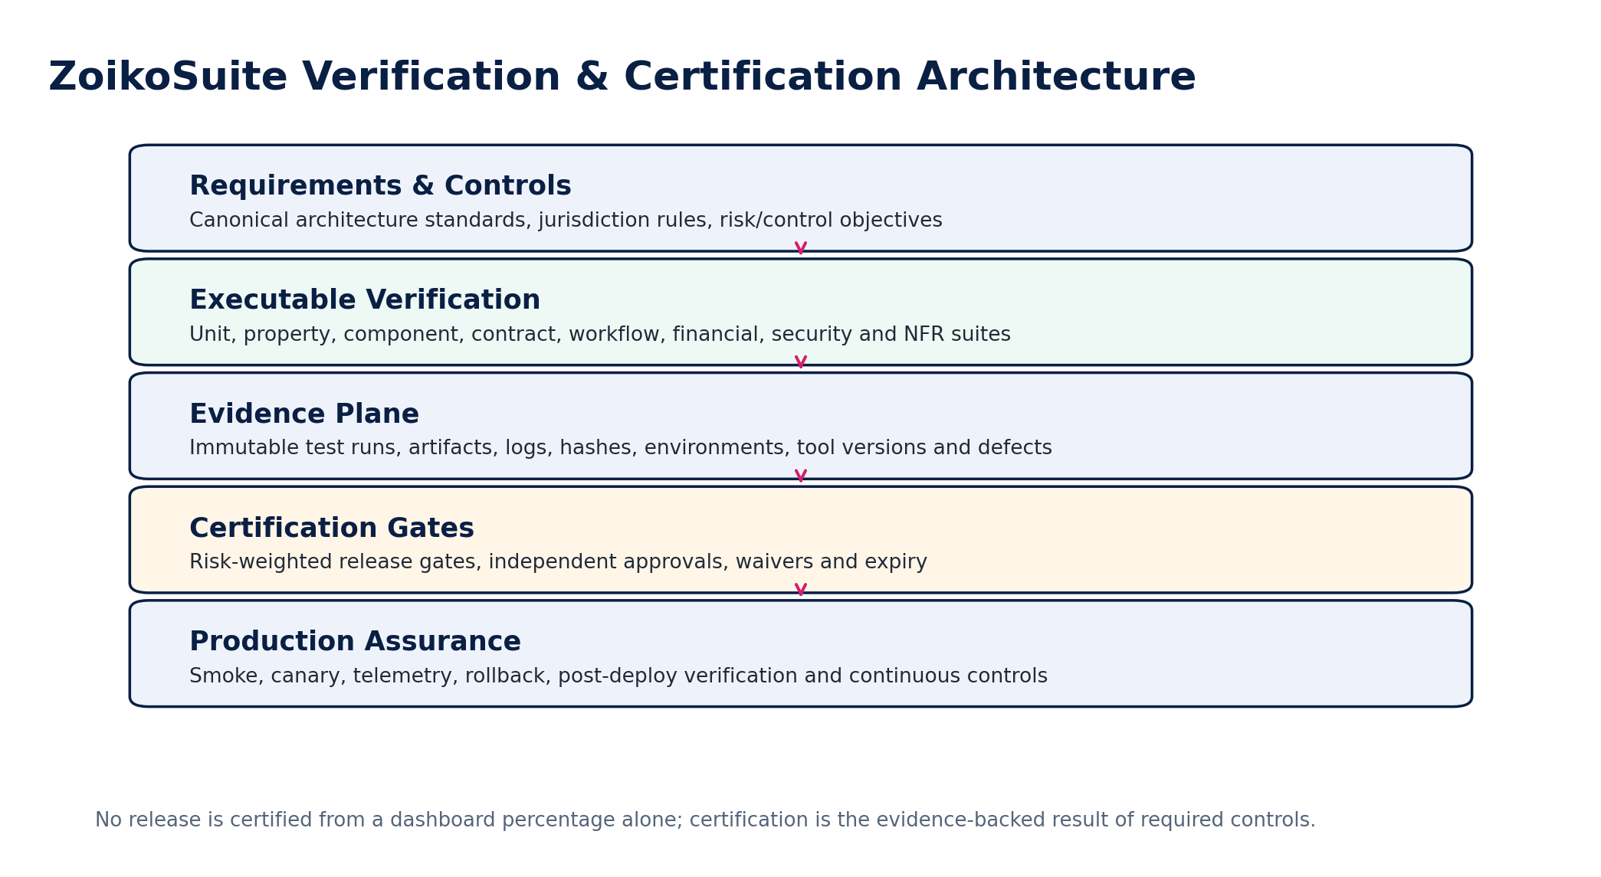
Figure 1 — Verification and certification control architecture

2. Scope, Authority & Relationship to Approved Architecture
ZS-QA-001 is the master engineering-verification standard for ZoikoSuite. It does not redefine business behavior. It verifies the behavior and control obligations established by the approved architecture standards.
Predecessor standard | Verification implications
ZS-DATA-001 — Canonical Data Model | Schema constraints, temporal history, identifier semantics, ownership boundaries, lineage and migration verification.
ZS-ACC-KERNEL-001 — Accounting Kernel | Balanced journals, deterministic posting, book/ledger scope, replay safety, closed periods, FX, control accounts and source-to-ledger traceability.
ZS-STATE-001 — State / Workflow | Legal transitions, guards, approval invalidation, SoD, timeouts, replay, concurrency and terminal-state integrity.
ZS-API-001 — API Contract | HTTP semantics, commands vs resources, idempotency, ETag concurrency, errors, pagination, files, webhooks and version compatibility.
ZS-EVENT-001 — Domain Events | Transactional outbox/inbox, at-least-once delivery, deduplication, ordering, replay, schema evolution and residency.
ZS-IAM-001 — Authorization | Authentication context, RBAC/ABAC, scope, dynamic SoD, delegation, JIT privilege, break-glass and workload identity.
ZS-JUR-001 — Jurisdiction Packs | Regulatory provenance, effective dates, pack compilation, golden/boundary tests, deployment and rollback.
ZS-CONTROL-001 — Financial Controls | Frozen populations, assertions, tolerances, exceptions, reperformance, certification and close gates.
ZS-SEC-001 — Security Architecture | Tenant isolation, residency, cryptography, privacy, secure SDLC, supply chain, backup/recovery and incident controls.

AUTHORITY BOUNDARY
A test harness may observe, stimulate and verify an authoritative service. It must not contain a second copy of production business rules used to “prove” the implementation against itself. Expected outcomes must come from independent specifications, approved golden data, mathematical invariants or authoritative reference sources.

3. Non-Bypassable Verification Invariants
# | Invariant
1 | Every production release has a unique immutable release-candidate identifier and signed artifact digest.
2 | Every mandatory control has a stable ID, owner, risk tier, test mapping and release-gate behavior.
3 | A test result without environment, artifact, configuration and dependency identity is not certification evidence.
4 | All Q0/Q1 tests preserve enough inputs and versions to reproduce the result.
5 | Financial arithmetic tests use exact decimal semantics and explicit rounding rules.
6 | Negative paths are mandatory for authorization, payments, posting, tax filing, period close, migrations and privileged administration.
7 | Idempotency tests prove that retries and duplicates do not create duplicate business effects.
8 | Concurrency tests prove stale-write detection and invariant preservation under races.
9 | Contract tests protect published APIs/events against undocumented breaking change.
10 | Schema migrations are tested both forward and, where rollback is supported, backward/recovery-compatible.
11 | Jurisdiction-pack tests bind expected outcomes to exact rule-pack/source versions.
12 | Production data is not copied into lower environments without formal authorization and controls.
13 | Security defects are severity-scored independently from functional defect severity.
14 | No test may silently skip and still count as passed.
15 | Flaky tests are quarantined as defects; repeated reruns until green do not constitute evidence.
16 | Release blockers cannot be converted to warnings solely by changing pipeline thresholds.
17 | Mandatory test evidence is immutable or tamper-evident after release certification.
18 | Waivers are explicit, risk-owned, scoped, time-limited and automatically expire.
19 | Recovery tests reconcile business data after restoration/failover.
20 | Observability verifies business correctness signals, not merely infrastructure health.
21 | Accessibility verification targets WCAG 2.2 AA for user-facing web experiences unless a stricter jurisdictional rule applies.
22 | AI-generated outputs are never accepted as authoritative expected results for financial, tax or legal correctness.
23 | Independent sign-off is required where the same team cannot reasonably be both control operator and control certifier.
24 | Post-deployment verification must be able to trigger rollback or containment when mandatory conditions fail.
25 | Every escaped material defect results in a regression test or documented reason why automation is infeasible.

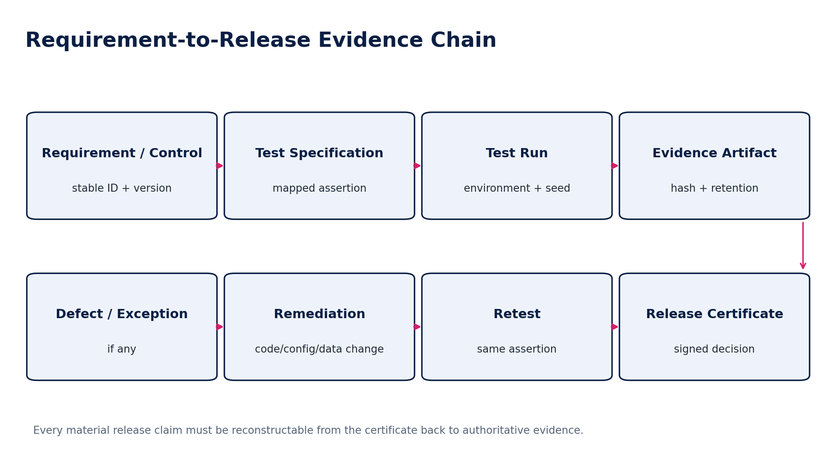
Figure 2 — Requirement-to-release evidence chain

4. Risk Classification & Verification Depth
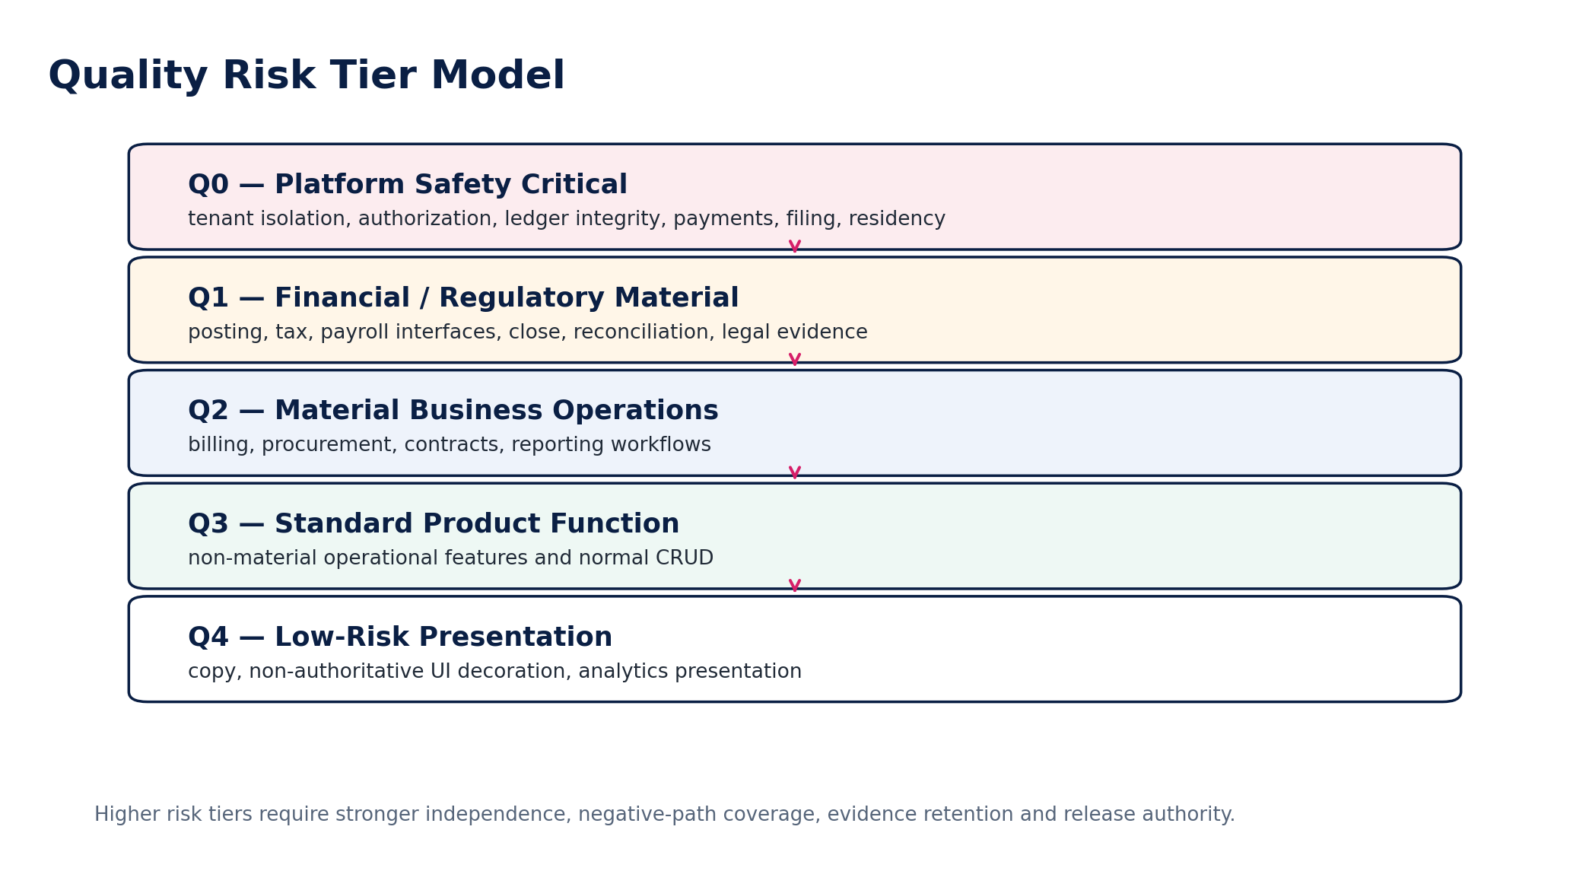
Figure 3 — Quality risk tiers
Risk tier | Typical scope | Minimum verification posture | Release authority
Q0 | Tenant isolation, IAM enforcement, ledger integrity, payments, tax filing, data residency, cryptographic control | Full automated + adversarial + failure + concurrency + negative-path + recovery evidence; independent certification | Engineering Quality + domain control owner + Security/Finance/Tax as applicable
Q1 | Financial/regulatory material functions, reconciliations, close, payroll interfaces, audit/legal evidence | Comprehensive functional/property/contract/integration tests; negative-path; historical/replay; independent domain sign-off | QA + accountable domain owner
Q2 | Material business operations | Automated functional/component/contract tests; representative E2E and error paths | QA / product engineering authority
Q3 | Standard product functionality | Unit/component/contract coverage plus targeted regression | Engineering owner under QA policy
Q4 | Low-risk presentation/non-authoritative analytics | Visual/accessibility/smoke verification proportionate to impact | Engineering/product owner

RISK INHERITANCE
A low-risk UI change that alters a Q0/Q1 command, authorization decision, accounting field, tax input, residency route or legal evidence becomes Q0/Q1 for certification purposes. Risk follows consequence, not repository location.

5. Verification Taxonomy
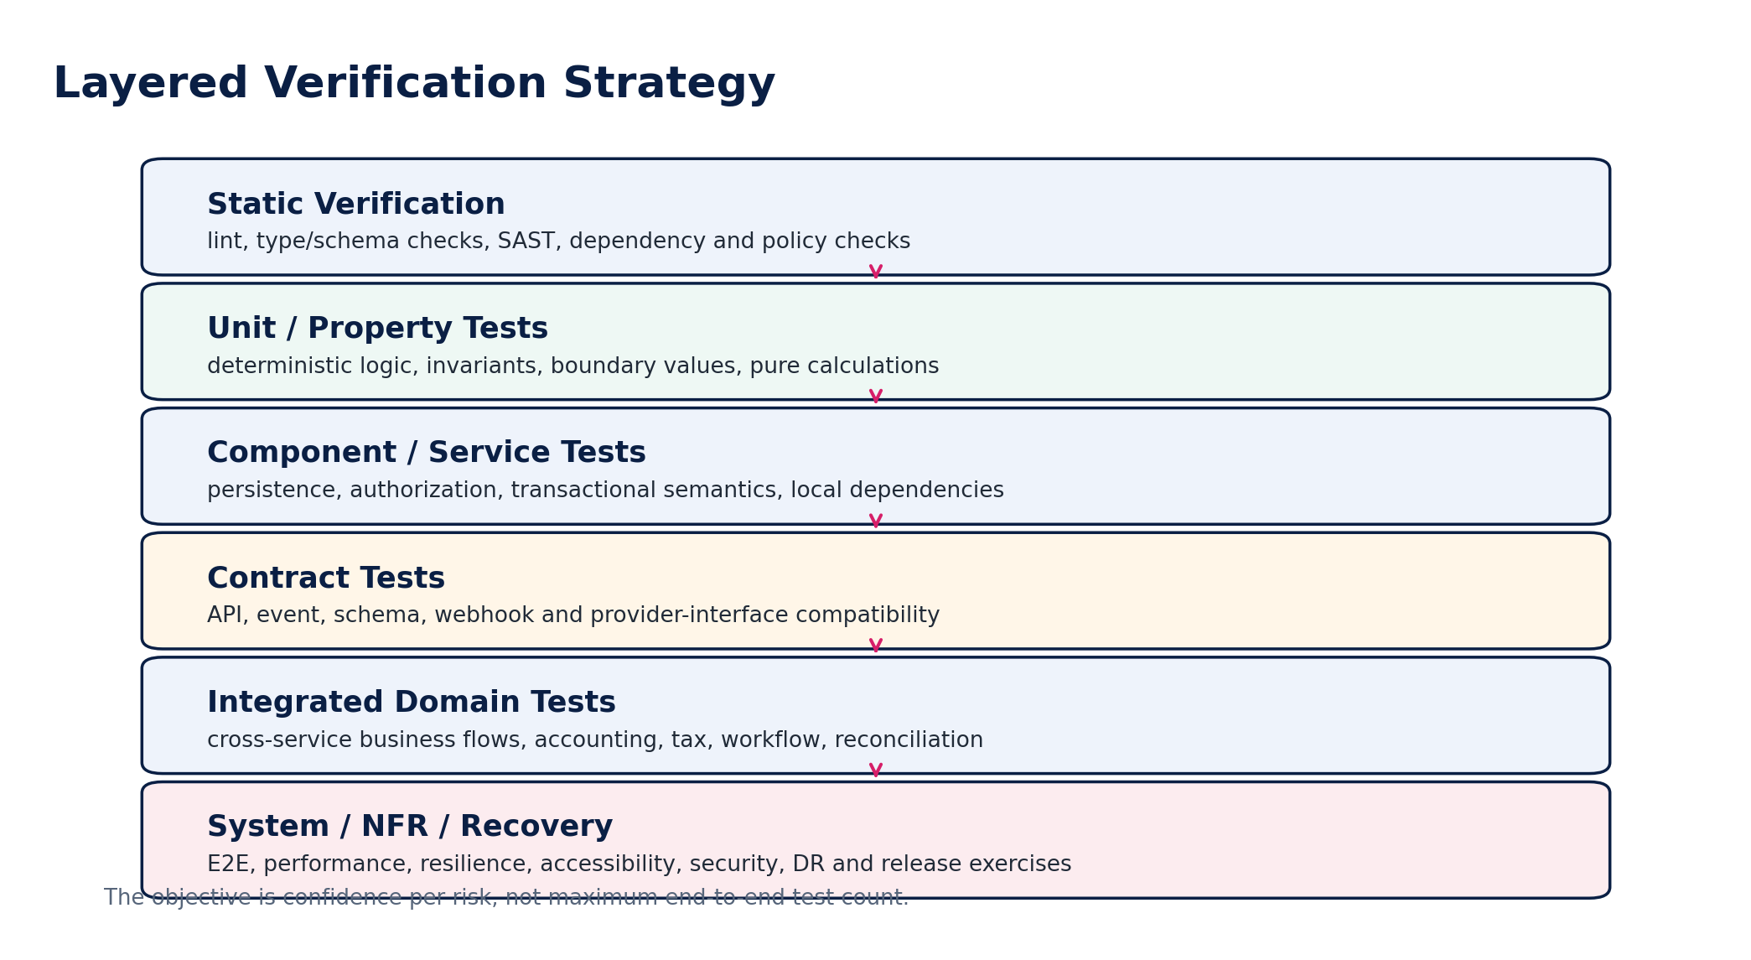
Figure 4 — Layered verification strategy
Verification class | Primary assertion | Required cadence
Static | Compile/type/lint/schema/policy checks | Every commit
Unit | Pure logic and boundary behavior | Every commit
Property-based | Invariants across generated inputs | Q0/Q1 calculations and state rules
Mutation | Strength of critical unit tests | Selected Q0/Q1 modules
Component | Service + authoritative store + local dependencies | Every merge
API contract | Published request/response/command semantics | Every contract change
Event contract | Envelope/schema/order/replay semantics | Every event change
Integration | Cross-service collaboration | Every release candidate
Workflow/model-based | State transitions, guards, timeout and race behavior | Every state-machine change
Golden financial | Known accounting/tax/control outcomes | Every financial engine change
Historical replay | Previously governed outcomes under prior versions | Jurisdiction/accounting/migration changes
Migration | Schema/data/opening-balance transformation | Every migration release
Security | ASVS, SAST/SCA, DAST, abuse, fuzzing, pen test | Risk-based + scheduled
Privacy/residency | Classification, purpose, retention, region routing, logging | Every relevant release
Accessibility | Automated + keyboard + screen-reader/manual critical journeys | User-facing releases
Performance | Latency/throughput/load/soak/stress | Capacity-impacting releases
Resilience | Dependency failure, queue pressure, retry, regional fault | Q0/Q1 and platform releases
DR | Backup/restore/failover + business reconciliation | Scheduled and material architecture changes
Compatibility | Browsers/clients/SDK/provider versions | Supported matrix
Production validation | Canary/smoke/business telemetry | Every production rollout

6. Traceability, Test Specification & Evidence Model
Each material requirement/control must map to a machine-queryable verification record. Test management may be implemented in code repositories and evidence stores, but the logical model below is mandatory.
Entity | Required fields
VerificationRequirement | requirement_id, source_document, source_version, section/control_id, risk_tier, owner, effective_from/to
TestSpecification | test_spec_id, mapped_requirements, assertion, preconditions, inputs, expected_result, negative_cases, automation_level, owner, version
TestRun | run_id, test_spec_version, artifact_digest, environment_id, config_snapshot, data_fixture/seed, started_at, completed_at, status, tool_versions
EvidenceArtifact | evidence_id, run_id, type, URI/object_ref, hash, classification, residency_region, retention_class, generated_at
Defect | defect_id, failed_assertion, severity, business_impact, affected_versions, owner, status, root_cause, remediation_ref
Waiver | waiver_id, blocked_control, scope, rationale, compensating_control, approver, expires_at, residual_risk
ReleaseCertificate | release_id, artifact_digest, required_control_set, evidence_manifest_hash, unresolved_defects, waivers, signatories, decision, timestamp

EVIDENCE MINIMUM
For Q0/Q1 verification, screenshots are supplemental—not primary evidence. Primary evidence should be machine-readable results, immutable logs/artifacts, hashes, structured inputs/outputs and authoritative record references.

7. Test Data Governance
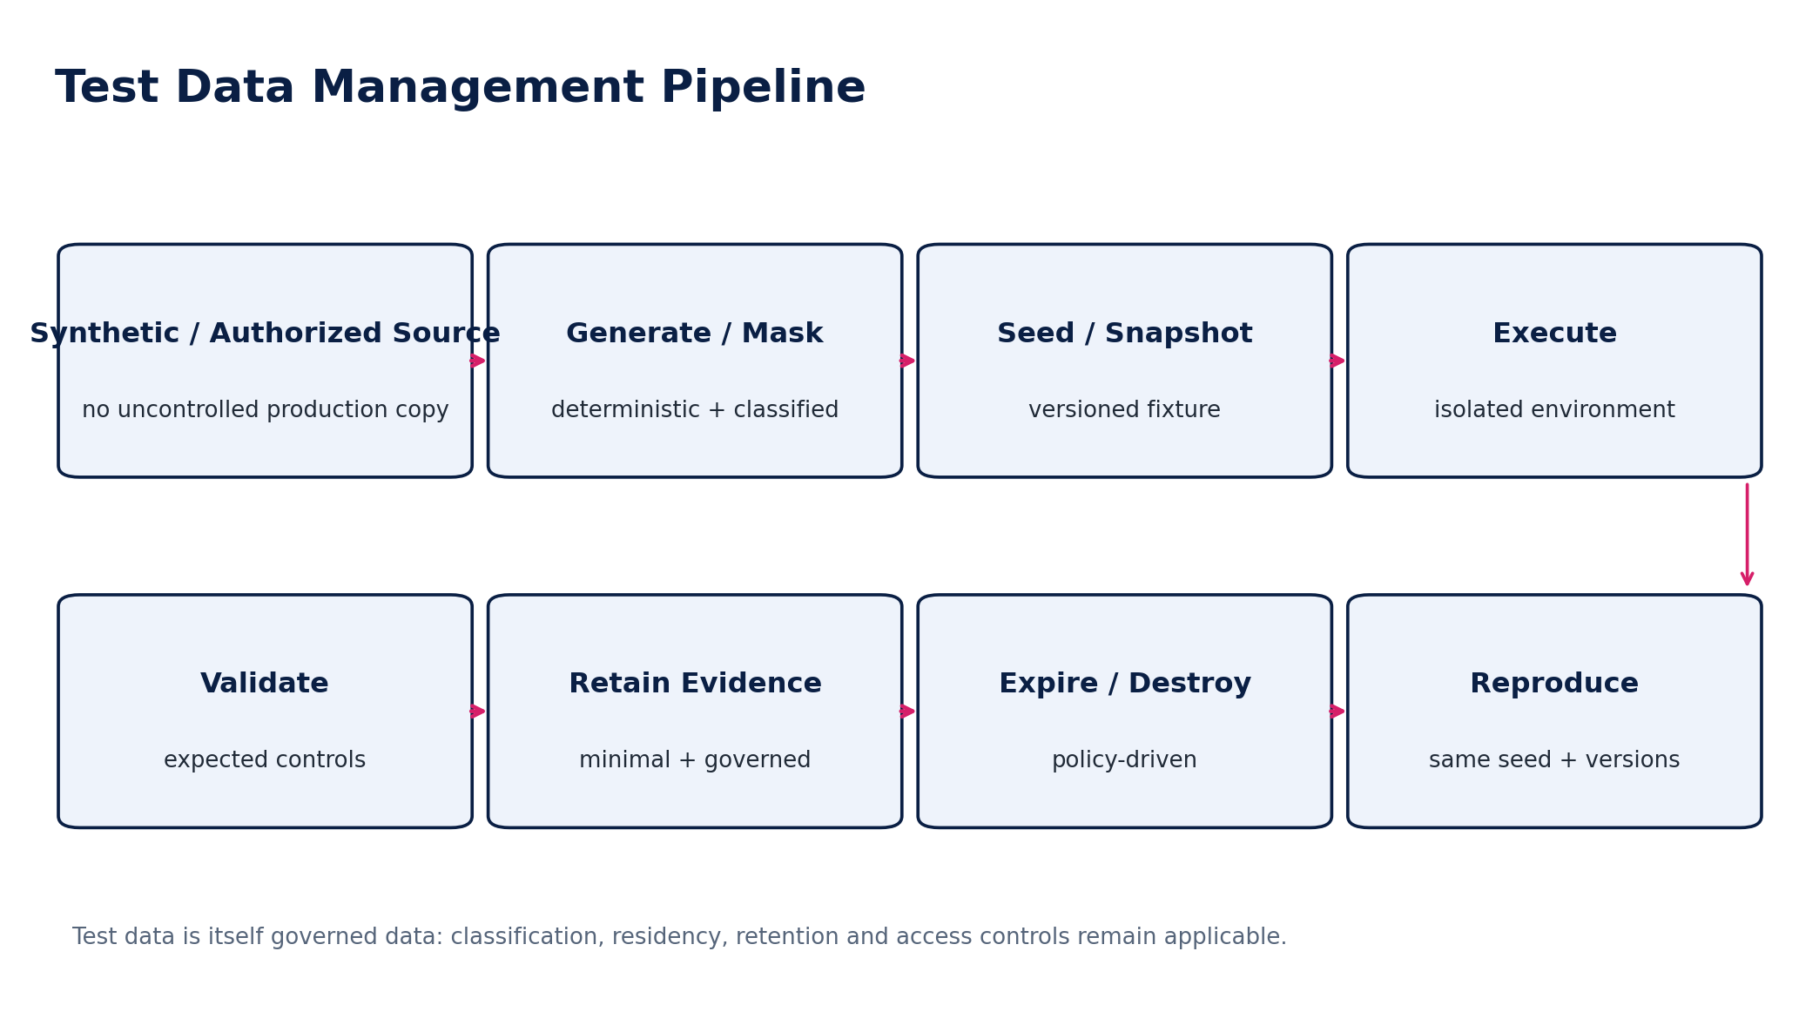
Figure 12 — Governed test-data pipeline
Rule | Engineering requirement
Default source | Synthetic, generated or purpose-built fixtures.
Production-derived data | Requires documented necessity, data owner authorization, minimization, masking/pseudonymization, residency and retention controls.
Financial fixtures | Use exact money, currency, date, FX/rule version and book/entity context.
Jurisdiction fixtures | Bind to pack version, effective date and source snapshot.
Identity fixtures | No real privileged credentials or live production secrets.
Determinism | Seeded generation for reproducibility; seed recorded in TestRun.
Boundary data | Include zero, negative where legal, max/min, precision, daylight-saving, leap dates, fiscal boundaries, thresholds and currency minor-unit cases.
Destruction | Temporary sensitive fixtures are destroyed by policy; evidence retains only what is needed to reproduce/defend the result.

8. Test Environment & Configuration Control
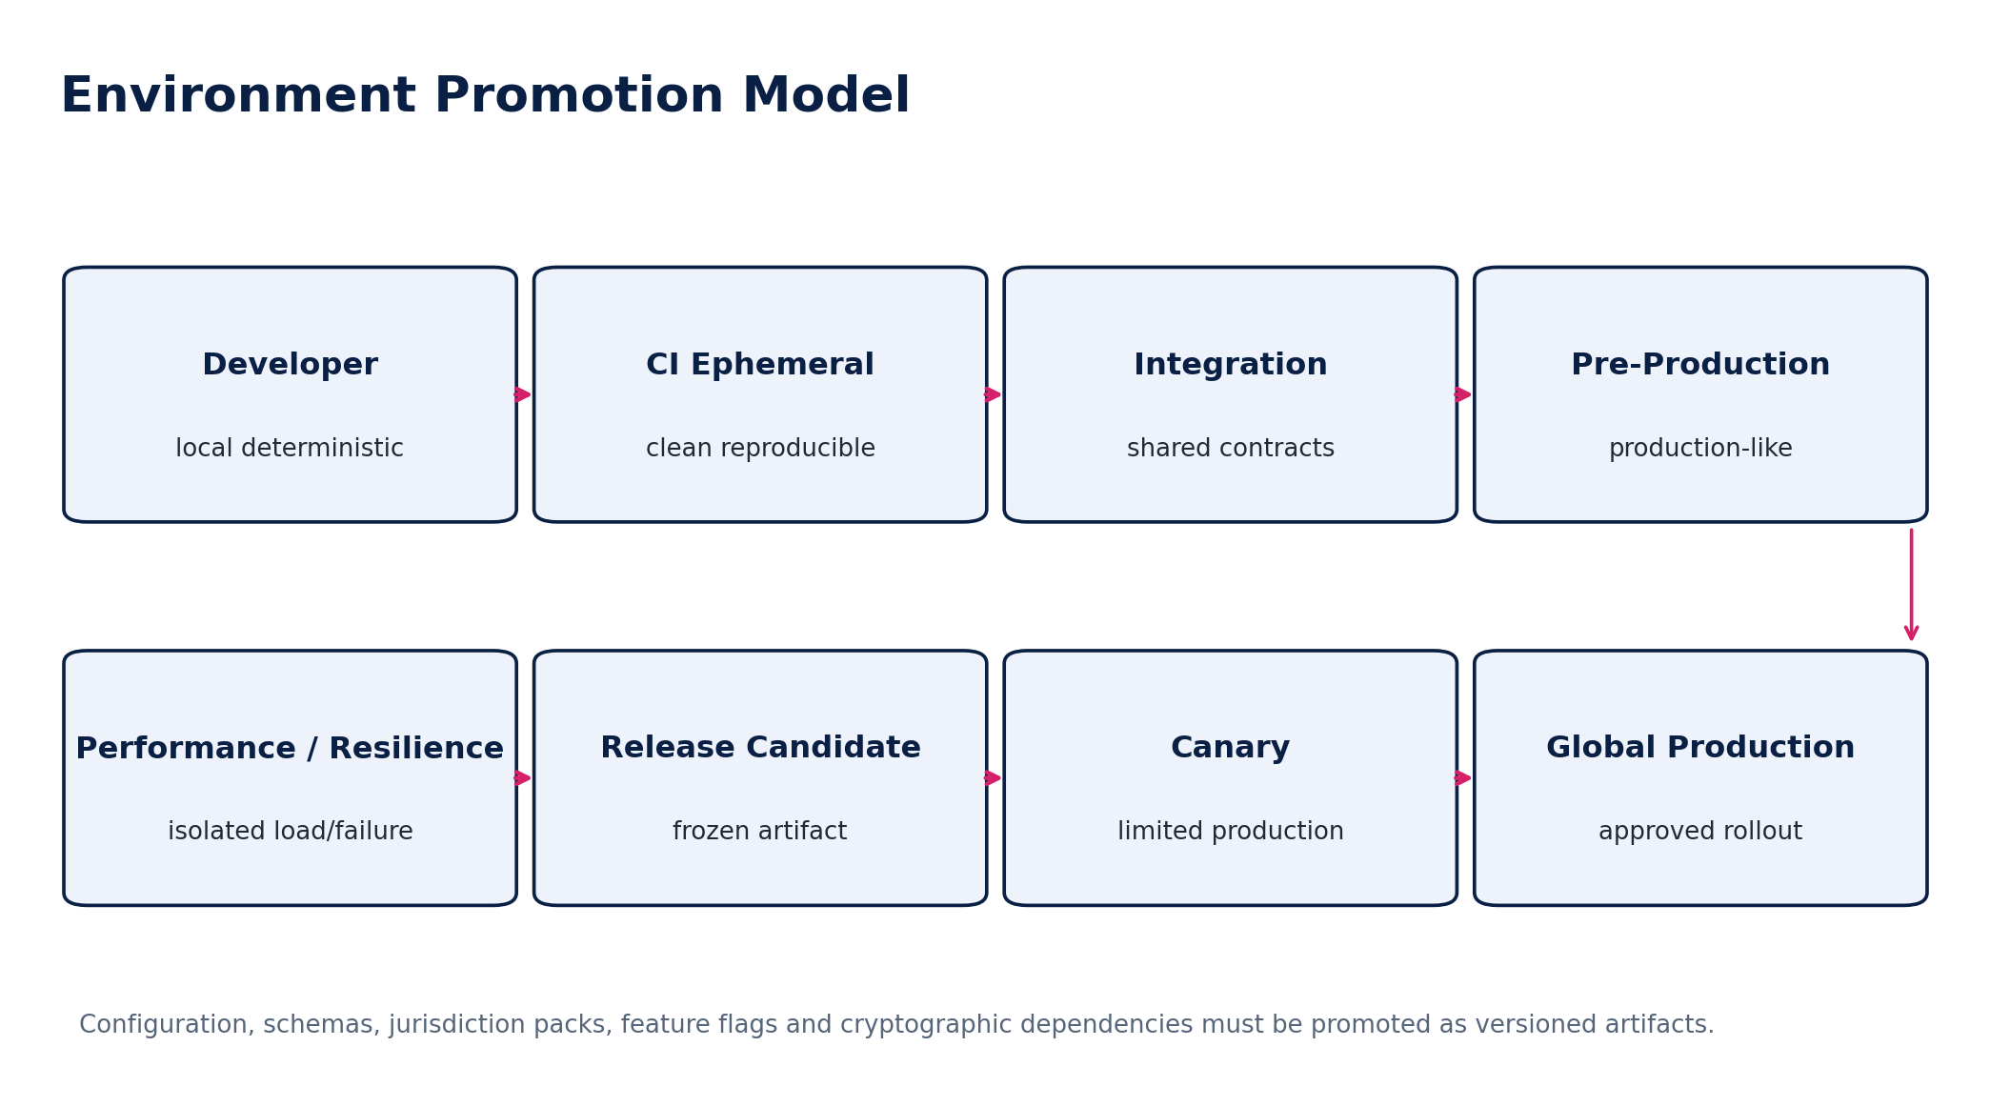
Figure 13 — Environment promotion model
Environment property | Requirement
Artifact identity | Same signed build promoted; no rebuild between certification and production.
Schema | Database/schema migration version captured.
Feature flags | Versioned snapshot; production-only flags explicitly tested before enabling.
Jurisdiction packs | Exact pack versions pinned and recorded.
Secrets/keys | Environment-specific; production material never copied downward.
External providers | Sandbox/test endpoints where available; high-risk provider differences documented and tested with contract simulators plus controlled certification.
Time | Clock control or deterministic time injection for deadlines, DST, period close and effective-dated rules.
Network/failure injection | Available in resilience environments without risking tenant data.
Observability | Test traces/logs/metrics use same semantic instrumentation as production where feasible.

9. CI/CD Quality Gates
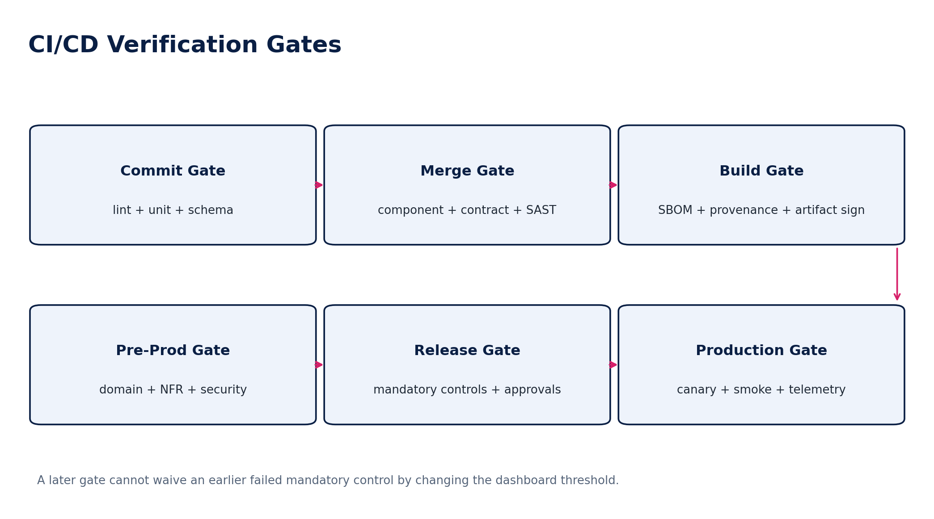
Figure 5 — CI/CD verification gates
Gate | Must prove | Blocking examples
G0 — Commit | Code compiles; unit/static/schema checks pass | Compile/type errors, failed unit tests, secrets detected
G1 — Merge | Component/contract/security checks pass | Breaking API/event change, SAST critical, missing migration
G2 — Build | Artifact provenance and supply-chain integrity | Unsigned artifact, missing SBOM, critical dependency policy failure
G3 — Pre-Production | Integrated domain + mandatory NFR verification | Ledger invariant failure, SoD bypass, residency leak, failed migration
G4 — Release Certification | Evidence complete; risk owners sign; waivers valid | Q0/Q1 mandatory control fail, expired waiver, unowned blocker
G5 — Production Canary | Critical journeys + telemetry + no material regression | Error budget burn, reconciliation break, auth anomalies
G6 — Global Rollout | Canary criteria sustained; rollback ready | Regional integrity mismatch, unresolved incident

10. Unit, Property, Mutation & Component Verification

10.1 Unit verification
- Pure business rules must be isolated enough to test without network or UI dependencies.
- Boundary-value analysis is mandatory for money, rates, thresholds, dates, fiscal periods, quantities and sequence/version counters.
- Randomized tests must record seeds when results affect certification.

10.2 Property-based verification
For Q0/Q1 rules, examples are insufficient. Properties should be stated as invariants and exercised across generated data.
Domain | Example property
Accounting | For every valid posted journal, total debit equals total credit in the governing book currency rules.
Idempotency | Repeating the same command with the same idempotency key creates at most one business effect.
State machine | No generated command sequence reaches an illegal state transition.
Authorization | A subject outside tenant/entity/book scope can never obtain an Allow decision for the protected resource.
Reconciliation | A certified control run cannot mutate its frozen population or evidence manifest.
Tax | A historical transaction evaluated against its pinned pack version reproduces the original deterministic result.
Events | Duplicate/replayed events cannot create duplicate authoritative effects.

10.3 Mutation testing
Selected high-risk pure-logic modules should use mutation testing or an equivalent strength assessment. A test suite that passes when a sign, comparator, boundary or posting account is deliberately mutated is not sufficiently sensitive.

11. API, Event & Integration Contract Certification
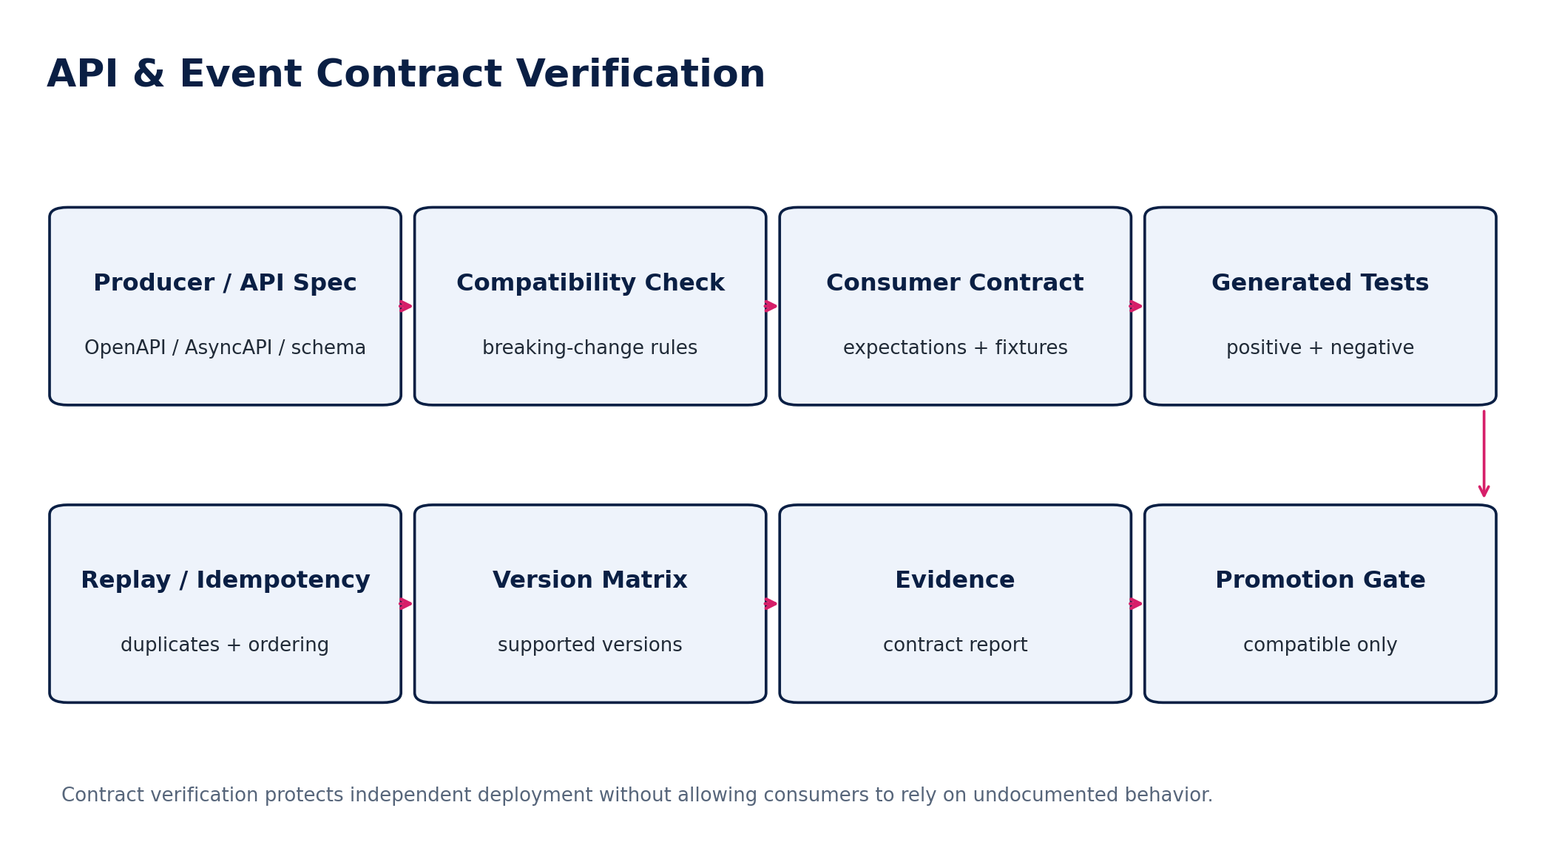
Figure 6 — API and event contract verification
Area | Mandatory verification
OpenAPI | Schema validity, request/response examples, required headers, errors, commands, idempotency, ETag behavior, pagination and compatibility diff.
AsyncAPI / events | Envelope, schema, producer/consumer compatibility, partition key, ordering, duplicates, gap handling, replay/backfill and residency.
Webhooks | Signature validation, timestamp/replay window, rotation, retries, duplicate delivery and unavailable consumer behavior.
Provider callbacks | Authentication, provider-event uniqueness, out-of-order status changes, disputed provider truth and manual reconciliation.
File/import | Malware/quarantine, schema mapping, preview, partial failure, atomicity rules, reconciliation and idempotent re-import.
SDKs | Generated/client compatibility against supported API versions; no client may bypass server-side controls.

12. Accounting Kernel Verification
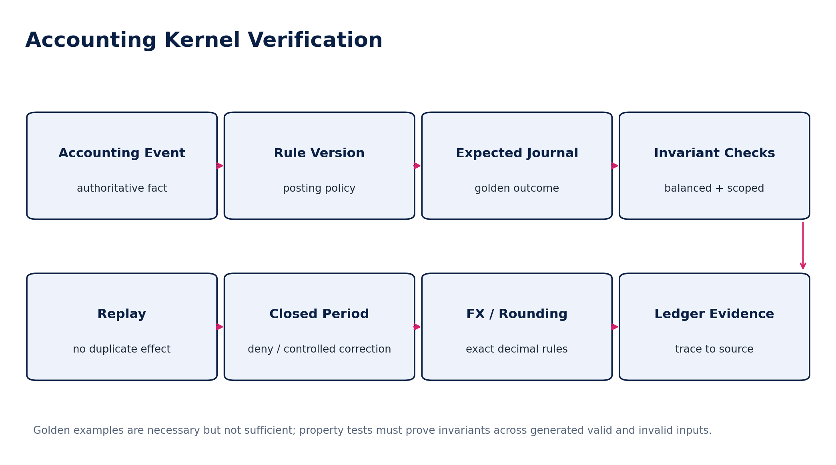
Figure 7 — Accounting kernel verification wireframe
Control family | Required tests
Journal integrity | Balanced lines, valid accounts/dimensions, correct book/ledger/entity, exact precision, immutable posted state.
Posting rules | Golden events per rule version; invalid/missing mapping rejection; deterministic line generation.
Replay | Repeated event/command does not duplicate journal or ledger effect.
Closed periods | Posting blocked; authorized correction/reopen path only.
Control accounts | Unauthorized direct posting denied; subledger-origin requirements enforced.
FX | Rate source/date/type, functional/reporting currency, realized/unrealized treatment, rounding.
Multi-book | Same economic event may produce distinct book outcomes without duplicate source facts.
Corrections | Reversal/adjustment/supersession preserves original and complete lineage.
Concurrency | Competing postings/period close operations preserve invariants.
Source-to-report | Every material balance can trace to source event, rule version, journal and evidence.

FINANCIAL CERTIFICATION GATE
A release that changes posting, precision, period, FX, control-account, consolidation or reconciliation behavior is Q0/Q1 regardless of code size. It requires accounting-domain sign-off and regression across affected books/jurisdictions.

13. Financial Reconciliation & Control Verification
Verification area | Mandatory behavior
Population freeze | Hash/count/control totals reproducible; post-freeze changes create a new run.
Assertion testing | Control proves its defined assertion rather than merely total equality.
Matching | Exact/composite/many-to-one rules deterministic; manual matches fully evidenced.
Tolerance | Versioned, authorized and non-editable by preparer during run.
Materiality | Individually small exceptions aggregate correctly.
Exceptions | Owner, reason, aging, SLA, financial exposure and affected assertion recorded.
Remediation | Authoritative correction linked; no spreadsheet-only “resolution”.
Reperformance | Resolved exception/control is retested on authoritative data.
Certification | Maker/checker/authority enforced; certified run immutable.
Close gate | Mandatory control failures block hard close/report release according to control policy.

14. Workflow, Approval & State-Machine Verification
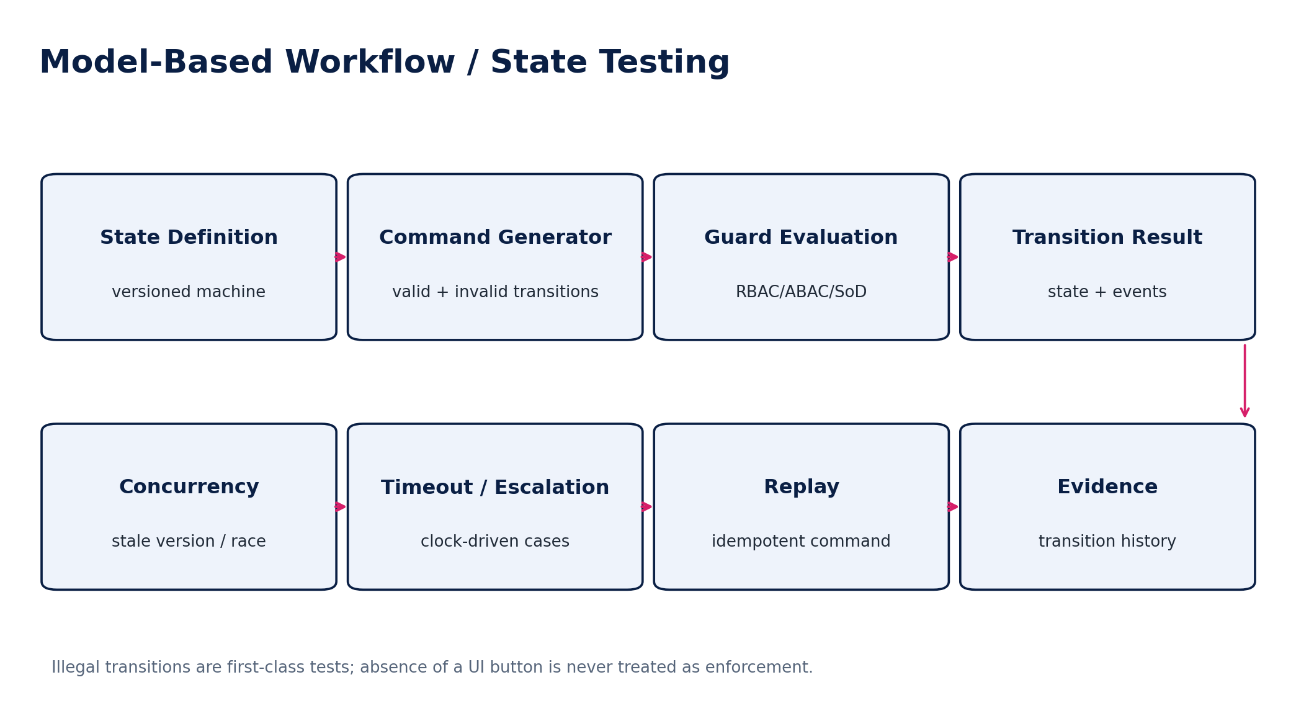
Figure 8 — Model-based state and workflow verification
Test family | Required cases
Legal transitions | Every allowed transition succeeds only when guards are satisfied.
Illegal transitions | Every disallowed transition is rejected with stable reason/evidence.
Approval binding | Material change invalidates approval fingerprint as defined.
SoD | Originator/preparer cannot perform prohibited approval/release action.
Delegation | Effective dates, scope, limit, expiry and non-redelegation enforced.
Timeouts | No silent approval; escalation/expiry/pause behavior deterministic.
Optimistic concurrency | Stale expected version rejected; no last-write-wins on governed objects.
Replay | Repeated transition command is idempotent.
External callback | Duplicate/out-of-order callbacks cannot drive illegal state.
Terminal states | Immutable/controlled correction semantics preserved.

15. Jurisdiction, Tax & Regulatory Certification
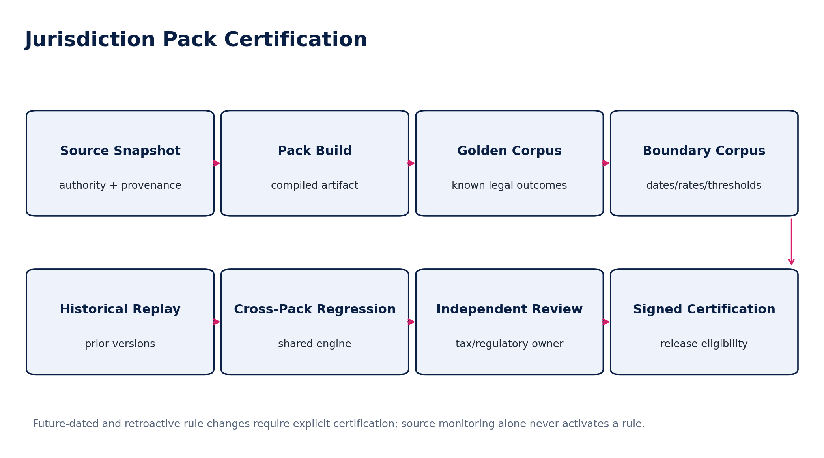
Figure 9 — Jurisdiction-pack certification pipeline
Corpus | Minimum content
Golden | Known authoritative examples with expected tax, invoice, filing or deadline outcomes.
Boundary | Threshold edges, effective-date cutovers, zero/max rates, rounding, exemption transitions.
Historical | Prior released pack versions and previously governed transactions.
Negative | Unsupported registrations, invalid classifications, missing evidence, impossible effective dates.
Cross-pack | Shared engine changes tested against all affected jurisdiction packs.
Authority-schema | E-invoice/return payload schema, code lists, validation and acknowledgement behavior.
Calendar | Business-day, holiday, deadline, grace-period and timezone cases.
Retroactive | Explicitly modeled legislative retroactivity; prior result preservation plus authorized reprocessing behavior.

INDEPENDENT REGULATORY REVIEW
The engineer who implements a material regulatory rule may not be the sole certifier of its legal/tax correctness. Production eligibility requires the jurisdiction pack’s defined regulatory approval authority.

16. IAM, Authorization & Segregation-of-Duties Verification
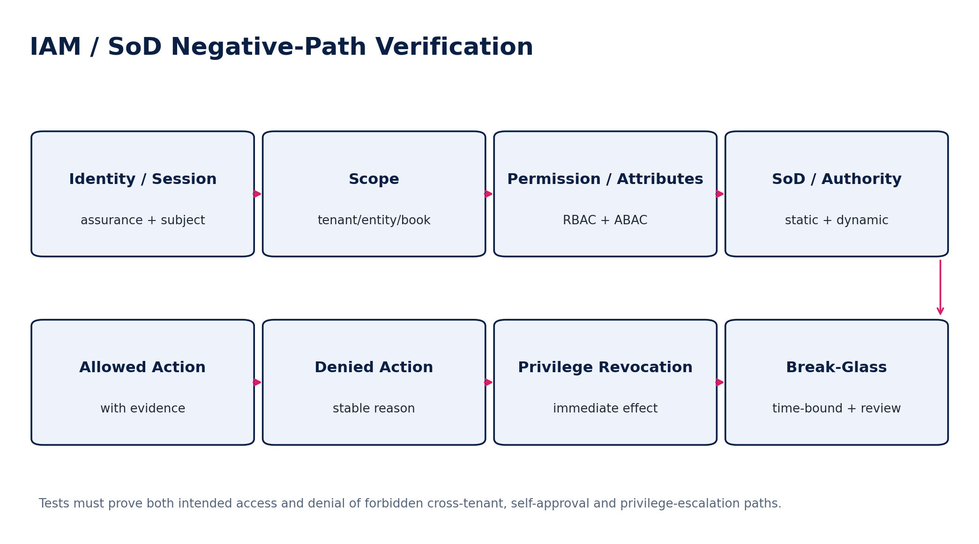
Figure 10 — IAM and SoD negative-path verification
Control | Required test evidence
Tenant/entity/book scope | Cross-scope denial under API, event, search/export and administrative paths.
RBAC | Role grants only documented permissions; role-version changes regression tested.
ABAC | Attribute predicates, relationships, sensitivity and purpose constraints evaluated server-side.
Dynamic SoD | Own-object approval/release and conflicting transaction history blocked.
Delegated authority | Finite scope/value/time; attribution to actor and delegator.
Revocation | Permission/session/privilege revocation takes effect within defined security objective.
JIT privilege | Elevation approval, step-up, time limit and automatic removal.
Break-glass | Emergency path cannot silently become standing privilege; retrospective review evidence.
Workload identity | Unique service subject, expected audience, short-lived credential and explicit service permission.
Support access | No silent impersonation; tenant/support purpose, scope and evidence preserved.

17. Security, Privacy & Residency Assurance
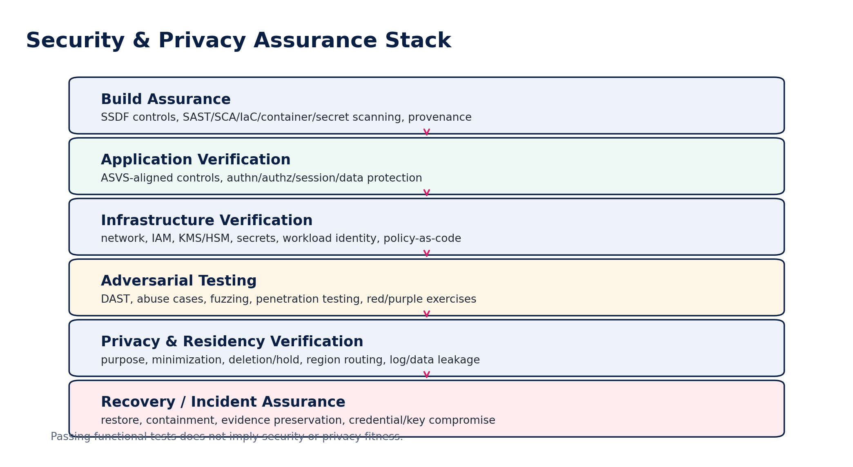
Figure 11 — Security and privacy assurance stack
Assurance area | Minimum requirement
Secure development | NIST SSDF-aligned practices, code review, threat modeling, dependency and supply-chain controls.
Application security | OWASP ASVS 5.0.0-aligned requirement mapping for applicable web/API controls.
Technical assessment | Vulnerability scanning, configuration review, DAST and penetration testing proportionate to risk.
Tenant isolation | Automated cross-tenant negative corpus across stores, caches, search, events, files, exports and admin tooling.
Residency | Data-bearing route tests, failover tests, backup/log routing and default-deny cross-region cases.
Cryptography | Algorithm/key policy, rotation, envelope metadata, BYOK/HYOK failure, revoked key and re-encryption tests.
Privacy | Purpose limitation, minimization, retention/disposition, legal hold, access/export/delete workflows where applicable.
Secrets | No secrets in source, logs, test evidence or artifacts; secret rotation and compromise playbooks tested.
Incident | Containment preserves evidence; credential/key isolation and recovery tested.

18. Data, Database & Migration Verification
Area | Required verification
Schema migration | Forward compatibility, lock/latency impact, large-table behavior, rollback/recovery strategy.
Data ownership | No cross-service direct writes to authoritative stores.
Temporal history | As-of/effective-time reconstruction correct before and after migration.
Identifiers | Internal ID immutability and external-reference uniqueness/mapping.
Opening balances | Trial balance, AR/AP open items, bank/tax/payroll balances reconcile to signed migration evidence.
Duplicate handling | Source IDs/idempotency prevent duplicate import.
Partial failure | Atomicity/compensation behavior defined and tested.
Data quality | Rejected/quarantined records do not silently enter authoritative state.
Lineage | Source → transformation → authoritative object → ledger/report remains reconstructable.
Rollback | No rollback plan may depend on deleting posted/regulated records; use controlled forward correction where necessary.

19. AI / Intelligent Automation Verification
Where ZoikoSuite uses AI for extraction, classification, explanation, anomaly detection or assistance, QA must distinguish probabilistic quality from authoritative system correctness.
Area | Verification requirement
Authority boundary | AI output cannot directly become a posted journal, payment release, tax filing, legal conclusion or approval without deterministic controls.
Grounding | RAG answers cite permitted authoritative sources; inaccessible tenant/entity data must never appear.
Numeric integrity | LLM does not invent authoritative financial values; material numbers come from deterministic systems.
Extraction | Field-level accuracy/confidence corpus; low-confidence material fields route to validation.
Prompt injection | Retrieved/user content cannot override system/data-access policy.
Data leakage | Cross-tenant, secret, training-data and tool-output leakage tests.
Model version | Every evaluated output records model/config/prompt/retrieval versions needed for comparison.
Regression | Fixed eval corpus plus adversarial cases before model/prompt/retrieval changes.
Human factors | UI clearly separates suggestion from authoritative record/action.
Fail-safe | Model/provider outage degrades gracefully without bypassing business controls.

20. Performance, Scalability & Resilience Verification
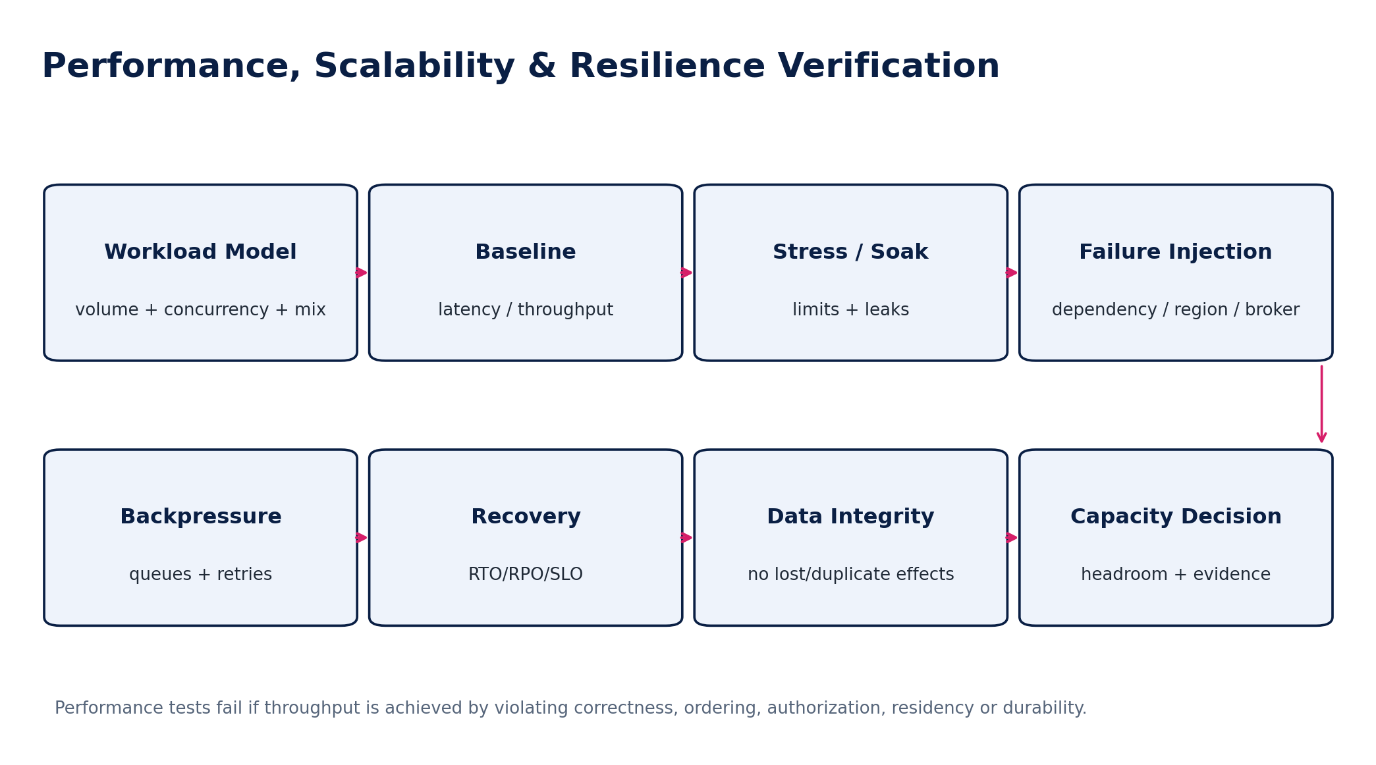
Figure 14 — Performance, scalability and resilience verification
Metric / scenario | Control expectation
Latency | SLOs defined by operation class; tail latency measured, not average only.
Throughput | Sustained target under realistic transaction mix and authorization/audit overhead.
Concurrency | No invariant violation under parallel posting, payment, import, close or workflow activity.
Soak | Memory/connection/resource leaks and queue growth detected over extended duration.
Stress | Known degradation curve and safe overload behavior.
Backpressure | Bounded queues/retries; no retry storm or uncontrolled duplicate effects.
Dependency failure | Fail closed/open only according to explicit policy; critical financial integrity never traded for availability.
Regional failure | Residency-aware failover only to permitted region; post-failover reconciliation required.
Recovery | RTO/RPO measured from exercises, not documentation estimates.
Capacity | Headroom and scale trigger decisions evidenced before launch.

21. Disaster Recovery & Business Continuity Verification
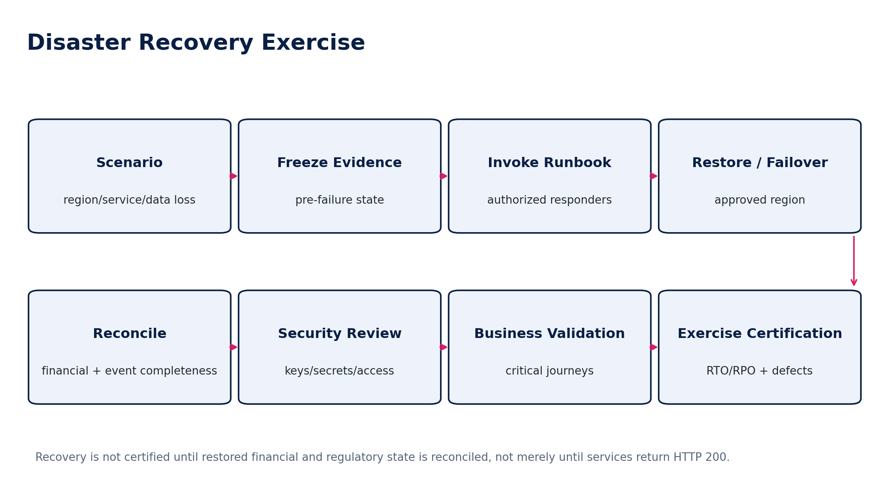
Figure 15 — Disaster recovery exercise and certification
Exercise component | Acceptance requirement
Scenario | Credible service, zone, region, data-store, credential or provider failure.
Activation | Authorized responders and communication path exercised.
Restore/failover | Uses approved backup/replication path and permitted residency region.
Integrity | Authoritative state, event offsets/inboxes, ledgers and control populations reconciled.
Security | Keys, secrets, access grants and break-glass sessions reviewed after event.
Business journeys | Posting, invoice, payment, filing, authentication and retrieval critical paths validated.
RTO/RPO | Measured values meet approved objectives or produce owned defects.
Evidence | Timeline, commands, snapshots, reconciliations and deviations retained.
Lessons | Every material exercise issue maps to remediation and retest.

22. Accessibility, Compatibility & User-Facing Acceptance
User-facing ZoikoSuite experiences target WCAG 2.2 AA as the platform baseline unless a jurisdiction or procurement commitment requires more. Automated tooling is necessary but insufficient.
Area | Required verification
Accessibility automated | Semantic structure, labels, contrast where tooling is reliable, common ARIA and form defects.
Keyboard | All critical journeys operable without pointer; visible and non-obscured focus.
Screen reader | Critical workflows tested with representative supported screen-reader/browser combinations.
Authentication | Accessible authentication and recovery patterns; no unnecessary cognitive barriers.
Responsive | Supported desktop/tablet/mobile layouts preserve function and information hierarchy.
Browser/client | Published support matrix with automated smoke and targeted manual regression.
Localization | Date, number, currency, timezone, text expansion, RTL where supported, legal/localized content.
Error UX | Validation and denial messages are actionable without exposing sensitive authorization details.

23. Defect Severity, Escaped Defects & Waiver Governance
Severity | Definition | Default release behavior
P0 / Critical | Tenant escape, ledger corruption, unauthorized payment/filing, exploitable critical security defect, unrecoverable data loss | Immediate block/containment; no ordinary waiver
P1 / High | Material financial/regulatory error, authorization bypass, significant privacy/residency defect, DR failure | Release blocked unless executive control authority explicitly approves extraordinary exception
P2 / Medium | Material user/business impairment with bounded workaround and no Q0/Q1 integrity breach | Risk-reviewed; may release only under defined criteria/waiver
P3 / Low | Minor functional/UX defect with low business impact | May defer with owner and target release
P4 / Cosmetic | Presentation-only issue without accessibility/legal impact | Product discretion

WAIVER DOCTRINE
A waiver is not a test pass. It is an explicit acceptance of known residual risk. It must identify the exact failed/missing control, scope, compensating controls, accountable approver and expiry. Expired waivers automatically become release blockers.

24. Release Certification
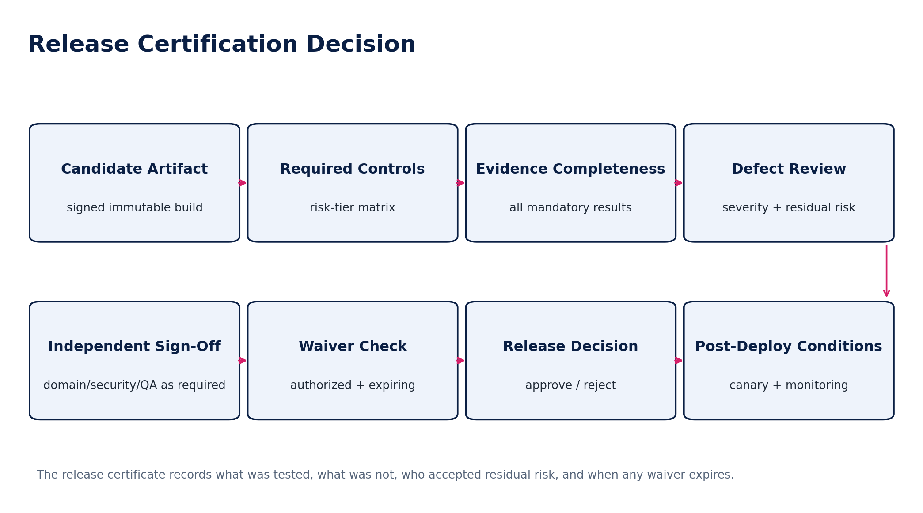
Figure 16 — Release certification decision
Certificate field | Required content
Release identity | release_id, version, commit/build, signed artifact digest, deployment manifest
Scope | services, schemas, jurisdiction packs, feature flags, regions, clients
Risk profile | highest risk tier and impacted control families
Required controls | versioned gate/control set used for this release
Evidence manifest | all mandatory TestRun/EvidenceArtifact references + hash
Known defects | open P0–P4 items, impact, owner and release decision
Waivers | IDs, approvers, residual risk, compensating controls, expiry
Approvals | engineering, QA, security, finance/tax/domain/SRE signatures as required
Deployment conditions | canary scope, rollout order, monitoring, rollback/containment triggers
Decision | Approved / Conditionally Approved / Rejected with timestamp and authority

25. Production Validation & Continuous Assurance
Control | Requirement
Pre-deploy | Confirm artifact digest, migration plan, feature flags, jurisdiction pack versions, rollback/containment readiness.
Canary smoke | Critical API/business journeys including authorization and source-to-ledger/control signals.
Business telemetry | Posting failures, duplicate attempts, reconciliation breaks, filing/provider rejects, event lag, access anomalies.
Technical telemetry | Error rate, saturation, latency, queue depth, resource health and dependency status.
Automatic abort | Defined conditions halt rollout without requiring manual debate during active degradation.
Post-deploy reconciliation | Q0/Q1 changes trigger targeted financial/event/control reconciliation.
Progressive rollout | Regions/tenants expanded only after acceptance window.
Post-release review | Material incidents/escapes update regression corpus, risk model and architecture controls.

26. Initial Mandatory Verification Control Catalogue
ID | Control | Tier | Cadence
QA-001 | Artifact identity/provenance | Q0 | Every release
QA-002 | Requirements-to-test traceability | Q0/Q1 | Every release
QA-003 | Skipped-test prohibition | All | Every pipeline
QA-004 | Flaky-test quarantine | All | Continuous
QA-005 | Idempotency business-effect test | Q0/Q1 | Every affected change
QA-006 | Optimistic concurrency test | Q0/Q1 | Every affected change
QA-007 | Cross-tenant isolation corpus | Q0 | Every relevant release
QA-008 | Cross-entity/book authorization corpus | Q0/Q1 | Every relevant release
QA-009 | Journal balance invariant | Q0 | Accounting releases
QA-010 | Control-account posting protection | Q0 | Accounting/subledger releases
QA-011 | Closed-period enforcement | Q0/Q1 | Accounting releases
QA-012 | FX/precision/rounding corpus | Q1 | Financial calculation releases
QA-013 | Accounting replay safety | Q0 | Event/posting releases
QA-014 | Subledger-to-GL reconciliation | Q1 | Financial release candidates
QA-015 | Bank settlement reconciliation | Q1 | Banking/payment releases
QA-016 | Tax-ledger/return reconciliation | Q1 | Tax releases
QA-017 | Jurisdiction golden corpus | Q1 | Pack releases
QA-018 | Jurisdiction boundary corpus | Q1 | Pack releases
QA-019 | Historical pack replay | Q1 | Pack/engine releases
QA-020 | Approval fingerprint invalidation | Q1 | Workflow releases
QA-021 | Dynamic SoD negative path | Q0/Q1 | IAM/workflow/payment releases
QA-022 | JIT privilege expiry | Q0 | Privileged-access changes
QA-023 | Break-glass review evidence | Q0 | Security/IAM releases
QA-024 | API breaking-change diff | Q1/Q2 | Contract releases
QA-025 | Event compatibility/replay | Q0/Q1 | Event releases
QA-026 | Webhook/provider callback replay | Q0/Q1 | Integration releases
QA-027 | Schema migration rehearsal | Q0/Q1 | DB migrations
QA-028 | Opening balance migration reconciliation | Q1 | Migration/cutover
QA-029 | Residency routing/failover | Q0 | Regional architecture releases
QA-030 | Sensitive logging leakage | Q0 | Every relevant release
QA-031 | OWASP ASVS mapped verification | Q0/Q1 | Application-security releases
QA-032 | Dependency/SBOM/provenance gate | Q0 | Every build
QA-033 | Performance baseline regression | Q1/Q2 | Capacity-impacting releases
QA-034 | Backpressure/retry storm test | Q0/Q1 | Async/platform releases
QA-035 | DR restore + financial reconciliation | Q0 | Scheduled/material changes
QA-036 | WCAG 2.2 AA critical journey | Q1/Q2 | User-facing releases
QA-037 | Production canary acceptance | Q0/Q1 | Every production rollout
QA-038 | Release waiver expiry check | All | Every certification
QA-039 | AI cross-tenant leakage corpus | Q0 | AI feature changes
QA-040 | AI authoritative-boundary test | Q0/Q1 | AI feature changes
QA-041 | Event-to-ledger completeness | Q0/Q1 | Accounting/event releases
QA-042 | Tax/e-invoice authority acknowledgment | Q1 | Regulatory integration releases
QA-043 | Payment duplicate-effect prevention | Q0 | Payment releases
QA-044 | Supplier bank change + release SoD | Q0 | AP/payment releases
QA-045 | Control population immutability | Q1 | Reconciliation engine releases
QA-046 | Material exception aggregation | Q1 | Control framework changes
QA-047 | Legal hold/retention behavior | Q1 | Data lifecycle changes
QA-048 | Backup encryption/restore key availability | Q0 | Backup/crypto releases
QA-049 | Credential/key compromise containment | Q0 | Security platform changes
QA-050 | Source-to-report lineage completeness | Q1 | Reporting/ledger releases

27. Negative-Path Engineering Acceptance Scenarios
ID | Scenario | Expected result
N01 | Same payment command replayed 20 times | One business effect; identical response or stable replay result.
N02 | Two actors concurrently approve/release same governed object | Only legal transition wins; stale command rejected.
N03 | Cross-tenant object ID guessed | No data/action leakage; deny logged without revealing existence.
N04 | Journal lines differ by 0.01 due to precision bug | Posting blocked; no auto-balancing line.
N05 | Posting attempted after hard close | Denied except authorized reopen/correction path.
N06 | Control totals match but one invoice omitted and another duplicated | Reconciliation fails composition/completeness assertion.
N07 | Tax threshold exactly at effective-date boundary | Correct pack/rule version selected deterministically.
N08 | Retroactive jurisdiction change released | Original historical result preserved; authorized reprocessing explicit.
N09 | Approval granted then material amount changes | Approval invalidated; execution blocked until re-approved.
N10 | Payment preparer tries to release own payment | Dynamic SoD denies.
N11 | Delegation expires during pending approval | Authority revalidated at execution; expired delegation denied.
N12 | Provider callback replayed/out of order | No duplicate/illegal state effect; reconciliation evidence preserved.
N13 | Event delivered twice after broker retry | Inbox/dedup prevents duplicate authoritative effect.
N14 | Event version gap detected | Consumer follows defined gap/quarantine policy; no silent progression.
N15 | Schema migration interrupted mid-run | System follows tested recovery/roll-forward strategy without corruption.
N16 | Test marked skipped in mandatory Q0 suite | Gate fails; skip cannot count as pass.
N17 | Flaky test passes on third rerun | Original flakiness remains defect; pipeline policy enforced.
N18 | Engineer changes pass threshold to hide failures | Policy-as-code / approval gate blocks unauthorized threshold change.
N19 | Expired waiver attached to release | Certification rejected.
N20 | Pen test finds critical auth bypass after functional green | Release blocked regardless of functional score.
N21 | Production-like load causes retry storm | Backpressure works; no duplicate financial effects; release fails if SLO/integrity breached.
N22 | Region fails during posting burst | Permitted failover only; ledger/event reconciliation proves completeness.
N23 | Backup restores but KMS key unavailable | DR fails until decryptability and business validation succeed.
N24 | Restore returns HTTP 200 but one ledger partition missing | DR certification fails reconciliation.
N25 | Sensitive tax ID appears in application log | Security/privacy gate fails.
N26 | AI assistant retrieves another tenant’s document | Q0 isolation failure; release blocked/contained.
N27 | AI suggests unsupported tax result | Output cannot become authoritative; grounding/guard test fails.
N28 | Accessibility automated scan green but keyboard cannot reach approval control | WCAG/manual acceptance fails.
N29 | Opening balance import totals match but source IDs duplicated | Migration certification fails identity/lineage control.
N30 | Bank feed omits one day | Completeness control detects missing statement/day.
N31 | Supplier bank details changed immediately before release | Risk/SoD revalidation blocks or routes enhanced approval.
N32 | Jurisdiction pack source changed but tests not recertified | Pack cannot promote.
N33 | Signed artifact differs from tested digest | Deployment admission rejects.
N34 | Production feature flag activates untested Q0 path | Rollout gate rejects/contains.
N35 | Business calendar DST/holiday edge changes filing deadline | Boundary corpus catches incorrect obligation date.
N36 | Material escaped defect discovered post-release | Incident + regression test + root cause + recertification path initiated.

28. Definition of Ready — Verification
- Requirement/control has stable ID, owner, risk tier and acceptance assertion.
- Data/API/event/state/accounting/jurisdiction/security dependencies are identified and versioned.
- Positive, negative, boundary, concurrency/replay and recovery cases are identified where relevant.
- Test data strategy and classification are approved.
- Expected results come from independent specification, invariant or authoritative golden source.
- Environment and dependency requirements are documented.
- Evidence and retention requirements are known.
- Automation feasibility and manual-test rationale are documented.
- Release-gate behavior for failure is defined.
- Required independent certifier(s) are identified.

29. Definition of Done — Release Candidate
- All mandatory controls for the release risk profile executed against the exact candidate artifact.
- No P0/P1 blocker remains unresolved unless extraordinary policy explicitly permits and accountable authority signs.
- All failed mandatory assertions have owned defects and successful retest or valid unexpired waiver.
- Contract, migration and jurisdiction compatibility gates pass.
- Financial/accounting/reconciliation controls pass where impacted.
- Security/privacy/residency gates pass where impacted.
- Performance/resilience/DR evidence meets release requirements.
- Accessibility/compatibility acceptance passes for affected user-facing journeys.
- Evidence manifest is complete, hashed and retained.
- Release certificate is signed by required authorities.
- Canary, monitoring, rollback/containment and post-deploy acceptance criteria are approved.

30. Engineering Implementation Sequence
Wave | Build / institutionalize
Wave 0 | Verification IDs, risk tiers, evidence schema, release-certificate model and CI policy engine.
Wave 1 | Unit/property/component standards; deterministic fixtures; static verification.
Wave 2 | OpenAPI/AsyncAPI contract tests, idempotency/concurrency harnesses, provider simulators.
Wave 3 | Accounting, workflow, IAM and reconciliation golden/property corpora.
Wave 4 | Jurisdiction-pack certification framework and historical/boundary corpora.
Wave 5 | Security/privacy/residency assurance automation; ASVS mapping; adversarial test program.
Wave 6 | Performance, soak, stress, fault injection, backpressure and capacity baselines.
Wave 7 | Migration/cutover rehearsal, backup/restore and DR/business reconciliation exercises.
Wave 8 | Release evidence graph, independent certification workflow, production canary controls and continuous assurance.

31. Controlled Pre-Production Decisions
Decision | Must be resolved before production
Quality risk policy | Final Q0–Q4 classification authority and examples.
Release authority | Who can approve/reject each risk tier and extraordinary exceptions.
Evidence retention | Retention classes by test/evidence type and jurisdiction.
Toolchain | Canonical test runner/report format, evidence store and signing mechanism.
Coverage thresholds | Language/repository-specific code coverage targets where useful; never substitute for mandatory control mapping.
Mutation scope | Which critical modules require mutation testing and minimum score.
Performance objectives | Numerical SLO/load/capacity targets by service/operation class.
DR objectives | RTO/RPO and exercise cadence by service/data class.
Pen test cadence | Independent test cadence and release triggers.
Accessibility matrix | Supported browser/assistive-technology matrix.
AI eval thresholds | Task-specific acceptance metrics, model-change triggers and adversarial corpus.
Waiver governance | Allowed severities, maximum durations and escalation/board reporting.

32. Prohibited QA / Certification Anti-Patterns
- “95% tests passed” used to approve a release with failed mandatory controls.
- Rerunning flaky tests until the dashboard turns green.
- Skipped tests counted as passed.
- Expected values generated by the same production function being tested.
- Screenshots used as sole evidence for financial or security correctness.
- Manual database edits to make test data “match.”
- Production secrets or uncontrolled production datasets copied into QA.
- UI-only tests used to prove server authorization or SoD.
- HTTP 200 used as proof of DR success without business reconciliation.
- Performance gains accepted when achieved by weakening logging, authorization, durability or residency.
- Tax/jurisdiction rule changes promoted without source-provenance and historical/boundary regression.
- Waivers without expiry or accountable risk owner.
- Critical security findings downgraded by the feature team without security authority.
- Direct production hotfixes that bypass artifact identity, evidence and post-fix verification.
- AI outputs used as the authoritative expected answer for accounting/tax/legal tests.

33. Current External Standards & Reference Baseline — August 2026
Reference | Current status / use in ZoikoSuite
ISO/IEC 25010:2023 | Published product-quality model with nine quality characteristics; used as the quality-attribute vocabulary for NFR coverage and acceptance.
ISO/IEC/IEEE 29119-2:2021 | Published test-process standard; informs governance/management/implementation of test processes across lifecycle models.
ISO/IEC/IEEE 29119-3:2021 | Published test-documentation standard; informs structured test/evidence artifacts without forcing document-heavy waterfall process.
OWASP ASVS 5.0.0 | Latest stable ASVS; used for version-pinned application-security verification requirements.
NIST SP 800-218 SSDF v1.1 | Current final SSDF. NIST SP 800-218 Rev.1 / SSDF v1.2 is an Initial Public Draft as of Aug 2026 and must not be represented as final.
NIST SP 800-115 | Final technical guide for information-security testing/assessment; informs vulnerability and penetration-testing program design.
NIST SP 800-34 Rev.1 | Contingency-planning guide; informs recovery testing and exercise discipline.
WCAG 2.2 | Current W3C Recommendation; ZoikoSuite targets AA for user-facing web experiences unless stricter obligations apply.

These references are control inputs, not substitutes for ZoikoSuite’s architecture standards or jurisdiction-specific obligations. Where a reference is draft, withdrawn or superseded, the controlling standards register must record that status explicitly.

Appendix A — Canonical TestRun Payload
ILLUSTRATIVE LOGICAL SCHEMA
test_run_id; test_spec_id/version; requirement_ids; release_candidate_id; artifact_digest; environment_id; tenant_fixture_id; jurisdiction_pack_versions; schema_versions; feature_flag_snapshot; data_fixture_id/seed; tool_versions; started_at/completed_at; outcome; assertions[]; evidence_refs[]; defect_refs[]; trace/correlation_id.

Appendix B — Release Certificate Minimum Statement
The undersigned certify that the identified release candidate was evaluated against the required verification-control set for its declared risk profile; that the evidence manifest is complete to the best of their knowledge; that unresolved defects and waivers are disclosed; and that the deployment conditions, canary criteria and rollback/containment controls stated in the certificate are mandatory conditions of release.

Appendix C — Final Architecture Decision
ARCHITECTURE DECISION
Adopt ZS-QA-001 as the controlling verification and release-certification standard for ZoikoSuite. No service, jurisdiction pack, schema migration, integration, AI capability, security control or production release is considered complete merely because implementation exists. Completion requires the defined verification evidence, risk-appropriate certification and production acceptance path.

