ZOIKOSUITE

Financial, Statutory & Regulatory Reporting
Detailed Service Specifications
REP-01 through REP-07 — Build-Ready Reporting & Digital Filing Baseline

Field | Value
Document ID | ZS-SVC-H-001
Version | 1.0
Date | 24 August 2026
Status | Build-ready domain specification — subject to jurisdictional filing-profile certification and production release gates
Owner | ZoikoSuite Platform Architecture / Financial Reporting
Prepared for | Engineering, Product, Finance, Accounting, Tax, Compliance, Security, QA, Operations, Audit & Filing Integrations
Classification | Internal Engineering / Architecture Control
Language | American English

Executive doctrine — A report is not authoritative because it renders successfully. Certified financial or statutory reporting must bind to a frozen authoritative source population, explicit reporting framework and jurisdiction profile, versioned mappings and disclosures, mandatory control results, independent approvals where required, and a tamper-evident evidence chain. Digital tagging and regulatory transmission are downstream representations of that certified report — never alternate sources of financial truth.

1. Critical Analysis & Architecture Decisions
- Financial reporting is a controlled derivation layer. It must never become a second ledger, tax engine, consolidation engine or free-form spreadsheet layer.
- Statutory outputs require a signed/frozen source identity. Live-ledger queries are acceptable for exploratory/internal draft reporting only when clearly labeled; they are not sufficient for certified statutory publication.
- Reporting state is orthogonal to filing state. A financial statement set can be Certified while a regulatory submission is Pending/Unknown, Rejected or Superseded.
- XBRL/iXBRL tagging is a representation of a certified report instance. Tagging does not authorize alteration of report values, accounting classifications or disclosure conclusions.
- Jurisdiction-specific forms, taxonomies, schemas, signatures, filing channels and deadlines are effective-dated regulatory artifacts resolved from the Jurisdiction Pack architecture.
- Report Builder is deliberately constrained to governed semantic datasets. It cannot execute raw SQL over authoritative stores, invent accounting logic or bypass field-level authorization.
- Management reporting may combine actual, forecast and operational facts, but the basis, freshness and assurance state of every material population must remain visible and reproducible.
- Regulatory submission uses a durable attempt model. A transmission timeout is Pending/Unknown until the original attempt is resolved; blind resubmission is prohibited.
- Corrections never mutate previously published or filed artifacts. Correct the authoritative source where necessary, generate a new report version, preserve comparatives/restatement treatment, and link the amendment/supersession chain.
- Every externally relied-on report fact must support source-to-report traceability back through controls, signed snapshot, ledger and source-domain evidence.
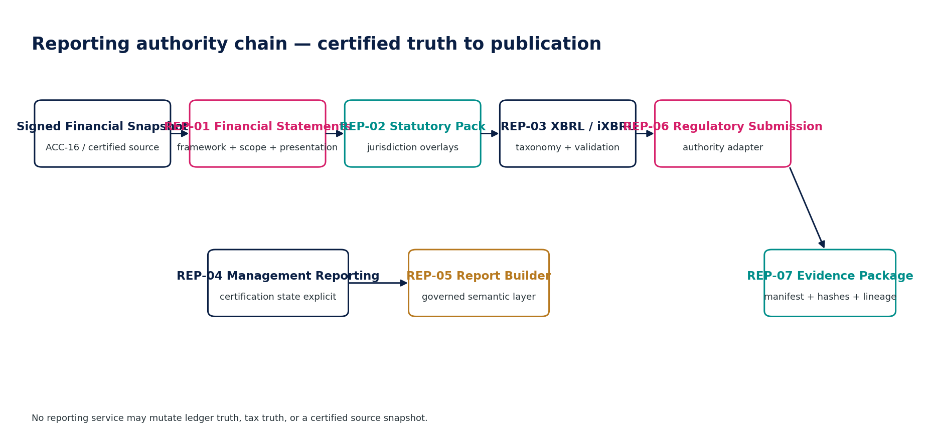
Figure 1 — Reporting authority chain.

2. Domain Scope, Service Inventory & Authority Model
ID | Service | Authoritative role
REP-01 | Financial Statements | Produce controlled primary financial statements, comparative columns, notes and disclosure schedules from certified accounting populations under an approved reporting framework.
REP-02 | Statutory Reporting Pack | Assemble jurisdiction-specific annual/statutory accounts packs from certified financial statements plus entity, governance, auditor and filing-specific disclosures.
REP-03 | XBRL / iXBRL | Map certified report facts to an approved taxonomy, govern filer extensions, generate XBRL/iXBRL artifacts, validate them and preserve fact-level tagging lineage.
REP-04 | Management Reporting | Produce controlled internal management and board reporting across actuals, budget, forecast and operational measures with an explicit assurance/freshness state.
REP-05 | Report Builder | Provide governed self-service reporting over approved semantic datasets without permitting direct authoritative-database access or invention of accounting/regulatory logic.
REP-06 | Regulatory Submission | Package, submit and resolve authority state for non-tax financial/statutory/regulatory reports using jurisdiction-specific adapters and durable submission attempts.
REP-07 | Export & Evidence Package | Create portable, tamper-evident packages containing reports, machine-readable data, manifests, mappings, approvals, lineage and verification material for audit, filing, handoff or archive.

2.1 Non-bypassable reporting invariants
- Certified statutory/financial reports SHALL reference an immutable signed source snapshot or equivalent certified source population.
- Reporting services SHALL NOT write directly to the General Ledger, Tax Ledger, AR/AP open items, bank settlement facts or consolidation adjustments.
- Every certified report SHALL persist reporting framework, jurisdiction profile, entity/group scope, period, currency and presentation/mapping versions.
- Every material reported fact SHALL be traceable to source facts and transformation/mapping versions.
- A report SHALL NOT be certified if mandatory reconciliations/control assertions for its source population are unresolved.
- Published/filed report artifacts SHALL be immutable; corrections create a new version linked by supersession/amendment/restatement metadata.
- Report approval SHALL be invalidated if protected report content, source identity, mapping, taxonomy or disclosure basis changes.
- Report Builder SHALL use approved semantic datasets and SHALL NOT access authoritative databases through arbitrary SQL.
- XBRL/iXBRL SHALL preserve taxonomy package/version, mapping version, contexts/units, extension taxonomy and validation evidence.
- A standard taxonomy concept SHALL be preferred; filer extension concepts require governed justification and review.
- Regulatory submission SHALL create a durable attempt before the external side effect and SHALL preserve provider/authority ambiguity as Pending/Unknown.
- Authority acknowledgements SHALL be authenticated, deduplicated and retained as evidence.
- Management reports mixing actual, forecast, provisional or operational populations SHALL make basis/freshness/assurance state explicit.
- Export of Restricted/Highly Restricted data SHALL obey classification, purpose, residency, retention and legal-hold policies.
- AI SHALL NOT invent authoritative numerics, filing outcomes, accounting conclusions or unsupported narrative in certified reports.
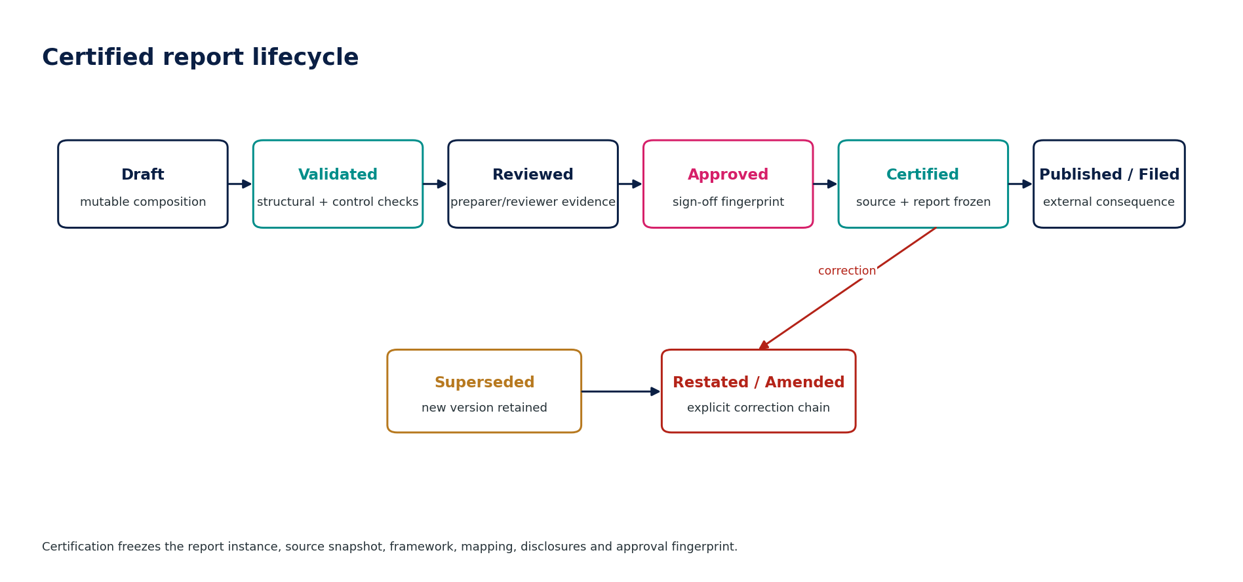
Figure 2 — Certified report lifecycle.

3. Shared Reporting Contract
Contract element | Mandatory behavior
Trusted context | tenant_id, entity/group scope, reporting period, accounting book, framework, jurisdiction, currency, language, purpose, permission and source snapshot identity are server-authoritative.
Identifiers | UUIDv7 internal IDs; external filing IDs/authority receipt IDs remain separate.
Precision | Financial numerics use fixed precision inherited from certified source; rendering may round/display but never alter authoritative underlying amount.
Concurrency | Mutable drafts use optimistic concurrency/ETag; approval/certification uses protected-content fingerprint.
Idempotency | Certification, package signing and external submission require stable idempotency keys and duplicate-effect protection.
Errors | RFC 9457-aligned API problem details; stable reporting-specific codes such as SOURCE_NOT_CERTIFIED, REPORT_OUT_OF_BALANCE, TAXONOMY_INVALID, SUBMISSION_OUTCOME_UNKNOWN.
Events | Transactional outbox for authoritative report/submission state events; consumers deduplicate.
Evidence | Every certification records source IDs/hashes, rule/mapping versions, validation runs, signers, timestamps and artifact digests.
Residency | Generation, caching, export, filing transport and evidence storage inherit GTRM/data-classification policy.
Retention | Certified/filed artifacts use record-class retention; active legal hold suspends disposition.
Correction | No in-place edit of certified/published/filed artifacts; supersede/amend/restatement creates new immutable instance.
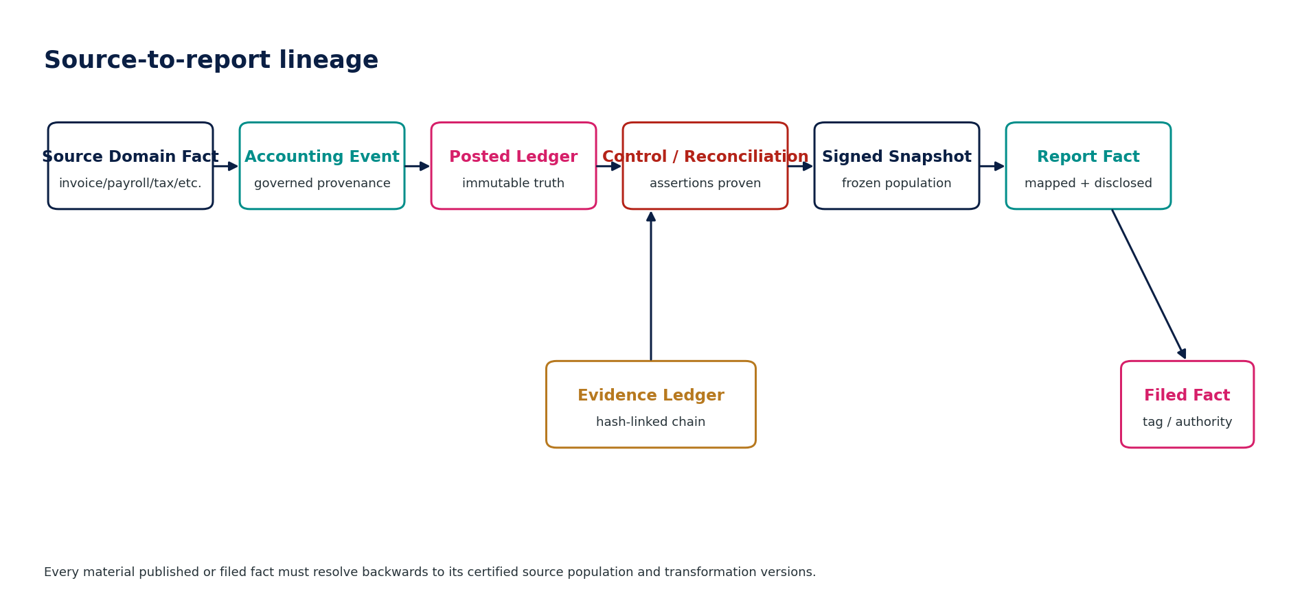
Figure 3 — Source-to-report lineage.

4. Detailed Service Specifications

4.1 REP-01 — Financial Statements
Purpose — Produce controlled primary financial statements, comparative columns, notes and disclosure schedules from certified accounting populations under an approved reporting framework.

Specification field | Build-ready requirement
Authoritative write ownership | FinancialStatementSet, StatementFact, DisclosureInstance, PresentationMappingUse, ComparativePresentation
Explicit non-ownership | GL balances; tax calculations; consolidation adjustments; statutory filing acknowledgement
Required source inputs | ACC-16 Signed Financial Snapshot; certified consolidation scope; reporting framework/profile; presentation mappings; disclosure checklist; comparative snapshots; materiality/display policy
Server-resolved context | tenant, legal entity/group, accounting book, reporting period, framework, presentation currency, jurisdiction, language, approval policy
Named commands | CreateStatementSet; RefreshDraft; ValidateStatements; SubmitForReview; ApproveStatementSet; CertifyStatementSet; SupersedeStatementSet
Queries / read surfaces | GetStatementSet; GetStatement; GetDisclosure; ExplainReportedFact; GetComparatives; GetValidationResults
State model | Draft → Validated → InReview → Approved → Certified → Published/Superseded
Permissions | report.prepare; report.review; report.approve; report.certify; report.publish
Segregation of duties | Preparer cannot independently certify material statutory statements; certification authority constrained by entity/group and threshold.
Domain events | FinancialStatementSetCreated; FinancialStatementsValidated; FinancialStatementsCertified; FinancialStatementsSuperseded
Dependencies | ACC-15/16, ACC-18, ZS-CONTROL, GOV-03/04/06/07, ZS-DATA-GOV
Failure / degradation semantics | Source snapshot changed or invalid → block refresh/certification; broken tie-out/cross-cast → validation failure; missing disclosure evidence → review exception.
Evidence / lineage | Snapshot ID/hash; statement mapping version; report framework version; comparative IDs; validation results; signers; certification fingerprint.
NFR / recovery profile | C1 authoritative reporting; deterministic rerun; certified instance immutable; source-to-report lookup p95 target <2s for indexed lineage.
Minimum negative tests | No live-ledger certification; totals/cross-casts; comparative/restatement; sign-off invalidation after protected change; missing source lineage blocks certification.

REP-01 — Mandatory engineering controls
- Certified output must bind to ACC-16 Signed Financial Snapshot (or explicitly equivalent controlled source) and a stable ledger/control watermark.
- Primary statements, note disclosures and comparative columns must cross-reference a single report instance and retain presentation mapping version.
- Cash-flow construction method and mapping are versioned; unexplained balancing plugs are prohibited.
- Restated comparatives are never silently substituted for originally published comparatives; basis must be explicit.
- Certification freezes report content, source identity, mappings, disclosures and signer fingerprint.
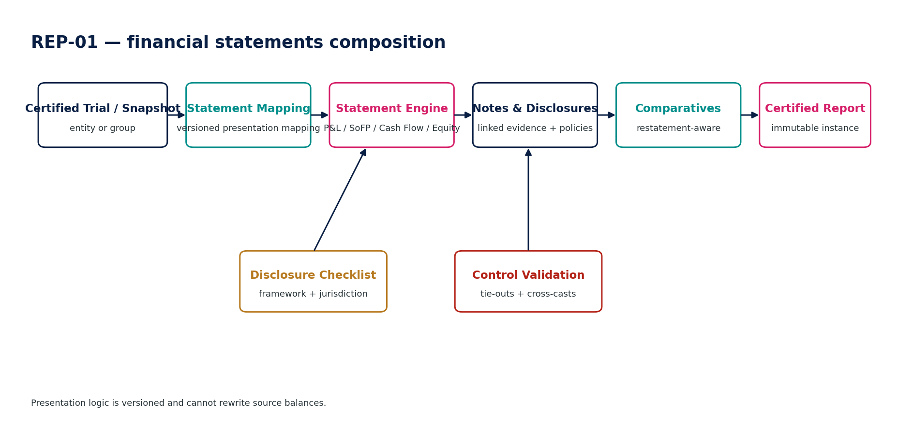
Figure 3 — REP-01 control flow.

4.2 REP-02 — Statutory Reporting Pack
Purpose — Assemble jurisdiction-specific annual/statutory accounts packs from certified financial statements plus entity, governance, auditor and filing-specific disclosures.

Specification field | Build-ready requirement
Authoritative write ownership | StatutoryPack, StatutoryComponent, FilingDisclosure, SignatureRequirementStatus
Explicit non-ownership | Accounting truth; legal entity master; tax return; regulator receipt
Required source inputs | REP-01 certified statement set; jurisdiction pack; entity/legal-form attributes; auditor status; directors/officers; local disclosure templates; language/format requirements
Server-resolved context | entity, jurisdiction, filing regime, period, size/classification, exemptions, language, filing obligation
Named commands | CreateStatutoryPack; ApplyJurisdictionOverlay; ValidatePack; SubmitForApproval; CertifyPack; SupersedePack
Queries / read surfaces | GetStatutoryPack; GetRequiredComponents; GetMissingDisclosures; GetSignatureRequirements; GetFilingReadiness
State model | Draft → Complete → Validated → Approved → Certified → Filed/Superseded
Permissions | statutory.prepare; statutory.review; statutory.approve; statutory.certify
Segregation of duties | Jurisdiction overlay changes after approval invalidate approval; regulated-signature requirements cannot be waived through UI configuration.
Domain events | StatutoryPackCreated; StatutoryPackValidated; StatutoryPackCertified; StatutoryPackSuperseded
Dependencies | REP-01, ORG, GOV/JUR, LEG records where applicable, ZS-DATA-GOV
Failure / degradation semantics | Unknown filing regime or effective rule gap → Blocked/ReviewRequired; incomplete mandatory component → not certifiable.
Evidence / lineage | Jurisdiction-pack version; legal-form classification; component manifest; signature evidence; validation corpus result; certified REP-01 source.
NFR / recovery profile | C1; reproducible pack generation; language/render determinism; archival retention per jurisdiction.
Minimum negative tests | Wrong jurisdiction/template; omitted mandatory component; stale entity classification; post-approval template change; prohibited manual override.

REP-02 — Mandatory engineering controls
- Statutory pack requirements are resolved from effective-dated jurisdiction pack and legal-entity classification.
- Local-language, auditor/director statement, signature and filing-form requirements are versioned components.
- A statutory pack cannot weaken or rewrite REP-01 financial facts; local presentation overlays remain traceable.
- Mandatory component completeness is a release gate, not a warning.
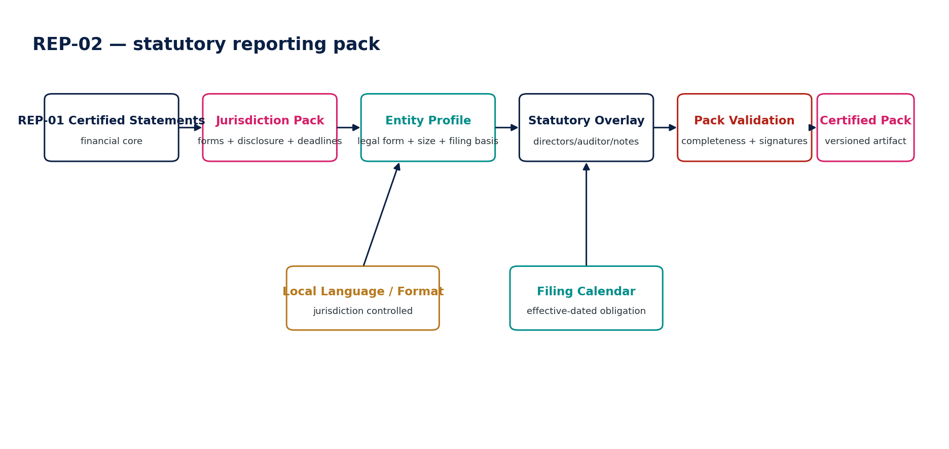
Figure 4 — REP-02 control flow.

4.3 REP-03 — XBRL / iXBRL
Purpose — Map certified report facts to an approved taxonomy, govern filer extensions, generate XBRL/iXBRL artifacts, validate them and preserve fact-level tagging lineage.

Specification field | Build-ready requirement
Authoritative write ownership | TaxonomyProfile, TaxonomyMapping, ExtensionConcept, TaggingInstance, XBRLValidationRun
Explicit non-ownership | Financial statement values; reporting framework decisions; regulator acceptance
Required source inputs | Certified REP-01/02 report; taxonomy package/entry point; jurisdiction profile; mapping registry; extension policy; contexts/units; labels/references
Server-resolved context | entity, period, taxonomy version, regulator/filer profile, language, currency, extension policy
Named commands | ResolveTaxonomy; MapReport; ProposeExtension; ApproveExtension; GenerateXBRL; GenerateInlineXBRL; ValidateXBRL; CertifyTaggingInstance
Queries / read surfaces | GetTaxonomyProfile; GetMappings; ExplainTag; GetExtension; GetValidationRun; GetFactLineage
State model | MappingDraft → Validated → Approved → Generated → ValidatedArtifact → Certified/Superseded
Permissions | xbrl.map; xbrl.extend; xbrl.review; xbrl.certify
Segregation of duties | Extension author cannot independently approve material extension; taxonomy package cannot be changed after certification.
Domain events | TaxonomyResolved; XBRLMappingApproved; InlineXBRLGenerated; XBRLValidationFailed; XBRLTaggingCertified
Dependencies | REP-01/02, schema registry, JUR pack, Evidence Ledger
Failure / degradation semantics | Unknown/expired taxonomy element, dimensional invalidity, duplicate fact inconsistency, extension-policy violation, invalid iXBRL → block certification.
Evidence / lineage | Taxonomy package digest; mapping version; extension taxonomy; validation logs; context/unit registry; report-fact ↔ XBRL-fact lineage.
NFR / recovery profile | C1 for statutory filings; deterministic output; conformance validation; large-note block tagging must remain bounded and reproducible.
Minimum negative tests | Taxonomy mismatch; expired element; wrong context/unit; unjustified extension; duplicate inconsistent fact; invalid iXBRL; mapping changed after approval.

REP-03 — Mandatory engineering controls
- Taxonomy selection is period/jurisdiction controlled; current IFRS taxonomy status is not inferred from calendar year alone.
- Fact mapping prefers base taxonomy concepts; extensions require justification, anchoring/review where regulator rules require it, and separate version control.
- Contexts, units, decimals and dimensional members are generated from controlled report metadata and validated for consistency.
- Inline XBRL generation uses the current supported iXBRL profile and regulator-specific restrictions; invalid artifacts are never released.
- Every tagged fact can be explained from report fact → mapping → taxonomy concept → context/unit → source lineage.
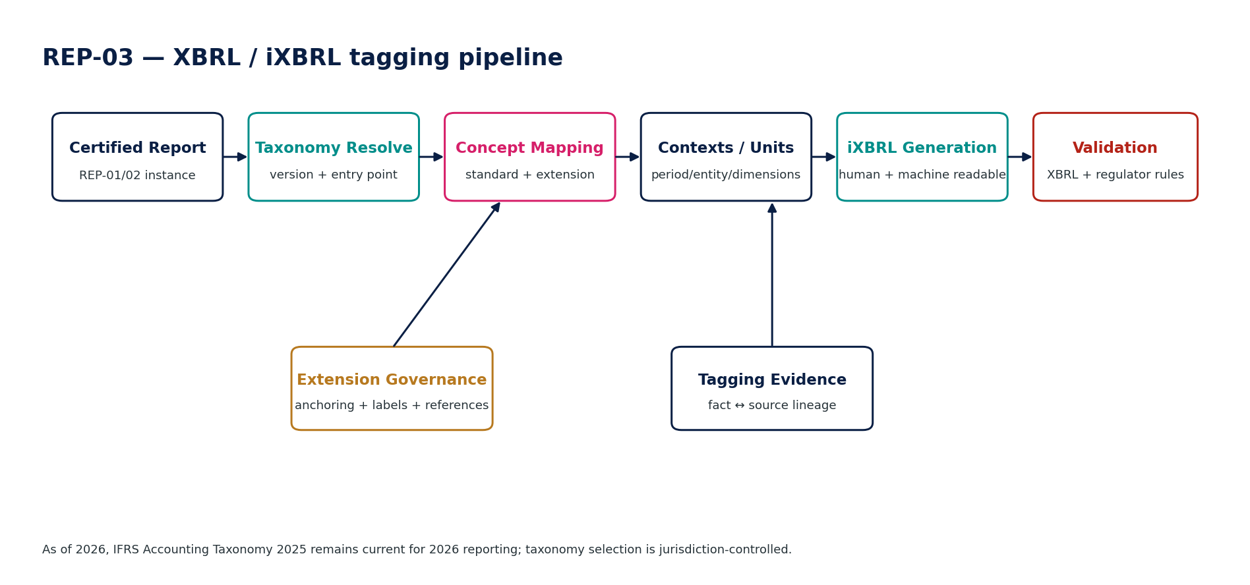
Figure 5 — REP-03 control flow.

4.4 REP-04 — Management Reporting
Purpose — Produce controlled internal management and board reporting across actuals, budget, forecast and operational measures with an explicit assurance/freshness state.

Specification field | Build-ready requirement
Authoritative write ownership | ManagementReportPack, ManagementMetricInstance, VariancePresentation, AssuranceLabel
Explicit non-ownership | Underlying accounting/forecast facts; KPI definition registry if governed elsewhere; statutory certification
Required source inputs | Certified/draft financial snapshots; FP&A scenario/version; governed semantic metrics; operational projections; management-report template; commentary
Server-resolved context | entity/group, period, scenario, currency, management hierarchy, freshness cutoff, assurance level
Named commands | CreateManagementPack; RefreshPack; ValidatePack; ReviewPack; CertifyControlledPack; PublishInternalPack
Queries / read surfaces | GetManagementPack; GetMetric; ExplainVariance; GetSourceBasis; GetFreshness; GetAssuranceState
State model | Draft → Refreshed → Reviewed → Controlled/Certified → Published/Superseded
Permissions | mgmtreport.prepare; mgmtreport.review; mgmtreport.publish
Segregation of duties | Report preparer cannot relabel draft/live data as certified; executive commentary cannot modify numeric source facts.
Domain events | ManagementReportCreated; ManagementReportRefreshed; ManagementReportPublished
Dependencies | ACC snapshots, FIN domain, governed semantic layer, DATA/AI (non-authoritative commentary only)
Failure / degradation semantics | Mixed-source basis without labeling, stale projection, metric-definition drift → validation warning/block based on report class.
Evidence / lineage | Source IDs/watermarks; scenario/version; metric-definition version; freshness timestamp; assurance label; approval evidence.
NFR / recovery profile | C2/C1 depending board use; refresh targets by report class; graceful stale-data label rather than silent substitution.
Minimum negative tests | Silent draft/certified mixing; stale forecast mislabeled current; KPI formula drift; unauthorized entity scope; source basis missing.

REP-04 — Mandatory engineering controls
- Management reports label actual, forecast, budget, operational and provisional populations separately.
- Freshness timestamps and assurance state are visible in controlled packs.
- Management commentary is separated from authoritative numeric facts; AI-assisted narrative requires source grounding and human review.
- Board/controlled packs capture an immutable evidence package of the exact viewed version.
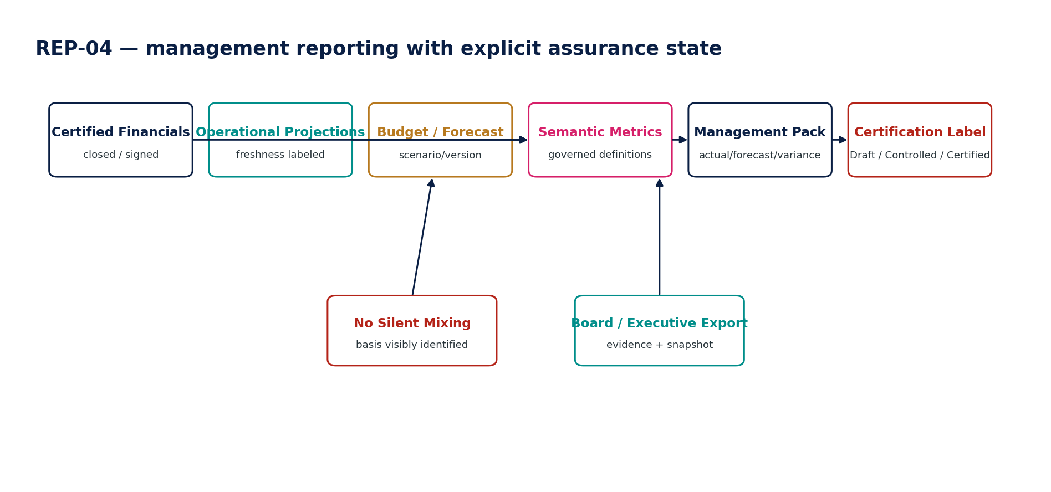
Figure 7 — REP-04 control flow.

4.5 REP-05 — Report Builder
Purpose — Provide governed self-service reporting over approved semantic datasets without permitting direct authoritative-database access or invention of accounting/regulatory logic.

Specification field | Build-ready requirement
Authoritative write ownership | ReportDefinition, ReportLayout, ReportFilterSet, SavedView, ReportExecutionMetadata
Explicit non-ownership | Authoritative financial facts; semantic metric definitions; accounting/tax rules; arbitrary SQL against source systems
Required source inputs | Approved semantic datasets; permitted measures/dimensions; filters; layout; grouping; presentation options; export request
Server-resolved context | tenant/entity scope, permission, purpose, classification, dataset version, watermark, row-level policies
Named commands | CreateReportDefinition; UpdateLayout; ValidateDefinition; ExecuteReport; SaveView; ExportReport; DeprecateReport
Queries / read surfaces | GetReportDefinition; ListAvailableFields; PreviewReport; GetExecutionMetadata; ExplainField
State model | Draft → Validated → Active → Deprecated
Permissions | reportbuilder.create; reportbuilder.execute; reportbuilder.export; reportbuilder.admin
Segregation of duties | Sensitive datasets require purpose/role gate; builder cannot elevate its own dataset scope.
Domain events | ReportDefinitionCreated; ReportExecuted; ReportExported; ReportDefinitionDeprecated
Dependencies | governed semantic layer, IAM/ABAC, data classification, Evidence Ledger for controlled exports
Failure / degradation semantics | Unauthorized dimension/field, unbounded query, stale dataset version, unsupported join → deny or bounded error; never fall back to raw SQL.
Evidence / lineage | Definition version; dataset/schema version; executed filters; watermark; user/purpose; export digest where controlled.
NFR / recovery profile | C2; query budgets, row caps, cancellation, tenant resource quotas, cached result isolation.
Minimum negative tests | Direct SQL bypass; cross-tenant filter attack; sensitive-field export; unbounded query; stale schema; formula attempts to recreate tax/accounting logic.

REP-05 — Mandatory engineering controls
- Only approved semantic datasets, measures and dimensions are exposed; raw authoritative-table access is prohibited.
- Row/field-level authorization is enforced server-side after tenant/entity resolution.
- Query cost budgets, result caps, cancellation and tenant resource isolation are mandatory.
- Custom formulas may combine permitted measures but cannot redefine tax, accounting, regulatory or certified KPI logic.
- Exports inherit classification/purpose/residency policy and persist execution metadata.
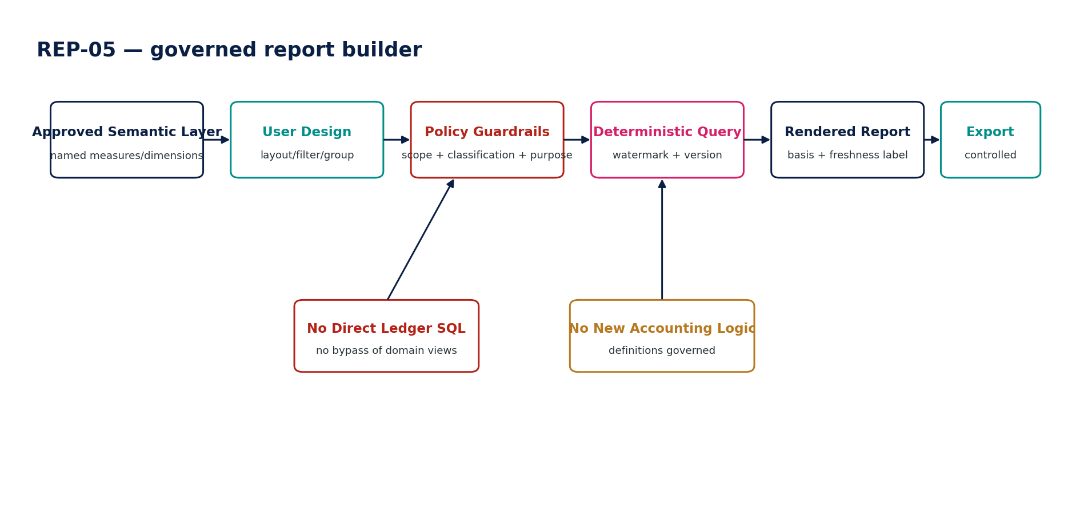
Figure 8 — REP-05 control flow.

4.6 REP-06 — Regulatory Submission
Purpose — Package, submit and resolve authority state for non-tax financial/statutory/regulatory reports using jurisdiction-specific adapters and durable submission attempts.

Specification field | Build-ready requirement
Authoritative write ownership | RegulatorySubmission, SubmissionAttempt, AuthorityAcknowledgement, SubmissionStatusHistory
Explicit non-ownership | Underlying report values; authority-side state; tax-return filing (TAX-10); bank payment execution
Required source inputs | Certified report/artifact; filing obligation; authority endpoint/profile; signer/agent authority; credentials; submission metadata
Server-resolved context | entity, regulator, jurisdiction, filing type, period, deadline, credential scope, residency, submission channel
Named commands | PrepareSubmission; ValidateSubmission; ApproveSubmission; Submit; PollAuthority; ApplyAuthorityCallback; MarkWithdrawnWhereAllowed; CreateAmendment
Queries / read surfaces | GetSubmission; GetAttempt; GetAuthorityStatus; GetAcknowledgement; GetDeadlineRisk
State model | Prepared → Validated → Approved → Submitted → Pending/Unknown → Accepted/Rejected/Withdrawn/Superseded
Permissions | regsubmit.prepare; regsubmit.approve; regsubmit.submit; regsubmit.resolve
Segregation of duties | Submitter cannot forge approver; credential/agent scope must match entity and filing type.
Domain events | RegulatorySubmissionPrepared; RegulatorySubmissionSubmitted; RegulatorySubmissionPending; RegulatorySubmissionAccepted; RegulatorySubmissionRejected
Dependencies | REP-02/03/07, JUR pack, secrets/workload identity, GTRM/residency, evidence ledger
Failure / degradation semantics | Transport timeout → Pending/Unknown; rejected → preserve authority reason; credential failure → block; never silently create a new attempt while prior outcome unresolved.
Evidence / lineage | Artifact digest; attempt ID/idempotency key; transport request/response metadata; authority acknowledgement; callback verification; status history.
NFR / recovery profile | C0/C1 by deadline; durable attempt before side effect; retry/poll policy jurisdiction adapter controlled.
Minimum negative tests | Blind resubmit after timeout; forged callback; wrong entity credential; post-approval artifact mutation; duplicate accepted filing; rejected filing overwritten.

REP-06 — Mandatory engineering controls
- A SubmissionAttempt is durably committed before network transmission.
- Transport success is not regulator acceptance; canonical state follows authenticated acknowledgement/polling.
- Pending/Unknown attempts must be resolved using the original authority reference/idempotency context before any new submission.
- Rejection reasons and authority receipts are immutable evidence; amendments create linked new submissions.
- Deadline-risk escalation integrates with obligation calendar and operational runbooks.
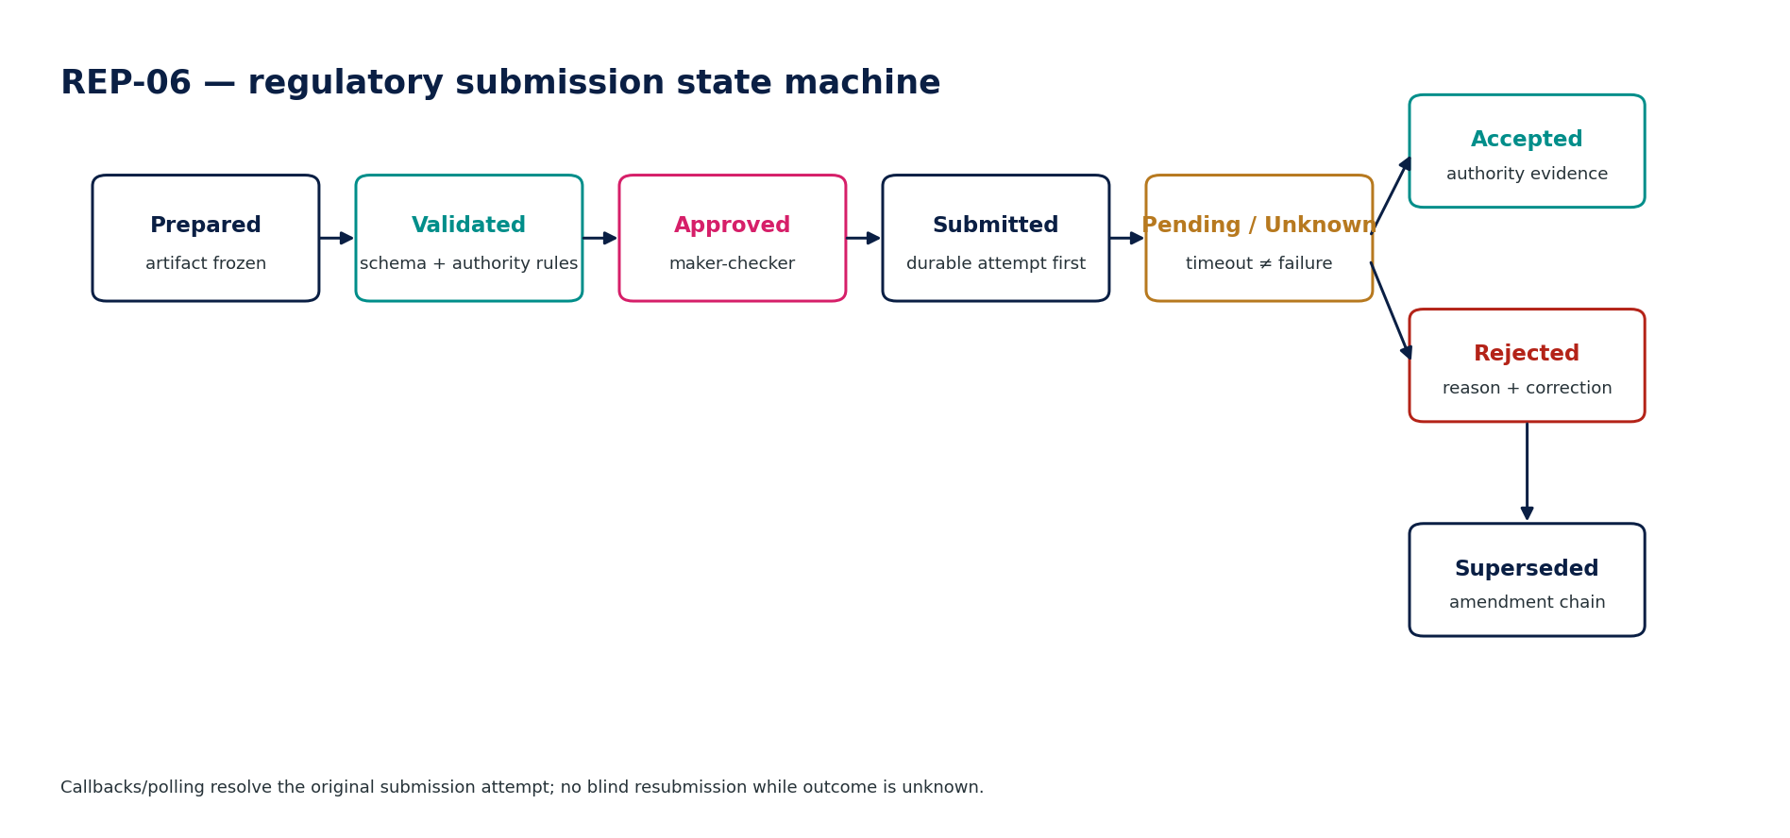
Figure 9 — REP-06 control flow.

4.7 REP-07 — Export & Evidence Package
Purpose — Create portable, tamper-evident packages containing reports, machine-readable data, manifests, mappings, approvals, lineage and verification material for audit, filing, handoff or archive.

Specification field | Build-ready requirement
Authoritative write ownership | ReportEvidencePackage, PackageManifest, ArtifactDigest, ExportCertification
Explicit non-ownership | Source records; legal hold policy; retention policy; authority acknowledgement
Required source inputs | Report instance; source lineage; mappings/rules; validation results; approval/certification evidence; requested export profile
Server-resolved context | purpose, recipient, data classification, residency/export policy, retention/hold state, encryption/signing profile
Named commands | CreateEvidencePackage; ValidateManifest; EncryptPackage; SignPackage; ReleasePackage; RevokeDownload; SupersedePackage
Queries / read surfaces | GetPackage; GetManifest; VerifyPackage; GetArtifactDigest; GetLineageSummary
State model | Draft → Assembled → Validated → Signed → Released → Archived/Superseded
Permissions | evidence.export.create; evidence.export.release; evidence.export.verify
Segregation of duties | Creator cannot bypass restricted-data export policy; release of highly restricted package may require independent approval.
Domain events | ReportEvidencePackageCreated; EvidencePackageSigned; EvidencePackageReleased; EvidencePackageSuperseded
Dependencies | REP services, GOV-07, ZS-DATA-GOV, ZS-SEC, retention/legal hold
Failure / degradation semantics | Missing manifest item/hash, retention/hold conflict, residency/export restriction, signature failure → block release.
Evidence / lineage | Package manifest itself; hashes; signature certificate/key version; source lineages; report IDs; validation/approval evidence.
NFR / recovery profile | C1 evidence integrity; streaming/large artifact support; deterministic manifest; cryptographic verification offline where feasible.
Minimum negative tests | Missing artifact digest; altered file after signing; legal hold conflict; restricted export to unauthorized region; incomplete lineage; package/source mismatch.

REP-07 — Mandatory engineering controls
- Package manifest enumerates report artifacts, source snapshots, mapping/taxonomy versions, validation runs, approvals and hashes.
- Signing keys are separated from encryption keys and governed under ZS-SEC.
- Package verification must detect any post-signature modification.
- Release checks retention/legal hold, recipient/purpose, residency and classification before export.
- Superseded packages remain verifiable and linked to replacement versions.
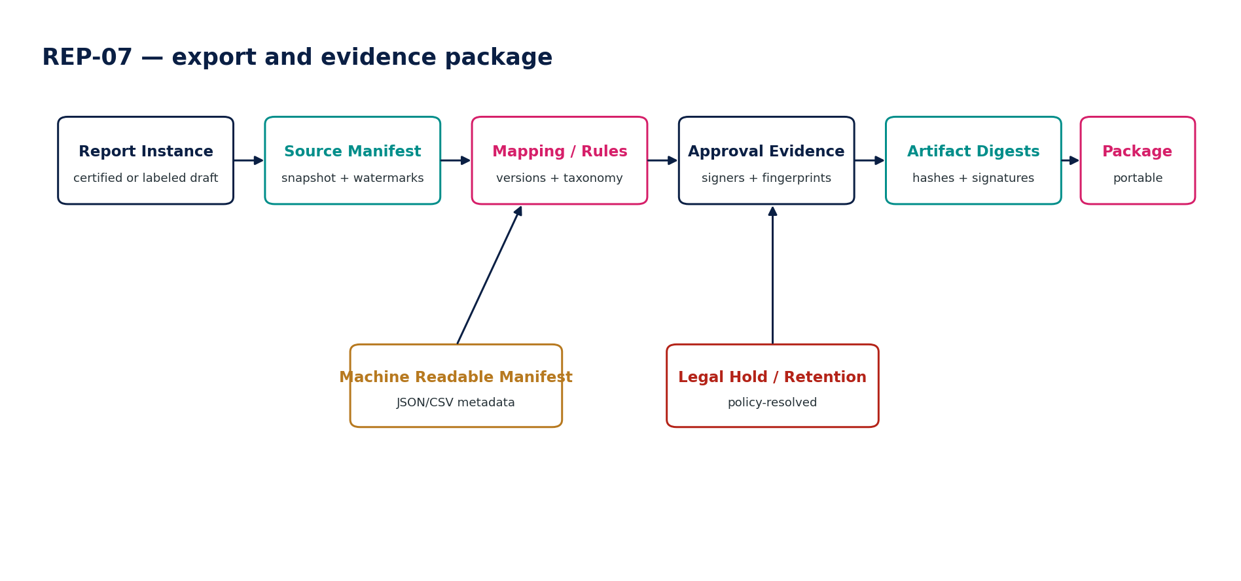
Figure 10 — REP-07 control flow.

5. Digital Reporting & Taxonomy Architecture
2026 taxonomy baseline — The IFRS Foundation states that the IFRS Accounting Taxonomy 2025 remains the current version for 2026 reporting periods; the next annual taxonomy is planned for Q1 2027. ZoikoSuite must therefore resolve taxonomy by certified filing profile, not by assuming a taxonomy named for every reporting year.

Layer | ZoikoSuite requirement
Base specification | XBRL 2.1 + XBRL Dimensions 1.0 remain the core business-reporting foundation.
Inline rendering | Inline XBRL 1.1 is the current iXBRL specification; regulator profiles may impose stricter syntax/filing rules.
IFRS taxonomy | Use the regulator-approved IFRS Accounting Taxonomy package. For 2026 reporting the IFRS Foundation says the 2025 taxonomy remains current.
Jurisdiction taxonomy | ESEF, UKSEF, SEC/US-GAAP, local GAAP or regulator-specific taxonomies are loaded as versioned packages via jurisdiction profile.
Mapping registry | Report concept → taxonomy concept mappings are versioned, reviewable and historically reconstructable.
Extensions | Extension taxonomy is separate from base taxonomy; justification, anchoring and validation are governed.
Validation | Run XBRL/iXBRL conformance plus regulator-specific filing validations before certification/submission.
Evidence | Persist taxonomy package digest, entry point, extension files, mapping version, validation output and generated artifact digest.
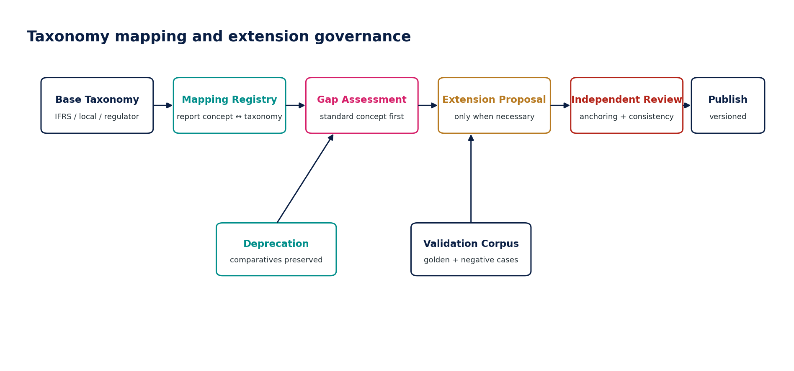
Figure 11 — Taxonomy mapping and extension governance.

6. Certification, Publication, Correction & Restatement
Scenario | Required treatment
Draft source change | Refresh draft using new source identity; retain execution history as needed.
Change after approval, before certification | Invalidate approval; revalidate and reapprove.
Change after certification, before publication | Create new report version; previous certified artifact remains immutable/superseded.
Accounting correction after publication | Correct through owning accounting/source domain, create new signed snapshot and report version; apply accounting-framework restatement treatment.
Tagging-only error after publication | Preserve financial report values; create corrected tagging/artifact version and amendment/re-file path where required.
Regulator rejection | Preserve rejected submission and reason; correct source/artifact; create linked amendment/new attempt.
Authority accepted but later amendment needed | Do not overwrite accepted receipt; create amendment/supersession chain.
Legal hold | Suspend destruction of applicable report/evidence versions; hold does not grant broader processing rights.
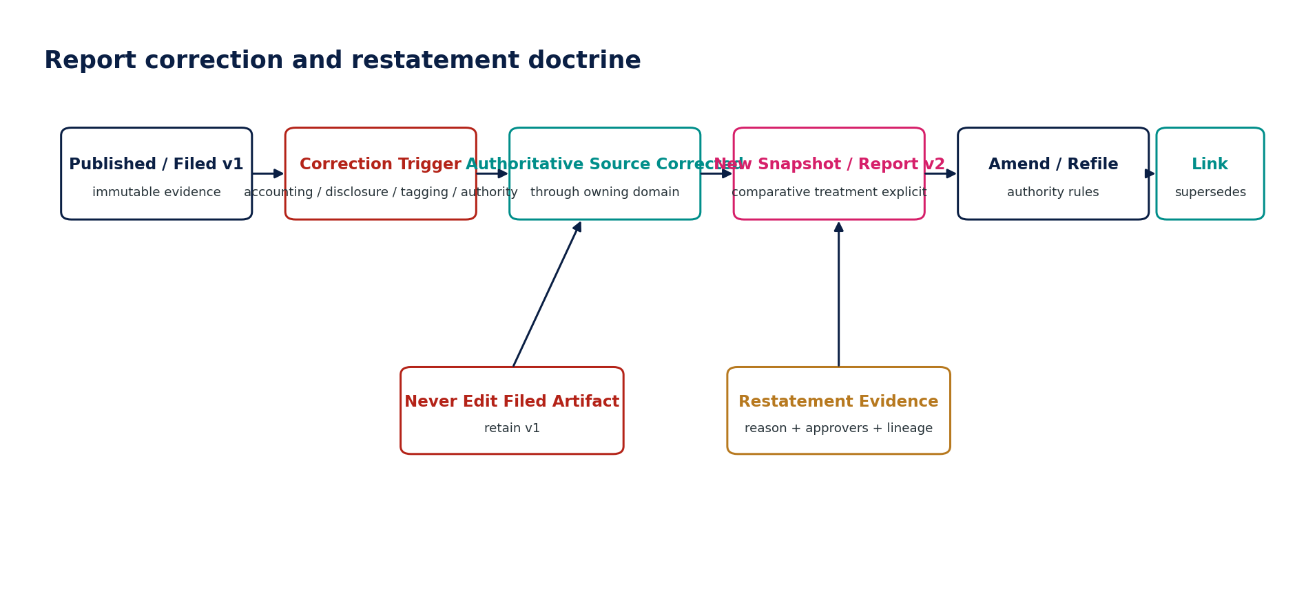
Figure 12 — Report correction and restatement doctrine.

7. Reporting Control Framework
Control ID | Control | Assertion
REP-CTRL-001 | Certified source snapshot required | Certified financial/statutory report references approved source population.
REP-CTRL-002 | Statement cross-cast | Primary statements and notes mathematically cross-cast.
REP-CTRL-003 | Statement-to-snapshot tie-out | Report facts reconcile to signed snapshot/mapping.
REP-CTRL-004 | Comparative basis | Comparatives/restatements are correct and explicitly identified.
REP-CTRL-005 | Disclosure completeness | Mandatory disclosures/components complete for framework/jurisdiction.
REP-CTRL-006 | Approval fingerprint | Protected content unchanged since approval.
REP-CTRL-007 | SoD | Preparer/reviewer/certifier segregation enforced where required.
REP-CTRL-008 | Taxonomy version | Correct taxonomy/profile for filing period and regulator.
REP-CTRL-009 | Tagging completeness | Required reported facts/tag blocks mapped.
REP-CTRL-010 | XBRL validity | Generated XBRL/iXBRL passes conformance and regulator validations.
REP-CTRL-011 | Extension governance | Extensions justified/reviewed/anchored as applicable.
REP-CTRL-012 | Management basis labeling | Actual/forecast/provisional/freshness labels complete.
REP-CTRL-013 | Report Builder authorization | Dataset/row/field/purpose access enforced.
REP-CTRL-014 | Submission idempotency | No duplicate regulatory submission effect.
REP-CTRL-015 | Authority callback verification | Acknowledgements authenticated and deduplicated.
REP-CTRL-016 | Unknown-state resolution | Pending/Unknown submission resolved before retry.
REP-CTRL-017 | Evidence package completeness | Manifest contains required source/mapping/approval/validation artifacts.
REP-CTRL-018 | Artifact integrity | Hash/signature verification passes.
REP-CTRL-019 | Source-to-report lineage | Material report facts trace back to source evidence.
REP-CTRL-020 | Retention/legal hold | Disposition/export honors policy resolution.
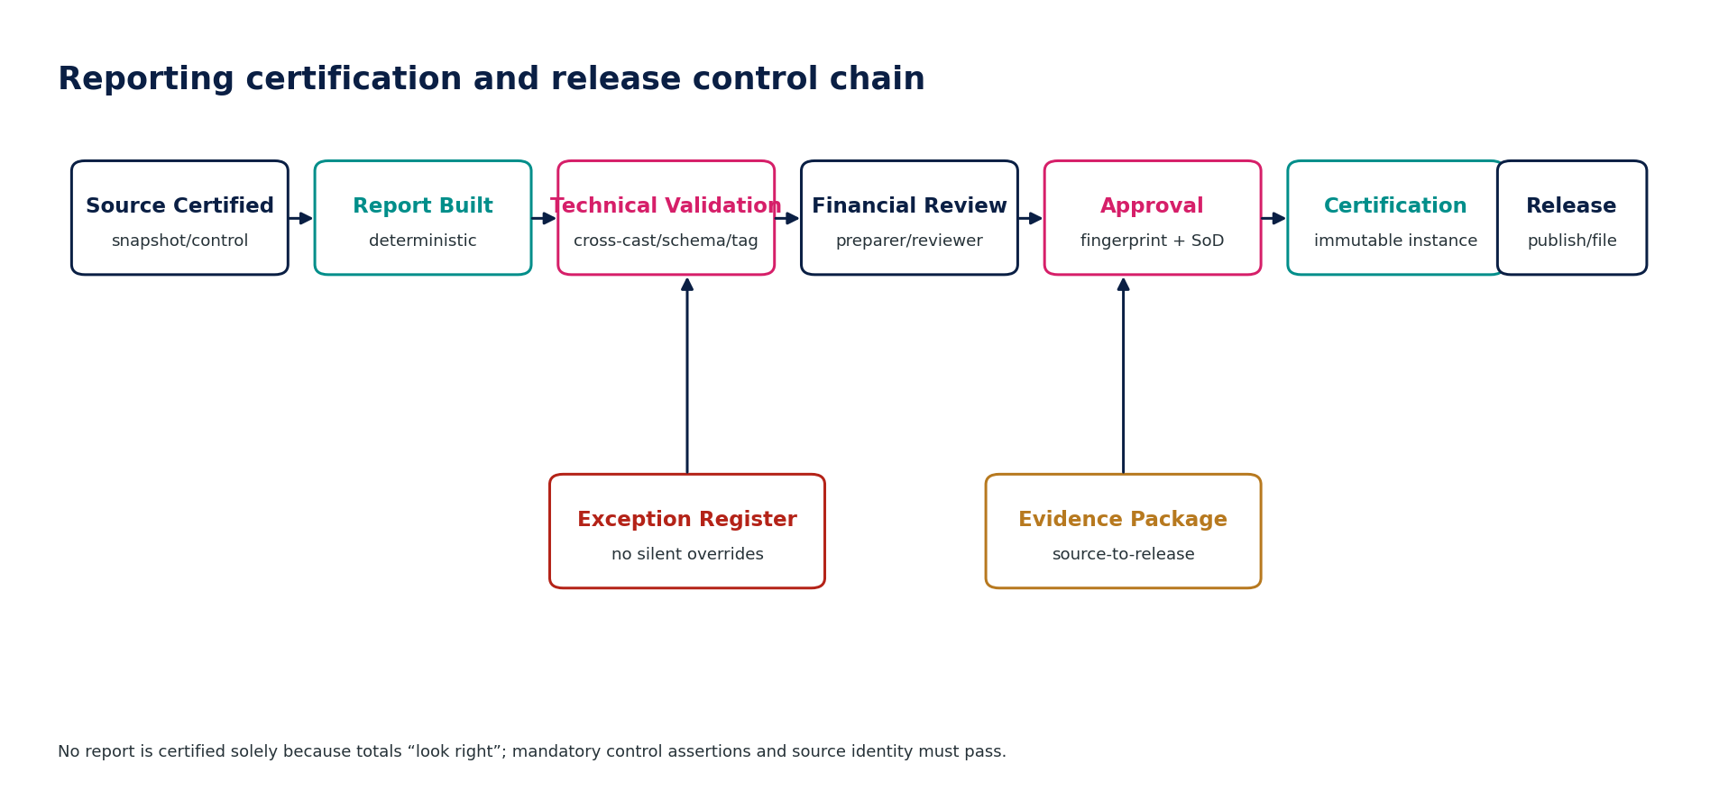
Figure 13 — Reporting certification and release control chain.

8. Canonical APIs, Events & Data Model
API surface | Examples | Control requirement
Resource/query APIs | GET /reporting/statement-sets/{id}; GET /reporting/submissions/{id} | Read-only authoritative representations; scoped and watermark-aware.
Named commands | POST /statement-sets/{id}:certify; /submissions/{id}:submit; /xbrl/{id}:validate | Protected business transitions; idempotency + expected version + approvals.
Async operations | large report render, XBRL generation, evidence package assembly | Operation resource with progress, immutable inputs, cancel policy.
Artifact delivery | signed URL or controlled download endpoint | Short-lived access; purpose/region/classification checks; download audit.
Authority callbacks | /callbacks/regulators/{provider} | Signature/authentication, replay protection, attempt correlation, ordering semantics.
Canonical entity | Core fields / relationships
ReportDefinition | id, type, framework, jurisdiction, version, semantic dataset/template refs
ReportInstance | id, definition_version, entity/group, period, currency, source_snapshot_id, state, certification_hash
ReportFact | report_instance_id, concept, amount/text, dimensions, source_lineage_ref, presentation attributes
DisclosureInstance | report_instance_id, disclosure_id, narrative/structured facts, evidence refs
StatutoryPack | report_instance_id, jurisdiction_pack_version, component manifest, signatures, state
TaxonomyProfile | taxonomy package, entry point, regulator profile, effective dates, digest
TaxonomyMapping | report concept, taxonomy concept, context rules, version, approval
ExtensionTaxonomy | extension concepts, anchors, labels, references, review, package digest
TaggingInstance | report_instance_id, taxonomy_profile_id, generated artifacts, validation status
RegulatorySubmission | artifact_id, authority, filing type, deadline, status, current_attempt_id
SubmissionAttempt | id, idempotency key, request digest, external ref, sent_at, result/unknown status
AuthorityAcknowledgement | attempt_id, authority_ref, status, timestamp, payload digest, verification result
ReportEvidencePackage | report/submission refs, manifest, hashes, signing key version, retention/hold state

9. Negative-Path Certification Suite
ID | Scenario | Expected result
REP-N01 | Attempt to certify financial statements directly from live mutable ledger balances | Block; certified source snapshot required.
REP-N02 | Signed source snapshot changes after report approval | Invalidate approval; new report version required.
REP-N03 | Statement total agrees but a mapped account is omitted | Completeness control fails despite headline tie-out.
REP-N04 | Cross-cast or note-to-primary-statement inconsistency | Validation fails; cannot certify.
REP-N05 | Comparative period uses superseded/restated basis without disclosure | Block certification or require explicit restatement treatment.
REP-N06 | Mandatory disclosure has no source/evidence | Exception; certification blocked for mandatory class.
REP-N07 | User attempts to edit certified report fact directly | Deny; correct owning source/report version.
REP-N08 | Statutory pack generated using wrong legal-entity classification | Validation failure; regenerate with correct effective classification.
REP-N09 | Jurisdiction pack changes after statutory approval | Invalidate approval and revalidate.
REP-N10 | Mandatory statutory component omitted | Pack incomplete; no certification.
REP-N11 | XBRL taxonomy version does not match filing period/profile | Block generation/certification.
REP-N12 | Expired taxonomy element used for current period | Validation failure.
REP-N13 | XBRL fact uses wrong period context | Validation failure and fact-level trace.
REP-N14 | Monetary fact tagged with wrong currency/unit | Validation failure.
REP-N15 | Duplicate XBRL facts have inconsistent values | Block certification.
REP-N16 | Filer extension created where standard concept exists | Reject or independent-review exception per extension policy.
REP-N17 | Extension mapping changed after tagging approval | Invalidate tagging approval.
REP-N18 | iXBRL generation produces invalid Inline XBRL | Block regulatory release.
REP-N19 | Management pack silently mixes certified actuals with draft forecast | Require explicit basis/assurance labels; otherwise block controlled publication.
REP-N20 | Management report uses stale operational projection without freshness label | Mark stale / fail based on report class.
REP-N21 | KPI definition changed mid-period without versioning | Fail deterministic comparison; require versioned metric definition.
REP-N22 | Report Builder attempts raw SQL against General Ledger | Deny; approved semantic interface only.
REP-N23 | Report Builder filter attempts cross-tenant access | Deny at authorization/data policy layer; security event.
REP-N24 | User exports restricted field without purpose/permission | Deny and audit.
REP-N25 | Unbounded report query threatens tenant capacity | Enforce query budget/cancel; no noisy-neighbor impact.
REP-N26 | Report definition references deprecated schema field | Validation failure; migration required.
REP-N27 | Regulatory transport times out after submission | State = Pending/Unknown; resolve original attempt.
REP-N28 | Operator retries a Pending/Unknown submission as new filing | Block duplicate; reuse/resolve original attempt.
REP-N29 | Forged regulator callback | Reject authentication/signature; security evidence.
REP-N30 | Authority rejects filing | Preserve rejection reason; no overwrite; amendment workflow.
REP-N31 | Artifact changes after submission approval | Invalidate submission approval/fingerprint.
REP-N32 | Accepted filing is deleted or overwritten | Deny; immutable status/evidence history.
REP-N33 | Evidence package file modified after signing | Verification fails; package not trusted.
REP-N34 | Evidence package missing mapping/rule version | Manifest incomplete; release blocked for certified class.
REP-N35 | Legal hold applies to source evidence while disposition job runs | Hold wins; destruction suspended.
REP-N36 | Package exported to unauthorized residency region | Block at policy/GTRM/export control.
REP-N37 | Report certification performed by preparer where independent review required | SoD denial.
REP-N38 | Approval signer authority revoked before certification | Re-evaluate authority; block certification.
REP-N39 | Closed-period source correction occurs after published report | Create new source snapshot/report version and explicit amendment/restatement chain.
REP-N40 | AI-generated narrative introduces unsupported financial claim | Do not certify; require source-grounded human-reviewed narrative.

10. Service Definition of Ready / Definition of Done

10.1 Definition of Ready
- Service authoritative ownership and non-ownership are approved and do not conflict with ACC/TAX/GOV/JUR/DATA domains.
- Applicable reporting frameworks, jurisdictions, taxonomies, filing profiles and effective dates are identified.
- Source snapshots/populations and mandatory reconciliation/control dependencies are defined.
- Commands, queries, state transitions, permissions, SoD and protected-content fingerprints are specified.
- Artifact schemas, mapping/version rules, evidence requirements, retention/legal-hold class and residency are defined.
- Negative-path tests and regulator/provider sandbox strategy exist.
- SLO/RPO/RTO classification and operational runbooks are assigned.

10.2 Definition of Done
- OpenAPI/AsyncAPI/schema contracts are versioned and CI-validated.
- All mandatory controls and negative-path scenarios pass with immutable test evidence.
- Certified reports are reproducible from source snapshot + mappings + framework/jurisdiction versions.
- XBRL/iXBRL artifacts pass applicable conformance and regulator validation suites.
- External submission ambiguity, duplicate callbacks, retries and rejected/amended states are tested.
- Source-to-report lineage resolves for material facts and evidence packages verify cryptographically.
- Performance, accessibility, security, residency, retention and DR gates pass under ZS-QA-001.
- Operational dashboards/runbooks exist for deadline risk, failed validation, Pending/Unknown submission and evidence-integrity failure.

11. Engineering Implementation Sequence
Wave | Scope | Exit gate
Wave 1 | Reporting foundation | ReportDefinition/Instance/Fact model; signed-snapshot binding; mapping registry; shared evidence and certification primitives.
Wave 2 | REP-01 Financial Statements | Primary statements, disclosures, comparatives, validation, certification and source-to-report explainability.
Wave 3 | REP-02 Statutory Pack | Jurisdiction overlays, component manifests, local signatures/forms/language requirements.
Wave 4 | REP-03 Digital Reporting | Taxonomy package registry, mapping/extension governance, XBRL/iXBRL generation and validation.
Wave 5 | REP-06 Submission | Authority adapters, durable attempts, callbacks/polling, deadline-risk operations.
Wave 6 | REP-07 Evidence | Portable manifests, signing/encryption, retention/legal-hold/export controls.
Wave 7 | REP-04/05 Internal Reporting | Management packs and self-service report builder over governed semantic layer.
Wave 8 | Certification & Scale | Regulator conformance suites, production volumes, failure injection, DR, accessibility and release certification.

12. Controlled Decisions Before Production
- Jurisdiction launch list and exact statutory filing profiles/taxonomies.
- Approved accounting/reporting frameworks per legal entity and early-adoption policy for standards such as IFRS 18.
- XBRL processor/tooling strategy and conformance suite ownership.
- Extension-taxonomy policy thresholds and independent-review model.
- Regulator credential custody, agency/representative authorization and submission signing requirements.
- Customer-facing vs internal report certification labels and SLA commitments.
- Materiality thresholds for disclosure validation and report-control exceptions.
- Retention schedule for draft, certified, filed, superseded and evidence-package records.

12.1 Prohibited reporting anti-patterns
Anti-pattern | Why prohibited
Direct live-ledger statutory certification | Produces non-reproducible reports and permits source drift.
Editable certified report values | Creates a second accounting authority.
Single generic report status | Collapses preparation, certification, publication and filing truth.
Hardcoded statutory form/taxonomy | Breaks jurisdiction/effective-date governance.
XBRL as spreadsheet tagging exercise | Loses mapping, context, extension and source lineage.
Blind regulatory retry | Can create duplicate filings or irreconcilable authority state.
Raw SQL report builder | Bypasses ownership, authorization, schema and semantic governance.
Silent mixing of actual and forecast data | Misstates assurance/basis.
Deleting rejected or superseded filings | Destroys regulatory evidence.
AI-generated authoritative narrative/numerics | Exceeds AI authority boundary and undermines evidence.

13. External Standards & Current 2026 Baseline
Reference | Architecture relevance | Official source
IFRS Accounting Taxonomy | The IFRS Foundation states that IFRS Accounting Taxonomy 2025 remains current for 2026 reporting periods; the next annual taxonomy is planned for Q1 2027. | https://www.ifrs.org/news-and-events/news/2026/02/ifrs-accounting-taxonomy-2025-to-remain-current-for-2026/
IFRS Taxonomy Architecture | IFRS Foundation published a 23 June 2026 edition of the IFRS Taxonomy Architecture technical guide. | https://www.ifrs.org/issued-standards/ifrs-taxonomy/ifrs-taxonomy-architecture/
XBRL core | XBRL 2.1 and XBRL Dimensions 1.0 remain the core XBRL specifications for multidimensional business reporting. | https://specifications.xbrl.org/xbrl-essentials.html
Inline XBRL | Inline XBRL 1.1 is the latest iXBRL version; the specification page shows the current Recommendation dated 14 July 2026. | https://specifications.xbrl.org/work-product-index-inline-xbrl-inline-xbrl-1.1.html
ESEF | ESMA introduced the updated 2025 IFRS taxonomy into the ESEF RTS process, with 2025 taxonomy intended for annual reports for financial years beginning on/after 1 January 2026 subject to the regulatory adoption process. | https://www.esma.europa.eu/press-news/esma-news/updated-2025-ifrs-taxonomy-introduced-european-single-electronic-format
UK iXBRL | HMRC requires company accounts and computations in Company Tax Returns to be filed in iXBRL for the applicable electronic filing population; UK filing channels continue to evolve and must be handled by jurisdiction profiles. | https://www.gov.uk/hmrc-internal-manuals/cotax-manual/com60040
US EDGAR | SEC EDGAR guidance for August 2026 references Inline XBRL 1.1 validation and filing-specific restrictions. | https://www.sec.gov/files/edgar/filer-information/specifications/xbrl-guide-2026-08-14.pdf

Compliance boundary — This specification is an engineering architecture baseline, not legal, accounting or filing advice. Each production jurisdiction/profile requires validation against the authoritative law, regulator taxonomy, filing manual, reporting framework and effective dates applicable to that entity and period.

14. Architecture Approval Gate
Build recommendation — Approve ZS-SVC-H-001 as the build baseline for REP-01 through REP-07, subject to the controlled production decisions in Section 12 and service certification under ZS-QA-001. No reporting implementation may bypass the Accounting Kernel, signed financial snapshot, jurisdiction pack, Evidence Ledger, authorization/SoD or data-governance controls defined by the ZoikoSuite master architecture.

