ZOIKOSUITE

Global API, Command &
Integration Contract Standard
Detailed Engineering Wireframe — HTTP APIs, Commands, Queries, Files, Webhooks & External Adapters
Architecture doctrine
One stable API constitution. Resource reads expose governed representations; business mutations execute explicit commands against authoritative domain owners. No client, integration, workflow engine or provider callback may bypass tenant isolation, state-machine guards, accounting controls, approvals, jurisdiction rules, idempotency, concurrency or evidence requirements.

Field | Value
Document ID | ZS-API-001
Version | 1.0 — Global API & Integration Baseline
Date | August 24, 2026
Status | For architecture / engineering approval
Owner | ZoikoSuite Product / Platform Architecture
Prepared for | Engineering, Architecture, Product, Security, Data, Accounting, Finance, Tax, Audit, Legal, QA, DevOps, Integrations
Classification | Confidential — Internal Engineering / Architecture Control
Parent documents | ZS-ARCH-SVC-001 v2.0; ZS-DATA-001 v1.0; ZS-ACC-KERNEL-001 v1.0; ZS-STATE-001 v1.0
Language | American English

CONTROLLED BASELINE
This document governs the external and internal HTTP interface contract for ZoikoSuite. Domain APIs may add stricter requirements but may not weaken the invariants, protocol semantics, security controls or compatibility rules defined here.

Document Roadmap & How to Use This Standard
ZS-API-001 translates ZoikoSuite’s authoritative data, accounting and lifecycle controls into one implementable network contract. It is the required parent standard for domain OpenAPI descriptions, SDKs, partner integrations, command endpoints, import/export interfaces and webhook profiles.
Layer | What this document decides
1 — Interface doctrine | When to use resource/query APIs versus explicit command endpoints, async operations, file pipelines or provider adapters.
2 — Wire contract | URI, HTTP method, headers, media types, request/response envelope, money/date/ID formats and errors.
3 — Control semantics | Tenant resolution, authorization, idempotency, optimistic concurrency, state/approval gates and audit evidence.
4 — Retrieval semantics | Filters, sort, cursor pagination, sparse fields, includes, historical/as-of reads and report/query boundaries.
5 — Integration semantics | Webhooks, verified callbacks, retries, external attempts, imports/exports, mapping versions and reconciliation.
6 — Governance | OpenAPI source of truth, compatibility, deprecation, CI gates, contract tests, observability and Definition of Done.

Golden rule
If an operation can create accounting, payment, tax, legal, compliance or irreversible business consequences, it is a command — not a generic field update.

Critical Analysis & Refinements Incorporated
Architecture defect | Why it fails | Final refinement
CRUD-only API design | Generic POST/PATCH/DELETE can bypass workflow and state semantics. | Separate resource/query interfaces from explicit command/action endpoints owned by the domain state machine.
Database-shaped contracts | Leaks implementation details and makes schema migrations externally breaking. | Expose canonical business resources and stable DTOs; persistence schemas remain private.
Tenant supplied as trusted input | Creates cross-tenant authorization and residency risk. | Resolve tenant from authenticated context/gateway; any multi-tenant selector is conditional and server-validated.
One retry strategy | Unsafe for payments, filings and postings because retries can duplicate effects. | Mandatory idempotency classes, replay semantics, semantic request hashing and durable attempt records.
Last-write-wins updates | Allows silent overwrite of approvals, amounts and financial facts. | ETag/If-Match optimistic concurrency for aggregate mutation; stale versions fail deterministically.
Arbitrary PATCH status | Bypasses the approved ZS-STATE-001 transition catalogue. | State changes only through named command endpoints.
JSON numbers for money | Cross-language floating-point parsing can lose exactness. | Serialize authoritative money/rates as canonical decimal strings plus ISO currency/basis.
Offset pagination everywhere | Duplicates/skips rows under concurrent writes and degrades at scale. | Opaque cursor pagination with stable sort and scoped snapshot semantics.
Ad hoc error bodies | Clients must special-case every service and operators lose stable reason codes. | RFC 9457 problem details plus stable Zoiko error-code extensions.
Unbounded query flexibility | Arbitrary SQL-like filters become security, performance and data-leak risks. | Governed filter grammar; advanced analytics uses dedicated report/query jobs.
Synchronous long operations | Causes client timeouts and ambiguous retry behavior. | 202 operation resources with durable progress, result, cancellation and terminal status.
Blind webhook trust | Spoofing, replay and out-of-order callbacks can corrupt state. | Registered endpoints, signing, timestamp/digest verification, delivery IDs and transition validation.
External provider as internal truth | Provider statuses get copied into domain state without reconciliation. | Persist provider attempt/state separately; authoritative domain transition occurs only after mapped verification.
Breaking change by stealth | Additive-looking enum/validation changes can break consumers. | Formal compatibility policy, OpenAPI diff gates, versioned examples and explicit major-version/deprecation lifecycle.
Sensitive data in URLs/logs | Tax IDs, bank data and search terms can leak via proxies and telemetry. | No sensitive values in paths/query strings; use protected body-based search where necessary and structured redaction.

1. Executive Doctrine & Scope
ZoikoSuite APIs shall behave as stable, versioned business contracts independent of database topology and deployment boundaries. HTTP semantics must remain standard; domain semantics live in resources, representations and named commands. Every state-changing request must be attributable, tenant-isolated, authorized, idempotent where replay is possible, concurrency-safe, policy/state validated and evidence-producing.

1.1 API surfaces in scope
- Public and customer-facing APIs.
- Partner and embedded APIs.
- Internal service-to-service HTTP APIs.
- Privileged platform administration APIs.
- Webhook delivery and inbound callback endpoints.
- File upload, import and export interfaces.
- External provider adapters for banking, tax, electronic invoicing, identity and other regulated integrations.
- OpenAPI descriptions, generated SDKs and contract-test artifacts.

1.2 Explicit non-goals
- This standard does not require every internal service to use HTTP; gRPC or messaging may be used where a separate approved contract exists.
- GraphQL is not the authoritative mutation interface for accounting, tax, legal or payment state; it may be used for controlled read aggregation if separately approved.
- This standard does not define the enterprise domain-event catalogue; that is the next controlled document.
- This standard does not make provider APIs authoritative for ZoikoSuite domain state.
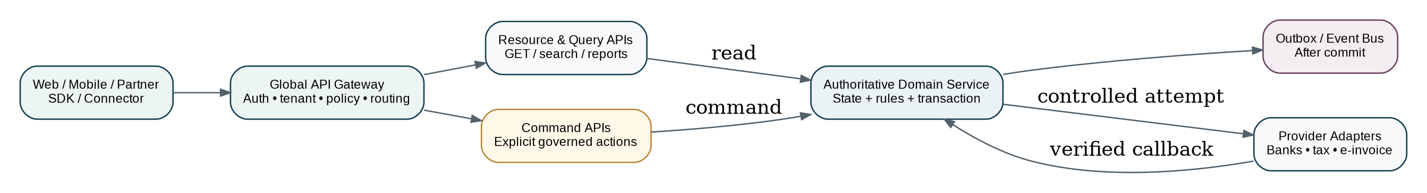
Figure 1 — ZoikoSuite API landscape and authoritative-domain boundary

2. Non-Negotiable API Invariants
ID | Invariant | Required behavior
A-01 | Authoritative owner | Exactly one domain service owns each writable business aggregate.
A-02 | Standard HTTP semantics | Do not redefine registered methods, status codes or standard headers.
A-03 | HTTPS only | Production APIs are exposed through secure HTTPS endpoints; insecure transport is prohibited.
A-04 | Tenant resolution | Tenant context is resolved and validated server-side before domain execution.
A-05 | Residency enforcement | GTRM/routing policy selects the permitted regional service pool before data-bearing execution.
A-06 | Explicit commands | Governed state changes use named commands/actions; direct state-field mutation is prohibited.
A-07 | Idempotency | Replay-capable mutations use a durable idempotency contract.
A-08 | Concurrency | Mutation of existing aggregates requires an expected version / conditional request unless explicitly append-only.
A-09 | Exact money | Authoritative monetary values use exact decimal representation.
A-10 | Stable IDs | Internal canonical IDs are opaque strings; human document numbers and external IDs are separate.
A-11 | Immutable posted facts | APIs cannot silently edit posted/issued/filed/executed facts; use corrective commands.
A-12 | Error uniformity | HTTP failures use problem details with stable machine codes.
A-13 | No hidden side effects on GET | GET/HEAD are safe and must not trigger business mutations.
A-14 | Event after commit | Events/webhooks are derived from committed domain state, never emitted before durable commit.
A-15 | External verification | Inbound provider callbacks must be authenticated, deduplicated, correlated and state-validated.
A-16 | Compatibility | Existing consumers must not break from additive evolution within a stable major version.
A-17 | Unknown request fields | Command/request schemas reject unsupported fields unless an extension point is explicitly defined.
A-18 | Unknown response fields | Clients/SDKs must tolerate additive response fields within the same major version.
A-19 | Sensitive URLs prohibited | Credentials and sensitive personal/financial search values must not appear in URLs.
A-20 | Evidence | Material commands preserve request identity, policy/rule versions, result and evidence/audit references.

3. API Surface Taxonomy & Routing Wireframe
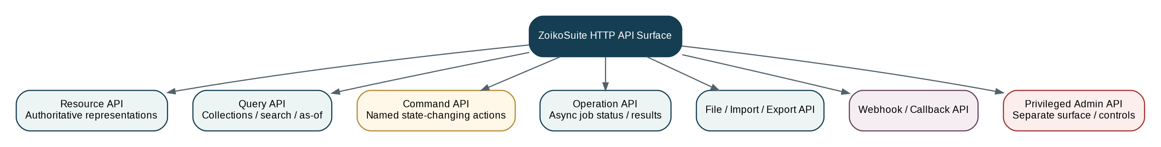
Figure 2 — Canonical ZoikoSuite HTTP API surface taxonomy
Surface | Primary purpose | Allowed mutation? | Typical example
Resource API | Retrieve canonical authoritative representations. | Only low-risk typed updates where explicitly documented. | GET /v1/legal-entities/{id}
Query API | Collections, search, historical/as-of and operational read models. | No. | GET /v1/customer-invoices?filter[status]=issued
Command API | Governed business transitions and irreversible actions. | Yes — named command only. | POST /v1/.../invoices/{id}/actions/issue
Operation API | Track long-running asynchronous work. | Cancel only where supported. | GET /v1/operations/{operation_id}
File / Import / Export | Controlled binary ingestion and generated artifacts. | Via session/commit commands. | POST /v1/imports
Webhook / Callback | Outbound event delivery or verified inbound external signal. | Inbound callbacks may cause a validated domain transition. | POST /callbacks/banks/{provider}
Privileged Admin | Cross-tenant/platform operations under enhanced access controls. | Yes, but isolated from tenant public surface. | /admin/v1/...

4. Canonical URI, Naming & Media-Type Standard

4.1 URI rules
- Stable major version in path: `/v1/...`.
- Resource collections use plural kebab-case nouns: `customer-invoices`, `legal-entities`, `tax-returns`.
- Opaque canonical IDs appear in path segments; display numbers do not act as primary resource identifiers.
- Nested paths are used only where parent scope is materially part of identity or authorization; avoid excessive nesting beyond three contextual levels.
- Named actions use `/actions/{verb}` and POST. Example: `/v1/legal-entities/{entity_id}/books/{book_id}/journals/{journal_id}/actions/post`.
- Privileged cross-tenant routes live under `/admin/v1/` and are never silently enabled on tenant APIs.
- No credentials, bank account numbers, tax IDs, medicine/health data or other sensitive search terms in URLs.

4.2 JSON naming
Element | Standard | Example
JSON fields | lower_snake_case | posting_date
Enums | lower_snake_case | partially_paid
IDs | opaque string | 0198f...
Boolean | clear semantic name | is_active
Collections | plural nouns | journal_lines
Dates | full-date string | 2026-08-24
Timestamp | RFC 3339 UTC | 2026-08-24T09:15:30Z
Money | decimal string + currency | {"amount":"1250.00","currency":"GBP"}

4.3 Media types
- Default request/response representation: `application/json`.
- Error representation: `application/problem+json`.
- File upload uses approved multipart or object-upload session flows; binary media types are explicit.
- Public/partner APIs must not depend on proprietary serialization that prevents standard tooling.

5. Canonical Request Processing Pipeline
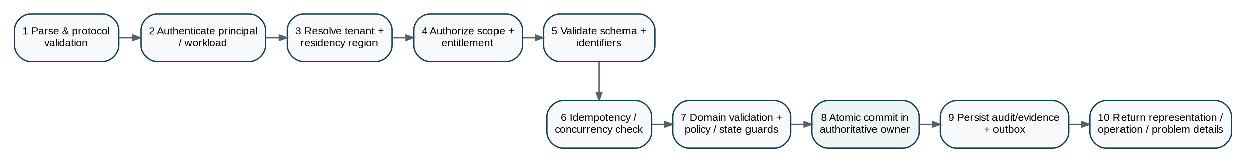
Figure 3 — Mandatory request evaluation sequence for state-changing APIs
The order is intentional. Tenant/residency and authorization checks occur before expensive domain work; idempotency and concurrency are evaluated before side effects; domain validation and policy/state guards occur before commit; audit/evidence and outbox records are committed atomically with authoritative state where applicable.

6. Request Context & Header Contract
Header / context | Direction | Requirement | Meaning / rule
Authorization | Request | Required except explicitly public endpoints | Bearer/service credential; token is validated and mapped to principal/workload.
Content-Type | Request | Required with body | Must match endpoint contract.
Accept | Request | Recommended | Client representation preference.
Idempotency-Key | Request | Required for replay-capable mutations | Opaque client key; never derive from PII or secret values.
If-Match | Request | Required for existing aggregate mutation | Carries ETag from latest representation; prevents stale mutation.
traceparent / tracestate | Both | Supported | Distributed trace propagation; must not contain sensitive business data.
Accept-Language | Request | Optional | Human-readable strings only; machine codes remain language-independent.
Prefer: respond-async | Request | Supported on eligible operations | Requests asynchronous processing where endpoint allows it.
Zoiko-Request-Id | Response | Required | Server request identifier for support/evidence; may echo a valid client request ID if policy permits.
ETag | Response | Required on versioned aggregate representations | Opaque concurrency token.
Location | Response | Required for created resources / async operations where applicable | Canonical URL of created resource or operation.
Retry-After | Response | Conditional | Used for retryable throttling or temporary unavailability.
Deprecation | Response | Conditional | RFC 9745 deprecation signal.
Sunset | Response | Conditional | RFC 8594 retirement intent.
Cache-Control | Response | Required policy | Tenant business data defaults to private/no-store unless explicitly classified otherwise.

Context hierarchy
Tenant context is not blindly trusted because a header or path supplied it. The gateway resolves the principal’s permitted tenants, the requested tenant/entity/book scope and residency decision, then passes a signed/internal context to the authoritative service. Public tenant APIs and privileged cross-tenant admin APIs remain separate surfaces.

7. Resource Representation Contract

7.1 Canonical resource metadata
{
"data": {
"id": "0198f5a1-...",
"object_type": "customer_invoice",
"version": 42,
"legal_entity_id": "0198e9...",
"invoice_number": "INV-2026-00421",
"lifecycle_state": "issued",
"approval_state": "approved",
"currency": "GBP",
"total_amount": "1250.00",
"created_at": "2026-08-24T08:44:17Z",
"updated_at": "2026-08-24T09:02:41Z"
},
"meta": {"request_id":"req_..."},
"links": {"self":"/v1/.../customer-invoices/0198f5a1-..."}
}

7.2 Representation rules
- Resource `version` increments on authoritative aggregate mutation and maps to the ETag concurrency token.
- Server-resolved policy/permission values are not echoed as client-authoritative inputs.
- Derived attention labels must be identified as derived/read-model fields, not confused with lifecycle state.
- Secrets, credentials and complete bank/payment tokens are never returned after creation.
- Redacted/masked values are represented explicitly; clients must not infer the underlying value from formatting.
- Responses may add fields within a major version; clients must ignore unknown response fields.

8. Command API Wireframe
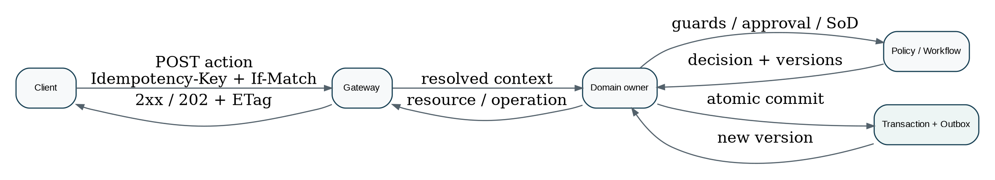
Figure 4 — Governed command execution sequence
POST /v1/legal-entities/{entity_id}/customer-invoices/{invoice_id}/actions/issue
Authorization: Bearer <token>
Idempotency-Key: 01J6...
If-Match: "v41"
Content-Type: application/json
{
"effective_at": "2026-08-24T09:15:00Z",
"reason_code": "customer_invoice_ready",
"evidence_refs": ["doc_0198..."]
}

Rule | Required behavior
Named action | One business command per endpoint/action name.
Transport method | POST for domain actions; action semantics are in the resource path/body, not a new HTTP method.
Expected version | If-Match required when acting on an existing mutable aggregate unless endpoint is explicitly append-only.
Idempotency | Required whenever a client retry could duplicate a material side effect.
Authorization | Domain action permission + object/entity scope + SoD/approval requirements.
State guard | Current state and orthogonal dimensions must permit the transition under ZS-STATE-001.
Policy versions | Material decision records store policy/rule/workflow versions used.
Result | Return updated representation when completed synchronously; otherwise return 202 operation resource.

9. Idempotency Contract
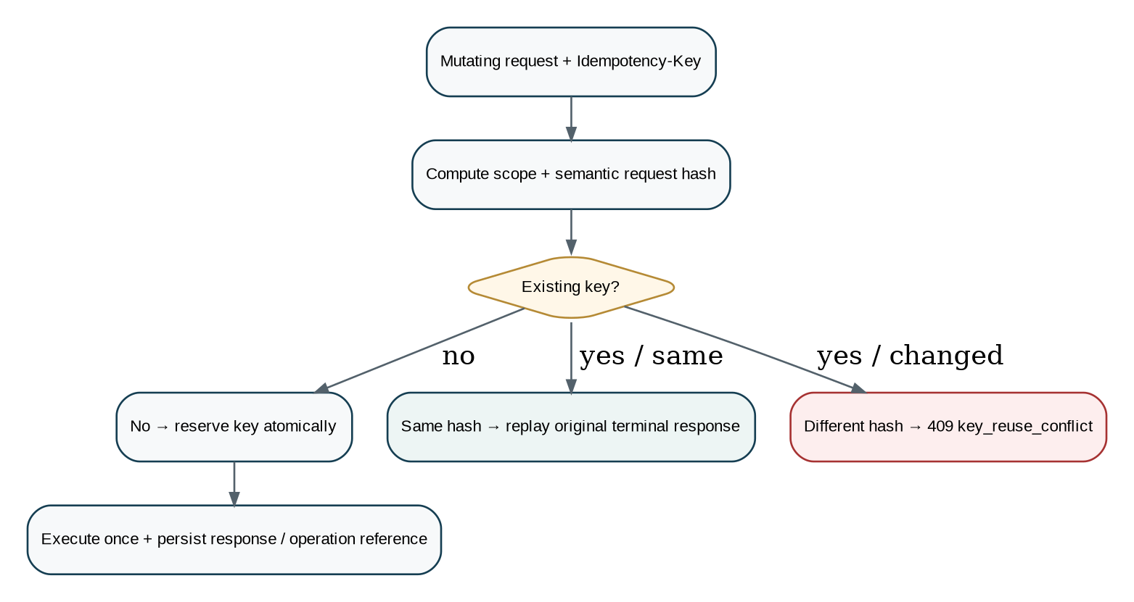
Figure 5 — Idempotency reservation, replay and misuse protection
Class | Examples | Minimum replay record | Rule
Class A — material | Payments, invoice issue, journal post, tax filing, e-invoice submission, contract execution. | 30 days online; durable evidence/hash per record retention. | Same key + same semantic request replays original result/operation; changed request returns 409.
Class B — standard mutation | Create draft, update configuration, task action. | At least 24 hours. | Same replay behavior; service may retain longer.
Async operation | Imports, exports, filings, large recalculations. | Through terminal state + at least 30 days. | Idempotency maps to the same operation_id.

9.1 Idempotency storage key
tenant_id + principal/client_id + normalized_route_template + idempotency_key → request_hash + result_reference + status + timestamps

- Do not rely on provider-side idempotency alone; ZoikoSuite keeps its own attempt and command record.
- Do not generate idempotency keys from invoice numbers, card data, tax IDs or other sensitive/business identifiers.
- A network timeout after commit is safe to retry using the same key.
- A different body under the same key is a client error, not a new operation.

10. Optimistic Concurrency & Conditional Requests
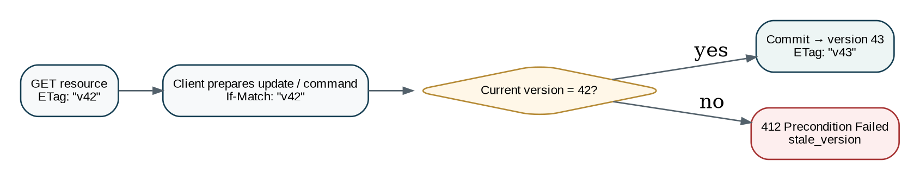
Figure 6 — Aggregate version and ETag/If-Match concurrency model
For HTTP clients, `ETag`/`If-Match` is the normative wire representation of the aggregate version. Internal command objects may materialize the parsed value as `expected_version`. If both are present in an internal bridge they must agree.
Scenario | Response / control
Missing If-Match on protected mutation | 428 Precondition Required with `precondition_required`.
Stale ETag | 412 Precondition Failed with `stale_version`; return current ETag when safe.
Correct ETag | Execute domain guards and commit; increment version.
Append-only child create | May omit If-Match only if contract guarantees it cannot overwrite/transition existing aggregate state.
Bulk items | Each item carries its own version token; no last-write-wins fallback.

11. HTTP Method & Status-Code Standard
Method | ZoikoSuite use | Restrictions
GET | Retrieve resource, collection, query result or operation. | No business side effects.
HEAD | Metadata/existence where useful. | Same safe semantics as GET; no body.
POST | Create subordinate resource, submit command/action, start query/import/export/operation. | Idempotency required when replay can duplicate side effects.
PUT | Replace a whole configuration/resource only where replacement semantics are meaningful. | Must be idempotent and version-protected where concurrent edits matter.
PATCH | Restricted typed/merge update for approved mutable resources. | Never used to set governed lifecycle status or edit posted/issued/filed facts.
DELETE | Delete only truly deletable draft/configuration resources. | Never destroys retained financial/legal evidence; otherwise use cancel/void/close commands.

Status | Use
200 | Successful read/action returning representation.
201 | Resource created; include Location.
202 | Accepted for asynchronous processing; include operation Location.
204 | Successful operation with intentionally no response body.
400 | Malformed syntax or general request invalidity not better expressed elsewhere.
401 | Missing/invalid authentication.
403 | Authenticated but not permitted.
404 | Resource not found or deliberately concealed by authorization policy.
409 | Domain conflict, duplicate semantic conflict or idempotency-key misuse.
412 | If-Match/ETag precondition failed.
422 | Syntactically valid request failing domain validation.
428 | Required conditional precondition missing.
429 | Rate limit/throttling; include Retry-After when possible.
500 | Unexpected internal failure.
502/503/504 | Gateway/dependency/unavailable/timeout semantics where actually applicable.

12. Error Contract — RFC 9457 Problem Details
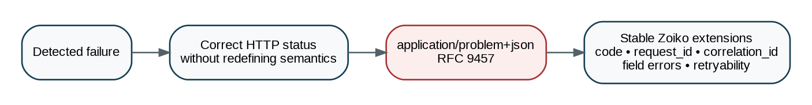
Figure 7 — Uniform API problem-details error contract
HTTP/1.1 422 Unprocessable Content
Content-Type: application/problem+json
{
"type": "https://api.zoikosuite.com/problems/domain-validation",
"title": "The request failed domain validation.",
"status": 422,
"detail": "One or more fields are invalid for this operation.",
"instance": "urn:zoikosuite:problem:req_01J6...",
"code": "invoice_tax_point_invalid",
"request_id": "req_01J6...",
"correlation_id": "corr_01J6...",
"retryable": false,
"errors": [
{"pointer":"#/tax_point_date","code":"outside_allowed_period","detail":"..."}
]
}

Extension | Rule
code | Stable lower_snake_case machine code; clients branch on this, not `detail`.
request_id | Support/evidence identifier for this request.
correlation_id | Cross-service business correlation where applicable.
retryable | Boolean advisory; retry strategy still respects idempotency and Retry-After.
errors[] | Field/item validation details using JSON Pointer-style locations.
current_version | May be included for stale-version problems when disclosure is authorized.
evidence_ref | May be included for regulated submission rejection/receipt evidence where appropriate.

13. Money, Rates, Quantity & Numerical Precision
Type | Wire format | Example / rule
Money amount | Canonical decimal string | "1250.00" — no exponent notation.
Currency | ISO 4217 alpha code | "GBP"; minor-unit rules are reference data, not inferred in clients.
Exchange rate | Decimal string + rate_type/source/date | "1.27654321".
Tax/percentage rate | Decimal fraction string by default | "0.200000" means 20%; field definition states basis.
Quantity | Decimal string where fractional | "12.500".
Count | JSON integer where bounded and non-financial | 42.
Large integer identifiers | String | Never rely on JavaScript-safe integer range for IDs.

Calculation authority
APIs transport authoritative values and calculation evidence; clients do not recalculate tax, FX, depreciation, payroll or ledger results and then present those client calculations as truth.

14. Date, Time, Calendar & Temporal Semantics
Semantic type | Format | Rule
Business date | YYYY-MM-DD | For invoice date, posting date, tax point date, due date. No timezone implied.
Instant/timestamp | RFC 3339 UTC | Use `Z`; server normalizes offsets to UTC for authoritative instants.
Local scheduled time | local_date + local_time + timezone_id | Required when business meaning depends on civil time/zone.
Effective period | effective_from / effective_to | Effective-dated facts retain history.
System record time | created_at / updated_at / recorded_at | System timestamps, not substitutes for business-effective time.
Historical query | as_of / effective_at / period | Only supported where domain contract defines reconstruction semantics.

15. Collection Query, Filtering, Sorting & Pagination
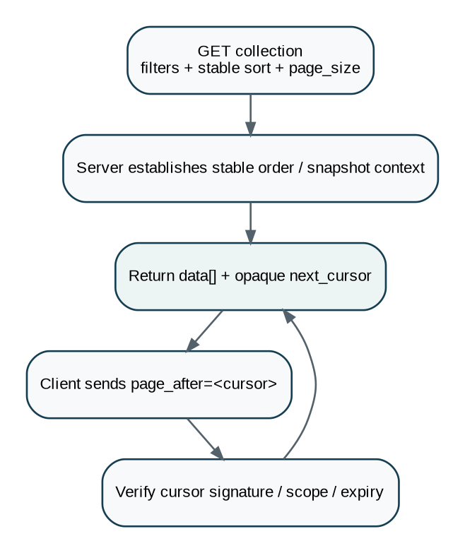
Figure 8 — Stable opaque-cursor pagination model

15.1 Filter grammar
GET /v1/customer-invoices?filter[legal_entity_id]=0198...&filter[lifecycle_state]=issued&filter[posting_date][gte]=2026-08-01&sort=-posting_date,id&page_size=50

- Allowed filter fields/operators are endpoint-defined in OpenAPI; unknown filters are rejected.
- Supported operators may include eq (implicit), ne, gt, gte, lt, lte, in and bounded text prefix where indexed.
- No arbitrary SQL, script, regular-expression or user-provided query language on authoritative transactional endpoints.
- Sensitive searches use a body-based search endpoint when query-string disclosure would be inappropriate.
- Sort must have a deterministic tie-breaker, normally canonical `id`.

15.2 Pagination rules
Rule | Baseline
Default page_size | 50 unless domain justifies another value.
Maximum page_size | 200 for standard transactional collections; lower for expensive endpoints.
Cursor | Opaque, signed/scoped and not client-edited.
Offset pagination | Permitted only for small/static reference collections; not the default.
Total count | Not guaranteed on high-volume endpoints; expose only when efficient/meaningful.
Snapshot consistency | Endpoints document whether cursor preserves a stable snapshot or stable ordering across concurrent writes.

16. Sparse Fields, Includes & Expansion
- Use `fields[resource]=field1,field2` only on endpoints that support sparse fieldsets.
- Use `include=lines,customer` only for explicitly allowed relationships.
- Includes are bounded in depth and cardinality; no arbitrary recursive graph expansion.
- Authorization is re-evaluated for included resources.
- Large child populations use separate paginated endpoints rather than unbounded expansion.
- Fields necessary for concurrency, identity and evidence may remain mandatory even when sparse fields are requested.

17. Historical / As-of Retrieval Contract
GET /v1/.../legal-entities/{id}?as_of=2026-06-30T23:59:59Z
GET /v1/.../tax-rules?effective_at=2026-04-01&jurisdiction=GB
GET /v1/.../ledger-balances?period=2026-07&snapshot_id=bal_...

Parameter | Meaning | Control
as_of | System-record reconstruction time. | Domain must support historical record versions.
effective_at | Business-effective rule/fact selection time. | Bitemporal/effective-dated model where applicable.
period | Accounting/reporting period. | Server resolves fiscal calendar and period state.
version | Specific immutable resource/rule version. | Access-controlled; cannot substitute for current mutation target.
snapshot_id | Signed/frozen financial population or report snapshot. | Immutable reference used for audit/reconciliation/reporting.

18. Asynchronous Operation Contract
Figure 9 — Long-running operation resource model
{
"data": {
"id": "op_0198...",
"operation_type": "tax_return_submission",
"state": "running",
"progress": {"completed_units": 2, "total_units": 5},
"resource_ref": "/v1/.../tax-returns/0198...",
"started_at": "2026-08-24T09:15:00Z",
"updated_at": "2026-08-24T09:15:06Z"
}
}

State | Meaning
queued | Accepted, durable, not yet executing.
running | Execution in progress.
waiting_external | Awaiting bank/tax/e-invoice/other provider response.
succeeded | Terminal success; result/reference available.
failed | Terminal failure; problem/evidence available.
cancel_requested | Cancellation requested, not yet guaranteed.
cancelled | Terminal cancellation before irreversible completion.

- Do not report success before the authoritative business state is committed.
- Client polling uses reasonable backoff and Retry-After when supplied.
- Cancellation is offered only before an irreversible provider/domain point of no return.
- Operation IDs are durable and idempotency retries resolve to the same operation.

19. Bulk & Batch Operations
Principle | Required behavior
No fake global transaction | A batch spanning independent aggregates is not presented as atomic unless one authoritative transactional boundary truly exists.
Per-item key | Each material item carries a client_reference/idempotency token where retry duplication is possible.
Bounded size | Default maximum 100 items; domains may set lower limits.
Async by default for heavy work | Large batches become operation resources.
Per-item outcome | Response/result exposes succeeded, failed, skipped and retryable outcomes with stable problem codes.
Reconciliation | Financial imports/batches return totals and reconciliation evidence.
Partial failure | Must be explicit; never return a simple “success” while silently dropping failed items.

20. File Upload, Import & Export Wireframe
Figure 10 — Controlled file ingestion and import pipeline

20.1 Upload controls
- Small files may use direct multipart upload within endpoint limits.
- Large files use upload sessions/object-storage handoff with short-lived scoped credentials.
- Client provides SHA-256 checksum; server verifies size/checksum and detects actual content type.
- Files enter quarantine until malware/content validation completes.
- Original filename is metadata only and is sanitized; sensitive information should not be encoded in filenames.
- A document/file becomes linkable to authoritative business records only after validation and classification.

20.2 Import lifecycle
Upload → Validate → Parse → Preview → Approve → Commit → Reconcile → Complete. Import preview must show row counts, totals, rejected items, mapping version, inferred entity/currency/period context and any blocking exceptions before commitment.

20.3 Export lifecycle
- Exports of large/sensitive datasets run asynchronously.
- Authorization is checked at request and again before artifact release when processing is long-running.
- Generated artifacts carry dataset/snapshot references and evidence metadata.
- Download links are short-lived, scoped and not permanent public URLs.
- Export endpoints enforce residency and purpose/permission constraints.

21. Webhook Delivery Contract
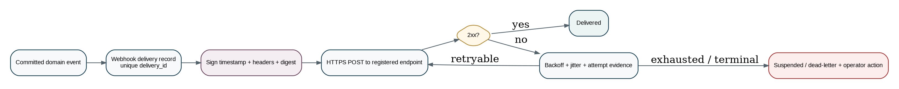
Figure 11 — Outbound webhook delivery, retry and suspension lifecycle
Field / control | Requirement
event_id | Stable underlying event identifier.
delivery_id | Unique per endpoint delivery attempt chain; consumer deduplicates by this or event_id according to profile.
occurred_at | Committed domain-event time.
schema_version | Version of webhook payload contract.
signature | Cryptographic signature/MAC over required message components.
timestamp / nonce | Replay defense within defined acceptance window.
content digest | Payload integrity value included in signature profile.
retry policy | Exponential backoff with jitter for retryable failures; honor Retry-After where reasonable.
terminal/suspension | Repeated permanent failures suspend endpoint and raise operator/customer action.
secret/key rotation | Overlapping verification window supports safe rotation.

POST /customer-webhook-endpoint HTTP/1.1
Content-Type: application/json
Zoiko-Webhook-Delivery-Id: whd_...
Zoiko-Webhook-Timestamp: 1787562923
Content-Digest: sha-256=:...:
Signature-Input: ...
Signature: ...
{"event_id":"evt_...","event_type":"customer_invoice.paid","schema_version":"1.0",...}

Security profile
For high-trust partner/webhook profiles, ZoikoSuite should align signing with RFC 9421 HTTP Message Signatures and content-digest requirements rather than inventing an incompatible canonicalization scheme. The exact required covered components and algorithms are profile-controlled.

22. Inbound Provider Callback Contract
Step | Required control
1 | Receive only on provider-specific registered callback route.
2 | Verify TLS/source/signature or provider-defined authentication before parsing as trusted signal.
3 | Validate timestamp/replay window and unique provider event/attempt identifier.
4 | Map callback to an existing external_attempt; uncorrelated signals are quarantined.
5 | Deduplicate duplicate callbacks.
6 | Validate provider transition order; out-of-order states do not automatically regress authoritative state.
7 | Persist raw/provider evidence subject to security/retention policy.
8 | Invoke the authoritative domain command/state transition only if mapping and guards permit it.
9 | Return provider-required acknowledgment without claiming internal completion prematurely.

23. External Provider Adapter Architecture
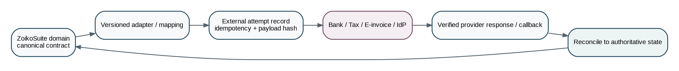
Figure 12 — Canonical domain-to-provider adapter and reconciliation boundary
Concern | Standard
Canonical model | Domain services send/receive ZoikoSuite canonical DTOs; provider schemas stay inside adapters.
Mapping version | Every transformation has a version and effective period.
Attempt record | Stores provider, request hash, provider reference, timestamps, status and evidence.
Retries | At-least-once-safe through Zoiko idempotency + provider idempotency where available.
Timeout ambiguity | Remain `unknown/pending_reconciliation`; do not assume failure or success.
Reconciliation | Scheduled/API/provider evidence reconciles external status to authoritative domain state.
Provider outage | Circuit breaker/backoff; no uncontrolled synchronous cascade into core ledger.
Credential storage | Secret manager/KMS; never persisted in domain resource payloads or returned to clients.

24. Authentication, Authorization & API Security Boundary
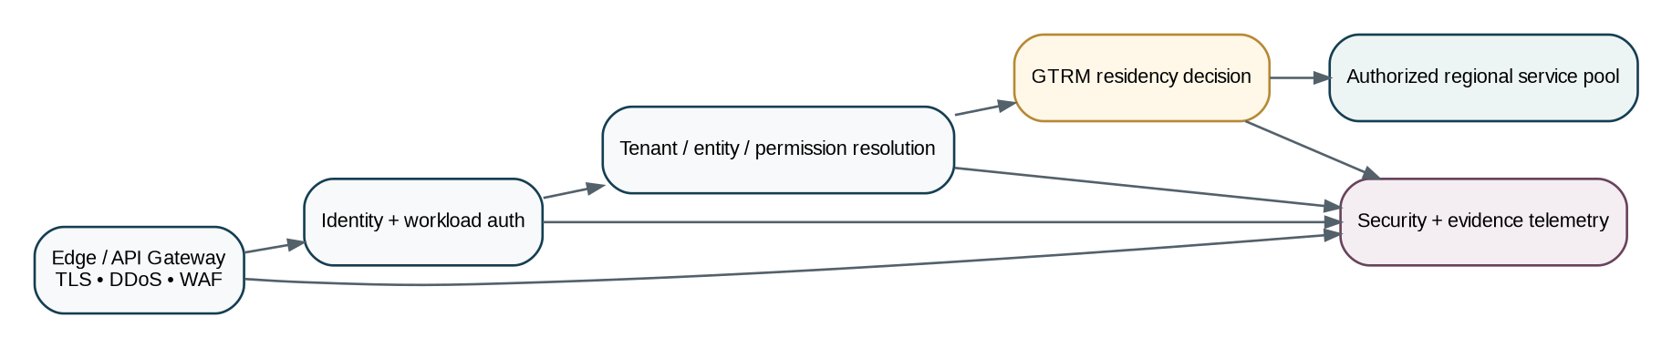
Figure 13 — API security, tenant isolation and residency enforcement boundary
- OAuth 2.0 / OpenID Connect profiles are the baseline for user/partner authorization; service workloads use approved workload identity/service credentials.
- Access tokens are short-lived and audience-restricted; JWT usage follows current JWT security best practices including explicit algorithm/audience/issuer validation.
- High-risk machine integrations may require mTLS, private-key client authentication and/or message signatures in addition to bearer authorization.
- Scopes express coarse API capabilities; final authorization always includes tenant, legal entity, resource attributes, role/ABAC, SoD and entitlement.
- API keys alone are insufficient for high-risk financial, tax, legal or privileged mutations unless wrapped in an approved stronger authentication profile.
- CORS is explicitly allow-listed for browser clients; wildcard credentialed origins are prohibited.
- CSRF protection applies to cookie/session-based browser surfaces; bearer API tokens are not stored in insecure browser contexts.
- No secret, token or raw credential is written to application logs.

25. Tenant, Legal-Entity, Book & Residency Context
Context | Where it comes from | Server behavior
tenant_id | Authenticated account/workspace context; privileged selector only where authorized. | Validate membership/role and route to tenant home/permitted region.
legal_entity_id | Path/body/resource relationship. | Validate belongs to tenant and actor scope.
book_id | Path/body for book-specific accounting action. | Validate belongs to entity and accounting framework/period permissions.
jurisdiction | Resolved from entity/establishment/transaction facts, not merely client claim. | Policy/tax engines choose applicable rule version.
residency_region | Tenant policy + traffic classification + incident state. | GTRM decides permitted regional service pool.
purpose_context | Explicit or workflow-derived for governed access. | Used where data-access policy requires purpose limitation.

26. Caching, ETags & Sensitive Data
- Authoritative tenant business responses default to `Cache-Control: private, no-store` unless a reviewed endpoint explicitly permits caching.
- ETag is primarily a concurrency validator for governed resources; it must not become a cross-user tracking identifier.
- Public/reference metadata may use explicit cache lifetimes and validators.
- Sensitive exports/downloads use no-store semantics and short-lived scoped URLs.
- CDN/edge caches must never vary tenant data only by a header that can be omitted/mis-keyed; tenant-private data should bypass shared caching unless formally proven safe.

27. Rate Limits, Quotas & Backpressure
Control | Standard
Rate limit dimension | May vary by tenant, principal/client, endpoint risk and resource cost.
429 response | Use 429 when caller exceeds enforced request quota; include Retry-After when a retry time is known.
Business quota | Plan/entitlement limits are domain problems, not disguised transport throttles.
Concurrency limit | Heavy exports/reports/imports have bounded concurrent operations per tenant.
Backpressure | Queue depth/provider degradation may return 503/202 depending whether work can be durably accepted.
Retry | Clients use exponential backoff with jitter and idempotency-safe replay.
No published universal number | Service SLO/capacity profiles define numeric limits; do not hard-code one global request rate.

28. OpenAPI Source of Truth & Schema Governance
As of August 24, 2026, OpenAPI Specification 3.2.0 is the latest published OAS release (September 19, 2025). ZoikoSuite should use OAS 3.2.x as the source format for new HTTP API descriptions, subject to tooling readiness; domains must not rely on undocumented behavior unsupported by the approved toolchain.
Artifact | Requirement
OpenAPI document | Stored in version control beside owning service/domain contract.
Schema components | Reuse canonical types for IDs, money, timestamps, problem details, pagination and operation resources.
Examples | Every material operation has valid request, success and failure examples.
Operation ID | Stable unique operationId used for SDK/documentation generation.
Security schemes | Explicit per operation; no implicit anonymous access.
Tags/ownership | Domain owner and support/on-call metadata linked from service catalogue.
Breaking-change diff | CI compares current stable contract with proposed version.
Schema registry | Approved external/event/import schemas versioned and discoverable.

29. Versioning, Compatibility, Deprecation & Sunset
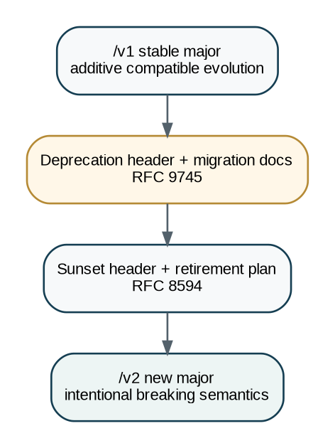
Figure 14 — Major-version, deprecation and sunset lifecycle

29.1 Compatible within a major version
- Adding an optional response field.
- Adding a new endpoint/resource.
- Adding an optional request field with server-default behavior.
- Adding a new problem type for a previously undocumented failure only if existing status semantics remain valid.
- Increasing maximum lengths/limits when no security issue results.

29.2 Breaking and therefore requires major/versioned migration
- Removing or renaming a field/resource/operation.
- Changing field type, units, money/rate basis or temporal meaning.
- Making an optional request field required.
- Changing enum semantics such that existing values become invalid or newly returned values were prohibited by contract.
- Changing authorization/tenant scoping in a way that invalidates existing valid requests.
- Changing a command’s business meaning or side-effect guarantees.

29.3 Deprecation policy
- Stable public/partner API retirement target: provide at least 12 months migration window unless security, legal or provider discontinuation makes that impossible.
- Send `Deprecation` response header once deprecated and provide a deprecation link/document.
- Send `Sunset` when a planned unavailability date is committed.
- Maintain migration guide, replacement operation mapping and SDK support notes.
- Beta/preview endpoints may use shorter terms but must be visibly identified and excluded from stable compatibility promises.

30. Privileged Administration API
Requirement | Control
Separate namespace | `/admin/v1/` or separately routed administrative origin; never hidden tenant-route behavior.
Authentication | Privileged identity/PAM session; step-up authentication for sensitive actions.
Tenant selection | Explicit target tenant/entity with reason and session scope.
Break-glass | Time-limited, justified, approved where required and fully evidenced.
Response masking | Admin APIs do not automatically reveal secret/payment/credential values.
Mutation | Still uses idempotency, If-Match, commands and domain ownership.
Audit | Every privileged read/mutation includes actor/session/target/reason in immutable security/evidence telemetry.

31. Import/Export & Migration API Profiles
Profile | Required data / controls
Master-data import | source_system, mapping_version, entity scope, duplicate strategy, validation preview.
Opening balance migration | cutover_date, book/ledger, opening trial balance, outstanding items, source reconciliation and approval.
Transaction history | source IDs, occurred/effective dates, currencies, tax treatment, source hashes.
Regulatory export | entity, jurisdiction, period, format/taxonomy version, approved snapshot, evidence.
Bulk operational export | authorized dataset, filters, snapshot/watermark, format, retention/download expiry.

32. Observability, Audit & Evidence Contract
Signal | Minimum fields
Request telemetry | request_id, trace_id, route_template, method, result status, latency, region, service version — without sensitive payloads.
Business command evidence | tenant, actor/workload, entity, aggregate ID/version, command, idempotency key hash/reference, policy/workflow versions, result.
External attempt | provider, attempt_id, provider_reference, request/response hashes, timestamps, mapped status, retry count.
Webhook delivery | event_id, endpoint ID, delivery_id, attempt, response status, signature profile, next retry.
Security event | principal, auth mechanism, denied scope/reason, privileged session, target resource classification.
SLO metrics | availability, latency percentiles, error class, saturation, dependency health, queue depth.

Logging prohibition
Do not log access tokens, refresh tokens, passwords, signing keys, full bank account numbers, raw tax identifiers, full document payloads or other high-sensitivity content merely because it arrived in an API request.

33. API Error / Problem Code Families
Family | Examples | Typical status
protocol_* | malformed_json, unsupported_media_type | 400 / 415
auth_* | invalid_token, insufficient_authentication | 401
authorization_* | permission_denied, entity_scope_denied | 403
not_found_* | resource_not_found | 404
precondition_* | precondition_required, stale_version | 428 / 412
idempotency_* | idempotency_key_reuse_conflict | 409
state_* | transition_not_allowed, terminal_state | 409 / 422
validation_* | field_invalid, date_outside_period | 422
accounting_* | journal_unbalanced, period_closed, control_account_restricted | 409 / 422
tax_* | registration_missing, tax_rule_unresolved | 422
external_* | provider_rejected, provider_unavailable, callback_unverified | 422 / 502 / 503
rate_* | rate_limit_exceeded | 429
system_* | internal_error, dependency_timeout | 500 / 504

34. Standard Command Result Patterns
Pattern | Response
Synchronous mutation | 200 with updated resource + new ETag.
Create resource | 201 + Location + representation.
Async accepted | 202 + Location of operation + operation representation.
No-body success | 204 only when clients do not need updated version/result.
Provider pending | 202 or 200 domain state `pending_external` depending command contract; never falsely mark settled/accepted.
Duplicate idempotent replay | Same semantic status/result or same operation reference as original execution.
Already in desired terminal state | May return current representation if command is explicitly idempotent by semantics; otherwise stable conflict problem.

35. SDK & Developer Experience Standard
- Generate typed SDKs only from approved OpenAPI contracts; generated code is not the source of truth.
- SDKs expose idempotency and expected-version primitives directly rather than hiding them.
- SDK retry middleware never retries unsafe mutations unless the endpoint is idempotency-protected and retry policy permits it.
- SDKs preserve request_id/correlation_id in exceptions for support.
- Examples default to secure credential storage and do not encourage hard-coded secrets.
- Sandbox/test environments use non-production credentials, synthetic data and clearly non-production endpoints.
- Every stable endpoint includes lifecycle status (stable/beta/deprecated), authorization requirements, examples and problem codes.

36. Contract Testing & CI/CD Gates
Gate | Must pass before merge/release
OpenAPI validation | Syntactically/semantically valid OAS using approved version/toolchain.
Style lint | Naming, headers, pagination, money/date/ID types, action routes and problem schemas conform to ZS-API-001.
Breaking-change diff | No unapproved breaking change against latest stable contract.
Example validation | Examples validate against request/response schemas.
Consumer contract | Critical internal/partner consumers pass compatibility tests where used.
Negative-path tests | Auth, tenant isolation, state guard, stale version, duplicate idempotency, malformed callback and retry behavior.
Security tests | AuthN/AuthZ, object-level authorization, input limits, SSRF/file handling, secret leakage, callback signature verification.
Performance tests | Latency/throughput/queue behavior against service SLO and worst-case pagination/filter patterns.
Residency tests | Requests cannot cross prohibited regional/data-residency boundaries.
Observability | Required request/business/evidence telemetry emitted without sensitive leakage.

37. Golden Engineering Acceptance Scenarios
ID | Scenario | Expected result
T-01 | GET is side-effect free | Repeated GET never changes authoritative state or triggers payment/filing/posting.
T-02 | Cross-tenant denial | Valid token for Tenant A cannot read/mutate Tenant B through altered IDs/headers.
T-03 | Residency enforcement | Data-bearing request is rejected/routed only to permitted regional pool.
T-04 | Idempotent invoice issue | Retry same issue command/key returns same invoice/result; no duplicate posting/e-invoice.
T-05 | Idempotency misuse | Same key with changed payload returns 409 and no additional side effect.
T-06 | Stale update | If-Match v41 against current v42 returns 412; no overwrite.
T-07 | Missing precondition | Protected mutation without If-Match returns 428.
T-08 | Illegal lifecycle mutation | PATCH lifecycle_state is rejected; only named action can transition.
T-09 | Closed period | Journal post command into hard-closed period fails with stable accounting problem.
T-10 | Money precision | Decimal string round-trips without binary floating-point loss.
T-11 | Cursor stability | Next cursor never returns duplicate/omitted rows under documented consistency semantics.
T-12 | Sensitive search | Tax/bank identifier cannot be supplied through prohibited query-string route.
T-13 | Async retry | Retry async import command resolves to same operation_id.
T-14 | Partial batch | Mixed batch returns explicit per-item outcomes and reconciliation totals.
T-15 | Forged callback | Invalid provider signature causes no domain state transition.
T-16 | Duplicate callback | Same provider event is deduplicated and does not duplicate settlement/posting.
T-17 | Out-of-order callback | Late prior provider state cannot regress authoritative completed state.
T-18 | Webhook retry | Non-2xx delivery retries with backoff; duplicate event remains identifiable.
T-19 | Deprecated API | Deprecated endpoint emits Deprecation metadata and documented replacement.
T-20 | Unknown request field | Command body with unsupported field is rejected rather than silently ignored.
T-21 | Additive response field | Older compliant client ignores a newly added response field.
T-22 | File malware | Malicious upload remains quarantined and cannot attach/import.
T-23 | Provider timeout ambiguity | Unknown payment/provider outcome stays pending reconciliation; not guessed failed/success.
T-24 | Privileged traceability | Admin cross-tenant read records PAM session, target, reason and evidence.

38. Definition of Ready — Domain API
- Owning domain service and authoritative write owner identified.
- Resource/command/query classification selected.
- Canonical data fields and system-resolved context mapped to ZS-DATA-001.
- State-transition implications mapped to ZS-STATE-001.
- Accounting/posting implications mapped to ZS-ACC-KERNEL-001 where relevant.
- Tenant/entity/book/jurisdiction/residency scope defined.
- Authorization, SoD and entitlement requirements defined.
- Idempotency class and concurrency behavior defined.
- HTTP route/method/status/media type defined.
- Request/response/problem schemas and examples drafted.
- Money/date/time/ID semantics defined.
- External-provider behavior and reconciliation defined if applicable.
- Retention/evidence/logging classification defined.
- SLO, pagination/filter and size limits defined.
- OpenAPI contract reviewed by architecture/security/domain owner.

39. Definition of Done — Domain API
- OpenAPI contract passes validation, style lint and breaking-change checks.
- Implementation passes schema/request/response contract tests.
- Tenant isolation/object-level authorization tests pass.
- Idempotency and stale-version negative tests pass.
- State/approval/period/domain guards are enforced server-side.
- No direct cross-domain database write exists.
- Audit/evidence/outbox records are produced where required.
- Errors conform to RFC 9457 + Zoiko extensions.
- Observability and SLO metrics are live; payload logs are redacted.
- File/callback/webhook security tests pass where applicable.
- Residency routing test passes.
- SDK/documentation examples validate against production contract.
- Runbook/support problem-code mapping exists.
- Rollback/backward compatibility plan is proven.
- Security and QA approvals recorded.

40. Engineering Implementation Sequence
Wave | Deliverables
0 — Foundation | Gateway routing, auth context, tenant/residency resolution, request IDs/tracing, common problem details, canonical schemas.
1 — Control primitives | Idempotency store, ETag/If-Match framework, command middleware, policy/state guard integration, audit/evidence hooks.
2 — Query layer | Collections, governed filters, cursor pagination, sparse/include rules, as-of access patterns.
3 — Async & file | Operation resources, job framework, upload sessions, quarantine, import preview/commit, exports.
4 — Integrations | External attempt model, provider adapters, callback verification, reconciliation framework.
5 — Webhooks | Subscription management, signing, delivery retry/suspension, endpoint rotation.
6 — Governance | OAS 3.2 toolchain, lint/diff CI gates, SDK generation, developer portal, deprecation automation.
7 — Certification | Golden negative-path suite, residency/security tests, load/SLO tests and production readiness review.

41. Controlled Pre-Production Decisions
Decision | Must be fixed before GA | Owner
API origins/domains | Production, sandbox, partner and admin origins; regional edge strategy. | Platform/Security
OAuth/OIDC profile | Issuer(s), token audiences, grant/client profiles, workload authentication. | Security/IAM
OpenAPI toolchain | 3.2-compatible validator, lint, diff, SDK/documentation generation. | Platform Architecture
Idempotency storage | Technology, retention tiers, regional consistency, disaster recovery. | Platform/Data
Webhook crypto profile | Covered headers/components, digest algorithm, key rotation and retry schedule. | Security/Integrations
File limits | Direct upload threshold, max object size, scan providers and quarantine SLA. | Platform/Security
Public API lifecycle | GA support policy, beta policy, deprecation notification channels and SLAs. | Product/Architecture
Rate/SLO numeric targets | Per endpoint/service class throughput, latency, concurrency and quotas. | SRE/Product
Admin API origin/PAM | Privileged network/authentication/session controls. | Security/Operations

42. Prohibited API & Integration Anti-Patterns
- `PATCH {"status":"paid"}` or equivalent direct lifecycle mutation.
- Client-supplied tenant ID used without authorization and server resolution.
- Direct browser/mobile access to internal service databases or provider credentials.
- Floating-point JSON numbers as the authoritative representation of money.
- POST retry without idempotency for payments, postings, filings, invoice issue or other material actions.
- Last-write-wins update of versioned financial/legal aggregates.
- GET endpoint that performs a business mutation.
- Arbitrary SQL/query expression accepted from internet clients.
- Offset pagination as the default for large mutable transaction tables.
- External callback that directly writes provider status into domain tables.
- Webhook signature scheme based only on a shared secret placed in URL/query string.
- Secrets, tokens or full sensitive payloads in logs/trace attributes.
- One public endpoint with hidden cross-tenant administrator behavior.
- Returning 200 for partial import while hiding rejected rows.
- Provider timeout treated automatically as business failure.
- Breaking a stable API by adding stricter validation or changing enum meaning without version/migration.
- Generated SDK code treated as contract source instead of approved OpenAPI.

43. Standards Baseline — Verified August 24, 2026
Standard | Current reference used by this architecture | Application in ZoikoSuite
OpenAPI Specification | OAS 3.2.0, published September 19, 2025 — latest published OAS as verified August 24, 2026. | Source-of-truth description for new HTTP APIs, subject to approved toolchain compatibility.
HTTP Semantics | RFC 9110 / STD 97. | HTTP method/status/header semantics; ZoikoSuite does not redefine them.
Building Protocols with HTTP | RFC 9205 / BCP 56. | HTTP API design and interoperability principles.
Problem Details | RFC 9457, which obsoletes RFC 7807. | Uniform machine-readable HTTP errors.
HTTP Message Signatures | RFC 9421. | Security profile foundation for high-trust webhooks/partner calls where used.
JSONPath | RFC 9535. | May be used internally/tooling for JSON selection; not exposed as arbitrary transactional query language.
JWT Best Current Practices | RFC 8725 / BCP 225. | JWT algorithm, issuer, audience and validation security guidance.
Deprecation Header | RFC 9745 (March 2025). | Machine-readable API deprecation signal.
Sunset Header | RFC 8594. | Planned endpoint retirement signal.
UUIDs | RFC 9562. | Canonical opaque UUID/UUIDv7 identifier framework where adopted by ZS-DATA-001.

Official references: spec.openapis.org/oas/latest.html; rfc-editor.org/rfc/rfc9110.html; RFC 9205; RFC 9457; RFC 9421; RFC 9535; RFC 8725; RFC 9745; RFC 8594; RFC 9562. Standards are implementation anchors, not substitutes for domain, jurisdictional or security review.

44. Final Architecture Decision
APPROVAL DECISION
Adopt ZS-API-001 as the controlling HTTP API, command, query, file, webhook and external-integration contract for ZoikoSuite. No domain API is Definition Ready unless its interface class, canonical schemas, tenant/entity/book scope, idempotency, concurrency, state/approval implications, errors, compatibility and evidence obligations are explicitly mapped to this standard.

The immediate successor document is ZS-EVENT-001 — ZoikoSuite Enterprise Domain Event Catalogue & Event Contract Standard. It should define the canonical event taxonomy, envelope, producer ownership, schema evolution, delivery semantics, replay, ordering, outbox/inbox controls, retention, dead-letter handling, webhook derivation and event-driven acceptance tests. Work on that document should begin only after ZS-API-001 is approved.

