ZOIKOSUITE
GLOBAL ACCOUNTING KERNEL
Detailed Engineering Wireframe & Posting Rules Standard
Accounting · Record-to-Report · Subledgers · FX · Intercompany · Consolidation · Controls

Field | Value
Document ID | ZS-ACC-KERNEL-001
Version | 1.0 — Engineering Architecture Baseline
Date | August 24, 2026
Status | For engineering approval
Owner | ZoikoSuite Product / Platform Architecture
Parent standard | ZS-DATA-001 — Global Canonical Data Model, Data Dictionary & ERD
Prepared for | Engineering, Architecture, Finance, Accounting, Tax, Audit, Security, Data, QA and Operations
Language | American English
Classification | Confidential — Internal

Architecture doctrine — A business fact is recorded once; accounting policy determines its book-specific consequences; every posted consequence is balanced, attributable, immutable, evidence-linked and reconstructable.

Document Roadmap & How to Use This Standard
This document is the engineering wireframe for ZoikoSuite’s accounting truth layer. It is intentionally more prescriptive than a conventional accounting requirements document: it defines the invariants, state machines, data contracts, posting mechanics, controls and acceptance tests that every accounting-producing domain must obey.
Layer | What this document decides | Primary consumers
Accounting constitution | Non-bypassable financial integrity rules | Architecture, Finance, Engineering
Book / ledger model | How multiple accounting bases coexist without duplicating source transactions | Accounting, Tax, Consolidation
Accounting-event model | How business facts become accounting consequences | All domain teams
Posting engine | Rule resolution, calculations, balancing, approvals and atomic posting | Backend Engineering
State machines | Permitted transitions for events, journals and accounting periods | Backend, QA, Operations
Posting matrices | Reference debit/credit patterns for major domains | Accounting SMEs, Engineering
Controls | Reconciliation, SoD, idempotency, close, correction and evidence | Finance Controls, Audit, Security
Interfaces | Canonical commands, APIs and events | Integration and Platform teams
Verification | Test packs and Definition of Done | QA, Release Management

Reading rule — Where a domain-specific requirement conflicts with this accounting kernel, the kernel wins unless the conflict is explicitly approved as a versioned architecture decision.

Critical Analysis Summary
Before drafting the final standard, the parent service catalogue and canonical data model were challenged against global accounting-system failure modes. The following weaknesses were treated as design defects and resolved in this version.
Observed risk | Why it is unacceptable | Refinement incorporated
Journal-centric business logic | Domain semantics become hidden in debits/credits and impossible to replay reliably. | Introduce canonical Accounting Events and a versioned Posting Rule Engine. Journals are outputs, not the origin of business meaning.
Single-book assumptions | A global entity may require statutory, management, tax and group bases with different recognition or measurement. | Make Accounting Book a first-class context above the ledger; one source fact may produce book-specific journal sets.
Editable posted entries | Destroys evidence and makes audits/corrections non-defensible. | Posted journals are immutable; corrections use reversals, adjusting journals, superseding events or approved reopening.
Period status as a UI flag | Back-posting can bypass close controls. | Period status becomes a server-side authorization gate enforced in the posting transaction.
Floating or undocumented FX logic | Creates irreproducible gains/losses and reporting differences. | Persist transaction, functional and presentation currency context plus rate type/date/source/version.
Control accounts open to direct posting | Subledgers can drift from GL. | Control accounts are posting-engine only except controlled migration/adjustment authorities.
Event replay can duplicate journals | Creates real financial misstatement from infrastructure behavior. | Idempotency and event-to-posting uniqueness are mandatory at database transaction level.
Partial posting across lines/books | Leaves unbalanced or inconsistent financial state. | Journal posting is atomic per posting unit; cross-book orchestration uses explicit completion/exception state and reconciliation.
Hard-coded framework rules | Prevents global accounting-policy change and future standards adoption. | Accounting policies, mappings and posting rules are versioned/effective-dated and resolved at runtime.
Reporting rules embedded in ledger | Presentation changes can force ledger redesign. | Ledger stores economic/accounting facts; reporting taxonomy and presentation remain separate versioned layers.
No source-to-report proof | Figures may be correct but not defensible. | Lineage joins source evidence → business object → accounting event → posting execution → journal → snapshot → report.
AI allowed near posting authority | Probabilistic outputs could become authoritative financial facts. | AI may classify/propose/explain only; deterministic rules and governed approvals control posting.

1. Executive Doctrine & Scope
ZoikoSuite’s accounting kernel is the authoritative mechanism that translates governed economic events into book-specific, balanced, traceable ledger consequences. It must support global entities, multiple accounting bases, multiple currencies, fiscal calendars, subledgers, intercompany relationships, consolidations and jurisdiction-specific policy without allowing business domains to write directly to the general ledger.

1.1 Objectives
- Provide one deterministic posting architecture across every ZoikoSuite business domain.
- Support multi-entity, multi-book, multi-ledger, multi-currency and multi-period accounting.
- Guarantee debit/credit balance, precision, period validity, authorization and idempotency before financial state changes.
- Preserve source-to-report evidence sufficient to reproduce every material calculation and journal.
- Enable changes in accounting policy through versioned rules rather than destructive schema/application changes.
- Provide real-time and period-end reconciliation between subledgers, the GL and signed balance snapshots.
- Make corrections explicit and auditable rather than permitting silent edits.

1.2 Non-goals
- This document does not prescribe a single chart of accounts for all tenants.
- It does not hard-code IFRS, US GAAP or any local GAAP into the ledger schema.
- It does not replace jurisdiction-specific accounting or tax advice.
- It does not make every logical component a separately deployed microservice.
- It does not permit AI-generated accounting conclusions to become authoritative without deterministic validation and governed approval.

2. Accounting Constitution — Non-Negotiable Invariants
ID | Invariant | Enforcement requirement
AK-INV-001 | Double-entry integrity | For every posted journal and currency/balancing unit, total debits must equal total credits exactly after approved rounding.
AK-INV-002 | No direct domain writes | AR, AP, Banking, Payroll, Assets, Inventory, Tax and other domains may not directly mutate GL tables.
AK-INV-003 | Immutable posting | A posted journal is never edited or deleted. Corrections create new accounting records.
AK-INV-004 | Book explicitness | Every journal belongs to exactly one accounting book and one target ledger.
AK-INV-005 | Period enforcement | The posting date must resolve to a posting-permitted period for the target book/ledger.
AK-INV-006 | Idempotent consequence | The same accounting event + posting basis + rule version cannot create the same consequence twice.
AK-INV-007 | Exact monetary arithmetic | Authoritative accounting calculations use fixed-precision decimal arithmetic, never binary floating point.
AK-INV-008 | Rule provenance | Every system-generated line identifies the posting-rule set/version that created it.
AK-INV-009 | Source provenance | Every journal is attributable to a source object/event or an explicitly authorized manual adjustment.
AK-INV-010 | Control-account governance | Subledger control accounts reject uncontrolled manual postings.
AK-INV-011 | Authorization server-side | Approval, SoD, legal-entity access and posting rights are resolved server-side.
AK-INV-012 | No partial journal | Either the full journal posts atomically or no ledger consequence is created.
AK-INV-013 | Currency reproducibility | Original amount, functional amount and applied FX basis are persisted where conversion occurs.
AK-INV-014 | History preservation | Period reopen, policy change, correction and migration actions preserve prior state and evidence.
AK-INV-015 | Search is not authority | Search, analytics and AI indexes may project ledger data but cannot authoritatively alter it.

3. Target Accounting Kernel Architecture
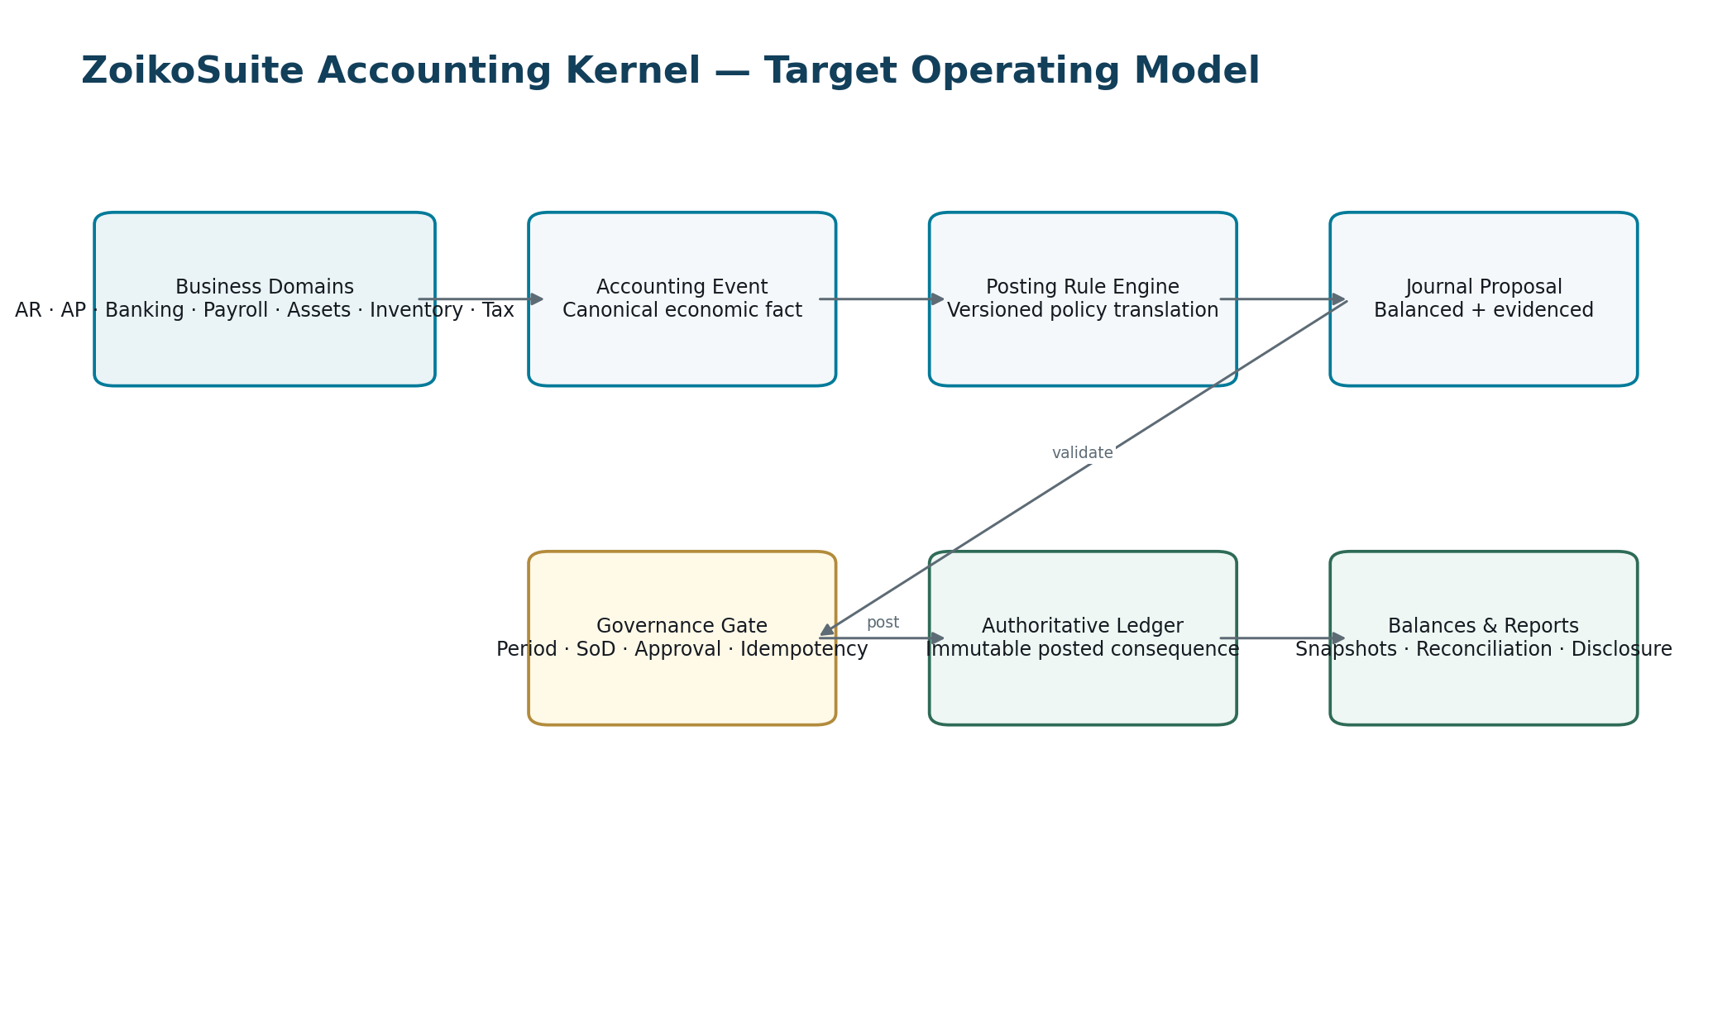
Figure 1 — Business domains create governed accounting events; the kernel alone creates authoritative journal consequences.
The posting engine owns accounting translation. Domain services own the business fact. The ledger owns posted financial truth. Reporting services consume signed/controlled financial facts but do not become the ledger of record.

4. Multi-Book & Ledger Architecture
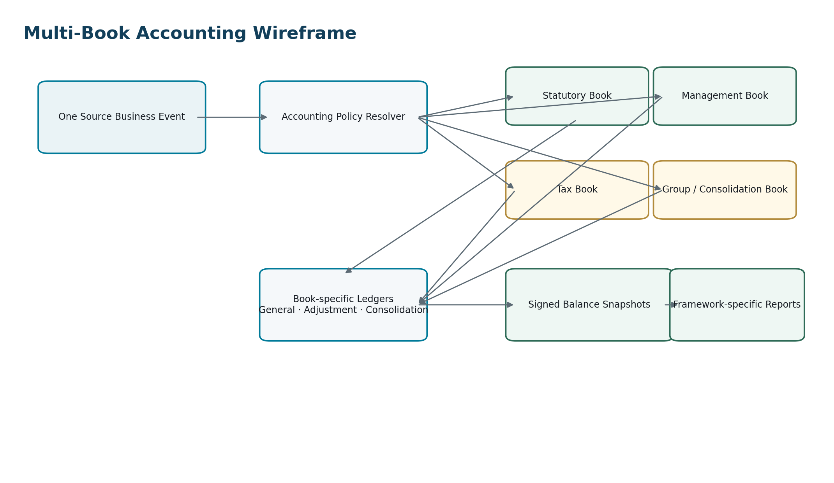
Figure 2 — One source business event may produce different book-specific consequences under versioned accounting policies.

4.1 Required accounting book types
Book type | Purpose | Typical differences
Primary statutory | Entity’s principal statutory accounting basis | Recognition, measurement, local chart mappings, functional currency
Management | Internal management basis | Management adjustments, allocations, KPI presentation
Tax | Tax-basis or tax-adjustment accounting where required | Tax depreciation, deductibility, timing differences
Group / consolidation | Group reporting basis | Group policy adjustments, eliminations, presentation currency
Regulatory / special purpose | Industry or regulator-specific basis where required | Regulatory chart, valuation or disclosure basis

Design rule — Book is a first-class accounting-policy context, not a tag on a journal. A tenant may configure only the books it actually requires.

4.2 Book contract
Field | Required | Meaning
book_id | Yes | Immutable internal identifier.
legal_entity_id | Yes | Entity whose accounting basis this book represents.
book_type | Yes | Statutory, management, tax, group/consolidation, regulatory or controlled extension.
accounting_framework_id | Yes | Versioned framework/policy package reference; not free text.
functional_currency | Yes | Currency of the primary economic environment for this book/entity context.
fiscal_calendar_id | Yes | Calendar controlling periods.
chart_of_accounts_id | Yes | Active chart/version mapping.
default_ledger_id | Yes | Primary posting ledger.
effective_from / effective_to | Yes | Effective-dated validity.
status | Yes | Draft, Active, Suspended, Retired.

5. Accounting Event Model
An Accounting Event is the canonical, immutable description of an economic event that may require accounting consequences. It is not a journal entry. It carries business semantics, source provenance, timing, currency, accounting attributes and the facts needed for deterministic rule evaluation.

5.1 Event contract
Field | Requirement | Example / rule
accounting_event_id | Mandatory | UUIDv7 internal ID.
event_type | Mandatory | AR.INVOICE_ISSUED, AP.INVOICE_APPROVED, BANK.RECEIPT_CONFIRMED, etc.
event_version | Mandatory | Schema version for semantic compatibility.
tenant_id | Mandatory | Resolved authoritative tenant.
legal_entity_id | Mandatory | Entity bearing the economic consequence.
source_object_type / id | Mandatory | Authoritative business record.
source_event_id | Mandatory | Original domain event; globally unique within producer scope.
occurred_at | Mandatory | When the economic event happened.
effective_at | Conditional | Business-effective timestamp if different.
document_date | Conditional | Source document date.
posting_date_requested | Conditional | Requested accounting date; server may reject/redirect only under policy.
transaction_currency | Mandatory when monetary | Original currency.
gross/net/tax/quantity facts | By type | Structured facts; not journal lines.
counterparty_id | Conditional | Canonical party/counterparty.
dimensions | Conditional | Project, department, location, cost center, product, etc.
evidence_refs | Conditional but required for supported source docs | Evidence/document references.
idempotency_key | Mandatory for state-changing intake | Protects command retry.
correlation_id / causation_id | Mandatory | End-to-end traceability.
source_system | Mandatory | Zoiko domain or external source.
payload_hash | Mandatory | Tamper/integrity evidence.

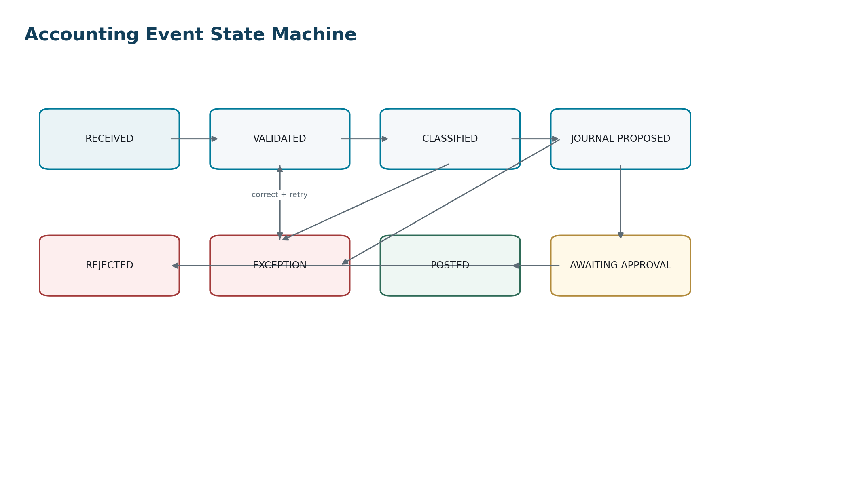
Figure 3 — Accounting events progress through deterministic validation, classification, posting proposal and governance states.

6. Posting Rule Architecture
Posting rules translate accounting events into journal lines for a specific accounting book. They are versioned, effective-dated, testable and approved. Rules must be declarative wherever practical; opaque procedural code may be used only behind a versioned rule interface with the same provenance and test obligations.

6.1 Rule hierarchy
- Global kernel invariant — cannot be overridden by tenant configuration.
- Accounting framework / jurisdiction policy — e.g., framework-specific recognition or measurement basis.
- Book policy — the entity/book-specific adoption of an accounting policy.
- Tenant configuration — chart mappings, dimensions, materiality/tolerance settings within permitted ranges.
- Transaction facts — source event attributes used to select the applicable branch of the rule.

6.2 Rule-set contract
Field | Meaning
posting_rule_set_id | Immutable rule-set identifier.
name / domain | Human-readable name and owning domain.
event_type | Accounting event type accepted.
book_type / framework applicability | Where the rule may execute.
effective_from / effective_to | Effective period.
version | Immutable semantic version.
status | Draft, Test, Approved, Active, Superseded, Retired.
conditions | Deterministic selection predicates.
line_templates | Debit/credit line generation expressions.
rounding_policy_id | Controlled rounding rule.
dimension_rules | Required/default/derived dimensions.
tax_dependency | Tax determination inputs/results if required.
fx_policy_id | Rate type/date/source rule if required.
approval_policy_id | Approval/SoD gates.
test_pack_id | Mandatory regression cases.
approved_by / approved_at | Governance evidence.
source_authority_refs | Accounting-policy/authority references where applicable.

7. Canonical Posting Pipeline
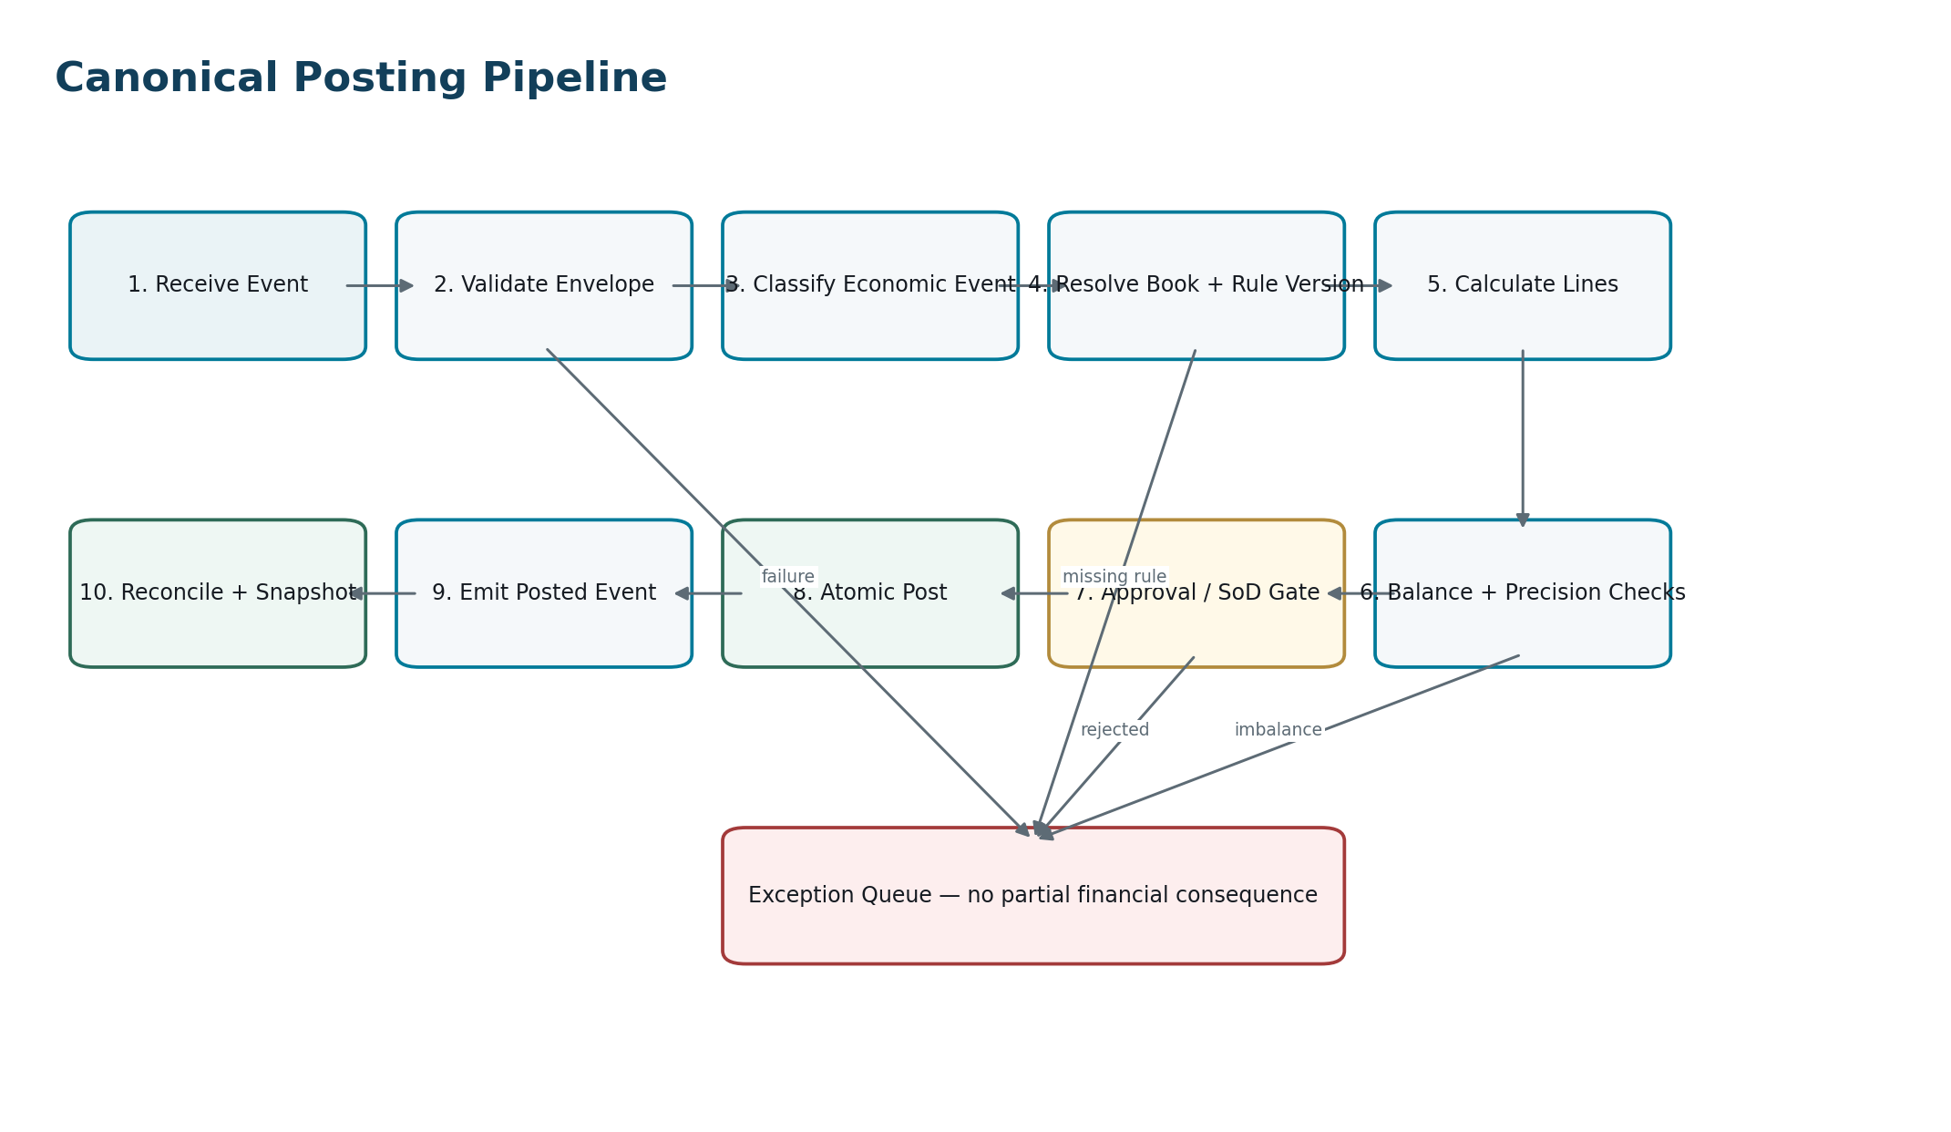
Figure 4 — Ten deterministic stages; failures create an exception, not a partial financial consequence.

7.1 Atomic posting transaction
The database transaction that creates a posted journal must, at minimum, persist the journal header, all journal lines, posting execution, event-to-posting uniqueness record, ledger watermark/balance impact metadata and transactional outbox event before commit. If any mandatory write fails, the transaction rolls back in full.
No distributed two-phase accounting transaction — Where one source event affects multiple books or entities, each authoritative posting unit remains locally atomic. Cross-unit completion is orchestrated explicitly, surfaced as incomplete until all required consequences reconcile, and never hidden behind eventual-consistency assumptions.

8. Journal Model & Detailed Engineering Wireframe

8.1 Journal header
Field | Rule
journal_id | Immutable internal ID.
journal_number | Human-readable sequence; unique per configured scope and never used as relational key.
tenant_id / legal_entity_id | Mandatory authoritative scope.
book_id / ledger_id | Mandatory target accounting context.
journal_type | System, Manual, Adjustment, Reversal, Opening, Consolidation, Allocation, Revaluation, Elimination.
source_accounting_event_id | Mandatory for system-generated journals; nullable only for authorized manual/closing journals.
posting_execution_id | Links to exact rule execution.
document_date / posting_date | Both retained.
accounting_period_id | Server-resolved from posting date/book.
transaction_currency context | Header default; lines may additionally carry controlled currency data.
description | Required meaningful narrative.
status | Controlled lifecycle.
prepared_by / approved_by / posted_by | Attributable actor/workload IDs.
created_at / posted_at | System timestamps.
reversal_of_journal_id | Explicit relation for reversals.
evidence_bundle_id | Evidence chain reference.
payload_hash / journal_hash | Integrity evidence.

8.2 Journal line
Field | Rule
journal_line_id | Immutable ID.
journal_id | Mandatory parent.
line_no | Stable order within journal.
account_id | Posting-enabled account valid for book/date.
debit_amount / credit_amount | Exactly one positive side for normal lines; both zero prohibited except controlled statistical extension.
functional_currency | Matches book functional currency unless ledger policy explicitly permits otherwise.
transaction_amount / currency | Preserved when source transaction is foreign currency.
exchange_rate / rate_ref | Persisted where conversion occurs.
counterparty_id | Required where account/policy demands.
dimensions | Validated against account/dimension rules.
tax_detail_ref | Links to authoritative tax determination where relevant.
source_line_ref | Links back to invoice/order/payroll/asset/etc. source line.
posting_rule_line_id | Exact rule template that generated the line.
memo | Optional controlled narrative.

8.3 Balance rule
Balance equation — For each journal balancing unit: Σ debit(functional currency) = Σ credit(functional currency) exactly. Any approved rounding residual must be resolved by a configured rounding rule and explicit rounding line — never silently discarded.

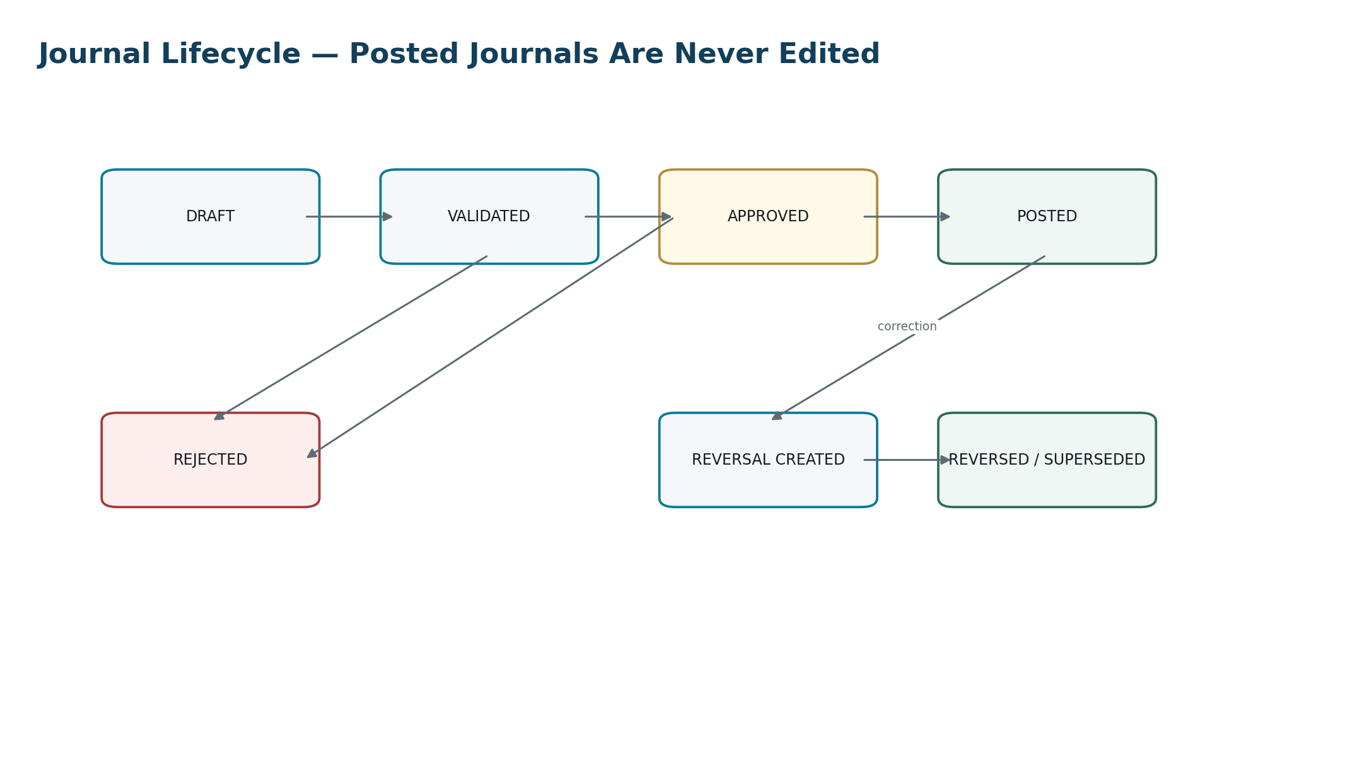
Figure 5 — Journal lifecycle. Posted records are immutable; correction creates a new accounting record.

9. Manual Journal Control
Manual journals are necessary for controlled adjustments, but they are a high-risk path. They must not become a bypass around subledgers, tax logic, approvals or closed-period controls.
Control | Mandatory behavior
Purpose classification | User selects controlled journal purpose; free-text alone is insufficient.
Control accounts | Direct posting rejected unless a specifically authorized adjustment or migration policy permits it.
Evidence | Attachment/reference mandatory above configured risk/materiality thresholds or for designated journal types.
Approval | Risk/amount/entity-based workflow; preparer cannot approve own journal where SoD policy requires separation.
Period | Same server-side period gate as system journals.
Future-dated posting | May be scheduled but cannot post before allowed period/time.
Recurring journals | Generate new journal instances; template is not itself posted.
Copy journal | Creates a new draft with new identity/provenance; never duplicates posting IDs.
Deletion | Drafts may be withdrawn per policy; posted records never deleted.
Audit trail | Every create/edit/submit/approve/reject/post/reverse action evidenced.

10. Accounting Period & Close Control
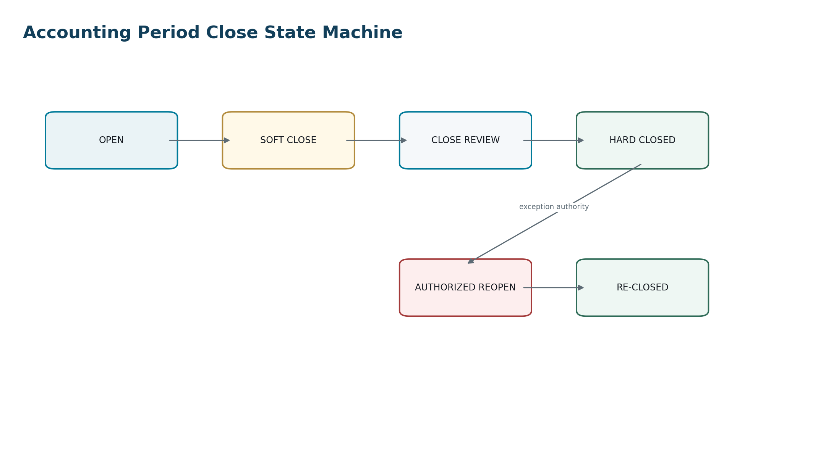
Figure 6 — Period close is an accounting control state machine, not a presentation preference.

10.1 Period states
State | Posting behavior | Typical purpose
Open | Normal authorized posting permitted. | Current operational period.
Soft Close | Restricted posting; exceptions require elevated approval and reason. | Close preparation and late adjustments.
Close Review | Only designated close journals/workflows permitted. | Reconciliations, review, sign-off.
Hard Closed | Posting rejected. | Finalized accounting period.
Authorized Reopen | Temporarily reopened under explicit authority; all activity separately evidenced. | Material correction or statutory requirement.
Re-Closed | Hard close reinstated with new close evidence and snapshot. | Restored final state.

10.2 Close gate checklist
- Subledger-to-GL reconciliations within approved tolerance.
- Bank reconciliation status complete or exceptions formally accepted.
- Payroll-to-GL and tax-to-GL controls complete where applicable.
- FX revaluation and translation jobs complete.
- Accruals, prepayments, depreciation and inventory close jobs complete as configured.
- Intercompany mismatches resolved or approved as explicit exceptions.
- Manual-journal review queue cleared.
- No failed posting executions with unresolved financial consequence.
- Signed trial balance/balance snapshot generated and retained.
- Close approval recorded with actor, scope, timestamp and evidence.

11. Corrections, Reversals & Accounting Change
ZoikoSuite must distinguish error correction, estimate change, accounting-policy change, source-document correction and ordinary commercial adjustment. The system records the nature of the correction because those categories can carry different accounting and disclosure consequences.
Pattern | Use | Required linkage
Exact reversal | Neutralize a previously posted journal before corrected reposting. | reversal_of_journal_id + reason + authorization
Adjusting journal | Correct or refine balances without reversing entire source journal. | affected object/account/period + evidence
Credit/debit note | Commercial AR/AP correction where source document requires formal adjustment. | original invoice + tax treatment
Superseding accounting event | Correct source facts while preserving original event history. | supersedes_event_id
Period reopen correction | Material correction to a hard-closed period under authority. | reopen authorization + new close snapshot
Opening/migration correction | Controlled correction of migration/opening data. | migration batch + reconciliation evidence

IAS 8 architecture anchor — The kernel must preserve enough policy/version/history information to support retrospective or prospective treatment as determined by the applicable accounting policy. The software should not collapse accounting policy changes, estimate changes and prior-period error corrections into one generic “adjustment” concept.

12. Chart of Accounts & Control Accounts
Account attribute | Required behavior
Account class/type | Controlled taxonomy driving normal balance and reporting mappings.
Posting enabled | Parent/header accounts cannot receive lines.
Book applicability | Account may be valid only for specified books/periods.
Currency restriction | Optional account-level restriction.
Control-account type | AR, AP, payroll, tax, inventory, asset, bank, etc.
Manual-post policy | Disallow, allow with elevated authority, or unrestricted for non-control accounts.
Dimension policy | Required, optional, derived or prohibited dimensions by account.
Effective dates | Cannot post outside account validity.
Replacement account | Retired accounts may map forward without rewriting history.
Reporting mappings | Separate versioned mapping to statements/taxonomies; not hard-coded in account identity.

13. Financial Dimensions & Balancing Units
Dimensions describe the economic context of a line without multiplying chart-of-account codes. Examples include department, cost center, profit center, location, project, product, fund, grant, customer and supplier.
Rule | Requirement
Dimension validity | Dimension value must be active for the posting date and legal entity/book scope.
Combinations | Forbidden/required combinations may be rule-driven.
Derived dimensions | Rules may inherit from source objects, but derived values remain visible in posting evidence.
Balancing dimension | If configured, journal must balance by the designated dimension or create explicit due-to/due-from lines.
Historical integrity | Dimension renaming/reorganization never rewrites posted line identity or historical meaning.
Reporting hierarchy | Hierarchy versions are effective-dated so historical reports can be reconstructed.

14. Core Posting Matrices — Reference Wireframes
The following matrices define generic accounting patterns only. Final account mappings, recognition policies and tax consequences are versioned by book, entity and applicable accounting policy.
Economic event | Debit pattern | Credit pattern | Minimum authoritative source
Customer invoice issued | Dr Accounts Receivable | Cr Revenue; Cr Output Tax / tax payable as applicable | Invoice + tax determination
Customer credit note | Dr Revenue / returns; Dr Output Tax adjustment | Cr Accounts Receivable | Original invoice + credit note
Customer cash receipt | Dr Bank / cash clearing | Cr Accounts Receivable | Bank/payment confirmation + allocation
Supplier invoice approved | Dr Expense/Asset/Inventory; Dr Recoverable Input Tax where applicable | Cr Accounts Payable | Supplier invoice + PO/receipt/tax
Supplier payment | Dr Accounts Payable | Cr Bank / payment clearing | Approved payment execution result
Expense reimbursement approved | Dr Expense; Dr recoverable tax where applicable | Cr Employee/Expense payable | Approved expense claim
Payroll finalized | Dr Compensation/benefit/employer tax expense | Cr Payroll liabilities; Cr Net pay payable | Approved payroll result
Payroll payment | Dr Net pay payable | Cr Bank / payroll clearing | Provider/bank execution evidence
Asset acquisition capitalization | Dr Fixed Asset | Cr AP/Bank/Clearing | Capitalization event
Depreciation | Dr Depreciation Expense | Cr Accumulated Depreciation | Asset schedule + policy version
Inventory receipt | Dr Inventory | Cr GRNI/AP depending process | Receipt + valuation policy
Inventory issue / COGS | Dr Cost of Goods Sold / consuming cost object | Cr Inventory | Shipment/consumption + costing layer
Accrual | Dr Expense/Asset as policy requires | Cr Accrued Liability | Accrual basis + evidence
Accrual reversal | Dr Accrued Liability | Cr Expense/Asset | Scheduled reversal reference
Prepayment | Dr Prepaid Asset | Cr AP/Bank | Supplier invoice/payment basis
Prepayment recognition | Dr Expense | Cr Prepaid Asset | Recognition schedule
FX revaluation loss | Dr FX Loss | Cr Revaluation adjustment / monetary account | Open item + closing rate
FX revaluation gain | Dr Revaluation adjustment / monetary account | Cr FX Gain | Open item + closing rate
Intercompany sale | Entity-specific AR/revenue and reciprocal AP/expense/asset patterns | Due-to/due-from mappings and group eliminations | Intercompany pair + agreement
Consolidation elimination | Eliminate reciprocal balances/transactions in group book | Balanced elimination lines | Matched intercompany population

15. Accounts Receivable Posting Rules
- Invoice issuance, not draft creation, is the default accounting recognition trigger unless configured policy requires another controlled event.
- Revenue, receivable and tax lines derive from authoritative invoice/tax facts; the ledger does not recalculate commercial invoice totals independently.
- Payment allocation reduces the specific receivable/open item and preserves allocation history.
- Unapplied cash posts to a controlled clearing/unapplied account until allocation.
- Credit notes reference original invoices and carry their own tax and accounting determination.
- Write-off requires reason code, authority, accounting mapping and preserved receivable history.
- Foreign-currency receivables preserve original currency and functional-currency basis for realized/unrealized FX.

16. Accounts Payable & Procurement Posting Rules
- Supplier invoice posting requires duplicate-detection completion and any required PO/receipt/tolerance controls.
- GRNI/accrual treatment is policy-driven; receipt and invoice timing are separate economic events.
- Supplier bank-detail changes do not alter accounting but may block payment workflow under fraud controls.
- Payment approval and accounting posting are distinct from provider/bank execution; execution result is the authoritative payment-status input.
- Input tax recoverability comes from the tax determination/service, not from free-text user selection where a jurisdiction pack governs the rule.
- AP control account posting is system-owned except controlled adjustment/migration authority.

17. Banking, Cash & Clearing Accounting
Pattern | Kernel treatment
Imported bank transaction | Does not automatically become a final journal solely because it was imported; normalization/matching and policy determine accounting.
Customer receipt via processor | May initially post to payment-processor clearing, then settle to bank with fee/FX lines.
Supplier payment initiated | No final bank credit merely because a payment instruction exists; posting policy distinguishes instruction, acceptance, settlement and rejection.
Bank fees | Separate bank/processor event with expense/tax treatment.
Chargeback / reversal | New economic event referencing original receipt and allocation.
Bank reconciliation adjustment | Controlled journal with explicit reconciliation case/evidence; never overwrite statement data.

18. Payroll Accounting Boundary
Zoiko Payroll or another payroll engine remains authoritative for gross-to-net and statutory payroll calculations. The ZoikoSuite accounting kernel consumes an approved payroll result and creates accounting consequences; it must not independently recompute payroll tax inside the GL posting engine.
Input | Posting requirement
Approved payroll run | Unique payroll_run_id, employing entity, pay period, currency, status.
Earnings/benefits | Expense/account mapping by earning/benefit code and dimensions.
Employee deductions | Liability mappings; net pay reconciliation.
Employer contributions | Employer expense + statutory/benefit liability.
Net pay | Net pay payable/clearing.
Payroll taxes | Authoritative payroll liability outputs and jurisdiction references.
Payment result | Settlement against net pay/liability accounts.
Evidence | Gross-to-net snapshot + payroll rule version + payroll approval.

19. Fixed Assets Accounting
- Capitalization event separates acquisition/payment from asset recognition where business process requires it.
- Depreciation is a deterministic schedule calculation with asset policy version, useful life, method, residual value, convention and period.
- Impairment, revaluation, transfer and disposal are separate asset events with explicit accounting consequences.
- Accumulated depreciation and asset cost reconcile to the fixed-asset subledger by asset class/entity/book.
- Asset policy changes do not rewrite historical depreciation postings; future schedules or controlled catch-up entries reflect approved treatment.

20. Inventory & Cost Accounting
- Inventory accounting consumes authoritative quantity movements and costing layers; the GL is not the quantity ledger.
- Costing method is versioned per item/location/book policy where supported.
- Negative inventory, landed cost, standard-cost variances and manufacturing extensions require explicit policy and exception behavior.
- Inventory valuation must reconcile by location/item class to GL control accounts.
- Period close may block late inventory movements or route them to controlled next-period/correction workflows according to policy.

21. Accruals, Prepayments, Deferrals & Allocations
Capability | Required inputs | Accounting controls
Accrual | Basis, amount/estimate, period, accounts, dimensions, evidence, reversal policy | Unique schedule; no duplicate accrual for same basis unless explicitly incremental.
Prepayment | Originating transaction, amount, start/end, recognition frequency, target expense | Schedule total must reconcile to original capitalized amount.
Deferral | Originating revenue/liability basis, recognition schedule, policy | Recognition postings must reference schedule line and remaining balance.
Allocation | Source pool, driver/basis, recipients, period, rule version | Allocated total equals source amount after explicit rounding line; driver snapshot retained.
Recurring journal | Template, cadence, amount/rule, start/end, approval policy | Every occurrence is a new journal with independent idempotency and period checks.

22. Tax Accounting Integration
The accounting kernel consumes tax determinations; it does not become the authoritative tax rules engine. Tax results must carry tax type, jurisdiction, taxable basis, rate, amount, recoverability/payability classification and rule-version provenance.
Tax event | Typical accounting consequence | Control
Sales tax / VAT / GST on sale | Output tax liability | Tax result must reconcile to invoice tax and tax ledger.
Recoverable purchase tax | Input tax receivable/recoverable | Recoverability from tax service; nonrecoverable portion mapped to cost/asset.
Withholding | Receivable/payable or expense treatment per policy | Authority, tax type and counterparty preserved.
Tax payment | Reduce tax payable / bank | Must settle registered tax liability/obligation.
Tax return adjustment | Controlled adjustment journal if required | Return version + approved adjustment + period treatment.
Income tax provision | Current/deferred tax journal from approved tax provision process | Separate tax-provision authority and evidence.

23. Foreign Currency Accounting
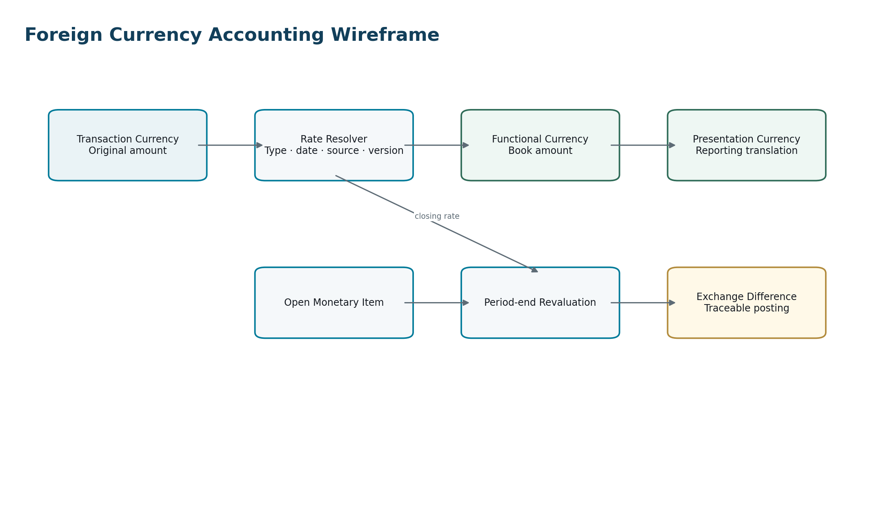
Figure 7 — Transaction currency, functional currency and presentation currency are distinct accounting concepts.

23.1 FX rate contract
Field | Requirement
base_currency / quote_currency | Mandatory currency pair.
rate | High-precision decimal.
rate_type | Spot, transaction, closing, average, historical, contractual or approved extension.
effective_at / rate_date | Exact applicable timestamp/date.
source | Provider/authority identifier.
source_rate_id | External or internal immutable reference.
ingested_at | System timestamp.
policy_id | Rule determining which rate type/date to use.
override | Explicitly controlled; reason/approver mandatory.
precision / rounding | Currency/rule-specific; persisted in calculation evidence.

IAS 21 architecture anchor — The data model and posting engine distinguish transaction currency, functional currency and presentation currency and preserve the exchange-rate basis used. This supports accounting for foreign-currency transactions, foreign operations and presentation translation without collapsing them into one currency field.

24. Revaluation & Realized FX
- Open monetary items are identified from subledger/ledger state using deterministic classification.
- Period-end revaluation uses the book’s configured closing-rate policy and valuation date.
- Unrealized revaluation postings are separately identifiable and reversible according to policy.
- When settlement occurs, realized exchange difference uses original recognition basis, subsequent revaluations and settlement rate consistently.
- Every revaluation job is idempotent by entity/book/period/run type and retains the population snapshot used.

25. Intercompany Accounting
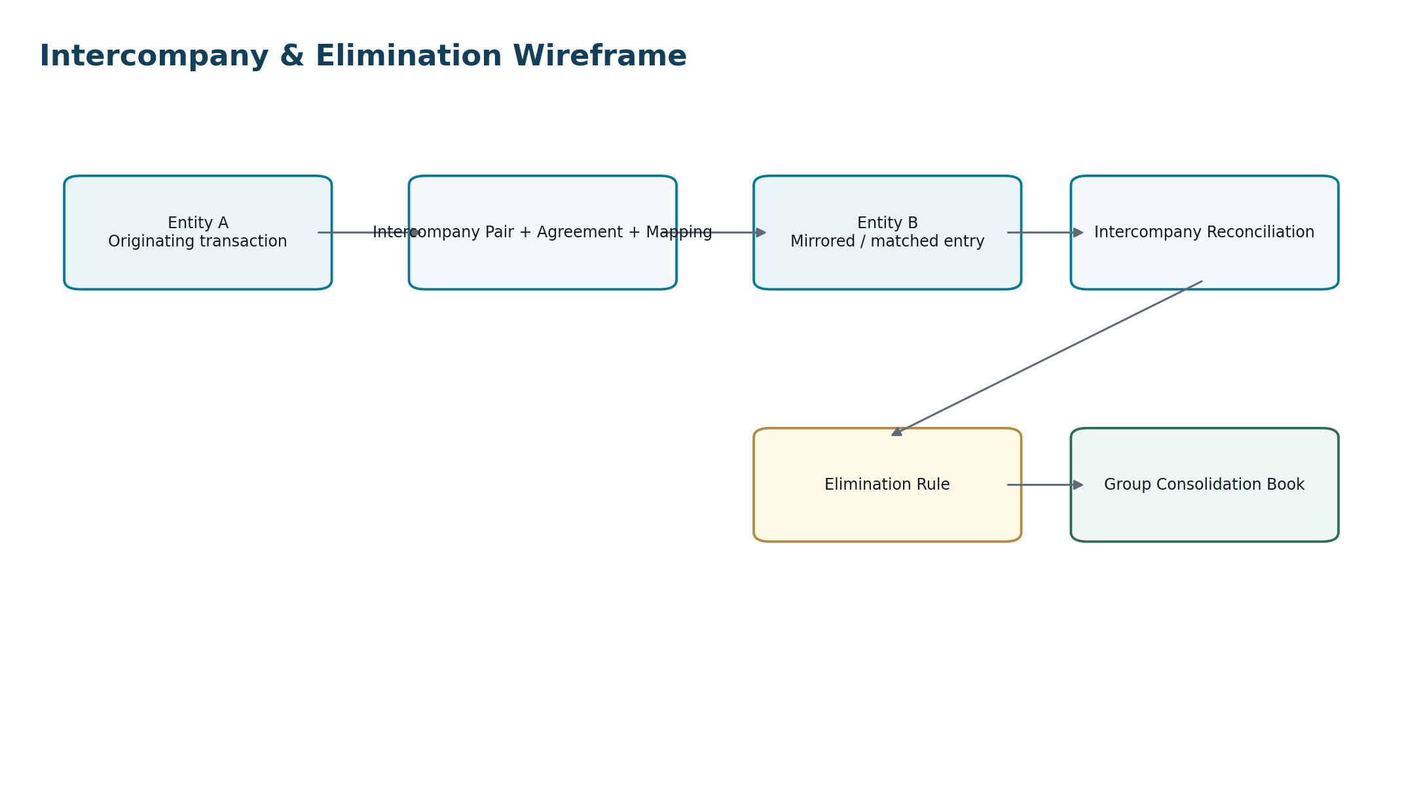
Figure 8 — Intercompany accounting uses explicit counterparty pairing, reconciliation and group-book eliminations.
Required object | Purpose
Intercompany relationship | Defines participating legal entities, effective dates and control relationship.
Intercompany account mapping | Maps due-to/due-from, revenue/expense, asset/liability and elimination accounts.
Transaction pair / reference | Creates traceable relation between entity-side records.
Transfer-pricing context | Reference only; authoritative policy/documentation lives in tax/legal domain.
Reconciliation status | Matched, timing difference, amount difference, currency difference, unmatched.
Elimination rule | Group-book rule generating elimination entries.
Settlement reference | Tracks actual settlement independently from elimination.

26. Consolidation Kernel Interface
Consolidation consumes controlled entity/book trial balances or journals and applies group policy adjustments, currency translation, ownership logic and eliminations in the group/consolidation book. It must not rewrite subsidiary statutory ledgers.
Stage | Required controls
Population freeze | Entity/book/period balance snapshot and ledger watermark.
Mapping | Local account → group account mapping version.
Translation | Functional → group presentation currency using approved rate categories.
Ownership | Effective-dated ownership/control relationship.
Group adjustments | Versioned group policy journal rules.
Intercompany elimination | Matched population + elimination rule.
Non-controlling interest | Policy-driven calculation where applicable.
Consolidation close | Group reconciliation + approved signed snapshot.

27. Reconciliation Framework
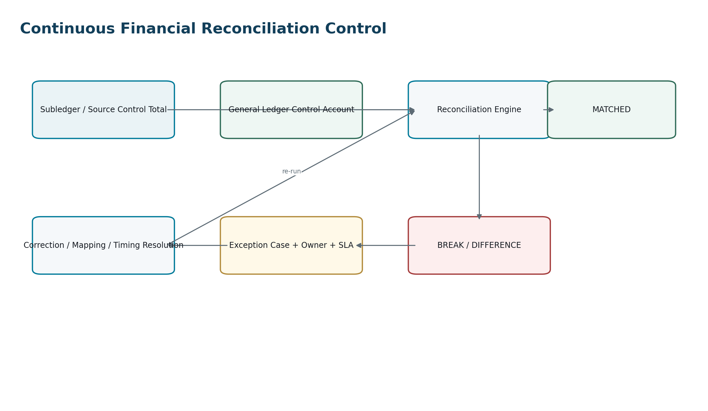
Figure 9 — Reconciliation breaks are explicit governed cases; they are not hidden by manual edits.

27.1 Mandatory reconciliations
- AR subledger → AR control account.
- AP subledger → AP control account.
- Bank statement / cash ledger → GL bank accounts.
- Payroll results/liabilities → payroll control accounts.
- Tax ledger/returns → tax control accounts.
- Fixed-asset register → asset cost and accumulated depreciation accounts.
- Inventory valuation → inventory control accounts.
- Intercompany reciprocal balances → counterparty entity positions.
- Source-event counts/totals → posting executions to detect missing/duplicate accounting events.
- Ledger balances → signed trial balance / report source dataset.

27.2 Reconciliation case contract
Field | Meaning
reconciliation_run_id | Unique execution/population reference.
reconciliation_type | AR_GL, AP_GL, BANK_GL, TAX_GL, etc.
entity/book/period | Mandatory accounting scope.
population_a / population_b | Immutable references/watermarks.
expected_total / actual_total | Controlled decimal totals.
difference | Calculated difference.
tolerance_rule_id | Approved threshold/version.
status | Matched, Warning, Break, Accepted Exception, Resolved.
owner / SLA | Operational accountability.
resolution_type | Timing, mapping, missing event, duplicate, manual correction, external issue, other controlled code.
evidence | Supporting references and approvals.

28. Opening Balances, Migration & Cutover
Migration is not a special permission to bypass financial integrity. Opening balances and outstanding subledger items must reconcile to a formally approved cutover population.
Phase | Required artifact / control
Extract | Source-system identifiers, source trial balance, AR/AP open items, bank, tax, asset and inventory populations.
Transform | Approved mapping versions for accounts, dimensions, parties, currencies and open-item identifiers.
Validate | Schema, referential integrity, debit/credit, currency and duplicate checks.
Preview | Human-readable migration reconciliation before posting.
Approve | Named migration authority and cutover window.
Post | Dedicated Opening/Migration journal types with batch IDs; atomic by approved posting unit.
Reconcile | Opening trial balance + subledger control totals + source totals.
Freeze evidence | Source extracts, hashes, mappings, approvals and final reconciliation retained.

29. Idempotency, Replay & Duplicate Prevention
Financial replay rule — Infrastructure retry or event replay must never create an additional accounting consequence unless the source event is intentionally a new economic event.

Control | Implementation requirement
Command idempotency | State-changing commands require idempotency key scoped to tenant/operation.
Source-event uniqueness | Producer + source_event_id + event_version unique at accounting-event intake.
Posting uniqueness | Accounting_event_id + book_id + posting_basis/rule identity unique for non-reposting consequence.
Transactional outbox | Posted state and outbound event commit together.
Consumer inbox/dedup | Consumers persist processed event IDs before side effects.
Replay mode | Explicit replay context; produces no duplicate journal if consequence already exists.
Correction | New source/correction event with explicit relation — never reuse original identity to force repost.

30. Approval, RBAC & Segregation of Duties
Capability | Minimum control
System auto-post | Permitted only for approved rule/event types and open periods; workload identity attributable.
Manual journal prepare | Role + entity/book/account scope.
Manual journal approve | Independent approver where policy requires; amount/risk thresholds.
Period soft-close override | Elevated finance role + reason + evidence.
Period reopen | Named authority, time-bounded scope, reason and approval.
Posting-rule activation | Separate build/test/approval authority; no unilateral production activation.
FX rate override | Restricted role, justification, approval and complete audit evidence.
Control-account adjustment | Exceptional role/workflow only.
Migration posting | Dedicated migration authority and time-bounded window.
Consolidation adjustment | Group finance scope; subsidiary books remain untouched.

31. Evidence & Source-to-Report Traceability
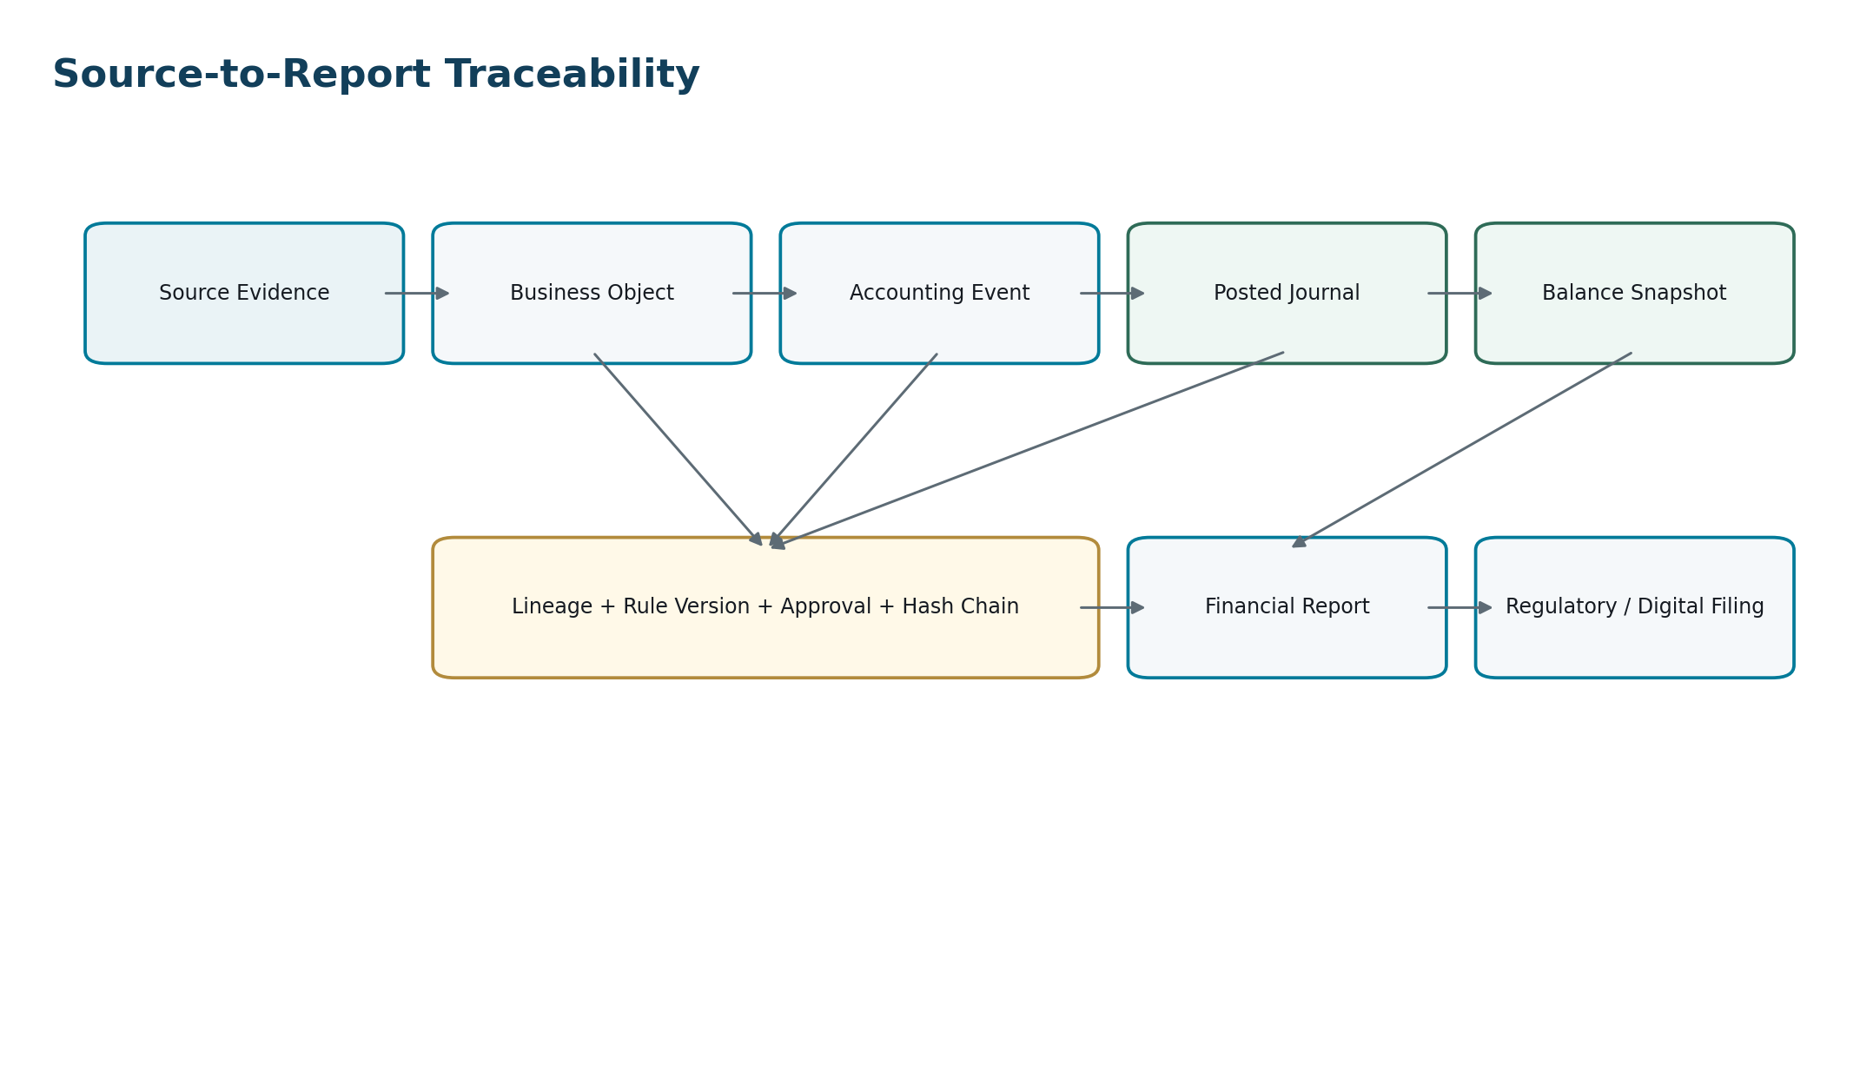
Figure 10 — Every material report figure must be traceable back through the accounting consequence to authoritative source evidence.

31.1 Minimum posting evidence
- Source object and source event identifiers.
- Accounting event payload hash/version.
- Book, ledger, period and posting date.
- Posting rule set/version and exact rule branch/line templates.
- Calculation evidence including FX, tax, rounding and allocation inputs where relevant.
- Approval/SoD decision and actor/workload identity.
- Journal and line identifiers.
- Correction/reversal/supersession relationships.
- Transactional outbox event ID, ledger watermark and linked documents/evidence bundle as applicable.

32. API / Command Wireframe
The following logical commands define the kernel interface. Concrete REST/gRPC/event contracts are produced under the separate API and Event standards, but these command semantics are mandatory.
Command | Minimum request | Result
RegisterAccountingEvent | Global envelope + accounting event payload | Accepted event ID or deterministic rejection.
EvaluatePosting | Event ID + target book context | Dry-run journal proposal + rule provenance; no financial mutation.
SubmitManualJournal | Journal draft + evidence | Draft/validation result.
ApproveJournal | Journal ID + expected version + decision | Approved/rejected state transition.
PostJournal | Journal ID + idempotency key | Posted journal + ledger watermark or rejection.
ReverseJournal | Posted journal ID + correction reason + posting date | New reversal journal relation.
RunRevaluation | Entity/book/period + valuation policy | Run ID + journal(s) + exception list.
RunAllocation | Rule + source population + period | Run ID + balanced allocation journals.
ClosePeriod | Entity/book/period + close checklist evidence | Closed state + signed balance snapshot.
ReopenPeriod | Closed period + authority + reason | Time-bound reopened state.
RunReconciliation | Type + populations/scope | Result summary + cases.
GetPostingTrace | Journal/report/source identifier | Complete authorized lineage graph.

33. Domain Event Catalogue — Accounting Kernel
Event | Emitted when | Critical consumers
AccountingEventAccepted | Canonical event passes intake validation. | Posting orchestration, audit.
AccountingEventRejected | Event rejected. | Source domain, operations.
JournalProposed | Posting rules generate balanced proposal. | Approval workflow, audit.
JournalApproved | Required approval completes. | Posting worker.
JournalRejected | Proposal/manual journal rejected. | Originator, audit.
JournalPosted | Atomic ledger posting commits. | Subledger reconciliation, reporting, tax, analytics.
JournalReversed | Reversal posts. | Reporting, subledger, audit.
PostingExceptionRaised | Posting cannot complete. | Operations, source domain.
PeriodSoftClosed | Period enters restricted state. | All posting domains.
PeriodHardClosed | Period finalizes. | Reporting, consolidation, audit.
PeriodReopened | Controlled reopen occurs. | Finance operations, audit.
BalanceSnapshotSigned | Snapshot generated after controlled checkpoint. | Reporting, consolidation, audit.
ReconciliationBreakRaised | Control difference exceeds tolerance. | Finance operations.
ReconciliationResolved | Break resolved/accepted. | Close control, audit.
PostingRuleActivated | New rule version becomes effective. | Posting engine, change governance.

34. Posting Error & Exception Taxonomy
Code family | Examples | Required behavior
AK-AUTH | Entity denied, role denied, SoD conflict | Reject before mutation; audit decision.
AK-PERIOD | Period closed, invalid posting date | Reject or enter approved exception workflow; never silently move date.
AK-RULE | No rule, ambiguous rule, inactive rule | No posting; exception with facts and candidate rules.
AK-COA | Invalid/inactive account, control-account violation | No posting.
AK-DIM | Missing/invalid dimension | No posting or configured derivation before proposal.
AK-BAL | Debits ≠ credits, rounding unresolved | No posting.
AK-FX | Missing rate, invalid source, precision failure | No posting unless explicit approved override workflow.
AK-TAX | Missing/inconsistent authoritative tax result | No posting for tax-dependent event.
AK-DUP | Duplicate source event/posting consequence | Return existing consequence where appropriate; no duplicate journal.
AK-CONC | Optimistic concurrency/version conflict | Reject and retry from current state.
AK-EXT | Dependency/provider unavailable | No partial posting; retry/exception based on stage.
AK-DATA | Schema/provenance/integrity failure | Quarantine/reject with evidence.

35. Precision, Rounding & Numerical Controls
- Use fixed-precision decimal types sized for the largest supported monetary and quantity ranges.
- Do not derive authoritative totals from formatted/display values.
- Currency minor-unit defaults come from controlled currency reference data but may be overridden by jurisdiction/instrument rules where legitimate.
- FX rates and calculation intermediates retain greater precision than displayed monetary values.
- Rounding occurs at explicitly defined calculation stages; stage and mode are part of rule evidence.
- Any balancing residual is posted through an explicit configured rounding account only within permitted tolerance.
- Allocation engines guarantee source total = allocated total after controlled residual handling.

36. Concurrency & Database Transaction Requirements
Concern | Requirement
Journal number generation | Concurrency-safe sequence; number allocation must not compromise accounting identity if a transaction rolls back.
Aggregate version | Optimistic concurrency for mutable pre-post states.
Posting lock | Prevent two workers from posting the same event/journal concurrently.
Balance calculation | Do not rely on race-prone read-modify-write totals as authoritative ledger truth.
Period close | Close transaction/gate must prevent new postings from slipping into the period after close watermark.
Reconciliation watermark | Population boundaries/watermarks make run results reproducible.
Rule activation | Effective version activation is atomic and prevents overlapping ambiguous active rules.

37. Performance & Scalability Wireframe
Correctness takes precedence over raw throughput, but the kernel must scale horizontally without sacrificing transaction integrity.
Area | Architecture requirement
Posting workers | Stateless workers partitioned/routed by tenant/entity/book or equivalent safe key.
Database | Authoritative posting data remains strongly consistent within the posting boundary.
Hot indexes | Journal/event IDs, entity-book-period, account-period, source references, posting execution.
Partitioning | Consider time/entity partitioning only after query/retention patterns are measured; preserve global uniqueness.
Balances | Use controlled materialized balance/read models for speed; journal lines remain source authority.
Reporting | Heavy analytics/report workloads consume governed snapshots/read models, not OLTP scans where avoidable.
Batch jobs | Revaluation, depreciation, allocations and close jobs are resumable, idempotent and population-watermarked.
Backpressure | Posting intake may throttle safely; never drop financial events silently.

38. Observability & Operational Controls
- Every accounting command, rule evaluation and posting execution carries correlation_id and accounting_event_id.
- Metrics: accepted/rejected events, posting latency, exception rate, duplicate-prevention hits, journal throughput, imbalance failures, period-close blockers, reconciliation breaks.
- Logs contain identifiers and diagnostic codes but avoid uncontrolled sensitive business values/documents.
- Alerting distinguishes infrastructure failure from accounting-control failure.
- Dead-letter queues are temporary operational queues with owner/SLA; they are not permanent repositories for unresolved financial events.
- Operations tooling must never allow “mark as posted” without an actual authoritative posting transaction.

39. Security & Resilience Requirements
Control area | Requirement
Tenant isolation | Every read/write enforces tenant context at service and data-access layers.
Entity/book scope | Financial privileges scoped to legal entity/book/ledger.
Workload identity | Service-to-service posting uses attributable short-lived identity.
Encryption | Financial data encrypted in transit and at rest; key policy aligned to tenant/residency requirements.
Privileged access | Time-bound, reasoned, logged and reviewable.
Backup | Point-in-time recovery appropriate to ledger durability objectives.
DR/failover | Recovery procedures preserve ordering/idempotency and do not create duplicate journals.
Tamper evidence | Posting/evidence hashes or equivalent controls support integrity verification.
Residency | Posting data remains in permitted region unless approved architecture explicitly provides otherwise.

40. Testing & Certification Framework

40.1 Mandatory test classes
- Rule unit tests — every posting rule branch and calculation.
- Golden journal tests — known event facts must produce exact expected lines/amounts/dimensions.
- Property tests — every posted journal balances; no invalid currency/period/account combination can post.
- Idempotency/replay tests — duplicate commands/events create no duplicate consequence.
- Concurrency tests — multiple workers cannot double-post or bypass close.
- Period-close tests — closed periods reject all unauthorized pathways.
- Correction tests — reversals/supersessions preserve lineage and historical balances.
- FX tests — transaction, revaluation, settlement and translation cases across precision/rounding edges.
- Subledger reconciliation tests — AR/AP/payroll/tax/assets/inventory populations reconcile.
- Migration tests — opening trial balance and open items reconcile exactly.
- Authorization/SoD tests — forbidden preparer/approver and entity-scope combinations fail.
- Failure-injection tests — crash/timeouts before/after transaction commit do not create partial or duplicate financial state.

40.2 Golden acceptance scenarios
ID | Scenario | Pass condition
A1 | Same invoice event delivered 10 times | Exactly one accounting consequence per target book; retries return/reference existing result.
A2 | Journal is one cent out of balance | Posting rejected; no ledger lines committed.
A3 | Period hard closes while worker is preparing journal | Journal cannot commit into closed period; deterministic conflict/exception.
A4 | Manual user tries to post directly to AR control account | Rejected unless exceptional controlled authority is explicitly in force.
A5 | Foreign-currency invoice later settles at different rate | Original functional basis retained; realized FX posted and traceable.
A6 | Closing-rate provider is unavailable | Revaluation does not silently use stale/alternate rate unless explicit fallback policy exists and is evidenced.
A7 | Posting rule changes next month | Historical event remains reproducible under old rule version; new effective events use new version.
A8 | Posted journal is found incorrect | No edit/delete; reversal/adjustment path preserves original and correction relationship.
A9 | Subledger total differs from GL | Reconciliation break case created with amount, population, owner and SLA.
A10 | Entity has statutory and management books | One source event may produce different rule-approved journal sets without duplicating source business record.
A11 | Disaster recovery replays outbound events | Consumers remain idempotent; no duplicate subledger or reporting consequences.
A12 | Auditor selects report figure | Authorized trace resolves report → snapshot → journal lines → accounting event → source evidence and rule versions.

41. Definition of Ready — Posting Capability
- Business event and authoritative source owner defined.
- Accounting event schema approved.
- Book/framework applicability defined.
- Posting rule set and effective-dating strategy approved.
- Account/dimension mappings defined.
- Tax and FX dependencies defined.
- State transition/recognition trigger agreed with Accounting.
- Correction/reversal behavior defined.
- Idempotency key and uniqueness boundaries defined.
- Authorization/approval/SoD matrix defined.
- Evidence and retention requirements defined.
- Reconciliation control defined.
- API/event contracts drafted.
- Error taxonomy mapped.
- Golden journal and failure cases prepared.

42. Definition of Done — Implemented Posting Capability
- All accounting invariants enforced in automated tests.
- No direct cross-domain GL writes exist.
- Posting is atomic and replay-safe.
- All generated lines carry rule provenance.
- Posted journals are immutable.
- Period gates are server-side and concurrency-safe.
- Control-account restrictions are enforced.
- Reconciliation control passes for representative populations.
- Source-to-report trace is demonstrable.
- Operational dashboards/alerts exist.
- Security/SoD tests pass.
- Migration/backfill behavior is defined where needed.
- Documentation, schema registry and event catalogue are updated.
- Finance/Accounting SME acceptance completed.
- Production rollout/rollback plan approved.

43. Development Sequence
Wave | Scope | Exit criterion
0 — Kernel foundations | Book/ledger/period/COA/dimensions; event intake; rule registry; evidence; authorization | Can evaluate a canonical event deterministically without posting.
1 — Posting core | Journal model, atomic posting, idempotency, outbox, manual journal, reversal | Golden journals post/reverse with complete lineage.
2 — AR/AP/Bank | Core operating accounting + control accounts + reconciliation | AR/AP/bank end-to-end scenarios reconcile.
3 — Period close / FX | Close state machine, revaluation, balances, snapshots | Month-end scenario closes and reproduces.
4 — Payroll/Assets/Inventory | Subledger integrations and schedules | Domain-to-GL reconciliations pass.
5 — Intercompany/Consolidation | Pairing, translation, elimination, group book | Multi-entity consolidation acceptance passes.
6 — Advanced policy | Allocations, specialized books, jurisdiction/framework extensions | Rule governance and multi-book regression pack certified.

44. Standards & Forward-Compatibility Anchors
ZoikoSuite is not hard-coded to one accounting framework. The architecture is nevertheless designed to preserve concepts required by major global accounting regimes and to accommodate standards change without redesigning the ledger.
Anchor | Architecture implication
IAS 8 — Basis of Preparation of Financial Statements | Accounting policies, estimates and prior-period error corrections must remain distinguishable; policy versions and historical treatments must be reconstructable.
IAS 21 — Effects of Changes in Foreign Exchange Rates | Functional currency, foreign-currency transaction accounting, foreign operations and presentation currency require explicit currency/rate semantics.
IFRS 18 — Presentation and Disclosure in Financial Statements | Effective for annual periods beginning on or after Jan. 1, 2027; reinforces separation between accounting ledger facts and versioned presentation/reporting structures.
Other GAAP / local frameworks | Implemented through policy/book/rule packages rather than alternate ledger schemas wherever practical.

Official references reviewed for this baseline: IFRS Foundation IAS 8, IAS 21 and IFRS 18 pages. These references inform architecture capability; they do not constitute jurisdiction-specific accounting advice.

45. Controlled Open Decisions
Decision | Recommended default | Decision owner / trigger
Physical ledger storage architecture | Relational strongly consistent ledger with append-oriented posted records; validate scale before specialized ledger technology. | CTO / Architecture review
Journal numbering scope | Configurable sequence by legal entity/book/journal type where local rules require; internal UUID remains primary key. | Accounting + Jurisdiction Pack
Balancing dimension feature | Support only where tenant/accounting policy requires; avoid universal complexity. | Product + Accounting
Multi-book posting orchestration | Independent atomic posting units with explicit orchestration/reconciliation status. | Architecture
Historical balance strategy | Journal lines authoritative; signed snapshots/read models for reporting performance. | Architecture + Data
Manual posting to control accounts | Default deny; exceptional workflow only. | Finance Controls
Rule DSL vs code implementation | Prefer declarative rule DSL for mappings/formulas; allow versioned code module only for complex controlled calculations. | Architecture
Statistical/non-monetary ledgers | Defer until a validated product requirement exists; do not weaken monetary journal invariants. | Product

46. Final Architecture Decision
Decision — Adopt this Accounting Kernel as the sole authoritative path for creating ZoikoSuite ledger consequences. Business domains emit governed Accounting Events; versioned posting rules translate them per Accounting Book; server-side controls validate authorization, period, account, dimension, currency, tax, precision, approval and idempotency; the kernel commits balanced journals atomically; posted entries are immutable; correction and reconciliation are explicit; reporting consumes controlled balances/snapshots rather than redefining accounting truth.

This standard is subordinate to the canonical data model for shared entity definitions and is the controlling parent for subsequent detailed workflow/state-machine, API, event, authorization, reconciliation and domain accounting specifications.

Appendix A — Posting Rule Pseudo-Schema
posting_rule_set:
id: uuidv7
event_type: AR.INVOICE_ISSUED
applies_to:
book_type: PRIMARY_STATUTORY
accounting_framework: <versioned-policy-ref>
effective_from: <timestamp>
version: 1.0.0
conditions:
- invoice.status == ISSUED
- tax_result.status == FINAL
lines:
- debit: account_map.AR_CONTROL
amount: invoice.total_gross
counterparty: invoice.customer_id
- credit: account_map.REVENUE_BY_LINE
amount: invoice.line_net
dimensions: inherit(invoice.line.dimensions)
- credit: account_map.OUTPUT_TAX
amount: tax_result.output_tax
tax_detail_ref: tax_result.id
balance_check: exact
rounding_policy: <policy-ref>
approval_policy: AUTO_POST_IF_CONTROLS_PASS
evidence:
- invoice.id
- tax_result.id

Appendix B — Canonical Journal Example
Line | Account | Debit | Credit | Currency / FX | Source
1 | Accounts Receivable | 1,200.00 |  | USD → GBP @ approved transaction rate | Invoice INV-...
2 | Revenue |  | 1,000.00 | functional amount | Invoice line
3 | Output Tax |  | 200.00 | functional amount | Tax determination
 |  | 1,200.00 | 1,200.00 |  | Balanced

Illustrative only: actual currencies, rates, tax treatment, recognition timing and accounts are determined by the applicable book and policy pack.

Appendix C — Control Account Matrix
Control account class | Primary subledger owner | Direct manual posting default | Mandatory reconciliation
Accounts Receivable | AR | Deny | AR open items → GL
Accounts Payable | AP | Deny | AP open items → GL
Bank / Cash | Banking | Restricted | Bank statement/cash ledger → GL
Payroll liabilities | Payroll interface | Deny/Restricted | Payroll result/liabilities → GL
Tax payable/receivable | Tax | Deny/Restricted | Tax ledger/return → GL
Inventory | Inventory | Deny | Inventory valuation → GL
Fixed Assets | Assets | Deny/Restricted | Asset register → GL
Intercompany | Intercompany | Restricted | Entity reciprocal balances → GL/group

Appendix D — Accounting Event Naming Convention
Event type format: DOMAIN.NOUN_ACTION or DOMAIN.OBJECT_STATE_CHANGE using stable business semantics rather than UI labels. Examples:
- AR.INVOICE_ISSUED
- AR.CREDIT_NOTE_ISSUED
- AR.PAYMENT_ALLOCATED
- AP.SUPPLIER_INVOICE_APPROVED
- AP.PAYMENT_SETTLED
- BANK.TRANSACTION_CONFIRMED
- PAYROLL.RUN_FINALIZED
- ASSET.DEPRECIATION_RECOGNIZED
- INVENTORY.GOODS_ISSUED
- TAX.PROVISION_APPROVED
- INTERCOMPANY.TRANSACTION_RECORDED

Appendix E — Prohibited Accounting Anti-Patterns
- Writing GL journal lines directly from frontend code.
- Using journal descriptions as the only source of business semantics.
- Editing or deleting posted journals.
- Reusing a journal number or source-event ID to force a repost.
- Moving a posting silently into the next open period without policy and evidence.
- Posting one side of a journal and “fixing” the balance later.
- Allowing search/BI totals to become authoritative balances.
- Hard-coding VAT/sales-tax/payroll rules inside generic GL code.
- Using binary floating point for authoritative monetary values.
- Relying on external provider status without storing provider reference/evidence.
- Allowing manual journals to bypass subledger control accounts by default.
- Changing an active posting rule in place instead of creating a new version.
- Applying an FX rate without rate date/type/source provenance.
- Generating production journal amounts from LLM output.
- Closing a period without reproducible reconciliation populations and balance snapshot.

Appendix F — References
Reference | Location
IFRS Foundation — IAS 8 Basis of Preparation of Financial Statements | https://www.ifrs.org/issued-standards/list-of-standards/ias-8-basis-of-preparation-of-financial-statements/
IFRS Foundation — IAS 21 The Effects of Changes in Foreign Exchange Rates | https://www.ifrs.org/issued-standards/list-of-standards/ias-21-the-effects-of-changes-in-foreign-exchange-rates/
IFRS Foundation — IFRS 18 Presentation and Disclosure in Financial Statements | https://www.ifrs.org/issued-standards/list-of-standards/ifrs-18-presentation-and-disclosure-in-financial-statements/
ZoikoSuite — ZS-DATA-001 Global Canonical Data Model, Data Dictionary & ERD | Internal architecture baseline, August 24, 2026

