ZOIKOSUITE

Global Authorization, RBAC/ABAC &
Segregation-of-Duties Standard
Detailed Engineering Wireframe
Executive doctrine
Authentication proves a principal. Entitlement determines whether a product capability exists. Authorization determines whether this authenticated principal may perform this action on this resource in this exact scope and context. Approval authority determines whether that principal may approve a governed business decision. ZoikoSuite MUST keep these concepts separate, evaluate authorization server-side at the point of enforcement, deny by default, and preserve evidence for every material privileged or financially consequential decision.

Control | Value
Document ID | ZS-IAM-001
Version | 1.0 — Global Identity & Authorization Baseline
Date | August 24, 2026
Status | Engineering baseline — subject to approval
Owner | ZoikoSuite Platform Architecture / Security
Applies to | All ZoikoSuite services, APIs, workflows, administrative surfaces, workloads and integrations
Predecessors | ZS-DATA-001 · ZS-ACC-KERNEL-001 · ZS-STATE-001 · ZS-API-001 · ZS-EVENT-001
Classification | Confidential — Internal
Language | American English

0. Critical Analysis — What Must Be Corrected Before Build
A conventional “users + roles + permissions” design is insufficient for a global accounting, tax, audit and legal platform. The following architecture risks were treated as build blockers and resolved in this standard.
Risk | Why it fails | Final architecture decision
Role-only authorization | A role such as Finance Manager cannot safely encode entity, book, jurisdiction, amount, object relationship, session assurance and SoD constraints. | Use RBAC for candidate permission bundles; ABAC/relationship and negative-control evaluation produces the final decision.
Identity conflation | An employee/customer/person record is not a security principal; one person may have multiple authentication identities or delegated contexts. | Separate Party/Person, Subject, Authentication Identity, Access Assignment, Delegation and Session.
Entitlement conflation | A subscription feature flag is not authority to read or mutate customer financial data. | Commercial entitlement gates capability existence; IAM separately decides access.
Overloaded global roles | “Admin” or “Accountant” without scope invites cross-entity/book privilege bleed. | Every access assignment has explicit scope and effective dates; global scope is exceptional and separately governed.
UI-enforced security | Hiding a button is not authorization. | PEPs at APIs/commands/services enforce every protected operation; UI consumes server-provided available actions.
Static SoD only | Role conflict checks cannot prevent a preparer from approving the exact object they created. | Implement static assignment conflicts plus dynamic object-history/maker-checker rules.
Approval = permission | Having `invoice.approve` does not prove signing authority, amount limit or independence. | Approval authority is a separate effective-dated policy evaluated and revalidated immediately before execution.
Stale authorization | Long-lived tokens/caches can preserve revoked access. | Short-lived sessions/tokens, version-aware decision caching and revocation/invalidation events.
Standing privilege | Permanent production/admin roles magnify blast radius. | JIT time-bound elevation, step-up authentication, explicit reason, approval where required and session evidence.
Support omniscience | Vendor support must not automatically see tenant financial/legal data. | Tenant-aware support access is purpose-bound, minimal, time-limited and consent/policy controlled.
Service account sprawl | Shared secrets and generic service users defeat attribution and least privilege. | Unique workload identities, short-lived credentials, audience restrictions and service-specific permissions.
Untraceable policy | A permit/deny answer without the evaluated policy/version cannot be defended. | Persist decision evidence for material actions: subject, context, policy/assignment versions, result and obligations.

Architecture conclusion
Authorization is a runtime control system, not a static role table. The final decision is the intersection of authenticated identity, product entitlement, assignment scope, permission grants, subject/resource/environment attributes, relationships, negative controls, delegated authority, session assurance, object state and domain-specific guards.

1. Scope and Operating Principles
- Human identities, external users, workforce users, contractors, auditors, advisers, support operators and privileged administrators.
- Machine/workload identities, service-to-service authorization and external integration principals.
- Tenant, legal-entity, accounting-book, organizational-unit, engagement/matter/project and individual-resource scopes.
- RBAC, ABAC and relationship predicates; permission taxonomy and policy decision/evaluation.
- Static and dynamic segregation of duties, maker-checker and dual-control patterns.
- Delegated authority, signing/approval limits, temporary assignments and absence coverage.
- JIT privilege, break-glass, support access and administrative command controls.
- Federation, SSO, MFA/passkeys, SCIM provisioning, lifecycle revocation and evidence.
- Authorization APIs, events, persistence, caching, observability and certification.

1.1 Explicit non-goals
- This document does not define commercial plan entitlements except the boundary with authorization.
- This document does not make the identity provider authoritative for ZoikoSuite business authorization.
- This document does not grant legal signing authority merely because a software permission exists.
- This document does not require a single vendor policy engine; implementations must satisfy the logical contract.
- This document does not permit AI to grant or escalate access independently.
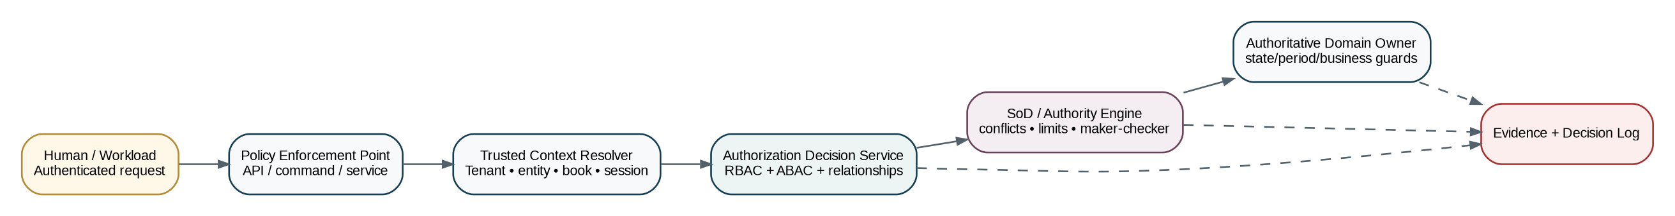
Figure 1 — Canonical ZoikoSuite authorization control architecture

2. Core Security Identity Model
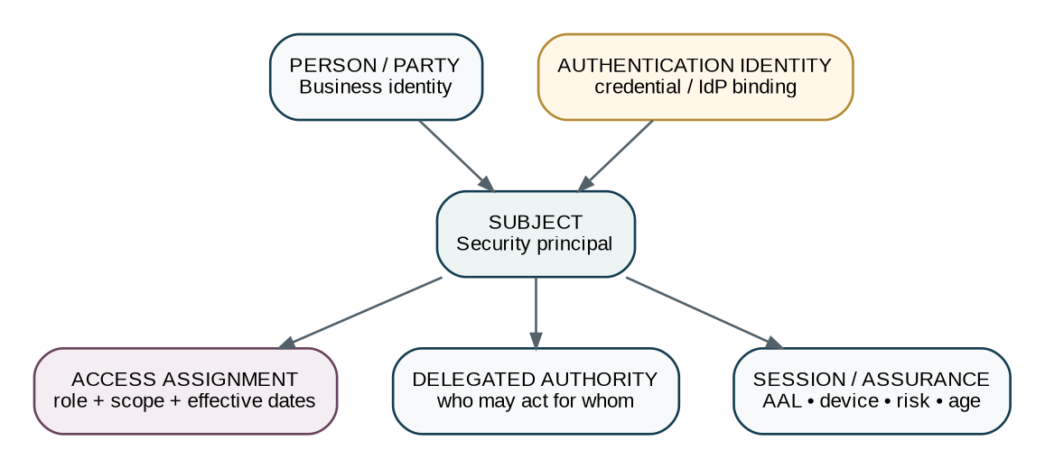
Figure 2 — Business identity, security subject, authentication identity, assignment and session are separate objects
Object | Purpose | Control
Party / Person | Business identity used by HR, suppliers, customers, directors or counterparties. | Does not itself authenticate or authorize.
Subject | Immutable ZoikoSuite security principal representing a human or workload. | Primary authorization subject_id.
Authentication Identity | Binding to credential/IdP identity, e.g., OIDC `sub`, SAML NameID, passkey credential. | Many-to-one with Subject where controlled.
Access Assignment | Role or explicit policy attachment to a subject/group at a defined scope and period. | Effective-dated and evidence-backed.
Group | Administrative collection of subjects; may be SCIM-provisioned. | Group membership may create candidate assignments but never bypass policy.
Delegation | Time-bound authority for one subject to act for another within explicit limits. | Delegate acts in own identity; on-behalf-of is preserved.
Session | Authenticated runtime context including assurance, device/risk, issue time and reauthentication state. | Session attributes can constrain authorization.
Workload Identity | Security principal for software, job, connector or service. | No shared “service user” identity.
Privileged Session | Separate time-bound elevated context. | Highly audited; cannot silently inherit ordinary session privilege.

3. Authentication & Session Assurance Boundary
Authentication is upstream of authorization but is not interchangeable with it. The authorization service consumes trusted authentication context rather than re-performing authentication.
Mechanism | Use | ZoikoSuite requirement
Password / federated session | Baseline only where permitted by tenant policy. | MFA required according to risk/policy; no password-only privileged sessions.
Passkey / WebAuthn | Preferred phishing-resistant human authenticator where platform/client support permits. | Attestation policy is tenant/security dependent; credential recovery is separately controlled.
OIDC federation | Preferred modern enterprise federation. | Validate issuer, audience, nonce/state/PKCE as applicable; local Subject remains canonical.
SAML 2.0 federation | Supported for enterprise compatibility. | Signed assertions, strict audience/recipient/time validation and controlled mappings.
MFA / step-up | Required before configured sensitive actions or privilege elevation. | Step-up creates a new assurance assertion with bounded age.
Session risk | Device posture, network/risk signals, impossible-travel or compromise indicators may constrain decisions. | Risk cannot silently expand privileges; only restrict or require stronger assurance.
Reauthentication age | Sensitive operations can require recent authentication. | Policy-defined maximum age; server-resolved.
Revocation | Disable subject, terminate sessions, revoke grants and propagate invalidation. | High-risk revocations must not wait for long cache/token expiry.

Current reference baseline
NIST SP 800-63-4 (final July 2025) is the current NIST Digital Identity Guidelines suite. WebAuthn Level 3 is a W3C Candidate Recommendation Snapshot dated May 26, 2026; ZoikoSuite must not depend on non-final Level 3-only behavior without compatibility testing.

4. Authorization Scope Model
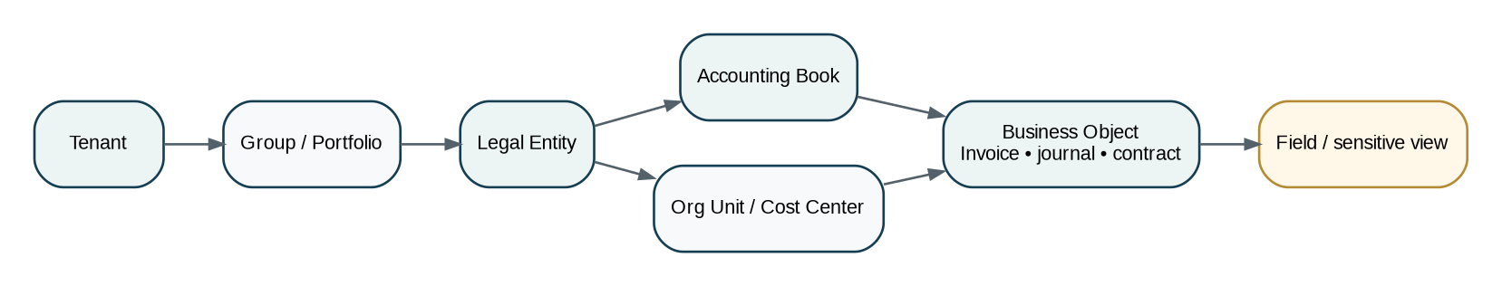
Figure 3 — Authorization scopes are explicit and hierarchical; object ownership does not imply broad parent access
An access assignment MUST identify where a permission applies. Scope inheritance is never assumed merely because a subject can access a parent object; policy declares any inheritance.
Scope | Examples | Rule
TENANT | Tenant-wide administrative or shared-service capability. | Exceptional for financial data; most business roles narrow further.
LEGAL_ENTITY | Entity-specific accounting, tax, contract and reporting authority. | Primary business scope for finance and statutory operations.
BOOK | Accounting-book-specific access. | Required for postings, close/reopen and book-specific reports.
ORG_UNIT | Department, branch, cost center or operating unit. | May constrain expenses, budgets, projects or workflow queues.
ENGAGEMENT / MATTER / PROJECT | Audit engagement, legal matter or project. | Membership relationship may be a required predicate.
RESOURCE | Single invoice, bank account, contract, report, workflow or case. | Used for exceptional delegation/share or object-specific authority.
FIELD / DATA CLASS | Fine-grained sensitive attributes such as bank details, tax IDs or privileged evidence. | Prefer purpose-based response shaping over proliferating UI-only roles.

4.1 Scope intersection
effective_scope = intersection(
authenticated_tenant,
assignment_scope,
resource_ownership_scope,
delegated_scope_if_any,
jurisdiction/residency constraints,
request_context
)
if effective_scope is empty: DENY

5. Permission Taxonomy — Stable Business Capabilities
Permissions are stable backend capabilities, not screen names. They use a namespaced `resource.action` convention. A role bundles permissions; a permission never implies a wider scope than its assignment.
Capability | Permission pattern | Control intent
Read | *.read | View authoritative resource subject to field/classification controls.
List/Search | *.list | Discover resources within permitted scope; search cannot widen authority.
Create | *.create | Create draft/resource where business rules allow.
Edit | *.edit | Modify mutable fields before terminal/governed state restrictions.
Submit | *.submit | Enter a governed workflow or validation process.
Approve | *.approve | Record an approval decision; separate authority/SoD rules still apply.
Reject/Return | *.reject / *.return | Reject or return for correction.
Issue/Execute | *.issue / *.execute | Cause external/business effect; typically high risk.
Post | journal.post | Create authoritative accounting consequence.
Reverse | journal.reverse | Create correction/reversal; never edit posted journal.
Close/Reopen | period.close / period.reopen | Govern accounting periods; privileged/high-risk.
Pay/Release | payment.release | Authorize provider-facing payment execution.
File/Submit | tax_return.file | Submit regulated return to authority.
Export | *.export | Create controlled data extract; classification/residency applies.
Administer | *.admin | Configure policy/master data; must be decomposed rather than universal admin.
Grant Access | iam.assignment.grant | Create access assignment within administrable scope.
Delegate | iam.delegation.grant | Grant controlled temporary authority.
Impersonation | support.session.start | Purpose-bound tenant support access; not ordinary user impersonation.

6. Hybrid RBAC + ABAC + Relationship Model
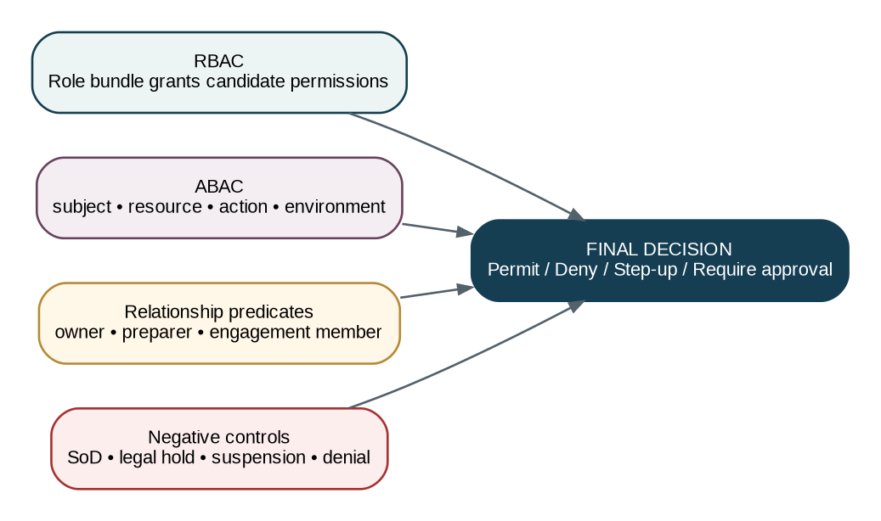
Figure 4 — Roles create candidate grants; attributes, relationships and negative controls determine the final decision

6.1 RBAC responsibilities
- Provide understandable job-function bundles such as Accounts Payable Preparer, Tax Reviewer or Audit Engagement Manager.
- Reduce assignment complexity and support enterprise provisioning.
- Never encode tenant/entity/book scope inside a role name; scope belongs to the assignment.
- Never treat a role as sufficient evidence for approval/signing authority.

6.2 ABAC inputs
Attribute family | Examples
Subject | employment/contractor state; business function; assurance; privilege eligibility; jurisdiction qualification where applicable.
Resource | tenant/entity/book; owner/preparer; amount; classification; state; jurisdiction; legal hold; sensitivity.
Action | permission requested; risk classification; whether irreversible/external/regulated.
Environment | current time; session assurance; authentication age; device/risk; region; incident mode.
Relationship | object preparer; assigned approver; engagement member; matter counsel; project owner; delegated-from subject.
Policy | role grants; explicit deny; SoD; approval limits; tenant policy; jurisdiction policy; break-glass restrictions.

7. Authorization Decision Pipeline
Figure 5 — Every protected operation follows the same server-side decision order
# | Stage | Required behavior
1 | Authenticate | Validate current human/workload identity and session/token integrity.
2 | Resolve context | Server resolves tenant, entity, book, jurisdiction and resource ownership.
3 | Check product entitlement | Capability must exist for tenant; entitlement never grants data authority.
4 | Candidate permission | Role/assignment or explicit policy supplies requested capability.
5 | ABAC/relationship | Evaluate subject, resource, environment and relationship predicates.
6 | Negative controls | Explicit deny, suspension, legal hold, SoD/conflict and restricted-data rules override grants.
7 | Assurance | Require step-up or recent authentication if policy requires.
8 | Domain guards | Owning service evaluates object state, accounting period, tax/legal/workflow and concurrency guards.
9 | Decision | PERMIT / DENY / STEP_UP / REQUIRE_APPROVAL plus obligations and reason codes.
10 | Evidence + execute | Persist material decision evidence; execute only through authoritative domain command.

Deny-by-default
No matching grant, unresolved tenant/entity/book context, stale/invalid session, policy error or unavailable mandatory policy source results in DENY for governed operations. High-risk financial/regulatory actions fail closed.

8. Policy Architecture — PAP, PDP, PIP & PEP
Component | Responsibility | Non-negotiable
PAP — Policy Administration Point | Author/version/approve/deploy role, ABAC, SoD and authority policies. | No direct runtime mutation without controlled publication.
PIP — Policy Information Point | Provides trusted attributes: assignments, scope, object metadata, session assurance, relationships. | Attributes have authoritative owners and freshness/version semantics.
PDP — Policy Decision Point | Evaluates normalized authorization request against active policy set. | Returns decision, obligations, reason codes and policy-version references.
PEP — Policy Enforcement Point | API gateway, command handler, service method or privileged admin endpoint. | MUST enforce decision; cannot downgrade obligations.
Evidence/Decision Store | Records material decisions and inputs/references sufficient for reconstruction. | Separate from operational telemetry; retention/classification policy applies.

8.1 Canonical authorization request
{
"subject_id": "...",
"principal_type": "HUMAN",
"session_id": "...",
"tenant_id": "...",
"legal_entity_id": "...",
"book_id": "...",
"resource_type": "payment_instruction",
"resource_id": "...",
"action": "payment.release",
"resource_version": 18,
"resource_attributes": {"amount": "250000.00", "currency": "GBP", "preparer_id": "..."},
"environment": {"authn_age_seconds": 210, "assurance": "PHISHING_RESISTANT", "risk": "LOW"},
"delegation_id": null,
"correlation_id": "..."
}

8.2 Canonical decision
{
"decision": "PERMIT",
"decision_id": "...",
"policy_set_version": "2026.08.24.4",
"matched_grants": ["role:treasury_releaser@entity:..."],
"negative_controls": [],
"obligations": ["REQUIRE_RECENT_AUTHN", "RECORD_HIGH_RISK_EVIDENCE"],
"expires_at": "2026-08-24T10:50:00Z",
"reason_codes": ["PERMISSION_GRANTED", "SOD_CLEAR", "AUTHORITY_WITHIN_LIMIT"]
}

9. Role Architecture & Assignment Lifecycle
Object | Definition | Control
System role template | ZoikoSuite-maintained permission bundle for common functions. | Versioned; customers cannot mutate canonical template silently.
Tenant custom role | Tenant-defined bundle from permitted granular permissions. | Cannot include protected platform-admin permissions.
Access assignment | Subject/group + role/policy + scope + effective dates. | Authoritative unit of granted access.
Assignment request | Governed request to create/modify assignment. | May require manager/data-owner/security approval depending on risk.
Assignment review | Periodic or event-triggered attestation. | Stale/unowned assignments must be removable.
Revocation | Immediate or effective-dated removal. | High-risk revocation invalidates decision cache/session claims as needed.

9.1 Initial enterprise role archetypes
Archetype | Default intent
Viewer / Auditor Read-Only | Read/list/export governed evidence within scope; no mutation.
AR Preparer | Create/edit/submit customer invoices; no final issue above policy threshold if maker-checker required.
AR Approver | Approve eligible invoices within authority; cannot approve own prepared object.
AP Preparer | Create/match supplier invoices; no payment release.
AP Approver | Approve supplier invoices within authority; independent from preparer where required.
Treasury Preparer | Create payment proposals/instructions; no release.
Treasury Releaser | Release approved payments within bank/entity/amount scope; no self-prepared payment.
Journal Preparer | Create/submit journals; control-account restrictions apply.
Journal Approver | Approve/post journals subject to amount/account/period rules and SoD.
Period Controller | Execute close checklist; cannot casually reopen.
Period Reopen Approver | Authorize reopen under elevated policy; separate from routine close role.
Tax Preparer | Prepare tax returns/calculations; no filing authority unless separately granted.
Tax Reviewer | Review/approve tax work; qualification/jurisdiction attributes may apply.
Tax Filer | Submit approved return to authority; credential/authority constraints apply.
Audit Engagement Member | Access engagement/workpapers assigned by membership relationship.
Audit Reviewer | Review/sign off workpapers; preparer cannot self-review where policy requires.
Legal Matter Member | Access scoped matter/contracts with privilege/classification controls.
Legal Signatory | Execute eligible contracts only within authority and entity/jurisdiction limit.
IAM Access Administrator | Manage ordinary access assignments within admin scope; cannot grant own protected privilege.
Security Privileged Operator | Eligible for JIT platform privilege; standing data access prohibited.
Support Operator | Purpose-bound support capabilities; tenant data access requires separately governed support session.

10. Segregation of Duties — Static and Dynamic
Figure 6 — SoD evaluates assignment conflicts and object-specific conflicts before authority limits
SoD is a negative control layer. It can deny an assignment, deny an action, require an additional independent approver, or require removal/expiration of a conflicting grant.

10.1 Static conflict matrix — minimum baseline
Role/action A | Role/action B | Scope | Severity | Rule
Payment Preparer | Payment Releaser | Same scope | Critical | No subject may both prepare and release payments where dual control policy applies.
Supplier Master Bank Editor | Payment Releaser | Same supplier/entity | Critical | Prevents bank-detail change plus cash release concentration.
Journal Preparer | Journal Final Approver | Same governed journal scope | High | Policy may permit low-risk exceptions only if explicitly configured.
Period Close Operator | Period Reopen Sole Approver | Same book | High | Reopen requires elevated independent authority.
Tax Preparer | Tax Sole Filer | Same filing obligation | High | Jurisdiction/tenant policy may require reviewer separation.
Access Administrator | Own Privileged Grant Approver | Self | Critical | No self-grant of protected privilege.
Audit Workpaper Preparer | Same Workpaper Reviewer | Same object | High | Dynamic conflict; listed here as canonical incompatibility.
Contract Drafter | Sole Contract Signatory | Same high-risk contract | High | Subject to entity/legal signing policy.

10.2 Dynamic SoD examples
Pattern | Predicate | Result
Own-object approval | resource.preparer_id == subject_id AND action == approve | DENY or require independent approval.
Supplier bank change proximity | subject changed supplier bank details within configured cooling window AND attempts release | DENY/step-up + independent release.
Requestor self-approval | expense.requestor_id == subject_id AND approval required | DENY.
Own access elevation | assignment.target_subject_id == subject_id AND protected privilege | DENY self-approval.
Prior rejected reviewer | policy may disallow same reviewer after material resubmission | Re-route or require second reviewer.
Related-party conflict | subject relationship attribute conflicts with vendor/customer/matter | DENY or require declared independent reviewer.

11. Delegated Authority & Acting on Behalf of Another
Figure 7 — Delegation never hides the actual actor and never creates authority the delegator did not possess
Field | Rule
delegation_id | Immutable identifier.
delegator_subject_id | Principal whose authority is being delegated.
delegate_subject_id | Actual actor eligible to exercise the grant.
scope | Tenant/entity/book/object domain.
actions | Explicit allowed permissions/actions; no wildcard by default.
authority_limit | Maximum value/other limit inherited as min(delegator limit, delegation limit).
effective_from / effective_to | Mandatory finite period for delegated approval/execution authority.
reason | Absence, named operational cover or other controlled purpose.
approval_reference | Required where policy says delegation needs independent approval.
revoked_at / revoked_by | Immediate revocation evidence.
constraints | No re-delegation unless explicitly permitted; protected privileges normally non-delegable.

Attribution rule
Every delegated action records both `actor_subject_id` and `on_behalf_of_subject_id` / `delegation_id`. Audit logs must never make it appear that the delegator personally performed the action.

12. Approval Authority, Signing Authority & Limits
Figure 8 — Approval authority is resolved and revalidated separately from ordinary permission grants
Dimension | Requirement
Authority type | invoice_approval, supplier_invoice_approval, payment_release, journal_approval, tax_filing, contract_signature, period_reopen, access_grant.
Scope | Tenant/entity/book/jurisdiction/bank account/contract class or other bounded domain.
Currency | Limit may be defined in authority currency; deterministic conversion basis required for comparison.
Lower/upper limit | Inclusive/exclusive boundary semantics explicitly defined.
Effective period | Authority can begin/end; expired authority cannot approve queued work.
Required role/qualification | Candidate must also have needed permission/role and any professional qualification attribute.
Delegability | Whether and how authority may be delegated.
Independence | Maker-checker and conflict predicates.
Quorum | Single, dual, N-of-M, sequential or committee approval.
Session assurance | Higher-risk limits can require step-up/recent authentication.
Execution revalidation | Before posting/payment/filing/signing, re-evaluate current authority and fingerprint of approved facts.

13. Privileged Access Management — JIT by Default
Figure 9 — Privileged access is eligible, requested, step-up authenticated, time-bound and reviewed
Control | Requirement
Eligibility | Standing eligibility is not standing privilege. Eligibility role identifies who may request specific elevated capabilities.
JIT request | Resource, requested actions, reason/ticket, duration and target environment are mandatory.
Approval | Independent approval for high-impact privileges; policy may auto-approve narrowly defined low-risk operational grants.
Step-up | Phishing-resistant or tenant/security-approved high-assurance authentication before session issue.
Session isolation | Privileged session is distinguishable from ordinary user session and visually/technically marked.
Time bound | Short maximum duration; no silent renewal. New request required after expiry.
Command only | Privileged data/administration mutations must use governed commands; direct DB writes are prohibited except controlled emergency procedures.
Recording/evidence | Every privileged action has actor, reason, resource, timestamp, command and result evidence.
Review | High-impact sessions trigger retrospective review; suspicious actions create security incident workflow.

14. Break-Glass Emergency Access
Figure 10 — Break-glass is an exceptional emergency control, not a convenience role
Control | Requirement
Trigger | Declared incident/emergency where ordinary authorization prevents necessary recovery or protection.
Eligible users | Small named security/operations population; eligibility periodically reviewed.
Authentication | High-assurance step-up; compromised/unverified session cannot break glass.
Scope | Narrowest resources/actions necessary; financial posting/payment/tax filing powers remain separately constrained unless emergency policy explicitly allows.
Duration | Very short; auto-expiry; no persistent role assignment.
Notification | Immediate security/governance alert to independent recipients.
Evidence | All commands tagged `BREAK_GLASS`, with reason, incident ID and session ID.
Review | Mandatory post-event review and attestation; policy abuse creates security/HR/legal escalation.
No concealment | Break-glass actions cannot be removed from audit/evidence history by the actor.

15. Tenant Support & Controlled Impersonation
Support access is distinct from ordinary tenant user access and distinct from platform privileged administration. “Impersonation” must not create an indistinguishable user session.
Control | Rule
Support capability | Operate diagnostics, metadata checks and non-sensitive troubleshooting without tenant-data access where possible.
Tenant-data support session | Explicit tenant, purpose, case/ticket, permitted object classes and finite duration.
Consent/policy | Tenant policy or approved support agreement governs whether support-data access requires tenant approval.
Actor visibility | All support-originated actions record the support operator; no audit log may attribute them solely to the tenant user.
Write restrictions | Default read-only; writes only through named support remediation commands and independent controls.
Sensitive fields | Banking credentials, secrets, privileged legal material and equivalent restricted data require additional policy or remain inaccessible.
Export | Bulk export disabled by default in support context.
Session expiry | Automatic termination and evidence/summary of accessed resources.

16. Workload Identity & Service-to-Service Authorization
Figure 11 — Machine actions require unique workload identity, short-lived credentials and explicit service authorization
Control | Requirement
Identity | Every service/job/connector has a unique workload identity; shared “backend” identities prohibited.
Credential | Prefer platform workload identity/federation, mTLS or other short-lived credential; long-lived secrets are exceptional.
Audience | Token/credential must be audience-bound to intended resource where supported.
Permission | Machine permission is granular and purpose-specific; human roles are not reused as service roles.
Tenant context | Downstream service receives validated tenant/entity/book context; a workload cannot invent or widen it.
User propagation | When acting because of a human request, preserve initiating subject/correlation separately from workload identity.
External connector | Provider credentials are owned by connector/integration boundary; callers invoke controlled capabilities rather than retrieve secrets.
Rotation/revocation | Automatable credential rotation and immediate workload disablement.
Evidence | Machine-originated material actions carry workload principal and human causation where relevant.

17. Federation, SSO & SCIM Provisioning
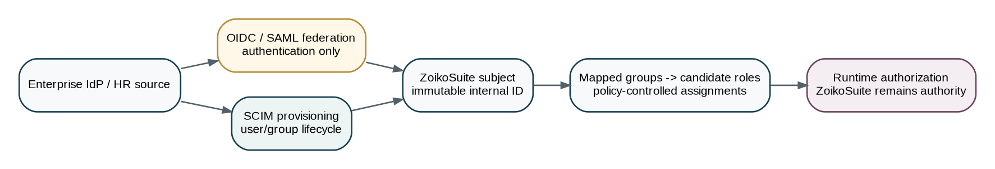
Figure 12 — Enterprise federation/provisioning feeds identity lifecycle; ZoikoSuite remains the authorization authority
External IdPs can authenticate users and provision identity/group lifecycle, but they do not directly dictate sensitive ZoikoSuite business permissions without controlled mapping and policy.
Mechanism | Purpose | Control
OIDC | Preferred federation protocol for modern applications. | Exact issuer/client configuration; PKCE for applicable clients; follow OAuth 2.0 Security BCP.
SAML | Supported for enterprise compatibility. | Signed assertions; strict audience/recipient/time; encrypted assertion where policy requires.
SCIM 2.0 | User/group provisioning and deprovisioning. | RFC 7643/7644 schema/protocol baseline; externalId maps to identity binding, not business authority.
JIT user creation | Optional for federation onboarding. | Creates Subject/identity only; protected role assignment still policy controlled.
Group-to-role mapping | Convenience for candidate access. | Mappings are tenant-owned/versioned; protected roles may require additional approval.
Deprovisioning | Disable identity/session and remove/revoke assignments as policy dictates. | Termination events prioritized; no reliance on nightly sync for critical revocation.
Domain discovery | Optional enterprise login routing. | Must not disclose tenant membership unnecessarily.

18. OAuth/API Authorization Security
ZS-API-001 remains controlling for API semantics. This IAM standard adds identity/authorization constraints. RFC 9700 (January 2025) is the current OAuth 2.0 Security Best Current Practice and deprecates insecure practices such as the implicit grant in security-sensitive deployments.
Area | Requirement
Authorization code | Use authorization code + PKCE for browser/native public clients; confidential clients should also use PKCE.
Redirect URIs | Exact registered matching except narrowly specified localhost behavior; no open redirectors.
Sender-constrained tokens | Use mTLS or DPoP where risk and ecosystem support justify protection against token replay.
Refresh tokens | Rotation or sender-constrained protection according to client class/risk; revoke on compromise.
Token audience/scope | Narrow resource audience; scopes represent API capability, not tenant/business scope alone.
Client credentials | Reserved for workload/service identities; never impersonate an end user.
Resource-owner password grant | Prohibited.
Access token exposure | Never in URLs/logs; short lifetime appropriate to risk.
Authorization server metadata | Publish/use standards-based metadata where applicable for secure configuration.

19. Authorization Caching, Freshness & Revocation
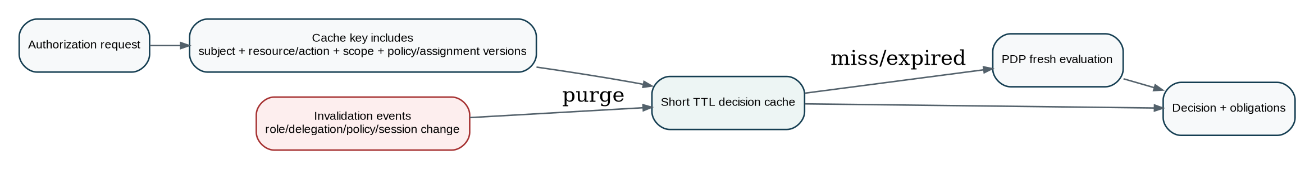
Figure 13 — Decision caching is short-lived, context/version-aware and explicitly invalidated
Topic | Rule
Cache eligibility | Only deterministic authorization decisions with bounded freshness tolerance.
Key | Includes subject, action, resource/scope, assignment/policy versions and relevant assurance attributes.
TTL | Short, risk-based; high-risk decisions may be uncached or cached for seconds only.
Invalidation | Role/assignment/delegation/policy change, subject disablement, privilege/session revoke and critical relationship change.
Negative decisions | May be cached briefly to protect services, but must respect policy update/retry semantics.
Domain state | Do not cache away authoritative business-state/period checks; owner revalidates them at execution.
Failure mode | If PDP/PIP is unavailable, governed/high-risk operations fail closed; limited read-only fail-safe behavior requires explicit policy and data classification.

20. Authorization Evidence & Explainability
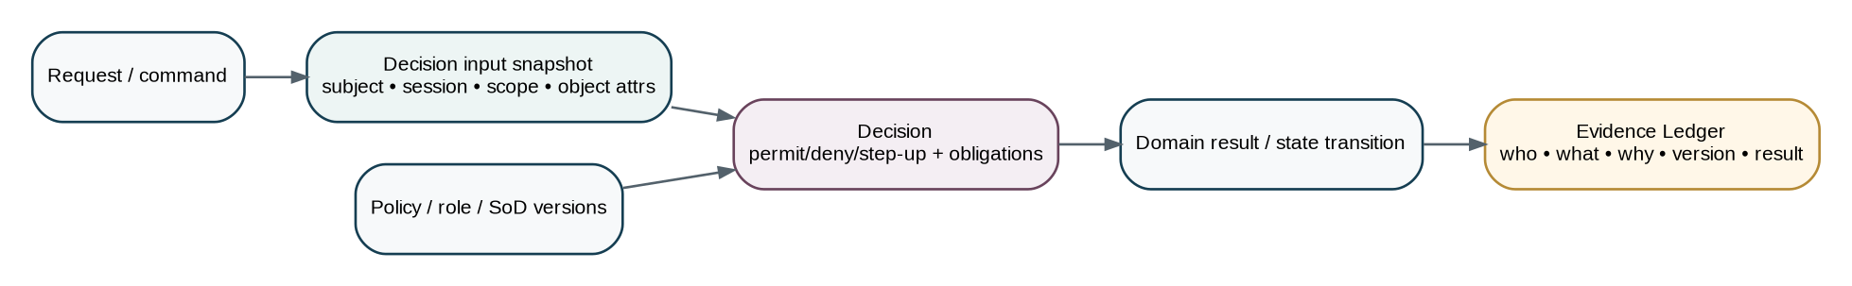
Figure 14 — Material authorization decisions are reconstructable without exposing secret policy internals to users
Evidence field | Purpose
decision_id | Globally unique decision reference.
subject_id / workload_id | Actual actor principal.
on_behalf_of / delegation_id | Delegated context if used.
tenant/entity/book/resource | Normalized scope and target.
action | Requested protected capability.
session assurance | Authentication method/assurance, issue time and step-up reference as appropriate.
assignment references | Assignments/groups/roles that supplied candidate grants.
policy_set_version | Exact deployed policy version.
SoD/authority result | Conflict checks, amount/signing authority and route outcome.
decision | PERMIT / DENY / STEP_UP / REQUIRE_APPROVAL.
obligations | Mandatory extra controls returned to PEP.
reason_codes | Stable machine-readable reasons; user-facing explanation can be redacted.
resource/object version | Version/fingerprint relevant to the decision.
timestamp/correlation | Traceability to command, workflow and resulting domain event.
retention/classification | Aligned with materiality, regulatory evidence and security policy.

21. Authorization APIs & Commands
Endpoint / command | Purpose | Controls
POST /internal/authorization/decisions | Evaluate a runtime authorization request. | Internal only; PEP calls with trusted normalized context.
GET /v1/me/capabilities | Return coarse UI/navigation capabilities for current user. | Convenience only; not substitute for operation authorization.
GET /v1/{resource}/{id}/available-actions | Return state + authorization-aware actions. | ZS-STATE-001 pattern; server-authoritative.
POST /v1/iam/access-assignments | Request/create assignment through governed workflow. | Idempotent; protected roles may require approval.
POST /v1/iam/access-assignments/{id}:revoke | Revoke assignment. | Emits revocation event; invalidates caches.
POST /v1/iam/delegations | Create controlled delegation. | Finite dates and explicit scope/actions required.
POST /v1/iam/delegations/{id}:revoke | Revoke delegation. | Immediate for high-risk delegations.
POST /admin/v1/privileged-sessions | Request JIT privileged session. | Separate admin surface and step-up.
POST /admin/v1/break-glass-sessions | Emergency access command. | Strict eligibility, reason and alerting.
POST /v1/support/sessions | Create purpose-bound tenant support session. | Tenant/policy approval as configured.
GET /v1/iam/access-reviews | Retrieve assigned attestations/reviews. | No broad IAM discovery beyond administrable scope.

22. IAM Data Model & Authoritative Ownership
Entity | Authoritative owner | Notes
subject | Identity Service | Canonical human/workload principal; immutable ID.
authentication_identity | Identity Service | IdP/credential binding to Subject.
group / group_membership | Identity/IAM | Administrative membership; externally provisioned provenance preserved.
role_definition / role_version | IAM Policy | Permission bundles and metadata.
permission_definition | IAM Policy | Stable protected capabilities.
access_assignment | IAM | Subject/group + role/policy + scope + effective dates.
delegation | IAM | Time-bounded on-behalf-of authority.
authority_limit | Governance/IAM | Approval/signing limit and scope.
sod_rule / conflict_set | Governance/IAM | Static/dynamic conflict policy.
policy_set / policy_version | IAM Policy | Runtime policy package.
session | Identity Service | Human authenticated runtime session.
privileged_session | Privileged Access | JIT elevated context.
support_session | Support Control | Purpose-bound tenant support context.
authorization_decision | IAM Evidence | Material decision record / reference.
access_review | IAM Governance | Certification campaign/review.
workload_identity | Identity Service | Machine principal and credential metadata.
scim_connection | Integration/IAM | Provisioning connection configuration; secrets stored separately.

23. Canonical IAM Domain Events
Event type | Meaning
identity.subject.created | Subject created.
identity.subject.disabled | Subject access disabled.
identity.session.revoked | Runtime session revoked.
iam.role.published | Role version activated.
iam.assignment.granted | Access assignment became effective.
iam.assignment.revoked | Assignment revoked/expired.
iam.delegation.granted | Delegation became effective.
iam.delegation.revoked | Delegation ended/revoked.
iam.authority_limit.changed | Approval/signing authority changed.
iam.sod_policy.published | SoD rule set activated.
iam.policy_set.published | Authorization policy version activated.
iam.access_review.started | Certification campaign initiated.
iam.access_review.completed | Review completed.
security.privileged_session.started | JIT elevated session began.
security.privileged_session.ended | Elevated session expired/revoked.
security.break_glass.started | Emergency session began.
security.break_glass.ended | Emergency session ended.
support.session.started | Tenant support access session began.
support.session.ended | Support session ended.
identity.scim_sync.completed | Provisioning synchronization completed.

24. Access Reviews & Continuous Governance
Control | Requirement
Periodic certification | Review users/roles/scopes on risk-based cadence; privileged and financial access reviewed more frequently.
Event-triggered review | Manager change, entity transfer, contractor end, privilege grant, dormant account or material policy change.
Reviewer | Manager, resource/data owner, security or independent approver depending on access type.
Evidence | Reviewer, reviewed grants, decision, reason, date and resulting revocations.
Dormancy | Unused privileged/high-risk assignments can be flagged for removal; usage alone does not prove necessity.
Orphan detection | Assignments without valid owner/manager/resource scope create governance exception.
Toxic combinations | Review detects newly introduced SoD conflicts after role/policy changes.
Certification outcome | KEEP / REVOKE / MODIFY / ESCALATE; unresolved high-risk review cannot silently close.

25. Privacy, Residency & Data Minimization
- IAM metadata is tenant-scoped and residency-aware; cross-region replication follows approved control-plane policy.
- Tokens, passwords, private keys, OTPs and raw secret material must never be stored in authorization decision logs.
- Decision evidence should store necessary attribute values or stable references; highly sensitive attributes may be hashed/referenced where reconstruction remains possible.
- Authorization responses expose only user-actionable reason information; internal policy structure and sensitive attributes are not leaked to unauthorized callers.
- Search/index projections of IAM data are non-authoritative and must preserve tenant scope.
- Support and privileged access to restricted personal/legal/financial data is purpose-bound and auditable.

26. Observability & Security Operations
Signal | Operational requirement
Decision metrics | permit/deny/step-up rates by service/action; never use metrics as authority.
Latency | PDP/PIP latency percentiles; high-risk actions have defined latency/SLO budget.
Policy health | Loaded policy version, compile/evaluation errors, stale attribute sources.
Cache health | hit rate, invalidation lag, stale-decision detection.
Revocation lag | time from disable/revoke event to denied access across PEPs.
SoD alerts | conflicting assignment attempts, self-approval attempts, privilege escalation patterns.
Privileged sessions | active count, nearing-expiry, denied JIT, break-glass activity.
SCIM/federation | sync failures, orphaned identities, issuer/config drift, anomalous provisioning.
Security analytics | impossible privilege use, token replay indicators, unusual export/access patterns; alerts remain non-authoritative until investigated.

27. Engineering Acceptance Scenarios — Negative Paths First
ID | Scenario | Condition | Expected result
A01 | Cross-tenant object ID guessed | Request resolves object in another tenant. | DENY; no existence disclosure beyond safe error contract.
A02 | Entity-scoped role used in sibling entity | Permission exists but assignment scope differs. | DENY.
A03 | Book-specific posting attempted in another book | Same entity, wrong book. | DENY.
A04 | Role grants action but no entitlement | Tenant plan lacks capability. | DENY capability; no data access side effect.
A05 | Approver prepared same payment | Dynamic SoD conflict. | DENY release; route independent releaser.
A06 | Payment releaser also changed supplier bank account | Cooling-window conflict. | DENY or require independent high-assurance control per policy.
A07 | Expired delegation | Delegate otherwise has candidate permission. | DENY delegated authority.
A08 | Delegator lost authority after delegation issued | Delegation still in date. | DENY because delegator authority no longer valid.
A09 | Authority limit exceeded after FX conversion | Local currency comparison exceeds limit. | DENY / route higher authority using deterministic FX basis.
A10 | Approval facts mutate after approval | Object fingerprint changes. | Invalidate approval; require reapproval.
A11 | Assignment revoked while session active | Token/session not yet expired. | Critical access denied after revocation propagation/invalidation.
A12 | Stale PDP cache after role change | Cache key/version old. | Purge or miss; new decision applies.
A13 | PDP unavailable during payment release | High-risk operation. | Fail closed; no provider call.
A14 | Support user requests bulk export | Support session exists. | DENY unless separately explicit governed export authority.
A15 | IAM admin grants own privileged role | Self-grant protected privilege. | DENY and alert.
A16 | Break-glass used without declared incident | Eligible operator requests access. | DENY.
A17 | Break-glass session expires mid-operation | Irreversible action not yet committed. | Revalidate; deny/abort safely.
A18 | Workload presents token for wrong audience | Credential otherwise valid. | DENY.
A19 | Workload invents tenant context | Caller sends tenant not bound to trusted flow. | DENY and security event.
A20 | SCIM group mapping adds protected role | External IdP adds user to mapped group. | Protected assignment enters required approval path; not immediately effective if policy requires.
A21 | Disabled IdP user remains provisioned | Federated login attempt after IdP disable. | Authentication fails; local access also subject to deprovisioning controls.
A22 | Field-level bank detail read without sensitive permission | Object read allowed. | Response masks/omits restricted field.
A23 | Legal hold object delete permission granted | Role allows delete, legal hold active. | Explicit negative control DENY.
A24 | Audit reviewer is not engagement member | Generic reviewer role exists. | DENY unless engagement membership/relationship predicate satisfied.
A25 | Tax filer lacks jurisdiction qualification attribute | Permission exists. | DENY / route authorized filer.
A26 | Session authentication too old for period reopen | Role/authority valid. | STEP_UP; no reopen until recent auth satisfied.
A27 | Duplicate assignment grant command | Same idempotency key. | Return original result; no duplicate grants.
A28 | Policy version rolls back | Current assignments unchanged. | Decision evidence references exact activated version; rollout/rollback audited.
A29 | Read model says user has access but IAM owner says revoked | Projection stale. | Authoritative runtime decision DENY.
A30 | AI suggests privilege grant | No human/governed command. | No access change; AI cannot create assignment.

28. Definition of Ready — IAM Capability
Gate | Must be true
Permission | Stable resource.action permission and risk classification defined.
Owner | Authoritative resource/action owner and PEP identified.
Scopes | Allowed scope types and inheritance behavior documented.
Role mapping | Candidate role bundles identified without encoding scope into role name.
ABAC inputs | Required subject/resource/environment/relationship attributes have authoritative sources.
SoD | Static and dynamic conflicts defined.
Authority | Approval/signing/value limit behavior defined where relevant.
Assurance | Authentication/step-up requirements defined.
Failure behavior | Fail-closed/fallback behavior defined.
Evidence | Decision/audit retention requirements defined.
Events | Grant/revoke/policy/invalidation events defined.
Tests | Positive and negative scenarios approved.

29. Definition of Done — IAM Capability
Gate | Completion evidence
PEP enforcement | All protected entry points enforce the same logical policy contract.
No UI bypass | Direct API calls cannot perform actions hidden by UI.
Scope isolation | Tenant/entity/book/object tests prove no cross-scope access.
SoD | Conflict tests pass, including dynamic own-object cases.
Revocation | Measured end-to-end revocation/invalidation within approved objective.
Evidence | Material decisions reconstructable with policy/assignment versions.
Load/performance | Authorization latency and dependency failure tests meet approved SLO.
Security | OAuth/session/token/federation tests complete; secrets absent from logs.
Provisioning | Create/change/disable SCIM and federation lifecycle tests pass where enabled.
Privileged access | JIT/break-glass/support session controls and retrospective evidence tested.
Accessibility/UI | Available-action and denial/step-up UX communicates actionable status without leaking policy internals.
Operational readiness | Dashboards, alerts, runbooks, ownership and rollback ready.

30. Engineering Implementation Sequence
Wave | Deliverables
Wave 0 — Foundations | Subject/authentication identity; trusted tenant context; permission registry; decision API contract.
Wave 1 — Scope + RBAC | Roles, assignments, tenant/entity/book scopes, admin workflows.
Wave 2 — ABAC/PDP | Policy engine, PIPs, relationship attributes, decision evidence.
Wave 3 — SoD + Authority | Static/dynamic conflict engine, approval/signing limits, delegation.
Wave 4 — Federation/Lifecycle | OIDC/SAML, SCIM, group mappings, deprovisioning and revocation propagation.
Wave 5 — Workloads | Workload identity, service authorization, short-lived credentials, connector boundary.
Wave 6 — Privileged Access | JIT privilege, support sessions, break-glass, post-session review.
Wave 7 — Governance | Access reviews, policy certification, analytics and dormant/orphan remediation.
Wave 8 — Hardening | Chaos/failure testing, cross-region/residency validation, performance, red-team and certification.

31. Controlled Pre-Production Decisions
Decision | Required closure
Policy engine implementation | Select/build PDP technology while preserving vendor-neutral contract and deterministic policy versioning.
Token format | JWT vs opaque/reference by channel/risk; resource servers must not rely on unvalidated token fields.
Sender-constrained OAuth | Decide DPoP/mTLS adoption by first-party/public/partner client classes.
Session assurance taxonomy | Finalize internal assurance levels mapped to authenticators and step-up actions.
Privileged maximum duration | Numeric JIT and break-glass session limits require Security approval.
Revocation SLO | Set measured maximum propagation time by risk tier.
Decision evidence retention | Finalize retention periods by jurisdiction/control category.
Support consent modes | Define tenant-configurable support-access approval model.
Initial role library | Finance/tax/audit/legal role templates require domain-owner validation.
SoD matrices | Finalize jurisdiction/customer-configurable conflicts vs platform-mandatory conflicts.
Authority currency conversion | Select authoritative FX basis for approval-limit comparisons.
WebAuthn Level 3 features | Adopt only after client/platform compatibility and Recommendation status/risk review.

32. Prohibited IAM Anti-Patterns
Anti-pattern | Required replacement
Universal `admin=true` flag | Replace with decomposed scoped permissions and JIT privileged capabilities.
Role name as authorization | Runtime policy must evaluate scope/attributes/negative controls.
Client-supplied tenant/entity trusted | Resolve/validate server-side.
Authorization in frontend only | Backend PEP required.
Long-lived bearer tokens for privileged actions | Short-lived/step-up and sender-constrained protection where appropriate.
Self-grant/self-approve protected privilege | Prohibited.
Shared service account | Unique workload identities.
Delegation by password sharing | Prohibited; explicit delegation object only.
Impersonation without attribution | Prohibited.
Direct IdP group = unrestricted financial authority | Mappings remain ZoikoSuite-governed.
Deleting authorization history | Material grant/revoke/decision evidence retained per policy.
Caching authorization without versions/invalidation | Prohibited for governed actions.
Hardcoded permission checks scattered in UI/services | Central contract/policy with PEP enforcement; domain guards remain owner-specific.
AI auto-granting access | Prohibited.
Support production DB access as normal workflow | Prohibited; exceptional emergency procedure only.
Permission wildcard `*:*` for ordinary users/workloads | Prohibited except narrowly governed platform emergency mechanisms.

Appendix A — Initial Permission Family Catalogue
Domain | Representative permissions
Accounting | account.read, journal.create/edit/submit/approve/post/reverse, period.read/close/reopen, reconciliation.read/resolve/approve
AR | customer.read/manage, invoice.read/create/edit/submit/approve/issue/credit/writeoff, receipt.allocate, collections.manage
AP | supplier.read/manage, supplier.bank_details.read/change, purchase_requisition.*, purchase_order.*, supplier_invoice.*, expense.*, payment_proposal.*
Treasury | bank_account.read/manage, bank_statement.read/import, bank_reconciliation.*, payment_instruction.read/create/approve/release/cancel, treasury_transfer.*
Tax | tax_registration.*, tax_rule.read/admin, tax_determination.read/recalculate, tax_return.read/prepare/review/approve/file/amend, tax_submission.read/retry
Assets/Inventory | asset.read/create/adjust/dispose/approve, inventory.read/adjust/count/approve, valuation.read/run
FP&A/Reporting | budget.*, forecast.*, scenario.*, management_report.read/publish, statutory_report.read/approve/file, report.export
Audit | audit_engagement.*, audit_population.*, audit_workpaper.read/prepare/review/signoff, audit_finding.*
Legal | corporate_record.*, contract.read/draft/review/approve/sign/amend, legal_matter.*, legal_hold.place/release, legal_document.read_restricted
Documents | document.read/upload/version/classify/export/delete, template.*, form.*
IAM | iam.role.read/manage, iam.assignment.read/grant/revoke, iam.delegation.*, iam.policy.read/publish, iam.access_review.*, iam.sod_rule.read/publish
Security/Admin | security.privilege.request/approve, security.break_glass.request, support.session.start/approve, platform.config.read/change
Integration | integration.connection.*, integration.credential.rotate, import.*, export.*, webhook.*
Commercial | subscription.read/change, entitlement.read/override, usage.read, commercial_invoice.read/manage

Appendix B — Standards & Reference Baseline
Reference | Subject | Use in ZoikoSuite
NIST SP 800-63-4 | Digital Identity Guidelines | Final July 2025; supersedes SP 800-63-3. Identity proofing, authentication and federation reference.
NIST SP 800-162 | Guide to Attribute Based Access Control | ABAC definition based on subject/object/action/environment attributes and policy.
NIST SP 800-207 | Zero Trust Architecture | No implicit trust based solely on network location; resource-focused authentication/authorization.
RFC 9700 / BCP 240 | Best Current Practice for OAuth 2.0 Security | January 2025; current OAuth 2.0 security BCP.
RFC 7643 / RFC 7644 | SCIM 2.0 Core Schema & Protocol | Standards for cross-domain user/group provisioning.
W3C WebAuthn Level 3 | Web Authentication API | Candidate Recommendation Snapshot May 26, 2026; use stable supported features and test compatibility.
RFC 9449 | OAuth 2.0 DPoP | Optional sender-constrained access-token mechanism.
RFC 8705 | OAuth 2.0 Mutual TLS | Optional mTLS client authentication and certificate-bound token mechanism.

Standards posture
These references are architecture anchors, not a claim of certification or legal compliance. ZoikoSuite policy must remain jurisdiction-aware, tenant-aware and independently reviewed before regulated deployment.

Appendix C — Final Architecture Decision
ZoikoSuite shall implement authorization as a centralized logical policy discipline with distributed enforcement. RBAC supplies understandable candidate grants; ABAC and relationship predicates bind those grants to the actual subject, resource, action and environment; negative controls and segregation of duties override risky combinations; approval/signing authority is separately versioned and revalidated; privileged access is just-in-time; workloads have unique identities; external federation/provisioning never becomes the authority for financial/legal access; and every material decision can be reconstructed from immutable evidence.
Controlling rule
No protected action is authorized because a user “has a role.” It is authorized only because the authenticated subject has a valid candidate grant in the correct scope, all contextual and relationship predicates are satisfied, no negative or SoD rule blocks the operation, session assurance is sufficient, approval/authority rules are satisfied where applicable, and the authoritative domain owner accepts the action in its current state.

