ZOIKOSUITE
GLOBAL FINANCIAL RECONCILIATION &
CONTROL FRAMEWORK
Detailed Engineering Wireframe

Build-ready architecture for continuous financial integrity across source systems, subledgers, the General Ledger, external providers, close, consolidation, reporting and regulatory outputs.

Field | Value
Document ID | ZS-CONTROL-001
Version | 1.0 — Global Financial Control Baseline
Date | August 24, 2026
Status | Engineering architecture baseline; entity-specific materiality, control ownership, control frequency, sign-off authority and regulatory reliance require formal approval before production activation.
Owner | ZoikoSuite Product / Platform Architecture / Finance Controls
Prepared for | Engineering, Finance, Accounting, Tax, Treasury, Payroll, Audit, Compliance, Security, Data, QA, DevOps, Support
Language | American English

1. Executive Doctrine
ZoikoSuite must be able to prove that every financially material population is complete, accurate, authorized, classified correctly, valued appropriately, recorded in the correct period, and traceable from source evidence through subledgers and the General Ledger to financial and regulatory outputs. Reconciliation and control therefore form a first-class platform capability, not a month-end spreadsheet activity.
A control is not “green” because two headline totals happen to agree. It is green only when its defined assertion has been tested over a reproducible population, approved tolerances have been applied, exceptions are resolved or explicitly governed, evidence is retained, and the authorized control owner certifies the result.

2. Critical Architecture Review & Refinements
Weak design pattern | Required ZoikoSuite refinement
Control totals only | Add record-level completeness checks, population hashes, sequence/gap tests and attribute-level tie-outs.
One generic reconciliation status | Separate lifecycle, result, exception and certification states.
Spreadsheet reconciliation outside platform | Provide governed population snapshots, matching rules, exception workflow and evidence in-platform; controlled exports remain secondary tools.
Tolerance chosen by operator | Version and approve tolerance/materiality policies; operator cannot widen them during a run.
Automatic “pass” after auto-match | Auto-match may resolve items; certification remains attributable to an authorized owner where policy requires.
Suspense as cleanup account | Treat suspense as temporary, owned, reason-coded, aged and escalation-controlled.
Month-end only | Support event-driven and daily controls for high-risk flows, plus close-period certification.
Reconciliation engine edits ledger directly | Engine proposes exceptions/remediation; accounting corrections execute through authoritative domains and the Accounting Kernel.
Closed population keeps changing | Freeze control populations with source watermarks/hashes; late data creates a new run or controlled supersession.
Unowned exceptions | Every material exception must have owner, due date, severity, reason code, aging state and evidence.
AI closes exceptions | AI may classify/prioritize; it cannot certify, waive, post or clear a material financial exception autonomously.
Same control across all entities without risk context | Control definitions support entity/book/jurisdiction scope, risk tier, materiality, frequency and assertion mapping.

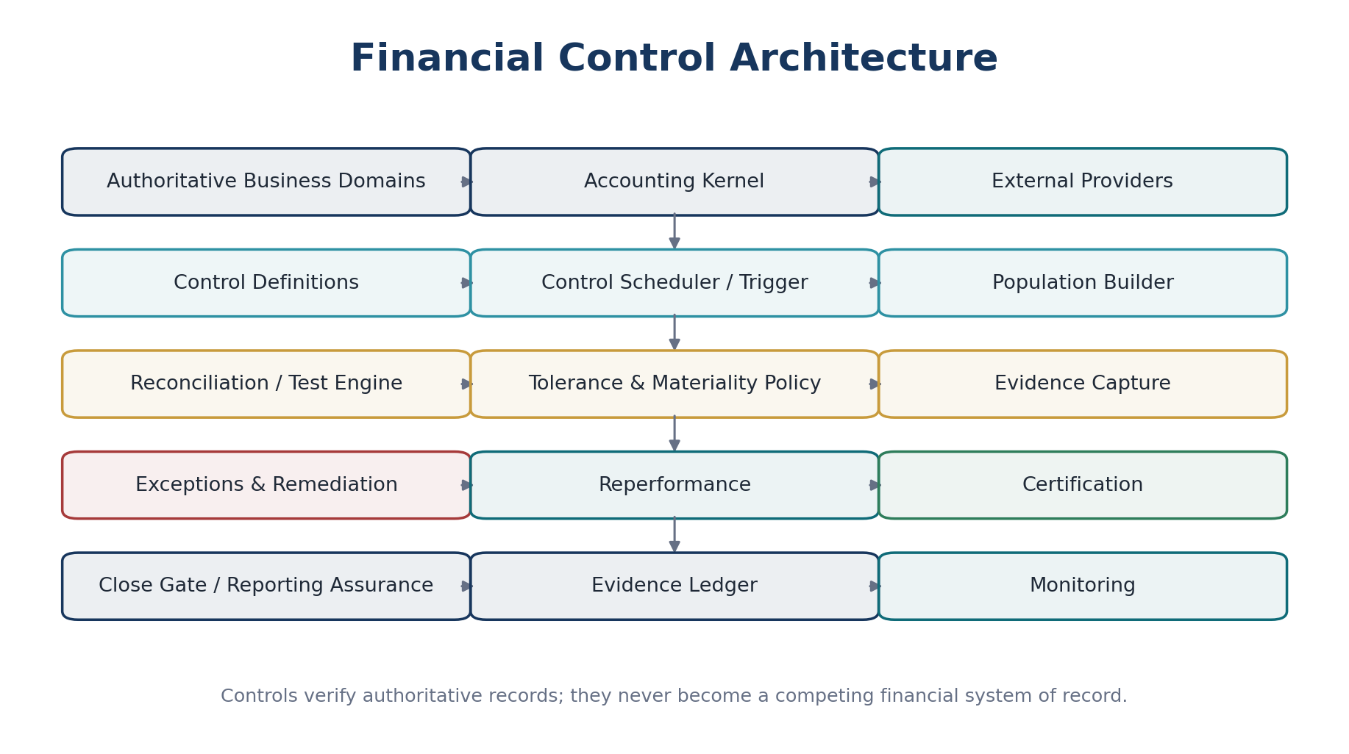
Figure 1 — Financial control architecture: authoritative records flow into governed control execution, exception remediation and certification.

3. Relationship to Approved ZoikoSuite Architecture
Approved standard | Dependency / boundary
ZS-DATA-001 | Provides canonical financial objects, provenance, bitemporal history and authoritative ownership.
ZS-ACC-KERNEL-001 | Owns journals, ledgers, control accounts, posting, books, periods and signed balance snapshots.
ZS-STATE-001 | Provides governed lifecycle, approval, exception and certification state transitions.
ZS-API-001 | Provides command/query semantics, idempotency, concurrency and error contracts.
ZS-EVENT-001 | Provides durable event facts, outbox/inbox semantics and replay-safe integration.
ZS-IAM-001 | Provides scoped authorization, SoD, approval authority, JIT privilege and evidence.
ZS-JUR-001 | Provides effective-dated jurisdiction rules, statutory obligations and regulatory evidence.

4. Non-Bypassable Control Invariants
# | Invariant
1 | Every control has one stable control_definition_id, one named owner role, a defined assertion, scope, frequency/trigger, source population, target population or expected condition, and evidence requirement.
2 | Every control run is immutable after certification; corrections create a new run, superseding certification or documented reopen workflow.
3 | Population snapshots are reproducible using source watermarks, IDs, versions, query definitions and cryptographic hashes where appropriate.
4 | Control rules, tolerances and materiality thresholds are versioned and pinned to the run.
5 | A tolerance never converts missing or unauthorized records into valid records; tolerance applies only to explicitly defined quantitative/temporal differences.
6 | A reconciliation engine does not create authoritative accounting entries directly.
7 | Every material exception has an owner, reason code, severity, due date, lifecycle and evidence trail.
8 | Suspense and clearing accounts are governed by approved policy and aging limits.
9 | A certified control result always identifies the certifier, certification authority, time, run version, unresolved exceptions and impact assessment.
10 | Period hard close can depend on mandatory controls and cannot be bypassed by front-end state changes.
11 | Control ownership and approval authority are revalidated at certification time.
12 | A preparer cannot self-certify where maker-checker policy applies.
13 | No system may silently delete a control failure, exception, prior certification or supporting evidence.
14 | Late-arriving data after population freeze creates an explicit late-data exception or a new/superseding run.
15 | External provider status is not inferred; authoritative provider/bank/authority acknowledgement is reconciled to internal state.
16 | Automated controls emit sufficient technical evidence to prove the algorithm, code/rule version, inputs and result.
17 | Financial reporting cannot be released from a population that bypasses required close controls.
18 | AI-generated signals are advisory until a deterministic rule or authorized human action changes control state.
19 | Control evidence obeys tenant, entity, jurisdiction and residency restrictions.
20 | Every control failure is observable and operationally owned; dead queues or stale exceptions are not acceptable control states.

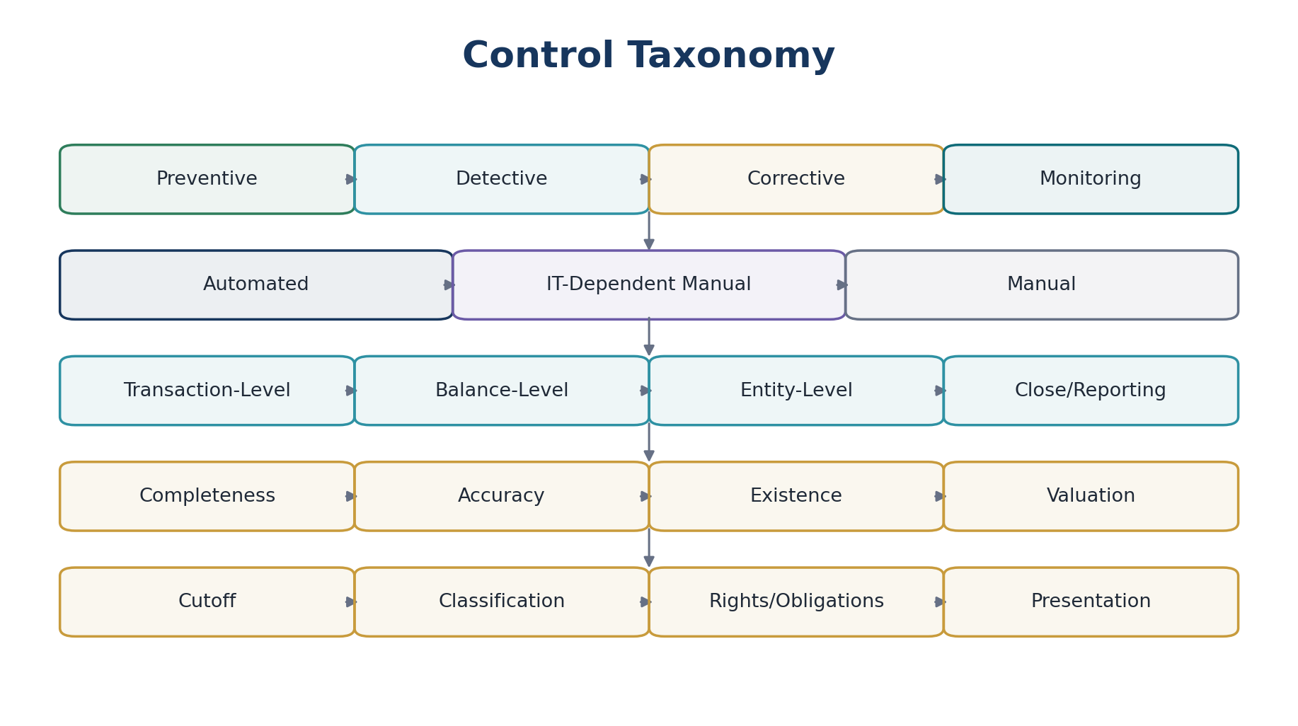
Figure 2 — Control taxonomy across purpose, execution mode, level and financial assertion.

5. Financial Assertions & Control Objectives
Assertion / objective | Engineering interpretation | Example
Completeness | All required source records are represented exactly once in the downstream population. | All issued customer invoices are present in AR and corresponding accounting events exist.
Accuracy | Amounts, currencies, dimensions, classifications and derived values agree to authoritative sources/rules. | Invoice tax and gross amount tie to AR and journal lines.
Existence / occurrence | Recorded balances and transactions correspond to real authorized business events. | Bank receipt represented in ledger exists in statement/provider record.
Valuation / allocation | Balances are valued using approved methodologies, rates and allocation rules. | FX revaluation and depreciation agree to pinned rates/policies.
Rights & obligations | Assets, liabilities and balances belong to / are owed by the correct legal entity. | Cash account owner and legal entity match.
Cutoff | Transactions are recorded in the correct accounting/tax period. | Goods receipt and supplier invoice cutoff around period end.
Classification | Records use correct account, dimension, tax, counterparty and intercompany classifications. | Payroll employer tax is not classified as employee withholding.
Presentation / disclosure | Certified data rolls into the intended reporting structure and disclosures. | Trial balance mapping ties to financial-statement line items.

6. Canonical Control & Reconciliation Data Model
Object | Purpose / key fields
ControlDefinition | control_definition_id, name, domain, assertion, risk tier, control type, frequency/trigger, scope, owner role, reviewer role, source specs, logic version, policy refs, evidence policy.
ControlRuleVersion | rule_version, code/config digest, effective dates, approval, test-pack version, deployment metadata.
TolerancePolicy | tolerance_id, metric, absolute/percentage/time tolerance, permitted contexts, materiality relationship, approver, effective dates.
MaterialityPolicy | entity/book/reporting basis, amount thresholds, qualitative triggers, aggregation basis, effective dates.
ControlRun | run_id, definition/version, scope, period, trigger, lifecycle_state, result_state, started/completed timestamps, source watermarks.
PopulationSnapshot | population_id, side, source, query/spec version, row count, currency totals, control totals, hash, watermark, frozen_at.
MatchResult | match_id, side-A refs, side-B refs, match rule, confidence for deterministic matcher, differences, result.
ControlException | exception_id, run_id, category, assertion, severity, amount exposure, currency, owner, due date, aging, state, evidence.
RemediationAction | exception_id, action type, authoritative command reference, proposed adjustment, approval/workflow, execution result.
ControlCertification | run_id, certifier, authority snapshot, result, unresolved exceptions, assessed exposure, timestamp, evidence package.
EvidencePackage | run inputs, population hashes, rule versions, match output, exception history, remediation refs, approval/signature refs.
ControlMetric | pass rate, unmatched amount/count, aging, run latency, late data, manual overrides, recurring exception rate.

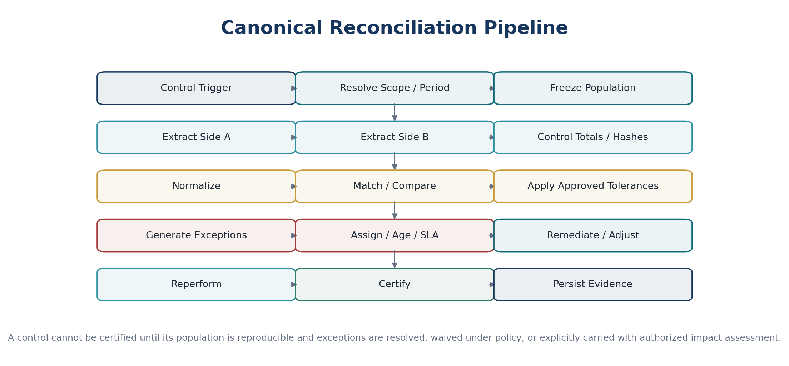
Figure 3 — Canonical reconciliation pipeline from trigger and population freeze through certification and evidence.
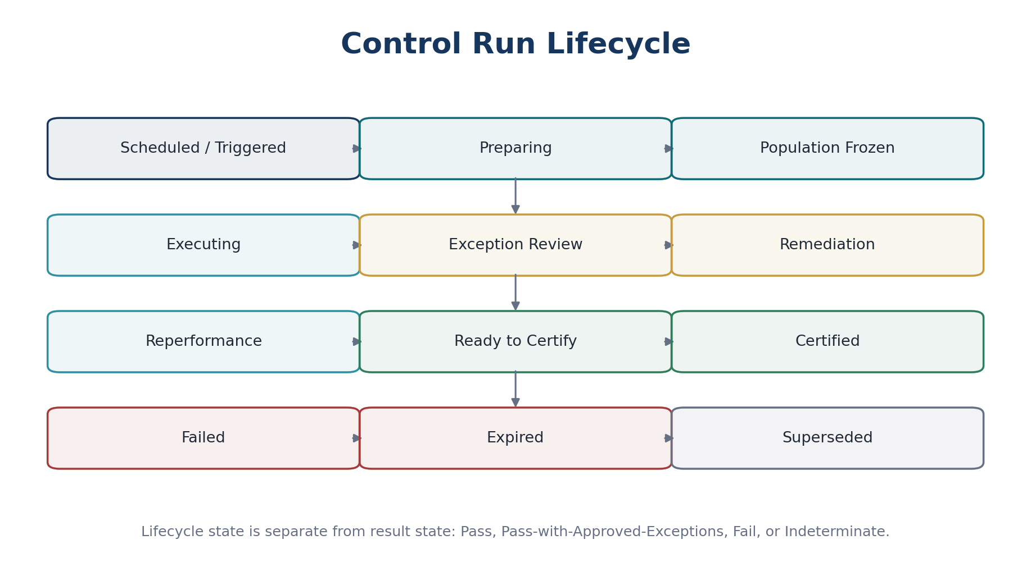
Figure 4 — Control run lifecycle; lifecycle state is independent from the financial result.

7. Orthogonal State Model
State dimension | Canonical values / rules
Lifecycle | Scheduled, Preparing, Population Frozen, Executing, Exception Review, Remediation, Reperformance, Ready to Certify, Certified, Failed, Expired, Superseded.
Result | Not Evaluated, Pass, Pass with Approved Exceptions, Fail, Indeterminate.
Exception | Open, Assigned, Investigating, Awaiting Evidence, Awaiting Adjustment, Remediated, Reperformed, Waived under Authority, Carried Forward under Authority, Closed.
Certification | Not Required, Pending, Certified, Rejected, Revoked, Superseded.
Attention / derived | Overdue, Material, SLA Breach, Recurrent, Data Late, Control Stale; derived signals never overwrite authoritative states.

8. Control Triggering & Scheduling
Trigger class | Examples | Required control behavior
Event-driven | Journal posted, bank statement received, payroll run approved, tax filing accepted. | Run or increment control only after authoritative event commit; preserve causation/correlation.
Intraday recurring | Bank/provider reconciliation, integration completeness, suspense aging. | Defined cadence; detect missing runs and stale source feeds.
Daily | Subledger control totals, unposted accounting events, duplicate detection. | Produce daily certification or monitored result depending policy.
Period-end | AR/AP/Payroll/Tax/FA/Inventory to GL, intercompany, consolidation. | Mandatory close gate where classified key control.
On demand | Audit rerun, investigation, post-correction reperformance. | Requires authorized command, reason and relationship to prior run.

9. Population Freeze, Completeness & Hash Controls
Every reconciliation must identify the exact records tested. Headline totals without a defined population are insufficient for financial assurance.
Required artifact | Minimum content
Source watermark | Commit sequence / event offset / provider statement ID / extraction time / dataset version.
Population query/spec | Version-controlled query, API criteria or canonical population definition.
Record identity set | Stable authoritative IDs or deterministic record keys.
Control totals | Row count, debit/credit totals, gross/net/tax totals, currency buckets, quantity totals as relevant.
Integrity fingerprint | Population hash/Merkle-style digest or equivalent reproducibility control where feasible.
Late-data rule | Policy for facts arriving after freeze; never silently mutate certified population.
Exclusions | Explicit documented exclusion criteria, reason, authority and count/value impact.

10. Matching & Comparison Engine
Capability | Required behavior
Exact match | Match stable IDs, amount/currency/date/reference where authoritative key exists.
Composite deterministic match | Use approved key combinations and tolerances; record exact rule version.
Many-to-one / one-to-many | Support split payments, consolidated receipts, fees and settlements with explicit allocation.
Cross-currency | Normalize only using approved FX basis and preserve original amounts/rates.
Timing differences | Identify as reconciling item with expected clearing date; do not treat as permanent mismatch.
Duplicate detection | Detect duplicate source/downstream records before ordinary matching.
Unmatched population | Generate item-level exceptions with exposure and owner.
Manual match | Requires permission, reason and evidence; cannot hide amount difference.
AI-assisted suggestion | May propose candidate matches; deterministic/human-authorized action establishes the match.

11. Tolerance, Materiality & Risk Policy
Tolerance answers “how much difference is operationally acceptable for this specific comparison?” Materiality answers “what financial-reporting risk does an unresolved difference create?” They are not the same control.

Policy area | Required controls
Absolute tolerance | Value in relevant currency/unit; versioned by control and scope.
Percentage tolerance | Permitted only where economically meaningful; base must be explicit.
Date tolerance | Defined number of business/calendar days for timing matches.
Rounding tolerance | Bound to known rounding rules, currencies and tax/accounting calculations.
Materiality | Entity/book/reporting-basis policy; quantitative and qualitative criteria.
Aggregation | Exceptions must be assessed individually and in aggregate; repeated small items may be material by pattern.
Override | No run-time widening by preparer. Policy change requires governed configuration change and prospective/reperformed controls.

12. Accounts Receivable → GL Detailed Wireframe
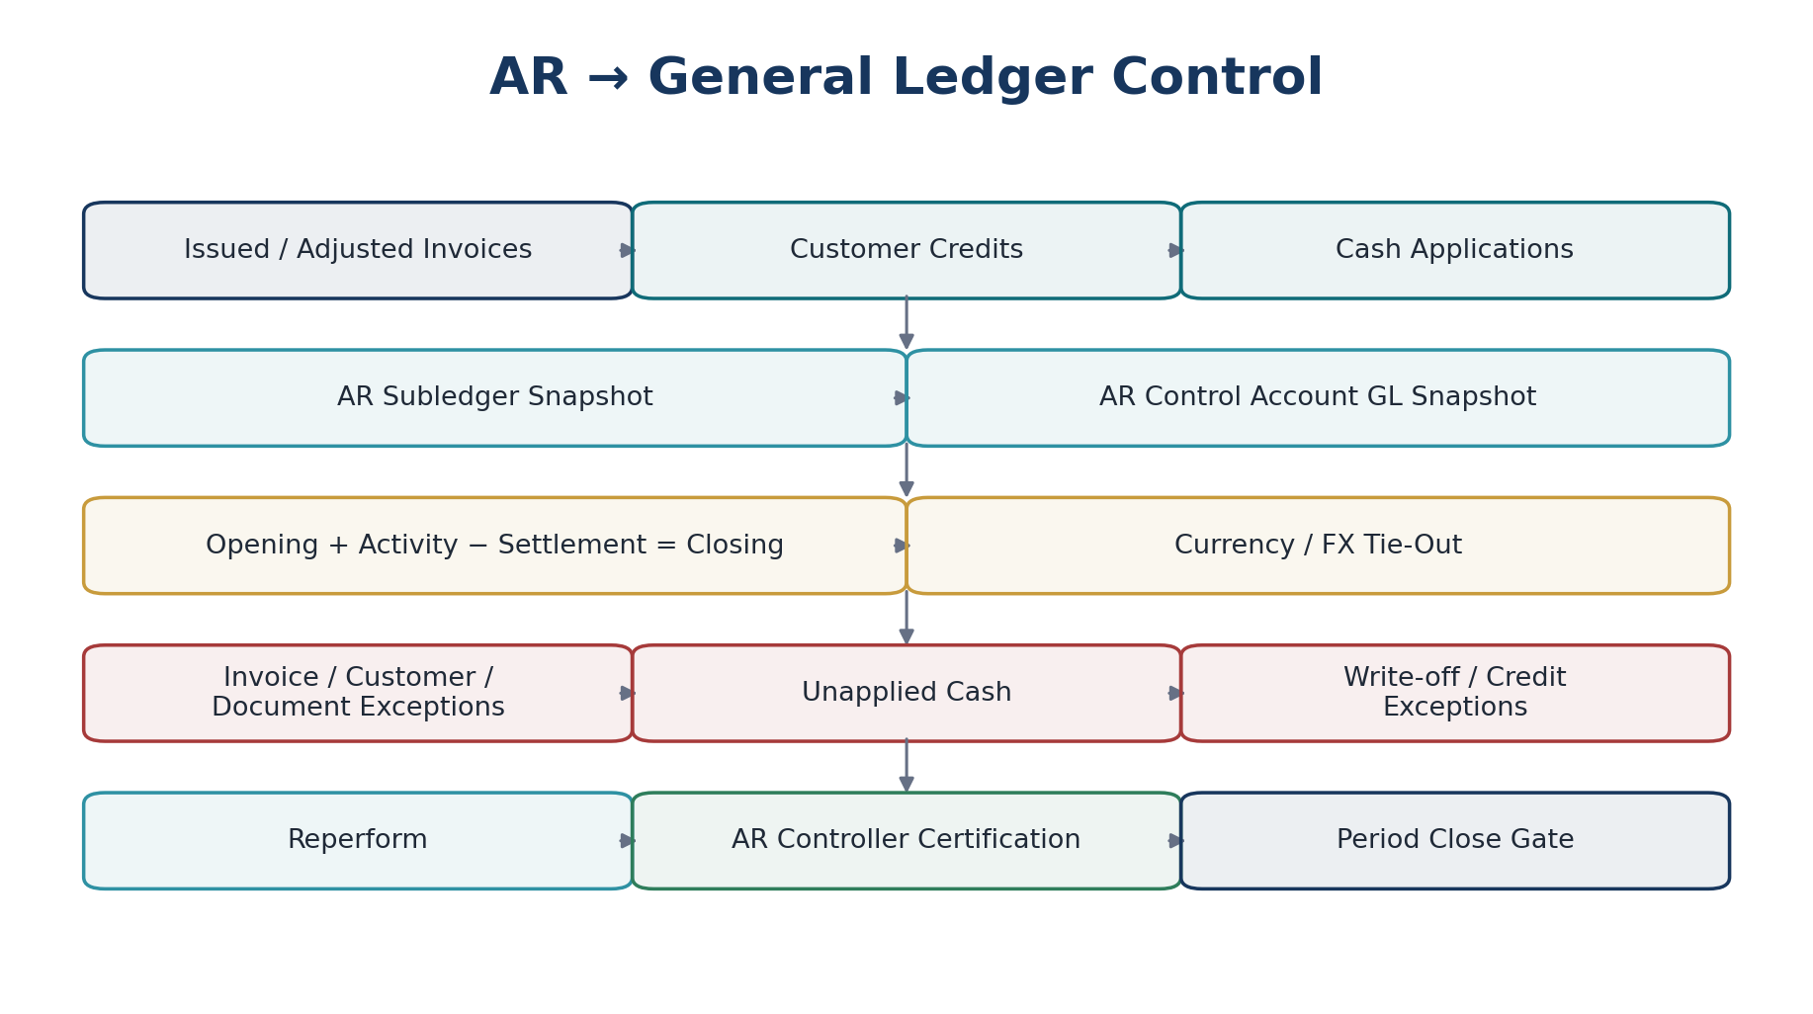
Figure 5 — AR-to-GL reconciliation and certification flow.
Control | Required tests / outputs
AR control-account tie-out | AR subledger closing balance equals GL AR control accounts by entity, book, currency and approved dimensions.
Rollforward | Opening AR + invoices + debit adjustments − credits − cash applications − write-offs = closing AR.
Invoice completeness | Every issued/adjusted invoice is represented once in AR and corresponding accounting consequences exist.
Cash application | Applied receipts tie to invoices; unapplied cash separately reconciled to clearing/unapplied accounts.
Aging integrity | Aging buckets derive from authoritative due dates and outstanding balances; total aging equals AR balance.
FX | Foreign-currency AR original and functional balances tie to approved rate/revaluation outputs.
Exception classes | Missing invoice, duplicate posting, unbalanced application, stale unapplied cash, unauthorized write-off, wrong entity/book/currency.

13. Accounts Payable → GL Detailed Wireframe
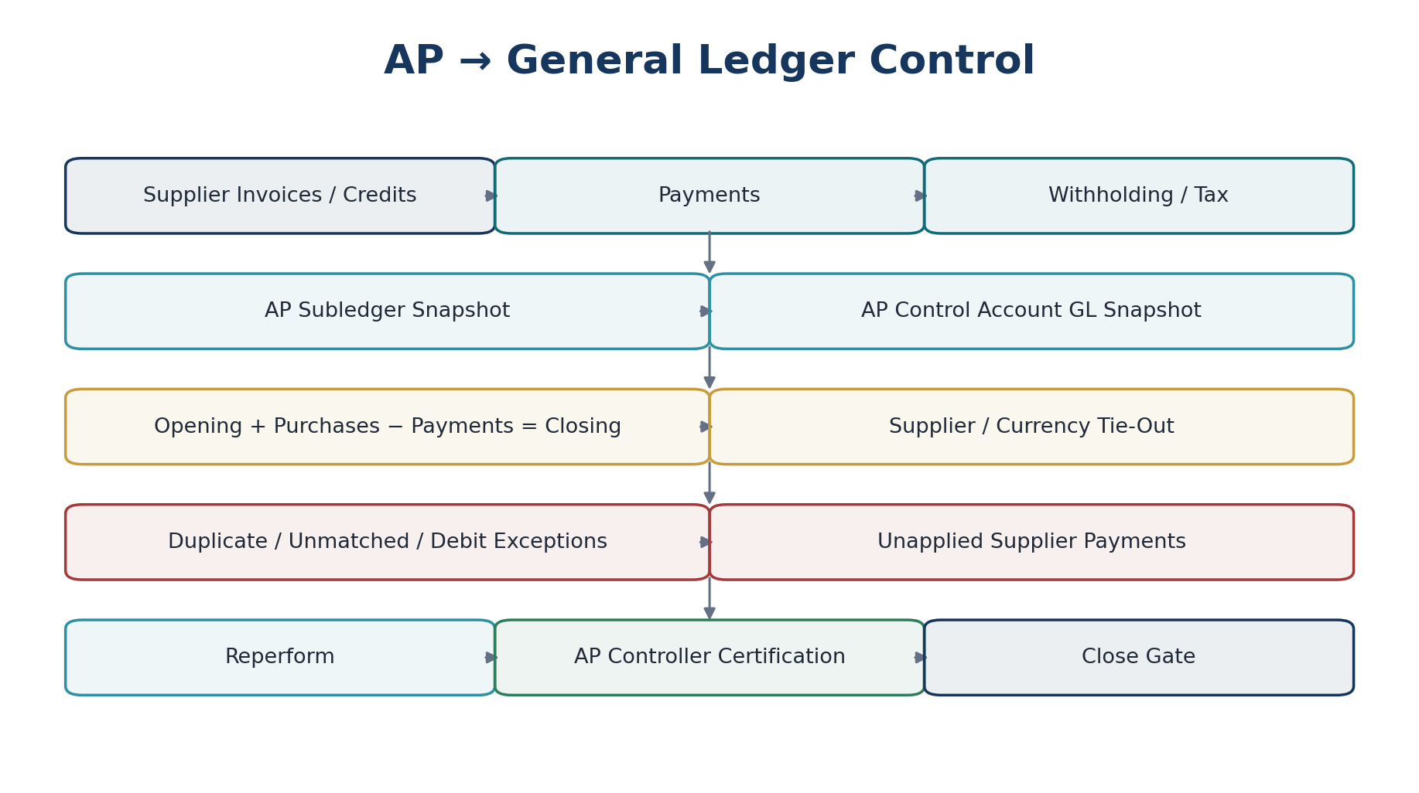
Figure 6 — AP-to-GL reconciliation and certification flow.
Control | Required tests / outputs
AP control-account tie-out | AP subledger equals GL AP control accounts by entity, book, currency and supplier class.
Rollforward | Opening AP + supplier invoices − credits − payments ± adjustments = closing AP.
Invoice completeness | Approved/posted supplier invoices are represented exactly once; duplicates and unposted approvals flagged.
Payment application | Payments allocated to supplier liabilities; unapplied/returned payments separately controlled.
Withholding / tax | Withholding amounts tie to payable/tax liability accounts and statutory records.
Aging integrity | Supplier aging totals equal AP balance and use authoritative due dates.
Exception classes | Duplicate invoice, missing PO/receipt linkage where required, payment mismatch, supplier debit, currency/entity mismatch.

14. Banking & Treasury → GL Detailed Wireframe
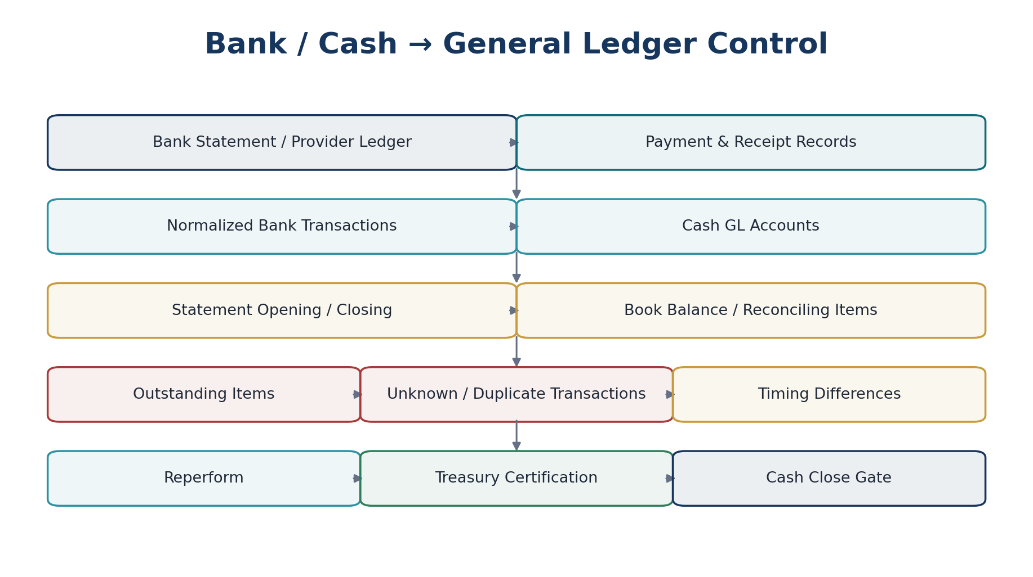
Figure 7 — Bank/provider-to-GL reconciliation with reconciling items and cash certification.
Control | Required tests / outputs
Statement completeness | All statements/transactions for expected account/date range received; missing statement days are exceptions.
Statement-to-book | Statement closing balance = book cash balance +/− approved reconciling items.
Provider settlement | Payment processor/provider settlement totals tie to internal payment/receipt records, fees, chargebacks and cash movement.
Outstanding items | Checks/transfers/deposits in transit carry expected clearing date and age until cleared.
Unknown transactions | Unidentified bank transactions route to controlled suspense/clearing with owner and aging.
Duplicate feed | Duplicate statement/provider transactions are detected before posting or matching.
Balance confirmation | Account ownership/currency/entity and bank-reported closing balance preserved as evidence.

15. Payroll → GL Detailed Wireframe
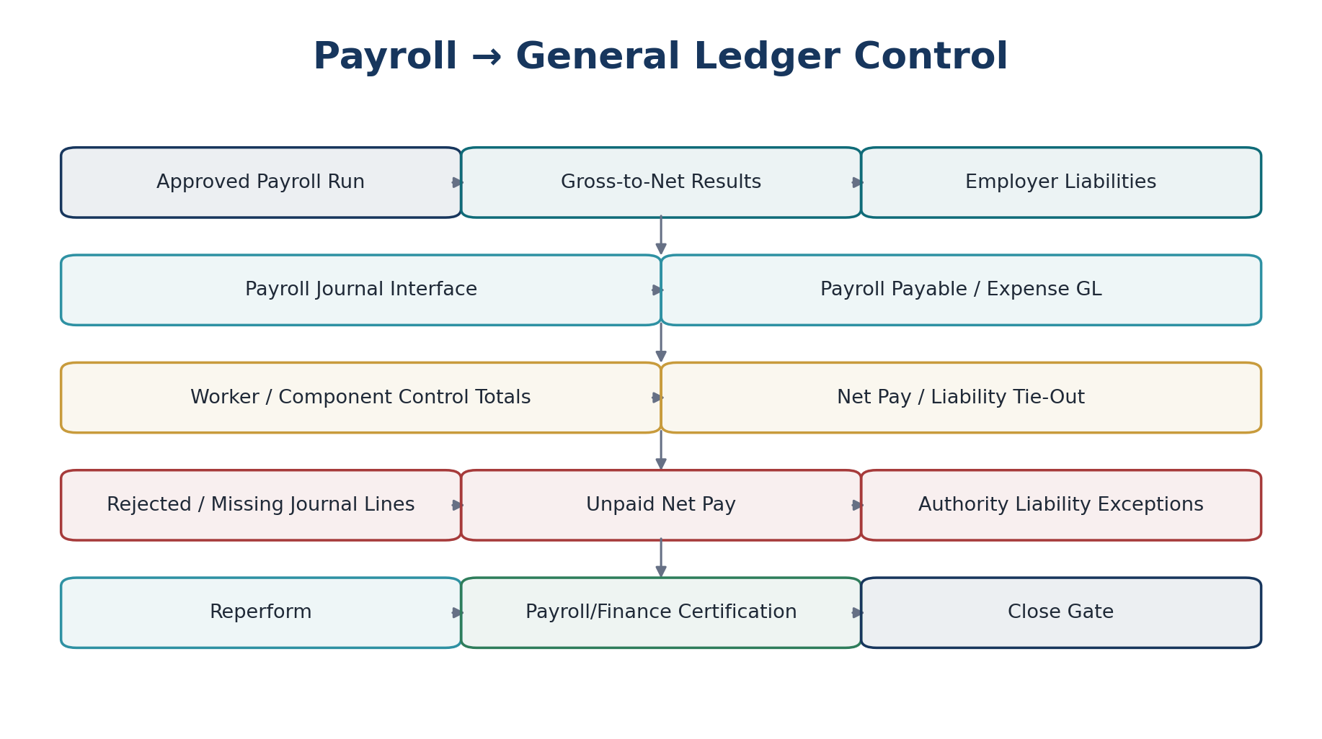
Figure 8 — Payroll-to-GL reconciliation from approved payroll results through payment and statutory liabilities.
Control | Required tests / outputs
Run-to-journal | Approved payroll run totals by earning/deduction/employer component tie to payroll journal interface and GL.
Gross-to-net | Gross earnings − employee deductions/taxes = net pay at worker and run-control-total levels.
Employer liabilities | Employer taxes/contributions tie to statutory liability accounts and payable schedules.
Net pay | Net payroll payable ties to payment instruction population and provider/bank results.
Unpaid/returned payroll | Rejected or returned payments remain explicit liabilities; no silent clearing.
Entity/cost allocation | Payroll expenses and liabilities post to correct employing entity and dimensions.
Rule provenance | Control evidence preserves payroll rule-pack/version references supplied by Zoiko Payroll or authoritative payroll source.

16. Tax → GL & Return Detailed Wireframe
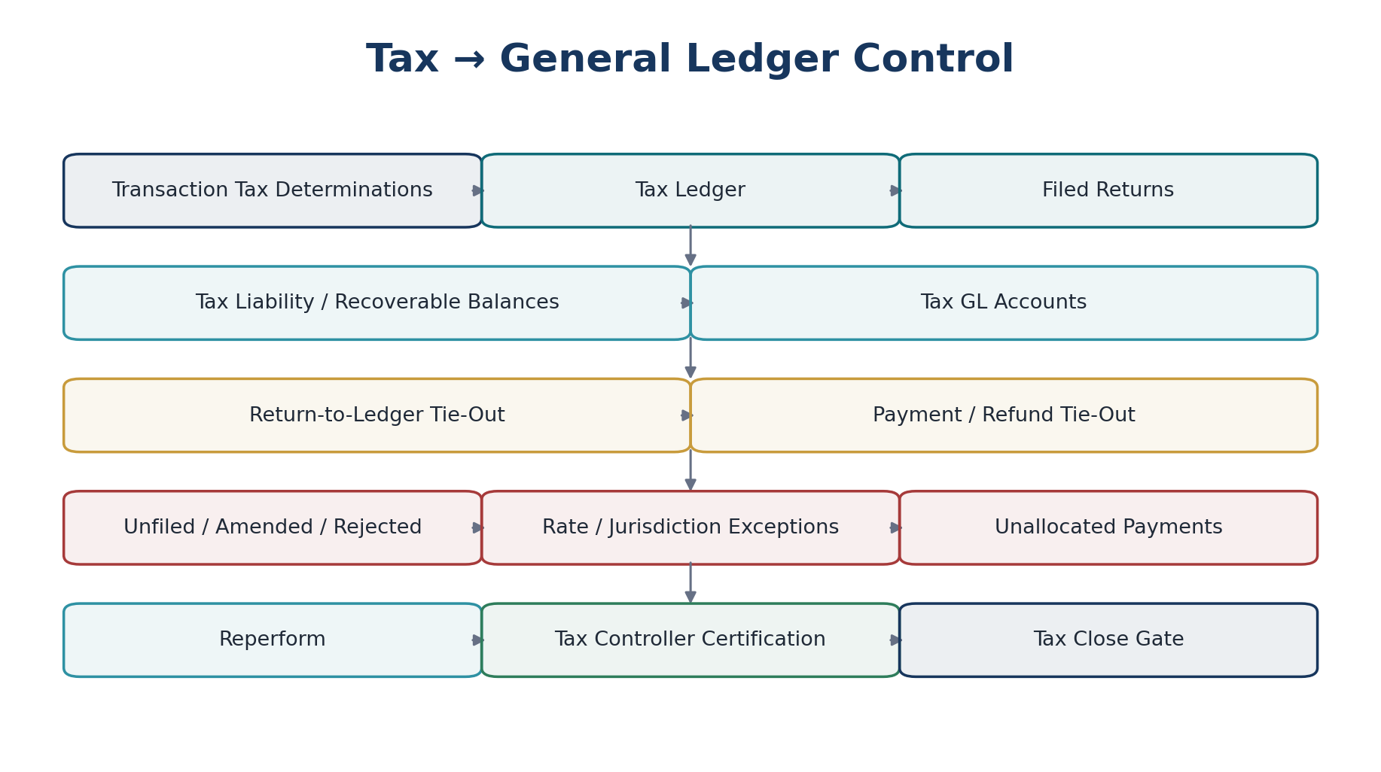
Figure 9 — Tax determination, tax ledger, GL, return and payment reconciliation.
Control | Required tests / outputs
Transaction tax to tax ledger | Tax determinations posted to tax ledger exactly once with rule/jurisdiction provenance.
Tax ledger to GL | Tax payable/recoverable by tax type, jurisdiction and period ties to mapped GL accounts.
Return to tax ledger | Filed/amended return values reconcile to certified tax-ledger population and authorized adjustments.
Return to liability | Accepted filing liability/refund ties to GL tax balance, with differences explained.
Payments/refunds | Authority payments/refunds tie to bank/provider and tax liability clearance.
Filing status | Rejected/unacknowledged returns cannot be treated as accepted merely because transmission succeeded.
Cross-period items | Carryforwards, credits and prior-period amendments remain traceable and separately controlled.

17. Fixed Assets & Inventory → GL Detailed Wireframe
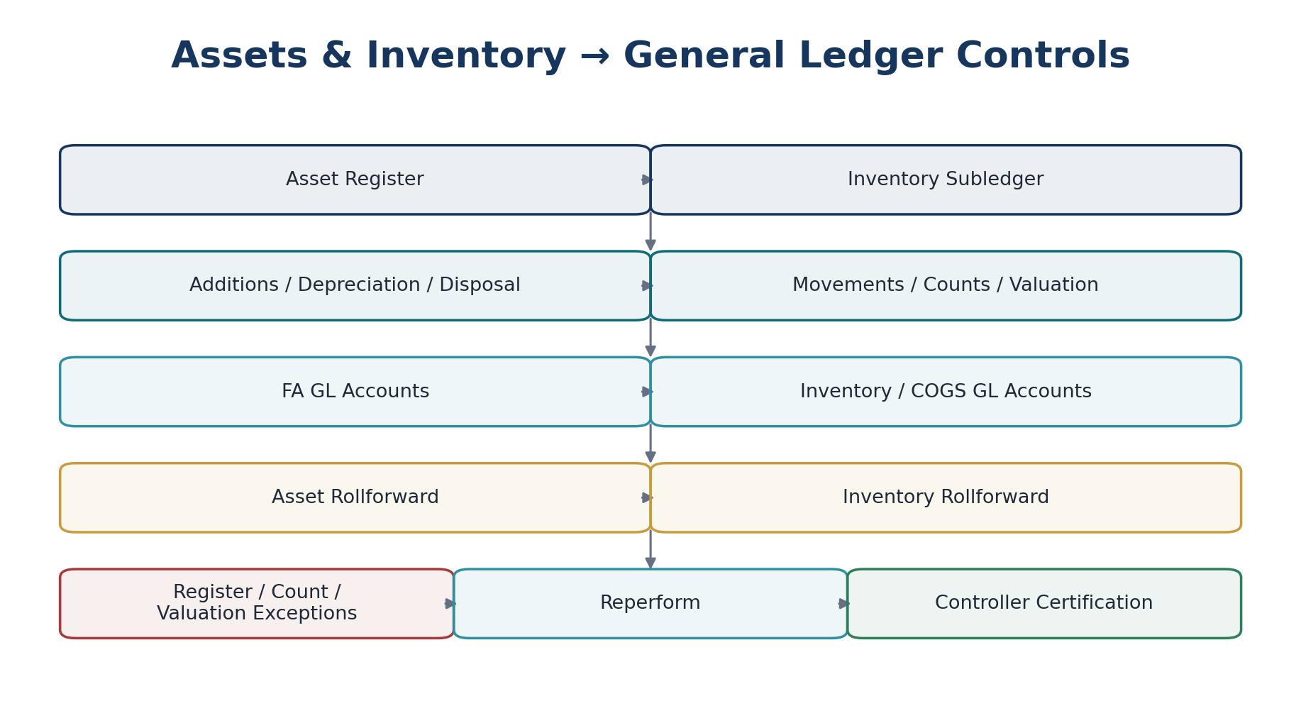
Figure 10 — Fixed-asset and inventory subledger-to-GL controls.
Area | Required tests / outputs
Fixed-asset rollforward | Opening NBV + additions + transfers/revaluations − depreciation − disposals/impairments = closing NBV.
Asset register to GL | Cost, accumulated depreciation and related balances tie to GL control accounts by asset class/entity.
Depreciation | Calculated depreciation agrees to approved method, useful life, policy version and posted journal.
Inventory rollforward | Opening quantity/value + receipts + production/adjustments − issues/sales = closing quantity/value.
Inventory valuation | Subledger valuation agrees to costing policy and inventory/COGS GL accounts.
Physical count | Approved count differences are separately evidenced, approved and posted; unapproved differences remain exceptions.
Negative/invalid inventory | Unsupported negative quantities, valuation layers or location/entity mismatches are control exceptions.

18. Intercompany & Consolidation Detailed Wireframes
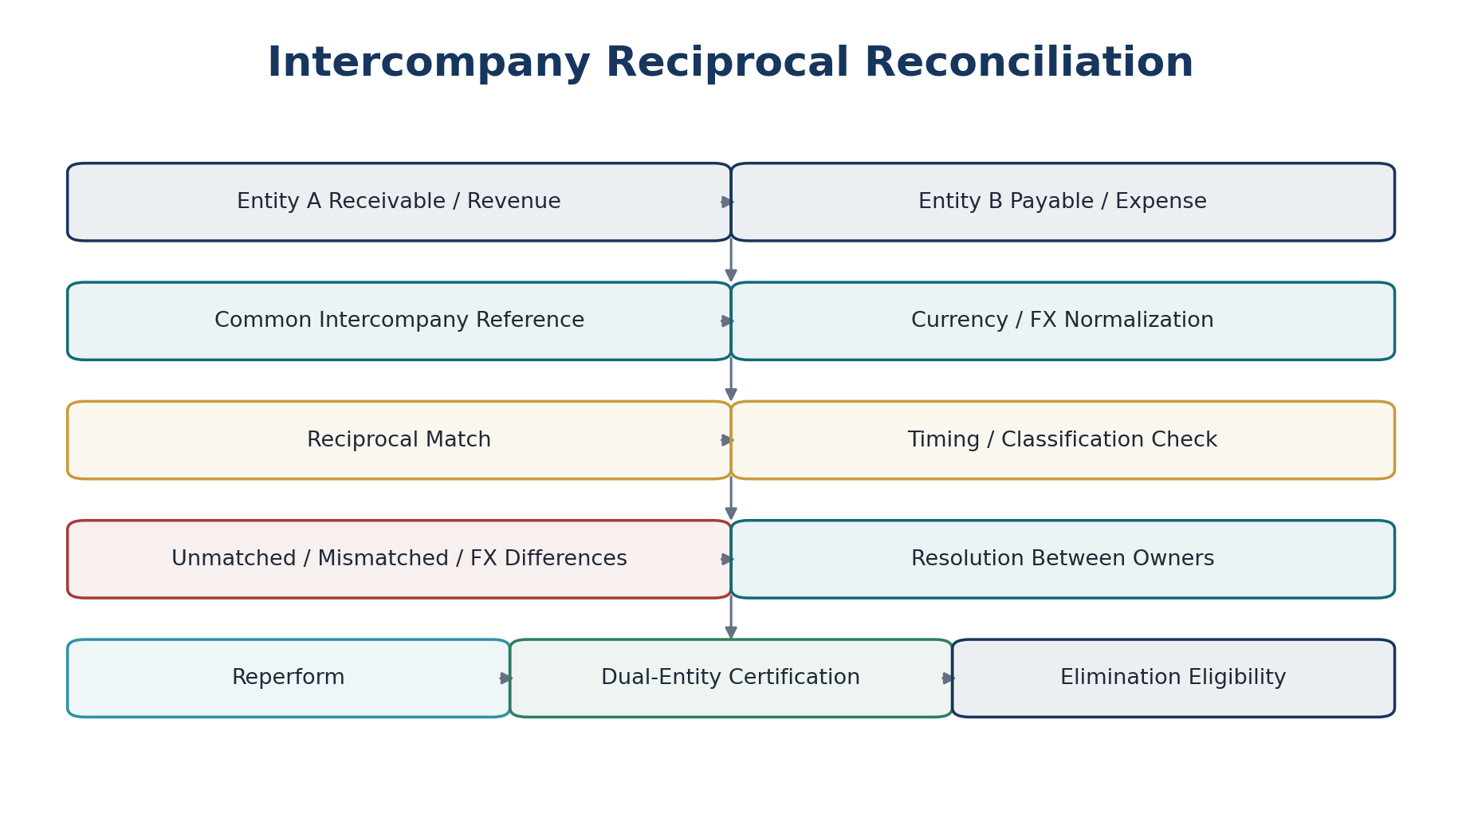
Figure 11 — Reciprocal intercompany reconciliation before elimination eligibility.
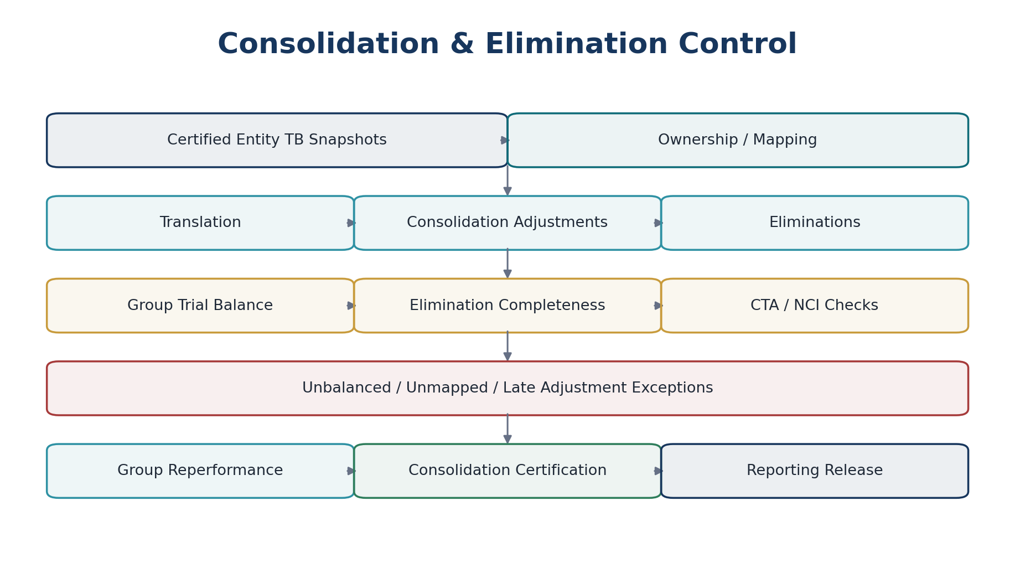
Figure 12 — Consolidation and elimination control flow using certified entity trial-balance snapshots.
Control | Required tests / outputs
Reciprocal balances | Entity A intercompany receivable/payable and P&L counterparties match Entity B by common reference, currency and period.
Reciprocal activity | Intercompany invoices, credits, settlements and journals match on both sides.
FX/timing differences | Differences are classified, aged and resolved before elimination or explicitly adjusted under policy.
Elimination eligibility | Only controlled/matched populations enter automated eliminations unless approved exception policy permits otherwise.
Entity TB certification | Consolidation consumes signed/certified entity trial-balance snapshots with watermarks.
Translation | Functional-to-presentation translation ties to approved FX rates/methodology; CTA controlled separately.
Eliminations | Elimination entries are balanced, traceable to reciprocal source balances and separately reviewed.
Group tie-out | Consolidated statements tie to group trial balance after mappings, adjustments, NCI/ownership effects and eliminations.

19. Integration & Interface Completeness Controls
Control pattern | Required behavior
Source count/hash to ingest | Compare exported source population count/control totals/hash to accepted inbound population.
Ingest to domain commit | Every accepted import record produces authoritative domain outcome or explicit rejection/quarantine.
Domain event to consumer | Use event/inbox metrics to identify missing, duplicate, lagged or poison events.
Provider request to provider result | Every payment/filing/e-invoice request has external attempt state and terminal/owned unresolved outcome.
File import batches | Upload → validate → preview → approve → commit → reconcile; partial failure never masquerades as complete.
Migration/cutover | Opening balances, open AR/AP, cash, tax and other migrated balances reconcile to signed source/control totals before acceptance.
Schema/version | Unexpected schema, code-list or contract version blocks or quarantines; no lossy silent mapping.

20. Suspense, Clearing & Unapplied Balances
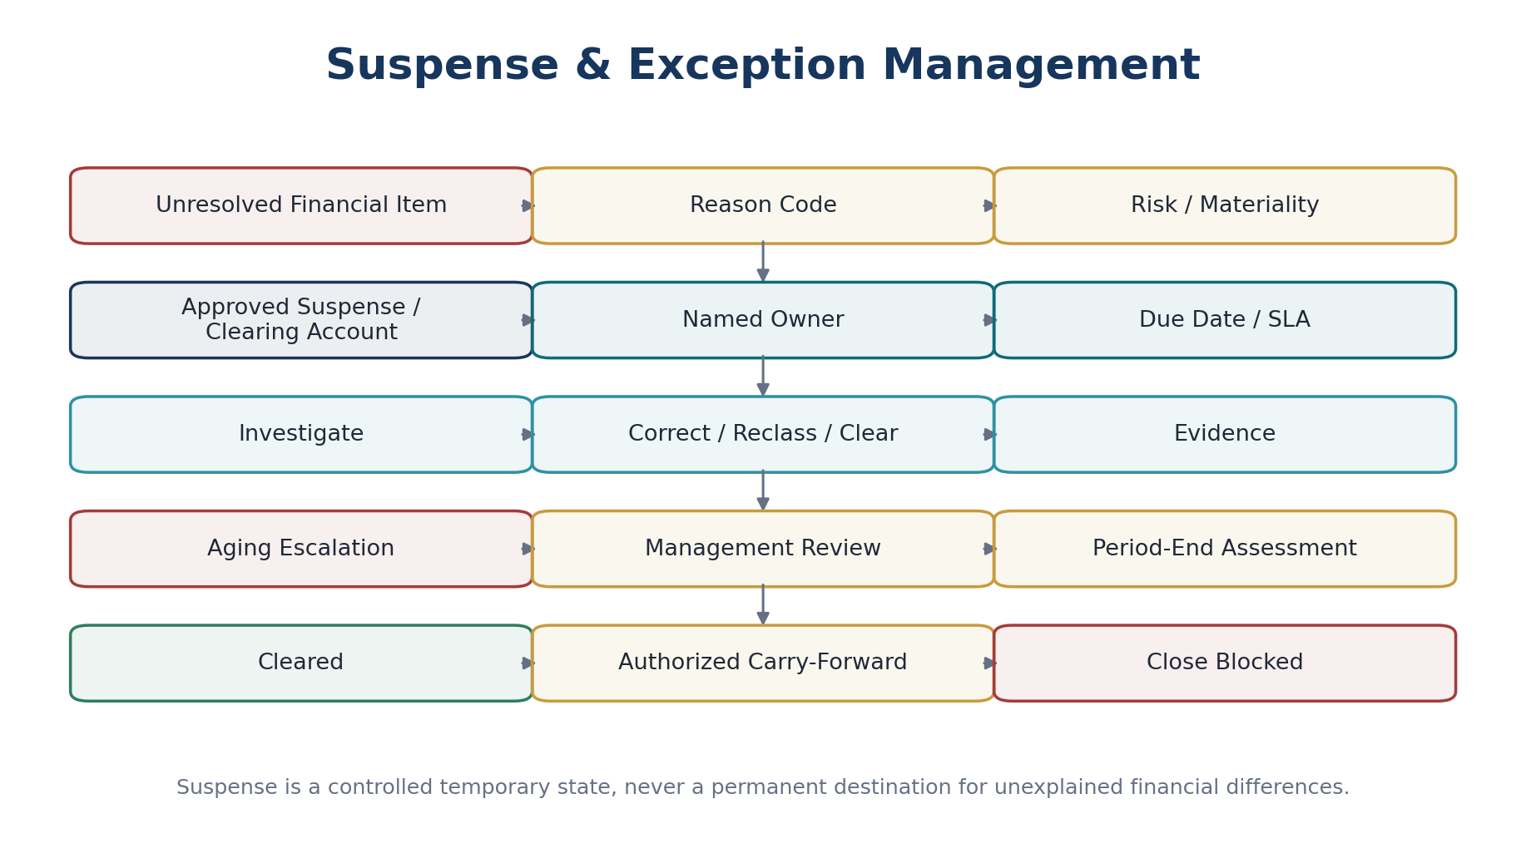
Figure 13 — Suspense and exception control: temporary, owned, aged and actively cleared.
Requirement | Standard
Account allowlist | Only approved suspense/clearing accounts may receive unresolved amounts.
Origin | Each balance links to originating transaction/import/provider record and reason code.
Ownership | Named responsible role/person and legal entity.
Aging | Configurable aging buckets with escalating severity and overdue state.
Materiality | Assess amount and pattern; repeated small balances can escalate.
Clearance | Clearing requires authoritative correction/reclassification/application, not manual status-only closure.
Carry-forward | Requires explicit authority, rationale, assessed financial-statement impact and next review date.
Close impact | Material unexplained suspense may block hard close or reporting release.

21. Exception Management & Root-Cause Control
Exception attribute | Required content
Category | Missing, duplicate, mismatch, timing, valuation, classification, authorization, data quality, external status, late data, control execution failure.
Financial exposure | Original currency and reporting/functional exposure where relevant.
Assertion impacted | Completeness, accuracy, existence, valuation, rights/obligations, cutoff, classification, presentation.
Severity | Policy-derived from materiality, age, recurrence, qualitative risk and close/reporting impact.
Owner / reviewer | Authorized owner and escalation chain.
Due date / SLA | Expected remediation/review time and breach state.
Root cause | Required for significant/recurrent exceptions; standardized taxonomy plus narrative.
Remediation | Authoritative command/workflow reference; adjustment itself lives in owning domain.
Reperformance | Exception cannot be considered control-resolved until the control is reperformed or an authorized alternate procedure is documented.
Recurrence | Recurring exceptions trigger control-design review, not endless item-by-item closure.

22. Period-End Close Certification
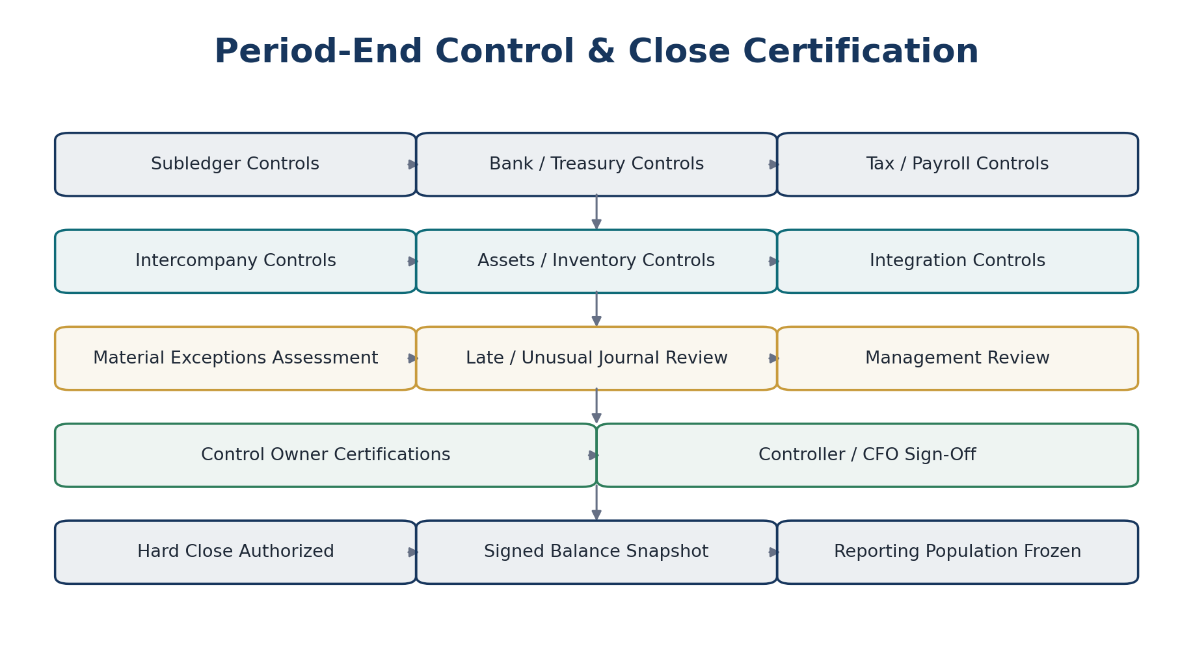
Figure 14 — Period-end close certification using mandatory control results and signed balance snapshots.
Close gate | Minimum evidence
Subledger completeness | Mandatory AR/AP/Payroll/Tax/Assets/Inventory controls certified or policy-approved exception outcome.
Cash | Bank reconciliations complete for material accounts; reconciling items classified and aged.
Intercompany | Material reciprocal differences resolved/approved and elimination population certified.
Unusual/late journals | Late, manual and unusual entries reviewed under defined risk rules.
Suspense | Material suspense/clearing positions resolved or explicitly assessed/authorized.
Reconciliations | Control run IDs and evidence packages pinned to close instance.
Management certification | Named controller and, where required, higher authority certify outstanding items and reporting readiness.
Hard close | Accounting Period Service transitions only after mandatory gates are satisfied; result produces signed balance snapshot/reporting watermark.

23. Source-to-Report Traceability
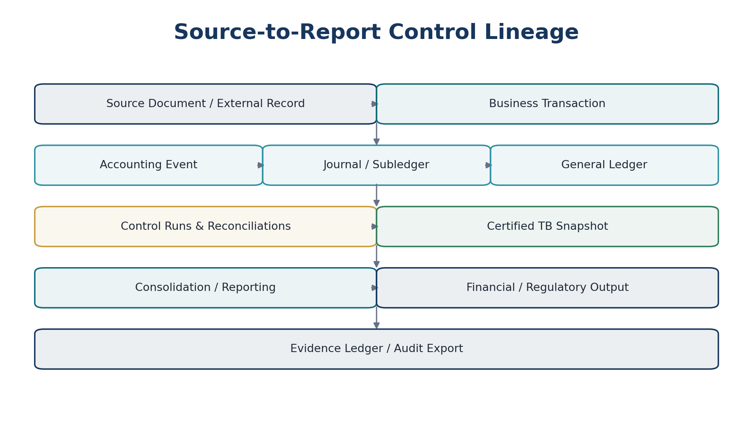
Figure 15 — Source-to-report lineage places control results between the authoritative ledger and released reporting outputs.
For any material financial-statement amount, ZoikoSuite should be able to retrieve the certified reporting population, underlying trial-balance accounts, relevant journals, subledger/source records, applicable control runs, unresolved/approved exceptions, and evidence package.

24. Control Evidence Standard
Evidence component | Required contents
Definition snapshot | Control definition/version, owner, assertion, frequency, risk tier, policy references.
Run context | Tenant/entity/book/period, run ID, trigger, timestamps, software/rule versions.
Population evidence | Source identifiers, query/spec versions, watermarks, counts, totals, hashes.
Execution evidence | Matching/comparison algorithm version, tolerance/materiality versions, result output.
Exceptions | All exceptions, changes, owners, aging, remediation, waivers/carryforwards and reperformance.
Approvals | Preparer/reviewer/certifier identity, authority snapshot, SoD outcome, timestamps.
Accounting correction references | Journal/reversal/adjustment/credit/debit note IDs; control does not embed authoritative correction as free text.
Integrity | Evidence digest/signature or tamper-evident Evidence Ledger reference.
Retention/residency | Retention class, legal hold and residency region/policy.

25. API / Command Wireframe
GET /controls/v1/definitions/{control_definition_id}
POST /controls/v1/runs
GET /controls/v1/runs/{run_id}
GET /controls/v1/runs/{run_id}/population
POST /controls/v1/runs/{run_id}:execute
GET /controls/v1/runs/{run_id}/exceptions
POST /controls/v1/exceptions/{exception_id}:assign
POST /controls/v1/exceptions/{exception_id}:record-remediation
POST /controls/v1/runs/{run_id}:reperform
POST /controls/v1/runs/{run_id}:certify
POST /controls/v1/runs/{run_id}:reject-certification
GET /controls/v1/runs/{run_id}/evidence
GET /controls/v1/periods/{period_id}/close-readiness
Command requirement | Rule
Idempotency | Mandatory for run creation, execution, reperformance and certification commands.
Concurrency | Use expected_version / ETag semantics for exceptions, remediation and certification.
Scope | Tenant/entity/book/period and purpose resolved server-side; client context validated, not blindly trusted.
Authorization | Re-evaluate permission, SoD and certification authority on every material command.
Reason | Required for manual matches, waivers, carry-forward, reruns, supersession and reopen.
Evidence | Material commands append auditable evidence and correlation/causation IDs.
No direct ledger mutation | Correction command references authoritative accounting/domain commands; Control Service cannot PATCH ledger state.

26. Domain Event Contract
Event | Meaning
control.run.created | A governed control run has been created.
control.population.frozen | Population snapshot and watermarks are final for the run.
control.execution.completed | Comparison/test execution finished; result may still require review.
control.exception.opened | A control exception was created.
control.exception.assigned | Ownership established or changed.
control.exception.remediation_recorded | Authorized remediation reference recorded.
control.run.reperformed | Control executed again after remediation.
control.run.ready_for_certification | No further preparer action required before certification decision.
control.run.certified | Authorized certifier approved the run result.
control.run.certification_rejected | Certification rejected; run returns to controlled workflow.
control.run.failed | Control could not determine a valid result.
control.close_gate.blocked | Required control state blocks period close/reporting release.
control.close_gate.satisfied | Required control set is satisfied for the defined scope.
control.exception.sla_breached | Exception exceeded governed SLA/aging threshold.

27. RBAC, SoD & Approval Authority
Control action | Minimum access pattern
Design/modify control definition | Control Architect role; independent approval for key controls.
Modify tolerance/materiality | Finance Control Policy authority; effective-dated change; cannot be same operator widening current-run tolerance.
Prepare/review exception | Scoped preparer/reviewer roles.
Manual match | Explicit permission; reason/evidence; blocked if own-transaction rule applies.
Record remediation | Scoped domain/control role; authoritative financial correction separately authorized.
Certify key control | Named certification authority; maker-checker and dynamic SoD revalidated.
Carry unresolved material exception | Higher authority / close-governance permission; impact assessment required.
Reopen/supersede certified run | Restricted command, reason, evidence, prior certification retained.
Administrative support | JIT privileged session; tenant support boundary and purpose restriction under ZS-IAM-001.

28. Continuous Control Monitoring & Observability
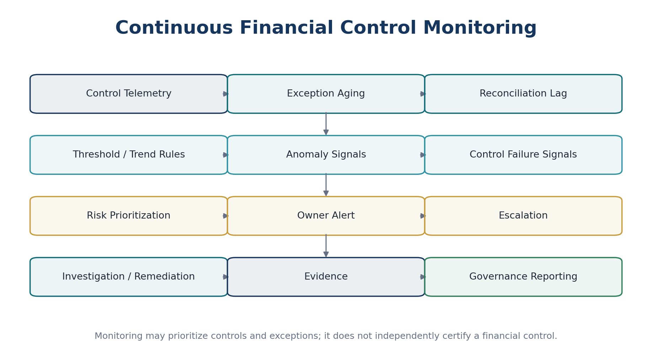
Figure 16 — Continuous control monitoring identifies risk and operational failure without replacing certification authority.
Metric / signal | Why it matters
Control completion rate | Detect missing/scheduled controls and operational gaps.
Run duration / lag | Identify stale control evidence and source-feed delays.
Exception count and amount | Measure control exposure by assertion/domain/entity.
Exception aging | Identify unresolved risk and SLA breaches.
Manual-match rate | High/manual trend may indicate weak source keys or control design.
Recurring exception rate | Signals systemic process/design defects.
Late-data rate | Measures instability of source populations around close.
Suspense aging / value | Direct visibility into unexplained financial balances.
Certification latency | Measures close/readiness bottlenecks.
Control failure / indeterminate rate | Separates financial mismatch from technical inability to execute control.

29. Initial Enterprise Control Catalogue
ID | Control | Owner domain | Level | Frequency | Assertions
FIN-CTRL-001 | AR subledger to GL | Accounting / AR | Balance | Period-end | Completeness, Accuracy
FIN-CTRL-002 | AP subledger to GL | Accounting / AP | Balance | Period-end | Completeness, Accuracy
FIN-CTRL-003 | Bank statement to cash GL | Treasury | Balance | Daily / Period-end | Existence, Completeness, Accuracy
FIN-CTRL-004 | Payment provider settlement | Treasury | Transaction | Daily | Completeness, Accuracy
FIN-CTRL-005 | Payroll run to GL | Payroll / Finance | Balance | Payroll run / Period-end | Completeness, Accuracy, Classification
FIN-CTRL-006 | Payroll net-pay to payment | Payroll / Treasury | Transaction | Payroll run | Completeness, Accuracy
FIN-CTRL-007 | Tax ledger to GL | Tax / Accounting | Balance | Period-end | Completeness, Accuracy
FIN-CTRL-008 | Tax return to tax ledger | Tax | Reporting | Filing period | Completeness, Accuracy, Cutoff
FIN-CTRL-009 | Tax payment/refund to liability | Tax / Treasury | Transaction | Event-driven | Accuracy, Existence
FIN-CTRL-010 | Fixed asset register to GL | Assets / Accounting | Balance | Period-end | Completeness, Valuation
FIN-CTRL-011 | Depreciation run to GL | Assets | Transaction | Period-end | Accuracy, Valuation
FIN-CTRL-012 | Inventory subledger to GL | Inventory / Accounting | Balance | Daily / Period-end | Completeness, Valuation
FIN-CTRL-013 | Physical count to inventory | Inventory | Balance | Count cycle | Existence, Valuation
FIN-CTRL-014 | Intercompany reciprocal balances | Intercompany | Balance | Daily / Period-end | Completeness, Accuracy
FIN-CTRL-015 | Intercompany reciprocal activity | Intercompany | Transaction | Daily / Period-end | Completeness, Cutoff
FIN-CTRL-016 | Elimination completeness | Consolidation | Reporting | Period-end | Completeness, Classification
FIN-CTRL-017 | Entity TB to consolidation input | Consolidation | Interface | Period-end | Completeness, Accuracy
FIN-CTRL-018 | Consolidated TB to statements | Reporting | Reporting | Period-end | Completeness, Presentation
FIN-CTRL-019 | Accounting event to journal | Accounting Kernel | Interface | Continuous | Completeness, Accuracy
FIN-CTRL-020 | Journal debit-credit balance | Accounting Kernel | Transaction | Continuous | Accuracy
FIN-CTRL-021 | Control-account direct posting | Accounting Kernel | Preventive | Continuous | Classification, Authorization
FIN-CTRL-022 | Unposted accounting events | Accounting Kernel | Monitoring | Daily / Close | Completeness
FIN-CTRL-023 | Late/manual journal review | Accounting / Close | Review | Period-end | Occurrence, Authorization, Cutoff
FIN-CTRL-024 | Closed-period posting block | Accounting Kernel | Preventive | Continuous | Cutoff, Authorization
FIN-CTRL-025 | Foreign-currency revaluation to GL | Accounting | Balance | Period-end | Valuation, Accuracy
FIN-CTRL-026 | FX rate source completeness | Reference / Accounting | Interface | Daily | Accuracy, Valuation
FIN-CTRL-027 | Customer invoice sequence / issue completeness | AR | Transaction | Daily | Completeness
FIN-CTRL-028 | Supplier invoice duplicate control | AP | Preventive/Detective | Continuous | Occurrence, Accuracy
FIN-CTRL-029 | Unapplied cash aging | AR / Treasury | Monitoring | Daily | Classification, Accuracy
FIN-CTRL-030 | Supplier unapplied payment aging | AP / Treasury | Monitoring | Daily | Classification, Accuracy
FIN-CTRL-031 | Suspense account aging | Accounting | Monitoring | Daily / Close | Accuracy, Classification
FIN-CTRL-032 | Bank feed completeness | Treasury / Integration | Interface | Daily | Completeness
FIN-CTRL-033 | Import batch completeness | Integration | Interface | Per batch | Completeness, Accuracy
FIN-CTRL-034 | Event producer-consumer completeness | Platform / Domain | Interface | Continuous | Completeness
FIN-CTRL-035 | E-invoice submission to internal invoice | AR / Tax | External | Event-driven | Completeness, Accuracy
FIN-CTRL-036 | E-invoice authority acknowledgement | AR / Tax | External | Event-driven | Occurrence, Completeness
FIN-CTRL-037 | Tax filing acknowledgement | Tax | External | Event-driven | Occurrence, Completeness
FIN-CTRL-038 | Opening balance migration tie-out | Migration / Accounting | Balance | Cutover | Completeness, Accuracy
FIN-CTRL-039 | Open AR/AP migration tie-out | Migration | Balance | Cutover | Completeness, Accuracy
FIN-CTRL-040 | Report population to certified TB | Reporting | Reporting | Per report | Completeness, Presentation
FIN-CTRL-041 | Close mandatory-control gate | Close | Entity-level | Period-end | Reporting reliability
FIN-CTRL-042 | Material exception aggregation | Close / Controls | Monitoring | Period-end | Reporting reliability
FIN-CTRL-043 | Related-party/intercompany classification | Accounting / Governance | Transaction | Daily / Close | Classification
FIN-CTRL-044 | Cash account ownership/entity validation | Treasury / Master Data | Preventive | On change | Rights & obligations
FIN-CTRL-045 | Supplier bank detail change vs payment release SoD | AP / Treasury / IAM | Preventive | Continuous | Authorization

30. Negative-Path Engineering Acceptance Scenarios
# | Scenario | Expected control outcome
01 | Duplicate source transaction | Control identifies duplicate and prevents false completeness result.
02 | Missing source record downstream | Population/count/hash control fails and opens completeness exception.
03 | Two totals agree but record composition differs | Record-level comparison detects offsetting errors; run cannot pass from headline total alone.
04 | Operator widens tolerance during run | Rejected; tolerance version is pinned to run.
05 | Late event after population freeze | Creates late-data exception/new run; certified population is not silently mutated.
06 | Manual match with amount difference | Requires explicit approved tolerance or remains exception; narrative alone cannot force pass.
07 | Unmatched bank transaction | Routes to owned suspense/clearing; ages until resolved.
08 | Suspense item reaches aging threshold | Severity/escalation increases; close gate responds according to policy.
09 | Control engine technical outage | Result is Indeterminate/Failed, never Pass.
10 | Certifier prepared same key control where prohibited | Dynamic SoD blocks certification.
11 | Certification authority revoked before sign-off | Execution-time authorization check blocks certification.
12 | Certified run later found erroneous | Original certification retained; controlled superseding/reopen workflow required.
13 | AR balance equals GL but unapplied cash excluded improperly | Population/exclusion controls identify omission.
14 | AP duplicate invoice posts twice | Duplicate/completeness controls open exception; reconciliation does not conceal by netting.
15 | Provider callback duplicated | External-state reconciliation remains idempotent; duplicate does not duplicate settlement.
16 | Bank statement day missing | Statement completeness control fails before ordinary transaction matching.
17 | Payroll journal missing one worker/component | Run-to-journal control totals and record-level reconciliation fail.
18 | Tax return transmitted but authority rejected | Filing control remains rejected/unresolved; GL liability not treated as accepted result.
19 | Inventory count adjustment unapproved | Subledger-to-GL control flags unauthorized/unposted difference.
20 | Intercompany balances differ by FX timing | Classify separately; elimination eligibility follows policy, not forced match.
21 | Entity TB changes after consolidation population freeze | Late-change exception/new consolidation run required.
22 | Report uses non-certified trial balance | Reporting release/control gate blocks or visibly marks non-certified population.
23 | Migration control totals match but open-item identities missing | Migration acceptance fails identity/population completeness checks.
24 | Exception waived without authority | Command rejected and waiver not applied.
25 | Series of individually immaterial exceptions becomes material in aggregate | Aggregation control escalates and reassesses close impact.
26 | Recurring exception repeatedly closed item-by-item | Recurrence metric triggers control-design/root-cause review.
27 | AI suggests incorrect match | Suggestion has no authoritative effect until deterministic/human-controlled action; evidence preserved.
28 | Cross-tenant reconciliation query attempted | Authorization and tenant isolation block population construction.
29 | Control evidence document under legal hold | Retention/disposition cannot delete supporting evidence.
30 | Control definition changes mid-period | Existing runs stay pinned; new version applies under effective-date/reperformance policy.

31. Definition of Ready — Control Implementation
- Control owner, reviewer/certifier and accountable domain identified.
- Financial assertion and risk addressed are explicit.
- Scope (tenant/entity/book/account/currency/jurisdiction) is defined.
- Source and target populations are authoritative and reproducible.
- Control frequency/trigger and close criticality are approved.
- Matching/comparison rules and data normalization are specified.
- Tolerance/materiality policies are approved and versioned.
- Exception taxonomy, severity, owner and SLA model are defined.
- SoD and certification authority are defined.
- Evidence, retention and residency requirements are defined.
- Negative test cases and expected results are documented.
- Operational owner/SLO and failure escalation exist.

32. Definition of Done — Control Implementation
- Control executes against authoritative reproducible populations.
- Run, result, exception and certification states comply with ZS-STATE-001.
- Idempotent commands and concurrency controls comply with ZS-API-001.
- Events comply with ZS-EVENT-001 and do not lose committed control state.
- RBAC/ABAC/SoD checks comply with ZS-IAM-001.
- Tolerance/materiality versions and calculation/matching versions are persisted.
- Evidence package is complete and tamper-evident.
- Reperformance works after authoritative remediation.
- All negative-path scenarios for the control pass.
- Control metrics, alerts, runbooks and on-call ownership exist.
- Performance/load tests support expected transaction and close volumes.
- Finance/Accounting/Tax/Treasury owner accepts control behavior and release gate.

33. Engineering Implementation Sequence
Wave | Scope | Exit gate
0 | Control metadata model, evidence model, IAM integration, run state machine. | Create and retrieve governed control definitions/runs.
1 | Population builder, watermarks, hashes, exact matching, exceptions. | Deterministic side-A/side-B reconciliation with evidence.
2 | AR, AP and Bank/Cash controls. | Core operating subledgers reconcile to GL.
3 | Payroll, Tax, Assets and Inventory controls. | Specialized financial domains reconcile to GL.
4 | Intercompany, consolidation and reporting controls. | Certified entity-to-group/reporting chain.
5 | Suspense/aging, close gates, certification, materiality aggregation. | Period close can depend on control framework.
6 | External provider/integration completeness and migration controls. | End-to-end source/provider assurance.
7 | Continuous monitoring, dashboards, recurrence/root-cause metrics. | Operational financial-control command center.
8 | Scale, DR, evidence export, external-audit support, jurisdiction overlays. | Enterprise production certification.

34. Controlled Decisions Before Production
Decision | Required owner / evidence
Key-control classification by domain/entity | Finance Controls / Controller / Audit; risk assessment and materiality.
Materiality methodology and thresholds | CFO/Controller; reporting basis and governance approval.
Tolerance catalogue | Finance domain owners; test evidence and rationale.
Control frequency and close criticality | Controller / process owners; risk-based design.
Exception SLA and escalation matrix | Finance Operations / Risk.
Suspense aging limits | Controller / Treasury / Tax as appropriate.
Certification hierarchy | Finance leadership + IAM/SoD governance.
Evidence retention | Legal/Compliance/Tax/Audit + jurisdiction-pack rules.
Continuous-control SLOs | Engineering/SRE + Finance Controls.
External-audit reliance package format | Audit/Finance Controls; engagement-specific validation where required.

35. Prohibited Control Anti-Patterns
- A reconciliation that can be marked complete without a population definition.
- A generic “difference = zero” test used as proof of all financial assertions.
- Mutable certified evidence or overwritten prior control runs.
- Manual deletion of exceptions to make a control pass.
- Uncontrolled Excel/CSV as the sole evidence for a key automated control.
- Runtime tolerance widening by the preparer.
- Control engine direct writes to posted ledger balances or journal lines.
- Permanent unexplained suspense or clearing balances.
- Automatic waiver of material exceptions.
- Close override through frontend/database status edits.
- Same person prepares and certifies a key control where policy requires separation.
- AI autonomous certification, waiver, accounting correction or close authorization.
- Using analytics/search caches as authoritative reconciliation sources.
- Treating a technical control failure as financial Pass.
- Ignoring late-arriving data after certification.

36. Standards & External Reference Anchors
This architecture is a product-engineering control framework, not a legal opinion or substitute for an entity’s own internal-control assessment. Its control taxonomy and evidence design are informed by recognized financial-control concepts.
Reference | Architecture relevance
COSO Internal Control — Integrated Framework (2013 refresh) | Provides widely used principles for control environment, risk assessment, control activities, information/communication and monitoring; supports the distinction between preventive, detective and monitoring controls.
PCAOB AS 2201 — Audit of Internal Control Over Financial Reporting | Provides recognized ICFR concepts including reliability of financial reporting, period-end process controls, relevant assertions and risk-based control evaluation. Amendments shown by PCAOB become effective December 15, 2026.
Approved ZoikoSuite standards ZS-DATA/ACC-KERNEL/STATE/API/EVENT/IAM/JUR | Authoritative internal architecture governing data, posting, states, commands, events, access and jurisdiction logic.

Official reference links: https://www.coso.org/internal-control and https://pcaobus.org/oversight/standards/auditing-standards/details/AS2201

37. Final Architecture Decision
ZoikoSuite shall implement financial reconciliation and control as a governed platform capability with versioned definitions, reproducible populations, deterministic matching/testing, explicit exception management, authoritative remediation references, reperformance, certification, close gating and durable evidence. The framework verifies financial truth; it never becomes a second ledger.

The next companion document in the approved sequence is ZS-SEC-001 — ZoikoSuite Security, Privacy, Residency & Cryptographic Architecture Standard. It must not be started until ZS-CONTROL-001 is approved.

