ZOIKOSUITE
GLOBAL JURISDICTION PACK &
REGULATORY RULE ARCHITECTURE STANDARD
Detailed Engineering Wireframe

Build-ready control architecture for versioned, effective-dated, source-proven regulatory rules across accounting, tax, invoicing, filing, payroll statutory parameters, retention and business compliance.

Field | Value
Document ID | ZS-JUR-001
Version | 1.0 — Global Jurisdiction & Regulatory Rule Baseline
Date | August 24, 2026
Status | Engineering architecture baseline; jurisdiction-specific packs require local expert/legal/tax validation before production activation.
Owner | ZoikoSuite Product / Platform Architecture / Global Tax & Regulatory Engineering
Prepared for | Engineering, Product, Tax, Accounting, Legal, Payroll, Compliance, Security, Data, QA, DevOps, Support
Language | American English

1. Executive Doctrine
ZoikoSuite must treat jurisdiction-specific law and regulation as a governed software supply chain. Regulatory behavior must not be scattered across application code, mutable database flags, UI conditionals, spreadsheets or analyst memory. It must be compiled into signed, versioned jurisdiction-pack artifacts that can be resolved deterministically at runtime and reconstructed historically.
One regulatory outcome must be explainable as: applicable jurisdiction → applicable regime → exact pack version → exact rule version → authoritative source → runtime facts → deterministic result → approval/evidence trail.

2. Critical Architecture Review & Refinements
Risk found in naïve design | Required refinement
One “country configuration” object | Model jurisdiction, subdivision, regime and version separately; one country can contain many authorities and obligations.
Newest rule wins | Resolve by effective date, transaction/tax-point date, filing period and other domain dates; preserve historical versions.
Tax rates stored as editable rows | Rates, thresholds, formulas and exemptions live in immutable released rule modules with provenance and tests.
Government websites referenced informally | Capture authoritative source metadata, publication/effective dates, jurisdiction, hash/snapshot reference and interpretation record.
Country packs encode only tax | Packs must cover invoicing, e-invoicing/reporting, filing, calendars, registrations, retention, payroll statutory parameters and related accounting mappings where in scope.
Developers directly patch production rules | Author → test → independent review → certify → sign → staged deploy; emergency hotfix still uses evidence and dual approval.
Rollback means reinstall old code | Pack release and application release are decoupled; pack rollback is controlled, reversible and evidence-preserving.
Rules conflict silently | Precedence metadata and conflict tests are mandatory; unresolved conflicts block certification.
AI interprets law at runtime | AI may assist research/drafting, but authoritative runtime rules must be human-reviewed deterministic artifacts.
One pack version per country | Different rule families can have separate release cadence but must resolve through a coherent pack manifest and compatibility matrix.
Regulatory calendar is manually entered | Due dates are derived from effective-dated obligation rules plus business-day/holiday rules and permitted extensions.
Compliance tests are examples only | Golden, boundary, historical, negative, migration and cross-pack regression cases are release gates.

3. Non-Bypassable Jurisdiction-Pack Invariants
- No production regulatory rule exists outside a registered pack artifact.
- Every material rule has a stable rule ID, jurisdiction/regime scope, effective interval and provenance.
- Released pack versions are immutable; corrections create new versions.
- Historical calculations remain reproducible using the original pack/rule version.
- The client may provide facts; the server resolves applicable jurisdiction, regime and authoritative rule version.
- No runtime dependency on a live government website is required for core deterministic decisions.
- A pack cannot be promoted without deterministic tests, approval evidence and a signed digest.
- Unresolved precedence or rule conflicts block release.
- Regulatory rule changes never silently rewrite previously posted accounting, filed returns or issued invoices.
- External filing/e-invoicing schemas and code lists are versioned dependencies, not hard-coded constants.
- Time zones, holidays and business-day rules are explicit inputs to deadline calculation.
- Jurisdiction packs are residency-aware deployment artifacts but are not themselves tenant data.
- Sensitive credentials for authorities/networks never live inside pack artifacts.
- AI-generated interpretation is never authoritative without qualified human approval.
- A pack release has an owner, support window, rollback path and observability plan.
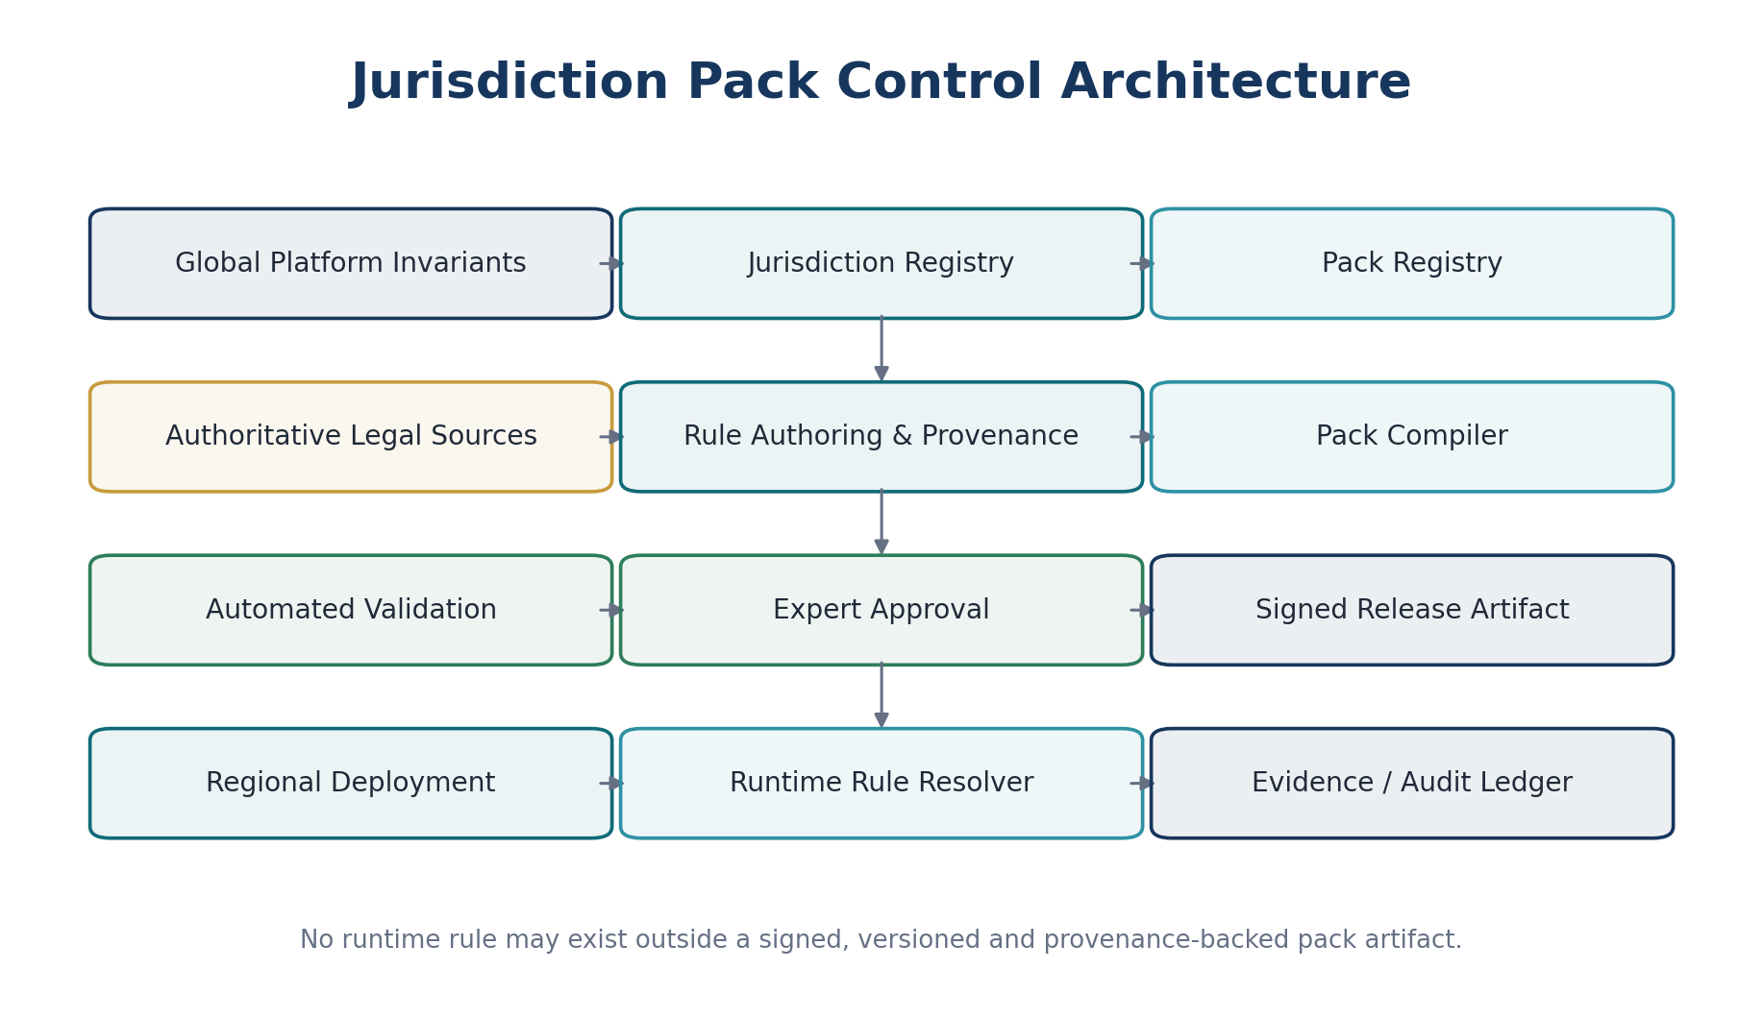
Figure 1 — Jurisdiction Pack Control Architecture

4. Canonical Jurisdiction & Regulatory Hierarchy
The model separates legal authority from software deployment. A jurisdiction is a legal/regulatory scope; a regime is a coherent rule family applied within one or more jurisdictions; a pack is the versioned software artifact that implements approved rules.
Object | Purpose | Illustrative examples
Global baseline | Platform-wide invariants and shared data types | Money/date precision, provenance, rule identity, evidence
Supranational/treaty layer | Rules spanning multiple sovereign jurisdictions | EU VAT framework, treaty provisions where product scope supports them
Country | National authority scope | United Kingdom, United States, India, Australia, Germany, Canada
Subdivision | State/province/territory/land scope | US state, Canadian province, German Land, Indian state
Local authority | Municipality/county/local tax or filing scope | Local levy or registration where supported
Regime | Cohesive regulatory domain | VAT/GST, sales tax, withholding, e-invoicing, corporate filing, payroll statutory, retention
Jurisdiction pack | Signed implementation artifact | Rules + schemas + code lists + tests + evidence + release metadata

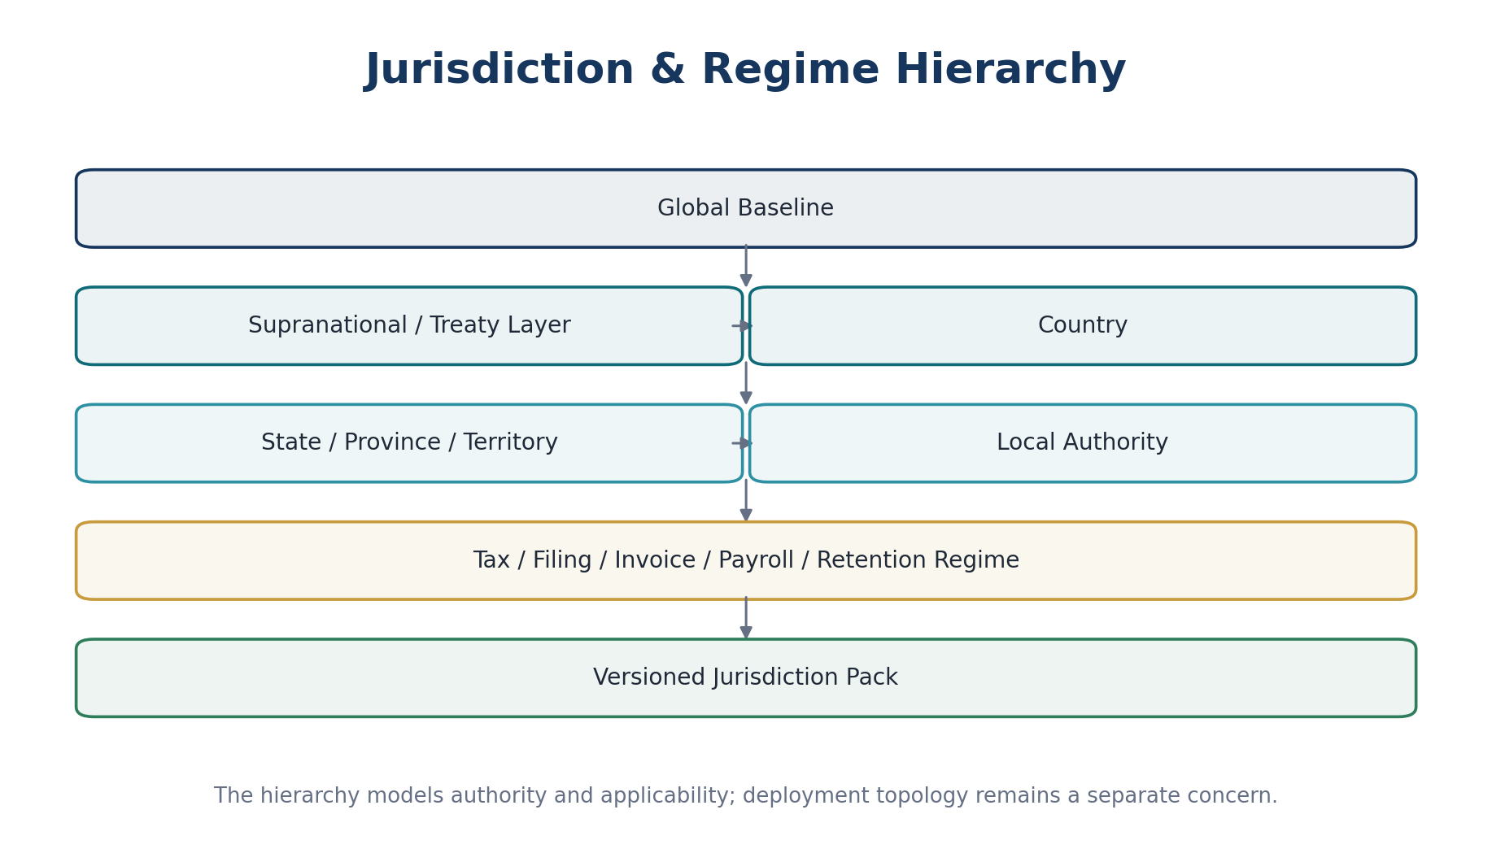
Figure 2 — Jurisdiction and Regime Hierarchy

5. Pack Manifest — Canonical Contract
Every jurisdiction-pack release must be described by a machine-readable manifest. The manifest is the entry point for discovery, dependency resolution, signature verification and runtime eligibility.
pack_id: jur.gb.tax.core
pack_version: 2026.08.1
jurisdiction_ids: [GB]
regimes: [vat, withholding, filing-calendar]
status: released
effective_from: 2026-08-01
effective_to: null
dependencies:
- ref.iso4217@2026.06
- global.tax.core@3.4
source_register_version: 14
rule_modules: [...]
schema_dependencies: [...]
test_bundle_digest: sha256:...
artifact_digest: sha256:...
approval_refs: [...]
signature: ...
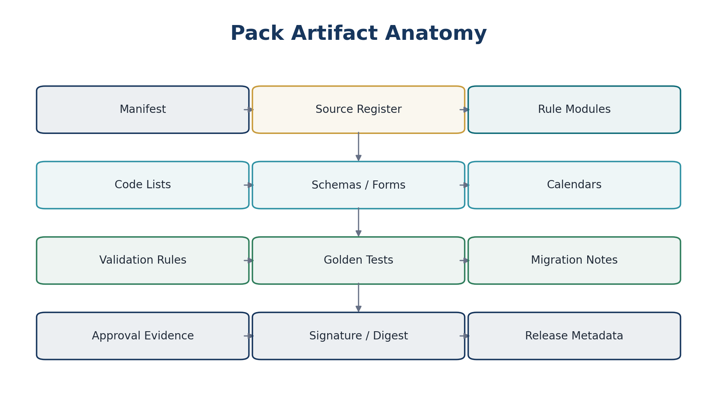
Figure 3 — Pack Artifact Anatomy

6. Required Pack Components
Component | Mandatory content | Control
Manifest | Identity, version, scope, dependencies, dates, status, digests | Schema validated; immutable once released
Source Register | Authority, document/URL reference, publication date, effective date, source classification, captured hash/snapshot reference | Independent source review
Rule Modules | Rates, thresholds, formulas, applicability, exemptions, validations, mappings | Stable rule IDs + effective dates
Code Lists | Tax codes, authority codes, invoice codes, reason codes, schema enumerations | Versioned dependency
Schemas / Forms | XML/JSON/XBRL/e-file/e-invoice structures where legally/technically required | Checksum + compatibility version
Calendars | Holidays, business-day rules, filing cycles, due-date formulas | Effective dated and independently testable
Validation Rules | Structural, semantic, cross-field and jurisdiction-specific validations | Machine executable
Golden Tests | Known inputs and expected outputs | Release blocking
Migration Notes | Behavior changes and affected records/processes | Required for breaking/behavioral change
Approval Evidence | Reviewer roles, decisions, timestamps, interpretation refs | Immutable evidence
Release Metadata | Promotion ring, support owner, monitoring, rollback target | Operational ownership

7. Rule Identity, Effective Dating & Temporal Semantics
Field | Requirement
rule_id | Stable semantic identifier; never reused for a different meaning.
rule_version | Monotonic or semantically ordered implementation version.
jurisdiction_id | Canonical jurisdiction registry reference.
regime_id | Canonical regulatory regime reference.
effective_from / effective_to | Business-effective legal interval.
recorded_at | When ZoikoSuite recorded the rule version.
published_at | Publication timestamp/date from authority where available.
applies_to_period_from/to | Optional filing/payroll/reporting-period applicability separate from transaction date.
source_refs | One or more authoritative source records.
precedence | Declared resolution precedence; never implicit.
supersedes | Prior rule/version reference when appropriate.
interpretation_ref | Approved interpretation/decision record.
status | Draft, review, certified, released, withdrawn, superseded.

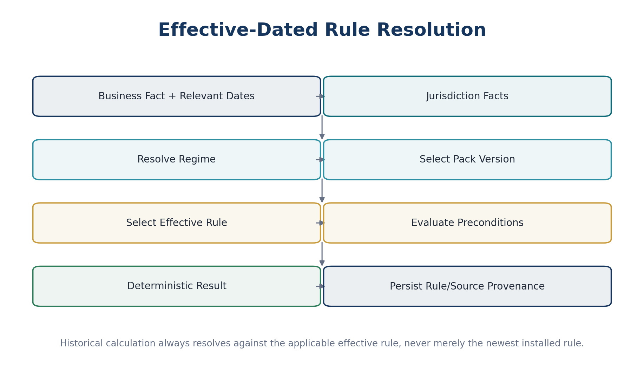
Figure 4 — Effective-Dated Rule Resolution

8. Authoritative Source & Provenance Standard
The Source Register is evidence, not merely a bibliography. Each rule must be traceable to the authority material used to create or change it.
Source attribute | Requirement
source_id | Immutable internal ID.
authority | Issuing legislature, ministry, tax authority, regulator, standards body or network.
source_type | Statute, regulation, notice, technical specification, schema, guidance, administrative ruling, code list, official calendar.
title / identifier | Human-readable title and official identifier where available.
publication / effective dates | Captured separately.
location | Official URL, publication reference or controlled document store reference.
snapshot/hash | Evidence that the reviewed source can be identified later.
language | Original language and approved translation reference where needed.
authority_level | Binding law / regulation / administrative requirement / technical mandate / guidance.
reviewed_by | Qualified reviewer and date.
interpretation_notes | Controlled rationale; not embedded as informal developer comments.

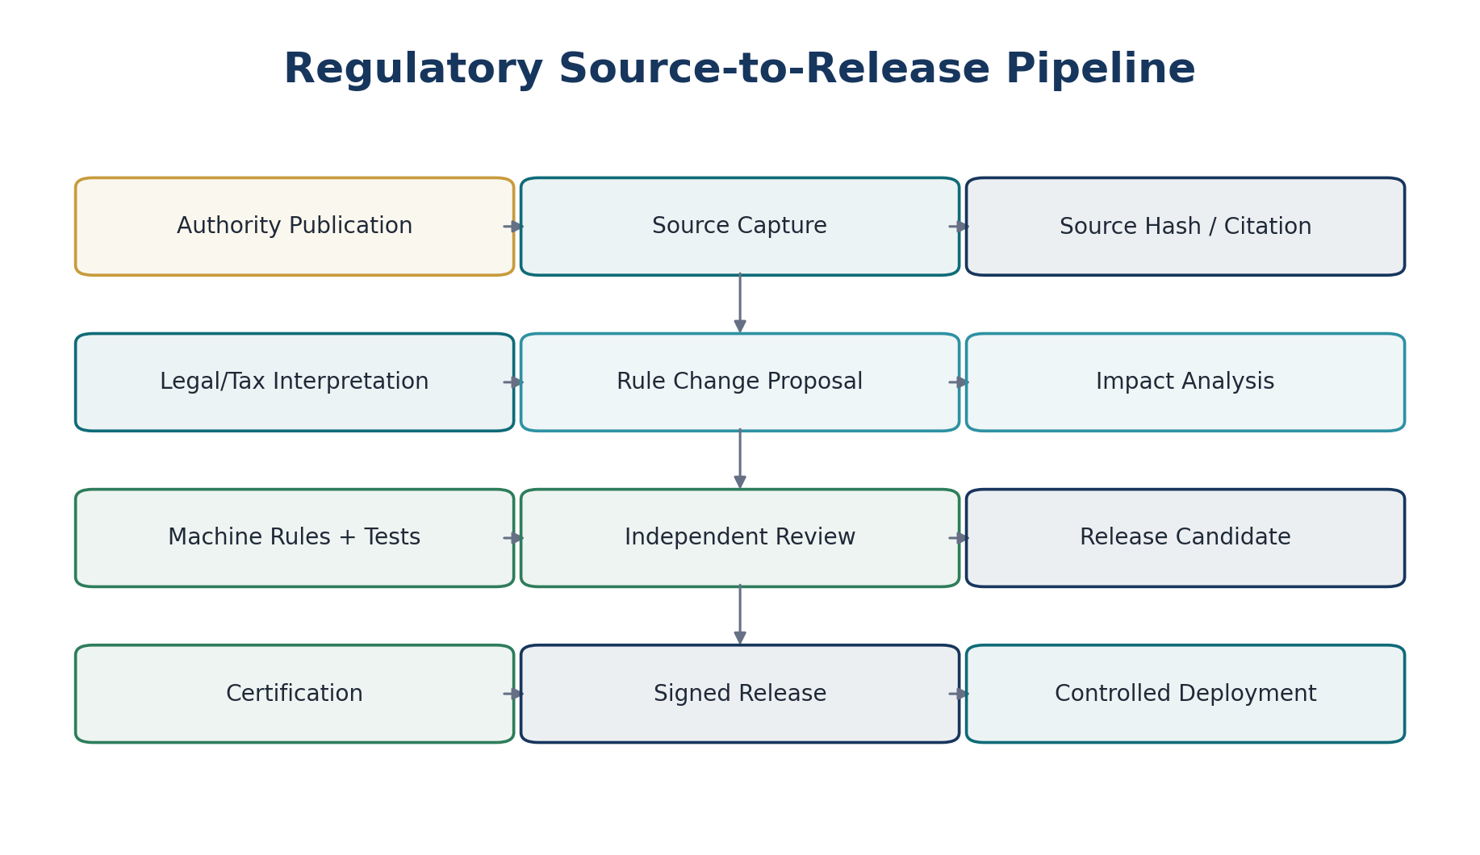
Figure 5 — Regulatory Source-to-Release Pipeline

9. Jurisdiction Determination & Applicability Engine
Jurisdiction determination is a governed domain decision. It must use authoritative entity, registration, counterparty, establishment, location, product/service, transaction and temporal facts. A client-supplied country code may be an input fact but never the final authority.
Input class | Representative facts
Entity | Legal entity, branch/establishment, tax residence, registrations, licenses
Counterparty | Legal/business location, registration identifiers, business/consumer status where relevant
Transaction | Supply type, document type, tax point, invoice date, payment date, ship-from/to, service location
Product/service | Tax category/classification, goods/services type, regulated category
Threshold/election | Turnover thresholds, registrations, elections, schemes where legally permitted
Temporal | Effective date, tax point, return period, payroll period, business calendar
External facts | Authority acknowledgement, network capability, schema version, approved evidence

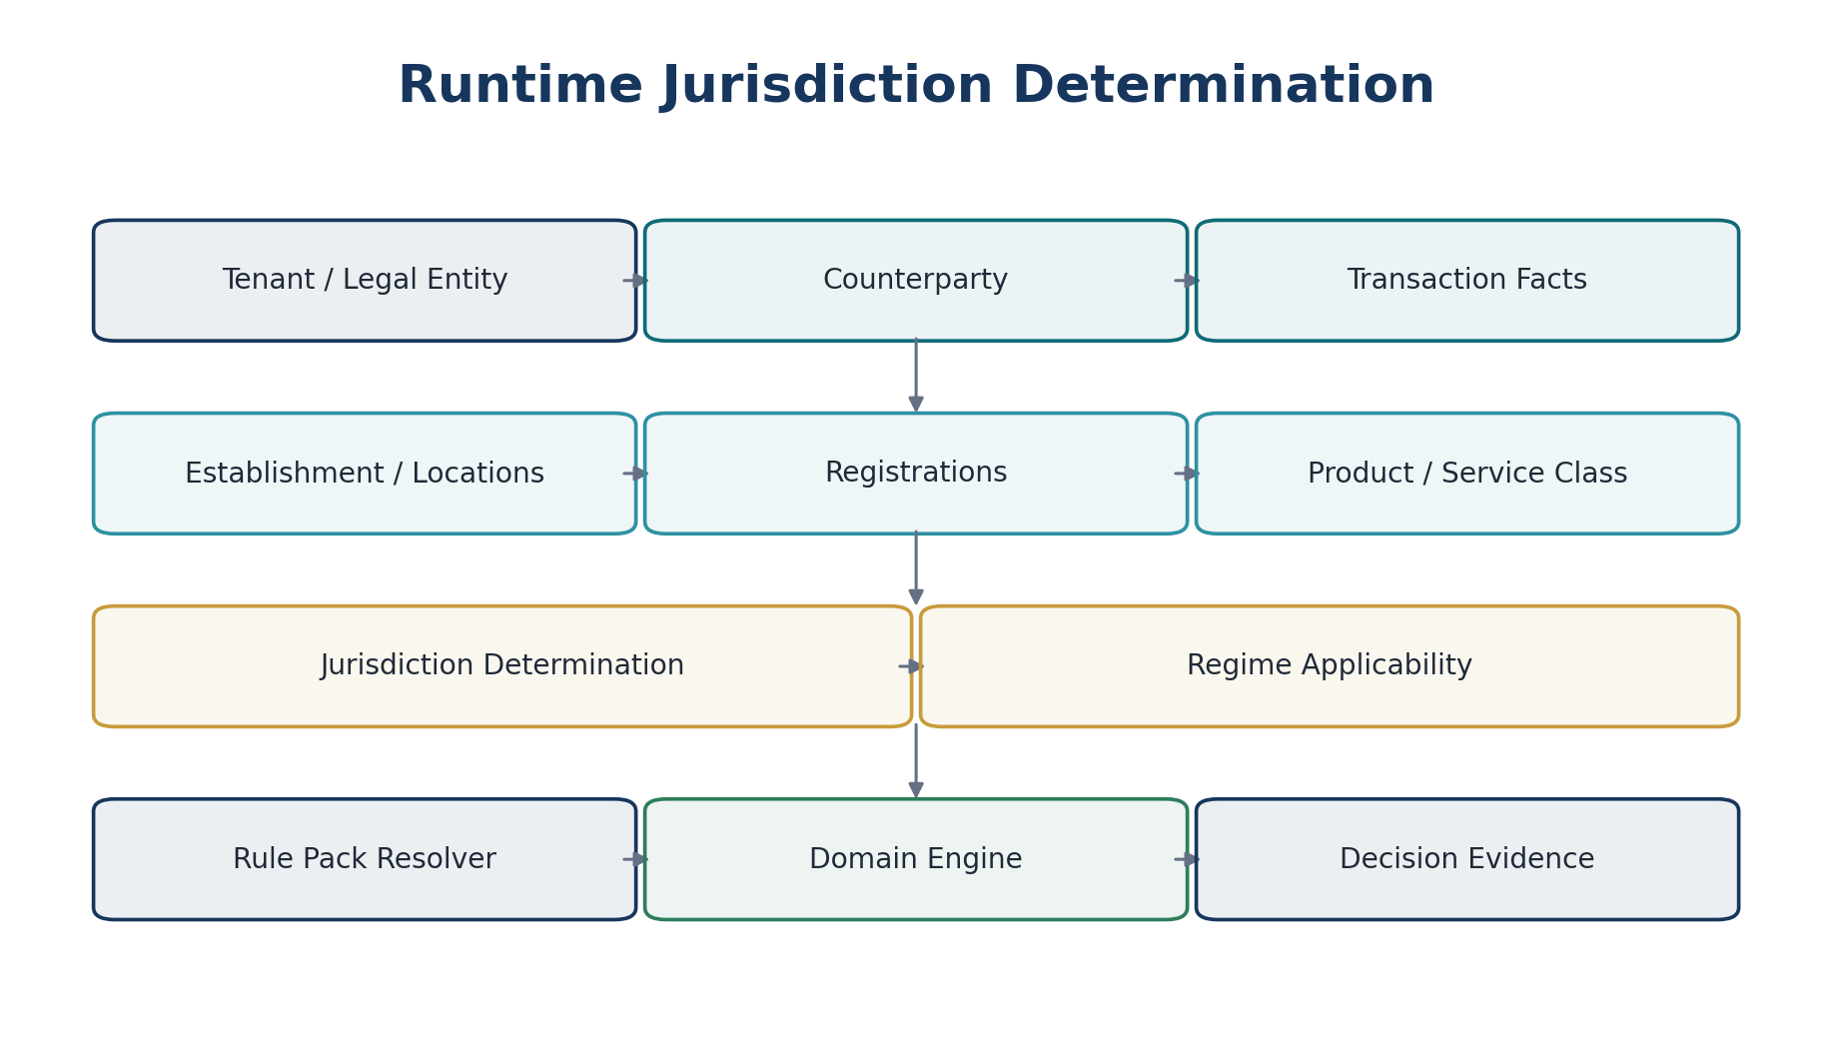
Figure 6 — Runtime Jurisdiction Determination
The jurisdiction engine produces an explainable applicability decision. Domain engines then calculate tax, validate invoices, prepare filings or enforce retention using the resolved pack/rule set.

10. Rule Precedence & Conflict Resolution
Precedence must be explicit and legal-context aware. A generic hierarchy is not sufficient to decide every legal conflict, so each override relation must be declared and tested.
Conflict class | Required handling
Global invariant vs jurisdiction rule | Global security/accounting integrity invariants cannot be overridden by packs.
Supranational vs national | Apply declared legal precedence and effective implementation rules; require expert certification.
National vs subdivision/local | Resolve only when the regime permits subdivision/local variation.
General vs regime-specific | Specific rule may override only through declared metadata.
Tenant configuration vs law | Tenant election applies only when the pack declares the election legally permitted.
Two active rules overlap | Certification blocker unless explicit precedence/combination rule exists.
Source ambiguity | Block production rule activation or mark as unsupported pending approved interpretation.

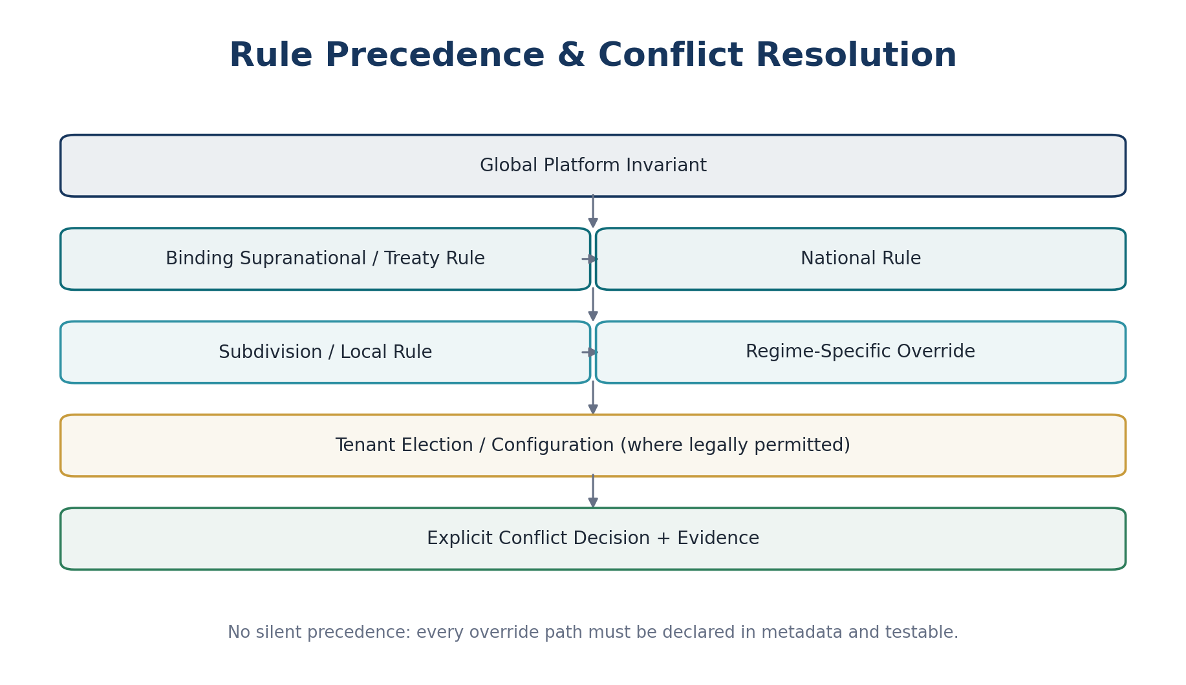
Figure 7 — Rule Precedence & Conflict Resolution

11. Rule Module Taxonomy
Rule family | Examples of machine-executable content
Registration / nexus | Thresholds, mandatory/optional registration triggers, effective registration intervals
Transaction tax | Rates, taxable bases, place-of-supply/situs logic, exemptions, reverse charge, rounding
Withholding | Payment types, payee classes, rate/threshold logic, exemption/treaty evidence hooks
Invoice validity | Mandatory fields, numbering constraints, tax wording, currency/tax presentation rules
E-invoice / digital reporting | Semantic profile, schema, code lists, clearance/reporting mode, deadlines
Statutory filing | Return schema, reporting period, due-date calculation, amendment rules, receipt statuses
Corporate compliance | Entity filings, license/permit deadlines, recurring obligations
Payroll statutory | Tax/social contribution parameters, caps, thresholds, statutory calendars; consumed by Zoiko Payroll boundary
Retention | Record class, minimum period, trigger date, legal hold interaction
Accounting mapping | Required tax/control accounts, statutory reporting mappings where relevant
Business calendar | Holidays, weekends, authority business-day adjustments

12. Tax Rule Architecture
Tax rules are deterministic, versioned and evidence-preserving. The jurisdiction pack supplies applicability and rule parameters; the ZoikoSuite tax engine executes the calculation and records the exact rule versions used.
Stage | Pack responsibility | Runtime engine responsibility
Determine | Jurisdiction/regime applicability rules | Resolve transaction facts and applicable regime
Classify | Tax categories/code lists | Validate product/service classification
Calculate | Rates, thresholds, formula, rounding rules | Execute exact decimal calculation
Validate | Required evidence/conditions | Block/warn on missing facts per rule severity
Evidence | Rule/source IDs | Persist inputs, steps, result, rule versions, overrides
Post | Accounting mapping policy | Emit approved tax accounting event; Accounting Kernel posts

13. Electronic Invoicing & Digital Reporting Profile
E-invoicing requirements change by jurisdiction and may require clearance, exchange-network delivery, real-time/near-real-time reporting or post-issuance reporting. ZoikoSuite therefore separates the authoritative invoice model from jurisdiction/network profiles and adapters.
Profile component | Required input/data
Profile identity | Jurisdiction, network/authority, document type, effective dates, version
Semantic mapping | Canonical invoice field → target semantic element
Syntax binding | UBL/XML/JSON or authority-specific syntax where required
Code lists | Currency, tax category, identifier schemes, unit codes, reason codes
Validation | Schema + semantic + jurisdiction-specific business rules
Transmission mode | Exchange, clearance, reporting, acknowledgement, polling/callback
Timing | Issue/report deadline, retry window, correction window
Evidence | Outbound payload hash, signature where used, submission ID, receipt/rejection, timestamps
Correction | Credit/cancel/amend workflow permitted by that profile

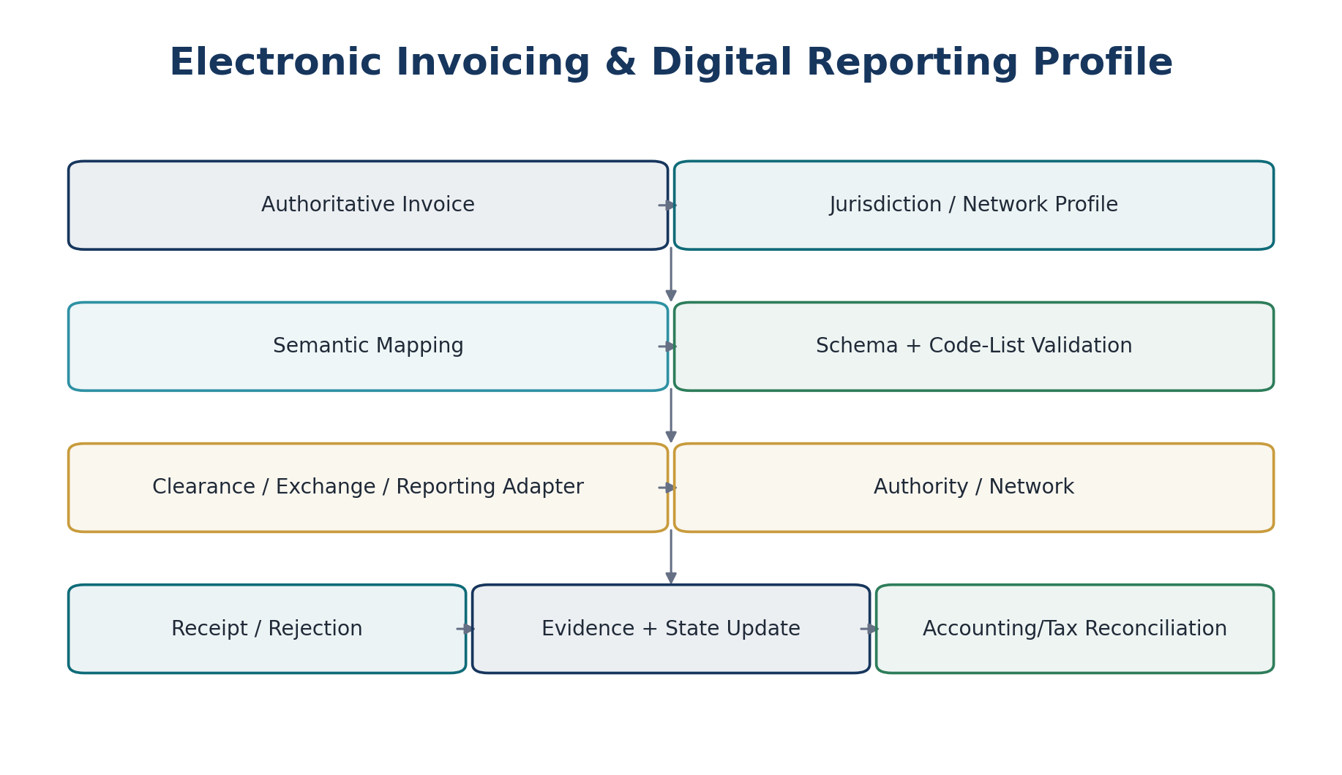
Figure 8 — Electronic Invoicing & Digital Reporting Profile
Current interoperability examples confirm the need for this specialization architecture: Peppol PINT provides a global billing model that jurisdictions can specialize, and current EU PINT releases add jurisdiction-specific validation rules on top of shared PINT rules.

14. Statutory Filing & Authority Submission
Capability | Pack-controlled requirements
Obligation | Registration/filing type, frequency, start/end, threshold/scheme conditions
Data contract | Return fields, schema version, business rules, code lists
Calculation | Tax/financial values and jurisdiction-specific derivations
Approval | Required reviewer/signatory/authority before submission
Submission | Authority endpoint/profile reference and authentication capability requirement
Acknowledgement | Accepted/rejected/processing statuses and receipt identifiers
Correction | Amended/superseding filing rules and periods
Retention | Return, working papers, receipts and evidence retention class

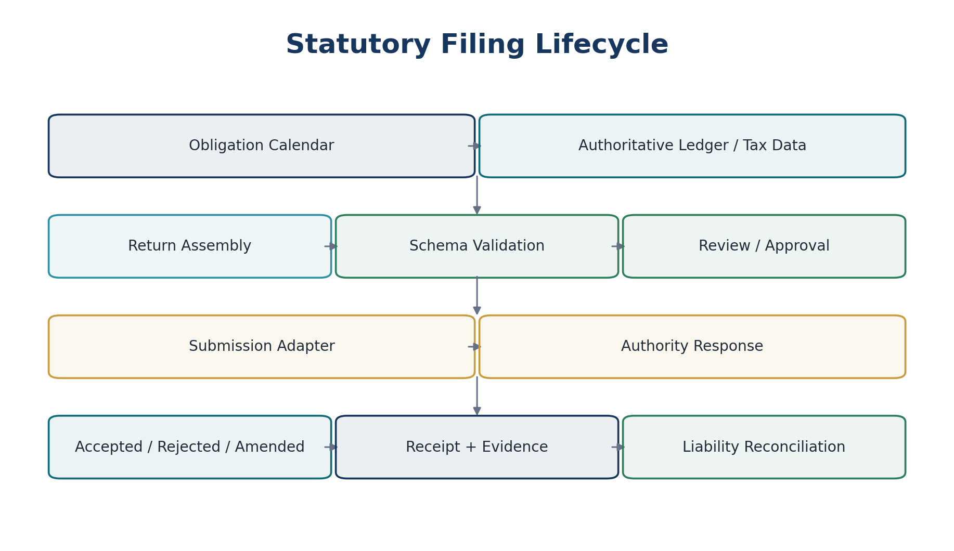
Figure 9 — Statutory Filing Lifecycle

15. Regulatory Calendar & Obligation Engine
Due dates must be derived, not hand-entered. The obligation engine consumes registration facts, filing frequency, period, due-date formulas, holidays/business-day rules and any valid extension/election.
Required rule element | Example behavior
Period basis | Monthly, quarterly, annual, event-driven, payroll cycle
Anchor | Period end, transaction date, registration date, meeting date, incorporation anniversary
Offset | N days/months after anchor
Business-day adjustment | Next/previous business day or no adjustment
Holiday set | Jurisdiction/authority calendar version
Extension/election | Only where legally supported and evidenced
Time-zone cutoff | Authority-local cutoff where applicable
Owner/escalation | Operational responsibility and SLA

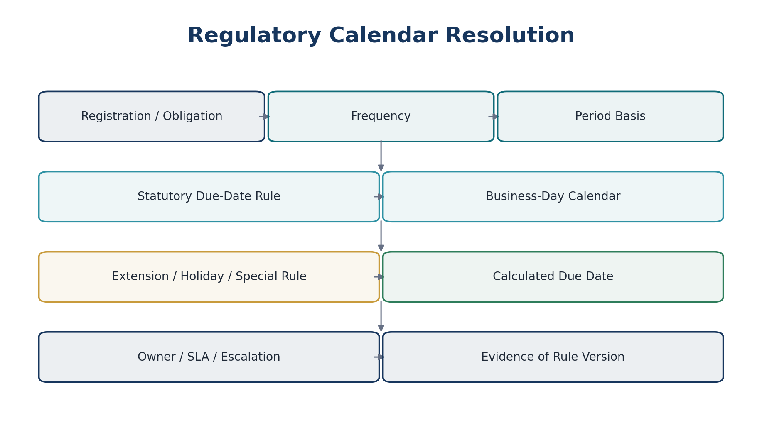
Figure 10 — Regulatory Calendar Resolution

16. Registration, License & Scheme Configuration
Data object | Required fields
Registration Type | Jurisdiction, regime, authority, identifier format, validation rules
Entity Registration | Legal entity/establishment, registration number, effective/expiry dates, status, evidence
Scheme/Election | Scheme ID, eligibility rule, election start/end, evidence, cancellation/lock-in rules
License/Permit | Authority, jurisdiction, issue/expiry/renewal rules, evidence
Threshold Monitor | Metric definition, rolling/static period, threshold, breach/effective behavior

17. Payroll Statutory Parameter Boundary
Jurisdiction packs may supply versioned payroll statutory parameters, but payroll calculation remains owned by Zoiko Payroll when that product is the authoritative engine. ZoikoSuite consumes payroll outputs for accounting, liabilities and reporting through defined interfaces.
Parameter class | Pack content
Income/withholding | Bands, thresholds, allowances, rates, periodization rules
Employee contributions | Social security/insurance/pension statutory rates and caps
Employer contributions | Employer statutory rates/caps/levies
Statutory pay/leave | Eligibility and rate parameters where included in payroll product scope
Calendars | Tax/payroll year, pay-period rules, authority due dates
Filing schemas | Employer/employee statutory submission schemas and versions
Evidence | Authority source, effective period, test cases, certification owner

18. Retention & Record-keeping Rules
Retention packs provide minimum legal/regulatory requirements; tenant policy may extend but cannot shorten a mandatory minimum. Legal hold always overrides ordinary disposition.
Rule field | Requirement
record_class | Canonical record category.
jurisdiction/regime | Scope.
trigger | Creation, period end, filing date, contract end, employment end or other defined event.
minimum_duration | Deterministic duration or authority-defined rule.
format/evidence | Original, readable copy, audit file or other mandated requirement where applicable.
legal_hold_override | Mandatory.
destruction_rule | Eligibility only; disposition service performs governed deletion/anonymization.
source_ref | Authoritative provenance.

19. Accounting & Reporting Mapping Layer
Jurisdiction packs may declare mapping requirements for statutory/tax reporting, but they must not directly post ledger entries. The Accounting Kernel remains the sole posting authority.
Mapping type | Purpose
Tax code → tax account class | Supports deterministic posting-rule selection.
Statutory line → canonical metric/account mapping | Supports jurisdiction-specific statements/returns.
Reporting taxonomy mapping | Maps canonical report facts to filing taxonomy elements.
Disclosure requirement | Declares required data/evidence; reporting engine assembles.
Control account designation | Defines permitted account class, not direct mutation.

20. Pack Authoring Workflow
Stage | Required output | Gate
Source capture | Source register entry + snapshot/hash | Authority and effective date verified
Interpretation | Structured interpretation/decision record | Qualified reviewer assigned
Impact assessment | Affected rules, services, schemas, tests, tenants/jurisdictions | Materiality classified
Rule authoring | Machine-readable rule changes | Schema lint passes
Test authoring | Golden/boundary/historical/negative cases | Coverage threshold met
Independent review | Tax/legal/accounting/technical review as applicable | No unresolved material findings
Certification | Signed certification report | Release authorized
Packaging | Immutable artifact + digest/signature | Registry accepts artifact
Deployment | Ring/canary rollout | Telemetry/reconciliation healthy

21. Pack Compiler & Artifact Registry
The pack compiler converts reviewed source-controlled definitions into deterministic runtime artifacts. Runtime services consume compiled artifacts, not ad hoc authoring files.
Compiler responsibility | Requirement
Schema validation | Reject unknown/malformed fields and invalid effective intervals.
Dependency resolution | Pin exact compatible dependency versions.
Conflict detection | Detect overlapping active rules and undeclared precedence.
Code generation/normalization | Compile formulas/decision tables into approved runtime representation.
Test execution | Run all mandatory suites and capture result digest.
Artifact digest | Generate cryptographic hash.
Signature | Attach approved signing identity/key metadata.
SBOM/dependency manifest | Record schemas, code lists and runtime libraries if applicable.
Registry publish | Write immutable release artifact and metadata.

22. Testing & Certification Harness
Test class | Must prove
Golden cases | Known authority/example scenarios produce exact expected output.
Boundary cases | Threshold edges, dates, zero/negative values, rounding limits, registration boundaries.
Historical cases | Past periods still resolve to prior effective rule versions.
Negative cases | Missing evidence, invalid registration, prohibited combinations, expired schemas are rejected correctly.
Cross-pack conflicts | Overlapping jurisdiction/regime rules resolve deterministically or block release.
Migration cases | New version does not silently mutate prior authoritative outcomes.
Schema tests | External filing/invoice payload conforms to required schema/code lists.
Regression corpus | Previously certified behavior remains stable unless intentionally changed.
Performance | Rule resolution/calculation meets platform latency/SLO budget.
Security | Untrusted pack cannot be loaded; signature/digest validation fails closed.

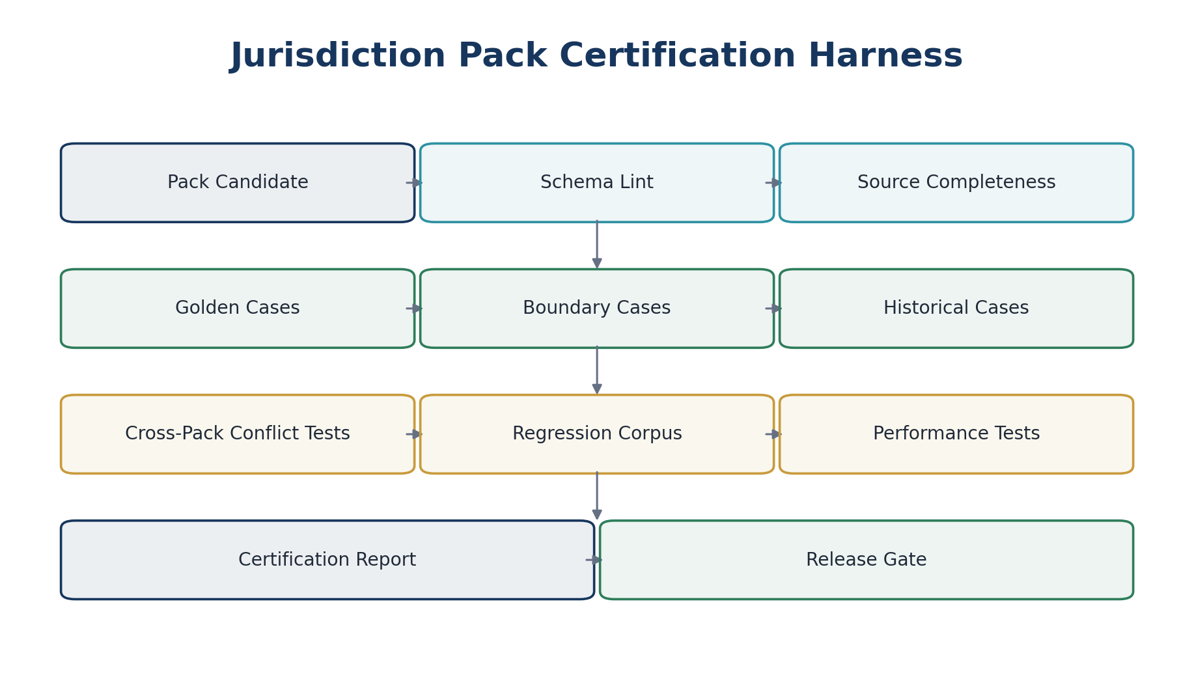
Figure 11 — Jurisdiction Pack Certification Harness

23. Release, Deployment & Rollback
Pack releases are independent deployable regulatory artifacts. They should be promoted through controlled rings and pinned by runtime services through eligibility metadata.
Release state | Meaning
Draft | Authoring only; cannot be resolved at runtime.
Review | Under technical/domain review.
Certified | Tests and approvals complete; not yet production eligible.
Released | Signed and registered; eligible for configured deployment rings.
Withdrawn | No new resolutions; retained for historical reconstruction.
Superseded | Newer version exists; historical resolution still permitted.
Emergency blocked | Operational control prevents use pending incident review.

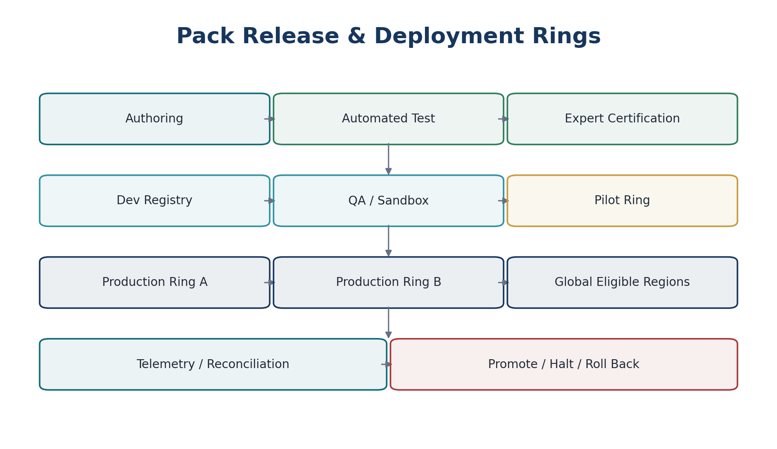
Figure 12 — Pack Release & Deployment Rings

24. Emergency Hotfix Standard
Urgent regulatory corrections may use an accelerated path, but never bypass source provenance, focused regression testing, dual approval, signing, staged deployment and evidence.
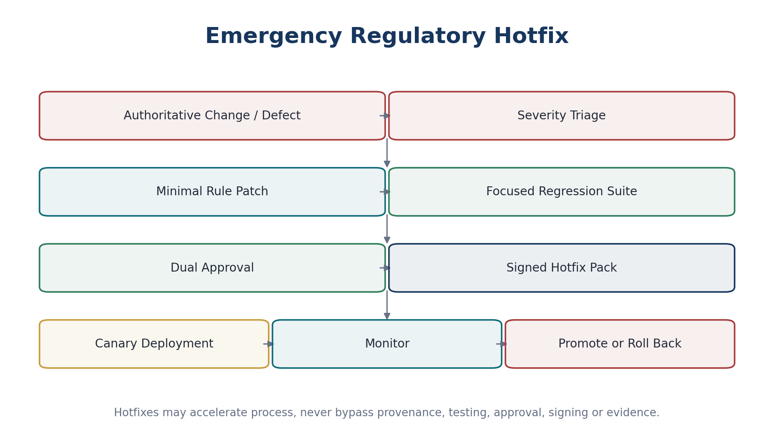
Figure 13 — Emergency Regulatory Hotfix
Hotfix control | Requirement
Severity | P0/P1 criteria defined before use.
Scope | Smallest safe rule/module delta.
Review | At least two independent authorized reviewers for production financial/regulatory effect.
Tests | Focused plus impacted golden/regression suites.
Deployment | Canary/ring first unless incident commander documents exception.
Rollback | Known prior compatible artifact identified before promotion.
Post-review | Mandatory retrospective within defined SLA.

25. Runtime APIs & Commands
Interface | Purpose | Key controls
GET /jurisdictions | Discover supported jurisdiction metadata | Read model only; no legal conclusion
POST /jurisdiction-decisions:resolve | Resolve applicable jurisdiction/regime | Authorized facts + effective date + evidence response
POST /rule-resolutions:resolve | Resolve exact applicable rules | Returns rule IDs/versions/source refs
POST /regulatory-calculations:execute | Execute deterministic rule family | Idempotency, version pinning, evidence
GET /packs/{id}/versions/{version} | Retrieve released pack metadata | Immutable released representation
POST /admin/packs:publish | Publish certified artifact | Privileged command + signature verification
POST /admin/packs/{id}:withdraw | Prevent new use | Privileged, reason/evidence required
POST /admin/packs/{id}:promote | Move deployment ring | Health gates + authorization
POST /admin/packs/{id}:rollback | Restore prior eligible version | Compatibility/reconciliation gate

26. Canonical Domain Events
Event family | Examples
Jurisdiction registry | jurisdiction.created, jurisdiction.updated, jurisdiction.support-changed
Source/provenance | regulatory-source.captured, regulatory-source.superseded
Pack lifecycle | jurisdiction-pack.certified, .released, .promoted, .withdrawn, .rolled-back
Rule lifecycle | regulatory-rule.versioned, .effective, .expired
Runtime decisions | jurisdiction-decision.resolved, regulatory-calculation.completed, .failed
Obligations | regulatory-obligation.created, .due-date-calculated, .overdue
External compliance | filing.submitted, filing.accepted/rejected, einvoice.accepted/rejected

27. Persistence Model
Entity | Authoritative owner / key purpose
Jurisdiction | Jurisdiction Registry — legal/regulatory scope identity
RegulatoryRegime | Jurisdiction Platform — coherent rule family
JurisdictionPack | Pack Registry — pack identity
JurisdictionPackVersion | Pack Registry — immutable release version
RegulatoryRule | Rule Registry — stable semantic rule identity
RegulatoryRuleVersion | Rule Registry — effective-dated immutable rule version
RegulatorySource | Source Register — authoritative-source evidence
InterpretationRecord | Governance — approved interpretation/rationale
PackDependency | Pack Registry — exact dependency graph
RulePrecedence | Rule Registry — declared conflict/override relationship
RegulatoryCalendar | Calendar Service — effective-dated business/authority calendar
RegulatoryObligation | Obligation Service — entity-specific obligation
PackCertification | QA/Governance — signed certification result
PackDeployment | Platform Ops — region/ring eligibility
RuleDecisionEvidence | Evidence Ledger — runtime provenance

28. Security, Privilege & Supply-Chain Controls
- Pack authoring, certification, signing and promotion are separate privileged capabilities.
- Pack artifacts are signed; runtime loaders verify signature and digest before activation.
- Only approved registries may supply production packs.
- Authority credentials, API keys, filing certificates and network secrets are stored in the secrets platform, never in pack source or artifacts.
- Changes to rules affecting payments, tax liabilities, payroll liabilities, filing or invoice validity require enhanced review.
- Production hotfix access is time-bounded and fully evidenced.
- Dependencies and toolchains used to compile packs are inventoried and scanned.
- Tenant-specific overrides are stored separately and allowed only when a released pack explicitly declares a configurable election.

29. Observability & Regulatory Operations
Metric / signal | Why it matters
Pack resolution rate by version | Detect stale or unintended pack usage.
Rule-resolution failures | Find missing facts, conflicts or unsupported jurisdiction cases.
Historical replay drift | Must remain zero unless correction is explicitly versioned.
E-invoice/filing rejection rate | Detect schema/rule/authority changes.
Upcoming effective changes | Operational readiness for future-dated rules.
Pack deployment skew | Detect regions/services running inconsistent releases.
Certification age | Identify packs approaching review/support thresholds.
Source-change watch | Triggers controlled review; never auto-publishes rules.
Deadline calculation exceptions | Protect filing/compliance calendars.
Override/election usage | Detect unusual tenant-specific regulatory choices.

30. Source-to-Outcome Traceability
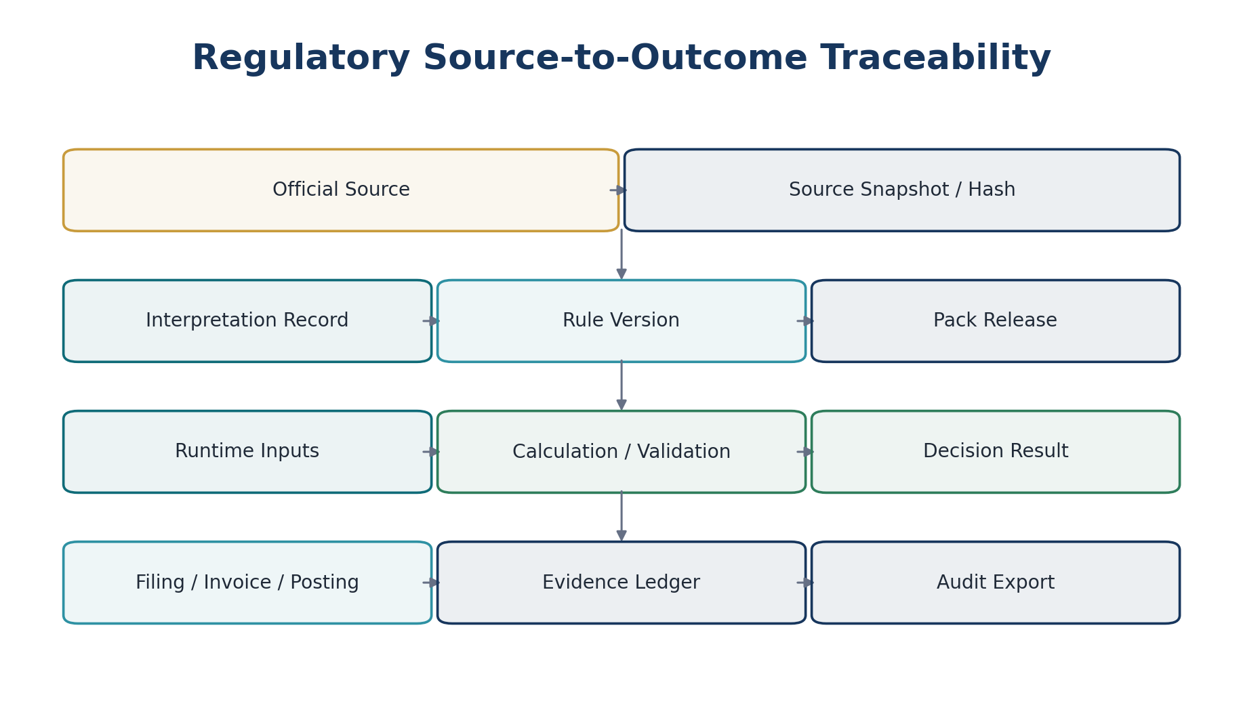
Figure 14 — Regulatory Source-to-Outcome Traceability
Every material compliance output must support backward reconstruction from filing/invoice/posting to runtime calculation, rule version, pack release, interpretation record and authoritative source reference.

31. Regulatory Change Management
Change type | Required response
Future-dated law/regulation | Author pack version in advance; test with future effective date; activate automatically only after certified deployment.
Authority schema/code-list update | Pin new dependency, regression-test, release compatible pack.
Interpretive clarification | Create interpretation record; version rule only if runtime behavior changes.
Retroactive legal change | Do not silently rewrite history; issue correction version and explicit remediation workflow.
Authority outage/process change | Operational adapter/config change unless substantive rule behavior changes.
Source withdrawal | Preserve source record; mark superseded/withdrawn and link replacement.
Disputed interpretation | Block or constrain affected capability until governance decision is approved.

32. Initial Jurisdiction-Pack Portfolio Structure
This standard defines the architecture, not the substantive local law. Individual country/state/province packs must be produced and certified separately. A recommended initial portfolio structure is:
Layer / pack family | Initial purpose
global.reference | ISO/canonical currencies, countries/subdivisions, generic date/money semantics
global.tax.core | Shared tax calculation contract, provenance, rounding framework
global.invoice.core | Canonical invoice semantics and common validation contract
eu.vat.framework | Shared EU-layer VAT/e-invoicing/digital-reporting framework where applicable
gb.* | UK tax, invoicing, filing, calendar and retention pack families
us.federal.* | US federal tax/filing rule families
us.state.<state>.* | State-specific rule families
in.* | India national/state GST and related compliance pack families
au.* | Australia tax/reporting pack families
de.* | Germany national/EU-aligned pack families
ca.federal.* / ca.province.* | Canada federal/provincial pack families

The inclusion of a jurisdiction family in the portfolio does not mean ZoikoSuite has certified substantive rules for that jurisdiction. Production support begins only when the applicable pack has completed local expert review and certification.

33. Current Interoperability Anchors — August 2026
The architecture intentionally supports evolving external mandates through versioned dependencies rather than application rewrites.
Anchor | Architecture implication
EU VAT in the Digital Age (ViDA) | EU VAT/e-invoicing/digital-reporting capabilities require future-dated, phased rule activation. The European Commission states ViDA was adopted March 11, 2025, entered into force April 14, 2025, and rolls out progressively through 2035; cross-border B2B digital reporting applies from July 1, 2030.
Peppol PINT / PINT-EU | Use a canonical invoice model plus jurisdiction specialization. Peppol PINT provides a general billing model; EU PINT adds jurisdiction-specific rules and versioned validation artefacts.
OECD SAF-T 2.0 | Audit-data exports should be jurisdiction adapters over canonical accounting data, with versioned mappings and schemas rather than bespoke ledger models.
Authority e-file schemas/business rules | Treat authority schemas and business rules as versioned external dependencies. IRS MeF, for example, publishes tax-year/processing-year schema/business-rule packages and version changes.
National digital tax programs | Feature activation must be effective-dated and eligibility-driven; jurisdiction rollout dates belong in packs, not release notes or UI constants.

34. Negative-Path Engineering Acceptance Scenarios
ID | Scenario | Expected result
JUR-NEG-01 | Transaction dated before new tax rate effective date | Old rule version resolves; new rate is not used.
JUR-NEG-02 | Two active rules overlap without precedence | Pack certification fails.
JUR-NEG-03 | Pack artifact digest does not match registry | Runtime refuses activation.
JUR-NEG-04 | Unsigned pack presented to production loader | Fail closed; security event emitted.
JUR-NEG-05 | Client supplies jurisdiction inconsistent with entity/transaction facts | Server re-resolves or rejects; client value is not authoritative.
JUR-NEG-06 | Government source URL changes after release | Released rule remains reproducible from captured source evidence.
JUR-NEG-07 | Past tax return recalculated after a rate update | Historical rule version is selected.
JUR-NEG-08 | Authority schema version becomes invalid after cutoff | Submission blocked with precise dependency/version error.
JUR-NEG-09 | E-invoice rejected by authority | Invoice lifecycle follows jurisdiction profile; no false accepted state.
JUR-NEG-10 | Duplicate filing callback | Idempotent handling; one authoritative outcome.
JUR-NEG-11 | Late/out-of-order filing callback | Provider/authority state reconciliation prevents illegal regression.
JUR-NEG-12 | Tenant attempts to shorten mandatory retention | Rejected; tenant policy may extend only.
JUR-NEG-13 | Holiday calendar amended | Only due dates governed by applicable calendar version change; prior evidence remains.
JUR-NEG-14 | Emergency rule hotfix lacks second approver | Promotion blocked.
JUR-NEG-15 | Pack dependency unavailable in one region | Pack not eligible for promotion to that region.
JUR-NEG-16 | Subdivision rule conflicts with national invariant | Certification blocks unless legally valid explicit override is declared.
JUR-NEG-17 | Missing registration evidence for exemption | Rule returns blocked/exception outcome per pack specification.
JUR-NEG-18 | AI proposes rule change without human certification | Cannot reach released state.
JUR-NEG-19 | Rollback requested after transactions already processed under new version | Rollback affects future resolution only; remediation workflow handles prior outcomes.
JUR-NEG-20 | Same pack version rebuilt with different content | Registry rejects immutable-version collision.
JUR-NEG-21 | Future-dated rule deployed early | Runtime selects it only when applicable effective date is reached.
JUR-NEG-22 | Unsupported jurisdiction transaction | Explicit unsupported/needs-review result; no guessed tax treatment.
JUR-NEG-23 | Pack source classified as non-binding guidance but rule claims mandatory effect | Certification requires explicit approved interpretation/authority basis.
JUR-NEG-24 | Cross-border transaction activates two tax regimes | Applicability engine resolves combined/precedence behavior or blocks ambiguity.
JUR-NEG-25 | Rule formula attempts binary floating-point arithmetic | Compiler/linter rejects financially material float operations.
JUR-NEG-26 | Filing due date lands on authority holiday | Applicable business-day adjustment rule determines due date.
JUR-NEG-27 | Authority requires a new code list mid-cycle | Versioned dependency update and regression suite required.
JUR-NEG-28 | Pack withdrawn | No new decisions use it; historical evidence remains resolvable.
JUR-NEG-29 | Production service runs stale pack | Telemetry detects deployment skew and blocks regulated action where policy requires consistency.
JUR-NEG-30 | Retroactive legislation changes liability | Explicit correction/remediation path; historical record is not silently mutated.

35. Definition of Ready — Jurisdiction Pack
- Jurisdiction and regime IDs exist in the canonical registry.
- Authoritative sources are captured and reviewed.
- Interpretation decisions and assumptions are documented.
- Effective-date model is unambiguous.
- Dependencies, code lists and schemas are pinned.
- Rule modules have stable IDs and declared precedence.
- Golden, boundary, negative and historical cases exist.
- Security/data classification and residency impacts are reviewed.
- Operational owner and support model are assigned.
- Rollback target and migration/remediation notes are defined.

36. Definition of Done — Production Release
- Compiler, schema lint, dependency and conflict checks pass.
- All mandatory tests pass with captured digest.
- Qualified independent review is complete.
- Certification record is approved and immutable.
- Artifact digest and signature verify.
- Deployment rings and region eligibility are configured.
- Runtime services can resolve pack/rule version deterministically.
- Observability dashboards/alerts are active.
- Source-to-outcome evidence is demonstrably reconstructable.
- Rollback and emergency support procedures are exercised or evidenced.
- Documentation and user-facing regulatory disclosures are updated where required.

37. Engineering Implementation Sequence
Wave | Deliverables
0 — Registries | Jurisdiction, regime, source and pack registries; identifiers; schemas.
1 — Compiler | Manifest validation, effective dating, dependencies, conflict detection, signed artifacts.
2 — Runtime resolver | Jurisdiction determination, rule resolution, evidence contract, caching/invalidation.
3 — Test/certification | Golden corpus, boundary/historical tests, certification workflow, CI gates.
4 — Tax/calendar | Tax rule modules, obligations, authority/business-day calendars.
5 — E-invoice/filing | Profile registry, schema/code-list dependencies, adapters, receipts/rejections.
6 — Payroll/retention/reporting | Statutory parameter interfaces, retention rules, statutory mappings.
7 — Operations | Ring deployment, rollback, hotfix, observability, source-change intake.
8 — Jurisdiction rollout | Country/subdivision packs produced one-by-one under separate certification packs.

38. Controlled Pre-Production Decisions
Decision | Required owner
Runtime rule DSL / decision-table technology | Architecture + Tax/Regulatory Engineering
Pack artifact format and registry technology | Platform Architecture
Signing/key hierarchy for pack releases | Security / Cryptography
Source snapshot retention mechanism | Legal/Compliance + Data Governance
Jurisdiction expert approval model | Global Tax/Legal Leadership
Supported launch jurisdictions and exact regulatory scope | Product + Legal + Commercial
Country-by-country e-invoice/filing provider strategy | Product + Partnerships + Tax Engineering
SLOs for regulated calculations/submissions | Platform + Product
Regulatory change-intelligence intake process | Tax/Legal Operations

39. Prohibited Anti-Patterns
- Hard-coded country or tax-rate conditionals scattered through domain services.
- Mutable production tax-rate tables with no immutable version history.
- Selecting “latest rule” without effective-date resolution.
- Using a live government web page as the runtime calculation dependency.
- Allowing an administrator to directly edit a released rule in production.
- Embedding filing credentials or certificates inside jurisdiction-pack artifacts.
- Treating a country as a single undifferentiated regulatory scope.
- Allowing tenant configuration to override law without explicit pack authorization.
- Auto-publishing AI-extracted regulatory changes.
- Deleting superseded pack versions required for historical reconstruction.
- Changing previously filed/posted records merely because the pack changed.
- Shipping a jurisdiction pack without golden, boundary and historical regression tests.

40. Final Architecture Decision
ZoikoSuite shall implement jurisdiction and regulatory behavior as a governed, provenance-backed, effective-dated and signed software supply chain. Domain engines consume certified packs; packs never bypass the Accounting Kernel, Workflow/Approval, IAM, Evidence Ledger, API or Event standards.

The next companion standard should define the global financial reconciliation and control framework so every jurisdiction-driven tax, filing, payment and accounting consequence can be reconciled end-to-end against authoritative source populations.

Appendix A — Pack Authoring Checklist
- Jurisdiction/regime identified
- Source authority captured
- Effective dates confirmed
- Interpretation approved
- Rule IDs assigned
- Dependencies pinned
- Precedence declared
- Golden cases written
- Boundary cases written
- Historical regression written
- Negative tests written
- Schema/code-list versions pinned
- Certification owners assigned
- Rollback target identified
- Monitoring plan defined

Appendix B — Reference Standards & Current Anchors
Reference | Use in this architecture
European Commission — VAT in the Digital Age (ViDA) | Phased, future-dated digital VAT/e-invoicing/reporting requirements.
OpenPeppol — PINT / PINT-EU | Global invoice model with jurisdiction specializations and validation artefacts.
OECD — Guidance for SAF-T Version 2.0 | Standardized tax/audit data extraction concept.
ISO 3166 / canonical subdivision registry | Jurisdiction identifiers; local registry may add authority-specific extensions.
ISO 4217 / currency code lists | Currency metadata dependency for tax/invoice profiles.
Authority-specific e-file/e-invoice schemas | Versioned external dependencies, not embedded platform assumptions.

