ZOIKOSUITE.
GLOBAL MIGRATION, OPENING BALANCE
& CUTOVER STANDARD
Detailed Engineering Wireframe & Data Conversion Control Standard
Accounting • Finance • Taxation • Audit • Legal • Business Operations
EXECUTIVE MIGRATION DOCTRINE
ZoikoSuite migration is a governed conversion and cutover process, not a direct database copy or one-off ETL exercise. Every authoritative migrated fact must preserve source identity and provenance, pass deterministic validation, reconcile to a frozen source population, enter ZoikoSuite through controlled domain interfaces, and remain reconstructable after cutover. Opening balances, open subledger items and historical detail are distinct populations and must never double count the same economic activity.

Document control | Value
Document ID | ZS-MIG-001
Version | 1.0 — Global Migration & Cutover Baseline
Date | August 24, 2026
Status | Engineering architecture baseline — migration-specific mappings, cutover dates, source-system inventories, materiality/tolerance values and business sign-offs remain program-specific
Owner | ZoikoSuite Platform Architecture / Data Migration / Finance Transformation
Prepared for | Engineering, Data, Finance, Accounting, Tax, Audit, Security, Legal/Compliance, SRE, QA, Product, Customer Success and Implementation teams
Language | American English

1. Critical Analysis & Refinement Decisions
The previously approved ZoikoSuite architecture defines canonical data, accounting, state/workflow, APIs, events, authorization, jurisdiction rules, financial controls, security and release certification. Migration is the controlled bridge from an external source of truth into that architecture. The following decisions close the most dangerous migration ambiguities before engineering begins.
Observed risk / ambiguity | Refined architecture decision
Migration treated as ETL | Migration is a controlled business conversion with authoritative source snapshots, versioned mappings, domain validation, reconciliation and certification.
Opening balance used as catch-all | Opening balances, open AR/AP items, bank positions, tax/payroll liabilities and historical transactions are distinct migration populations with separate acceptance controls.
Direct writes to target databases | Prohibited. Authoritative target state is created only through migration-approved domain commands/loaders that enforce canonical invariants.
Legacy IDs discarded | Every canonical migrated object preserves source-system/object identity through a durable crosswalk and migration lineage.
Historical detail re-posted into live ledgers | Default is stratified history: operational history when needed, read-only history where appropriate, and governed archive for older evidence.
Manual spreadsheet transformations | Mappings and transformation logic are versioned, reviewed, testable artifacts. Ad-hoc manual edits require controlled exception evidence.
Unknown source quality discovered during cutover | Full profiling and repeated dry runs are mandatory before production cutover.
“Totals match” as sole acceptance criterion | Certification tests record counts, financial totals, balances, hashes, key relationships, aging/cutoff and domain-specific assertions.
Rollback assumed to mean restore database | After irreversible financial/external effects, forward correction is generally required. Rollback is allowed only inside a defined reversible boundary.
Cutover timing expressed informally | Every cutover uses explicit source/target watermarks, timezone, freeze windows, delta boundaries and last-processed identifiers.
Production data copied freely to test | Migration rehearsal data inherits source classification, residency and privacy controls; synthetic or masked subsets are preferred where feasible.
Hypercare ends when system is “stable” | Exit requires signed stabilization criteria: reconciliations, defect aging, integration completeness, support backlog and first-close readiness.

NON-NEGOTIABLE DECISION
A migrated record is accepted only when ZoikoSuite can answer: where it came from, which extract contained it, which mapping/transformation version was applied, which canonical object it became, which validations passed, which reconciliation proved completeness/accuracy, and who certified the population.

2. Purpose, Scope & Boundaries

2.1 Purpose
ZS-MIG-001 defines the common architecture, controls, wireframes and evidence required to move tenants from legacy systems into ZoikoSuite without losing financial integrity, regulatory defensibility, provenance, historical reconstructability or operational continuity.

2.2 In Scope
- Source discovery and inventory
- Data profiling and quality assessment
- Extract/landing/staging/quarantine architecture
- Canonical mapping and transformation
- Identity crosswalk and deduplication
- Master/configuration migration
- Opening balances and subledger open items
- Historical transactions and read-only archives
- Documents, evidence and attachments
- Bank, tax, payroll, fixed-asset, inventory and project positions
- Migration reconciliation and certification
- Dry runs and dress rehearsals
- Cutover freeze/delta orchestration
- Rollback/forward-correction controls
- Security, privacy, residency and legal hold
- Post-cutover stabilization and first-close readiness

2.3 Out of Scope
- Customer-specific mapping values that have not yet been discovered
- Authoritative legal/accounting judgments unique to a customer or jurisdiction
- Source-vendor extraction rights or commercial licensing decisions
- Production cutover dates before program governance approves them
- Bypassing approved ZoikoSuite domain validation because a source system previously allowed inconsistent data
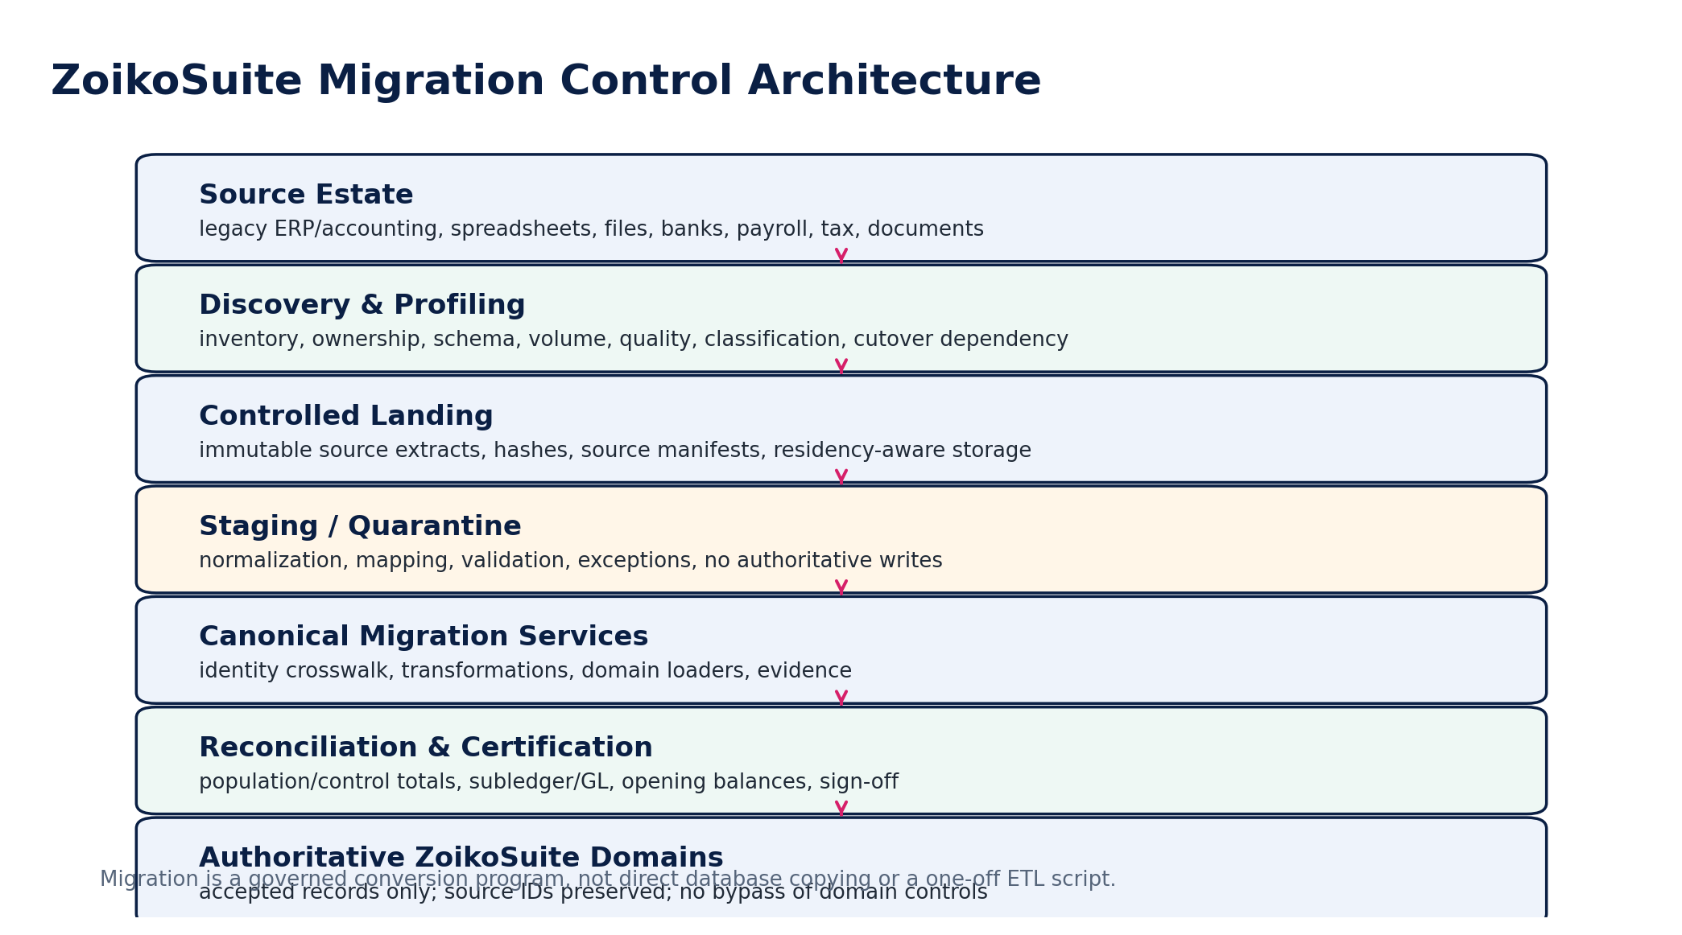
Figure 1 — Migration Control Architecture

3. Migration Doctrine & Non-Bypassable Invariants
ID | Invariant
MIG-INV-01 | No authoritative target write without tenant, legal-entity and residency context.
MIG-INV-02 | Every imported object preserves source-system, source-object and migration-batch identity.
MIG-INV-03 | Source extracts are immutable after landing; corrections create new extract versions.
MIG-INV-04 | No migration transformation may silently change financial meaning.
MIG-INV-05 | All financially material transformations use deterministic, versioned rules.
MIG-INV-06 | Authoritative target state is created through approved domain interfaces; direct DB writes are prohibited.
MIG-INV-07 | Opening balances must balance by legal entity, book, ledger and currency basis.
MIG-INV-08 | Open subledger items reconcile to migrated control-account balances.
MIG-INV-09 | Historical detail may not double post activity already represented in opening balances.
MIG-INV-10 | No cutover is approved without repeatable full-volume rehearsal.
MIG-INV-11 | Cutover boundaries use explicit watermarks and timezone-aware timestamps.
MIG-INV-12 | All quarantine items have owner, reason code and disposition.
MIG-INV-13 | No unresolved material difference may be hidden in suspense or plug accounts.
MIG-INV-14 | Legacy and canonical identifiers remain mutually discoverable.
MIG-INV-15 | Financial totals, record counts and critical relationship counts are independently reconciled.
MIG-INV-16 | Historical effective dates are not replaced by migration execution dates.
MIG-INV-17 | Jurisdiction/tax rule versions are preserved when migrated history depends on them.
MIG-INV-18 | Security classification and residency constraints survive migration.
MIG-INV-19 | Legal holds and retention rules override ordinary archival/disposition.
MIG-INV-20 | Cutover go/no-go requires named business, finance, technology and control ownership.
MIG-INV-21 | Post-activation corrections use authoritative adjustment/supersession models, not destructive edits.
MIG-INV-22 | Source access is frozen/read-only according to the approved cutover boundary.
MIG-INV-23 | Migration evidence is retained long enough to support audit, regulatory and contractual obligations.
MIG-INV-24 | All migration pipelines are idempotent or safely restartable.
MIG-INV-25 | AI may assist mapping/profiling but may not independently approve transformations, balances or acceptance.

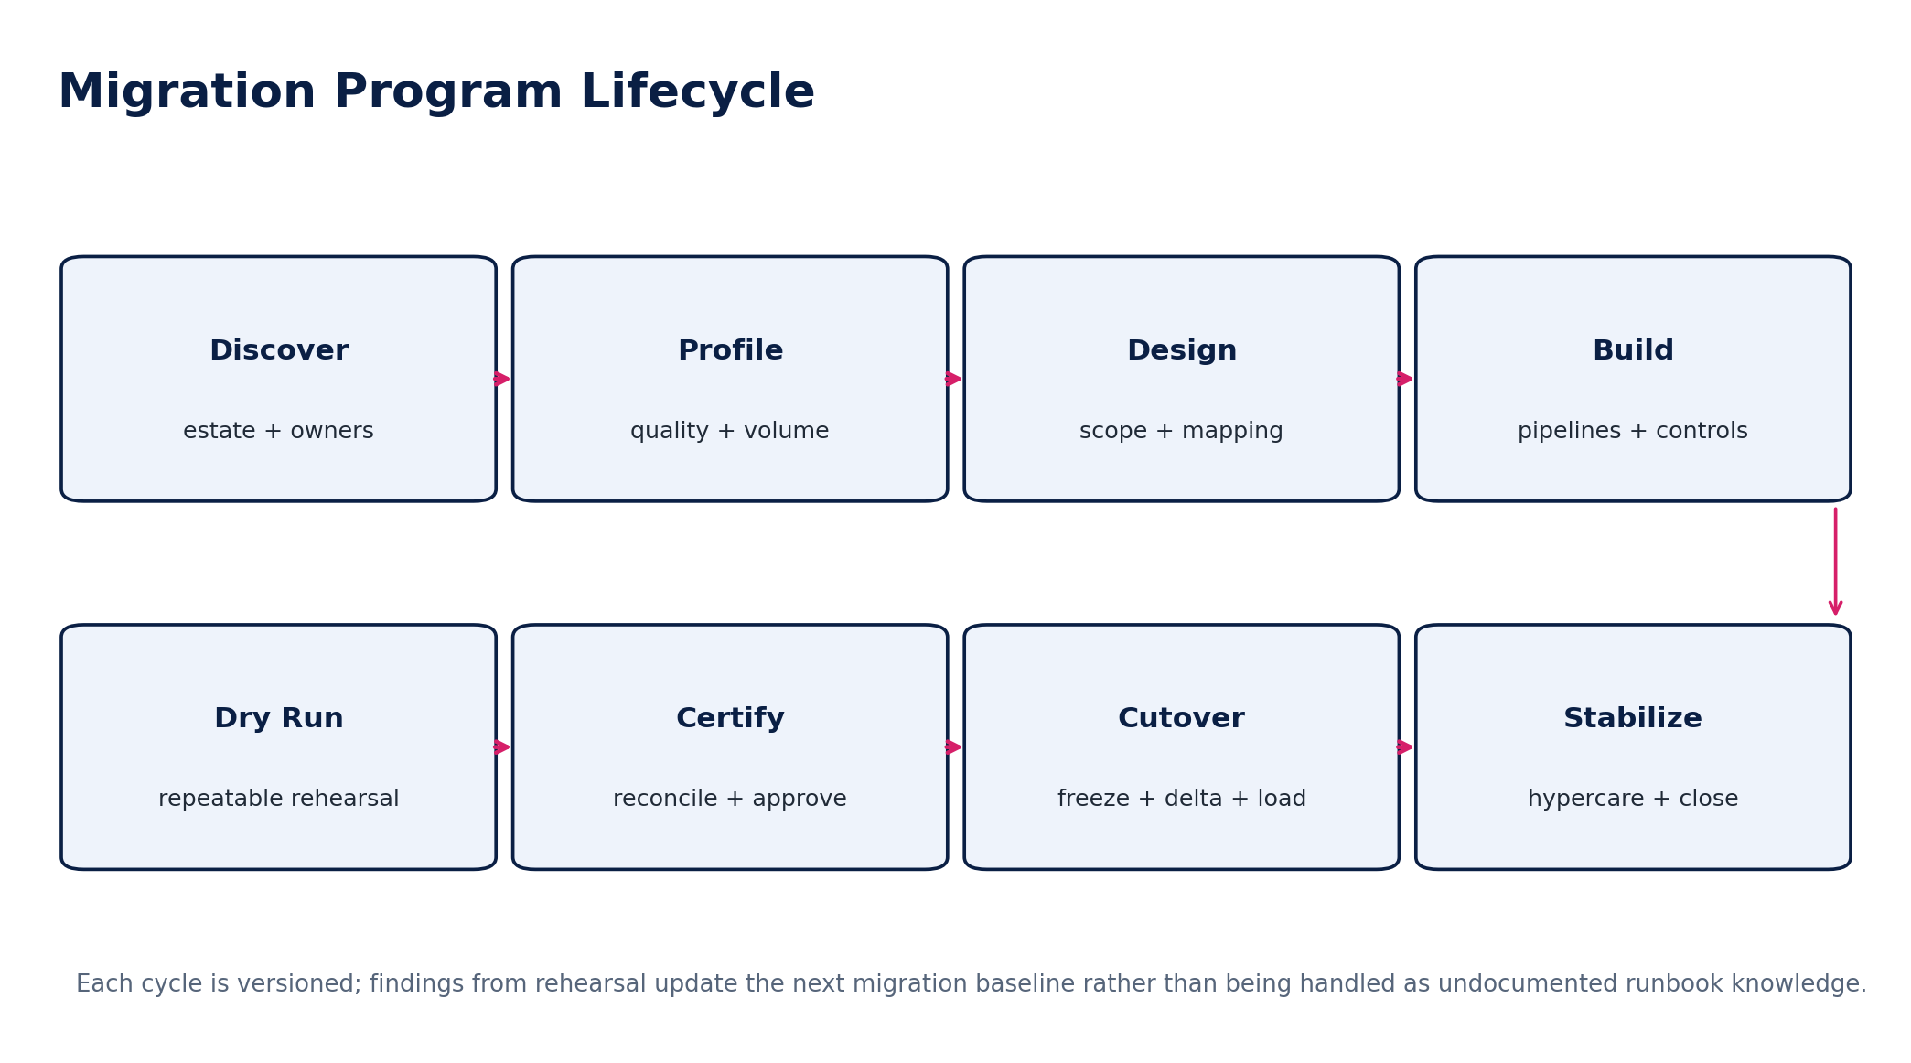
Figure 2 — Migration Program Lifecycle

4. Canonical Migration Object Model
Object | Purpose / key fields
MigrationProgram | tenant, program_id, source estate, target scope, owner, status, cutover strategy
SourceSystem | source_system_id, vendor/product, version, owner, region, extraction method, authority period
SourceDataset | dataset_id, object type, schema version, classification, authoritative period, expected volumes
SourceExtract | extract_id, source watermark, generated_at, files/objects, manifest hash, record count, amount controls
MigrationBatch | batch_id, program, domain, extract_refs, mapping versions, target environment, execution status
MappingRuleSet | source schema → canonical schema, transforms, reference lookups, effective version, test evidence
IdentityCrosswalk | source_system + source_type + source_id ↔ canonical_id, match evidence, alias history
MigrationCandidate | normalized canonical payload prior to authoritative load
QuarantineItem | candidate, reason code, severity, owner, resolution, evidence, disposition
MigrationRun | pipeline execution, environment, tool/image version, timings, metrics, failures
ReconciliationRun | source/target populations, controls, differences, materiality, result
MigrationCertificate | scope, source watermarks, accepted batches, unresolved exceptions, sign-offs, hashes
CutoverRun | runbook version, freeze start/end, delta watermarks, commands, timestamps, decisions
StabilizationCase | post-cutover defect/control issue, owner, SLA, correction and closure evidence

5. Governance, Roles & RACI
Role | Primary accountability
Executive / Program Sponsor | business outcome, funding, acceptance of program-level residual risk
Migration Architect | migration architecture, mapping principles, target-domain conformance
Source System Owner | source meaning, extraction authority, source completeness and freeze
Data Migration Lead | pipelines, batches, quality, runbooks and evidence
Domain Product/Engineering Owner | target validation rules, domain loaders, API behavior
Finance Controller | opening balances, subledger/GL tie-out, cutover financial certification
Tax / Regulatory Owner | tax balances, registrations, returns, historical rule treatment
Security / Privacy | classification, residency, access, secrets and lawful data handling
QA / Certification | independent verification, negative paths, regression and release evidence
SRE / Operations | cutover execution, observability, recovery, activation and stabilization
Customer Business Owner | business acceptance, open items, master/reference confirmation
Audit / Assurance Liaison | evidence package, opening-balance audit support where applicable

SEGREGATION OF DUTIES
The person who prepares or changes financially material mapping rules must not be the sole approver of the resulting balance reconciliation or migration certificate.

6. Source Discovery & Profiling
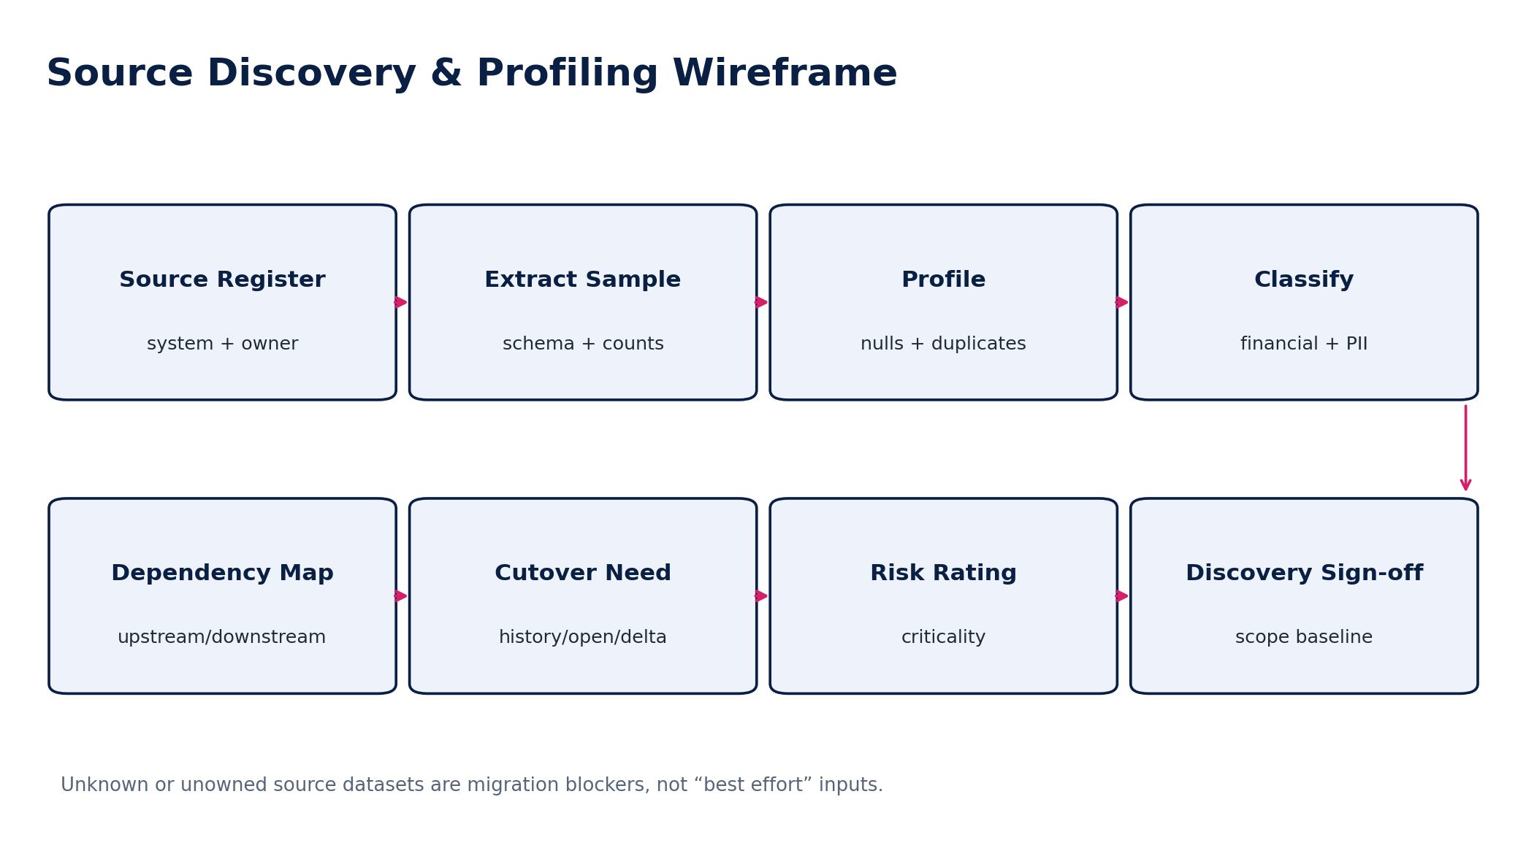
Figure 3 — Source Discovery & Profiling Wireframe
Discovery dimension | Required output
Ownership | business owner, technical owner, data steward, source authority window
Technical profile | product/version, database/file/API, encoding, timezone, schema, volume, peak rate
Business scope | legal entities, books, fiscal periods, modules, branches, currencies, jurisdictions
Quality profile | nulls, invalid codes, duplicates, referential breaks, impossible dates, outliers
Financial profile | record counts, debit/credit totals, balances, open items, aging, control accounts
Security/privacy | classification, PII/sensitive fields, residency, legal hold, access restrictions
Operational dependency | integrations, scheduled jobs, inbound/outbound files, manual processes
Cutover behavior | full extract, incremental extract, CDC/delta support, last transaction semantics
Retention/audit | required history, evidence, audit support and archive obligations

7. Controlled Landing, Staging & Quarantine
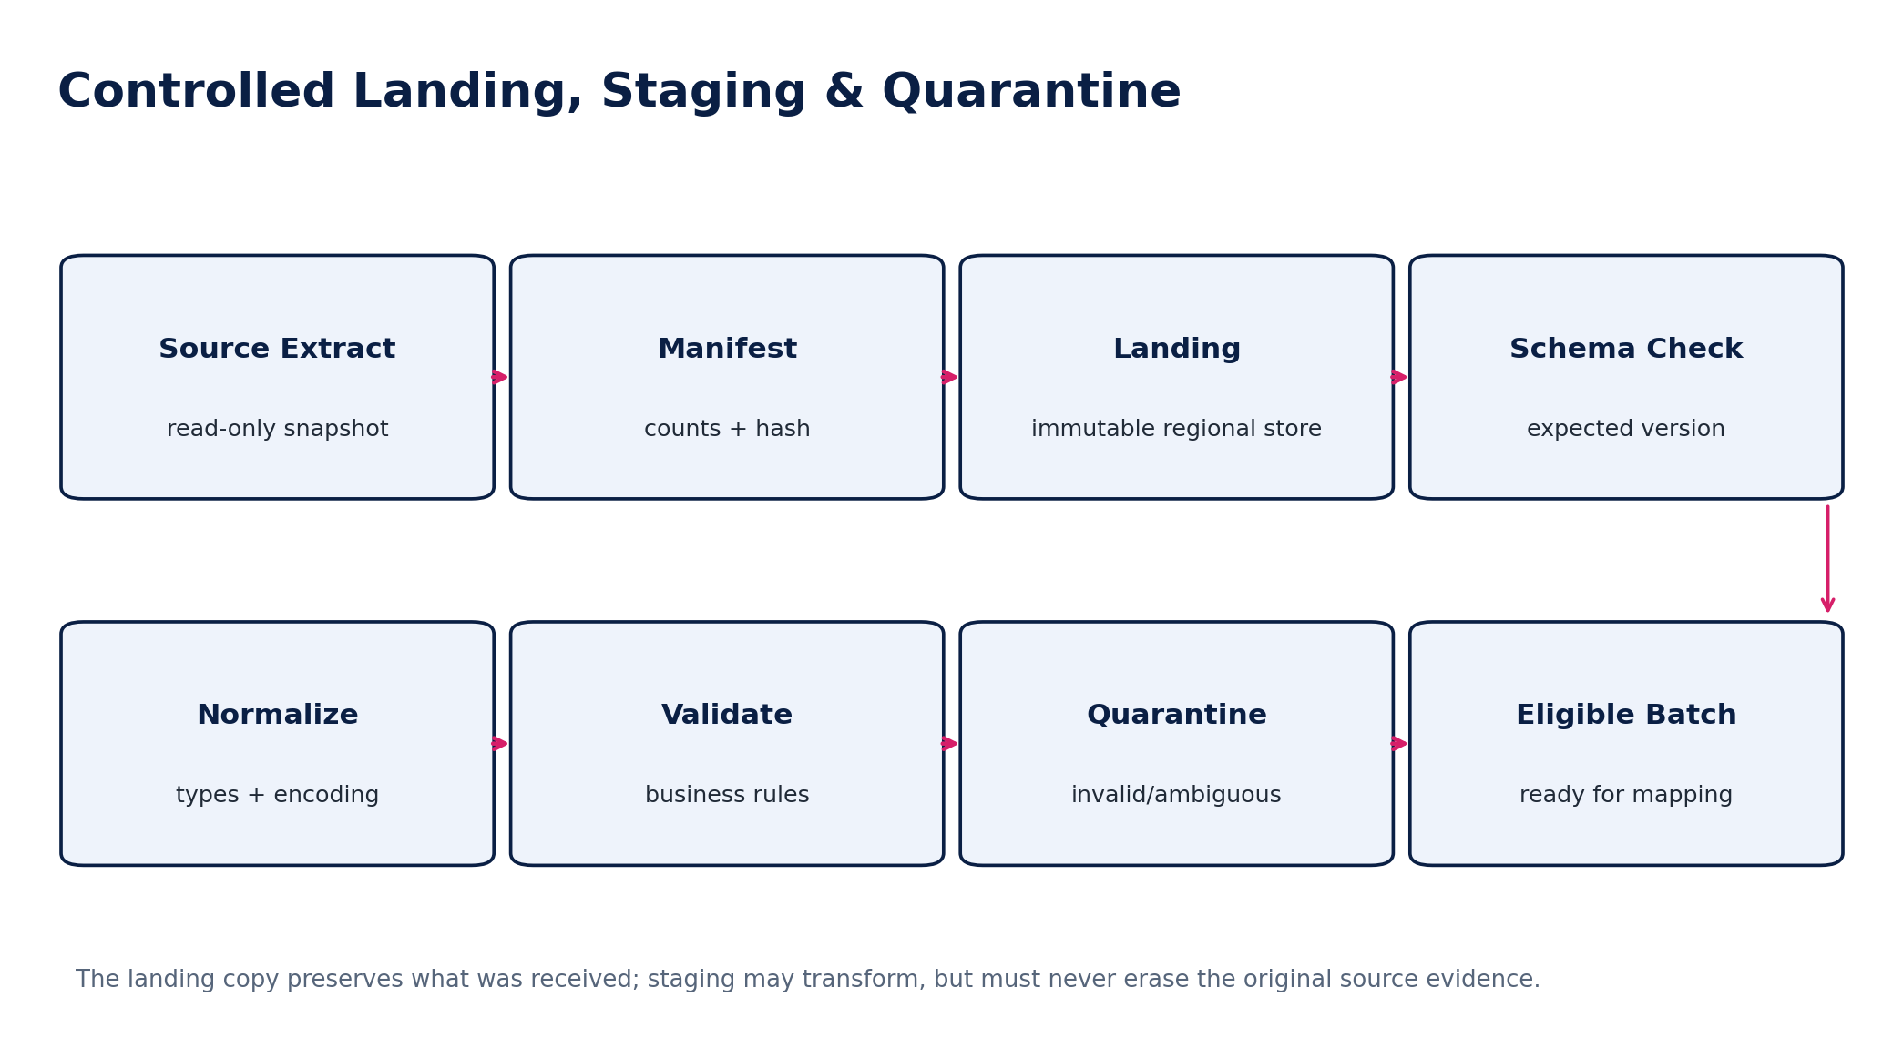
Figure 4 — Controlled Landing, Staging & Quarantine
Zone | Permitted behavior | Prohibited behavior
Landing | store exact received bytes/records; attach manifest, hash, source/time metadata | editing source files; deleting rejected rows; treating landing as queryable target state
Staging | normalize encoding/types; derive technical fields; execute mapping candidates | creating authoritative target IDs without crosswalk; hiding invalid records
Quarantine | hold invalid/ambiguous records with reason, owner and evidence | silent dropping; manual correction without provenance
Eligible batch | contains validated canonical candidates and mapping versions | changing mapping after batch certification without new version
Authoritative target | domain loader/command creates accepted state | direct database inserts or disabling invariants

8. Mapping, Transformation & Reference Resolution
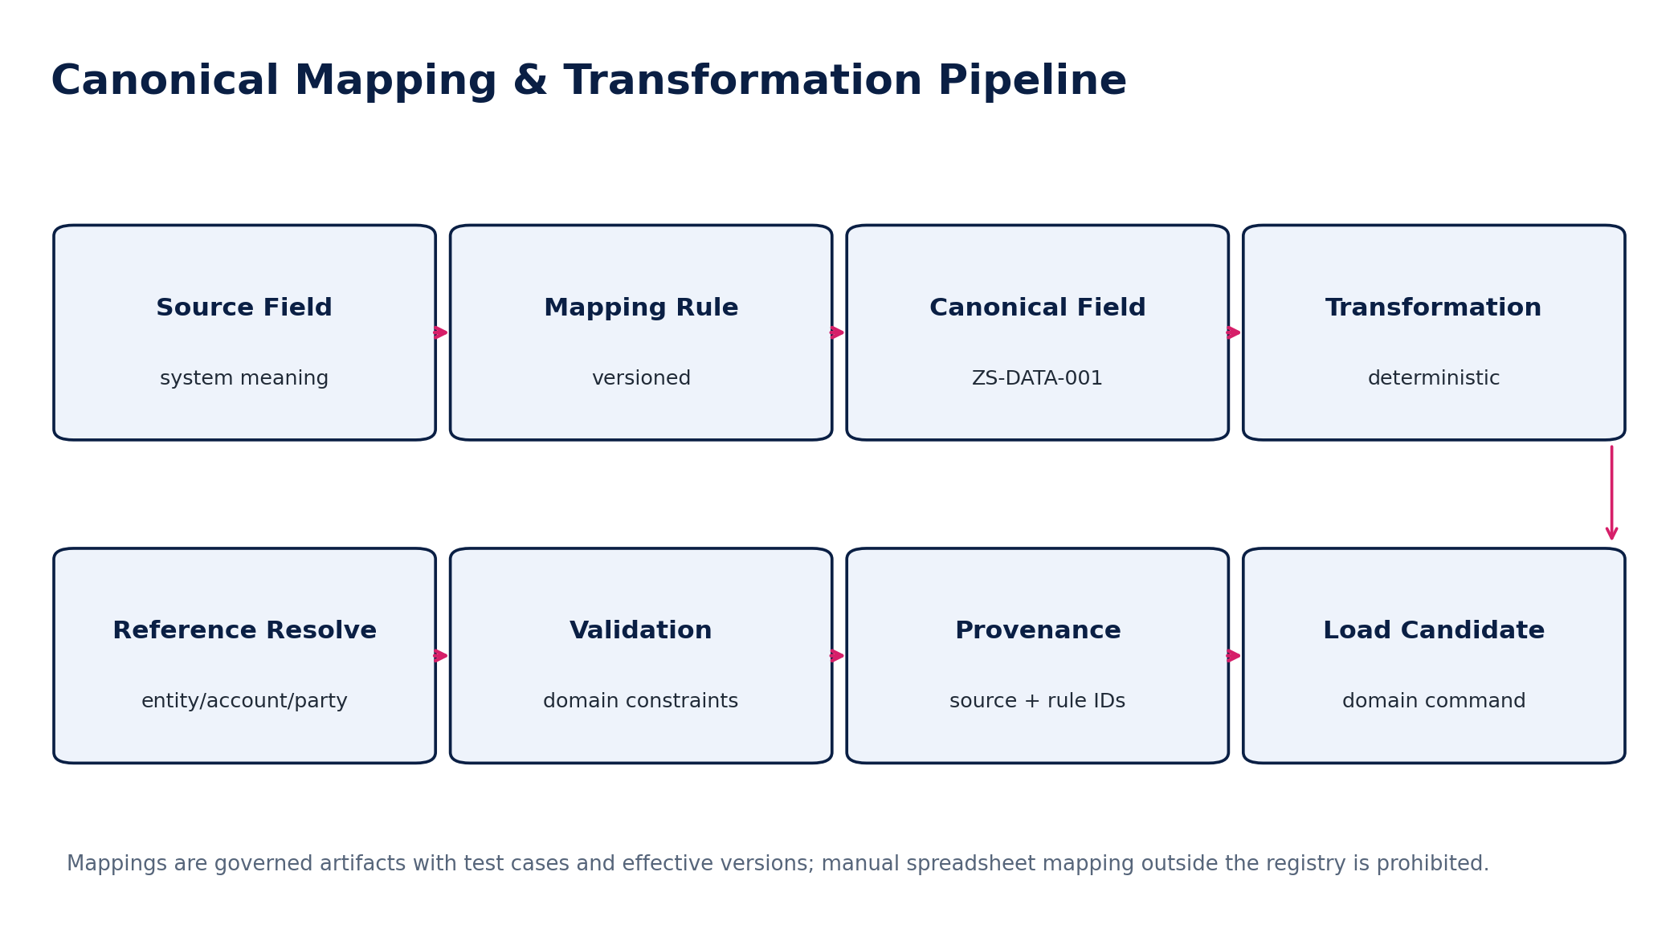
Figure 5 — Canonical Mapping & Transformation Pipeline
Rule component | Requirement
Source semantic definition | document what the source field actually means, not only its column name
Canonical target | reference ZS-DATA-001 canonical entity/field and authoritative owner
Transformation | deterministic expression or code artifact; no hidden spreadsheet formulas
Reference mapping | legacy account/tax/customer/vendor/location codes to canonical IDs
Defaulting | allowed only when business meaning is proven and explicitly approved
Rounding / currency | exact decimal behavior and source/functional/reporting currency semantics
Date handling | preserve document, posting, tax-point, occurrence and effective dates independently
Null behavior | distinguish unknown, not applicable, zero and blank
Source lineage | preserve source field/value reference when material
Test coverage | positive, boundary, invalid, historical and idempotency cases

MAPPING GOVERNANCE
A mapping change after a successful rehearsal creates a new mapping version and invalidates any certification that depended on the previous mapping where the changed rule affects the certified population.

9. Identity Crosswalk, Matching & Deduplication
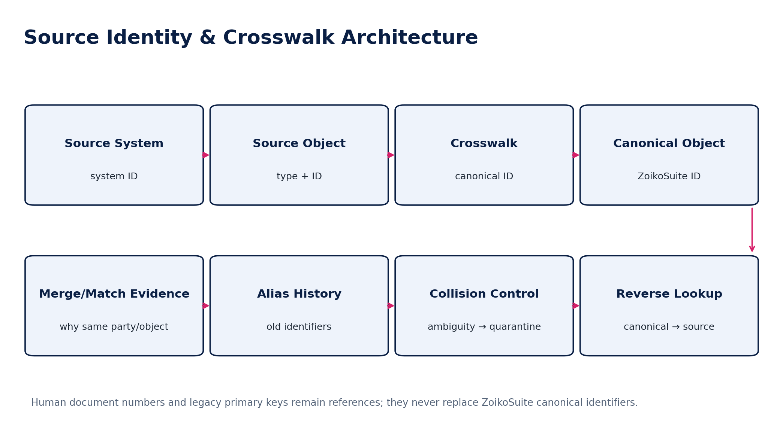
Figure 6 — Source Identity & Crosswalk Architecture
Matching class | Rule
Deterministic identifier match | use authoritative registration/tax/bank/reference identifiers where permitted and validated
Composite deterministic match | use controlled combination such as legal name + registration + jurisdiction
Probabilistic suggestion | may assist review only; must not auto-merge material parties or financial records without policy
Collision | two source objects compete for one canonical object → quarantine/review
Split | one source object must create multiple canonical roles/objects → explicit mapping evidence
Merge | multiple legacy aliases refer to one canonical party/object → preserve all aliases and source relationships
Re-key | never replace canonical UUID with legacy primary key or human document number

10. Master & Configuration Migration
Population | Required migration inputs / controls
Tenant / entities | legal names, registrations, addresses, functional currency, fiscal calendars, residency, effective dates
Chart of accounts | account codes/names/types, parent hierarchy, control-account flags, effective dates, book mappings
Dimensions | cost centers, departments, locations, projects, products, hierarchy and validity
Parties | customers, suppliers, employees/contractors interfaces, banks, tax authorities, advisers; dedupe/crosswalk
Tax configuration | registrations, tax IDs, applicable jurisdiction-pack references; no ad-hoc tax rule import
Payment terms / methods | terms, due rules, bank/payment rails, approval policy references
Users / access | normally provision through IAM/federation/SCIM; legacy application permissions are not copied blindly
Opening periods | fiscal years/periods and cutover period status determined by Accounting Kernel
Documents/templates | controlled versions only; preserve legal/effective dates and source provenance

11. Opening Balances & Accounting Cutover
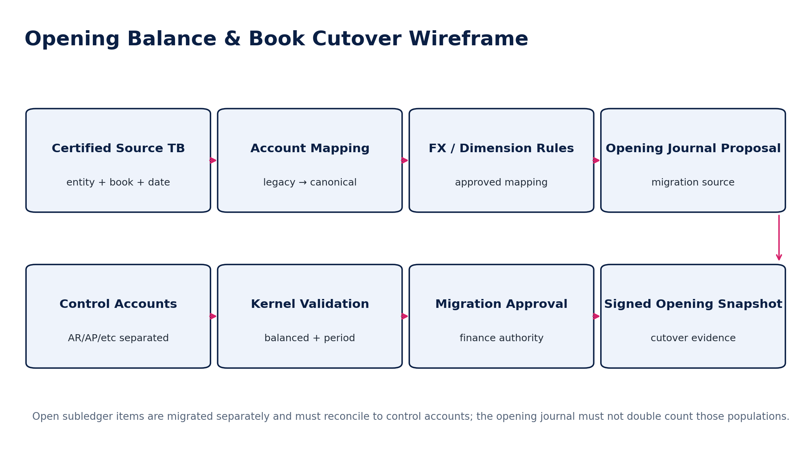
Figure 7 — Opening Balance & Book Cutover Wireframe
Opening balances represent the authoritative financial state at the approved cutover boundary. They are not a mechanism for masking unresolved migration differences.
Control | Required behavior
Cutover date | explicit legal entity/book/ledger date and timezone
Source TB | certified source trial balance with source watermark and evidence
Book scope | statutory/management/tax/consolidation books handled according to approved target model
Account mapping | all source balances map to valid target accounts or explicit approved migration adjustment accounts
Dimensions | material dimensions preserved or deliberately transformed under approved policy
Foreign currency | source currency, functional currency and historical/closing-rate basis documented
Control accounts | AR/AP/payroll/tax/assets/inventory handled consistently with migrated subledgers
Balancing | debits = credits at required scope; no unexplained plug
Migration journal | source=MIGRATION, evidence refs, mapping version, approval, idempotency key
Signed snapshot | post-load trial balance and reconciliation hash retained as cutover evidence

ACCOUNTING BOUNDARY
If open AR/AP items are loaded into subledgers and create GL entries, the opening-balance strategy must exclude or offset those control-account amounts. The same economic balance must never be represented twice.

12. Open AR/AP & Other Subledger Positions
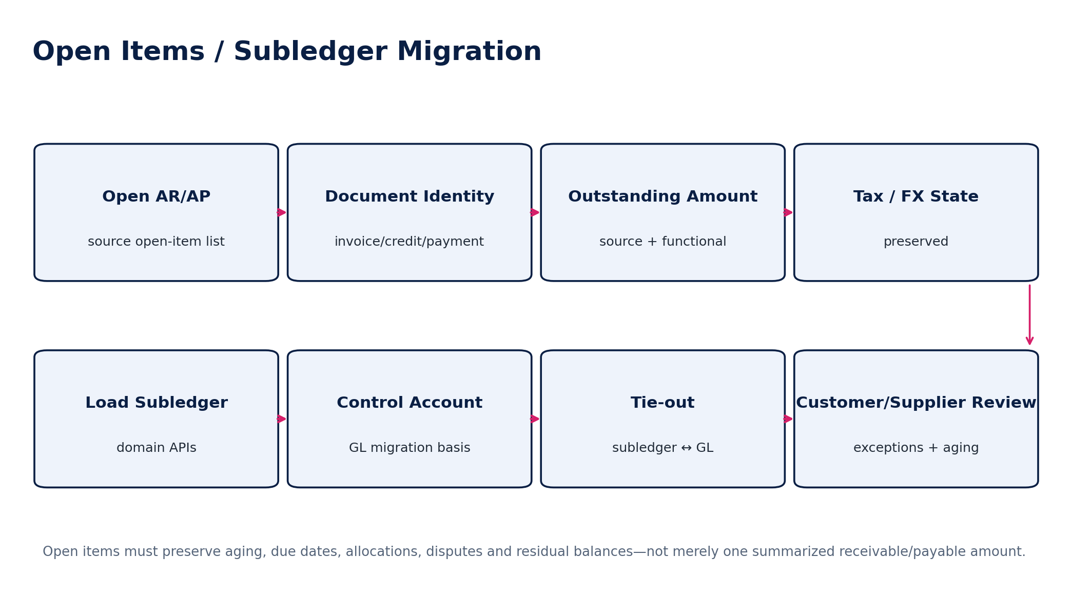
Figure 8 — Open Items / Subledger Migration
Population | Minimum preserved state
Customer invoices | document no., issue/tax dates, due date, original/gross/net/tax amounts, currency, outstanding balance, aging, dispute state, allocations
Customer credits/deposits | remaining amount, original reference, application eligibility
Supplier invoices | supplier invoice no., dates, PO/receipt refs if relevant, currency, withholding/tax, remaining liability, aging
Supplier credits/prepayments | remaining amount and permitted application
Payments in transit | provider/bank status, source reference, intended allocation, execution/value date
Unapplied cash | payer/reference, currency, amount, receipt date, reason/state
Accrual/prepayment schedules | remaining recognition schedule, accounts, dimensions, start/end/effective dates

13. Domain-Specific Migration Requirements
Domain | Required migration treatment
Banking / Treasury | bank accounts, opening cash balances, latest certified statements, outstanding reconciling items; bank connections re-authorized rather than copying secrets/tokens
Tax | registrations, open liabilities/credits, submitted returns, acknowledgment IDs, carry-forwards, filing periods; bind historical facts to appropriate rule context
Payroll interfaces | payroll liabilities, outstanding payroll payments and journals; avoid duplicating payroll history already represented in GL
Fixed Assets | asset register, acquisition/capitalized cost, accumulated depreciation, remaining useful life, method, impairment/revaluation history where operationally necessary
Inventory | item/location masters, on-hand quantity, valuation layers or approved opening valuation basis, in-transit/consignment if in scope, physical-count reconciliation
Projects / Jobs | active projects, commitments, WIP/cost-to-date, billing state and customer relationships
Budgets / Forecasts | approved active versions and assumptions if needed; clearly distinguish migrated plan data from actual financial history
Contracts / Legal | executed documents, parties, effective/expiry dates, obligations, legal-hold status, source evidence
Audit | active engagements/workpapers only where contractually and legally appropriate; preserve provenance and reviewer state
Commercial subscription data | ZoikoSuite customer subscription plane remains separate from the tenant’s own books

14. Historical Data Strategy
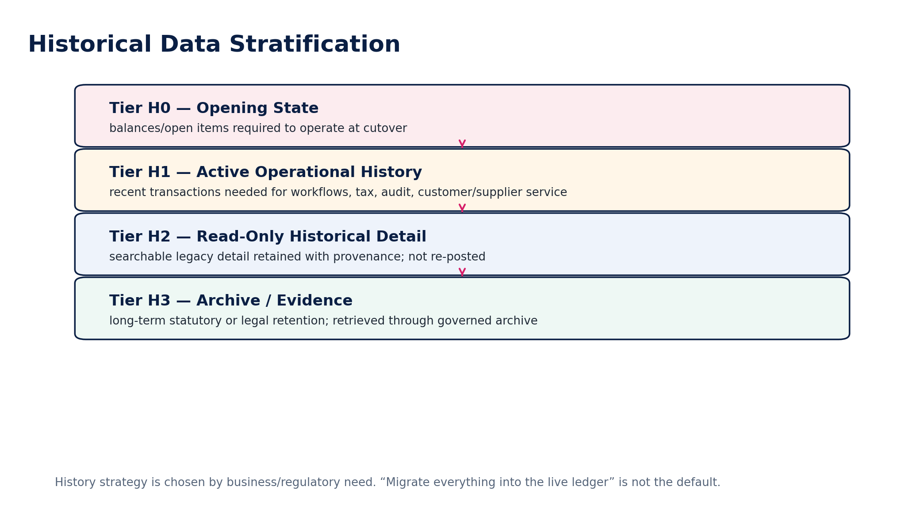
Figure 9 — Historical Data Stratification
The migration program must explicitly choose how much history belongs in live transactional domains versus controlled read-only access. The choice is based on operational, audit, tax, legal, customer-service and reporting needs—not on a generic “migrate all years” rule.
Tier | Typical content | Target behavior
H0 — Opening state | balances, open items, active schedules, current asset/inventory positions | authoritative operational state at cutover
H1 — Active history | recent invoices/payments/orders/tax filings/contracts needed for operations | canonical history where target domain supports it; no duplicate accounting effect
H2 — Read-only history | older transaction detail needed for search/comparison/audit | read-only historical store/index with source identity and immutable provenance
H3 — Archive/evidence | very old statutory/legal records and documents | governed archive with retention, legal hold and export/retrieval

15. Documents, Attachments & Evidence
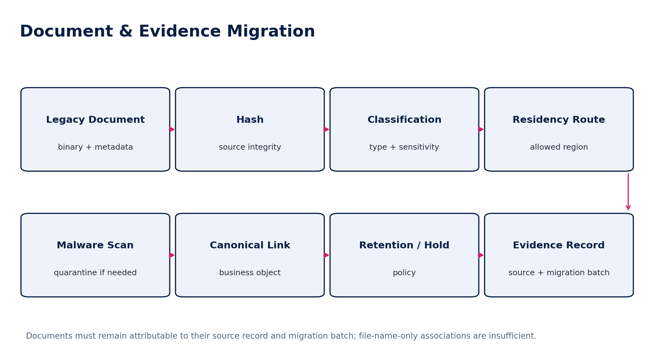
Figure 10 — Document & Evidence Migration
- Preserve source document ID, source object relationship, filename, MIME type, original created/modified timestamps where trustworthy, byte size and hash.
- Do not use filename similarity as the only association to a financial/legal object.
- Run malware/content validation before making documents accessible.
- Preserve executed/signature evidence and legal-hold state.
- If OCR/extraction is performed during migration, store it as a derived artifact with engine/version and field-to-source evidence; never rewrite the source file.

16. Data Quality, Exceptions & Quarantine
Severity | Meaning | Required disposition
MQ0 — Blocker | threatens tenant isolation, ledger balance, legal entity, regulatory filing, financial completeness or cutover integrity | stop affected batch/cutover; executive/domain owner resolution required
MQ1 — Material | financial/regulatory/business effect above approved materiality | must resolve or receive formally approved, time-limited migration exception
MQ2 — Significant | operational impact but not financially material | owned remediation; may proceed only if acceptance criteria permit
MQ3 — Minor | non-material presentation/reference defect | documented remediation/backlog
MQ4 — Informational | quality observation with no current effect | track/monitor as appropriate

Reason family | Examples
IDENTITY | duplicate, collision, missing canonical relationship
REFERENCE | unknown account, tax code, currency, dimension, entity
TEMPORAL | invalid date, effective-date conflict, cutoff outside migration window
FINANCIAL | unbalanced journal, control mismatch, currency inconsistency
SUBLEDGER | open-item amount/aging/allocation inconsistency
TAX | registration/rule/return relationship unresolved
DOCUMENT | missing/corrupt/unlinked/unsafe file
SCHEMA | unexpected type/field/version
SECURITY | residency/classification/access violation
SOURCE | source population incomplete or extract integrity failure

17. Reconciliation & Migration Certification
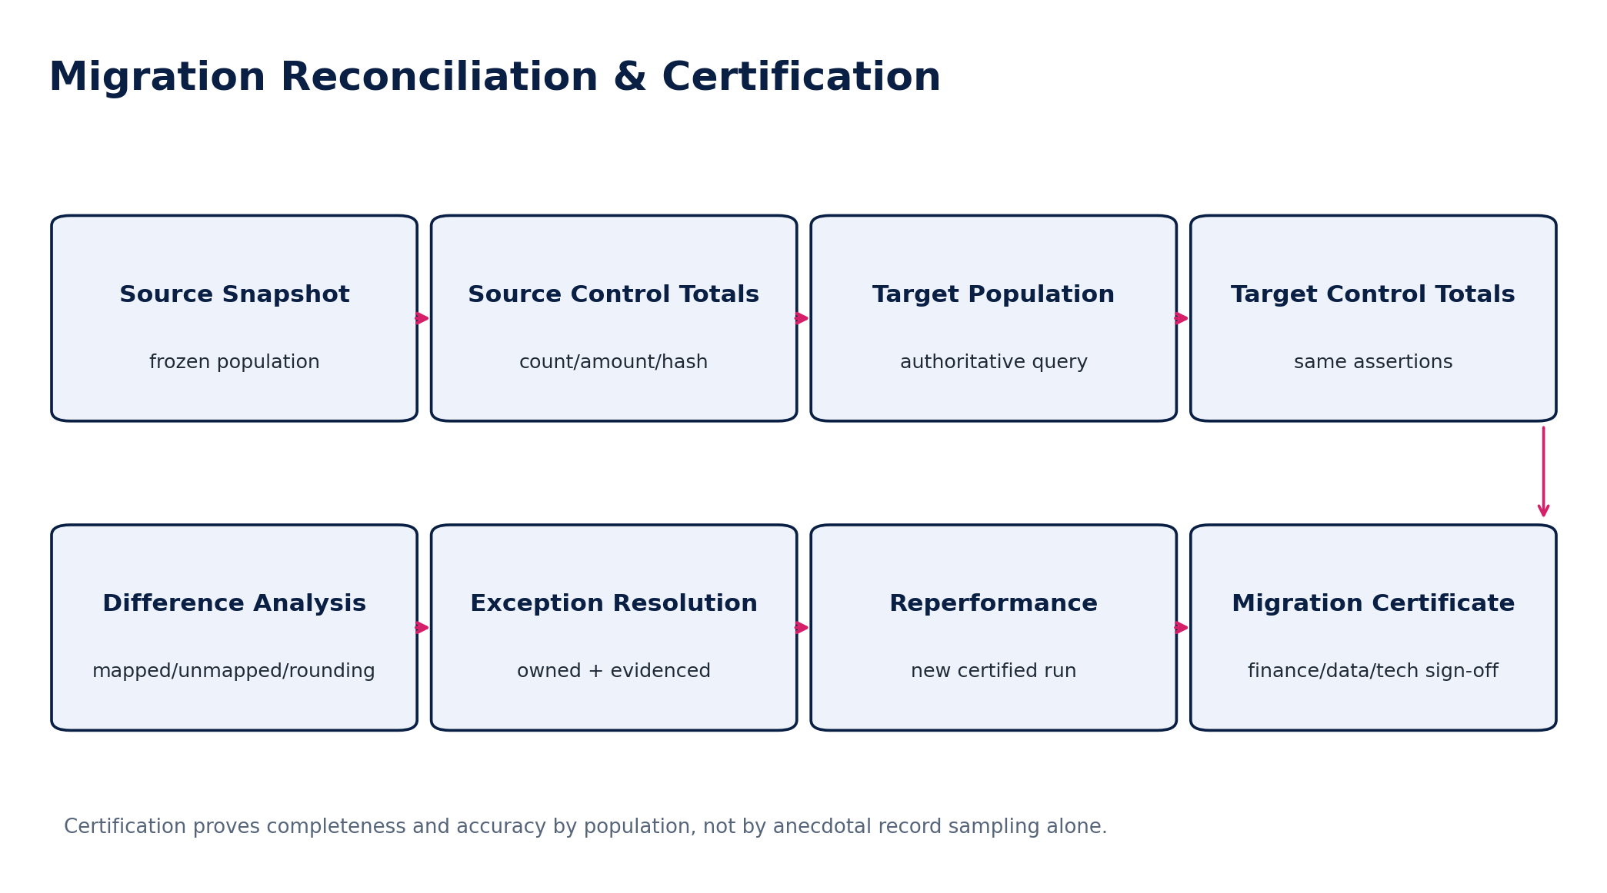
Figure 11 — Migration Reconciliation & Certification
Assertion | Representative controls
Completeness | source count/hash vs target + quarantined + explicitly excluded = 100% accounted for
Accuracy | financial totals, quantities, tax, currencies and key field comparisons
Existence / occurrence | target objects trace to valid source records or approved migration-created adjustments
Cutoff | transactions/open items assigned to the correct pre/post-cutover side
Classification | accounts, dimensions, party roles, tax classifications and object types
Valuation | FX, depreciation, inventory valuation, outstanding amounts and balances
Relationships | invoice-payment allocations, parent/child hierarchies, party/document links, entity/book ownership
Evidence | source manifest, mapping/rule versions, run IDs, exceptions and approvals retained

MIGRATION CERTIFICATE MINIMUM
A certificate identifies the exact source watermarks, extract hashes, mapping versions, accepted batches, target release/schema version, reconciliation runs, unresolved approved exceptions, cutover runbook version and named signatories.

18. Dry Runs, Performance & Rehearsal
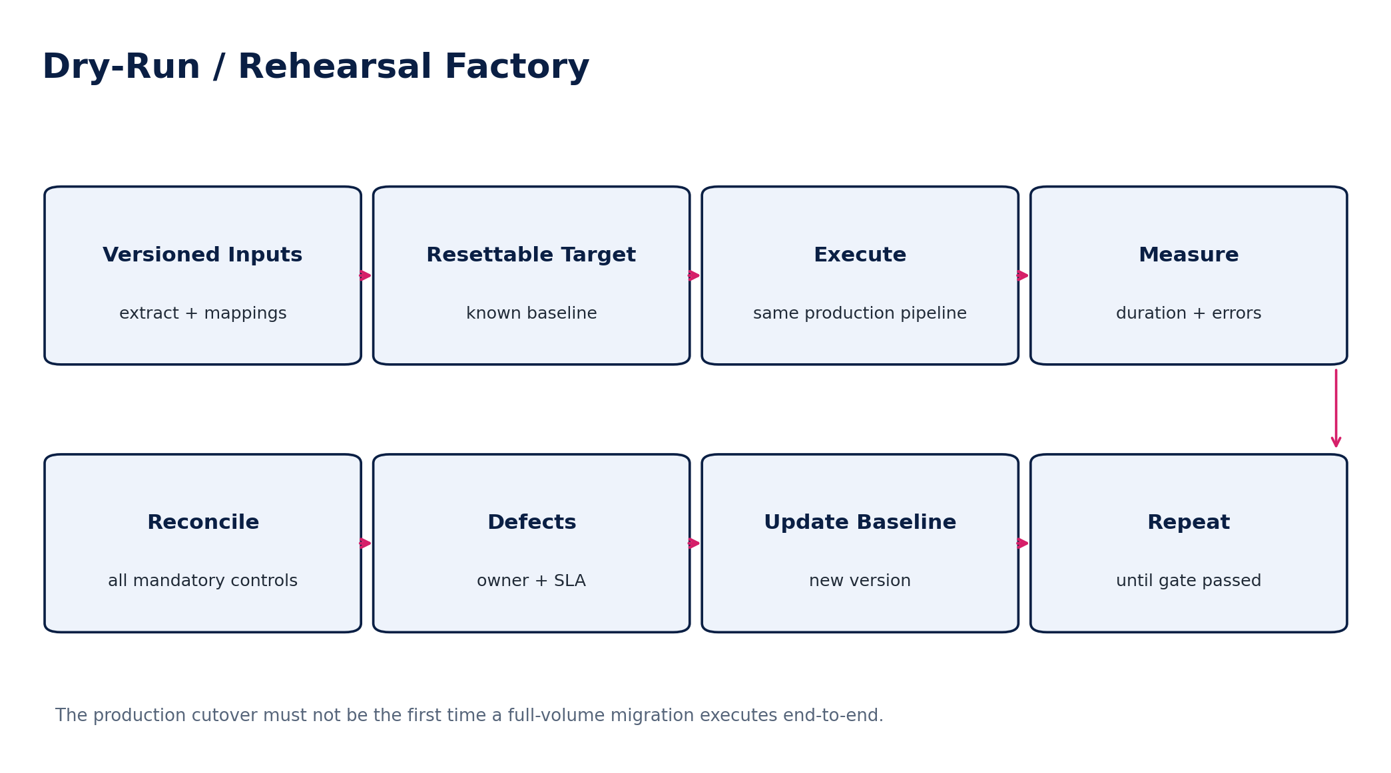
Figure 12 — Dry-Run / Rehearsal Factory
Rehearsal requirement | Acceptance
At least one full-volume run | uses production-scale volumes and same migration software path
Repeatability | same inputs/version produce same canonical results except explicitly nondeterministic technical metadata
Runtime | fits within approved cutover window with contingency
Recovery | failed stage can restart safely/idempotently without duplicate authoritative effects
Reconciliation | all mandatory migration controls execute automatically or through defined evidenced manual controls
Business validation | sampled operational workflows and key customer/supplier/finance journeys validated
Operational readiness | runbooks, contacts, dashboards, permissions, credentials, storage and incident paths tested
Final rehearsal freeze | mapping/config changes after final rehearsal require impact review and possibly re-certification

19. Cutover Freeze, Delta & Watermark Architecture
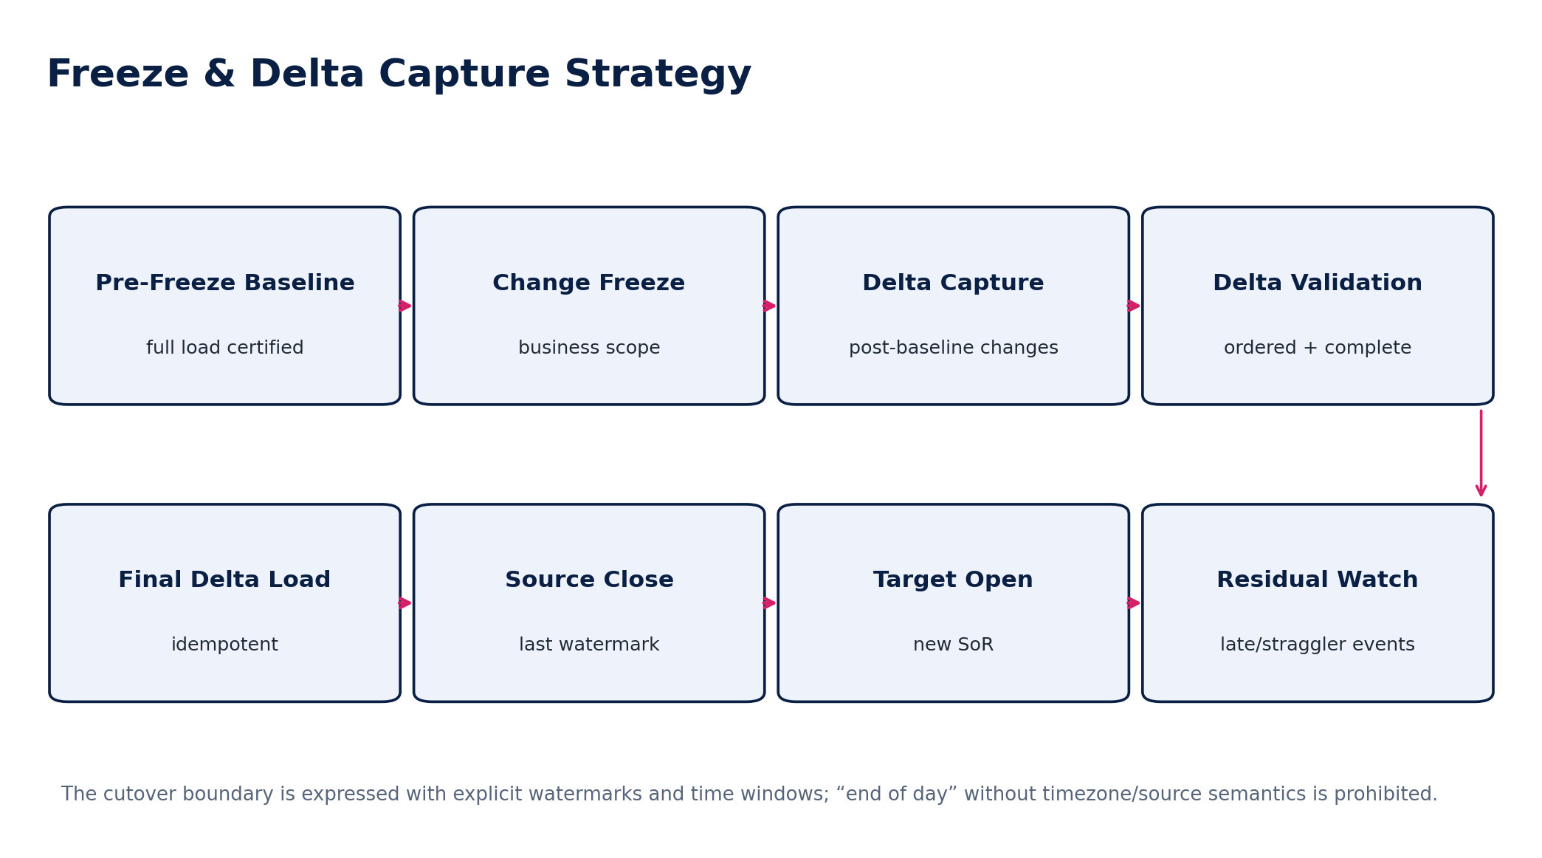
Figure 13 — Freeze & Delta Capture Strategy
Cutover boundary element | Required definition
Business freeze | which source transactions/users/jobs stop, and when
Technical freeze | which schemas/configs/integrations cannot change
Last source watermark | timestamp + timezone and/or monotonic sequence/ID
Delta start/end | exclusive/inclusive semantics explicitly documented
Late arrivals | how source events timestamped earlier but arriving later are detected and handled
External providers | final settlement/filing/payment callbacks and ownership during transition
Target activation | exact moment ZoikoSuite becomes authoritative for each domain
Legacy mode | read-only/archive/decommission state after cutover

20. Production Cutover Runbook
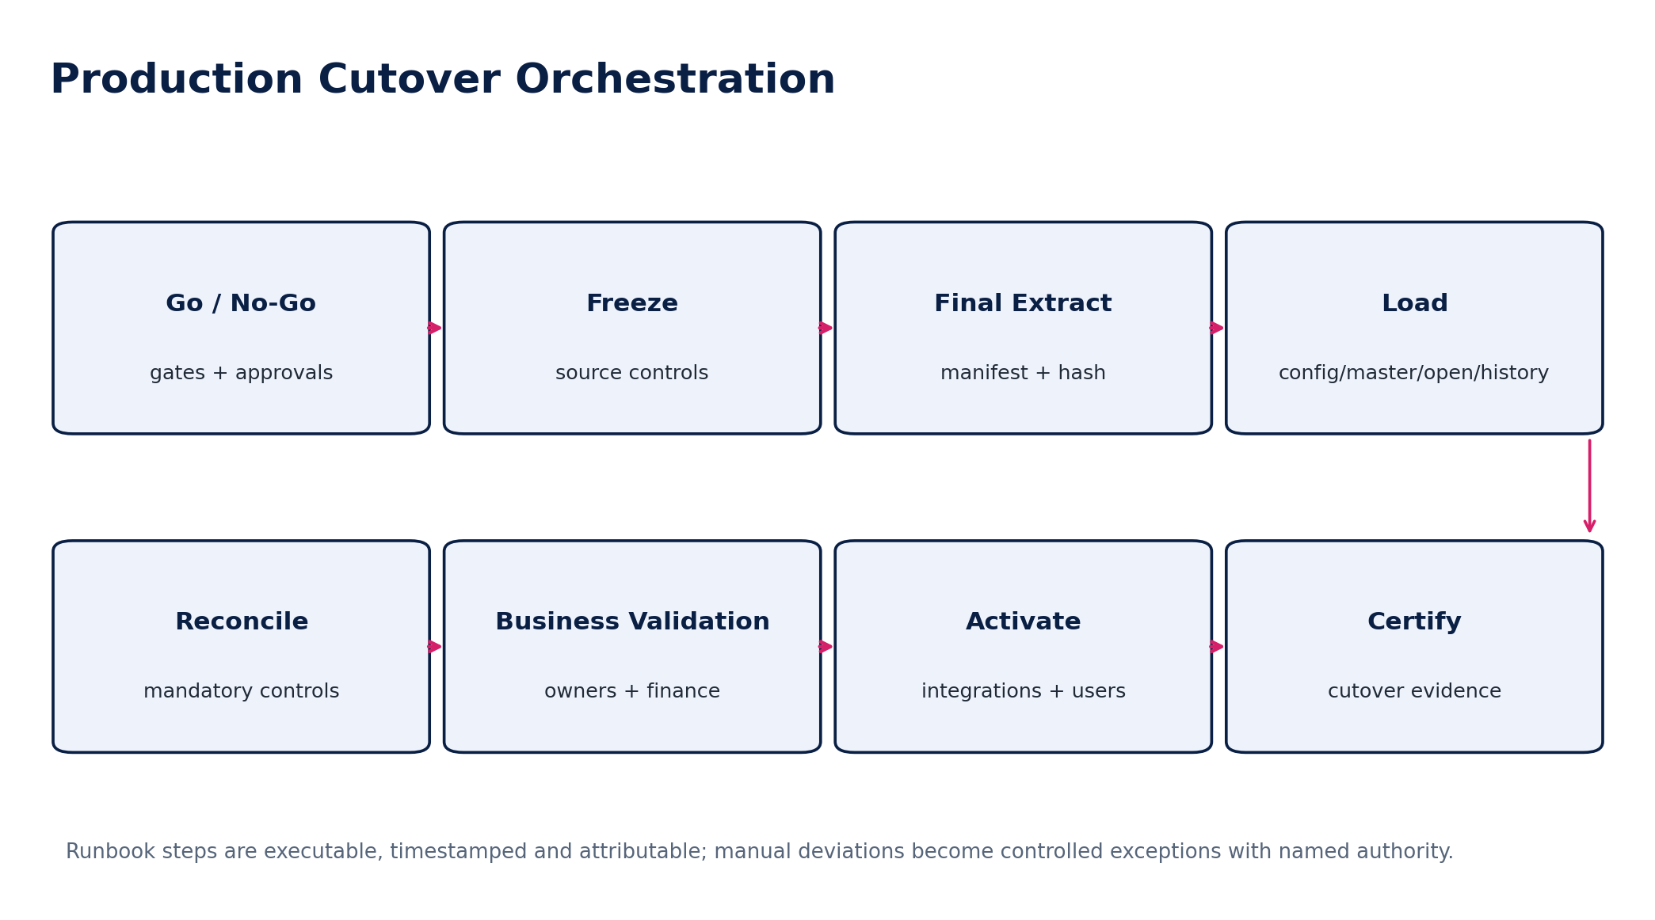
Figure 14 — Production Cutover Orchestration
Gate | Minimum evidence
G0 — Scope locked | source inventory, mapping versions, target release and jurisdiction packs fixed
G1 — Rehearsal passed | full-volume rehearsal, runtime and recovery within threshold
G2 — Finance ready | opening balances/open items/control strategy approved
G3 — Security/residency ready | regions, access, encryption, secrets and support path verified
G4 — Operational ready | runbook, dashboards, incident command, vendor/support contacts
G5 — Freeze accepted | business owners accept source freeze and transaction handling
G6 — Migration loaded | all required batches completed or accounted for
G7 — Reconciliation passed | mandatory controls green or formally accepted within policy
G8 — Business acceptance | finance/domain owners validate critical journeys
G9 — Target activation | interfaces/users/providers switched under controlled command
G10 — Cutover certificate | signed evidence package and explicit authority-of-record transition

21. Rollback, Forward Correction & Failure Containment
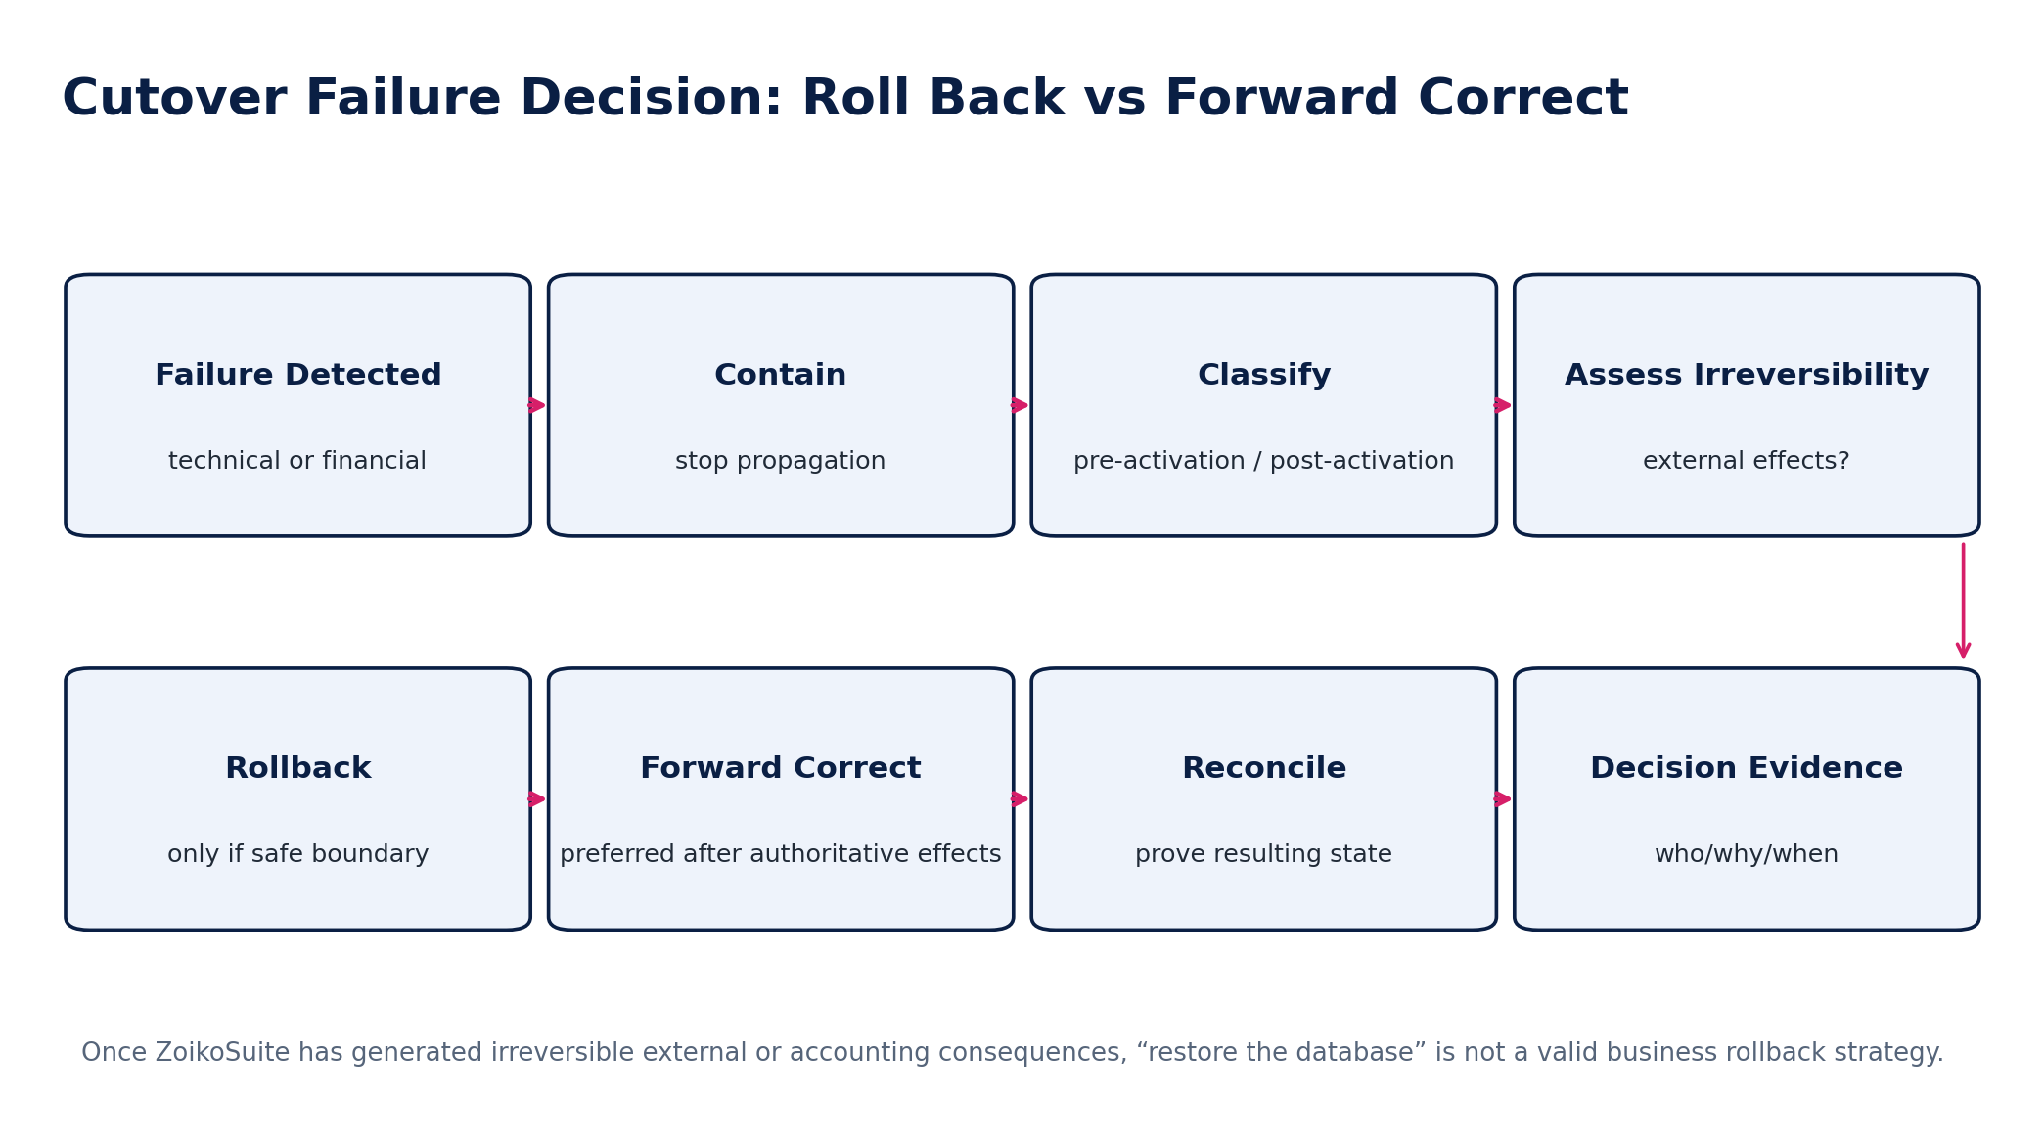
Figure 15 — Cutover Failure Decision: Roll Back vs Forward Correct
The program must define a reversible boundary before cutover. “Rollback” is a business-state decision, not merely an infrastructure restore operation.
Condition | Preferred response
Failure before target activation and no irreversible target/external effects | rollback to certified pre-cutover state may be appropriate
Partial target data loaded but not authoritative and safely purgeable by batch identity | controlled batch reset/purge then rerun
Target posted journals, sent invoices, executed payments, submitted filings or accepted external messages | forward correction using authoritative domain semantics; do not simply restore database
Source already resumed activity after failed activation | new migration boundary required; reconcile divergent changes
Uncertain data completeness | contain, prevent further business effects, reconcile populations before decision
Security/residency breach | security incident process overrides ordinary migration timeline; preserve evidence

22. Post-Cutover Stabilization & Hypercare
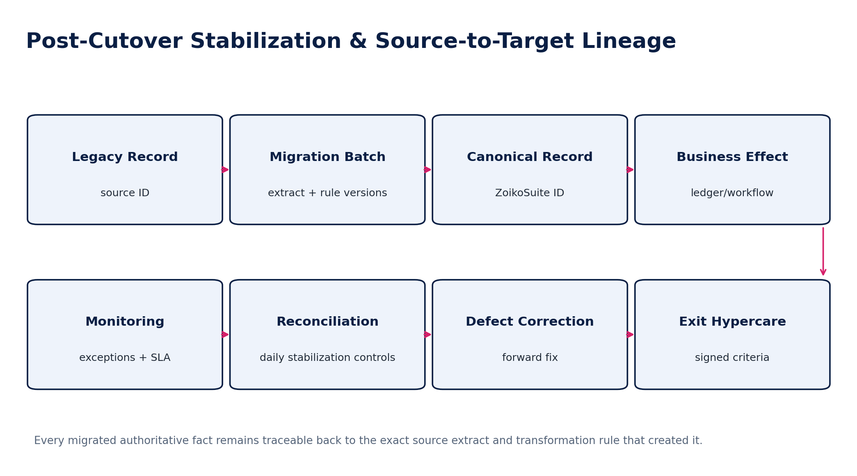
Figure 16 — Post-Cutover Stabilization & Source-to-Target Lineage
Stabilization control | Exit criterion
Daily financial reconciliation | no unresolved material source/target/control differences
Interface completeness | all inbound/outbound integrations stable; backlog and retry queues within normal bounds
Open-item quality | AR/AP aging, allocations, unapplied cash/payments and disputes validated
Banking | statement ingestion/reconciliation and payment flows operating normally
Tax/payroll liabilities | opening liabilities and authority/payment states confirmed
User access | IAM provisioning/role scopes validated; no emergency broad access remains
Defects | P0/P1 none unresolved; P2 within approved plan/SLA
Performance | production load/latency within SLO; no migration artifacts causing degradation
First close readiness | control owners confirm period-close and reporting populations are reproducible
Legacy estate | read-only/archive/decommission plan executed with retention/legal hold

23. Migration APIs, Commands & Event Contracts
Interface / command | Purpose / key controls
POST /migration-programs | create governed program; privileged admin + tenant scope
POST /source-extracts:register | register immutable source manifest/hash/watermark
POST /migration-batches:validate | schema/mapping/domain validation only; no authoritative writes
POST /migration-batches:execute | approved batch load through domain loaders; idempotency required
POST /migration-batches:cancel | allowed only before defined irreversible target effects
POST /quarantine-items/{id}:resolve | record corrected mapping/source value/disposition and evidence
POST /reconciliation-runs | execute source-target control assertions
POST /migration-certificates:issue | requires mandatory reconciliation results and authorized sign-offs
POST /cutover-runs | instantiate approved runbook/version
POST /cutover-runs/{id}:activate-target | privileged named command; revalidate all go/no-go gates
GET /migration-lineage/{canonical_id} | retrieve source → extract → mapping → batch → canonical lineage
GET /migration-crosswalk | resolve source IDs to canonical IDs and reverse lookup

Canonical migration domain events include: MigrationProgramCreated, SourceExtractRegistered, MigrationBatchValidated, MigrationBatchQuarantined, MigrationBatchLoaded, MigrationReconciliationCompleted, MigrationCertificateIssued, CutoverFreezeStarted, TargetAuthorityActivated, CutoverCompleted, StabilizationExited and MigrationExceptionApproved. Event publication follows ZS-EVENT-001 transactional outbox/inbox rules.

24. Persistence & Evidence Model
Entity / store | Retention / integrity requirement
Source extract manifest | immutable; source hash, counts, watermarks, storage URI, encryption/residency metadata
Mapping rule set | versioned, signed/approved where material; source and target schemas plus tests
Crosswalk | durable while migrated records remain in use/retention; reverse searchable
Batch/run record | status, software artifact version, configuration, timings, idempotency key, metrics/errors
Quarantine item | immutable issue history; current disposition plus remediation evidence
Reconciliation run | source/target populations, queries/watermarks, totals, differences, result and sign-off
Migration certificate | immutable evidence package; certificate hash/signature
Cutover command log | timestamped steps, actor/workload, result, evidence and exception references
Legacy archive | read-only, encrypted, indexed by source ID and retention/legal-hold policy

25. Security, Privacy & Residency Controls
- Migration workloads receive unique service identities and least-privilege, time-limited access to source and target systems.
- Source credentials/tokens are never embedded in mapping files or scripts; use approved secrets management.
- Data landing and staging follow the tenant residency decision; cross-region copies are default-deny and evidenced.
- Production-derived rehearsal data is minimized/masked where feasible and remains within classification/retention rules.
- Bulk exports and legacy archives are encrypted, access-logged and lifecycle-controlled.
- PII/sensitive-field exposure in migration logs is prohibited; errors use object IDs/reason codes, not raw record dumps.
- Legal hold applies through migration and decommissioning; migration does not authorize destruction of held source evidence.

26. Observability & Operational Metrics
Metric / signal | Purpose
records_extracted / landed / eligible / quarantined / loaded | population completeness funnel
financial_control_total_source / target | amount-based reconciliation
unmapped_reference_count | mapping readiness
quarantine_age_by_severity | exception governance
batch_duration / throughput | cutover capacity
idempotent_replay_count | restart/retry safety
crosswalk_collision_count | identity-quality risk
late_delta_count | cutoff/watermark risk
reconciliation_difference_amount | financial exposure
cutover_step_duration / status | runbook control
migration_error_rate_by_reason | root-cause trending
stabilization_defect_backlog | hypercare exit readiness

27. Initial Canonical Migration Control Catalogue
ID | Control | Acceptance statement
MIG-C01 | Source inventory complete | All in-scope sources have owner, extraction method and authority period
MIG-C02 | Source extract integrity | Manifest hash/counts validated before use
MIG-C03 | Source schema version | Unexpected schema blocks batch
MIG-C04 | Record accountability | loaded + quarantined + excluded = source population
MIG-C05 | Legacy ID preservation | all authoritative objects retain crosswalk
MIG-C06 | Crosswalk uniqueness | no ambiguous source→canonical mapping
MIG-C07 | Party deduplication | material merges independently reviewed
MIG-C08 | Entity mapping | every financial record resolves legal entity
MIG-C09 | Book/ledger mapping | financial records resolve correct book/ledger
MIG-C10 | Account mapping completeness | 100% of source posting accounts mapped or explicitly excluded
MIG-C11 | Dimension mapping | required dimensions map with effective validity
MIG-C12 | Currency validation | currency codes/minor units/functional currency valid
MIG-C13 | Date preservation | document/posting/tax/effective dates not collapsed
MIG-C14 | Opening TB balance | debits = credits at required scope
MIG-C15 | Opening TB tie-out | source certified TB = target opening state
MIG-C16 | AR control tie-out | open AR detail = AR control-account strategy
MIG-C17 | AP control tie-out | open AP detail = AP control-account strategy
MIG-C18 | AR aging preservation | aging/due dates/outstanding amounts reconcile
MIG-C19 | AP aging preservation | aging/due dates/outstanding amounts reconcile
MIG-C20 | Unapplied cash | all unapplied receipts accounted for
MIG-C21 | Unapplied supplier payments | all unapplied payments accounted for
MIG-C22 | Bank opening balances | bank position reconciles to source statement/ledger
MIG-C23 | Bank reconciling items | outstanding items preserved/accounted for
MIG-C24 | Tax liability tie-out | open tax liabilities/credits reconcile to GL/returns
MIG-C25 | Tax filing evidence | open/previous filing IDs and acknowledgments preserved where in scope
MIG-C26 | Payroll liability tie-out | open payroll liabilities and payment states reconcile
MIG-C27 | Fixed asset cost | asset cost/accumulated depreciation reconcile
MIG-C28 | Asset remaining life | method/useful life/residual state valid
MIG-C29 | Inventory quantity | on-hand by item/location reconciles
MIG-C30 | Inventory valuation | valuation basis and GL tie-out certified
MIG-C31 | Project WIP | active project balances/commitments reconciled
MIG-C32 | Document completeness | expected document count/hash accounted for
MIG-C33 | Document linkage | documents linked to intended canonical objects
MIG-C34 | Legal hold preservation | held items retained and marked
MIG-C35 | Historical tier compliance | history loaded only into approved H0/H1/H2/H3 tier
MIG-C36 | No duplicate accounting effect | history/open items/opening balances do not double post
MIG-C37 | Quarantine ownership | all MQ0–MQ2 items named owner and disposition
MIG-C38 | Transformation reproducibility | same inputs/rules produce same business outputs
MIG-C39 | Mapping version pinning | batch tied to immutable mapping version
MIG-C40 | Batch idempotency | re-run does not duplicate authoritative target effects
MIG-C41 | Delta completeness | final delta watermarks account for all post-baseline changes
MIG-C42 | Cutoff correctness | source vs target transaction boundary is unambiguous
MIG-C43 | Cutover runtime | fits approved window with contingency
MIG-C44 | Recovery rehearsal | failed stage successfully restarted/recovered
MIG-C45 | Target release pinning | migration certified against exact target schema/release
MIG-C46 | Residency enforcement | landing/staging/target remain in approved regions
MIG-C47 | Access expiry | migration privileged access removed/expired after use
MIG-C48 | Migration certificate | all required reconciliations/sign-offs attached
MIG-C49 | Post-cutover daily control | stabilization reconciliations execute and remain within thresholds
MIG-C50 | First-close readiness | finance/control owners certify the first period-close control population

28. Negative-Path Engineering Acceptance Scenarios
ID | Scenario | Expected result
MIG-N01 | Source extract count differs from source manifest | Reject extract/batch.
MIG-N02 | Landing file hash changes after registration | Security/integrity incident; never use changed artifact.
MIG-N03 | Unknown source schema version appears | Block batch; require schema/mapping update.
MIG-N04 | Source customer matches two canonical parties | Quarantine; no automatic merge.
MIG-N05 | Two source objects claim same unique registration ID | Collision investigation required.
MIG-N06 | Opening TB is unbalanced by entity/book | Block finance migration/cutover.
MIG-N07 | AR open-item total differs from control account | Block certification; resolve strategy/difference.
MIG-N08 | AP open item has missing due date required for aging | Quarantine or controlled approved derivation.
MIG-N09 | Historical invoice is loaded and reposts revenue already in opening balance | Test must detect duplicate economic effect.
MIG-N10 | Legacy payment reference duplicates during retry | Idempotency prevents duplicate target payment/application.
MIG-N11 | Mapping rule changes after final rehearsal | Invalidate impacted certification; rerun affected scope.
MIG-N12 | Source uses invalid currency code | Quarantine; no silent substitution.
MIG-N13 | Legacy date lacks timezone and is used for cutoff | Require source-specific interpretation rule; do not guess.
MIG-N14 | Tax liability has no filing/registration context | Quarantine/material exception.
MIG-N15 | Asset accumulated depreciation exceeds cost without allowed model | Block/quarantine for finance review.
MIG-N16 | Inventory layer has negative quantity where policy forbids it | Block item/location migration.
MIG-N17 | Document binary is corrupt or malware-positive | Quarantine and preserve source evidence.
MIG-N18 | Legal-hold document is marked for archive deletion | Retention control blocks disposition.
MIG-N19 | Migration job attempts direct database insert | Security/policy gate rejects.
MIG-N20 | Batch retry after partial load | Resume/replay without duplicate target effects.
MIG-N21 | Final delta misses a source sequence number | Cutover blocks until gap resolved.
MIG-N22 | Late source event arrives after declared last timestamp | Late-arrival rule captures/account for event.
MIG-N23 | Business user enters transaction during freeze | Defined freeze handling rejects/queues/routes it.
MIG-N24 | Cutover fails before activation | Rollback path restores certified reversible boundary.
MIG-N25 | Cutover fails after tax filing submitted from target | Forward-correct; no raw DB rollback.
MIG-N26 | Target reconciliation query includes wrong entity | Scope control detects mismatch.
MIG-N27 | Quarantine item manually edited without evidence | Reject resolution.
MIG-N28 | Source-to-target record count matches but financial amounts differ | Certification fails despite count match.
MIG-N29 | Financial totals match but 100 records were swapped/misclassified | Record/relationship tests detect false-positive total match.
MIG-N30 | Production extract copied to unauthorized test region | Residency/security control blocks and raises incident.
MIG-N31 | Migration service credential remains active after cutover | Post-cutover access control fails certification.
MIG-N32 | Legacy bank token is copied into target | Prohibited; target bank connection must be re-authorized.
MIG-N33 | Target release changes during cutover window | Block activation unless explicitly re-certified.
MIG-N34 | Unresolved MQ1 difference is hidden in migration suspense account | Close/cutover certificate blocked.
MIG-N35 | First post-cutover bank statement does not reconcile | Stabilization remains open; defect owned.
MIG-N36 | First period close reveals opening-balance control drift | Hypercare/first-close escalation and corrective certification required.

29. Definition of Ready — Migration Program / Domain
- Source systems and datasets are inventoried with owners and scope.
- Target tenant/legal-entity/book model is approved.
- Source extraction method and authority are proven.
- Data classification/residency/legal-hold rules are known.
- Canonical mapping specifications are versioned and reviewed.
- Identity/crosswalk strategy is defined.
- Opening-balance/open-item/history strategy is approved by Finance.
- Mandatory reconciliation assertions and materiality/tolerance policies are defined.
- Dry-run environment and reset strategy are ready.
- Migration loaders/APIs and idempotency behavior are tested.
- Cutover watermarks/freeze/delta strategy is defined.
- Runbook, recovery and incident authority are assigned.

30. Definition of Done — Production Migration
- All accepted source populations are accounted for as loaded, quarantined or explicitly excluded.
- Mandatory source-to-target reconciliations pass or have valid approved residual exceptions within policy.
- Opening balances and control-account strategies are certified.
- Migration certificate is signed by required business/finance/technology/control owners.
- Target authority-of-record activation is complete and evidenced.
- Legacy source is in approved read-only/archive/decommission state.
- Migration privileged access has expired or been removed.
- Crosswalk and lineage are queryable.
- Post-cutover stabilization controls are green for the required period.
- P0/P1 migration defects are closed; remaining defects have accepted plans.
- First-close readiness is certified.
- All migration evidence is retained under the approved policy.

31. Engineering Implementation Sequence
Wave | Capability
Wave 0 — Framework | program/source/extract/batch/crosswalk/evidence schemas; IAM/residency integration
Wave 1 — Discovery & Landing | source register, profiling, manifests, landing, schema checks, quarantine
Wave 2 — Mapping & Crosswalk | mapping registry/compiler, deterministic transforms, identity resolution
Wave 3 — Master & Configuration | entity/COA/dimensions/party/reference loaders
Wave 4 — Financial Cutover | opening balances, AR/AP, banking, tax/payroll liabilities, assets/inventory
Wave 5 — History & Documents | H1/H2/H3 history, documents/evidence/archive
Wave 6 — Reconciliation | control totals, population snapshots, migration certificate
Wave 7 — Rehearsal & Cutover | dry-run factory, delta/watermark, runbook, go/no-go, activation
Wave 8 — Stabilization | daily controls, defect management, first-close readiness, legacy decommission

32. Controlled Pre-Production Decision Register
Decision | Must be resolved before production migration
Migration scope by source/domain/history | Yes
Cutover date/timezone and authority boundary | Yes
History stratification H0–H3 | Yes
Opening-balance vs subledger posting strategy | Yes
Migration materiality/tolerance policy | Yes
Crosswalk matching/merge thresholds | Yes
Quarantine authority and exception SLA | Yes
Source freeze and delta method | Yes
Rollback reversible boundary | Yes
Target release/schema/jurisdiction pack versions | Yes
Legacy archive/decommission model | Yes
Hypercare duration and exit thresholds | Yes

33. Prohibited Migration Anti-Patterns
- Direct database copying into authoritative ZoikoSuite tables.
- Treating a migration as successful because the row count matches.
- Using plug/suspense accounts to force opening balances to reconcile.
- Discarding source IDs after generating canonical IDs.
- Migrating all historical transactions into the live ledger without double-count protection.
- Changing mapping spreadsheets during cutover without version/evidence.
- Dropping rejected source records without quarantine accounting.
- Using client-supplied tenant/entity/book scope without server validation.
- Copying source credentials, OAuth tokens, bank authorizations or private keys into target systems.
- Running the first production-scale migration during the real cutover.
- Calling an infrastructure restore a valid rollback after external/financial effects occurred.
- Allowing AI to auto-approve mappings, merges, balances or migration certification.

34. External Standards & Professional Reference Baseline
This standard is an engineering control framework, not an accounting or audit opinion. Where relevant, migration programs should align with authoritative professional requirements for data quality, financial transition and opening balances.
Reference | How it informs ZS-MIG-001
ISO 8000-61:2016 — Data quality management: Process reference model | ISO confirms this edition remains current after review in 2022. It supports a process-based approach to data quality rather than ad-hoc cleansing.
ISO 8000-150:2022 — Data quality management: Roles and responsibilities | Supports explicit ownership, responsibility and documentary evidence for data-quality management.
IFRS 1 — First-time Adoption of IFRS Accounting Standards | Where a customer is genuinely a first-time IFRS adopter, opening IFRS financial position and transition reconciliations may be relevant. A software migration by itself is not first-time IFRS adoption.
ISA 510 — Initial Audit Engagements — Opening Balances | Provides a professional audit context for the importance of opening-balance evidence in initial audit engagements; ZoikoSuite migration evidence can support, but does not replace, auditor procedures.

REFERENCE CAUTION
Accounting framework transitions, tax positions, audit procedures and legal retention judgments remain customer/jurisdiction-specific. ZoikoSuite migration tooling must preserve the evidence needed for those decisions rather than silently making them.

35. Final Architecture Decision
ZS-MIG-001 is the controlling migration architecture for any legacy-to-ZoikoSuite implementation that creates or imports authoritative business, financial, regulatory or evidentiary state. Program-specific migration plans may add stricter controls but may not weaken these invariants without formal architecture, finance/control and security approval.
TARGET END STATE
One source fact enters the migration pipeline with a source identity; is preserved in an immutable extract; is transformed under a versioned mapping; becomes a canonical ZoikoSuite record through an authorized domain interface; is reconciled to the source population; is certified at the cutover boundary; and remains traceable for the life of the record.

END OF ZS-MIG-001 • v1.0

