ZOIKOSUITE.
GLOBAL NON-FUNCTIONAL REQUIREMENTS,
SLO & RESILIENCE STANDARD
Detailed Engineering Wireframe & Runtime Quality Control Standard
Accounting • Finance • Taxation • Audit • Legal • Business Operations

Control | Value
Document ID | ZS-NFR-001
Version | 1.0 — Global Non-Functional Requirements & Resilience Baseline
Date | August 24, 2026
Status | Engineering Architecture Baseline — Requires service-specific SLO calibration before production
Owner | ZoikoSuite Platform Architecture / SRE / Engineering
Prepared for | Engineering, SRE, Platform, Product, Security, Data, Finance, Tax, Audit, Legal, QA and Operations
Classification | Internal Engineering / Architecture Control
Language | American English

Architecture doctrine — A service is not production-ready because it starts successfully or passes functional tests. It is production-ready only when its user/business journeys have measurable quality objectives, bounded failure modes, sufficient capacity, recoverability evidence, operational ownership and controlled degradation behavior.

1. Critical Analysis & Refinement Decisions
The preceding ZoikoSuite architecture standards define what the platform must know, how financial facts post, how workflow and authorization operate, how regulatory logic is versioned, how controls reconcile, how security is enforced, how releases are verified and how migrations are governed. This document closes the runtime-quality gap: how reliably, quickly, correctly and recoverably those systems must operate under normal load, partial failure, regional disruption and change.
Issue | Finding | Why it matters | Final architecture decision
Single uptime percentage | Insufficient | A service can return HTTP 200 while data is stale, wrong, duplicated or unrecoverable. | Use availability, latency, freshness, correctness, durability and recovery objectives.
Uniform SLO across all services | Economically and technically unsound | Analytics and an irreversible payment path do not carry the same business risk. | Use criticality classes C0–C3 and service-specific SLO profiles.
100% reliability target | Counterproductive | Eliminates useful risk budget, obscures tradeoffs and usually produces hidden unreliability. | Use explicit error budgets and burn-rate policies.
Average latency | Misleading | Averages hide tail latency that users actually experience. | Use percentile/distribution SLIs and user-journey measures.
RPO/RTO as document-only promises | Unsafe | Recovery objectives without exercised evidence are assumptions. | Require tested recovery scenarios and reconciliation-backed DR certificates.
Autoscaling alone | Incomplete | Scaling cannot fix serialized bottlenecks, dependency quotas or bad queue design. | Pair capacity models with saturation, headroom, queue and dependency budgets.
Infinite retries / queues | Dangerous | Turns dependency failure into retry storms and unbounded financial lag. | Use retry budgets, jitter, bounded queues, backpressure and owned quarantine.
Active-active everywhere | Unnecessary and risky | Can worsen consistency, residency and financial correctness. | Choose topology by criticality, consistency and residency requirements.
Failover equals recovery | False | Failover without integrity verification can propagate corruption. | Require post-recovery invariant and financial reconciliation before normal operation.
Monitoring equals observability | Insufficient | Dashboards without traceable user/business journeys cannot support SLO control. | Standardize metrics, logs, traces, domain events, synthetic probes and SLI computation.
Maintenance excluded from availability | Potentially misleading | Users experience planned downtime too. | Define explicit SLI treatment; customer-impacting maintenance normally consumes budget unless a contract states otherwise.
Production SLOs copied from current performance | Backwards | Locks architecture to current limitations rather than user need. | Set objectives from business/user criticality, then validate cost and feasibility.

Locked refinement — Availability, durability, recoverability and correctness are separate quality dimensions. No service may claim reliability from uptime alone.

2. Purpose, Scope & Boundaries

2.1 Purpose
ZS-NFR-001 defines the measurable runtime-quality constitution for ZoikoSuite. It converts non-functional expectations into engineering contracts that can be designed, tested, monitored, budgeted, operated and certified.

2.2 In Scope
- Service criticality and SLO classes
- SLI definitions and measurement points
- Availability and user-journey reliability
- Latency and performance budgets
- Throughput, concurrency and capacity
- Scalability and headroom
- Consistency, correctness and data freshness
- Durability, RPO and RTO
- Regional resilience and residency-aware failover
- Backpressure, retry and queue behavior
- Dependency isolation and bulkheads
- Graceful degradation and safe-mode behavior
- Observability and alerting
- Batch/period-close windows
- Maintenance and change resilience
- Disaster recovery certification
- NFR APIs, events, evidence and ownership
- Acceptance scenarios and engineering gates

2.3 Out of Scope
- Functional business requirements already governed by service/domain specifications
- Detailed cryptographic controls governed by ZS-SEC-001
- Test-process governance already governed by ZS-QA-001
- Commercial customer SLA wording and remedies, which require separate legal/commercial approval
- Final production numbers for every service before representative load, dependency and cost validation
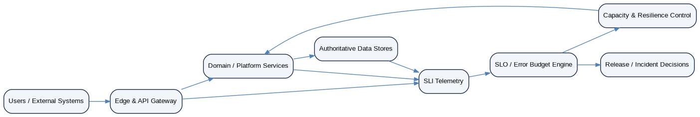
Figure 1 — Non-functional requirements and SLO control architecture

3. Executive Doctrine & Quality Model
ID | Non-bypassable invariant
NFR-INV-01 | Every production service has an owner, criticality class and approved SLO profile.
NFR-INV-02 | SLIs are measured at the closest feasible point to the user/business outcome, not only inside the service.
NFR-INV-03 | Correctness and financial integrity can override availability; unsafe writes must be blocked rather than accepted.
NFR-INV-04 | No service claims 100% availability as an internal SLO.
NFR-INV-05 | Every SLO defines measurement window, numerator/denominator, exclusions and data source.
NFR-INV-06 | Tail latency is measured; averages alone are prohibited for interactive paths.
NFR-INV-07 | Capacity plans include forecast demand, tested maximum, headroom and dependency quotas.
NFR-INV-08 | Queues are bounded and expose age, depth, oldest-item and failure metrics.
NFR-INV-09 | Retries are bounded by policy and use exponential backoff with jitter where applicable.
NFR-INV-10 | Every critical dependency has timeout, isolation and defined failure behavior.
NFR-INV-11 | Regional failover may only target a region permitted by residency policy.
NFR-INV-12 | Recovery is not complete until data integrity and required financial controls have passed.
NFR-INV-13 | RPO/RTO are certified through exercises, not inferred from architecture diagrams.
NFR-INV-14 | Irreversible financial/regulatory side effects have stricter retry, idempotency and recovery controls.
NFR-INV-15 | Error-budget exhaustion triggers predefined reliability actions.
NFR-INV-16 | Planned maintenance treatment is explicit and consistent in SLO calculations.
NFR-INV-17 | Degraded modes are explicit product states; silent partial correctness is prohibited.
NFR-INV-18 | Production telemetry is privacy/residency controlled and adequate to reconstruct incidents.
NFR-INV-19 | Performance and resilience regressions are release-blocking according to risk tier.
NFR-INV-20 | No service depends on unbounded synchronous fan-out across critical paths.
NFR-INV-21 | Background work exposes freshness/lag objectives, not merely job-success status.
NFR-INV-22 | Caches/search/analytics are never allowed to silently become authoritative transactional sources.
NFR-INV-23 | A service cannot be declared healthy solely because process-level health checks pass.
NFR-INV-24 | All SLO exceptions/waivers are explicit, expiring, owned and auditable.
NFR-INV-25 | Service-specific NFRs may be stricter than this standard but cannot weaken platform invariants without architecture approval.

3.1 Product Quality Model
ZoikoSuite uses ISO/IEC 25010:2023 as the external product-quality reference model, while this standard specializes the runtime qualities that matter most to a global accounting and business platform: reliability, performance efficiency, compatibility, interaction capability, maintainability, flexibility, safety and security-related runtime properties.
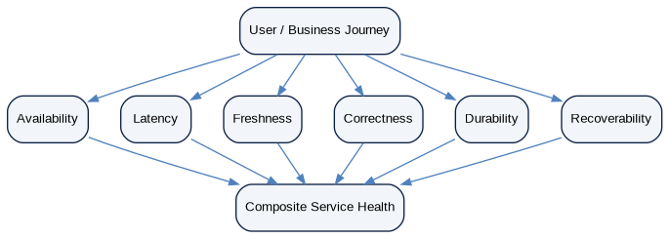
Figure 2 — Multi-dimensional service-level objective model

4. Service Criticality & NFR Classes
Criticality is assigned to the user/business journey and authoritative capability, not simply to an infrastructure component. A low-level dependency may inherit the highest criticality of the journeys that cannot operate safely without it.
Class | Description | Examples | Operating posture
C0 — Critical Value / Regulatory | Irreversible or time-critical value movement, financial posting authority, filing/clearance, identity/security control, hard close | Payment release, journal posting, tax submission, e-invoice clearance, authorization decision | Strongest correctness, recovery and observability; no unsafe degradation.
C1 — Authoritative Transactional | Core authoritative business transactions where outage materially impairs customers | AR/AP, invoicing, procurement, bank reconciliation, document/evidence | High availability and bounded recovery; controlled queuing may be allowed.
C2 — Operational Support | Important workflows that can tolerate bounded delay | Collections, management reporting preparation, workflow queues, import orchestration | Moderate availability; delayed processing acceptable within freshness SLO.
C3 — Analytics / Admin | Non-authoritative analytical or administrative experience | Dashboards, BI, noncritical exports, historical search | May degrade/read from delayed projections; never controls authoritative writes.
Figure 3 — Service criticality classes

4.1 Provisional SLO Class Defaults
Important — The figures below are engineering starting points, not customer-contract SLAs. Each service must validate them against user need, architecture, operational cost, dependency capability and representative production testing before launch.

Class | Availability starting point | Latency starting point | Freshness starting point | Data-loss starting point | Recovery starting point
C0 | 99.99% monthly good-event ratio | p99 critical command ≤ 2.0 s excluding external authority wait | Critical async freshness ≤ 60 s unless authority-driven | RPO 0 for acknowledged in-region commit; cross-region target ≤ 5 min | RTO target ≤ 30 min
C1 | 99.95% monthly | p95 interactive ≤ 1.5 s; p99 ≤ 4 s | Authoritative projections ≤ 5 min | Cross-region target ≤ 15 min | RTO target ≤ 60 min
C2 | 99.90% monthly | p95 interactive ≤ 2.5 s | Operational freshness ≤ 15 min | RPO target ≤ 60 min | RTO target ≤ 4 h
C3 | 99.50% monthly | p95 interactive ≤ 4 s | Analytical freshness defined per dataset, typically ≤ 24 h | RPO target ≤ 24 h | RTO target ≤ 24 h

5. SLI, SLO, SLA & Error-Budget Model

5.1 Terminology
Term | ZoikoSuite definition
SLI | A quantitative measure of delivered service quality.
SLO | An internal target or range for an SLI over a defined window.
Error Budget | The permitted amount of non-good service implied by the SLO.
SLA | A customer/commercial/legal commitment; not automatically identical to an internal SLO.
Good Event | A request, minute, job, record, or business outcome that satisfies the SLI definition.
Burn Rate | Rate at which the error budget is being consumed relative to the allowed rate.

5.2 Mandatory SLO Definition Fields
Field | Requirement
slo_id | Stable identifier
service_or_journey | Owner of the outcome
criticality_class | C0–C3
sli_type | Availability, latency, freshness, correctness, durability, recovery, etc.
good_event_definition | Exact success condition
total_event_definition | Denominator / eligible population
measurement_point | Edge, client, service, job, data plane, synthetic probe, etc.
window | Rolling 28d, calendar month, business period, etc.
target | Objective value
exclusions | Explicit and narrowly governed exclusions
data_source | Authoritative telemetry source
owner | Accountable team
error_budget_policy | Actions at burn thresholds
version | Effective-dated SLO definition version
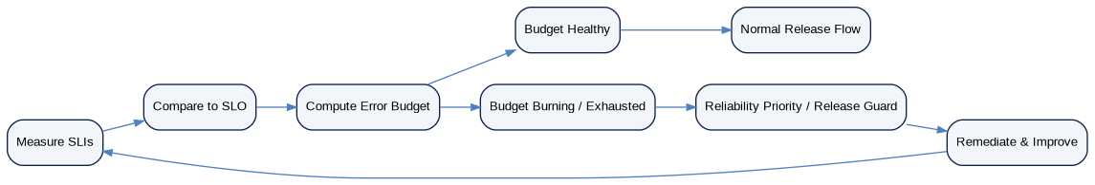
Figure 4 — Error-budget operating loop

5.3 Error-Budget Governance
Error budgets are reliability control mechanisms, not excuses for avoidable incidents. A service that burns budget rapidly must reduce change risk and prioritize reliability according to predefined policy. Different SLO dimensions may maintain separate budgets; a correctness or durability breach can trigger immediate escalation even if availability budget remains healthy.
State | Trigger | Required action
Healthy | < 50% projected monthly burn | Normal change flow subject to ordinary gates.
Watch | 50–80% projected burn | Reliability review; restrict risky changes; verify capacity/dependencies.
Critical | 80–100% projected burn | Freeze nonessential high-risk change; prioritize remediation.
Exhausted | ≥100% | Release guard for affected service except security/P0/reliability fixes; executive/SRE review.
Catastrophic correctness/durability breach | Any confirmed unauthorized loss, duplicate irreversible effect or corrupt authoritative state | Immediate incident and release stop independent of availability budget.

6. Availability & User-Journey Reliability
Availability must be measured from a meaningful user/business journey. Process uptime and internal health endpoints are supporting signals, not the primary measure.
Journey type | Recommended availability SLI | Critical interpretation
Interactive API | Good eligible requests / total eligible requests | Measure at gateway/edge plus synthetic journey where feasible.
Accounting posting | Valid posting commands completed exactly once within objective / eligible commands | Incorrect or duplicate posting is not “available.”
Payment release | Authorized payment-release commands durably accepted and tracked / eligible commands | External-provider wait may move to async operation state rather than hold HTTP open.
Tax filing | Submission attempts accepted into governed workflow / eligible attempts | Authority outage is separately classified but user-facing availability treatment remains explicit.
Batch close | Mandatory close jobs completed by certified deadline / scheduled mandatory jobs | Job runner uptime is not sufficient.
Reporting | Reports generated from certified population within target / eligible reports | Stale/unreconciled report is not a good event.

7. Latency & Performance Budgets
Every interactive critical path must have an end-to-end latency budget and component budgets. Tail percentiles are required because finance users experience the slowest meaningful portion of requests, not the average.
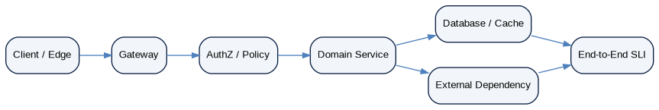
Figure 5 — End-to-end latency budget decomposition
Path | Required metrics | Rule
Simple authoritative read | p50 / p95 / p99 | Exclude cache-only target if authoritative freshness is required.
State-changing command | p95 / p99 acceptance latency | Measure until durable authoritative acceptance, not until asynchronous external side effect finishes.
Search / analytics | p95 / p99 plus freshness | Latency without freshness can reward stale data.
Export / report | Completion-time distribution by size class | Separate interactive generation from asynchronous operation.
External-provider interaction | Internal acceptance + provider completion distribution | Do not hide provider latency inside internal service SLO.
Batch/close | Deadline completion ratio and job runtime percentile | Use business deadlines and dependency windows.

8. Throughput, Concurrency, Capacity & Scalability
Figure 6 — Capacity planning and autoscaling control loop
Capacity dimension | Requirement
Demand model | Peak RPS/TPS, concurrent sessions, batch volume, record/document sizes, seasonal close/tax peaks.
Tested maximum | Demonstrated sustained and burst capacity under representative data size and dependency behavior.
Headroom | Reserved capacity above expected peak; set per class and scaling latency.
Scaling unit | Horizontal replicas, partitions/shards, workers, queues, database capacity or provider quotas.
Saturation signals | CPU, memory, DB connections, locks, I/O, queue age/depth, thread pools, rate-limit utilization.
Quota inheritance | External provider, database and regional quotas must be included in capacity plans.
Hot-key control | Tenant/entity/account hotspots require partition and fairness testing.
Noisy-neighbor control | Per-tenant fairness and resource governance required for multi-tenant services.

9. Backpressure, Queues, Retries & Admission Control
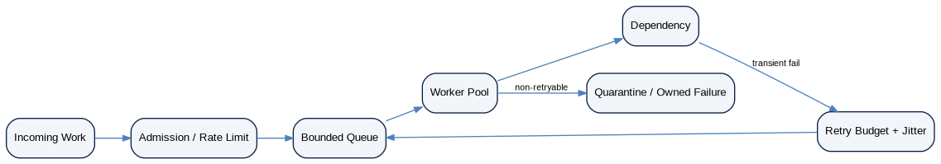
Figure 7 — Bounded-work and retry architecture
Control | Requirement
Timeouts | Every remote dependency call has a bounded timeout aligned with the caller latency budget.
Retries | Retry only retryable failures; bounded count/time; exponential backoff and jitter where applicable.
Retry budget | Retry volume is capped to prevent retries from overwhelming healthy capacity.
Queues | Bounded depth/age; explicit overflow behavior; oldest-item and stuck-item alerts.
Admission control | Protect critical paths before saturation through rate limits, concurrency caps or load shedding.
Priority | Irreversible financial/regulatory and recovery traffic may receive protected capacity.
Quarantine | Poison/non-retryable work is owned, observable and recoverable; DLQ is not permanent storage.
Idempotency | Retryable state-changing work requires idempotent business effects.

10. Dependency Isolation, Bulkheads & Failure Containment
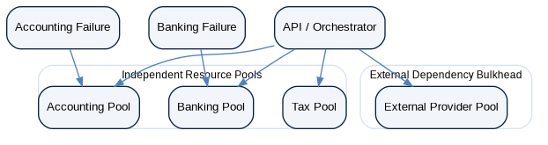
Figure 8 — Dependency bulkhead and resource-pool isolation
Failure domains must be intentionally bounded. A slow tax authority, reporting workload or one large tenant must not be able to exhaust the accounting posting pool, authorization service or payment release capacity.
Pattern | Required behavior
Resource pools | Separate worker/connection/concurrency pools for materially different dependency or workload classes.
Circuit breakers | Open on sustained dependency failure to stop wasteful calls; recover through controlled probing.
Fallbacks | Only use fallbacks that preserve correctness and policy; never substitute stale tax/accounting authority silently.
Tenant fairness | Protect system capacity from single-tenant monopolization.
Dependency budgets | Define expected latency, availability and quota for each critical dependency.
Synchronous fan-out | Avoid unbounded fan-out; aggregate asynchronously where correctness permits.
Blast-radius labels | Every dependency and queue documents affected journeys, tenants/regions and safe degradation mode.

11. Correctness, Consistency, Freshness & Durability
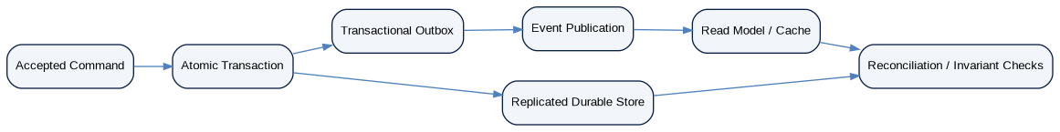
Figure 9 — Correctness and durability control plane

11.1 Correctness SLOs
For ZoikoSuite, some of the most important SLIs are correctness SLIs: balanced journals, exactly-once business effects, reconciled control accounts, no unauthorized cross-tenant reads, accurate tax rule selection, and complete event propagation. A correctness breach can be more severe than an outage.
Correctness domain | Objective
Accounting invariants | 100% of posted journals balance and satisfy book/period/control-account invariants.
Duplicate irreversible effects | Zero tolerated confirmed duplicates caused by platform replay in payment, filing, clearance or posting.
Cross-tenant leakage | Zero tolerated confirmed unauthorized cross-tenant data disclosure.
Read-your-write | Required on authoritative workflows where user must observe accepted state immediately.
Projection freshness | Bounded by explicit freshness SLO; projection lag must be visible.
Event completeness | Producer/consumer completeness controls verify no committed authoritative event silently disappears.
Reconciliation | Material subledger/GL/control differences must fail certification rather than be hidden by availability metrics.

11.2 Data Freshness
Data plane | Freshness requirement
Authoritative transactional state | Immediate after committed operation, subject to consistency model.
Search/read model | Explicit lag SLO by domain; display freshness where material.
Analytics warehouse | Dataset-specific ingestion and transformation freshness objective.
External bank/provider state | Provider-dependent; internal last-success and age must be observable.
FX/reference data | Source-specific maximum age and effective-date rules.
Regulatory rules | Effective-dated release activation; no silent stale-pack fallback.

12. Regional Resilience, RPO & RTO
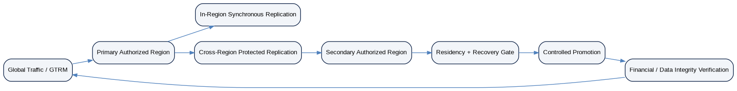
Figure 10 — Residency-aware regional failover architecture
Figure 11 — RPO and RTO measurement model
Recovery architecture must distinguish local component failure, availability-zone failure, regional impairment, data corruption, security compromise and provider failure. The recovery mechanism for one scenario may be unsafe for another.
Class | Provisional RPO target | Provisional RTO target
C0 | In-region acknowledged commits: RPO 0 design target; cross-region catastrophic scenario target ≤5 min unless service-specific profile is stricter | ≤30 min to controlled service restoration plus integrity validation
C1 | ≤15 min cross-region target | ≤60 min
C2 | ≤60 min | ≤4 h
C3 | ≤24 h | ≤24 h

Recovery doctrine — A backup restore or regional promotion does not complete recovery. Critical services remain in recovery state until schema, identity, residency, ledger/event invariants and required financial reconciliations pass.

13. Graceful Degradation & Safe Modes
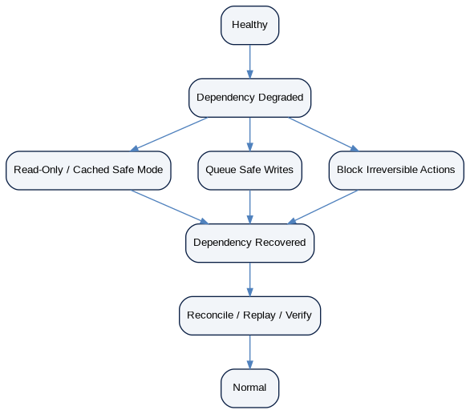
Figure 12 — Explicit degradation and safe-mode lifecycle
Mode | Required behavior
Read-only safe mode | Permit verified reads while blocking unsafe writes during authoritative dependency failure.
Queue-safe mode | Durably accept work for later processing only when business semantics allow deferred execution and idempotency is preserved.
Cached experience | Use only where freshness is non-authoritative and clearly bounded.
Feature isolation | Disable noncritical analytics/export/AI before critical transaction paths.
Provider outage mode | Preserve submitted/pending state; do not misreport success or retry without policy.
Regulatory uncertainty | Block governed outcome or route to exception; never guess.
Recovery mode | Limit high-risk changes while replay/reconciliation/integrity checks are running.

14. Observability, Telemetry & Alerting
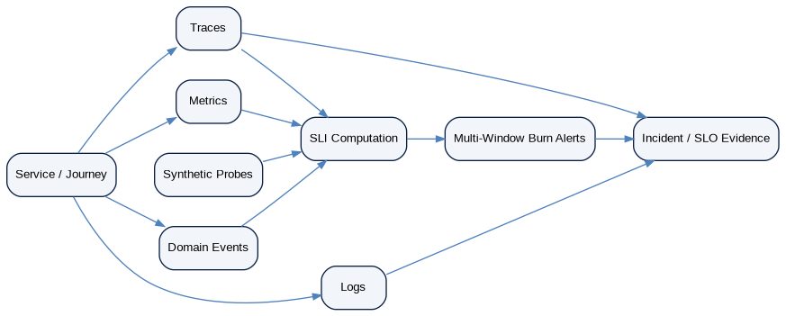
Figure 13 — SLI observability and evidence architecture
Telemetry type | Standard
Metrics | Request success, latency distributions, saturation, queue age/depth, freshness, error-budget burn, dependency health.
Logs | Structured, redacted, correlated; not a dumping ground for financial/personal payloads.
Traces | Distributed traces across gateway, authz, workflow, domain, data and permitted external boundaries.
Domain events | Operationally correlate business transitions and asynchronous effects.
Synthetic probes | Test key user journeys from representative regions without creating uncontrolled financial effects.
Business probes | Reconciliation/control probes for accounting/event/data correctness.
Burn alerts | Multi-window/multi-burn alerts to detect fast incidents and slow degradation.
Ownership | Every actionable alert has named team, runbook and escalation path.

14.1 Alert Quality
- Page on user/business impact or imminent SLO exhaustion, not every low-level anomaly.
- Dashboards support diagnosis; alerts drive action.
- Repeated noisy alerts require remediation and cannot be normalized as operational background.
- Correctness/durability/security alarms may bypass ordinary error-budget thresholds.

15. Batch, Scheduled Jobs & Period-Close NFRs
Figure 14 — Batch and period-close reliability window
Batch control | Requirement
Deadline SLO | Mandatory job population completes before certified business deadline.
Job idempotency | Re-execution cannot duplicate financial consequences.
Watermarks | Input population and cutoff/watermark are explicit.
Dependency gates | Do not run close-dependent jobs on stale/incomplete upstream populations.
Catch-up capacity | System can clear backlog after outage within defined recovery window.
Partial failure | Per-item failure is visible and reconcilable; headline “job succeeded” cannot hide failures.
Close priority | Period-close/reconciliation jobs receive protected capacity during close windows.
Evidence | Run inputs, outputs, versions, timings and reconciliation evidence preserved.

16. Data-Plane NFRs

16.1 Authoritative Databases
Area | Requirement
Transactions | Atomicity and isolation appropriate to financial invariant; no partial authoritative commit.
Connection capacity | Bounded pools; headroom; fail-fast/backpressure before exhaustion.
Locking/contention | Monitor lock waits/deadlocks; design hot-paths to avoid tenant/account hotspots.
Schema change | Online/compatible migration where required; rollback/forward-fix plan.
Replication | Lag SLO; read routing cannot violate correctness/freshness requirements.
Backups | Encrypted, isolated, tested; restoration measured against RPO/RTO.
Integrity | Constraints and reconciliation complement application validation.
Maintenance | Vacuum/index/statistics/compaction jobs capacity-bounded and observed.

16.2 Caches, Search & Analytics
Plane | NFR
Cache | Never authoritative; cache-key includes tenant/scope/version where required; explicit TTL/invalidation.
Search | Index lag SLO; permission filtering enforced; stale index cannot authorize action.
Analytics | Freshness and lineage SLO; warehouse unavailable must not stop authoritative accounting unless explicitly required.
Read model rebuild | Must be reproducible from authoritative source/events and support controlled backfill.
Cache stampede | Single-flight, jittered TTL or equivalent protection for hot keys.
Eviction behavior | System remains correct under full cache loss.

17. Interface-Specific NFRs
Interface | NFR requirements
API | Latency/error/availability SLIs by endpoint class; idempotency and concurrency controls preserved under retry/failover.
Events | Producer lag, delivery lag, duplicate rate, consumer lag, gap/quarantine metrics; at-least-once semantics remain safe.
Webhooks | Delivery SLO, retry horizon, signature verification, endpoint isolation and backlog controls.
Files/Imports | Size/throughput classes, malware/quarantine latency, validation completion, partial-failure visibility.
Exports | Async for large outputs; bounded resource use; authorization/residency preserved throughout generation.
AI/RAG | Latency and availability are subordinate to authority/grounding/privacy; safe refusal is preferable to fabricated output.

18. Disaster Recovery & Recovery Certification
Figure 15 — Disaster-recovery certification flow
DR element | Required evidence
Scenario catalogue | Zone failure, region failure, corruption, credential/key loss, ransomware, provider outage, control-plane outage.
Exercise frequency | Risk-based; C0/C1 exercised more frequently than C2/C3.
Measured RPO/RTO | Use exercise evidence, not theoretical replication settings.
Data reconciliation | Record counts/hashes plus financial/accounting control assertions where applicable.
Security/residency | Recovery region, keys, identities and logs remain policy-compliant.
Operational readiness | Runbooks, contacts, access and approvals tested.
Certificate | Recovery exercise produces evidence package, measured objectives, exceptions and remediation actions.

19. Maintenance, Deployment & Change Resilience
Change control | Requirement
Zero/low-downtime deployment | Required for C0/C1 unless approved exception; use rolling, blue/green or equivalent.
Backward compatibility | API/event/schema compatibility maintained during mixed-version windows.
Database migrations | Expand/contract or compatible sequence for high-availability changes.
Feature flags | Must not bypass authorization/accounting/regulatory controls.
Canaries | Observe SLIs/error budget before broad rollout.
Rollback | Code rollback available where business-safe; irreversible business effects use forward correction.
Maintenance | Capacity and user impact planned; SLO treatment explicitly defined.
Release guard | High burn or unresolved critical reliability defects can block rollout.

20. NFR Ownership, Review & Exception Governance
Role | Accountability
Service owner | Owns SLO profile, capacity, runbooks and reliability backlog.
Product owner | Represents user/business criticality and acceptable degradation.
SRE / Platform | Owns SLO tooling, telemetry standards, resilience patterns and reliability governance.
Security | Approves security/residency implications of degradation and recovery.
Finance/Tax/Legal domain owner | Approves correctness and time-criticality implications for regulated/value paths.
Architecture | Approves criticality classification, cross-service dependency assumptions and exceptions.
QA | Certifies performance/resilience evidence before release per ZS-QA-001.
All material exceptions are time-bounded, explicitly risk-accepted, linked to remediation and re-reviewed before expiry. Permanent “temporary” waivers are prohibited.

21. Canonical NFR / SLO Data Model
Entity | Core fields
ServiceProfile | service_id, owner, criticality, residency, dependency_set, version
JourneyDefinition | journey_id, steps, user/business outcome, eligible_population
SLIDefinition | sli_id, type, numerator, denominator, measurement_point, data_source
SLODefinition | slo_id, sli_id, target, window, exclusions, effective_dates, version
ErrorBudgetState | slo_id, window, consumed, remaining, burn_rates, status
CapacityProfile | forecast, tested_max, headroom, autoscale_policy, quotas
DependencyProfile | dependency_id, owner, timeout, quota, fallback, failure_mode
RecoveryProfile | scenario, RPO, RTO, topology, region_constraints
DRExercise | exercise_id, scenario, actual_rpo, actual_rto, evidence, result
NFRException | exception_id, scope, risk, approver, expiry, remediation
ReliabilityCertificate | service/version, SLO evidence, test evidence, DR evidence, approvals

21.1 Management APIs / Commands
Contract | Purpose
GET /admin/v1/nfr/services/{id} | Read service NFR profile.
POST /admin/v1/nfr/services/{id}:classify | Governed criticality classification/change.
POST /admin/v1/nfr/slos | Create draft SLO definition.
POST /admin/v1/nfr/slos/{id}:activate | Activate approved SLO version.
GET /admin/v1/nfr/slos/{id}/budget | Read current error-budget state.
POST /admin/v1/nfr/exceptions | Request time-bounded NFR exception.
POST /admin/v1/nfr/dr-exercises | Register approved DR exercise.
POST /admin/v1/nfr/dr-exercises/{id}:certify | Certify measured recovery result.
GET /admin/v1/nfr/reliability/{service_id} | Read reliability posture/evidence.

21.2 Canonical Domain Events
Event | Meaning
nfr.slo.activated.v1 | Approved SLO version becomes effective.
nfr.slo.budget_warning.v1 | Budget crosses watch threshold.
nfr.slo.exhausted.v1 | Error budget exhausted.
nfr.capacity.risk_detected.v1 | Forecast/tested headroom falls below threshold.
nfr.dependency.degraded.v1 | Critical dependency degradation detected.
nfr.recovery.exercise_completed.v1 | DR exercise run completed.
nfr.recovery.certified.v1 | Recovery profile/exercise certified.
nfr.exception.approved.v1 | Time-bounded exception approved.
nfr.exception.expired.v1 | Exception expires.
nfr.reliability.certificate_issued.v1 | Service/version reliability certificate issued.

22. Initial Canonical NFR Control Catalogue
Control ID | Requirement | Status
SLO-01 | Every production service has criticality class and owner | Mandatory
SLO-02 | Every C0/C1 user journey has availability SLI | Mandatory
SLO-03 | Every interactive path has percentile latency SLI | Mandatory
SLO-04 | Every asynchronous projection/job has freshness/deadline SLI | Mandatory
SLO-05 | Every SLO defines error-budget policy | Mandatory
SLO-06 | SLO exclusions are explicit and audited | Mandatory
SLO-07 | Correctness/durability breaches have independent escalation | Mandatory
CAP-01 | Forecast demand and tested maximum are recorded | Mandatory
CAP-02 | Headroom policy exists | Mandatory
CAP-03 | Dependency quotas are modeled | Mandatory
CAP-04 | Noisy-neighbor controls tested | Mandatory
CAP-05 | Hot-key/partition risk tested | Mandatory
CAP-06 | Catch-up capacity after outage tested | Mandatory
PERF-01 | Tail latency measured | Mandatory
PERF-02 | End-to-end latency budget documented | Mandatory
PERF-03 | Large operations use async pattern | Mandatory
PERF-04 | Performance regression gate exists | Mandatory
PERF-05 | Representative data-size tests exist | Mandatory
RES-01 | Timeouts on all critical remote calls | Mandatory
RES-02 | Retries bounded with backoff/jitter | Mandatory
RES-03 | Retry budget enforced | Mandatory
RES-04 | Queues bounded and monitored | Mandatory
RES-05 | Circuit breaker/failure isolation for critical dependencies | Mandatory
RES-06 | Safe degradation mode defined | Mandatory
RES-07 | Synchronous fan-out bounded | Mandatory
RES-08 | Regional failover restricted by residency | Mandatory
DATA-01 | Authoritative commit durability defined | Mandatory
DATA-02 | Replication lag monitored | Mandatory
DATA-03 | Projection freshness measured | Mandatory
DATA-04 | Read-model rebuild tested | Mandatory
DATA-05 | Cache loss preserves correctness | Mandatory
DATA-06 | Duplicate irreversible effects monitored as zero-tolerance | Mandatory
DR-01 | RPO/RTO profile approved | Mandatory
DR-02 | Backups isolated/encrypted | Mandatory
DR-03 | Restore/failover exercises executed | Mandatory
DR-04 | Recovery includes financial/data reconciliation | Mandatory
DR-05 | Recovery region/key/identity policy verified | Mandatory
DR-06 | DR evidence retained | Mandatory
OBS-01 | Metrics/logs/traces/domain events correlated | Mandatory
OBS-02 | Synthetic probes for key journeys | Mandatory
OBS-03 | Multi-window burn alerts | Mandatory
OBS-04 | Alert has owner/runbook | Mandatory
OBS-05 | Telemetry residency/privacy compliant | Mandatory
OBS-06 | Incident reconstruction evidence adequate | Mandatory
CHG-01 | C0/C1 canary or staged rollout | Mandatory
CHG-02 | Schema/API/event compatibility validated | Mandatory
CHG-03 | Error-budget release guard integrated | Mandatory
CHG-04 | Business-safe rollback/forward-fix defined | Mandatory
BATCH-01 | Mandatory batch/close deadlines defined | Mandatory
BATCH-02 | Batch idempotency tested | Mandatory
BATCH-03 | Input watermarks/cutoffs explicit | Mandatory
BATCH-04 | Partial failures visible | Mandatory
GOV-01 | NFR exceptions expire | Mandatory
GOV-02 | Reliability certificate required before production | Mandatory
GOV-03 | SLO version changes governed | Mandatory
GOV-04 | Criticality changes approved by architecture/product/domain owner | Mandatory

23. Negative-Path Engineering Acceptance Scenarios
ID | Scenario | Required result
NFR-NEG-01 | Process health is green while user requests fail | Availability SLI fails and alert is generated.
NFR-NEG-02 | HTTP 200 returns stale financial balance outside freshness target | Freshness/correctness SLI fails; response cannot be counted as good.
NFR-NEG-03 | Average latency is healthy but p99 breaches | Tail-latency SLO burns budget.
NFR-NEG-04 | Single tenant creates extreme load | Fairness/admission controls protect other tenants.
NFR-NEG-05 | Dependency slows without failing | Timeout/circuit/bulkhead prevents thread/connection exhaustion.
NFR-NEG-06 | Retryable provider outage lasts 20 minutes | Retry budget/queue prevents retry storm and preserves pending state.
NFR-NEG-07 | Poison event repeatedly fails | Item quarantined with owner; queue continues.
NFR-NEG-08 | Queue reaches configured maximum | Admission/overflow policy activates; unbounded growth prohibited.
NFR-NEG-09 | Autoscaler reacts slower than traffic burst | Headroom/burst capacity keeps SLO or sheds noncritical load.
NFR-NEG-10 | Database connection pool saturates | Backpressure protects DB; clear saturation telemetry.
NFR-NEG-11 | Cache cluster is completely lost | Authoritative correctness preserved; performance degradation is controlled.
NFR-NEG-12 | Search index lags by 30 minutes | Freshness SLO fails; index not used for authoritative decision.
NFR-NEG-13 | Read replica exceeds allowed lag | Traffic not routed where stale read violates consistency requirement.
NFR-NEG-14 | Duplicate command delivered after timeout | Idempotency prevents duplicate irreversible effect.
NFR-NEG-15 | Event broker redelivers committed event | Consumer dedupe prevents duplicate financial effect.
NFR-NEG-16 | Regional outage occurs | GTRM selects only residency-authorized recovery target.
NFR-NEG-17 | Secondary region has stale replication beyond RPO | Promotion blocked or explicitly risk-approved; condition is visible.
NFR-NEG-18 | Failover completes but reconciliation fails | Service remains in recovery/degraded state.
NFR-NEG-19 | Backup job reports success but restore is corrupt | DR exercise fails; backup success alone not accepted.
NFR-NEG-20 | Key/identity service unavailable | Unsafe privileged/irreversible actions fail closed or enter defined safe mode.
NFR-NEG-21 | Tax authority unavailable | Submission remains pending/exception; no false success.
NFR-NEG-22 | FX feed stale | Calculation blocks or uses approved fallback with explicit provenance per domain policy.
NFR-NEG-23 | Period-close workload doubles unexpectedly | Protected capacity/catch-up plan meets or explicitly fails close deadline SLO.
NFR-NEG-24 | Batch reports success with failed items | Control detects partial failure; job not counted as good.
NFR-NEG-25 | Planned maintenance impacts customers | SLO calculation follows approved maintenance policy; impact not silently excluded.
NFR-NEG-26 | Error budget exhausted before planned feature release | Release guard blocks nonessential risky change.
NFR-NEG-27 | Telemetry pipeline partially fails | SLO system marks measurement uncertainty; does not fabricate healthy status.
NFR-NEG-28 | Synthetic probe itself causes value-changing action | Probe design rejected; synthetic checks must be non-destructive or safely isolated.
NFR-NEG-29 | Cross-region analytics export attempts to move restricted data | Residency gate blocks transfer.
NFR-NEG-30 | Huge export competes with payment release | Resource isolation preserves C0 path.
NFR-NEG-31 | Schema migration causes mixed-version incompatibility | Compatibility gate blocks deployment or safe expand/contract path used.
NFR-NEG-32 | Slow memory leak degrades service over days | Soak/saturation monitoring detects before SLO exhaustion.
NFR-NEG-33 | Clock skew affects distributed latency/event timing | Clock synchronization/monotonic measurement prevents incorrect SLI or ordering decisions.
NFR-NEG-34 | User journey succeeds but reconciliation later finds duplicate posting | Correctness breach triggers incident independent of availability score.
NFR-NEG-35 | C3 analytics outage persists while C0 accounting remains healthy | Blast radius remains isolated; critical service SLO unaffected except shared dependency impact.
NFR-NEG-36 | Expired NFR waiver remains configured | Governance rejects use; exception expiration generates action/event.

24. Definition of Ready — Service NFR Profile
- Named service and business/user journeys
- Criticality class approved
- Authoritative owner and on-call owner
- Dependency inventory complete
- SLIs defined with numerator/denominator and measurement point
- Provisional SLOs and error-budget policy defined
- Capacity/load model defined
- Consistency/freshness requirements defined
- RPO/RTO and recovery topology defined
- Degradation/fail-closed behavior defined
- Security/residency implications reviewed
- Performance/resilience test plan approved
- Observability/runbook design complete
- Known external-provider quotas/SLO assumptions recorded
- Exceptions/waivers identified with owners and expiry

25. Definition of Done — Production Reliability Certification
- All mandatory NFR controls pass
- Representative performance/load/soak tests pass
- Critical dependency failure tests pass
- Capacity headroom demonstrated
- SLO dashboards and burn alerts active
- Runbooks and escalation paths tested
- RPO/RTO exercise evidence meets target
- Recovery reconciliation passes
- No unresolved P0/P1 reliability defects
- C0/C1 correctness/durability controls certified
- Telemetry privacy/residency checks pass
- Canary/staged rollout path proven
- Error-budget policy integrated with release governance
- Reliability certificate issued and linked to release/environment
- Residual risks formally accepted with expiring waivers

26. Engineering Implementation Sequence
Wave | Deliverable
Wave 0 — Inventory | Service registry, owners, journeys, criticality classes, dependencies.
Wave 1 — Observability Foundation | Metrics/logs/traces/domain-event correlation and SLI computation.
Wave 2 — SLO Control Plane | SLO registry, error budgets, burn alerts and dashboards.
Wave 3 — Performance & Capacity | Load harness, capacity models, headroom, autoscaling and fairness.
Wave 4 — Resilience Patterns | Timeouts, retries, queues, backpressure, circuit breakers, bulkheads and degradation.
Wave 5 — Data Durability & Freshness | Replication, lag/freshness SLIs, backup/restore and correctness controls.
Wave 6 — Regional Recovery | Residency-aware failover, DR orchestration and reconciliation.
Wave 7 — Batch / Close Reliability | Deadline SLIs, protected capacity, catch-up and partial-failure controls.
Wave 8 — Release Governance | Error-budget gates, reliability certificates and continuous assurance.

27. Controlled Pre-Production Decisions
Decision | Owner | Gate
Final SLO targets per service/journey | Product + SRE + Architecture + domain owner | Before production certification
Measurement windows and SLA relationship | Product/Commercial/Legal/SRE | Before customer commitments
Regional topology per residency cluster | Platform + Security + Architecture | Before regional launch
C0/C1 failover RPO/RTO values | SRE + Platform + Finance/Tax domain owner | Before production
Error-budget release thresholds | CTO/SRE/Product | Before broad release cadence
Capacity headroom policy | SRE/Platform/Finance | Before scale launch
Maintenance treatment in SLOs | SRE/Product/Commercial | Before SLA publication
External dependency fallback policies | Domain owner + Security + Architecture | Before integration launch
DR exercise frequency | SRE/Security/Business continuity | Before production
Long-running export/import size classes | Platform/Product | Before GA

28. Prohibited NFR & Reliability Anti-Patterns
- Claiming reliability from uptime alone
- Using averages as the only latency measure
- Setting every service to 99.99% without criticality/cost analysis
- Unbounded retries, queues or concurrency
- Synchronous fan-out to many dependencies on critical paths
- Failing open on authorization, regulatory or financial-integrity controls
- Treating failover as complete before integrity verification
- Using cache/search/warehouse as hidden transactional authority
- Ignoring external-provider quotas in capacity plans
- Excluding all planned maintenance from SLOs without explicit policy
- Suppressing alerts instead of fixing noisy conditions
- Measuring only infrastructure health rather than user/business journeys
- Autoscaling without headroom or scaling-latency analysis
- Restoring backups without reconciliation
- Allowing one tenant to monopolize shared capacity
- Allowing analytics/export/AI workloads to starve financial control paths
- Letting stale regulatory/reference data silently pass as current
- Using successful batch exit code as proof every record succeeded
- Permanent NFR waivers
- Publishing customer SLAs directly from provisional engineering defaults

29. External Standards & Industry Reference Baseline
Reference | Use in this standard | Source
ISO/IEC 25010:2023 | Current ISO product-quality model; nine quality characteristics used as general external quality framing. | https://www.iso.org/standard/78176.html
ISO 22301:2019 | Business continuity management requirements; supports continuity and recovery governance. | https://www.iso.org/standard/75106.html
NIST SP 800-160 Vol. 2 Rev. 1 | Cyber-resilient systems engineering: anticipate, withstand, recover from and adapt to adverse conditions. | https://csrc.nist.gov/pubs/sp/800/160/v2/r1/final
Google Site Reliability Engineering — SLOs | Industry reference for SLIs, SLOs and error-budget operating model. | https://sre.google/sre-book/service-level-objectives/
Google SRE Workbook — Error Budget Policy | Industry reference for operational response to exhausted error budgets. | https://sre.google/workbook/error-budget-policy/
ZoikoSuite architecture standards | ZS-DATA-001 through ZS-MIG-001 remain authoritative internal controls and take precedence where stricter. | Internal controlled documents

30. Final Architecture Decision
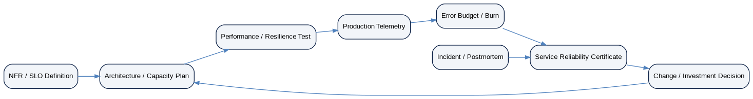
Figure 16 — NFR evidence and reliability-certification chain
ZS-NFR-001 is the controlling runtime-quality standard for ZoikoSuite. Every deployable service and material user/business journey must derive a service-specific NFR profile from this document. Numerical objectives become production commitments only after representative testing, dependency validation, cost review and governance approval.
Target operating principle — ZoikoSuite must fail predictably, recover measurably and protect financial truth even under stress. Reliability is the controlled ability to deliver correct business outcomes within explicit performance, capacity and recovery bounds—not merely the absence of visible outages.

Appendix A — Provisional Reliability Class Matrix
Dimension | C0 | C1 | C2 | C3
Availability good-event ratio | 99.99% | 99.95% | 99.90% | 99.50%
Interactive latency | p99 ≤ 2s for critical command acceptance | p95 ≤1.5s / p99≤4s | p95≤2.5s | p95≤4s
Projection freshness | ≤60s where critical | ≤5m | ≤15m | dataset-specific
Cross-region catastrophic RPO | ≤5m target | ≤15m | ≤60m | ≤24h
RTO | ≤30m | ≤60m | ≤4h | ≤24h
DR exercise posture | Frequent + scenario rotation | Regular | Periodic | Risk-based
Degradation | Fail safe; preserve correctness | Queue/read-only as allowed | Delayed processing acceptable | Analytics delay acceptable
Error-budget release guard | Strict | Strong | Moderate | Risk-based

Appendix B — SLO Definition Example
{
"slo_id": "slo.accounting.posting.availability.v1",
"journey": "accounting.post-journal",
"criticality": "C0",
"sli": {
"good": "eligible posting commands durably committed exactly once within 2s",
"total": "all eligible validated posting commands",
"measurement_point": "API gateway + authoritative posting receipt"
},
"window": "rolling_28d",
"target": "99.99%",
"exclusions": ["approved synthetic traffic"],
"owner": "Accounting Platform",
"version": 1
}

Appendix C — Reliability Certificate Minimum Content
- Service/version/environment identity
- Criticality and journey inventory
- Active SLO versions
- Current error-budget state
- Performance/capacity evidence
- Dependency and quota evidence
- Resilience/failure-injection evidence
- Latest DR exercise and measured RPO/RTO
- Correctness/reconciliation evidence where applicable
- Open reliability defects and expiring waivers
- Observability/runbook readiness
- Approvals and certificate timestamp

