ZOIKOSUITE.
GLOBAL OPERATIONAL RUNBOOK &
PRODUCTION CONTROL STANDARD
Detailed Engineering Wireframe & Production Operations Control Standard
Accounting • Finance • Taxation • Audit • Legal • Business Operations

Field | Value
Document ID | ZS-OPS-001
Version | 1.0 — Global Production Operations Baseline
Date | August 24, 2026
Status | Engineering control standard — subject to production calibration, operating-model approval and service-specific runbook certification
Owner | Platform Engineering / SRE / Production Operations
Prepared for | Engineering, SRE, Finance Operations, Security, Privacy, Tax, Legal, Support, Product, QA, Internal Controls and Executive Incident Leadership
Classification | Internal Engineering / Architecture Control
Language | American English
Executive doctrine: Production operations must restore service without sacrificing financial truth, regulatory correctness, tenant isolation, residency, authorization or evidence. Recovery is complete only when both technical health and authoritative business integrity are proven.

1. Critical Analysis & Refinement Decisions
The preceding ZoikoSuite standards define the platform’s canonical data, accounting, workflow, APIs, events, authorization, jurisdiction packs, financial controls, security, verification, migration and non-functional behavior. ZS-OPS-001 closes the operational gap: how production teams respond when those controls encounter real-world failure, partial execution, ambiguous provider state, backlog, corruption risk, deadline pressure or regional impairment.
# | Refinement | Engineering consequence
1 | Runbooks are executable control contracts, not wiki prose. | Each runbook must define trigger, scope, authority, preconditions, safe actions, forbidden actions, evidence, reconciliation and exit criteria.
2 | Service recovery and business recovery are distinct. | Green infrastructure cannot close an incident until authoritative financial/regulatory/data integrity is proven where applicable.
3 | Rollback is conditional. | After an irreversible financial, regulatory or external effect, raw rollback can create false history. Forward correction/reversal/reconciliation becomes the default.
4 | Unknown provider state is first-class. | Timeout does not mean failure. Payment/tax/e-invoice runbooks must resolve external truth before reissuing side effects.
5 | Incident severity is multi-dimensional. | Customer impact, financial integrity, regulatory/legal exposure, security/residency, recoverability and operational scope all influence severity.
6 | Single incident command. | One Incident Commander owns command; specialized leads advise and execute under that command. Competing command channels are prohibited.
7 | Privileged intervention is a governed workflow. | JIT access, independent approval, recorded session, bounded scope, evidence and post-action reconciliation are mandatory.
8 | Backlog recovery is controlled processing. | Teams may not simply increase concurrency until queues drain. Ordering, idempotency, provider quotas, downstream capacity and business priority govern drain strategy.
9 | Emergency change is not uncontrolled change. | Approval path may compress, but scope, authority, evidence, testing proportionate to urgency, and retrospective review remain mandatory.
10 | Operations cannot mutate authoritative state directly. | No direct database edits or manual status flipping. Corrections use governed commands/domain interfaces unless a formally approved exceptional mechanism exists.
11 | Communications are part of control. | All material incident updates distinguish facts from hypotheses, preserve timestamps and use one factual source of truth.
12 | Operational closure requires learning and verification. | PIR, problem management, corrective action, recurrence testing and control improvement are required based on impact tier.
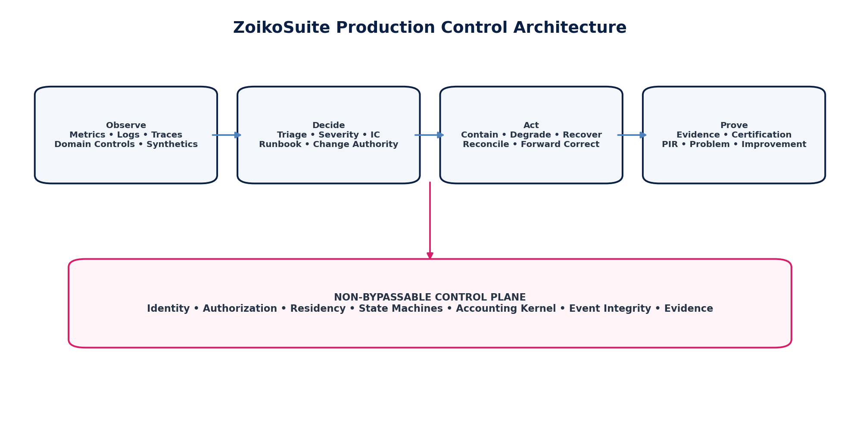
Figure 1 — Production control architecture: observe, decide, act and prove under non-bypassable platform controls.

2. Purpose, Scope & Boundaries

2.1 Purpose
ZS-OPS-001 defines the global production-operations constitution for ZoikoSuite. It standardizes how teams detect, declare, command, contain, recover, reconcile, communicate, evidence and learn from production incidents and operational exceptions across all regions, tenants and business domains.

2.2 In Scope
- Production incident management and major-incident command
- Operational exceptions and degraded service states
- Financial-processing failure and partial-execution handling
- Payment-provider ambiguity, rejection and settlement exceptions
- Tax/e-invoice filing rejection and authority-response operations
- Reconciliation breaks, suspense and financial-close operations
- Queue, event, batch and workflow backlog recovery
- External dependency/provider incidents
- Regional impairment and residency-aware recovery coordination
- Production changes, emergency changes and maintenance windows
- Rollback versus forward-correction decisions
- Privileged production interventions and break-glass operations
- Customer/internal/regulatory communications
- Problem management and post-incident review
- Operational evidence, APIs, events, runbook catalogue and certification

2.3 Explicit Boundaries
This standard does not replace the Security Incident Response Plan, Business Continuity Plan, Disaster Recovery Plan, domain accounting policies, legal notification rules or jurisdiction-specific regulatory procedures. It provides the common operational control plane those specialized procedures must plug into. Where a specialized plan imposes stricter requirements, the stricter control governs.
A runbook may automate mechanics; it may not automate away required approval, segregation-of-duties, residency, accounting, tax, legal or evidence controls.

3. Production Operations Constitution — 25 Invariants
ID | Invariant
OPS-INV-001 | Every production incident has one authoritative incident record and one Incident Commander once declared.
OPS-INV-002 | No operator may directly mutate authoritative business state outside approved domain commands or a formally controlled emergency mechanism.
OPS-INV-003 | Technical recovery does not imply business-integrity recovery.
OPS-INV-004 | Unknown external provider state must be resolved before repeating an irreversible side effect.
OPS-INV-005 | All production interventions are attributable to a human/workload identity and correlated to incident/change authority.
OPS-INV-006 | Privileged access is time-bound, least-privileged, purpose-bound and evidenced.
OPS-INV-007 | Incident severity may escalate immediately; de-escalation requires evidence and IC approval.
OPS-INV-008 | Financially material incidents require a Financial Control Lead or formally delegated equivalent.
OPS-INV-009 | Security/privacy/residency indicators activate the specialized security/privacy incident path without delaying containment.
OPS-INV-010 | Retry and replay are controlled operations with idempotency and business-effect validation.
OPS-INV-011 | Queue draining preserves required ordering and does not overload downstream dependencies.
OPS-INV-012 | No incident response may bypass tenant isolation or residency to restore availability.
OPS-INV-013 | Emergency change preserves evidence, approval and retrospective review.
OPS-INV-014 | Rollback is prohibited when it would erase or contradict an authoritative external/business effect.
OPS-INV-015 | Corrections preserve the original fact and causation chain.
OPS-INV-016 | Material reconciliation differences block incident resolution and relevant close/release gates.
OPS-INV-017 | Status communications distinguish verified facts from hypotheses.
OPS-INV-018 | Incident records preserve UTC event time plus local/regulatory context where required.
OPS-INV-019 | Runbooks are versioned, owned, tested and effective-dated.
OPS-INV-020 | A failed runbook step cannot be silently skipped; alternate actions require explicit authority and evidence.
OPS-INV-021 | Operational automation is fail-safe for high-risk financial/regulatory paths.
OPS-INV-022 | Production evidence is immutable or tamper-evident and retention-aware.
OPS-INV-023 | Incidents that expose control weaknesses create tracked corrective actions/problem records.
OPS-INV-024 | The same actor cannot self-authorize a high-risk privileged intervention where SoD requires independent approval.
OPS-INV-025 | A closed incident remains historically reconstructable from signal through final certification.

4. Operating Model & Production Authority

4.1 Operating Structure
Production authority is federated by service ownership but governed by one global standard. Domain teams own service-specific runbooks and operational readiness; SRE/Production Operations owns common incident mechanics, platform tooling, command discipline, major-incident process, reliability data and operational evidence. Finance, Tax, Security, Privacy and Legal retain authority for their respective control outcomes.
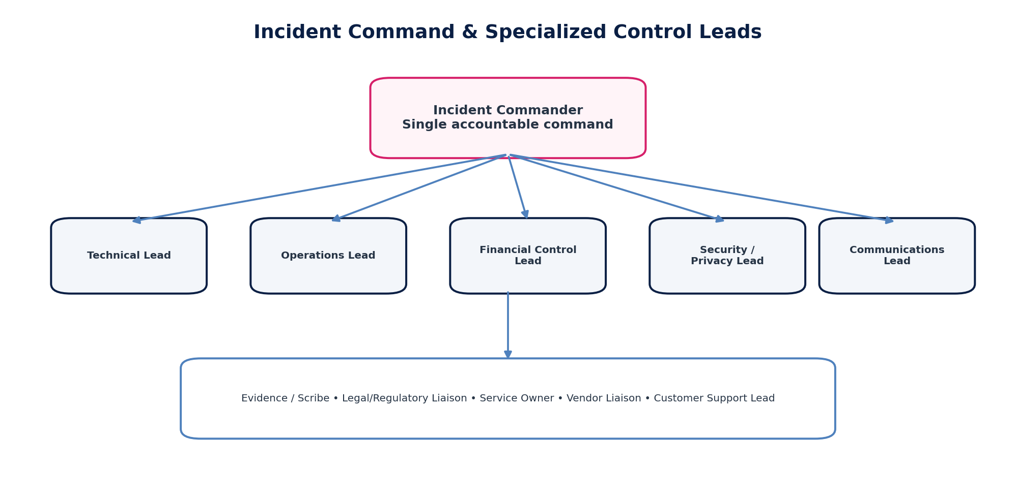
Figure 2 — Incident command structure with specialized control leads.

4.2 Production Roles
Role | Production accountability
Incident Commander (IC) | Owns incident command, severity, priorities, decisions, delegation, update cadence and resolution declaration. Does not need to be the deepest technical expert.
Operations Lead | Coordinates SRE/platform actions, runbook execution, traffic controls, queues, capacity, failover and operational tooling.
Technical Lead | Owns technical diagnosis, safe remediation plan and engineering execution.
Financial Control Lead | Determines financial-integrity exposure, reconciliation requirements, correction/reversal path and financial close impact.
Security / Privacy Lead | Owns security/privacy/residency containment and specialized notification/evidence requirements.
Tax / Regulatory Lead | Owns tax/e-invoice/filing correctness, authority deadlines and jurisdiction-specific recovery constraints.
Communications Lead | Publishes approved internal/customer/executive status updates and maintains message consistency.
Evidence / Scribe | Maintains timestamped incident timeline, decisions, evidence references and action log.
Service Owner | Provides service accountability, dependency knowledge and approves service-specific recovery where required.
Vendor Liaison | Coordinates cloud/payment/tax/e-invoice/identity/communications providers without delegating ZoikoSuite accountability.
Customer Support Lead | Coordinates support macros, impacted-customer identification and frontline feedback.
Legal / Regulatory Liaison | Coordinates contractual, legal, regulatory and notification obligations where triggered.

5. Canonical Operational State Model
Incidents use an explicit lifecycle rather than a free-text “open/closed” field. Operational state is separate from severity, customer impact, financial integrity status, security classification and communications status.
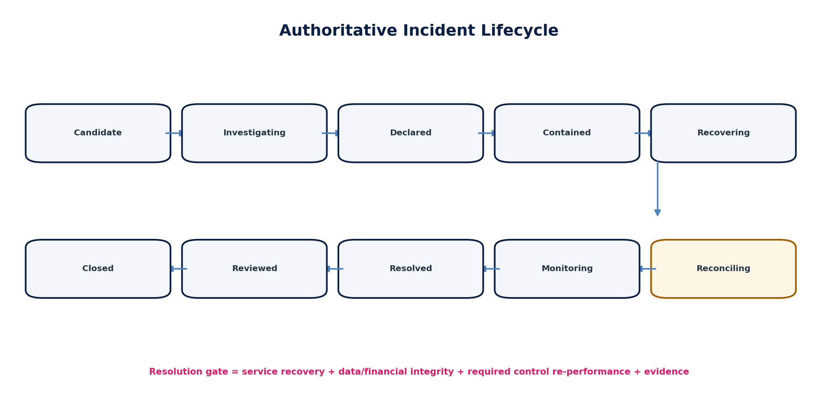
Figure 3 — Authoritative incident lifecycle. Reconciliation is a formal recovery phase, not an optional afterthought.
State | Meaning | Transition authority
Candidate | Signal or exception exists; incident not yet declared. | Automated/system
Investigating | Triage underway; scope and impact unresolved. | Triage Lead
Declared | Incident record, IC, severity and command channel established. | IC
Contained | Immediate amplification stopped or bounded; root cause may remain. | IC
Recovering | Technical/business recovery actions underway. | IC
Reconciling | Required financial/data/regulatory integrity checks and re-performance underway. | Financial/Domain Lead + IC
Monitoring | Service restored and controls passed; observation window active. | IC
Resolved | Incident impact ended; required evidence/reconciliation complete. | IC + required control leads
Reviewed | PIR completed/waived under policy; actions assigned. | Service Owner / Ops Governance
Closed | All mandatory closure conditions satisfied. | Ops Governance

6. Severity, Impact & Escalation
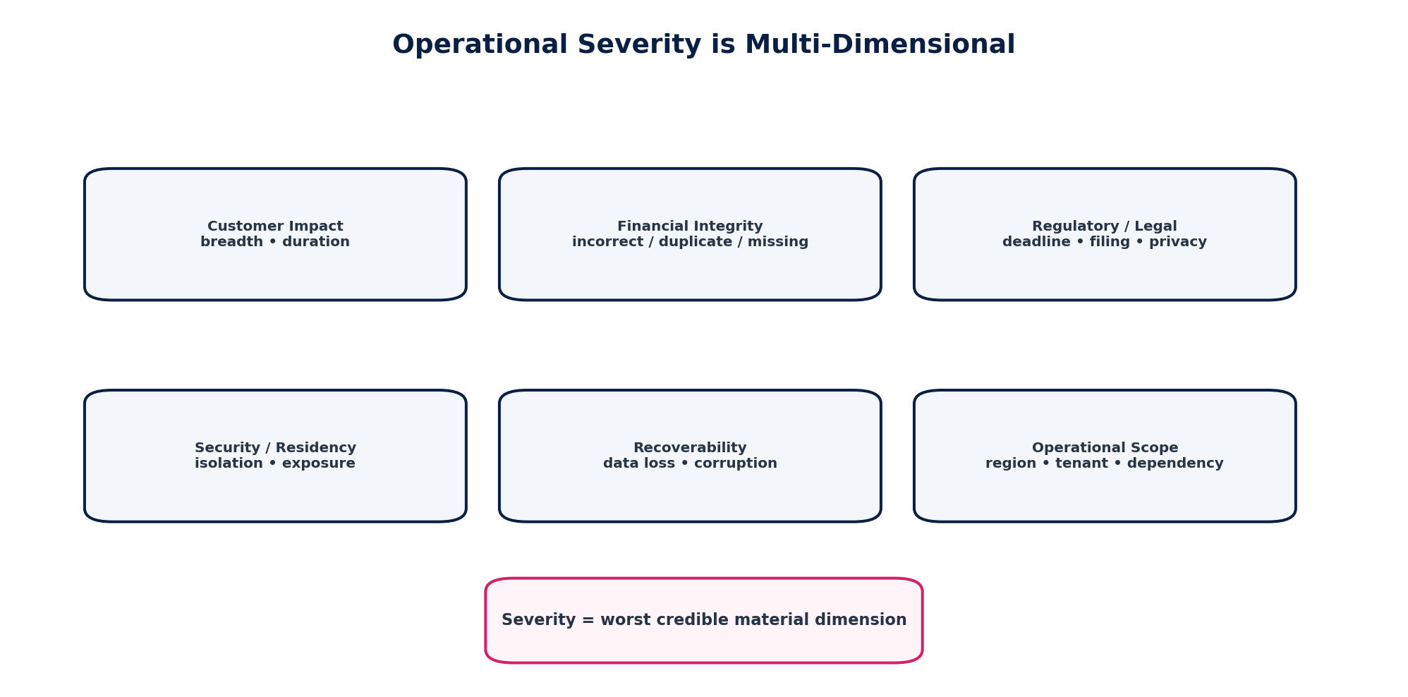
Figure 4 — Severity uses the worst credible material impact dimension, not request failure percentage alone.
Severity | Typical triggers | Command expectation
OPS-P0 — Catastrophic | Confirmed or credible platform-wide/large-scope financial corruption or duplicate irreversible effects; cross-tenant disclosure; material data loss; broad regulatory failure; critical production outage with no safe workaround. | Immediate executive + specialized leads; highest response cadence.
OPS-P1 — Major | Material regional or multi-tenant outage; significant financial correctness risk; widespread payment/filing failure; critical close blocker; severe dependency failure. | Major incident command; executive awareness; frequent communications.
OPS-P2 — Significant | Material single-tenant/entity issue, bounded financial exception, partial service degradation, sustained backlog threatening SLO or deadline. | Service/SRE command with domain lead; scheduled updates.
OPS-P3 — Minor | Limited customer impact, recoverable operational defect, non-material backlog or isolated processing issue. | Service team runbook; normal incident workflow.
OPS-P4 — Routine / Advisory | No current material impact; operational observation, service request or informational anomaly. | Normal operations queue.
Severity clocks below are engineering starting points, not customer SLAs. Production adoption requires executive/operations approval and alignment with contractual/regulatory commitments.
Severity | Target declaration | IC assignment | Internal update cadence | Customer/external update starting point
P0 | ≤5 min | ≤5 min | ≤15 min | ≤30 min or contractual/regulatory sooner
P1 | ≤10 min | ≤15 min | ≤30 min | ≤60 min or as required
P2 | ≤30 min | ≤60 min | ≤2 h | Impact-based
P3 | Same business day | As assigned | As needed | Usually none
P4 | Queue triage | N/A | N/A | None

7. Detection, Alerting & Triage
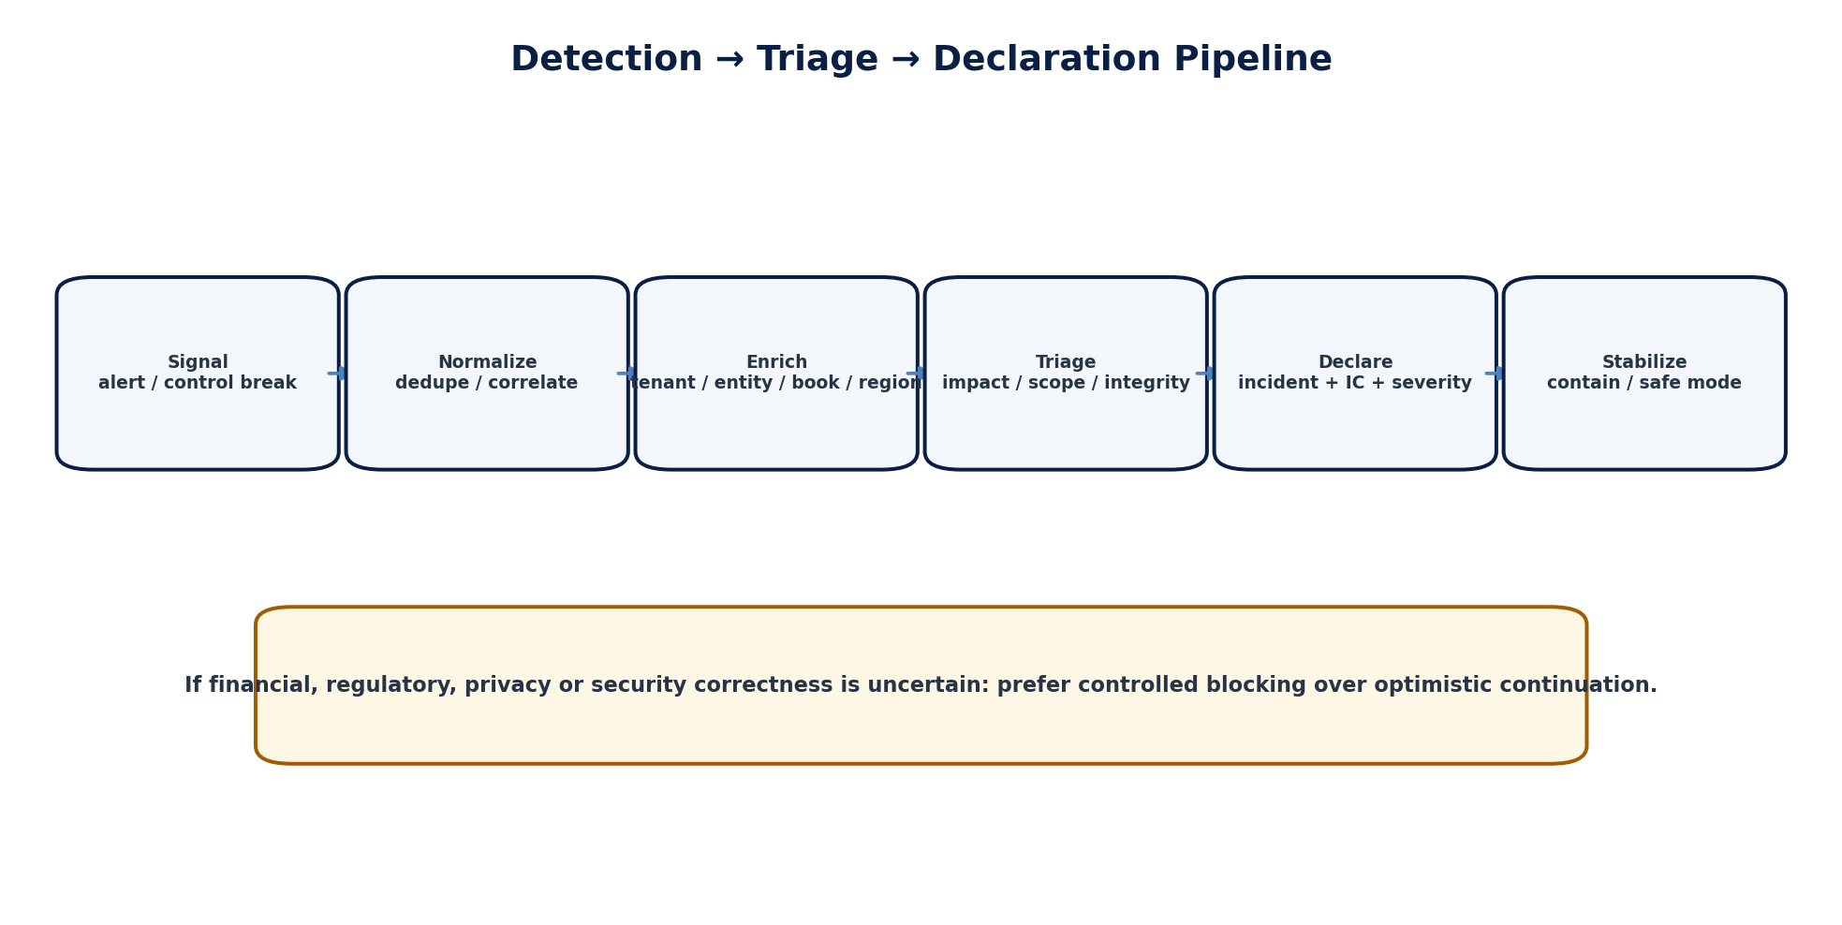
Figure 5 — Signal-to-declaration pipeline with business-context enrichment.

7.1 Signal Sources
- SLO/error-budget burn alerts
- Financial reconciliation and control breaks
- Accounting-kernel invariant failures
- Workflow and approval state anomalies
- Payment settlement/callback exceptions
- Tax/e-invoice authority errors and deadline monitors
- Event/queue lag, poison messages and consumer gaps
- Security, privacy, residency and tenant-isolation signals
- Synthetic customer journeys and business correctness probes
- Support/customer escalation patterns
- External provider status and contractual alerts
- Manual operator detection

7.2 Alert Quality Controls
Control | Requirement
Actionability | Every paging alert links to owner, service, dashboard, runbook and known dependency context.
Deduplication | Correlated symptoms collapse under one incident candidate where causally related.
Enrichment | Tenant/entity/book/region/jurisdiction/provider context is attached before human triage where possible.
Routing | Page the accountable team and specialized control lead based on impact class.
Silence | Maintenance/suppression is time-bounded, authorized and cannot hide correctness/control alerts.
Audit | Alert creation, acknowledgement, suppression and escalation are evidenced.

8. Major Incident Command Protocol
1. Declare the incident and create the authoritative record.
2. Assign Incident Commander and open a controlled command channel.
3. State current verified impact and key unknowns.
4. Stabilize: stop amplification, disable unsafe retries, isolate dependency or enter safe mode.
5. Assign technical, operations and specialized control leads.
6. Create explicit workstreams; avoid duplicated uncontrolled troubleshooting.
7. Publish update cadence and communication owner.
8. Track decisions, actions, hypotheses and evidence with timestamps.
9. Recover the service using the approved runbook/change authority.
10. Perform required data/financial/regulatory reconciliation.
11. Observe for recurrence and backlog catch-up.
12. Resolve only when technical and business-integrity gates pass.
13. Complete PIR/problem/corrective-action obligations according to severity.
The incident command channel is a control surface. Decisions made in side chats that materially affect production must be copied into the authoritative incident timeline.

9. Financial Processing Incident Doctrine
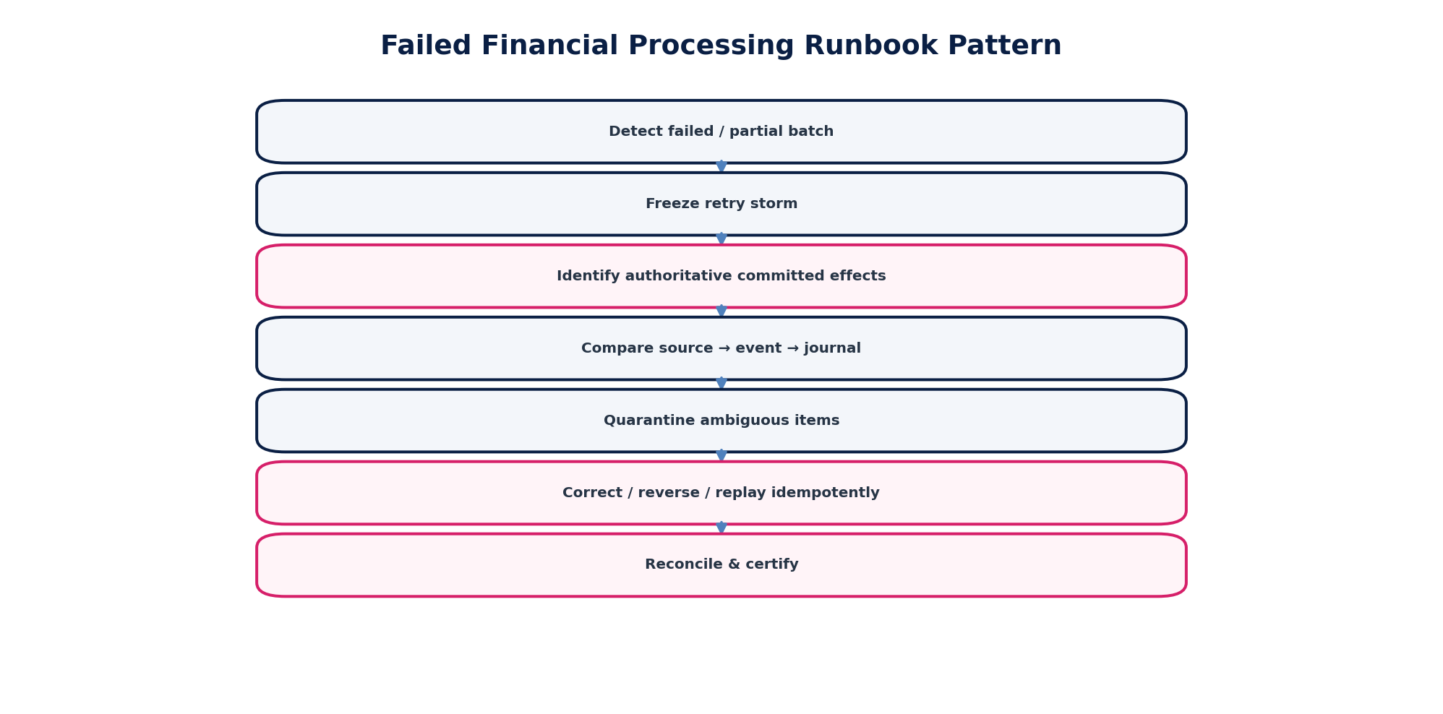
Figure 6 — Standard failed-financial-processing runbook pattern.

9.1 Core Questions
1. What authoritative source facts existed at the incident boundary?
2. Which commands were accepted, rejected, timed out or replayed?
3. Which domain state transitions committed?
4. Which accounting events and journals committed?
5. Which external effects occurred or may have occurred?
6. Which events/callbacks were emitted/received and deduplicated?
7. Which populations are incomplete, duplicated, misclassified or stale?
8. What correction/reversal/replay is lawful and systemically safe?
9. Which reconciliations and control runs prove recovery?

9.2 Prohibited Financial-Operations Actions
- Editing posted journal rows in place
- Deleting failed/duplicate business records to “clean up” evidence
- Reissuing payments solely because an API response timed out
- Replaying events without idempotency/business-effect checks
- Posting balancing plugs to hide unexplained differences
- Reopening a hard-closed period without approved accounting workflow
- Marking a tax/e-invoice submission accepted without authority evidence
- Closing the incident before required subledger/GL/provider reconciliation passes

10. Failed Posting / Journal Runbook Wireframe
Runbook field | Requirement
Trigger | Accounting event accepted but no journal; journal proposal failed; posting result ambiguous; imbalance/control-account/period rule failure.
Immediate containment | Pause affected posting worker/rule/version if amplification possible. Do not suppress unrelated healthy books/entities without reason.
Determine committed truth | Inspect command ID, event ID, accounting-event state, posting execution, journal ID, database commit and outbox record.
Classify | Validation/policy failure; dependency failure; concurrency; duplicate; rule defect; period state; data corruption; unknown.
Correct | Repair governed source data/rule where authorized; create reversal/correction or idempotent replay. Never modify a posted journal in place.
Reconcile | Source event → posting execution → journal → ledger → control account/trial balance.
Exit | No unaccounted events, no duplicates, balances/invariants pass, backlog controlled, evidence attached.

11. Payment Exception & Settlement Operations
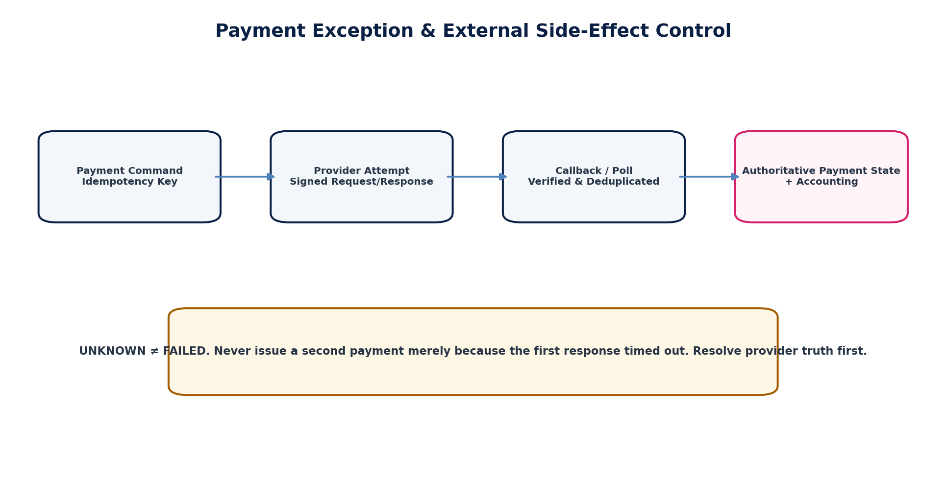
Figure 7 — Payment operations treat provider ambiguity as UNKNOWN rather than FAILED.
Operational state | Runbook behavior
Validation rejected | Correct input/authorization; no provider attempt if pre-send.
Provider rejected | Record provider code; no blind retry unless code/policy permits.
Timed out / unknown | Poll/provider lookup using attempt/reference; suppress duplicate initiation.
Accepted / pending | Await authoritative callback/poll; enforce bounded SLA/escalation.
Succeeded | Reconcile provider settlement, cash/clearing and business object.
Failed after acceptance | Record terminal provider result; release/reverse accounting as domain policy requires.
Returned / reversed | Create new authoritative return/reversal event; preserve original payment truth.
Duplicate suspected | Freeze further attempts; compare idempotency/business references/provider records; resolve before customer balance changes.

12. Tax Filing & E-Invoice Exception Operations
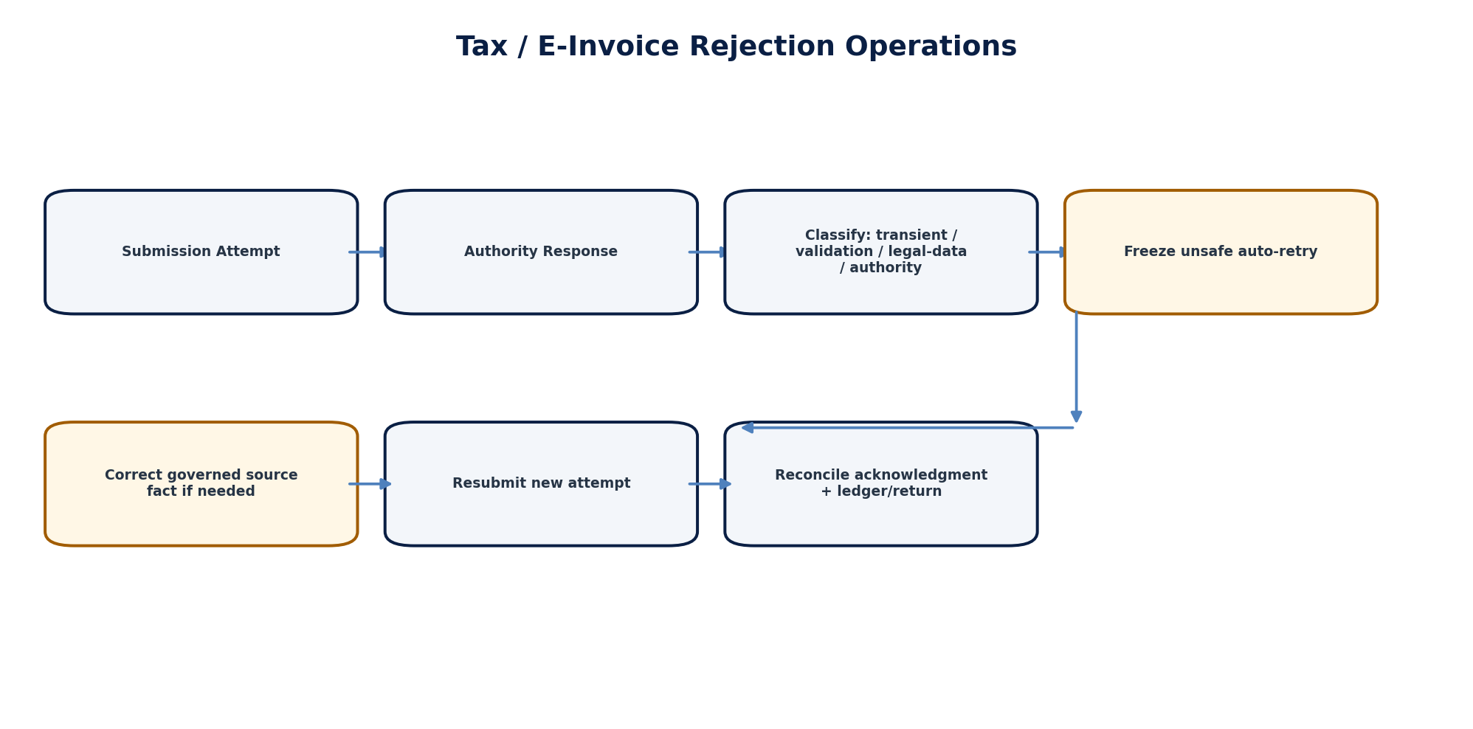
Figure 8 — Authority rejection and correction use new governed attempts, never history rewriting.
Exception class | Operational control
Transport/network | Retry only under adapter policy with idempotent submission reference.
Schema/syntax rejection | Correct canonical payload mapping or source data; create new submission attempt.
Business validation rejection | Route to tax/regulatory owner; no automated guess of legal interpretation.
Authentication/certificate | Rotate/repair approved credential; preserve failed attempt evidence.
Authority outage | Queue under deadline-aware policy; activate contingency/regulatory communications if threshold reached.
Accepted but acknowledgment missing | Resolve authority truth; do not mark accepted on assumption.
Deadline at risk | Escalate to Tax/Regulatory Lead and Legal as applicable; customer/regulator communication follows jurisdiction pack.
Correction/amendment | Use jurisdiction-defined amendment/cancellation/credit process; preserve original filing/e-invoice record.

13. Reconciliation Break & Suspense Operations
A reconciliation break is an operational incident when it threatens financial correctness, close readiness, reporting, regulatory deadlines or material customer balances. Suspense is controlled temporary containment, not a resolution method.
Stage | Requirement
Detection | Control run fails, unexplained difference, missing population, stale source or provider mismatch.
Contain | Prevent affected certification/close/release; isolate suspect population.
Preserve population | Freeze control-run IDs, watermarks, hashes, record counts and totals.
Classify difference | Timing, missing, duplicate, valuation, mapping, FX, classification, external/provider, data defect.
Remediate | Correct authoritative source/business fact or create governed accounting correction.
Reperform | Run the original control definition against the corrected/frozen population or documented superseding population.
Certify | Control owner/financial authority approves result; incident may then progress to monitoring/resolution.

14. Queue, Event & Backlog Recovery
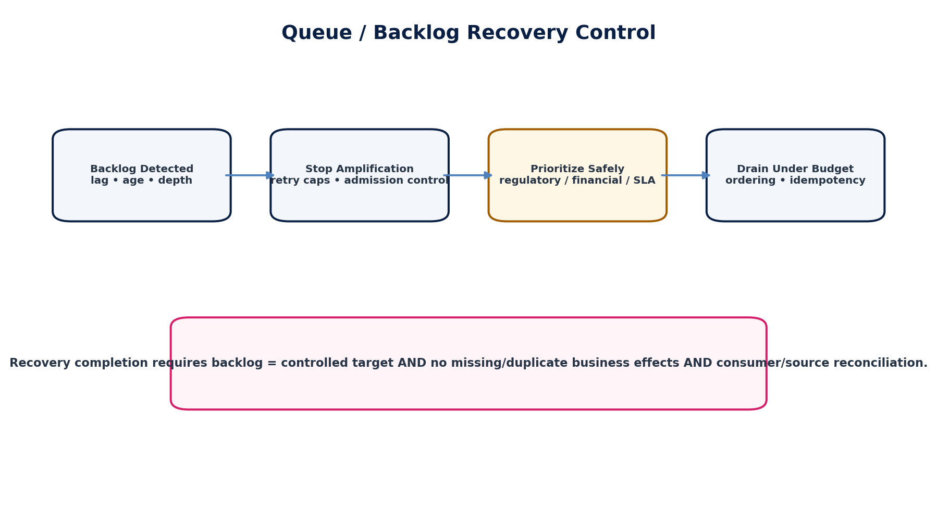
Figure 9 — Backlog recovery protects ordering, idempotency, downstream capacity and business priority.

14.1 Backlog Prioritization
Priority is not FIFO alone. The recovery plan considers statutory deadlines, financial irreversibility, customer harm, source ordering requirements, event causality, tenant fairness, downstream capacity and provider quotas. Within an aggregate/order-sensitive stream, required sequence is preserved.

14.2 Recovery Controls
- Stop retry storms before increasing capacity
- Measure oldest age, depth, arrival rate and drain rate
- Identify poison messages separately from healthy backlog
- Protect high-priority regulatory/payment/close work where safe
- Use bounded concurrency and provider-aware rate limits
- Maintain inbox/outbox deduplication
- Record replay/backfill job IDs and source ranges
- Reconcile producer/outbox/broker/consumer/business effects after drain
- Do not declare recovery merely because queue depth reached zero

15. Workflow & State-Machine Operational Exceptions
Exception | Operational action
Stuck workflow | Confirm authoritative business-object state, workflow version, current task, timeout/escalation state and required approvals.
Duplicate approval task | Do not manually delete history; identify dedupe/idempotency defect and preserve decisions.
Approval changed after mutation | Invalidate/re-route approval per ZS-STATE-001; never force-approved status.
Expired delegation | Re-resolve eligible approver; preserve original route evidence.
Orphaned workflow instance | Rebind/reconstruct only through approved repair command with object/version checks.
State mismatch | Authoritative domain object wins. Workflow projection must be repaired, not vice versa.
Mass stuck population | Declare incident; stop amplification; batch-repair through idempotent governed command with reconciliation.

16. External Dependency & Provider Incidents
Cloud, identity, banking, payment, tax, e-invoice, communications, data and AI providers are dependencies—not delegated accountability. ZoikoSuite retains responsibility for safe behavior, customer state and reconciliation.
Control | Requirement
Detection | Synthetic/API/contract signals plus provider status; never rely solely on provider status page.
Isolation | Circuit breaker/bulkhead/alternate path only if pre-approved and data/residency safe.
State ambiguity | Treat uncertain provider result as unknown; resolve by reference/poll/callback.
Fallback | Feature/provider fallback must preserve entitlements, authorization, data classification and jurisdiction requirements.
Communications | State ZoikoSuite impact, not merely “vendor outage.”
Recovery | Verify replay/catch-up, callbacks, reconciliations and duplicate effects after provider restoration.

17. Regional Incident & Disaster-Recovery Coordination
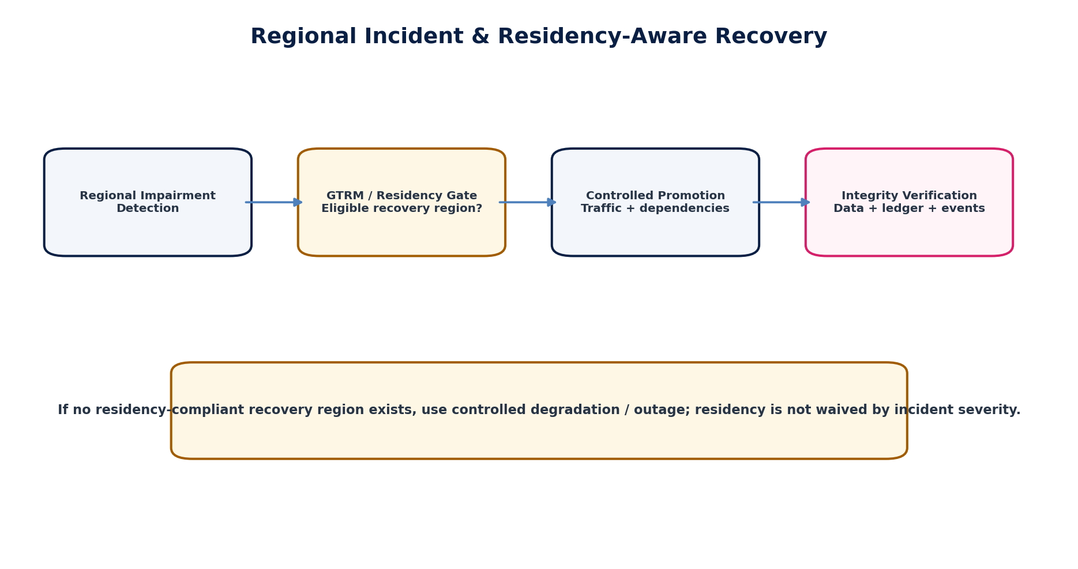
Figure 10 — Regional recovery is gated by residency and post-failover integrity checks.
ZS-NFR-001 and ZS-SEC-001 define RPO/RTO, recovery classes and residency. ZS-OPS-001 defines how an active incident coordinates those mechanisms. Promotion must use an approved runbook and an eligible region. If no eligible region exists, controlled degradation or outage is safer than an unauthorized cross-border failover.
Post-promotion verification | Minimum evidence
Identity and authorization | Pass/fail recorded with timestamp, owner and evidence reference.
Tenant/routing correctness | Pass/fail recorded with timestamp, owner and evidence reference.
Residency policy | Pass/fail recorded with timestamp, owner and evidence reference.
Database/schema integrity | Pass/fail recorded with timestamp, owner and evidence reference.
Event/outbox/inbox completeness | Pass/fail recorded with timestamp, owner and evidence reference.
Accounting invariants | Pass/fail recorded with timestamp, owner and evidence reference.
Payment/provider state | Pass/fail recorded with timestamp, owner and evidence reference.
Reconciliation/control runs | Pass/fail recorded with timestamp, owner and evidence reference.
Regulatory/tax queues | Pass/fail recorded with timestamp, owner and evidence reference.
Customer traffic/canary health | Pass/fail recorded with timestamp, owner and evidence reference.

18. Production Change Management
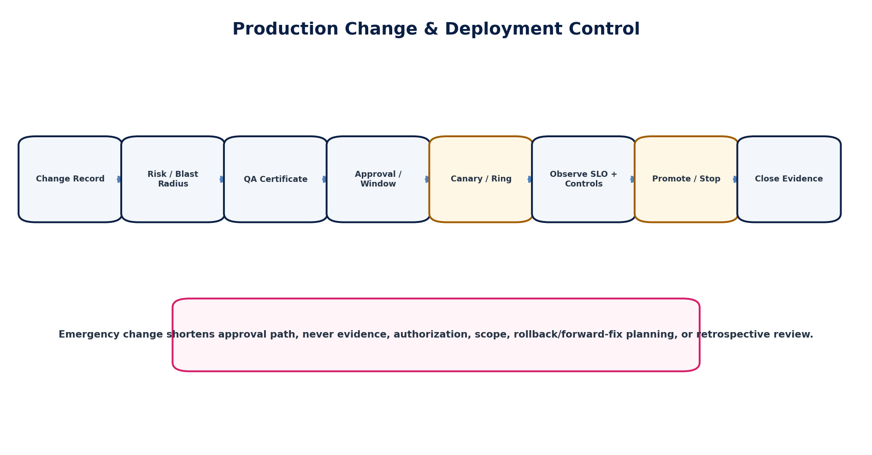
Figure 11 — Change control couples QA evidence, risk, canary rollout, SLO/control observation and closure evidence.
Change type | Definition | Approval model
Standard | Pre-authorized, low-risk, repeatable, tested procedure with bounded scope. | Catalog authorization + normal evidence.
Normal | Planned production change requiring explicit risk assessment, QA certificate and approval. | Change authority based on risk/criticality.
Emergency | Urgent change required to contain/recover material incident or critical exposure. | Compressed approval; IC/change authority; full evidence + retrospective review.
Regulatory emergency | Urgent jurisdiction-pack/config/code change driven by legal/authority deadline. | Tax/Regulatory + Engineering + required governance approval.
Security emergency | Urgent containment/patch/credential/key action. | Security incident/change authority + evidence.

18.1 Change Record Minimum
- Change ID, owner and service/domain
- Purpose and incident/problem/reference
- Risk, criticality and blast radius
- Tenant/entity/region/jurisdiction scope
- Artifact/config/rule versions
- QA/release certificate
- Prechecks and rollback/forward-correction plan
- Maintenance/customer communication needs
- Approvers and SoD evidence
- Canary/ring plan and success/abort criteria
- Execution timestamps and actor identities
- Post-change SLO/control/reconciliation evidence

19. Rollback vs Forward Correction
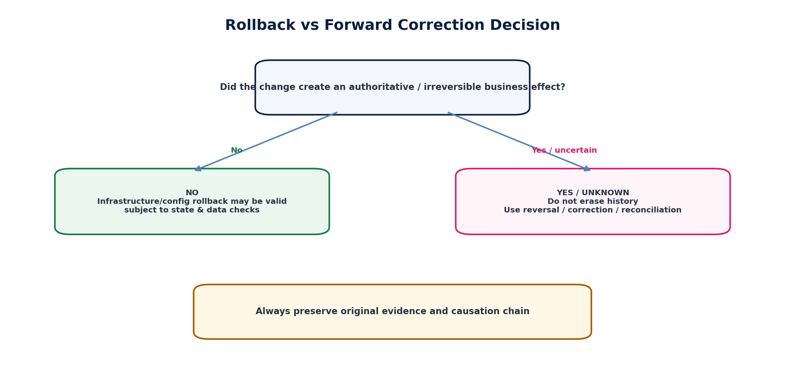
Figure 12 — Rollback is safe only when it does not contradict authoritative business effects.
Effect type | Recovery doctrine
UI/read-only deployment, no data change | Rollback normally acceptable after compatibility/state check.
Configuration/routing change | Rollback acceptable if state produced under new config remains compatible and reconciled.
Schema/data migration | Rollback only if explicitly designed/reversible and no later writes would be lost; otherwise forward migration.
Posted accounting journal | Never erase by rollback. Use reversal/adjustment under Accounting Kernel.
Payment initiated/provider accepted | Never resend/erase based on deployment rollback. Resolve provider state and use return/reversal process.
Tax/e-invoice submitted | Do not delete/pretend unsent. Use authority-defined cancellation/amendment/new attempt.
Customer invoice issued | Use void/credit/correction semantics allowed by state/jurisdiction.
Security key/credential rotation | Rollback only if cryptographically and operationally safe; compromise revocation may make old state invalid.

20. Privileged Production Intervention & Break-Glass
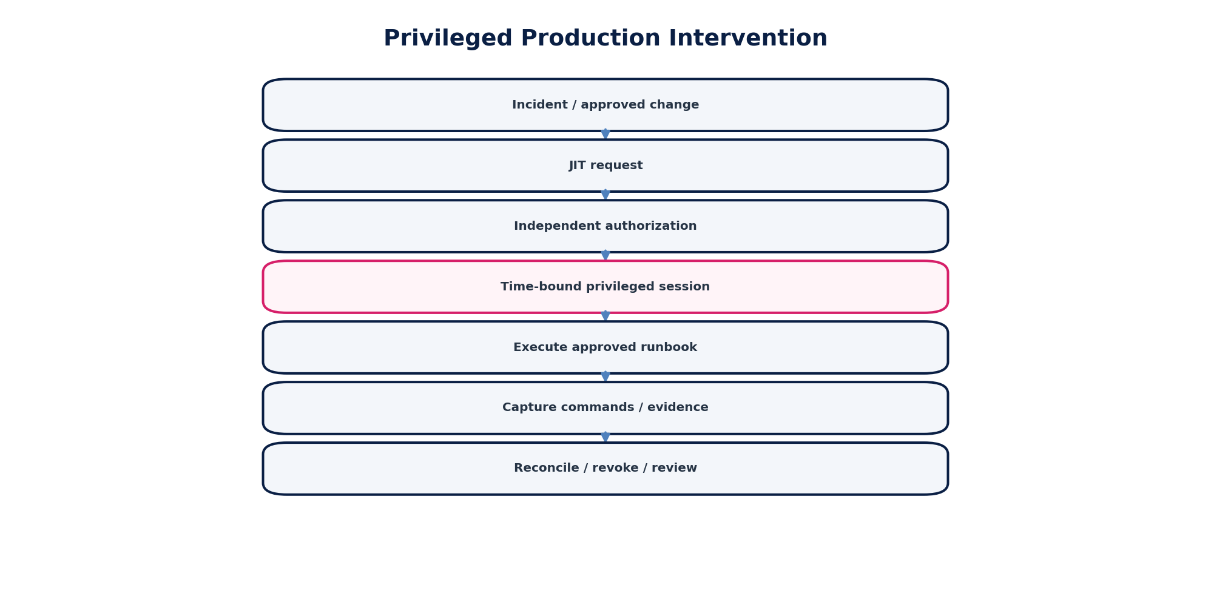
Figure 13 — JIT privileged intervention with independent authorization and post-action reconciliation.

20.1 Permitted Intervention Categories
- Controlled process restart or failover
- Feature/kill-switch operation
- Queue pause/resume/drain control
- Approved replay/backfill command
- Provider credential/certificate repair
- Read-only diagnostic query
- Governed repair command
- Emergency infrastructure or routing change

20.2 Prohibited Default Actions
- Direct mutation of financial tables
- Disabling audit/evidence logging
- Sharing privileged accounts
- Long-lived emergency credentials
- Copying S3/S4 production data into unapproved tools
- Cross-tenant “temporary” access
- Bypassing maker-checker or signing authority
- Deleting provider callbacks/events to resolve duplicates
Break-glass widens access only to the minimum emergency scope; it does not suspend accounting, residency, evidence or legal obligations.

21. Runbook Engineering Standard
Every Tier-1 runbook is versioned, executable and testable. A runbook may be implemented as automation plus human gates, but its control contract is the same.
Runbook field | Mandatory content
Runbook ID / version | Stable ID, semantic version, owner, effective date, review date.
Trigger | Machine/manual trigger conditions and severity guidance.
Applicability | Service, environment, region, tenant/entity/book/jurisdiction scope.
Preconditions | Required incident/change authority, access, backup/snapshot, maintenance state.
Inputs | IDs, time range, provider reference, correlation IDs, evidence sources.
Safety checks | Tenant/residency, idempotency, state/version, financial close, dependency health.
Steps | Numbered deterministic actions with expected output.
Human gates | Approvals, SoD, finance/tax/security/legal decisions.
Forbidden actions | Explicitly disallowed shortcuts.
Abort conditions | Conditions requiring stop/escalation.
Reconciliation | Control runs or comparisons proving business integrity.
Exit criteria | Technical + business + evidence requirements.
Evidence | Logs, commands, IDs, screenshots only where appropriate, hashes, approvals.
Test method | Simulation/game day/staging/production-safe drill.
Dependencies | Dashboards, tools, APIs, vendor contacts, backup/failover dependencies.

22. Operational Runbook Catalogue — Initial Baseline
Runbook ID | Runbook | Owner domain
RB-OPS-001 | Major incident declaration & command | Platform
RB-OPS-002 | Incident severity escalation/de-escalation | Platform
RB-OPS-003 | Production safe-mode activation | Platform
RB-OPS-004 | Emergency change execution | Platform
RB-OPS-005 | JIT privileged intervention | IAM/Security
RB-OPS-006 | Break-glass access | IAM/Security
RB-OPS-007 | Regional traffic failover | GTRM
RB-OPS-008 | Regional failback | GTRM
RB-OPS-009 | Database failover/promotion | Data Platform
RB-OPS-010 | Restore from backup | Data Platform
RB-OPS-011 | Event-broker partition/backlog recovery | Event Platform
RB-OPS-012 | Outbox relay backlog | Event Platform
RB-OPS-013 | Consumer inbox/dedupe fault | Event Platform
RB-OPS-014 | Poison event quarantine/replay | Event Platform
RB-OPS-015 | API gateway degradation | API Platform
RB-OPS-016 | Identity provider/federation outage | IAM
RB-OPS-017 | Authorization policy distribution fault | IAM
RB-OPS-018 | Accounting posting failure | Accounting
RB-OPS-019 | Unposted accounting-event backlog | Accounting
RB-OPS-020 | Closed-period posting attempt spike | Accounting
RB-OPS-021 | Trial-balance/control-account mismatch | Accounting/Controls
RB-OPS-022 | AR-to-GL reconciliation break | AR/Controls
RB-OPS-023 | AP-to-GL reconciliation break | AP/Controls
RB-OPS-024 | Bank-to-GL reconciliation break | Treasury/Controls
RB-OPS-025 | Payment provider timeout/unknown | Payments
RB-OPS-026 | Payment duplicate suspected | Payments
RB-OPS-027 | Payment settlement mismatch | Payments/Controls
RB-OPS-028 | Bank-feed missing day | Banking
RB-OPS-029 | Tax calculation/rule-pack defect | Tax
RB-OPS-030 | Tax filing rejection | Tax
RB-OPS-031 | Tax authority outage/deadline risk | Tax
RB-OPS-032 | E-invoice rejection | E-Invoice
RB-OPS-033 | E-invoice acknowledgment missing | E-Invoice
RB-OPS-034 | Jurisdiction-pack emergency hotfix | Tax/Regulatory
RB-OPS-035 | Payroll-to-GL mismatch | Payroll/Controls
RB-OPS-036 | Fixed-assets-to-GL mismatch | Assets/Controls
RB-OPS-037 | Inventory-to-GL mismatch | Inventory/Controls
RB-OPS-038 | Intercompany break | Intercompany/Controls
RB-OPS-039 | Consolidation input/control failure | Consolidation
RB-OPS-040 | Period-close mandatory control failure | Close
RB-OPS-041 | Workflow instance stuck | Workflow
RB-OPS-042 | Approval routing/delegation defect | Workflow/IAM
RB-OPS-043 | Bulk import partial failure | Data/Migration
RB-OPS-044 | Search/read-model stale projection | Platform
RB-OPS-045 | External provider outage | Integration
RB-OPS-046 | Object storage/document evidence outage | Documents
RB-OPS-047 | Notification delivery backlog | Notifications
RB-OPS-048 | Telemetry pipeline degradation | Observability
RB-OPS-049 | Secrets/KMS access incident | Security
RB-OPS-050 | Production data exposure suspicion | Security/Privacy
RB-OPS-051 | Tenant-isolation suspicion | Security
RB-OPS-052 | Residency-routing suspicion | Security/GTRM
RB-OPS-053 | Ransomware/destructive event coordination | Security/DR
RB-OPS-054 | First-close post-migration stabilization | Migration/Finance
RB-OPS-055 | AI/RAG safety or data-boundary incident | AI Platform
RB-OPS-056 | Customer status communications | Communications

23. Maintenance Windows & Operational Freeze
Window | Operational policy
Routine maintenance | Prefer no customer impact; notify if service/SLA requires; preserve fail-safe mode.
Financial close freeze | Restrict high-risk schema/config/rule changes during close window unless approved emergency.
Payroll processing freeze | Protect payroll run and payment windows from unrelated high-risk change.
Tax/regulatory deadline freeze | Protect filing/e-invoice/jurisdiction-pack stability around material deadlines.
Migration/cutover freeze | Governed by ZS-MIG-001; conflicting production changes blocked.
Security emergency exception | May override freeze with appropriate incident/change authority and full evidence.

24. Batch, Period-Close & Scheduled Operations
Scheduled operations are treated as production services with owners, deadlines, dependencies, idempotency, checkpoints, observability and recovery plans. A scheduler “success” flag is not authoritative if constituent financial work failed.
Control | Requirement
Watermark | Record exact source cutoff and population.
Dependency gate | Do not start dependent batch on stale/incomplete upstream state.
Checkpoint | Long-running jobs checkpoint safely without duplicate business effects.
Partial failure | Expose item-level failures and aggregate impact.
Retry | Retry only known-safe/idempotent operations.
Catch-up | Protect capacity and downstream dependencies during recovery.
Close gate | Mandatory control failures block hard close/release.
Evidence | Preserve job version, parameters, counts, totals, errors and reconciliation IDs.

25. Customer, Executive & Regulatory Communications
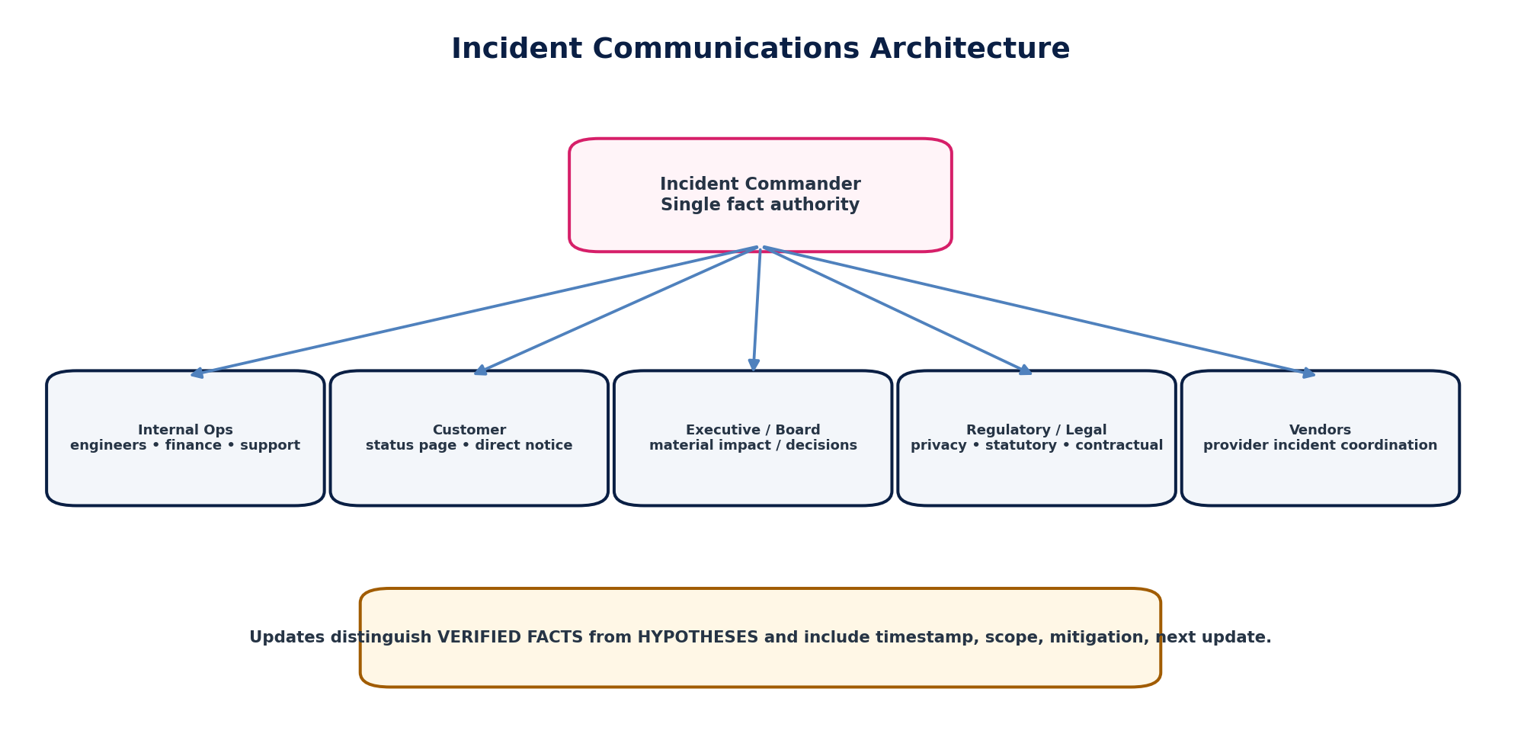
Figure 14 — One factual source of truth feeds audience-specific incident communications.

25.1 Update Template
Field | Required content
Timestamp | UTC plus local/regulatory time where useful.
Incident ID / Severity | Stable reference and current severity.
Verified impact | Who/what is affected; avoid unsupported scope claims.
Integrity status | State whether financial/data/regulatory correctness is confirmed, unaffected, uncertain or under reconciliation.
Mitigation | What safe action has been taken.
Customer action | Required only if customers genuinely need to act.
Next update | Committed time or condition.
Hypotheses | Never present as fact; normally kept to internal technical channel.

25.2 Notification Governance
Legal, privacy, security, regulatory and contractual notification obligations are determined by the appropriate specialist and jurisdiction pack/policy. Operations owns timely escalation and factual evidence, not unilateral legal conclusions.

26. Operational Evidence & Decision Logging
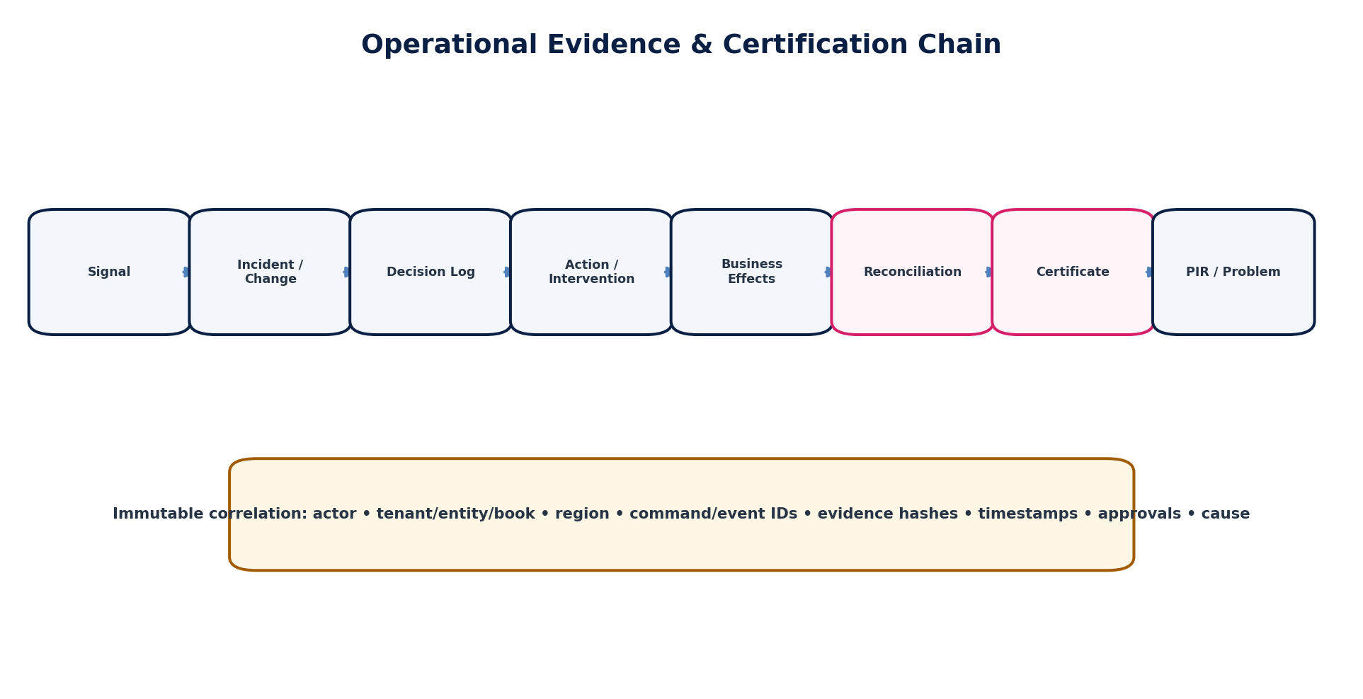
Figure 15 — Operational evidence chain from signal through certification and problem management.
Evidence family | Minimum fields
Incident identity | incident_id, severity, service/domain, tenant/entity/book/region/jurisdiction scope
Timeline | signal time, detection, declaration, containment, recovery, reconciliation, resolution
Actors | human/workload subject IDs, roles, delegated authority, privileged session IDs
Decisions | decision, owner, timestamp, evidence considered, alternatives/risks
Actions | command/change/runbook step, parameters, object/provider references
Effects | state transitions, journals, payments, submissions, callbacks, events
Evidence | log/trace/control/evidence IDs and cryptographic hashes where applicable
Communications | message version, audience, timestamp, approver
Certification | reconciliation/control results, resolver/approver, final integrity statement
Follow-up | PIR, problem, corrective action and verification references

27. Operational APIs, Commands & Domain Events

27.1 Canonical Commands
Endpoint pattern | Purpose
POST /ops/incidents | Declare incident
POST /ops/incidents/{id}:assign-commander | Assign/replace IC
POST /ops/incidents/{id}:change-severity | Escalate/de-escalate severity
POST /ops/incidents/{id}:contain | Record containment
POST /ops/incidents/{id}:begin-recovery | Move to recovery
POST /ops/incidents/{id}:begin-reconciliation | Enter reconciliation
POST /ops/incidents/{id}:resolve | Resolve with evidence gates
POST /ops/incidents/{id}:close | Close after review obligations
POST /ops/interventions | Request privileged intervention
POST /ops/interventions/{id}:approve | Approve intervention
POST /ops/runbooks/{id}:execute | Execute controlled runbook
POST /ops/replays | Request replay/backfill
POST /ops/changes | Create governed production change
POST /ops/changes/{id}:execute | Execute approved change
POST /ops/certificates | Issue operational recovery certificate

27.2 Canonical Events
Event type | Meaning
ops.incident.declared | incident → declared
ops.incident.severity_changed | incident → severity_changed
ops.incident.contained | incident → contained
ops.incident.recovery_started | incident → recovery_started
ops.incident.reconciliation_started | incident → reconciliation_started
ops.incident.resolved | incident → resolved
ops.incident.closed | incident → closed
ops.intervention.requested | intervention → requested
ops.intervention.approved | intervention → approved
ops.intervention.completed | intervention → completed
ops.runbook.execution_started | runbook → execution_started
ops.runbook.execution_failed | runbook → execution_failed
ops.runbook.execution_completed | runbook → execution_completed
ops.replay.requested | replay → requested
ops.replay.completed | replay → completed
ops.change.started | change → started
ops.change.aborted | change → aborted
ops.change.completed | change → completed
ops.recovery.certified | recovery → certified
ops.pir.completed | pir → completed
ops.problem.created | problem → created

28. Canonical Operational Data Model
Entity | Authority / purpose
Incident | Authoritative incident record and lifecycle.
IncidentImpact | Customer/tenant/entity/region/domain impact dimensions.
IncidentRoleAssignment | IC and specialized lead assignments with effective times.
IncidentTimelineEntry | Timestamped fact, hypothesis, decision, action or communication.
OperationalSignal | Alert/control/customer/provider signal linked to incident.
RunbookDefinition | Versioned runbook contract.
RunbookExecution | Concrete execution with inputs, actor and evidence.
RunbookStepExecution | Step-level status, timestamps and output.
ProductionIntervention | Privileged intervention request/approval/session.
ProductionChange | Change record, scope, risk, artifact and outcome.
ReplayBackfillJob | Controlled event/job range replay.
OperationalCommunication | Audience/version/timestamp/approval of status message.
RecoveryCheck | Technical or business-integrity verification.
OperationalCertificate | Signed recovery/cutover/incident integrity certificate.
PostIncidentReview | PIR content and approvals.
ProblemRecord | Underlying defect/control weakness and recurrence risk.
CorrectiveAction | Owner, due date, verification and closure.
ProviderIncidentLink | External provider incident/reference and reconciliation state.

29. Observability, Dashboards & Control Rooms
Every production service must expose operational views appropriate to its criticality. Dashboards are read models; they never become the authority for financial state.
Operational view | Required signals
Service health | SLIs, error budget, saturation, dependency health, deployment markers
Business correctness | posting errors, reconciliation breaks, duplicate-prevention alarms, provider unknown states
Queues/events | depth, oldest age, lag, retry rate, DLQ/quarantine, outbox/inbox gaps
Financial operations | unposted events, payment exceptions, bank breaks, suspense aging, close blockers
Tax/regulatory | submission backlog, rejection codes, deadlines at risk, authority outage
Security/privacy | tenant/residency anomalies, privileged sessions, data-access signals
Incident command | current severity, timeline, workstreams, owners, next update, pending recovery checks

30. Problem Management & Post-Incident Review
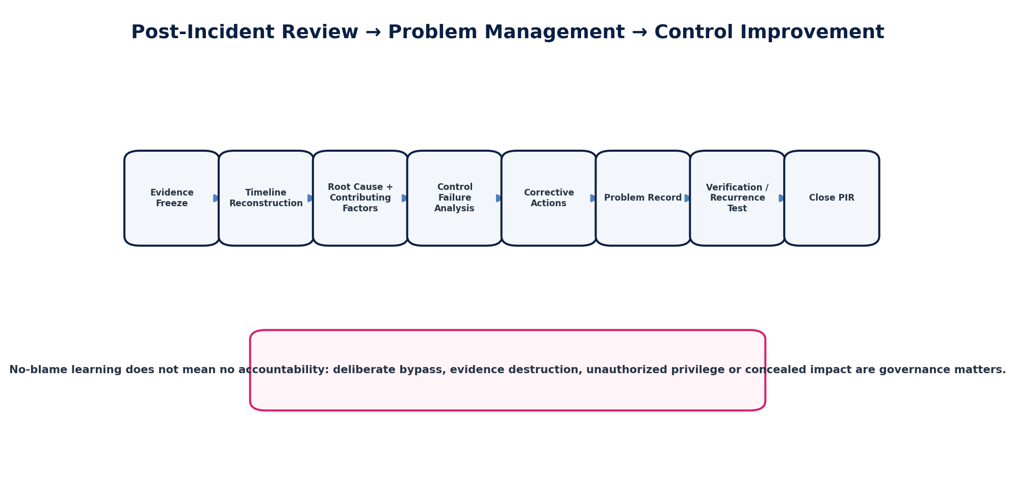
Figure 16 — PIR becomes a control-improvement pipeline, not a narrative postmortem.

30.1 PIR Required Content
- Executive summary and material impact
- Detection and response timeline
- What went well / what failed
- Root cause and contributing conditions
- Why preventive/detective controls did or did not work
- Financial/data/regulatory reconciliation outcome
- Customer/contract/regulatory communication outcome
- Manual/privileged interventions performed
- Corrective and preventive actions
- Owners, due dates and priority
- Recurrence tests / control changes
- Residual risk and accepted exceptions

30.2 PIR Threshold
P0 and P1 incidents require formal PIR and problem review. P2 requires PIR when financial/regulatory/security correctness, recurrence, control failure or material customer harm is involved. P3/P4 use service-owner review as defined by policy. Closure cannot be accelerated by simply downgrading severity after recovery.

31. Operational Control Catalogue — Initial Baseline
Control ID | Control | Execution model | Owner
OPS-CTRL-001 | Single authoritative incident record | Automated where possible; otherwise evidenced human control. | Service/SRE or specialized domain owner
OPS-CTRL-002 | Incident Commander assignment | Automated where possible; otherwise evidenced human control. | Service/SRE or specialized domain owner
OPS-CTRL-003 | Severity evidence and escalation | Automated where possible; otherwise evidenced human control. | Service/SRE or specialized domain owner
OPS-CTRL-004 | Impact scope enrichment | Automated where possible; otherwise evidenced human control. | Service/SRE or specialized domain owner
OPS-CTRL-005 | Decision log completeness | Automated where possible; otherwise evidenced human control. | Service/SRE or specialized domain owner
OPS-CTRL-006 | Verified-fact communication control | Automated where possible; otherwise evidenced human control. | Service/SRE or specialized domain owner
OPS-CTRL-007 | Runbook ownership/versioning | Automated where possible; otherwise evidenced human control. | Service/SRE or specialized domain owner
OPS-CTRL-008 | Runbook review freshness | Automated where possible; otherwise evidenced human control. | Service/SRE or specialized domain owner
OPS-CTRL-009 | Runbook simulation evidence | Automated where possible; otherwise evidenced human control. | Service/SRE or specialized domain owner
OPS-CTRL-010 | JIT privileged-access enforcement | Automated where possible; otherwise evidenced human control. | Service/SRE or specialized domain owner
OPS-CTRL-011 | Independent intervention approval | Automated where possible; otherwise evidenced human control. | Service/SRE or specialized domain owner
OPS-CTRL-012 | Privileged-session recording/evidence | Automated where possible; otherwise evidenced human control. | Service/SRE or specialized domain owner
OPS-CTRL-013 | Break-glass post-review | Automated where possible; otherwise evidenced human control. | Service/SRE or specialized domain owner
OPS-CTRL-014 | Direct database mutation prevention | Automated where possible; otherwise evidenced human control. | Service/SRE or specialized domain owner
OPS-CTRL-015 | Change-to-QA certificate binding | Automated where possible; otherwise evidenced human control. | Service/SRE or specialized domain owner
OPS-CTRL-016 | Canary/abort criteria | Automated where possible; otherwise evidenced human control. | Service/SRE or specialized domain owner
OPS-CTRL-017 | Emergency-change retrospective review | Automated where possible; otherwise evidenced human control. | Service/SRE or specialized domain owner
OPS-CTRL-018 | Rollback/forward-correction classification | Automated where possible; otherwise evidenced human control. | Service/SRE or specialized domain owner
OPS-CTRL-019 | Irreversible-effect rollback prevention | Automated where possible; otherwise evidenced human control. | Service/SRE or specialized domain owner
OPS-CTRL-020 | Payment unknown-state duplicate prevention | Automated where possible; otherwise evidenced human control. | Service/SRE or specialized domain owner
OPS-CTRL-021 | Provider callback deduplication | Automated where possible; otherwise evidenced human control. | Service/SRE or specialized domain owner
OPS-CTRL-022 | Payment settlement reconciliation | Automated where possible; otherwise evidenced human control. | Service/SRE or specialized domain owner
OPS-CTRL-023 | Tax/e-invoice retry policy | Automated where possible; otherwise evidenced human control. | Service/SRE or specialized domain owner
OPS-CTRL-024 | Authority acknowledgment verification | Automated where possible; otherwise evidenced human control. | Service/SRE or specialized domain owner
OPS-CTRL-025 | Regulatory deadline escalation | Automated where possible; otherwise evidenced human control. | Service/SRE or specialized domain owner
OPS-CTRL-026 | Accounting-event-to-journal recovery | Automated where possible; otherwise evidenced human control. | Service/SRE or specialized domain owner
OPS-CTRL-027 | Posted-journal immutability in operations | Automated where possible; otherwise evidenced human control. | Service/SRE or specialized domain owner
OPS-CTRL-028 | Closed-period operational enforcement | Automated where possible; otherwise evidenced human control. | Service/SRE or specialized domain owner
OPS-CTRL-029 | Reconciliation-break incident gating | Automated where possible; otherwise evidenced human control. | Service/SRE or specialized domain owner
OPS-CTRL-030 | Suspense aging escalation | Automated where possible; otherwise evidenced human control. | Service/SRE or specialized domain owner
OPS-CTRL-031 | Backlog oldest-age monitoring | Automated where possible; otherwise evidenced human control. | Service/SRE or specialized domain owner
OPS-CTRL-032 | Backpressure/retry-storm control | Automated where possible; otherwise evidenced human control. | Service/SRE or specialized domain owner
OPS-CTRL-033 | Poison-message quarantine | Automated where possible; otherwise evidenced human control. | Service/SRE or specialized domain owner
OPS-CTRL-034 | Replay authorization and source-range evidence | Automated where possible; otherwise evidenced human control. | Service/SRE or specialized domain owner
OPS-CTRL-035 | Post-replay business reconciliation | Automated where possible; otherwise evidenced human control. | Service/SRE or specialized domain owner
OPS-CTRL-036 | Workflow repair through governed commands | Automated where possible; otherwise evidenced human control. | Service/SRE or specialized domain owner
OPS-CTRL-037 | External provider incident linkage | Automated where possible; otherwise evidenced human control. | Service/SRE or specialized domain owner
OPS-CTRL-038 | Residency-aware failover gate | Automated where possible; otherwise evidenced human control. | Service/SRE or specialized domain owner
OPS-CTRL-039 | Post-failover integrity verification | Automated where possible; otherwise evidenced human control. | Service/SRE or specialized domain owner
OPS-CTRL-040 | Batch population/watermark evidence | Automated where possible; otherwise evidenced human control. | Service/SRE or specialized domain owner
OPS-CTRL-041 | Partial-batch failure visibility | Automated where possible; otherwise evidenced human control. | Service/SRE or specialized domain owner
OPS-CTRL-042 | Close blocker enforcement | Automated where possible; otherwise evidenced human control. | Service/SRE or specialized domain owner
OPS-CTRL-043 | Maintenance/change freeze enforcement | Automated where possible; otherwise evidenced human control. | Service/SRE or specialized domain owner
OPS-CTRL-044 | Operational communication cadence | Automated where possible; otherwise evidenced human control. | Service/SRE or specialized domain owner
OPS-CTRL-045 | Customer notification approval | Automated where possible; otherwise evidenced human control. | Service/SRE or specialized domain owner
OPS-CTRL-046 | Regulatory/legal escalation | Automated where possible; otherwise evidenced human control. | Service/SRE or specialized domain owner
OPS-CTRL-047 | Incident evidence immutability | Automated where possible; otherwise evidenced human control. | Service/SRE or specialized domain owner
OPS-CTRL-048 | Recovery certificate completeness | Automated where possible; otherwise evidenced human control. | Service/SRE or specialized domain owner
OPS-CTRL-049 | PIR completion | Automated where possible; otherwise evidenced human control. | Service/SRE or specialized domain owner
OPS-CTRL-050 | Corrective-action ownership | Automated where possible; otherwise evidenced human control. | Service/SRE or specialized domain owner
OPS-CTRL-051 | Corrective-action verification | Automated where possible; otherwise evidenced human control. | Service/SRE or specialized domain owner
OPS-CTRL-052 | Recurring-incident problem detection | Automated where possible; otherwise evidenced human control. | Service/SRE or specialized domain owner
OPS-CTRL-053 | Support escalation integration | Automated where possible; otherwise evidenced human control. | Service/SRE or specialized domain owner
OPS-CTRL-054 | Provider contact/escalation freshness | Automated where possible; otherwise evidenced human control. | Service/SRE or specialized domain owner
OPS-CTRL-055 | Incident metrics and trend review | Automated where possible; otherwise evidenced human control. | Service/SRE or specialized domain owner
OPS-CTRL-056 | Production access recertification | Automated where possible; otherwise evidenced human control. | Service/SRE or specialized domain owner
OPS-CTRL-057 | Control-room/dashboard freshness | Automated where possible; otherwise evidenced human control. | Service/SRE or specialized domain owner
OPS-CTRL-058 | Runbook dependency health check | Automated where possible; otherwise evidenced human control. | Service/SRE or specialized domain owner
OPS-CTRL-059 | Safe-mode activation control | Automated where possible; otherwise evidenced human control. | Service/SRE or specialized domain owner
OPS-CTRL-060 | Incident closure business-integrity gate | Automated where possible; otherwise evidenced human control. | Service/SRE or specialized domain owner

32. Negative-Path Engineering Acceptance Scenarios
Scenario | Failure injection / condition | Expected control outcome
OPS-AT-001 | API latency recovers but AR→GL remains out of balance. | Incident cannot resolve; enters/continues reconciliation.
OPS-AT-002 | Payment provider times out after receiving request. | Second initiation blocked; provider truth resolved by attempt reference.
OPS-AT-003 | Duplicate provider callback arrives. | Deduplicated; one business effect only.
OPS-AT-004 | Operator attempts direct SQL update to posted journal. | Denied/prevented; alert/evidence generated.
OPS-AT-005 | Emergency change requested without incident/change authority. | Execution blocked.
OPS-AT-006 | Break-glass actor attempts self-approval. | Blocked by SoD.
OPS-AT-007 | Privileged session exceeds approved duration. | Access expires automatically; incident/change remains active if needed.
OPS-AT-008 | Queue drain increases downstream 5xx and retries. | Drain throttles/stops under backpressure policy.
OPS-AT-009 | Poison message repeatedly fails. | Quarantined; healthy queue continues where ordering permits.
OPS-AT-010 | Replay range includes already-processed events. | Inbox/idempotency prevents duplicate business effects.
OPS-AT-011 | Consumer lag reaches zero but one aggregate version is missing. | Recovery fails reconciliation; incident remains open.
OPS-AT-012 | Tax authority rejects payload for business validation. | No blind retry; correction routed to governed source/regulatory owner.
OPS-AT-013 | E-invoice accepted but acknowledgment callback is lost. | Authority truth resolved; acceptance not inferred from timeout.
OPS-AT-014 | Hard-closed period receives replayed accounting event. | Posting blocked/exception routed; period not bypassed.
OPS-AT-015 | Region fails and only available region violates residency. | No unauthorized failover; controlled degradation/outage.
OPS-AT-016 | Failover completes with stale event consumers. | Post-failover integrity gate fails; service remains recovering/degraded.
OPS-AT-017 | Deployment created customer invoices before rollback. | Rollback cannot erase invoices; forward correction semantics required.
OPS-AT-018 | Database schema rollback would lose post-change writes. | Rollback blocked; forward migration/correction required.
OPS-AT-019 | Incident severity lowered to avoid P1 PIR. | Governance rule requires evidence; PIR obligation persists based on maximum/material impact.
OPS-AT-020 | Status update includes unverified root-cause hypothesis as fact. | Communication validation/approval rejects or flags message.
OPS-AT-021 | Runbook version changed mid-execution. | Execution remains pinned to approved version or formally transitions with evidence.
OPS-AT-022 | Runbook step fails but automation proceeds. | Abort/escalation condition triggers; no silent skip.
OPS-AT-023 | Manual workflow repair attempts to set object status directly. | Denied; governed repair command required.
OPS-AT-024 | Supplier-bank change and payment release handled by same unauthorized actor during incident. | Dynamic SoD blocks payment release.
OPS-AT-025 | Reconciliation difference falls under per-item tolerance but aggregate is material. | Aggregate materiality blocks certification.
OPS-AT-026 | Telemetry pipeline is unavailable during incident. | Fallback evidence path and manual timeline activated; blind recovery prohibited.
OPS-AT-027 | External vendor status says recovered but Zoiko synthetic/business checks fail. | Zoiko incident remains active.
OPS-AT-028 | Batch scheduler says success but item-level failures exist. | Batch/control status remains failed/partial; close gate blocks if required.
OPS-AT-029 | Customer support attempts to close incident from ticket system. | Only authoritative incident workflow/IC can resolve.
OPS-AT-030 | Incident evidence is under legal hold. | Retention/deletion respects hold; evidence remains available.
OPS-AT-031 | Payment unknown-state exceeds provider SLA near period close. | Escalation + accounting/reconciliation treatment; no fabricated terminal state.
OPS-AT-032 | Tax deadline arrives during authority outage. | Contingency escalation/communications per jurisdiction pack; attempts/evidence preserved.
OPS-AT-033 | Cross-tenant diagnostic query requested during P0. | Still denied unless explicit authorized multi-tenant support mechanism permits safe scope.
OPS-AT-034 | Operator disables audit logging to improve incident performance. | Blocked; security event raised.
OPS-AT-035 | Corrective action marked complete without recurrence test. | Closure blocked where verification required.
OPS-AT-036 | Incident closed while backlog is zero but source-to-business control totals do not match. | Closure blocked; reconciliation required.

33. Operational Metrics & Governance Review
Metric | Definition
MTTD | Time from first qualifying signal to detection.
MTTA | Time to human/team acknowledgement.
MTTDcl | Time from detection to formal declaration.
MTTC | Time to containment.
MTTR-tech | Time to technical service restoration.
MTTR-business | Time to business-integrity/reconciliation recovery.
Time to customer update | From declaration/material-impact confirmation.
Reopen rate | Resolved incidents later reopened.
Repeat incident rate | Recurrence by root cause/problem.
Runbook success rate | Executions completing without unplanned deviation.
Privileged intervention count | By service/incident/change; trend standing manual operations.
Emergency change rate | Frequency and post-review findings.
Backlog recovery time | Oldest-age/depth normalization plus reconciliation.
Financial correction rate | Incidents requiring reversal/adjustment/correction.
PIR action aging | Open corrective actions by severity/due date.

34. Definition of Ready — Production Service
DoR # | Requirement
1 | Named service owner and on-call/operations owner
2 | Criticality class and SLOs approved
3 | Dependency map and failure modes documented
4 | At least one actionable dashboard and paging path
5 | Service-specific runbooks for material failure modes
6 | Safe-mode/degradation behavior defined
7 | Privileged intervention requirements defined
8 | Backup/failover/recovery path tested where applicable
9 | Financial/regulatory reconciliation controls mapped
10 | Provider escalation contacts and references current
11 | Customer/status communication template available
12 | Incident metadata and evidence integration implemented
13 | Security/privacy/residency escalation paths defined
14 | QA/release certificate requirements satisfied
15 | Game-day or operational rehearsal passed for C0/C1 services

35. Definition of Done — Incident / Operational Recovery
DoD # | Requirement
1 | Immediate impact contained
2 | Technical service state restored or explicitly degraded under approved mode
3 | No uncontrolled retry/amplification remains
4 | Unknown provider/external effects resolved or formally tracked under approved exception
5 | Required data/financial/regulatory reconciliations pass
6 | Backlogs/catch-up within controlled target
7 | Required control runs reperformed
8 | Customer/internal/regulatory communications completed as applicable
9 | Privileged sessions revoked and reviewed
10 | Evidence package complete
11 | Incident severity/impact final assessment recorded
12 | PIR/problem obligation assigned
13 | Corrective actions created with owners/dates
14 | Recovery/incident certificate issued where required
15 | Incident moves through monitoring/resolved under authoritative workflow

36. Engineering Implementation Sequence
Wave | Build focus
Wave 1 — Foundation | Incident object model, severity, IC roles, timeline/evidence, alert-to-incident integration.
Wave 2 — Command & Communications | Major-incident command tooling, status templates, workstreams, escalation clocks.
Wave 3 — Privileged Operations | JIT intervention, break-glass, session evidence, runbook execution framework.
Wave 4 — Financial Operations | Posting/payment/reconciliation/tax/e-invoice runbooks and recovery certificates.
Wave 5 — Queue & Integration Recovery | Replay/backfill, backlog drain, provider-incident integration and reconciliation.
Wave 6 — Change & Release Operations | Change records, canary/abort, emergency change, freeze windows and rollback/forward classification.
Wave 7 — Regional/DR Operations | GTRM failover/failback command, residency gate and post-promotion integrity checks.
Wave 8 — Problem & Learning | PIR, problem records, corrective actions, recurrence tests and trend analytics.
Wave 9 — Certification | Runbook test corpus, game days, operational control catalogue and production readiness certification.

37. Controlled Pre-Production Decisions
Decision ID | Decision | Owner
OPS-DEC-001 | Final P0–P4 declaration and communication clocks | Operations + Executive + Support + Legal
OPS-DEC-002 | 24×7 on-call coverage model by service criticality | Engineering/SRE
OPS-DEC-003 | Incident management / paging / status tooling | Platform Operations
OPS-DEC-004 | Session-recording and privileged-access tooling | Security/IAM
OPS-DEC-005 | Customer status-page segmentation and tenant-specific notification model | Product/Support/Legal
OPS-DEC-006 | Regulatory notification playbook ownership by jurisdiction | Legal/Privacy/Tax
OPS-DEC-007 | Formal change advisory model vs automated risk-based authority | Engineering Governance
OPS-DEC-008 | Game-day frequency per criticality class | SRE/QA
OPS-DEC-009 | PIR review board composition and thresholds | Operations/Engineering/Control
OPS-DEC-010 | Retention period for operational evidence beyond legal/regulatory minima | Security/Privacy/Legal

38. Prohibited Operational Anti-Patterns
Anti-pattern | Why prohibited
“Just restart it” | Restart without understanding irreversible/partial effects or proving post-restart integrity.
Database hotfix as normal operations | Manual authoritative state edits outside governed repair commands.
Green dashboard closure | Closing before business/data/financial reconciliation.
Blind provider retry | Repeating payment/tax/e-invoice action after timeout without resolving external truth.
Queue brute force | Increasing workers/retries until backlog disappears regardless of dependencies/order.
Evidence deletion | Deleting duplicate/error records, callbacks or logs to tidy production.
War-room democracy | Multiple competing commanders or unowned decisions.
Side-channel decisions | Material actions made in private chat without authoritative timeline entry.
Permanent emergency access | Break-glass/JIT privilege becoming standing entitlement.
Emergency-change exemption | Treating urgency as exemption from evidence and review.
Rollback theatre | Restoring binaries/database while leaving contradictory external/business effects.
Blameless = ownerless | Using learning culture to avoid corrective-action accountability.
Vendor outsourcing | Treating provider recovery notice as proof ZoikoSuite recovered.
Status speculation | Publishing hypotheses as customer facts.
Runbook drift | Wiki procedure diverges from actual system/permissions without version/testing.

39. External Standards & Current Reference Baseline
Reference | Use in ZS-OPS-001
ISO/IEC 20000-1:2018 | Service management system requirements; current version confirmed by ISO in 2023, with Amd 1:2024.
NIST SP 800-61 Rev. 3 (2025) | Current NIST incident-response recommendations integrated with CSF 2.0; supersedes Rev. 2.
NIST Cybersecurity Framework 2.0 (2024) | Govern/Identify/Protect/Detect/Respond/Recover context for cyber incident operations.
ISO 22301:2019 | Business continuity management requirements; used alongside ZS-NFR-001 and DR planning.
Google SRE practices | Operational concepts such as incident command, SLOs/error budgets, postmortems and toil reduction are useful engineering references, not normative legal standards.
References are architecture anchors. Contractual SLAs, statutory reporting/notification deadlines, accounting treatments and jurisdiction-specific legal obligations remain governed by approved agreements, policies, jurisdiction packs and professional/legal review.

40. Final Architecture Decision
ZOIKOSUITE PRODUCTION OPERATIONS SHALL OPTIMIZE FOR SAFE RESTORATION OF AUTHORITATIVE BUSINESS TRUTH — NOT MERELY SPEED OF SERVICE RESTART. Every material incident must preserve command accountability, controlled privilege, tenant/residency boundaries, domain-state integrity, financial/regulatory correctness and immutable evidence from signal through certification.
ZS-OPS-001 is the global baseline. Each service/domain must derive tested, versioned runbooks from this standard. Service-specific procedures may add stricter controls but must not weaken these invariants.

