ZOIKOSUITE

Governance & Control Plane
Detailed Service Specifications
GOV-01 through GOV-12 — Build-Ready Engineering Wireframe

Field | Value
Document ID | ZS-SVC-A-001
Version | 1.0 — Governance & Control Plane Baseline
Date | 24 August 2026
Status | Engineering baseline — subject to approval
Scope | GOV-01 through GOV-12 only
Parent Standards | ZS-ARCH-SVC-001; ZS-SVC-SPEC-001; ZS-DATA-001; ZS-STATE-001; ZS-API-001; ZS-EVENT-001; ZS-IAM-001; ZS-JUR-001; ZS-CONTROL-001; ZS-SEC-001; ZS-QA-001; ZS-NFR-001; ZS-OPS-001; ZS-DATA-GOV-001
Classification | Internal Engineering / Architecture Control

Document Roadmap & Engineering Use
This pack is the first instantiation of the approved ZoikoSuite service-specification standard. It turns the twelve Governance & Control Plane capabilities into implementable contracts without prescribing that each Service ID must become an independent microservice. Teams may co-locate runtime components where appropriate, but authoritative ownership, policy boundaries, contracts, state, evidence, permissions and SLO responsibilities defined here remain mandatory.
This is an implementation-control document, not a product feature list. A service is build-ready only when its contract is machine-readable, its negative paths are testable, and its authoritative ownership cannot be bypassed by another service or by the UI.

1. Critical Analysis & Refinements Incorporated
Refinement | Engineering consequence
Eliminate circular authority | Tenant Context resolves identity/scope; GTRM decides region; Authorization decides access; SoD blocks conflict; Policy resolves rules; Workflow orchestrates approval; the owning business domain still decides whether a transition is legal.
No trusted client context | Tenant, entity, book, jurisdiction, residency and effective policy are server-resolved. Client hints are never authoritative.
No policy/configuration mutability in place | Released policy, workflow, schema, retention and control artifacts are immutable versions with effective-dated activation.
No feature-flag security | Feature exposure cannot grant permission, bypass SoD, override jurisdiction rules or create a new business transition.
No legal-hold = access shortcut | A hold suspends disposition; it does not broaden purpose, visibility or authorization.
No break-glass = super-admin | Emergency elevation is scoped, time-limited, independently approved, fully evidenced and followed by reconciliation/review.
No evidence afterthought | Material governance decisions create evidence IDs and version references as part of completion semantics, not as asynchronous best effort.
No registry without consumer governance | Schema publication and retirement require compatibility analysis and consumer adoption evidence.
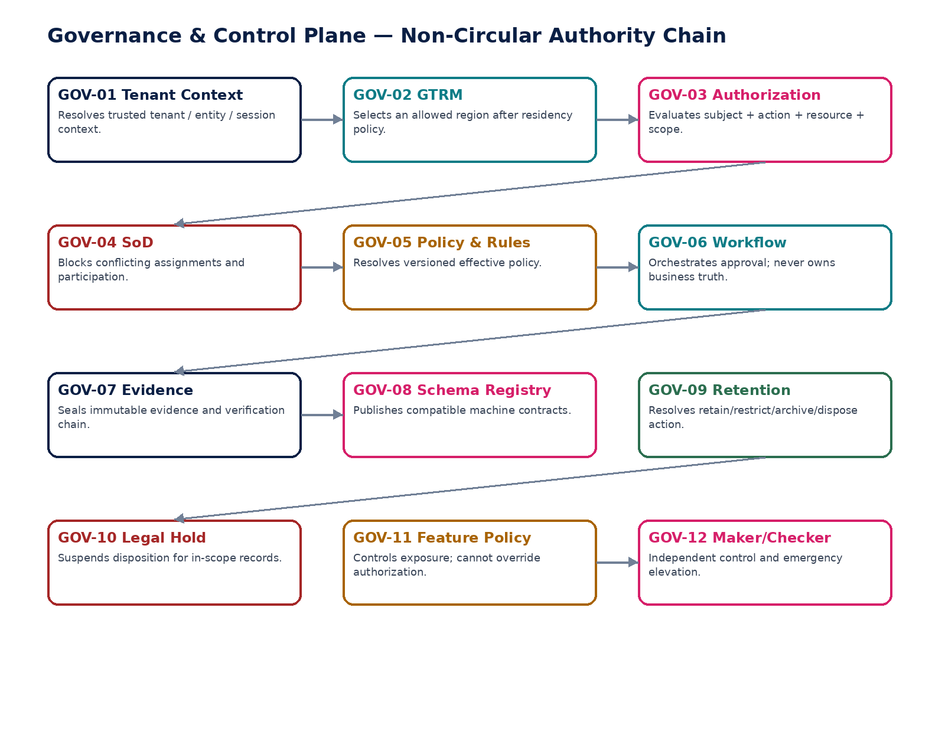
Figure 1 — Governance services form a control chain with explicit, non-circular authority.

2. Domain Constitution & Shared Invariants
# | Invariant
1 | Every protected request resolves trusted tenant/context before authorization or domain execution.
2 | No service accepts a client-supplied tenant, region, legal entity, accounting book or policy version as authoritative.
3 | Deny and conflict decisions are fail-closed for protected writes and sensitive reads.
4 | Policy, workflow, schema, retention and feature artifacts are immutable once released; change creates a new version.
5 | Workflow approval does not itself execute the business transition.
6 | Authorization does not override SoD; SoD does not create permission; feature exposure does not grant either.
7 | Legal hold suspends disposition but never creates a new processing purpose.
8 | Break-glass cannot bypass tenant isolation, residency, accounting integrity, tax validity or other domain invariants.
9 | Material decisions retain correlation, causation, actor, scope and governing-version evidence.
10 | Outbox publication occurs only after authoritative commit; consumers assume at-least-once delivery.
11 | Historical decisions remain reproducible from original policy/schema/workflow/retention versions.
12 | UI and SDKs render server-authoritative available actions; they never decide legality locally.
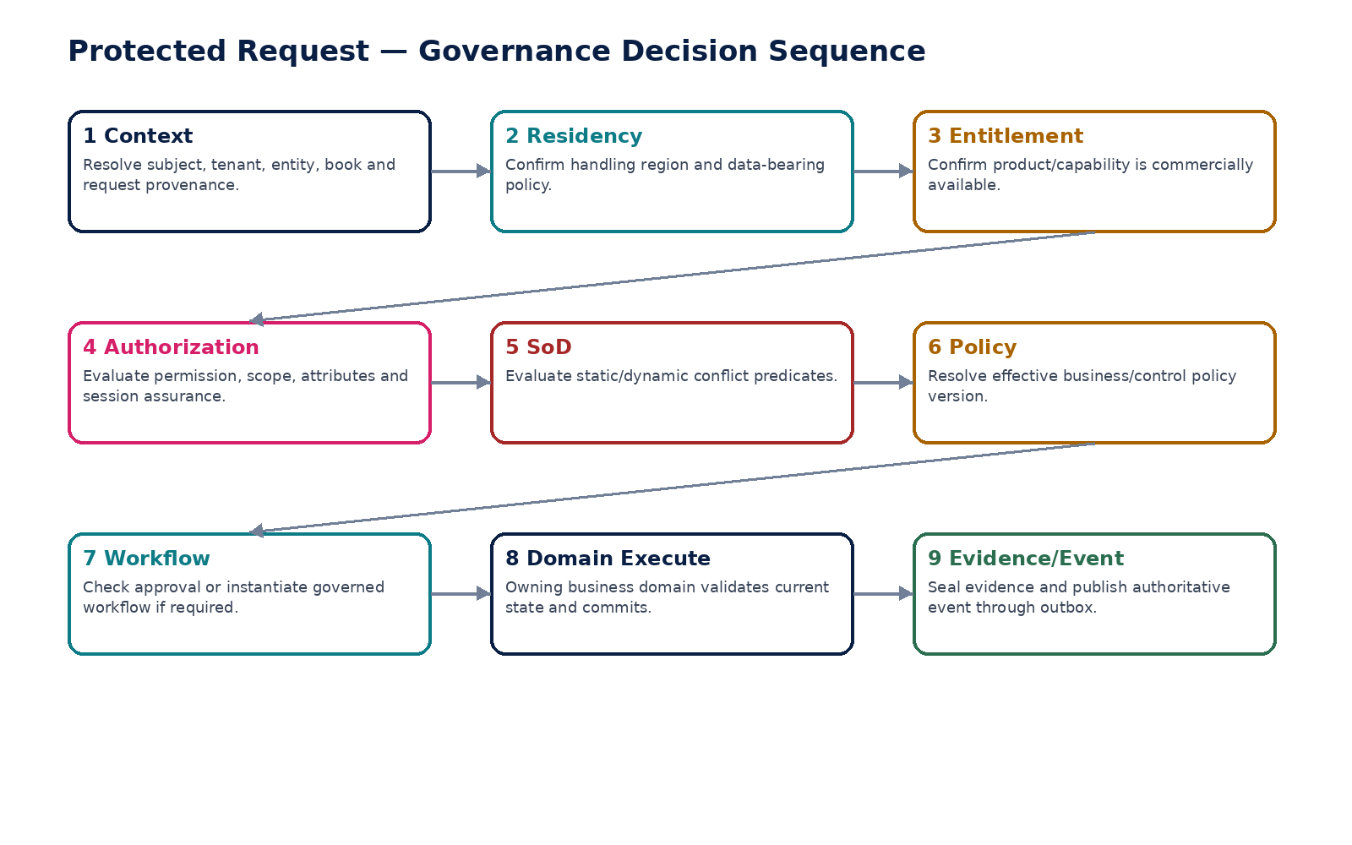
Figure 2 — Protected request sequence from trusted context through domain commit and evidence.

3. Cross-Service Authority Matrix
Service | Authoritative decision / write ownership | Must never own
GOV-01 | Trusted request context resolution | Tenant master, authorization decision, residency policy
GOV-02 | Region eligibility and failover authorization | Tenant identity, business state, security permission
GOV-03 | Permit/Deny + obligations | SoD exception, workflow approval, domain transition
GOV-04 | Static/dynamic conflict decision | Permission grant, business approval
GOV-05 | Versioned policy/rule artifacts and effective resolution | Business object state
GOV-06 | Workflow/approval instance and decision records | Underlying business truth
GOV-07 | Evidence objects/packages and integrity verification | Business facts it evidences
GOV-08 | Machine contract versions and compatibility status | Business data
GOV-09 | Retention/disposition decision and certificate | Legal-hold matter or privacy request authority
GOV-10 | Legal-hold matter/scope/release | Retention rule or data-access permission
GOV-11 | Feature/capability exposure policy | Authorization, entitlement or business transition
GOV-12 | Maker-checker and emergency-elevation control state | Underlying business permission/domain truth

4. GOV-01 — Tenant Context & Resolution
Resolve the trusted tenant and operating context for every request, command, event, batch and support session before business processing begins.

Contract field | Specification
Service ID / owner | GOV-01 — Governance & Control Plane; accountable product/engineering owner assigned in service registry.
Purpose / bounded scope | Resolve the trusted tenant and operating context for every request, command, event, batch and support session before business processing begins.
Authoritative ownership | TenantContextResolution, TenantRoutingHint cache, context decision evidence; does not own tenant master data.
Required source inputs | Authenticated subject/session; hostname or canonical ingress identifier; workload identity; request correlation; optional non-authoritative tenant hint.
Server-resolved / derived context | tenant_id; organization/legal-entity scope; environment; residency policy reference; entitlement context reference; session assurance; source channel.
Commands | RefreshTenantContextCache; InvalidateTenantContext; AttachSupportContext (privileged).
Queries / read contracts | ResolveTenantContext; GetEffectiveContext; ExplainContextResolution.
State model | Resolution is stateless per request; cache entries: Fresh / Stale / Invalidated.
Authorization / permissions | System-internal by default; support context requires privileged session and tenant-support policy.
Segregation of duties | No caller may self-assert tenant ownership or override context.
Events produced | TenantContextCacheInvalidated; TenantContextResolutionFailed; SupportContextAttached.
Dependencies | Authoritative tenant/org registry, IAM identity, GTRM policy references, commercial entitlement read model.
Failure / degradation semantics | Ambiguous or unresolved tenant => deny; stale context may be read only within bounded TTL for non-material reads; no fallback to global/default tenant.
Evidence / lineage | Context decision ID, resolved identifiers, source of resolution, policy/version references, correlation/causation IDs.
NFR / recovery profile | C0 on protected write paths; low-latency; multi-region local read cache; zero tolerated cross-tenant misresolution.

Engineering Interaction Wireframe
Type | Operation | Illustrative contract surface | Mandatory controls
QUERY | ResolveTenantContext | GET/POST /internal/v1/gov01/resolveTenantContext | Read-only; scoped; correlation required
QUERY | GetEffectiveContext | GET/POST /internal/v1/gov01/getEffectiveContext | Read-only; scoped; correlation required
QUERY | ExplainContextResolution. | GET/POST /internal/v1/gov01/explainContextResolution. | Read-only; scoped; correlation required
COMMAND | RefreshTenantContextCache | POST /internal/v1/gov01/commands/refreshTenantContextCache | Idempotency-Key + expected_version where stateful
COMMAND | InvalidateTenantContext | POST /internal/v1/gov01/commands/invalidateTenantContext | Idempotency-Key + expected_version where stateful
COMMAND | AttachSupportContext (privileged). | POST /internal/v1/gov01/commands/attachSupportContext (privileged). | Idempotency-Key + expected_version where stateful

Minimum Negative-Path Acceptance
# | Scenario | Required result
1 | Spoofed tenant header is ignored/rejected | Deny/block/quarantine or preserve UNKNOWN state; create stable error code and evidence; no unauthorized side effect.
2 | Unknown hostname cannot fall back to another tenant | Deny/block/quarantine or preserve UNKNOWN state; create stable error code and evidence; no unauthorized side effect.
3 | Support-session context expires automatically | Deny/block/quarantine or preserve UNKNOWN state; create stable error code and evidence; no unauthorized side effect.
4 | Cache invalidation removes stale privilege/context promptly | Deny/block/quarantine or preserve UNKNOWN state; create stable error code and evidence; no unauthorized side effect.

5. GOV-02 — Global Traffic & Residency Manager (GTRM)
Route tenant traffic and data-bearing operations only to regions permitted by effective residency and availability policy.

Contract field | Specification
Service ID / owner | GOV-02 — Governance & Control Plane; accountable product/engineering owner assigned in service registry.
Purpose / bounded scope | Route tenant traffic and data-bearing operations only to regions permitted by effective residency and availability policy.
Authoritative ownership | ResidencyRoutingPolicy, RegionEligibilityDecision, failover authorization record; does not own tenant master residency declaration.
Required source inputs | Trusted tenant_id; traffic classification; operation type; data-bearing flag; current region; dependency health; recovery scenario.
Server-resolved / derived context | allowed regions; primary/secondary priority; failover constraints; prohibited transfer list; policy version; decision rationale.
Commands | ActivateRoutingPolicy; SchedulePolicyChange; InitiateTenantFailover; CompleteFailover; AbortFailover; MarkRegionUnavailable.
Queries / read contracts | ResolveRegion; ExplainRoutingDecision; GetTenantResidencyTopology; GetFailoverReadiness.
State model | Policy: Draft/Approved/Scheduled/Active/Superseded; Failover: Requested/Validated/Promoting/Reconciling/Completed/Aborted.
Authorization / permissions | Platform reliability + security; failover requires privileged approval and regional-control permission.
Segregation of duties | Requester and approver independent for material cross-region failover; no operator may widen residency scope during incident.
Events produced | RoutingPolicyActivated; TenantFailoverInitiated; RegionPromotionCompleted; ResidencyRouteDenied.
Dependencies | Tenant context, policy/rules, regional health, security/residency control plane, evidence ledger.
Failure / degradation semantics | No allowed healthy region => fail closed for data-bearing writes; read-only/degraded behavior only if explicitly certified.
Evidence / lineage | Policy version, eligible-region set, health inputs, approval, start/end timestamps, reconciliation certificate.
NFR / recovery profile | C0; local decision cache; deterministic; failover decision survives regional impairment; zero tolerated prohibited-region routing.

Engineering Interaction Wireframe
Type | Operation | Illustrative contract surface | Mandatory controls
QUERY | ResolveRegion | GET/POST /internal/v1/gov02/resolveRegion | Read-only; scoped; correlation required
QUERY | ExplainRoutingDecision | GET/POST /internal/v1/gov02/explainRoutingDecision | Read-only; scoped; correlation required
QUERY | GetTenantResidencyTopology | GET/POST /internal/v1/gov02/getTenantResidencyTopology | Read-only; scoped; correlation required
QUERY | GetFailoverReadiness. | GET/POST /internal/v1/gov02/getFailoverReadiness. | Read-only; scoped; correlation required
COMMAND | ActivateRoutingPolicy | POST /internal/v1/gov02/commands/activateRoutingPolicy | Idempotency-Key + expected_version where stateful
COMMAND | SchedulePolicyChange | POST /internal/v1/gov02/commands/schedulePolicyChange | Idempotency-Key + expected_version where stateful
COMMAND | InitiateTenantFailover | POST /internal/v1/gov02/commands/initiateTenantFailover | Idempotency-Key + expected_version where stateful
COMMAND | CompleteFailover | POST /internal/v1/gov02/commands/completeFailover | Idempotency-Key + expected_version where stateful

Minimum Negative-Path Acceptance
# | Scenario | Required result
1 | Failover to prohibited region is blocked | Deny/block/quarantine or preserve UNKNOWN state; create stable error code and evidence; no unauthorized side effect.
2 | Data-bearing traffic cannot use generic nearest-region routing | Deny/block/quarantine or preserve UNKNOWN state; create stable error code and evidence; no unauthorized side effect.
3 | Policy version is preserved on every decision | Deny/block/quarantine or preserve UNKNOWN state; create stable error code and evidence; no unauthorized side effect.
4 | Failover not complete until reconciliation passes | Deny/block/quarantine or preserve UNKNOWN state; create stable error code and evidence; no unauthorized side effect.

6. GOV-03 — Authorization — RBAC/ABAC
Return a server-authoritative Permit/Deny decision with obligations for a subject attempting an action on a resource within explicit scope.

Contract field | Specification
Service ID / owner | GOV-03 — Governance & Control Plane; accountable product/engineering owner assigned in service registry.
Purpose / bounded scope | Return a server-authoritative Permit/Deny decision with obligations for a subject attempting an action on a resource within explicit scope.
Authoritative ownership | AuthorizationDecision evidence and policy bindings; role/assignment master facts may be owned by IAM administration plane.
Required source inputs | subject_id; action; resource type/id; tenant/entity/book scope; session assurance; environment; relationship and resource attributes.
Server-resolved / derived context | effective roles/permissions; ABAC predicates; purpose; feature/jurisdiction obligations; policy versions; deny reasons.
Commands | InvalidateAuthorizationCache; RecomputeSubjectEffectiveAccess (administrative).
Queries / read contracts | EvaluateAuthorization; ExplainAuthorization; ListAvailableActions.
State model | Decision is immutable fact; cache entries Fresh/Stale/Invalidated.
Authorization / permissions | All protected backends call internally; explanation access restricted to prevent policy leakage.
Segregation of duties | Authorization never overrides SoD; Deny wins; privileged roles do not imply approval/signing authority.
Events produced | AuthorizationDenied; AuthorizationPolicyVersionChanged; AuthorizationCacheInvalidated.
Dependencies | Tenant context, IAM assignments, policy/rules, feature policy, resource attribute providers.
Failure / degradation semantics | Policy engine unavailable => fail closed for writes and sensitive reads; narrowly scoped cached permits only where explicitly allowed.
Evidence / lineage | decision_id, subject, action, resource, scope, attributes digest, result, obligations, policy versions, timestamp.
NFR / recovery profile | C0/C1 depending path; deterministic; bounded latency; zero tolerated unauthorized protected action.

Engineering Interaction Wireframe
Type | Operation | Illustrative contract surface | Mandatory controls
QUERY | EvaluateAuthorization | GET/POST /internal/v1/gov03/evaluateAuthorization | Read-only; scoped; correlation required
QUERY | ExplainAuthorization | GET/POST /internal/v1/gov03/explainAuthorization | Read-only; scoped; correlation required
QUERY | ListAvailableActions. | GET/POST /internal/v1/gov03/listAvailableActions. | Read-only; scoped; correlation required
COMMAND | InvalidateAuthorizationCache | POST /internal/v1/gov03/commands/invalidateAuthorizationCache | Idempotency-Key + expected_version where stateful
COMMAND | RecomputeSubjectEffectiveAccess (administrative). | POST /internal/v1/gov03/commands/recomputeSubjectEffectiveAccess (administrative). | Idempotency-Key + expected_version where stateful

Minimum Negative-Path Acceptance
# | Scenario | Required result
1 | Role alone cannot bypass ABAC predicate | Deny/block/quarantine or preserve UNKNOWN state; create stable error code and evidence; no unauthorized side effect.
2 | Stale assignment is invalidated after revocation | Deny/block/quarantine or preserve UNKNOWN state; create stable error code and evidence; no unauthorized side effect.
3 | Cross-tenant resource ID returns deny without disclosure | Deny/block/quarantine or preserve UNKNOWN state; create stable error code and evidence; no unauthorized side effect.
4 | AvailableActions equals backend-authorized actions | Deny/block/quarantine or preserve UNKNOWN state; create stable error code and evidence; no unauthorized side effect.

7. GOV-04 — Segregation of Duties (SoD)
Prevent conflicting access assignments and conflicting participation in material business actions using static and dynamic conflict rules.

Contract field | Specification
Service ID / owner | GOV-04 — Governance & Control Plane; accountable product/engineering owner assigned in service registry.
Purpose / bounded scope | Prevent conflicting access assignments and conflicting participation in material business actions using static and dynamic conflict rules.
Authoritative ownership | SoDPolicy, SoDConflictDecision, compensating-control reference; does not own business approval state.
Required source inputs | subject; candidate assignment/action; resource; prior participants; preparer/requester/approver/executor identities; amount/risk context.
Server-resolved / derived context | conflict set; dynamic predicates; severity; compensating-control eligibility; required independent actor.
Commands | PublishSoDPolicy; ApproveCompensatingControl; RevokeCompensatingControl; ReevaluateConflict.
Queries / read contracts | EvaluateStaticConflict; EvaluateDynamicConflict; ExplainSoDDecision; ListConflictingPermissions.
State model | Policy lifecycle versioned; exception: Requested/Approved/Active/Expired/Revoked.
Authorization / permissions | IAM/security/control owners; compensating control approval restricted and independently reviewed.
Segregation of duties | Service is the SoD authority; exceptions cannot be self-approved and always expire.
Events produced | SoDConflictDetected; CompensatingControlApproved; SoDExceptionExpired.
Dependencies | Authorization/IAM, workflow, policy/rules, resource participation history, evidence ledger.
Failure / degradation semantics | Unknown participation/history on material action => block or require independent review; never silently assume no conflict.
Evidence / lineage | rule version, participants, predicates, conflict, exception reference, reviewer, expiry.
NFR / recovery profile | C0 for payment/posting/filing/access-elevation; deterministic, low latency, strong historical reconstruction.

Engineering Interaction Wireframe
Type | Operation | Illustrative contract surface | Mandatory controls
QUERY | EvaluateStaticConflict | GET/POST /internal/v1/gov04/evaluateStaticConflict | Read-only; scoped; correlation required
QUERY | EvaluateDynamicConflict | GET/POST /internal/v1/gov04/evaluateDynamicConflict | Read-only; scoped; correlation required
QUERY | ExplainSoDDecision | GET/POST /internal/v1/gov04/explainSoDDecision | Read-only; scoped; correlation required
QUERY | ListConflictingPermissions. | GET/POST /internal/v1/gov04/listConflictingPermissions. | Read-only; scoped; correlation required
COMMAND | PublishSoDPolicy | POST /internal/v1/gov04/commands/publishSoDPolicy | Idempotency-Key + expected_version where stateful
COMMAND | ApproveCompensatingControl | POST /internal/v1/gov04/commands/approveCompensatingControl | Idempotency-Key + expected_version where stateful
COMMAND | RevokeCompensatingControl | POST /internal/v1/gov04/commands/revokeCompensatingControl | Idempotency-Key + expected_version where stateful
COMMAND | ReevaluateConflict. | POST /internal/v1/gov04/commands/reevaluateConflict. | Idempotency-Key + expected_version where stateful

Minimum Negative-Path Acceptance
# | Scenario | Required result
1 | Payment preparer cannot release same payment | Deny/block/quarantine or preserve UNKNOWN state; create stable error code and evidence; no unauthorized side effect.
2 | User cannot approve own access elevation | Deny/block/quarantine or preserve UNKNOWN state; create stable error code and evidence; no unauthorized side effect.
3 | Expired exception immediately stops authorizing conflict | Deny/block/quarantine or preserve UNKNOWN state; create stable error code and evidence; no unauthorized side effect.
4 | Policy change does not rewrite historical decisions | Deny/block/quarantine or preserve UNKNOWN state; create stable error code and evidence; no unauthorized side effect.

8. GOV-05 — Policy & Rules Registry / Resolver
Author, review, approve, activate and resolve effective versioned policy/rule artifacts used by governance and business domains.

Contract field | Specification
Service ID / owner | GOV-05 — Governance & Control Plane; accountable product/engineering owner assigned in service registry.
Purpose / bounded scope | Author, review, approve, activate and resolve effective versioned policy/rule artifacts used by governance and business domains.
Authoritative ownership | PolicyDefinition, PolicyVersion, RuleArtifact, ActivationSchedule, source/rationale metadata.
Required source inputs | policy source; scope; effective dates; conditions; rule expression/artifact; tests; owner; rationale; dependencies.
Server-resolved / derived context | compiled artifact digest; dependency graph; compatibility result; effective version by context/time.
Commands | CreatePolicyDraft; SubmitPolicyReview; ApprovePolicy; ScheduleActivation; ActivatePolicy; SupersedePolicy; EmergencySuspendPolicy.
Queries / read contracts | ResolveEffectivePolicy; GetPolicyVersion; ComparePolicyVersions; ExplainPolicyResolution.
State model | Draft/Review/Approved/Scheduled/Active/Suspended/Superseded/Retired.
Authorization / permissions | Policy owners/authors/reviewers separated by class; emergency suspension privileged.
Segregation of duties | Author cannot be sole approver for material control/regulatory policy; production activation requires approved artifact.
Events produced | PolicyApproved; PolicyActivated; PolicySuspended; PolicySuperseded.
Dependencies | Schema registry, workflow, evidence, jurisdiction packs where applicable.
Failure / degradation semantics | No applicable policy for mandatory decision => fail closed; never fall back to latest by timestamp.
Evidence / lineage | source, rationale, diff, tests, approvals, digest, activation actor/time, affected scopes.
NFR / recovery profile | C0 resolution for material controls; immutable released versions; historical as-of resolution.

Engineering Interaction Wireframe
Type | Operation | Illustrative contract surface | Mandatory controls
QUERY | ResolveEffectivePolicy | GET/POST /internal/v1/gov05/resolveEffectivePolicy | Read-only; scoped; correlation required
QUERY | GetPolicyVersion | GET/POST /internal/v1/gov05/getPolicyVersion | Read-only; scoped; correlation required
QUERY | ComparePolicyVersions | GET/POST /internal/v1/gov05/comparePolicyVersions | Read-only; scoped; correlation required
QUERY | ExplainPolicyResolution. | GET/POST /internal/v1/gov05/explainPolicyResolution. | Read-only; scoped; correlation required
COMMAND | CreatePolicyDraft | POST /internal/v1/gov05/commands/createPolicyDraft | Idempotency-Key + expected_version where stateful
COMMAND | SubmitPolicyReview | POST /internal/v1/gov05/commands/submitPolicyReview | Idempotency-Key + expected_version where stateful
COMMAND | ApprovePolicy | POST /internal/v1/gov05/commands/approvePolicy | Idempotency-Key + expected_version where stateful
COMMAND | ScheduleActivation | POST /internal/v1/gov05/commands/scheduleActivation | Idempotency-Key + expected_version where stateful

Minimum Negative-Path Acceptance
# | Scenario | Required result
1 | Future policy cannot apply before effective time | Deny/block/quarantine or preserve UNKNOWN state; create stable error code and evidence; no unauthorized side effect.
2 | Overlapping conflicting rules are blocked | Deny/block/quarantine or preserve UNKNOWN state; create stable error code and evidence; no unauthorized side effect.
3 | Emergency suspension is evidenced and reviewed | Deny/block/quarantine or preserve UNKNOWN state; create stable error code and evidence; no unauthorized side effect.
4 | Historical request resolves original active version | Deny/block/quarantine or preserve UNKNOWN state; create stable error code and evidence; no unauthorized side effect.
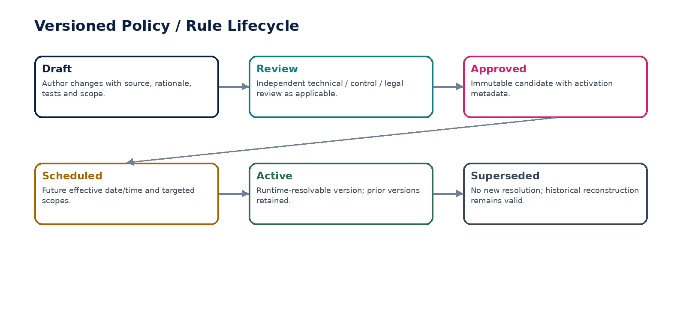
Figure 3 — Policy/rule versions move through governed review, activation and supersession.

9. GOV-06 — Workflow & Approval Orchestration
Instantiate and execute version-pinned approval/workflow processes without becoming the authoritative owner of the underlying business object.

Contract field | Specification
Service ID / owner | GOV-06 — Governance & Control Plane; accountable product/engineering owner assigned in service registry.
Purpose / bounded scope | Instantiate and execute version-pinned approval/workflow processes without becoming the authoritative owner of the underlying business object.
Authoritative ownership | WorkflowDefinition/Version, WorkflowInstance, ApprovalRequest, ApprovalDecision, task/escalation state.
Required source inputs | business object ref/version; requested transition; approval subject fingerprint; amount/risk/jurisdiction; candidate approvers.
Server-resolved / derived context | route; quorum; due dates; delegation; signing/approval authority; invalidation conditions.
Commands | StartWorkflow; Approve; Reject; RequestChanges; CancelWorkflow; Escalate; Expire; RevalidateApproval.
Queries / read contracts | GetWorkflow; ListPendingApprovals; GetApprovalEvidence; GetRequiredRoute.
State model | Draft? definitions versioned; instance: Pending/InProgress/Approved/Rejected/Cancelled/Expired/Invalidated.
Authorization / permissions | Approvers need workflow action + underlying approval authority; system transitions restricted.
Segregation of duties | No self-approval where prohibited; approver authority revalidated at execution; material change invalidates prior approval.
Events produced | WorkflowStarted; ApprovalRecorded; WorkflowApproved; WorkflowRejected; ApprovalInvalidated; WorkflowExpired.
Dependencies | Authorization, SoD, policy/rules, IAM authority/delegation, business object provider, evidence.
Failure / degradation semantics | Missing approver/authority => pending exception; timeout never equals approval; duplicate approvals idempotent.
Evidence / lineage | object version/fingerprint, route version, each decision, authority snapshot, delegation, timestamps.
NFR / recovery profile | C1/C0 by business path; durable long-running state; timer recovery; exact historical audit.

Engineering Interaction Wireframe
Type | Operation | Illustrative contract surface | Mandatory controls
QUERY | GetWorkflow | GET/POST /internal/v1/gov06/getWorkflow | Read-only; scoped; correlation required
QUERY | ListPendingApprovals | GET/POST /internal/v1/gov06/listPendingApprovals | Read-only; scoped; correlation required
QUERY | GetApprovalEvidence | GET/POST /internal/v1/gov06/getApprovalEvidence | Read-only; scoped; correlation required
QUERY | GetRequiredRoute. | GET/POST /internal/v1/gov06/getRequiredRoute. | Read-only; scoped; correlation required
COMMAND | StartWorkflow | POST /internal/v1/gov06/commands/startWorkflow | Idempotency-Key + expected_version where stateful
COMMAND | Approve | POST /internal/v1/gov06/commands/approve | Idempotency-Key + expected_version where stateful
COMMAND | Reject | POST /internal/v1/gov06/commands/reject | Idempotency-Key + expected_version where stateful
COMMAND | RequestChanges | POST /internal/v1/gov06/commands/requestChanges | Idempotency-Key + expected_version where stateful

Minimum Negative-Path Acceptance
# | Scenario | Required result
1 | Modified-after-approval object invalidates approval | Deny/block/quarantine or preserve UNKNOWN state; create stable error code and evidence; no unauthorized side effect.
2 | Expired delegation cannot approve | Deny/block/quarantine or preserve UNKNOWN state; create stable error code and evidence; no unauthorized side effect.
3 | Timeout does not auto-approve | Deny/block/quarantine or preserve UNKNOWN state; create stable error code and evidence; no unauthorized side effect.
4 | Workflow upgrade does not mutate in-flight version | Deny/block/quarantine or preserve UNKNOWN state; create stable error code and evidence; no unauthorized side effect.

10. GOV-07 — Evidence Ledger & Verification
Create immutable, integrity-verifiable evidence records and packages for material decisions, financial/regulatory controls and privileged operations.

Contract field | Specification
Service ID / owner | GOV-07 — Governance & Control Plane; accountable product/engineering owner assigned in service registry.
Purpose / bounded scope | Create immutable, integrity-verifiable evidence records and packages for material decisions, financial/regulatory controls and privileged operations.
Authoritative ownership | EvidenceObject, EvidenceManifest, EvidencePackage, IntegrityVerification, chain-of-custody facts.
Required source inputs | subject refs; content/digest; provenance; actor/system; timestamps; classification; record class; related decisions/events.
Server-resolved / derived context | canonical hash; manifest digest; linkage graph; storage/retention policy; verification result.
Commands | AppendEvidence; SealEvidencePackage; VerifyEvidenceIntegrity; SupersedeEvidenceReference; ExportEvidencePackage.
Queries / read contracts | GetEvidence; GetEvidenceChain; VerifyPackage; SearchBySubject (privileged).
State model | Evidence object immutable; package: Open/Sealed/Verified/Compromised/SupersededReference.
Authorization / permissions | Append via trusted services; read/export strongly scoped; no general-purpose admin rewrite.
Segregation of duties | Package seal/release for regulated evidence may require independent certification.
Events produced | EvidenceAppended; EvidencePackageSealed; EvidenceVerificationFailed; EvidenceExported.
Dependencies | Object storage/WORM tier, KMS, retention, legal hold, audit search projection.
Failure / degradation semantics | Hash mismatch => quarantine/critical incident; storage failure blocks completion of actions requiring evidence-before-commit.
Evidence / lineage | This service is itself evidence authority; preserve hashes, signers, verification method, related control IDs.
NFR / recovery profile | C0 durability; strong integrity; regional retention compliance; long-lived verification/crypto agility.

Engineering Interaction Wireframe
Type | Operation | Illustrative contract surface | Mandatory controls
QUERY | GetEvidence | GET/POST /internal/v1/gov07/getEvidence | Read-only; scoped; correlation required
QUERY | GetEvidenceChain | GET/POST /internal/v1/gov07/getEvidenceChain | Read-only; scoped; correlation required
QUERY | VerifyPackage | GET/POST /internal/v1/gov07/verifyPackage | Read-only; scoped; correlation required
QUERY | SearchBySubject (privileged). | GET/POST /internal/v1/gov07/searchBySubject (privileged). | Read-only; scoped; correlation required
COMMAND | AppendEvidence | POST /internal/v1/gov07/commands/appendEvidence | Idempotency-Key + expected_version where stateful
COMMAND | SealEvidencePackage | POST /internal/v1/gov07/commands/sealEvidencePackage | Idempotency-Key + expected_version where stateful
COMMAND | VerifyEvidenceIntegrity | POST /internal/v1/gov07/commands/verifyEvidenceIntegrity | Idempotency-Key + expected_version where stateful
COMMAND | SupersedeEvidenceReference | POST /internal/v1/gov07/commands/supersedeEvidenceReference | Idempotency-Key + expected_version where stateful

Minimum Negative-Path Acceptance
# | Scenario | Required result
1 | Evidence content cannot be overwritten | Deny/block/quarantine or preserve UNKNOWN state; create stable error code and evidence; no unauthorized side effect.
2 | Tampered object fails verification | Deny/block/quarantine or preserve UNKNOWN state; create stable error code and evidence; no unauthorized side effect.
3 | Held evidence cannot be disposed | Deny/block/quarantine or preserve UNKNOWN state; create stable error code and evidence; no unauthorized side effect.
4 | Export records chain-of-custody event | Deny/block/quarantine or preserve UNKNOWN state; create stable error code and evidence; no unauthorized side effect.
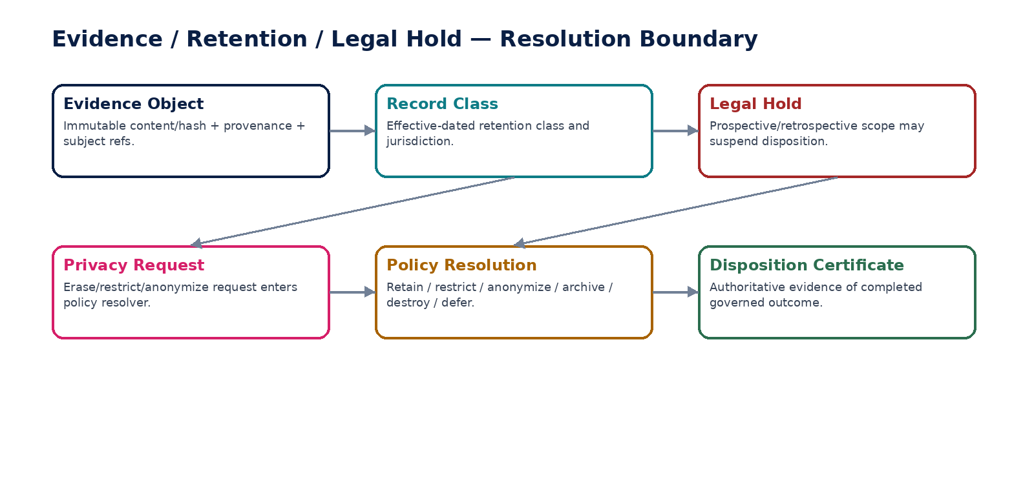
Figure 4 — Evidence, retention, legal hold and privacy resolution remain distinct authorities.

11. GOV-08 — Schema & Contract Registry
Govern machine-readable API, event, data and file schemas so producers and consumers cannot deploy incompatible or uncontrolled contracts.

Contract field | Specification
Service ID / owner | GOV-08 — Governance & Control Plane; accountable product/engineering owner assigned in service registry.
Purpose / bounded scope | Govern machine-readable API, event, data and file schemas so producers and consumers cannot deploy incompatible or uncontrolled contracts.
Authoritative ownership | SchemaArtifact, ContractVersion, CompatibilityResult, ConsumerRegistration, deprecation/sunset metadata.
Required source inputs | OpenAPI/AsyncAPI/JSON Schema/file schema; owner; semantic version; classification annotations; compatibility mode.
Server-resolved / derived context | digest; breaking-change analysis; consumers; sensitive-field flags; publication status.
Commands | RegisterDraftSchema; RunCompatibilityCheck; ApproveSchema; PublishSchema; DeprecateSchema; RetireSchema.
Queries / read contracts | GetActiveSchema; CompareSchemas; ListConsumers; GetCompatibilityReport.
State model | Draft/Validated/Approved/Published/Deprecated/Retired/Rejected.
Authorization / permissions | Schema owner authors; independent reviewer/publisher for shared contracts.
Segregation of duties | Producer cannot bypass compatibility gate for protected shared contract without governed waiver.
Events produced | SchemaPublished; CompatibilityFailed; SchemaDeprecated; SchemaRetired.
Dependencies | CI/CD, API/event gateway tooling, evidence ledger, service catalogue/spec registry.
Failure / degradation semantics | Breaking change without approved versioning/migration plan => block publication/deployment.
Evidence / lineage | schema digest, diff, compatibility output, reviewers, consumer certifications, dates.
NFR / recovery profile | C1; high read availability to CI/tooling; published artifacts immutable and globally addressable by digest.

Engineering Interaction Wireframe
Type | Operation | Illustrative contract surface | Mandatory controls
QUERY | GetActiveSchema | GET/POST /internal/v1/gov08/getActiveSchema | Read-only; scoped; correlation required
QUERY | CompareSchemas | GET/POST /internal/v1/gov08/compareSchemas | Read-only; scoped; correlation required
QUERY | ListConsumers | GET/POST /internal/v1/gov08/listConsumers | Read-only; scoped; correlation required
QUERY | GetCompatibilityReport. | GET/POST /internal/v1/gov08/getCompatibilityReport. | Read-only; scoped; correlation required
COMMAND | RegisterDraftSchema | POST /internal/v1/gov08/commands/registerDraftSchema | Idempotency-Key + expected_version where stateful
COMMAND | RunCompatibilityCheck | POST /internal/v1/gov08/commands/runCompatibilityCheck | Idempotency-Key + expected_version where stateful
COMMAND | ApproveSchema | POST /internal/v1/gov08/commands/approveSchema | Idempotency-Key + expected_version where stateful
COMMAND | PublishSchema | POST /internal/v1/gov08/commands/publishSchema | Idempotency-Key + expected_version where stateful

Minimum Negative-Path Acceptance
# | Scenario | Required result
1 | Breaking field removal is detected | Deny/block/quarantine or preserve UNKNOWN state; create stable error code and evidence; no unauthorized side effect.
2 | Sensitive field without classification is blocked | Deny/block/quarantine or preserve UNKNOWN state; create stable error code and evidence; no unauthorized side effect.
3 | Retired schema still retrievable historically | Deny/block/quarantine or preserve UNKNOWN state; create stable error code and evidence; no unauthorized side effect.
4 | Consumer adoption evidence required before retirement | Deny/block/quarantine or preserve UNKNOWN state; create stable error code and evidence; no unauthorized side effect.
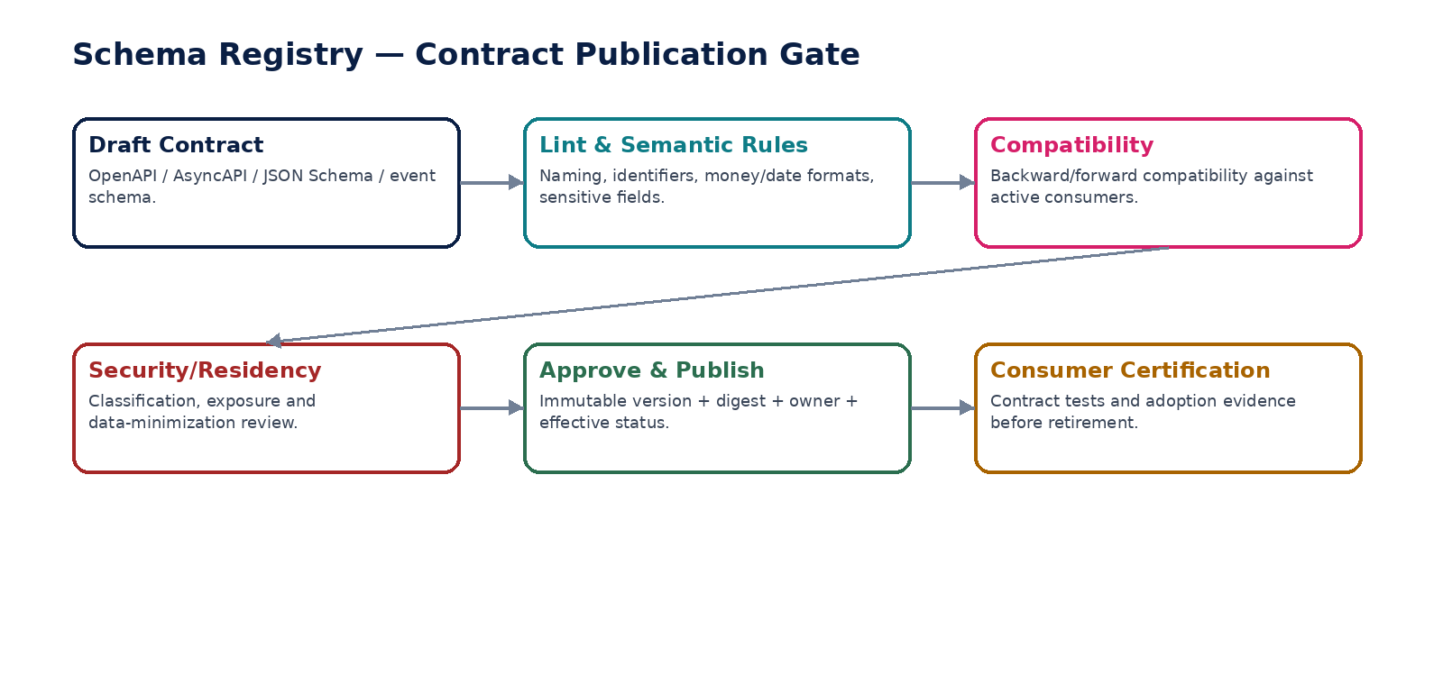
Figure 5 — Contract publication requires compatibility, security and consumer-certification gates.

12. GOV-09 — Retention & Disposition Policy
Resolve effective retention/disposition obligations and execute governed archive, restriction, anonymization or destruction only when legally permitted.

Contract field | Specification
Service ID / owner | GOV-09 — Governance & Control Plane; accountable product/engineering owner assigned in service registry.
Purpose / bounded scope | Resolve effective retention/disposition obligations and execute governed archive, restriction, anonymization or destruction only when legally permitted.
Authoritative ownership | RetentionClass, RetentionRuleVersion, DispositionSchedule, DispositionDecision/Certificate.
Required source inputs | record class; jurisdiction; purpose; creation/trigger dates; data classification; legal hold refs; privacy request refs.
Server-resolved / derived context | retention trigger; minimum/maximum period; action; hold status; conflicts; due date.
Commands | PublishRetentionRule; ScheduleDisposition; ApproveDisposition; ExecuteDisposition; ReperformDisposition; SuspendDisposition.
Queries / read contracts | ResolveRetention; GetDispositionEligibility; ExplainRetentionDecision; ListDueDisposition.
State model | Record disposition: NotDue/Due/SuspendedByHold/PendingApproval/Executing/Completed/Failed/Deferred.
Authorization / permissions | Data governance/privacy/records roles; destructive actions require privileged authorization and evidence.
Segregation of duties | Policy author not sole approver for destructive batch; operator cannot override legal hold.
Events produced | DispositionDue; DispositionSuspended; DispositionExecuted; DispositionFailed.
Dependencies | Legal hold, privacy requests, evidence ledger, archive/storage services, data owners.
Failure / degradation semantics | Ambiguous policy/active hold => do not destroy; partial multi-store deletion => failed until convergence verified.
Evidence / lineage | resolved rules, holds, approvals, target stores, execution receipts, residual checks, certificate.
NFR / recovery profile | C1; exact policy resolution; resumable batch; cross-store convergence and historical proof.

Engineering Interaction Wireframe
Type | Operation | Illustrative contract surface | Mandatory controls
QUERY | ResolveRetention | GET/POST /internal/v1/gov09/resolveRetention | Read-only; scoped; correlation required
QUERY | GetDispositionEligibility | GET/POST /internal/v1/gov09/getDispositionEligibility | Read-only; scoped; correlation required
QUERY | ExplainRetentionDecision | GET/POST /internal/v1/gov09/explainRetentionDecision | Read-only; scoped; correlation required
QUERY | ListDueDisposition. | GET/POST /internal/v1/gov09/listDueDisposition. | Read-only; scoped; correlation required
COMMAND | PublishRetentionRule | POST /internal/v1/gov09/commands/publishRetentionRule | Idempotency-Key + expected_version where stateful
COMMAND | ScheduleDisposition | POST /internal/v1/gov09/commands/scheduleDisposition | Idempotency-Key + expected_version where stateful
COMMAND | ApproveDisposition | POST /internal/v1/gov09/commands/approveDisposition | Idempotency-Key + expected_version where stateful
COMMAND | ExecuteDisposition | POST /internal/v1/gov09/commands/executeDisposition | Idempotency-Key + expected_version where stateful

Minimum Negative-Path Acceptance
# | Scenario | Required result
1 | Active hold blocks destruction | Deny/block/quarantine or preserve UNKNOWN state; create stable error code and evidence; no unauthorized side effect.
2 | Cache/search copies converge before completion | Deny/block/quarantine or preserve UNKNOWN state; create stable error code and evidence; no unauthorized side effect.
3 | Rule change does not falsify prior certificate | Deny/block/quarantine or preserve UNKNOWN state; create stable error code and evidence; no unauthorized side effect.
4 | Unknown retention policy fails safe | Deny/block/quarantine or preserve UNKNOWN state; create stable error code and evidence; no unauthorized side effect.

13. GOV-10 — Legal Hold
Issue, scope, propagate, monitor and release preservation holds that suspend governed disposition without broadening unrelated access or use.

Contract field | Specification
Service ID / owner | GOV-10 — Governance & Control Plane; accountable product/engineering owner assigned in service registry.
Purpose / bounded scope | Issue, scope, propagate, monitor and release preservation holds that suspend governed disposition without broadening unrelated access or use.
Authoritative ownership | LegalHoldMatter, HoldVersion, HoldScope, HoldCustodian/SubjectMatch, HoldRelease.
Required source inputs | matter/case ref; legal authority; scope predicates; custodians/subjects; date range; record classes; jurisdictions; prospective capture flag.
Server-resolved / derived context | matched records/systems; preservation obligations; conflicts; completeness state.
Commands | IssueLegalHold; AmendHoldScope; AddCustodian; RemoveCustodian; ReleaseHold; ReconcileHoldCoverage.
Queries / read contracts | EvaluateHoldCoverage; GetHold; ListHeldRecords; GetPropagationStatus.
State model | Draft/Approved/Active/Amended/PartiallyPropagated/Released/Closed.
Authorization / permissions | Legal-authorized users; system propagation workloads; reads restricted to matter team and custodians where appropriate.
Segregation of duties | Requester/approver separation for sensitive holds; release requires independent authority.
Events produced | LegalHoldIssued; LegalHoldScopeChanged; HoldPropagationFailed; LegalHoldReleased.
Dependencies | Retention, evidence ledger, content/data stores, search/index, archive, identity/custodian directory.
Failure / degradation semantics | Propagation uncertainty => disposition remains suspended for potentially in-scope population until reconciled.
Evidence / lineage | authority, scope version, matched population digest, acknowledgements from stores, amendments, release decision.
NFR / recovery profile | C0 for disposition safety; durable; prospective capture; auditable propagation status.

Engineering Interaction Wireframe
Type | Operation | Illustrative contract surface | Mandatory controls
QUERY | EvaluateHoldCoverage | GET/POST /internal/v1/gov10/evaluateHoldCoverage | Read-only; scoped; correlation required
QUERY | GetHold | GET/POST /internal/v1/gov10/getHold | Read-only; scoped; correlation required
QUERY | ListHeldRecords | GET/POST /internal/v1/gov10/listHeldRecords | Read-only; scoped; correlation required
QUERY | GetPropagationStatus. | GET/POST /internal/v1/gov10/getPropagationStatus. | Read-only; scoped; correlation required
COMMAND | IssueLegalHold | POST /internal/v1/gov10/commands/issueLegalHold | Idempotency-Key + expected_version where stateful
COMMAND | AmendHoldScope | POST /internal/v1/gov10/commands/amendHoldScope | Idempotency-Key + expected_version where stateful
COMMAND | AddCustodian | POST /internal/v1/gov10/commands/addCustodian | Idempotency-Key + expected_version where stateful
COMMAND | RemoveCustodian | POST /internal/v1/gov10/commands/removeCustodian | Idempotency-Key + expected_version where stateful

Minimum Negative-Path Acceptance
# | Scenario | Required result
1 | Hold release does not destroy immediately without retention reevaluation | Deny/block/quarantine or preserve UNKNOWN state; create stable error code and evidence; no unauthorized side effect.
2 | Hold does not grant extra read permission | Deny/block/quarantine or preserve UNKNOWN state; create stable error code and evidence; no unauthorized side effect.
3 | Propagation failure blocks disposition | Deny/block/quarantine or preserve UNKNOWN state; create stable error code and evidence; no unauthorized side effect.
4 | Scope amendment preserves version history | Deny/block/quarantine or preserve UNKNOWN state; create stable error code and evidence; no unauthorized side effect.

14. GOV-11 — Feature Policy & Capability Exposure
Determine whether a capability may be exposed to a tenant/user based on entitlement, release ring, jurisdiction, tenant policy and operational kill-switches—without becoming an authorization bypass.

Contract field | Specification
Service ID / owner | GOV-11 — Governance & Control Plane; accountable product/engineering owner assigned in service registry.
Purpose / bounded scope | Determine whether a capability may be exposed to a tenant/user based on entitlement, release ring, jurisdiction, tenant policy and operational kill-switches—without becoming an authorization bypass.
Authoritative ownership | FeatureDefinition, FeaturePolicyVersion, ReleaseRingAssignment, EmergencyDisable state.
Required source inputs | feature; tenant; product entitlement ref; jurisdiction; release channel; tenant configuration; incident/kill-switch condition.
Server-resolved / derived context | enabled/disabled/hidden/read-only; rationale; constraints; rollout cohort.
Commands | CreateFeaturePolicy; ApproveFeaturePolicy; AssignReleaseRing; EnableTenantFeature; DisableTenantFeature; EmergencyDisableFeature.
Queries / read contracts | EvaluateFeaturePolicy; ListEffectiveFeatures; ExplainFeatureDecision.
State model | Feature policy Draft/Approved/Active/Suspended/Retired; exposure Off/Pilot/Canary/GA/Disabled.
Authorization / permissions | Product/release owners; tenant admins only for tenant-configurable dimensions; emergency disable privileged.
Segregation of duties | Feature enablement cannot grant IAM permission, override SoD, bypass jurisdiction or activate unapproved contracts.
Events produced | FeaturePolicyActivated; TenantFeatureChanged; FeatureEmergencyDisabled.
Dependencies | Commercial entitlement, jurisdiction pack, authorization, release management, service health.
Failure / degradation semantics | Unknown policy => disabled for protected capability; emergency disable must fail safe and propagate quickly.
Evidence / lineage | entitlement/policy versions, cohort, actor, rollout reason, emergency ticket, effective timestamps.
NFR / recovery profile | C1 on gating; low latency/cacheable with invalidation; fast global emergency disable.

Engineering Interaction Wireframe
Type | Operation | Illustrative contract surface | Mandatory controls
QUERY | EvaluateFeaturePolicy | GET/POST /internal/v1/gov11/evaluateFeaturePolicy | Read-only; scoped; correlation required
QUERY | ListEffectiveFeatures | GET/POST /internal/v1/gov11/listEffectiveFeatures | Read-only; scoped; correlation required
QUERY | ExplainFeatureDecision. | GET/POST /internal/v1/gov11/explainFeatureDecision. | Read-only; scoped; correlation required
COMMAND | CreateFeaturePolicy | POST /internal/v1/gov11/commands/createFeaturePolicy | Idempotency-Key + expected_version where stateful
COMMAND | ApproveFeaturePolicy | POST /internal/v1/gov11/commands/approveFeaturePolicy | Idempotency-Key + expected_version where stateful
COMMAND | AssignReleaseRing | POST /internal/v1/gov11/commands/assignReleaseRing | Idempotency-Key + expected_version where stateful
COMMAND | EnableTenantFeature | POST /internal/v1/gov11/commands/enableTenantFeature | Idempotency-Key + expected_version where stateful
COMMAND | DisableTenantFeature | POST /internal/v1/gov11/commands/disableTenantFeature | Idempotency-Key + expected_version where stateful

Minimum Negative-Path Acceptance
# | Scenario | Required result
1 | Disabled feature backend command remains unauthorized | Deny/block/quarantine or preserve UNKNOWN state; create stable error code and evidence; no unauthorized side effect.
2 | Jurisdiction-prohibited feature cannot be tenant-enabled | Deny/block/quarantine or preserve UNKNOWN state; create stable error code and evidence; no unauthorized side effect.
3 | Entitlement loss removes exposure | Deny/block/quarantine or preserve UNKNOWN state; create stable error code and evidence; no unauthorized side effect.
4 | Emergency kill switch does not mutate business records | Deny/block/quarantine or preserve UNKNOWN state; create stable error code and evidence; no unauthorized side effect.
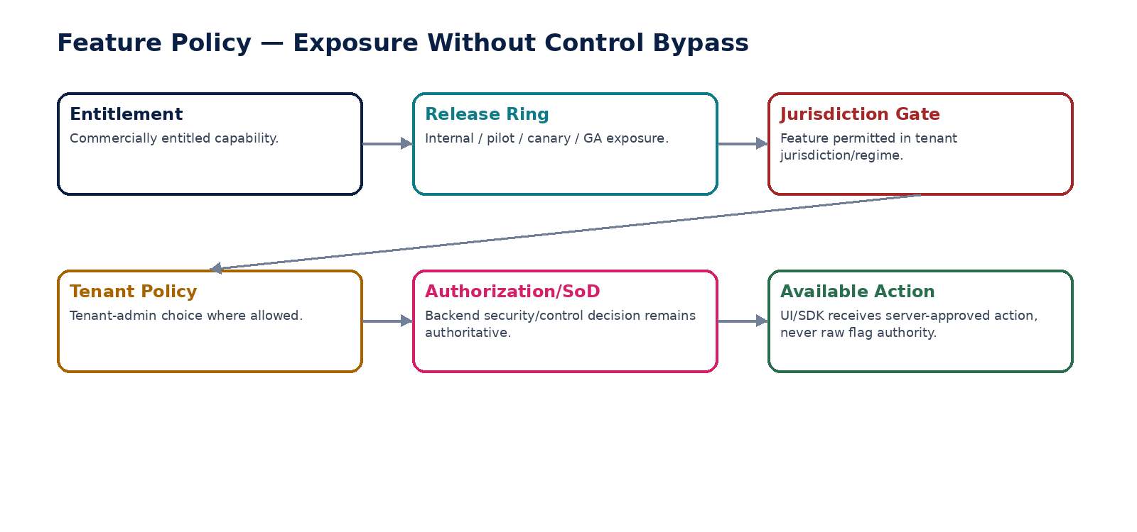
Figure 6 — Feature exposure sits outside authorization and cannot bypass backend controls.

15. GOV-12 — Maker–Checker & Break-Glass Control
Provide reusable independent-control and emergency-elevation mechanisms for material actions while preserving least privilege, evidence and post-action reconciliation.

Contract field | Specification
Service ID / owner | GOV-12 — Governance & Control Plane; accountable product/engineering owner assigned in service registry.
Purpose / bounded scope | Provide reusable independent-control and emergency-elevation mechanisms for material actions while preserving least privilege, evidence and post-action reconciliation.
Authoritative ownership | MakerCheckerRequirement, CheckerDecision, BreakGlassRequest/Grant/Session/Review.
Required source inputs | subject/action/resource; risk class; maker identity; required checker/quorum; incident/ticket; requested emergency scope/TTL.
Server-resolved / derived context | independence result; eligible checkers; approval route; privileged command scope; expiry; review obligations.
Commands | RequestCheckerApproval; ApproveCheckerAction; RejectCheckerAction; RequestBreakGlass; ApproveBreakGlass; ActivateBreakGlass; RevokeBreakGlass; CompleteBreakGlassReview.
Queries / read contracts | EvaluateMakerChecker; GetBreakGlassStatus; ListEligibleCheckers; GetEmergencySessionEvidence.
State model | Checker Pending/Approved/Rejected/Expired/Invalidated; Break-glass Requested/Approved/Active/Expired/Revoked/ReviewPending/Closed.
Authorization / permissions | High-risk; independent checker and privileged-session permissions; strong step-up authentication.
Segregation of duties | Requester cannot approve own emergency elevation; checker must satisfy dynamic SoD; privileges cannot exceed approved scope.
Events produced | CheckerApprovalRecorded; BreakGlassRequested; BreakGlassActivated; BreakGlassRevoked; BreakGlassReviewCompleted.
Dependencies | Authorization, SoD, workflow, IAM/session assurance, evidence, incident/runbook platform.
Failure / degradation semantics | Approval ambiguity => no activation; expired session terminates immediately; emergency action still subject to domain invariants.
Evidence / lineage | request reason, incident, scope, approver, session ID, commands executed, before/after state refs, reconciliation/review.
NFR / recovery profile | C0; no standing access; strong expiry/revocation; complete privileged-session evidence.

Engineering Interaction Wireframe
Type | Operation | Illustrative contract surface | Mandatory controls
QUERY | EvaluateMakerChecker | GET/POST /internal/v1/gov12/evaluateMakerChecker | Read-only; scoped; correlation required
QUERY | GetBreakGlassStatus | GET/POST /internal/v1/gov12/getBreakGlassStatus | Read-only; scoped; correlation required
QUERY | ListEligibleCheckers | GET/POST /internal/v1/gov12/listEligibleCheckers | Read-only; scoped; correlation required
QUERY | GetEmergencySessionEvidence. | GET/POST /internal/v1/gov12/getEmergencySessionEvidence. | Read-only; scoped; correlation required
COMMAND | RequestCheckerApproval | POST /internal/v1/gov12/commands/requestCheckerApproval | Idempotency-Key + expected_version where stateful
COMMAND | ApproveCheckerAction | POST /internal/v1/gov12/commands/approveCheckerAction | Idempotency-Key + expected_version where stateful
COMMAND | RejectCheckerAction | POST /internal/v1/gov12/commands/rejectCheckerAction | Idempotency-Key + expected_version where stateful
COMMAND | RequestBreakGlass | POST /internal/v1/gov12/commands/requestBreakGlass | Idempotency-Key + expected_version where stateful

Minimum Negative-Path Acceptance
# | Scenario | Required result
1 | Requester cannot self-approve break glass | Deny/block/quarantine or preserve UNKNOWN state; create stable error code and evidence; no unauthorized side effect.
2 | Expired grant cannot execute | Deny/block/quarantine or preserve UNKNOWN state; create stable error code and evidence; no unauthorized side effect.
3 | Break glass cannot bypass tenant/residency boundary | Deny/block/quarantine or preserve UNKNOWN state; create stable error code and evidence; no unauthorized side effect.
4 | Financial emergency action requires post-action reconciliation | Deny/block/quarantine or preserve UNKNOWN state; create stable error code and evidence; no unauthorized side effect.
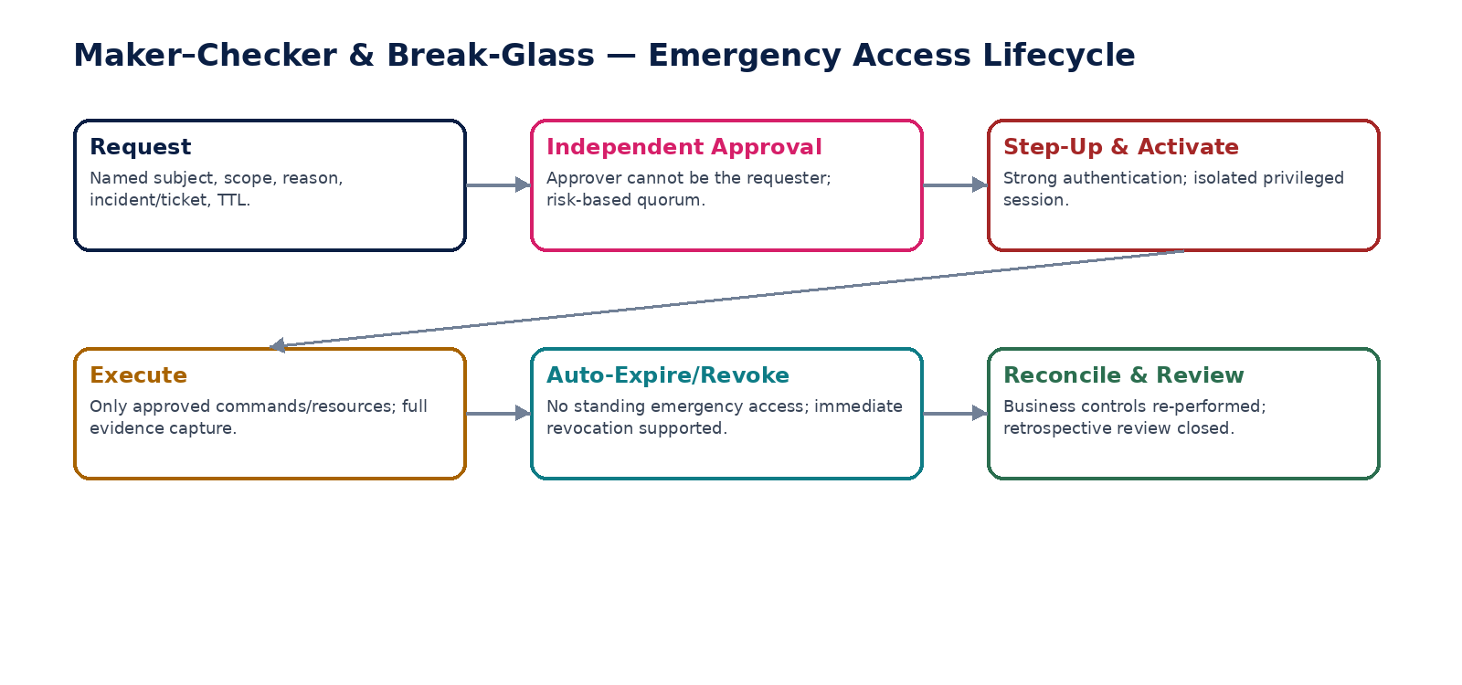
Figure 7 — Emergency elevation is independently approved, scoped, time-limited and reviewed.

16. Shared Contract Envelopes & Error Semantics
Envelope field | Requirement
request_id / correlation_id | Globally unique; propagated end-to-end.
causation_id | References initiating command/event where applicable.
subject_id / workload_id | Authenticated server-resolved identity.
tenant_id | Resolved by GOV-01; never trusted from arbitrary client header.
entity_id / book_id | Explicit where material; server-validated.
region / residency_policy_version | Resolved by GTRM/security control plane.
policy_versions | Exact versions used for decision.
idempotency_key | Mandatory for stateful I2–I4 commands.
expected_version | Mandatory for protected optimistic-concurrency updates.
purpose / reason_code | Required for privileged, destructive or emergency commands.
evidence_id | Returned for material governance decision/transition.
Stable error classes: CONTEXT_UNRESOLVED, RESIDENCY_DENIED, AUTHORIZATION_DENIED, SOD_CONFLICT, POLICY_NOT_EFFECTIVE, APPROVAL_REQUIRED, APPROVAL_INVALIDATED, EVIDENCE_INTEGRITY_FAILED, CONTRACT_INCOMPATIBLE, RETENTION_BLOCKED, LEGAL_HOLD_ACTIVE, FEATURE_DISABLED, BREAK_GLASS_REQUIRED, BREAK_GLASS_EXPIRED, CONCURRENCY_CONFLICT, IDEMPOTENCY_MISMATCH.

17. Cross-Service Event Contract Baseline
Producer | Representative authoritative events | Primary consumers
GOV-01 | TenantContextCacheInvalidated; SupportContextAttached | GOV-03, service gateways, audit
GOV-02 | RoutingPolicyActivated; TenantFailoverInitiated; RegionPromotionCompleted | GTRM edge, security, ops, evidence
GOV-03 | AuthorizationDenied; AuthorizationCacheInvalidated | Security analytics, support/audit
GOV-04 | SoDConflictDetected; CompensatingControlApproved | Workflow, IAM governance, audit
GOV-05 | PolicyApproved; PolicyActivated; PolicySuperseded | All policy consumers, schema/evidence
GOV-06 | WorkflowStarted; ApprovalRecorded; WorkflowApproved/Rejected | Owning domains, notifications, evidence
GOV-07 | EvidencePackageSealed; EvidenceVerificationFailed | Audit, records, security
GOV-08 | SchemaPublished; CompatibilityFailed; SchemaDeprecated | CI/CD, producers/consumers
GOV-09 | DispositionDue; DispositionExecuted/Failed | Data owners, privacy, legal, evidence
GOV-10 | LegalHoldIssued; ScopeChanged; Released | Retention, stores, archive, evidence
GOV-11 | FeaturePolicyActivated; FeatureEmergencyDisabled | Gateways/UI projections, release ops
GOV-12 | BreakGlassActivated/Revoked; CheckerApprovalRecorded | IAM, security, incident ops, evidence
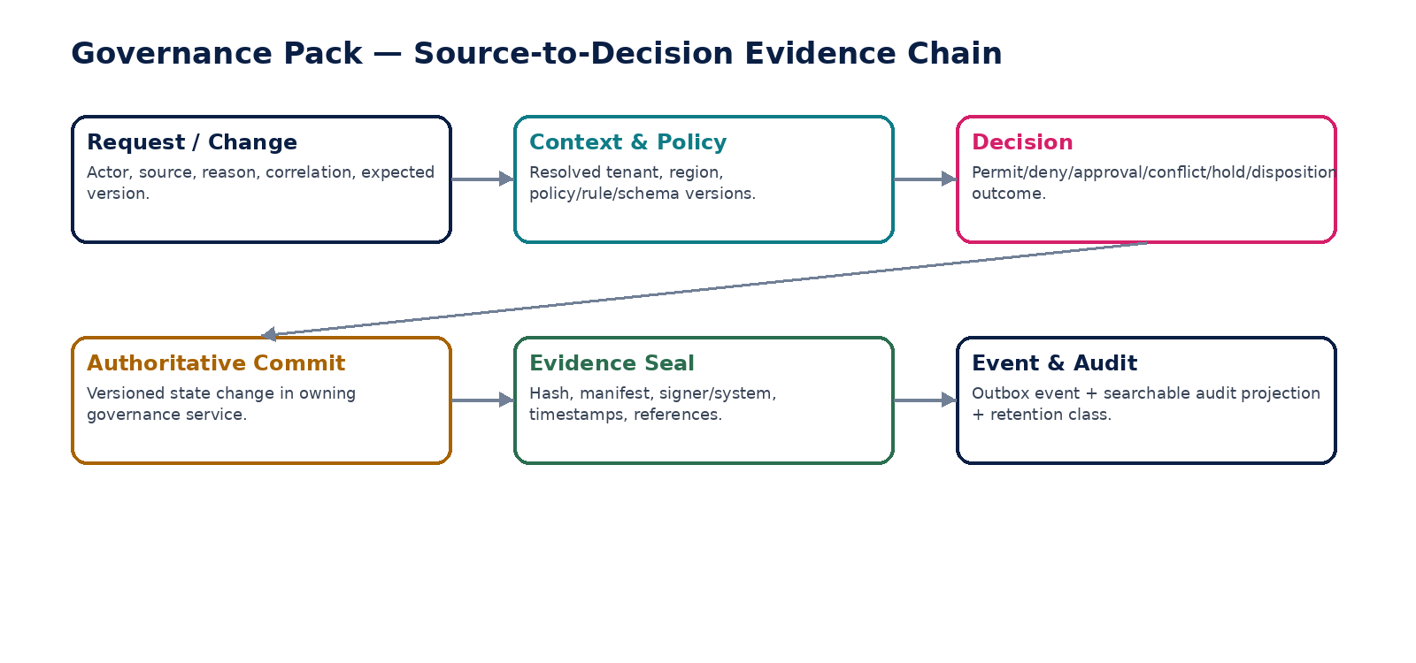
Figure 8 — Every material governance decision retains a source-to-decision evidence chain.

18. Cross-Service Data Model
Entity | Authoritative owner | Key fields / notes
TenantContextDecision | GOV-01 | decision_id, subject, ingress source, tenant, entity, environment, assurance, expires_at
ResidencyRoutingPolicy / Decision | GOV-02 | policy_version, tenant, allowed_regions, primary/secondary, operation class, reason
AuthorizationDecision | GOV-03 | subject, action, resource, scope, result, obligations, policy digest
SoDPolicy / ConflictDecision | GOV-04 | rule_version, participant roles, conflict predicate, decision, exception ref
PolicyDefinition / Version | GOV-05 | stable key, version, scope, effective interval, artifact digest, source/rationale
WorkflowInstance / ApprovalDecision | GOV-06 | definition version, object ref/version/fingerprint, route, participants, decisions
EvidenceObject / Package | GOV-07 | content hash, manifest hash, provenance, classification, record class, seal status
SchemaArtifact / ConsumerRegistration | GOV-08 | schema kind, semantic version, digest, compatibility mode, consumers
RetentionRule / DispositionDecision | GOV-09 | record class, jurisdiction, trigger, period, action, holds, certificate
LegalHold / HoldScope | GOV-10 | matter, authority, predicates, custodians, propagation, release
FeaturePolicy | GOV-11 | feature, entitlement ref, ring, jurisdiction, tenant option, kill switch
BreakGlassGrant / PrivilegedSession | GOV-12 | requester, approver, scope, TTL, session, commands, review

19. Domain-Level Negative-Path Certification
# | Scenario | Certification requirement
1 | Spoofed tenant or entity context | Automated or controlled test proves fail-safe outcome, no unauthorized side effect, stable error/evidence, and recoverable state.
2 | Cross-region write where no permitted region is healthy | Automated or controlled test proves fail-safe outcome, no unauthorized side effect, stable error/evidence, and recoverable state.
3 | Authorization policy engine unavailable on protected write | Automated or controlled test proves fail-safe outcome, no unauthorized side effect, stable error/evidence, and recoverable state.
4 | Stale access assignment after revocation | Automated or controlled test proves fail-safe outcome, no unauthorized side effect, stable error/evidence, and recoverable state.
5 | Static SoD conflict introduced through role assignment | Automated or controlled test proves fail-safe outcome, no unauthorized side effect, stable error/evidence, and recoverable state.
6 | Dynamic SoD conflict on same business object | Automated or controlled test proves fail-safe outcome, no unauthorized side effect, stable error/evidence, and recoverable state.
7 | Policy overlap creates two equally applicable active versions | Automated or controlled test proves fail-safe outcome, no unauthorized side effect, stable error/evidence, and recoverable state.
8 | Future policy activated early | Automated or controlled test proves fail-safe outcome, no unauthorized side effect, stable error/evidence, and recoverable state.
9 | Workflow times out with no approver | Automated or controlled test proves fail-safe outcome, no unauthorized side effect, stable error/evidence, and recoverable state.
10 | Material object changes after approval | Automated or controlled test proves fail-safe outcome, no unauthorized side effect, stable error/evidence, and recoverable state.
11 | Duplicate approval/replay | Automated or controlled test proves fail-safe outcome, no unauthorized side effect, stable error/evidence, and recoverable state.
12 | Evidence object hash mismatch | Automated or controlled test proves fail-safe outcome, no unauthorized side effect, stable error/evidence, and recoverable state.
13 | Evidence storage unavailable before evidence-mandatory completion | Automated or controlled test proves fail-safe outcome, no unauthorized side effect, stable error/evidence, and recoverable state.
14 | Breaking schema published without migration/version path | Automated or controlled test proves fail-safe outcome, no unauthorized side effect, stable error/evidence, and recoverable state.
15 | Sensitive schema field lacks classification | Automated or controlled test proves fail-safe outcome, no unauthorized side effect, stable error/evidence, and recoverable state.
16 | Retention rule ambiguous | Automated or controlled test proves fail-safe outcome, no unauthorized side effect, stable error/evidence, and recoverable state.
17 | Disposition attempted under active legal hold | Automated or controlled test proves fail-safe outcome, no unauthorized side effect, stable error/evidence, and recoverable state.
18 | Partial deletion leaves search/cache copy | Automated or controlled test proves fail-safe outcome, no unauthorized side effect, stable error/evidence, and recoverable state.
19 | Legal hold propagation fails on one store | Automated or controlled test proves fail-safe outcome, no unauthorized side effect, stable error/evidence, and recoverable state.
20 | Legal hold release followed by immediate delete without reevaluation | Automated or controlled test proves fail-safe outcome, no unauthorized side effect, stable error/evidence, and recoverable state.
21 | Feature enabled without entitlement | Automated or controlled test proves fail-safe outcome, no unauthorized side effect, stable error/evidence, and recoverable state.
22 | Feature allowed despite jurisdiction prohibition | Automated or controlled test proves fail-safe outcome, no unauthorized side effect, stable error/evidence, and recoverable state.
23 | Feature flag used to bypass backend authorization | Automated or controlled test proves fail-safe outcome, no unauthorized side effect, stable error/evidence, and recoverable state.
24 | Break-glass requester self-approves | Automated or controlled test proves fail-safe outcome, no unauthorized side effect, stable error/evidence, and recoverable state.
25 | Break-glass scope exceeds approved resources | Automated or controlled test proves fail-safe outcome, no unauthorized side effect, stable error/evidence, and recoverable state.
26 | Break-glass expires mid-session | Automated or controlled test proves fail-safe outcome, no unauthorized side effect, stable error/evidence, and recoverable state.
27 | Emergency action attempts cross-tenant access | Automated or controlled test proves fail-safe outcome, no unauthorized side effect, stable error/evidence, and recoverable state.
28 | Outbox event publication fails after commit | Automated or controlled test proves fail-safe outcome, no unauthorized side effect, stable error/evidence, and recoverable state.
29 | Duplicate domain event consumed twice | Automated or controlled test proves fail-safe outcome, no unauthorized side effect, stable error/evidence, and recoverable state.
30 | Stale policy cache after policy suspension | Automated or controlled test proves fail-safe outcome, no unauthorized side effect, stable error/evidence, and recoverable state.
31 | Consumer still uses retired schema | Automated or controlled test proves fail-safe outcome, no unauthorized side effect, stable error/evidence, and recoverable state.
32 | Support context remains active after session end | Automated or controlled test proves fail-safe outcome, no unauthorized side effect, stable error/evidence, and recoverable state.
33 | Evidence export occurs without chain-of-custody event | Automated or controlled test proves fail-safe outcome, no unauthorized side effect, stable error/evidence, and recoverable state.
34 | Compensating SoD control expires | Automated or controlled test proves fail-safe outcome, no unauthorized side effect, stable error/evidence, and recoverable state.
35 | GTRM failover completes before reconciliation | Automated or controlled test proves fail-safe outcome, no unauthorized side effect, stable error/evidence, and recoverable state.
36 | Governance service database modified directly outside named command | Automated or controlled test proves fail-safe outcome, no unauthorized side effect, stable error/evidence, and recoverable state.

20. Definition of Ready — Individual GOV Service
# | Ready gate
1 | Owner and authoritative fact boundary approved
2 | 52-field contract instantiated and reviewed
3 | OpenAPI/AsyncAPI/schema drafts available where applicable
4 | Commands/queries and stable error catalogue defined
5 | State/workflow/approval rules versioned
6 | Permissions, ABAC and dynamic SoD rules specified
7 | Idempotency/concurrency classes specified
8 | Evidence/retention/legal-hold requirements mapped
9 | Dependencies/timeouts/degradation behavior specified
10 | SLO/RPO/RTO and capacity profile approved
11 | Runbooks and alerts identified
12 | Positive and negative acceptance suites executable

21. Definition of Done — Individual GOV Service
# | Done gate
1 | Machine contract published and compatibility certified
2 | Authoritative datastore and ownership constraints implemented
3 | No generic path bypasses named governance commands
4 | Authorization/SoD enforcement verified server-side
5 | Outbox/inbox and idempotency tests pass
6 | Historical version/as-of reconstruction demonstrated
7 | Evidence chain complete for material actions
8 | Retention/hold/privacy behavior tested where applicable
9 | NFR/load/failure tests meet approved class
10 | Security/residency tests pass
11 | Operational dashboards/runbooks exercised
12 | Release certificate generated with no unresolved mandatory control

22. Recommended Engineering Sequence
Wave | Services | Reason
1 | GOV-01, GOV-05, GOV-08 | Trusted context, versioned policy and machine contracts underpin everything else.
2 | GOV-03, GOV-04 | Authorization and SoD establish protected execution boundary.
3 | GOV-06, GOV-12 | Workflow/maker-checker/break-glass add governed human decisions and emergency control.
4 | GOV-07 | Evidence ledger becomes mandatory completion dependency for material actions.
5 | GOV-09, GOV-10 | Retention and legal hold govern record lifecycle and disposition.
6 | GOV-11 | Feature exposure can safely sit on top of entitlement, jurisdiction and backend authorization.
7 | GOV-02 | GTRM integrated with mature tenant/security/residency and operational-recovery controls; prove failover end to end.

23. Controlled Open Decisions Before Production
Decision | Required owner / evidence
Physical deployment grouping of GOV logical services | Platform Architecture; load/failure/residency evidence
Policy language/runtime technology | Architecture + Security; determinism, sandboxing, versioning tests
Evidence signing profile and HSM/KMS model | Security/Cryptography; long-lived verification requirements
Contract compatibility modes by artifact type | API/Event Governance; consumer migration policy
Retention source-of-law operating process | Legal/Privacy/Data Governance; jurisdiction evidence
Break-glass quorum by risk class | Security + Finance/Control + Operations
GTRM failover automation level | Reliability + Security + Compliance; DR exercises and residency certification

24. Prohibited Governance Anti-Patterns
# | Prohibited pattern
1 | Client-supplied tenant header treated as authority
2 | Feature flag used as permission
3 | Role name hard-coded in business domain instead of permission contract
4 | Workflow engine writes business-domain state directly
5 | Policy row edited in place after activation
6 | Legal hold implemented as a boolean column only
7 | Retention batch deletes before cross-store convergence check
8 | Break-glass implemented as permanent super-admin role
9 | Schema change deployed before compatibility/consumer certification
10 | Evidence stored only in ordinary application logs
11 | Generic PATCH changes protected governance state
12 | Cross-service direct database writes
13 | Failover to an unapproved region because it is healthy
14 | Timeout interpreted as approval or provider failure
15 | Unknown external state retried with a new irreversible request

25. Final Architecture Decision
APPROVED DESIGN BASELINE — GOV-01 through GOV-12 are logical governance capabilities with explicit, non-circular authority. They may share runtime infrastructure, but their authoritative facts, commands, decisions, evidence, policies and failure semantics must remain separately testable and non-bypassable. No downstream domain may replicate these controls as local shortcuts.

This pack is complete when engineering can generate machine contracts, datastore schemas, policy/workflow artifacts, automated negative-path tests, operational runbooks and release evidence for each GOV capability without inventing new authority boundaries. Any divergence requires an architecture decision record and impact review against the master ZoikoSuite standards.

