ZOIKOSUITE

Integration, File Exchange & External Connectivity
Detailed Service Specifications
ZS-SVC-M-001 • Version 1.0 • Build-Ready Integration & External Connectivity Baseline
Executive doctrine — ZoikoSuite integration services transport, translate, authenticate and evidence interactions without inheriting the authority of the business domain they connect. External outcomes remain distinct from transport outcomes; every irreversible side effect uses a durable attempt and idempotent subject; events are at-least-once with outbox/inbox controls; imports execute owning-domain commands rather than direct database writes; and every connector, file, webhook, callback and provider interaction remains tenant-scoped, residency-compliant, version-pinned, observable and reconcilable.

Field | Value
Document ID | ZS-SVC-M-001
Version | 1.0 — Build-Ready Integration & External Connectivity Baseline
Date | August 24, 2026
Status | Detailed engineering specification; provider-specific production certification, tenant connector enablement and commercial availability remain separately governed.
Owner | ZoikoSuite Product / Integration Platform / Architecture
Prepared for | Engineering, Platform Architecture, Security, Banking, Tax, Billing, IAM, Data Governance, QA, Operations, Partnerships, Legal/Compliance
Language | American English
Scope | INT-01 through INT-10 only, plus the shared file-exchange, provider-profile, callback, quarantine, reconciliation and integration-evidence controls required by those services.

0. Critical Analysis & Refined Architecture Decision
- Integration is a transport and translation plane, not a business-authority plane. Every connected domain remains authoritative for its own facts, state and decisions.
- INT-01 API Gateway SHALL authenticate/admit/rate-limit/route, but a protected command is authorized again by the downstream owning service using GOV-03/GOV-04 and domain invariants. Gateway admission alone is never sufficient.
- INT-02 Event Bus provides durable at-least-once transport. ZoikoSuite SHALL NOT claim broker-level exactly-once. INT-03 outbox/inbox, deduplication and idempotent business effects provide the required consistency model.
- External side effects require a durable ProviderAttempt before network transmission. A timeout or missing callback produces Pending/Unknown unless an authoritative outcome can be proven; blind duplicate retries are prohibited.
- Provider-specific schemas, SDKs, status codes and authentication details remain inside certified adapters/profiles. Core Banking, Tax, AR, IAM and Accounting models consume canonical outcomes only.
- Bulk/file imports are staged, scanned, schema-validated, previewed, approved and reconciled. Material financial imports cannot directly insert authoritative rows or bypass maker-checker/control totals.
- Connector credentials, signing keys and secrets are references to SEC-01 managed material; integration configuration stores no plaintext secret.
- Residency applies to requests, payloads, events, files, queues, logs, dead letters, retries, backups and support access. “Integration metadata” is not a blanket exemption.
- Identity federation links external identities by trusted issuer + stable subject, not email address alone. Provisioning cannot auto-create privileged authorization outside an approved mapping and SoD path.
- Integration success is multi-dimensional: transport success, schema validity, canonical mapping, external authority/provider state, downstream domain acceptance and reconciliation are separate facts.
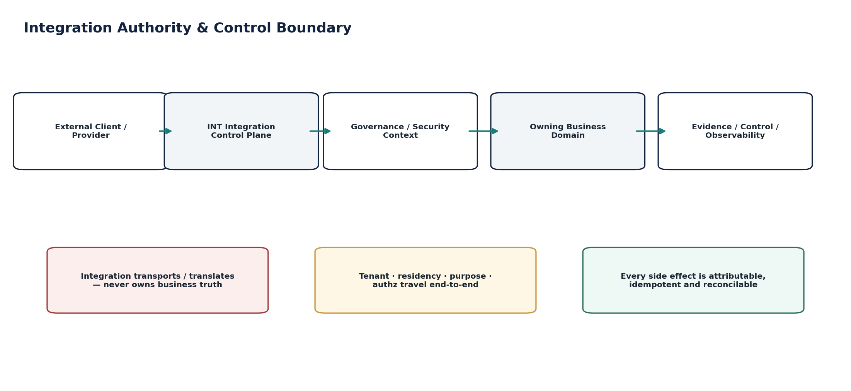
Figure 1 — Integration authority and control boundary.

1. Scope, Authority & Shared Invariants
This pack instantiates the ten canonical Integration & API Platform services from ZS-ARCH-SVC-001 and ZS-SVC-SPEC-001. It does not replace ZS-API-001, ZS-EVENT-001, ZS-IAM-001, ZS-SEC-001, ZS-NFR-001 or domain-specific adapter contracts; it applies those standards to the integration runtime.

1.1 Non-Bypassable Integration Invariants
- 1. Every inbound request/message/file resolves tenant context before business processing.
- 2. External caller-supplied tenant/entity/residency fields are untrusted until server-resolved.
- 3. API Gateway admission does not replace domain authorization or state validation.
- 4. Every API/event/provider/file contract is versioned and machine-verifiable.
- 5. Event transport is at-least-once; consumers must tolerate duplicates and controlled replay.
- 6. Business-state/event consistency uses transactional outbox or an equivalent atomic guarantee.
- 7. Consumer effects use durable inbox/deduplication plus idempotent business commands.
- 8. No irreversible external side effect is sent before a durable attempt/idempotency subject exists.
- 9. Pending/Unknown is a first-class external state; timeout is not invented failure.
- 10. Provider callbacks are authenticated, correlated, deduplicated and ordering-checked.
- 11. Provider-specific payloads/statuses do not become canonical business models.
- 12. Connectors store secret references, never plaintext credentials.
- 13. Connector purpose, scopes, destination and residency are explicit approved facts.
- 14. Webhook payloads are minimized and signed; replay protection is mandatory.
- 15. Imports never write directly into authoritative domain tables.
- 16. Financial/material imports require frozen preview population, control totals and reconciliation.
- 17. Files retain immutable manifest, schema/profile version and content hash.
- 18. Breaking provider/API/schema changes require a new certified version and migration/deprecation path.
- 19. Integration queues/dead letters/quarantine are observable and have named owners/runbooks.
- 20. No silent message/file drop; every terminal failure is evidenced.
- 21. Retry budgets, backpressure and circuit breakers prevent retry storms and shared-resource collapse.
- 22. Egress is allowlisted by purpose/provider and region; unauthorized cross-border transfer is blocked.
- 23. Routine logs/metrics never contain secrets or unrestricted financial/PII payloads.
- 24. Identity federation cannot auto-create privileged role authority.
- 25. Integration completion is not certified until required downstream/domain reconciliation succeeds.
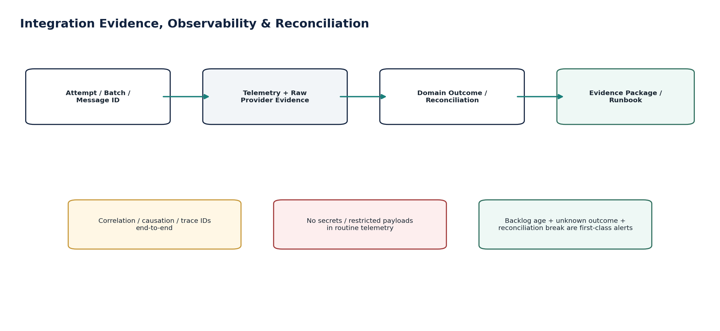
Figure 2 — Integration evidence, observability and reconciliation.

2. Shared Integration Contract

2.1 Trusted Integration Context Envelope
Field | Requirement
tenant_id | Server-resolved tenant authority; never trusted solely from external header/body.
legal_entity_id / book_id | Resolved when the target domain requires entity/book scope; absent only when genuinely not applicable.
actor_subject / workload_identity | Authenticated user/service principal with assurance level and delegation/support context.
purpose | Approved business/integration purpose used for data-minimization and egress decisions.
home_region / processing_region | Residency-policy decision from GTRM; propagated to queues/files/providers.
correlation_id / causation_id / trace_id | End-to-end observability and evidence identifiers.
idempotency_key / subject_fingerprint | Stable identity for commands/side effects where applicable.
contract_version / schema_profile | Exact OpenAPI, AsyncAPI, event, file or provider schema/profile version.
data_classification | Maximum sensitivity of payload; drives logging/redaction/egress rules.
source_system / destination_system | Canonical connector/provider identities, not free-form strings.
request_or_event_time | UTC instant plus relevant business/effective date kept separately.
authz_decision_ref | Reference to downstream/gateway policy decision evidence where applicable.

2.2 Stable Error / Quarantine Taxonomy
Code | Meaning
INT-CTX-001 | Invalid or unresolved tenant/context
INT-REG-002 | Residency/egress policy denied
INT-AUTH-003 | Authentication/authorization denied
INT-SCHEMA-004 | Contract/schema/profile mismatch
INT-IDEM-005 | Duplicate or conflicting idempotency subject
INT-EXT-006 | External outcome pending/unknown
INT-RATE-007 | Provider/gateway rate limited
INT-QUAR-008 | Payload/message/item quarantined
INT-SIG-009 | Signature/callback verification failed
INT-CRED-010 | Credential/consent expired or revoked
INT-RECON-011 | Integration/domain reconciliation mismatch
INT-VERS-012 | Unsupported/deprecated provider version
INT-SCOPE-013 | Connector scope/purpose denied
INT-FILE-014 | File manifest/hash/integrity failure
INT-CB-015 | Callback replay/out-of-order conflict
INT-BP-016 | Backpressure/admission protection active
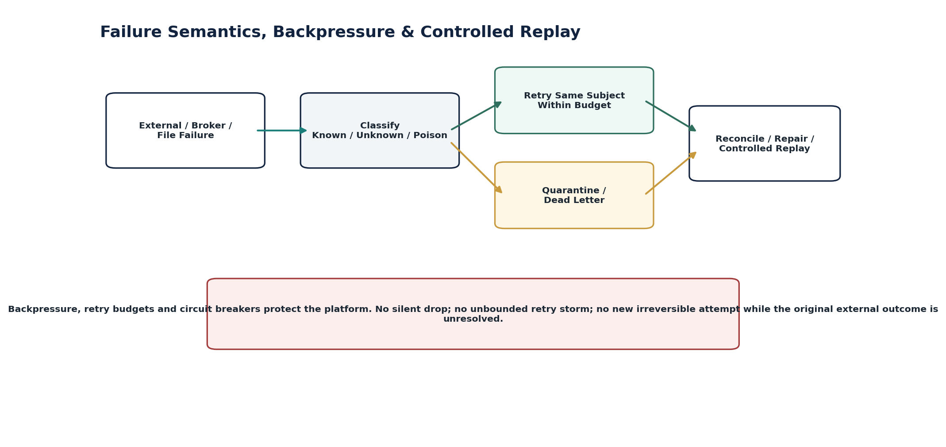
Figure 3 — Failure semantics, backpressure and controlled replay.

2.3 Interaction Profiles
Profile | Use | Mandatory controls
HTTP API | Synchronous command/query/resource APIs | OpenAPI; authn/authz; tenant context; idempotency where applicable; RFC 9457 errors; rate/size limits; trace.
Domain Event | Asynchronous state-change distribution | AsyncAPI; CloudEvents-aligned envelope; schema registry; outbox/inbox; partition/order policy; replay controls.
Webhook | Tenant-configured outbound event delivery | Subscription allowlist; minimized payload; signature; event ID/time; bounded retry; dead-letter/disable policy.
File Exchange | Inbound/outbound structured bulk exchange | Manifest/hash; malware scan; schema/profile; encryption/transport; counts/totals; acknowledgement; reconciliation.
Provider Adapter | Bank/tax/e-invoice/other external API translation | Durable attempt; provider profile version; raw refs; callback verification; Pending/Unknown; canonical mapping.
Identity Federation | OIDC/SAML/SCIM enterprise identity integration | Issuer/subject binding; exact metadata/config; provisioning scope; privilege guard; deprovision priority; audit trail.

3. Cross-Service Authority Matrix
Service | Owns | Explicitly does not own
INT-01 API Gateway | Gateway admission/routing/rate/telemetry decisions | Domain authorization, business state, accounting/tax/payment decisions.
INT-02 Event Bus | Durable event transport/offsets/partition delivery | Business truth or consumer side-effect correctness.
INT-03 Outbox/Inbox | Publish/consume receipts, dedupe state, processing evidence | Domain state itself or broker semantics beyond its interface.
INT-04 Webhook | Subscriptions and signed delivery attempts | External recipient business state.
INT-05 Connector Management | Connector config, scope, health, checkpoints, provider profile ref | Secrets, business facts, provider finality.
INT-06 Import | Import batch/preview/quarantine/reconciliation state | Imported business facts after owning-domain acceptance.
INT-07 Banking Adapter | Provider translation/attempt evidence/raw refs | Payment approval, finality, cash/ledger truth.
INT-08 Tax Authority Adapter | Authority transport/schema translation/receipts | Tax calculation, return content authority, accounting.
INT-09 E-Invoice Network Adapter | Network profile translation/status/receipt | Invoice economics, tax determination, AR settlement.
INT-10 IdP/Provisioning Adapter | Federation/provisioning mapping and sync state | Privileged authorization, SoD, HR/legal identity conclusions.
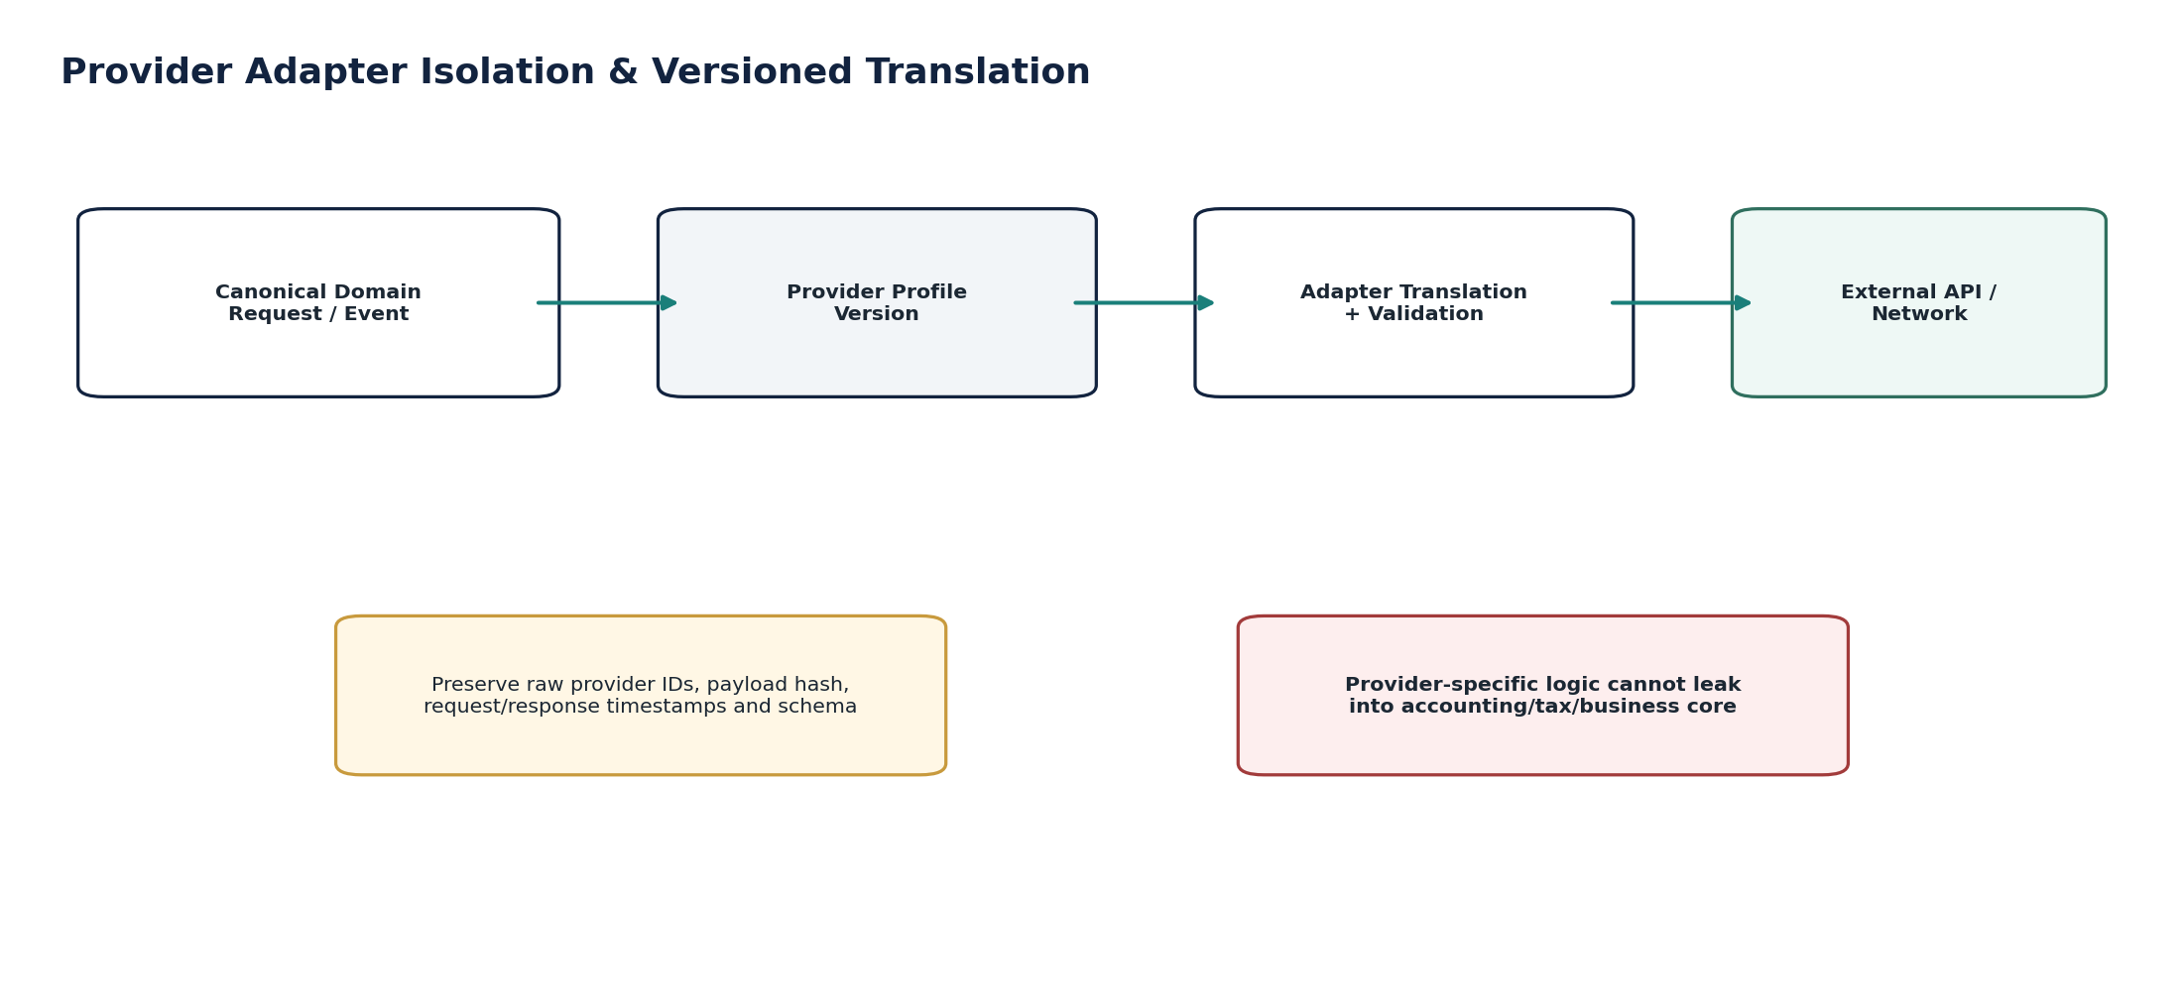
Figure 4 — Provider adapter isolation and versioned translation.

4. Detailed Build-Ready Service Specifications

4.1 INT-01 — API Gateway
Contract area | Build-ready requirement
Purpose / outcome | Authenticate/admit, normalize, throttle and route HTTP/API traffic while preserving trusted context, API version and gateway evidence.
Authoritative ownership | APIRequestDecision, route/policy evaluation telemetry, rate-limit counters/decisions, request/response correlation metadata.
Must not own | Business authorization, domain state transitions, accounting/tax logic, tenant identity master, business idempotency outcome.
Required source inputs | HTTPS request; client/user credential/token; requested API/version; method/path; headers; content metadata; client/network context.
Server-resolved context | Tenant; API client/workload; route; environment; residency; request size/content policy; rate/quota; threat/WAF posture; downstream service.
Runtime operations | Authenticate/validate token or client binding; resolve route/version; enforce size/rate/egress rules; attach trusted context; forward; capture evidence.
Queries / administration | GetGatewayDecision; GetClientUsage; GetRouteVersionStatus; ListDeniedRequests; GetRateLimitState. Route/policy publication remains governed configuration.
State / workflow | Request-scoped decision: Received → Validating → Admitted / Denied / RateLimited / RejectedMalformed → Forwarded → Completed.
Authorization / SoD | Gateway may reject; it cannot grant a protected domain command beyond the permissions later evaluated by the domain service.
Events | api_request_denied; api_rate_limited; api_route_version_unavailable; api_abuse_threshold_exceeded.
Idempotency / concurrency | Gateway preserves client idempotency key untouched; does not invent business idempotency outcome. Rate counters must be concurrency-safe.
Failure semantics | Unknown route/version, invalid token, oversized request, residency block or unavailable protected context fails closed. Downstream 5xx remains distinguishable from gateway failure.
Evidence / lineage | Request/correlation IDs, authenticated subject, route/version, decision reasons, downstream status class, redacted telemetry.
NFR / recovery | C0/C1 path; bounded added latency; multi-AZ; fail-safe rate limiting; overload shedding; no gateway single point of global failure.
Minimum acceptance tests | Forged tenant header; valid token but downstream permission denied; API version unsupported; request-size abuse; rate-limit race/bypass; route/config rollback; residency-denied path; downstream timeout.
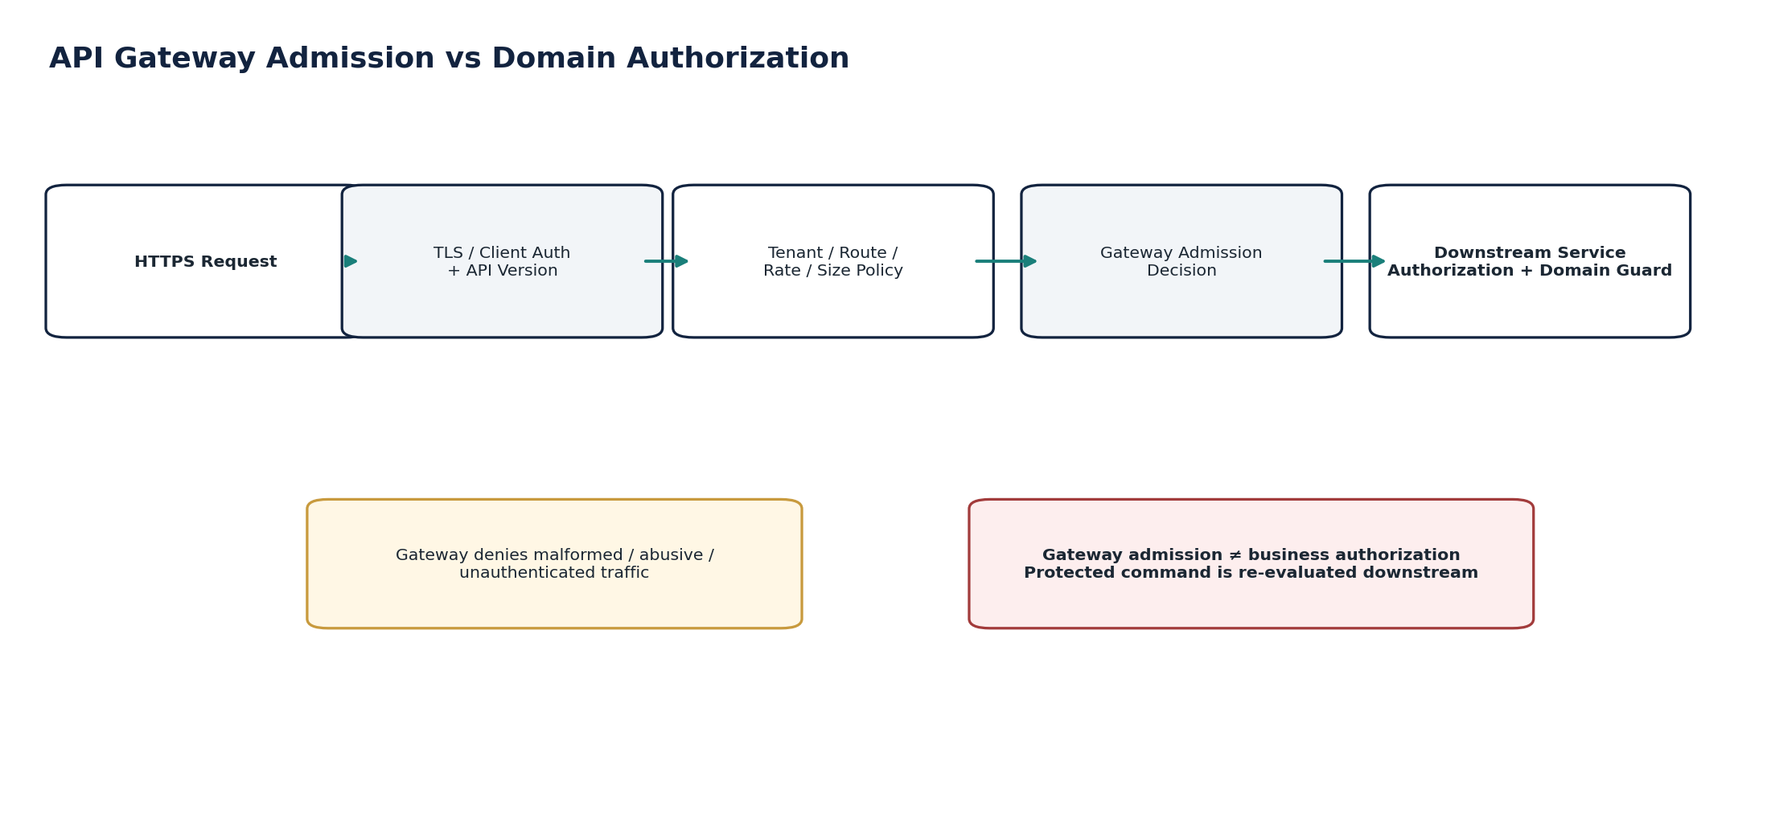
Figure 5 — INT-01 — API Gateway control flow.

4.2 INT-02 — Event Bus
Contract area | Build-ready requirement
Purpose / outcome | Distribute versioned domain/integration events durably across authorized producers/consumers with explicit partitioning, ordering and residency policy.
Authoritative ownership | Transport-level message record/offset/partition metadata and broker delivery state.
Must not own | Producer domain state, consumer business effects, canonical business truth or exactly-once business guarantees.
Required source inputs | Validated event envelope from transactional outbox or approved publisher; schema version; partition key; producer identity.
Server-resolved context | Topic/channel; region; retention; ACL; partition/order policy; consumer group; schema registry compatibility.
Runtime operations | Publish; consume; retain; replay within approved window; isolate/route poison events according to policy.
Queries / administration | GetTopicHealth; GetConsumerLag; GetMessageMetadata; RequestControlledReplay; ListPartitions/Offsets.
State / workflow | Accepted → Stored → Available → Delivered/re-delivered → Retained/Expired per policy; consumer lag independent.
Authorization / SoD | Producer/consumer workload ACLs and tenant/region controls; topic administration is privileged and change-controlled.
Events | event_bus_publish_failed; consumer_lag_exceeded; partition_unavailable; replay_started; replay_completed.
Idempotency / concurrency | Transport may duplicate. Event ID stable; ordering guaranteed only within documented partition/order domain.
Failure semantics | Broker outage/backpressure surfaces explicitly; no silent drops; publishers retain outbox until confirmed publish.
Evidence / lineage | Event ID, producer, schema version, partition/offset, timestamps, region, delivery/replay metadata.
NFR / recovery | High durability; capacity headroom; backpressure; replay from retained durable log; residency-aware regional recovery.
Minimum acceptance tests | Duplicate event; out-of-order cross-partition event; partition key error; schema mismatch; broker outage; lag alarm; controlled replay; cross-region topic denial.
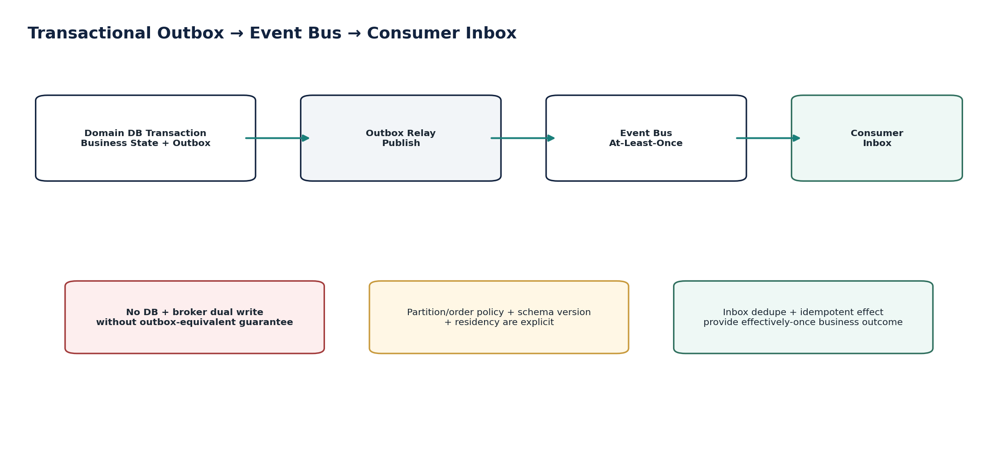
Figure 6 — INT-02 — Event Bus control flow.

4.3 INT-03 — Transactional Outbox / Inbox
Contract area | Build-ready requirement
Purpose / outcome | Guarantee producer state/event consistency and consumer deduplication/idempotent processing receipts.
Authoritative ownership | OutboxRecord, publish status/attempts; InboxReceipt, dedupe key, processing state/result reference.
Must not own | Business entity state, broker topic lifecycle or downstream business authorization.
Required source inputs | Committed domain state change + event envelope; consumer message/event ID + intended business command/effect.
Server-resolved context | DB transaction boundary; relay policy; retry budget; dedupe retention; consumer service/tenant; event schema.
Named operations | EnqueueOutboxWithinDomainTransaction; ClaimOutbox; MarkPublished; RecordInboxReceipt; CompleteInboxProcessing; QuarantineProcessing; ReplayControlled.
Queries | GetOutboxRecord; ListStuckOutbox; GetInboxReceipt; FindDuplicateMessage; GetProcessingEvidence.
State / workflow | Outbox: Pending → Claimed → Published / Retry / Quarantined. Inbox: Received → Processing → Completed / FailedRetryable / Quarantined.
Authorization / SoD | Service/workload only; privileged repair/replay requires JIT approval and evidence.
Events | outbox_publish_delayed; outbox_quarantined; inbox_duplicate_detected; inbox_processing_quarantined.
Idempotency / concurrency | Producer DB write and outbox insert are atomic. Consumer inbox receipt and business effect use one atomic/idempotent boundary wherever technically feasible.
Failure semantics | If broker publish succeeds but status update fails, relay may republish same event ID; consumer dedupe absorbs duplicate. Consumer crash after effect before acknowledgement reuses same business idempotency subject.
Evidence / lineage | Transaction ID, event ID, outbox attempts, broker metadata, inbox receipt, business command/result ref, operator repair/replay refs.
NFR / recovery | Stuck-age SLO; scalable relay; dedupe retention at least covers replay/transport horizon; repair tooling cannot mutate event payload.
Minimum acceptance tests | DB commit/broker outage; duplicate relay publish; consumer crash after side effect; duplicate message after restart; stale dedupe entry; quarantine/replay; privileged repair without approval.

4.4 INT-04 — Webhook
Contract area | Build-ready requirement
Purpose / outcome | Deliver tenant-configured outbound events to approved destinations using minimized payloads, cryptographic authenticity and bounded retry.
Authoritative ownership | WebhookSubscription, event-filter/version config, delivery attempts, destination response evidence, terminal delivery status.
Must not own | Recipient business state, recipient credentials, source-domain facts or external acceptance beyond the HTTP exchange.
Required source inputs | Approved subscription; event; destination URI; allowed event types/fields; signing-key reference; delivery policy.
Server-resolved context | Tenant; egress/region allowlist; data classification/minimization; signing profile; retry budget; TLS policy; destination health.
Named commands | CreateWebhookSubscription; ApproveWebhookSubscription; RotateSigningKeyRef; SuspendWebhook; RevokeWebhook; ReplayDeliveryAttempt.
Queries | GetSubscription; ListDeliveryAttempts; GetDeliveryEvidence; ListDeadLetters; GetDestinationHealth.
State / workflow | Subscription Draft → PendingApproval → Active → Suspended/Disabled → Revoked. Delivery Pending → Sent → Succeeded / Retrying / DeadLettered.
Authorization / SoD | Creating/changing destination or sensitive event scope may require maker-checker; secret/signing key remains in SEC-01.
Events | webhook_subscription_activated; webhook_delivery_failed; webhook_dead_lettered; webhook_disabled; webhook_replay_requested.
Idempotency / concurrency | Stable delivery ID per subscription+event. Retries reuse same event/delivery identity.
Failure semantics | Non-2xx, timeout or TLS failure enters bounded retry/dead-letter policy; success means transport response only, not recipient business processing.
Evidence / lineage | Event ID, minimized payload hash, signature metadata, destination, attempt timestamps, response code/body hash within redaction policy.
NFR / recovery | Per-destination bulkhead; retry budget/jitter; no global retry storm; configurable concurrency; circuit breaker.
Minimum acceptance tests | Invalid destination approval; restricted field leak; invalid signature; replay; destination 500/429; egress to prohibited region; TLS failure; endpoint changed after approval.
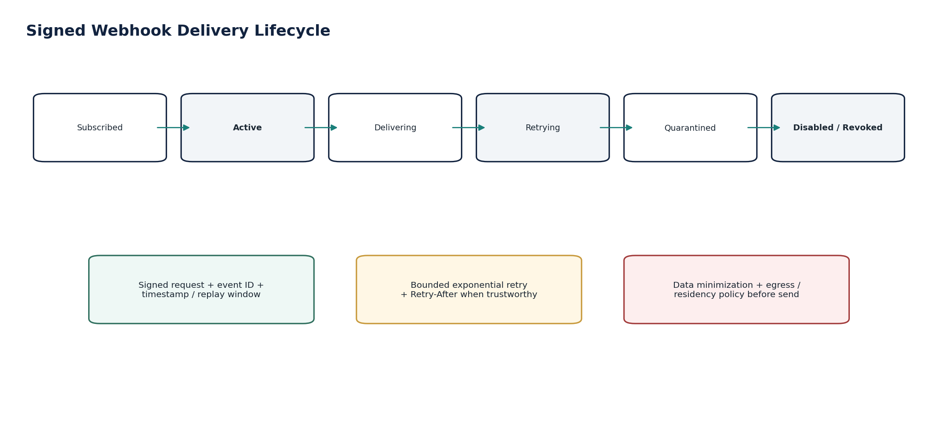
Figure 8 — INT-04 — Webhook control flow.

4.5 INT-05 — Connector Management
Contract area | Build-ready requirement
Purpose / outcome | Create and govern external-system connection configurations, scopes, purpose, provider profile, health and synchronization checkpoints.
Authoritative ownership | Connector, ConnectorScope, ConnectorHealth, SyncCheckpoint, consent/config metadata and provider-profile reference.
Must not own | Plaintext secrets, business records synchronized through the connector, provider finality or commercial entitlement authority.
Required source inputs | Connector/provider type; tenant; approved purpose; external account/endpoint; requested scopes; sync mode; credential/consent reference; mappings/profile.
Server-resolved context | Entitlement; data classification; residency/egress; provider certification status; secret policy; allowed scopes; rate limits.
Named commands | CreateConnector; ApproveConnector; ActivateConnector; RefreshConsentRef; SuspendConnector; RevokeConnector; ResetSyncCheckpoint; UpgradeProviderProfile.
Queries | GetConnector; ListConnectors; GetConnectorHealth; GetSyncCheckpoint; ListScopeChanges; GetProviderProfileStatus.
State / workflow | Draft → PendingApproval → Active → Degraded → Suspended → Revoked → Archived.
Authorization / SoD | High-risk destination/scope/credential changes require maker-checker; support can diagnose but not widen scope.
Events | connector_activated; connector_degraded; connector_scope_changed; connector_revoked; sync_checkpoint_advanced; connector_profile_upgrade_required.
Idempotency / concurrency | Connector config versioned; protected-field changes use optimistic concurrency and approval fingerprint.
Failure semantics | Expired/revoked credential, provider outage, profile incompatibility or residency conflict degrades/suspends without losing checkpoint/history.
Evidence / lineage | Approval, purpose/scopes, destination, provider profile/version, secret reference, health transitions, sync checkpoints.
NFR / recovery | Health freshness SLO; resumable sync; isolated provider bulkheads; connector-specific rate/concurrency policies.
Minimum acceptance tests | Secret appears in DB/log; scope widened without approval; destination region changes; credential revoked mid-sync; checkpoint rollback; unsupported provider version; entitlement removed.
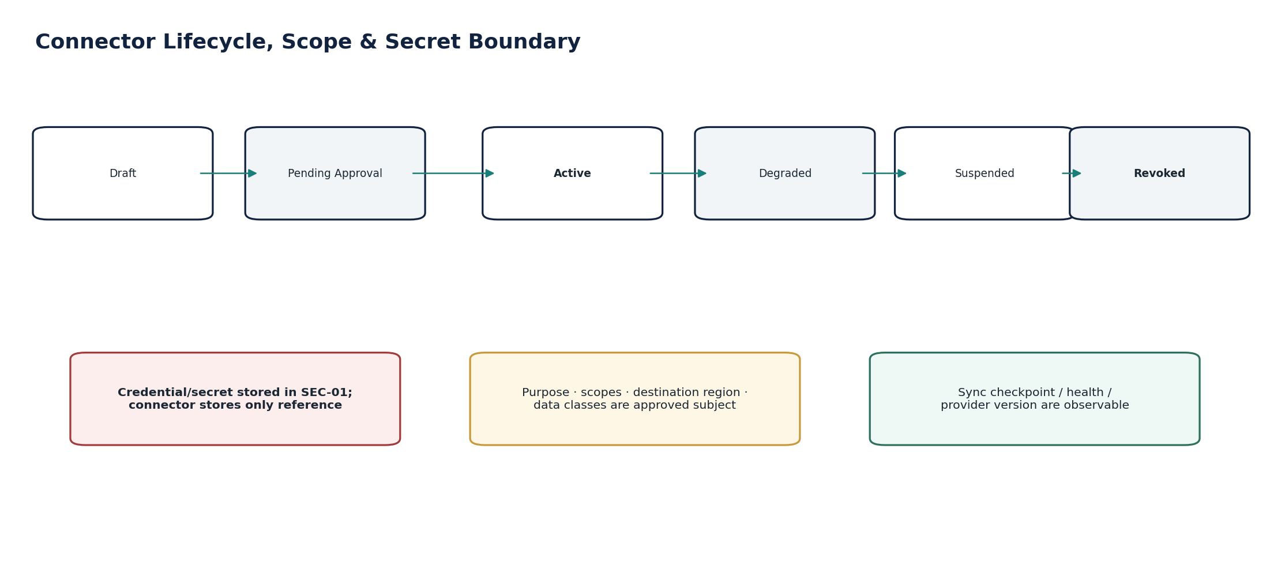
Figure 9 — INT-05 — Connector Management control flow.

4.6 INT-06 — Import
Contract area | Build-ready requirement
Purpose / outcome | Bulk import structured data through scan, schema validation, preview, approval, domain-command execution, exception handling and reconciliation.
Authoritative ownership | ImportBatch, source manifest, file/content hash, mapping version, validation/preview results, item statuses, quarantine and reconciliation status.
Must not own | Imported business facts after owning-domain acceptance; migration authority outside ZS-MIG-001; domain validation logic.
Required source inputs | File/data stream; import type; schema/profile; tenant/entity; mapping; duplicate strategy; source system; optional counts/control totals.
Server-resolved context | Uploader/workload permission; residency; malware policy; schema registry; target service readiness; mapping version; materiality/risk classification.
Named commands | CreateImportBatch; UploadImportContent; ValidateImport; GeneratePreview; ApproveImport; ExecuteImport; QuarantineItem; RetryItem; ReconcileImport; CancelPreExecutionImport.
Queries | GetImportBatch; GetPreview; ListValidationErrors; ListItemStatuses; GetControlTotals; GetReconciliationResult.
State / workflow | Uploaded → Scanned → Parsed → Validated → Previewed → Approved → Importing → Completed → Reconciled; alternate Quarantined/Failed/Cancelled.
Authorization / SoD | Material financial imports require separate approver; approved payload fingerprint must match executed content/mapping.
Events | import_validated; import_preview_approved; import_started; import_item_quarantined; import_completed; import_reconciliation_failed.
Idempotency / concurrency | Batch ID/source hash prevents accidental duplicate batch. Item idempotency is delegated to owning-domain command keys.
Failure semantics | Malware/hash/schema failure blocks before preview. Partial failures remain explicit; batch cannot falsely report complete/reconciled.
Evidence / lineage | Manifest, file hash, scan, schema/mapping versions, preview/control totals, approval, per-item domain command/result refs, reconciliation.
NFR / recovery | Chunked/resumable upload; bounded worker pools; backpressure; large-file streaming; quarantine retention; deterministic rerun from immutable source.
Minimum acceptance tests | Malware; hash mismatch; schema mismatch; duplicate file; preview differs from execution; direct DB write attempt; partial failure; missing control totals; cross-entity import; duplicate domain item.
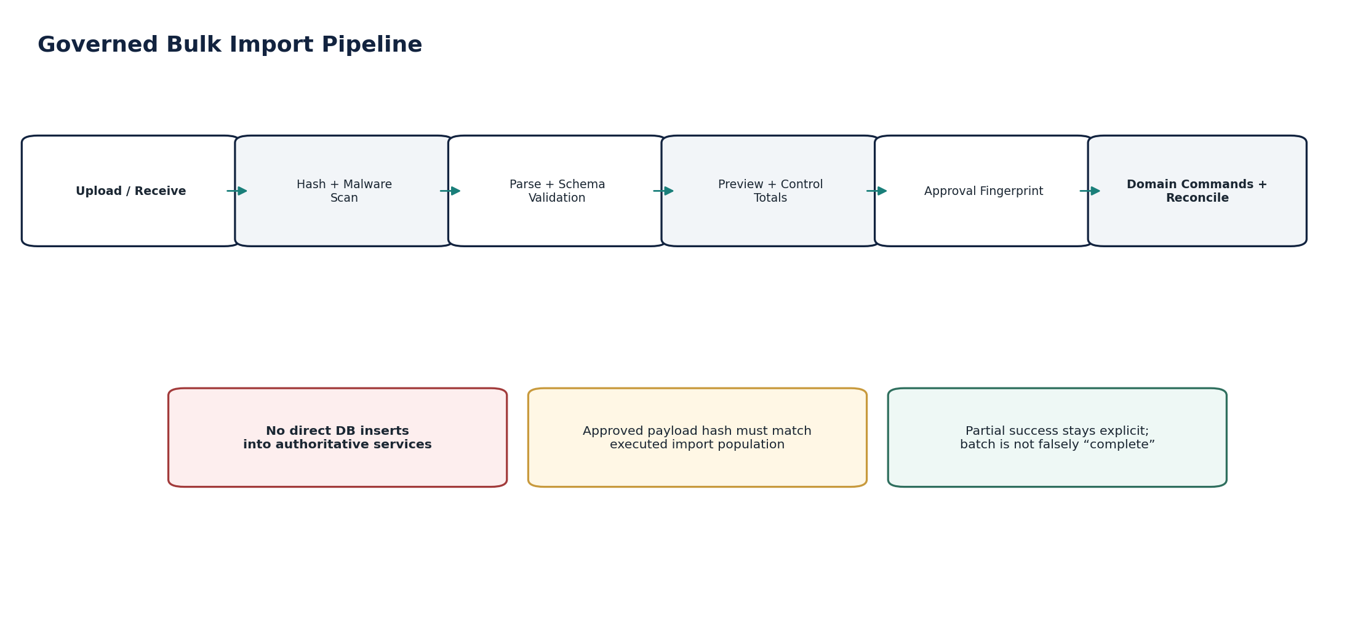
Figure 10 — INT-06 — Import control flow.

4.7 INT-07 — Banking Adapter
Contract area | Build-ready requirement
Purpose / outcome | Translate canonical Banking/payment requests and provider/bank responses across bank, open-banking, PSP and rail-specific APIs/message formats.
Authoritative ownership | Provider translation profile, outbound/inbound payload evidence, adapter attempt refs, raw provider identifiers/status mapping evidence.
Must not own | Payment approval, payee master, payment/cash finality, bank-account ownership or ledger truth; BNK-06/BNK-07 remain authoritative.
Required source inputs | Canonical Banking request/attempt; bank/provider connector; account reference; rail/method; approved payee/payment subject; provider callback/response.
Server-resolved context | Provider/rail profile version; credential ref; region; provider limits/cutoffs; callback verification profile; ISO/message profile where applicable.
Named operations | TranslatePaymentRequest; SubmitProviderAttempt; TranslateProviderResponse; VerifyProviderCallback; MapProviderStatus; FetchOriginalAttemptStatus.
Queries | GetProviderAttemptEvidence; GetRawProviderReference; GetProfileVersion; ListCallbackReceipts; GetAdapterHealth.
State / workflow | Attempt Prepared → Submitted → ProviderAcknowledged / PendingUnknown / Rejected; canonical finality is resolved by BNK-07.
Authorization / SoD | Adapter accepts only approved canonical subject from Banking; cannot change amount/payee/account after Banking authorization.
Events | bank_adapter_attempt_submitted; bank_adapter_unknown_outcome; bank_callback_received; bank_adapter_profile_deprecated.
Idempotency / concurrency | Provider idempotency/reference derived from canonical Banking attempt; retry resolves same attempt, never invents a new financial subject.
Failure semantics | Timeout/missing callback = Pending/Unknown unless bank/provider query proves outcome. Out-of-order callback cannot regress canonical state.
Evidence / lineage | Canonical attempt ID, exact sent payload hash, provider refs, response/callback hashes, timestamps, profile version, correlation to BNK-07 outcome.
NFR / recovery | C0/C1 financial path; provider-specific circuit breaker, retry budget, reconciliation and status polling.
Minimum acceptance tests | Timeout then blind retry; duplicate callback; callback signature failure; status regression; unsupported rail version; amount mutation; provider 429; provider says success but bank finality absent.
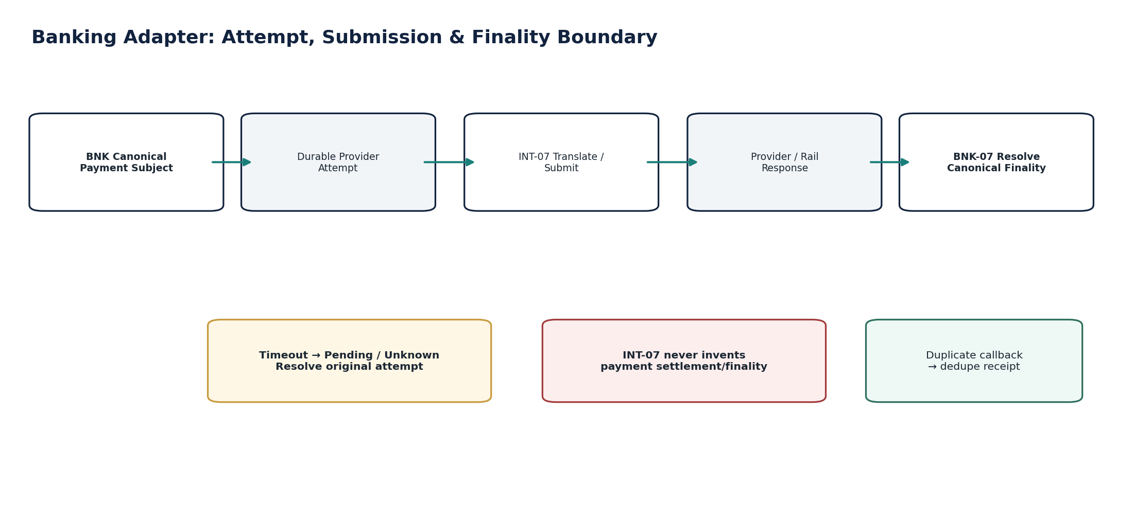
Figure 11 — INT-07 — Banking Adapter control flow.

4.8 INT-08 — Tax Authority Adapter
Contract area | Build-ready requirement
Purpose / outcome | Translate canonical tax-return, filing, clearance or reporting payloads to authority-specific APIs/schemas and map authority outcomes back to canonical state.
Authoritative ownership | Authority adapter profile, submission transport attempt, exact payload/response/receipt evidence and canonical mapping evidence.
Must not own | Tax calculation, return facts/population, filing approval, tax ledger or accounting. TAX-03/TAX-09/TAX-10 remain authoritative.
Required source inputs | Approved canonical filing/reporting payload; taxpayer registration; authority endpoint/profile; submission attempt identity.
Server-resolved context | Jurisdiction; authority schema/API version; credential/certificate ref; filing period; endpoint environment; outage/deadline policy.
Named operations | TranslateAuthorityPayload; ValidateAuthoritySchema; SubmitAuthorityAttempt; VerifyAuthorityResponse; PollOriginalSubmission; MapAuthorityStatus.
Queries | GetAuthorityAttemptEvidence; GetAuthorityReceipt; GetProfileVersion; GetAuthorityHealth; ListSubmissionCallbacks.
State / workflow | Prepared → Validated → Submitted → PendingUnknown → Accepted / Rejected / Superseded as returned to TAX domain.
Authorization / SoD | Adapter executes only TAX-approved submission subject; cannot modify return facts to satisfy authority validation.
Events | tax_authority_attempt_submitted; tax_authority_unknown_outcome; tax_authority_response_received; tax_authority_profile_changed.
Idempotency / concurrency | One authority attempt identity per approved TAX submission subject; retries/status checks resolve original subject.
Failure semantics | Authority timeout/outage = Pending/Unknown; schema validation error = block; new schema/profile cannot auto-transform an already approved payload without revalidation/approval.
Evidence / lineage | Exact sent content hash, schema/profile, credential/cert ref, authority transaction/receipt IDs, timestamps, raw response hash and TAX outcome ref.
NFR / recovery | Deadline-aware retry/poll; provider outage escalation; no duplicate filing storm; retention per tax record class.
Minimum acceptance tests | Authority timeout then duplicate filing; unsupported schema; expired certificate; callback replay; authority receipt mismatch; payload changed after approval; endpoint outage near deadline.
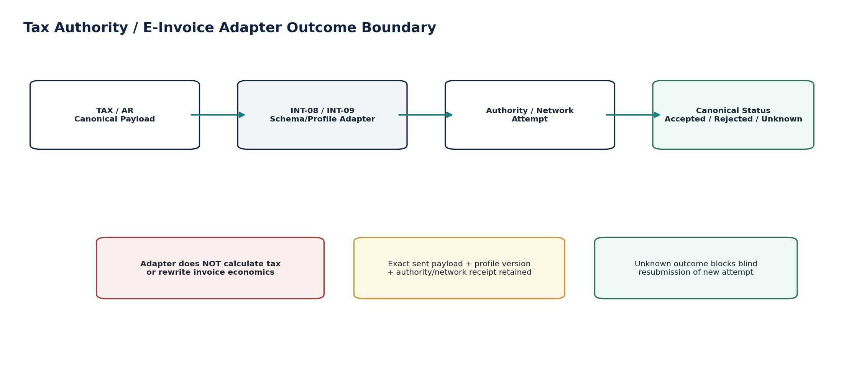
Figure 12 — INT-08 — Tax Authority Adapter control flow.

4.9 INT-09 — E-Invoicing Network Adapter
Contract area | Build-ready requirement
Purpose / outcome | Translate approved canonical invoice/credit-note documents into certified e-invoicing network/local-scheme profiles and transport them with exact payload/receipt evidence.
Authoritative ownership | Network profile/version, transformed payload, transport attempt, network document/reference IDs, acknowledgements and mapped delivery/clearance status evidence.
Must not own | Invoice economics, tax determination, document number, AR open item or settlement. AR-04/AR-05/TAX-11 remain authoritative.
Required source inputs | Approved invoice/credit-note representation; endpoint/party identifiers; network profile; attachments where permitted; submission subject.
Server-resolved context | Jurisdiction/network; PINT/local profile version; UBL/XML/schema/code lists; credential/certificate ref; transport/security policy; recipient capability.
Named operations | TransformEInvoice; ValidateNetworkProfile; SubmitNetworkAttempt; VerifyNetworkReceipt; PollNetworkStatus; MapNetworkStatus.
Queries | GetNetworkPayloadEvidence; GetNetworkReceipt; GetProfileVersion; GetDocumentReference; GetAdapterHealth.
State / workflow | Prepared → Validated → Submitted → PendingUnknown → Accepted / Rejected / Delivered / Superseded according to owning AR/TAX state model.
Authorization / SoD | Adapter receives only sealed/approved document subject; cannot change amounts/tax/document identity to “make it pass.”
Events | einvoice_network_submitted; einvoice_network_unknown_outcome; einvoice_network_accepted; einvoice_network_rejected; einvoice_profile_deprecated.
Idempotency / concurrency | Network document identity and submission subject stable. Retry/status check reuses original network attempt where supported.
Failure semantics | Profile/schema rejection is explicit. Network timeout is Pending/Unknown. Recipient/address/profile ambiguity blocks before send.
Evidence / lineage | Canonical document ID/version, exact transformed payload hash, profile/code-list versions, network refs, response/receipt hashes, timestamps.
NFR / recovery | Provider-specific queues/bulkheads; deadline/clearance-aware polling; high evidence durability; no silent document loss.
Minimum acceptance tests | Wrong profile; transformed total differs from canonical invoice; network timeout; duplicate send; recipient ID invalid; callback replay; profile update after approval; attachment prohibited.

4.10 INT-10 — Identity Provider / Provisioning Adapter
Contract area | Build-ready requirement
Purpose / outcome | Integrate tenant enterprise authentication and identity provisioning using controlled federation/provisioning mappings.
Authoritative ownership | Tenant federation connection, issuer/metadata/profile version, claim/provisioning mapping, external-subject link evidence, sync/provisioning status.
Must not own | Human/legal identity facts, authentication provider internals, privileged role authority, SoD decision or HR employment status.
Required source inputs | Tenant IdP metadata/config; OIDC/SAML assertions/tokens; SCIM/provisioning events; stable external subject; directory attributes; approved mapping profile.
Server-resolved context | Tenant; IdP trust profile; issuer/audience; signature keys/metadata; allowed claims; mapping/version; baseline assignment policy; deprovision priority.
Named commands | ConfigureFederation; ApproveFederation; RotateMetadataOrCertificateRef; ConfigureProvisioningMapping; SuspendFederation; ReconcileDirectorySync.
Queries | GetFederationConfig; GetExternalSubjectLink; GetProvisioningStatus; ListSyncExceptions; GetDeprovisionLatency.
State / workflow | Draft → PendingApproval → Active → Degraded/Suspended → Revoked; provisioning event Received → Validated → Applied/Rejected → Reconciled.
Authorization / SoD | External claims may map only to approved baseline assignments. Privileged roles require GOV approval/SoD. Email alone is not stable identity binding.
Events | federation_activated; identity_link_created; provisioning_applied; provisioning_rejected; deprovision_applied; federation_degraded.
Idempotency / concurrency | External identity link keyed by tenant + issuer + stable subject; SCIM/provisioning event IDs deduplicated.
Failure semantics | Issuer/audience/signature mismatch fails closed. Deprovision failure escalates; stale identity must not retain access beyond policy. Mapping ambiguity quarantines.
Evidence / lineage | Federation config/version, issuer/subject, signature validation result, mapped assignments, approvals, provisioning event, revoke/deprovision result.
NFR / recovery | Authentication path C0/C1; metadata/key refresh; deprovision latency SLO; IdP outage behavior defined per tenant; no insecure fallback.
Minimum acceptance tests | Email collision across issuers; token wrong issuer/audience; expired signing key; SCIM privilege escalation; duplicate provisioning event; deprovision delayed; mapping change after approval; IdP outage fallback.
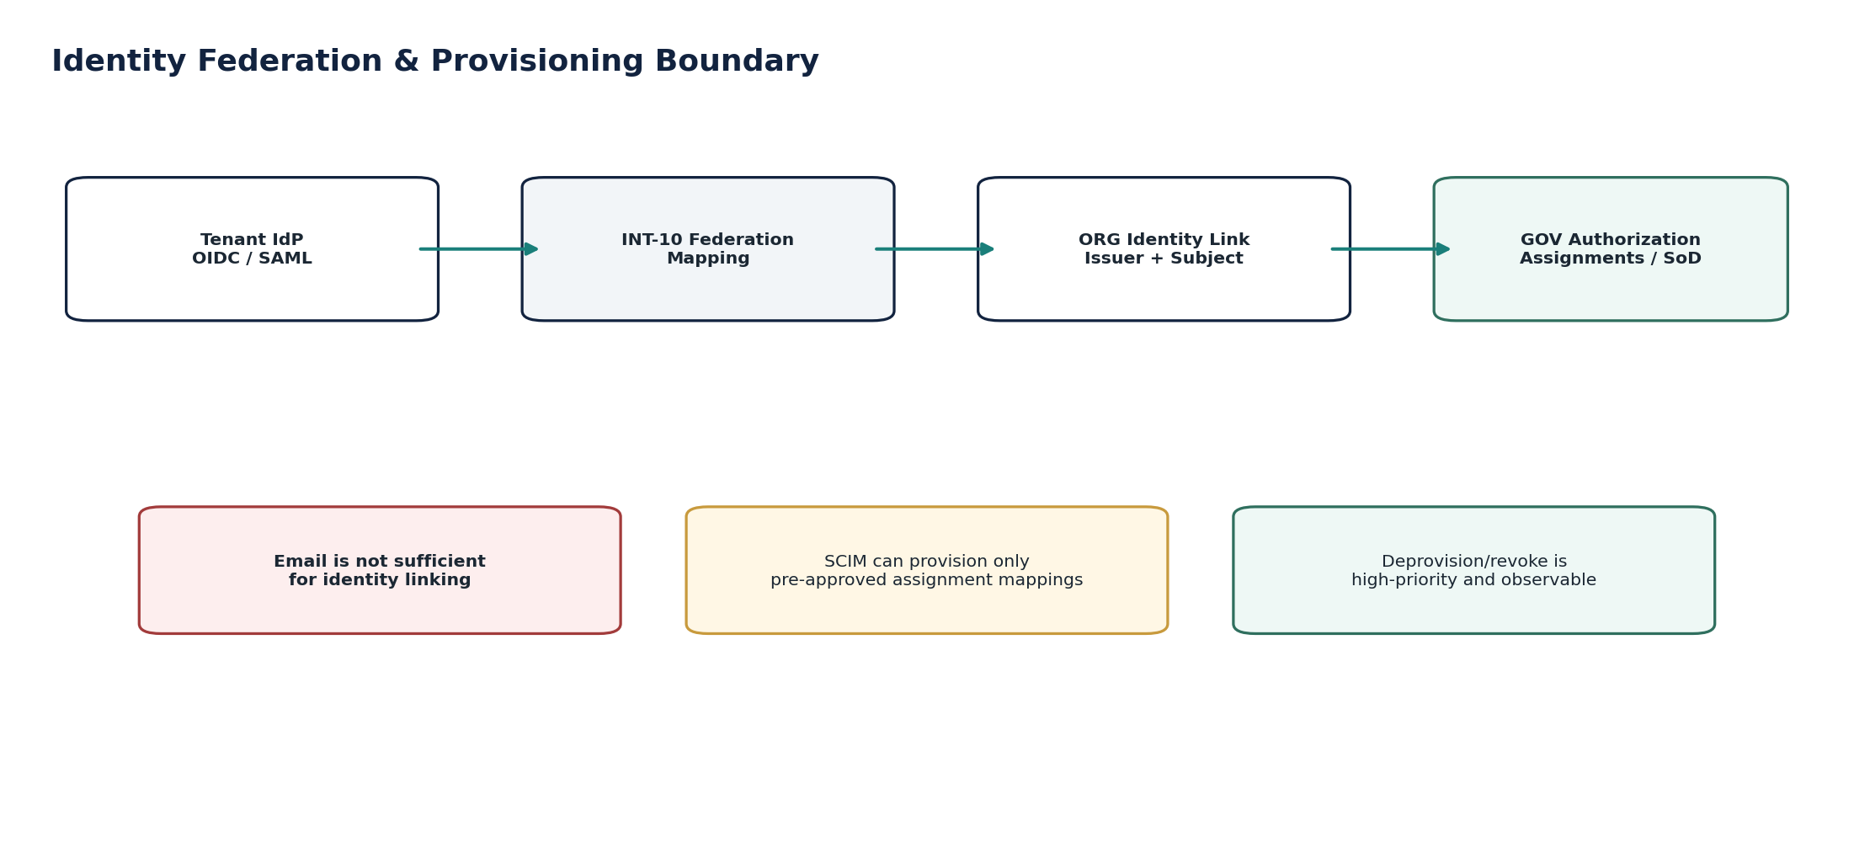
Figure 14 — INT-10 — Identity Provider / Provisioning Adapter control flow.

5. File Exchange & Bulk Transfer Control Standard
File exchange is a cross-cutting integration profile implemented through INT-05 Connector Management plus INT-06 Import for inbound structured data, and through owning-domain export services plus controlled connectors for outbound files. It is not a separate authority for the data in the file.
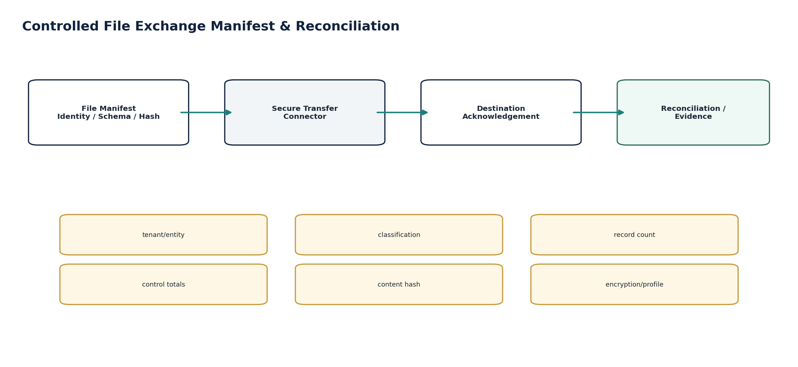
Figure 15 — Controlled file exchange manifest and reconciliation.

5.1 Canonical File Manifest
Field | Requirement
file_exchange_id | Immutable transfer identity.
tenant/entity | Resolved scope; entity required when file content is entity-specific.
source/destination | Approved connector/system identities.
purpose | Approved transfer purpose.
schema/profile version | Exact file/message definition used.
classification | Maximum data sensitivity and privacy class.
content hash | Cryptographic digest before/after transfer.
record count / control totals | Required for material populations; financial totals by relevant currency/basis.
encryption / key reference | Transport/content-protection profile; no key material in manifest.
created/received/acknowledged timestamps | UTC instants with source timezone if business meaning depends on local time.
status | Prepared / Sent / Received / Acknowledged / Rejected / Quarantined / Reconciled.
retention/legal hold | Record class and hold status from data-governance plane.

5.2 File Transfer Requirements
- Inbound content is malware-scanned and integrity-checked before parsing or domain execution.
- Outbound material files are sealed after approval; post-approval modification creates a new artifact/version.
- Large files use streaming/chunking and resumable transfer without weakening whole-file integrity verification.
- Encryption/signing uses approved SEC-01/ZS-SEC-001 cryptographic material and algorithms; no custom cryptography.
- File names are not authoritative metadata. Tenant/entity/period/schema are carried in the signed/controlled manifest.
- Receipt/acknowledgement is distinct from business acceptance. Reconciliation proves the destination/source population when required.
- Unacknowledged material transfers enter an exception/runbook path; they are never silently assumed delivered.

6. Contract, Schema & Provider Version Governance
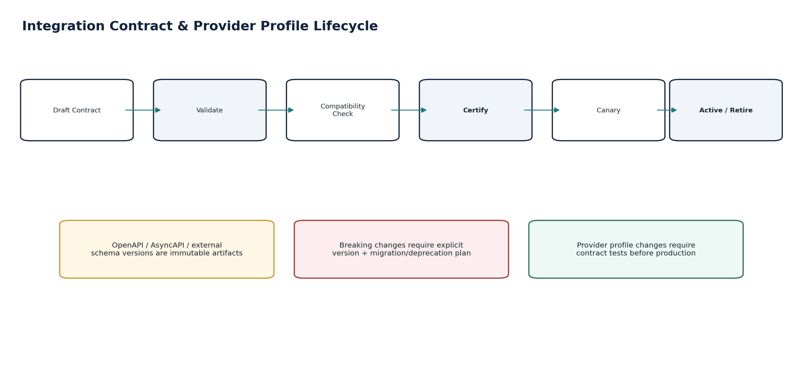
Figure 16 — Integration contract and provider-profile lifecycle.
Artifact | Required governance
OpenAPI contract | Versioned; lint/validation; compatibility classification; generated SDK/test fixtures where useful; deprecation policy; runtime conformance tests.
AsyncAPI contract | Producer/consumer operations; message schema; channel/binding; correlation/partition semantics; compatibility tests.
CloudEvents-aligned envelope | Stable event identity/type/source/time/subject/data schema and extension context.
File schema/profile | Versioned JSON/XML/CSV/fixed-width specification, encoding, delimiter/locale rules, manifest and validation suite.
Provider profile | Endpoint/scheme/API version, auth profile, limits, status mapping, callbacks, idempotency behavior, certification evidence.
Identity federation profile | Protocol/version, issuer/metadata, algorithms, claim/provisioning mapping and trust/key lifecycle.

Breaking external/provider change policy — An adapter may support multiple provider versions concurrently, but it SHALL NOT silently upgrade an approved tenant connector or re-transform an already approved financial/regulatory subject under a new schema without required compatibility, validation and approval controls.

7. Security, Privacy, Residency & Credential Controls
- All connector credentials, API secrets, signing keys, private keys and refresh tokens are managed by SEC-01/ZS-SEC-001. Integration stores opaque references and usage metadata only.
- OAuth integrations follow current security best practice, including exact redirect handling where relevant, PKCE for authorization-code flows, sender-constrained tokens where justified, least privilege and rotation/revocation handling.
- HTTP callbacks/webhooks use authenticated transport plus message authenticity/replay controls appropriate to the provider; RFC 9421 HTTP Message Signatures is the preferred standards-aligned option when ecosystem support exists.
- Outbound egress is allowlisted by provider/purpose/region. DNS resolution, redirect handling and SSRF controls prevent an approved connector from becoming arbitrary outbound network access.
- PII/financial payloads are minimized. Routine logs capture identifiers/hashes/statuses rather than full sensitive bodies; raw evidence is access-controlled and retained by record class.
- Cross-region integration queues, dead letters, retries and support access are subject to the same residency policy as the payload they contain.

8. Operational Resilience, Backpressure & Reconciliation
Control area | Build-ready rule
Timeouts | Every external call has explicit connect/read/overall timeout; no infinite waits.
Retries | Retry only retryable conditions; bounded attempts/time budget; exponential backoff+jitter; original idempotency subject preserved.
Rate limits | Provider/Gateway rate limits are surfaced; Retry-After honored only when trustworthy; caller/backlog admission adjusted.
Circuit breakers | Per provider/connector, not global; open state is observable and runbook-linked.
Bulkheads | Separate provider/tenant/resource pools prevent one failing connector from exhausting shared capacity.
Backpressure | Queues have bounded capacity/age; producers slow/deny low-priority work before shared collapse.
Quarantine/DLQ | Terminal/poison items preserve payload hash, reason, owner, next action and replay eligibility.
Unknown outcomes | External unknown is reconciled against original attempt before any new irreversible effect.
Reconciliation | Counts/totals/IDs and domain outcomes prove no silent loss/duplication for material integrations.
Runbooks | Named runbooks exist for API abuse, event lag, stuck outbox, poison event, webhook storm, connector credential expiry, import quarantine, provider schema change, bank/tax/e-invoice ambiguity and IdP/deprovision incidents.

9. Canonical Integration Data Model
Entity | Authority
ApiRequestDecision | Gateway admission/routing/rate decision evidence.
EventTransportRecord | Broker transport/offset/partition metadata.
OutboxRecord | Producer transactional event publication record.
InboxReceipt | Consumer dedupe/processing receipt.
WebhookSubscription | Approved destination/filter/signing policy.
WebhookDeliveryAttempt | Signed delivery attempt and response evidence.
Connector | Approved external connection configuration.
ConnectorScope | Purpose/data/resource scopes.
ConnectorCredentialRef | Opaque reference to secret/credential material.
SyncCheckpoint | Incremental synchronization cursor/watermark.
ExternalProfile | Provider/network/authority/IdP schema/API profile version.
ImportBatch | Bulk import lifecycle and source manifest.
ImportItem | Per-record validation/execution status.
ImportMappingVersion | Versioned source→canonical/domain mapping.
QuarantineItem | Non-discarded failed/poison item and reason/owner.
ProviderAttempt | Durable external side-effect/operation attempt.
ProviderCallbackReceipt | Verified callback event and dedupe/order metadata.
FileExchangeManifest | File identity, hash, schema, counts/totals and transfer status.
IntegrationReconciliationRun | Frozen population comparison and exception results.
IntegrationEvidencePackage | Attempt/batch/message evidence and source/domain linkage.

10. Canonical Integration Events
Event | Minimum payload
api_request_denied | event_id, type, occurred_at, tenant_id, correlation/causation, subject ID/version, service, region, schema version, actor/workload where applicable
api_rate_limited | event_id, type, occurred_at, tenant_id, correlation/causation, subject ID/version, service, region, schema version, actor/workload where applicable
consumer_lag_exceeded | event_id, type, occurred_at, tenant_id, correlation/causation, subject ID/version, service, region, schema version, actor/workload where applicable
outbox_publish_delayed | event_id, type, occurred_at, tenant_id, correlation/causation, subject ID/version, service, region, schema version, actor/workload where applicable
outbox_quarantined | event_id, type, occurred_at, tenant_id, correlation/causation, subject ID/version, service, region, schema version, actor/workload where applicable
inbox_duplicate_detected | event_id, type, occurred_at, tenant_id, correlation/causation, subject ID/version, service, region, schema version, actor/workload where applicable
webhook_subscription_activated | event_id, type, occurred_at, tenant_id, correlation/causation, subject ID/version, service, region, schema version, actor/workload where applicable
webhook_delivery_failed | event_id, type, occurred_at, tenant_id, correlation/causation, subject ID/version, service, region, schema version, actor/workload where applicable
webhook_dead_lettered | event_id, type, occurred_at, tenant_id, correlation/causation, subject ID/version, service, region, schema version, actor/workload where applicable
connector_activated | event_id, type, occurred_at, tenant_id, correlation/causation, subject ID/version, service, region, schema version, actor/workload where applicable
connector_degraded | event_id, type, occurred_at, tenant_id, correlation/causation, subject ID/version, service, region, schema version, actor/workload where applicable
connector_revoked | event_id, type, occurred_at, tenant_id, correlation/causation, subject ID/version, service, region, schema version, actor/workload where applicable
sync_checkpoint_advanced | event_id, type, occurred_at, tenant_id, correlation/causation, subject ID/version, service, region, schema version, actor/workload where applicable
import_validated | event_id, type, occurred_at, tenant_id, correlation/causation, subject ID/version, service, region, schema version, actor/workload where applicable
import_preview_approved | event_id, type, occurred_at, tenant_id, correlation/causation, subject ID/version, service, region, schema version, actor/workload where applicable
import_item_quarantined | event_id, type, occurred_at, tenant_id, correlation/causation, subject ID/version, service, region, schema version, actor/workload where applicable
import_completed | event_id, type, occurred_at, tenant_id, correlation/causation, subject ID/version, service, region, schema version, actor/workload where applicable
import_reconciliation_failed | event_id, type, occurred_at, tenant_id, correlation/causation, subject ID/version, service, region, schema version, actor/workload where applicable
provider_attempt_submitted | event_id, type, occurred_at, tenant_id, correlation/causation, subject ID/version, service, region, schema version, actor/workload where applicable
provider_outcome_unknown | event_id, type, occurred_at, tenant_id, correlation/causation, subject ID/version, service, region, schema version, actor/workload where applicable
provider_callback_rejected | event_id, type, occurred_at, tenant_id, correlation/causation, subject ID/version, service, region, schema version, actor/workload where applicable
external_profile_deprecated | event_id, type, occurred_at, tenant_id, correlation/causation, subject ID/version, service, region, schema version, actor/workload where applicable
bank_adapter_unknown_outcome | event_id, type, occurred_at, tenant_id, correlation/causation, subject ID/version, service, region, schema version, actor/workload where applicable
tax_authority_unknown_outcome | event_id, type, occurred_at, tenant_id, correlation/causation, subject ID/version, service, region, schema version, actor/workload where applicable
einvoice_network_rejected | event_id, type, occurred_at, tenant_id, correlation/causation, subject ID/version, service, region, schema version, actor/workload where applicable
federation_activated | event_id, type, occurred_at, tenant_id, correlation/causation, subject ID/version, service, region, schema version, actor/workload where applicable
provisioning_rejected | event_id, type, occurred_at, tenant_id, correlation/causation, subject ID/version, service, region, schema version, actor/workload where applicable
deprovision_applied | event_id, type, occurred_at, tenant_id, correlation/causation, subject ID/version, service, region, schema version, actor/workload where applicable
integration_backpressure_active | event_id, type, occurred_at, tenant_id, correlation/causation, subject ID/version, service, region, schema version, actor/workload where applicable
integration_reconciliation_failed | event_id, type, occurred_at, tenant_id, correlation/causation, subject ID/version, service, region, schema version, actor/workload where applicable

11. Canonical Integration Control Catalogue
Control ID | Mandatory assertion
INT-CTRL-001 | Tenant/context resolved before integration processing
INT-CTRL-002 | Downstream protected command authorization re-evaluated
INT-CTRL-003 | OpenAPI/API version/runtime conformance
INT-CTRL-004 | Gateway request size/rate/abuse control
INT-CTRL-005 | Event schema/producer authorization
INT-CTRL-006 | Partition/order policy defined
INT-CTRL-007 | Transactional outbox atomicity
INT-CTRL-008 | Consumer inbox/deduplication
INT-CTRL-009 | Controlled event replay
INT-CTRL-010 | Webhook signature/replay protection
INT-CTRL-011 | Webhook data minimization/egress
INT-CTRL-012 | Bounded webhook retry/dead-letter
INT-CTRL-013 | Connector secret externalization
INT-CTRL-014 | Connector scope/purpose approval
INT-CTRL-015 | Connector residency/egress allowlist
INT-CTRL-016 | Sync checkpoint integrity
INT-CTRL-017 | Import malware/integrity scan
INT-CTRL-018 | Import schema/mapping validation
INT-CTRL-019 | Import preview approval fingerprint
INT-CTRL-020 | Import control totals/reconciliation
INT-CTRL-021 | No direct authoritative DB import writes
INT-CTRL-022 | Durable provider attempt before side effect
INT-CTRL-023 | Callback authenticity/dedup/order
INT-CTRL-024 | Pending/Unknown external outcome
INT-CTRL-025 | Provider/profile version pinning
INT-CTRL-026 | File manifest/hash/acknowledgement
INT-CTRL-027 | Bank adapter finality separation
INT-CTRL-028 | Tax adapter calculation separation
INT-CTRL-029 | E-invoice economics separation
INT-CTRL-030 | IdP issuer/subject identity binding
INT-CTRL-031 | Provisioning privilege guard
INT-CTRL-032 | Deprovision latency/reconciliation
INT-CTRL-033 | Retry budget/backpressure/circuit breaker
INT-CTRL-034 | Quarantine/dead-letter ownership
INT-CTRL-035 | Sensitive telemetry redaction
INT-CTRL-036 | Integration-to-domain reconciliation

12. Negative-Path Engineering Certification
ID | Scenario | Required outcome
INT-NP-001 | Forged tenant header conflicts with authenticated tenant context | Reject; do not route business command.
INT-NP-002 | Valid gateway credential lacks downstream permission | Gateway may forward; domain rejects; evidence keeps both decisions.
INT-NP-003 | Unsupported API version requested | Reject with stable problem detail; no fallback to semantically different version.
INT-NP-004 | Oversized/decompression-bomb request | Reject before downstream resource exhaustion.
INT-NP-005 | Concurrent requests attempt rate-limit bypass | Concurrency-safe quota enforcement.
INT-NP-006 | Producer sends event with incompatible schema | Reject/quarantine before consumer effect.
INT-NP-007 | Same event delivered twice | Consumer inbox dedupe; one business effect.
INT-NP-008 | Events arrive out of order within protected aggregate | Detect sequence/version conflict; do not regress state.
INT-NP-009 | Wrong partition key breaks expected ordering | Certification test fails; producer configuration blocked.
INT-NP-010 | Event replay occurs after old consumer side effect | Stable event/business idempotency prevents duplicate effect.
INT-NP-011 | Domain DB commits but broker is unavailable | Outbox remains pending and later publishes; business state is not lost.
INT-NP-012 | Broker publish succeeds but relay crashes before marking published | Republish same event ID; consumer dedupe absorbs duplicate.
INT-NP-013 | Consumer crashes after irreversible side effect but before ACK | Retry same business subject; no duplicate irreversible effect.
INT-NP-014 | Webhook signature invalid | Recipient/test verifier rejects; delivery not marked successful.
INT-NP-015 | Webhook is replayed inside/outside replay window | Duplicate/event-time policy rejects replay.
INT-NP-016 | Webhook destination returns 500/429 repeatedly | Bounded retry, circuit breaker/dead-letter; no retry storm.
INT-NP-017 | Webhook payload contains field outside approved subscription scope | Pre-send minimization blocks and raises control failure.
INT-NP-018 | Webhook destination resolves/redirects to prohibited region/private metadata endpoint | Egress/SSRF policy blocks.
INT-NP-019 | Connector plaintext credential appears in config/log | Security test fails; secret must be externalized/redacted.
INT-NP-020 | Credential/consent revoked mid-sync | Connector degrades/suspends; checkpoint preserved; no unauthorized continuation.
INT-NP-021 | Connector scope widened without approval | Reject activation/version change.
INT-NP-022 | Provider API version becomes unsupported | Connector/profile enters controlled degraded/upgrade-required state; no silent schema guess.
INT-NP-023 | Connector destination changes after approval | Approval fingerprint invalidated.
INT-NP-024 | Inbound import contains malware | Quarantine before parse/domain execution.
INT-NP-025 | File content hash differs from manifest | Reject/quarantine; no partial authoritative import.
INT-NP-026 | Import schema/profile mismatch | Validation fails before preview/approval.
INT-NP-027 | Same import file is uploaded twice | Batch/source hash identifies duplicate; domain effects not duplicated.
INT-NP-028 | Approved preview payload changes before execution | Fingerprint mismatch invalidates approval.
INT-NP-029 | Partial import failures are reported as completed | Certification fails; terminal batch must expose exceptions/reconciliation.
INT-NP-030 | Material financial import lacks counts/control totals | Approval/execution blocked.
INT-NP-031 | Import worker attempts direct DB write into target domain | Blocked by architecture/runtime permissions; only named domain commands allowed.
INT-NP-032 | Bank provider times out after receiving payment request | INT-07 returns Pending/Unknown; resolve original attempt before retry.
INT-NP-033 | Duplicate bank callback received | Verify and dedupe; canonical payment state changes once.
INT-NP-034 | Older provider callback arrives after newer final status | Ordering/state guards prevent regression.
INT-NP-035 | Tax authority times out after submission | Pending/Unknown; do not create new filing attempt blindly.
INT-NP-036 | Authority schema changes after tax payload approval | Old approved payload not silently retransformed; revalidation/approval if required.
INT-NP-037 | E-invoice adapter uses wrong network/profile version | Validation blocks before transmission.
INT-NP-038 | Transformed e-invoice totals differ from sealed canonical invoice | Hard fail; adapter cannot alter economics.
INT-NP-039 | Same email exists under two identity issuers | No account merge by email; issuer+subject links remain distinct.
INT-NP-040 | SCIM group maps directly to privileged role without approved mapping | Provisioning rejected/quarantined; privileged authority requires GOV controls.
INT-NP-041 | Deprovision event fails/delays while account retains access | Alert/escalate and revoke through controlled recovery; latency SLO breached.
INT-NP-042 | OIDC/SAML assertion has wrong issuer/audience/signature | Fail closed; no federation fallback.
INT-NP-043 | Provider callback cannot correlate to durable attempt | Quarantine; no canonical state mutation.
INT-NP-044 | Integration backlog is silently dropped during overload | Control test fails; bounded queue/backpressure with durable evidence required.
INT-NP-045 | Replay/dead-letter is moved to non-compliant region | Residency gate blocks movement.
INT-NP-046 | Provider rate-limit response triggers unbounded retry storm | Retry budget/circuit breaker/backpressure contains failure.
INT-NP-047 | Raw provider response includes secrets/PII in normal logs | Redaction/allowlist test fails; raw evidence stored separately with restricted access.
INT-NP-048 | Integration reports success although downstream reconciliation differs | Certification fails; success state cannot conceal reconciliation break.

13. Definition of Ready / Definition of Done

13.1 Definition of Ready — Each Integration Service / Provider Profile
- Canonical business owner and explicit non-ownership are documented.
- OpenAPI/AsyncAPI/file/provider schema/profile version exists and passes lint/contract validation.
- Tenant, residency, purpose, data classification and egress path are defined.
- Authentication/credential/signing approach is approved by Security; secrets are externalized.
- Idempotency subject, external outcome model, callback verification and replay rules are specified.
- Timeouts, retry budgets, rate limits, backpressure, quarantine and reconciliation are specified.
- Provider sandbox/certification environment and representative test fixtures are available where applicable.
- Negative-path tests and operational runbook owner are assigned.

13.2 Definition of Done — Production Certification
- Contract/schema conformance and compatibility tests pass in CI.
- All mandatory integration controls and applicable negative-path scenarios pass.
- No plaintext secret or sensitive routine telemetry finding remains.
- Tenant isolation, egress/residency and callback replay tests pass.
- Idempotency/duplicate/replay tests prove no duplicate business effect.
- Provider timeout/unknown-outcome tests prove safe recovery without blind new attempt.
- Import/file controls prove manifest/hash/preview/reconciliation integrity where applicable.
- Load/backpressure/queue-lag tests meet approved NFRs.
- Runbooks, dashboards, alerts and on-call ownership are operational.
- Release/provider-profile certificate links exact artifact versions, test evidence and approvals.

14. Implementation Sequence
- Wave 1 — Shared integration context, contract registry integration and canonical error/evidence envelope.
- Wave 2 — INT-03 transactional outbox/inbox plus INT-02 event transport controls.
- Wave 3 — INT-01 API Gateway runtime conformance, downstream context propagation and abuse protection.
- Wave 4 — INT-05 Connector Management, secret references, provider-profile registry and health/checkpoints.
- Wave 5 — INT-04 Webhooks plus cross-cutting callback/signature/replay framework.
- Wave 6 — INT-06 Import and controlled file-exchange framework.
- Wave 7 — High-risk adapters: INT-07 Banking, INT-08 Tax Authority and INT-09 E-Invoice Network.
- Wave 8 — INT-10 Identity Provider / Provisioning Adapter and deprovision/reconciliation controls.
- Wave 9 — Full resilience/load/failure certification, reconciliation dashboards and provider change management.

15. Controlled Pre-Production Decisions
Decision | Required owner(s)
Broker technology, partition/retention topology and regional deployment | Platform Architecture + Security + SRE
Gateway technology/WAF/rate-limit implementation | Platform Architecture + Security
Webhook signature algorithms/profile and recipient compatibility policy | Security + Integration
Managed file transfer protocols/providers and content-encryption profiles | Security + Integration + Compliance
Connector certification tiers and onboarding evidence | Integration + Security + Domain Product + Partnerships
Provider/API deprecation support windows | Integration + Domain Product + Operations
Import partial-success policy by domain/materiality | Domain Product + Finance Control + Data Governance
Provider timeout/retry/poll values and deadline escalation | Domain Product + Integration + SRE
Federation JIT provisioning posture and baseline role mappings | IAM + Security + Tenant Admin Product
Per-provider/data-class residency eligibility | Security/Privacy + Legal/Compliance + GTRM owner

16. Prohibited Integration Anti-Patterns
Anti-pattern | Why prohibited
Gateway token = final business authorization | Bypasses domain state, SoD and contextual authorization.
DB write + event publish as two unrelated operations | Creates state/event divergence.
Claiming broker “exactly once” as financial guarantee | Transport semantics do not guarantee one business effect.
Infinite retries | Creates storms, duplicates and provider harm.
Timeout = failed | Can cause duplicate irreversible external effects.
Provider SDK/status types inside core domain model | Couples business truth to vendor behavior/version.
Plaintext connector secrets in database/config/logs | Creates credential exposure and poor rotation/revocation.
Import directly into domain tables | Bypasses authorization, validation, workflows, evidence and idempotency.
CSV filename as tenant/entity/period authority | Untrusted metadata and easy misrouting.
Webhook full-object dumps | Violates minimization and increases leakage/compatibility risk.
Email-based SSO identity linking | Unsafe across issuers/directories and rename/reuse scenarios.
SCIM group → privileged role without governance | External directory would bypass ZoikoSuite privilege controls.
Silent provider/profile auto-upgrade | Can alter financial/regulatory behavior without certification.
Dead-letter as permanent storage | Hides unresolved business risk and retention/residency obligations.
Transport 200/202 = business acceptance | Conflates protocol response with external/domain outcome.
Integration logs containing raw secrets/full sensitive bodies by default | Creates unnecessary security/privacy exposure.

17. Current External Standards Baseline — August 2026
Standard / specification | Current baseline and use in this pack
OpenAPI Specification 3.2.0 | Published September 19, 2025. Machine-readable HTTP API contract baseline for INT-01 and connector/provider HTTP interfaces. Official: https://spec.openapis.org/oas/v3.2.0.html
AsyncAPI Specification 3.1.0 | Released January 31, 2026. Machine-readable event/message API baseline for INT-02/INT-03 and event-driven connector interfaces. Official: https://www.asyncapi.com/docs/reference/specification/v3.1.0
CloudEvents 1.0.2 | Current stable CloudEvents core/event-format/binding release in the CNCF specification repository. Used as the event-envelope alignment baseline. Official: https://github.com/cloudevents/spec
RFC 9457 — Problem Details for HTTP APIs | Stable structured HTTP error format used by ZS-API-001/INT-01. Official: https://www.rfc-editor.org/rfc/rfc9457
RFC 9421 — HTTP Message Signatures | Standards-track mechanism for signing selected HTTP message components; preferred standards-aligned option for compatible webhook/callback ecosystems. Official: https://www.rfc-editor.org/rfc/rfc9421
RFC 9700 / BCP 240 — OAuth 2.0 Security BCP | Current OAuth 2.0 security best-current-practice baseline, including PKCE and sender-constrained token recommendations. Official: https://www.rfc-editor.org/info/rfc9700/
RFC 9110 — HTTP Semantics | Internet Standard defining common HTTP semantics used by gateway/provider HTTP contracts. Official: https://www.rfc-editor.org/rfc/rfc9110

Standards scope — These specifications define technical interoperability and security baselines; they do not determine whether a particular provider, file transfer, cross-border flow, identity federation, payment rail, tax authority or e-invoicing network is legally/commercially available in a jurisdiction. Provider- and jurisdiction-specific validation remains mandatory.

