ZOIKOSUITE

Legal, Corporate Governance & Contract Lifecycle
Detailed Service Specifications
ZS-SVC-O-001 • Version 1.0 • Build-Ready Legal & Governance Baseline
Executive doctrine — ZoikoSuite Legal manages governed legal records, corporate-governance evidence, contracts, obligations, signatures, matters, permits and IP records. It must never manufacture legal conclusions, bypass the target business domain, overwrite historical instruments, or treat an electronic signature/provider response as proof of enforceability in every jurisdiction. Legal authority, execution authority, business execution and evidential proof remain distinct.

Field | Value
Document ID | ZS-SVC-O-001
Version | 1.0 — Build-Ready Legal & Governance Baseline
Date | 24 August 2026
Status | Engineering baseline — jurisdiction-specific legal validation and production sign-off required
Owner | ZoikoSuite Product / Legal & Corporate Governance Architecture
Audience | Engineering, Product, Legal, Corporate Secretariat, Compliance, Security, Privacy, QA, Operations
Language | American English
Precedence | ZS-SVC-SPEC-001 plus ZS-IAM-001, ZS-DATA-GOV-001, ZS-STATE-001, ZS-API-001, ZS-EVENT-001, ZS-JUR-001, ZS-SEC-001 and ZS-OPS-001

0. Critical Analysis & Refined Architecture Decision
- Legal records are not a substitute for the canonical Legal Entity/Party master. ORG-03/ORG-07 own identity; LEG services own legal instruments, relationships and evidential versions that refer to those identities.
- A corporate resolution may authorize a follow-on act but cannot execute a payment, journal, user-access change, employment action or filing in another domain. The target domain must re-evaluate authority and invariants.
- LEG-03 statutory shareholder/ownership evidence is distinct from ORG-04 operational group/ownership relationships. ORG-04 consumes certified legal ownership data where relevant but cannot rewrite the statutory register.
- ORG-09 owns generic registration/license identifiers tied to entity identity; LEG-10 owns operational permit/license lifecycle, conditions, renewals, suspensions and obligation evidence.
- Electronic signature evidence does not by itself prove legal validity or enforceability. Applicable form, authority, transaction type, jurisdiction and trust-service rules remain explicit policy inputs.
- Contract approval, execution, effectiveness, performance, amendment, renewal, termination and dispute are orthogonal facts. A single generic contract status is prohibited.
- Executed legal instruments are immutable evidence. Amendments, restatements, novations, assignments, resignations and terminations create linked superseding events rather than in-place edits.
- Clause-library content and AI suggestions are aids, not legal advice. Deviation approvals and legal acceptability remain accountable human decisions under approved playbooks and jurisdiction profiles.
- Extracted obligations, dates or clauses from AI/document processing are candidates until validated against the signed instrument and applicable rules.
- Privilege, confidentiality and legal-hold controls are distinct. A legal hold suspends disposition but does not expand who may access privileged or restricted content.
- Corporate/statutory deadlines must preserve their rule source, trigger, effective date, business-calendar logic and timezone. Generic reminders cannot become the authority for legal due dates.
- Legal/Corporate Governance functionality is an engineering control framework, not legal advice or a substitute for qualified counsel or local corporate-secretarial validation.
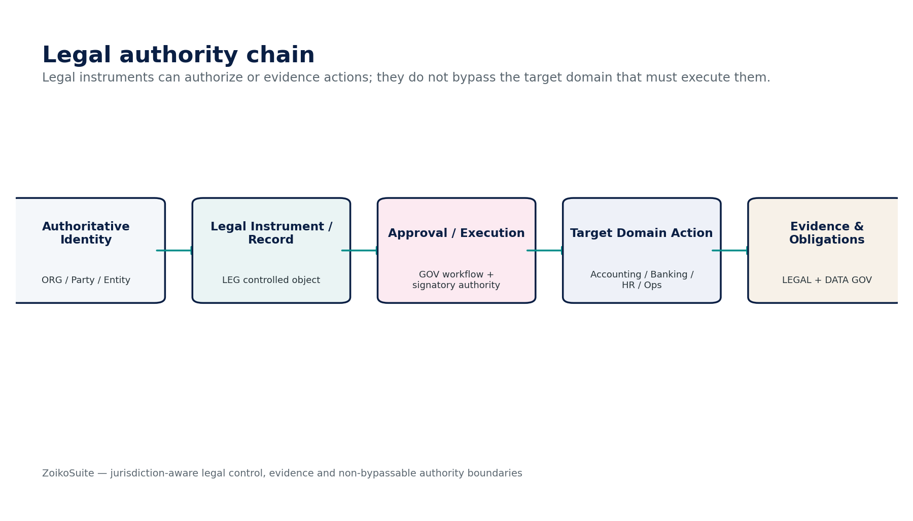
Figure 1 — Legal authority chain and target-domain execution boundary.
Critical decision — The Legal domain may record authority, consent, signature and obligation evidence, but protected business effects are executed only by the authoritative domain that owns the resulting fact.

1. Domain Scope, Service Inventory & Authority Model
ID | Service | Authoritative role
LEG-01 | Corporate Record | Govern corporate constitutional/statutory records, filings, certificates and evidence versions without replacing ORG-03 legal-entity identity.
LEG-02 | Director / Officer Register | Maintain effective-dated office appointments, resignations/removals, terms, consents and filing evidence linked to ORG identities.
LEG-03 | Shareholder / Ownership Register | Maintain statutory shareholding/capital events and registered ownership positions; feed certified ownership relationships to ORG-04.
LEG-04 | Board / Shareholder Resolution | Govern meeting/written-resolution proposals, quorum/eligibility, voting/consent, execution and authorization evidence.
LEG-05 | Contract Lifecycle | Govern drafting, negotiation, approval, execution, effectiveness, amendment, renewal, termination and archive of contracts.
LEG-06 | Clause Library | Maintain approved clause/template versions, playbooks, jurisdiction/language applicability and deviation controls.
LEG-07 | Contract Obligation | Track validated obligations, covenants, milestones, notice windows, renewals and completion/breach evidence.
LEG-08 | Electronic Signature Adapter | Create/track signature envelopes, authentication profiles, signing evidence, certificates/timestamps and provider outcomes.
LEG-09 | Legal Matter / Case | Manage matters/cases, parties, counsel, deadlines, restricted evidence, privilege classification, spend links and hold triggers.
LEG-10 | License / Permit Register | Manage operational permits/licenses, issuing authorities, conditions, scope, renewal/suspension/expiry and evidence.
LEG-11 | Intellectual Property Register | Maintain IP assets/rights, owners, filings, jurisdictions/classes, licenses/encumbrances, renewals and supporting evidence.
LEG-12 | Corporate Obligation Calendar | Resolve and track statutory/corporate/legal deadlines from jurisdiction profiles, instruments, permits, IP and governance events.

1.1 Non-bypassable Legal & Corporate Governance invariants
- No LEG service SHALL directly post journals, release payments, alter bank finality, change payroll results, grant IAM privileges or rewrite authoritative source-domain facts.
- Every legal object SHALL be tenant/entity scoped and linked to canonical ORG identities rather than duplicating uncontrolled party/entity records.
- Every protected legal instrument SHALL retain immutable version identity, digest/hash, source/provenance, effective dates and supersession relationships.
- Executed contracts/resolutions/filings SHALL NOT be edited in place; corrections SHALL use amendment, restatement, withdrawal, supersession or jurisdiction-approved correction processes.
- Board/shareholder voting SHALL use an effective-dated entitlement population and preserve quorum, eligibility, vote/consent and conflict evidence.
- Corporate actions requiring follow-on execution SHALL emit authorization evidence but SHALL NOT bypass the target domain command/approval controls.
- Signature envelopes SHALL bind to the exact approved document digest and signer/role set; protected document/signatory changes SHALL invalidate prior approval/signature workflow.
- Provider timeout or incomplete signature callback SHALL become Pending/Unknown until the original envelope is resolved.
- Clause and obligation AI extraction SHALL remain candidate data until validated; AI SHALL NOT determine enforceability or provide authoritative legal advice.
- Legal matter privilege/confidentiality classifications SHALL enforce need-to-know access independently of ordinary matter membership.
- Legal hold SHALL suspend disposition across in-scope copies/derivatives without creating new access rights.
- Corporate/legal deadlines SHALL be rule- and trigger-versioned; manual date changes SHALL require authority, reason and evidence.
- License/permit status SHALL NOT be inferred solely from date expiry when regulator suspension/revocation/extension state exists.
- IP rights SHALL preserve jurisdiction/office/source identifiers and status history; the platform SHALL NOT autonomously determine infringement, validity or ownership disputes.
- External filing/signature/registry provider acknowledgements SHALL remain separate from internal lifecycle state and legal effect.
- Cross-tenant/entity access, search, export and AI retrieval SHALL be blocked even when document identifiers are known.
- Retention/disposition SHALL follow ZS-DATA-GOV-001 and active legal holds; ordinary user delete SHALL never destroy protected legal evidence.
- Any legal/corporate rule with jurisdictional effect SHALL resolve through a versioned jurisdiction/profile artifact, not free-form application code.
- All material approvals SHALL preserve signer/approver authority basis and subject fingerprint.
- Legal AI features SHALL remain assistive and SHALL not autonomously approve contracts, resolutions, filings, permits, matters, IP actions or legal conclusions.
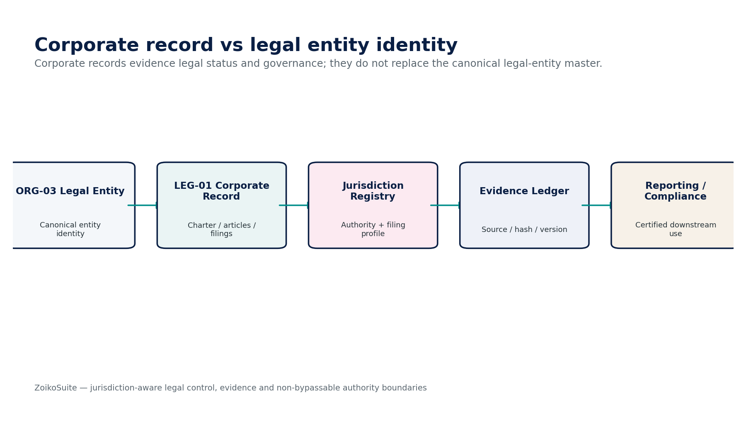
Figure 2 — Corporate record and canonical legal-entity identity separation.

1.2 Cross-domain authority matrix
Authority | Owns | Legal-domain boundary
ORG-03 / ORG-07 | Legal entity and party identity | LEG references canonical IDs; corporate instruments do not create duplicate identity masters.
ORG-04 | Operational group/ownership graph | LEG-03 supplies certified statutory ownership evidence; ORG-04 remains operational relationship authority.
ORG-09 | Entity registration identifier | LEG-10 owns operational permit/license conditions and lifecycle.
GOV-03 / GOV-04 / GOV-06 | Authorization, SoD, workflow | Legal approvals/resolutions rely on governance controls; they cannot self-authorize.
GOV-10 | Legal Hold | LEG-09 may trigger/request a hold; GOV-10 owns hold issuance/scope/release.
ACC / BNK / WFP / AR / AP | Financial and operational effects | Legal instruments authorize/evidence only; target domain executes and records authoritative result.
INT | External transport/provider adapters | LEG owns canonical signature/filing intent and outcome semantics; INT transports/translates.
DATA / AI | Extraction/search/RAG | May propose/classify/summarize; cannot create authoritative legal conclusions.

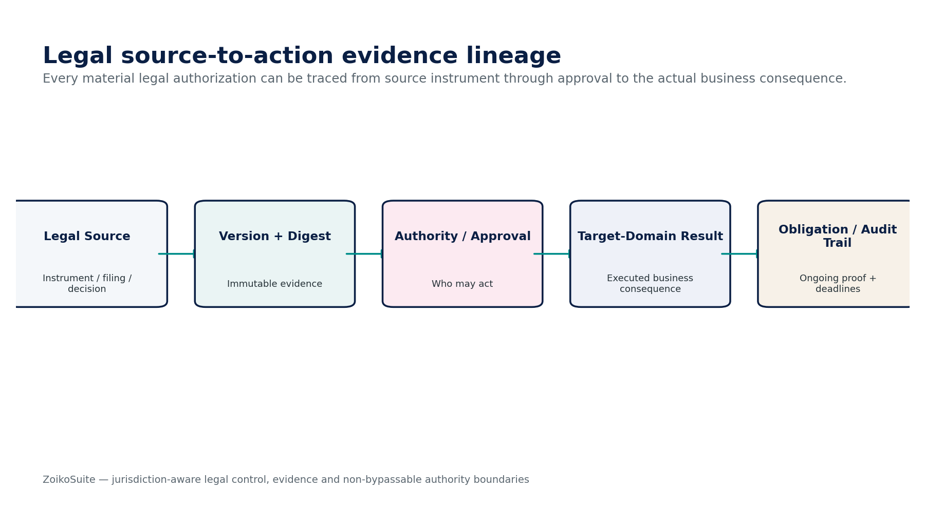
Figure 3 — Legal source-to-action evidence lineage.

2. Shared Legal Contract, Context & State Architecture

2.1 Trusted legal-command context
Field | Engineering requirement
tenant_id | GOV-01 resolved; never trusted from unverified client context.
legal_entity_id | ORG-03 authoritative entity; required for entity-scoped governance/contract/permit records.
jurisdiction_profile | Versioned jurisdiction/corporate-law/signature/filing profile resolved by server.
actor_subject | Authenticated human/workload identity plus role/delegation/authority context.
purpose | Approved legal/business purpose for sensitive matter/contract access.
effective_date | Legal effect date distinct from creation/submission/recording dates.
expected_version | Optimistic concurrency guard for material legal objects.
idempotency_key | Required for material commands and provider attempts.
evidence_context | Source object, file hash, signer/approval fingerprint and related matter/contract/resolution IDs.
retention_hold_context | Record class, retention policy and active hold state from governance layer.

2.2 Shared lifecycle dimensions
Dimension | States
Instrument lifecycle | Draft / Review / Approved / Executed / Effective / Superseded / Terminated / Archived
External submission | Not Submitted / Submitted / Pending-Unknown / Accepted / Rejected / Withdrawn
Signature | Not Requested / Sent / Partially Signed / Completed / Declined / Expired / Pending-Unknown / Voided
Obligation | Planned / Due / In Progress / Satisfied / Waived / Breached / Disputed / Superseded
Matter | Intake / Open / On Hold / Active / Settling / Closed / Archived
Permit/IP | Applied / Pending / Granted / Active / Suspended / Expired / Revoked / Abandoned / Renewed
Attention | Normal / Upcoming / Due / Overdue / Blocked / Escalated / Critical

Design rule — one overloaded status field is prohibited. Contract lifecycle, signature, external filing, obligation, dispute and attention states evolve independently.

2.3 Shared commands and stable errors
Command family | Contract
CreateDraft / Propose | Create governed candidate object; no protected external or legal effect.
SubmitForReview / Approve / Reject | GOV-controlled approval with protected subject fingerprint.
Execute / RecordExecution | Commit executed legal object only after signer/authority/form conditions pass.
Amend / Restate / Supersede | Create linked version; preserve prior executed artifact.
SubmitExternal / ResolveExternalOutcome | Create durable attempt; resolve Pending/Unknown before retry.
OpenMatter / CloseMatter | Matter lifecycle with hold, privilege and unresolved-obligation gates.
Schedule / Complete / WaiveObligation | Require owner, basis, evidence, authority and due-date provenance.
Archive / Dispose | Delegated to data-governance retention/hold resolution; ordinary delete prohibited.

Error | Meaning
LEGAL_CONTEXT_MISSING | Required entity/jurisdiction/legal-purpose context unavailable.
AUTHORITY_INSUFFICIENT | Actor lacks required corporate/signatory/delegated authority.
QUORUM_OR_ELIGIBILITY_FAILED | Required governance population/quorum/voter eligibility failed.
PROTECTED_SUBJECT_CHANGED | Approved/signed subject changed; reapproval/resign required.
FORM_REQUIREMENT_BLOCKED | Required execution/formality/signature/witness/notary rule unresolved.
EXTERNAL_OUTCOME_UNKNOWN | Provider/registry/authority state is ambiguous; original attempt must be resolved.
HOLD_OR_RETENTION_BLOCK | Disposition/edit prohibited by legal hold or retention policy.
PRIVILEGE_ACCESS_DENIED | Matter/document privilege/confidentiality policy denies access.
JURISDICTION_RULE_MISSING | No certified applicable rule/profile available.
CONFLICT_OR_SOD_FAILED | Maker-checker/conflict/SoD policy blocks action.

3. LEG-01 — Corporate Record
Contract field | Build-ready requirement
Purpose & authority | Own corporate constitutional/statutory documents, filing artifacts, certificates, record-book entries and evidence versions; does not own canonical Legal Entity identity.
Required inputs | ORG-03 Legal Entity; jurisdiction/registry profile; filed documents; resolutions; external registry acknowledgements.
Named commands | CreateCorporateRecord; RecordFiling; RecordCertificate; SupersedeRecord; WithdrawRecord; LinkRegistryAcknowledgement.
Queries / read surfaces | GetRecord; ListRecordBook; GetAsOfRecord; VerifyDigest; GetFilingHistory.
Lifecycle / state | Draft → Approved → Filed/Pending → Accepted/Rejected → Effective → Superseded/Archived.
Authorization / SoD | Corporate Secretary/Legal Administrator; maker-checker for filing/correction; no self-approval for material constitutional changes.
Canonical events | CorporateRecordCreated; FilingSubmitted; FilingAccepted; FilingRejected; CorporateRecordSuperseded.
Dependencies | ORG-03, REF-01, GOV-05/06/07/09/10, INT external registry adapter.
Failure / correction semantics | External filing timeout becomes Pending/Unknown; preserve source package and original submission attempt.
Evidence / retention | Constitutional documents, certificates, filing receipts, digests, effective dates, supersession chain; legal hold aware.

3.1 Mandatory service invariants
- Corporate constitutional/filing record content cannot overwrite ORG-03 entity identity fields without approved ORG change workflow.
- External registry acceptance/rejection remains separate from internal record creation and legal effective date.
- Historical corporate records remain reconstructable as of any effective/recording date.

4. LEG-02 — Director / Officer Register
Contract field | Build-ready requirement
Purpose & authority | Own statutory office relationship, appointment/resignation/removal/term/consent evidence; ORG owns person identity and IAM owns permissions.
Required inputs | ORG identity; LEG-04 resolution/consent basis; jurisdiction eligibility/filing profile; term/effective dates.
Named commands | ProposeAppointment; ApproveAppointment; RecordAppointment; RecordResignation; RemoveOfficer; RecordFiling.
Queries / read surfaces | GetOfficeHolder; ListBoardAsOf; ListOfficersAsOf; GetAppointmentEvidence.
Lifecycle / state | Proposed → Approved → Appointed → Active → Resigned/Removed/Expired → Archived.
Authorization / SoD | Corporate Secretary + authorized appointing body; conflict/SoD and authority checks; appointment does not grant application access.
Canonical events | OfficeAppointmentRecorded; OfficerResigned; OfficerRemoved; OfficerTermExpired.
Dependencies | ORG-01/06, LEG-04, GOV-03/04/06, REF-01, INT filing adapter.
Failure / correction semantics | Identity mismatch, unresolved eligibility or missing governance basis blocks appointment; late filing remains separate from office effectiveness where law permits.
Evidence / retention | Consent, resolution, term, role, authority basis, registry receipt and as-of board/officer composition.

4.1 Mandatory service invariants
- Appointment is a legal office relationship; it does not automatically create an IAM role or application permission.
- Eligibility, consent and governance basis are required where the jurisdiction/profile demands them.
- Resignation/removal never deletes prior office tenure from history.
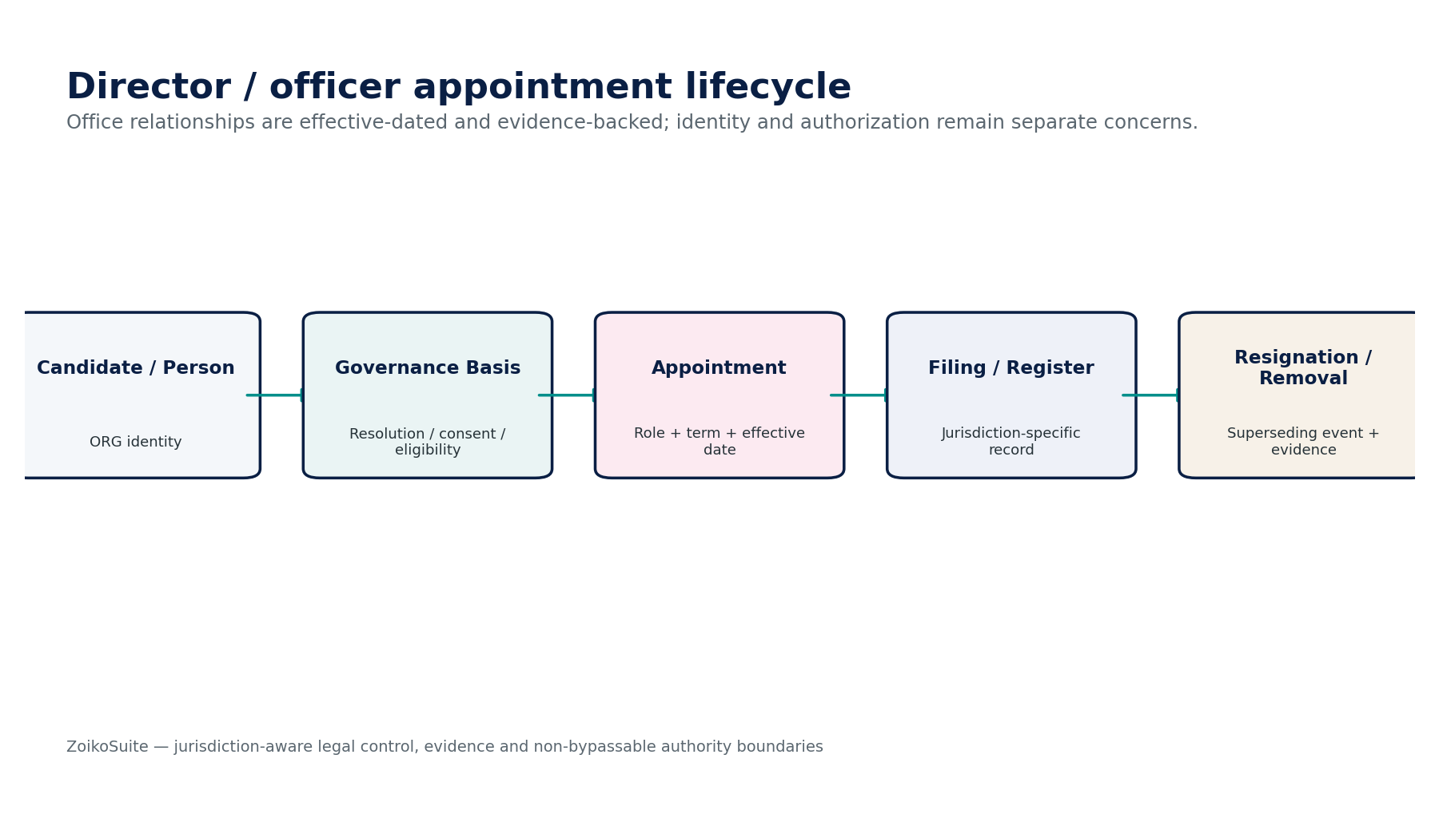
Figure 3 — Director / Officer Register control flow.

5. LEG-03 — Shareholder / Ownership Register
Contract field | Build-ready requirement
Purpose & authority | Own statutory share classes, issuances, transfers, cancellations and registered-holder positions; ORG-04 consumes certified relationships.
Required inputs | ORG parties; constitutional capital authority; LEG-04 approval; consideration/reference; jurisdiction rules; certificates/transfer instruments.
Named commands | CreateShareClass; IssueShares; TransferShares; CancelShares; RecordBeneficialOwnerEvidence; CertifyRegisterSnapshot.
Queries / read surfaces | GetCapTableAsOf; GetHolderPosition; GetShareClass; GetTransactionHistory; GetCertifiedOwnershipSnapshot.
Lifecycle / state | Proposed event → Approved → Effective → Registered → Superseded/Corrected.
Authorization / SoD | Corporate Secretary + finance/legal approvers; transferor/transferee conflicts and maker-checker as configured.
Canonical events | SharesIssued; SharesTransferred; SharesCancelled; OwnershipSnapshotCertified.
Dependencies | ORG-03/04/07, LEG-01/04, GOV-06/07, REF-01.
Failure / correction semantics | Negative/over-authorized positions, stale register version or missing approval block event; corrections are reversal/supersession, not row edits.
Evidence / retention | Share transaction instrument, approval, holder identity, class, quantity, effective/registration dates, certificates and reconciliation totals.

5.1 Mandatory service invariants
- Share-register quantities must reconcile by class; negative positions and unexplained issued-capital deltas are prohibited.
- ORG-04 group relationships are derived from certified ownership evidence but may include non-share control relationships separately.
- Beneficial-ownership evidence must be access-restricted and purpose-limited where sensitive.
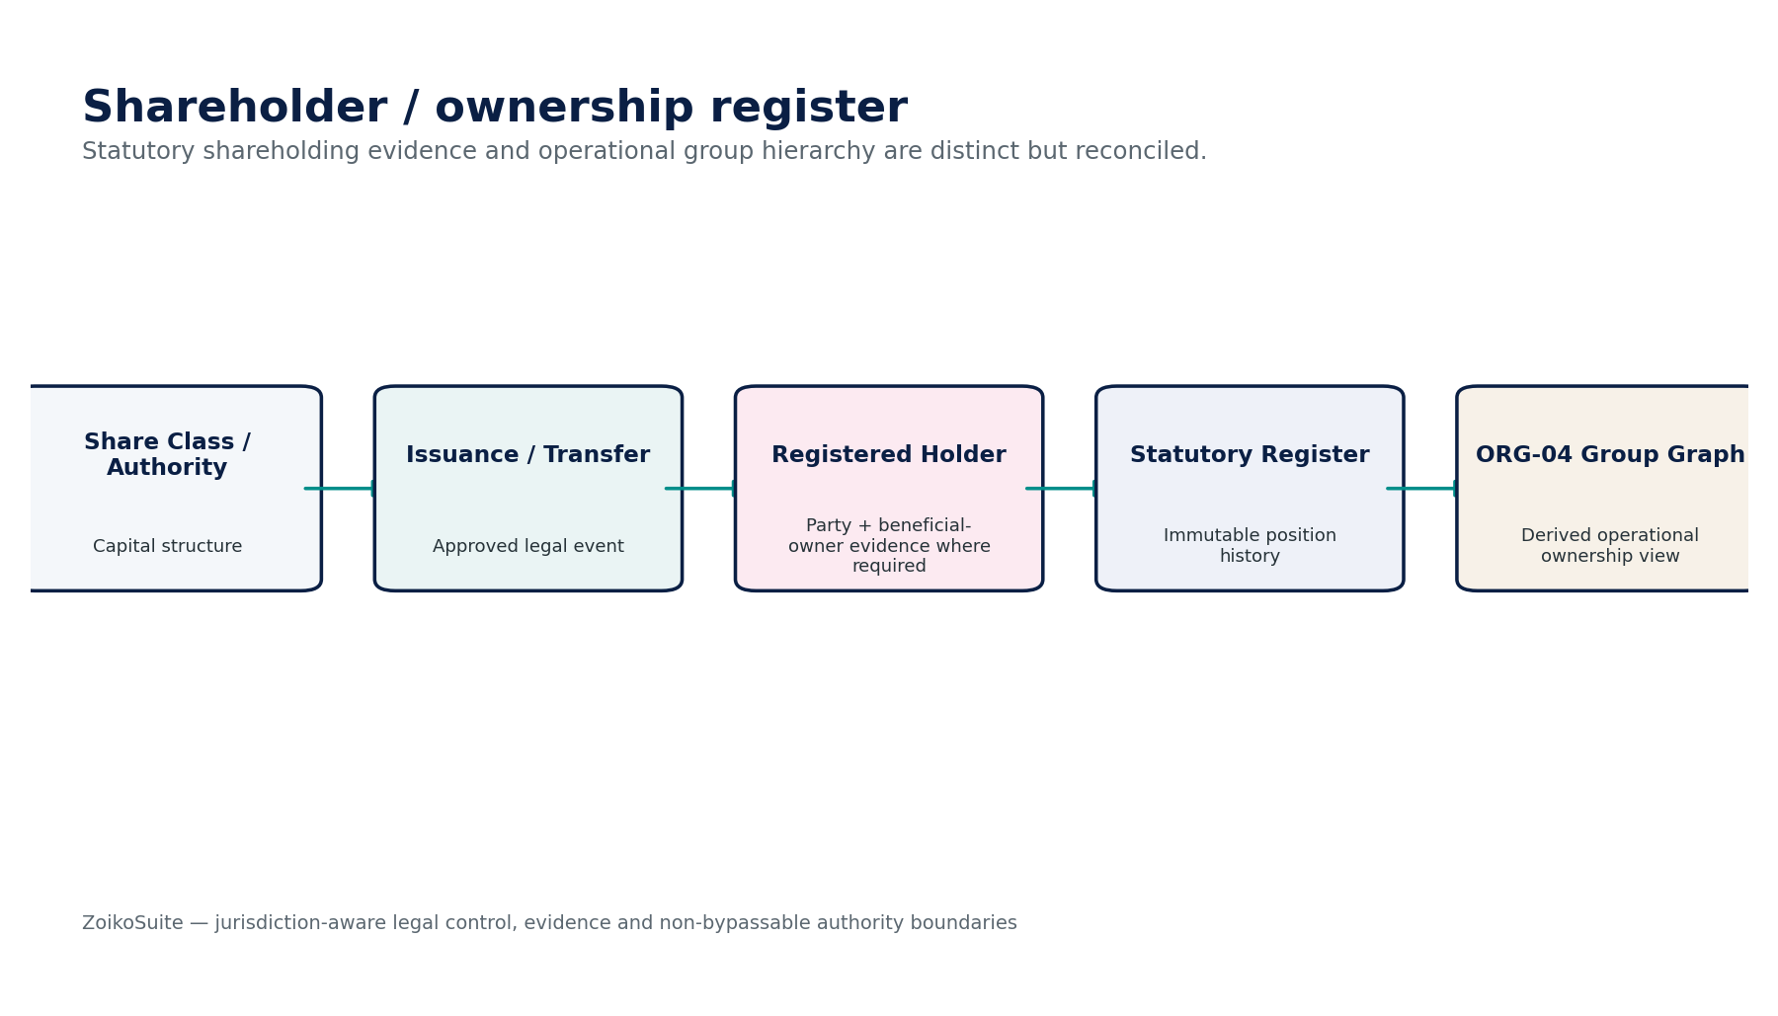
Figure 4 — Shareholder / Ownership Register control flow.

6. LEG-04 — Board / Shareholder Resolution
Contract field | Build-ready requirement
Purpose & authority | Own proposal, meeting/written-resolution record, entitlement population, quorum, vote/consent, final text, execution and authorization evidence.
Required inputs | Entity governance profile; directors/shareholders as-of; agenda/proposal; conflicts; quorum/voting rules; attachments.
Named commands | CreateResolution; OpenVoting; CastVote/RecordConsent; CloseVoting; ApproveMinutes; ExecuteResolution; SupersedeResolution.
Queries / read surfaces | GetResolution; GetVoterPopulation; GetVoteLedger; GetQuorumEvidence; GetResolutionEvidence.
Lifecycle / state | Draft → Proposed → Open → Passed/Failed → Executed → Effective → Superseded/Archived.
Authorization / SoD | Only eligible voters; conflicts/abstentions preserved; secretary may administer but cannot fabricate vote/consent.
Canonical events | ResolutionProposed; QuorumSatisfied; ResolutionPassed; ResolutionFailed; ResolutionExecuted.
Dependencies | LEG-02/03, ORG-03/06, GOV-03/04/06/07, REF-01.
Failure / correction semantics | Quorum failure, stale voter population or changed resolution text invalidates vote/approval; passed resolution does not execute target-domain action.
Evidence / retention | Frozen voter population, quorum rules, votes/consents, conflicts, final text digest, signatures, effective date and follow-on authorization references.

6.1 Mandatory service invariants
- Quorum and voter eligibility are evaluated against a frozen as-of entitlement population.
- Changing the resolution text after voting begins invalidates prior votes/approval unless jurisdiction rules explicitly permit a controlled amendment process.
- Passed resolution emits authorization evidence only; target action remains governed by owning domain.
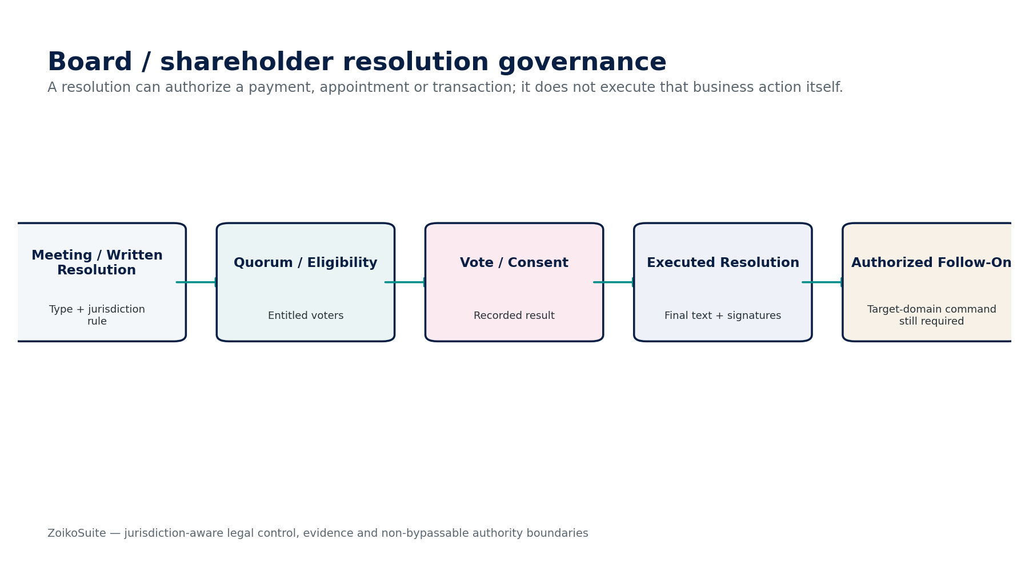
Figure 5 — Board / Shareholder Resolution control flow.

7. LEG-05 — Contract Lifecycle
Contract field | Build-ready requirement
Purpose & authority | Own contract document/version lifecycle, parties/roles, negotiation history, approval, execution, amendment, renewal, termination and archive.
Required inputs | ORG parties; business request; template/clause set; jurisdiction/governing-law profile; commercial terms; approval matrix; signature profile.
Named commands | CreateContract; CreateVersion; SubmitReview; ApproveContract; SendForSignature; RecordExecution; Amend; Renew; Terminate; Assign/Novate.
Queries / read surfaces | GetContract; GetVersion; CompareVersions; ListParties; GetApprovalTrail; GetExecutedArtifact.
Lifecycle / state | Draft → Review/Negotiation → Approved → Signature Pending → Executed → Effective → Amended/Renewed/Terminated/Expired → Archived.
Authorization / SoD | Legal + business owner + delegated signatory; finance/security/privacy/procurement reviews triggered by policy; self-approval blocked.
Canonical events | ContractCreated; ContractApproved; ContractExecuted; ContractAmended; ContractRenewed; ContractTerminated.
Dependencies | LEG-06/07/08, ORG-07, GOV-05/06/07/09/10, TAX/AR/AP/SEC as review dependencies.
Failure / correction semantics | Protected terms or final document digest changed after approval invalidates approval/signature workflow; execution provider unknown remains Pending/Unknown.
Evidence / retention | Every version/redline, approvals, executed artifact, signatures, party authority, governing profile, obligations and supersession chain.

7.1 Mandatory service invariants
- Contract version approved for signature is immutable; any protected change creates a new version and invalidates prior approvals.
- Commercial, tax, security/privacy and financial-review gates are policy-driven by contract type/risk.
- Termination/expiry does not erase surviving obligations, confidentiality, IP or record-retention requirements.
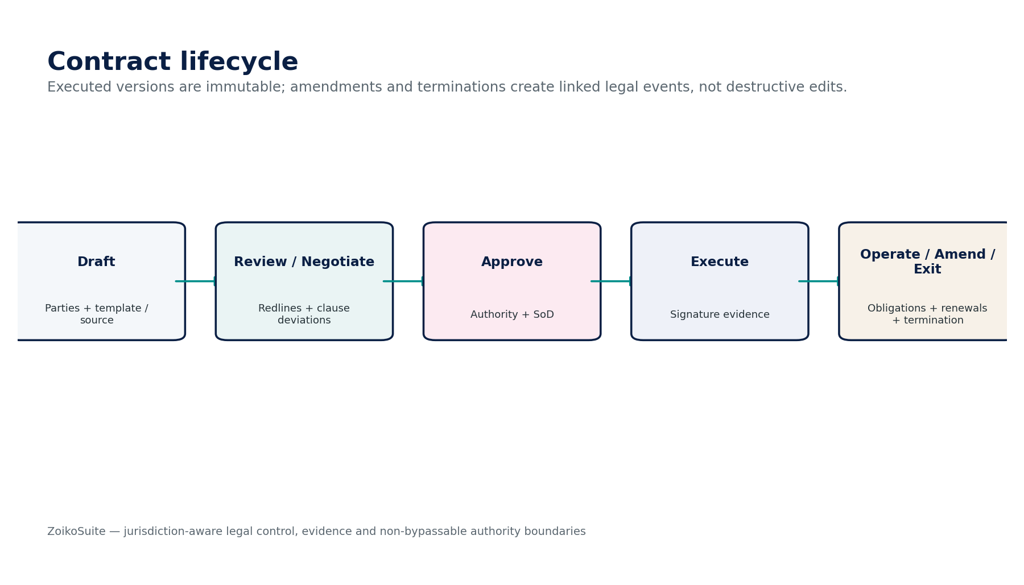
Figure 6 — Contract Lifecycle control flow.

8. LEG-06 — Clause Library
Contract field | Build-ready requirement
Purpose & authority | Own approved clause/template/playbook versions, jurisdiction/language applicability, fallback positions and deviation approval requirements.
Required inputs | Legal-authored clause text; policy tags; jurisdiction; contract type; risk classification; approval owner; effective dates.
Named commands | CreateClause; CreateClauseVersion; ApproveClause; RetireClause; CreateTemplate; ApproveDeviationRule.
Queries / read surfaces | FindApprovedClause; GetClauseAsOf; CompareClauseVersions; GetPlaybook; ListDeviationRules.
Lifecycle / state | Draft → Legal Review → Approved → Active → Retired/Superseded.
Authorization / SoD | Legal content owners; maker-checker for approved standard language; AI cannot approve legal text.
Canonical events | ClauseVersionApproved; ClauseRetired; TemplateApproved; DeviationRuleChanged.
Dependencies | GOV-05/06, REF-01, LEG-05, DATA/AI.
Failure / correction semantics | Missing applicable clause/version or conflicting jurisdiction playbook blocks auto-assembly; historical contracts retain original clause versions.
Evidence / retention | Author, reviewer, clause text hash, jurisdiction/language, risk/playbook metadata, effective dates and approval trail.

8.1 Mandatory service invariants
- Approved clause versions are effective-dated; existing executed contracts retain the clause version actually executed.
- Clause deviations require risk/playbook classification and accountable approval.
- LLM-generated draft language can never be promoted to approved clause status without human legal review.
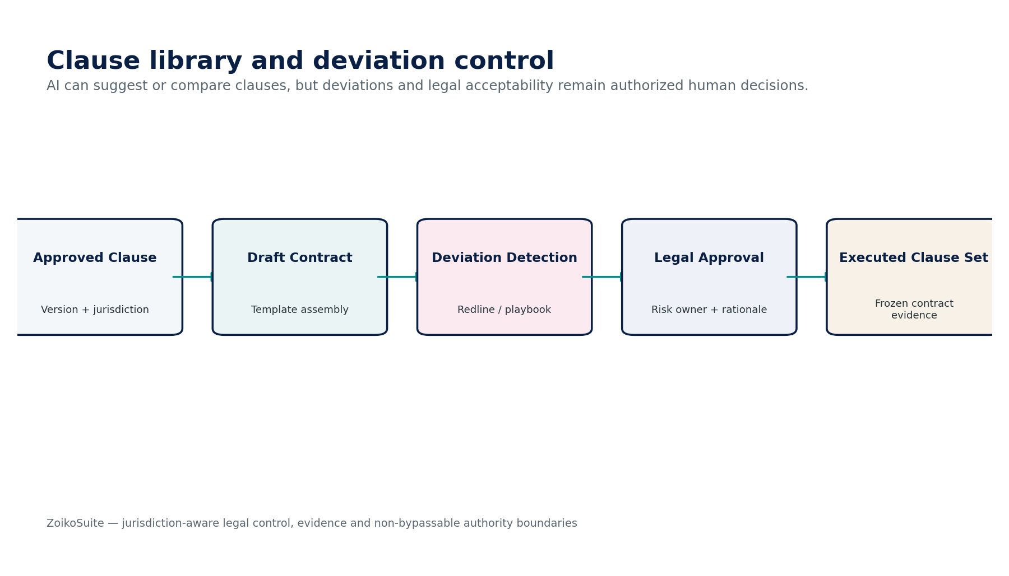
Figure 7 — Clause Library control flow.

9. LEG-07 — Contract Obligation
Contract field | Build-ready requirement
Purpose & authority | Own validated obligation/milestone/covenant/notice/renewal records derived from executed contracts and their completion/breach evidence.
Required inputs | Executed LEG-05 version; validated clause/obligation candidate; trigger; due calculation; owner; dependencies; waiver authority.
Named commands | CreateObligation; ValidateExtractedObligation; Schedule; Complete; Waive; RecordBreach; Dispute; Supersede.
Queries / read surfaces | ListObligations; GetDueSchedule; GetEvidence; GetContractObligationMap; GetOverdueCritical.
Lifecycle / state | Planned → Active → Due → In Progress → Satisfied/Waived/Breached/Disputed/Superseded.
Authorization / SoD | Business/legal obligation owner; waiver requires delegated authority and may require finance/compliance approval.
Canonical events | ObligationActivated; ObligationDue; ObligationSatisfied; ObligationBreached; ObligationWaived.
Dependencies | LEG-05/12, REF-10 calendar, GOV-05/06/07, DATA/AI extraction.
Failure / correction semantics | AI extraction cannot activate obligation without validation; trigger/date ambiguity blocks due-date certification.
Evidence / retention | Source clause/evidence span, trigger logic, due-date provenance, owner, notices, completion/breach/waiver evidence and audit trail.

9.1 Mandatory service invariants
- Obligation due dates retain source clause, trigger and calculation method.
- Waiver is distinct from satisfaction and requires documented authority.
- Breach status does not automatically create financial accrual, payment or legal remedy; target domains act separately.
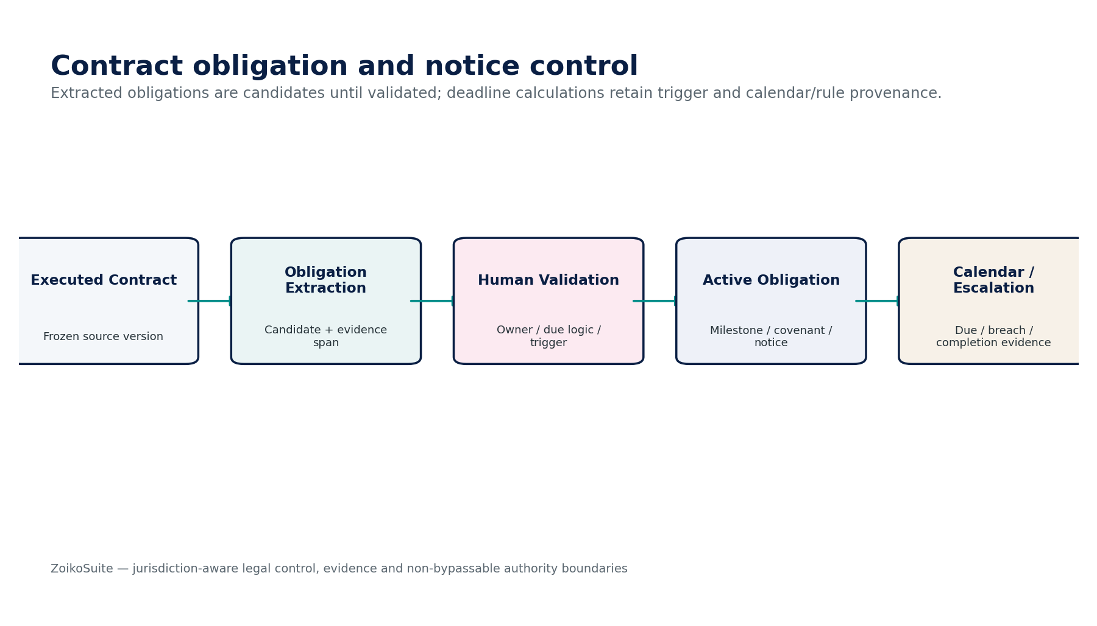
Figure 8 — Contract Obligation control flow.

10. LEG-08 — Electronic Signature Adapter
Contract field | Build-ready requirement
Purpose & authority | Own signature-envelope intent, provider attempts, signer/authentication profile, status evidence, signed artifact/certificate/timestamp metadata; not legal validity.
Required inputs | Approved final document digest; signer identities/roles; signing authority; required auth/witness/notary profile; provider configuration.
Named commands | CreateEnvelope; SendEnvelope; VoidEnvelope; RefreshStatus; ResolveUnknownOutcome; VerifySignedArtifact.
Queries / read surfaces | GetEnvelope; GetSignerStatus; GetAuditTrail; GetCertificateValidation; GetSignedArtifact.
Lifecycle / state | Draft → Sent → In Progress → Completed/Declined/Expired/Voided/Pending-Unknown.
Authorization / SoD | Only approved contract/resolution versions; signer authority separately validated; adapter operator cannot substitute signers.
Canonical events | SignatureEnvelopeCreated; SignatureCompleted; SignatureDeclined; SignatureOutcomeUnknown; SignedArtifactVerified.
Dependencies | LEG-04/05, ORG identity, GOV-03/06/07, INT provider adapter, SEC crypto.
Failure / correction semantics | Provider timeout = Pending/Unknown; changed document digest/signer set invalidates envelope; expired/revoked certificate produces review/block per profile.
Evidence / retention | Exact signed artifact, provider audit trail, signer/authentication events, timestamps, certificate chain/status, document digest and envelope IDs.

10.1 Mandatory service invariants
- Envelope must cryptographically bind to the exact approved document digest and signer set.
- Electronic signature legal effect is jurisdiction/form-specific; adapter status is evidence, not universal validity.
- Unknown provider outcome must be resolved on the original envelope before re-sending or creating a replacement.
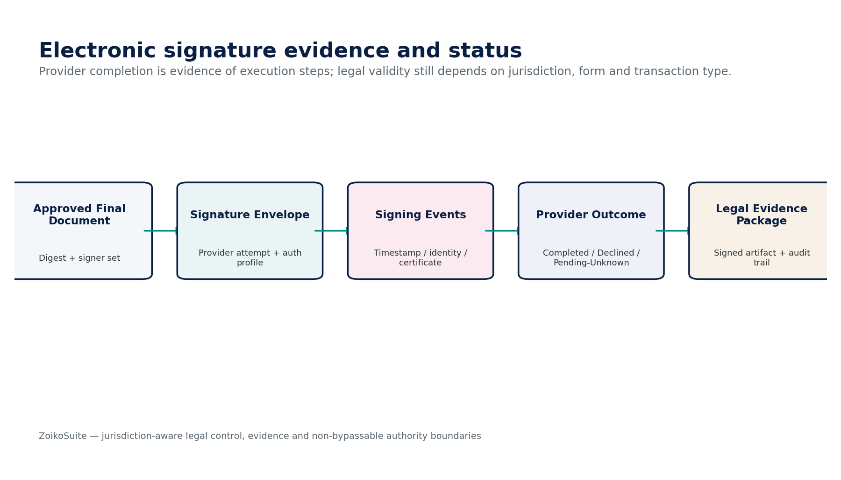
Figure 9 — Electronic Signature Adapter control flow.

11. LEG-09 — Legal Matter / Case
Contract field | Build-ready requirement
Purpose & authority | Own matter metadata, parties/counsel, issues, deadlines, strategy/workstream records, restricted evidence links, privilege/confidentiality, settlements and closure evidence.
Required inputs | Intake request; ORG parties; counsel; jurisdiction/forum; matter type; source documents; hold/retention triggers; budget/spend links.
Named commands | OpenMatter; AssignCounsel; AddIssue; AddDeadline; ClassifyPrivilege; RequestLegalHold; RecordSettlement; CloseMatter; ReopenMatter.
Queries / read surfaces | GetMatter; ListDeadlines; GetRestrictedEvidence; GetCounsel; GetMatterTimeline; GetHoldStatus.
Lifecycle / state | Intake → Open → Active/On Hold → Settling → Closed → Archived; reopen creates controlled state transition.
Authorization / SoD | Need-to-know access; privilege compartments; external counsel access time/scope bounded; spend approvals delegated to AP/finance.
Canonical events | MatterOpened; PrivilegeClassChanged; HoldRequested; SettlementRecorded; MatterClosed.
Dependencies | GOV-10, DATA GOV, ORG-07, AP for legal spend, LEG-12, INT secure exchange.
Failure / correction semantics | Privilege/confidentiality denial overrides ordinary matter membership; closure blocked by active obligations/hold requirements as configured.
Evidence / retention | Matter intake, issues, counsel, privileged/restricted classifications, deadlines, evidence references, settlement/closure basis and hold history.

11.1 Mandatory service invariants
- Privilege/confidentiality access is evaluated independently from ordinary matter role.
- Requesting a legal hold routes to GOV-10; LEG-09 does not self-implement hold semantics.
- Matter closure cannot destroy or relax retained evidence, surviving obligations or hold restrictions.
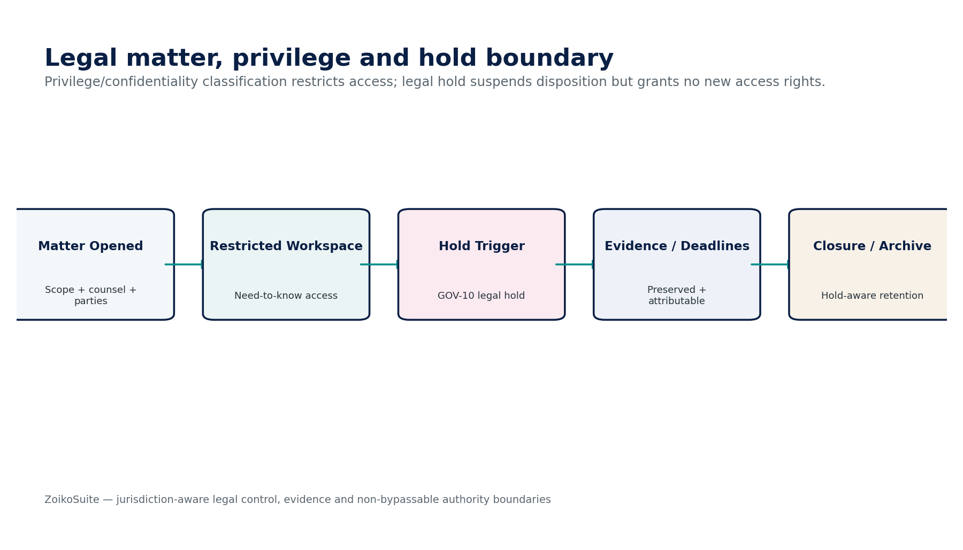
Figure 10 — Legal Matter / Case control flow.

12. LEG-10 — License / Permit Register
Contract field | Build-ready requirement
Purpose & authority | Own operational permit/license application, issuance, scope, conditions, reporting duties, renewal, suspension, revocation and expiry.
Required inputs | ORG-03 entity; ORG-09 registration identifier where applicable; authority; jurisdiction; activity/location; conditions; evidence.
Named commands | CreatePermitRecord; SubmitApplication; RecordGrant; RecordCondition; Renew; Suspend; Revoke; RecordExpiry.
Queries / read surfaces | GetPermit; ListActivePermits; ListConditions; GetRenewalSchedule; GetAuthorityEvidence.
Lifecycle / state | Draft/Application → Pending → Granted/Active → Renewing → Suspended/Expired/Revoked/Abandoned.
Authorization / SoD | Legal/compliance owner; regulated operations may require maker-checker; platform cannot infer continued validity solely from internal dates.
Canonical events | PermitGranted; PermitConditionChanged; PermitRenewalDue; PermitSuspended; PermitExpired; PermitRevoked.
Dependencies | ORG-03/09, REF-01, LEG-12, GOV-05/06/07, INT authority adapter.
Failure / correction semantics | Authority status conflicts or unknown external response create Review/Pending-Unknown; expired permit may block configured operations via GOV policy.
Evidence / retention | Authority-issued artifact, scope/conditions, dates, filings, inspection evidence, status acknowledgements and renewal history.

12.1 Mandatory service invariants
- Authority status evidence outranks internally calculated expiry when they conflict.
- Permit conditions can emit governance/compliance obligations but do not directly alter operational configuration unless GOV policy maps them.
- Renewal is a new controlled event; it never edits the original issued term.
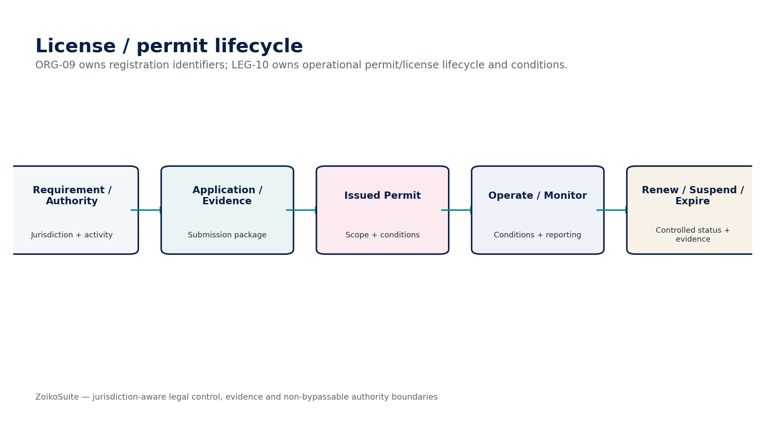
Figure 11 — License / Permit Register control flow.

13. LEG-11 — Intellectual Property Register
Contract field | Build-ready requirement
Purpose & authority | Own IP asset/right records, filings, territories/classes, registered owner, licenses/encumbrances, renewals, status evidence and linked works/inventions.
Required inputs | ORG owner/creator; IP type; jurisdiction/office; application/registration number; classes; priority/filing dates; license documents.
Named commands | CreateIPAsset; RecordApplication; RecordRegistration; RecordAssignment; RecordLicense; Renew; Abandon; RecordExpiry.
Queries / read surfaces | GetIPAsset; ListRightsByTerritory; GetRenewalSchedule; GetOwnershipHistory; GetLicenseMap.
Lifecycle / state | Idea/Unregistered → Filed → Pending → Registered/Granted → Active → Renewed/Expired/Abandoned/Cancelled.
Authorization / SoD | IP/legal owner; assignment/license approval per authority; no AI determination of infringement/validity/title disputes.
Canonical events | IPApplicationFiled; IPRightGranted; IPOwnershipChanged; IPRenewalDue; IPExpired.
Dependencies | ORG-07, LEG-05/12, REF-01, GOV-06/07, INT IP-office adapters.
Failure / correction semantics | Conflicting ownership/office status or missing source evidence creates review state; renewal action cannot fabricate authority acceptance.
Evidence / retention | Filing/registration artifacts, office identifiers, owner chain, priority, class/territory, license/encumbrance and renewal evidence.

13.1 Mandatory service invariants
- IP ownership chain and office status are evidence records; disputes/infringement conclusions remain outside automated authority.
- Licenses/assignments link to executed LEG-05 contracts where applicable.
- Renewal deadlines preserve jurisdiction/office rule provenance and filing evidence.
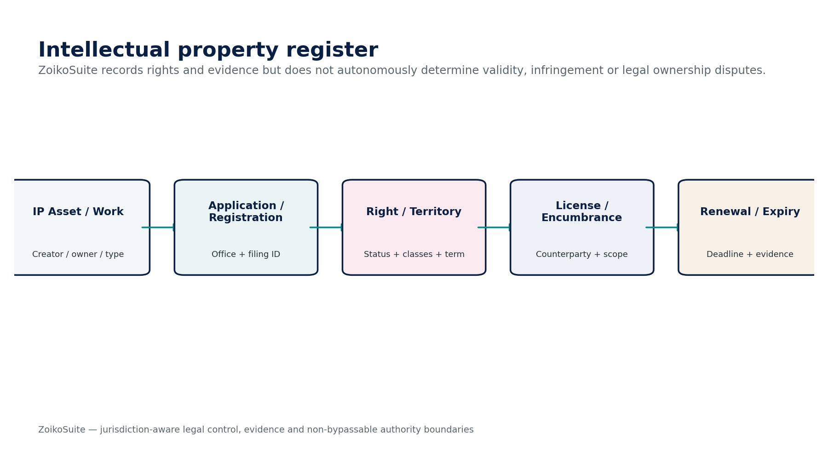
Figure 12 — Intellectual Property Register control flow.

14. LEG-12 — Corporate Obligation Calendar
Contract field | Build-ready requirement
Purpose & authority | Own resolved corporate/legal deadline instances and escalation state derived from jurisdiction profiles and authoritative source obligations.
Required inputs | Jurisdiction pack; LEG-01/02/03/04/07/09/10/11 events; REF-10 business calendar; authority-specific filing calendar.
Named commands | GenerateObligation; Recalculate; AssignOwner; Escalate; RecordCompletion; WaiveWherePermitted; SupersedeDeadline.
Queries / read surfaces | ListCalendar; GetUpcoming; GetOverdue; GetDeadlineProvenance; GetCompletionEvidence.
Lifecycle / state | Planned → Upcoming → Due → Completed/Waived/Overdue/Blocked/Superseded.
Authorization / SoD | Corporate Secretary/Legal/Compliance owners; manual due-date override requires documented authority and reason.
Canonical events | LegalDeadlineCreated; LegalDeadlineDue; LegalDeadlineOverdue; LegalDeadlineCompleted.
Dependencies | ZS-JUR, REF-10, LEG source services, GOV-05/06/07, notifications.
Failure / correction semantics | Missing/ambiguous rule or trigger blocks certified due date; timezone/business-day adjustment retains original statutory date and calculation provenance.
Evidence / retention | Rule/source version, trigger event, base due date, calendar adjustment, owner, reminders/escalations and completion/filing evidence.

14.1 Mandatory service invariants
- Deadlines are derived, not free-form reminders; every certified deadline has source rule/obligation/trigger provenance.
- Manual override requires reason, authority and preserved original due date.
- Completion must reference filing/meeting/notice/renewal evidence, not a checkbox alone.

15. Cross-Service Data Model, APIs, Events & Evidence
Canonical object | Purpose
LegalInstrument | Common immutable/versioned base for corporate records, resolutions, contracts, filings and certificates.
CorporateRecord | Constitutional/statutory record instance plus filing/registry metadata.
OfficeAppointment | Person-to-office relationship with term/effective dates and evidence.
ShareClass / ShareTransaction / OwnershipPosition | Capital structure, legal events and as-of holder positions.
Resolution / Vote / Consent | Governance proposal, entitlement population, vote record and executed resolution.
Contract / ContractVersion / ContractParty | Contract identity, immutable version and party-role structure.
ClauseVersion / Deviation | Approved clause text/version and negotiated deviation decision.
ContractObligation | Validated obligation, trigger, due logic, status and evidence.
SignatureEnvelope / SignatureEvidence | Provider attempt, signer status, certificate/timestamp and signed artifact.
LegalMatter | Matter/case identity, privilege/confidentiality, counsel, issues and deadlines.
PermitLicense | Operational permit/license, conditions, authority status and renewal evidence.
IPAsset / IPRight | Underlying IP asset and jurisdiction-specific right/application/registration.
LegalDeadline | Resolved statutory/corporate/legal obligation instance with provenance.
LegalEvidenceManifest | Source digests, approvals, signatures, external acknowledgements and target-domain references.

15.1 Canonical Legal events
Event | Minimum payload
CorporateRecordFiled | event_id, tenant_id, legal_entity_id, aggregate_id, aggregate_version, occurred_at, effective_at where applicable, actor/causation, evidence_ref, jurisdiction/profile version
CorporateRecordAccepted | event_id, tenant_id, legal_entity_id, aggregate_id, aggregate_version, occurred_at, effective_at where applicable, actor/causation, evidence_ref, jurisdiction/profile version
OfficeAppointmentRecorded | event_id, tenant_id, legal_entity_id, aggregate_id, aggregate_version, occurred_at, effective_at where applicable, actor/causation, evidence_ref, jurisdiction/profile version
OfficerResigned | event_id, tenant_id, legal_entity_id, aggregate_id, aggregate_version, occurred_at, effective_at where applicable, actor/causation, evidence_ref, jurisdiction/profile version
SharesIssued | event_id, tenant_id, legal_entity_id, aggregate_id, aggregate_version, occurred_at, effective_at where applicable, actor/causation, evidence_ref, jurisdiction/profile version
SharesTransferred | event_id, tenant_id, legal_entity_id, aggregate_id, aggregate_version, occurred_at, effective_at where applicable, actor/causation, evidence_ref, jurisdiction/profile version
OwnershipSnapshotCertified | event_id, tenant_id, legal_entity_id, aggregate_id, aggregate_version, occurred_at, effective_at where applicable, actor/causation, evidence_ref, jurisdiction/profile version
ResolutionPassed | event_id, tenant_id, legal_entity_id, aggregate_id, aggregate_version, occurred_at, effective_at where applicable, actor/causation, evidence_ref, jurisdiction/profile version
ResolutionExecuted | event_id, tenant_id, legal_entity_id, aggregate_id, aggregate_version, occurred_at, effective_at where applicable, actor/causation, evidence_ref, jurisdiction/profile version
ContractApproved | event_id, tenant_id, legal_entity_id, aggregate_id, aggregate_version, occurred_at, effective_at where applicable, actor/causation, evidence_ref, jurisdiction/profile version
ContractExecuted | event_id, tenant_id, legal_entity_id, aggregate_id, aggregate_version, occurred_at, effective_at where applicable, actor/causation, evidence_ref, jurisdiction/profile version
ContractAmended | event_id, tenant_id, legal_entity_id, aggregate_id, aggregate_version, occurred_at, effective_at where applicable, actor/causation, evidence_ref, jurisdiction/profile version
ContractTerminated | event_id, tenant_id, legal_entity_id, aggregate_id, aggregate_version, occurred_at, effective_at where applicable, actor/causation, evidence_ref, jurisdiction/profile version
ObligationDue | event_id, tenant_id, legal_entity_id, aggregate_id, aggregate_version, occurred_at, effective_at where applicable, actor/causation, evidence_ref, jurisdiction/profile version
ObligationSatisfied | event_id, tenant_id, legal_entity_id, aggregate_id, aggregate_version, occurred_at, effective_at where applicable, actor/causation, evidence_ref, jurisdiction/profile version
SignatureCompleted | event_id, tenant_id, legal_entity_id, aggregate_id, aggregate_version, occurred_at, effective_at where applicable, actor/causation, evidence_ref, jurisdiction/profile version
SignatureOutcomeUnknown | event_id, tenant_id, legal_entity_id, aggregate_id, aggregate_version, occurred_at, effective_at where applicable, actor/causation, evidence_ref, jurisdiction/profile version
MatterOpened | event_id, tenant_id, legal_entity_id, aggregate_id, aggregate_version, occurred_at, effective_at where applicable, actor/causation, evidence_ref, jurisdiction/profile version
HoldRequested | event_id, tenant_id, legal_entity_id, aggregate_id, aggregate_version, occurred_at, effective_at where applicable, actor/causation, evidence_ref, jurisdiction/profile version
PermitGranted | event_id, tenant_id, legal_entity_id, aggregate_id, aggregate_version, occurred_at, effective_at where applicable, actor/causation, evidence_ref, jurisdiction/profile version
PermitSuspended | event_id, tenant_id, legal_entity_id, aggregate_id, aggregate_version, occurred_at, effective_at where applicable, actor/causation, evidence_ref, jurisdiction/profile version
IPRightGranted | event_id, tenant_id, legal_entity_id, aggregate_id, aggregate_version, occurred_at, effective_at where applicable, actor/causation, evidence_ref, jurisdiction/profile version
IPRenewalDue | event_id, tenant_id, legal_entity_id, aggregate_id, aggregate_version, occurred_at, effective_at where applicable, actor/causation, evidence_ref, jurisdiction/profile version
LegalDeadlineOverdue | event_id, tenant_id, legal_entity_id, aggregate_id, aggregate_version, occurred_at, effective_at where applicable, actor/causation, evidence_ref, jurisdiction/profile version

15.2 Integration and provider boundary
- Every external registry, signature, court/filing, IP-office or permit provider interaction creates a durable attempt before network side effect where replay could duplicate or alter legal state.
- Callback authenticity, replay protection, provider object ID, payload hash, received timestamp and ordering metadata are mandatory.
- Transport success is not equivalent to authority acceptance or legal effectiveness.
- External adapters translate provider-specific formats only; canonical legal meaning remains in LEG services.

Figure 14 — Electronic signature evidence and provider-status boundary.

16. Canonical Legal Control Catalogue
Control ID | Control | Engineering assertion
LEG-CTRL-001 | Entity/party identity integrity | Every legal object references canonical ORG identities; no uncontrolled duplicate legal-party master.
LEG-CTRL-002 | Immutable executed instrument | Executed legal instrument cannot be edited in place.
LEG-CTRL-003 | Approval fingerprint | Protected subject hash binds approvals to exact version/parties/terms.
LEG-CTRL-004 | Signatory authority | Signer authority/delegation verified as-of execution.
LEG-CTRL-005 | Resolution quorum | Frozen entitlement population + quorum/vote evidence required.
LEG-CTRL-006 | Resolution follow-on separation | Resolution cannot directly perform target-domain action.
LEG-CTRL-007 | Ownership reconciliation | Share transactions reconcile issued/cancelled/outstanding positions by class.
LEG-CTRL-008 | Office register as-of | Appointments/resignations reconstructable at any effective date.
LEG-CTRL-009 | Clause version control | Approved clause/template/playbook version effective-dated.
LEG-CTRL-010 | Deviation approval | Material clause deviation requires accountable approval/rationale.
LEG-CTRL-011 | Contract version immutability | Approved/executed version immutable; amendment creates new version.
LEG-CTRL-012 | Contract survival terms | Termination/expiry preserves surviving obligations/records.
LEG-CTRL-013 | Obligation source trace | Every obligation links to source clause/instrument/evidence span.
LEG-CTRL-014 | Deadline provenance | Every certified due date retains rule/trigger/calendar/timezone provenance.
LEG-CTRL-015 | Waiver authority | Waiver separate from satisfaction and requires authority.
LEG-CTRL-016 | Signature digest binding | Envelope binds to exact document digest and signer set.
LEG-CTRL-017 | Signature unknown handling | Provider ambiguity remains Pending/Unknown and is resolved before retry.
LEG-CTRL-018 | Signature evidence integrity | Signed artifact/audit trail/certificate/timestamps preserved.
LEG-CTRL-019 | Privilege compartment | Privileged/restricted matter evidence requires need-to-know authorization.
LEG-CTRL-020 | Legal hold routing | Matter triggers route to GOV-10; scope/release controlled there.
LEG-CTRL-021 | Permit authority evidence | Permit status and conditions backed by authority/source evidence.
LEG-CTRL-022 | Permit expiry/suspension gate | Configured regulated operations can be blocked by effective status via GOV policy.
LEG-CTRL-023 | IP source evidence | IP application/registration/status backed by office/source evidence.
LEG-CTRL-024 | IP renewal provenance | Renewal deadline tied to office/jurisdiction rule and right status.
LEG-CTRL-025 | External filing attempt | Durable attempt/evidence before retriable registry/authority submission.
LEG-CTRL-026 | External callback verification | Authenticated, deduplicated, ordered callback handling.
LEG-CTRL-027 | Retention/hold enforcement | No destructive delete of protected legal evidence.
LEG-CTRL-028 | Cross-tenant isolation | Legal docs/matters/search/exports enforce tenant/entity/field authorization.
LEG-CTRL-029 | AI legal-authority boundary | AI cannot approve, conclude enforceability or execute protected legal actions.
LEG-CTRL-030 | Target-domain reauthorization | Legal authorization evidence never bypasses target domain policy/SoD.
LEG-CTRL-031 | Registry-vs-internal state | Internal workflow state separated from registry/authority acceptance.
LEG-CTRL-032 | Effective vs recorded date | Legal effective date distinct from creation/filing/recording timestamps.
LEG-CTRL-033 | As-of reconstruction | Corporate/ownership/officer/contract states reconstructable historically.
LEG-CTRL-034 | Evidence manifest | Material legal action has source digests, approvals, signatures and downstream references.
LEG-CTRL-035 | Disposition certificate | Disposition only after retention/hold resolution with evidence.
LEG-CTRL-036 | Jurisdiction profile version | Material legal/form/deadline rule pins exact profile version.
LEG-CTRL-037 | Conflicts/SoD | Conflict and maker-checker policies applied to material legal actions.
LEG-CTRL-038 | Sensitive beneficial ownership | Purpose-limited/field-restricted access to beneficial-owner data.
LEG-CTRL-039 | Export minimization | Legal export packages apply least-necessary disclosure and manifest/integrity seal.
LEG-CTRL-040 | Operational observability | Deadline misses, external unknowns, signature anomalies and policy blocks are observable/runbook-backed.

17. Negative-Path Engineering Certification
Test | Negative path | Expected control outcome
T01 | Cross-tenant contract ID guessed | Deny without metadata leakage; security event.
T02 | Corporate record attempts to overwrite ORG-03 legal name | Reject; route to ORG change workflow.
T03 | Director appointment with missing resolution/authority | Block appointment.
T04 | Appointment completed but IAM role auto-created | Fail: office relationship must not grant application privilege.
T05 | Resignation deletes historic director record | Fail; preserve tenure and superseding event.
T06 | Share issue exceeds authorized capital/profile | Block and surface policy error.
T07 | Share transfer produces negative holder position | Block transaction atomically.
T08 | Ownership register changed after certified snapshot without new version | Fail; invalidate downstream snapshot.
T09 | Resolution vote uses stale entitlement population | Reject/reperform vote.
T10 | Resolution quorum not satisfied | Cannot pass/execute.
T11 | Resolution text edited after votes collected | Invalidate votes/approval unless controlled jurisdiction-specific amendment flow.
T12 | Passed resolution directly releases payment | Fail; Banking/AP target command required.
T13 | Contract approved then protected term changed | Invalidate approval; new version/review.
T14 | Signature envelope created from non-final contract digest | Block.
T15 | Executed contract edited in place | Block; use amendment/restatement.
T16 | Terminated contract obligations all auto-closed | Fail; surviving obligations remain.
T17 | AI-generated clause promoted to approved clause without legal review | Block.
T18 | Historical contract clause silently updates to new library version | Fail; preserve executed version.
T19 | Material clause deviation lacks approval rationale | Block execution.
T20 | AI-extracted obligation activates automatically | Block until validated.
T21 | Obligation due date lacks trigger/rule provenance | Cannot certify deadline.
T22 | Waived obligation marked satisfied | Fail; distinct states/evidence.
T23 | Signature provider timeout treated as failure and envelope resent | Block duplicate; resolve original Pending/Unknown.
T24 | Signer set changed after envelope approval | Invalidate/recreate controlled envelope.
T25 | Signed document digest mismatches approved digest | Reject execution evidence; critical alert.
T26 | Expired/revoked certificate accepted where profile requires valid certificate | Block/review.
T27 | Matter member accesses privileged evidence without privilege clearance | Deny.
T28 | Matter closes and active legal hold records are disposed | Block disposition.
T29 | Legal hold grants access to previously restricted documents | Fail; hold does not expand access.
T30 | Permit internally active but authority callback says suspended | Surface conflict and enforce configured operational block.
T31 | Permit renewal submission timeout marked rejected | Set Pending/Unknown.
T32 | Permit expiry date manually extended without authority evidence | Block/require approved override with evidence.
T33 | IP registration status inferred from elapsed time | Fail; authority/source evidence required.
T34 | IP renewal reminder silently changes statutory due date | Fail; preserve original and provenance.
T35 | IP assignment changes owner without executed instrument | Block.
T36 | Beneficial ownership data appears in unrestricted global search snippet | Block and security finding.
T37 | Corporate deadline generated with wrong timezone/business-day profile | Fail certification and recalculate.
T38 | Manual deadline override loses original due date | Fail; preserve source and override lineage.
T39 | External registry webhook replay accepted twice | Deduplicate and preserve first outcome.
T40 | Registry callback signature invalid | Reject/quarantine.
T41 | External filing accepted but internal workflow marked rejected | Surface reconciliation exception; no silent overwrite.
T42 | Contract export includes unrelated privileged matter attachment | Block via purpose/minimization rules.
T43 | Legal document subject to retention policy deleted by user | Deny.
T44 | AI assistant states contract is legally enforceable as authoritative conclusion | Fail evaluation/guardrail.
T45 | AI tool call executes contract termination directly | Block; target LEG command + approval required.
T46 | Legal authorization token reused after underlying resolution superseded | Reject stale authority.
T47 | Shareholder vote self-approved through delegated service account | Block conflict/SoD.
T48 | External signature provider silently switches data region | Block/incident under residency policy.
T49 | Contract version lacks signed-artifact provenance but marked executed | Block certification.
T50 | Legal matter archive exported without manifest/digest/access expiry | Block release.

18. Service Definition of Ready / Done & Implementation Sequence

18.1 Definition of Ready
- Authoritative ownership and cross-domain non-ownership agreed.
- Jurisdiction/profile dependencies identified, including form/signature/filing/deadline rules.
- Commands, states, protected fields, approval fingerprints and SoD defined.
- Evidence/retention/legal-hold classification defined.
- External provider/registry contracts and Pending/Unknown semantics defined.
- Negative-path tests and control IDs mapped to requirements.
- NFR, residency, privilege/confidentiality and runbook requirements agreed.

18.2 Definition of Done
- OpenAPI/events/schemas versioned and contract-tested.
- All protected commands enforce tenant/entity/auth/SoD/workflow/version/idempotency controls.
- Historical/as-of reconstruction tests pass for corporate, office, ownership, contract and obligation objects.
- External adapters pass callback authenticity, replay, unknown-outcome and reconciliation tests.
- Retention/legal-hold and privilege-access tests pass.
- All mandatory negative-path scenarios pass with evidence.
- Operational dashboards/runbooks exist for overdue obligations, signature unknowns, filing rejections, permit suspensions and critical legal deadlines.

18.3 Recommended implementation sequence
Wave | Scope
Wave 1 | Shared legal object/version/evidence model; jurisdiction/profile binding; access classifications.
Wave 2 | LEG-01/02/03/04 corporate records, office register, ownership register and resolutions.
Wave 3 | LEG-05/06 contract lifecycle and clause library.
Wave 4 | LEG-07 obligations and LEG-12 legal/corporate calendar.
Wave 5 | LEG-08 signature adapter with provider abstraction and evidence package.
Wave 6 | LEG-09 matter/case workspace integrated with legal hold/privilege.
Wave 7 | LEG-10 permits/licenses and LEG-11 IP register.
Wave 8 | External registry/authority/IP-office integrations and reconciliation.
Wave 9 | AI extraction/search assist after authorization/evaluation controls are certified.

19. Controlled Decisions Before Production
Decision | Must be resolved
Legal framework profiles | Launch jurisdictions, corporate forms, meeting/voting rules, filing rules and evidence requirements.
Electronic signature profiles | Accepted signature levels/providers/authentication, witness/notary requirements, certificate-validation policy by jurisdiction/transaction type.
Corporate authority matrix | Who may propose/approve/execute resolutions, contracts, filings, appointments, share events and permit/IP actions.
Contract risk taxonomy | Contract types, review gates, clause playbooks, deviation thresholds and required specialist reviews.
Privilege/confidentiality model | Matter/document classification, external counsel access and search/AI exclusions.
Retention / legal hold | Jurisdiction/record-class schedules, hold triggers and archive/disposition rules.
Deadline catalog | Authoritative statutory/corporate/license/IP deadline sources and update/certification ownership.
External providers | Signature, corporate registry, permit and IP-office integrations; data residency and evidence-retention terms.
AI boundaries | Approved legal use cases, prohibited conclusions, citation requirements and human-validation thresholds.

19.1 Prohibited anti-patterns
- Using LEG records as a duplicate legal-entity master.
- One generic status for contract/signature/filing/obligation states.
- Editing executed contracts/resolutions/corporate records in place.
- Treating board resolution as execution of payment/accounting/IAM action.
- Using e-sign provider “completed” as universal proof of enforceability.
- Automatically trusting AI-extracted obligations, legal positions or clause acceptability.
- Storing beneficial ownership or privileged matter data in unrestricted search/analytics indexes.
- Using ordinary delete for legal records or matter evidence.
- Hardcoding jurisdiction filing/signature rules in application code.
- Blindly retrying unknown external registry/signature submissions.

20. Current External Standards / Reference Baseline
Reference | Engineering relevance / status | Official source
ISO 37000:2021 — Governance of organizations — Guidance | Published and confirmed by ISO; supports principles for governing bodies and accountability. | https://www.iso.org/standard/65036.html
G20/OECD Principles of Corporate Governance 2023 | Global benchmark covering shareholder rights, disclosure/transparency and board responsibilities. | https://www.oecd.org/en/publications/g20-oecd-principles-of-corporate-governance-2023_ed750b30-en.html
ISO 37301:2021 + Amd 1:2024 — Compliance management systems | ISO confirms the 2021 edition remains current; useful for obligation/compliance governance, not a substitute for local law. | https://www.iso.org/standard/75080.html
UNCITRAL Model Law on Electronic Signatures (2001) | Technology-neutral principles of non-discrimination, functional equivalence and reliability for electronic signatures; enacted law varies by jurisdiction. | https://uncitral.un.org/en/texts/ecommerce/modellaw/electronic_signatures
EU eIDAS Regulation 910/2014 as amended by Regulation (EU) 2024/1183 | Current EU trust-services framework includes electronic signatures, seals, timestamps, registered delivery, archiving, attestations and electronic ledgers. | https://eur-lex.europa.eu/eli/reg/2014/910/2024-05-20/eng
ISO 56005:2020 — IP management guidance | Published current edition remains available but ISO has an approved work item for Edition 2; engineering must not assume the current edition is permanently static. | https://www.iso.org/standard/72761.html

Scope note — This document defines software architecture and control requirements. It is not legal advice, does not determine the validity or enforceability of any contract/resolution/signature/right, and does not replace jurisdiction-specific legal, corporate-secretarial, regulatory, tax or professional review.

