ZOIKOSUITE

Organization, Legal Entity & Global Reference Data
Detailed Service Specifications
ORG-01 through ORG-10 · REF-01 through REF-10 — Build-Ready Master & Reference Data Baseline

Field | Value
Document ID | ZS-SVC-I-001
Version | 1.0
Date | 24 August 2026
Status | Build-ready domain specification — authoritative master/reference baseline; jurisdiction-specific legal/tax validation remains required
Owner | ZoikoSuite Platform Architecture / Finance Platform / Data Governance
Prepared for | Engineering, Architecture, Finance, Tax, Security, Product, QA, Operations, Data Governance
Language | American English
Classification | Internal Engineering / Architecture Control

Executive doctrine — Master and reference data establish controlled identity, scope, classification and calculation context. They do not become alternate authorities for accounting, tax, payment, reporting or legal conclusions. Every material master fact is versioned, source-linked, effective-dated where necessary, and reconstructable as-of the business date and recorded date.

1. Critical Analysis & Architecture Decisions
- Tenant, legal entity, party, organizational unit, address and establishment are distinct concepts. Collapsing them creates cross-entity accounting, tax, privacy and authorization defects.
- Legal Entity is the accounting/legal obligation anchor; Party is a reusable counterparty identity. An entity may also have a party representation, but the identifiers and lifecycle must remain distinct.
- Address normalization is not legal presence determination. ORG-08 stores structured addresses and establishment facts; TAX-01/Jurisdiction Packs decide nexus/registration consequences.
- ORG-10 is the external beneficiary/payee master. BNK-01 remains authoritative for the tenant legal entity’s own bank accounts. Supplier invoice/remittance text is never authoritative payee banking data.
- ORG-06 stores role/delegation facts; GOV-03 and GOV-04 remain the decision authorities for authorization and SoD. Delegation can narrow or transmit authority but cannot manufacture authority.
- REF-01 stores identifiers/hierarchy only. Regulatory/tax/legal treatment is resolved by jurisdiction/policy/tax services rather than inferred from a country code.
- REF-05 owns accounting-period identity and authoritative period state, while ACC-14 owns close/reopen orchestration, control completion and approval evidence. This removes circular authority.
- REF-06 identifies accounting books/bases; ACC-05 owns posted ledger truth. Book master data cannot directly modify balances.
- REF-03 exchange rates are source-proven, type-specific and versioned. Historical rates consumed by accounting/tax/reporting are never silently replaced.
- All reference updates that can change financial outcomes use effective dates, source versions, maker-checker where required, compatibility/impact checks and evidence.
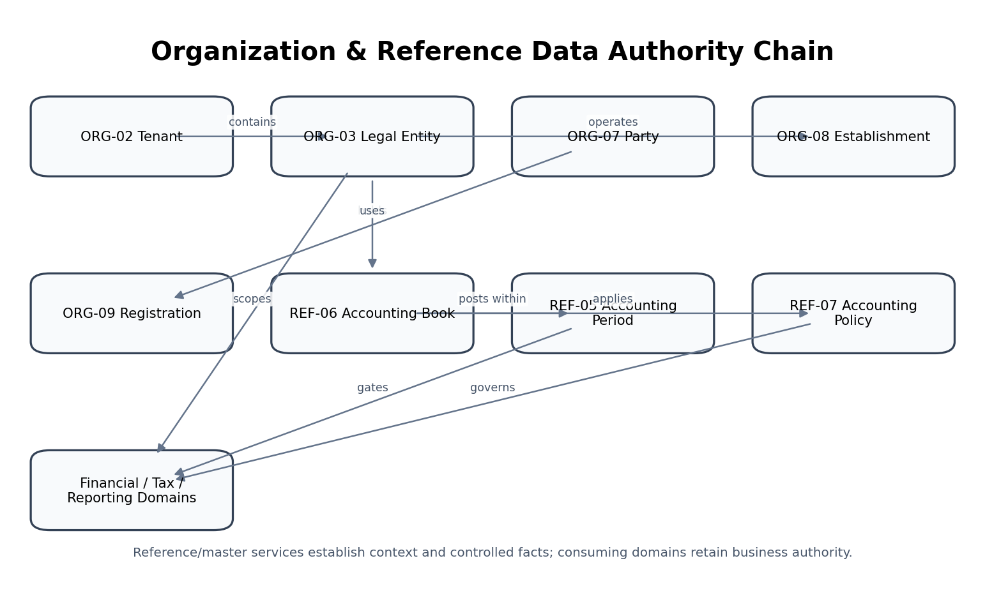
Figure 1 — Organization and reference-data authority chain.
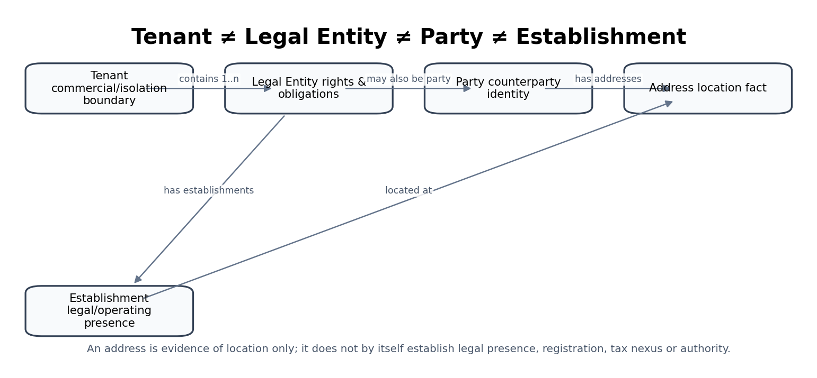
Figure 2 — Tenant, legal entity, party, address and establishment are separate canonical concepts.

2. Domain Scope, Service Inventory & Authority Model

2.1 Non-bypassable organization/reference-data invariants
- Every entity-specific transaction SHALL resolve exactly one tenant and authoritative legal entity before financial/tax processing.
- Legal entity identity SHALL be effective-dated and historical versions SHALL remain reconstructable.
- Party merge/split SHALL preserve lineage to every affected financial/business record; destructive merge is prohibited.
- An address SHALL NOT, by itself, prove legal establishment, tax nexus, registration or payment authority.
- External payee banking destinations SHALL be versioned, independently verified and maker-checker controlled for material changes.
- Role/delegation facts SHALL NOT bypass GOV-03 Authorization or GOV-04 SoD.
- Jurisdiction identifiers SHALL be sourced/versioned; legal treatment SHALL come from effective policy/rule resolution.
- Currencies SHALL use ISO codes/precision metadata and exact decimal arithmetic.
- FX rates SHALL persist source, pair, rate type, effective/observation time and immutable version identity.
- Fiscal calendars and accounting periods SHALL never be rewritten to hide historical postings or close states.
- Every posting/report SHALL identify one authoritative accounting book/basis.
- Accounting policy versions SHALL be applied by effective date and persisted with material accounting consequences.
- Financial dimension hierarchy changes SHALL NOT rewrite historic postings or previously certified reports.
- Unit conversions used in financial/inventory/billing calculations SHALL be deterministic, dimensionally valid and version-pinned where changeable.
- Historical due dates SHALL NOT silently recalculate because holiday calendars or payment terms later changed.
- Reference-data caches/search indexes SHALL never become transactional authorities.
- Master/reference corrections SHALL create a superseding version or governed correction, not silent in-place history mutation.
- Every high-risk master-data change SHALL emit an authoritative event and evidence link.
- Cross-tenant master-data identifiers SHALL never be accepted as authorization to access another tenant.
- AI MAY propose duplicate candidates or explanations, but SHALL NOT autonomously merge parties, activate payee destinations, select accounting policy, or alter period/book state.
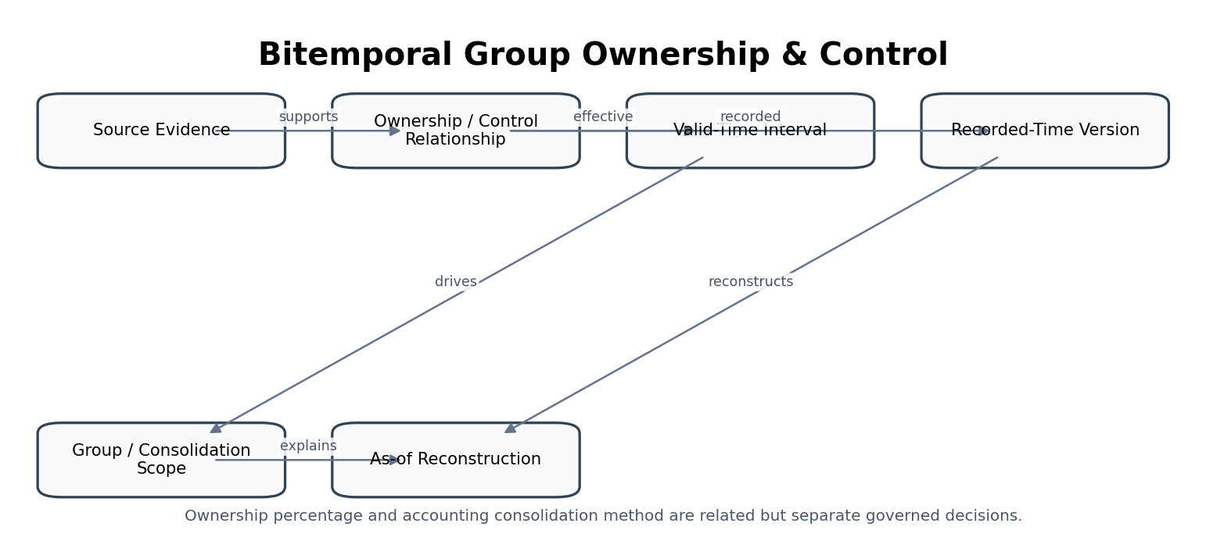
Figure 3 — Bitemporal group ownership and control reconstruction.
ID | Service | Authoritative role
ORG-01 | Identity | Canonical subject identity, IdP linkage and authentication assurance facts.
ORG-02 | Tenant | Tenant lifecycle, isolation identity and baseline tenancy configuration.
ORG-03 | Legal Entity | Effective-dated legal-entity identity and legal profile.
ORG-04 | Corporate Group & Ownership | Effective-dated group ownership, voting and control relationships.
ORG-05 | Organizational Unit | Organizational-unit identity and operating hierarchy.
ORG-06 | Role & Delegation | Business-role assignment, delegation and authority-limit facts.
ORG-07 | Party / Counterparty | Canonical party/counterparty golden record and party-role identity.
ORG-08 | Address & Establishment | Structured addresses and separate establishment/legal-presence records.
ORG-09 | Registration & License | Generic registration/license evidence and lifecycle.
ORG-10 | Banking Identity / Payee Master | Verified external payee/beneficiary banking destination versions.
REF-01 | Jurisdiction Registry | Canonical jurisdiction identifiers and hierarchy.
REF-02 | Currency Registry | Currency identity, minor-unit and platform support metadata.
REF-03 | Foreign Exchange Rates | Versioned source-proven exchange rates and rate sets.
REF-04 | Fiscal Calendar | Fiscal-calendar definitions and transitions.
REF-05 | Accounting Period | Accounting-period instances and authoritative period state.
REF-06 | Accounting Book / Ledger Basis | Accounting-book identity, basis and posting eligibility.
REF-07 | Accounting Policy | Versioned effective accounting-policy artifacts and applicability.
REF-08 | Financial Dimension Registry | Financial dimension values, hierarchies and posting eligibility.
REF-09 | Units of Measure | Units, quantity dimensions and controlled conversions.
REF-10 | Business Calendar & Payment Terms | Business calendars and payment-term calculation rules.

Fact / decision | Authoritative owner | Critical boundary
Tenant isolation identity/status | ORG-02 + GOV-01 context resolution | Legal entity is not a tenant boundary.
Legal entity legal profile | ORG-03 | Party record does not replace legal-entity accounting identity.
Group ownership/control | ORG-04 | ACC-13 decides accounting consolidation treatment using approved policy.
Role/delegation fact | ORG-06 | GOV-03/GOV-04 decide authorization/SoD.
Party golden record | ORG-07 | AR/AP/WFP own domain financial/workforce profiles.
Establishment fact | ORG-08 | TAX/JUR decide nexus/regulatory consequence.
Tax registration operational state | TAX-01 | ORG-09 may preserve generic registration evidence/reference.
External payee destination | ORG-10 | BNK-01 owns tenant’s own bank account; AP/BNK use fingerprint.
Jurisdiction identifier | REF-01 | Rules/treatment owned by JUR/GOV/TAX.
Currency identity/precision | REF-02 | FX value owned by REF-03.
FX observation/rate set | REF-03 | Accounting revaluation owned by ACC-10.
Fiscal calendar | REF-04 | Period state owned by REF-05.
Period state | REF-05 | Close orchestration/evidence owned by ACC-14.
Accounting book basis | REF-06 | Posted truth owned by ACC-05.
Accounting policy version | REF-07 | Applied through ACC-04 and domain calculators.
Financial dimensions | REF-08 | Operational source objects remain owned by source domains.
Unit conversion rule | REF-09 | Physical/business quantity remains source-domain fact.
Payment term/business calendar | REF-10 | Issued invoice due date remains AR/AP document fact after calculation.

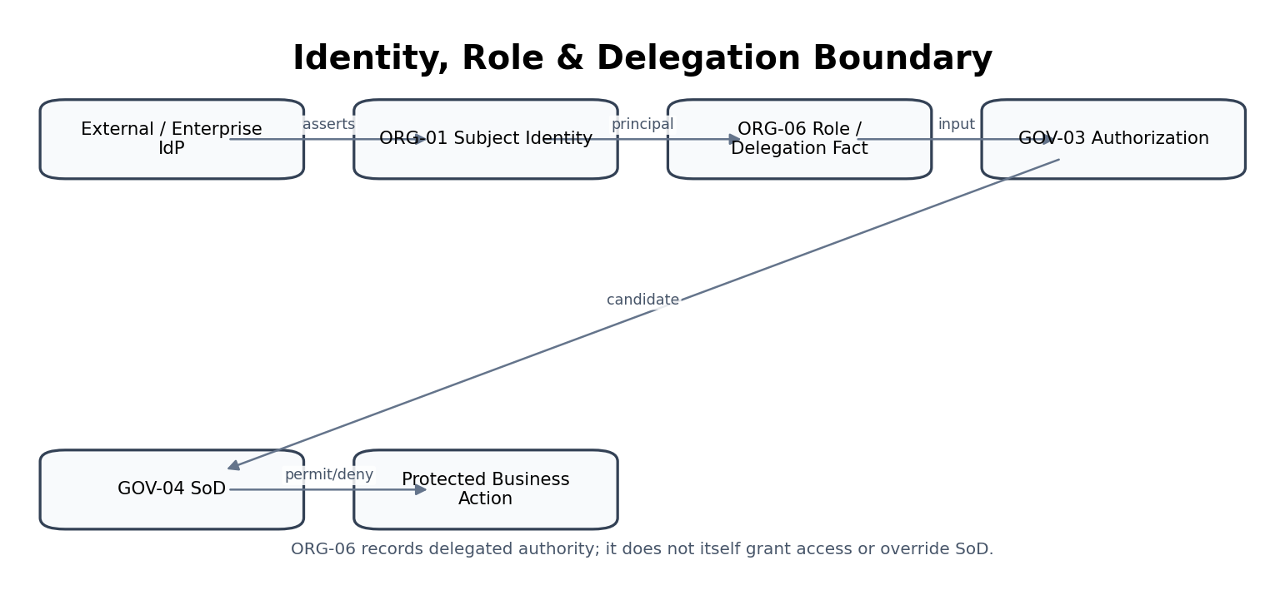
Figure 4 — Identity, role and delegation boundary.
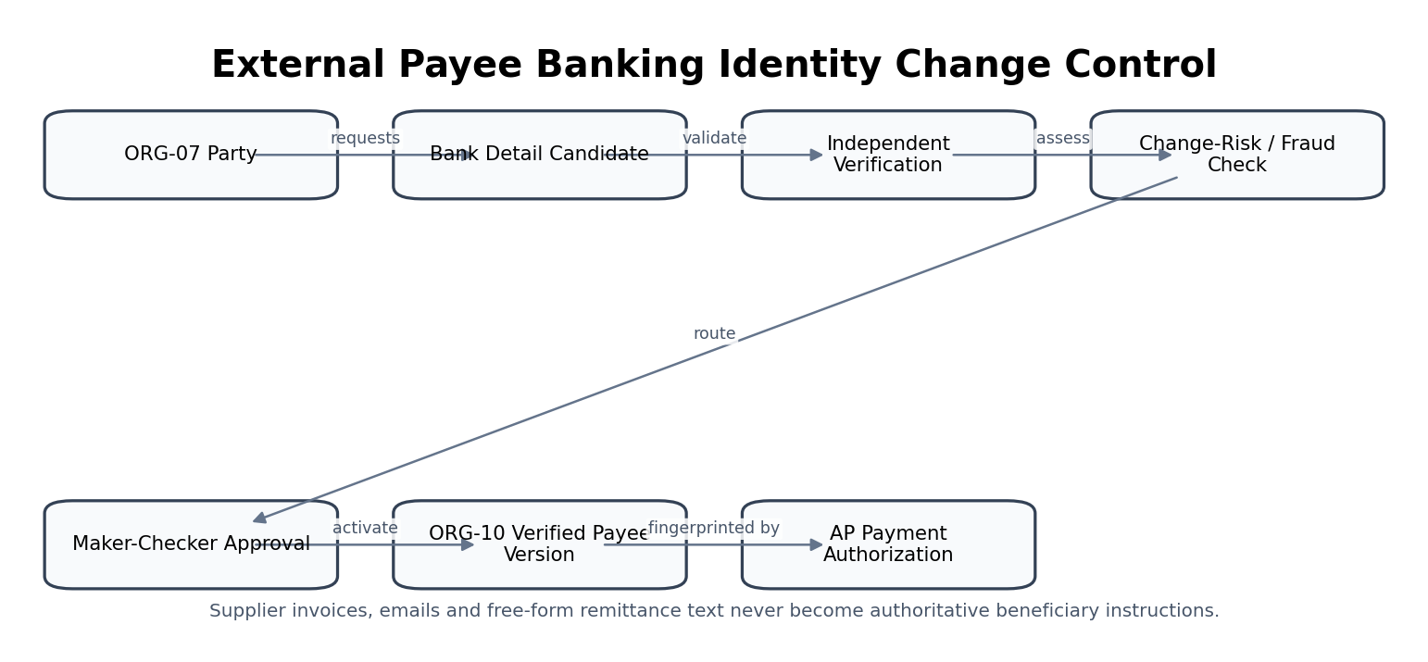
Figure 5 — External payee banking-identity change control.

3. Shared Organization & Reference Data Contract
Contract element | Mandatory behavior
Trusted context | tenant_id, actor/workload, legal_entity_id where applicable, jurisdiction, effective_at, recorded_at, purpose, correlation_id and expected_version are server-validated.
Identifiers | UUIDv7 internal identifiers. Registry numbers, LEIs, ISO codes and external provider IDs are attributes/external identifiers, not substitutes for tenant-scoped internal identity.
Temporal model | Material legal/master/reference facts use effective-dated versions; bitemporal recorded-time is required where late corrections or as-of reconstruction matter.
Write ownership | Exactly one service owns each canonical fact. Consumers reference owner IDs/versions and do not update owner tables directly.
Concurrency | All material master updates require optimistic concurrency; activation/approval binds protected-field fingerprint.
Idempotency | Imports/commands use source/version or idempotency key; replays return the original material result and never duplicate versions.
Search | Search indexes are disposable projections. Exact authoritative retrieval comes from owning service.
Corrections | Supersede/correct with reason/evidence. Do not erase previously used master versions from historical financial lineage.
Privacy/security | Field masking, purpose limitation, residency, JIT privilege, evidence and retention apply according to ZS-SEC-001 and ZS-DATA-GOV-001.
Events | Authoritative changes publish through transactional outbox and include tenant, object, version, effective_at and correlation/causation identifiers.
Errors | Use stable typed errors: CONTEXT_INVALID, VERSION_CONFLICT, DUPLICATE_CANDIDATE, INVALID_TRANSITION, RULE_AMBIGUOUS, SOURCE_UNVERIFIED, SOD_DENIED, REFERENCE_RETIRED, DEPENDENCY_UNAVAILABLE.
Historical use | Consumers persist applied IDs/versions required to reconstruct tax, accounting, payment, reporting and due-date outcomes.

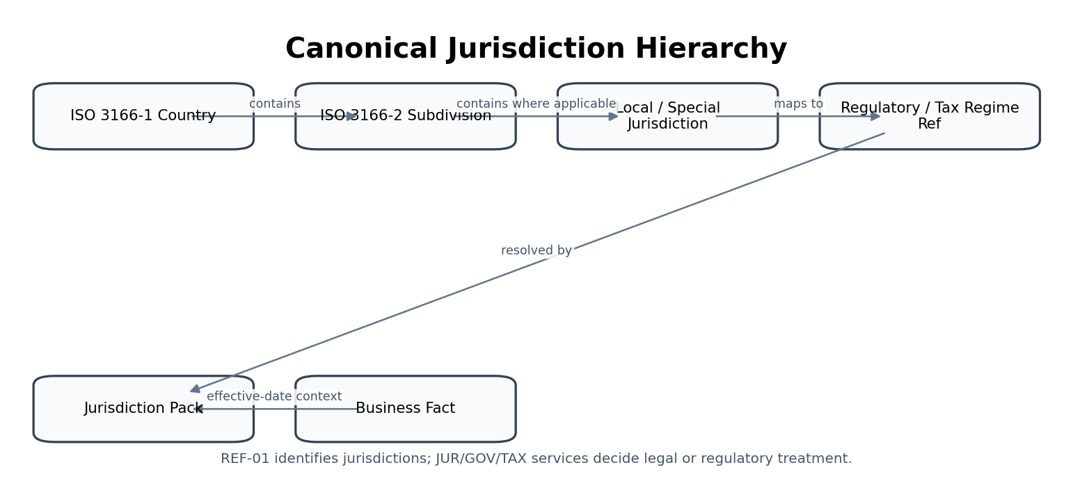
Figure 6 — Canonical jurisdiction hierarchy and rule boundary.
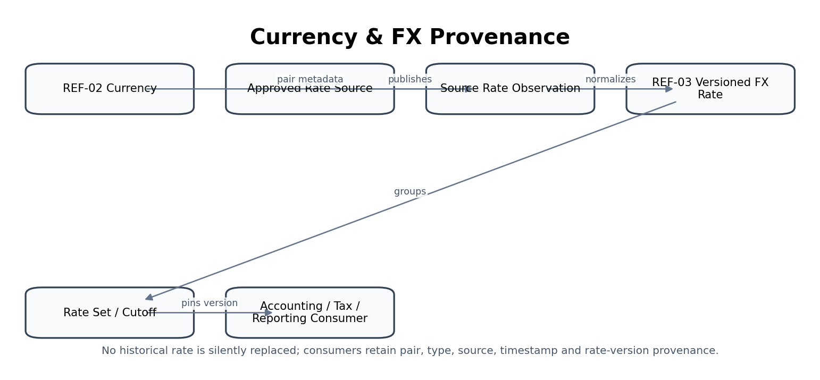
Figure 7 — Currency and FX-rate provenance.

4. Detailed Service Specifications

4.1 ORG-01 — Identity
Purpose — Authenticate human subjects, maintain canonical subject identity and establish authentication assurance without absorbing authorization authority.

Specification field | Build-ready requirement
Authoritative write ownership | SubjectIdentity, IdentityProviderLink, AuthenticationSessionReference, AssuranceObservation
Explicit non-ownership | Authorization decision, SoD decision, role entitlement, tenant membership commercial entitlement
Required source inputs | Identity-provider assertion or credential; tenant reference; requested authentication flow; MFA/step-up factors; device/session context
Server-resolved context | Tenant IdP configuration; account state; risk signals; authentication policy; permitted assurance methods
Named commands | LinkIdentityProvider; Authenticate; StepUp; DisableIdentity; RevokeSession; MergeDuplicateIdentity
Read/query surfaces | GetSubjectIdentity; ListIdentityLinks; GetAssuranceHistory; ListAuthenticationEvents
State / lifecycle | Invited/Unverified → Verified → Active → Suspended/Disabled → Closed
Permissions / authorization | Identity administration permission; self-service only for permitted profile/authenticator actions; privileged recovery requires independent control
Segregation of duties | Recovery administrator cannot approve own emergency identity recovery; privileged admin actions require JIT where applicable
Events produced | IdentityLinked; IdentityVerified; AssuranceEstablished; IdentitySuspended; SessionRevoked
Dependencies | GOV-01 Tenant Context; ZS-IAM architecture; GOV-03 Authorization; GOV-07 Evidence
Idempotency / concurrency | Authentication attempts correlation-scoped; identity linking/merge commands idempotent by source-provider subject + tenant
Failure & degradation semantics | Identity ambiguity or IdP unavailability fails closed for protected operations; cached identity may not create fresh assurance
Evidence / lineage | IdP issuer/subject, auth method, assurance, correlation, device/session identifiers, decision timestamp; never log secrets
NFR / recovery profile | C0/C1 for authentication path; low-latency assurance check; revocation propagation objective; region/privacy constraints
Minimum service acceptance | Reject forged IdP issuer/subject; deny protected action with insufficient assurance; revoke session propagation; no credential/secrets in telemetry.

ORG-01 — Mandatory engineering controls
- All protected changes require authoritative current version and validated tenant/entity scope.
- Historical versions remain retrievable after supersession or deactivation.
- Downstream consumers receive change events with stable object/version identity.
- High-risk master changes preserve source evidence, actor, reason and approval chain.

4.2 ORG-02 — Tenant
Purpose — Create and maintain the customer-organization tenancy that defines the hard isolation/commercial boundary.

Specification field | Build-ready requirement
Authoritative write ownership | Tenant, TenantLifecycle, TenantHomeRegionReference, TenantDefaultConfigurationReference
Explicit non-ownership | Legal entity, subscription billing, user authorization, residency-policy decision
Required source inputs | Tenant legal/business name; primary jurisdiction; default locale/timezone; functional defaults; residency preference; onboarding evidence
Server-resolved context | Available regions; plan entitlement; uniqueness; onboarding policy; restricted-jurisdiction checks
Named commands | CreateTenant; ActivateTenant; SuspendTenant; ResumeTenant; InitiateTermination; CompleteTermination; ChangeDefaultLocale
Read/query surfaces | GetTenant; ResolveTenantByHost; ListTenantLifecycleHistory; GetTenantDefaults
State / lifecycle | Provisioning → Active → Suspended → Terminating → Terminated
Permissions / authorization | Platform tenant provisioning/admin permissions; tenant admin cannot change hard isolation identifiers
Segregation of duties | Tenant creation/termination and home-region changes require maker-checker for controlled environments
Events produced | TenantCreated; TenantActivated; TenantSuspended; TenantTerminationInitiated; TenantTerminated
Dependencies | GOV-01, GOV-02 GTRM, COM Entitlement, GOV-07 Evidence
Idempotency / concurrency | Create by approved onboarding correlation/external customer key; lifecycle commands use expected_version
Failure & degradation semantics | Provisioning partial failure remains Provisioning/FailedProvisioning with compensating cleanup; never expose partially isolated tenant as Active
Evidence / lineage | Onboarding request, approval, home-region decision, configuration version, lifecycle actor/reason
NFR / recovery profile | C0 isolation context; strong consistency for status/home-region pointer; durable lifecycle evidence
Minimum service acceptance | Cross-tenant resolution impossible; suspended tenant denied; partially provisioned tenant not active; termination preserves governed retained records.

ORG-02 — Mandatory engineering controls
- All protected changes require authoritative current version and validated tenant/entity scope.
- Historical versions remain retrievable after supersession or deactivation.
- Downstream consumers receive change events with stable object/version identity.
- High-risk master changes preserve source evidence, actor, reason and approval chain.

4.3 ORG-03 — Legal Entity
Purpose — Maintain effective-dated incorporated or registered legal-entity identity and legal profile.

Specification field | Build-ready requirement
Authoritative write ownership | LegalEntity, LegalEntityProfileVersion, LegalFormReference, FormationReference
Explicit non-ownership | Tenant, party role, ownership graph, tax determination, accounting books
Required source inputs | Legal name; entity type/legal form; incorporation jurisdiction; registry number/date; registered address; functional-currency preference; fiscal-calendar reference; supporting evidence
Server-resolved context | Jurisdiction validity; ISO 20275/registry mapping where available; duplicate checks; parent-group context; permitted calendar/currency references
Named commands | CreateLegalEntity; AmendLegalProfile; ChangeRegisteredOffice; ChangeLegalName; DeactivateLegalEntity; MergeDuplicateCandidate
Read/query surfaces | GetLegalEntity; FindByRegistryNumber; ListEntityVersions; GetLegalEntityAsOf
State / lifecycle | Draft → Verified → Active → Inactive/Dissolved; profile versions effective-dated
Permissions / authorization | Legal entity master administration; sensitive identifier access scoped; material changes independently approved
Segregation of duties | Maker cannot approve legal-name/registry/jurisdiction change; no self-approval of merge
Events produced | LegalEntityCreated; LegalEntityProfileAmended; LegalEntityStatusChanged; RegisteredOfficeChanged
Dependencies | ORG-08 Address; ORG-09 Registration; REF-01 Jurisdiction; REF-02 Currency; REF-04 Fiscal Calendar; GOV controls
Idempotency / concurrency | Natural key candidate registry+jursdiction is dedup signal not universal identifier; commands use UUID and expected_version
Failure & degradation semantics | Conflicting registry identity quarantined for resolution; historical profile never overwritten
Evidence / lineage | Source registry/evidence refs, verified fields, legal-form code/source, effective/recorded time, approver
NFR / recovery profile | C1 master-data authority; bitemporal reconstruction; high durability; global-read/local-write residency policy
Minimum service acceptance | Duplicate registry collision quarantined; historical profile preserved; jurisdiction/legal-form changes approved; as-of entity reconstruction exact.

ORG-03 — Mandatory engineering controls
- Legal name, registry identity, legal form, formation jurisdiction and registered-office changes are effective-dated and evidence-backed.
- Where LEI is available, store LEI as an external organizational identifier with source/status rather than using it as the internal primary key.
- Legal-form mapping may use ISO 20275/ELF code where available, while preserving local legal-form text/source.
- Dissolution/inactivation does not delete historical financial/legal references.

4.4 ORG-04 — Corporate Group & Ownership
Purpose — Maintain effective-dated parent/subsidiary, ownership, voting and control relationships for group context.

Specification field | Build-ready requirement
Authoritative write ownership | OwnershipRelationship, ControlRelationship, GroupMembershipVersion
Explicit non-ownership | Legal-entity identity, accounting consolidation method, intercompany transaction
Required source inputs | Parent entity; subsidiary/entity; ownership/voting percentages; relationship/control type; effective dates; evidence; beneficial/control notes
Server-resolved context | Entity validity; hierarchy cycle detection; overlap/conflict checks; accounting/consolidation policy references
Named commands | ProposeOwnershipRelationship; ApproveOwnershipRelationship; SupersedeRelationship; EndRelationship
Read/query surfaces | GetOwnershipGraph; GetGroupAsOf; ListEntityParents; ExplainControlChain
State / lifecycle | Proposed → Approved/Active → Superseded/Ended
Permissions / authorization | Group/legal master permission; sensitive beneficial/control information scoped
Segregation of duties | Relationship proposer cannot approve material control change; consolidation impact requires finance review
Events produced | OwnershipRelationshipActivated; OwnershipRelationshipSuperseded; ControlRelationshipChanged
Dependencies | ORG-03; REF-07; ACC-13 consumes; GOV-07
Idempotency / concurrency | Relationship identity parent+child+type+valid interval; overlap detection mandatory
Failure & degradation semantics | Cycles/contradictory overlapping control relationships blocked or routed to approved exception
Evidence / lineage | Source filings/contracts, percentages, control rationale, valid time, recorded time, approval
NFR / recovery profile | C1; as-of graph reconstruction; deterministic hierarchy queries
Minimum service acceptance | Reject ownership cycle/contradictory overlap; reconstruct group as-of date; preserve source evidence; consolidation consumes correct effective graph.

ORG-04 — Mandatory engineering controls
- All protected changes require authoritative current version and validated tenant/entity scope.
- Historical versions remain retrievable after supersession or deactivation.
- Downstream consumers receive change events with stable object/version identity.
- High-risk master changes preserve source evidence, actor, reason and approval chain.

Figure — ORG-04 control flow.

4.5 ORG-05 — Organizational Unit
Purpose — Maintain departments, business units, functions and operating hierarchies within legal-entity scope.

Specification field | Build-ready requirement
Authoritative write ownership | OrganizationUnit, OrganizationHierarchyVersion, UnitManagerReference
Explicit non-ownership | Financial dimension itself, workforce identity, approval rule
Required source inputs | Legal entity; unit name/type; parent unit; manager; location; cost/profit center mapping; effective dates
Server-resolved context | Hierarchy integrity; manager identity; dimension mappings; effective overlap validation
Named commands | CreateOrgUnit; ReparentOrgUnit; ChangeManager; ActivateOrgUnit; DeactivateOrgUnit
Read/query surfaces | GetOrgUnit; ListHierarchy; GetHierarchyAsOf; FindUnitsByManager
State / lifecycle | Draft → Active → Inactive; hierarchy versions effective-dated
Permissions / authorization | Organization master admin; local managers may propose but not approve structural changes above scope
Segregation of duties | Reparenting affecting financial dimensions/approvals requires independent approval
Events produced | OrgUnitCreated; OrgUnitReparented; OrgUnitManagerChanged; OrgUnitDeactivated
Dependencies | ORG-03; ORG-01; REF-08; GOV-05/06
Idempotency / concurrency | Unique code within entity/type/effective interval; reparent expected_version
Failure & degradation semantics | Hierarchy loops and orphaned active children blocked; downstream mapping impact surfaced
Evidence / lineage | Change reason, old/new parent, effective date, manager/mapping references, approval
NFR / recovery profile | C1/C2; fast hierarchy reads; historical hierarchy reconstruction
Minimum service acceptance | Reject hierarchy loop; deactivated parent with active child handled; reparenting effective-dated; financial dimension mapping impact surfaced.

ORG-05 — Mandatory engineering controls
- All protected changes require authoritative current version and validated tenant/entity scope.
- Historical versions remain retrievable after supersession or deactivation.
- Downstream consumers receive change events with stable object/version identity.
- High-risk master changes preserve source evidence, actor, reason and approval chain.

4.6 ORG-06 — Role & Delegation
Purpose — Maintain business-role assignments and delegated-authority facts consumed by authorization/SoD.

Specification field | Build-ready requirement
Authoritative write ownership | BusinessRoleAssignment, Delegation, AuthorityLimit
Explicit non-ownership | Permission decision, SoD decision, identity authentication, workflow approval decision
Required source inputs | Principal; role; scope; delegator; monetary/quantitative authority limit; effective start/end; reason
Server-resolved context | Delegator authority; role definition; GOV-04 SoD constraints; expiry policy; subject/tenant status
Named commands | AssignBusinessRole; DelegateAuthority; RevokeDelegation; SuspendAssignment; ExtendDelegation
Read/query surfaces | ListPrincipalAssignments; GetEffectiveDelegations; ExplainDelegationChain; GetAssignmentsAsOf
State / lifecycle | Proposed → Active → Suspended/Expired/Revoked
Permissions / authorization | Role/delegation admin and delegated self-service where policy permits
Segregation of duties | Delegation cannot exceed delegator authority; cannot delegate around SoD; self-approval prohibited
Events produced | RoleAssigned; DelegationActivated; DelegationRevoked; AssignmentExpired
Dependencies | ORG-01; GOV-03; GOV-04; GOV-05; GOV-07
Idempotency / concurrency | Assignment scoped by principal+role+scope+validity; duplicate effective overlap prevented
Failure & degradation semantics | Ambiguous/expired delegation excluded from authorization; no grace extension without explicit policy
Evidence / lineage | Delegator, authority basis, scope, limits, valid time, approval, revocation reason
NFR / recovery profile | C0/C1 input to protected authorization; revocation freshness stringent
Minimum service acceptance | Delegation cannot exceed delegator; expired/revoked assignment denied; SoD cannot be bypassed; delegation history reconstructable.

ORG-06 — Mandatory engineering controls
- All protected changes require authoritative current version and validated tenant/entity scope.
- Historical versions remain retrievable after supersession or deactivation.
- Downstream consumers receive change events with stable object/version identity.
- High-risk master changes preserve source evidence, actor, reason and approval chain.

Figure — ORG-06 control flow.

4.7 ORG-07 — Party / Counterparty
Purpose — Maintain canonical external/internal party golden records and role relationships.

Specification field | Build-ready requirement
Authoritative write ownership | Party, PartyProfileVersion, PartyRole, ExternalIdentifierReference, MergeSplitHistory
Explicit non-ownership | Customer financial profile, supplier AP profile, employee HR record, legal-entity accounting identity
Required source inputs | Party type; legal/display names; registration IDs; addresses; contacts; tax IDs; external refs; role evidence
Server-resolved context | Duplicate-resolution policy; jurisdiction validation; privacy/sensitivity classification; screening hooks
Named commands | CreateParty; AmendPartyProfile; AddPartyRole; RemovePartyRole; MergeParties; SplitParty; LinkExternalIdentifier
Read/query surfaces | GetParty; SearchParties; GetPartyAsOf; ExplainMergeHistory; FindByExternalIdentifier
State / lifecycle | Candidate → Verified/Active → Inactive; merge/split creates lineage not overwrite
Permissions / authorization | Party master permission; sensitive identifiers masked by field policy
Segregation of duties | Merge/split requires independent review when linked to financial records
Events produced | PartyCreated; PartyProfileAmended; PartyRoleAdded; PartiesMerged; PartySplit
Dependencies | ORG-08; ORG-09; TAX/AR/AP/WFP consume; GOV-07; privacy controls
Idempotency / concurrency | External source identifier + source system used for ingest dedup; canonical party ID remains stable unless governed merge
Failure & degradation semantics | Uncertain duplicate remains separate candidate/link; never auto-merge high-risk parties
Evidence / lineage | Source identities, match rationale/confidence, merge/split approvals, external refs, effective profile versions
NFR / recovery profile | C1 master; high-search scale with authoritative write path separate from search index
Minimum service acceptance | No unsafe auto-merge; merge/split lineage preserved; sensitive identifiers masked; external-source dedup idempotent.

ORG-07 — Mandatory engineering controls
- Golden-record merge is a governed relationship change, not a database row merge.
- Match confidence alone cannot auto-merge parties linked to financial, tax or legal records.
- Party roles are explicit and time-aware; a supplier/customer role does not redefine party identity.
- Search projections may use normalized names, but authoritative legal names/source identifiers remain preserved.

4.8 ORG-08 — Address & Establishment
Purpose — Maintain structured addresses and separately governed establishment/legal-presence facts.

Specification field | Build-ready requirement
Authoritative write ownership | Address, AddressVersion, Establishment, EstablishmentStatus
Explicit non-ownership | Legal entity itself, tax nexus determination, registration/license, geospatial truth beyond source confidence
Required source inputs | Address lines; locality; subdivision; postal code; country; address type; establishment type; effective period; source/verification evidence
Server-resolved context | Country/subdivision normalization; postal/address validation source; tax-jurisdiction mapping candidate; verification confidence
Named commands | CreateAddress; VerifyAddress; AmendAddress; CreateEstablishment; ChangeEstablishmentStatus; LinkAddressToParty
Read/query surfaces | GetAddress; GetEstablishment; SearchAddresses; ListEntityEstablishments; GetEstablishmentsAsOf
State / lifecycle | Address Unverified → Verified/Superseded; Establishment Proposed → Active → Inactive/Closed
Permissions / authorization | Master-data admin; establishment changes may require legal/tax review
Segregation of duties | No single operator may create and legally activate material establishment where policy requires independent evidence
Events produced | AddressVerified; AddressSuperseded; EstablishmentActivated; EstablishmentClosed
Dependencies | REF-01; ORG-03/07/09; TAX-01 consumes as input only
Idempotency / concurrency | Canonical address normalization aids matching but source addresses retained; establishment has separate ID from address
Failure & degradation semantics | Low-confidence geocoding/normalization does not silently alter legal address; tax nexus not inferred from address alone
Evidence / lineage | Original address, normalized form, verification provider/result, establishment evidence, effective dates
NFR / recovery profile | C1/C2; privacy/residency aware; historical versions retained
Minimum service acceptance | Free-text address cannot determine legal establishment; normalization preserves original; low-confidence verification surfaced; history retained.

ORG-08 — Mandatory engineering controls
- All protected changes require authoritative current version and validated tenant/entity scope.
- Historical versions remain retrievable after supersession or deactivation.
- Downstream consumers receive change events with stable object/version identity.
- High-risk master changes preserve source evidence, actor, reason and approval chain.

4.9 ORG-09 — Registration & License
Purpose — Maintain generic company, permit, payroll and regulated registration/license evidence and lifecycle.

Specification field | Build-ready requirement
Authoritative write ownership | RegistrationLicenseRecord, IssuingAuthorityReference, RenewalObligationReference, EvidenceLink
Explicit non-ownership | Tax calculation, tax filing status semantics, legal-entity identity, regulator acceptance beyond recorded evidence
Required source inputs | Registration/license type; issuing authority; jurisdiction; number; holder; issue/effective/expiry dates; evidence
Server-resolved context | Authority/jurisdiction validity; renewal rules; entity/party linkage; duplicate identifier checks; sensitivity mask policy
Named commands | CreateRegistration; VerifyRegistration; RenewRegistration; SuspendRegistration; ExpireRegistration; RevokeRegistration
Read/query surfaces | GetRegistration; FindByNumber; ListExpiringRegistrations; GetRegistrationHistory
State / lifecycle | Draft → Verified/Active → Suspended/Expired/Revoked/Superseded
Permissions / authorization | Registration/license admin; sensitive identifier field policies
Segregation of duties | Material regulated registration activation/renewal requires evidence and independent approval where policy says
Events produced | RegistrationVerified; RegistrationRenewed; RegistrationExpiring; RegistrationExpired; RegistrationRevoked
Dependencies | ORG-03/07; REF-01; TAX-01 owns tax-registration operational semantics; GOV-07
Idempotency / concurrency | Authority+type+number+holder candidate uniqueness with jurisdiction-specific exceptions
Failure & degradation semantics | Unverifiable registration remains Unverified and cannot be treated as active proof
Evidence / lineage | Issuing authority, source document/API result, identifier, dates, verifier, hash
NFR / recovery profile | C1; expiry alerts; bitemporal history; sensitive search masking
Minimum service acceptance | Unverified registration cannot appear active; expiry/revocation surfaced; sensitive search masked; TAX-01 remains authoritative for tax-reg semantics.

ORG-09 — Mandatory engineering controls
- All protected changes require authoritative current version and validated tenant/entity scope.
- Historical versions remain retrievable after supersession or deactivation.
- Downstream consumers receive change events with stable object/version identity.
- High-risk master changes preserve source evidence, actor, reason and approval chain.

4.10 ORG-10 — Banking Identity / Payee Master
Purpose — Maintain controlled external beneficiary/payee banking identity and verified destination versions.

Specification field | Build-ready requirement
Authoritative write ownership | PayeeBankingIdentity, PayeeDestinationVersion, VerificationEvidence, ChangeRiskRecord
Explicit non-ownership | Tenant-owned bank account (BNK-01), payment authorization, payment execution, invoice remittance text
Required source inputs | Party; financial institution; account identifier/token; country; currency; payee name; source and independent verification evidence
Server-resolved context | Format validation; account-country rules; sanctions/fraud hooks; party status; change-risk classification; prior version
Named commands | ProposePayeeDestination; VerifyPayeeDestination; ApprovePayeeDestination; ActivateDestination; SuspendDestination; SupersedeDestination
Read/query surfaces | GetActivePayeeDestination; ListPayeeVersions; GetPayeeChangeHistory; VerifyAuthorizationFingerprintInput
State / lifecycle | Candidate → VerificationPending → Verified → ApprovalPending → Active → Suspended/Superseded
Permissions / authorization | Payee-master admin; masked access; read of full destination strictly purpose-limited
Segregation of duties | Maker/approver separation; supplier-profile editor cannot alone activate changed beneficiary details; break-glass separately controlled
Events produced | PayeeDestinationProposed; PayeeDestinationVerified; PayeeDestinationActivated; PayeeDestinationSuspended; PayeeDestinationSuperseded
Dependencies | ORG-07; BNK provider validation; GOV-04/06/07/12; AP-10 fingerprints active version
Idempotency / concurrency | Destination candidate fingerprint detects duplicates; activation only one active version per party/scope unless explicit multi-destination policy
Failure & degradation semantics | Unverified/changed destination blocks new authorization; invoice/email bank details are non-authoritative evidence only
Evidence / lineage | Original source, independent verification, risk checks, approvers, masked fingerprint, effective version
NFR / recovery profile | C0/C1 high-risk master; strong consistency; immediate change-event propagation
Minimum service acceptance | Invoice-supplied bank data never activates destination; changed destination invalidates AP authorization; maker-checker enforced; full account never overexposed.

ORG-10 — Mandatory engineering controls
- Bank details from invoice OCR, email or free text are candidate evidence only.
- Activation requires independent verification appropriate to risk/jurisdiction/provider.
- Any active-destination change emits an immediate high-risk event consumed by AP authorization controls.
- Full account identifiers are tokenized/masked and exposed only under purpose-limited privileged access.

Figure — ORG-10 control flow.

4.11 REF-01 — Jurisdiction Registry
Purpose — Maintain canonical country, subdivision, local and special-jurisdiction identifiers/hierarchies.

Specification field | Build-ready requirement
Authoritative write ownership | Jurisdiction, JurisdictionHierarchy, JurisdictionAlias, JurisdictionLifecycle
Explicit non-ownership | Tax/legal treatment, jurisdiction pack content, residency decision
Required source inputs | Country/subdivision/local code; jurisdiction type; display/legal name; parent; effective dates; source standard/authority
Server-resolved context | ISO 3166 mappings; internal hierarchy rules; active/retired code status; regulatory ownership references
Named commands | ImportJurisdictionUpdate; AddInternalJurisdiction; AmendJurisdictionAlias; RetireJurisdiction
Read/query surfaces | ResolveJurisdiction; GetHierarchy; GetJurisdictionAsOf; MapExternalJurisdictionCode
State / lifecycle | Proposed → Active → Retired/Superseded
Permissions / authorization | Reference-data steward; ISO/source updates maker-checker in production
Segregation of duties | Publisher/approver separation for externally sourced code-list updates
Events produced | JurisdictionAdded; JurisdictionUpdated; JurisdictionRetired; JurisdictionHierarchyChanged
Dependencies | ISO 3166 source; JUR-architecture consumes; GOV-02/TAX/ORG consume
Idempotency / concurrency | External source code+source version; internal jurisdiction UUID stable across aliases
Failure & degradation semantics | Unknown/retired codes fail explicit resolution where legal treatment depends on them; never guess from free text
Evidence / lineage | Source standard/version, import hash, effective dates, mapping rationale
NFR / recovery profile | C0/C1 read-heavy global reference; cached with version pinning; fast resolution
Minimum service acceptance | Unknown/retired code explicit; ISO source update versioned; hierarchy as-of exact; no tax/legal treatment inferred solely by country.

REF-01 — Mandatory engineering controls
- All protected changes require authoritative current version and validated tenant/entity scope.
- Historical versions remain retrievable after supersession or deactivation.
- Downstream consumers receive change events with stable object/version identity.
- High-risk master changes preserve source evidence, actor, reason and approval chain.

Figure — REF-01 control flow.

4.12 REF-02 — Currency Registry
Purpose — Maintain supported currencies, minor-unit/precision metadata and lifecycle.

Specification field | Build-ready requirement
Authoritative write ownership | Currency, CurrencyLifecycle, MinorUnitMetadata, PlatformSupportStatus
Explicit non-ownership | FX rate, accounting functional currency assignment, monetary amount
Required source inputs | ISO 4217 alpha/numeric code; currency name; minor-unit exponent; validity dates; fund/metal classification where applicable
Server-resolved context | ISO 4217 maintenance source; platform support; rounding defaults; jurisdiction associations
Named commands | ImportCurrencyUpdate; ActivatePlatformCurrency; RestrictCurrency; RetireCurrency
Read/query surfaces | GetCurrency; ListSupportedCurrencies; GetCurrencyAsOf; ResolveNumericCurrencyCode
State / lifecycle | Known → Supported/Restricted → Retired
Permissions / authorization | Reference-data steward; support activation requires finance/platform approval
Segregation of duties | Source import and platform-support activation separated for production
Events produced | CurrencyUpdated; CurrencySupportChanged; CurrencyRetired
Dependencies | ISO 4217 source; ACC/AR/AP/BNK/TAX consume
Idempotency / concurrency | ISO code+source-version import idempotency; historical codes retained
Failure & degradation semantics | Unknown currency rejects financial command; retired currency may remain readable for history
Evidence / lineage | ISO source/version, minor-unit change evidence, support decision
NFR / recovery profile | C0 reference; high-cacheability; exact-decimal precision metadata
Minimum service acceptance | Unknown currency blocks financial command; minor-unit metadata versioned; retired currency historical read works; no float arithmetic.

REF-02 — Mandatory engineering controls
- All protected changes require authoritative current version and validated tenant/entity scope.
- Historical versions remain retrievable after supersession or deactivation.
- Downstream consumers receive change events with stable object/version identity.
- High-risk master changes preserve source evidence, actor, reason and approval chain.

4.13 REF-03 — Foreign Exchange Rates
Purpose — Maintain provenance-rich versioned exchange-rate observations, rate sets and approved sources.

Specification field | Build-ready requirement
Authoritative write ownership | FXRateObservation, FXRateSet, FXSource, FXRateVersion
Explicit non-ownership | Currency identity, accounting revaluation result, hedge/trading decision
Required source inputs | Base/quote currency; rate; rate type; source/provider; effective/observation timestamp; market date; source payload/reference
Server-resolved context | Approved source list; calendar cutoff; inversion/cross-rate policy; duplicate/outlier checks; source timezone
Named commands | IngestFXObservation; ApproveFXRateSet; SupersedeRateObservation; CloseRateSet
Read/query surfaces | GetRate; GetRateSet; ListRatesBySource; ExplainDerivedCrossRate; GetHistoricalRate
State / lifecycle | Observed → Validated → Approved/InRateSet → Superseded/Rejected
Permissions / authorization | Market/reference data ingestion; finance approval for controlled closing rates where policy requires
Segregation of duties | Rate source operator cannot approve exceptional manual rate used for close
Events produced | FXRateObserved; FXRateApproved; FXRateSetClosed; FXRateSuperseded
Dependencies | REF-02; REF-10 calendar; ACC-10/ACC-13/TAX/REP consume
Idempotency / concurrency | Provider observation ID or source+pair+type+timestamp; derived cross rate has lineage to component rates
Failure & degradation semantics | Missing approved rate blocks authoritative calculation or routes to explicit exception; no silent fallback
Evidence / lineage | Raw provider payload/hash, source, timestamps, pair/type, validation/outlier checks, approver
NFR / recovery profile | C1; timely ingestion/freshness SLO; historical immutability; exact decimal
Minimum service acceptance | Missing approved rate blocks authoritative calculation; historical rate immutable; source/outlier evidence retained; cross rate traceable.

REF-03 — Mandatory engineering controls
- Rate type is mandatory: spot, average, closing, tax, contractual or other governed type cannot be conflated.
- Manual exceptional rates require reason, source evidence and independent approval.
- Derived inverse/cross rates retain lineage to component observations and derivation formula.
- Closing/reporting rate sets are immutable once certified; correction creates superseding set/version.

Figure — REF-03 control flow.

4.14 REF-04 — Fiscal Calendar
Purpose — Maintain entity-specific fiscal-calendar definitions and controlled transitions.

Specification field | Build-ready requirement
Authoritative write ownership | FiscalCalendar, FiscalCalendarVersion, CalendarTransitionPlan
Explicit non-ownership | Period close evidence, journal posting, tax filing calendar
Required source inputs | Entity; fiscal-year start; period frequency/pattern; special periods; week/month convention; transition request
Server-resolved context | Jurisdiction defaults; existing periods/books; migration history; downstream close/report dependencies
Named commands | CreateFiscalCalendar; ProposeCalendarChange; ApproveCalendarTransition; ActivateCalendarVersion
Read/query surfaces | GetFiscalCalendar; GetCalendarAsOf; ListCalendarVersions; PreviewPeriods
State / lifecycle | Draft → Approved → Active → Superseded
Permissions / authorization | Finance master admin; calendar changes require controller-level approval
Segregation of duties | Calendar proposer cannot approve transition affecting active books
Events produced | FiscalCalendarCreated; FiscalCalendarVersionActivated; FiscalCalendarSuperseded
Dependencies | ORG-03; REF-05; REF-06; ACC-14/REP/TAX consume
Idempotency / concurrency | One active calendar version per entity/scope/effective interval unless explicit parallel basis
Failure & degradation semantics | Change that overlaps posted/closed history requires transition plan; never rewrite historical periods
Evidence / lineage | Old/new calendar, rationale, impact assessment, approvals, migration/transition mapping
NFR / recovery profile | C1; high durability; as-of reconstruction
Minimum service acceptance | Calendar change cannot rewrite posted history; transition plan required; period preview deterministic; one active applicable calendar per scope.

REF-04 — Mandatory engineering controls
- All protected changes require authoritative current version and validated tenant/entity scope.
- Historical versions remain retrievable after supersession or deactivation.
- Downstream consumers receive change events with stable object/version identity.
- High-risk master changes preserve source evidence, actor, reason and approval chain.

4.15 REF-05 — Accounting Period
Purpose — Maintain period instances and authoritative accounting-period state consumed by posting gates.

Specification field | Build-ready requirement
Authoritative write ownership | AccountingPeriod, AccountingPeriodState, PeriodStateHistory
Explicit non-ownership | Close checklist/workflow evidence (ACC-14), postings, fiscal-calendar definition
Required source inputs | Fiscal calendar/version; period identifier; start/end; requested state transition; transition reason
Server-resolved context | ACC-14 close/reopen authorization; outstanding controls; book/module scope; policy
Named commands | MaterializePeriods; RequestSoftClose; SetHardClosed; AuthorizeReopen; ReclosePeriod
Read/query surfaces | GetPeriod; ResolvePeriodByDate; ListOpenPeriods; GetPeriodStateHistory
State / lifecycle | Open → SoftClose → CloseReview/HardClosed → AuthorizedReopen → Reclosed
Permissions / authorization | Period state command permission; ordinary users cannot mutate state directly
Segregation of duties | Hard close/reopen requires independent authorized workflow; service validates command provenance
Events produced | PeriodOpened; PeriodSoftClosed; PeriodHardClosed; PeriodReopened; PeriodReclosed
Dependencies | REF-04; ACC-14 orchestrates; ACC-04 consumes; GOV workflow/evidence
Idempotency / concurrency | State transitions expected_version and workflow decision fingerprint
Failure & degradation semantics | Illegal transition rejected; closed-period check fails safely even if close orchestrator unavailable
Evidence / lineage | Requested transition, ACC-14 workflow/approval refs, control snapshot, actor, timestamps
NFR / recovery profile | C0/C1 posting gate; strongly consistent state; low-latency read
Minimum service acceptance | Illegal transition rejected; ACC-14 provenance required for close/reopen; posting gate reads strongly consistent state; state history immutable.

REF-05 — Mandatory engineering controls
- REF-05 accepts close/reopen commands only with authoritative ACC-14 workflow/control evidence.
- Posting services must consult period state server-side; UI state is never sufficient.
- Authorized reopen is time-bound/scoped and reclose generates a new certified close state.
- Period boundaries are inherited from the applicable fiscal-calendar version and never silently moved after use.
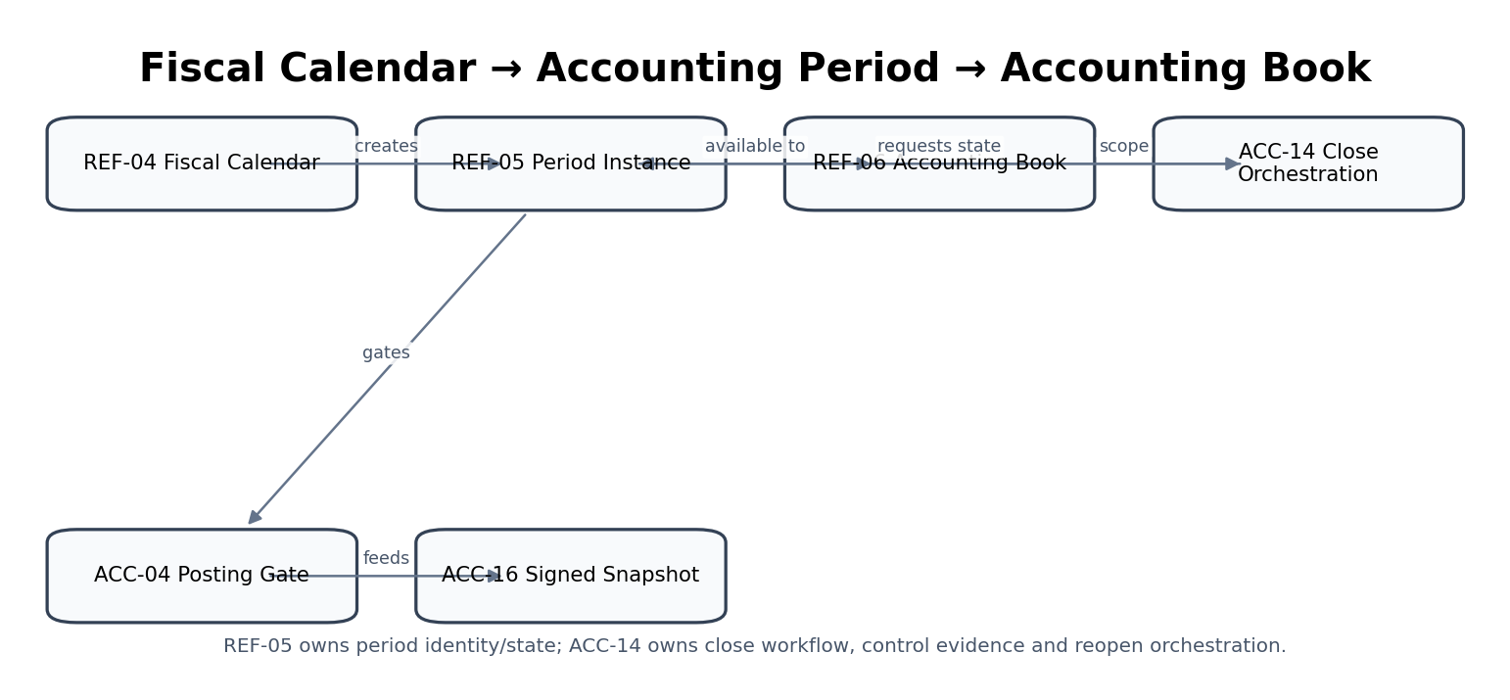
Figure — REF-05 control flow.

4.16 REF-06 — Accounting Book / Ledger Basis
Purpose — Define statutory, management, tax, consolidation and regulatory accounting-book identities/bases.

Specification field | Build-ready requirement
Authoritative write ownership | AccountingBook, BookBasisVersion, BookPostingEligibility, BookCurrencyBasis
Explicit non-ownership | Ledger lines/balances, chart accounts, reporting output, accounting policy content
Required source inputs | Entity/group; book name/type; framework/basis; functional/presentation currency; chart reference; effective dates; purpose
Server-resolved context | Allowed frameworks/bases; entity currency/calendar; posting policy; parallel-book and consolidation-role rules
Named commands | CreateAccountingBook; ActivateBook; AmendBookBasis; SuspendPosting; RetireBook
Read/query surfaces | GetAccountingBook; ListEntityBooks; GetBookAsOf; ExplainBookBasis
State / lifecycle | Draft → Active → PostingSuspended → Retired
Permissions / authorization | Accounting master admin; statutory/tax book activation controller-approved
Segregation of duties | Book creator cannot self-approve material statutory-basis activation
Events produced | AccountingBookCreated; AccountingBookActivated; BookBasisChanged; BookPostingSuspended
Dependencies | ORG-03; REF-02/04/07; ACC-01/04/05/13 consume
Idempotency / concurrency | Unique book code within entity/group; basis version effective-dated
Failure & degradation semantics | No posting allowed to inactive/ambiguous book; basis changes cannot rewrite historical ledger consequences
Evidence / lineage | Framework/basis, currencies, purpose, effective period, approvals, chart/policy refs
NFR / recovery profile | C0/C1 core accounting context; strongly consistent; historical versioning
Minimum service acceptance | Inactive book cannot post; book basis cannot be conflated; parallel books remain separate; historical basis version reconstructable.

REF-06 — Mandatory engineering controls
- Every financial posting/report specifies book explicitly; “default ledger” inference is prohibited for protected operations.
- Statutory, management, tax and consolidation books remain separate even if charts/accounts overlap.
- Book functional/presentation currency and framework are versioned basis attributes.
- Book retirement prevents new postings but retains historical retrieval and report lineage.

4.17 REF-07 — Accounting Policy
Purpose — Maintain effective-dated approved accounting-policy versions and rule mappings by book/entity/jurisdiction.

Specification field | Build-ready requirement
Authoritative write ownership | AccountingPolicyVersion, PolicyApplicability, PolicyRuleMapping
Explicit non-ownership | Posting result, tax rule, report fact, legal interpretation beyond approved policy artifact
Required source inputs | Policy domain; book; entity/jurisdiction; approved policy text/rule reference; effective period; rationale/evidence
Server-resolved context | Accounting-framework applicability; jurisdiction-pack references; superseded versions; dependency graph
Named commands | DraftAccountingPolicy; ApprovePolicyVersion; ActivatePolicyVersion; SupersedePolicyVersion; EmergencySuspendPolicy
Read/query surfaces | ResolveAccountingPolicy; GetPolicyVersion; ListApplicablePolicies; ExplainPolicyResolution
State / lifecycle | Draft → Review → Approved → Active → Superseded/Suspended
Permissions / authorization | Accounting policy steward; activation requires designated accounting authority
Segregation of duties | Author cannot solely approve material policy; emergency suspension separately authorized
Events produced | AccountingPolicyApproved; AccountingPolicyActivated; AccountingPolicySuperseded; AccountingPolicySuspended
Dependencies | REF-06; JUR/GOV-05; ACC-04/07/08/09/10/13; REP
Idempotency / concurrency | Policy semantic version + scope/effective interval; no overlapping contradictory active versions without explicit precedence
Failure & degradation semantics | Ambiguous/missing material policy blocks authoritative calculation; no UI fallback
Evidence / lineage | Framework source, policy rationale, approval, effective dates, dependency versions
NFR / recovery profile | C0/C1 deterministic resolution; version pinned; audit-grade evidence
Minimum service acceptance | Ambiguous policy blocks posting; applied version pinned; policy author/approver separated; supersession preserves history.

REF-07 — Mandatory engineering controls
- Policy resolution uses book + entity/jurisdiction + effective date + policy domain.
- UI configuration cannot override an approved accounting policy.
- Material calculations/postings persist applied policy ID/version.
- Policy change includes impact analysis for future/open periods and does not mutate closed-history treatment.
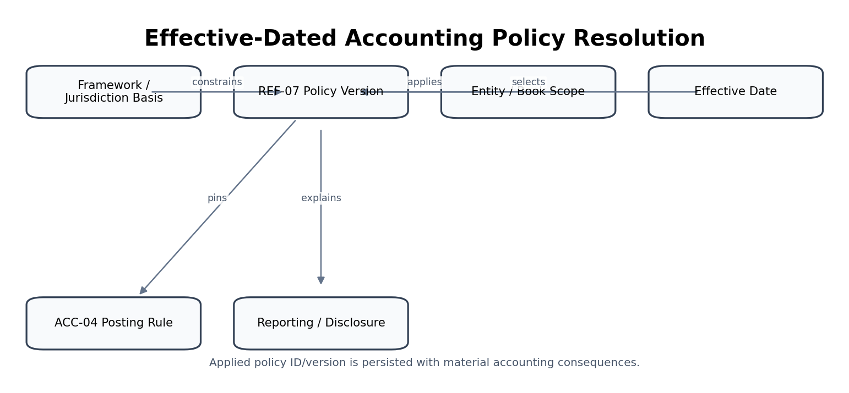
Figure — REF-07 control flow.

4.18 REF-08 — Financial Dimension Registry
Purpose — Maintain dimension types, values, posting eligibility and effective-dated hierarchies.

Specification field | Build-ready requirement
Authoritative write ownership | DimensionType, DimensionValue, DimensionHierarchyVersion, PostingEligibility
Explicit non-ownership | Operational source object such as project/location/product, posted journal dimension value copy
Required source inputs | Dimension type; code/value; label; entity scope; parent/hierarchy; effective dates; operational-source mapping
Server-resolved context | Uniqueness; hierarchy integrity; source-object status; book/posting eligibility; roll-up rules
Named commands | CreateDimensionType; CreateDimensionValue; ReparentDimensionValue; ActivateDimensionValue; DeactivateDimensionValue; MapSourceObject
Read/query surfaces | GetDimensionValue; ResolveDimension; GetHierarchyAsOf; ListPostingEligibleValues
State / lifecycle | Draft → Active → Inactive; hierarchy versions effective-dated
Permissions / authorization | Finance/reference-data steward; source-domain mappings may require joint approval
Segregation of duties | Hierarchy changes affecting reporting/control aggregation independently reviewed
Events produced | DimensionValueCreated; DimensionHierarchyChanged; DimensionValueDeactivated; SourceDimensionMapped
Dependencies | ORG-05/08; PRJ/INV source domains; ACC/REP/FP&A consume
Idempotency / concurrency | Code uniqueness by type/entity/effective scope; source mapping versioned
Failure & degradation semantics | Inactive values remain valid for history but reject new postings unless explicit controlled exception
Evidence / lineage | Source mapping, hierarchy change, effective date, approval, impacted reporting nodes
NFR / recovery profile | C1 read-heavy; stable historical resolution; cache by version
Minimum service acceptance | Inactive dimension rejected for new posting; historical roll-up reconstructable; hierarchy loops rejected; source mapping versioned.

REF-08 — Mandatory engineering controls
- Dimension codes are stable within scope; renaming does not change historical identity.
- Hierarchy is effective-dated separately from dimension-value identity.
- Operational source-to-dimension mappings are versioned and traceable.
- Inactive dimensions reject new posting while historical facts remain reportable.
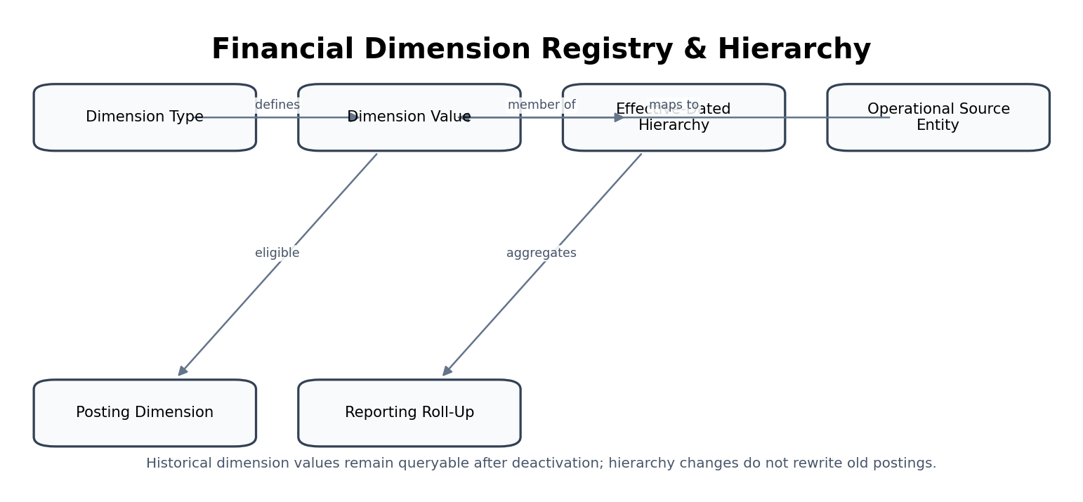
Figure — REF-08 control flow.

4.19 REF-09 — Units of Measure
Purpose — Maintain units, quantity dimensions and controlled conversion rules/versions.

Specification field | Build-ready requirement
Authoritative write ownership | UnitOfMeasure, QuantityDimension, ConversionRule, ConversionVersion
Explicit non-ownership | Inventory quantity, billable quantity, physical measurement evidence
Required source inputs | Unit code; quantity dimension; symbol/description; base-unit relation; conversion factor/formula; precision/effective date
Server-resolved context | Canonical unit mapping; dimensional compatibility; source standard; rounding/conversion policy
Named commands | CreateUnit; ApproveConversion; SupersedeConversion; RetireUnit
Read/query surfaces | GetUnit; ConvertQuantity; GetConversionVersion; ListUnitsByDimension
State / lifecycle | Draft → Active → Retired; conversions versioned
Permissions / authorization | Reference-data steward; material nonstandard conversion requires domain review
Segregation of duties | Manual conversion override used in financial inventory/billing cannot be self-approved
Events produced | UnitCreated; ConversionRuleActivated; ConversionRuleSuperseded; UnitRetired
Dependencies | ISO 80000 principles; INV/AR/AP/PRJ consume
Idempotency / concurrency | Unit code+dimension/source; conversion pair/effective interval uniqueness
Failure & degradation semantics | Dimensionally incompatible conversions rejected; missing rule blocks authoritative conversion
Evidence / lineage | Source, factor/formula, exact precision, approval, effective dates, calculation lineage
NFR / recovery profile | C1/C2; deterministic exact arithmetic; fast cached conversion lookup
Minimum service acceptance | Incompatible unit conversion rejected; exact precision preserved; conversion version pinned to inventory/billing calculation; hidden UI conversion prohibited.

REF-09 — Mandatory engineering controls
- Conversion dimensionality is checked before arithmetic.
- Prefer exact rational/decimal factors; floating-point conversion is prohibited for authoritative quantity-to-money calculations.
- If a conversion changes over time, the applied conversion version is retained with the business fact.
- Nonlinear or context-dependent conversions require explicit specialized rules, not generic factor fields.
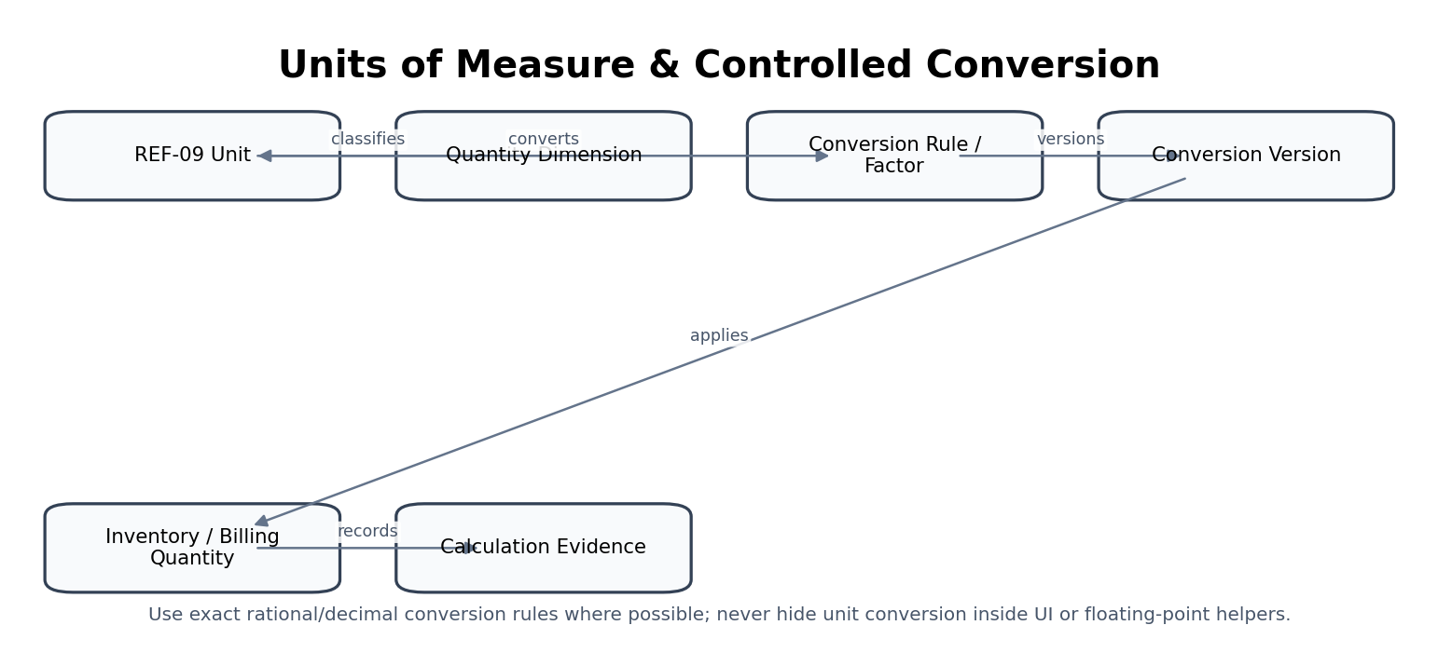
Figure — REF-09 control flow.

4.20 REF-10 — Business Calendar & Payment Terms
Purpose — Maintain holidays/business-day conventions and versioned payment-term calculation rules.

Specification field | Build-ready requirement
Authoritative write ownership | BusinessCalendar, BusinessCalendarVersion, HolidayOccurrence, PaymentTerm, PaymentTermVersion
Explicit non-ownership | Invoice due-date fact after issuance, bank settlement calendar, tax obligation calendar
Required source inputs | Jurisdiction/calendar; holidays/weekends; observed-holiday rules; payment term code; basis-date rule; due-day methodology; discount/grace rules
Server-resolved context | Jurisdiction reference; banking-day policy; tenant-approved overrides; historical versions
Named commands | ImportHolidayCalendar; CreateBusinessCalendar; ApprovePaymentTerm; SupersedePaymentTerm; RetirePaymentTerm
Read/query surfaces | IsBusinessDay; AddBusinessDays; CalculateDueDate; GetPaymentTerm; ExplainDueDate
State / lifecycle | Draft → Active → Superseded/Retired
Permissions / authorization | Reference/finance steward; local overrides approval-controlled
Segregation of duties | Payment-term creator cannot approve exceptional term that changes controlled credit policy above threshold
Events produced | BusinessCalendarUpdated; HolidayOccurrenceChanged; PaymentTermActivated; PaymentTermSuperseded
Dependencies | REF-01; AR/AP/BNK; TAX-12 owns tax obligation calendar
Idempotency / concurrency | Calendar/version and payment-term/version scoped by jurisdiction/tenant/effective interval
Failure & degradation semantics | Historical due dates are never silently recalculated after calendar/term update; calculation returns applied version/provenance
Evidence / lineage | Source holiday authority, override rationale, term formula, effective dates, approver
NFR / recovery profile | C1/C2 read-heavy; deterministic due-date calculation; historical reproducibility
Minimum service acceptance | Historical due date not silently changed; holiday override versioned; business-day calculation deterministic; applied term/calendar provenance returned.

REF-10 — Mandatory engineering controls
- Due-date calculation returns due date plus term version, calendar version, basis date and adjustment convention.
- Observed-holiday changes do not mutate existing invoice/payable due dates.
- Tax obligation calendars remain TAX-12 authority and may consume REF-10 business-day functions.
- Banking settlement calendars may consume REF-10 but retain rail/provider-specific finality rules in BNK.
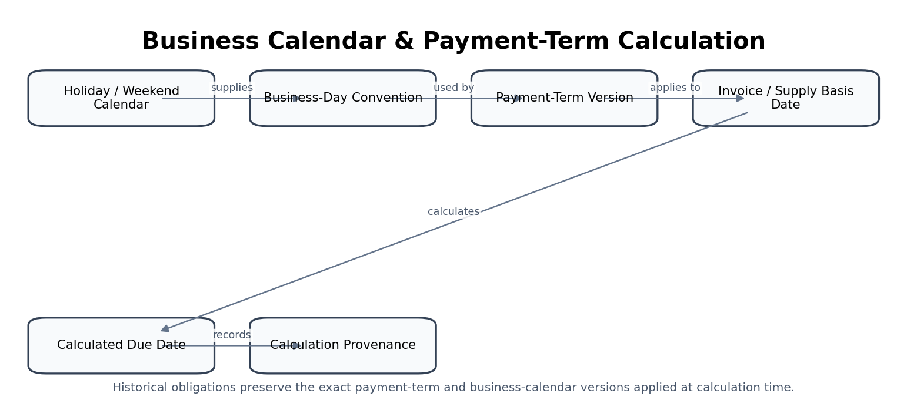
Figure — REF-10 control flow.

5. Cross-Domain Control Contracts
Control chain | Required assertion | Blocking condition
Tenant → Legal Entity | entity.tenant_id matches resolved tenant; entity active for transaction date | Cross-tenant or inactive entity
Legal Entity → Accounting Book | book belongs to entity/group and is active/applicable | No applicable active book
Book → Fiscal Calendar / Period | period belongs to active calendar and book date basis | Date outside valid period or state blocks
Book → Accounting Policy | exact effective policy version resolves for domain/date | Missing/ambiguous policy
Party → AR/AP Profile | domain profile references canonical party version/role | Merged/superseded unresolved party
External Payee → AP Authorization | authorization fingerprints active verified ORG-10 version | Destination changed/unverified
Jurisdiction → JUR/TAX | REF-01 ID valid; effective rule pack resolves separately | Unknown/retired jurisdiction or no certified rule
Currency → Amount | REF-02 currency active/supported for operation and precision known | Unknown unsupported currency
FX → Accounting/Tax/Reporting | approved rate/rate-set version available for required type/date | Missing/stale/unapproved required rate
Dimension → Posting | dimension value active/eligible for new posting | Inactive/non-eligible value
UOM → Quantity Calculation | dimensionally valid conversion version available | Incompatible/missing conversion
Payment Term → Invoice/Payable | due date stores applied term/calendar versions | No deterministic due-date result

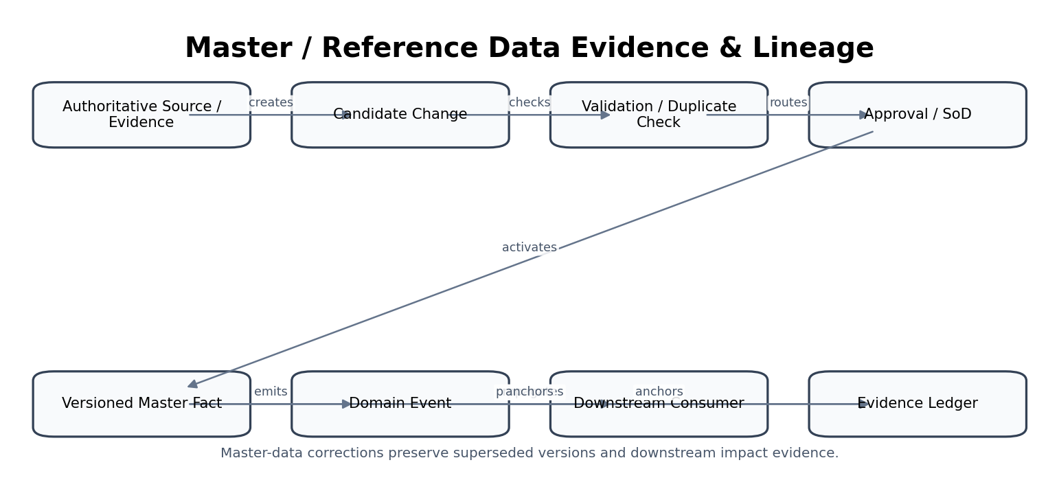
Figure 13 — Master/reference data evidence and downstream lineage.

6. Canonical Persistence Model
Entity | Key fields / relationships | Authority notes
Tenant | tenant_id, lifecycle, home_region_ref, defaults_version | ORG-02; hard isolation boundary
SubjectIdentity | subject_id, provider_links, assurance_refs, status | ORG-01; not authorization
LegalEntity | legal_entity_id, tenant_id, legal_profile_versions | ORG-03; accounting/legal anchor
OwnershipRelationship | parent_id, child_id, type, percentage, valid_from/to, recorded_at | ORG-04 bitemporal
OrganizationUnit | unit_id, entity_id, parent_id, type, valid interval | ORG-05
Delegation | principal, delegator, role, scope, limit, valid interval | ORG-06; GOV consumes
Party | party_id, profile_versions, roles, external_ids | ORG-07 golden record
Address | address_id, original, normalized, source, confidence, valid interval | ORG-08
Establishment | establishment_id, entity/party, address_id, type, status, valid interval | ORG-08 distinct from address
RegistrationLicense | registration_id, holder, authority, jurisdiction, type, number, dates, status | ORG-09
PayeeDestination | payee_destination_id, party_id, tokenized_identifier, verification, version, status | ORG-10
Jurisdiction | jurisdiction_id, external codes, type, parent, valid interval | REF-01
Currency | currency_id, alpha/numeric code, minor_unit, lifecycle | REF-02
FXRateObservation | rate_id, pair, type, value, source, observed_at, effective_at, version | REF-03
FiscalCalendar | calendar_id, entity_id, version, pattern, effective interval | REF-04
AccountingPeriod | period_id, calendar_version, start/end, state, version | REF-05
AccountingBook | book_id, entity/group, type, framework, currencies, status | REF-06
AccountingPolicyVersion | policy_id, domain, scope, effective interval, semantic version, approval | REF-07
DimensionValue | dimension_value_id, type, entity scope, hierarchy_version, status | REF-08
UnitConversion | conversion_id, from/to unit, factor/formula, precision, version | REF-09
BusinessCalendar | business_calendar_id, jurisdiction/scope, holiday rules, version | REF-10
PaymentTermVersion | term_id, basis, rule, discount/grace, calendar_ref, version | REF-10

7. API, Command & Event Contract Baseline
Protected master/reference changes use named commands. Generic PATCH is limited to explicitly non-material draft/profile metadata and may never bypass workflow, SoD, effective-date, provenance or version controls.

Pattern | Example | Rule
Resource query | GET /v1/legal-entities/{id}?as_of=... | Returns authoritative version and ETag/version.
Named command | POST /v1/legal-entities/{id}:amend-profile | Idempotency-Key + expected_version + reason/evidence.
Reference resolution | GET /v1/fx-rates:resolve?pair=USDGBP&type=closing&date=... | Returns rate + source + applied version; no implicit fallback.
Period command | POST /v1/accounting-periods/{id}:hard-close | Requires ACC-14 workflow/control evidence reference.
Payee activation | POST /v1/payee-destinations/{id}:activate | Requires independent verification + approval fingerprint.
Due-date calculation | POST /v1/payment-terms:calculate-due-date | Returns calculated date + term/calendar versions and basis.
Bulk source import | POST /v1/reference-imports | Async operation with manifest/hash, source version, validation and quarantine.
Historical query | GET /v1/parties/{id}/versions?recorded_at=... | Supports as-of business/recorded time where required.

Event | Producer | Minimum payload
IdentityLinked | ORG-01 | tenant_id; object_id; object_version; effective_at; recorded_at; actor/workload; correlation_id; evidence_ref where material
TenantCreated | ORG-02 | tenant_id; object_id; object_version; effective_at; recorded_at; actor/workload; correlation_id; evidence_ref where material
LegalEntityCreated | ORG-03 | tenant_id; object_id; object_version; effective_at; recorded_at; actor/workload; correlation_id; evidence_ref where material
OwnershipRelationshipActivated | ORG-04 | tenant_id; object_id; object_version; effective_at; recorded_at; actor/workload; correlation_id; evidence_ref where material
OrgUnitCreated | ORG-05 | tenant_id; object_id; object_version; effective_at; recorded_at; actor/workload; correlation_id; evidence_ref where material
RoleAssigned | ORG-06 | tenant_id; object_id; object_version; effective_at; recorded_at; actor/workload; correlation_id; evidence_ref where material
PartyCreated | ORG-07 | tenant_id; object_id; object_version; effective_at; recorded_at; actor/workload; correlation_id; evidence_ref where material
AddressVerified | ORG-08 | tenant_id; object_id; object_version; effective_at; recorded_at; actor/workload; correlation_id; evidence_ref where material
RegistrationVerified | ORG-09 | tenant_id; object_id; object_version; effective_at; recorded_at; actor/workload; correlation_id; evidence_ref where material
PayeeDestinationProposed | ORG-10 | tenant_id; object_id; object_version; effective_at; recorded_at; actor/workload; correlation_id; evidence_ref where material
JurisdictionAdded | REF-01 | tenant_id; object_id; object_version; effective_at; recorded_at; actor/workload; correlation_id; evidence_ref where material
CurrencyUpdated | REF-02 | tenant_id; object_id; object_version; effective_at; recorded_at; actor/workload; correlation_id; evidence_ref where material
FXRateObserved | REF-03 | tenant_id; object_id; object_version; effective_at; recorded_at; actor/workload; correlation_id; evidence_ref where material
FiscalCalendarCreated | REF-04 | tenant_id; object_id; object_version; effective_at; recorded_at; actor/workload; correlation_id; evidence_ref where material
PeriodOpened | REF-05 | tenant_id; object_id; object_version; effective_at; recorded_at; actor/workload; correlation_id; evidence_ref where material
AccountingBookCreated | REF-06 | tenant_id; object_id; object_version; effective_at; recorded_at; actor/workload; correlation_id; evidence_ref where material
AccountingPolicyApproved | REF-07 | tenant_id; object_id; object_version; effective_at; recorded_at; actor/workload; correlation_id; evidence_ref where material
DimensionValueCreated | REF-08 | tenant_id; object_id; object_version; effective_at; recorded_at; actor/workload; correlation_id; evidence_ref where material
UnitCreated | REF-09 | tenant_id; object_id; object_version; effective_at; recorded_at; actor/workload; correlation_id; evidence_ref where material
BusinessCalendarUpdated | REF-10 | tenant_id; object_id; object_version; effective_at; recorded_at; actor/workload; correlation_id; evidence_ref where material

8. Domain Negative-Path Certification
# | Service | Negative path | Required result
1 | ORG-01 | Forged IdP issuer/subject | Reject; no identity/session created; security event.
2 | ORG-01 | Authentication assurance below protected-action requirement | Step-up or deny; never downgrade control.
3 | ORG-02 | Host resolves to tenant A but body/header claims tenant B | Reject before data access; record isolation evidence.
4 | ORG-02 | Suspended tenant calls financial API | Deny protected write; controlled read policy only if allowed.
5 | ORG-03 | Same registry number claimed by two active entities in same jurisdiction | Quarantine duplicate conflict; no silent merge.
6 | ORG-03 | Legal name changed after financial history exists | Create effective profile version; history resolves original version.
7 | ORG-04 | Ownership relationship creates cycle | Reject unless relationship type legitimately supports cycle and explicitly modeled; control relationship graph remains valid.
8 | ORG-04 | Backdated control relationship affects certified consolidation | Create new relationship version and downstream restatement/impact workflow; never rewrite prior certification.
9 | ORG-05 | Reparent creates hierarchy loop | Reject.
10 | ORG-05 | Deactivate parent with active children | Block or require controlled reparent/deactivation plan.
11 | ORG-06 | Delegator grants higher limit than own authority | Reject.
12 | ORG-06 | Revoked delegation still cached in authorization path | Authorization freshness test fails; revoke cache/deny.
13 | ORG-07 | Fuzzy match suggests two parties are duplicates | Do not auto-merge; human/governed review.
14 | ORG-07 | Merge would combine records across tenants | Reject absolutely.
15 | ORG-08 | Normalized address differs materially from legal source | Preserve original; flag confidence; do not silently replace.
16 | ORG-08 | Tax service asks whether address proves nexus | Return address/establishment facts only; no legal conclusion.
17 | ORG-09 | Registration expired but broad search index still says active | Authoritative query wins; projection freshness incident.
18 | ORG-09 | Tax registration record conflicts with TAX-01 state | Surface conflict; TAX-01 operational tax state remains authoritative.
19 | ORG-10 | Supplier invoice contains new bank account | Treat as non-authoritative candidate; do not activate.
20 | ORG-10 | Active payee changed after AP authorization | Emit invalidation; payment authorization cannot execute.
21 | ORG-10 | Same operator proposes and approves risky destination change | SoD deny.
22 | REF-01 | Unknown country/subdivision code | Reject protected legal/tax context resolution; no guess.
23 | REF-01 | Country name changed/retired code | Preserve historical code/version; map current alias without rewriting history.
24 | REF-02 | Amount submitted with unsupported currency | Reject before posting/payment.
25 | REF-02 | Minor-unit metadata changes | Version metadata; historical amount precision unchanged.
26 | REF-03 | Closing rate missing | Block close/revaluation or explicit approved exception; no silent spot fallback.
27 | REF-03 | Provider sends duplicate observation | Deduplicate by source identity; no duplicate rate version.
28 | REF-03 | Manual rate is extreme outlier | Route to independent approval and evidence.
29 | REF-04 | Fiscal calendar changed across already posted period | Require transition plan; no boundary mutation.
30 | REF-05 | User directly requests hard-close without ACC-14 evidence | Reject.
31 | REF-05 | Period reopened without authorized workflow | Reject and security/control event.
32 | REF-06 | Posting omits book | Reject protected posting; do not infer default.
33 | REF-06 | Tax book used as statutory book by report | Report certification blocks basis mismatch.
34 | REF-07 | Two policies resolve at same precedence/date | Ambiguous; block authoritative calculation.
35 | REF-07 | Policy changed after journal posted | Do not mutate historical journal; new policy applies prospectively/effective-dated.
36 | REF-08 | Posting uses inactive dimension value | Reject unless controlled historical/migration exception.
37 | REF-08 | Hierarchy changes after certified report | Do not rewrite prior roll-up; new report uses new hierarchy version.
38 | REF-09 | Convert mass unit to length unit | Reject dimensional mismatch.
39 | REF-09 | Floating-point factor creates penny drift in billable quantity | Certification fails; use exact deterministic arithmetic.
40 | REF-10 | Holiday added after invoice issued | Do not silently change invoice due date.
41 | REF-10 | Payment-term rule cannot resolve basis date | Block due-date certification; explicit exception required.
42 | CROSS | Search index returns stale active payee/reference fact | Authoritative service check blocks use; freshness alarm.
43 | CROSS | Reference import schema changes incompatibly | Registry/contract gate blocks activation.
44 | CROSS | Master event delivered twice | Consumer dedup prevents duplicate business effect.
45 | CROSS | Cross-region cache contains restricted master field | Security/residency certification fails; purge/contain.
46 | CROSS | Legal hold exists on superseded master evidence | Disposition suspended; hold does not grant unrelated use.
47 | CROSS | AI proposes entity/party merge with high confidence | Proposal only; no autonomous activation.
48 | CROSS | Restore master DB to earlier snapshot after financial actions | Reconcile versions/events; no silent rollback of authoritative history.

9. Service Definition of Ready & Definition of Done

9.1 Definition of Ready
- Authoritative fact ownership and explicit non-ownership are approved and reflected in the canonical data model.
- Tenant/entity/jurisdiction/book/effective-date context requirements are defined.
- External standards/source-code lists and update mechanism are identified with licensing/usage validated.
- Commands, queries, events, error taxonomy, idempotency and concurrency classes are documented.
- Bitemporal/effective-date behavior and correction/supersession semantics are defined.
- Authorization, SoD, JIT privilege and approval thresholds are mapped.
- Downstream consumers and invalidation/change-impact behavior are identified.
- Data classification, residency, privacy, retention and legal-hold requirements are approved.
- Negative-path tests and source-to-report/source-to-payment lineage requirements are executable.

9.2 Definition of Done
- OpenAPI/AsyncAPI/schema contracts pass compatibility gates and generated client/server validation.
- Authoritative write path uses named commands, expected version, idempotency and transactional outbox.
- Historical/as-of retrieval is verified against correction and late-arriving-change scenarios.
- Cross-tenant, stale-cache, duplicate-import, replay, SoD and source-verification tests pass.
- All external/reference source imports preserve manifest, source version, hash and quarantine evidence.
- Dependent accounting/tax/payment/reporting services consume pinned IDs/versions and pass integration controls.
- Runbooks, SLOs, alerts, backup/restore and reconciliation procedures are production-certified.
- Accessibility/security/privacy/data-governance gates pass and evidence package is attached to release certificate.

10. Implementation Sequence
Wave | Scope | Exit gate
1 | ORG-02 Tenant + GOV context integration; ORG-01 identity bindings | Hard tenant isolation and authenticated subject context certified.
2 | ORG-03 Legal Entity + ORG-08 Address/Establishment + ORG-09 Registration | Entity master and as-of legal profile certified.
3 | ORG-07 Party + ORG-10 Payee Master | Golden record and high-risk beneficiary change controls certified.
4 | REF-01 Jurisdiction + REF-02 Currency + REF-09 UOM | Core reference identifiers and deterministic conversions certified.
5 | REF-04 Fiscal Calendar + REF-05 Accounting Period + REF-06 Book | Accounting context and close/posting gates integrated.
6 | REF-07 Accounting Policy + REF-08 Dimensions | Policy/dimension version resolution integrated with ACC.
7 | REF-03 FX Rates + REF-10 Business Calendar/Payment Terms | Rate provenance and due-date reproducibility certified.
8 | ORG-04 Group Ownership + ORG-05 Org Unit + ORG-06 Delegation | Group/hierarchy/delegation as-of behavior and downstream invalidations certified.
9 | Portfolio integration / migration / restore / DR / performance | All dependent domain packs pass cross-domain negative tests and production release certification.

11. Controlled Pre-Production Decisions
Decision | Required owner(s) | Required before
Authoritative external source/update mechanism for ISO/GLEIF/entity legal form code lists | Architecture + Data Governance + Legal/Commercial | Production reference imports
LEI and national-registry enrichment providers/verification model | Legal Entity Product + Compliance + Procurement | Automated verification
Party matching thresholds and when human merge review is mandatory | Data Governance + AR/AP/Legal | Party master scale-out
Payee verification methods and risk tiers by jurisdiction/payment rail | Security + AP + Banking + Compliance | Payment authorization go-live
FX source hierarchy, approved rate types, market cutoffs and manual exception authority | Finance/Controller + Treasury | Close/revaluation go-live
Fiscal-calendar transition governance and permitted special-period patterns | Finance/Controller | Multi-entity onboarding
Accounting-book taxonomy and supported framework/basis combinations | Global Accounting Product + Controller | Parallel-book production
Accounting-policy approval board and semantic versioning convention | Finance Policy + Architecture | Policy registry production
Dimension master ownership model: central vs entity-delegated stewardship | Finance + Data Governance | Dimension self-service
Payment-term override authority and local holiday/calendar sourcing | AR/AP + Finance Operations | Customer/supplier onboarding

12. Prohibited Architecture Anti-Patterns
Anti-pattern | Why prohibited
Tenant = legal entity | Breaks multi-entity customers and isolation/accounting semantics.
Party = legal entity | Conflates counterparty identity with accounting/legal obligation anchor.
Address implies establishment/nexus | Creates incorrect legal/tax conclusions.
Registry number used as global primary key | Not globally unique/stable across all registries and lifecycle conditions.
Supplier invoice bank details copied into payee master automatically | Enables payment-diversion fraud.
Roles directly grant access without GOV-03/GOV-04 | Bypasses authorization and SoD policy.
Country code decides tax/legal rule | REF-01 identifiers are not legal conclusions.
Floating-point currency/unit arithmetic | Creates nondeterministic precision/reconciliation defects.
One global FX rate per day | Conflates source, rate type, timestamp, market cutoff and use case.
Fiscal calendar edits old period boundaries | Destroys historical accounting reconstruction.
Period close state owned only in UI or batch flag | Allows posting/control bypass.
Single default accounting book | Conflates statutory, tax, management and consolidation bases.
Accounting policy embedded in UI/service code | Prevents governed effective-dated policy and historical reconstruction.
Dimension hierarchy overwrite | Changes historical reporting meaning.
Hidden UOM conversion inside application code | Breaks source-to-calculation provenance.
Payment due dates recomputed every read | Changes contractual/operational history when terms/calendars change.
Search/cache/warehouse treated as master | Creates stale or cross-tenant authoritative decisions.
Master data hard-deleted after financial use | Breaks audit, legal, tax and source-to-report evidence.
AI auto-merge/auto-activate master records | Transfers authoritative decisions to probabilistic inference.

13. Current External Standards & Reference Baseline
ISO 3166-1:2020 — Current published country-code standard; ISO confirmed it in 2025. Use maintained country/subdivision code sources rather than hardcoded lists. Official source
ISO 4217:2015 — Current published currency-code standard; provides alpha/numeric codes and minor-unit relationship. ISO states it remains current. Official source
ISO 17442-1:2020 — Current LEI assignment standard; ISO states it was reviewed and confirmed in 2026. LEI is an external organizational identifier, not ZoikoSuite internal primary key. Official source
GLEIF LEI / Global LEI Index — LEI is a unique 20-character identifier linked to verified legal-entity reference information. Official source
ISO 20275:2017 / GLEIF ELF list — Current ISO entity-legal-form standard; GLEIF maintains the ELF code list and released version 1.6 in February 2026. Official source
ISO 8601-1:2019 — Current published date/time representation standard, confirmed in 2024; a replacement edition is under development in 2026, so do not claim the draft as final. Official source
ISO 80000-1:2022 — Current general quantities-and-units standard; useful baseline for dimensional consistency and unit semantics. Official source
Engineering/legal boundary — This standard defines platform architecture and control behavior. It does not determine whether an entity is legally established, whether a registration is legally sufficient, whether a tax nexus exists, or which accounting treatment is legally required in a jurisdiction. Those conclusions require the applicable jurisdiction pack, professional policy ownership and local validation.

