ZOIKOSUITE

Planning, Forecasting & Performance
Detailed Service Specifications
ZS-SVC-J-001 • Version 1.0 • Build-Ready FP&A Baseline
Executive doctrine — FP&A owns governed plans, outlooks, scenarios, performance definitions and management/board decision artifacts. It never owns actual ledger truth. Every plan result must remain reproducible from source actuals, assumptions, model versions, overrides, approvals and assurance labels.

Field | Value
Document ID | ZS-SVC-J-001
Version | 1.0 — Build-Ready FP&A Baseline
Date | 24 August 2026
Status | Engineering baseline; numeric performance thresholds and organization-specific approval limits require calibrated production decisions.
Owner | ZoikoSuite Finance Platform / Product Architecture
Scope | FIN-01 through FIN-07
Depends on | ZS-SVC-B Accounting; ZS-SVC-H Reporting; ZS-SVC-I Organization/Reference; GOV/IAM/Data Governance/NFR/QА standards
Language | American English

0. Critical Analysis & Refined Architecture Decision
Critical finding — FP&A is useful precisely because it is allowed to model alternative futures. That flexibility becomes dangerous if planning facts can silently acquire accounting authority. The architecture therefore treats actual, plan, forecast, scenario and management-overlay populations as distinct classes with explicit source, version, assurance and promotion rules.
- Certified actuals originate from Accounting/Reporting controlled snapshots. FP&A may consume them, compare them and explain them, but cannot rewrite them.
- Approved budgets and forecasts are immutable versions. Revisions, reforecasts and assumption changes create new versions with new approval evidence.
- Planning FX, planning allocations and planning assumptions are not accounting facts. Where an accounting consequence is intended, the action must enter the Accounting Kernel through the appropriate domain/accounting service.
- Scenarios are isolated non-authoritative workspaces. Promotion creates a new forecast candidate; it never overwrites the base or bypasses approval.
- Variance analysis freezes both actual and comparator populations, plus currency, materiality and normalization policy. A moving comparator is not a valid variance baseline.
- KPI definitions are governed assets: owner, purpose, formula, unit, aggregation behavior, dimensions, source lineage, effective dates and version are mandatory.
- Management accounts and board packs preserve the assurance state of every material population—certified actual, provisional actual, budget, forecast or scenario. Silent mixing is prohibited.
- AI/Forecast Assist may propose drivers, ranges or narrative, but cannot become the source of authoritative plan numerics or executive assertions without explicit human action and source evidence.
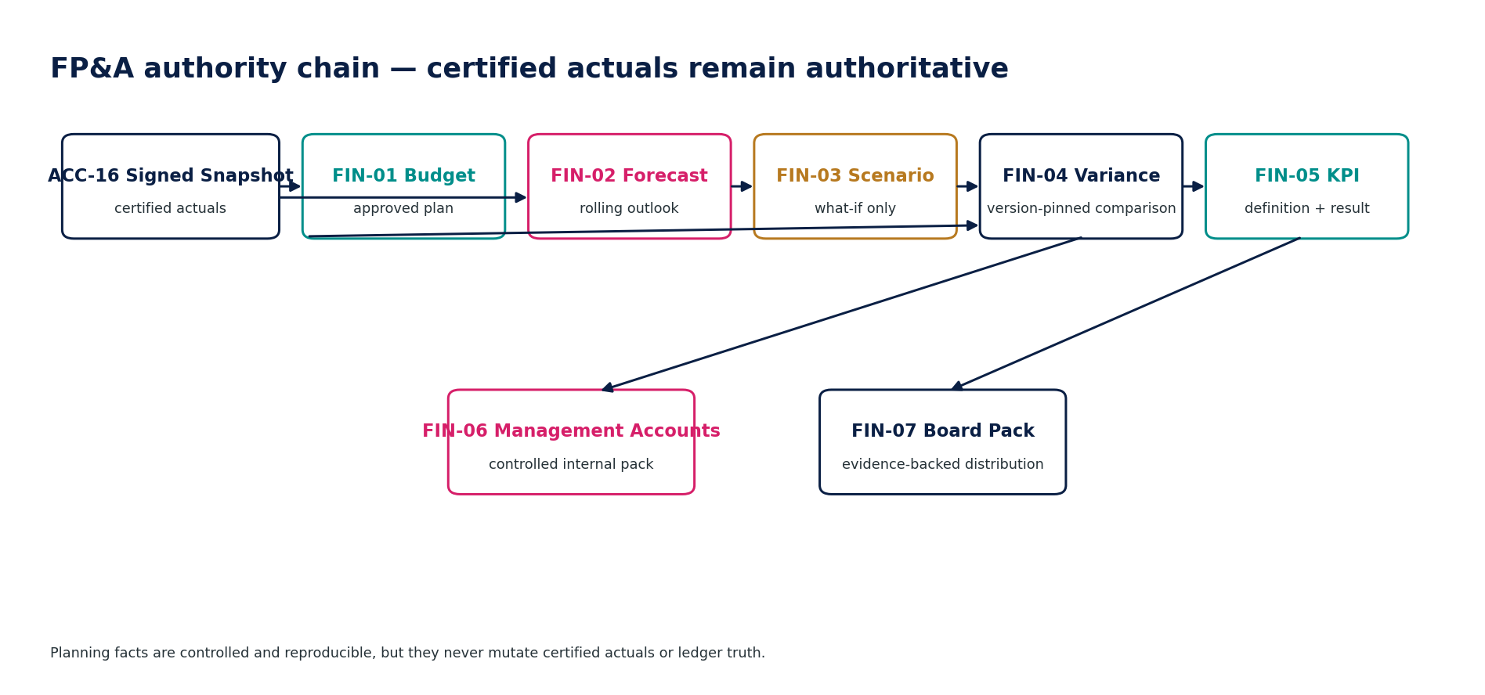
Figure 1 — FP&A authority chain.

1. Domain Scope, Inventory & Authority Model
ID | Service | Authoritative role
FIN-01 | Budget | Maintain governed budgets by entity/group, account, dimension and period without altering actual accounting truth.
FIN-02 | Forecast | Maintain rolling or periodic forecasts that combine an explicit actual baseline with versioned driver assumptions and model logic.
FIN-03 | Scenario | Create isolated what-if cases from a frozen budget/forecast base and changed assumptions without changing the base or actuals.
FIN-04 | Variance Analysis | Compare a frozen actual population with a frozen budget, forecast, scenario or prior-period comparator and preserve currency/materiality policy.
FIN-05 | KPI Registry & Calculation | Define, govern and calculate consistent performance metrics with explicit ownership, formula, unit, source lineage and effective dates.
FIN-06 | Management Accounts | Assemble periodic internal management accounts from controlled actuals, management overlays, budget/forecast, KPI/variance results and reviewed commentary.
FIN-07 | Board Reporting Pack | Create a restricted, evidence-backed board-level performance pack from approved financial reports, KPI results, budgets/forecasts and reviewed narrative.

1.1 Non-bypassable FP&A invariants
- FIN services SHALL NOT write directly to the General Ledger, Tax Ledger, bank settlement facts, AR/AP open items or certified financial reports.
- Every plan/forecast/scenario result SHALL carry tenant/entity scope, period/horizon, currency basis, source version(s), model/assumption versions and creation timestamp.
- Approved or published Budget, Forecast, Management Accounts and Board Pack versions SHALL be immutable.
- Protected changes after approval SHALL invalidate approval and require a new version or workflow.
- Actual populations used for FP&A SHALL expose assurance state: Certified, Controlled/Provisional or other approved classification.
- Planning FX assumptions SHALL remain separate from accounting FX rates unless the accounting service explicitly consumes the same source/profile by policy.
- Plan allocation SHALL NOT create accounting postings. Accounting allocations route to ACC-09 and the normal posting/control chain.
- Scenario outputs SHALL be explicitly labeled non-authoritative and isolated from their base version.
- Variance analyses SHALL freeze actual and comparator identities and the normalization/materiality policy.
- Every active KPI SHALL have an owner, clear definition, formula, unit, aggregation semantics, source lineage and effective dates.
- No two conflicting active KPIs may share a business label without explicit alias/deprecation governance.
- Management overlays SHALL NOT be represented as statutory/accounting actuals unless posted through the Accounting Kernel.
- Management/board packs SHALL expose basis, version, freshness and assurance state of material populations.
- Board Pack release SHALL bind to an immutable artifact digest and approved recipient/distribution list version.
- AI SHALL NOT autonomously approve, publish, promote or alter authoritative FP&A versions.
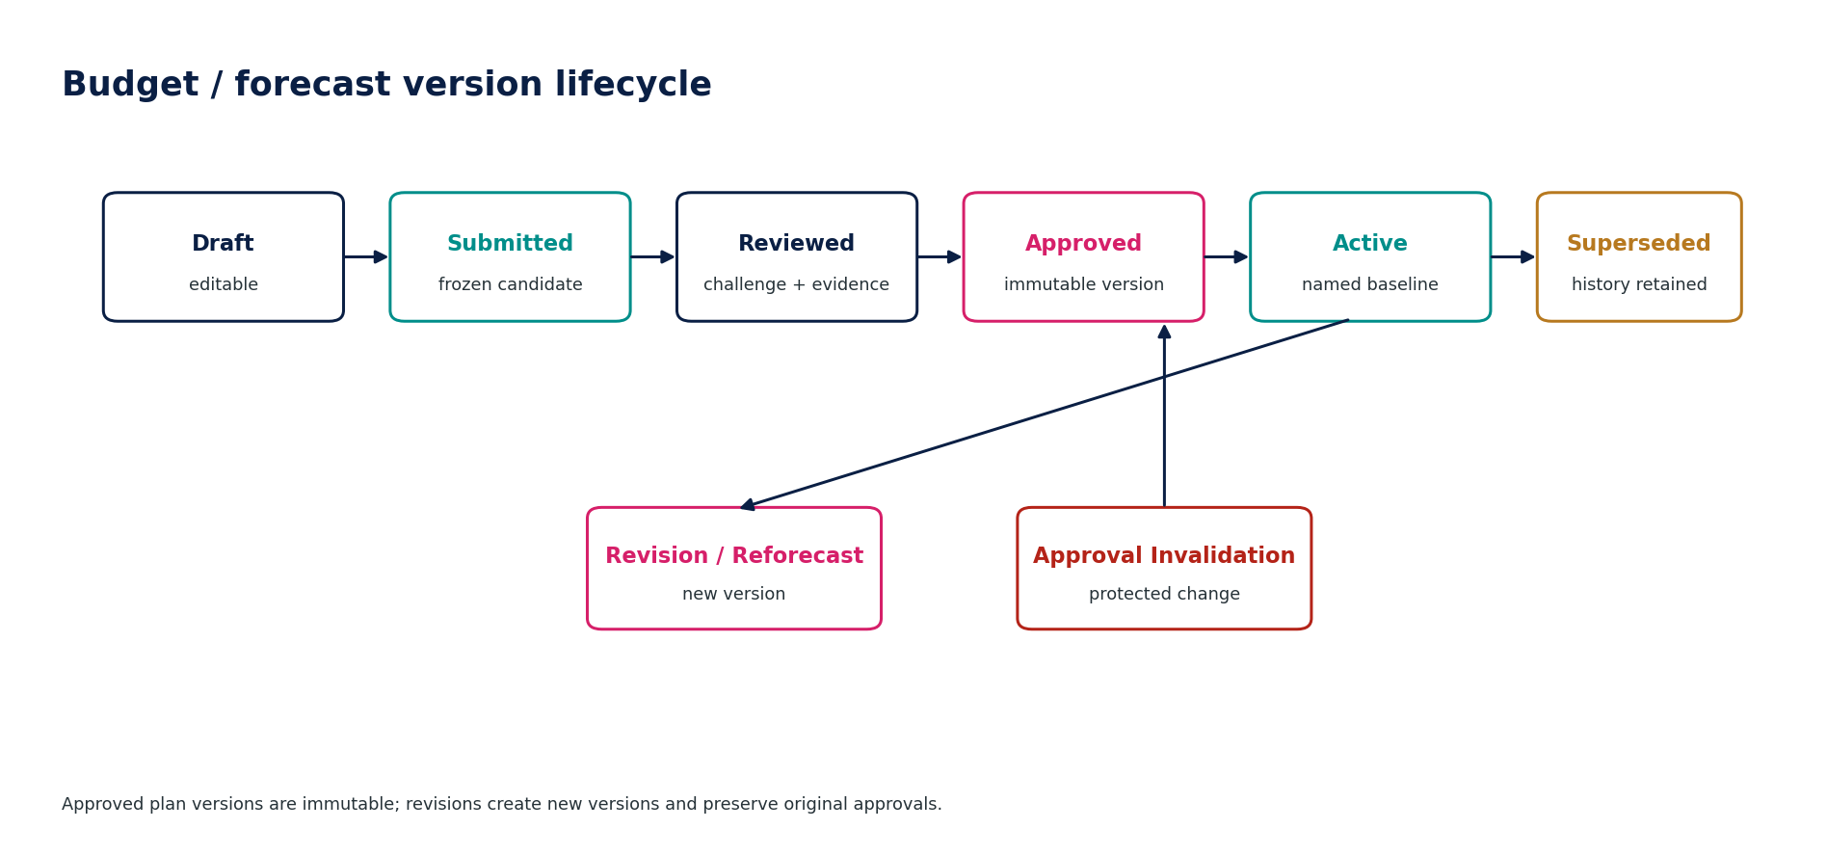
Figure 2 — Budget and forecast version lifecycle.

2. Shared FP&A Engineering Contract
Contract element | Mandatory behavior
Trusted context | tenant_id, entity/group scope, fiscal calendar, period/horizon, accounting/reporting basis, currency, permission and source actual identity are server-authoritative.
Population classes | CertifiedActual, ProvisionalActual, Budget, Forecast, Scenario and ManagementOverlay remain distinct and are never silently coerced.
Versioning | Approved/published versions are immutable; revision creates a new version and explicit supersession relationship.
Precision | Money and ratios use fixed precision; display rounding never changes stored plan values or variance calculations.
Concurrency | Mutable drafts use optimistic concurrency; approval binds a protected-content fingerprint.
Idempotency | Imports, recalculations, approvals, publication and board-pack release use stable idempotency keys where duplicate effect matters.
Errors | Stable problem codes include SOURCE_STALE, COMPARATOR_MOVED, MODEL_VERSION_MISMATCH, ASSUMPTION_OUT_OF_RANGE, KPI_CONFLICT, APPROVAL_INVALIDATED.
Lineage | Every output records source IDs/watermarks, assumption/model versions, overrides, normalization rules and result digest.
Assurance labeling | Every controlled pack exposes whether values are certified actual, provisional actual, budget, forecast, scenario or management overlay.
AI boundary | AI-05/other AI may suggest drivers, commentary or anomaly explanations, but suggestions require source links, are not authoritative and require governed acceptance.
Residency/classification | Forecast models, uploads, exports and board packs inherit tenant/entity residency, classification, purpose and retention policies.
Correction | No in-place correction of approved/published versions; supersede, reforecast or issue a corrected pack/version.
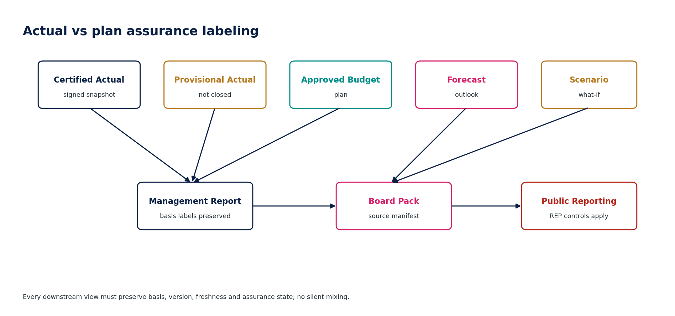
Figure 3 — Actual versus plan assurance labeling.

3. Detailed Service Specifications

3.1 FIN-01 — Budget
Purpose — Maintain governed budgets by entity/group, account, dimension and period without altering actual accounting truth.

Specification field | Build-ready requirement
Authoritative write ownership | Budget, BudgetVersion, BudgetLine, BudgetAssumptionLink, BudgetApproval
Explicit non-ownership | Actual ledger balances; accounting postings; statutory accounting policy; source operational facts
Required source inputs | Entity/group; fiscal year; book/reporting basis; accounts; dimensions; period values; assumptions; planning currency; version intent
Server-resolved context | tenant, entity/group scope, fiscal calendar, accounting book/reporting basis, chart/dimension validity, approval policy, planning FX set
Named commands | CreateBudget; AddBudgetLines; ImportBudget; ValidateBudget; SubmitBudget; ApproveBudget; ActivateBudget; CreateBudgetRevision; SupersedeBudget
Queries / read surfaces | GetBudget; GetBudgetVersion; GetBudgetLine; CompareBudgetVersions; GetApprovalState; GetAssumptions
State model | Draft → Submitted → Reviewed → Approved → Active → Superseded
Permissions | budget.prepare; budget.review; budget.approve; budget.activate
Segregation of duties | Material budget approver cannot be sole preparer; protected line/assumption changes after approval invalidate approval.
Domain events | BudgetCreated; BudgetSubmitted; BudgetApproved; BudgetActivated; BudgetSuperseded
Dependencies | ORG/REF, ACC snapshots, GOV-03/04/06, Evidence Ledger, FX/reference data
Failure / degradation semantics | Invalid account/dimension, missing planning FX, approval conflict or stale version → block; import errors quarantine rows, not partial silent acceptance.
Evidence / lineage | Version ID; source/import manifest; assumption versions; approval fingerprint; currency/FX basis; change history.
NFR / recovery profile | C2; deterministic recalculation; large budget import with row-level diagnostics; immutable approved versions.
Minimum negative tests | Budget writes actuals; invalid dimension; post-approval mutation; unauthorized activation; stale version; duplicate import; planning FX confused with accounting FX.

FIN-01 — Mandatory engineering controls
- Budget grain is explicit by account/dimension/period; aggregation does not invent missing detail.
- Approved budget versions are immutable; revisions retain parent version and reason.
- Input templates/imports carry schema/version and row-level diagnostics.
- Planning currency and FX assumptions are recorded separately from accounting-rate provenance.
- Activation requires completed approval and valid account/dimension reference versions.
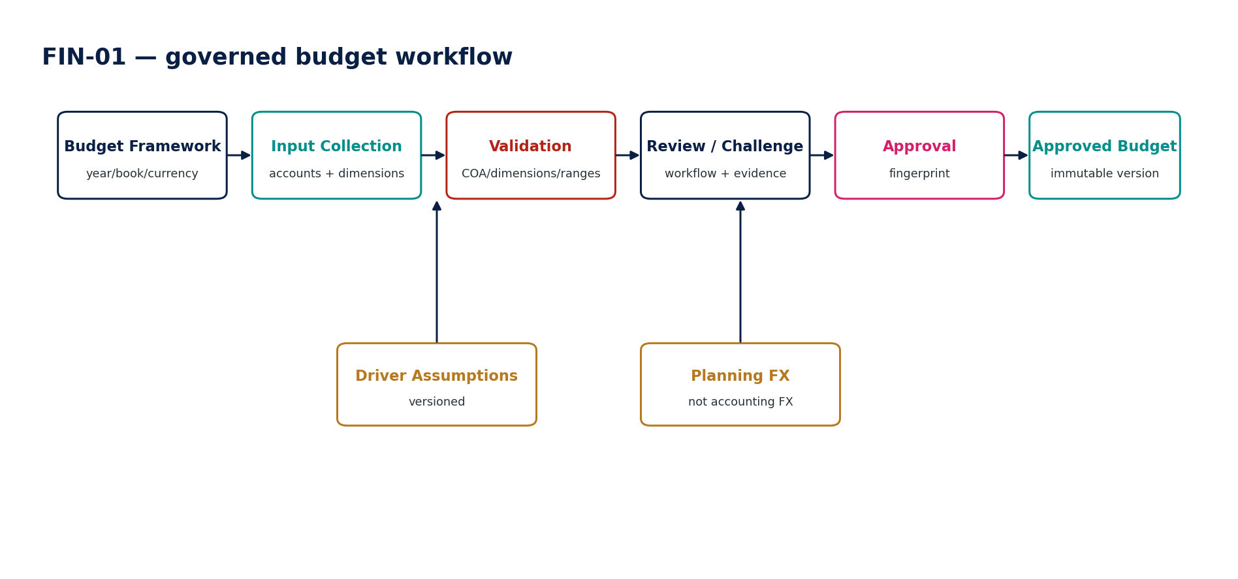
Figure — FIN-01 control flow.

3.2 FIN-02 — Forecast
Purpose — Maintain rolling or periodic forecasts that combine an explicit actual baseline with versioned driver assumptions and model logic.

Specification field | Build-ready requirement
Authoritative write ownership | Forecast, ForecastVersion, ForecastLine, ForecastDriverSet, ForecastOverride
Explicit non-ownership | Actual ledger truth; budget authority; source operational facts; AI-generated authoritative numerics
Required source inputs | Actual history/snapshot; forecast horizon; baseline budget/forecast; driver assumptions; dimensions; override proposals; scenario context
Server-resolved context | tenant/entity, actual source assurance state, source watermark, fiscal calendar, forecast cadence, model version, planning FX assumptions
Named commands | CreateForecast; SeedFromActuals; ApplyDriverSet; RecalculateForecast; ApplyOverride; SubmitForecast; ApproveForecast; PublishForecast; CreateReforecast
Queries / read surfaces | GetForecast; GetForecastVersion; ExplainForecastLine; GetDrivers; GetOverrides; CompareForecastVersions
State model | Draft → Calculated → Reviewed → Approved → Published → Superseded
Permissions | forecast.prepare; forecast.override; forecast.review; forecast.approve; forecast.publish
Segregation of duties | Override author cannot approve own material override; AI suggestion cannot bypass human review.
Domain events | ForecastCreated; ForecastCalculated; ForecastOverrideApplied; ForecastApproved; ForecastPublished
Dependencies | ACC-16/controlled actuals, FIN-01/03, semantic data, REF FX/calendar, AI-05 advisory only
Failure / degradation semantics | Missing baseline, stale actual source, model-version mismatch, unsupported driver or invalid override → block/review; never fall back to prior source silently.
Evidence / lineage | Actual snapshot/watermark; model version; driver set; overrides/reasons; planning FX; approvers; recalculation digest.
NFR / recovery profile | C2; reproducible recalculation; forecast explainability; bounded model runtime; versioned cache keys.
Minimum negative tests | Forecast overwrites budget; stale actuals unlabeled; model drift; hidden override; AI authoritative write; missing driver source; post-approval mutation.

FIN-02 — Mandatory engineering controls
- Forecast baseline identifies exact actual snapshot/watermark and prior plan version.
- Rolling horizon rules, cadence and actualization policy are versioned.
- Every override records author, timestamp, reason and old/new value; material overrides require review.
- Model/driver changes create new calculation versions; approved results are never silently recomputed.
- AI-assisted forecast suggestions remain proposals until accepted through normal command/workflow.
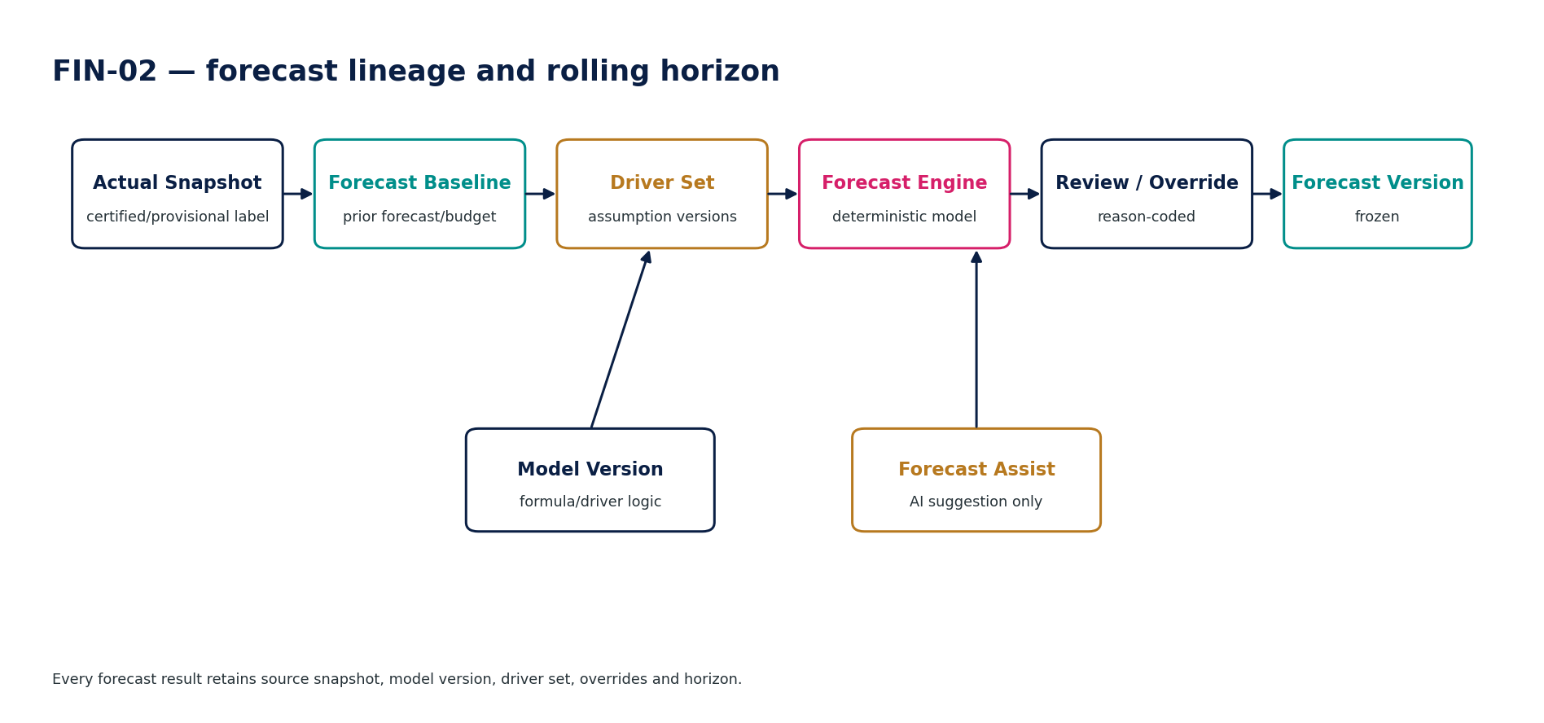
Figure — FIN-02 control flow.

3.3 FIN-03 — Scenario
Purpose — Create isolated what-if cases from a frozen budget/forecast base and changed assumptions without changing the base or actuals.

Specification field | Build-ready requirement
Authoritative write ownership | Scenario, ScenarioVersion, ScenarioAssumptionDelta, ScenarioResult, ScenarioComparison
Explicit non-ownership | Budget/forecast base version; actual ledger; operational source; promoted forecast unless separately governed
Required source inputs | Base budget/forecast; changed assumptions; scenario name; horizon; owner; optional sensitivity ranges
Server-resolved context | tenant/entity, base version, model version, permissible driver ranges, planning FX, access purpose
Named commands | CreateScenario; ApplyAssumptionDelta; CalculateScenario; RunSensitivity; CompareScenarios; FreezeScenario; PromoteToForecastCandidate; ArchiveScenario
Queries / read surfaces | GetScenario; GetScenarioResult; ExplainDeltaToBase; CompareScenarios; GetSensitivity
State model | Draft → Calculated → Frozen → Archived / PromotedCandidate
Permissions | scenario.create; scenario.calculate; scenario.promote; scenario.archive
Segregation of duties | Scenario creator cannot promote directly to approved forecast; promotion creates new governed FIN-02 workflow.
Domain events | ScenarioCreated; ScenarioCalculated; ScenarioFrozen; ScenarioPromotedCandidate
Dependencies | FIN-01/02, forecast model, semantic data, REF FX/calendar
Failure / degradation semantics | Base version missing/superseded, driver outside governed range or model incompatible → block/review; scenario remains isolated.
Evidence / lineage | Base version; assumption deltas; model version; sensitivity parameters; result digest; promotion lineage.
NFR / recovery profile | C2; sandbox resource quotas; reproducible result; no authoritative side effects.
Minimum negative tests | Scenario mutates base; scenario posts journal; driver range bypass; silent base change; promotion bypasses forecast approval; cross-tenant scenario access.

FIN-03 — Mandatory engineering controls
- Scenario base is frozen by ID/version; base mutations never propagate silently.
- Scenario assumptions are deltas with bounds and provenance; base assumptions remain intact.
- Scenario workloads are isolated and resource-limited by tenant.
- Promotion generates a forecast candidate with complete lineage and normal FIN-02 approval.
- Scenario output cannot be presented as certified actual, approved budget or published forecast without explicit transition.
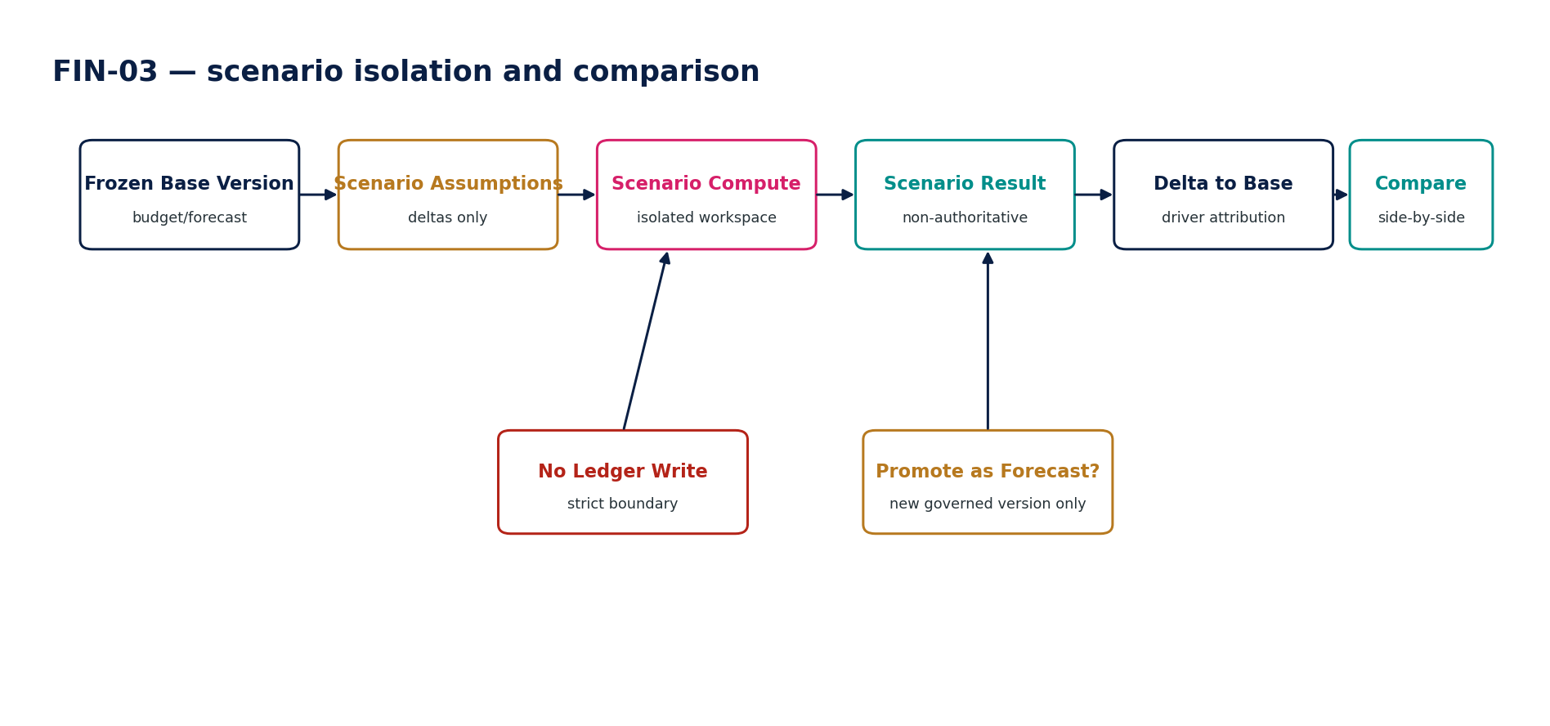
Figure — FIN-03 control flow.

3.4 FIN-04 — Variance Analysis
Purpose — Compare a frozen actual population with a frozen budget, forecast, scenario or prior-period comparator and preserve currency/materiality policy.

Specification field | Build-ready requirement
Authoritative write ownership | VarianceAnalysis, VarianceResult, VarianceDriverAttribution, VarianceCommentaryWorkflow
Explicit non-ownership | Source actuals; comparator dataset; KPI definitions; accounting corrections
Required source inputs | Actual snapshot; comparator dataset/version; period; account/dimensions; variance basis; requested driver analysis
Server-resolved context | materiality thresholds, sign convention, calendar alignment, planning/actual FX policy, constant-currency policy, semantic mappings
Named commands | CreateVarianceAnalysis; RecalculateVariance; SetMaterialityProfile; SubmitCommentary; ApproveCommentary; FreezeAnalysis
Queries / read surfaces | GetVariance; DrillToActual; GetComparator; ExplainVariance; GetCommentary; GetMateriality
State model | Draft → Calculated → Explained → Reviewed → Frozen
Permissions | variance.calculate; variance.comment; variance.review; variance.freeze
Segregation of duties | Comment author cannot change source/comparator versions; threshold changes after freeze require new analysis version.
Domain events | VarianceAnalysisCreated; VarianceCalculated; VarianceCommentarySubmitted; VarianceFrozen
Dependencies | ACC/REP actuals, FIN budget/forecast/scenario, FIN-05, REF currency/calendar
Failure / degradation semantics | Moving comparator, source mismatch, incompatible period/currency basis, missing lineage → block or explicitly flag non-comparable.
Evidence / lineage | Actual/comparator IDs; FX/normalization policy; thresholds; driver method; commentary owner/reviewer; frozen digest.
NFR / recovery profile | C2; drill-through p95 target <2s for indexed lineage; large cube comparison via bounded jobs.
Minimum negative tests | Comparator changes mid-analysis; wrong sign; unversioned constant currency; hidden immaterial threshold change; missing actual drill-through; stale commentary basis.

FIN-04 — Mandatory engineering controls
- Actual and comparator population identities are frozen before calculation.
- Variance amount, percentage, sign convention, constant-currency and calendar normalization are explicit.
- Materiality/attention thresholds are versioned and cannot be widened mid-review.
- Driver attribution is explainable and must reconcile to the calculated variance or disclose residual.
- Commentary is linked to the exact variance instance and invalidates if the underlying comparison changes.
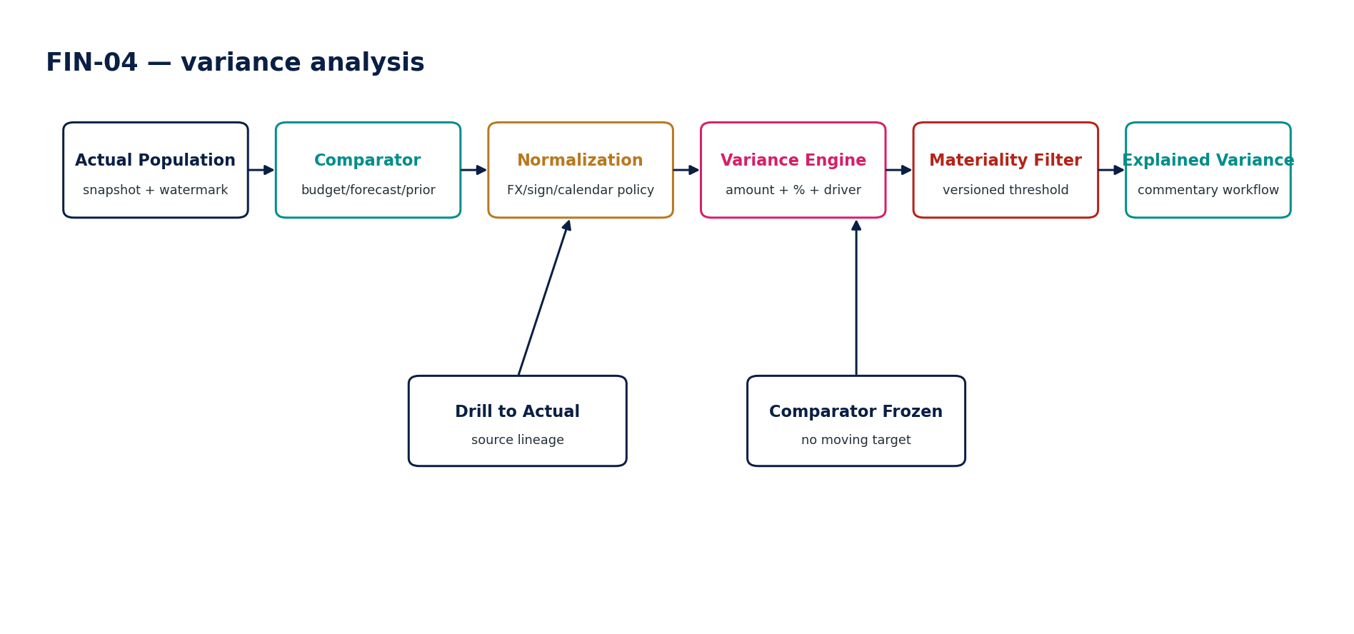
Figure — FIN-04 control flow.

3.5 FIN-05 — KPI Registry & Calculation
Purpose — Define, govern and calculate consistent performance metrics with explicit ownership, formula, unit, source lineage and effective dates.

Specification field | Build-ready requirement
Authoritative write ownership | KPIDefinition, KPIVersion, KPICalculationRun, KPIResult, KPIAlias/Deprecation
Explicit non-ownership | Underlying source facts; accounting/tax policy; public-report disclosure classification; ad hoc ungoverned spreadsheet metrics
Required source inputs | Metric name/definition; purpose; source facts; formula; dimensions; unit; aggregation rule; owner; effective dates; thresholds/targets
Server-resolved context | semantic model, source assurance state, calculation-engine version, entity/group scope, currency/unit conversion policy, disclosure/use classification
Named commands | CreateKPI; SubmitKPIDefinition; ApproveKPI; ActivateKPI; CalculateKPI; SetTarget; DeprecateKPI; SupersedeKPI
Queries / read surfaces | GetKPI; GetDefinitionVersion; CalculatePreview; ExplainKPI; GetSourceLineage; GetTargets; FindConflictingKPI
State model | Draft → Reviewed → Approved → Active → Deprecated/Superseded
Permissions | kpi.define; kpi.review; kpi.approve; kpi.calculate; kpi.admin
Segregation of duties | KPI author cannot independently approve a material executive/public KPI; conflicting duplicate definition requires governance decision.
Domain events | KPIDefined; KPIApproved; KPIActivated; KPICalculated; KPIDeprecated
Dependencies | semantic data, ACC/REP actuals, FIN plan facts, REF units/currency, GOV workflow, Evidence Ledger
Failure / degradation semantics | Missing owner/source/formula/unit, circular formula, incompatible aggregation or conflicting active KPI → block activation.
Evidence / lineage | Definition/version; semantic source IDs; formula AST/hash; engine version; unit/currency rules; calculation input watermark; result digest.
NFR / recovery profile | C1/C2 by use; deterministic calculation; batch + on-demand execution; cached results version-scoped.
Minimum negative tests | Duplicate KPI conflict; hidden formula change; source lineage missing; wrong aggregation; stale target; unauthorized definition activation; public MPM used without REP disclosure governance.

FIN-05 — Mandatory engineering controls
- KPI formula is stored as governed expression/AST rather than opaque spreadsheet text where feasible.
- Aggregation semantics explicitly identify additive, semi-additive, ratio/non-additive and time behavior.
- Unit, currency and sign conventions are mandatory for numeric KPIs.
- Definition conflict detection prevents duplicate active meanings under the same label.
- If a metric becomes a management-defined performance measure in public communications, Reporting must apply the applicable IFRS 18/disclosure governance; FIN-05 alone is not sufficient.
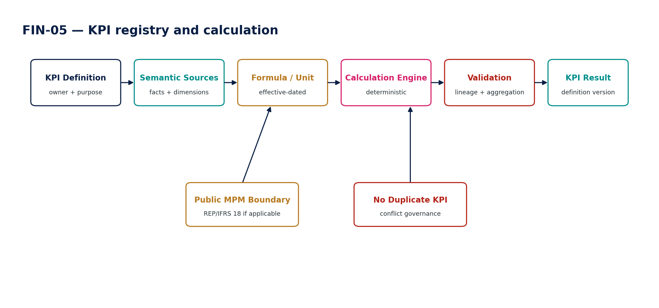
Figure — FIN-05 control flow.

3.6 FIN-06 — Management Accounts
Purpose — Assemble periodic internal management accounts from controlled actuals, management overlays, budget/forecast, KPI/variance results and reviewed commentary.

Specification field | Build-ready requirement
Authoritative write ownership | ManagementAccountsPack, ManagementAdjustmentOverlay, ManagementCommentary, PackApproval
Explicit non-ownership | Statutory ledger; posted management-book journals; certified external financial statements; forecast/budget source versions
Required source inputs | Approved/certified actual snapshot; management adjustments/overlay; comparator; KPI/variance results; commentary; period; pack template
Server-resolved context | entity/group, period, management hierarchy, management-book policy, assurance state, currency, distribution classification
Named commands | CreateManagementAccounts; ApplyManagementOverlay; RefreshPack; ValidatePack; SubmitForReview; ApprovePack; PublishInternalPack; SupersedePack
Queries / read surfaces | GetManagementAccounts; GetSourceBasis; GetManagementAdjustments; ExplainMetric; GetComparatives; GetApprovalState
State model | Draft → Refreshed → Reviewed → Approved → Published → Superseded
Permissions | mgmtaccounts.prepare; mgmtaccounts.adjust; mgmtaccounts.review; mgmtaccounts.approve; mgmtaccounts.publish
Segregation of duties | Overlay preparer cannot self-approve material adjustments; an overlay cannot masquerade as statutory/accounting truth.
Domain events | ManagementAccountsCreated; ManagementOverlayApplied; ManagementAccountsApproved; ManagementAccountsPublished
Dependencies | ACC/REP actuals, FIN-01/02/04/05, GOV workflow, Evidence Ledger, Data Governance
Failure / degradation semantics | Source assurance mismatch, unapproved management overlay, stale comparator or unexplained material variance → warn/block by pack policy.
Evidence / lineage | Actual snapshot; overlay version; comparator; KPI versions; commentary approvals; pack digest; assurance labels.
NFR / recovery profile | C1/C2 by governance use; deterministic pack generation; immutable published version; source-basis drill-through.
Minimum negative tests | Overlay edits statutory ledger; provisional actual mislabeled certified; unapproved overlay; stale forecast; commentary changes numeric fact; published pack overwritten.

FIN-06 — Mandatory engineering controls
- Management adjustments are overlays or management-book inputs, never hidden edits to statutory actuals.
- Pack tables/graphs retain source basis, comparator version and assurance label.
- Material unexplained variance may block controlled publication according to policy.
- Numeric facts and commentary are distinct; commentary cannot overwrite calculated facts.
- Published internal packs are immutable and superseded by new versions.
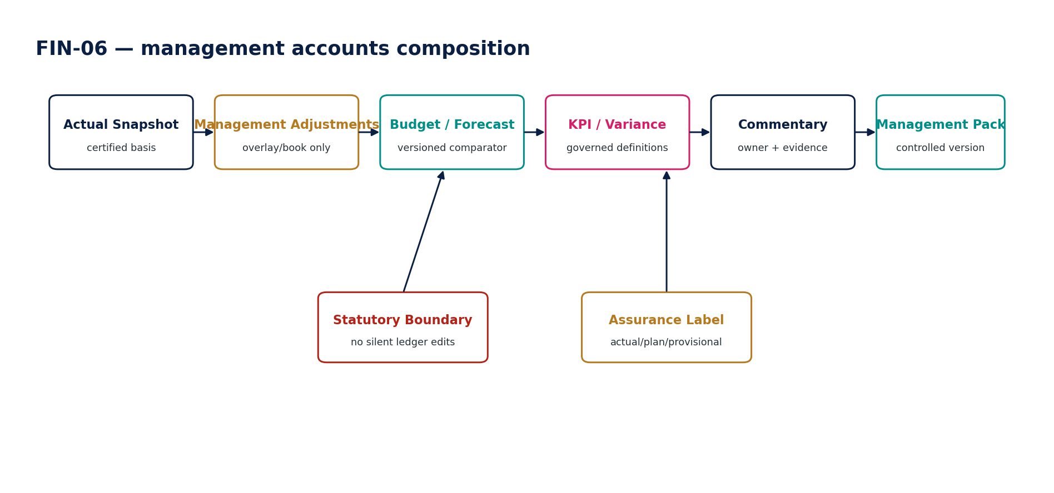
Figure — FIN-06 control flow.

3.7 FIN-07 — Board Reporting Pack
Purpose — Create a restricted, evidence-backed board-level performance pack from approved financial reports, KPI results, budgets/forecasts and reviewed narrative.

Specification field | Build-ready requirement
Authoritative write ownership | BoardPack, BoardPackVersion, BoardNarrative, DistributionListVersion, BoardPackEvidenceManifest
Explicit non-ownership | Underlying financial/plan/KPI facts; corporate-secretary board minutes; regulatory/public filing unless routed to REP
Required source inputs | Approved financial reports; management accounts; KPI/variance results; budgets/forecasts; narratives/risks; period; sign-offs; distribution list
Server-resolved context | group/entity scope, reporting period, board audience, classification, purpose, distribution permissions, source snapshot references, legal hold/retention
Named commands | CreateBoardPack; AssembleSources; ValidatePack; SubmitForReview; ApproveBoardPack; ReleaseBoardPack; RevokeAccess; SupersedeBoardPack
Queries / read surfaces | GetBoardPack; GetSourceManifest; GetNarrative; GetDistribution; VerifyPack; GetAccessAudit
State model | Draft → Assembled → Reviewed → Approved → Released → Superseded/Archived
Permissions | boardpack.prepare; boardpack.review; boardpack.approve; boardpack.release; boardpack.admin
Segregation of duties | Preparer cannot unilaterally release restricted board pack; recipient list changes after approval invalidate release approval.
Domain events | BoardPackCreated; BoardPackApproved; BoardPackReleased; BoardPackAccessRevoked; BoardPackSuperseded
Dependencies | FIN-04/05/06, REP approved reports, ZS-SEC, ZS-DATA-GOV, GOV-07, IAM/ABAC
Failure / degradation semantics | Missing source manifest, stale/unapproved source, unauthorized recipient, distribution policy conflict or altered artifact after approval → block release.
Evidence / lineage | Source IDs/versions/hashes; narrative owners; sign-offs; artifact digest; recipient list version; release/audit history.
NFR / recovery profile | C1 confidentiality/integrity; encrypted controlled distribution; immutable released artifact; access revocation where technically supported.
Minimum negative tests | Unapproved source included; recipient added after approval; source version missing; pack modified after signing; cross-tenant distribution; AI narrative unsupported; released pack overwritten.

FIN-07 — Mandatory engineering controls
- Board pack assembles only approved/allowed source versions and stores a complete source manifest.
- Narratives and risk statements have accountable owners and source references where factual.
- Recipient/distribution list is versioned and protected; changes after approval invalidate release approval.
- Released artifact digest/signature allows recipient-side verification and prevents undetected mutation.
- Public/investor-use content is routed to REP/public-disclosure governance rather than assuming board-pack approval is sufficient.
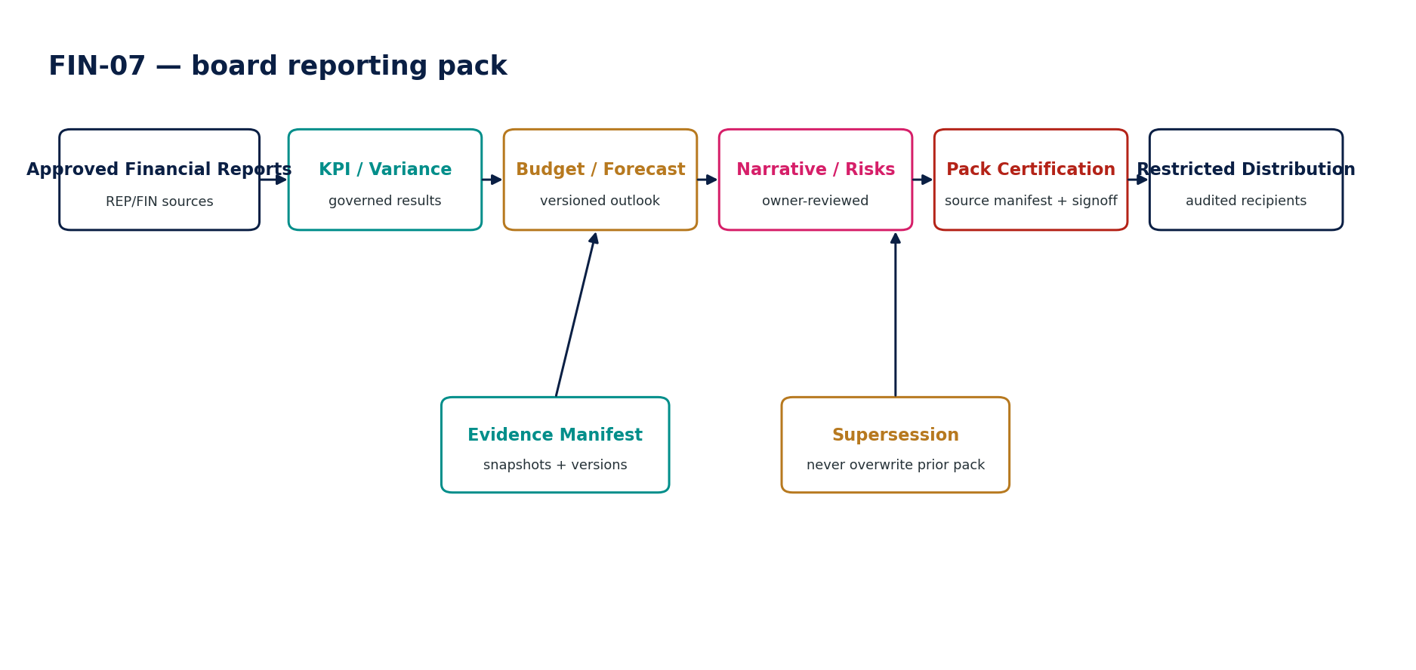
Figure — FIN-07 control flow.

4. Canonical FP&A Data Model & Cross-Domain Boundaries
Entity | Owned by | Key requirements
Budget / BudgetVersion | FIN-01 | Entity/group scope, fiscal basis, planning currency, status, parent/supersession, approval fingerprint.
BudgetLine | FIN-01 | Account/dimensions/period, amount/quantity, assumption links, source/import reference.
Forecast / ForecastVersion | FIN-02 | Actual source snapshot/watermark, horizon, model version, driver set, override set, approval state.
ForecastOverride | FIN-02 | Protected cell/range, prior/new value, reason, author, review state.
Scenario / ScenarioVersion | FIN-03 | Frozen base version, assumption deltas, model version, sensitivity configuration, result digest.
VarianceAnalysis | FIN-04 | Actual/comparator IDs, normalization/materiality profiles, result state, commentary workflow.
KPIDefinition / KPIVersion | FIN-05 | Owner, purpose, formula, unit, aggregation, source facts, dimensions, effective dates.
KPIResult | FIN-05 | Definition version, input watermark, entity/period, result, assurance/freshness, calculation digest.
ManagementAccountsPack | FIN-06 | Source actual, overlay, comparator, KPI/variance versions, commentary and approval evidence.
BoardPack / Version | FIN-07 | Source manifest, narrative owners, artifact digest, distribution list version, approvals/release audit.
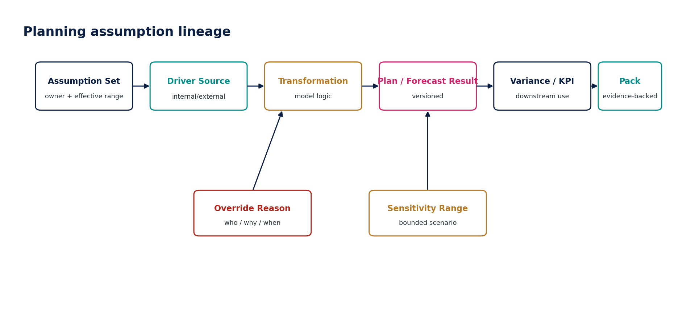
Figure 11 — Planning assumption lineage.

4.1 Cross-domain authority matrix
Fact / decision | Authority | FP&A behavior
Posted actuals / ledger truth | ACC-04/05 + certified ACC-16/REP sources | Read/compare only.
Accounting period close | ACC-14 / REF-05 state | Consume state; cannot reopen.
Planning FX assumption | FIN version with REF source where applicable | May differ from accounting FX; label/version.
Accounting FX rate | REF-03 + accounting policy | Consume only where applicable; FIN cannot replace.
Accounting allocation | ACC-09 | FIN may propose/plan, but cannot post.
Budget | FIN-01 | Authoritative plan version.
Forecast | FIN-02 | Authoritative outlook version, not accounting truth.
Scenario | FIN-03 | Authoritative scenario artifact, explicitly non-authoritative economically.
KPI definition/result | FIN-05 | Govern internal metric; public-report use may invoke REP/IFRS 18 governance.
Certified financial statements | REP-01 | Consume; do not recreate.
Board pack | FIN-07 | Controlled internal artifact; external/public release requires relevant disclosure/reporting governance.
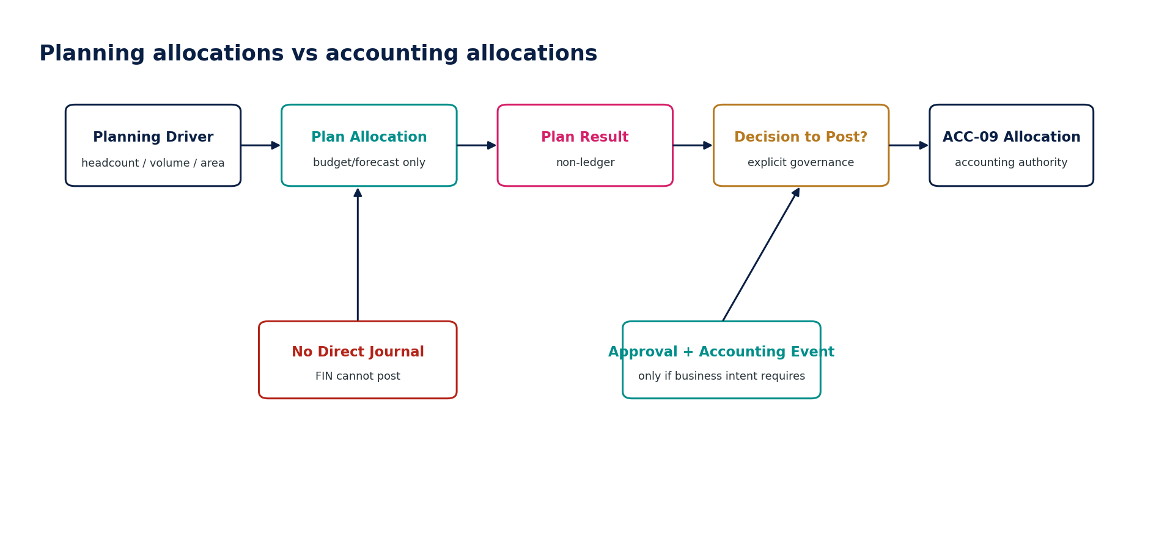
Figure 12 — Planning allocations versus accounting allocations.

5. Controls, Evidence, Observability & APIs
Control ID | Control | Blocking / evidence requirement
FIN-CTRL-001 | Plan/actual authority separation | Any FIN attempt to mutate actual accounting truth is blocked and security-audited.
FIN-CTRL-002 | Approved version immutability | Protected change requires new version/reapproval.
FIN-CTRL-003 | Actual source assurance | Source snapshot/watermark and assurance state mandatory.
FIN-CTRL-004 | Planning FX separation | Planning rate set/source/version required; cannot masquerade as accounting FX.
FIN-CTRL-005 | Driver/model version integrity | Forecast/scenario outputs bind to model and driver versions.
FIN-CTRL-006 | Override governance | Material overrides require reason/owner/review.
FIN-CTRL-007 | Scenario isolation | No base mutation or accounting side effect.
FIN-CTRL-008 | Comparator freeze | Variance actual and comparator versions frozen for run.
FIN-CTRL-009 | Materiality version | Threshold profile immutable per frozen analysis.
FIN-CTRL-010 | KPI definition completeness | Owner, formula, unit, aggregation and lineage required.
FIN-CTRL-011 | KPI conflict detection | Conflicting active KPI definitions require resolution.
FIN-CTRL-012 | Management overlay separation | Overlay cannot be represented as statutory actual.
FIN-CTRL-013 | Assurance labeling | Management/board views preserve basis and freshness.
FIN-CTRL-014 | Board source manifest | All material source versions/hashes included before approval.
FIN-CTRL-015 | Board distribution control | Approved recipient list/version bound to release.
FIN-CTRL-016 | Artifact integrity | Released controlled packs bind to digest/signature/evidence.
FIN-CTRL-017 | AI advisory boundary | AI suggestions cannot publish/approve authoritative output.
FIN-CTRL-018 | Lineage completeness | Every material plan/KPI/variance result supports explainability to inputs.
FIN-CTRL-019 | Retention/legal hold | Approved/released artifacts obey record class, disposition and holds.
FIN-CTRL-020 | Restated actual propagation | Dependent analyses/packs are marked stale/superseded when source actual is restated.
API / command pattern | Contract expectation
POST /budgets | Create draft budget; tenant/entity/book context server-authoritative.
POST /budgets/{id}:submit|approve|activate | Named state transitions; approval fingerprint and idempotency.
POST /forecasts/{id}:recalculate | Requires source/model/driver expected versions.
POST /forecasts/{id}:override | Reason-coded protected override; review policy applies.
POST /scenarios/{id}:calculate | Isolated compute; no business side effects.
POST /variances | Freeze actual/comparator and normalization policy at run creation.
POST /kpis/{id}:calculate | Definition version and input watermark mandatory.
POST /management-accounts/{id}:publish | Validates assurance labels, overlays, approvals and source basis.
POST /board-packs/{id}:release | Validates artifact digest, source manifest, recipient list and release approval.
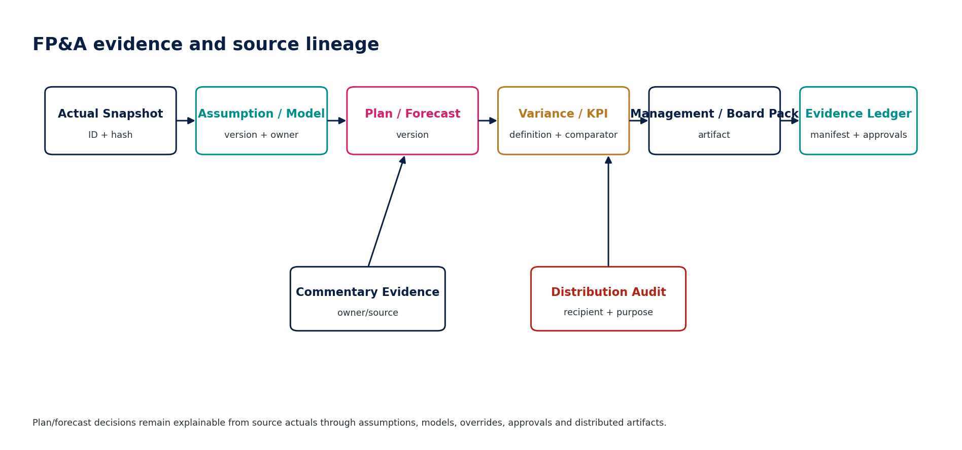
Figure 13 — FP&A evidence and source lineage.

5.1 Operational observability
- Budget/forecast version counts by state; approval aging; rejected imports and invalid dimensions.
- Forecast actual-source freshness, model/driver version distribution, override rate and material override aging.
- Scenario compute duration, resource-quota throttling and promotion rate.
- Variance unexplained residuals, commentary SLA, comparator staleness and materiality-profile version.
- KPI calculation failures, lineage gaps, conflicting definitions and stale cached results.
- Management/board pack source-assurance mix, overdue reviews, stale source dependencies and release failures.
- Board pack download/access/revocation events according to classification and privacy policy.

6. Negative-Path Engineering Certification
Certification rule — Headline calculation accuracy is insufficient. A service fails certification if it can cross an authority boundary, lose version/source provenance, mislabel assurance state, bypass approval/SoD, or silently mutate an approved artifact.

ID | Scenario | Expected result
FIN-N01 | Budget command attempts to update actual ledger balance | Deny; FIN has no authoritative actual-write path.
FIN-N02 | Approved budget line is edited in place | Deny; create revision/new version and reapprove.
FIN-N03 | Budget import contains invalid dimension among otherwise valid rows | Quarantine/report row errors; no silent partial authoritative activation.
FIN-N04 | Budget uses planning FX but downstream labels it accounting closing rate | Block/label mismatch; planning FX remains separate.
FIN-N05 | Unauthorized user activates approved budget | Deny by permission/scope.
FIN-N06 | Forecast uses stale actual snapshot without assurance/freshness label | Block publish or mark explicitly provisional per policy.
FIN-N07 | Forecast model changes after approval | Invalidate approval; new version/recalculation required.
FIN-N08 | Forecast override lacks owner/reason | Block material override.
FIN-N09 | AI-05 writes forecast result directly as authoritative | Deny; AI suggestions require governed human action.
FIN-N10 | Forecast silently falls back to previous driver set after source failure | Block/degrade; no silent substitution.
FIN-N11 | Scenario modifies base forecast version | Deny; scenario deltas are isolated.
FIN-N12 | Scenario attempts accounting journal post | Deny; no accounting authority.
FIN-N13 | Scenario driver exceeds approved range | Block or route to review.
FIN-N14 | Scenario is promoted directly to approved forecast | Create FIN-02 candidate and execute normal approval workflow.
FIN-N15 | Cross-tenant scenario/base reference | Deny; tenant/context mismatch.
FIN-N16 | Variance analysis comparator changes mid-run | Freeze comparator/version or invalidate run.
FIN-N17 | Variance uses incompatible fiscal periods without normalization disclosure | Block as non-comparable or require explicit policy.
FIN-N18 | Materiality threshold is widened after commentary review | Invalidate analysis/review and create new version.
FIN-N19 | Variance total is correct but drill-through actual population is incomplete | Fail completeness control.
FIN-N20 | Constant-currency calculation lacks FX source/version | Block certification of analysis.
FIN-N21 | KPI definition has no owner or source lineage | Block activation.
FIN-N22 | Two active KPIs share label but conflicting formulas | Raise conflict; governance decision required.
FIN-N23 | KPI formula changes without new version | Deny; version/supersede required.
FIN-N24 | KPI aggregation sums a non-additive ratio across dimensions | Validation failure.
FIN-N25 | Publicly communicated management-defined performance measure bypasses REP/IFRS 18 governance | Route to reporting/disclosure governance; internal KPI alone is insufficient.
FIN-N26 | Management overlay changes statutory book balances directly | Deny; use Accounting Kernel if accounting effect intended.
FIN-N27 | Management pack mixes certified and provisional actuals without labels | Block controlled publication.
FIN-N28 | Management commentary alters rendered numeric fact | Deny; commentary and facts remain separate.
FIN-N29 | Management adjustment created and approved by same person above threshold | Dynamic SoD failure.
FIN-N30 | Published management pack is overwritten | Deny; supersede with new immutable version.
FIN-N31 | Board pack includes unapproved forecast version | Block approval/release.
FIN-N32 | Recipient added after board pack approval | Invalidate release approval.
FIN-N33 | Board artifact changes after signing/fingerprint | Block release/verification failure.
FIN-N34 | Board narrative contains unsupported AI-generated claim | Block until source-grounded and human-reviewed.
FIN-N35 | Board pack crosses residency/export restriction | Block distribution; route governed exception if legally allowed.
FIN-N36 | Board pack source manifest omits one material KPI source | Fail completeness.
FIN-N37 | Plan allocation result is posted directly to ledger | Deny; accounting allocation must use ACC-09 and normal controls.
FIN-N38 | Forecast uses a KPI definition version that expired mid-period without policy | Block or resolve effective version explicitly.
FIN-N39 | Actual snapshot is restated but existing variance/board pack remains labeled current | Mark stale/superseded and require regeneration.
FIN-N40 | Deletion request targets approved budget under legal hold | Suspend disposition; maintain access restrictions and hold evidence.
FIN-N41 | Scenario compute exceeds tenant resource quota | Throttle/queue/abort safely; no cross-tenant impact.
FIN-N42 | KPI cached result is served after source watermark changes | Invalidate versioned cache.
FIN-N43 | Budget approver lacks entity scope | Deny.
FIN-N44 | Forecast is calculated from unsupported external driver file with no provenance | Quarantine/block until source provenance accepted.
FIN-N45 | Board pack distributed to revoked user after release | Enforce current access/revocation where technically supported and retain audit evidence.

7. Definition of Ready / Definition of Done

7.1 Service Definition of Ready
- Authoritative ownership and non-ownership approved against Accounting, Reporting, Organization/Reference and Governance domains.
- Plan/actual population class, source-assurance model, versioning and correction semantics defined.
- Commands, states, permissions, SoD, idempotency and concurrency rules agreed.
- Data grain, dimensions, calendar, currency/unit, model/assumption and aggregation semantics specified.
- Lineage/evidence requirements and retention/classification identified.
- Negative-path tests and measurable NFRs defined before production implementation.

7.2 Service Definition of Done
- OpenAPI/event contracts and persistence schema implemented with compatibility tests.
- Approved-version immutability, source/version binding and approval invalidation verified.
- Cross-domain authority tests prove FIN cannot mutate accounting/tax/banking truth.
- Deterministic recalculation and lineage explanation pass golden/negative test corpora.
- Observability, runbooks, SLOs, security/residency and recovery behavior pass ZS-QA-001 gates.
- Production release certificate identifies exact service/config/model versions and unresolved accepted risks.

8. Implementation Sequence
Wave | Scope | Exit gate
1 — Common planning foundation | Population classes, versioning, source snapshot references, planning currency/assumptions, shared command/error model. | Authority-separation and immutable-version tests pass.
2 — Budget | FIN-01 data model, import, workflow, approval, activation/revision. | Budget-to-actual isolation and approval invalidation certified.
3 — Forecast & scenario | FIN-02/03 model/driver framework, actual seeding, overrides, scenario sandbox. | Reproducibility, scenario isolation and AI advisory boundary pass.
4 — Variance & KPI | FIN-04/05 comparator freeze, materiality, KPI registry/calculation. | Lineage, aggregation and conflict tests pass.
5 — Management accounts | FIN-06 source assembly, management overlays, assurance labels, commentary. | No silent mixing; overlay/accounting boundary certified.
6 — Board pack | FIN-07 source manifest, approval, artifact integrity, restricted distribution. | Recipient/version binding and release audit certified.
7 — Scale / operations | Capacity, large import/cube workloads, cache invalidation, DR/runbooks. | ZS-NFR/OPS/QA production gates pass.

9. Controlled Pre-Production Decisions & Prohibited Anti-Patterns
Decision | Required resolution before production
Budget / forecast approval thresholds | Entity/group and materiality-based authority matrix.
Forecast cadence and actualization policy | Monthly/weekly cadence, cutoff, provisional/certified actual handling.
Planning FX policy | Sources, date basis, rates by forecast/budget/scenario, and disclosure rules.
Forecast model framework | Supported driver/model types, reproducibility, model governance and performance limits.
KPI semantic registry ownership | Finance governance owners, naming/alias/deprecation and public-use escalation.
Management overlay approach | Overlay-only vs dedicated management book; rules for conversion to accounting entry.
Board pack classification/distribution | Encryption, recipient lifecycle, mobile/download controls, retention/hold and external sharing.
AI Forecast Assist | Allowed use cases, grounding, evaluation, human acceptance and prohibited authority.

9.1 Prohibited architecture anti-patterns
Anti-pattern | Why prohibited
Budget/forecast table reused as ledger actuals | Collapses plan and authoritative accounting truth.
Editable approved budget/forecast | Destroys version history and approval evidence.
Single generic FX rate for plan and accounting | Creates irreproducible variance and accounting contamination.
Scenario writes back to base automatically | Destroys isolation and what-if integrity.
Moving comparator during variance review | Makes variance result non-reproducible.
KPI formula hidden in dashboard code | Eliminates ownership, lineage, versioning and auditability.
Management overlay silently changes statutory actuals | Bypasses Accounting Kernel and control framework.
Board pack assembled from screenshots/spreadsheets without source manifest | Breaks source-to-decision evidence.
AI-generated forecast treated as authoritative without acceptance | Delegates finance authority to non-authoritative model output.
Published pack overwritten | Destroys board/audit evidence and historical reconstruction.

10. Standards & External Boundary Notes
IFRS 18 boundary — IFRS 18 is effective for annual periods beginning on or after 1 January 2027. It introduces disclosure requirements for management-defined performance measures used in public communications. Internal KPI governance in FIN-05 is therefore intentionally separated from REP/public-report disclosure governance: when an internal KPI meets the public MPM definition, the Reporting domain must apply the applicable reporting controls.
Management Commentary boundary — The IASB issued the revised IFRS Practice Statement 1 Management Commentary in June 2025. It is a global benchmark for management commentary and connected narrative reporting. FIN-07 Board Pack remains an internal controlled artifact; content repurposed for investor/public management commentary must route to the Reporting/public-disclosure governance appropriate to the jurisdiction and reporting framework.
- Official reference: IFRS Foundation — IFRS 18 Presentation and Disclosure in Financial Statements (effective annual periods beginning on or after 1 January 2027).
- Official reference: IFRS Foundation — revised IFRS Practice Statement 1 Management Commentary, issued June 2025.
- This engineering standard is not accounting, securities-law or corporate-governance advice. Entity-specific public KPI, board disclosure and management-commentary obligations require jurisdiction and professional validation.

