ZOIKOSUITE

Procurement, Expenses & Accounts Payable
Detailed Service Specifications
AP-01 through AP-12 • Build-Ready Procure-to-Pay Engineering Baseline

Field | Value
Document ID | ZS-SVC-D-001
Version | 1.0 — Procurement & AP Engineering Baseline
Date | 24 August 2026
Status | Build-ready domain specification; jurisdiction-specific tax/e-invoice/withholding rules, bank/payment providers, numeric SLOs and delegated approval limits remain subject to certified launch configuration.
Owner | ZoikoSuite Product Architecture / Finance Platform Engineering
Applies to | Engineering, Product, Procurement, Finance/AP, Treasury, Tax, Security, QA, Support, Audit/Compliance and Integration teams
Language | American English

Executive doctrine: procure-to-pay authority must remain explicit. Supplier identity, controlled payee banking identity, requisition, purchase order, receipt, supplier invoice, matching, payable open item, payment proposal, payment authorization, external bank settlement, accounting consequence and recovery are separate authoritative facts. No supplier invoice, operator or payment batch may bypass the owning control boundary.

Document Roadmap & How to Use This Pack
This pack instantiates the approved ZoikoSuite service contract standard for AP-01 through AP-12. It is an engineering build contract, not a recommendation to deploy twelve separate microservices. Physical deployment may group capabilities, but authority boundaries, commands, data ownership, states, events, evidence, negative paths and financial controls remain independently testable.
Procure-to-pay truth flows in controlled stages: supplier/payee master → approved demand → purchase commitment → receipt/service evidence → supplier invoice → matching/tax/approval → payable → payment proposal → exact authorization → Banking initiation/confirmation → accounting event → Accounting Kernel → AP/GL/bank/GRNI reconciliation → certified reporting. Expense claims enter the same payable/payment control chain after policy and approval.

1. Critical Analysis & Refinements Incorporated
Refinement | Engineering consequence
Separate supplier financial settings from payee banking identity | AP-01 owns supplier-specific finance/procurement settings. Beneficiary bank identity is controlled by ORG-10/Treasury. Invoice-printed bank details are evidence only and never payment authority.
Procurement commitment is not ledger truth | Requisitions and POs are non-posting by default. Optional encumbrance/commitment accounting, if configured, still routes through the Accounting Kernel and book-specific rules.
Receipt evidence is independent of invoice approval | AP-04 confirms what was received/accepted. It may create GRNI/inventory/expense accounting events under policy, but never direct GL writes.
Supplier invoice has orthogonal state | Intake, match, approval, accounting, settlement and dispute/hold states remain separate; one generic status is prohibited.
Duplicate detection is a hard pre-approval control | Exact and near-duplicate supplier invoices are quarantined/flagged with reproducible evidence before liability recognition.
Matching is evidence, not approval authority | AP-06 produces a deterministic match result using a frozen tolerance policy. It cannot widen tolerance or self-waive material differences.
Payment proposal, authorization and execution are distinct | AP-09 selects; AP-10 authorizes the exact frozen subject; AP-11 orchestrates; Banking owns external initiation and settlement truth.
Payee fingerprint survives into authorization | Payment approval binds amount/currency/value date/paying account/method plus the approved ORG-10 beneficiary identity version. Any protected-field or bank-detail change invalidates approval.
External UNKNOWN is distinct from FAILED | Provider timeout/async state remains Pending/Unknown until BNK reconciles the original attempt, preventing duplicate payments.
Supplier recovery is not fabricated netting | Overpayments/duplicate payments are recovered only by confirmed inbound refund or an explicitly approved/legal offset, with AP/GL/bank reconciliation.

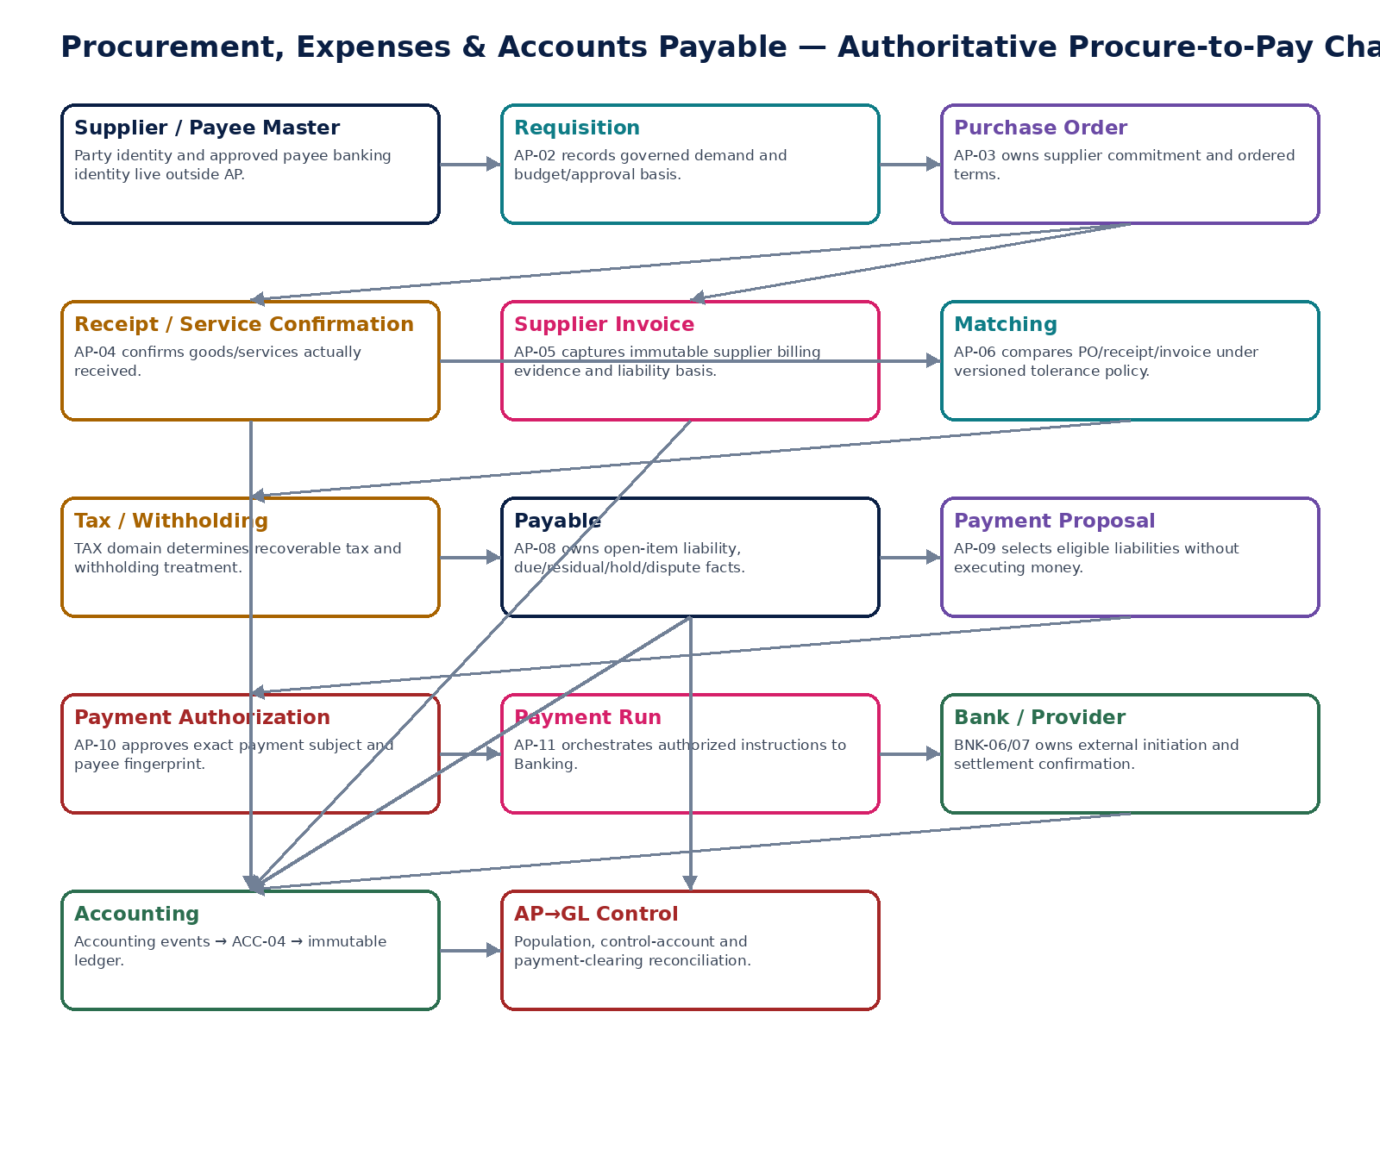
Figure 1 — Authoritative procure-to-pay control chain and domain boundaries.

2. Domain Constitution & Non-Negotiable Invariants
# | Invariant
1 | Supplier invoice free text or extracted bank account data is never authoritative payment-routing data.
2 | Beneficiary/payee banking identity is sourced from the controlled payee master and versioned/fingerprinted for payment authorization.
3 | Any protected payee, amount, currency, value-date, payer-account or method change after payment authorization invalidates that authorization.
4 | Requisitions and purchase orders do not directly write statutory/general-ledger balances.
5 | Confirmed goods/service receipts are not deleted in place; corrections use reversal/superseding receipt evidence.
6 | Receipt-triggered accounting, where configured, enters ACC-04 through governed accounting events.
7 | Accepted supplier invoices/source documents are immutable and retain original payload/hash/provenance.
8 | Duplicate supplier invoice detection occurs before liability approval/recognition and remains reproducible.
9 | Tax and withholding results are consumed from the TAX domain with exact rule-pack/version provenance.
10 | Invoice intake, match, approval, accounting, settlement and dispute/hold states are orthogonal.
11 | Invoice matching uses a frozen, versioned tolerance policy; operators cannot widen tolerance mid-run.
12 | Match result does not itself approve a supplier invoice or authorize payment.
13 | Expense claimant cannot approve their own claim where maker-checker applies.
14 | Payable residual is derived from authoritative sources/applications and cannot be free-form overwritten.
15 | Held, disputed, duplicate-risk or ambiguous in-flight payables are excluded from ordinary payment proposals.
16 | Payment proposal is non-executing; payment authorization is bound to an exact frozen subject.
17 | Payment run cannot alter any authorized protected field.
18 | External payment timeout/ambiguity is Pending/Unknown until Banking reconciles authoritative provider/bank state.
19 | No payable is marked settled solely from a payment-initiation response.
20 | All accounting consequences route through governed accounting events and ACC-04; AP never writes directly to the GL.
21 | AP-to-GL and payment-clearing controls test population completeness as well as headline totals.
22 | Supplier recovery/refund is not recognized as cash until Banking confirms receipt.
23 | Offsets/netting require explicit policy/legal basis, authority and source-level traceability.
24 | Cross-tenant/cross-entity suppliers, payables, proposals, authorizations and payment runs are denied by default.
25 | AI may extract/classify/suggest duplicate or match candidates but cannot approve invoices/claims/payments, change payee identity, assert settlement finality or waive controls.

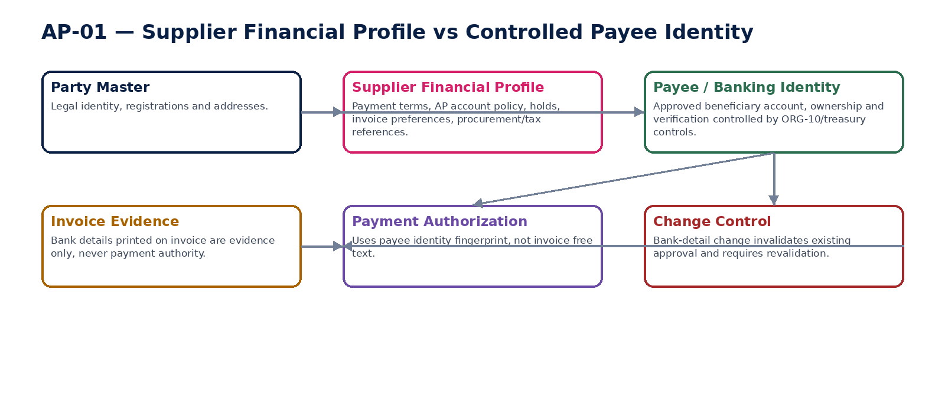
Figure 2 — Supplier financial profile and controlled payee/bank identity are separate authorities.

3. Cross-Service Authority Matrix
Service | Authoritative ownership | Must never own / bypass
AP-01 | Supplier financial/procurement/AP settings and holds | Party legal identity, beneficiary bank account, payment settlement, GL
AP-02 | Purchase requisition and approval basis | Supplier commitment, receipt, liability, payment
AP-03 | Issued PO commercial commitment and revisions | Receipt truth, supplier invoice, direct statutory GL
AP-04 | Goods/service receipt and acceptance evidence | Supplier invoice approval, payment authorization, direct GL
AP-05 | Supplier invoice/source document and liability basis | Payee bank master, independent tax calculation, direct bank settlement/GL
AP-06 | Matching result, frozen inputs/tolerance version and exceptions | Invoice approval, payment authorization, source-document mutation
AP-07 | Expense claim/evidence/policy approval basis | Self-approval, external settlement, direct GL
AP-08 | Payable open items, residuals, due/hold/dispute/application facts | Bank balance, free-form liability edit
AP-09 | Payment proposal selection and frozen subject | Payment authorization or external execution
AP-10 | Authorization decision/signers/subject fingerprint | Payee-bank mutation, provider settlement truth
AP-11 | Payment-run orchestration and BNK references | Provider/bank settlement authority, authorized-field mutation
AP-12 | Supplier recovery case, approved offset/refund linkage | Invented bank receipt, unapproved netting, direct GL

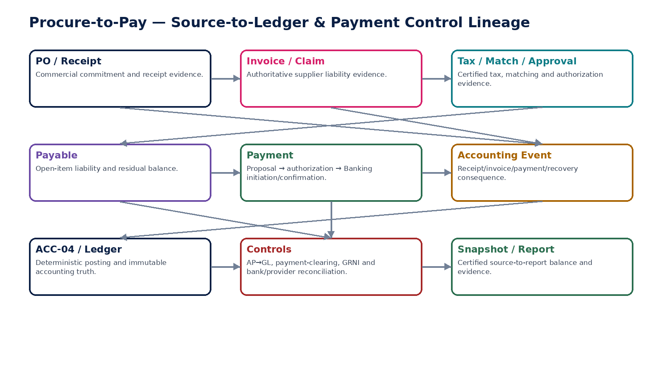
Figure 3 — Procure-to-pay source-to-ledger and payment-control lineage.

4. AP-01 — Supplier Financial Profile
Maintain entity-scoped supplier financial, procurement and payable settings without duplicating party identity or controlled beneficiary banking identity.

Contract field | Specification
Service ID / owner | AP-01 — Procurement, Expenses & Accounts Payable; accountable engineering/product/control owner recorded in service registry.
Purpose / bounded scope | Maintain entity-scoped supplier financial, procurement and payable settings without duplicating party identity or controlled beneficiary banking identity.
Authoritative ownership | SupplierFinancialProfile; effective-dated payment terms; AP account policy; invoice channel/preferences; supplier hold; procurement/category references; approved payment-method preference and risk/control flags.
Required source inputs | supplier party/role ID; legal entity; requested payment terms; category; invoice channel; payment method preference; tax/withholding classification references; hold/change request.
Server-resolved / derived context | party/legal identity; ORG-10 payee/banking identity reference and version; jurisdiction/registration facts; authorization/SoD; effective date; risk-source provenance.
Commands | CreateSupplierFinancialProfile; AmendSupplierFinancialProfile; ChangePaymentTerms; PlaceSupplierHold; ReleaseSupplierHold; ChangePaymentMethodPreference; RetireSupplierFinancialProfile
Queries / read contracts | GetSupplierFinancialProfile; GetSupplierFinancialProfileAsOf; GetPayeeReference; GetAvailableActions; ListProfileHistory
State model | Draft → Active → OnHold/Suspended → Retired; effective-dated attributes versioned.
Authorization / permissions | supplier.financial.read/manage; supplier.hold.manage; supplier.terms.manage; supplier.profile.approve.
Segregation of duties | Supplier-profile changer cannot approve own high-risk change; bank/payee master changes remain outside AP; users able to change payee identity cannot authorize resulting payment without independent control.
Events produced | SupplierFinancialProfileCreated; SupplierFinancialProfileChanged; SupplierHoldPlaced; SupplierHoldReleased; SupplierPaymentTermsChanged
Dependencies | Party/Organization master; ORG-10 Banking Identity/Payee Master; IAM/SoD; Policy; TAX registrations; Evidence.
Failure / degradation semantics | Missing/invalid supplier/entity/payee context blocks material processing; no fallback to invoice-printed bank details or stale payee versions.
Evidence / lineage | Prior/new values, effective interval, actor/approver, reason, source/risk references and payee identity reference/version.
NFR / recovery profile | C1 authoritative setup; historical reconstruction; strong change audit; low-latency reads.

Engineering Interaction Wireframe
Type | Operation | Illustrative contract surface | Mandatory controls
QUERY | GetSupplierFinancialProfile | GET/POST /internal/v1/ap01/getSupplierFinancialProfile | Scoped read; correlation + authorization context
QUERY | GetSupplierFinancialProfileAsOf | GET/POST /internal/v1/ap01/getSupplierFinancialProfileAsOf | Scoped read; correlation + authorization context
QUERY | GetPayeeReference | GET/POST /internal/v1/ap01/getPayeeReference | Scoped read; correlation + authorization context
QUERY | GetAvailableActions | GET/POST /internal/v1/ap01/getAvailableActions | Scoped read; correlation + authorization context
QUERY | ListProfileHistory | GET/POST /internal/v1/ap01/listProfileHistory | Scoped read; correlation + authorization context
COMMAND | CreateSupplierFinancialProfile | POST /internal/v1/ap01/commands/createSupplierFinancialProfile | Idempotency-Key; expected_version where stateful; server-resolved entity/jurisdiction
COMMAND | AmendSupplierFinancialProfile | POST /internal/v1/ap01/commands/amendSupplierFinancialProfile | Idempotency-Key; expected_version where stateful; server-resolved entity/jurisdiction
COMMAND | ChangePaymentTerms | POST /internal/v1/ap01/commands/changePaymentTerms | Idempotency-Key; expected_version where stateful; server-resolved entity/jurisdiction
COMMAND | PlaceSupplierHold | POST /internal/v1/ap01/commands/placeSupplierHold | Idempotency-Key; expected_version where stateful; server-resolved entity/jurisdiction

Minimum Negative-Path Acceptance
# | Scenario | Required result
1 | Invoice bank details differ from payee master | Block/deny/quarantine or preserve safe/Unknown state; stable error and evidence; no unauthorized, duplicate or unbalanced financial consequence.
2 | Supplier payment terms overlap effective periods | Block/deny/quarantine or preserve safe/Unknown state; stable error and evidence; no unauthorized, duplicate or unbalanced financial consequence.
3 | Bank changer attempts to authorize supplier payment | Block/deny/quarantine or preserve safe/Unknown state; stable error and evidence; no unauthorized, duplicate or unbalanced financial consequence.
4 | Inactive supplier used in new PO/invoice | Block/deny/quarantine or preserve safe/Unknown state; stable error and evidence; no unauthorized, duplicate or unbalanced financial consequence.


Figure 4 — Supplier financial profile vs controlled payee identity.

5. AP-02 — Purchase Requisition
Record governed internal demand, coding and approval basis before supplier commitment, while remaining non-posting unless an explicitly configured commitment/encumbrance book applies.

Contract field | Specification
Service ID / owner | AP-02 — Procurement, Expenses & Accounts Payable; accountable engineering/product/control owner recorded in service registry.
Purpose / bounded scope | Record governed internal demand, coding and approval basis before supplier commitment, while remaining non-posting unless an explicitly configured commitment/encumbrance book applies.
Authoritative ownership | PurchaseRequisition; lines; requester; business purpose; category; requested quantity/amount/date; financial dimensions; budget/project/contract references; approval state.
Required source inputs | requester/entity; item/service/category; quantity/amount; currency; required date; business purpose; cost center/project; preferred supplier if allowed; attachments.
Server-resolved / derived context | budget/project availability if configured; category/procurement policy; delegated authority; supplier eligibility; jurisdiction; entity/currency/calendar; approval workflow.
Commands | CreateRequisition; AmendRequisition; SubmitRequisition; ApproveRequisition; RejectRequisition; CancelRequisition; ConvertToPurchaseOrder
Queries / read contracts | GetRequisition; ListRequisitions; GetApprovalStatus; GetAvailableActions; GetRequisitionHistory
State model | Draft → PendingApproval → Approved/Rejected → Converted/Cancelled/Expired; material amendments invalidate approval.
Authorization / permissions | requisition.read/create/manage; requisition.submit; requisition.approve; requisition.cancel.
Segregation of duties | Requester cannot approve own requisition where maker-checker applies; threshold/category/related-party exceptions require independent approval.
Events produced | PurchaseRequisitionCreated; PurchaseRequisitionSubmitted; PurchaseRequisitionApproved; PurchaseRequisitionRejected; PurchaseRequisitionConverted
Dependencies | AP-01; Product/Service/Category; FIN/PRJ budget/project; Workflow/SoD; Documents; Policy.
Failure / degradation semantics | Budget/policy service unavailable may block controlled categories; approved requisition cannot silently change before PO conversion.
Evidence / lineage | Versioned lines, business purpose, coding, budget/project response, approvals, policy version and conversion link.
NFR / recovery profile | C2 transactional; concurrency protected; non-posting by default.

Engineering Interaction Wireframe
Type | Operation | Illustrative contract surface | Mandatory controls
QUERY | GetRequisition | GET/POST /internal/v1/ap02/getRequisition | Scoped read; correlation + authorization context
QUERY | ListRequisitions | GET/POST /internal/v1/ap02/listRequisitions | Scoped read; correlation + authorization context
QUERY | GetApprovalStatus | GET/POST /internal/v1/ap02/getApprovalStatus | Scoped read; correlation + authorization context
QUERY | GetAvailableActions | GET/POST /internal/v1/ap02/getAvailableActions | Scoped read; correlation + authorization context
QUERY | GetRequisitionHistory | GET/POST /internal/v1/ap02/getRequisitionHistory | Scoped read; correlation + authorization context
COMMAND | CreateRequisition | POST /internal/v1/ap02/commands/createRequisition | Idempotency-Key; expected_version where stateful; server-resolved entity/jurisdiction
COMMAND | AmendRequisition | POST /internal/v1/ap02/commands/amendRequisition | Idempotency-Key; expected_version where stateful; server-resolved entity/jurisdiction
COMMAND | SubmitRequisition | POST /internal/v1/ap02/commands/submitRequisition | Idempotency-Key; expected_version where stateful; server-resolved entity/jurisdiction
COMMAND | ApproveRequisition | POST /internal/v1/ap02/commands/approveRequisition | Idempotency-Key; expected_version where stateful; server-resolved entity/jurisdiction

Minimum Negative-Path Acceptance
# | Scenario | Required result
1 | Requester self-approves above threshold | Block/deny/quarantine or preserve safe/Unknown state; stable error and evidence; no unauthorized, duplicate or unbalanced financial consequence.
2 | Approved requisition amount changed before conversion | Block/deny/quarantine or preserve safe/Unknown state; stable error and evidence; no unauthorized, duplicate or unbalanced financial consequence.
3 | Budget check bypassed for controlled category | Block/deny/quarantine or preserve safe/Unknown state; stable error and evidence; no unauthorized, duplicate or unbalanced financial consequence.
4 | Cancelled requisition converted to PO | Block/deny/quarantine or preserve safe/Unknown state; stable error and evidence; no unauthorized, duplicate or unbalanced financial consequence.

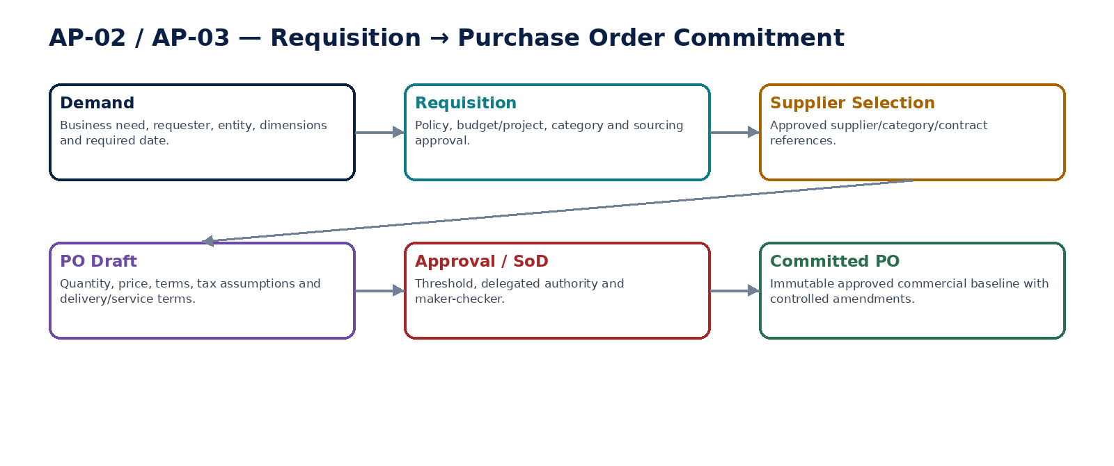
Figure 5 — Requisition-to-purchase-order commitment path.

6. AP-03 — Purchase Order
Create the authoritative supplier commercial commitment from approved procurement basis, with controlled amendments and no direct ledger bypass.

Contract field | Specification
Service ID / owner | AP-03 — Procurement, Expenses & Accounts Payable; accountable engineering/product/control owner recorded in service registry.
Purpose / bounded scope | Create the authoritative supplier commercial commitment from approved procurement basis, with controlled amendments and no direct ledger bypass.
Authoritative ownership | PurchaseOrder; PO lines; supplier/entity; prices; quantities; currency; terms; delivery/service obligations; tax assumptions; commitment state; revision history.
Required source inputs | approved requisition/contract/direct PO basis; supplier; item/service; quantity; price; currency; delivery/service terms; payment terms; ship/service location; project/dimensions.
Server-resolved / derived context | active supplier profile/hold; payee reference (informational, not payment execution); catalog/contract/price source; tax estimate/context; delegated authority; budget/commitment policy.
Commands | CreatePurchaseOrder; AmendPurchaseOrder; SubmitPOForApproval; ApprovePurchaseOrder; IssuePurchaseOrder; PlacePOHold; ReleasePOHold; CancelPurchaseOrder; ClosePurchaseOrder
Queries / read contracts | GetPurchaseOrder; GetPORevision; GetOpenQuantity; GetReceiptStatus; GetInvoiceStatus; GetAvailableActions
State model | Draft → PendingApproval → Approved → Issued → PartiallyReceived/PartiallyInvoiced → Fulfilled/Closed; Hold/Cancelled branches; revisions preserve prior issued versions.
Authorization / permissions | po.read/create/manage; po.approve; po.issue; po.hold; po.cancel/close.
Segregation of duties | PO preparer cannot approve above authority; supplier/price/quantity changes after approval require reapproval; related-party/sensitive procurement may require enhanced approval.
Events produced | PurchaseOrderCreated; PurchaseOrderApproved; PurchaseOrderIssued; PurchaseOrderAmended; PurchaseOrderHeld; PurchaseOrderClosed; PurchaseOrderCancelled
Dependencies | AP-01/02; contracts/catalog; TAX estimate; Workflow/SoD; Budget/Project; Documents.
Failure / degradation semantics | Issued PO is not edited destructively; amendments create new controlled revision; supplier hold blocks issue unless approved exception.
Evidence / lineage | PO revision, source requisition/contract, price source, approvals, supplier terms, communication evidence and receipt/invoice links.
NFR / recovery profile | C1 commercial commitment; deterministic remaining quantity/amount; concurrency protected.

Engineering Interaction Wireframe
Type | Operation | Illustrative contract surface | Mandatory controls
QUERY | GetPurchaseOrder | GET/POST /internal/v1/ap03/getPurchaseOrder | Scoped read; correlation + authorization context
QUERY | GetPORevision | GET/POST /internal/v1/ap03/getPORevision | Scoped read; correlation + authorization context
QUERY | GetOpenQuantity | GET/POST /internal/v1/ap03/getOpenQuantity | Scoped read; correlation + authorization context
QUERY | GetReceiptStatus | GET/POST /internal/v1/ap03/getReceiptStatus | Scoped read; correlation + authorization context
QUERY | GetInvoiceStatus | GET/POST /internal/v1/ap03/getInvoiceStatus | Scoped read; correlation + authorization context
QUERY | GetAvailableActions | GET/POST /internal/v1/ap03/getAvailableActions | Scoped read; correlation + authorization context
COMMAND | CreatePurchaseOrder | POST /internal/v1/ap03/commands/createPurchaseOrder | Idempotency-Key; expected_version where stateful; server-resolved entity/jurisdiction
COMMAND | AmendPurchaseOrder | POST /internal/v1/ap03/commands/amendPurchaseOrder | Idempotency-Key; expected_version where stateful; server-resolved entity/jurisdiction
COMMAND | SubmitPOForApproval | POST /internal/v1/ap03/commands/submitPOForApproval | Idempotency-Key; expected_version where stateful; server-resolved entity/jurisdiction

Minimum Negative-Path Acceptance
# | Scenario | Required result
1 | Issued PO overwritten in place | Block/deny/quarantine or preserve safe/Unknown state; stable error and evidence; no unauthorized, duplicate or unbalanced financial consequence.
2 | PO quantity increased after approval without reapproval | Block/deny/quarantine or preserve safe/Unknown state; stable error and evidence; no unauthorized, duplicate or unbalanced financial consequence.
3 | PO issued to held supplier without exception | Block/deny/quarantine or preserve safe/Unknown state; stable error and evidence; no unauthorized, duplicate or unbalanced financial consequence.
4 | Receipt/invoice exceeds controlled PO remaining amount | Block/deny/quarantine or preserve safe/Unknown state; stable error and evidence; no unauthorized, duplicate or unbalanced financial consequence.

7. AP-04 — Goods / Service Receipt
Record independent evidence that ordered goods, services or milestones were actually received/accepted, providing the authoritative receipt basis for matching and optional GRNI/inventory/expense accounting events.

Contract field | Specification
Service ID / owner | AP-04 — Procurement, Expenses & Accounts Payable; accountable engineering/product/control owner recorded in service registry.
Purpose / bounded scope | Record independent evidence that ordered goods, services or milestones were actually received/accepted, providing the authoritative receipt basis for matching and optional GRNI/inventory/expense accounting events.
Authoritative ownership | GoodsServiceReceipt; receipt lines; quantities/amounts; receipt/service date; location; receiver/acceptor; inspection/acceptance evidence; reversal/correction links.
Required source inputs | PO/order line; delivered quantity/service milestone; receipt date; location; receiver; delivery/service evidence; inspection/acceptance result; dimensions if required.
Server-resolved / derived context | PO open quantity/amount; supplier/entity; item/UOM; tolerance/over-receipt policy; user authority; period/accounting policy; inventory/project context.
Commands | CreateReceipt; AmendReceiptDraft; ConfirmReceipt; RejectReceipt; ReverseReceipt; RecordServiceAcceptance; AttachReceiptEvidence
Queries / read contracts | GetReceipt; ListReceiptsForPO; GetReceivedToDate; GetAvailableActions; GetReceiptAccountingStatus
State model | Draft → PendingConfirmation → Confirmed → PartiallyReversed/FullyReversed; Rejected branch; corrections linked rather than overwriting confirmed receipt.
Authorization / permissions | receipt.read/create/confirm/reverse; service.accept.
Segregation of duties | Receiver/acceptor cannot self-certify sensitive services where policy requires independent acceptance; receipt confirmer cannot override PO tolerance without approved exception.
Events produced | GoodsServiceReceiptCreated; GoodsServiceReceiptConfirmed; GoodsServiceReceiptReversed; ServiceAcceptanceRecorded
Dependencies | AP-03; Inventory/Project/Asset domains; Workflow/SoD; Accounting Kernel; Evidence.
Failure / degradation semantics | Over-receipt or closed/cancelled PO blocks unless approved exception; accounting event failure leaves visible pending/exception state, never silent receipt deletion.
Evidence / lineage | Delivery/service evidence, receiver/approver, PO revision, quantity/amount, exception reason, accounting event/posting references.
NFR / recovery profile | C1 operational financial basis; idempotent confirmation/reversal; historical receipt reconstruction.

Engineering Interaction Wireframe
Type | Operation | Illustrative contract surface | Mandatory controls
QUERY | GetReceipt | GET/POST /internal/v1/ap04/getReceipt | Scoped read; correlation + authorization context
QUERY | ListReceiptsForPO | GET/POST /internal/v1/ap04/listReceiptsForPO | Scoped read; correlation + authorization context
QUERY | GetReceivedToDate | GET/POST /internal/v1/ap04/getReceivedToDate | Scoped read; correlation + authorization context
QUERY | GetAvailableActions | GET/POST /internal/v1/ap04/getAvailableActions | Scoped read; correlation + authorization context
QUERY | GetReceiptAccountingStatus | GET/POST /internal/v1/ap04/getReceiptAccountingStatus | Scoped read; correlation + authorization context
COMMAND | CreateReceipt | POST /internal/v1/ap04/commands/createReceipt | Idempotency-Key; expected_version where stateful; server-resolved entity/jurisdiction
COMMAND | AmendReceiptDraft | POST /internal/v1/ap04/commands/amendReceiptDraft | Idempotency-Key; expected_version where stateful; server-resolved entity/jurisdiction
COMMAND | ConfirmReceipt | POST /internal/v1/ap04/commands/confirmReceipt | Idempotency-Key; expected_version where stateful; server-resolved entity/jurisdiction
COMMAND | RejectReceipt | POST /internal/v1/ap04/commands/rejectReceipt | Idempotency-Key; expected_version where stateful; server-resolved entity/jurisdiction

Minimum Negative-Path Acceptance
# | Scenario | Required result
1 | Receipt exceeds PO tolerance without approval | Block/deny/quarantine or preserve safe/Unknown state; stable error and evidence; no unauthorized, duplicate or unbalanced financial consequence.
2 | Receipt confirmed against cancelled PO | Block/deny/quarantine or preserve safe/Unknown state; stable error and evidence; no unauthorized, duplicate or unbalanced financial consequence.
3 | Confirmed receipt deleted to fix mismatch | Block/deny/quarantine or preserve safe/Unknown state; stable error and evidence; no unauthorized, duplicate or unbalanced financial consequence.
4 | GRNI event emitted twice on replay | Block/deny/quarantine or preserve safe/Unknown state; stable error and evidence; no unauthorized, duplicate or unbalanced financial consequence.

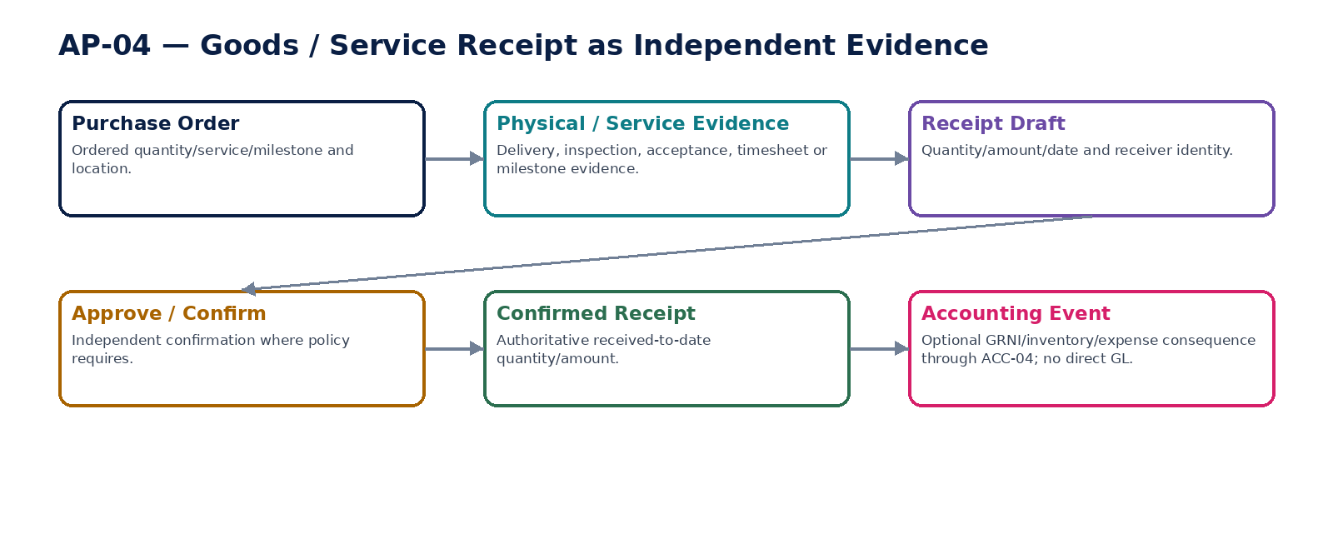
Figure 6 — Goods/service receipt as independent evidence.

8. AP-05 — Supplier Invoice
Capture and govern the authoritative supplier billing document/liability basis, including duplicate detection, immutable accepted representation, TAX/withholding provenance and correction linkage, without trusting invoice bank details for payment authority.

Contract field | Specification
Service ID / owner | AP-05 — Procurement, Expenses & Accounts Payable; accountable engineering/product/control owner recorded in service registry.
Purpose / bounded scope | Capture and govern the authoritative supplier billing document/liability basis, including duplicate detection, immutable accepted representation, TAX/withholding provenance and correction linkage, without trusting invoice bank details for payment authority.
Authoritative ownership | SupplierInvoiceDocument; immutable source representation/hash; supplier document number/type; lines; dates; totals; currency; PO/receipt refs; tax/withholding refs; intake/approval/accounting/settlement/dispute dimensions; correction links.
Required source inputs | supplier/entity; supplier invoice/credit document; invoice number/date/tax point/due terms; lines/amounts/currency; PO/receipt references; tax details; attachments/e-invoice payload; source channel.
Server-resolved / derived context | active supplier profile; ORG-10 payee identity reference; duplicate-risk result; TAX determination/withholding result; jurisdiction; PO/receipt/match context; accounting period/mapping; approval policy.
Commands | CaptureSupplierInvoice; AmendInvoiceDraft; ValidateSupplierInvoice; QuarantineSupplierInvoice; SubmitInvoiceForApproval; ApproveSupplierInvoice; RejectSupplierInvoice; AcceptSupplierCreditDocument; PlaceInvoiceHold; ReleaseInvoiceHold; LinkCorrection
Queries / read contracts | GetSupplierInvoice; GetInvoiceSourceRepresentation; GetInvoiceStateDimensions; GetDuplicateAssessment; GetAccountingStatus; GetAvailableActions; GetInvoiceHistory
State model | Intake, Match, Approval, Accounting, Settlement and Dispute/Hold are orthogonal. Accepted/posted supplier source representation is immutable; corrections use linked supplier credit/debit documents or governed reversal.
Authorization / permissions | supplierinvoice.read/capture/validate/approve/hold; supplierinvoice.exception.resolve.
Segregation of duties | Invoice capturer cannot approve own high-risk invoice; supplier-master/payee-bank changer cannot approve payment path without independent control; invoice bank details never override ORG-10.
Events produced | SupplierInvoiceCaptured; SupplierInvoiceValidated; SupplierInvoiceQuarantined; SupplierInvoiceApproved; SupplierInvoiceRejected; SupplierInvoiceHoldPlaced; SupplierCreditDocumentAccepted; SupplierInvoiceAccountingRequested
Dependencies | AP-01/03/04/06; TAX-03/05; ORG-10; Workflow/SoD; ACC; Documents; inbound e-invoice/connector.
Failure / degradation semantics | Duplicate/ambiguous invoice quarantined; missing TAX/withholding or invalid supplier/entity blocks approval; provider/document parsing uncertainty remains explicit; no direct GL/payee mutation.
Evidence / lineage | Original payload/file hash, source channel, duplicate assessment, PO/receipt/match references, TAX/withholding versions, approvals, accounting and payment lineage.
NFR / recovery profile | C0/C1 financial source; durable intake; duplicate-proof idempotency; immutable source evidence; exact historical reconstruction.

Engineering Interaction Wireframe
Type | Operation | Illustrative contract surface | Mandatory controls
QUERY | GetSupplierInvoice | GET/POST /internal/v1/ap05/getSupplierInvoice | Scoped read; correlation + authorization context
QUERY | GetInvoiceSourceRepresentation | GET/POST /internal/v1/ap05/getInvoiceSourceRepresentation | Scoped read; correlation + authorization context
QUERY | GetInvoiceStateDimensions | GET/POST /internal/v1/ap05/getInvoiceStateDimensions | Scoped read; correlation + authorization context
QUERY | GetDuplicateAssessment | GET/POST /internal/v1/ap05/getDuplicateAssessment | Scoped read; correlation + authorization context
QUERY | GetAccountingStatus | GET/POST /internal/v1/ap05/getAccountingStatus | Scoped read; correlation + authorization context
QUERY | GetAvailableActions | GET/POST /internal/v1/ap05/getAvailableActions | Scoped read; correlation + authorization context
QUERY | GetInvoiceHistory | GET/POST /internal/v1/ap05/getInvoiceHistory | Scoped read; correlation + authorization context
COMMAND | CaptureSupplierInvoice | POST /internal/v1/ap05/commands/captureSupplierInvoice | Idempotency-Key; expected_version where stateful; server-resolved entity/jurisdiction
COMMAND | AmendInvoiceDraft | POST /internal/v1/ap05/commands/amendInvoiceDraft | Idempotency-Key; expected_version where stateful; server-resolved entity/jurisdiction

Minimum Negative-Path Acceptance
# | Scenario | Required result
1 | Exact duplicate supplier invoice submitted twice | Block/deny/quarantine or preserve safe/Unknown state; stable error and evidence; no unauthorized, duplicate or unbalanced financial consequence.
2 | Near-duplicate invoice with formatting-altered number bypasses detection | Block/deny/quarantine or preserve safe/Unknown state; stable error and evidence; no unauthorized, duplicate or unbalanced financial consequence.
3 | Invoice bank details differ from payee master and are used for payment | Block/deny/quarantine or preserve safe/Unknown state; stable error and evidence; no unauthorized, duplicate or unbalanced financial consequence.
4 | Tax/withholding result changed after invoice approval | Block/deny/quarantine or preserve safe/Unknown state; stable error and evidence; no unauthorized, duplicate or unbalanced financial consequence.

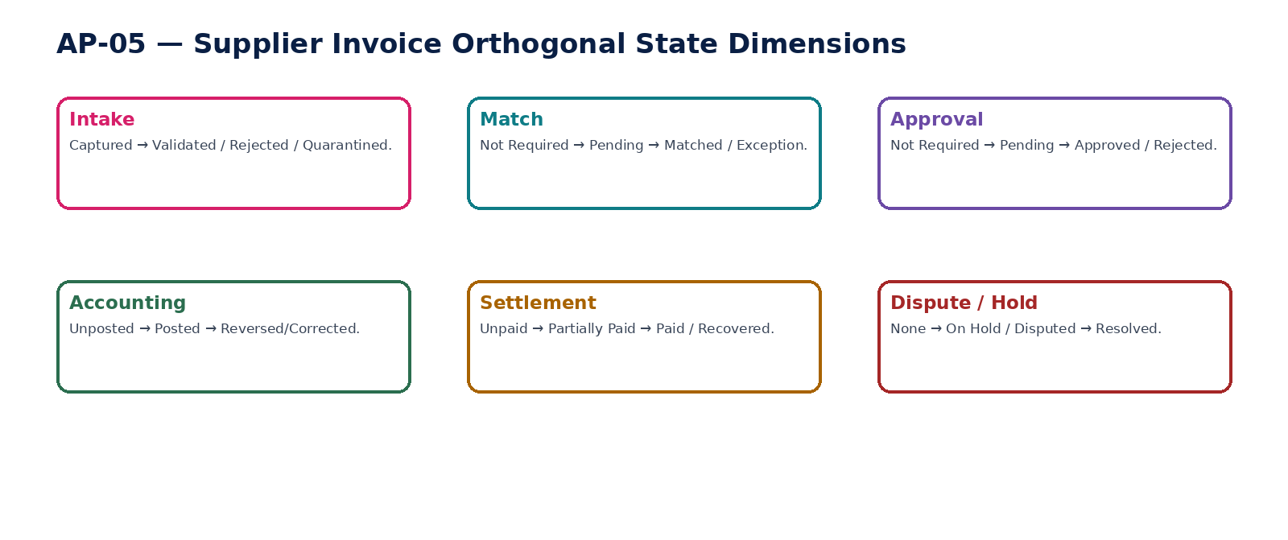
Figure 7 — Supplier invoice orthogonal state dimensions.

9. AP-06 — Invoice Matching
Evaluate invoice-to-PO/receipt/service evidence under versioned two-way/three-way/n-way policy, producing a reproducible match result and exceptions without approving invoices or waiving material differences itself.

Contract field | Specification
Service ID / owner | AP-06 — Procurement, Expenses & Accounts Payable; accountable engineering/product/control owner recorded in service registry.
Purpose / bounded scope | Evaluate invoice-to-PO/receipt/service evidence under versioned two-way/three-way/n-way policy, producing a reproducible match result and exceptions without approving invoices or waiving material differences itself.
Authoritative ownership | InvoiceMatchRun; frozen population/version; line-level match facts; tolerance policy version; matched/unmatched quantities/amounts; exception categories; resolution references.
Required source inputs | supplier invoice; PO revision; goods/service receipts; configured matching policy; relevant UOM/currency/tax dimensions.
Server-resolved / derived context | effective tolerance policy; category/entity/jurisdiction rules; FX/UOM conversions where explicitly approved; exception authority; prior match history.
Commands | RunInvoiceMatch; ReperformInvoiceMatch; AcknowledgeMatchException; RouteMatchException; RecordApprovedVariance; SupersedeMatchRun
Queries / read contracts | GetMatchResult; GetLineMatchDetail; ListMatchExceptions; GetMatchPolicyVersion; GetAvailableActions
State model | Created → Running → Matched/WithinTolerance/Exception/Incomplete → Superseded; certified run immutable.
Authorization / permissions | invoice.match.run/read; invoice.match.exception.resolve; match.policy.manage separate.
Segregation of duties | Operator cannot widen tolerance during run or self-waive material exception; policy editor cannot certify results under unreviewed policy change.
Events produced | InvoiceMatchStarted; InvoiceMatched; InvoiceMatchExceptionRaised; InvoiceMatchVarianceApproved; InvoiceMatchSuperseded
Dependencies | AP-03/04/05; Policy; UOM/FX; Workflow/SoD; Evidence.
Failure / degradation semantics | Missing PO/receipt data produces Incomplete, not false match; policy changes create new run/version; engine never mutates source documents.
Evidence / lineage | Frozen inputs, IDs/hashes, counts/totals, tolerance version, line differences, approver/reason and supersession chain.
NFR / recovery profile | C1 control service; deterministic/replayable; low-latency per invoice; batch support for large populations.

Engineering Interaction Wireframe
Type | Operation | Illustrative contract surface | Mandatory controls
QUERY | GetMatchResult | GET/POST /internal/v1/ap06/getMatchResult | Scoped read; correlation + authorization context
QUERY | GetLineMatchDetail | GET/POST /internal/v1/ap06/getLineMatchDetail | Scoped read; correlation + authorization context
QUERY | ListMatchExceptions | GET/POST /internal/v1/ap06/listMatchExceptions | Scoped read; correlation + authorization context
QUERY | GetMatchPolicyVersion | GET/POST /internal/v1/ap06/getMatchPolicyVersion | Scoped read; correlation + authorization context
QUERY | GetAvailableActions | GET/POST /internal/v1/ap06/getAvailableActions | Scoped read; correlation + authorization context
COMMAND | RunInvoiceMatch | POST /internal/v1/ap06/commands/runInvoiceMatch | Idempotency-Key; expected_version where stateful; server-resolved entity/jurisdiction
COMMAND | ReperformInvoiceMatch | POST /internal/v1/ap06/commands/reperformInvoiceMatch | Idempotency-Key; expected_version where stateful; server-resolved entity/jurisdiction
COMMAND | AcknowledgeMatchException | POST /internal/v1/ap06/commands/acknowledgeMatchException | Idempotency-Key; expected_version where stateful; server-resolved entity/jurisdiction
COMMAND | RouteMatchException | POST /internal/v1/ap06/commands/routeMatchException | Idempotency-Key; expected_version where stateful; server-resolved entity/jurisdiction

Minimum Negative-Path Acceptance
# | Scenario | Required result
1 | Tolerance widened during active match | Block/deny/quarantine or preserve safe/Unknown state; stable error and evidence; no unauthorized, duplicate or unbalanced financial consequence.
2 | Invoice quantity exceeds receipt but auto-matched | Block/deny/quarantine or preserve safe/Unknown state; stable error and evidence; no unauthorized, duplicate or unbalanced financial consequence.
3 | Match engine self-approves material variance | Block/deny/quarantine or preserve safe/Unknown state; stable error and evidence; no unauthorized, duplicate or unbalanced financial consequence.
4 | Missing receipt treated as zero-difference match | Block/deny/quarantine or preserve safe/Unknown state; stable error and evidence; no unauthorized, duplicate or unbalanced financial consequence.

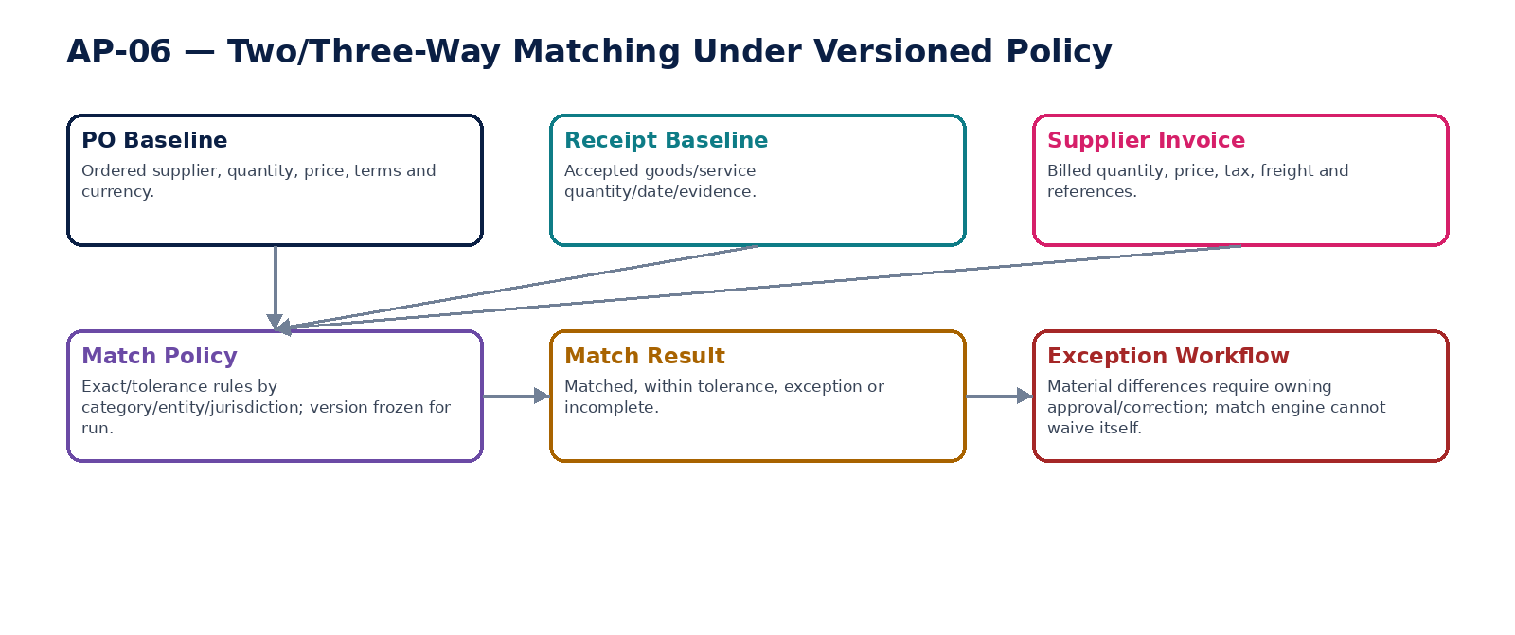
Figure 8 — Versioned two/three-way matching and exception workflow.

10. AP-07 — Expense Claim
Capture employee/authorized claimant expenses with receipt, business-purpose, policy, tax and approval evidence, creating a reimbursement/payable basis without allowing self-approval or direct bank execution.

Contract field | Specification
Service ID / owner | AP-07 — Procurement, Expenses & Accounts Payable; accountable engineering/product/control owner recorded in service registry.
Purpose / bounded scope | Capture employee/authorized claimant expenses with receipt, business-purpose, policy, tax and approval evidence, creating a reimbursement/payable basis without allowing self-approval or direct bank execution.
Authoritative ownership | ExpenseClaim; claim lines; claimant; merchant/date/amount/currency; business purpose; receipt/document links; policy/tax result; approval state; reimbursement basis.
Required source inputs | claimant/worker; entity; expense lines; receipts; merchant/date/amount/currency; business purpose; project/cost center; payment/reimbursement preference reference.
Server-resolved / derived context | worker/party status; expense policy version; duplicate receipt assessment; TAX recoverability; delegated authority; project/customer rebill context if applicable.
Commands | CreateExpenseClaim; AddExpenseLine; SubmitExpenseClaim; ApproveExpenseClaim; RejectExpenseClaim; ReturnForCorrection; CancelExpenseClaim; RecordExpensePolicyException
Queries / read contracts | GetExpenseClaim; GetPolicyAssessment; GetDuplicateReceiptAssessment; GetAvailableActions; GetClaimHistory
State model | Draft → Submitted → PendingApproval → Approved/Rejected/Returned → Reimbursable/Closed; corrections preserve prior submitted version/evidence.
Authorization / permissions | expense.read/create; expense.approve; expense.exception.approve.
Segregation of duties | Claimant cannot approve own claim; approver cannot override policy/receipt requirement outside delegated exception authority; duplicate-receipt conflicts require independent resolution.
Events produced | ExpenseClaimCreated; ExpenseClaimSubmitted; ExpenseClaimApproved; ExpenseClaimRejected; ExpenseClaimPolicyExceptionApproved; ExpenseClaimPayableRequested
Dependencies | Workforce/ORG; Policy; TAX; Workflow/SoD; Documents; AP-08; Project/CRM if rebillable.
Failure / degradation semantics | Missing required receipt/purpose/policy assessment blocks approval; claimant status ambiguity blocks payment; no direct settlement or GL write.
Evidence / lineage | Receipt hashes, merchant/date/amount, claimant, policy version/result, TAX result, approvals, duplicate checks and reimbursement/payable link.
NFR / recovery profile | C1 expense financial source; privacy-sensitive; mobile/offline intake may be C2 but approval/financial consequence C1.

Engineering Interaction Wireframe
Type | Operation | Illustrative contract surface | Mandatory controls
QUERY | GetExpenseClaim | GET/POST /internal/v1/ap07/getExpenseClaim | Scoped read; correlation + authorization context
QUERY | GetPolicyAssessment | GET/POST /internal/v1/ap07/getPolicyAssessment | Scoped read; correlation + authorization context
QUERY | GetDuplicateReceiptAssessment | GET/POST /internal/v1/ap07/getDuplicateReceiptAssessment | Scoped read; correlation + authorization context
QUERY | GetAvailableActions | GET/POST /internal/v1/ap07/getAvailableActions | Scoped read; correlation + authorization context
QUERY | GetClaimHistory | GET/POST /internal/v1/ap07/getClaimHistory | Scoped read; correlation + authorization context
COMMAND | CreateExpenseClaim | POST /internal/v1/ap07/commands/createExpenseClaim | Idempotency-Key; expected_version where stateful; server-resolved entity/jurisdiction
COMMAND | AddExpenseLine | POST /internal/v1/ap07/commands/addExpenseLine | Idempotency-Key; expected_version where stateful; server-resolved entity/jurisdiction
COMMAND | SubmitExpenseClaim | POST /internal/v1/ap07/commands/submitExpenseClaim | Idempotency-Key; expected_version where stateful; server-resolved entity/jurisdiction
COMMAND | ApproveExpenseClaim | POST /internal/v1/ap07/commands/approveExpenseClaim | Idempotency-Key; expected_version where stateful; server-resolved entity/jurisdiction

Minimum Negative-Path Acceptance
# | Scenario | Required result
1 | Claimant approves own expense | Block/deny/quarantine or preserve safe/Unknown state; stable error and evidence; no unauthorized, duplicate or unbalanced financial consequence.
2 | Same receipt used on two claims | Block/deny/quarantine or preserve safe/Unknown state; stable error and evidence; no unauthorized, duplicate or unbalanced financial consequence.
3 | Expense over receipt threshold approved without evidence | Block/deny/quarantine or preserve safe/Unknown state; stable error and evidence; no unauthorized, duplicate or unbalanced financial consequence.
4 | Tax reclaim inferred without TAX result | Block/deny/quarantine or preserve safe/Unknown state; stable error and evidence; no unauthorized, duplicate or unbalanced financial consequence.

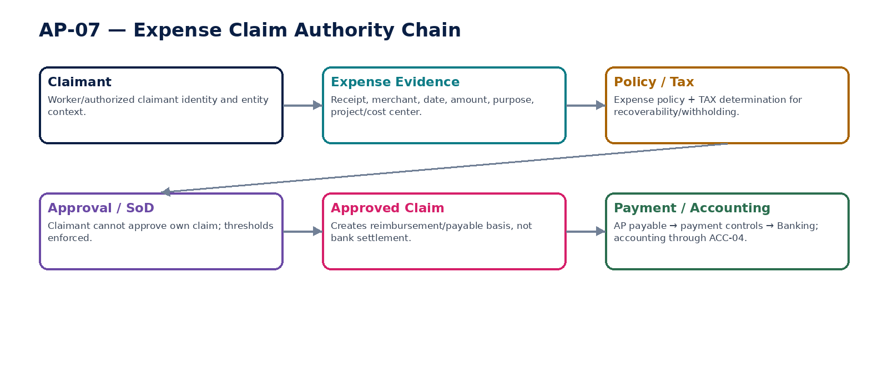
Figure 9 — Expense claim approval and payable boundary.

11. AP-08 — Payables
Maintain authoritative supplier/expense open-item liabilities, residual amounts, due dates, holds/disputes, credits and settlement applications as the basis for payment selection and AP-to-GL reconciliation.

Contract field | Specification
Service ID / owner | AP-08 — Procurement, Expenses & Accounts Payable; accountable engineering/product/control owner recorded in service registry.
Purpose / bounded scope | Maintain authoritative supplier/expense open-item liabilities, residual amounts, due dates, holds/disputes, credits and settlement applications as the basis for payment selection and AP-to-GL reconciliation.
Authoritative ownership | PayableOpenItem; source invoice/claim/credit reference; original/residual amount; due date; currency; hold/dispute; applications; withholding; recovery/correction links; aging facts.
Required source inputs | approved/recognized supplier invoice or expense claim; supplier credit; authorized adjustment; confirmed payment/recovery application.
Server-resolved / derived context | accounting posting status; supplier/payment terms; business calendar; TAX withholding; hold/dispute policy; settlement confirmations; entity/book/currency.
Commands | CreatePayableFromApprovedSource; ApplySupplierCredit; PlacePayableHold; ReleasePayableHold; OpenPayableDispute; ResolvePayableDispute; ApplyConfirmedPayment; ApplyRecovery; ClosePayable
Queries / read contracts | GetPayable; ListOpenPayables; GetSupplierBalance; GetAging; GetPaymentEligibility; GetAvailableActions; GetPayableHistory
State model | Recognized → Open → PartiallySettled → Settled; orthogonal Hold/Dispute; Corrected/Recovered links preserve history.
Authorization / permissions | payable.read/managehold/dispute; payable.adjustment.approve; settlement application mostly system-owned.
Segregation of duties | No free-form balance edit; manual adjustments require independent approval; payment selection/authorization conflicts enforced.
Events produced | PayableCreated; PayableHeld; PayableDisputeOpened; PayablePartiallySettled; PayableSettled; PayableCorrected; PayableRecoveryApplied
Dependencies | AP-05/07/12; ACC; TAX; Business Calendar; Banking status; DATA-07 reconciliation.
Failure / degradation semantics | Residual cannot go negative except explicit supplier-credit state; payment application requires authoritative BNK status; accounting mismatch blocks certification/payment per policy.
Evidence / lineage | Source document IDs, posting refs, applications, residual calculation, hold/dispute changes, recovery/correction and reconciliation run refs.
NFR / recovery profile | C0/C1 authoritative liability; strong consistency for residual/payment eligibility; exact as-of reconstruction.

Engineering Interaction Wireframe
Type | Operation | Illustrative contract surface | Mandatory controls
QUERY | GetPayable | GET/POST /internal/v1/ap08/getPayable | Scoped read; correlation + authorization context
QUERY | ListOpenPayables | GET/POST /internal/v1/ap08/listOpenPayables | Scoped read; correlation + authorization context
QUERY | GetSupplierBalance | GET/POST /internal/v1/ap08/getSupplierBalance | Scoped read; correlation + authorization context
QUERY | GetAging | GET/POST /internal/v1/ap08/getAging | Scoped read; correlation + authorization context
QUERY | GetPaymentEligibility | GET/POST /internal/v1/ap08/getPaymentEligibility | Scoped read; correlation + authorization context
QUERY | GetAvailableActions | GET/POST /internal/v1/ap08/getAvailableActions | Scoped read; correlation + authorization context
QUERY | GetPayableHistory | GET/POST /internal/v1/ap08/getPayableHistory | Scoped read; correlation + authorization context
COMMAND | CreatePayableFromApprovedSource | POST /internal/v1/ap08/commands/createPayableFromApprovedSource | Idempotency-Key; expected_version where stateful; server-resolved entity/jurisdiction
COMMAND | ApplySupplierCredit | POST /internal/v1/ap08/commands/applySupplierCredit | Idempotency-Key; expected_version where stateful; server-resolved entity/jurisdiction

Minimum Negative-Path Acceptance
# | Scenario | Required result
1 | Payable residual manually overwritten | Block/deny/quarantine or preserve safe/Unknown state; stable error and evidence; no unauthorized, duplicate or unbalanced financial consequence.
2 | Disputed payable included as eligible payment | Block/deny/quarantine or preserve safe/Unknown state; stable error and evidence; no unauthorized, duplicate or unbalanced financial consequence.
3 | Confirmed payment applied twice | Block/deny/quarantine or preserve safe/Unknown state; stable error and evidence; no unauthorized, duplicate or unbalanced financial consequence.
4 | AP totals match GL but duplicate/missing open items remain | Block/deny/quarantine or preserve safe/Unknown state; stable error and evidence; no unauthorized, duplicate or unbalanced financial consequence.

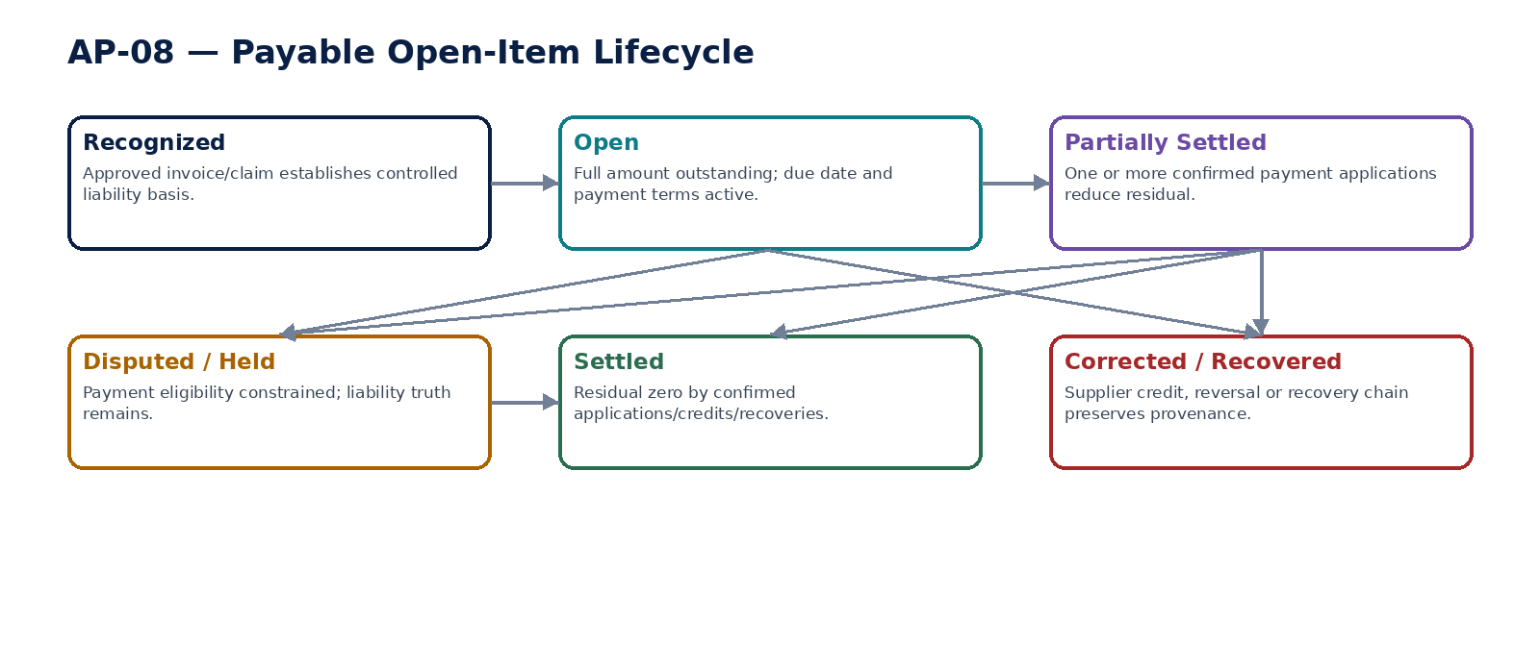
Figure 10 — Payable open-item lifecycle.

12. AP-09 — Payment Proposal
Select eligible payables into an exact payment proposal under due-date, discount, liquidity, hold, withholding and payment-method policy, while remaining non-executing and fully reversible before authorization.

Contract field | Specification
Service ID / owner | AP-09 — Procurement, Expenses & Accounts Payable; accountable engineering/product/control owner recorded in service registry.
Purpose / bounded scope | Select eligible payables into an exact payment proposal under due-date, discount, liquidity, hold, withholding and payment-method policy, while remaining non-executing and fully reversible before authorization.
Authoritative ownership | PaymentProposal; selected payable items; proposed gross/net/withholding amounts; currency; paying entity/account reference; method; value date; selection policy/version; exception flags; subject fingerprint.
Required source inputs | eligible payable population; payment date/value date; paying entity; bank account reference; currency/method; payment policy; optional liquidity/discount priorities.
Server-resolved / derived context | payable/payment eligibility; supplier/payee identity version; TAX withholding; sanctions/risk/hold facts where integrated; bank-account availability; duplicate/in-flight payment state; delegated review rules.
Commands | CreatePaymentProposal; AddEligiblePayable; RemovePayable; RecalculatePaymentProposal; SubmitProposalForReview; FreezePaymentProposal; CancelPaymentProposal
Queries / read contracts | GetPaymentProposal; ListProposalItems; GetSelectionRationale; GetExceptionFlags; GetFingerprint; GetAvailableActions
State model | Draft → Calculated → Review → Frozen → Authorized/Rejected/Cancelled; any protected mutation after freeze creates new version and invalidates authorization.
Authorization / permissions | paymentproposal.read/create/manage/freeze; paymentproposal.exception.resolve.
Segregation of duties | Proposal preparer cannot be sole authorizer where maker-checker applies; held/disputed/in-flight items cannot be force-added without controlled exception.
Events produced | PaymentProposalCreated; PaymentProposalCalculated; PaymentProposalFrozen; PaymentProposalChanged; PaymentProposalCancelled
Dependencies | AP-01/08; ORG-10; TAX-05; BNK account/cash availability; Policy; IAM/SoD.
Failure / degradation semantics | Unavailable payee/bank/withholding context blocks freeze; proposal is never evidence of payment execution; ambiguous in-flight item excluded until reconciled.
Evidence / lineage | Frozen population IDs/control totals, selection policy, payee versions, net/gross/withholding, exception reasons and fingerprint.
NFR / recovery profile | C0/C1 payment control; deterministic selection; high-volume batch capacity; strong concurrency.

Engineering Interaction Wireframe
Type | Operation | Illustrative contract surface | Mandatory controls
QUERY | GetPaymentProposal | GET/POST /internal/v1/ap09/getPaymentProposal | Scoped read; correlation + authorization context
QUERY | ListProposalItems | GET/POST /internal/v1/ap09/listProposalItems | Scoped read; correlation + authorization context
QUERY | GetSelectionRationale | GET/POST /internal/v1/ap09/getSelectionRationale | Scoped read; correlation + authorization context
QUERY | GetExceptionFlags | GET/POST /internal/v1/ap09/getExceptionFlags | Scoped read; correlation + authorization context
QUERY | GetFingerprint | GET/POST /internal/v1/ap09/getFingerprint | Scoped read; correlation + authorization context
QUERY | GetAvailableActions | GET/POST /internal/v1/ap09/getAvailableActions | Scoped read; correlation + authorization context
COMMAND | CreatePaymentProposal | POST /internal/v1/ap09/commands/createPaymentProposal | Idempotency-Key; expected_version where stateful; server-resolved entity/jurisdiction
COMMAND | AddEligiblePayable | POST /internal/v1/ap09/commands/addEligiblePayable | Idempotency-Key; expected_version where stateful; server-resolved entity/jurisdiction
COMMAND | RemovePayable | POST /internal/v1/ap09/commands/removePayable | Idempotency-Key; expected_version where stateful; server-resolved entity/jurisdiction

Minimum Negative-Path Acceptance
# | Scenario | Required result
1 | Held payable force-added without exception | Block/deny/quarantine or preserve safe/Unknown state; stable error and evidence; no unauthorized, duplicate or unbalanced financial consequence.
2 | Duplicate/in-flight payable added to second proposal | Block/deny/quarantine or preserve safe/Unknown state; stable error and evidence; no unauthorized, duplicate or unbalanced financial consequence.
3 | Proposal amount changes after freeze but approval retained | Block/deny/quarantine or preserve safe/Unknown state; stable error and evidence; no unauthorized, duplicate or unbalanced financial consequence.
4 | Payment uses stale payee identity version | Block/deny/quarantine or preserve safe/Unknown state; stable error and evidence; no unauthorized, duplicate or unbalanced financial consequence.

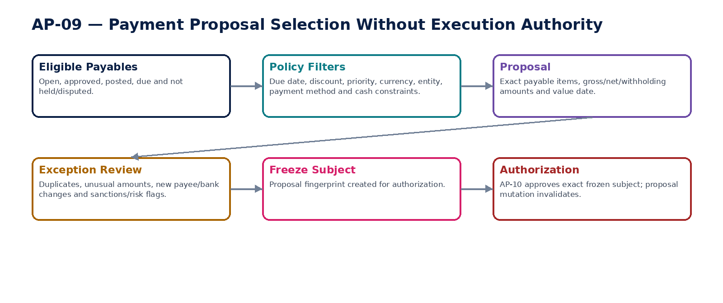
Figure 11 — Payment proposal selection and freeze.

13. AP-10 — Payment Authorization
Authorize the exact frozen payment subject using delegated limits, maker-checker, payee-identity verification and a protected-field fingerprint that becomes invalid on any material change.

Contract field | Specification
Service ID / owner | AP-10 — Procurement, Expenses & Accounts Payable; accountable engineering/product/control owner recorded in service registry.
Purpose / bounded scope | Authorize the exact frozen payment subject using delegated limits, maker-checker, payee-identity verification and a protected-field fingerprint that becomes invalid on any material change.
Authoritative ownership | PaymentAuthorization; proposal/version reference; subject hash; approved payee identity versions; signers; authority path; limits; approval evidence; expiry/revocation/consumption state.
Required source inputs | frozen payment proposal; signer identity/session; approval action; reason/evidence for exception; optional step-up authentication evidence.
Server-resolved / derived context | delegated signing limit; static/dynamic SoD; ORG-10 payee identity/version; payer bank account; JIT/session assurance; risk flags; proposal fingerprint.
Commands | RequestPaymentAuthorization; ApprovePayment; RejectPayment; RevokePaymentAuthorization; ExpirePaymentAuthorization; ConsumePaymentAuthorization
Queries / read contracts | GetPaymentAuthorization; GetAuthorizationSubject; ValidateAuthorization; GetSignerAuthority; GetAvailableActions; GetAuthorizationHistory
State model | Requested → Pending → Approved/Rejected → Consumed/Revoked/Expired; any protected-field mismatch invalidates.
Authorization / permissions | payment.authorize; payment.authorize.highvalue; payment.authorization.revoke/validate.
Segregation of duties | Maker cannot be checker when prohibited; payee-bank changer conflicts with payment authorization; signer limits/quorum enforced; no shared credentials.
Events produced | PaymentAuthorizationRequested; PaymentAuthorized; PaymentAuthorizationRejected; PaymentAuthorizationInvalidated; PaymentAuthorizationConsumed
Dependencies | AP-09; ORG-10; GOV-03/04/06/12; SEC privileged/session controls; Evidence.
Failure / degradation semantics | Bank-detail/proposal/currency/value-date change invalidates authorization; unavailable SoD/session assurance blocks approval; no offline/manual override without break-glass evidence.
Evidence / lineage | Subject fingerprint, payee/payer versions, signer identities, session assurance, authority/SoD decision, approval timestamps and consumption link.
NFR / recovery profile | C0 irreversible-control path; low latency but fail-safe; zero tolerated unauthorized approval.

Engineering Interaction Wireframe
Type | Operation | Illustrative contract surface | Mandatory controls
QUERY | GetPaymentAuthorization | GET/POST /internal/v1/ap10/getPaymentAuthorization | Scoped read; correlation + authorization context
QUERY | GetAuthorizationSubject | GET/POST /internal/v1/ap10/getAuthorizationSubject | Scoped read; correlation + authorization context
QUERY | ValidateAuthorization | GET/POST /internal/v1/ap10/validateAuthorization | Scoped read; correlation + authorization context
QUERY | GetSignerAuthority | GET/POST /internal/v1/ap10/getSignerAuthority | Scoped read; correlation + authorization context
QUERY | GetAvailableActions | GET/POST /internal/v1/ap10/getAvailableActions | Scoped read; correlation + authorization context
QUERY | GetAuthorizationHistory | GET/POST /internal/v1/ap10/getAuthorizationHistory | Scoped read; correlation + authorization context
COMMAND | RequestPaymentAuthorization | POST /internal/v1/ap10/commands/requestPaymentAuthorization | Idempotency-Key; expected_version where stateful; server-resolved entity/jurisdiction
COMMAND | ApprovePayment | POST /internal/v1/ap10/commands/approvePayment | Idempotency-Key; expected_version where stateful; server-resolved entity/jurisdiction
COMMAND | RejectPayment | POST /internal/v1/ap10/commands/rejectPayment | Idempotency-Key; expected_version where stateful; server-resolved entity/jurisdiction

Minimum Negative-Path Acceptance
# | Scenario | Required result
1 | Payee bank details changed after approval | Block/deny/quarantine or preserve safe/Unknown state; stable error and evidence; no unauthorized, duplicate or unbalanced financial consequence.
2 | Signer exceeds delegated limit | Block/deny/quarantine or preserve safe/Unknown state; stable error and evidence; no unauthorized, duplicate or unbalanced financial consequence.
3 | Proposal maker self-authorizes where prohibited | Block/deny/quarantine or preserve safe/Unknown state; stable error and evidence; no unauthorized, duplicate or unbalanced financial consequence.
4 | Authorization token replayed after consumption | Block/deny/quarantine or preserve safe/Unknown state; stable error and evidence; no unauthorized, duplicate or unbalanced financial consequence.

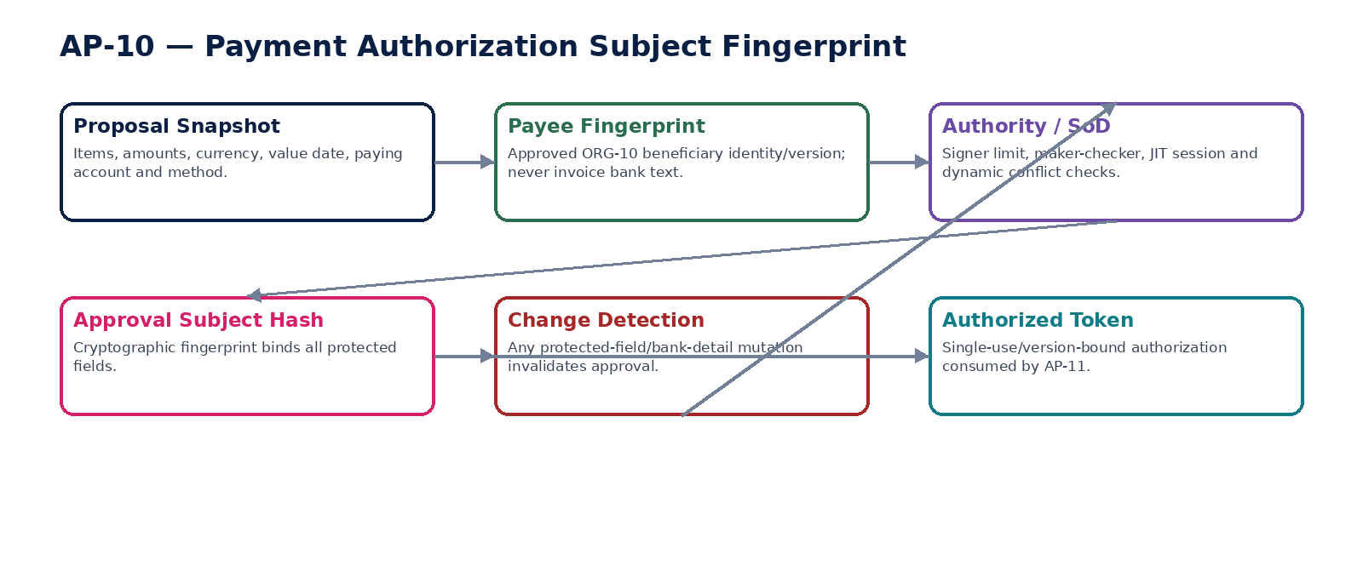
Figure 12 — Payment authorization protected-subject fingerprint.

14. AP-11 — Payment Run
Orchestrate authorized payable instructions into controlled payment runs and hand them to Banking for external initiation/status, while preserving idempotency, external UNKNOWN states and payment-clearing/accounting lineage.

Contract field | Specification
Service ID / owner | AP-11 — Procurement, Expenses & Accounts Payable; accountable engineering/product/control owner recorded in service registry.
Purpose / bounded scope | Orchestrate authorized payable instructions into controlled payment runs and hand them to Banking for external initiation/status, while preserving idempotency, external UNKNOWN states and payment-clearing/accounting lineage.
Authoritative ownership | PaymentRun; authorized instruction set; batch/run grouping; AP payment instruction references; BNK initiation/status references; orchestration state; exception and reconciliation links.
Required source inputs | approved/consumable payment authorizations; paying entity/account; currency/method; value date; execution window; run grouping.
Server-resolved / derived context | authorization validation; payee identity current-version check; bank connectivity/limits; duplicate/in-flight checks; service health; residency; accounting/payment-clearing policy.
Commands | CreatePaymentRun; ValidatePaymentRun; LockPaymentRun; SubmitPaymentRun; ReconcilePaymentRunStatus; CancelUnsubmittedRun; RetrySafeInstruction; ClosePaymentRun
Queries / read contracts | GetPaymentRun; ListRunInstructions; GetExternalStatus; GetRunExceptions; GetAccountingStatus; GetAvailableActions
State model | Draft → Validated → Locked → Submitted → Pending/Unknown → Accepted/Rejected/PartiallyAccepted → Settled/Completed/Exception; status reflects BNK authority, not inference.
Authorization / permissions | paymentrun.read/create/submit/reconcile; paymentrun.exception.resolve.
Segregation of duties | Run operator cannot alter authorized fields; unauthorized re-initiation prohibited; exception retry uses original idempotency/provider reference.
Events produced | PaymentRunCreated; PaymentRunSubmitted; PaymentInstructionPending; PaymentInstructionAccepted; PaymentInstructionRejected; PaymentInstructionSettled; PaymentRunExceptionRaised; PaymentRunCompleted
Dependencies | AP-08/09/10; BNK-06/07; ACC; INT outbox/inbox; OPS; Evidence.
Failure / degradation semantics | Timeout becomes Pending/Unknown; never initiate duplicate because response missing; partial acceptance handled per instruction; payable/payment-clearing updated only from authoritative status.
Evidence / lineage | Authorization consumption, instruction IDs, idempotency keys, BNK/provider refs, status timeline, accounting events, settlement and reconciliation refs.
NFR / recovery profile | C0 irreversible financial path; durable attempts; strong idempotency; high availability; recovery requires bank/AP/GL reconciliation.

Engineering Interaction Wireframe
Type | Operation | Illustrative contract surface | Mandatory controls
QUERY | GetPaymentRun | GET/POST /internal/v1/ap11/getPaymentRun | Scoped read; correlation + authorization context
QUERY | ListRunInstructions | GET/POST /internal/v1/ap11/listRunInstructions | Scoped read; correlation + authorization context
QUERY | GetExternalStatus | GET/POST /internal/v1/ap11/getExternalStatus | Scoped read; correlation + authorization context
QUERY | GetRunExceptions | GET/POST /internal/v1/ap11/getRunExceptions | Scoped read; correlation + authorization context
QUERY | GetAccountingStatus | GET/POST /internal/v1/ap11/getAccountingStatus | Scoped read; correlation + authorization context
QUERY | GetAvailableActions | GET/POST /internal/v1/ap11/getAvailableActions | Scoped read; correlation + authorization context
COMMAND | CreatePaymentRun | POST /internal/v1/ap11/commands/createPaymentRun | Idempotency-Key; expected_version where stateful; server-resolved entity/jurisdiction
COMMAND | ValidatePaymentRun | POST /internal/v1/ap11/commands/validatePaymentRun | Idempotency-Key; expected_version where stateful; server-resolved entity/jurisdiction
COMMAND | LockPaymentRun | POST /internal/v1/ap11/commands/lockPaymentRun | Idempotency-Key; expected_version where stateful; server-resolved entity/jurisdiction

Minimum Negative-Path Acceptance
# | Scenario | Required result
1 | Payment run replayed after timeout | Block/deny/quarantine or preserve safe/Unknown state; stable error and evidence; no unauthorized, duplicate or unbalanced financial consequence.
2 | Provider callback forged/replayed | Block/deny/quarantine or preserve safe/Unknown state; stable error and evidence; no unauthorized, duplicate or unbalanced financial consequence.
3 | Run marks payment settled from initiation response | Block/deny/quarantine or preserve safe/Unknown state; stable error and evidence; no unauthorized, duplicate or unbalanced financial consequence.
4 | Cross-tenant payable included in run | Block/deny/quarantine or preserve safe/Unknown state; stable error and evidence; no unauthorized, duplicate or unbalanced financial consequence.

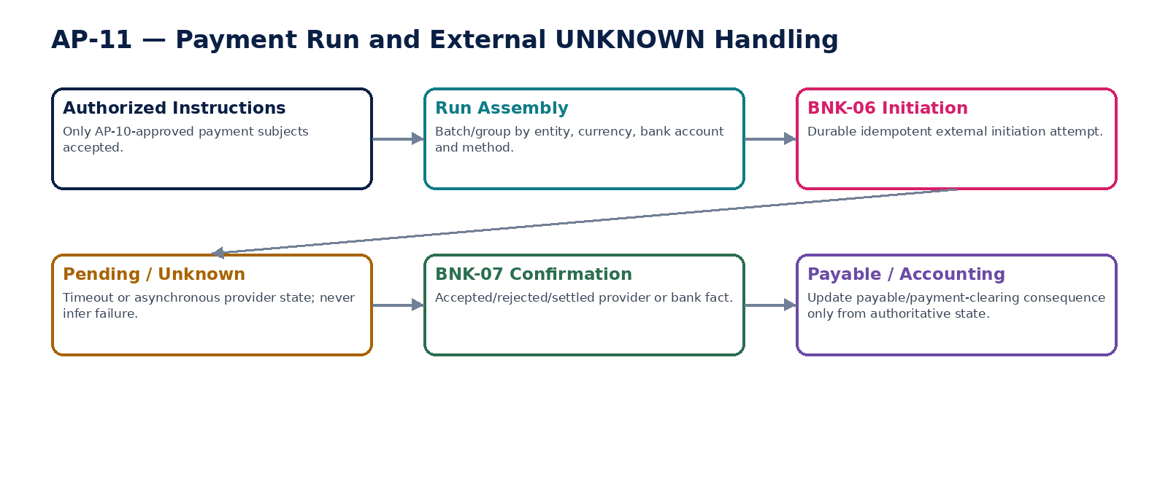
Figure 13 — Payment run with external Pending/Unknown handling.

15. AP-12 — Supplier Refund / Recovery
Govern recovery of supplier overpayments, duplicate payments, supplier credits and contractual amounts through confirmed inbound refund or approved offset, preserving source linkage, legal/tax treatment and accounting reconciliation.

Contract field | Specification
Service ID / owner | AP-12 — Procurement, Expenses & Accounts Payable; accountable engineering/product/control owner recorded in service registry.
Purpose / bounded scope | Govern recovery of supplier overpayments, duplicate payments, supplier credits and contractual amounts through confirmed inbound refund or approved offset, preserving source linkage, legal/tax treatment and accounting reconciliation.
Authoritative ownership | SupplierRecoveryCase; recovery basis; source invoices/payments; amount/currency; expected recovery method; supplier communication; refund/offset applications; dispute/legal state; closure evidence.
Required source inputs | supplier/entity; source overpayment/duplicate payment/credit balance; amount/currency; recovery reason; expected method; supporting evidence.
Server-resolved / derived context | payable/open-item state; Banking confirmed inbound receipt; legal/contract right; TAX treatment; offset eligibility; approvals/SoD; aging and materiality policy.
Commands | CreateSupplierRecoveryCase; ApproveRecoveryPlan; RecordSupplierCommitment; ApplyApprovedOffset; LinkConfirmedSupplierRefund; EscalateRecovery; CloseRecoveryCase; WriteOffRecovery
Queries / read contracts | GetRecoveryCase; GetRecoveryExposure; ListOpenRecoveries; GetAvailableActions; GetRecoveryHistory
State model | Open → Proposed → Approved → InRecovery → PartiallyRecovered → Recovered/Closed; Disputed/Escalated/WriteOff branches.
Authorization / permissions | supplierrecovery.read/manage; recovery.offset.approve; recovery.writeoff.approve.
Segregation of duties | Case owner cannot self-approve material offset/write-off; supplier refund cannot be marked received without Banking confirmation; offset must respect legal/contract/tax policy.
Events produced | SupplierRecoveryCaseCreated; SupplierRecoveryPlanApproved; SupplierRefundConfirmed; SupplierRecoveryOffsetApplied; SupplierRecoveryEscalated; SupplierRecoveryClosed
Dependencies | AP-08/11; BNK statement/transaction; TAX; Legal/Contract; Workflow/SoD; ACC; Evidence.
Failure / degradation semantics | Expected refund is not cash until BNK confirms; offset cannot create negative payable without explicit credit state; unresolved legal/tax basis blocks forced netting.
Evidence / lineage | Source payment/invoice refs, supplier communications, approvals, bank receipt refs, offset calculation, tax/legal basis and AP/GL reconciliation.
NFR / recovery profile | C1 financial recovery; aging/collections visibility; strong evidence and as-of reconstruction.

Engineering Interaction Wireframe
Type | Operation | Illustrative contract surface | Mandatory controls
QUERY | GetRecoveryCase | GET/POST /internal/v1/ap12/getRecoveryCase | Scoped read; correlation + authorization context
QUERY | GetRecoveryExposure | GET/POST /internal/v1/ap12/getRecoveryExposure | Scoped read; correlation + authorization context
QUERY | ListOpenRecoveries | GET/POST /internal/v1/ap12/listOpenRecoveries | Scoped read; correlation + authorization context
QUERY | GetAvailableActions | GET/POST /internal/v1/ap12/getAvailableActions | Scoped read; correlation + authorization context
QUERY | GetRecoveryHistory | GET/POST /internal/v1/ap12/getRecoveryHistory | Scoped read; correlation + authorization context
COMMAND | CreateSupplierRecoveryCase | POST /internal/v1/ap12/commands/createSupplierRecoveryCase | Idempotency-Key; expected_version where stateful; server-resolved entity/jurisdiction
COMMAND | ApproveRecoveryPlan | POST /internal/v1/ap12/commands/approveRecoveryPlan | Idempotency-Key; expected_version where stateful; server-resolved entity/jurisdiction
COMMAND | RecordSupplierCommitment | POST /internal/v1/ap12/commands/recordSupplierCommitment | Idempotency-Key; expected_version where stateful; server-resolved entity/jurisdiction
COMMAND | ApplyApprovedOffset | POST /internal/v1/ap12/commands/applyApprovedOffset | Idempotency-Key; expected_version where stateful; server-resolved entity/jurisdiction

Minimum Negative-Path Acceptance
# | Scenario | Required result
1 | Supplier refund marked received before bank confirmation | Block/deny/quarantine or preserve safe/Unknown state; stable error and evidence; no unauthorized, duplicate or unbalanced financial consequence.
2 | Offset applied without legal/policy authority | Block/deny/quarantine or preserve safe/Unknown state; stable error and evidence; no unauthorized, duplicate or unbalanced financial consequence.
3 | Recovery write-off self-approved | Block/deny/quarantine or preserve safe/Unknown state; stable error and evidence; no unauthorized, duplicate or unbalanced financial consequence.
4 | Recovery closes while AP/GL/bank difference remains | Block/deny/quarantine or preserve safe/Unknown state; stable error and evidence; no unauthorized, duplicate or unbalanced financial consequence.

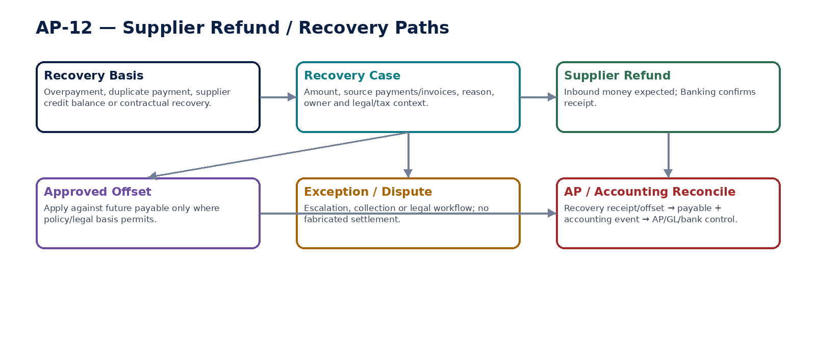
Figure 14 — Supplier recovery/refund and controlled offset paths.

16. Shared Procurement / AP Command & Error Contract
Field | Domain requirement
tenant_id / entity_id | Server-resolved and authorization-scoped for every material command.
supplier_party_id / supplier_role_id | Stable supplier relationship reference; AP profile does not duplicate master identity.
payee_identity_id / payee_version | Controlled ORG-10/Treasury beneficiary identity; invoice-extracted bank details are never substituted.
source_object_id / source_event_id | Requisition/PO/receipt/invoice/claim/payment/recovery source identity retained end-to-end.
document_date / receipt_date / due_date / tax_point_date / value_date | Distinct business dates with jurisdiction/calendar semantics.
transaction_currency | Explicit; no implicit conversion. Functional/presentation currency remains accounting/reporting context.
tax_determination_id / withholding_result_id | Exact TAX results and jurisdiction-pack versions used for liability/payment calculations.
idempotency_key | Mandatory for receipt confirmation, supplier invoice acceptance, payment proposal freeze, authorization, payment submission, payment application and recovery.
expected_version | Required for mutable state transitions and protected financial objects.
subject_fingerprint | Mandatory for payment authorization; binds payable population, amounts, payee versions, payer account, currency, method and value date.
correlation_id / causation_id | Propagated across procurement, AP, TAX, Banking, Accounting, reconciliation and evidence.
reason_code / evidence_id | Mandatory for holds, match exceptions, reversals, recovery offsets/write-offs and privileged intervention.

Stable domain errors must distinguish validation failure, authorization denial, SoD conflict, duplicate risk, match exception, stale version, held/disputed item, payee-version mismatch, authorization invalidation, provider Pending/Unknown, jurisdiction/tax unavailable, accounting-period block and reconciliation failure. Clients must never infer control meaning from free-form text.

17. Cross-Service Event Contract Baseline
Event family | Required envelope / consequence
Procurement | Requisition/PO/receipt events carry tenant, entity, source version, effective/business dates, correlation/causation and evidence refs.
Supplier Invoice / Expense | Capture/approval/correction events include source-document hash, TAX/withholding/match refs and immutable source IDs.
Payable | Open/hold/dispute/application/settlement events include original/residual amount, currency and source/accounting refs.
Payment Proposal / Authorization | Frozen population control totals, subject fingerprint, payee versions and approval decisions are versioned and auditable.
Payment Run | Instruction IDs, idempotency keys, BNK/provider references and Pending/Unknown/settlement states preserved.
Accounting | Receipt/invoice/payment/recovery accounting events flow only to the Accounting Kernel; no service writes ledger state directly.
Control / Evidence | AP→GL, GRNI, payment-clearing and bank/provider reconciliation events link to control runs and signed evidence.

18. Canonical Procurement / AP Data Model
Canonical object | Owning service | Critical relationships
SupplierFinancialProfile | AP-01 | Party/supplier role; legal entity; ORG-10 payee identity reference; effective-dated terms/holds
PurchaseRequisition | AP-02 | Requester; lines; dimensions; budget/project; approval
PurchaseOrder / PORevision | AP-03 | Supplier; requisition/contract; lines; terms; receipt/invoice links
GoodsServiceReceipt | AP-04 | PO line; delivery/service evidence; reversal; accounting event
SupplierInvoiceDocument | AP-05 | Supplier; source file/payload hash; PO/receipt/match; TAX/withholding; payable/accounting refs
InvoiceMatchRun / MatchException | AP-06 | PO + receipt + invoice frozen population; tolerance policy version
ExpenseClaim / ExpenseLine | AP-07 | Claimant; receipts; policy/TAX results; approval; payable link
PayableOpenItem | AP-08 | Invoice/claim/credit source; residual; hold/dispute; payment/recovery applications
PaymentProposal | AP-09 | Payable population; selection policy; payer account; fingerprint
PaymentAuthorization | AP-10 | Proposal/version; payee versions; signers; authority/SoD; subject hash
PaymentRun / APInstruction | AP-11 | Authorization; BNK initiation/status; accounting/reconciliation
SupplierRecoveryCase | AP-12 | Source payment/invoice; expected refund/offset; bank confirmation; accounting/reconciliation

19. AP-to-Accounting, Banking & Control Matrix
Business fact | Authority | Accounting / external consequence | Mandatory control
PO issued | AP-03 | No statutory GL by default; optional commitment/encumbrance event via ACC-04 | PO approval/revision integrity; budget/commitment controls where configured
Receipt confirmed | AP-04 | Optional inventory/expense + GRNI accounting event via ACC-04 | PO/receipt quantity and GRNI reconciliation
Supplier invoice approved | AP-05 | Invoice/liability accounting event → ACC-04; TAX/withholding refs included | AP subledger → GL control; duplicate and match evidence
Supplier credit/correction accepted | AP-05 | Correction accounting event → ACC-04 | Source-document correction chain + AP/GL/tax reconciliation
Expense claim approved | AP-07 | Expense/payable accounting event → ACC-04 | Policy/TAX/approval + claimant payable tie-out
Payment proposal frozen | AP-09 | No bank/GL consequence | Eligible population + payee identity + control totals
Payment authorized | AP-10 | No settlement consequence; single-use authorization subject | Maker-checker, delegated limit, payee fingerprint
Payment initiated/accepted | BNK-06/07 | Book-specific payment-in-transit/clearing event only when policy says authoritative | Provider attempt/status + duplicate prevention
Payment settled | BNK-07 + AP-11 | Payable settlement + bank/payment-clearing accounting consequence | Provider/bank ↔ AP payable ↔ GL clearing/cash reconciliation
Supplier refund received | BNK + AP-12 | Recovery/application accounting event | Bank ↔ recovery case ↔ AP ↔ GL reconciliation
Recovery offset | AP-12 | Controlled payable/recovery accounting consequence | Legal/policy basis + source-level application + AP/GL tie-out


Figure 15 — AP, Banking, Accounting and control lineage from source evidence to certified reporting.

20. Domain-Level Negative-Path Certification
# | Scenario | Certification requirement
1 | Supplier profile resolved from wrong legal entity | Automated/controlled test proves fail-safe or explicit Pending/Unknown state, no unauthorized/duplicate financial effect, stable error/evidence and reconciliable AP/Bank/GL state.
2 | Supplier invoice bank details override controlled payee master | Automated/controlled test proves fail-safe or explicit Pending/Unknown state, no unauthorized/duplicate financial effect, stable error/evidence and reconciliable AP/Bank/GL state.
3 | Payee bank details change after payment authorization | Automated/controlled test proves fail-safe or explicit Pending/Unknown state, no unauthorized/duplicate financial effect, stable error/evidence and reconciliable AP/Bank/GL state.
4 | Inactive/held supplier used for new purchase order | Automated/controlled test proves fail-safe or explicit Pending/Unknown state, no unauthorized/duplicate financial effect, stable error/evidence and reconciliable AP/Bank/GL state.
5 | Requester self-approves requisition above threshold | Automated/controlled test proves fail-safe or explicit Pending/Unknown state, no unauthorized/duplicate financial effect, stable error/evidence and reconciliable AP/Bank/GL state.
6 | Approved requisition materially changes before PO conversion | Automated/controlled test proves fail-safe or explicit Pending/Unknown state, no unauthorized/duplicate financial effect, stable error/evidence and reconciliable AP/Bank/GL state.
7 | Issued PO overwritten rather than revised | Automated/controlled test proves fail-safe or explicit Pending/Unknown state, no unauthorized/duplicate financial effect, stable error/evidence and reconciliable AP/Bank/GL state.
8 | PO quantity increased after approval without reapproval | Automated/controlled test proves fail-safe or explicit Pending/Unknown state, no unauthorized/duplicate financial effect, stable error/evidence and reconciliable AP/Bank/GL state.
9 | Receipt entered against cancelled PO | Automated/controlled test proves fail-safe or explicit Pending/Unknown state, no unauthorized/duplicate financial effect, stable error/evidence and reconciliable AP/Bank/GL state.
10 | Receipt exceeds PO tolerance without approved exception | Automated/controlled test proves fail-safe or explicit Pending/Unknown state, no unauthorized/duplicate financial effect, stable error/evidence and reconciliable AP/Bank/GL state.
11 | Confirmed receipt deleted to fix mismatch | Automated/controlled test proves fail-safe or explicit Pending/Unknown state, no unauthorized/duplicate financial effect, stable error/evidence and reconciliable AP/Bank/GL state.
12 | GRNI accounting event duplicated on retry | Automated/controlled test proves fail-safe or explicit Pending/Unknown state, no unauthorized/duplicate financial effect, stable error/evidence and reconciliable AP/Bank/GL state.
13 | Exact duplicate supplier invoice accepted twice | Automated/controlled test proves fail-safe or explicit Pending/Unknown state, no unauthorized/duplicate financial effect, stable error/evidence and reconciliable AP/Bank/GL state.
14 | Near-duplicate invoice bypasses duplicate detection by number formatting | Automated/controlled test proves fail-safe or explicit Pending/Unknown state, no unauthorized/duplicate financial effect, stable error/evidence and reconciliable AP/Bank/GL state.
15 | Supplier invoice accepted without required TAX/withholding result | Automated/controlled test proves fail-safe or explicit Pending/Unknown state, no unauthorized/duplicate financial effect, stable error/evidence and reconciliable AP/Bank/GL state.
16 | Supplier invoice tax result changes after approval | Automated/controlled test proves fail-safe or explicit Pending/Unknown state, no unauthorized/duplicate financial effect, stable error/evidence and reconciliable AP/Bank/GL state.
17 | Match run uses tolerance changed mid-run | Automated/controlled test proves fail-safe or explicit Pending/Unknown state, no unauthorized/duplicate financial effect, stable error/evidence and reconciliable AP/Bank/GL state.
18 | Missing receipt treated as successful three-way match | Automated/controlled test proves fail-safe or explicit Pending/Unknown state, no unauthorized/duplicate financial effect, stable error/evidence and reconciliable AP/Bank/GL state.
19 | Match engine self-waives material mismatch | Automated/controlled test proves fail-safe or explicit Pending/Unknown state, no unauthorized/duplicate financial effect, stable error/evidence and reconciliable AP/Bank/GL state.
20 | Expense claimant approves own claim | Automated/controlled test proves fail-safe or explicit Pending/Unknown state, no unauthorized/duplicate financial effect, stable error/evidence and reconciliable AP/Bank/GL state.
21 | Same receipt reused on multiple expense claims | Automated/controlled test proves fail-safe or explicit Pending/Unknown state, no unauthorized/duplicate financial effect, stable error/evidence and reconciliable AP/Bank/GL state.
22 | Expense over evidence threshold approved without exception | Automated/controlled test proves fail-safe or explicit Pending/Unknown state, no unauthorized/duplicate financial effect, stable error/evidence and reconciliable AP/Bank/GL state.
23 | Payable residual manually overwritten | Automated/controlled test proves fail-safe or explicit Pending/Unknown state, no unauthorized/duplicate financial effect, stable error/evidence and reconciliable AP/Bank/GL state.
24 | Disputed/held payable included in ordinary payment proposal | Automated/controlled test proves fail-safe or explicit Pending/Unknown state, no unauthorized/duplicate financial effect, stable error/evidence and reconciliable AP/Bank/GL state.
25 | Same payable included in two in-flight proposals | Automated/controlled test proves fail-safe or explicit Pending/Unknown state, no unauthorized/duplicate financial effect, stable error/evidence and reconciliable AP/Bank/GL state.
26 | Payment proposal changes after freeze but authorization remains valid | Automated/controlled test proves fail-safe or explicit Pending/Unknown state, no unauthorized/duplicate financial effect, stable error/evidence and reconciliable AP/Bank/GL state.
27 | Stale payee identity version used at authorization | Automated/controlled test proves fail-safe or explicit Pending/Unknown state, no unauthorized/duplicate financial effect, stable error/evidence and reconciliable AP/Bank/GL state.
28 | Payment signer exceeds delegated limit | Automated/controlled test proves fail-safe or explicit Pending/Unknown state, no unauthorized/duplicate financial effect, stable error/evidence and reconciliable AP/Bank/GL state.
29 | Proposal maker self-authorizes where prohibited | Automated/controlled test proves fail-safe or explicit Pending/Unknown state, no unauthorized/duplicate financial effect, stable error/evidence and reconciliable AP/Bank/GL state.
30 | Consumed payment authorization replayed | Automated/controlled test proves fail-safe or explicit Pending/Unknown state, no unauthorized/duplicate financial effect, stable error/evidence and reconciliable AP/Bank/GL state.
31 | Payment run alters authorized amount or beneficiary | Automated/controlled test proves fail-safe or explicit Pending/Unknown state, no unauthorized/duplicate financial effect, stable error/evidence and reconciliable AP/Bank/GL state.
32 | Payment run replayed after provider timeout | Automated/controlled test proves fail-safe or explicit Pending/Unknown state, no unauthorized/duplicate financial effect, stable error/evidence and reconciliable AP/Bank/GL state.
33 | Provider Pending/Unknown treated as Failed and duplicate reinitiated | Automated/controlled test proves fail-safe or explicit Pending/Unknown state, no unauthorized/duplicate financial effect, stable error/evidence and reconciliable AP/Bank/GL state.
34 | Forged/replayed provider callback accepted | Automated/controlled test proves fail-safe or explicit Pending/Unknown state, no unauthorized/duplicate financial effect, stable error/evidence and reconciliable AP/Bank/GL state.
35 | Payable marked settled from initiation response before authoritative confirmation | Automated/controlled test proves fail-safe or explicit Pending/Unknown state, no unauthorized/duplicate financial effect, stable error/evidence and reconciliable AP/Bank/GL state.
36 | Cross-tenant payable included in payment run | Automated/controlled test proves fail-safe or explicit Pending/Unknown state, no unauthorized/duplicate financial effect, stable error/evidence and reconciliable AP/Bank/GL state.
37 | Supplier refund marked received before Banking confirmation | Automated/controlled test proves fail-safe or explicit Pending/Unknown state, no unauthorized/duplicate financial effect, stable error/evidence and reconciliable AP/Bank/GL state.
38 | Recovery offset applied without legal/policy authority | Automated/controlled test proves fail-safe or explicit Pending/Unknown state, no unauthorized/duplicate financial effect, stable error/evidence and reconciliable AP/Bank/GL state.
39 | AP headline total agrees with GL but population contains missing/duplicate open items | Automated/controlled test proves fail-safe or explicit Pending/Unknown state, no unauthorized/duplicate financial effect, stable error/evidence and reconciliable AP/Bank/GL state.
40 | Payment-clearing or GRNI difference hidden by tolerance change | Automated/controlled test proves fail-safe or explicit Pending/Unknown state, no unauthorized/duplicate financial effect, stable error/evidence and reconciliable AP/Bank/GL state.

21. Definition of Ready — Individual AP Service
# | Ready gate
1 | Authoritative fact/write boundary approved
2 | Canonical service contract instantiated
3 | OpenAPI/AsyncAPI/schema drafts available
4 | Supplier/entity/currency/date/jurisdiction semantics explicit
5 | Commands, queries, orthogonal states and stable errors defined
6 | Payee-bank/TAX/Accounting/Banking ownership boundaries mapped
7 | Permissions, maker-checker and dynamic SoD specified
8 | Idempotency/concurrency/external Pending/Unknown behavior specified
9 | Duplicate/match/payment/recovery controls mapped
10 | Evidence/retention/legal-hold behavior mapped
11 | Dependencies/timeouts/retry/degradation specified
12 | SLO/RPO/RTO/capacity and positive/negative acceptance suites approved

22. Definition of Done — Individual AP Service
# | Done gate
1 | Machine contracts published and compatibility certified
2 | Authoritative datastore constraints implemented
3 | No generic API bypasses protected approval/match/payment/recovery commands
4 | Server resolves supplier/entity/payee/jurisdiction/TAX/accounting context
5 | Outbox/inbox/idempotency/provider-reconciliation tests pass
6 | Supplier source documents and corrections preserve immutable provenance
7 | Duplicate/matching/payable/payment controls pass
8 | Accounting events and AP→GL/GRNI/payment-clearing controls pass
9 | Payee-identity fingerprint and authorization invalidation tests pass
10 | Security/residency/privacy tests pass
11 | NFR/load/failure/runbook tests meet approved class
12 | Release certificate generated with no unresolved mandatory control

23. Recommended Engineering Sequence
Wave | Services | Reason
1 | AP-01 + ORG-10 boundary + shared context | Establish supplier finance settings and controlled payee identity separation first.
2 | AP-02 + AP-03 | Build governed demand and supplier commitment with revision/approval controls.
3 | AP-04 + AP-05 | Establish receipt evidence and immutable supplier-invoice intake/liability basis.
4 | AP-06 + AP-07 | Add deterministic matching and employee expense path.
5 | AP-08 | Establish authoritative payable open-item state and AP→GL control population.
6 | AP-09 + AP-10 | Implement proposal/freeze and exact payment authorization with payee fingerprint.
7 | AP-11 + Banking integration | Add idempotent payment-run orchestration and authoritative external-state reconciliation.
8 | AP-12 + controls / performance certification | Close supplier recovery, GRNI/payment-clearing/AP→GL controls and failure certification.

24. Controlled Pre-Production Decisions
Decision | Required owner / evidence
Supplier onboarding/payee bank verification model | Finance/Treasury/Risk/Security approval; ORG-10 workflow and independent verification tests.
Duplicate-invoice matching keys and fuzzy thresholds | AP Controller/Risk approval using representative supplier populations and false-positive/negative tests.
Two-way/three-way matching categories and tolerances | Procurement/AP Controller approval; versioned policy with materiality and exception matrix.
GRNI/receipt accounting by product/service/category/book | Controller/Accounting approval; ACC posting rules and reversal/reconciliation tests.
Expense policy, receipt thresholds and delegated approvers | Finance/HR/Tax/Legal approval per jurisdiction/entity.
Withholding treatment at invoice/payment stage | Tax/Jurisdiction Pack certification; AP consumes results and never invents withholding.
Payment proposal selection, discount, cut-off and liquidity rules | AP/Treasury approval with bank operating calendar and cash-control evidence.
Payment signer limits/quorum and bank-detail change cooling/reverification controls | Treasury/Risk/Security approval; dynamic SoD and fraud scenarios tested.
Payment clearing model and settlement finality per rail/provider | Treasury/Accounting approval; BNK-06/07 contract and reconciliation tests.
Supplier recovery/offset authority | Finance/Legal/Tax approval by market and contract type.
Numeric SLOs, capacity and retention periods | SRE/Finance/Compliance approval after representative load and legal analysis.

25. Prohibited Procurement / AP Anti-Patterns
Anti-pattern | Why prohibited
Use bank details printed on supplier invoice | Invoice content is untrusted for payment routing and enables payment-diversion fraud.
Supplier profile directly owns beneficiary bank account | Breaks independent payee-master verification and high-risk change controls.
Single supplier-invoice status field | Cannot truthfully represent intake, match, approval, posting, dispute and settlement simultaneously.
Delete confirmed receipt or accepted supplier invoice | Destroys audit/accounting provenance; use reversal/correction links.
AP calculates tax/withholding ad hoc | Bypasses jurisdiction-pack authority and reproducibility.
Matching engine changes tolerance to make invoice pass | Destroys control integrity and exception evidence.
Match success equals invoice/payment approval | Matching is evidence, not delegated authority.
Free-form payable balance edit | Breaks open-item provenance and AP→GL reconciliation.
Payment proposal also authorizes/executes | Collapses maker-checker and creates a single-point fraud path.
Authorization survives beneficiary/amount/value-date change | Approval no longer applies to the executed financial subject.
Treat provider timeout as failed payment | Can create duplicate irreversible payments.
Payment run marks settlement without BNK authority | Confuses initiation with actual money movement.
Net supplier recovery without approved basis | Can unlawfully or incorrectly extinguish liabilities/receivables.
Headline AP total-only reconciliation | Can conceal duplicate/missing open items or payment-clearing defects even when totals agree.
AP service directly writes GL | All financial consequences must enter through governed accounting events and ACC-04.

26. Current Interoperability & Regulatory Architecture Notes
This domain pack intentionally keeps inbound electronic-invoice syntax, digital-reporting obligations, withholding rules and payment-rail message formats behind certified jurisdiction/integration contracts rather than embedding one global implementation inside AP.
As of August 2026, the EU ViDA package is being implemented progressively through 2035; cross-border B2B Digital Reporting Requirements based on e-invoicing apply from 1 July 2030. OpenPeppol PINT provides an international billing methodology with jurisdiction-specific implementations, including supplier/self-billing profiles in some markets. ZoikoSuite therefore preserves a stable AP source-document model while jurisdiction/network adapters evolve independently.

ISO 20022 remains the global financial-services messaging framework, with a current nine-part edition published in April 2026. AP-11 must not construct or own external payment-rail messages directly: it hands authorized payment intent to the Banking domain, whose adapters own ISO 20022/provider-specific initiation and status contracts. This prevents AP business workflow from becoming a bank-protocol implementation.

Engineering references: European Commission — VAT in the Digital Age (ViDA); OpenPeppol PINT Billing/Self-Billing specifications; ISO 20022 Registration Authority. Exact launch-market obligations and provider contracts are governed by ZS-JUR-001, ZS-API-001, ZS-EVENT-001 and the Banking domain, not inferred from this document.

27. Final Architecture Decision
APPROVED BASELINE: Procurement, Expenses & Accounts Payable is implemented as an explicit procure-to-pay authority chain. Supplier/payee identity, procurement commitment, receipt evidence, supplier invoice, matching, payable liability, payment selection, authorization, Banking settlement, accounting consequence and recovery remain separate governed facts. The domain is build-ready only when payee-master integrity, duplicate/match controls, payment-subject fingerprinting, external Pending/Unknown semantics, AP/GRNI/payment-clearing reconciliations and negative paths are enforced in code and certified end-to-end.

