ZOIKOSUITE

Revenue, Billing & Accounts Receivable
Detailed Service Specifications
AR-01 through AR-10 • Build-Ready Customer-to-Cash Engineering Baseline

Field | Value
Document ID | ZS-SVC-C-001
Version | 1.0 — Revenue & AR Engineering Baseline
Date | 24 August 2026
Status | Build-ready domain specification; jurisdiction-specific invoice/e-invoice/tax rules, numeric SLOs and production provider configurations remain subject to certified pack and launch approval.
Owner | ZoikoSuite Product Architecture / Finance Platform Engineering
Applies to | Engineering, Product, Finance, Billing Operations, Treasury, Tax, Security, QA, Support, Audit/Compliance and Integration teams
Language | American English

Executive doctrine: customer-to-cash authority must remain explicit. Commercial intent, tax determination, issued billing documents, receivable open items, external payment settlement, cash application, accounting consequence and collections workflow are separate authoritative facts. No service may collapse them into a single mutable status or bypass the owning domain.

Document Roadmap & How to Use This Pack
This pack instantiates the approved ZoikoSuite service contract standard for AR-01 through AR-10. It is an engineering build contract, not a recommendation to deploy ten separate microservices. Physical deployment may group capabilities, but authority boundaries, commands, events, data ownership, negative paths, evidence and controls remain independently testable.
Customer-to-cash truth flows in controlled stages: governed commercial basis → tax result → authoritative invoice/correction → receivable open item → external settlement fact → cash application → accounting event → Accounting Kernel → reconciliation/control → reporting. Collections and communications never rewrite financial truth.

1. Critical Analysis & Refinements Incorporated
Refinement | Engineering consequence
Separate financial customer settings from party master | AR-01 owns customer-specific financial terms/credit/billing policy, while legal identity/address/party facts remain with master-data services.
Invoice is authoritative, not tax engine or payment engine | AR-04 issues the receivable/tax document using a resolved TAX result; it does not calculate tax independently or execute money movement.
No overloaded invoice status | Lifecycle, delivery, e-invoice, settlement, dispute and attention states remain orthogonal and independently sourced.
Issued documents are immutable | Corrections use AR-06 credit/debit notes or jurisdiction-permitted cancellation/replacement; issued invoice content is not edited in place.
E-invoice is an adapter state, not invoice truth | AR-05 owns transmission attempts and authority/network acknowledgements; rejection does not erase or mutate the source invoice.
External UNKNOWN is distinct from FAILED | Payment/e-invoice timeouts remain Pending/Unknown until reconciled with the external authority, preventing duplicate irreversible effects.
Receivable balance is an open-item consequence | AR-07 owns open items/residuals/aging, not free-form customer-balance edits.
Cash application requires confirmed settlement | AR-08 allocates Banking-owned confirmed receipts; it never invents settlement finality.
Collections is workflow, not accounting | AR-09 manages dunning/promises/escalation and must never alter balances to reflect collection activity.
Refund and write-off have different authorities | Refund external execution remains Banking/Payment; write-off is a governed AR/accounting adjustment with tax implications where applicable.

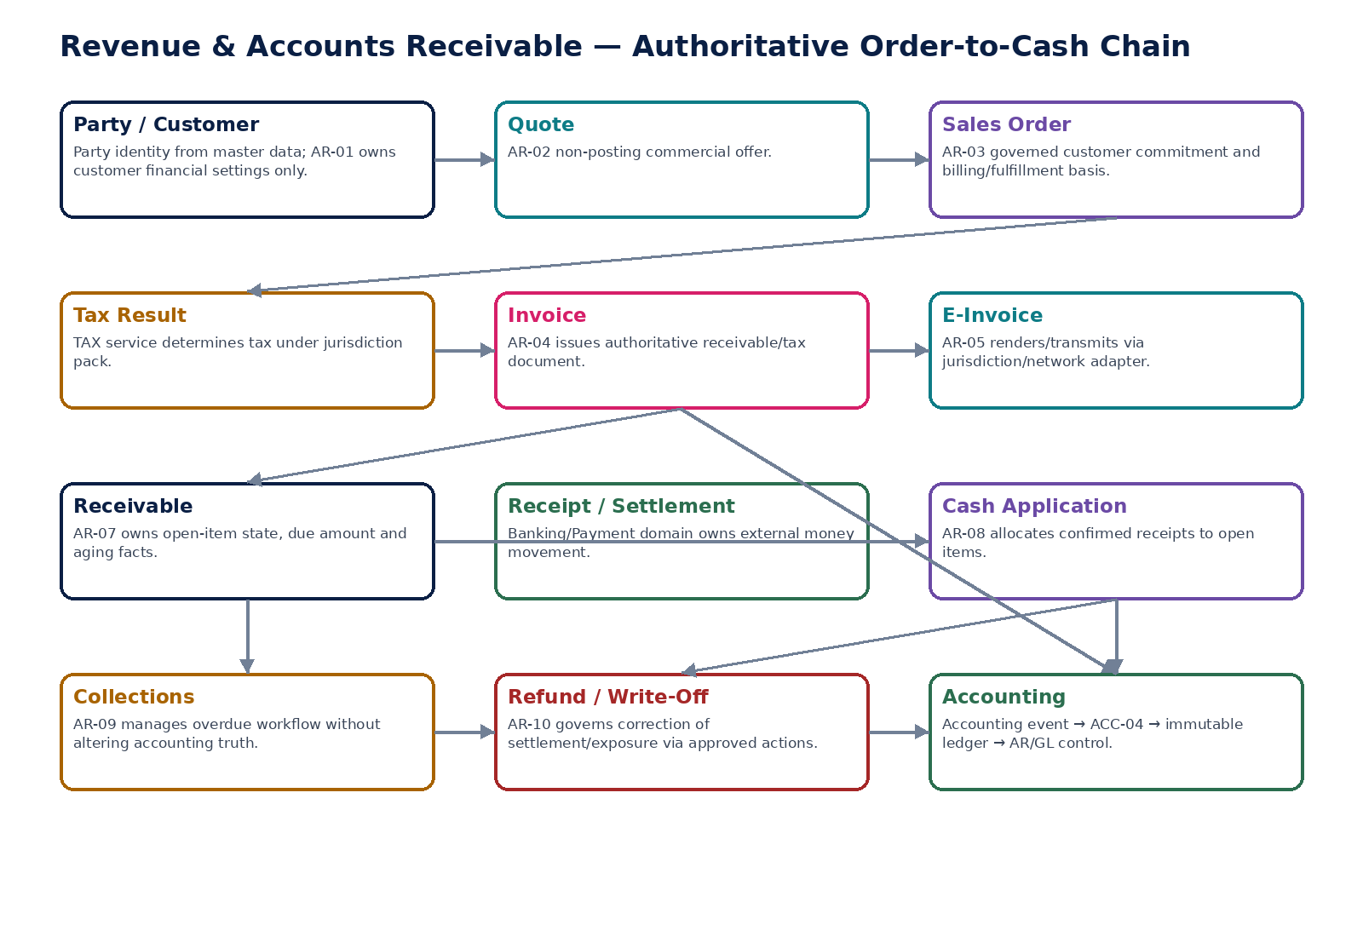
Figure 1 — Authoritative order-to-cash control chain and domain boundaries.

2. Domain Constitution & Non-Negotiable Invariants
# | Invariant
1 | An issued invoice or issued credit/debit note is never edited in place.
2 | Invoice issuance is idempotent and atomic with legal numbering/document sealing and authoritative outbox publication.
3 | Tax determination is consumed from the TAX domain with exact rule-pack/version provenance; AR does not improvise tax.
4 | Invoice lifecycle, delivery, e-invoice, settlement, dispute and attention states are orthogonal.
5 | External e-invoice/payment timeout or ambiguity is modeled as Pending/Unknown until reconciled.
6 | Receivable open items can change only from authoritative billing, application, correction, refund/write-off or governed adjustment events.
7 | Customer balance projections are derived from open items and can never be directly overwritten to “make them agree.”
8 | Confirmed settlement comes from Banking/Payment authority before cash application.
9 | Cash application is idempotent and must reconcile receipt total to applied + unapplied + authorized differences.
10 | Collections activity never creates, settles, writes off or reverses a financial balance by itself.
11 | Credit/debit notes link to source billing and preserve the original issued document.
12 | Refund destination changes after approval invalidate approval and require revalidation.
13 | Write-offs require controlled reason, delegated authority, tax treatment and accounting consequence.
14 | All accounting consequences enter through governed accounting events and ACC-04; AR services never write directly to the GL.
15 | AR-to-GL reconciliation tests population completeness as well as headline totals.
16 | Customer/entity/currency/jurisdiction context is server-authoritative for every material command.
17 | Control totals, external references, source IDs and evidence are retained for historical/as-of reconstruction.
18 | Legal numbering/e-invoice/correction semantics are jurisdiction-pack controlled and effective-dated.
19 | AI may suggest matching, collection prioritization or explanations but cannot issue invoices, approve write-offs/refunds, or assert settlement finality.
20 | Cross-tenant or cross-entity customer balances, invoices, receipts or refunds are denied by default.

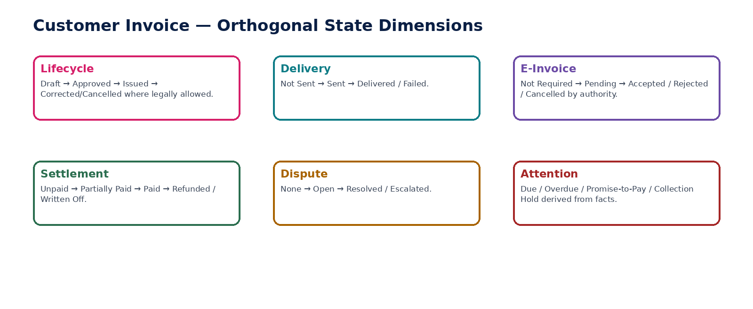
Figure 2 — Invoice state dimensions are orthogonal rather than collapsed into one status.

3. Cross-Service Authority Matrix
Service | Authoritative ownership | Must never own / bypass
AR-01 | Customer financial profile, credit/terms/AR preferences | Party legal identity, payment settlement, ledger entries
AR-02 | Quote versions, assumptions, commercial acceptance evidence | Receivable, tax liability, accounting posting
AR-03 | Sales order, billing basis, fulfillment/billing state | Tax determination, invoice issue, ledger truth
AR-04 | Issued customer invoice and lifecycle | Independent tax calculation, e-invoice network state, bank settlement, direct GL
AR-05 | E-invoice render/submission attempts/acknowledgements | Source invoice truth, jurisdiction rules
AR-06 | Issued credit/debit notes and correction linkage | Edit of original invoice, direct ledger write
AR-07 | Receivable open items, residual amount, aging/dispute/hold facts | Bank balance, free-form customer balance
AR-08 | Receipt-to-open-item applications and unapplied residual | External settlement finality, source invoice amount
AR-09 | Collection cases, dunning, promises, contact/escalation history | Receivable amount, write-off/refund execution
AR-10 | Refund/write-off requests, approvals and AR consequence | External bank settlement, tax determination, direct GL

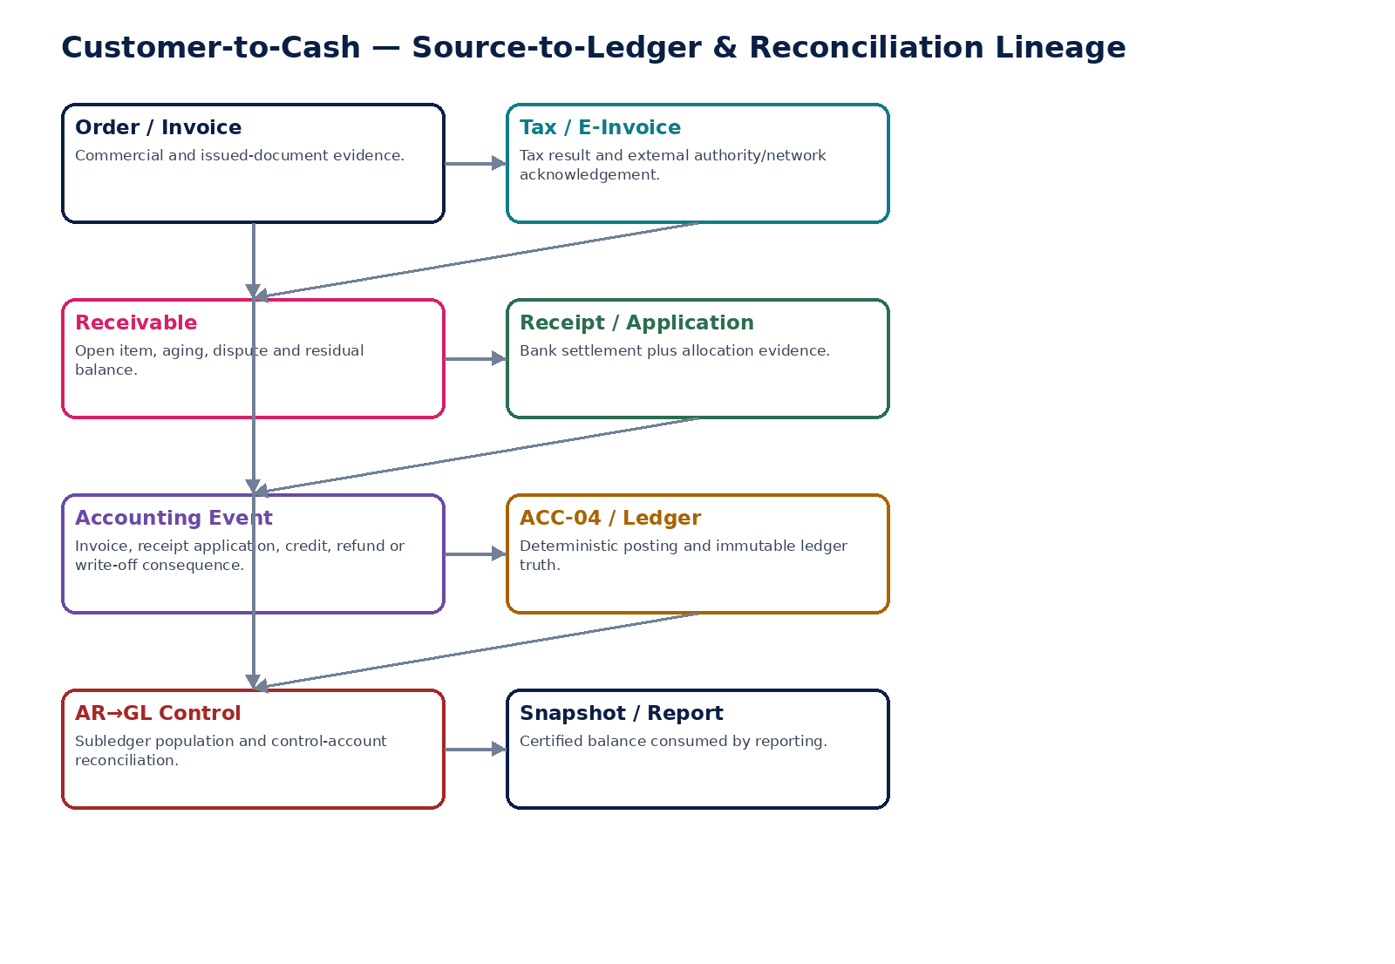
Figure 3 — Customer-to-cash source-to-ledger and reconciliation lineage.

4. AR-01 — Customer Financial Profile
Maintain entity-scoped customer financial, billing, credit and collection settings without duplicating party identity master data.

Contract field | Specification
Service ID / owner | AR-01 — Revenue, Billing & Accounts Receivable; accountable engineering/product/control owner recorded in service registry.
Purpose / bounded scope | Maintain entity-scoped customer financial, billing, credit and collection settings without duplicating party identity master data.
Authoritative ownership | CustomerFinancialProfile, effective-dated credit/payment terms, invoice/statement preferences, AR account policy, dunning/hold settings and approved customer risk/credit attributes.
Required source inputs | party/customer role ID; legal entity; requested payment terms; billing preferences; credit limit/hold request; statement/dunning preferences; tax/customer classification references.
Server-resolved / derived context | party identity/status; legal-entity scope; currency policy; jurisdiction/customer registration facts; authorization; delegated authority; effective date; risk-source provenance.
Commands | CreateFinancialProfile; AmendFinancialProfile; SetCreditLimit; PlaceCreditHold; ReleaseCreditHold; ChangePaymentTerms; RetireFinancialProfile
Queries / read contracts | GetFinancialProfile; GetFinancialProfileAsOf; GetAvailableActions; GetCreditStatus; ListProfileHistory
State model | Draft → Active → Suspended/OnHold → Retired; individual effective-dated attributes versioned.
Authorization / permissions | customer.financial.read/manage; customer.credit.limit.manage/approve; customer.credit.hold.manage.
Segregation of duties | Credit-limit changer cannot approve own out-of-policy limit increase; sensitive bank/refund instructions not stored here; high-risk profile changes may require maker-checker.
Events produced | CustomerFinancialProfileCreated; CustomerFinancialProfileChanged; CustomerCreditLimitChanged; CustomerCreditHoldPlaced; CustomerCreditHoldReleased
Dependencies | Party/Organization master; IAM/SoD; Policy; TAX/customer registration; Evidence.
Failure / degradation semantics | Missing party/entity scope blocks mutation; expired/ambiguous effective version blocks invoice/order use; no fallback to stale profile for material issuance.
Evidence / lineage | Persist prior/new values, effective interval, actor/approver, reason, source/risk references and policy version.
NFR / recovery profile | C1 authoritative setup; strong auditability; low-latency reads; historical reconstruction required.

Engineering Interaction Wireframe
Type | Operation | Illustrative contract surface | Mandatory controls
QUERY | GetFinancialProfile | GET/POST /internal/v1/ar01/getFinancialProfile | Scoped read; correlation + authorization context
QUERY | GetFinancialProfileAsOf | GET/POST /internal/v1/ar01/getFinancialProfileAsOf | Scoped read; correlation + authorization context
QUERY | GetAvailableActions | GET/POST /internal/v1/ar01/getAvailableActions | Scoped read; correlation + authorization context
QUERY | GetCreditStatus | GET/POST /internal/v1/ar01/getCreditStatus | Scoped read; correlation + authorization context
QUERY | ListProfileHistory | GET/POST /internal/v1/ar01/listProfileHistory | Scoped read; correlation + authorization context
COMMAND | CreateFinancialProfile | POST /internal/v1/ar01/commands/createFinancialProfile | Idempotency-Key; expected_version where stateful; server-resolved entity/jurisdiction
COMMAND | AmendFinancialProfile | POST /internal/v1/ar01/commands/amendFinancialProfile | Idempotency-Key; expected_version where stateful; server-resolved entity/jurisdiction
COMMAND | SetCreditLimit | POST /internal/v1/ar01/commands/setCreditLimit | Idempotency-Key; expected_version where stateful; server-resolved entity/jurisdiction
COMMAND | PlaceCreditHold | POST /internal/v1/ar01/commands/placeCreditHold | Idempotency-Key; expected_version where stateful; server-resolved entity/jurisdiction

Minimum Negative-Path Acceptance
# | Scenario | Required result
1 | Party record inactive | Block/deny/quarantine or preserve safe/unknown state; stable error and evidence; no unauthorized, duplicate or unbalanced financial consequence.
2 | Credit limit raised by unauthorized user | Block/deny/quarantine or preserve safe/unknown state; stable error and evidence; no unauthorized, duplicate or unbalanced financial consequence.
3 | Two active payment-term versions overlap | Block/deny/quarantine or preserve safe/unknown state; stable error and evidence; no unauthorized, duplicate or unbalanced financial consequence.
4 | Invoice attempts to use future/expired profile | Block/deny/quarantine or preserve safe/unknown state; stable error and evidence; no unauthorized, duplicate or unbalanced financial consequence.

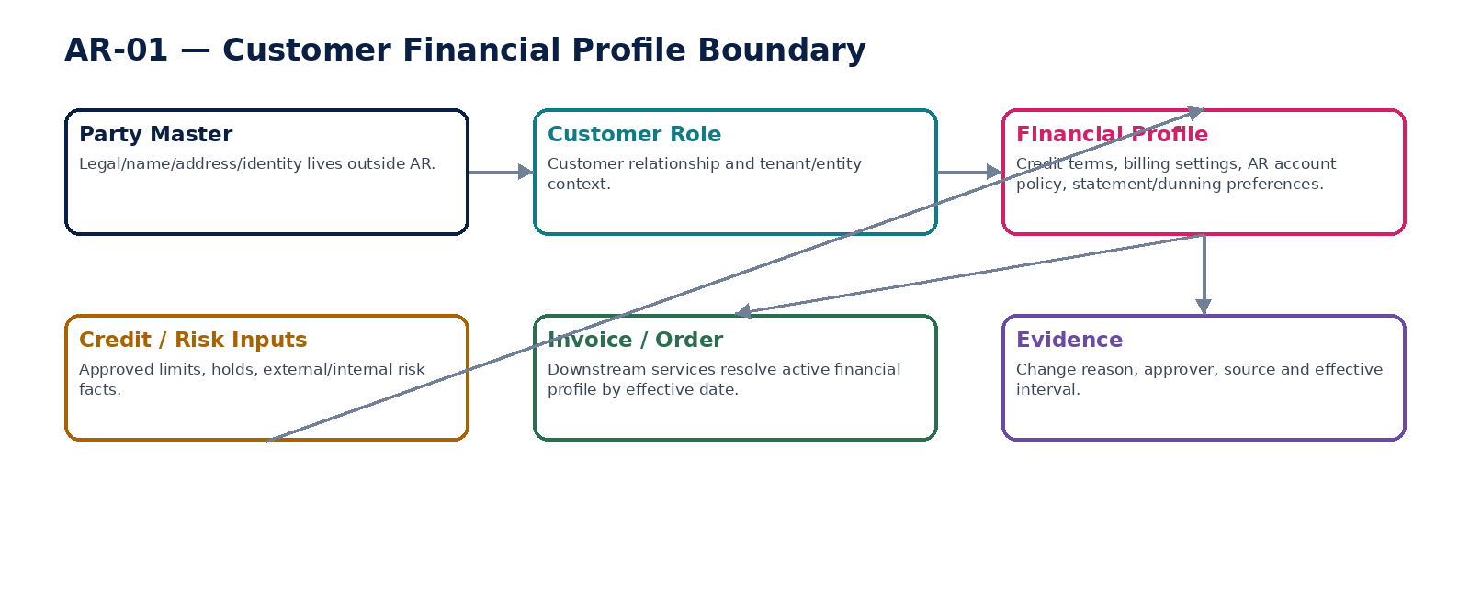
Figure 4 — Customer financial profile boundary and effective-dated resolution.

5. AR-02 — Quote / Estimate
Create and manage non-posting customer offers while preserving the boundary between commercial proposals and authoritative financial documents.

Contract field | Specification
Service ID / owner | AR-02 — Revenue, Billing & Accounts Receivable; accountable engineering/product/control owner recorded in service registry.
Purpose / bounded scope | Create and manage non-posting customer offers while preserving the boundary between commercial proposals and authoritative financial documents.
Authoritative ownership | Quote, quote version, quote lines, validity, assumptions, pricing/source references, acceptance evidence and conversion linkage.
Required source inputs | customer; entity; products/services; quantities; requested prices/discounts; currency; validity; terms; optional tax estimate request.
Server-resolved / derived context | active customer profile; price/catalog version; discount authority; tax estimate result if requested; jurisdiction; approval policy.
Commands | CreateQuote; AmendQuote; SubmitQuoteForApproval; ApproveQuote; SendQuote; RecordAcceptance; RejectQuote; ExpireQuote; ConvertQuoteToOrder
Queries / read contracts | GetQuote; GetQuoteVersion; ListQuotes; GetAvailableActions; GetQuoteHistory
State model | Draft → PendingApproval → Approved → Sent → Accepted/Rejected/Expired → Converted; superseded versions preserved.
Authorization / permissions | quote.read/create/manage/send; quote.approve; quote.convert.
Segregation of duties | Quote preparer cannot approve discounts beyond own authority; acceptance cannot be fabricated by internal user without evidence/policy.
Events produced | QuoteCreated; QuoteApproved; QuoteSent; QuoteAccepted; QuoteRejected; QuoteExpired; QuoteConvertedToOrder
Dependencies | AR-01; Product/Catalog/Pricing; TAX estimate; Workflow/SoD; Documents/communications.
Failure / degradation semantics | Quote is non-posting; missing price/tax estimate may block approval but never creates receivable/accounting consequence.
Evidence / lineage | Versioned lines, assumptions, price sources, approvals, send/acceptance evidence and conversion references.
NFR / recovery profile | C2 transactional; quote reads scale high; no ledger RPO implications beyond evidence retention.

Engineering Interaction Wireframe
Type | Operation | Illustrative contract surface | Mandatory controls
QUERY | GetQuote | GET/POST /internal/v1/ar02/getQuote | Scoped read; correlation + authorization context
QUERY | GetQuoteVersion | GET/POST /internal/v1/ar02/getQuoteVersion | Scoped read; correlation + authorization context
QUERY | ListQuotes | GET/POST /internal/v1/ar02/listQuotes | Scoped read; correlation + authorization context
QUERY | GetAvailableActions | GET/POST /internal/v1/ar02/getAvailableActions | Scoped read; correlation + authorization context
QUERY | GetQuoteHistory | GET/POST /internal/v1/ar02/getQuoteHistory | Scoped read; correlation + authorization context
COMMAND | CreateQuote | POST /internal/v1/ar02/commands/createQuote | Idempotency-Key; expected_version where stateful; server-resolved entity/jurisdiction
COMMAND | AmendQuote | POST /internal/v1/ar02/commands/amendQuote | Idempotency-Key; expected_version where stateful; server-resolved entity/jurisdiction
COMMAND | SubmitQuoteForApproval | POST /internal/v1/ar02/commands/submitQuoteForApproval | Idempotency-Key; expected_version where stateful; server-resolved entity/jurisdiction
COMMAND | ApproveQuote | POST /internal/v1/ar02/commands/approveQuote | Idempotency-Key; expected_version where stateful; server-resolved entity/jurisdiction

Minimum Negative-Path Acceptance
# | Scenario | Required result
1 | Quote approval reused after material price change | Block/deny/quarantine or preserve safe/unknown state; stable error and evidence; no unauthorized, duplicate or unbalanced financial consequence.
2 | Expired quote converted | Block/deny/quarantine or preserve safe/unknown state; stable error and evidence; no unauthorized, duplicate or unbalanced financial consequence.
3 | Unauthorized discount approval | Block/deny/quarantine or preserve safe/unknown state; stable error and evidence; no unauthorized, duplicate or unbalanced financial consequence.
4 | Quote acceptance recorded without evidence | Block/deny/quarantine or preserve safe/unknown state; stable error and evidence; no unauthorized, duplicate or unbalanced financial consequence.

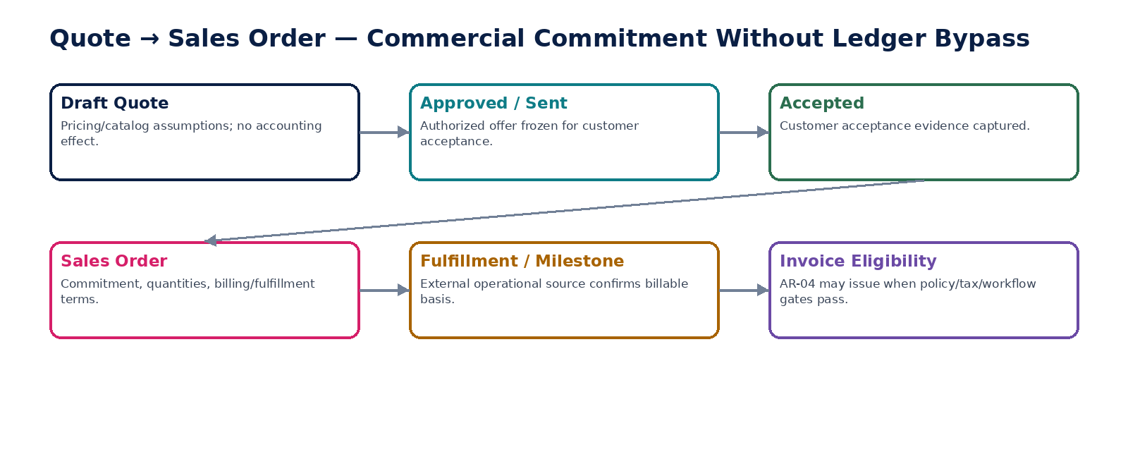
Figure 5 — Quote-to-order commitment path without ledger bypass.

6. AR-03 — Sales Order
Record governed customer commitment, billing/fulfillment basis and order-level commercial obligations without posting directly to the ledger.

Contract field | Specification
Service ID / owner | AR-03 — Revenue, Billing & Accounts Receivable; accountable engineering/product/control owner recorded in service registry.
Purpose / bounded scope | Record governed customer commitment, billing/fulfillment basis and order-level commercial obligations without posting directly to the ledger.
Authoritative ownership | SalesOrder, order lines, billing schedule/terms, fulfillment references, cancellation/hold state and invoiced/remaining quantities/amounts.
Required source inputs | accepted quote or direct order basis; customer/entity; products/services; quantities; prices; currency; delivery/service terms; billing milestones/schedule; PO/customer reference.
Server-resolved / derived context | customer profile/credit hold; catalog/price version; tax applicability context; fulfillment policy; authorization; effective jurisdiction.
Commands | CreateSalesOrder; AmendSalesOrder; SubmitOrder; ApproveOrder; ConfirmOrder; PlaceOrderHold; ReleaseOrderHold; CancelOrder; RecordBillableMilestone; CloseOrder
Queries / read contracts | GetSalesOrder; GetOrderBillingStatus; GetInvoiceEligibility; GetAvailableActions; GetOrderHistory
State model | Draft → PendingApproval → Confirmed → InFulfillment/PartiallyBilled → FullyBilled → Closed; Hold/Cancelled branches with controlled correction.
Authorization / permissions | salesorder.read/create/manage; salesorder.approve/confirm/hold/cancel.
Segregation of duties | Order creator cannot approve above commercial/credit thresholds; hold release may require independent authority; fulfillment evidence comes from owning operational domain.
Events produced | SalesOrderCreated; SalesOrderConfirmed; SalesOrderHeld; SalesOrderReleased; BillableMilestoneRecorded; SalesOrderPartiallyBilled; SalesOrderFullyBilled; SalesOrderCancelled
Dependencies | AR-01/02; Product/Catalog; fulfillment/project/service domains; Workflow/SoD; TAX; AR-04.
Failure / degradation semantics | Confirmed order cannot be silently mutated after billing begins; changes create governed amendments; credit hold can block new confirmation/invoicing per policy.
Evidence / lineage | Order version, source quote/PO, billing schedule, fulfillment evidence, approvals and invoice links.
NFR / recovery profile | C1 commercial source; concurrency protected; deterministic remaining-to-bill calculations.

Engineering Interaction Wireframe
Type | Operation | Illustrative contract surface | Mandatory controls
QUERY | GetSalesOrder | GET/POST /internal/v1/ar03/getSalesOrder | Scoped read; correlation + authorization context
QUERY | GetOrderBillingStatus | GET/POST /internal/v1/ar03/getOrderBillingStatus | Scoped read; correlation + authorization context
QUERY | GetInvoiceEligibility | GET/POST /internal/v1/ar03/getInvoiceEligibility | Scoped read; correlation + authorization context
QUERY | GetAvailableActions | GET/POST /internal/v1/ar03/getAvailableActions | Scoped read; correlation + authorization context
QUERY | GetOrderHistory | GET/POST /internal/v1/ar03/getOrderHistory | Scoped read; correlation + authorization context
COMMAND | CreateSalesOrder | POST /internal/v1/ar03/commands/createSalesOrder | Idempotency-Key; expected_version where stateful; server-resolved entity/jurisdiction
COMMAND | AmendSalesOrder | POST /internal/v1/ar03/commands/amendSalesOrder | Idempotency-Key; expected_version where stateful; server-resolved entity/jurisdiction
COMMAND | SubmitOrder | POST /internal/v1/ar03/commands/submitOrder | Idempotency-Key; expected_version where stateful; server-resolved entity/jurisdiction
COMMAND | ApproveOrder | POST /internal/v1/ar03/commands/approveOrder | Idempotency-Key; expected_version where stateful; server-resolved entity/jurisdiction

Minimum Negative-Path Acceptance
# | Scenario | Required result
1 | Order exceeds credit limit without approval | Block/deny/quarantine or preserve safe/unknown state; stable error and evidence; no unauthorized, duplicate or unbalanced financial consequence.
2 | Billed line quantity reduced in place | Block/deny/quarantine or preserve safe/unknown state; stable error and evidence; no unauthorized, duplicate or unbalanced financial consequence.
3 | Duplicate milestone creates duplicate invoice eligibility | Block/deny/quarantine or preserve safe/unknown state; stable error and evidence; no unauthorized, duplicate or unbalanced financial consequence.
4 | Cancelled order invoiced without explicit exception | Block/deny/quarantine or preserve safe/unknown state; stable error and evidence; no unauthorized, duplicate or unbalanced financial consequence.

7. AR-04 — Customer Invoice
Issue the authoritative receivable/tax document from an approved billing basis while delegating tax determination, e-invoice transmission, payment settlement and ledger posting to their owning domains.

Contract field | Specification
Service ID / owner | AR-04 — Revenue, Billing & Accounts Receivable; accountable engineering/product/control owner recorded in service registry.
Purpose / bounded scope | Issue the authoritative receivable/tax document from an approved billing basis while delegating tax determination, e-invoice transmission, payment settlement and ledger posting to their owning domains.
Authoritative ownership | CustomerInvoice, invoice lines, legal/document number, issue/due dates, tax-result reference, totals, immutable issued representation, lifecycle state and source/billing links.
Required source inputs | customer/entity; order/milestone or direct billing basis; line quantities/amounts; currency; dates; payment terms; references; attachments/notes permitted by policy.
Server-resolved / derived context | active customer financial profile; legal entity/book; jurisdiction; TAX determination and rule-pack version; invoice numbering rule; approval/SoD; period state; accounting mappings; required e-invoice profile.
Commands | CreateInvoiceDraft; AmendInvoiceDraft; SubmitInvoiceForApproval; ApproveInvoice; IssueInvoice; CancelUnissuedInvoice; RequestLegalCancellation; MarkDeliveryResult; LinkCorrectionDocument
Queries / read contracts | GetInvoice; GetInvoiceAsIssued; GetInvoiceStateDimensions; GetAvailableActions; GetInvoiceHistory; GetInvoiceAccountingStatus
State model | Lifecycle: Draft → PendingApproval → Approved → Issued → Corrected/Cancelled where legally permitted. Delivery, E-Invoice, Settlement, Dispute and Attention states are orthogonal.
Authorization / permissions | invoice.read/create/manage; invoice.approve; invoice.issue; invoice.cancel.request/approve.
Segregation of duties | Issuer cannot self-approve material invoice where maker-checker applies; number allocation and issue are server-authoritative; tax cannot be overridden by invoice editor.
Events produced | InvoiceDraftCreated; InvoiceApproved; CustomerInvoiceIssued; InvoiceDeliveryFailed; InvoiceCorrectionLinked; InvoiceCancellationRequested
Dependencies | AR-01/03; TAX; Numbering/Reference Data; Workflow/SoD; AR-05/07; ACC-04; Evidence/Documents.
Failure / degradation semantics | Issuance is atomic/idempotent. If tax, numbering, approval or period/accounting prerequisite is unresolved, remain unissued. Delivery/e-invoice failure does not roll back an already valid issued invoice.
Evidence / lineage | Frozen issue representation, tax result, numbering source, source-order/milestone, approvals, policy/rule versions, accounting event and delivery references.
NFR / recovery profile | C0 financially/regulatorily critical; zero duplicate issue; low-latency issue path; durable outbox; strict historical retrieval.

Engineering Interaction Wireframe
Type | Operation | Illustrative contract surface | Mandatory controls
QUERY | GetInvoice | GET/POST /internal/v1/ar04/getInvoice | Scoped read; correlation + authorization context
QUERY | GetInvoiceAsIssued | GET/POST /internal/v1/ar04/getInvoiceAsIssued | Scoped read; correlation + authorization context
QUERY | GetInvoiceStateDimensions | GET/POST /internal/v1/ar04/getInvoiceStateDimensions | Scoped read; correlation + authorization context
QUERY | GetAvailableActions | GET/POST /internal/v1/ar04/getAvailableActions | Scoped read; correlation + authorization context
QUERY | GetInvoiceHistory | GET/POST /internal/v1/ar04/getInvoiceHistory | Scoped read; correlation + authorization context
QUERY | GetInvoiceAccountingStatus | GET/POST /internal/v1/ar04/getInvoiceAccountingStatus | Scoped read; correlation + authorization context
COMMAND | CreateInvoiceDraft | POST /internal/v1/ar04/commands/createInvoiceDraft | Idempotency-Key; expected_version where stateful; server-resolved entity/jurisdiction
COMMAND | AmendInvoiceDraft | POST /internal/v1/ar04/commands/amendInvoiceDraft | Idempotency-Key; expected_version where stateful; server-resolved entity/jurisdiction
COMMAND | SubmitInvoiceForApproval | POST /internal/v1/ar04/commands/submitInvoiceForApproval | Idempotency-Key; expected_version where stateful; server-resolved entity/jurisdiction

Minimum Negative-Path Acceptance
# | Scenario | Required result
1 | Issue command replayed after timeout | Block/deny/quarantine or preserve safe/unknown state; stable error and evidence; no unauthorized, duplicate or unbalanced financial consequence.
2 | Tax result changed after approval | Block/deny/quarantine or preserve safe/unknown state; stable error and evidence; no unauthorized, duplicate or unbalanced financial consequence.
3 | Invoice number collision | Block/deny/quarantine or preserve safe/unknown state; stable error and evidence; no unauthorized, duplicate or unbalanced financial consequence.
4 | Delivery failure incorrectly voids issued invoice | Block/deny/quarantine or preserve safe/unknown state; stable error and evidence; no unauthorized, duplicate or unbalanced financial consequence.

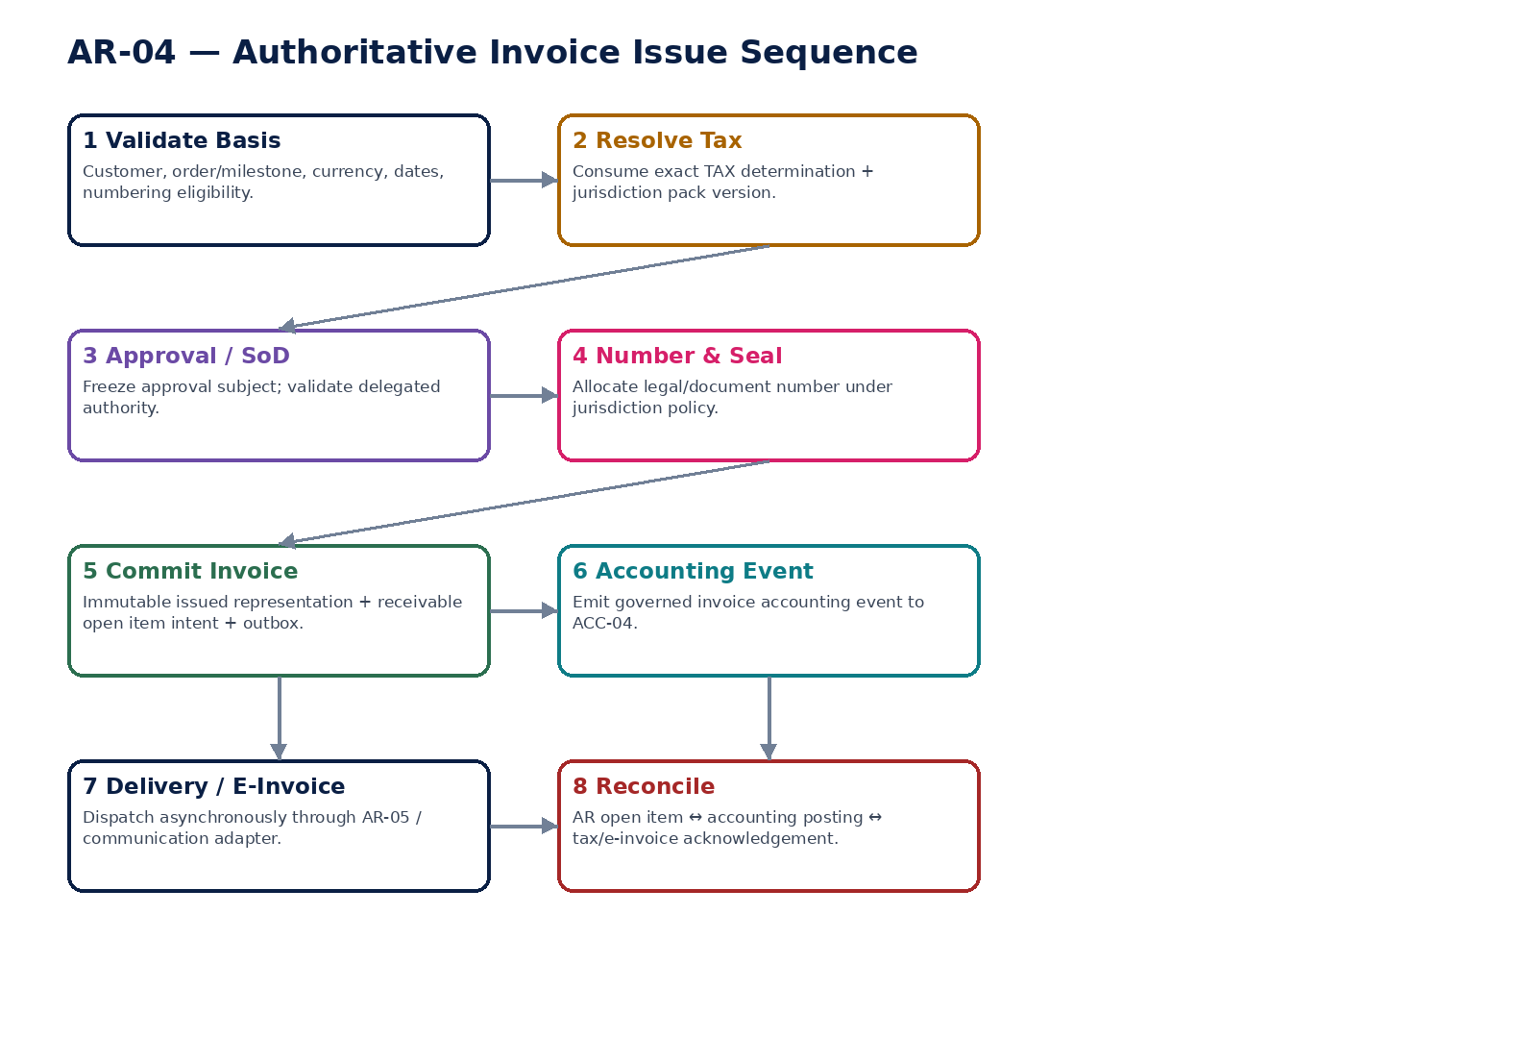
Figure 6 — Customer invoice authoritative issue sequence.

8. AR-05 — Electronic Invoice
Render, validate and transmit an issued invoice/credit note through jurisdiction/network-specific electronic invoicing adapters while preserving the source document as authoritative.

Contract field | Specification
Service ID / owner | AR-05 — Revenue, Billing & Accounts Receivable; accountable engineering/product/control owner recorded in service registry.
Purpose / bounded scope | Render, validate and transmit an issued invoice/credit note through jurisdiction/network-specific electronic invoicing adapters while preserving the source document as authoritative.
Authoritative ownership | EInvoiceSubmission, syntax/render artifact, validation result, submission attempt, provider/network reference, acknowledgement/rejection and resubmission chain.
Required source inputs | issued invoice/credit note ID; required jurisdiction/network profile; endpoint/participant identifiers; transmission purpose.
Server-resolved / derived context | jurisdiction-pack e-invoice profile; syntax/code-list version; network/provider configuration; credential/signing profile; residency routing; invoice immutable content hash.
Commands | PrepareEInvoice; ValidateEInvoice; SubmitEInvoice; RetrySubmission; RecordProviderCallback; ReconcileSubmissionState; CancelSubmissionWherePermitted
Queries / read contracts | GetEInvoiceStatus; GetSubmissionAttempt; GetValidationErrors; GetAcknowledgement; ListSubmissionHistory
State model | NotRequired/Required → Prepared → Validated → Submitted → Pending/Unknown → Accepted/Rejected; superseded/resubmitted attempts preserved.
Authorization / permissions | einvoice.read; einvoice.submit/retry/reconcile; adapter.admin restricted.
Segregation of duties | Invoice issuer need not hold provider credential; manual callback/status override prohibited except controlled admin evidence path.
Events produced | EInvoicePrepared; EInvoiceSubmitted; EInvoiceAccepted; EInvoiceRejected; EInvoiceStateUnknown; EInvoiceSubmissionReconciled
Dependencies | AR-04/06; Jurisdiction Pack; Integration/API; Security/Secrets; GTRM; provider/network; Evidence.
Failure / degradation semantics | Timeout becomes Pending/Unknown, not Failed. Reconcile external authority before retry if duplicate submission risk exists. Rejection never mutates issued invoice truth.
Evidence / lineage | Rendered artifact hash, syntax/profile version, attempt IDs, provider refs, callback signature verification, acknowledgements and reconciliation history.
NFR / recovery profile | C0 regulatory delivery path where mandated; durable attempts; provider isolation; retry/backoff; residency-aware.

Engineering Interaction Wireframe
Type | Operation | Illustrative contract surface | Mandatory controls
QUERY | GetEInvoiceStatus | GET/POST /internal/v1/ar05/getEInvoiceStatus | Scoped read; correlation + authorization context
QUERY | GetSubmissionAttempt | GET/POST /internal/v1/ar05/getSubmissionAttempt | Scoped read; correlation + authorization context
QUERY | GetValidationErrors | GET/POST /internal/v1/ar05/getValidationErrors | Scoped read; correlation + authorization context
QUERY | GetAcknowledgement | GET/POST /internal/v1/ar05/getAcknowledgement | Scoped read; correlation + authorization context
QUERY | ListSubmissionHistory | GET/POST /internal/v1/ar05/listSubmissionHistory | Scoped read; correlation + authorization context
COMMAND | PrepareEInvoice | POST /internal/v1/ar05/commands/prepareEInvoice | Idempotency-Key; expected_version where stateful; server-resolved entity/jurisdiction
COMMAND | ValidateEInvoice | POST /internal/v1/ar05/commands/validateEInvoice | Idempotency-Key; expected_version where stateful; server-resolved entity/jurisdiction
COMMAND | SubmitEInvoice | POST /internal/v1/ar05/commands/submitEInvoice | Idempotency-Key; expected_version where stateful; server-resolved entity/jurisdiction
COMMAND | RetrySubmission | POST /internal/v1/ar05/commands/retrySubmission | Idempotency-Key; expected_version where stateful; server-resolved entity/jurisdiction

Minimum Negative-Path Acceptance
# | Scenario | Required result
1 | Provider timeout followed by duplicate resubmission | Block/deny/quarantine or preserve safe/unknown state; stable error and evidence; no unauthorized, duplicate or unbalanced financial consequence.
2 | Rejected e-invoice mutates source invoice | Block/deny/quarantine or preserve safe/unknown state; stable error and evidence; no unauthorized, duplicate or unbalanced financial consequence.
3 | Forged callback accepted | Block/deny/quarantine or preserve safe/unknown state; stable error and evidence; no unauthorized, duplicate or unbalanced financial consequence.
4 | Wrong jurisdiction syntax/profile selected | Block/deny/quarantine or preserve safe/unknown state; stable error and evidence; no unauthorized, duplicate or unbalanced financial consequence.

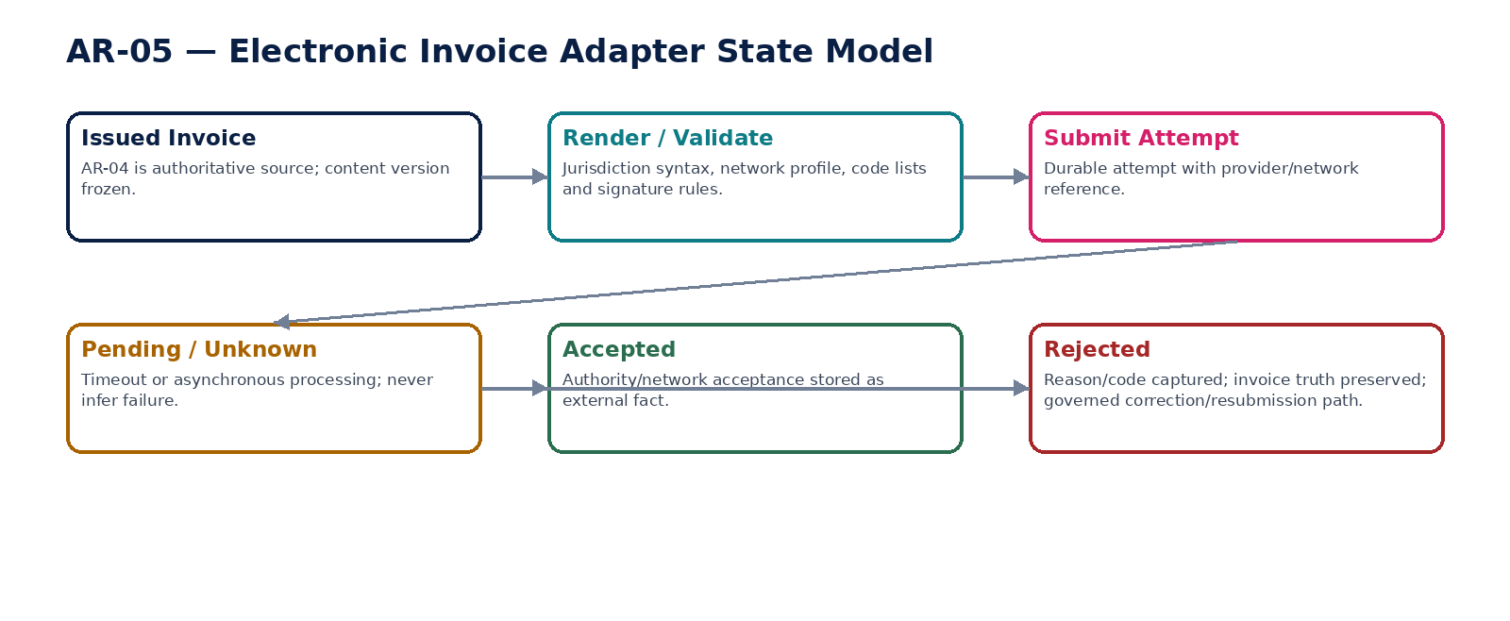
Figure 7 — Electronic invoice submission and external-state reconciliation.

9. AR-06 — Credit / Debit Note
Correct or adjust issued customer billing through new linked authoritative documents rather than editing previously issued invoices.

Contract field | Specification
Service ID / owner | AR-06 — Revenue, Billing & Accounts Receivable; accountable engineering/product/control owner recorded in service registry.
Purpose / bounded scope | Correct or adjust issued customer billing through new linked authoritative documents rather than editing previously issued invoices.
Authoritative ownership | CreditNote/DebitNote, correction reason, linkage to source invoice(s), tax result, issued representation, AR/accounting consequence and state.
Required source inputs | source invoice(s); correction reason; adjusted lines/amounts/quantities; effective dates; currency; supporting evidence.
Server-resolved / derived context | remaining correctable amount; TAX correction determination; jurisdiction correction rules; approval authority; period state; numbering policy.
Commands | CreateCorrectionDraft; SubmitCorrectionForApproval; ApproveCorrection; IssueCreditNote; IssueDebitNote; CancelUnissuedCorrection; LinkReplacementInvoice
Queries / read contracts | GetCorrection; GetCorrectableAmount; GetCorrectionChain; GetAvailableActions; GetCorrectionAccountingStatus
State model | Draft → PendingApproval → Approved → Issued → Applied/Settled; correction chain immutable; unissued drafts cancelable.
Authorization / permissions | creditnote/debitnote.read/create/manage; correction.approve/issue.
Segregation of duties | Preparer cannot approve material correction/write-down beyond authority; tax result and source invoice linkage immutable at issue.
Events produced | CreditNoteIssued; DebitNoteIssued; InvoiceCorrected; CorrectionApplicationRequested
Dependencies | AR-04/07; TAX; Workflow/SoD; ACC-04; AR-05 if e-invoice required.
Failure / degradation semantics | Cannot credit more than permitted source exposure without explicit standalone credit policy; issued note never edits original invoice.
Evidence / lineage | Source invoice refs, reason, tax correction, approval, issued artifact, accounting event and application result.
NFR / recovery profile | C0 financial/regulatory; exact arithmetic; duplicate correction suppression; audit-grade history.

Engineering Interaction Wireframe
Type | Operation | Illustrative contract surface | Mandatory controls
QUERY | GetCorrection | GET/POST /internal/v1/ar06/getCorrection | Scoped read; correlation + authorization context
QUERY | GetCorrectableAmount | GET/POST /internal/v1/ar06/getCorrectableAmount | Scoped read; correlation + authorization context
QUERY | GetCorrectionChain | GET/POST /internal/v1/ar06/getCorrectionChain | Scoped read; correlation + authorization context
QUERY | GetAvailableActions | GET/POST /internal/v1/ar06/getAvailableActions | Scoped read; correlation + authorization context
QUERY | GetCorrectionAccountingStatus | GET/POST /internal/v1/ar06/getCorrectionAccountingStatus | Scoped read; correlation + authorization context
COMMAND | CreateCorrectionDraft | POST /internal/v1/ar06/commands/createCorrectionDraft | Idempotency-Key; expected_version where stateful; server-resolved entity/jurisdiction
COMMAND | SubmitCorrectionForApproval | POST /internal/v1/ar06/commands/submitCorrectionForApproval | Idempotency-Key; expected_version where stateful; server-resolved entity/jurisdiction
COMMAND | ApproveCorrection | POST /internal/v1/ar06/commands/approveCorrection | Idempotency-Key; expected_version where stateful; server-resolved entity/jurisdiction
COMMAND | IssueCreditNote | POST /internal/v1/ar06/commands/issueCreditNote | Idempotency-Key; expected_version where stateful; server-resolved entity/jurisdiction

Minimum Negative-Path Acceptance
# | Scenario | Required result
1 | Credit exceeds eligible invoice amount | Block/deny/quarantine or preserve safe/unknown state; stable error and evidence; no unauthorized, duplicate or unbalanced financial consequence.
2 | Correction issued with stale tax rule | Block/deny/quarantine or preserve safe/unknown state; stable error and evidence; no unauthorized, duplicate or unbalanced financial consequence.
3 | Original invoice edited instead of note | Block/deny/quarantine or preserve safe/unknown state; stable error and evidence; no unauthorized, duplicate or unbalanced financial consequence.
4 | Same correction replayed twice | Block/deny/quarantine or preserve safe/unknown state; stable error and evidence; no unauthorized, duplicate or unbalanced financial consequence.

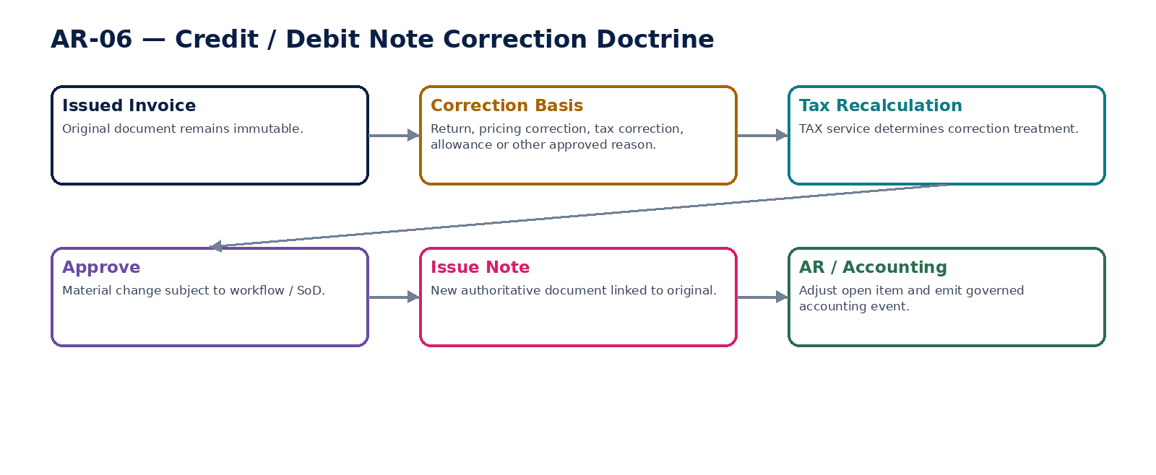
Figure 8 — Credit/debit note correction doctrine.

10. AR-07 — Receivables
Own customer open-item balances, residual amounts, aging facts and settlement/dispute exposure derived from authoritative billing and application events.

Contract field | Specification
Service ID / owner | AR-07 — Revenue, Billing & Accounts Receivable; accountable engineering/product/control owner recorded in service registry.
Purpose / bounded scope | Own customer open-item balances, residual amounts, aging facts and settlement/dispute exposure derived from authoritative billing and application events.
Authoritative ownership | ReceivableOpenItem, residual amount, due date, application history, dispute/hold flags, write-off/correction links and customer AR balance projection.
Required source inputs | issued invoice/credit/debit consequences; cash application events; write-off/refund/correction events; customer/entity/book/currency.
Server-resolved / derived context | accounting/AR control-account context; business calendar; aging buckets; dispute/collection policy; current applications.
Commands | CreateOpenItemFromDocument; ApplyReceivableAdjustment; OpenDispute; ResolveDispute; PlaceCollectionHold; ReleaseCollectionHold; CloseOpenItem
Queries / read contracts | GetOpenItem; GetCustomerReceivables; GetAging; GetBalanceAsOf; GetOpenItemHistory; GetAvailableActions
State model | Created → Open → PartiallySettled → Settled; Disputed/Held orthogonal; WrittenOff/Corrected terminal adjustment paths.
Authorization / permissions | receivables.read; receivables.dispute/hold/manage; sensitive balance export controlled.
Segregation of duties | Balance adjustment cannot be manual free-form; adjustment must reference owning event/document; dispute resolver separated from write-off approver where material.
Events produced | ReceivableOpenItemCreated; ReceivablePartiallySettled; ReceivableSettled; ReceivableDisputed; CollectionHoldPlaced; ReceivableWrittenOff
Dependencies | AR-04/06/08/10; ACC-04/06; Calendar/Reference Data; Collections.
Failure / degradation semantics | Projection mismatch raises explicit control exception; no silent balance plug. Missing application/event must not be guessed.
Evidence / lineage | Document/source refs, application history, residual calculations, aging inputs, dispute evidence, accounting/control refs.
NFR / recovery profile | C0/C1 subledger truth; point-in-time/as-of reconstruction; high read scale; exact balances.

Engineering Interaction Wireframe
Type | Operation | Illustrative contract surface | Mandatory controls
QUERY | GetOpenItem | GET/POST /internal/v1/ar07/getOpenItem | Scoped read; correlation + authorization context
QUERY | GetCustomerReceivables | GET/POST /internal/v1/ar07/getCustomerReceivables | Scoped read; correlation + authorization context
QUERY | GetAging | GET/POST /internal/v1/ar07/getAging | Scoped read; correlation + authorization context
QUERY | GetBalanceAsOf | GET/POST /internal/v1/ar07/getBalanceAsOf | Scoped read; correlation + authorization context
QUERY | GetOpenItemHistory | GET/POST /internal/v1/ar07/getOpenItemHistory | Scoped read; correlation + authorization context
QUERY | GetAvailableActions | GET/POST /internal/v1/ar07/getAvailableActions | Scoped read; correlation + authorization context
COMMAND | CreateOpenItemFromDocument | POST /internal/v1/ar07/commands/createOpenItemFromDocument | Idempotency-Key; expected_version where stateful; server-resolved entity/jurisdiction
COMMAND | ApplyReceivableAdjustment | POST /internal/v1/ar07/commands/applyReceivableAdjustment | Idempotency-Key; expected_version where stateful; server-resolved entity/jurisdiction
COMMAND | OpenDispute | POST /internal/v1/ar07/commands/openDispute | Idempotency-Key; expected_version where stateful; server-resolved entity/jurisdiction

Minimum Negative-Path Acceptance
# | Scenario | Required result
1 | Residual becomes negative without authorized credit | Block/deny/quarantine or preserve safe/unknown state; stable error and evidence; no unauthorized, duplicate or unbalanced financial consequence.
2 | Aging date uses wrong business calendar | Block/deny/quarantine or preserve safe/unknown state; stable error and evidence; no unauthorized, duplicate or unbalanced financial consequence.
3 | Manual balance edit attempted | Block/deny/quarantine or preserve safe/unknown state; stable error and evidence; no unauthorized, duplicate or unbalanced financial consequence.
4 | AR total matches GL while duplicate open items exist | Block/deny/quarantine or preserve safe/unknown state; stable error and evidence; no unauthorized, duplicate or unbalanced financial consequence.

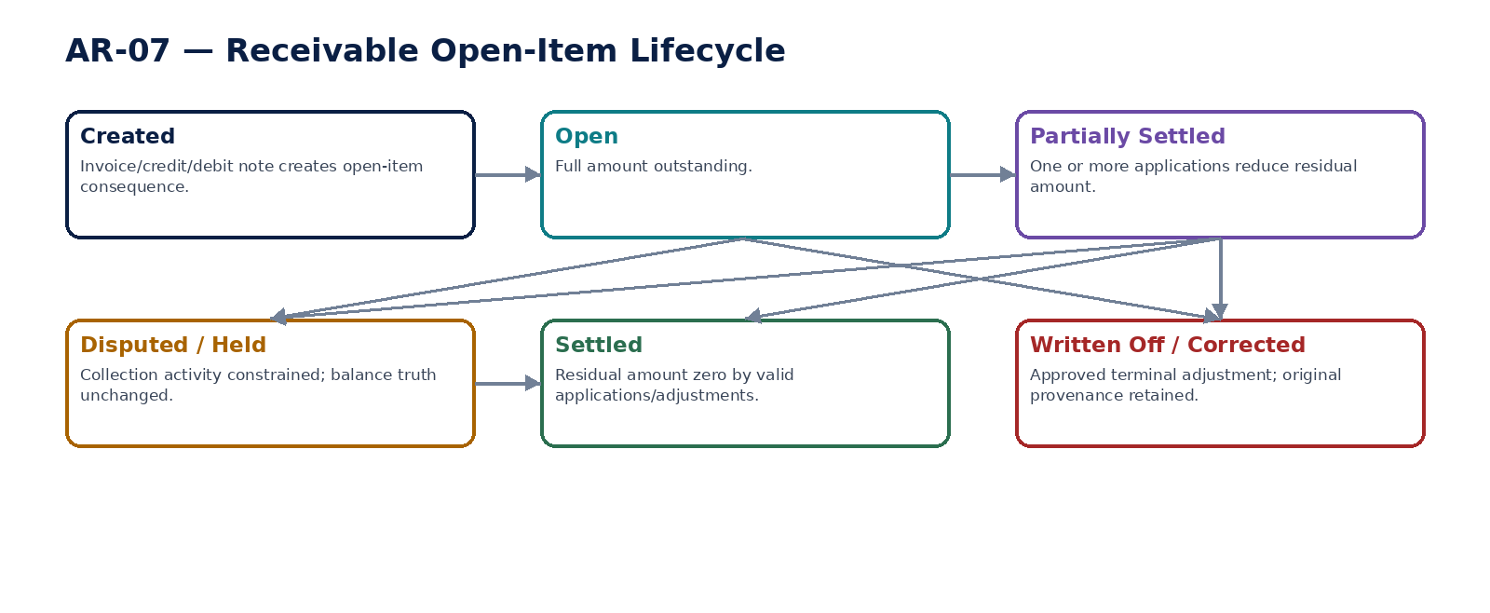
Figure 9 — Receivable open-item lifecycle.

11. AR-08 — Cash Application
Allocate confirmed receipts/settlements to receivable open items with deterministic reconciliation, preserving unapplied cash and external settlement ownership.

Contract field | Specification
Service ID / owner | AR-08 — Revenue, Billing & Accounts Receivable; accountable engineering/product/control owner recorded in service registry.
Purpose / bounded scope | Allocate confirmed receipts/settlements to receivable open items with deterministic reconciliation, preserving unapplied cash and external settlement ownership.
Authoritative ownership | CashApplication, application lines, unapplied residual, payer/customer inference, FX/fee treatment references and application state.
Required source inputs | confirmed bank/provider receipt; amount/currency/value date; payer/remittance references; candidate customer/open items; remittance advice.
Server-resolved / derived context | settlement finality from Banking; open-item balances; matching policy; FX policy/rates; tolerance policy; authorization.
Commands | CreateApplicationBatch; GenerateMatchCandidates; ApplyReceipt; ApproveManualMatch; UnapplyReceipt; ReapplyReceipt; ReconcileApplicationBatch
Queries / read contracts | GetApplication; GetUnappliedCash; GetMatchCandidates; GetApplicationReconciliation; GetAvailableActions
State model | Unapplied → Proposed → PartiallyApplied/FullyApplied → Reconciled; reversible by governed unapply/reapply where period/policy permits.
Authorization / permissions | cashapplication.read/manage; cashapplication.manualmatch.approve; unapply/reapply restricted.
Segregation of duties | Receipt creator/settlement owner does not automatically gain allocation override; manual high-value/related-party matches may require independent approval.
Events produced | ReceiptApplicationProposed; CashApplied; CashUnapplied; CashApplicationReconciled; CashUnappliedByCorrection
Dependencies | Banking/Payment; AR-07; FX/Reference Data; ACC-04; Workflow/SoD; Evidence.
Failure / degradation semantics | Never create application against unconfirmed/ambiguous external money movement. Total receipt must reconcile to applied + unapplied + authorized fee/FX difference.
Evidence / lineage | Settlement ref, match candidates/scores, manual decisions, application lines, FX/fee policy, accounting event and reconciliation.
NFR / recovery profile | C0 financial path; idempotent allocation; deterministic totals; high-volume batch support and replay safety.

Engineering Interaction Wireframe
Type | Operation | Illustrative contract surface | Mandatory controls
QUERY | GetApplication | GET/POST /internal/v1/ar08/getApplication | Scoped read; correlation + authorization context
QUERY | GetUnappliedCash | GET/POST /internal/v1/ar08/getUnappliedCash | Scoped read; correlation + authorization context
QUERY | GetMatchCandidates | GET/POST /internal/v1/ar08/getMatchCandidates | Scoped read; correlation + authorization context
QUERY | GetApplicationReconciliation | GET/POST /internal/v1/ar08/getApplicationReconciliation | Scoped read; correlation + authorization context
QUERY | GetAvailableActions | GET/POST /internal/v1/ar08/getAvailableActions | Scoped read; correlation + authorization context
COMMAND | CreateApplicationBatch | POST /internal/v1/ar08/commands/createApplicationBatch | Idempotency-Key; expected_version where stateful; server-resolved entity/jurisdiction
COMMAND | GenerateMatchCandidates | POST /internal/v1/ar08/commands/generateMatchCandidates | Idempotency-Key; expected_version where stateful; server-resolved entity/jurisdiction
COMMAND | ApplyReceipt | POST /internal/v1/ar08/commands/applyReceipt | Idempotency-Key; expected_version where stateful; server-resolved entity/jurisdiction
COMMAND | ApproveManualMatch | POST /internal/v1/ar08/commands/approveManualMatch | Idempotency-Key; expected_version where stateful; server-resolved entity/jurisdiction

Minimum Negative-Path Acceptance
# | Scenario | Required result
1 | Same receipt applied twice | Block/deny/quarantine or preserve safe/unknown state; stable error and evidence; no unauthorized, duplicate or unbalanced financial consequence.
2 | Timeout causes reapplication without idempotency | Block/deny/quarantine or preserve safe/unknown state; stable error and evidence; no unauthorized, duplicate or unbalanced financial consequence.
3 | Manual match exceeds open amount | Block/deny/quarantine or preserve safe/unknown state; stable error and evidence; no unauthorized, duplicate or unbalanced financial consequence.
4 | Unconfirmed provider payment applied | Block/deny/quarantine or preserve safe/unknown state; stable error and evidence; no unauthorized, duplicate or unbalanced financial consequence.

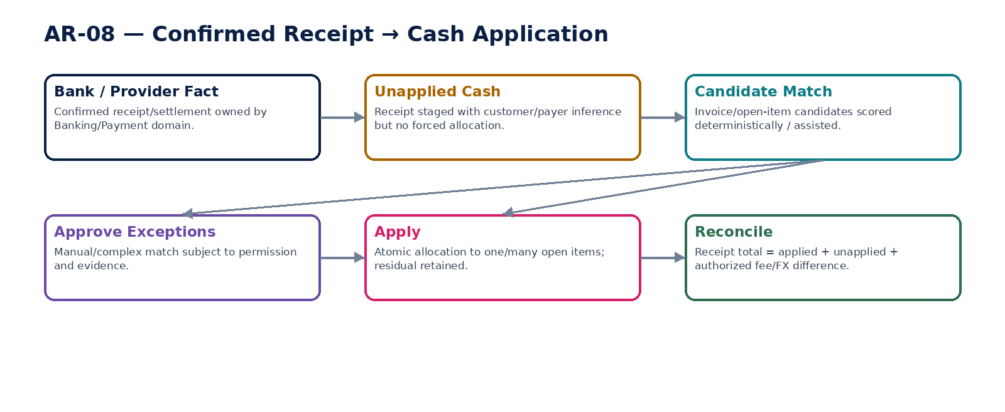
Figure 10 — Confirmed receipt to cash application and reconciliation.

12. AR-09 — Collections & Dunning
Manage overdue receivable communication, promises, holds and escalation while leaving financial balances to AR-07 and legal actions to governed legal workflows.

Contract field | Specification
Service ID / owner | AR-09 — Revenue, Billing & Accounts Receivable; accountable engineering/product/control owner recorded in service registry.
Purpose / bounded scope | Manage overdue receivable communication, promises, holds and escalation while leaving financial balances to AR-07 and legal actions to governed legal workflows.
Authoritative ownership | CollectionCase, dunning stage, communication history, promise-to-pay, assigned owner, collection hold, escalation/referral and resolution linkage.
Required source inputs | overdue open items/aging; customer profile; dispute/hold status; contact preferences; collection policy; jurisdiction/contact restrictions.
Server-resolved / derived context | business calendar; grace periods; protected/vulnerable/customer-contact rules where configured; legal referral threshold; current payments/applications.
Commands | OpenCollectionCase; AdvanceDunningStage; SendDunningNotice; RecordPromiseToPay; PlaceCollectionHold; ResumeCollections; EscalateCollectionCase; CloseCollectionCase
Queries / read contracts | GetCollectionCase; GetDunningSchedule; GetCustomerCollectionHistory; GetAvailableActions; GetPromisesDue
State model | Eligible → Active → PromiseToPay/Held/Disputed → Escalated → Resolved/Closed; overdue is derived from AR facts, not a mutable status.
Authorization / permissions | collections.read/manage; dunning.send; collections.escalate; hold manage.
Segregation of duties | Collector cannot approve own write-off; legal escalation does not grant legal-case authority; automated dunning obeys contact-policy and dispute/hold blocks.
Events produced | CollectionCaseOpened; DunningNoticeSent; PromiseToPayRecorded; CollectionHoldPlaced; CollectionEscalated; CollectionCaseResolved
Dependencies | AR-01/07/08/10; Communications; Workflow; Legal referral; Calendar/Policy.
Failure / degradation semantics | Communication failure does not change receivable truth. Dispute/hold must suppress prohibited automated contact. Collection service must not fabricate payment status.
Evidence / lineage | Aging snapshot, notice artifact, communication delivery, promises, holds, escalation reason and resolution references.
NFR / recovery profile | C1 operational; batch/scheduler reliability; rate-limited communications; strong audit trail.

Engineering Interaction Wireframe
Type | Operation | Illustrative contract surface | Mandatory controls
QUERY | GetCollectionCase | GET/POST /internal/v1/ar09/getCollectionCase | Scoped read; correlation + authorization context
QUERY | GetDunningSchedule | GET/POST /internal/v1/ar09/getDunningSchedule | Scoped read; correlation + authorization context
QUERY | GetCustomerCollectionHistory | GET/POST /internal/v1/ar09/getCustomerCollectionHistory | Scoped read; correlation + authorization context
QUERY | GetAvailableActions | GET/POST /internal/v1/ar09/getAvailableActions | Scoped read; correlation + authorization context
QUERY | GetPromisesDue | GET/POST /internal/v1/ar09/getPromisesDue | Scoped read; correlation + authorization context
COMMAND | OpenCollectionCase | POST /internal/v1/ar09/commands/openCollectionCase | Idempotency-Key; expected_version where stateful; server-resolved entity/jurisdiction
COMMAND | AdvanceDunningStage | POST /internal/v1/ar09/commands/advanceDunningStage | Idempotency-Key; expected_version where stateful; server-resolved entity/jurisdiction
COMMAND | SendDunningNotice | POST /internal/v1/ar09/commands/sendDunningNotice | Idempotency-Key; expected_version where stateful; server-resolved entity/jurisdiction
COMMAND | RecordPromiseToPay | POST /internal/v1/ar09/commands/recordPromiseToPay | Idempotency-Key; expected_version where stateful; server-resolved entity/jurisdiction

Minimum Negative-Path Acceptance
# | Scenario | Required result
1 | Dunning sent while dispute hold active | Block/deny/quarantine or preserve safe/unknown state; stable error and evidence; no unauthorized, duplicate or unbalanced financial consequence.
2 | Promise date changed without history | Block/deny/quarantine or preserve safe/unknown state; stable error and evidence; no unauthorized, duplicate or unbalanced financial consequence.
3 | Collector self-approves write-off | Block/deny/quarantine or preserve safe/unknown state; stable error and evidence; no unauthorized, duplicate or unbalanced financial consequence.
4 | Communication delivery marked as payment | Block/deny/quarantine or preserve safe/unknown state; stable error and evidence; no unauthorized, duplicate or unbalanced financial consequence.

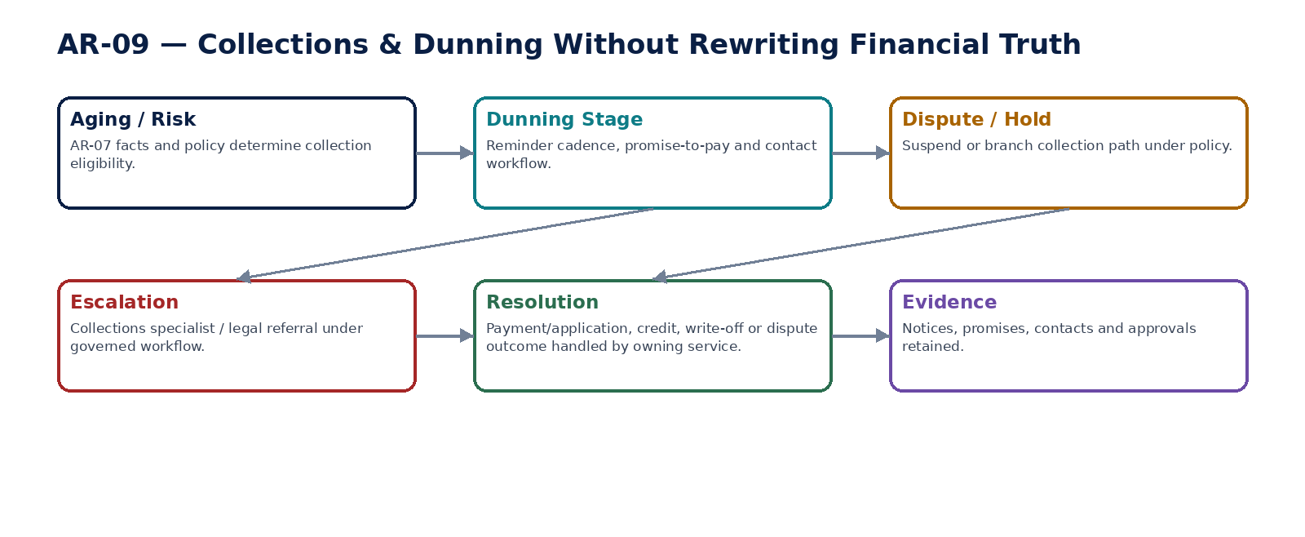
Figure 11 — Collections and dunning workflow without accounting mutation.

13. AR-10 — Customer Refund / Write-Off
Govern customer refunds, overpayment returns and bad-debt/immaterial write-offs with separate payment, tax and accounting authorities.

Contract field | Specification
Service ID / owner | AR-10 — Revenue, Billing & Accounts Receivable; accountable engineering/product/control owner recorded in service registry.
Purpose / bounded scope | Govern customer refunds, overpayment returns and bad-debt/immaterial write-offs with separate payment, tax and accounting authorities.
Authoritative ownership | RefundRequest, refund approval/state and external payment reference; WriteOffRequest, reason/category, approved amount and AR/accounting consequence.
Required source inputs | customer/open item/credit balance; requested amount/currency; refund destination reference; write-off reason; supporting evidence; original payment/billing refs.
Server-resolved / derived context | current residual/credit; payment destination validation; fraud/risk controls; approval limits; TAX correction implications; period state; Banking provider state.
Commands | CreateRefundRequest; ApproveRefund; SubmitRefundForPayment; ReconcileRefundState; CancelUnsubmittedRefund; CreateWriteOffRequest; ApproveWriteOff; CommitWriteOff
Queries / read contracts | GetRefund; GetRefundPaymentStatus; GetWriteOff; GetAvailableActions; GetRefundWriteOffHistory
State model | Refund: Draft → PendingApproval → Approved → Submitted → Pending/Unknown → Settled/Failed/Cancelled. Write-off: Draft → PendingApproval → Approved → Committed.
Authorization / permissions | refund.read/create/approve/submit; writeoff.read/create/approve/commit.
Segregation of duties | Refund maker cannot approve/release own material refund; destination change after approval invalidates approval; write-off requester cannot approve above delegated authority.
Events produced | RefundRequested; RefundSubmitted; RefundSettled; RefundFailed; WriteOffApproved; ReceivableWrittenOff
Dependencies | AR-07; Banking/Payment; TAX; ACC-04; Workflow/SoD; Fraud/Risk; Evidence.
Failure / degradation semantics | Refund timeout becomes Pending/Unknown until provider reconciliation. Write-off commits only after approval/accounting prerequisites; no direct bank or ledger writes.
Evidence / lineage | Original payment/credit refs, destination verification, approvals, provider attempts, tax treatment, accounting event and AR residual update.
NFR / recovery profile | C0 financial value path; strict idempotency, anti-fraud and provider reconciliation; no duplicate external effect.

Engineering Interaction Wireframe
Type | Operation | Illustrative contract surface | Mandatory controls
QUERY | GetRefund | GET/POST /internal/v1/ar10/getRefund | Scoped read; correlation + authorization context
QUERY | GetRefundPaymentStatus | GET/POST /internal/v1/ar10/getRefundPaymentStatus | Scoped read; correlation + authorization context
QUERY | GetWriteOff | GET/POST /internal/v1/ar10/getWriteOff | Scoped read; correlation + authorization context
QUERY | GetAvailableActions | GET/POST /internal/v1/ar10/getAvailableActions | Scoped read; correlation + authorization context
QUERY | GetRefundWriteOffHistory | GET/POST /internal/v1/ar10/getRefundWriteOffHistory | Scoped read; correlation + authorization context
COMMAND | CreateRefundRequest | POST /internal/v1/ar10/commands/createRefundRequest | Idempotency-Key; expected_version where stateful; server-resolved entity/jurisdiction
COMMAND | ApproveRefund | POST /internal/v1/ar10/commands/approveRefund | Idempotency-Key; expected_version where stateful; server-resolved entity/jurisdiction
COMMAND | SubmitRefundForPayment | POST /internal/v1/ar10/commands/submitRefundForPayment | Idempotency-Key; expected_version where stateful; server-resolved entity/jurisdiction
COMMAND | ReconcileRefundState | POST /internal/v1/ar10/commands/reconcileRefundState | Idempotency-Key; expected_version where stateful; server-resolved entity/jurisdiction

Minimum Negative-Path Acceptance
# | Scenario | Required result
1 | Refund destination changed after approval | Block/deny/quarantine or preserve safe/unknown state; stable error and evidence; no unauthorized, duplicate or unbalanced financial consequence.
2 | Provider timeout triggers duplicate refund | Block/deny/quarantine or preserve safe/unknown state; stable error and evidence; no unauthorized, duplicate or unbalanced financial consequence.
3 | Write-off self-approved above limit | Block/deny/quarantine or preserve safe/unknown state; stable error and evidence; no unauthorized, duplicate or unbalanced financial consequence.
4 | Refund settles but AR/GL reconciliation omitted | Block/deny/quarantine or preserve safe/unknown state; stable error and evidence; no unauthorized, duplicate or unbalanced financial consequence.

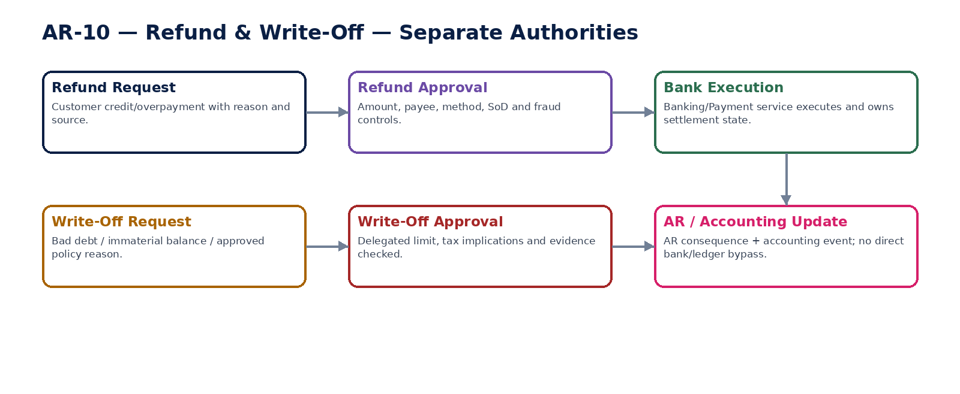
Figure 12 — Separate refund and write-off authority paths.

14. Shared Revenue / AR Command & Error Contract
Field | Domain requirement
tenant_id / entity_id | Server-resolved and authorization-scoped for every material command.
customer_party_id / customer_role_id | Stable party/customer relationship reference; AR profile does not duplicate master identity.
source_object_id / source_event_id | Quote/order/milestone/invoice/payment/correction source identity retained end-to-end.
document_date / issue_date / due_date / tax_point_date | Distinct business dates; jurisdiction/business-calendar rules applied explicitly.
transaction_currency | Explicit; no implicit currency conversion. Functional/presentation currency belongs to accounting/reporting context.
tax_determination_id | Exact TAX result and jurisdiction-pack version used at issue/correction.
idempotency_key | Mandatory for invoice issue, correction issue, cash application, refund/write-off and external submission commands.
expected_version | Required for mutable pre-issue/pre-commit state transitions.
correlation_id / causation_id | Propagated across order, invoice, receivable, settlement, application, accounting and evidence.
reason_code / evidence_id | Mandatory for corrections, holds, disputes, write-offs, refunds, manual matches and privileged actions.
external_attempt_id | Durable identity for e-invoice/refund/provider attempts; never replace with transient HTTP request ID.
accounting_event_id | Reference to governed accounting consequence; AR never substitutes GL write.

Stable error classes include CUSTOMER_PROFILE_INACTIVE, CREDIT_HOLD_ACTIVE, QUOTE_EXPIRED, ORDER_NOT_BILLABLE, TAX_DETERMINATION_MISSING, INVOICE_APPROVAL_INVALIDATED, INVOICE_NUMBER_COLLISION, INVOICE_ALREADY_ISSUED, EINVOICE_VALIDATION_FAILED, EXTERNAL_STATE_UNKNOWN, CORRECTION_EXCEEDS_ELIGIBLE_AMOUNT, RECEIVABLE_RESIDUAL_INVALID, SETTLEMENT_NOT_CONFIRMED, CASH_APPLICATION_DUPLICATE, APPLICATION_OUT_OF_BALANCE, COLLECTION_HOLD_ACTIVE, REFUND_DESTINATION_CHANGED, REFUND_STATE_UNKNOWN, WRITEOFF_APPROVAL_REQUIRED and AR_GL_RECONCILIATION_BREAK.

15. Cross-Service Event Contract Baseline
Producer | Representative authoritative events | Primary consumers
AR-01 | CustomerFinancialProfileChanged; CustomerCreditHoldPlaced/Released | AR-03/04/09, credit/risk, evidence
AR-02 | QuoteApproved; QuoteAccepted; QuoteConvertedToOrder | AR-03, CRM, evidence
AR-03 | SalesOrderConfirmed; BillableMilestoneRecorded; SalesOrderPartially/FullyBilled | AR-04, fulfillment, analytics
AR-04 | CustomerInvoiceIssued; InvoiceDeliveryFailed; InvoiceCorrectionLinked | AR-05/07, TAX, ACC-04, reporting
AR-05 | EInvoiceSubmitted; EInvoiceAccepted/Rejected; EInvoiceStateUnknown | AR-04/09, tax/regulatory ops, evidence
AR-06 | CreditNoteIssued; DebitNoteIssued; InvoiceCorrected | AR-07, TAX, ACC-04, AR-05
AR-07 | ReceivableOpenItemCreated; ReceivablePartiallySettled/Settled; ReceivableDisputed | AR-08/09/10, ACC-06, analytics
AR-08 | CashApplied; CashUnapplied; CashApplicationReconciled | AR-07, ACC-04/06, customer statements
AR-09 | DunningNoticeSent; PromiseToPayRecorded; CollectionEscalated | AR-07/10, legal, communications
AR-10 | RefundSubmitted/Settled; ReceivableWrittenOff | AR-07, Banking, TAX, ACC-04/06

16. Canonical Revenue / AR Data Model
Entity | Owner | Key fields / notes
CustomerFinancialProfile / Version | AR-01 | customer/entity, terms, credit limit/hold, statement/dunning preferences, effective interval, approvals
Quote / QuoteVersion / QuoteLine | AR-02 | customer, price/catalog refs, assumptions, validity, approval, acceptance, conversion
SalesOrder / OrderLine / BillingMilestone | AR-03 | commitment, billing schedule, fulfillment refs, invoiced/remaining quantities/amounts
CustomerInvoice / InvoiceLine | AR-04 | document number, issue/due/tax-point dates, currency, tax result, totals, source links, frozen issued hash
EInvoiceSubmission / Attempt | AR-05 | profile/syntax version, artifact hash, provider/network refs, state, acknowledgement/rejection
CreditDebitNote / Line | AR-06 | source invoice refs, correction reason, tax result, issued state, accounting consequence
ReceivableOpenItem | AR-07 | source document, original/residual amount, due date, settlement/dispute/hold state, applications
CashApplication / ApplicationLine | AR-08 | settlement ref, open-item refs, applied amount, residual/unapplied, FX/fee treatment, reconciliation
CollectionCase / PromiseToPay / DunningAction | AR-09 | aging snapshot, stage, contacts, promises, holds, escalation, resolution
RefundRequest / RefundAttempt | AR-10 | credit/open-item refs, amount, destination verification, approvals, provider refs, settlement
WriteOffRequest | AR-10 | open-item refs, reason/category, authority limit, tax/accounting refs, approval/commit state
ARControlLink | Cross-domain | AR population watermark, accounting event/posting refs, GL control-account reconciliation evidence

17. AR-to-Accounting & Control Matrix
Business fact | AR authority | Accounting consequence | Mandatory control
Customer invoice issued | AR-04 | Emit invoice accounting event → ACC-04 posts AR / revenue / tax as configured | Invoice issue population ↔ posting completeness; AR control account tie-out
Credit/debit note issued | AR-06 | Emit correction accounting event → ACC-04 | Source correction chain + tax/GL reconciliation
Receipt confirmed | Banking/Payment | No AR settlement until authoritative bank/provider fact | Bank/provider settlement reconciliation
Cash applied | AR-08 | Emit application/settlement accounting event as accounting policy requires | Receipt = applied + unapplied + authorized differences; AR residual tie-out
Refund settled | Banking/Payment + AR-10 request | Emit governed refund accounting consequence | Provider state ↔ bank ↔ AR ↔ GL
Write-off committed | AR-10 | Emit write-off/bad debt consequence → ACC-04 | Delegated authority + tax treatment + AR/GL tie-out
Collections notice / promise | AR-09 | No accounting effect | Must not alter receivable truth
Dispute/hold | AR-07/09 | No automatic accounting effect unless separate adjustment issued | Collection suppression + exposure reporting


Figure 13 — AR, accounting and control lineage from source document to certified reporting.

18. Domain-Level Negative-Path Certification
# | Scenario | Certification requirement
1 | Customer financial profile resolved from wrong legal entity | Automated/controlled test proves fail-safe or explicit Unknown state, no unauthorized/duplicate financial effect, stable error/evidence and reconcilable state.
2 | Overlapping effective-dated payment terms | Automated/controlled test proves fail-safe or explicit Unknown state, no unauthorized/duplicate financial effect, stable error/evidence and reconcilable state.
3 | Credit-hold customer order confirmed without approved exception | Automated/controlled test proves fail-safe or explicit Unknown state, no unauthorized/duplicate financial effect, stable error/evidence and reconcilable state.
4 | Expired quote converted to order | Automated/controlled test proves fail-safe or explicit Unknown state, no unauthorized/duplicate financial effect, stable error/evidence and reconcilable state.
5 | Material quote changed after approval without reapproval | Automated/controlled test proves fail-safe or explicit Unknown state, no unauthorized/duplicate financial effect, stable error/evidence and reconcilable state.
6 | Order billed beyond remaining eligible quantity/amount | Automated/controlled test proves fail-safe or explicit Unknown state, no unauthorized/duplicate financial effect, stable error/evidence and reconcilable state.
7 | Duplicate billable milestone creates duplicate invoice eligibility | Automated/controlled test proves fail-safe or explicit Unknown state, no unauthorized/duplicate financial effect, stable error/evidence and reconcilable state.
8 | Invoice tax result missing at issue | Automated/controlled test proves fail-safe or explicit Unknown state, no unauthorized/duplicate financial effect, stable error/evidence and reconcilable state.
9 | Tax result changes after invoice approval | Automated/controlled test proves fail-safe or explicit Unknown state, no unauthorized/duplicate financial effect, stable error/evidence and reconcilable state.
10 | Invoice number collision under concurrent issue | Automated/controlled test proves fail-safe or explicit Unknown state, no unauthorized/duplicate financial effect, stable error/evidence and reconcilable state.
11 | Invoice issue replayed after timeout | Automated/controlled test proves fail-safe or explicit Unknown state, no unauthorized/duplicate financial effect, stable error/evidence and reconcilable state.
12 | Issued invoice edited in place | Automated/controlled test proves fail-safe or explicit Unknown state, no unauthorized/duplicate financial effect, stable error/evidence and reconcilable state.
13 | Delivery failure voids issued invoice | Automated/controlled test proves fail-safe or explicit Unknown state, no unauthorized/duplicate financial effect, stable error/evidence and reconcilable state.
14 | Wrong e-invoice jurisdiction/network profile | Automated/controlled test proves fail-safe or explicit Unknown state, no unauthorized/duplicate financial effect, stable error/evidence and reconcilable state.
15 | Forged e-invoice callback accepted | Automated/controlled test proves fail-safe or explicit Unknown state, no unauthorized/duplicate financial effect, stable error/evidence and reconcilable state.
16 | E-invoice timeout treated as failed and duplicate resubmitted | Automated/controlled test proves fail-safe or explicit Unknown state, no unauthorized/duplicate financial effect, stable error/evidence and reconcilable state.
17 | Credit note exceeds eligible correction amount | Automated/controlled test proves fail-safe or explicit Unknown state, no unauthorized/duplicate financial effect, stable error/evidence and reconcilable state.
18 | Correction issued against wrong source invoice | Automated/controlled test proves fail-safe or explicit Unknown state, no unauthorized/duplicate financial effect, stable error/evidence and reconcilable state.
19 | Receivable residual becomes negative without authorized credit | Automated/controlled test proves fail-safe or explicit Unknown state, no unauthorized/duplicate financial effect, stable error/evidence and reconcilable state.
20 | Receivable balance manually overwritten | Automated/controlled test proves fail-safe or explicit Unknown state, no unauthorized/duplicate financial effect, stable error/evidence and reconcilable state.
21 | AR totals match GL but duplicate/missing open items exist | Automated/controlled test proves fail-safe or explicit Unknown state, no unauthorized/duplicate financial effect, stable error/evidence and reconcilable state.
22 | Unconfirmed payment applied to receivable | Automated/controlled test proves fail-safe or explicit Unknown state, no unauthorized/duplicate financial effect, stable error/evidence and reconcilable state.
23 | Same receipt applied twice | Automated/controlled test proves fail-safe or explicit Unknown state, no unauthorized/duplicate financial effect, stable error/evidence and reconcilable state.
24 | Receipt application does not reconcile to receipt total | Automated/controlled test proves fail-safe or explicit Unknown state, no unauthorized/duplicate financial effect, stable error/evidence and reconcilable state.
25 | Manual cash match exceeds user authority | Automated/controlled test proves fail-safe or explicit Unknown state, no unauthorized/duplicate financial effect, stable error/evidence and reconcilable state.
26 | Application crosses tenant/entity boundary | Automated/controlled test proves fail-safe or explicit Unknown state, no unauthorized/duplicate financial effect, stable error/evidence and reconcilable state.
27 | Dunning sent while dispute/collection hold active | Automated/controlled test proves fail-safe or explicit Unknown state, no unauthorized/duplicate financial effect, stable error/evidence and reconcilable state.
28 | Promise-to-pay history overwritten | Automated/controlled test proves fail-safe or explicit Unknown state, no unauthorized/duplicate financial effect, stable error/evidence and reconcilable state.
29 | Collector self-approves write-off | Automated/controlled test proves fail-safe or explicit Unknown state, no unauthorized/duplicate financial effect, stable error/evidence and reconcilable state.
30 | Refund destination changed after approval | Automated/controlled test proves fail-safe or explicit Unknown state, no unauthorized/duplicate financial effect, stable error/evidence and reconcilable state.
31 | Refund provider timeout triggers duplicate refund | Automated/controlled test proves fail-safe or explicit Unknown state, no unauthorized/duplicate financial effect, stable error/evidence and reconcilable state.
32 | Refund settles but AR remains open without exception | Automated/controlled test proves fail-safe or explicit Unknown state, no unauthorized/duplicate financial effect, stable error/evidence and reconcilable state.
33 | Write-off above delegated limit | Automated/controlled test proves fail-safe or explicit Unknown state, no unauthorized/duplicate financial effect, stable error/evidence and reconcilable state.
34 | Write-off tax implication ignored | Automated/controlled test proves fail-safe or explicit Unknown state, no unauthorized/duplicate financial effect, stable error/evidence and reconcilable state.
35 | Accounting event missing for issued invoice/correction/write-off | Automated/controlled test proves fail-safe or explicit Unknown state, no unauthorized/duplicate financial effect, stable error/evidence and reconcilable state.
36 | AR-to-GL reconciliation exception hidden by tolerance change | Automated/controlled test proves fail-safe or explicit Unknown state, no unauthorized/duplicate financial effect, stable error/evidence and reconcilable state.

19. Definition of Ready — Individual AR Service
# | Ready gate
1 | Authoritative fact/write boundary approved
2 | Canonical service contract instantiated
3 | OpenAPI/AsyncAPI/schema drafts available
4 | Customer/entity/currency/date/jurisdiction semantics explicit
5 | Commands, queries, states and stable errors defined
6 | Tax/accounting/payment/e-invoice ownership boundaries mapped
7 | Permissions and dynamic SoD specified
8 | Idempotency/concurrency/external Unknown behavior specified
9 | Evidence/retention/legal-hold behavior mapped
10 | Dependencies/timeouts/retry/degradation specified
11 | SLO/RPO/RTO/capacity approved
12 | Positive and negative acceptance suites executable

20. Definition of Done — Individual AR Service
# | Done gate
1 | Machine contracts published and compatibility certified
2 | Authoritative datastore constraints implemented
3 | No generic API bypasses protected issue/correction/application/refund commands
4 | Server resolves customer/entity/jurisdiction/tax/accounting context
5 | Outbox/inbox/idempotency/provider-reconciliation tests pass
6 | Issued financial documents and correction chains preserve history
7 | AR open-item and cash-application reconciliation tests pass
8 | Accounting events and AR→GL controls pass
9 | Security/residency/privacy tests pass
10 | NFR/load/failure tests meet approved class
11 | Runbooks for e-invoice/payment/application/reconciliation exceptions exercised
12 | Release certificate generated with no unresolved mandatory control

21. Recommended Engineering Sequence
Wave | Services | Reason
1 | AR-01 + shared customer/accounting/tax context | Establish customer financial profile and effective-dated commercial basis.
2 | AR-02 + AR-03 | Create non-posting quote/order commitment and billing eligibility.
3 | AR-04 + AR-07 | Establish authoritative issued invoice and receivable open-item chain.
4 | AR-05 + AR-06 | Add electronic invoice and immutable correction paths.
5 | AR-08 | Integrate Banking-owned settlements with deterministic cash application.
6 | AR-09 + AR-10 | Add collections, refunds and write-offs under SoD and external-state controls.
7 | AR/GL controls + performance/failure certification | Close the domain with reconciliation, resilience and operational certification.

22. Controlled Pre-Production Decisions
Decision | Required owner / evidence
Jurisdiction-specific invoice numbering and cancellation semantics | Tax/Legal/Jurisdiction Pack certification; no hard-coded global assumption.
E-invoice networks/providers by launch market | Tax/Compliance/Integration/Security approval; provider credentials and callback verification tested.
Credit policy and delegated approval thresholds | Finance/Credit/Product approval with test matrix.
Cash-application tolerances and FX/fee policy | Finance/Controller approval; AR/Bank/GL reconciliation tests.
Dunning cadence and customer-contact restrictions | Collections/Legal/Privacy approval per market.
Refund and write-off limits / maker-checker rules | Finance/Treasury/Risk approval.
Numeric SLOs, capacity and retention periods | SRE/Finance/Compliance approval after representative load and legal analysis.

23. Prohibited Revenue / AR Anti-Patterns
Anti-pattern | Why prohibited
Single invoice status field | Cannot represent issued, accepted, partially paid, disputed and overdue simultaneously without contradictions.
Editable issued invoice | Destroys legal/accounting/audit history; use correction documents.
AR service calculates tax ad hoc | Bypasses jurisdiction-pack authority and reproducibility.
E-invoice adapter edits invoice | External transport state is not source-document authority.
Treat timeout as failure | Creates duplicate invoice/e-invoice/refund side effects.
Free-form customer balance edit | Breaks open-item provenance and AR→GL reconciliation.
Apply payment before settlement authority | Confuses initiation/provider callback with confirmed money movement.
Collections changes receivable amount | Workflow cannot become accounting authority.
Refund service directly marks bank payment settled | External settlement must come from Banking/Provider authority.
Write-off without reason/approval/tax review | Creates uncontrolled financial loss and regulatory/accounting defects.
Invoice directly writes GL | All accounting consequences must flow through governed accounting events and ACC-04.
Headline AR total-only reconciliation | Can conceal missing/duplicate open items even where totals agree.

24. Current Interoperability & Regulatory Architecture Notes
This service pack intentionally keeps electronic-invoicing requirements behind certified jurisdiction/network profiles rather than embedding one global invoice syntax. That design is necessary because mandates and technical specifications evolve independently by market.
EU ViDA architecture reinforces this separation: the package was adopted in March 2025 and is being phased through 2035, with cross-border B2B digital reporting based on e-invoicing applying from 1 July 2030. OpenPeppol PINT likewise provides a common international invoice methodology with market-specific specializations. ZoikoSuite therefore treats e-invoicing as a versioned jurisdiction/adapter concern, while AR-04 remains the authoritative billing-document service.

Engineering references: European Commission, VAT in the Digital Age (ViDA), current implementation material; OpenPeppol PINT Billing specifications. Exact market obligations must be resolved by ZS-JUR-001 and certified launch-market packs, not inferred from this domain document.

25. Final Architecture Decision
APPROVED BASELINE: Revenue, Billing & Accounts Receivable is implemented as an explicit customer-to-cash authority chain. Customer commercial intent, tax, invoice issuance, e-invoice transport, receivable open items, settlement, application, collections, refunds/write-offs and accounting are separate governed facts. The domain is build-ready only when those boundaries, negative paths, reconciliation controls and external-state semantics are enforced in code and certified end-to-end.

