ZOIKOSUITE
SECURITY, PRIVACY, RESIDENCY
& CRYPTOGRAPHIC ARCHITECTURE
Detailed Engineering Wireframe & Global Control Standard
Accounting • Finance • Taxation • Audit • Legal • Business Operations
EXECUTIVE SECURITY DOCTRINE
Every ZoikoSuite request, workload, data object, cryptographic operation and administrative action must be attributable, explicitly authorized, residency-compliant, least-privileged, protected in transit and at rest, observable without leaking sensitive content, recoverable, and reconstructable from evidence. Security controls must remain non-bypassable under retries, failover, support access, incident response and disaster recovery.

Document control | Value
Document ID | ZS-SEC-001
Version | 1.0 — Global Security Architecture Baseline
Date | August 24, 2026
Status | Engineering architecture baseline — subject to formal security, privacy, legal and compliance approval before production
Owner | ZoikoSuite Platform Architecture / Security
Prepared for | Engineering, Security, Privacy, SRE, DevOps, Data, IAM, Product, Audit, Legal/Compliance, QA and Operations
Language | American English

1. Executive Decision
ZoikoSuite must treat security as a platform control plane, not as a perimeter product and not as a collection of optional middleware features. The security architecture in this standard applies equally to customer-facing APIs, internal workloads, batch processing, data pipelines, administrator tooling, background jobs, event consumers, migration utilities, backup/recovery, AI services and support operations.
PRIMARY ARCHITECTURE DECISION
Security policy is evaluated continuously across identity, tenant scope, legal entity/book context, data classification, residency, purpose, workload identity, authorization state, cryptographic policy and operational risk. A network location, authenticated session or internal service identity is never sufficient by itself.

1.1 Critical Analysis — Material Gaps Closed
Observed risk | Why it is unacceptable | Final architecture refinement
Perimeter-centric security | Internal services, jobs and operators can become implicit trust zones. | Adopt zero-trust service-to-service authorization, workload identity and mTLS throughout the platform.
Tenant isolation treated only as a database concern | Cross-tenant exposure can occur through cache keys, queues, search, logs, analytics, exports or support tooling. | Make tenant isolation a cross-layer invariant enforced in routing, authorization, persistence, events, caches, logs and analytics.
Residency treated as hosting location | Data can cross regions through observability, backup, event replication, support, AI or incident tooling. | Treat every data-bearing path as residency-governed and default-deny cross-region transfer.
One encryption key per environment | Compromise or operational mistakes create excessive blast radius. | Use hierarchical, region- and tenant-aware envelope encryption with purpose-scoped keys and auditable cryptographic metadata.
Encryption without crypto agility | Long-lived records become coupled to algorithms or provider-specific formats. | Standardize versioned encryption/signature envelopes and maintain an algorithm/key inventory with migration capability.
BYOK as a marketing toggle | Key custody can be ambiguous and operationally unsafe. | Define explicit platform-managed, BYOK and HYOK custody contracts, revocation behavior, outage semantics and evidence.
Secrets stored as configuration | Long-lived credentials leak through source, CI, logs and runtime environments. | Use a secrets broker with short-lived/dynamic credentials, automated rotation and no plaintext secret persistence.
Support access via impersonation | Tenant support becomes unauditable and may bypass SoD. | Use purpose-bound support sessions with explicit scope, consent/authority, JIT privilege and immutable evidence.
Security logs capture everything | Logs become a parallel sensitive-data repository. | Use allowlisted structured telemetry, redaction/tokenization, regional routing and separate access controls.
Backup security is assumed from production encryption | Ransomware or account compromise can destroy both production and backup. | Use logically isolated/immutable backup vaults, separate authorization and restore testing.
PQC deferred indefinitely | Long-lived encrypted/signature data may require future algorithm migration. | Establish crypto inventory, algorithm abstraction and tested post-quantum migration readiness now.
Secure SDLC stops at vulnerability scanning | Build-system, dependency and artifact compromise remain unaddressed. | Require SBOM, provenance, artifact signing, deployment verification and supply-chain policy gates.

1.2 Architecture Outcomes
- Compromise of one tenant, service, key, region or operator session must not imply compromise of another.
- Every material decrypt, privileged action, support session, cross-region transfer and key-lifecycle action must be attributable.
- Security controls must be enforceable during degraded operation; fail-open behavior is prohibited for material financial, tax, legal and administrative actions.
- Privacy and residency decisions must be applied before sensitive data reaches telemetry, analytics, AI, backup or external processors.
- Cryptographic design must support algorithm and key migration without rewriting business-domain data models.
- Recovery procedures must preserve tenant scope, residency, evidence and accounting integrity.

2. Document Roadmap
Part | Purpose
A — Security constitution | Principles, trust model, control planes and classifications.
B — Tenant / residency / network | Isolation, regional routing, network and service boundaries.
C — Cryptography / secrets | Encryption, keys, BYOK/HYOK, signatures, tokenization, secrets and crypto agility.
D — Privacy engineering | Purpose limitation, minimization, retention, cross-border controls and safe observability.
E — Platform defense | Runtime, supply chain, vulnerabilities, logging, backup and recovery.
F — Operations / incident | Privileged access, security operations, incident containment and evidence.
G — Engineering contracts | APIs, events, data objects, tests, DoR/DoD and implementation waves.

3. Security Constitution

3.1 Non-Bypassable Security Invariants
ID | Invariant
SEC-INV-01 | Deny by default for protected resources and material commands.
SEC-INV-02 | Every request and event is bound to an authoritative tenant context.
SEC-INV-03 | Legal-entity/book scope is revalidated server-side for financial operations.
SEC-INV-04 | No internal network location, VPC or service mesh membership creates implicit authorization.
SEC-INV-05 | Service-to-service calls use unique workload identity and authenticated transport.
SEC-INV-06 | Restricted data is encrypted in transit and at rest using approved algorithms and managed keys.
SEC-INV-07 | Root/master key material is isolated from application workloads.
SEC-INV-08 | Cryptographic keys have explicit owner, purpose, algorithm, region, status, version and lifecycle.
SEC-INV-09 | Plaintext secrets are not stored in source repositories, container images, CI variables intended for general use, logs or tickets.
SEC-INV-10 | Cross-region data movement is explicitly authorized by residency policy; replication is not implicitly trusted.
SEC-INV-11 | Caches, indexes, analytics, logs, exports and AI stores inherit tenant, classification, retention and residency controls.
SEC-INV-12 | Material privileged access is JIT, time-bound, attributable and reviewable.
SEC-INV-13 | Support access never uses silent user impersonation.
SEC-INV-14 | Security controls fail closed for material operations when policy, identity or key status cannot be established.
SEC-INV-15 | Material decryption, detokenization, key changes, break-glass actions and cross-region transfers create evidence.
SEC-INV-16 | Production and backup credentials/key scopes are separated.
SEC-INV-17 | Backup restoration requires authorization and is tested on a defined cadence.
SEC-INV-18 | Sensitive data is never logged merely for debugging convenience.
SEC-INV-19 | Artifact provenance/signature verification occurs before production deployment.
SEC-INV-20 | Security findings cannot be waived silently; exceptions are time-bound, owned and risk-accepted.
SEC-INV-21 | Incident containment may reduce service availability but may not intentionally corrupt financial or evidentiary integrity.
SEC-INV-22 | Crypto algorithms and formats are versioned and replaceable.
SEC-INV-23 | Long-lived data/signature use cases are included in post-quantum migration planning.
SEC-INV-24 | Deletion/disposition respects legal hold, retention and evidence requirements.
SEC-INV-25 | Security and privacy control state is observable and testable in CI and production.

4. Security Reference Architecture
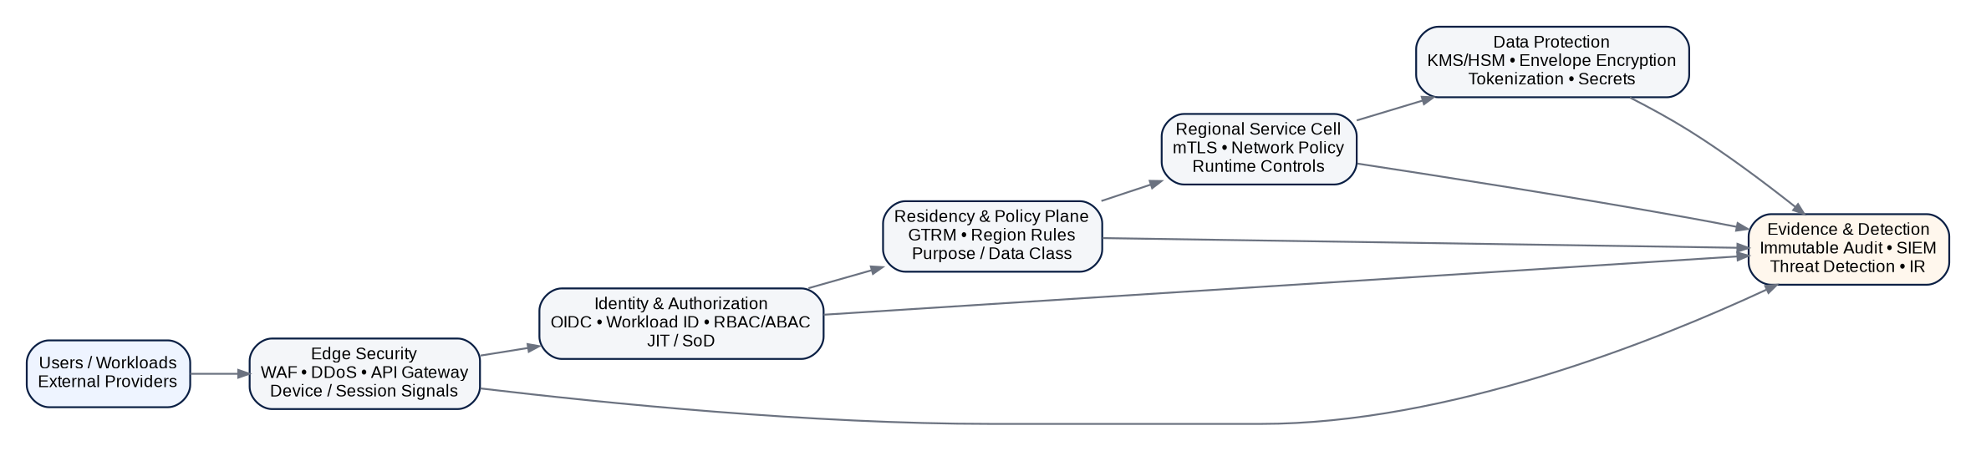
Figure 1 — Security reference architecture

4.1 Security Control Planes
Control plane | Authoritative responsibility
Identity & Authorization | Human/workload identity, session assurance, RBAC/ABAC, SoD, JIT and signing/approval authority.
Tenant & Residency | Tenant resolution, home/permitted regions, traffic classification, cross-region transfer policy.
Cryptography | Algorithms, key hierarchy, KMS/HSM, key custody, certificate/signature policies and crypto inventory.
Data Protection | Classification, field/object encryption, tokenization, masking, minimization and retention handling.
Network & Runtime | Edge defense, service mesh/mTLS, egress, network policy, runtime hardening and container/workload controls.
Evidence & Detection | Audit/evidence ledger, security telemetry, SIEM, threat detection and incident forensics.
Supply Chain | Source, dependency, build, SBOM, provenance, signing, deployment verification and runtime drift.
Recovery | Backup isolation, disaster recovery, restore authorization, key recovery and recovery evidence.

5. Data Classification & Handling Standard
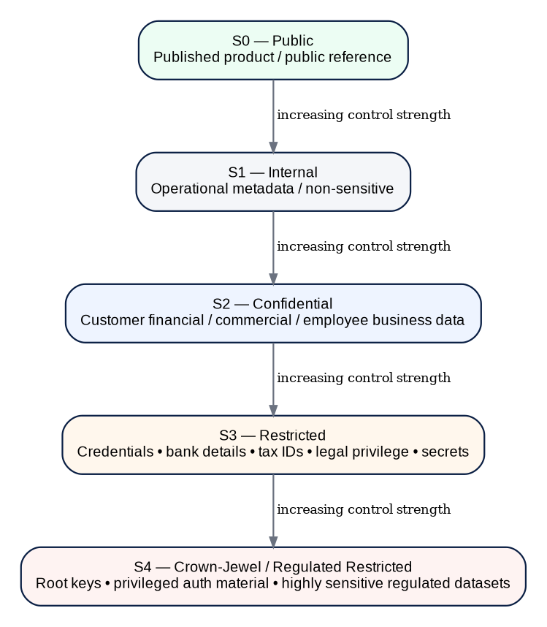
Figure 2 — Data classification model
Class | Examples | Minimum handling
S0 Public | Published pricing, public reference data, approved marketing content. | Integrity control; standard availability controls.
S1 Internal | Non-sensitive operational metadata, internal service status. | Authenticated access; controlled sharing; normal logging allowed subject to minimization.
S2 Confidential | Customer accounting data, invoices, contracts, commercial information, business employee records. | Encryption; tenant isolation; least privilege; controlled exports; retention/residency policy.
S3 Restricted | Bank details, tax identifiers, government identifiers, credentials, legal privilege, sensitive HR/payroll attributes. | Enhanced field/object protection; tokenization where practical; detokenization/decrypt evidence; no raw telemetry.
S4 Crown-Jewel / Regulated Restricted | Root/HSM keys, privileged authentication material, cryptographic seeds, highly sensitive regulated data sets. | Strongest isolation, HSM/external key control where applicable, dual control, exceptional access only, continuous monitoring.

CLASSIFICATION PROPAGATION
Derived data inherits the highest material sensitivity of its inputs unless an approved transformation demonstrably removes that sensitivity. Search indexes, caches, analytics extracts, AI embeddings, reports and exports do not become less sensitive because they are “derived.”

6. Tenant Isolation Architecture
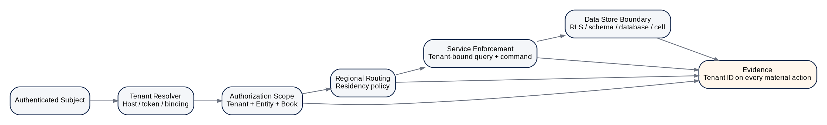
Figure 3 — Tenant-isolation enforcement stack

6.1 Required Isolation Surfaces
Surface | Required control
API / commands | Tenant resolved from trusted binding; caller-supplied tenant IDs are validated, never trusted.
Database | Tenant predicate enforced in service data access plus database-level isolation where supported; high-risk cells may use stronger physical boundaries.
Object storage | Tenant/region-specific namespace and access policy; signed URLs short-lived and scope-bound.
Cache | Tenant included in key derivation; no unscoped shared cache entries for tenant data.
Search | Tenant and authorization filters are enforced server-side; index is non-authoritative.
Events / queues | Tenant ID and residency region in envelope; consumer authorization and regional topic policy.
Analytics | Tenant-scoped datasets/read models; cross-tenant aggregate access requires explicit analytics policy and de-identification.
Logs / traces | No raw S3/S4 data; tenant metadata protected and regionally routed.
Backups | Tenant/region provenance retained; restore cannot silently relocate data across regions.
Support | Tenant support session explicitly names tenant, reason, scope and duration; evidence required.

6.2 Isolation Failure Policy
- Any detected cross-tenant read/write possibility is Severity 0/P0 until proven otherwise.
- A failed tenant-context assertion blocks the request; fallback to “default tenant” is prohibited.
- Background jobs and scheduled tasks carry explicit tenant scope; unbounded scans require privileged system purpose and audit evidence.
- Cross-tenant administrative reports must use purpose-built controlled datasets, not ad hoc database queries.

7. Data Residency & Cross-Border Processing
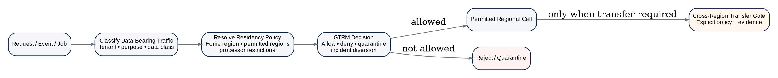
Figure 4 — Residency-aware routing and transfer gate

7.1 Residency Policy Object
ResidencyPolicy {
tenant_id, home_region, permitted_regions[], prohibited_regions[],
data_classes[], processing_purposes[], processor_restrictions[],
backup_regions[], telemetry_regions[], ai_processing_policy,
cross_region_transfer_rules[], failover_policy,
effective_from, effective_to, policy_version, approval_ref
}

7.2 Data-Bearing Traffic Classes
Class | Examples | Rule
R0 — Control-only | Health probes, routing metadata without tenant data. | May use global control plane if no tenant-sensitive payload is present.
R1 — Tenant metadata | Tenant ID, region, feature state, non-sensitive configuration. | Region/purpose policy still applies; logging minimized.
R2 — Business data | Accounting, invoices, tax, contracts, operational records. | Must remain within permitted processing/residency regions.
R3 — Restricted data | Credentials, bank/tax IDs, highly sensitive personal/business data. | Tightest processing-region rules; cross-region default deny.
R4 — Cryptographic material | Keys, secrets, HSM operations, credential seeds. | Region/key-custody boundary; export normally prohibited unless explicit design requires it.

7.3 Cross-Region Transfer Gate
- Identify tenant, source region, destination region, data class and processing purpose.
- Resolve active residency policy and applicable jurisdiction-pack constraints.
- Verify destination service/processor is approved for the purpose and class.
- Minimize/tokenize data before transfer where possible.
- Authorize transfer; otherwise reject or quarantine.
- Attach correlation/evidence ID and record policy version.
- Apply destination retention/deletion and onward-transfer restrictions.

8. Network, Edge & Runtime Security
Layer | Required controls
Internet edge | DDoS protection, WAF, rate limiting, bot/abuse controls, TLS, API gateway, request-size limits.
Ingress | Authenticated routes, hostname/tenant resolution, protocol normalization, header sanitation.
Service-to-service | mTLS, unique workload identity, service authorization, network policy, egress allowlists.
Data tier | Private endpoints, no public database exposure, least-privilege service accounts, encrypted connections.
Administration | Separate privileged plane; JIT access; hardened bastion/session broker where interactive access is unavoidable.
Runtime | Non-root containers where possible, read-only filesystem where practical, seccomp/AppArmor-like controls, resource limits, vulnerability and drift monitoring.
Egress | Destination allowlists or policy-aware proxy, DNS controls, explicit provider adapters; uncontrolled outbound internet prohibited for privileged workloads.

9. Workload Identity & Service-to-Service Trust
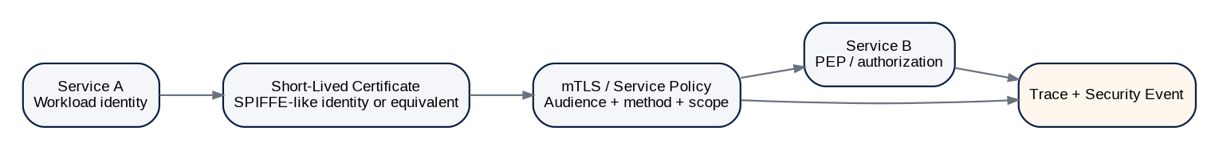
Figure 5 — Workload identity and mTLS
- Every service, worker, scheduler and connector has a unique workload identity; shared service credentials are prohibited.
- Credentials/certificates are short-lived and automatically rotated.
- Identity is bound to environment, region, service and permitted audience.
- mTLS authenticates transport; application authorization still determines whether a method/resource may be invoked.
- Forwarded user/tenant context is signed or carried in trusted internal claims and is revalidated by the receiving service.
- Workload credentials are non-exportable where platform capability permits.

10. Cryptographic Architecture

10.1 Cryptographic Policy
Domain | Baseline policy
Data at rest | Approved AEAD encryption using centrally governed algorithms; envelope encryption for material stores and objects.
Data in transit | TLS 1.3 preferred; minimum protocol/cipher policy centrally managed; mTLS for sensitive internal service traffic.
Hashing / integrity | Approved cryptographic hashes; no MD5/SHA-1 for security integrity except narrowly defined legacy interoperability that is explicitly risk-controlled.
Passwords | Modern memory-hard or approved password hashing; passwords never reversibly encrypted.
Digital signatures | Approved signature algorithms with protected keys and evidence; algorithm identified in signed format.
Randomness | OS/HSM approved CSPRNG; no application-generated predictable seeds.
Key derivation | Approved KDFs and explicit context separation.
Cryptographic modules | Use validated modules where customer/regulatory profile requires; FIPS 140-3 capable pathways for regulated deployments.
Algorithm lifecycle | Registry states: Approved, Preferred, Transitional, Deprecated, Prohibited, Migration Target.

10.2 Key Hierarchy
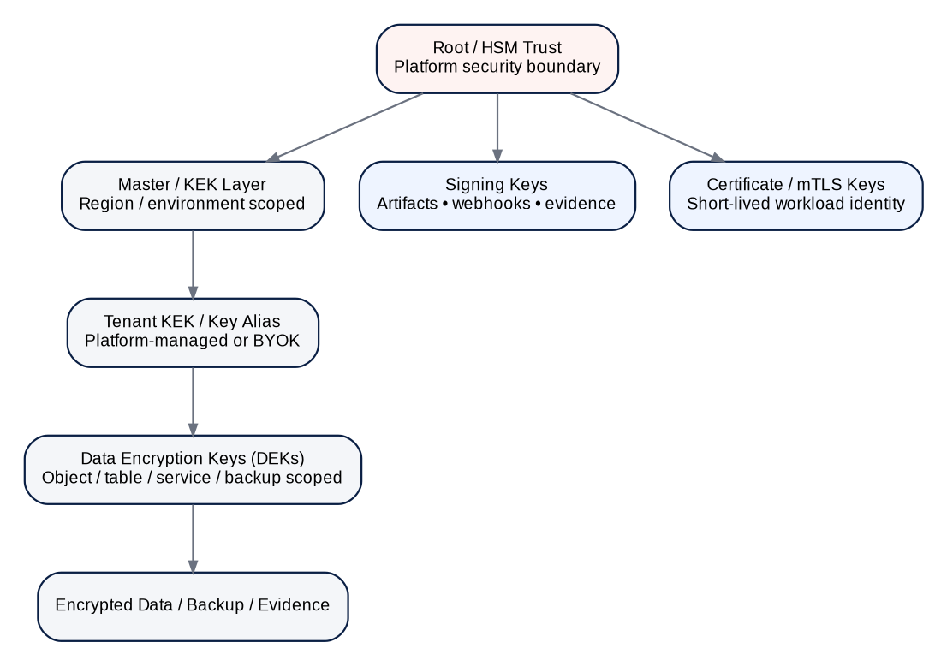
Figure 6 — Cryptographic key hierarchy

10.3 Envelope Encryption
Figure 7 — Envelope-encryption flow
CryptoEnvelope {
algorithm_id, envelope_version, key_reference, key_version,
ciphertext, nonce_iv, authentication_tag,
authenticated_context_hash, created_at, region,
tenant_id, data_class, crypto_policy_version
}

AUTHENTICATED CONTEXT
Tenant ID, object ID, object type, region and other invariant security context should be cryptographically bound as associated data where appropriate. This prevents valid ciphertext from being transplanted into an unauthorized object or tenant context.

11. Key Management Lifecycle
Lifecycle stage | Engineering requirement
Generate / import | Approved KMS/HSM or approved external key manager; record origin and custody mode.
Activate | Explicit purpose, region, tenant scope, algorithm and effective date.
Use | KMS policy enforces permitted services/actions; material decrypt/sign operations logged.
Rotate | Scheduled and event-driven rotation; new writes use active version; old versions retained only as required for decrypt/verification.
Re-encrypt | Controlled batch process with idempotency, progress evidence and rollback/retry semantics.
Suspend | Temporarily prevent new operations while preserving controlled recovery path.
Revoke / destroy | Dual control for high-impact keys; dependent data assessed before irreversible destruction.
Archive | Verification/decryption-only keys may be archived for legally required periods under reduced privilege.
Compromise | Immediate disable/rotation, blast-radius assessment, re-encryption/signature response and incident evidence.

11.1 Key Metadata
KeyRecord {
key_id, provider, external_key_id, custody_mode,
tenant_scope, region, environment, purpose,
algorithm, strength, status, version,
created_at, activated_at, rotate_by, retired_at,
exportability, hsm_backed, policy_version, owner,
compromise_state, evidence_refs[]
}

12. Platform-Managed Keys, BYOK & HYOK
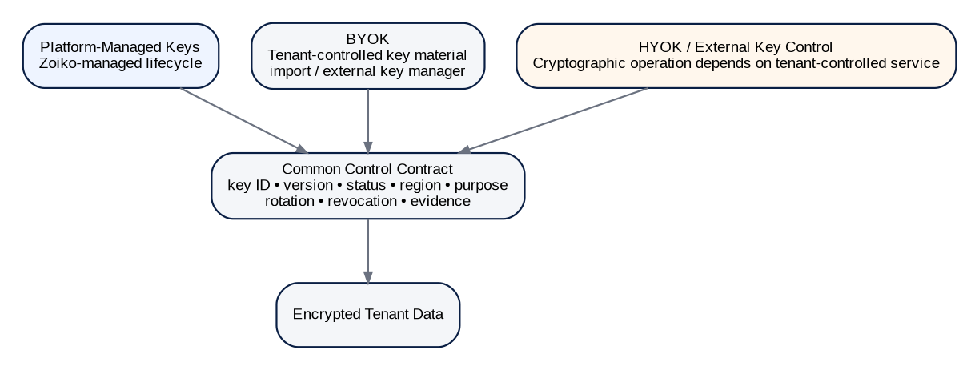
Figure 8 — Key custody modes
Mode | Tenant control | ZoikoSuite responsibility | Failure semantics
Platform-managed | Policy/configuration; no direct key custody. | Full lifecycle, KMS/HSM security, rotation, evidence and availability. | Platform must preserve redundancy and recovery.
BYOK | Tenant supplies/imports or controls external key material depending provider capability. | Validate key compatibility, bind use to tenant/purpose, honor disable/revocation, expose evidence. | Tenant key disable may intentionally make protected data unavailable; UI/API must make this explicit.
HYOK / external key control | Tenant retains control of cryptographic operation or root custody outside ZoikoSuite. | Integrate secure external key service, minimize cached key material, define outage and revocation behavior. | External key service outage may block decrypt/write; no silent fallback to platform keys.

13. Secrets & Credential Management
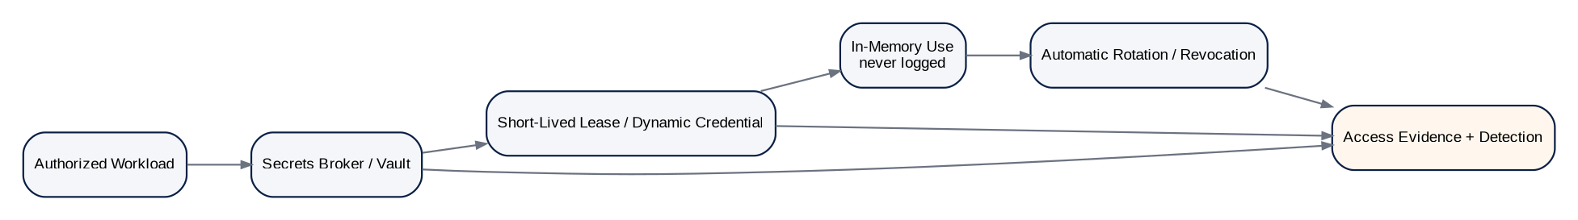
Figure 9 — Secrets lifecycle
- Prefer identity federation and dynamic credentials over stored static secrets.
- Secrets are obtained just in time from an approved broker/vault and kept in memory only for the minimum period.
- No secrets in source control, application configuration repositories, container image layers, logs, crash dumps, screenshots, tickets or analytics.
- Secret scanning is mandatory in pre-commit/CI and artifact scanning.
- Rotation must be automated where provider capability permits; shared production secrets require documented exception.
- Emergency secret retrieval requires privileged workflow and evidence.

14. Tokenization, Masking & Pseudonymization
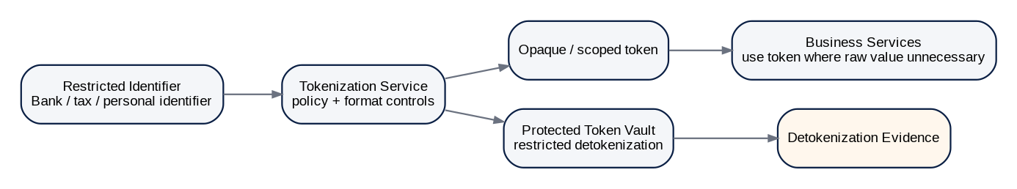
Figure 10 — Restricted-identifier tokenization
Technique | Use | Non-negotiable rule
Tokenization | Bank details, tax identifiers, external account references, selected personal identifiers. | Business services use token whenever raw value is unnecessary.
Masking | UI and support display. | Masking is display protection, not encryption; authorization remains required.
Pseudonymization | Analytics/test or privacy-reduced processing. | Re-identification mapping is separately protected and purpose restricted.
Irreversible anonymization | Aggregated/statistical datasets where individual linkage is unnecessary. | Must pass an approved re-identification-risk assessment; “hashed ID” alone is not automatically anonymous.

15. Privacy Engineering Architecture

15.1 Core Privacy Controls
Control | Requirement
Purpose limitation | Every sensitive processing path declares a business/security purpose; secondary use requires explicit authorization.
Data minimization | Collect, transmit, persist and expose only fields required for the operation.
Field-level classification | Schema registry and data dictionary carry classification and handling metadata for sensitive fields.
Retention | Retention/disposition determined by record type, jurisdiction, tenant policy and legal hold.
Data subject / privacy operations | Where applicable, privacy requests operate through governed workflows that preserve financial/legal retention constraints.
AI processing | Sensitive tenant data is not sent to unapproved models/providers; AI processing inherits residency, purpose and retention rules.
Non-production | Production-sensitive data is not copied to dev/test by default; use synthetic, masked or tokenized datasets.
Telemetry | No raw S3/S4 values in logs/traces/metrics; high-cardinality tenant identifiers minimized where not operationally required.
Support | Support access is purpose-bound, least privilege and visible/evidenced.
Deletion | Deletion is controlled disposition, not ad hoc row deletion; evidence and legal-hold constraints apply.

PRIVACY FRAMEWORK STATUS
As of August 2026, NIST Privacy Framework 1.1 is still published as an Initial Public Draft rather than a final release. ZoikoSuite may use it as forward-looking guidance but should not represent it as a final normative standard.

16. Secure Logging, Telemetry & Evidence
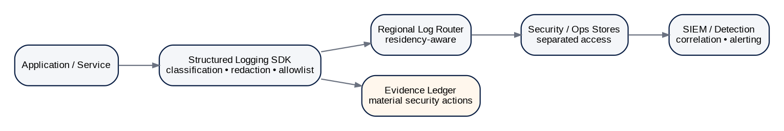
Figure 11 — Secure logging and evidence pipeline
Telemetry type | May contain | Must not contain
Application logs | Request/correlation ID, service, operation, status, bounded error code, tenant metadata where required. | Passwords, tokens, private keys, raw bank/tax IDs, full confidential documents.
Distributed traces | Service spans, timings, route templates, correlation IDs. | Full query/body payloads by default; sensitive headers.
Metrics | Aggregated counts, latency, error rates, resource utilization. | Per-person sensitive values or raw financial content.
Security events | Auth failures, policy denies, privilege changes, key actions, suspicious behavior. | Reusable credentials or plaintext secrets.
Evidence ledger | Material action metadata, hashes, policy/rule/version refs, actor and approval refs. | Unnecessary full document duplication when a content-addressed reference suffices.

17. Privileged Access & Support Security
Figure 12 — JIT privileged-access lifecycle

17.1 Break-Glass
- Break-glass is a distinct emergency mechanism, not a shortcut around normal IAM.
- Requires named human identity, strong MFA, emergency reason, narrowly scoped privilege, finite duration and immediate security notification.
- Material actions are recorded and reviewed after the incident; emergency access cannot erase or disable evidence.
- Where safety permits, dual control is required for destructive cryptographic or financial-administration actions.

17.2 Tenant Support Sessions
- Support personnel never authenticate as the customer user.
- Session records support agent, tenant, authorized purpose, approved scopes, start/end time and evidence reference.
- Sensitive values are masked by default; detokenization/decryption requires separate elevated authorization.
- Support sessions expire automatically and cannot be converted into standing tenant access.

18. Backup, Disaster Recovery & Ransomware Resilience
Figure 13 — Secure backup and recovery
Control | Requirement
Backup isolation | Separate account/project/security boundary; production workloads cannot freely delete backup history.
Encryption | Backup encrypted with approved keys; key access separated from routine application credentials.
Immutability | Use object lock/WORM or equivalent for defined recovery tiers where practical.
Residency | Backup region must be permitted by tenant residency policy.
Restore testing | Automated and human-validated restore exercises; not merely backup-job success.
Integrity | Snapshot metadata, checksums/hashes, source watermark and restore verification.
RPO/RTO | Defined per service/data class and demonstrated through tests.
Recovery authorization | Production restore is a governed operation with scope, reason and evidence.
Key recovery | Cryptographic recovery procedures tested; no undocumented single-person dependency.
Ransomware response | Ability to isolate compromised credentials, preserve clean restore points and rebuild infrastructure from trusted artifacts.

19. Secure Software Supply Chain & SDLC
Figure 14 — Secure software supply chain

19.1 Mandatory Engineering Gates
Gate | Required evidence
Threat model / abuse case | Data flow, trust boundaries, attacker goals, misuse cases and mitigations for material features.
Code review | Protected branches, required reviewers and ownership rules for security-critical components.
SAST / secret scan | Blocking severity policy; no committed secrets.
Dependency / SCA | Known-vulnerability policy, package provenance and dependency freshness.
IaC / cloud config | Policy-as-code checks for public exposure, encryption, IAM and logging.
Container / artifact scan | OS/package vulnerabilities and malware checks.
SBOM | Machine-readable component inventory linked to artifact digest.
Build provenance | Traceable source→build→artifact identity; controlled build environment.
Artifact signing | Protected signing key; signature and digest recorded.
Deployment admission | Verify signature/provenance; approved environment/region; policy gates pass.
DAST / API security | Risk-based dynamic testing including authz, input validation and exceptional conditions.
Penetration testing | Independent testing for high-risk release classes and major architecture changes.
Post-deploy monitoring | Runtime drift, unexpected packages/images, exploit signals and rollback readiness.

CURRENT APPLICATION SECURITY BASELINE
OWASP ASVS 5.0.0 was released May 30, 2025 and should be the primary application-security verification baseline. OWASP Top 10:2025 should be used as a risk-awareness and engineering education baseline, not as a substitute for ASVS verification.

20. Vulnerability & Exposure Management
Stage | Required behavior
Discover | Continuous asset inventory, package/image inventory, dependency intelligence and external attack-surface monitoring.
Triage | Severity + exploitability + exposure + tenant/data impact + compensating controls; CVSS alone is insufficient.
Contain | Disable vulnerable feature/route, WAF/network mitigation, isolate service or revoke credential as appropriate.
Remediate | Patch/upgrade/configure; produce tested artifact through normal supply-chain controls unless emergency procedure applies.
Verify | Retest vulnerability and regression controls; confirm no unauthorized drift.
Close | Evidence fix, affected versions, deployment scope and residual risk.
Exception | Time-bound owner, compensating controls, expiration and risk approval; exceptions auto-expire.

21. Threat Modeling & Abuse-Case Standard
- Model trust boundaries, tenant boundaries, regional boundaries, external providers and privileged planes.
- Include financial abuse cases: duplicate payment, unauthorized journal, invoice tampering, tax filing manipulation, supplier bank substitution and fraudulent entitlement elevation.
- Include data-abuse cases: cross-tenant search leak, cache confusion, log leakage, token replay, export overreach, AI prompt/data exfiltration and support misuse.
- Include infrastructure abuse: SSRF/metadata access, secrets theft, build compromise, poisoned dependency, container escape, backup deletion and key compromise.
- Threat mitigations must map to testable controls and owners; “use encryption” or “use IAM” is not a sufficient mitigation statement.

22. Incident Detection, Containment & Recovery
Figure 15 — Security incident containment and recovery

22.1 Required Incident Scope Dimensions
Dimension | Examples
Tenant | Single tenant / cohort / cross-tenant risk.
Region | Single cell, residency region, global control plane.
Identity | Human session, workload identity, external provider credential.
Data | Classification, record categories, time range, exports/decrypts.
Cryptography | Key IDs/versions, certificates, secrets and potential plaintext exposure.
Financial impact | Payments, journals, invoices, tax filings, entitlement or balance changes.
Evidence | Logs, traces, snapshots, audit ledger, provider records, build/deployment provenance.

CONTAINMENT PRINCIPLE
Containment may intentionally reduce availability, but it must not silently mutate or delete authoritative financial records, evidence, audit history or legal-hold data. Where a service is unsafe to operate, the preferred state is controlled rejection/read-only/quarantine—not uncontrolled continued processing.

23. Cryptographic Agility & Post-Quantum Readiness
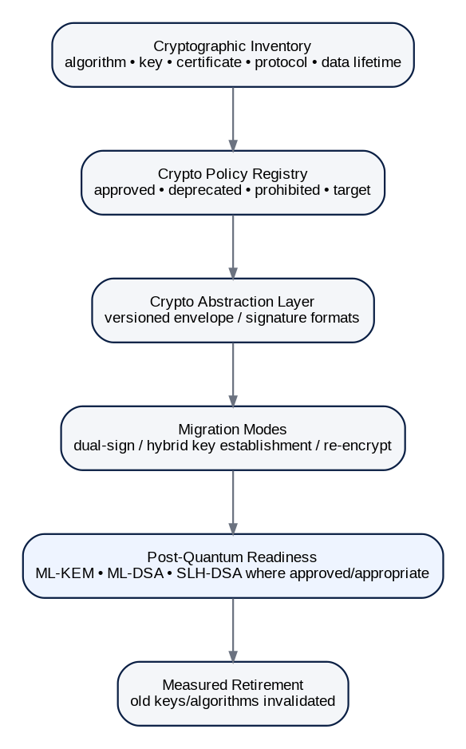
Figure 16 — Crypto-agility and post-quantum migration model

23.1 PQC Architecture Position
NIST finalized FIPS 203 (ML-KEM), FIPS 204 (ML-DSA) and FIPS 205 (SLH-DSA) on August 13, 2024. ZoikoSuite should therefore maintain a cryptographic inventory and migration-ready abstraction now, while deploying post-quantum algorithms only through approved, interoperability-tested profiles appropriate to the relevant protocol and customer/regulatory environment. The architecture must not hard-code algorithm identifiers or key sizes into business-domain schemas.
Capability | Required design
Inventory | Enumerate algorithms, keys, certificates, signatures, protocols, libraries, providers and data-protection lifetimes.
Abstraction | Versioned encryption/signature envelope independent of provider and algorithm.
Policy | Central registry marks algorithms Preferred/Approved/Transitional/Deprecated/Prohibited/Migration Target.
Hybrid migration | Support dual-signature or hybrid key-establishment patterns where standards/protocols support them.
Re-encryption | Batch migration for long-lived encrypted data; resumable, idempotent and evidenced.
Signature longevity | Preserve algorithm, certificate/key version, timestamp/evidence and verification path for long-lived legal/audit artifacts.
Testing | Interoperability, performance, key sizes, HSM/KMS support and disaster recovery tested before production activation.
Errata monitoring | Track NIST and provider implementation guidance/errata before promoting new PQC profiles.

24. Security Data Model
Canonical entity | Minimum purpose / fields
SecurityPolicy | Policy version, scope, effective dates, owner, status.
DataClassification | Classification, handling controls, field/object binding.
ResidencyPolicy | Tenant region rules, purposes, backup/telemetry/AI constraints.
CryptoPolicy | Algorithms, protocol floors, key rules, lifecycle states.
KeyRecord | Key custody, provider, version, region, purpose, status.
CryptoOperationEvidence | Decrypt/sign/wrap/rotate action evidence.
SecretLease | Workload, secret reference, lease start/end, rotation state.
WorkloadIdentity | Service/job identity, environment, region, audience.
CertificateRecord | Issuer, subject/workload, serial, validity, revocation.
PrivilegedSession | Actor, reason, ticket, scope, start/end, approval, evidence.
SupportSession | Agent, tenant, purpose, scopes, consent/authority, evidence.
SecurityException | Control, risk, owner, compensating controls, expiry.
VulnerabilityFinding | Asset, component, severity, exploitability, SLA, status.
SecurityIncident | Scope, severity, timeline, affected assets/tenants/data.
CrossRegionTransfer | Source/destination, tenant, class, purpose, policy version.
BackupSnapshot | Region, source watermark, encryption key, immutability, hash.
SBOMRecord | Artifact digest, components, build/provenance reference.
ArtifactSignature | Artifact digest, signing key, algorithm, timestamp/status.
SecurityEvent | Actor/workload, action, resource, severity, evidence.
CryptoInventoryItem | Algorithm/protocol/key/certificate usage and migration state.

25. Security APIs & Administrative Commands
API / command | Contract intent
GET /security/policies/effective | Resolve effective security/crypto/residency policy for authorized diagnostic use.
POST /security/keys/{id}:rotate | Governed key rotation command.
POST /security/keys/{id}:suspend | Suspend new key use.
POST /security/keys/{id}:revoke | High-risk revocation/destruction workflow.
POST /security/support-sessions | Create purpose-bound tenant support session.
POST /security/privileged-sessions | Request JIT privileged access.
POST /security/transfers:evaluate | Evaluate cross-region transfer policy.
POST /security/exceptions | Request time-bound security control exception.
POST /security/incidents/{id}:contain | Execute approved containment action set.
GET /security/evidence/{correlation_id} | Retrieve authorized security evidence package.
GET /security/crypto-inventory | Inventory cryptographic dependencies and migration state.
POST /security/backups/{id}:restore-request | Initiate governed restore workflow.

ADMIN API BOUNDARY
Security administration APIs must be separate from ordinary tenant business APIs, require stronger session assurance, enforce IAM/SoD and produce evidence. They must never provide generic “run SQL,” “decrypt arbitrary object,” or unrestricted impersonation endpoints.

26. Security Domain Events
Event family | Canonical examples
Policy / residency | SecurityPolicyActivated, ResidencyPolicyActivated, DataClassificationChanged, SecurityExceptionGranted, SecurityExceptionExpired, CryptoPolicyActivated
Cryptography | KeyCreated, KeyRotated, KeySuspended, KeyRevoked, KeyCompromiseDeclared, CertificateIssued, CryptoMigrationStarted, CryptoMigrationCompleted
Secrets / certificates | CertificateIssued, CertificateRevoked, SecretLeaseIssued, SecretLeaseRevoked
Privilege / support | PrivilegedSessionRequested, PrivilegedSessionApproved, PrivilegedSessionStarted, PrivilegedSessionExpired, SupportSessionStarted, SupportSessionEnded
Transfers | CrossRegionTransferAllowed, CrossRegionTransferDenied
Vulnerability / incident | VulnerabilityDetected, VulnerabilityRemediated, SecurityIncidentDeclared, ContainmentActionExecuted
Backup / supply chain | BackupSnapshotCreated, BackupRestoreTestPassed, BackupRestoreCompleted, ArtifactSigned, ArtifactVerificationFailed, SupplyChainPolicyFailed

27. Security Control Catalogue — Initial Baseline
Control ID | Control | Family
SEC-GOV-001 | Security policy registry | GOV
SEC-GOV-002 | Security exception workflow | GOV
SEC-GOV-003 | Threat model gate | GOV
SEC-GOV-004 | Security architecture review | GOV
SEC-GOV-005 | Security risk acceptance expiry | GOV
SEC-TEN-001 | Tenant context enforcement | TEN
SEC-TEN-002 | Cross-tenant negative tests | TEN
SEC-TEN-003 | Tenant cache isolation | TEN
SEC-TEN-004 | Search tenant filtering | TEN
SEC-TEN-005 | Support-session tenant binding | TEN
SEC-RES-001 | Home/permitted region policy | RES
SEC-RES-002 | Data-bearing traffic classification | RES
SEC-RES-003 | Cross-region transfer gate | RES
SEC-RES-004 | Regional telemetry routing | RES
SEC-RES-005 | Backup region enforcement | RES
SEC-NET-001 | TLS policy | NET
SEC-NET-002 | mTLS workload traffic | NET
SEC-NET-003 | Egress allowlist | NET
SEC-NET-004 | Database private access | NET
SEC-NET-005 | Edge WAF/DDoS | NET
SEC-NET-006 | Network policy default deny | NET
SEC-CRY-001 | Crypto policy registry | CRY
SEC-CRY-002 | Envelope encryption | CRY
SEC-CRY-003 | HSM/KMS root isolation | CRY
SEC-CRY-004 | Tenant/purpose key scope | CRY
SEC-CRY-005 | Key rotation | CRY
SEC-CRY-006 | Key compromise workflow | CRY
SEC-CRY-007 | BYOK lifecycle | CRY
SEC-CRY-008 | HYOK outage/revocation | CRY
SEC-CRY-009 | Crypto inventory | CRY
SEC-CRY-010 | PQC migration readiness | CRY
SEC-SEC-001 | Secrets broker | SEC
SEC-SEC-002 | Dynamic credentials | SEC
SEC-SEC-003 | Secret scanning | SEC
SEC-SEC-004 | Secret rotation | SEC
SEC-SEC-005 | Credential revocation | SEC
SEC-DAT-001 | Classification propagation | DAT
SEC-DAT-002 | Tokenization | DAT
SEC-DAT-003 | Non-prod masking | DAT
SEC-DAT-004 | Sensitive export control | DAT
SEC-DAT-005 | Secure deletion/disposition | DAT
SEC-DAT-006 | Legal-hold protection | DAT
SEC-LOG-001 | Structured logging allowlist | LOG
SEC-LOG-002 | Sensitive-data redaction | LOG
SEC-LOG-003 | SIEM forwarding | LOG
SEC-LOG-004 | Material security evidence | LOG
SEC-LOG-005 | Log access separation | LOG
SEC-PRV-001 | Purpose limitation | PRV
SEC-PRV-002 | Data minimization | PRV
SEC-PRV-003 | AI processing approval | PRV
SEC-PRV-004 | Privacy request workflow | PRV
SEC-PRV-005 | Retention enforcement | PRV
SEC-PAM-001 | JIT privilege | PAM
SEC-PAM-002 | Step-up MFA | PAM
SEC-PAM-003 | Break-glass | PAM
SEC-PAM-004 | Privileged session review | PAM
SEC-PAM-005 | No silent impersonation | PAM
SEC-BKP-001 | Isolated backup vault | BKP
SEC-BKP-002 | Backup encryption | BKP
SEC-BKP-003 | Immutability | BKP
SEC-BKP-004 | Restore test | BKP
SEC-BKP-005 | Recovery authorization | BKP
SEC-SDL-001 | Branch protection/review | SDL
SEC-SDL-002 | SAST/SCA/IaC scans | SDL
SEC-SDL-003 | SBOM | SDL
SEC-SDL-004 | Build provenance | SDL
SEC-SDL-005 | Artifact signing | SDL
SEC-SDL-006 | Admission verification | SDL
SEC-SDL-007 | DAST/API security | SDL
SEC-SDL-008 | Penetration test gate | SDL
SEC-VUL-001 | Asset/component inventory | VUL
SEC-VUL-002 | Continuous vulnerability detection | VUL
SEC-VUL-003 | Risk-based triage | VUL
SEC-VUL-004 | Remediation SLA | VUL
SEC-VUL-005 | Exception expiry | VUL
SEC-IR-001 | Incident declaration | IR
SEC-IR-002 | Containment playbooks | IR
SEC-IR-003 | Evidence preservation | IR
SEC-IR-004 | Credential/key rotation | IR
SEC-IR-005 | Recovery validation | IR
SEC-IR-006 | Post-incident control review | IR

28. Observability & Security SLOs
Metric / indicator | Intent
Cross-tenant authorization denies | Detect attempted or defective tenant-boundary violations.
Policy-evaluation latency / errors | Authorization and residency control plane reliability.
Key-service availability / decrypt failures | Cryptographic dependency health and tenant impact.
Secret lease age / static-secret count | Measure drift from short-lived credential model.
mTLS identity failures | Detect expired, misissued or unauthorized workloads.
Privileged session count / duration | Standing privilege and administrative-risk trend.
Unreviewed privileged sessions | Control-governance backlog.
Cross-region transfer attempts/denials | Residency enforcement and misconfiguration signals.
S3/S4 logging violations | Data-loss prevention for observability.
Unpatched exploitable vulnerabilities | Actual exposure, not raw scanner volume.
Unsigned/unverified deployment attempts | Supply-chain admission enforcement.
Backup restore success / age | Recovery readiness.
Crypto inventory deprecated exposure | Migration debt and algorithm retirement readiness.
Security exception count / expiry | Risk-debt backlog.
Incident containment time | Operational responsiveness by severity.

29. Negative-Path Engineering Acceptance Scenarios
ID | Adversarial / failure scenario | Expected result
SEC-T01 | Caller supplies another tenant_id in request body. | Server ignores/rejects untrusted tenant override; no cross-tenant access.
SEC-T02 | Cache entry generated without tenant key. | CI/control test blocks release; runtime must never return unscoped tenant object.
SEC-T03 | Search query omits tenant filter. | Search gateway injects authoritative filter or rejects query.
SEC-T04 | Background job starts with no tenant scope. | Job rejected unless explicitly privileged system-purpose workflow.
SEC-T05 | Cross-region event replication attempts prohibited destination. | GTRM/event policy blocks and records denial.
SEC-T06 | Telemetry exporter configured for disallowed region. | Deployment/admission gate fails.
SEC-T07 | Service presents valid mTLS certificate but lacks method permission. | Request denied; transport authentication does not imply authorization.
SEC-T08 | Expired workload certificate is replayed. | TLS/identity validation rejects; security event generated.
SEC-T09 | Ciphertext copied to another tenant/object context. | AEAD authenticated-context check fails.
SEC-T10 | Key marked suspended during write. | New cryptographic operation fails closed.
SEC-T11 | BYOK tenant disables key. | Protected operation reports explicit key-unavailable state; no fallback key.
SEC-T12 | HYOK provider times out. | Operation fails according to defined policy; no plaintext caching/fallback.
SEC-T13 | Developer commits secret. | Pre-commit/CI secret scan blocks merge and triggers rotation if exposure occurred.
SEC-T14 | Secret appears in runtime log. | Redaction/DLP alert fires; incident workflow evaluates exposure.
SEC-T15 | Support agent requests raw bank details. | Masked by default; detokenization requires additional scoped approval and evidence.
SEC-T16 | Privileged session exceeds approved duration. | Privilege auto-expires; subsequent command denied.
SEC-T17 | Break-glass used without incident reason. | Request denied.
SEC-T18 | Backup deletion attempted with normal production role. | Denied by separate backup security boundary.
SEC-T19 | Restore targets region prohibited by tenant policy. | Restore workflow blocks before data movement.
SEC-T20 | Artifact digest differs from signed provenance. | Deployment admission rejects artifact.
SEC-T21 | Dependency becomes actively exploited after build. | Exposure detection opens incident/remediation path even if artifact was previously approved.
SEC-T22 | S3 data copied to test environment. | Data policy blocks unless approved masked/tokenized transformation exists.
SEC-T23 | AI connector configured to send restricted tenant data to unapproved provider. | Policy denies outbound processing.
SEC-T24 | Security exception reaches expiry. | Control automatically reverts to enforced state; new exception requires fresh approval.
SEC-T25 | Key compromise declared. | New key use blocked/rotated; blast-radius inventory identifies affected ciphertext/signatures.
SEC-T26 | Old algorithm changes from Approved to Prohibited. | New operations blocked; migration queue identifies remaining dependent objects.
SEC-T27 | Incident containment isolates accounting service mid-transaction. | Transaction remains atomic; no partial authoritative journal state.
SEC-T28 | Log search user attempts access across tenants. | SIEM/log access policy enforces authorized purpose/scope.
SEC-T29 | Detokenization API receives arbitrary token from another tenant. | Tenant/context binding denies and records attempt.
SEC-T30 | Encrypted backup restored with missing key version. | Recovery fails safely; key-recovery procedure invoked; no corruption accepted.
SEC-T31 | Certificate CA compromise suspected. | Revocation/rotation playbook can invalidate trust and reissue workload identities.
SEC-T32 | External provider callback includes unexpected sensitive payload. | Adapter validates schema, discards/quarantines excess fields, prevents logging.
SEC-T33 | Database snapshot taken outside approved backup pipeline. | Cloud/config detection flags unauthorized snapshot and access is restricted.
SEC-T34 | Operator tries to disable audit logging during incident. | Denied or treated as break-glass destructive control action with immutable meta-evidence.
SEC-T35 | Crypto migration interrupted halfway. | Idempotent migration resumes; each object records old/new envelope state without ambiguity.
SEC-T36 | PQC profile activated without provider/HSM interoperability proof. | Release gate fails; profile remains inactive.

30. Definition of Ready — Security-Sensitive Feature
# | Ready gate
1 | Data flow and trust boundaries documented.
2 | Tenant/entity/book scope identified.
3 | Data classification and retention/residency requirements assigned.
4 | Threat model and abuse cases reviewed.
5 | Authorization and privileged-operation model defined.
6 | Cryptographic needs mapped to approved policy; no custom cryptography.
7 | Secrets and external-provider credentials lifecycle defined.
8 | Logging/telemetry schema reviewed for sensitive-data leakage.
9 | Backup/recovery implications documented.
10 | Security APIs/events/schemas versioned.
11 | Negative tests defined, including cross-tenant and failure-mode cases.
12 | Supply-chain/dependency implications reviewed.
13 | Security/privacy owner assigned.
14 | Jurisdiction/legal questions identified for specialist approval where required.

31. Definition of Done — Security-Sensitive Feature
# | Done gate
1 | All required security unit/integration/contract tests pass.
2 | Cross-tenant negative tests pass.
3 | Authorization and SoD tests pass.
4 | Sensitive-data logging test passes.
5 | Encryption/key/secrets integration tested.
6 | Residency routing/transfer tests pass.
7 | Threat-model mitigations verified and evidence attached.
8 | SAST/SCA/IaC/container/secret scans meet release policy.
9 | SBOM and build provenance generated.
10 | Artifact signed and deployment verification active.
11 | Vulnerability exceptions, if any, are explicit, time-bound and approved.
12 | Observability/security alerts exist for material failure modes.
13 | Backup/restore impact verified where stateful data changed.
14 | Runbooks and incident response steps updated.
15 | Security evidence references linked to release.
16 | No unresolved P0/P1 security defects; P2+ defects handled under approved risk policy.

32. Engineering Implementation Sequence
Wave | Scope
Wave 0 — Inventory & policy | Asset/data/crypto inventory; security policy registry; classification standard; security exception workflow.
Wave 1 — Identity & tenant trust | Workload identity, mTLS, tenant enforcement, admin plane, JIT privilege integration.
Wave 2 — Cryptographic foundation | KMS/HSM abstraction, key hierarchy, envelope encryption, secrets broker, crypto evidence.
Wave 3 — Residency & privacy controls | GTRM integration, data-bearing traffic classification, transfer gate, telemetry/backup regionalization.
Wave 4 — Runtime & observability | Network/egress policy, secure logging, SIEM, runtime hardening, support-session controls.
Wave 5 — Supply chain | SBOM, provenance, signing, deployment admission, vulnerability and secret gates.
Wave 6 — Backup & incident resilience | Isolated backups, restore testing, containment playbooks, key/credential compromise playbooks.
Wave 7 — Advanced tenant key custody | BYOK, then HYOK only after failure semantics and operational support are proven.
Wave 8 — Crypto agility / PQC | Crypto inventory automation, migration tooling, approved hybrid/PQC profiles and long-lived signature strategy.

33. Controlled Pre-Production Decisions
Decision | Required closure
Key provider / HSM topology | Select providers and regional HSM/KMS design; document service limits and DR.
FIPS profile | Identify which editions/customers require FIPS-validated modules and map exact service dependencies.
Tenant key granularity | Choose default KEK/DEK granularity by service/data class based on blast radius and operational cost.
BYOK availability | Define supported providers, import/external-key modes and tenant operational responsibilities.
HYOK availability | Treat as enterprise feature only after availability, latency, recovery and support implications are proven.
TLS policy | Lock protocol/cipher policy and exception process for legacy external integrations.
Telemetry architecture | Lock regional log/SIEM storage and data minimization rules.
Backup topology | Lock immutable retention tiers, isolation accounts/projects and restore regions.
PQC roadmap | Choose target protocols/use cases and migration checkpoints; track NIST/provider errata.
Security SLOs | Set numeric P0/P1 containment, patch, key-rotation, backup/restore and access-review targets.
Pen-test cadence | Define independent testing cadence and high-risk release triggers.
Privacy legal mapping | Map country/regime-specific controller/processor, transfer and retention requirements through Jurisdiction Packs and legal review.

34. Prohibited Security Anti-Patterns
- Global “super admin” credentials usable without JIT approval and evidence.
- Shared production passwords or API keys between unrelated services.
- Direct production database access as a normal operational workflow.
- Publicly reachable databases, caches or internal message brokers.
- Client-supplied tenant IDs accepted without authoritative scope validation.
- Cross-region replication enabled solely because infrastructure supports it.
- One environment-wide encryption key for all tenants and all purposes.
- Hard-coded algorithms/key sizes in business-domain schemas.
- Fallback from BYOK/HYOK to platform keys without explicit tenant authorization.
- Plaintext secrets in CI logs, environment dumps, tickets or screenshots.
- Logging complete request/response bodies for financial, tax, legal or identity APIs by default.
- Customer support by logging in as the customer.
- Disabling security telemetry during incident response without immutable meta-evidence.
- Production data copied to developer laptops or test environments without approved transformation.
- Unsigned or unverifiable artifacts deployed to production.
- Security exceptions with no expiry.
- Backup success accepted without restore testing.
- “Exactly once” assumptions used to justify unsafe security/financial side effects.
- AI systems receiving unrestricted tenant data because they are “internal.”
- Custom cryptographic algorithms or bespoke key-exchange protocols.

35. Current Standards & External Reference Baseline
Reference | Architecture relevance | Canonical source
NIST Cybersecurity Framework 2.0 | Published February 26, 2024; governance-inclusive cybersecurity risk framework. | https://doi.org/10.6028/NIST.CSWP.29
NIST SP 800-53 Rev. 5 | Security and privacy control catalogue; use as a control-reference source, tailored to ZoikoSuite risk. | https://doi.org/10.6028/NIST.SP.800-53r5
NIST SP 800-207 | Zero Trust Architecture; supports no implicit trust based on network location. | https://doi.org/10.6028/NIST.SP.800-207
NIST SP 800-57 Part 1 Rev. 5 | Key-management lifecycle and cryptoperiod guidance. | https://doi.org/10.6028/NIST.SP.800-57pt1r5
FIPS 140-3 | Security requirements for cryptographic modules; relevant for validated-module deployment profiles. | https://doi.org/10.6028/NIST.FIPS.140-3
FIPS 203 | ML-KEM post-quantum key-encapsulation standard; finalized August 13, 2024. | https://doi.org/10.6028/NIST.FIPS.203
FIPS 204 | ML-DSA post-quantum digital-signature standard; finalized August 13, 2024. NIST listed minor errata updates in 2026. | https://doi.org/10.6028/NIST.FIPS.204
FIPS 205 | SLH-DSA post-quantum digital-signature standard; finalized August 13, 2024. | https://doi.org/10.6028/NIST.FIPS.205
OWASP ASVS 5.0.0 | Latest stable ASVS; released May 30, 2025. | https://owasp.org/www-project-application-security-verification-standard/
OWASP Top 10:2025 | Current web-application risk awareness baseline. | https://owasp.org/Top10/2025/
NIST Privacy Framework 1.1 IPD | As of August 2026 remains an Initial Public Draft; use as forward-looking guidance, not final normative status. | https://www.nist.gov/privacy-framework/new-projects/privacy-framework-version-11
RFC 8446 — TLS 1.3 | Transport security protocol baseline. | https://www.rfc-editor.org/rfc/rfc8446

36. Final Architecture Decision
ADOPT AS CONTROLLING SECURITY STANDARD
ZS-SEC-001 should govern the implementation of tenant isolation, privacy engineering, data residency, cryptography, secrets, privileged access, secure telemetry, backup security, software supply chain, incident containment and crypto agility across every ZoikoSuite domain. Domain teams may add stricter controls, but they may not weaken or bypass these platform invariants.

The next architecture layer should convert this standard into environment-specific security profiles, control-as-code policies, KMS/HSM configurations, IAM policies, network policies, secure logging schemas, incident runbooks and automated certification tests. Security architecture is complete only when its controls are continuously testable and observable—not when a diagram has been approved.

