ZOIKOSUITE

Tax, E-Invoicing & Regulatory Compliance
Detailed Service Specifications
TAX-01 through TAX-15 • Build-Ready Global Tax & Regulatory Baseline

Field | Value
Document ID | ZS-SVC-F-001
Version | 1.0 — Tax, E-Invoicing & Regulatory Compliance Engineering Baseline
Date | 24 August 2026
Status | Build-ready domain specification. Jurisdiction-specific rates, thresholds, registrations, tax opinions, authority credentials, filing schemas, e-invoicing mandates, filing calendars and legal interpretations remain controlled through certified jurisdiction packs and launch configuration.
Owner | ZoikoSuite Product Architecture / Global Tax Platform Engineering
Applies to | Engineering, Product, Tax, Finance, Accounting, AR/AP, Payroll, Banking, Compliance, Security, QA, Audit, Legal and Integration teams
Language | American English

Executive doctrine: ZoikoSuite Tax is an authoritative, versioned and evidence-first tax calculation and regulatory-compliance layer. It determines tax from certified facts and rules, maintains a tax subledger, prepares and transmits regulatory outputs, and preserves historical evidence. It does not invent law, embed rates in application code, mutate business documents after issuance, treat transport success as legal acceptance, or write the General Ledger directly.

1. Architecture Decisions That Must Not Be Diluted
Decision | Engineering consequence
Tax rules are governed software artifacts | Rates, thresholds, exemptions, return schemas, e-invoice validation and calendars are effective-dated, source-proven, signed/certified and selected by runtime context.
Jurisdiction pack and tax engine are distinct | ZS-JUR-001 governs rule artifacts; TAX-02 binds certified packs; TAX-03/04/05/06 execute them. Production operators cannot edit tax tables to “fix” results.
Tax determination is immutable once consumed | A changed law, corrected input or override creates a superseding result/correction chain; historic issued documents remain explainable using the original rule version.
Tax Ledger is not the GL | TAX-07 owns tax subledger truth. Recognized accounting consequences are emitted as accounting events and posted only by ACC-04.
Return preparation and filing are separate | TAX-09 owns the frozen return and derivation; TAX-10 owns durable external submission attempts and authority acknowledgement state.
E-invoice regulatory state is not invoice economics | AR/AP owns the business document; TAX-11 owns transformation/clearance/reporting state and never rewrites price/tax economics from a network response.
UNKNOWN is explicit external state | Tax/e-invoice authority timeouts remain Pending/Unknown until the original attempt is resolved. Blind resubmission is prohibited.
Reconciliation is mandatory | Source↔Tax Ledger↔GL↔Return↔Authority/payment populations must reconcile; matching headline totals do not prove completeness.
AI is non-authoritative | AI may explain, classify or help research, but cannot invent rates/rules, make legal conclusions, approve filings, or override tax calculations.

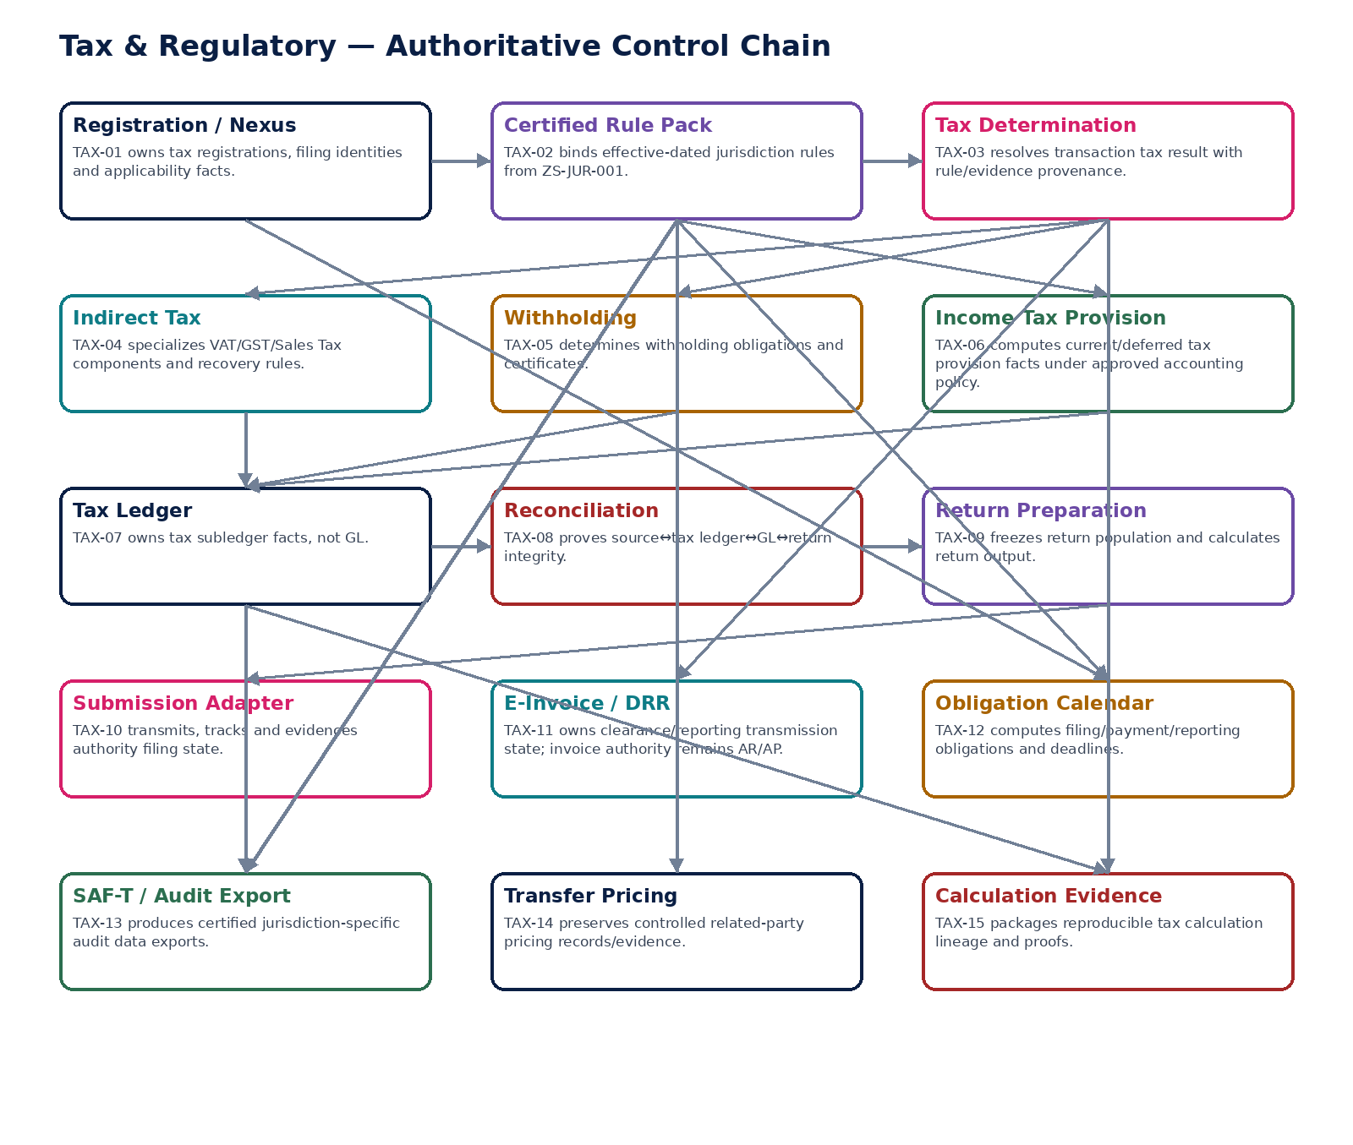
Figure 1 — Tax & Regulatory authoritative control chain.

2. Domain Constitution & Non-Negotiable Invariants
# | Invariant
1 | Every material tax result identifies tenant, legal entity, jurisdiction/regime, registration, effective/tax-point date, currency and certified rule version.
2 | No tax rate, threshold, exemption or filing deadline is hardcoded in UI/client code or mutable production configuration outside certified rule packs.
3 | Missing or ambiguous rules fail safely to Blocked/ReviewRequired; the platform never guesses a tax rule from a neighboring jurisdiction or prior period.
4 | Tax arithmetic uses exact fixed-precision decimal semantics and the approved jurisdiction rounding method.
5 | Historic consumed tax results are immutable; correction creates a superseding tax result and linked business/accounting correction.
6 | Tax-point/document/posting/effective dates remain separate where law/accounting requires them.
7 | TAX-03 never trusts client-supplied jurisdiction, registration, tax rate or exemption status without server-side verification.
8 | TAX-04 indirect-tax recovery and reverse-charge logic remains regime-specific and evidence-versioned.
9 | TAX-05 withholding cannot be bypassed by AP/Payroll payment execution.
10 | TAX-06 provision uses certified accounting populations and retains recognition assumptions; it cannot post directly to GL.
11 | TAX-07 tax entries are immutable and source-linked; balance overwrites are prohibited.
12 | TAX-08 reconciles frozen populations and independently tracks material exceptions, remediation and certification.
13 | TAX-09 freezes return populations; a protected-field/population change invalidates approval.
14 | TAX-10 creates a durable submission attempt before authority side effects and preserves raw acknowledgement evidence.
15 | Transport success is not filing acceptance; authority/native state and canonical state are both retained.
16 | TAX-11 does not make an invoice legally/economically different from the AR/AP-issued document; regulatory identifiers are appended as controlled evidence.
17 | Jurisdiction-specific e-invoice syntax/validation is adapter/specialization-driven, not one global hardcoded XML/JSON shape.
18 | TAX-12 due dates are computed from effective rules, calendars, holidays/extensions and explicit timezones.
19 | TAX-13 exports use frozen source populations, control totals, schema validation and a sealed manifest.
20 | TAX-14 transfer-pricing records preserve method/benchmark evidence and never autonomously select legal conclusions or comparables.
21 | TAX-15 evidence supports as-of reconstruction using the exact historic source/rule versions.
22 | Privacy/retention/legal hold controls apply to tax records without destroying statutory evidence that must legally be retained.
23 | Provider/authority callback replay, out-of-order messages and duplicate submissions are explicitly controlled.
24 | No Tax service writes posted GL entries directly; accounting consequences enter ACC-04 through governed accounting events.
25 | AI may summarize/explain source-linked rules but must not generate authoritative numerics, legal positions, filing approvals or external submissions.

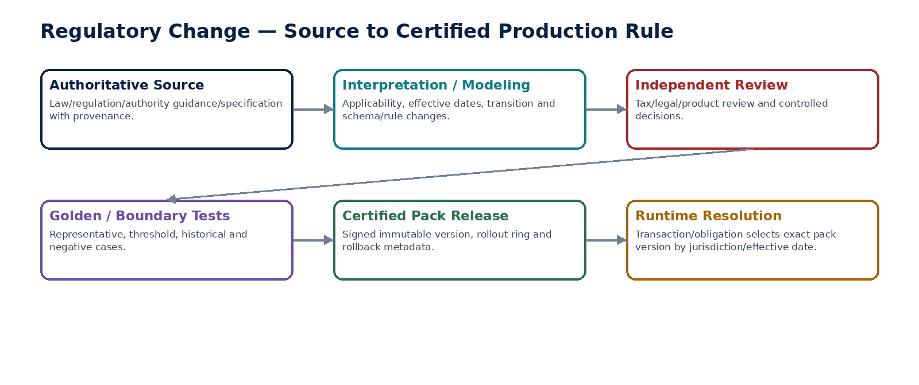
Figure 2 — Regulatory source-to-certified-runtime rule lifecycle.

3. Cross-Service Authority Matrix
Service | Authoritative ownership | Must never own / bypass
TAX-01 | TaxRegistration | Legal entity identity or tax-law content
TAX-02 | TaxRulePack binding/projection | Editable production law/rate tables
TAX-03 | TaxDetermination | Business-document issuance, GL, provider settlement
TAX-04 | IndirectTaxComponent | General tax-law source or invoice ownership
TAX-05 | WithholdingDetermination | Payment execution or payee master
TAX-06 | IncomeTaxProvisionRun | General Ledger or financial statement authority
TAX-07 | TaxLedgerEntry | GL or source-document economics
TAX-08 | TaxReconciliationRun | Ledger edits or tolerance self-waiver
TAX-09 | TaxReturn | Authority submission state
TAX-10 | TaxSubmissionAttempt | Return calculation/population
TAX-11 | EInvoiceRegulatorySubmission | Invoice economics or AR/AP lifecycle
TAX-12 | TaxObligation | Ad-hoc user deadlines
TAX-13 | TaxAuditExport | Editable parallel reporting database
TAX-14 | TransferPricingRecord | Autonomous tax advice or ledger posting
TAX-15 | TaxEvidencePackage | Business/source fact ownership

4. Shared Command, Error & Context Contract
Area | Required behavior
Context | Every protected command resolves tenant, legal entity, establishment, jurisdiction/regime, registration, effective/tax-point date, currency, actor/workload, region/residency, correlation/causation and idempotency server-side.
Rule identity | Every calculation/reporting/filing result persists certified rule/schema/mapping versions and their effective interval.
Concurrency | Mutable aggregates use expected-version semantics. Approval/signing/certification binds a protected-field fingerprint and frozen population where applicable.
Errors | Stable types include TAX_RULE_NOT_FOUND, TAX_RULE_AMBIGUOUS, REGISTRATION_INVALID, TAX_DATE_OUT_OF_SCOPE, TAX_RESULT_CHANGED, RETURN_POPULATION_CHANGED, RETURN_NOT_RECONCILED, AUTHORITY_STATE_UNKNOWN, CALLBACK_REPLAYED, EINVOICE_SCHEMA_INVALID, OBLIGATION_RULE_MISSING and TAX_EVIDENCE_UNVERIFIABLE.
External state | Submitted/Pending/Accepted/Rejected/Assessed/Cleared/Reported are authority states, not inferred from HTTP transport.
Evidence | Each material command/result links inputs, rule/schema IDs, calculation trace, approvals, request/acknowledgement evidence and source hashes.

5. Canonical Tax Domain Data Model
Entity | Primary authority / purpose
TaxRegistration | TAX-01 — tax ID/regime/status/effective period and applicability evidence
TaxNexusAssessment | TAX-01 — source-driven threshold/applicability result
TaxRulePackBinding | TAX-02 — certified jurisdiction artifact binding and runtime activation
TaxDetermination | TAX-03 — deterministic tax result and trace
IndirectTaxComponent | TAX-04 — VAT/GST/Sales Tax regime-specific component
WithholdingDetermination | TAX-05 — withholding basis/rate/amount/treaty evidence
IncomeTaxProvisionRun | TAX-06 — current/deferred provision calculation
TaxLedgerEntry | TAX-07 — immutable tax subledger fact
TaxReconciliationRun | TAX-08 — frozen population assertions/certification
TaxReturn | TAX-09 — frozen return population and line derivation
TaxSubmissionAttempt | TAX-10 — durable filing attempt and acknowledgement
EInvoiceRegulatorySubmission | TAX-11 — clearance/reporting transmission state
TaxObligation | TAX-12 — filing/payment/reporting obligation and due rule
TaxAuditExport | TAX-13 — sealed SAF-T/audit export
TransferPricingRecord | TAX-14 — controlled related-party pricing/documentation record
TaxEvidencePackage | TAX-15 — immutable calculation/reconstruction evidence

6. Canonical Tax Domain Events
Event | Minimum contract
TaxNexusAssessed | event_id; tenant/entity; jurisdiction/regime/registration where applicable; aggregate_id/version; occurred_at; business/tax effective date; correlation/causation; producer; rule/schema version; residency context; no confidential credential material.
TaxRegistrationActivated | event_id; tenant/entity; jurisdiction/regime/registration where applicable; aggregate_id/version; occurred_at; business/tax effective date; correlation/causation; producer; rule/schema version; residency context; no confidential credential material.
TaxRulePackActivated | event_id; tenant/entity; jurisdiction/regime/registration where applicable; aggregate_id/version; occurred_at; business/tax effective date; correlation/causation; producer; rule/schema version; residency context; no confidential credential material.
TaxDetermined | event_id; tenant/entity; jurisdiction/regime/registration where applicable; aggregate_id/version; occurred_at; business/tax effective date; correlation/causation; producer; rule/schema version; residency context; no confidential credential material.
IndirectTaxCalculated | event_id; tenant/entity; jurisdiction/regime/registration where applicable; aggregate_id/version; occurred_at; business/tax effective date; correlation/causation; producer; rule/schema version; residency context; no confidential credential material.
WithholdingDetermined | event_id; tenant/entity; jurisdiction/regime/registration where applicable; aggregate_id/version; occurred_at; business/tax effective date; correlation/causation; producer; rule/schema version; residency context; no confidential credential material.
IncomeTaxProvisionApproved | event_id; tenant/entity; jurisdiction/regime/registration where applicable; aggregate_id/version; occurred_at; business/tax effective date; correlation/causation; producer; rule/schema version; residency context; no confidential credential material.
TaxLedgerEntryPosted | event_id; tenant/entity; jurisdiction/regime/registration where applicable; aggregate_id/version; occurred_at; business/tax effective date; correlation/causation; producer; rule/schema version; residency context; no confidential credential material.
TaxReconciliationCertified | event_id; tenant/entity; jurisdiction/regime/registration where applicable; aggregate_id/version; occurred_at; business/tax effective date; correlation/causation; producer; rule/schema version; residency context; no confidential credential material.
TaxReturnPopulationFrozen | event_id; tenant/entity; jurisdiction/regime/registration where applicable; aggregate_id/version; occurred_at; business/tax effective date; correlation/causation; producer; rule/schema version; residency context; no confidential credential material.
TaxReturnApproved | event_id; tenant/entity; jurisdiction/regime/registration where applicable; aggregate_id/version; occurred_at; business/tax effective date; correlation/causation; producer; rule/schema version; residency context; no confidential credential material.
TaxReturnSubmitted | event_id; tenant/entity; jurisdiction/regime/registration where applicable; aggregate_id/version; occurred_at; business/tax effective date; correlation/causation; producer; rule/schema version; residency context; no confidential credential material.
TaxReturnAccepted | event_id; tenant/entity; jurisdiction/regime/registration where applicable; aggregate_id/version; occurred_at; business/tax effective date; correlation/causation; producer; rule/schema version; residency context; no confidential credential material.
TaxReturnRejected | event_id; tenant/entity; jurisdiction/regime/registration where applicable; aggregate_id/version; occurred_at; business/tax effective date; correlation/causation; producer; rule/schema version; residency context; no confidential credential material.
EInvoiceSubmitted | event_id; tenant/entity; jurisdiction/regime/registration where applicable; aggregate_id/version; occurred_at; business/tax effective date; correlation/causation; producer; rule/schema version; residency context; no confidential credential material.
EInvoiceAccepted | event_id; tenant/entity; jurisdiction/regime/registration where applicable; aggregate_id/version; occurred_at; business/tax effective date; correlation/causation; producer; rule/schema version; residency context; no confidential credential material.
EInvoiceRejected | event_id; tenant/entity; jurisdiction/regime/registration where applicable; aggregate_id/version; occurred_at; business/tax effective date; correlation/causation; producer; rule/schema version; residency context; no confidential credential material.
TaxObligationCreated | event_id; tenant/entity; jurisdiction/regime/registration where applicable; aggregate_id/version; occurred_at; business/tax effective date; correlation/causation; producer; rule/schema version; residency context; no confidential credential material.
TaxObligationOverdue | event_id; tenant/entity; jurisdiction/regime/registration where applicable; aggregate_id/version; occurred_at; business/tax effective date; correlation/causation; producer; rule/schema version; residency context; no confidential credential material.
TaxAuditExportSealed | event_id; tenant/entity; jurisdiction/regime/registration where applicable; aggregate_id/version; occurred_at; business/tax effective date; correlation/causation; producer; rule/schema version; residency context; no confidential credential material.
TPAdjustmentApproved | event_id; tenant/entity; jurisdiction/regime/registration where applicable; aggregate_id/version; occurred_at; business/tax effective date; correlation/causation; producer; rule/schema version; residency context; no confidential credential material.
TaxEvidenceSealed | event_id; tenant/entity; jurisdiction/regime/registration where applicable; aggregate_id/version; occurred_at; business/tax effective date; correlation/causation; producer; rule/schema version; residency context; no confidential credential material.

7. Detailed Service Specifications — TAX-01 through TAX-15
The following profiles are build contracts. Physical deployment may be consolidated, but each service retains separate authoritative facts, commands, states, evidence and certification requirements.

TAX-01 — Tax Registration & Nexus
Maintain jurisdiction/regime registrations and evidence-based applicability/nexus facts required to determine and fulfil tax obligations.

Contract field | Build requirement
Authoritative ownership | TaxRegistration; registration identifiers/status/effective dates; nexus/applicability assessment; filing identity reference; authority scheme participation; deregistration history.
Required business/source inputs | legal entity/establishment; jurisdictions; business activities/presence; turnover/transaction signals; marketplace/import/export/payroll signals; existing tax IDs; effective dates.
Server-resolved/derived context | jurisdiction hierarchy; threshold/rule version; treaty/special scheme context; authority channel; residency; permissions/SoD; filing identity security classification.
Explicit commands | AssessNexus; CreateRegistration; VerifyRegistration; AmendRegistration; ActivateRegistration; SuspendRegistration; Deregister; RecordAuthorityChange
Queries/retrieval | GetRegistration; GetRegistrationAsOf; ListApplicableJurisdictions; GetNexusAssessment; GetRegistrationEvidence; GetAvailableActions

Control field | Build requirement
State model | Assessment Draft→Reviewed→Applicable/NotApplicable; Registration Pending→Active→Suspended→Deregistered; historical versions immutable.
Permissions | tax.registration.read/manage/verify/deregister.
Segregation of duties | Assessor cannot unilaterally approve high-risk registration overrides; tax ID change/deregistration requires maker-checker where configured.
Events produced | TaxNexusAssessed; TaxRegistrationCreated; TaxRegistrationActivated; TaxRegistrationChanged; TaxRegistrationDeregistered
Dependencies | ORG; JUR; GOV Policy/Workflow; IAM/SoD; Evidence; Security.
Failure/degradation semantics | Missing/uncertain threshold or jurisdiction rule yields ReviewRequired/Blocked, not guessed applicability; filing identity secret is never stored as tax ID.

Evidence / NFR | Build requirement
Evidence & lineage | Source facts, rule IDs/version, threshold path, authority evidence, tax ID, effective dates, actor/reviewer and override rationale.
NFR / resilience profile | C1; historical reconstruction; registration-expiry/threshold monitoring; legal-hold capable.
Minimum negative-path certification | Nexus threshold crossed but no obligation raised; Tax ID changed without evidence; Deregistered registration used for determination; Filing credential exposed as registration data

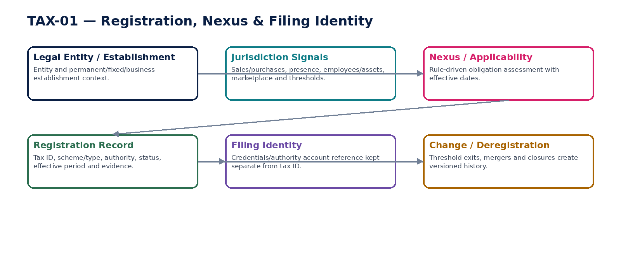
Figure 3 — Registration and nexus evidence chain.

TAX-02 — Jurisdiction Tax Rule Pack
Expose certified effective-dated tax rule artifacts to runtime services without allowing operators to edit production tax logic ad hoc.

Contract field | Build requirement
Authoritative ownership | TaxRulePack binding/projection; tax regime/version metadata; runtime activation state; specialization dependencies and compatibility metadata.
Required business/source inputs | certified ZS-JUR-001 pack; jurisdiction/regime; effective/transaction dates; release/signature metadata; rollout ring.
Server-resolved/derived context | applicability hierarchy; supersession chain; compatibility; runtime cache identity; legal/source provenance and certified test status.
Explicit commands | BindTaxRulePack; ActivateTaxRulePack; SuspendTaxRulePack; PromoteRulePack; RollBackRulePack; RefreshRuntimeCache
Queries/retrieval | GetEffectiveTaxRulePack; GetRulePackAsOf; GetRuleSourceProvenance; ListRulePackVersions; GetCompatibility

Control field | Build requirement
State model | Draft/Certified/Active/Suspended/Superseded/Retired mirrors certified jurisdiction artifact; runtime cannot modify contents.
Permissions | tax.rule.read; tax.rule.activate; tax.rule.emergency.suspend.
Segregation of duties | Pack author/reviewer/releaser separation follows ZS-JUR-001; emergency activation/suspension requires controlled evidence.
Events produced | TaxRulePackBound; TaxRulePackActivated; TaxRulePackSuspended; TaxRulePackSuperseded
Dependencies | ZS-JUR-001; Schema Registry; QA; Evidence; Security signing.
Failure/degradation semantics | Unsigned/uncertified/inapplicable rule pack blocks calculation; overlapping effective versions quarantine resolution rather than choose heuristically.

Evidence / NFR | Build requirement
Evidence & lineage | Source citations, interpretation decision, pack hash/signature, test certificate, effective interval and rollout evidence.
NFR / resilience profile | C0; highly cached but fail-closed on ambiguity; deterministic as-of resolution and instant version observability.
Minimum negative-path certification | Unsigned pack activated; Overlapping rule versions silently resolved; Future rule applied to historical transaction; Operator edits rate in production table

TAX-03 — Tax Determination
Produce deterministic source-linked tax results for transactions using certified registrations, jurisdiction facts and rule versions.

Contract field | Build requirement
Authoritative ownership | TaxDetermination; tax components/bases/rates/amounts; taxability; exemptions/reverse charge; place/jurisdiction; recovery indicators; calculation trace/evidence reference.
Required business/source inputs | transaction type; seller/buyer legal parties/registrations; items/services; amounts/discounts/charges; currencies; ship/bill/service locations; document/tax-point dates; exemption certificates.
Server-resolved/derived context | effective rule pack; registration/nexus; place-of-supply rules; product tax category; approved FX/rounding; threshold/exception state; authorization context.
Explicit commands | DetermineTax; RedetermineTax; ExplainTaxResult; SupersedeTaxDetermination; ValidateTaxDeterminationForIssue
Queries/retrieval | GetTaxDetermination; GetTaxBreakdown; GetTaxExplanation; GetTaxDeterminationAsOf; GetRuleTrace

Control field | Build requirement
State model | Draft→Calculated→Validated→Consumed; superseding result never overwrites consumed historic result.
Permissions | tax.determine; tax.result.read; tax.result.explain; tax.result.supersede.
Segregation of duties | Manual override of material result requires independent approval and reason; business-document approver cannot silently alter tax result.
Events produced | TaxDetermined; TaxDeterminationValidated; TaxDeterminationSuperseded; TaxDeterminationExceptionRaised
Dependencies | TAX-01/02; REF; ORG; AR/AP; Evidence; ACC events.
Failure/degradation semantics | Ambiguous jurisdiction, missing rule, invalid registration or unsupported transaction blocks issue/consumption; no LLM-generated rates or arithmetic.

Evidence / NFR | Build requirement
Evidence & lineage | Input fingerprint, rule IDs, formula path, rates, rounding, FX source/version, exemptions and output hash.
NFR / resilience profile | C0; deterministic; low-latency transaction path; exact decimal arithmetic; replayable historical results.
Minimum negative-path certification | Missing rule guessed from prior period; Manual rate override without approval; Same input/version produces different result; Historical invoice recalculated with current rate

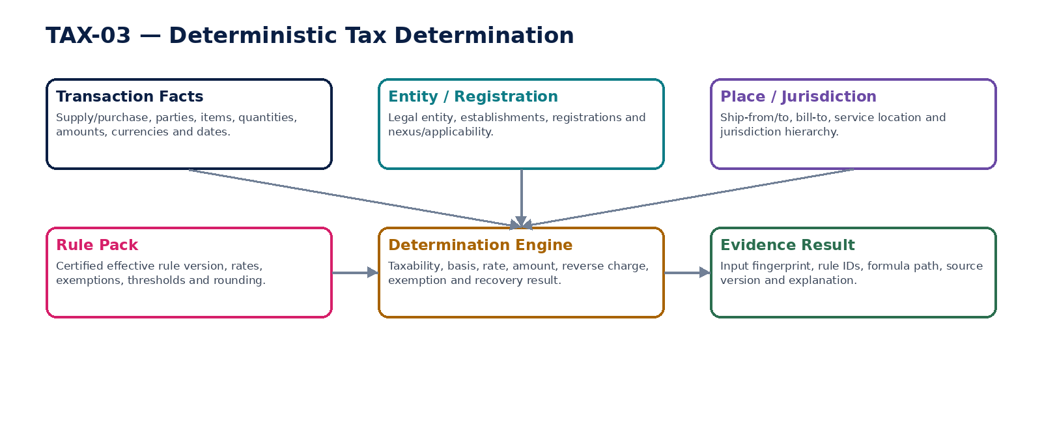
Figure 4 — Deterministic transaction tax determination.

TAX-04 — VAT / GST / Sales Tax
Specialize indirect tax treatment, recovery and reporting attributes across VAT, GST, sales/use and similar transaction taxes.

Contract field | Build requirement
Authoritative ownership | IndirectTaxComponent; regime-specific liability/recovery; input/output tax classification; reverse-charge/self-assessment; place/sourcing attributes; reporting codes.
Required business/source inputs | TAX-03 base transaction facts/results; supply/purchase/import context; invoice evidence; recovery/business-use attributes; exemption/certificate data.
Server-resolved/derived context | regime specialization; recovery percentage; partial exemption/pro-rata rule; destination/origin sourcing; marketplace/deemed supplier rules; invoice/reporting requirements.
Explicit commands | CalculateIndirectTax; AssessRecovery; AssessReverseCharge; ReclassifyIndirectTax; SupersedeIndirectTaxTreatment
Queries/retrieval | GetIndirectTaxResult; GetRecoveryResult; GetReportingCodes; GetIndirectTaxAsOf

Control field | Build requirement
State model | Calculated→Validated→Reported; adjustment creates superseding/correction tax fact.
Permissions | tax.indirect.calculate/read/adjust.
Segregation of duties | Recovery percentage/manual partial exemption adjustment requires approved policy and maker-checker.
Events produced | IndirectTaxCalculated; TaxRecoveryAssessed; ReverseChargeAssessed; IndirectTaxAdjusted
Dependencies | TAX-01/02/03; AR/AP; TAX-07/09/11; ACC.
Failure/degradation semantics | Missing regime specialization blocks result; incompatible invoice/report code raises explicit exception.

Evidence / NFR | Build requirement
Evidence & lineage | Regime/rule IDs, basis/rate, recovery path, reporting code and source-document lineage.
NFR / resilience profile | C0/C1; high volume; deterministic; batch rerun and historical replay.
Minimum negative-path certification | Reverse charge omitted despite rule; Input tax recovery exceeds permitted percentage; Sales tax sourced to wrong jurisdiction; Adjustment rewrites original tax fact

TAX-05 — Withholding Tax
Determine, accrue, remit and evidence withholding obligations arising from payments/accruals without conflating withholding with payment execution.

Contract field | Build requirement
Authoritative ownership | WithholdingDetermination; basis/rate/amount; payer/payee jurisdiction; treaty/exemption path; remittance liability mapping; certificate/reporting attributes.
Required business/source inputs | payee/payer; income/payment type; amount/currency; accrual/payment date; residence/tax IDs; treaty/exemption/beneficial-owner documentation; source jurisdiction.
Server-resolved/derived context | certified domestic/treaty rules; documentation validity; threshold; FX; remittance calendar; tax registration; SoD.
Explicit commands | DetermineWithholding; ValidateTreatyClaim; ApproveWithholdingOverride; CreateWithholdingLiability; IssueWithholdingCertificate; SupersedeWithholding
Queries/retrieval | GetWithholdingResult; GetTreatyTrace; GetCertificate; GetRemittanceLiability; GetAsOf

Control field | Build requirement
State model | Calculated→Validated→Accrued→Remitted/Reported; certificate state tracked separately.
Permissions | tax.withholding.calculate/read/override/certificate.
Segregation of duties | Person supplying treaty documentation cannot self-approve material override; payment execution cannot modify withholding result.
Events produced | WithholdingDetermined; WithholdingLiabilityCreated; WithholdingRemitted; WithholdingCertificateIssued
Dependencies | TAX-01/02/07/12; AP/Payroll; BNK; ACC; Evidence.
Failure/degradation semantics | Expired/missing documentation defaults according certified law, never operator guess; payment timeout does not reverse tax liability automatically.

Evidence / NFR | Build requirement
Evidence & lineage | Documentation hashes, treaty/rule path, basis/rate, remittance and certificate references.
NFR / resilience profile | C0/C1; deadline-aware; certificate generation durable; historical treaty version reproducible.
Minimum negative-path certification | Expired treaty certificate still used; Withholding bypassed on supplier payment; Operator self-approves treaty override; Payment failure silently deletes withholding liability

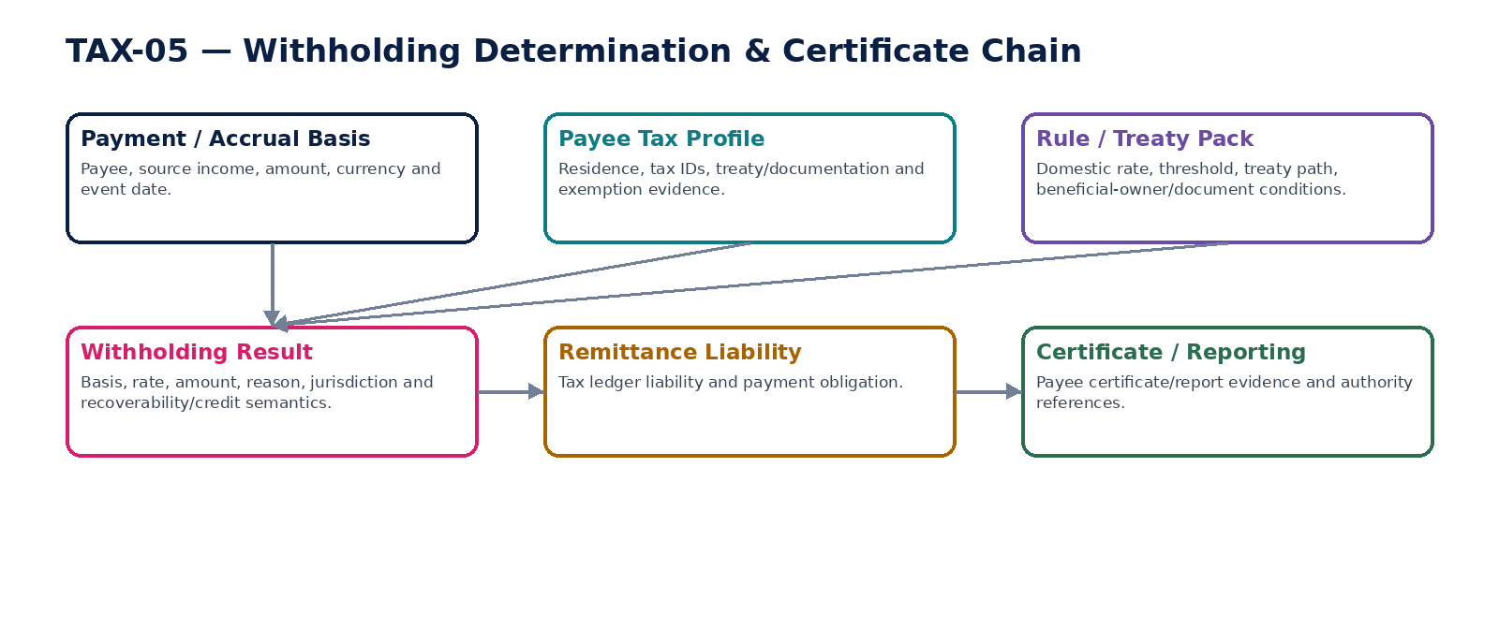
Figure 5 — Withholding determination and remittance/certificate chain.

TAX-06 — Income Tax Provision
Calculate governed current and deferred income tax provision facts from certified accounting state and tax bases while keeping recognition/accounting approval separate.

Contract field | Build requirement
Authoritative ownership | IncomeTaxProvisionRun; current tax; tax bases/temporary differences; deferred tax assets/liabilities; losses/credits; jurisdiction allocation; provision adjustments/assumptions.
Required business/source inputs | certified TB/snapshot; tax bases; current taxable-income adjustments; losses/credits; enacted/substantively enacted rates where policy permits; entity/jurisdiction structure.
Server-resolved/derived context | IAS 12/accounting-policy profile where applicable; jurisdiction tax rules; recognition thresholds; Pillar Two or other regime feature flags where applicable; FX.
Explicit commands | PrepareTaxProvision; RecalculateProvision; RecordProvisionAdjustment; ApproveProvision; SupersedeProvision; EmitProvisionAccountingEvent
Queries/retrieval | GetProvision; GetTemporaryDifferences; GetLossCreditSchedule; GetProvisionEvidence; GetAsOf

Control field | Build requirement
State model | Draft→Calculated→Reviewed→Approved→Posted; reopening/adjustment creates new version.
Permissions | tax.provision.prepare/review/approve/post.
Segregation of duties | Preparer cannot approve material provision; manual recognition assumptions independently reviewed.
Events produced | IncomeTaxProvisionCalculated; ProvisionAdjustmentRecorded; IncomeTaxProvisionApproved; ProvisionAccountingEventEmitted
Dependencies | ACC-15/16; TAX-02/07/08; Workflow/SoD; Evidence.
Failure/degradation semantics | Missing certified TB/rate/policy blocks provision; estimation uncertainty is explicit and never hidden as a deterministic fact.

Evidence / NFR | Build requirement
Evidence & lineage | TB watermark, tax-base schedules, temporary differences, rate/source versions, assumptions, approvals and journal-event reference.
NFR / resilience profile | C1 period-close; reproducible; high-precision; close-gate and rerun controls.
Minimum negative-path certification | Provision uses uncertified TB; Rate changed after approval without invalidation; Deferred tax asset recognized without required evidence; Provision posts directly to GL

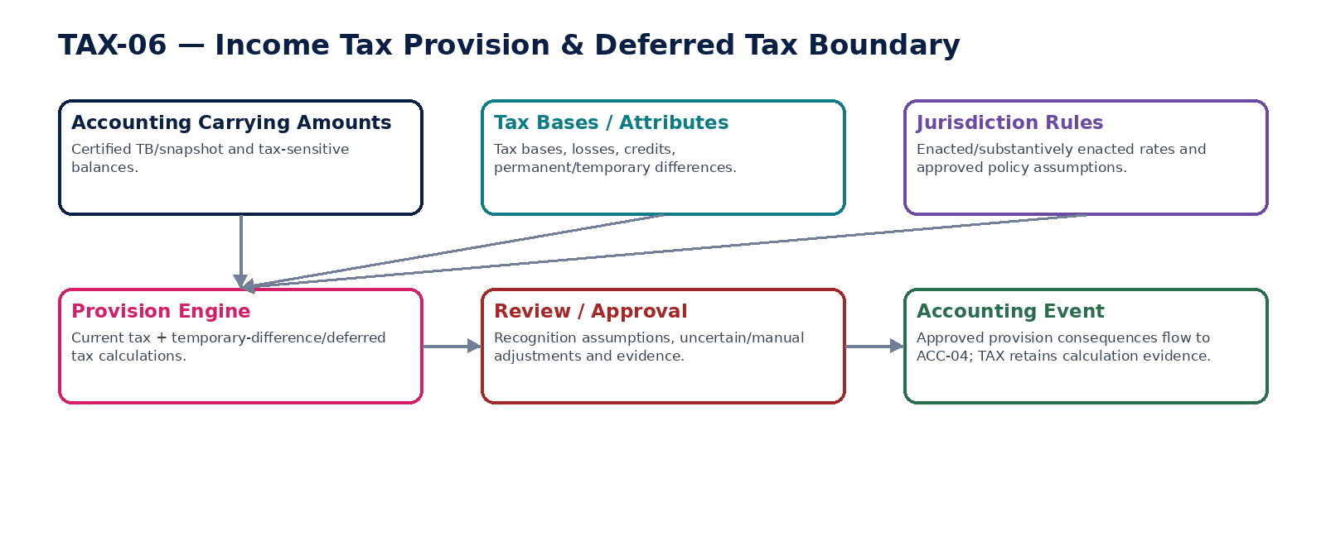
Figure 6 — Income tax provision and deferred-tax accounting boundary.

TAX-07 — Tax Ledger
Maintain immutable tax subledger entries and balances by regime, jurisdiction, registration, period and source without becoming the General Ledger.

Contract field | Build requirement
Authoritative ownership | TaxLedgerEntry; tax liability/asset/credit/payment/refund/adjustment facts; registration/regime/period dimensions; source links; tax balance projections.
Required business/source inputs | validated tax determinations; withholding; provision facts; tax payments/refunds; assessments/authority adjustments; corrections.
Server-resolved/derived context | registration/regime/period; source event version; accounting mapping; close state; currency/FX; retention/evidence policy.
Explicit commands | PostTaxLedgerEntry; ReverseTaxLedgerEntry; AdjustTaxLedger; CloseTaxPeriod; ReopenTaxPeriodControlled
Queries/retrieval | GetTaxLedger; GetTaxBalance; GetTaxLedgerEntry; GetTaxLedgerAsOf; GetSourceLineage

Control field | Build requirement
State model | Open→SoftClosed→HardClosed→AuthorizedReopen→Reclosed at tax-period control level; entries immutable.
Permissions | tax.ledger.read/post/adjust/close/reopen.
Segregation of duties | Direct manual entry restricted; close/reopen and material adjustments require maker-checker.
Events produced | TaxLedgerEntryPosted; TaxLedgerEntryReversed; TaxPeriodClosed; TaxPeriodReopened
Dependencies | TAX-03/04/05/06; ACC; BNK; TAX-08/09; Evidence.
Failure/degradation semantics | Closed period blocks ordinary entries; duplicate source event idempotently returns original; no mutable balance overwrite.

Evidence / NFR | Build requirement
Evidence & lineage | Source IDs/events, entry hash, rule/version, accounting mapping, actor and correction chain.
NFR / resilience profile | C0; high durability; exact decimals; historical reconstruction and reconciliation.
Minimum negative-path certification | Duplicate source creates duplicate tax entry; Closed tax period accepts normal entry; Balance manually overwritten; Tax ledger used as GL substitute

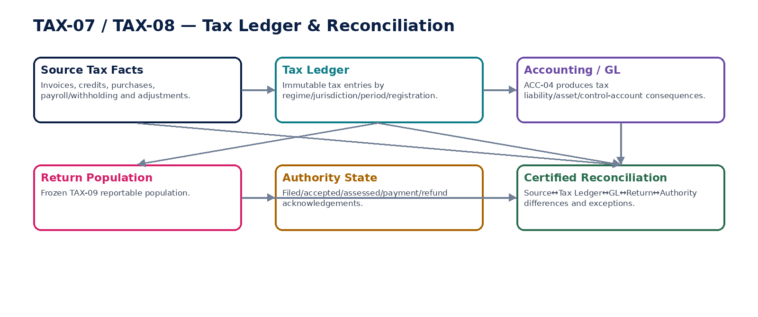
Figure 7 — Tax Ledger and cross-population reconciliation.

TAX-08 — Tax Reconciliation
Certify frozen-population reconciliations between source transactions, Tax Ledger, General Ledger, returns and authority/payment state.

Contract field | Build requirement
Authoritative ownership | TaxReconciliationRun; population snapshot/hash; assertion results; exceptions; remediation/reperformance; certification.
Required business/source inputs | source documents; TAX-07; GL/tax control accounts; TAX-09 return population; TAX-10/11 authority acknowledgements; BNK payments/refunds.
Server-resolved/derived context | control definition/version; materiality/tolerance; period; legal entity/registration; cutoffs/watermarks; certifier authority.
Explicit commands | StartTaxReconciliation; MatchTaxPopulation; RaiseTaxException; RemediateTaxException; ReperformTaxControl; CertifyTaxReconciliation
Queries/retrieval | GetReconciliation; GetPopulation; GetExceptions; GetCertification; GetControlStatus

Control field | Build requirement
State model | Draft→Running→Exception/Passed→Remediating→Reperformed→Certified; certified populations immutable.
Permissions | tax.recon.run/read/remediate/certify.
Segregation of duties | Operator cannot certify own unresolved material exception or widen tolerance during run.
Events produced | TaxReconciliationStarted; TaxReconciliationExceptionRaised; TaxReconciliationCertified
Dependencies | ZS-CONTROL-001; TAX-07/09/10/11; ACC; BNK; Evidence.
Failure/degradation semantics | Matching totals with different composition is failure; late data after certification creates new/superseding run.

Evidence / NFR | Build requirement
Evidence & lineage | Population IDs/hashes, counts/totals, assertion results, exceptions, approvals, reperformance and certificate.
NFR / resilience profile | C0 period-close; batch scale; reproducible; close/report release gate.
Minimum negative-path certification | Return total equals GL but source population differs; Tolerance widened mid-run; Late transaction mutates certified run; Reconciler certifies own material waiver

TAX-09 — Tax Return Preparation
Prepare reproducible tax returns from frozen certified populations under effective filing schemas and rule packs.

Contract field | Build requirement
Authoritative ownership | TaxReturn; return lines/boxes; frozen population reference; calculation version; validation results; amendment/supersession chain; approval state.
Required business/source inputs | registration/obligation; period; TAX-07 population; reconciliations; jurisdiction schema; adjustments/credits/carryforwards; supporting schedules.
Server-resolved/derived context | effective return schema/rules; filing deadline; signatory requirements; rounding/currency; control status; prior filings/amendments.
Explicit commands | CreateTaxReturn; FreezeReturnPopulation; CalculateTaxReturn; ValidateTaxReturn; ApproveTaxReturn; AmendTaxReturn; SupersedeTaxReturn
Queries/retrieval | GetTaxReturn; GetReturnLineage; GetReturnPopulation; GetValidationErrors; GetReturnAsOf

Control field | Build requirement
State model | Draft→PopulationFrozen→Calculated→Validated→Approved→Submitted/Accepted via TAX-10; amendment version separate.
Permissions | tax.return.prepare/read/validate/approve/amend.
Segregation of duties | Preparer cannot be sole approver where maker-checker required; population changes invalidate approval.
Events produced | TaxReturnCreated; TaxReturnPopulationFrozen; TaxReturnCalculated; TaxReturnApproved; TaxReturnAmended
Dependencies | TAX-07/08/12; TAX-02; Workflow/SoD; TAX-10; Evidence.
Failure/degradation semantics | Unreconciled mandatory control or schema validation failure blocks approval/submission; amendment never rewrites original filed return.

Evidence / NFR | Build requirement
Evidence & lineage | Population hash, return schema/rule versions, line derivations, approvals and prior filing links.
NFR / resilience profile | C0 deadline path; deterministic batch; high durability; as-filed reconstruction.
Minimum negative-path certification | Return approved before mandatory reconciliation; Population changes after approval without invalidation; Amendment overwrites filed return; Wrong schema version used for period

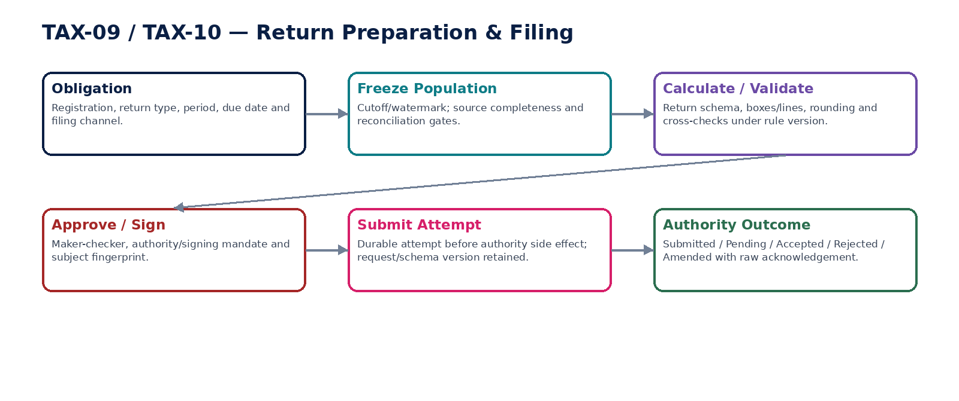
Figure 8 — Tax return preparation, approval and filing boundary.

TAX-10 — Tax Filing / Submission Adapter
Transmit approved tax returns/filings to authorities and resolve authoritative filing state without treating transport response as legal acceptance.

Contract field | Build requirement
Authoritative ownership | TaxSubmissionAttempt; authority request/reference; raw response/acknowledgement; canonical filing state; rejection reason; amendment linkage.
Required business/source inputs | approved TAX-09 return; registration/filing identity; authority endpoint/channel; schema payload; signature/credential reference; due date.
Server-resolved/derived context | authority protocol/version; security/signing profile; cut-off/outage state; idempotency; residency; retry/poll budget.
Explicit commands | PrepareTaxSubmission; SubmitTaxReturn; PollSubmissionStatus; ProcessAuthorityCallback; ResolveUnknownSubmission; RecordAuthorityAssessment; SubmitAmendment
Queries/retrieval | GetSubmission; GetAuthorityAcknowledgement; GetSubmissionStatus; ListAttempts; GetRawEvidence

Control field | Build requirement
State model | Prepared→Submitted→Pending/Unknown→Accepted/Rejected; Assessed/Amended tracked as later authority states.
Permissions | tax.file.submit/read/status/assessment.
Segregation of duties | Submitter/signatory separation per mandate; support cannot forge acceptance; raw authority evidence immutable.
Events produced | TaxSubmissionPrepared; TaxReturnSubmitted; TaxSubmissionPending; TaxReturnAccepted; TaxReturnRejected; TaxAuthorityAssessmentRecorded
Dependencies | TAX-09/12; INT Provider Adapter; Security; GTRM; Evidence; GOV Workflow.
Failure/degradation semantics | Timeout remains Pending/Unknown and original attempt must be resolved; duplicate submission blocked by durable idempotency.

Evidence / NFR | Build requirement
Evidence & lineage | Payload hash, signature/cert reference, request ID, transport receipt, raw acknowledgement, mapped state/version and timestamps.
NFR / resilience profile | C0 regulatory deadline; durable queue; provider/authority outage runbook; no data loss.
Minimum negative-path certification | Timeout treated as failed and resubmitted; Forged callback accepted; Authority rejection hidden as submitted; Filing sent from wrong registration identity


Figure 9 — Durable filing attempt and authoritative authority-state resolution.

TAX-11 — E-Invoice Clearance / Reporting
Transmit issued invoice/credit/debit facts to mandated clearance/e-invoicing/digital-reporting networks while preserving business-document ownership in AR/AP.

Contract field | Build requirement
Authoritative ownership | EInvoiceRegulatorySubmission; transformed payload; validation result; network/authority identifiers; canonical clearance/reporting state; rejection/correction linkage.
Required business/source inputs | issued AR/AP document; TAX-03 result; seller/buyer identifiers; jurisdiction profile; document type/date; payment/delivery references where mandated.
Server-resolved/derived context | mandate applicability; PINT/EN/local specialization; code lists; schema/validation artifacts; deadline; network endpoint; signature/security policy.
Explicit commands | PrepareRegulatoryInvoice; ValidateRegulatoryInvoice; SubmitRegulatoryInvoice; ProcessNetworkResponse; ResolveUnknownRegulatoryState; CancelOrCorrectRegulatoryInvoice
Queries/retrieval | GetRegulatoryInvoiceState; GetValidationReport; GetAuthorityIdentifier; GetSubmissionEvidence; GetAsOf

Control field | Build requirement
State model | Prepared→Validated→Submitted→Pending/Unknown→Accepted/Cleared/Reported/Rejected; cancellation/correction separate.
Permissions | tax.einvoice.prepare/submit/read/correct.
Segregation of duties | Document issuer cannot silently bypass mandatory submission; override of validation/mandate requires authorized exception process.
Events produced | EInvoicePrepared; EInvoiceSubmitted; EInvoiceAccepted; EInvoiceRejected; EInvoiceStateUnknown; EInvoiceCorrected
Dependencies | AR/AP; TAX-02/03; INT; Security; GTRM; Schema Registry; Evidence.
Failure/degradation semantics | Validation error blocks submission; timeout is unknown; provider/network status cannot mutate invoice economics.

Evidence / NFR | Build requirement
Evidence & lineage | Business document hash, transformation/schema versions, network IDs, acknowledgement, validation rules and correction chain.
NFR / resilience profile | C0/C1 by mandate; low-latency where clearance-before-issue; deadline/freshness SLI.
Minimum negative-path certification | Invoice issued where clearance-before-issue requires acceptance; Network timeout causes duplicate submission; Provider response rewrites invoice amount; Wrong jurisdiction specialization used

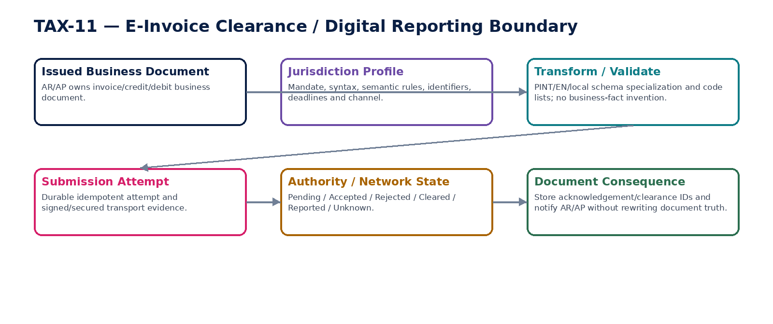
Figure 10 — E-invoice clearance/digital-reporting boundary.

TAX-12 — Tax Obligation Calendar
Compute authoritative filing/payment/reporting obligations and deadline risk from active registrations and certified jurisdiction rules.

Contract field | Build requirement
Authoritative ownership | TaxObligation; type/period/frequency/due date; owner; prerequisite/control state; extension/holiday adjustment; completion/authority reference.
Required business/source inputs | active registrations; business/entity state; tax periods; transaction/payroll/import/export participation; prior obligations; authority extensions.
Server-resolved/derived context | rule-pack deadline calendar; holidays; thresholds; filing frequency; special schemes; escalation policy; timezone.
Explicit commands | GenerateObligations; RecalculateObligation; AssignObligationOwner; RecordExtension; CompleteObligation; WaiveObligationControlled
Queries/retrieval | GetObligation; ListUpcomingObligations; ListOverdueObligations; GetDeadlineTrace; GetCalendarAsOf

Control field | Build requirement
State model | Projected→Due→InProgress→Completed; AtRisk/Overdue orthogonal; Cancelled/Waived controlled.
Permissions | tax.obligation.read/manage/extend/waive.
Segregation of duties | Owner cannot waive own statutory obligation without designated approval; due-date overrides require evidence.
Events produced | TaxObligationCreated; TaxObligationBecameAtRisk; TaxObligationOverdue; TaxObligationCompleted; TaxObligationExtended
Dependencies | TAX-01/02/09/10/11; OPS; Workflow; Evidence.
Failure/degradation semantics | Missing rule/registration conflict raises exception; deadlines never hardcoded in client/UI; timezone explicit.

Evidence / NFR | Build requirement
Evidence & lineage | Rule/version, registration, due-date formula, holiday/extension evidence, completion acknowledgement.
NFR / resilience profile | C0 deadline monitoring; scheduler resilient; alerts/escalation and as-of reconstruction.
Minimum negative-path certification | Obligation omitted after registration activation; Holiday rule applied from wrong year; User silently changes statutory due date; Completed obligation lacks authority evidence

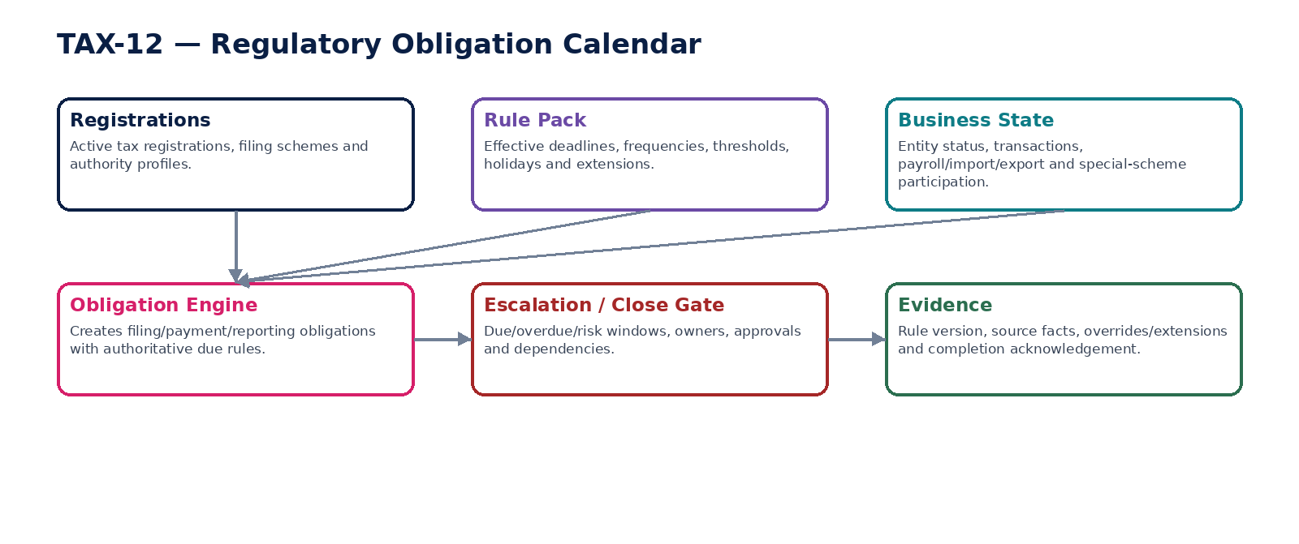
Figure 11 — Tax obligation calendar and deadline derivation.

TAX-13 — SAF-T / Audit Data Export
Produce certified jurisdiction-specific tax/audit data exports from authoritative source populations without creating a parallel editable reporting database.

Contract field | Build requirement
Authoritative ownership | TaxAuditExport; population manifest; schema/mapping version; generated file(s); validation report; control totals/hash/signature; delivery/archive evidence.
Required business/source inputs | certified GL/master/AR/AP/inventory/assets/tax data required by jurisdiction; period; entity/registration; authority/auditor request.
Server-resolved/derived context | SAF-T/local schema specialization; mappings/code lists; access/residency; export scope; legal hold/retention; signer.
Explicit commands | CreateAuditExport; FreezeExportPopulation; GenerateAuditExport; ValidateAuditExport; SealAuditExport; DeliverAuditExport; SupersedeAuditExport
Queries/retrieval | GetAuditExport; GetManifest; GetValidationReport; DownloadAuthorizedExport; GetExportLineage

Control field | Build requirement
State model | Requested→PopulationFrozen→Generated→Validated→Sealed→Delivered/Archived; supersession separate.
Permissions | tax.export.create/read/download/deliver.
Segregation of duties | Generator cannot self-approve material mapping exception; downloads purpose-scoped and audited.
Events produced | TaxAuditExportCreated; TaxAuditExportValidated; TaxAuditExportSealed; TaxAuditExportDelivered
Dependencies | ACC/DATA; TAX-02/07; AR/AP; Assets/Inventory; Security; Evidence/Retention.
Failure/degradation semantics | Missing source IDs/referential integrity/schema failure blocks seal; no silent truncation of large populations.

Evidence / NFR | Build requirement
Evidence & lineage | Manifest, source IDs/watermarks, counts/totals, mapping/schema versions, file hash/signature and delivery receipt.
NFR / resilience profile | C1 batch; scalable; reproducible; potentially large files; residency/secure delivery.
Minimum negative-path certification | Export omits records without failing; Schema validation warning ignored as success; Source population changes after seal; Export delivered to unauthorized requester

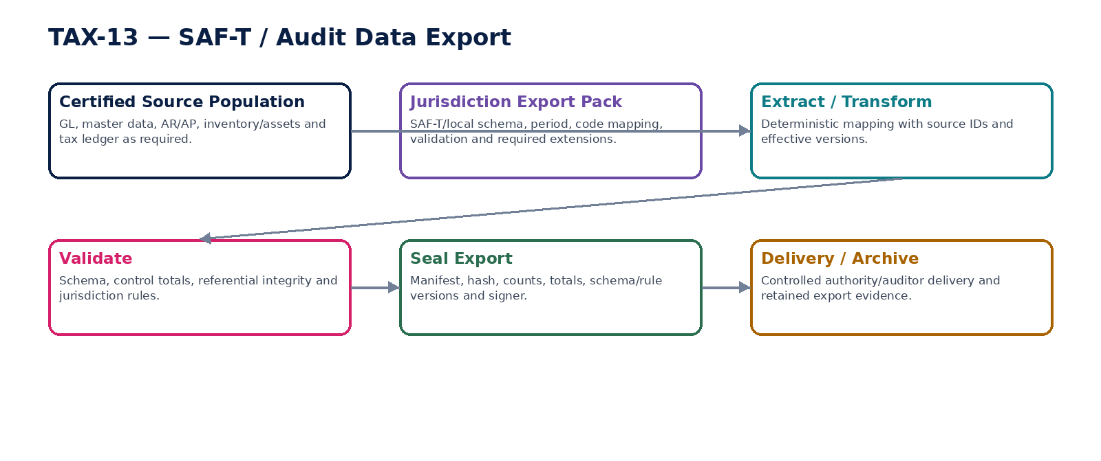
Figure 12 — Certified SAF-T/audit-data export.

TAX-14 — Transfer Pricing Record
Maintain governed related-party transaction, method, benchmark and adjustment evidence needed for transfer-pricing compliance without acting as autonomous tax advice.

Contract field | Build requirement
Authoritative ownership | TransferPricingRecord; related-party relationship; controlled transaction; policy/method; benchmark/comparable reference; tested party; calculation/adjustment; documentation links.
Required business/source inputs | intercompany transactions/contracts; entity relationships; functions/assets/risks inputs; financial results; benchmark studies/data references; currencies; periods.
Server-resolved/derived context | jurisdiction rules; approved TP policy; OECD/local method profile; materiality; FX; documentation requirements; reviewer authority.
Explicit commands | CreateTPRecord; LinkControlledTransactions; SetApprovedTPMethod; RecordBenchmark; CalculateTPAdjustment; ApproveTPAdjustment; GenerateTPDocumentationIndex
Queries/retrieval | GetTPRecord; GetControlledTransactions; GetMethodEvidence; GetAdjustment; GetDocumentationIndex; GetAsOf

Control field | Build requirement
State model | Draft→Documented→Reviewed→Approved; adjustment/accounting and filing states tracked separately.
Permissions | tax.tp.prepare/read/review/approve.
Segregation of duties | Preparer cannot approve material adjustment; benchmark/method change invalidates approval.
Events produced | TransferPricingRecordCreated; TPMethodApproved; TPAdjustmentCalculated; TPAdjustmentApproved
Dependencies | ORG/Intercompany; ACC; TAX-02/09; Legal; Evidence.
Failure/degradation semantics | Missing controlled-transaction data or method evidence blocks certification; platform does not invent comparables or legal conclusions.

Evidence / NFR | Build requirement
Evidence & lineage | Relationship, contracts, method rationale, benchmark reference/version, calculations, approvals and accounting/return links.
NFR / resilience profile | C1 period-end; evidence-heavy; jurisdiction-specific retention; deterministic calculations.
Minimum negative-path certification | Related-party transaction omitted from TP population; Method changed after approval; AI invents comparable companies; Adjustment posts directly to ledger

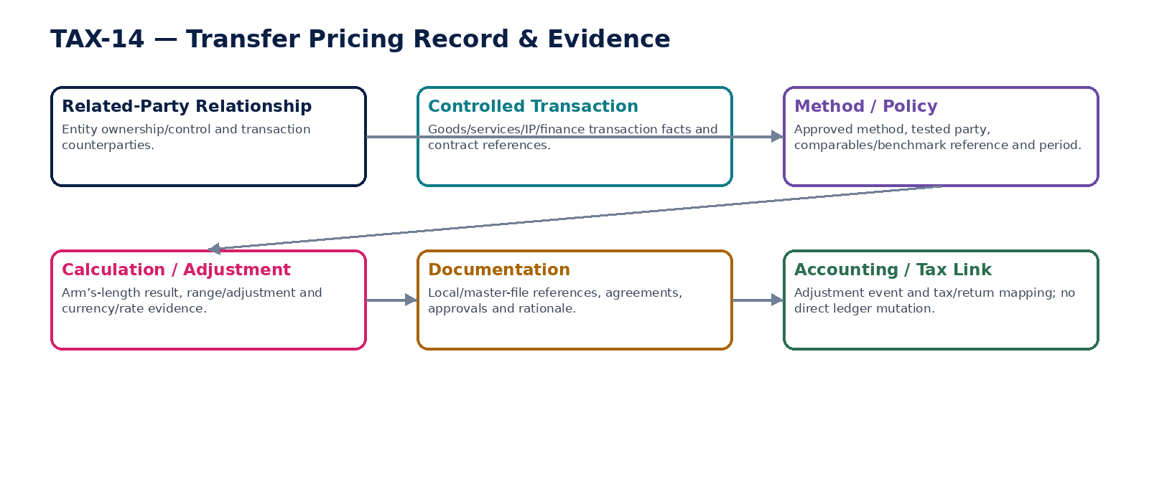
Figure 13 — Transfer-pricing evidence and adjustment boundary.

TAX-15 — Tax Calculation Evidence
Assemble immutable, source-linked evidence packages that allow every material tax result to be independently reconstructed as-of the original effective date.

Contract field | Build requirement
Authoritative ownership | TaxEvidencePackage; input/output manifests; calculation trace; rule/source references; hashes; approvals; jurisdiction/effective-date context; verification result.
Required business/source inputs | tax determination/provision/withholding/return/export result; source facts; rule IDs; calculation intermediates; approvals; authority acknowledgements.
Server-resolved/derived context | retention/legal hold; evidence schema; signing/hashing policy; source-to-report lineage; access purpose.
Explicit commands | BuildTaxEvidencePackage; VerifyTaxEvidencePackage; SealTaxEvidencePackage; AttachAuthorityEvidence; ExportTaxEvidenceAuthorized
Queries/retrieval | GetTaxEvidence; VerifyTaxEvidence; GetCalculationTrace; GetRuleSources; GetAsOf

Control field | Build requirement
State model | Building→Verified→Sealed; correction creates new linked package; sealed content immutable.
Permissions | tax.evidence.read/build/verify/export.
Segregation of duties | Calculation owner cannot alter sealed evidence; export/download is purpose-scoped and audited.
Events produced | TaxEvidenceBuilt; TaxEvidenceVerified; TaxEvidenceSealed; TaxEvidenceVerificationFailed
Dependencies | Evidence Ledger; TAX-01..14; Retention/Legal Hold; Security; Data Governance.
Failure/degradation semantics | Missing source/rule hash or non-reproducible calculation fails verification; evidence remains accessible under hold even if normal disposition would run.

Evidence / NFR | Build requirement
Evidence & lineage | Full input/output hashes, rule/source IDs, formulas, versions, actor/workload, timestamps and authority references.
NFR / resilience profile | C0 auditability; high durability; long retention; tamper detection and as-of replay.
Minimum negative-path certification | Sealed evidence modified; Historical replay uses current rules; Evidence package missing source hash; Legal hold fails to preserve tax evidence

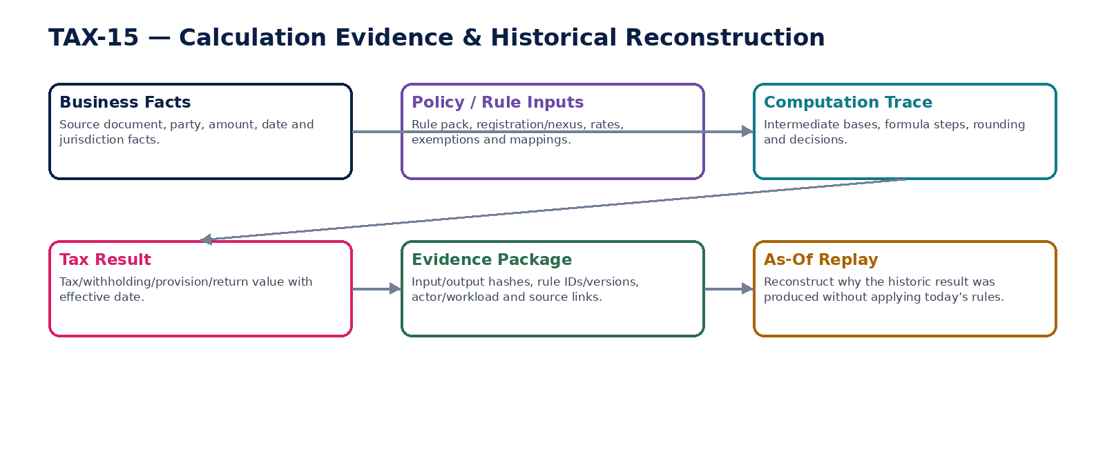
Figure 14 — Tax calculation evidence and historical reconstruction.

8. Tax Determination Consumption & Correction Matrix
Consumer / scenario | Authoritative rule | Correction behavior
AR customer invoice | Consumes validated TAX-03/TAX-04 result before issue. | After issue, changed tax requires credit/debit/correction document and superseding tax result; never mutate issued invoice.
AP supplier invoice | Validates supplier tax and computes buyer-side/recoverable tax as applicable. | Correction retains supplier document evidence and creates governed AP/tax correction.
Payment / withholding | TAX-05 result binds payment/accrual subject and documentation. | Changed treaty/documentation creates superseding withholding determination; payment authorization may require invalidation.
Income tax provision | TAX-06 consumes certified accounting population. | New facts/rates/assumptions create new provision version and accounting adjustment event.
Return | TAX-09 consumes TAX-07/reconciled frozen population. | Filed return is never overwritten; amendment/superseding return linked to original.
E-invoice | TAX-11 consumes issued business document + tax result. | Network rejection triggers correction workflow; network never edits economics itself.

9. Tax-to-Accounting / Authority Control Matrix
Control | Authoritative path | Mandatory assertion
Transaction tax | AR/AP → TAX-03/04 → TAX-07 → ACC-04 | Source tax components equal tax-ledger and GL consequences by entity/book/period/regime.
Withholding | AP/Payroll → TAX-05 → TAX-07 → BNK/ACC | Withheld amount, liability, remittance and certificate/return population reconcile.
Income tax provision | ACC certified TB → TAX-06 → TAX-07/ACC | Provision schedules reconcile to posted tax expense/assets/liabilities and signed financial snapshot.
Tax return | TAX-07 + source → TAX-08 → TAX-09 | Return population is frozen/reconciled and every line is source-traceable.
Filing | TAX-09 → TAX-10 → authority | Approved return hash equals submitted payload basis; authority acknowledgement mapped without loss.
E-invoice | AR/AP document → TAX-11 → network/authority | Document hash, schema specialization, submission and acceptance/rejection evidence remain linked.
Payment/refund | TAX liability/credit → BNK → TAX-07/08 | Bank/provider finality reconciles to tax liability/asset and authority state.


Figure 15 — Source, Tax Ledger, GL, return and authority reconciliation.

10. Regulatory Adapter Requirements
Requirement | Engineering rule
Specialization | Authority/network-specific schemas, endpoints, status codes and code lists terminate at adapters/profile packs; canonical tax objects remain stable.
Versioning | Schema, semantic/validation artifacts and code lists are explicit and stored with each generated/submitted payload.
Idempotency | Filing/e-invoice submission uses durable attempt identity before external side effect; retries resolve/reuse the same external identity where supported.
Authentication | Authority credentials, certificates and signing keys are managed under ZS-SEC-001 and referenced rather than copied into tax records.
Callbacks / polling | Authenticate, replay-protect, deduplicate and correlate. Unknown references quarantine. Polling obeys controlled retry/rate budgets.
Residency | Authority/provider route and retained payload/acknowledgement respect GTRM and data-residency policy.
Failure | Provider/authority outage yields pending/queued/blocked state based on legal deadline and duplicate risk; it never fabricates acceptance.

11. Tax Observability & Operational Evidence
Signal | Minimum requirement
Rule resolution | Rule-pack version, cache state, ambiguity/missing-rule counts and upcoming effective changes.
Determination | Volume/latency by regime; review-required rate; override rate; deterministic-replay mismatch must be zero.
Registrations/obligations | Expiring/suspended registrations, threshold-near entities, obligations due/at-risk/overdue.
Tax Ledger/reconciliation | Unposted/unreconciled tax facts, control-account differences, late items and certified-run state.
Returns/filings | Population freeze, validation errors, approvals, submission attempts, Pending/Unknown age, rejections and amendments.
E-invoicing | Validation failures, mandate misses, submission lag, unknown state age, network rejections and correction backlog.
Evidence | Unverifiable calculation packages, missing source/rule hashes and as-of replay failures.

12. Domain-Level Negative-Path Certification
# | Scenario | Certification requirement
1 | Tax calculation uses wrong legal entity registration | Automated/controlled test proves fail-safe Blocked/ReviewRequired/Pending/Unknown behavior, preserves source/rule evidence, prevents unauthorized tax or duplicate regulatory effect, and leaves source↔Tax Ledger↔GL↔return/authority state fully reconciliable.
2 | Client-supplied tax rate overrides certified rule | Automated/controlled test proves fail-safe Blocked/ReviewRequired/Pending/Unknown behavior, preserves source/rule evidence, prevents unauthorized tax or duplicate regulatory effect, and leaves source↔Tax Ledger↔GL↔return/authority state fully reconciliable.
3 | Missing rule falls back to prior-year rate | Automated/controlled test proves fail-safe Blocked/ReviewRequired/Pending/Unknown behavior, preserves source/rule evidence, prevents unauthorized tax or duplicate regulatory effect, and leaves source↔Tax Ledger↔GL↔return/authority state fully reconciliable.
4 | Overlapping rule versions resolved heuristically | Automated/controlled test proves fail-safe Blocked/ReviewRequired/Pending/Unknown behavior, preserves source/rule evidence, prevents unauthorized tax or duplicate regulatory effect, and leaves source↔Tax Ledger↔GL↔return/authority state fully reconciliable.
5 | Historic transaction recalculated with current rule | Automated/controlled test proves fail-safe Blocked/ReviewRequired/Pending/Unknown behavior, preserves source/rule evidence, prevents unauthorized tax or duplicate regulatory effect, and leaves source↔Tax Ledger↔GL↔return/authority state fully reconciliable.
6 | Tax result changes without source/rule/version change | Automated/controlled test proves fail-safe Blocked/ReviewRequired/Pending/Unknown behavior, preserves source/rule evidence, prevents unauthorized tax or duplicate regulatory effect, and leaves source↔Tax Ledger↔GL↔return/authority state fully reconciliable.
7 | Issued invoice tax mutated in place | Automated/controlled test proves fail-safe Blocked/ReviewRequired/Pending/Unknown behavior, preserves source/rule evidence, prevents unauthorized tax or duplicate regulatory effect, and leaves source↔Tax Ledger↔GL↔return/authority state fully reconciliable.
8 | Reverse charge omitted | Automated/controlled test proves fail-safe Blocked/ReviewRequired/Pending/Unknown behavior, preserves source/rule evidence, prevents unauthorized tax or duplicate regulatory effect, and leaves source↔Tax Ledger↔GL↔return/authority state fully reconciliable.
9 | Input tax recovery exceeds allowed percentage | Automated/controlled test proves fail-safe Blocked/ReviewRequired/Pending/Unknown behavior, preserves source/rule evidence, prevents unauthorized tax or duplicate regulatory effect, and leaves source↔Tax Ledger↔GL↔return/authority state fully reconciliable.
10 | Withholding bypassed on payable | Automated/controlled test proves fail-safe Blocked/ReviewRequired/Pending/Unknown behavior, preserves source/rule evidence, prevents unauthorized tax or duplicate regulatory effect, and leaves source↔Tax Ledger↔GL↔return/authority state fully reconciliable.
11 | Expired treaty documentation still accepted | Automated/controlled test proves fail-safe Blocked/ReviewRequired/Pending/Unknown behavior, preserves source/rule evidence, prevents unauthorized tax or duplicate regulatory effect, and leaves source↔Tax Ledger↔GL↔return/authority state fully reconciliable.
12 | Withholding override self-approved | Automated/controlled test proves fail-safe Blocked/ReviewRequired/Pending/Unknown behavior, preserves source/rule evidence, prevents unauthorized tax or duplicate regulatory effect, and leaves source↔Tax Ledger↔GL↔return/authority state fully reconciliable.
13 | Provision uses uncertified trial balance | Automated/controlled test proves fail-safe Blocked/ReviewRequired/Pending/Unknown behavior, preserves source/rule evidence, prevents unauthorized tax or duplicate regulatory effect, and leaves source↔Tax Ledger↔GL↔return/authority state fully reconciliable.
14 | Deferred tax rate change does not invalidate approval | Automated/controlled test proves fail-safe Blocked/ReviewRequired/Pending/Unknown behavior, preserves source/rule evidence, prevents unauthorized tax or duplicate regulatory effect, and leaves source↔Tax Ledger↔GL↔return/authority state fully reconciliable.
15 | Provision posts directly to GL | Automated/controlled test proves fail-safe Blocked/ReviewRequired/Pending/Unknown behavior, preserves source/rule evidence, prevents unauthorized tax or duplicate regulatory effect, and leaves source↔Tax Ledger↔GL↔return/authority state fully reconciliable.
16 | Duplicate source event creates duplicate tax-ledger entry | Automated/controlled test proves fail-safe Blocked/ReviewRequired/Pending/Unknown behavior, preserves source/rule evidence, prevents unauthorized tax or duplicate regulatory effect, and leaves source↔Tax Ledger↔GL↔return/authority state fully reconciliable.
17 | Closed tax period accepts ordinary entry | Automated/controlled test proves fail-safe Blocked/ReviewRequired/Pending/Unknown behavior, preserves source/rule evidence, prevents unauthorized tax or duplicate regulatory effect, and leaves source↔Tax Ledger↔GL↔return/authority state fully reconciliable.
18 | Tax ledger balance overwritten | Automated/controlled test proves fail-safe Blocked/ReviewRequired/Pending/Unknown behavior, preserves source/rule evidence, prevents unauthorized tax or duplicate regulatory effect, and leaves source↔Tax Ledger↔GL↔return/authority state fully reconciliable.
19 | Return total matches GL but source population differs | Automated/controlled test proves fail-safe Blocked/ReviewRequired/Pending/Unknown behavior, preserves source/rule evidence, prevents unauthorized tax or duplicate regulatory effect, and leaves source↔Tax Ledger↔GL↔return/authority state fully reconciliable.
20 | Tax reconciliation tolerance widened mid-run | Automated/controlled test proves fail-safe Blocked/ReviewRequired/Pending/Unknown behavior, preserves source/rule evidence, prevents unauthorized tax or duplicate regulatory effect, and leaves source↔Tax Ledger↔GL↔return/authority state fully reconciliable.
21 | Late data mutates certified tax reconciliation | Automated/controlled test proves fail-safe Blocked/ReviewRequired/Pending/Unknown behavior, preserves source/rule evidence, prevents unauthorized tax or duplicate regulatory effect, and leaves source↔Tax Ledger↔GL↔return/authority state fully reconciliable.
22 | Return population changes after approval | Automated/controlled test proves fail-safe Blocked/ReviewRequired/Pending/Unknown behavior, preserves source/rule evidence, prevents unauthorized tax or duplicate regulatory effect, and leaves source↔Tax Ledger↔GL↔return/authority state fully reconciliable.
23 | Filed return overwritten by amendment | Automated/controlled test proves fail-safe Blocked/ReviewRequired/Pending/Unknown behavior, preserves source/rule evidence, prevents unauthorized tax or duplicate regulatory effect, and leaves source↔Tax Ledger↔GL↔return/authority state fully reconciliable.
24 | Wrong return schema version used | Automated/controlled test proves fail-safe Blocked/ReviewRequired/Pending/Unknown behavior, preserves source/rule evidence, prevents unauthorized tax or duplicate regulatory effect, and leaves source↔Tax Ledger↔GL↔return/authority state fully reconciliable.
25 | Tax filing network timeout triggers duplicate submission | Automated/controlled test proves fail-safe Blocked/ReviewRequired/Pending/Unknown behavior, preserves source/rule evidence, prevents unauthorized tax or duplicate regulatory effect, and leaves source↔Tax Ledger↔GL↔return/authority state fully reconciliable.
26 | Forged authority callback accepted | Automated/controlled test proves fail-safe Blocked/ReviewRequired/Pending/Unknown behavior, preserves source/rule evidence, prevents unauthorized tax or duplicate regulatory effect, and leaves source↔Tax Ledger↔GL↔return/authority state fully reconciliable.
27 | Authority rejection displayed as accepted | Automated/controlled test proves fail-safe Blocked/ReviewRequired/Pending/Unknown behavior, preserves source/rule evidence, prevents unauthorized tax or duplicate regulatory effect, and leaves source↔Tax Ledger↔GL↔return/authority state fully reconciliable.
28 | Submission uses wrong filing identity | Automated/controlled test proves fail-safe Blocked/ReviewRequired/Pending/Unknown behavior, preserves source/rule evidence, prevents unauthorized tax or duplicate regulatory effect, and leaves source↔Tax Ledger↔GL↔return/authority state fully reconciliable.
29 | E-invoice issued despite clearance-before-issue rule | Automated/controlled test proves fail-safe Blocked/ReviewRequired/Pending/Unknown behavior, preserves source/rule evidence, prevents unauthorized tax or duplicate regulatory effect, and leaves source↔Tax Ledger↔GL↔return/authority state fully reconciliable.
30 | E-invoice timeout causes duplicate clearance request | Automated/controlled test proves fail-safe Blocked/ReviewRequired/Pending/Unknown behavior, preserves source/rule evidence, prevents unauthorized tax or duplicate regulatory effect, and leaves source↔Tax Ledger↔GL↔return/authority state fully reconciliable.
31 | Network response changes invoice amount | Automated/controlled test proves fail-safe Blocked/ReviewRequired/Pending/Unknown behavior, preserves source/rule evidence, prevents unauthorized tax or duplicate regulatory effect, and leaves source↔Tax Ledger↔GL↔return/authority state fully reconciliable.
32 | Wrong PINT/local specialization used | Automated/controlled test proves fail-safe Blocked/ReviewRequired/Pending/Unknown behavior, preserves source/rule evidence, prevents unauthorized tax or duplicate regulatory effect, and leaves source↔Tax Ledger↔GL↔return/authority state fully reconciliable.
33 | Obligation omitted after registration activation | Automated/controlled test proves fail-safe Blocked/ReviewRequired/Pending/Unknown behavior, preserves source/rule evidence, prevents unauthorized tax or duplicate regulatory effect, and leaves source↔Tax Ledger↔GL↔return/authority state fully reconciliable.
34 | User edits statutory deadline without evidence | Automated/controlled test proves fail-safe Blocked/ReviewRequired/Pending/Unknown behavior, preserves source/rule evidence, prevents unauthorized tax or duplicate regulatory effect, and leaves source↔Tax Ledger↔GL↔return/authority state fully reconciliable.
35 | Holiday/extension rule from wrong effective year | Automated/controlled test proves fail-safe Blocked/ReviewRequired/Pending/Unknown behavior, preserves source/rule evidence, prevents unauthorized tax or duplicate regulatory effect, and leaves source↔Tax Ledger↔GL↔return/authority state fully reconciliable.
36 | SAF-T export silently truncates records | Automated/controlled test proves fail-safe Blocked/ReviewRequired/Pending/Unknown behavior, preserves source/rule evidence, prevents unauthorized tax or duplicate regulatory effect, and leaves source↔Tax Ledger↔GL↔return/authority state fully reconciliable.
37 | Audit export sealed before schema/control-total pass | Automated/controlled test proves fail-safe Blocked/ReviewRequired/Pending/Unknown behavior, preserves source/rule evidence, prevents unauthorized tax or duplicate regulatory effect, and leaves source↔Tax Ledger↔GL↔return/authority state fully reconciliable.
38 | Sealed export population changes | Automated/controlled test proves fail-safe Blocked/ReviewRequired/Pending/Unknown behavior, preserves source/rule evidence, prevents unauthorized tax or duplicate regulatory effect, and leaves source↔Tax Ledger↔GL↔return/authority state fully reconciliable.
39 | Transfer-pricing method changes after approval | Automated/controlled test proves fail-safe Blocked/ReviewRequired/Pending/Unknown behavior, preserves source/rule evidence, prevents unauthorized tax or duplicate regulatory effect, and leaves source↔Tax Ledger↔GL↔return/authority state fully reconciliable.
40 | AI invents transfer-pricing comparable | Automated/controlled test proves fail-safe Blocked/ReviewRequired/Pending/Unknown behavior, preserves source/rule evidence, prevents unauthorized tax or duplicate regulatory effect, and leaves source↔Tax Ledger↔GL↔return/authority state fully reconciliable.
41 | TP adjustment posts directly to GL | Automated/controlled test proves fail-safe Blocked/ReviewRequired/Pending/Unknown behavior, preserves source/rule evidence, prevents unauthorized tax or duplicate regulatory effect, and leaves source↔Tax Ledger↔GL↔return/authority state fully reconciliable.
42 | Tax evidence package missing source hash | Automated/controlled test proves fail-safe Blocked/ReviewRequired/Pending/Unknown behavior, preserves source/rule evidence, prevents unauthorized tax or duplicate regulatory effect, and leaves source↔Tax Ledger↔GL↔return/authority state fully reconciliable.
43 | Sealed tax evidence altered | Automated/controlled test proves fail-safe Blocked/ReviewRequired/Pending/Unknown behavior, preserves source/rule evidence, prevents unauthorized tax or duplicate regulatory effect, and leaves source↔Tax Ledger↔GL↔return/authority state fully reconciliable.
44 | Historical replay uses current rules | Automated/controlled test proves fail-safe Blocked/ReviewRequired/Pending/Unknown behavior, preserves source/rule evidence, prevents unauthorized tax or duplicate regulatory effect, and leaves source↔Tax Ledger↔GL↔return/authority state fully reconciliable.
45 | Legal hold fails to suspend destruction of tax evidence | Automated/controlled test proves fail-safe Blocked/ReviewRequired/Pending/Unknown behavior, preserves source/rule evidence, prevents unauthorized tax or duplicate regulatory effect, and leaves source↔Tax Ledger↔GL↔return/authority state fully reconciliable.

13. Definition of Ready — Individual Tax Service
# | Ready gate
1 | Authoritative/prohibited ownership approved
2 | Jurisdiction/registration/effective-date semantics explicit
3 | Rule/schema/mapping source and versioning contract defined
4 | Commands/queries/states/errors instantiated
5 | Fixed-precision/rounding/date/FX semantics defined
6 | Permissions/maker-checker/signatory authority specified
7 | Idempotency/concurrency/external-UNKNOWN behavior specified
8 | Accounting and reconciliation impacts mapped
9 | Residency/security/credential handling mapped
10 | Evidence/retention/legal-hold/as-of reconstruction mapped
11 | SLO/RPO/RTO/deadline/provider dependencies defined
12 | Golden/boundary/historical/negative contract tests approved

14. Definition of Done — Individual Tax Service
# | Done gate
1 | Machine contracts published and compatibility certified
2 | Certified rule-pack resolution and historic replay tests pass
3 | No mutable/hardcoded tax-rate or filing-deadline bypass remains
4 | Exact-decimal/rounding and boundary tests pass
5 | Idempotency/replay/out-of-order/UNKNOWN external-state tests pass
6 | Authorization/SoD/signatory invalidation tests pass
7 | Tax Ledger/accounting/reconciliation controls pass
8 | Return/e-invoice/SAF-T schema and population tests pass as applicable
9 | Security/residency/privacy/legal-hold tests pass
10 | NFR/load/deadline/provider-outage/runbook tests pass
11 | Evidence package verifies source and rule hashes
12 | Release certificate has no unresolved mandatory control

15. Recommended Engineering Sequence
Wave | Services | Reason
1 | TAX-01 + TAX-02 + TAX-15 | Establish registration/applicability, certified rule binding and evidence before calculations.
2 | TAX-03 + TAX-04 + TAX-05 | Build transaction and withholding determination used by AR/AP/Payroll.
3 | TAX-07 + TAX-08 | Establish tax subledger and reconciliation before external reporting.
4 | TAX-12 | Generate authoritative obligations/deadlines from registrations and rules.
5 | TAX-09 + TAX-10 | Build return preparation and durable authority filing.
6 | TAX-11 | Add e-invoice clearance/digital reporting specializations and network adapters.
7 | TAX-13 | Add certified SAF-T/audit-data export.
8 | TAX-06 + TAX-14 + full domain certification | Add income tax provision and transfer-pricing evidence, then complete end-to-end certification.

16. Controlled Pre-Production Decisions
Decision | Required owner / evidence
Launch jurisdictions/regimes/registrations | Tax/Legal/Product approval backed by certified jurisdiction packs and source register.
Tax-point/place-of-supply/sourcing rules | Tax/Legal approval and golden/boundary/historical tests.
Rounding/FX/rate-source policies | Tax/Accounting approval with deterministic cross-service tests.
Indirect-tax recovery/partial-exemption policies | Tax/Controller approval by entity/jurisdiction.
Treaty/withholding documentation standards | Tax/Legal approval; expiry and evidence rules.
Income tax provision accounting policy | Controller/Tax approval; IAS 12 or applicable GAAP profile and recognition assumptions.
Return schemas/signatory mandates/credentials | Tax/Legal/Security approval and authority conformance tests.
E-invoice mandate/profile/network per market | Tax/Legal/Product/Integration approval; PINT/local schema validation and authority testing.
SAF-T/local audit export mapping | Tax/Audit/Accounting approval with control totals and schema certification.
Transfer-pricing policy/method evidence | Tax/Legal/Finance approval; jurisdiction/OECD/local documentation requirements.
Numeric SLOs/RPO/RTO/retention | SRE/Tax/Compliance approval after representative load, deadline and legal analysis.

17. Prohibited Tax / Regulatory Anti-Patterns
Anti-pattern | Why prohibited
Hardcode tax rate/threshold in application or UI | Breaks effective dating, jurisdiction governance and historical reconstruction.
Let users override tax result with free-form rate | Creates unaudited law changes and financial misstatement risk.
Use current rule to explain historic result | Destroys as-of accuracy and audit defensibility.
Tax service edits issued invoice | Correction belongs to governed business-document correction, not in-place mutation.
Tax Ledger becomes GL | Creates competing accounting truth.
Return built from mutable live queries | Filed population cannot be reproduced or certified.
Transport 200 = filing accepted | Protocol success is not legal/authority acceptance.
Retry filing/e-invoice on timeout as new submission | Can cause duplicate legal submissions.
One global e-invoice schema | Jurisdiction/network specializations evolve independently.
User-maintained statutory deadline | Deadline must derive from effective rule/calendar evidence.
SAF-T export without source manifest/control totals | Cannot prove completeness or reproduce delivered file.
AI writes authoritative tax numerics or legal position | Tax results require certified deterministic rules and accountable professional decisions.
Transfer-pricing record auto-posts adjustment | Accounting consequence requires approved governed event and ACC-04.
Delete tax evidence because privacy request exists | Retention/legal-hold/privacy resolution must determine lawful disposition first.

18. Current Regulatory / Interoperability Architecture Notes
EU ViDA was adopted on 11 March 2025 and entered into force on 14 April 2025. The European Commission states that cross-border B2B Digital Reporting Requirements based on e-invoicing apply from 1 July 2030, with domestic real-time reporting systems required to align by 1 January 2035. ZoikoSuite therefore models e-invoicing and digital reporting as versioned jurisdiction profiles rather than a static document export.

OpenPeppol lists Peppol PINT BIS Billing version 1.1.3 as a Final June 2026 release, and PINT EU specialization version 1.1.1 as Final in June 2026. TAX-11 accordingly treats semantic models, code lists and validation artifacts as versioned deployment inputs, not hardcoded invoice behavior.

OECD SAF-T Version 2.0 guidance describes a standardized XML audit file intended to carry reliable transaction data for a period. TAX-13 uses that as an architectural pattern only: each jurisdiction-specific SAF-T/local audit export remains a certified specialization with frozen source population, validation, control totals and evidence.

IAS 12 governs accounting for income taxes under IFRS, including current tax and temporary differences/deferred tax. TAX-06 therefore separates tax calculation evidence from GL authority and requires approved accounting-policy configuration. OECD Transfer Pricing Guidelines 2022 remain the core international arm’s-length reference; local law and later jurisdictional guidance always control applicability.

Architecture references: European Commission — VAT in the Digital Age; OpenPeppol — PINT 1.1.3 / PINT EU 1.1.1; OECD — International VAT/GST Guidelines and SAF-T v2 guidance; IFRS Foundation — IAS 12 Income Taxes; OECD Transfer Pricing Guidelines 2022. This engineering standard is not legal or tax advice and is not itself a compliance certification.

19. Final Architecture Decision
APPROVED BASELINE: ZoikoSuite Tax, E-Invoicing & Regulatory Compliance is implemented as a certified-rule, deterministic-calculation and evidence-first control layer. Registrations, rule binding, determinations, tax ledger, reconciliation, return preparation, filing, e-invoice clearance/reporting, obligations, audit exports, transfer-pricing records and evidence remain separate governed facts. The domain is build-ready only when historical rule resolution, exact calculations, external Pending/Unknown behavior, population reconciliation, schema/version controls, maker-checker, residency, source-to-report lineage and negative paths are enforced in code and certified end-to-end.

