ZOIKOSUITE

Workforce & Payroll Accounting Interface
Detailed Service Specifications
ZS-SVC-L-001 • Version 1.0 • Build-Ready Workforce / Payroll Financial Boundary
Executive doctrine — ZoikoSuite Workforce & Payroll financial interfaces consume approved workforce and payroll facts without becoming the authoritative HR or payroll-calculation engine. Gross-to-net results remain governed by the source payroll engine and exact jurisdiction/rule manifest; accounting consequences enter only through ACC-04; payroll payment instructions use approved payee identity and are executed/finalized only by Banking; and every payroll run, correction, liability and payment remains reconstructable from source through accounting and settlement evidence.

Field | Value
Document ID | ZS-SVC-L-001
Version | 1.0 — Build-Ready Workforce / Payroll Financial Boundary
Date | August 24, 2026
Status | Detailed engineering specification; jurisdiction-specific payroll rule packs, legal/employment-status determinations and production payroll-engine certification remain separately governed.
Owner | ZoikoSuite Product / Payroll Architecture / Finance Platform
Prepared for | Engineering, Payroll Product, Finance, Tax, HR, Banking, Security, Data Governance, QA, Operations, Legal/Compliance
Language | American English
Scope | WFP-01 through WFP-07 only; integrations with Zoiko HR, Zoiko Payroll, ZoikoTime or approved external workforce/payroll systems.

0. Critical Analysis & Refined Architecture Decision
- WFP is a financial integration boundary, not a replacement HRIS, workforce-management or payroll-calculation engine. Worker identity, employment/engagement facts, approved time/leave and gross-to-net calculations remain authoritative in their owning systems.
- Payroll gross-to-net results SHALL be accepted only when the source run is approved/final, the exact jurisdiction/rule manifest is preserved, worker/entity mappings are valid and control totals reconcile. ZoikoSuite SHALL NOT silently recalculate payroll numerics in the generic accounting layer.
- WFP-05 Payroll Journal Interface SHALL NOT insert journals or ledger rows directly. It creates governed accounting events/posting subjects for ACC-04 Posting Engine and retains payroll-result-to-journal lineage.
- WFP-06 Payroll Liability Interface separates recognized payroll liabilities from payment/filing status. A liability may be Recognized + Due + Unpaid even if a payment attempt exists.
- WFP-07 Payroll Payment Interface creates approved payment instructions only. Banking owns provider submission, settlement and finality. Timeout or missing callback becomes Pending/Unknown, not Failed or Paid.
- Payee bank details are resolved from the approved payee/worker banking identity; values embedded in payroll files, spreadsheets, emails or source text cannot override the controlled payee identity automatically.
- Payroll corrections are versioned and superseding. An approved result is never overwritten; accounting correction uses reversal/adjustment events, liabilities are adjusted explicitly and payment correction resolves the original banking attempt before any new payment.
- Jurisdiction-specific tax, social insurance, pension, benefit, garnishment, reporting and payment rules are effective-dated governed artifacts. The interface retains the exact rule manifest used by the payroll engine and blocks unsupported or unproven rule provenance.
- Payroll reconciliation is a first-class control: payroll result → accounting, net pay → Banking settlement, employer/employee liabilities → GL/authority, and source run → WFP accepted population must be independently reproducible.
- AI may explain anomalies or suggest classification/mapping candidates, but it cannot calculate authoritative statutory payroll numerics, approve a payroll run, authorize payment, waive a liability, post a journal or certify payroll compliance.
Critical finding — payroll financial integrity depends on preserving the boundary between workforce facts, payroll calculation, accounting recognition, statutory liabilities and banking settlement. Collapsing those authorities into one “payroll status” or one mutable payroll record would create duplicate-payment, double-posting, stale-rule and audit-reconstruction risks.
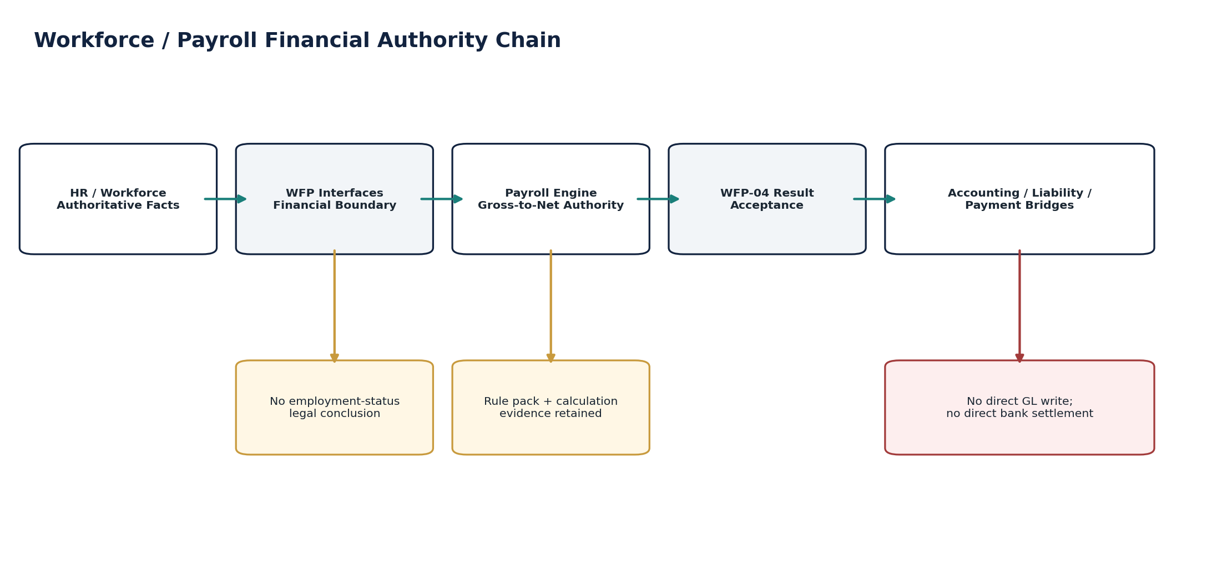
Figure 1 — Workforce / Payroll financial authority chain.

1. Domain Scope, Service Inventory & Authority Model

1.1 Canonical service inventory
ID | Service | Catalogue purpose
WFP-01 | Worker Financial Profile Interface | Receive worker attributes needed for accounting/payroll interfaces.
WFP-02 | Time & Leave Financial Import | Import approved time/leave for costing/payroll.
WFP-03 | Payroll Input Interface | Provide/receive payroll earning/deduction inputs.
WFP-04 | Payroll Result Interface | Receive approved gross-to-net results.
WFP-05 | Payroll Journal Interface | Route approved payroll results into governed accounting events / posting.
WFP-06 | Payroll Liability Interface | Track payroll tax/social/benefit liabilities.
WFP-07 | Payroll Payment Interface | Create approved payee payment instructions from payroll.

1.2 Non-bypassable Workforce / Payroll financial invariants
- WFP services SHALL NOT determine legal employment status, worker classification or payroll tax law independently from the authoritative HR/payroll/jurisdiction systems.
- Every payroll-relevant worker profile SHALL bind to tenant, legal entity, worker/assignment reference, payroll jurisdiction, pay currency and effective date.
- WFP-02 SHALL accept only approved/final time or leave populations with source approval evidence.
- WFP-03 SHALL retain provenance for each earning, deduction, benefit, reimbursement or adjustment input.
- Payroll input batches SHALL be frozen/versioned before a payroll calculation is accepted as final.
- WFP-04 SHALL accept only approved source payroll runs with calculation/rule evidence and control totals.
- WFP-04 SHALL NOT recompute gross-to-net using generic GL logic.
- Worker-level results SHALL roll to run-level gross, taxable pay, employee deduction, employer liability and net-pay control totals.
- Approved payroll results SHALL be immutable; corrections create superseding versions or explicit reversal/correction chains.
- WFP-05 SHALL create governed accounting events only; direct GL/journal database writes are prohibited.
- Payroll posting rules SHALL be versioned by book/entity/jurisdiction/effective period and retained with the accounting event.
- WFP-06 liabilities SHALL retain liability class, beneficiary/authority, due date, jurisdiction/rule reference, amount, currency and settlement state.
- Liability settlement SHALL be confirmed from authoritative Banking/authority evidence, not from payment initiation alone.
- WFP-07 SHALL resolve beneficiary identity from approved Payee Master/Banking Identity versions and SHALL NOT trust free-form bank details from payroll files.
- Protected payment-instruction changes after approval SHALL invalidate the approval fingerprint.
- WFP-07 SHALL NOT own payment execution, settlement or finality.
- External or provider ambiguity SHALL use Pending/Unknown and resolve the original attempt before any retry that could cause a second financial effect.
- Payroll, accounting, liability and payment populations SHALL reconcile using frozen populations and explicit exception ownership.
- Every material payroll financial fact SHALL retain source-to-report lineage and evidence under retention/legal-hold policy.
- No AI-generated numeric payroll result, liability, payment amount or accounting journal may become authoritative without deterministic engine output and governed approval.

1.3 Cross-domain authority matrix
Fact / decision | Authority | WFP boundary
Worker/person/legal employment facts | HR / Workforce system | WFP mirrors minimum financial attributes only.
Approved time / leave | ZoikoTime / HR / approved source | WFP-02 imports; does not approve attendance.
Gross-to-net calculation | Zoiko Payroll or approved payroll engine | WFP-04 accepts approved result; does not recompute.
Payroll tax/social rules | Jurisdiction Pack + payroll engine rule set | Exact version retained with run/result.
Accounting consequence | ACC-04 Posting Engine | WFP-05 emits governed accounting event only.
Payroll liabilities | WFP-06 + Tax/authority references | Financial liability tracking; authority state may be external.
Beneficiary/payee identity | ORG-10 Payee Master / Banking Identity | WFP-07 references approved version; no free-form override.
Payment execution/finality | Banking domain | WFP-07 proposes/authorizes instruction; Banking executes.
Reconciliation | DATA-07 / ZS-CONTROL-001 | Frozen payroll/accounting/bank/authority populations.
Retention/legal hold | ZS-DATA-GOV-001 / GOV-09/10 | Applies to payroll evidence and derived records.
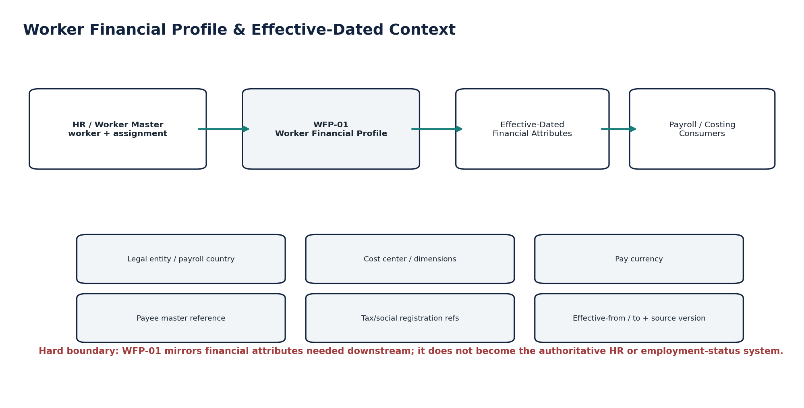
Figure 2 — Worker financial profile and effective-dated context.

2. Shared Domain Contract

2.1 Required server-resolved context
Context field | Requirement
tenant_id | Authenticated tenant context; never trusted from arbitrary client body.
legal_entity_id | Paying/employing entity resolved from worker/assignment and payroll run.
worker_id / assignment_id | Stable source references with source-system identity and effective dates.
payroll_jurisdiction_id | Country/subdivision/regime scope required for source payroll run.
payroll_period_id | Canonical payroll period and pay date; distinct from accounting posting period.
accounting_book_id | Book receiving payroll consequence, resolved by policy.
currency | Pay/run currency; conversions retain exact rate/source/version if required.
rule_manifest_id | Exact payroll calculation/rule-set manifest used by source engine.
source_system_id | Zoiko Payroll, external payroll provider, Zoiko HR/Time or approved source.
correlation_id / causation_id | Cross-run lineage and incident/replay correlation.

2.2 Canonical payroll run/result identity
A payroll result accepted by WFP-04 is identified by the tuple: tenant + legal entity + source payroll run ID + source run version + payroll period + pay date + rule manifest + result fingerprint. Replays of the same tuple must return the same accepted result. A materially changed source run must create a new version/supersession relationship rather than reuse the original identity.
Do not use “payroll period + employee” as the only idempotency key. Retro runs, off-cycle payrolls, corrections, parallel payroll groups and provider retries make that key unsafe.

2.3 Orthogonal payroll financial states
Dimension | Canonical states
Input state | Draft / Validated / Frozen / Superseded
Run acceptance state | Received / Validating / Accepted / Rejected / Quarantined / Superseded
Accounting state | NotRequired / Pending / EventCreated / Posted / Rejected / Corrected
Liability state | Recognized / Due / Scheduled / Paid / Reconciled / Disputed / Adjusted
Payment-instruction state | Draft / Validated / Approved / SubmittedToBanking / Cancelled / Superseded
Bank settlement state | NotSubmitted / PendingUnknown / Accepted / Settled / Rejected / Returned / Reversed
Exception state | None / ReviewRequired / Blocked / Investigation / Resolved

2.4 Idempotency, concurrency & frozen-population rules
- Material ingest/command operations require Idempotency-Key plus stable source/run identity.
- Protected changes require expected_version / If-Match semantics. A stale worker mapping, liability or payment instruction cannot silently overwrite a newer version.
- Payroll input and result populations become frozen when used for approved calculation, accounting event, liability schedule, payment instruction or certification.
- Late source records enter a controlled delta/correction workflow; they never mutate a certified population silently.
- Events are emitted only after authoritative commit via the transactional outbox and consumed through inbox/deduplication controls.
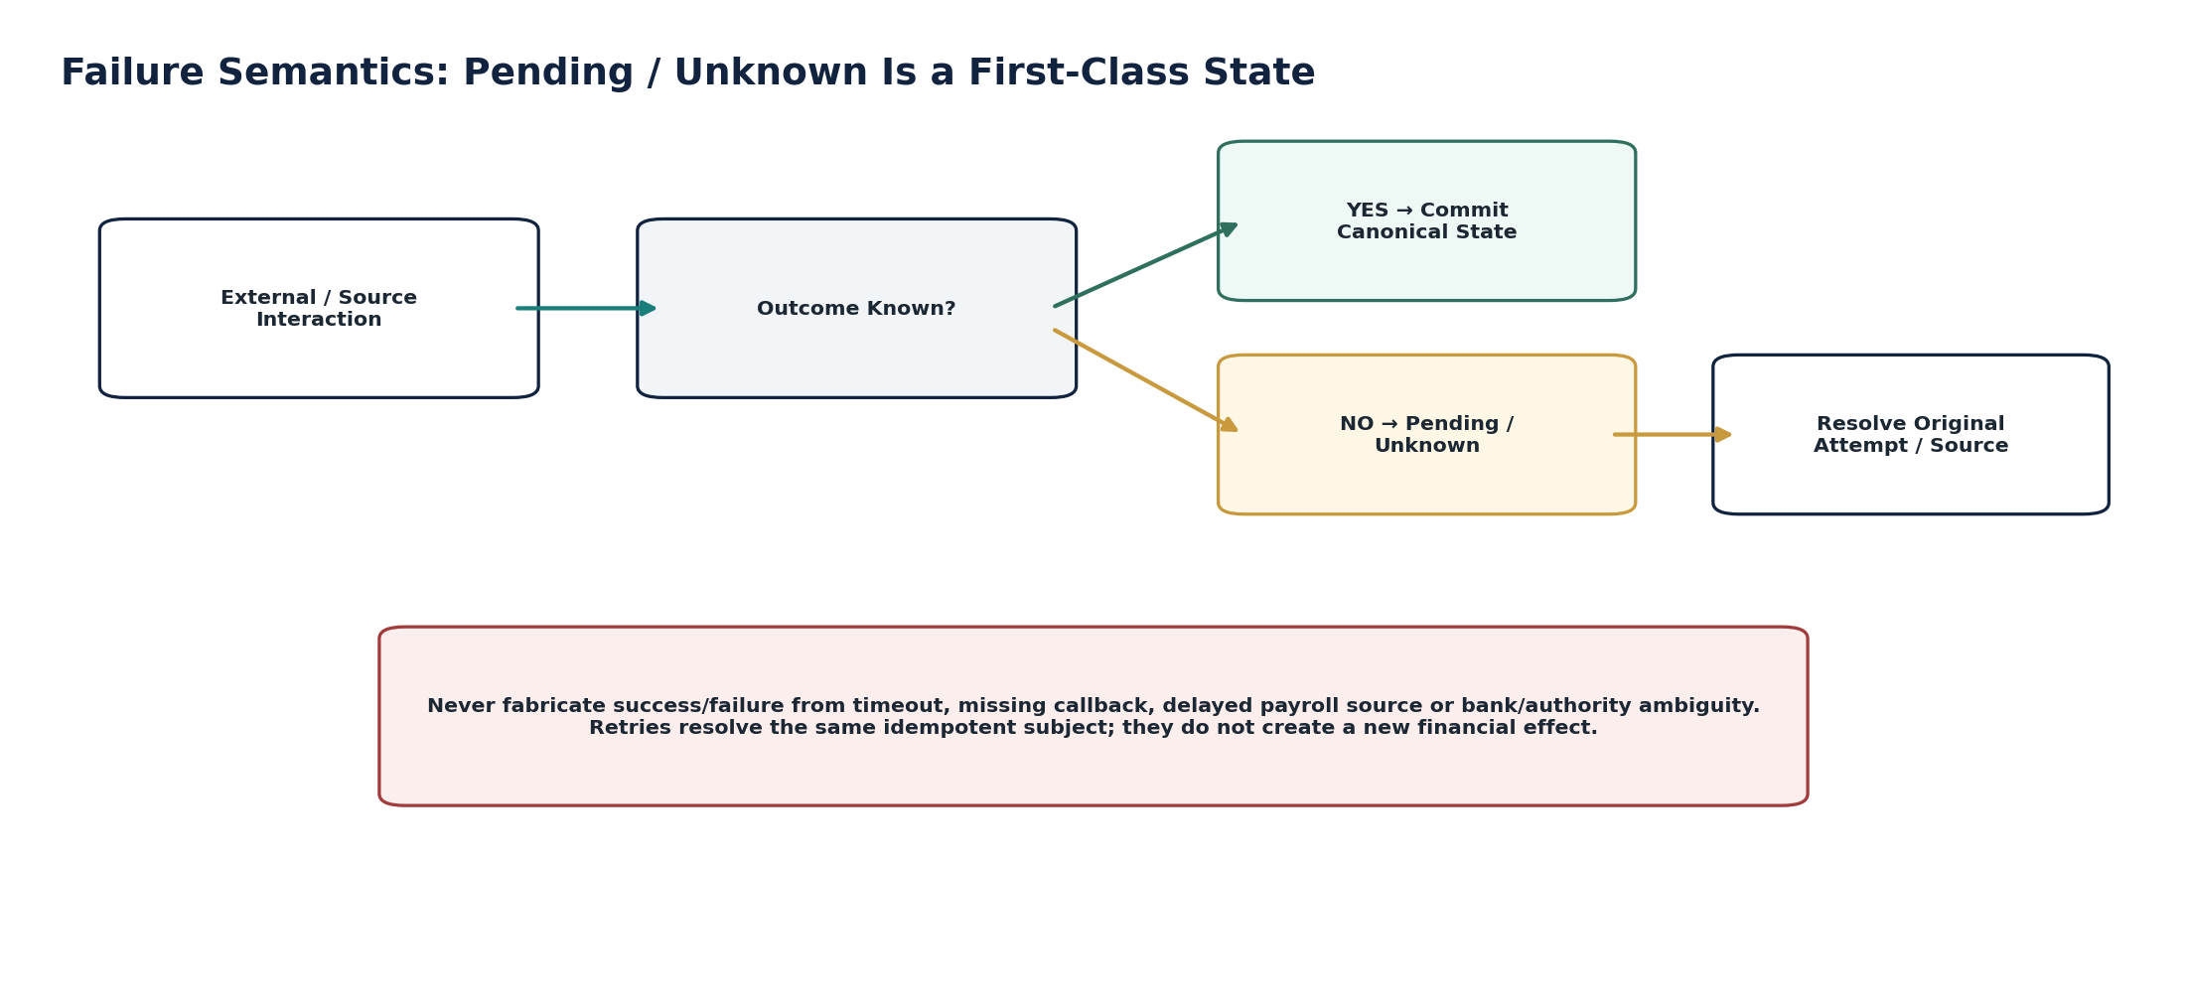
Figure 3 — Pending/Unknown is a first-class failure state.

3. Canonical Data Model, Events & Evidence

3.1 Canonical persistence objects
Object | Purpose
WorkerFinancialProfileRef | Financial subset of worker/assignment attributes with effective-dated source references.
TimeLeaveFinancialBatch | Approved time/leave population snapshot and control totals.
PayrollInputBatch | Frozen payroll earning/deduction/benefit input population.
PayrollInputLine | Source-linked earning, deduction, benefit, reimbursement or adjustment line.
PayrollRunRef | Source payroll run identity, version, status, period and rule-manifest reference.
PayrollResult | Accepted run-level payroll result and fingerprint.
PayrollResultWorker | Worker-level gross-to-net summary and source calculation evidence reference.
PayrollResultComponent | Earning/deduction/tax/social/employer-cost/net component with classification and amount.
PayrollRuleManifestRef | Exact effective-dated source payroll rule/calculation configuration manifest.
PayrollAccountingBridge | Mapping from accepted payroll result/version to accounting event and posted journal references.
PayrollLiability | Tax/social/pension/benefit/garnishment liability and settlement state.
PayrollPaymentInstruction | Approved net-pay instruction subject referencing controlled payee identity.
PayrollCorrectionChain | Original result, superseding result, reversal/adjustment and reason/evidence links.
PayrollReconciliationRun | Frozen population comparison and exception evidence.
PayrollEvidencePackage | Manifest linking source, approvals, rules, results, accounting, liabilities, payments and controls.

3.2 Canonical events
Event | Producer | Meaning
worker_financial_profile_synced | WFP-01 | Financial subset accepted/superseded.
time_leave_financial_batch_accepted | WFP-02 | Approved time/leave batch accepted.
payroll_input_batch_frozen | WFP-03 | Payroll input population frozen.
payroll_result_accepted | WFP-04 | Approved gross-to-net result accepted.
payroll_result_rejected | WFP-04 | Result failed authority/control checks.
payroll_result_superseded | WFP-04 | New result version supersedes original.
payroll_accounting_event_created | WFP-05 | Accounting event created for ACC-04.
payroll_accounting_rejected | WFP-05 | Posting subject rejected by Accounting Kernel.
payroll_liability_recognized | WFP-06 | Liability created/updated.
payroll_liability_settled | WFP-06 | Settlement confirmed from authority/banking evidence.
payroll_payment_instruction_approved | WFP-07 | Protected instruction approved.
payroll_payment_instruction_invalidated | WFP-07 | Protected subject changed after approval.
payroll_payment_submitted_to_banking | WFP-07 | Instruction handed to Banking domain.
payroll_reconciliation_exception_created | Control | Payroll/accounting/payment/liability difference created.
payroll_evidence_package_certified | Evidence | Evidence manifest frozen/certified.

3.3 Evidence minimum
- Source system/run identity and exact source version.
- Worker/assignment/entity mappings and effective dates.
- Approved time/leave and payroll input source references.
- Payroll engine rule manifest, calculation version and approval/finality evidence.
- Run-level and worker-level control totals/fingerprints.
- Accounting event/posting references and posting-rule version.
- Liability authority/beneficiary, due date, rule source and settlement evidence.
- Payment instruction approval fingerprint, payee identity version and Banking attempt/finality references.
- Reconciliation runs, exceptions, remediation and reperformance.
- Retention/legal-hold state, actor/workload, correlation/causation IDs and immutable audit events.
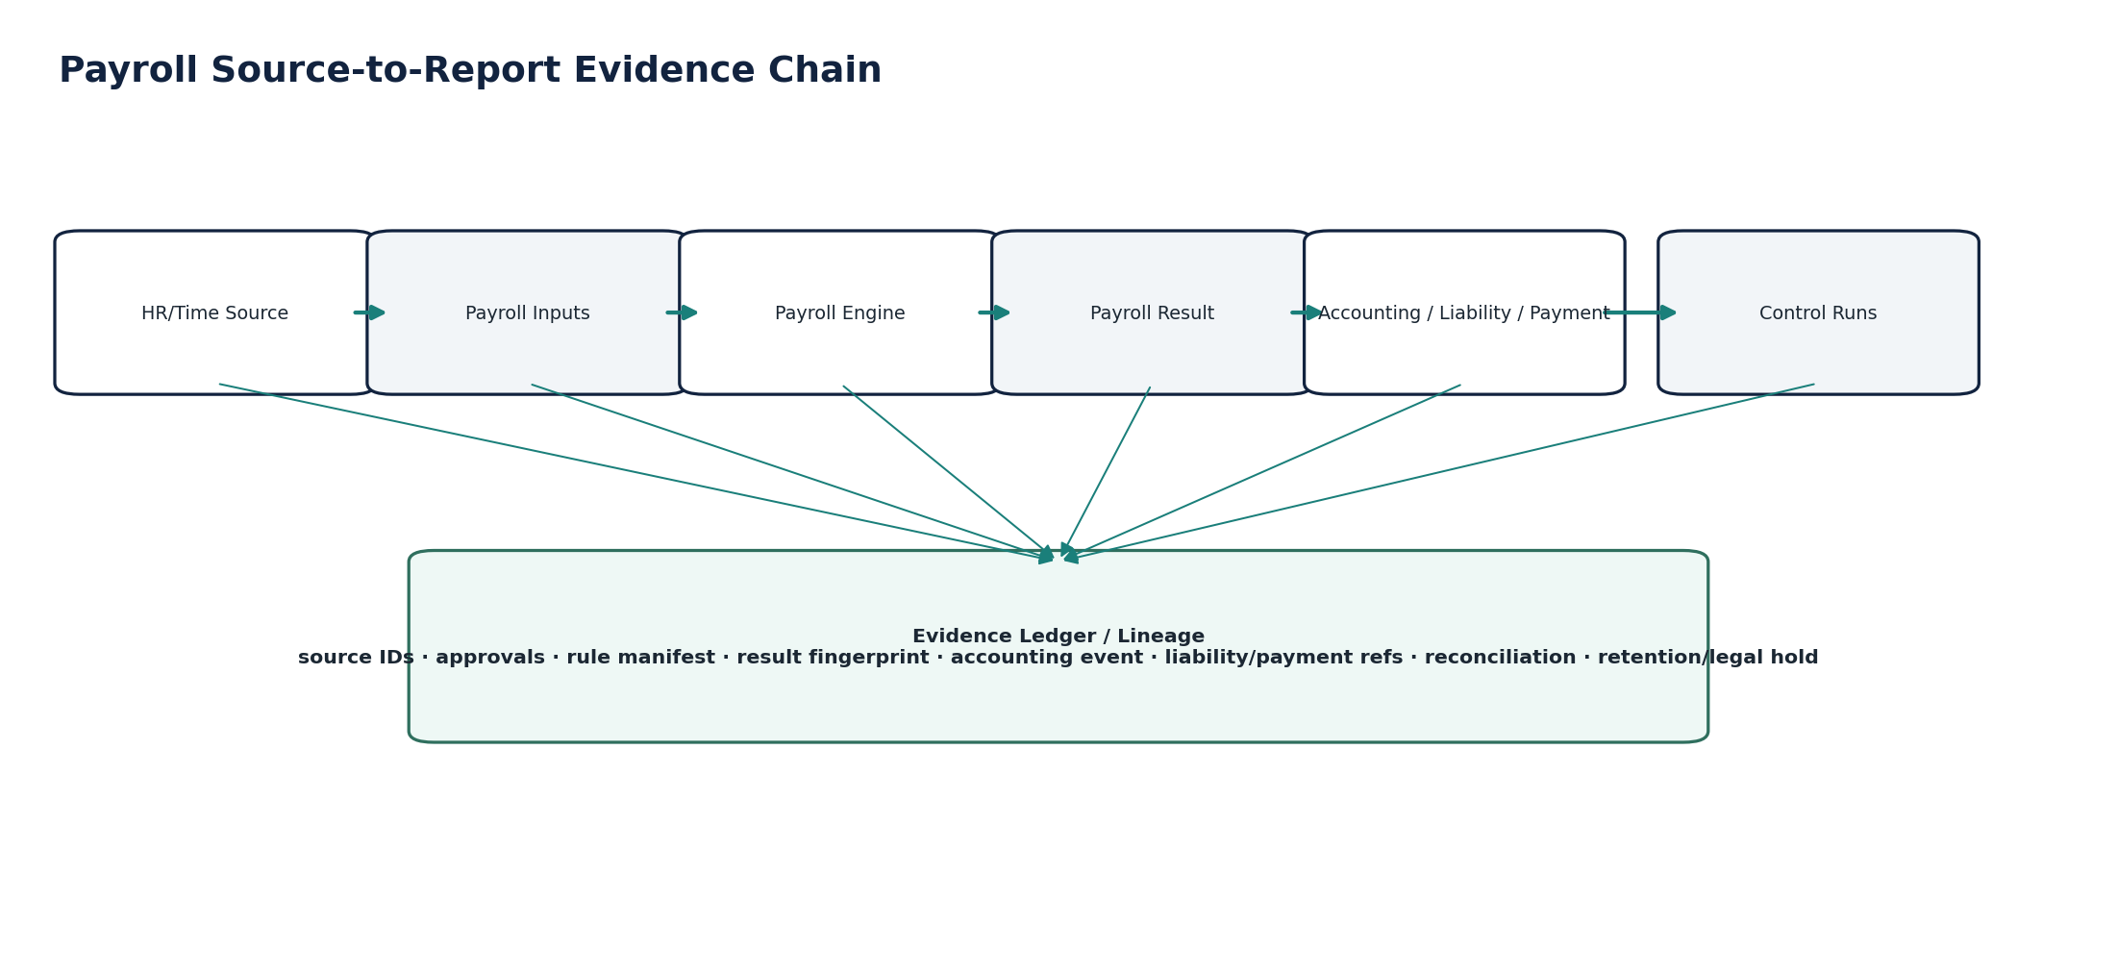
Figure 4 — Payroll source-to-report evidence chain.

4. WFP-01 — Worker Financial Profile Interface
Receive and version the minimum worker/assignment attributes required by costing, payroll financial interfaces, liabilities and payment routing without becoming the HR master.

Contract area | Build-ready requirement
Purpose / outcome | Receive and version the minimum worker/assignment attributes required by costing, payroll financial interfaces, liabilities and payment routing without becoming the HR master.
Authoritative ownership | WorkerFinancialProfileRef version, source mapping, financial dimensions, payroll jurisdiction/pay currency and approved payee-master reference as mirrored financial context.
Must not own | Legal employment-status conclusion, worker personal master, employment contract, HR lifecycle, tax calculation or bank settlement.
Required source inputs | worker_id; assignment_id; legal entity; payroll country/regime; pay currency; employment/engagement classification from authoritative source; cost center/dimensions; payee master ref; effective_from/to; source version.
Server-resolved context | Tenant; entity scope; dimension validity; jurisdiction registry; payee identity availability; source-system trust profile.
Named commands | SyncWorkerFinancialProfile; SupersedeWorkerFinancialProfile; DeactivateFinancialProfile; RevalidateMappings.
Queries | GetWorkerFinancialProfile; GetAsOfProfile; ListProfileVersions; ValidateWorkerFinancialContext.
State / workflow | Received → Validating → Active / Rejected / Quarantined → Superseded. High-risk payee-reference change may require maker-checker depending source/tenant policy.
Authorization / SoD | workforce.financial_profile.sync; read restricted by payroll/finance scope; support cannot alter source-owned facts.
Events | worker_financial_profile_synced; worker_financial_profile_rejected; worker_financial_profile_superseded.
Idempotency / concurrency | Idempotent by source system + worker/assignment + source version; protected changes require expected version.
Failure semantics | Missing legal entity, invalid dimension, unsupported payroll jurisdiction or unknown payee ref = block/quarantine; do not default.
Evidence / lineage | Source object/version, effective dates, mapping result, actor/workload, previous/new fingerprints.
NFR / recovery | C1 authoritative interface; stale profile detection before payroll freeze; as-of reconstruction required.
Minimum acceptance tests | Cross-entity mapping; stale source update; out-of-order effective dates; payee ref changed; inactive worker; jurisdiction mismatch; as-of replay.

Figure 5 — Worker Financial Profile Interface engineering flow.

5. WFP-02 — Time & Leave Financial Import
Import only approved time, absence and leave populations required for payroll or cost attribution.

Contract area | Build-ready requirement
Purpose / outcome | Import only approved time, absence and leave populations required for payroll or cost attribution.
Authoritative ownership | Financial import batch, normalized costing/payroll units, source line references, validation/quarantine results.
Must not own | Attendance truth, leave approval, schedule truth, overtime legal entitlement or final gross-to-net result.
Required source inputs | Approved time/leave batch; worker/assignment; work/leave date; approved hours/units; pay code/category; source approval status; source line ID; timezone; dimension/cost allocation where applicable.
Server-resolved context | Worker financial profile; payroll period; business calendar; UOM conversion; pay-code mapping; entity/dimension validity.
Named commands | ImportTimeLeaveBatch; ValidateTimeLeaveBatch; FreezeTimeLeaveFinancialBatch; QuarantineLine; SupersedeBatch.
Queries | GetBatch; ListBatchExceptions; GetWorkerImportedUnits; GetBatchControlTotals.
State / workflow | Received → Validating → Accepted → Frozen → Superseded; invalid lines may quarantine while batch policy determines partial or full rejection.
Authorization / SoD | Approved source connector/workload only for ingest; manual adjustments require separate maker-checker path.
Events | time_leave_financial_batch_received; time_leave_financial_batch_accepted; time_leave_line_quarantined; time_leave_financial_batch_frozen.
Idempotency / concurrency | Batch/line idempotency by source batch + source line; duplicate source record cannot create duplicate financial units.
Failure semantics | Unapproved time, missing worker, closed payroll input cutoff, invalid UOM or duplicate source line = block/quarantine.
Evidence / lineage | Source approval evidence, source hash/control totals, normalization version, mapping result, accepted/rejected counts.
NFR / recovery | Bulk/batch capable; deterministic replay; backpressure and partial-failure reporting required.
Minimum acceptance tests | Duplicate timesheet lines; approved→revoked source; daylight-saving boundary; cross-period line; UOM mismatch; late correction; partial batch failure.
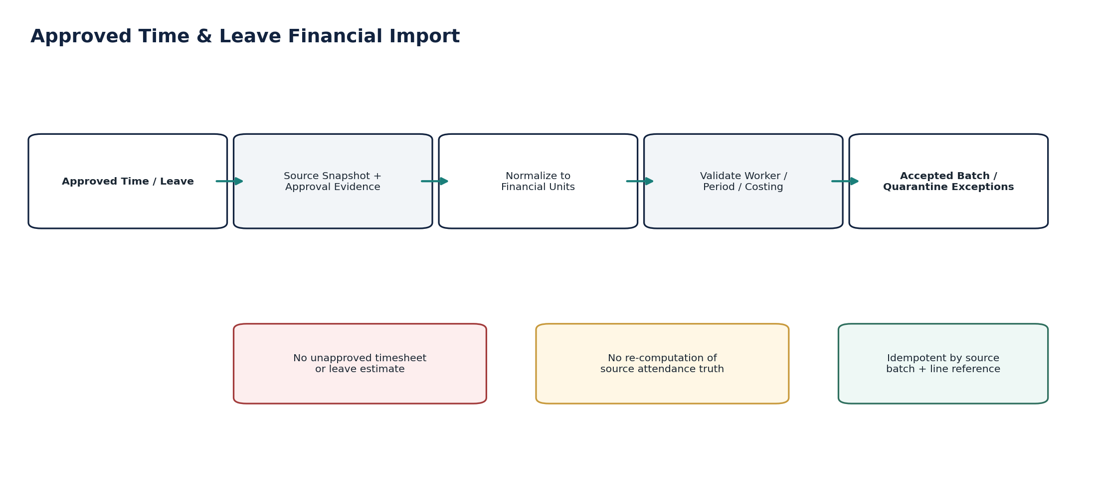
Figure 6 — Time & Leave Financial Import engineering flow.

6. WFP-03 — Payroll Input Interface
Provide/receive governed earning, deduction, benefit, reimbursement and adjustment inputs for a payroll calculation.

Contract area | Build-ready requirement
Purpose / outcome | Provide/receive governed earning, deduction, benefit, reimbursement and adjustment inputs for a payroll calculation.
Authoritative ownership | PayrollInputBatch, input lines, source provenance, classification/mapping, frozen input population and batch control totals.
Must not own | Gross-to-net calculation, statutory rates, payroll finality, accounting journal or payment settlement.
Required source inputs | Worker; input type/code; amount/quantity; currency/UOM; effective/pay period; source object; reason; taxability/pre-tax/post-tax classification from authoritative source where provided; approval evidence.
Server-resolved context | Worker financial profile; payroll calendar; source-system trust profile; jurisdiction/rule pack reference; payroll code mapping; duplicate rules.
Named commands | CreatePayrollInputBatch; AddPayrollInput; ValidatePayrollInputBatch; FreezePayrollInputBatch; SupersedePayrollInput; CancelUnfrozenBatch.
Queries | GetPayrollInputBatch; ListInputExceptions; GetWorkerInputs; GetInputControlTotals.
State / workflow | Draft → Validating → Ready → Frozen → Consumed / Superseded. Frozen batch cannot be edited in place.
Authorization / SoD | Input creator cannot approve protected manual payroll adjustment if maker-checker required; automated trusted-source input may use service identity with policy controls.
Events | payroll_input_created; payroll_input_batch_validated; payroll_input_batch_frozen; payroll_input_superseded.
Idempotency / concurrency | Stable source reference + input type + effective period; protected manual corrections version-bound.
Failure semantics | Missing provenance, ambiguous code mapping, unsupported currency/UOM, conflicting duplicate or expired approval = block/quarantine.
Evidence / lineage | Source reference, approval, code mapping version, amount/quantity, classification, prior/superseding line.
NFR / recovery | C1; deterministic import/replay; supports high-volume variable pay and benefits batches.
Minimum acceptance tests | Duplicate earning; negative deduction edge; retro input; superseded bonus; manual adjustment self-approval; mixed currencies; stale worker mapping.
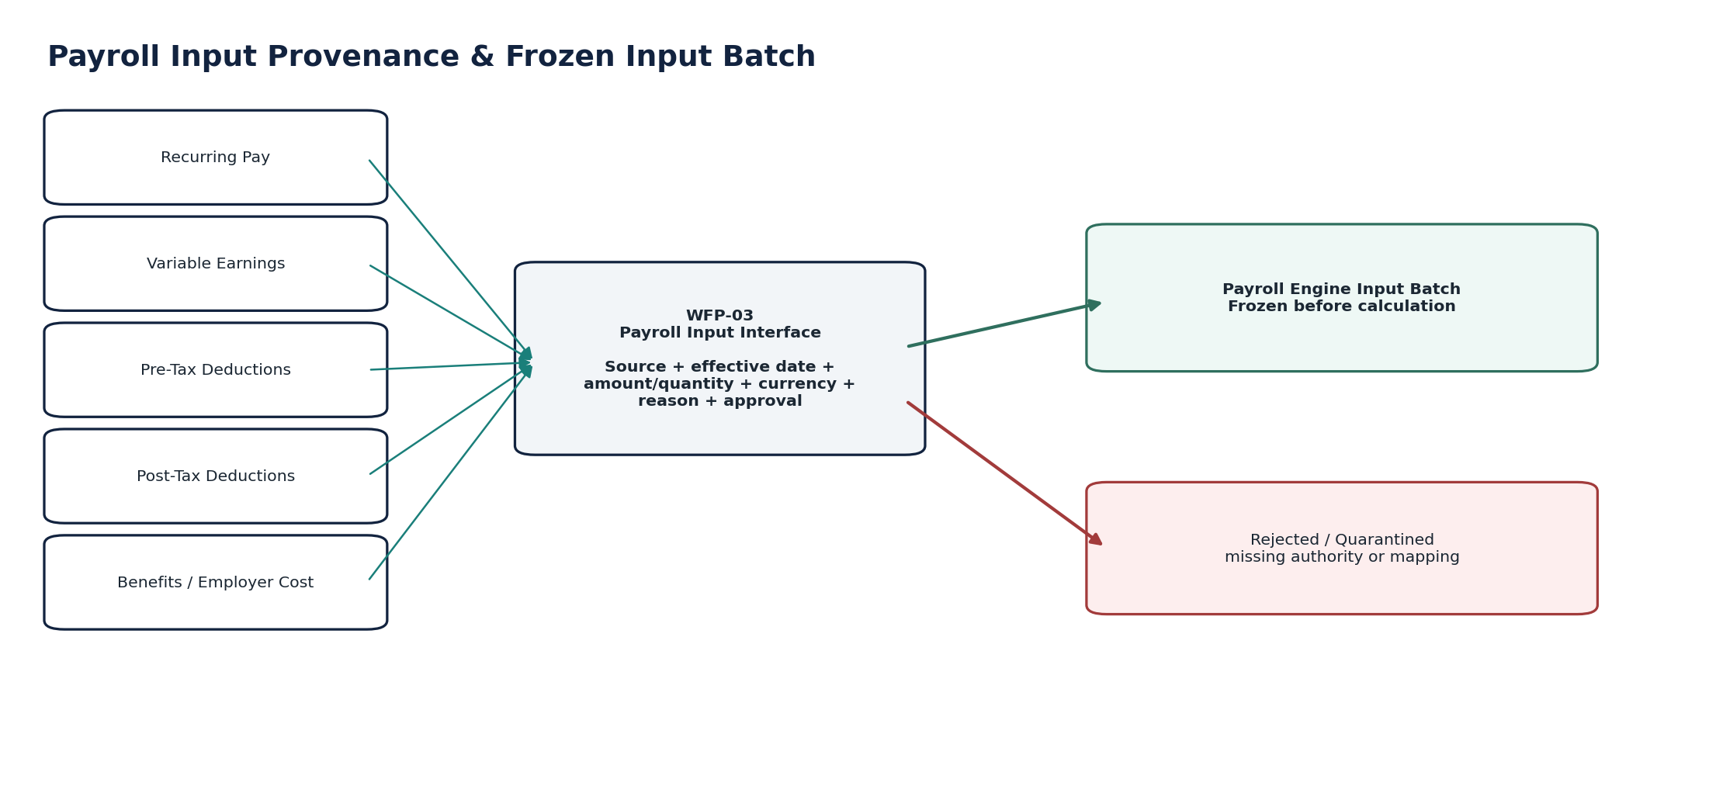
Figure 7 — Payroll Input Interface engineering flow.

7. WFP-04 — Payroll Result Interface
Receive and certify approved gross-to-net payroll results from Zoiko Payroll or an approved payroll engine.

Contract area | Build-ready requirement
Purpose / outcome | Receive and certify approved gross-to-net payroll results from Zoiko Payroll or an approved payroll engine.
Authoritative ownership | Payroll result reference/version, accepted worker/run component totals, result fingerprint and rule/calculation evidence references.
Must not own | Payroll statutory calculation logic itself, HR facts, journal posting, liability settlement or bank finality.
Required source inputs | Payroll run; worker result; gross; taxable pay where applicable; employee deductions; taxes/social/pension/benefit deductions; employer liabilities/costs; net pay; currency; period/pay date; source run status; rule/calculation evidence.
Server-resolved context | Source trust profile; worker/entity mapping; accepted frozen input batch refs; jurisdiction; rule manifest; tolerance/control profile.
Named commands | ReceivePayrollResult; ValidatePayrollResult; AcceptPayrollResult; RejectPayrollResult; SupersedePayrollResult; RevalidateControlTotals.
Queries | GetPayrollResult; GetWorkerResult; ListResultComponents; GetRunControlTotals; GetResultEvidence.
State / workflow | Received → Validating → Accepted / Rejected / Quarantined → Superseded. Accepted result is immutable.
Authorization / SoD | Only approved payroll connector/workload may submit; manual acceptance/rejection requires payroll finance authority and SoD.
Events | payroll_result_received; payroll_result_accepted; payroll_result_rejected; payroll_result_superseded.
Idempotency / concurrency | Idempotent by source run ID + source version + result fingerprint. Changed result must create a new version.
Failure semantics | Run not final, missing rule manifest, control-total mismatch, worker/entity mismatch or duplicate conflicting version = block; never “fix” by recomputing in WFP.
Evidence / lineage | Source run approval/finality, exact rule manifest, calculation evidence ref, worker/control totals, input batch refs, fingerprint.
NFR / recovery | C0/C1 financial correctness; zero tolerated accepted result with broken gross-to-net/control totals.
Minimum acceptance tests | Duplicate run; changed result same ID; missing employer liability; net pay mismatch; stale rule manifest; off-cycle run; retro correction; cross-entity worker.
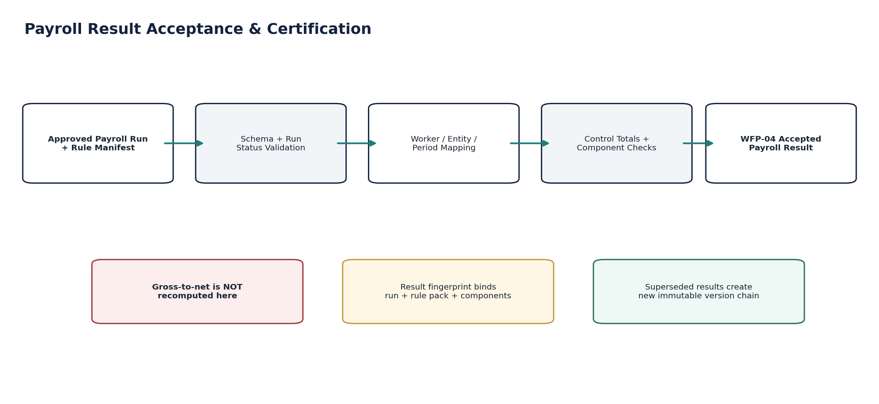
Figure 8 — Payroll Result Interface engineering flow.

8. WFP-05 — Payroll Journal Interface
Translate accepted payroll results into governed accounting-event subjects and route them through ACC-04 Posting Engine.

Contract area | Build-ready requirement
Purpose / outcome | Translate accepted payroll results into governed accounting-event subjects and route them through ACC-04 Posting Engine.
Authoritative ownership | PayrollAccountingBridge, accounting-event request/status and result-to-journal lineage.
Must not own | General Ledger, journal posting, chart-of-accounts authority, accounting period state or payroll calculation.
Required source inputs | Accepted PayrollResult version; result components; entity/book/period; dimensions; posting basis; correction relationship if applicable.
Server-resolved context | Accounting book; posting rule version; account mappings; control accounts; period state; FX policy/rate source if cross-currency.
Named commands | CreatePayrollAccountingEvent; SubmitPayrollAccountingEvent; ReversePayrollAccountingEvent; ReconcilePayrollPosting.
Queries | GetPayrollAccountingBridge; GetPostingStatus; GetJournalReferences; GetPayrollToGLLineage.
State / workflow | NotRequired / Pending → EventCreated → Submitted → Posted / Rejected → Corrected. No direct GL insert path.
Authorization / SoD | Payroll result acceptance and posting approval separated where required; Accounting Kernel enforces posting authority.
Events | payroll_accounting_event_created; payroll_accounting_posted; payroll_accounting_rejected; payroll_accounting_corrected.
Idempotency / concurrency | One canonical accounting subject per accepted result version + book + posting purpose; retries reuse same subject.
Failure semantics | Closed period, missing account mapping, invalid dimension, unbalanced posting proposal or control-account policy failure = Accounting rejection; payroll result remains unchanged.
Evidence / lineage | Payroll result version → accounting event → posting rule → journal/posting ID → signed snapshot lineage.
NFR / recovery | C0 accounting correctness; posting retries idempotent; no duplicate journals.
Minimum acceptance tests | Direct GL write blocked; duplicate event retry; closed period; missing mapping; unbalanced posting; corrected payroll result reversal; multiple books.
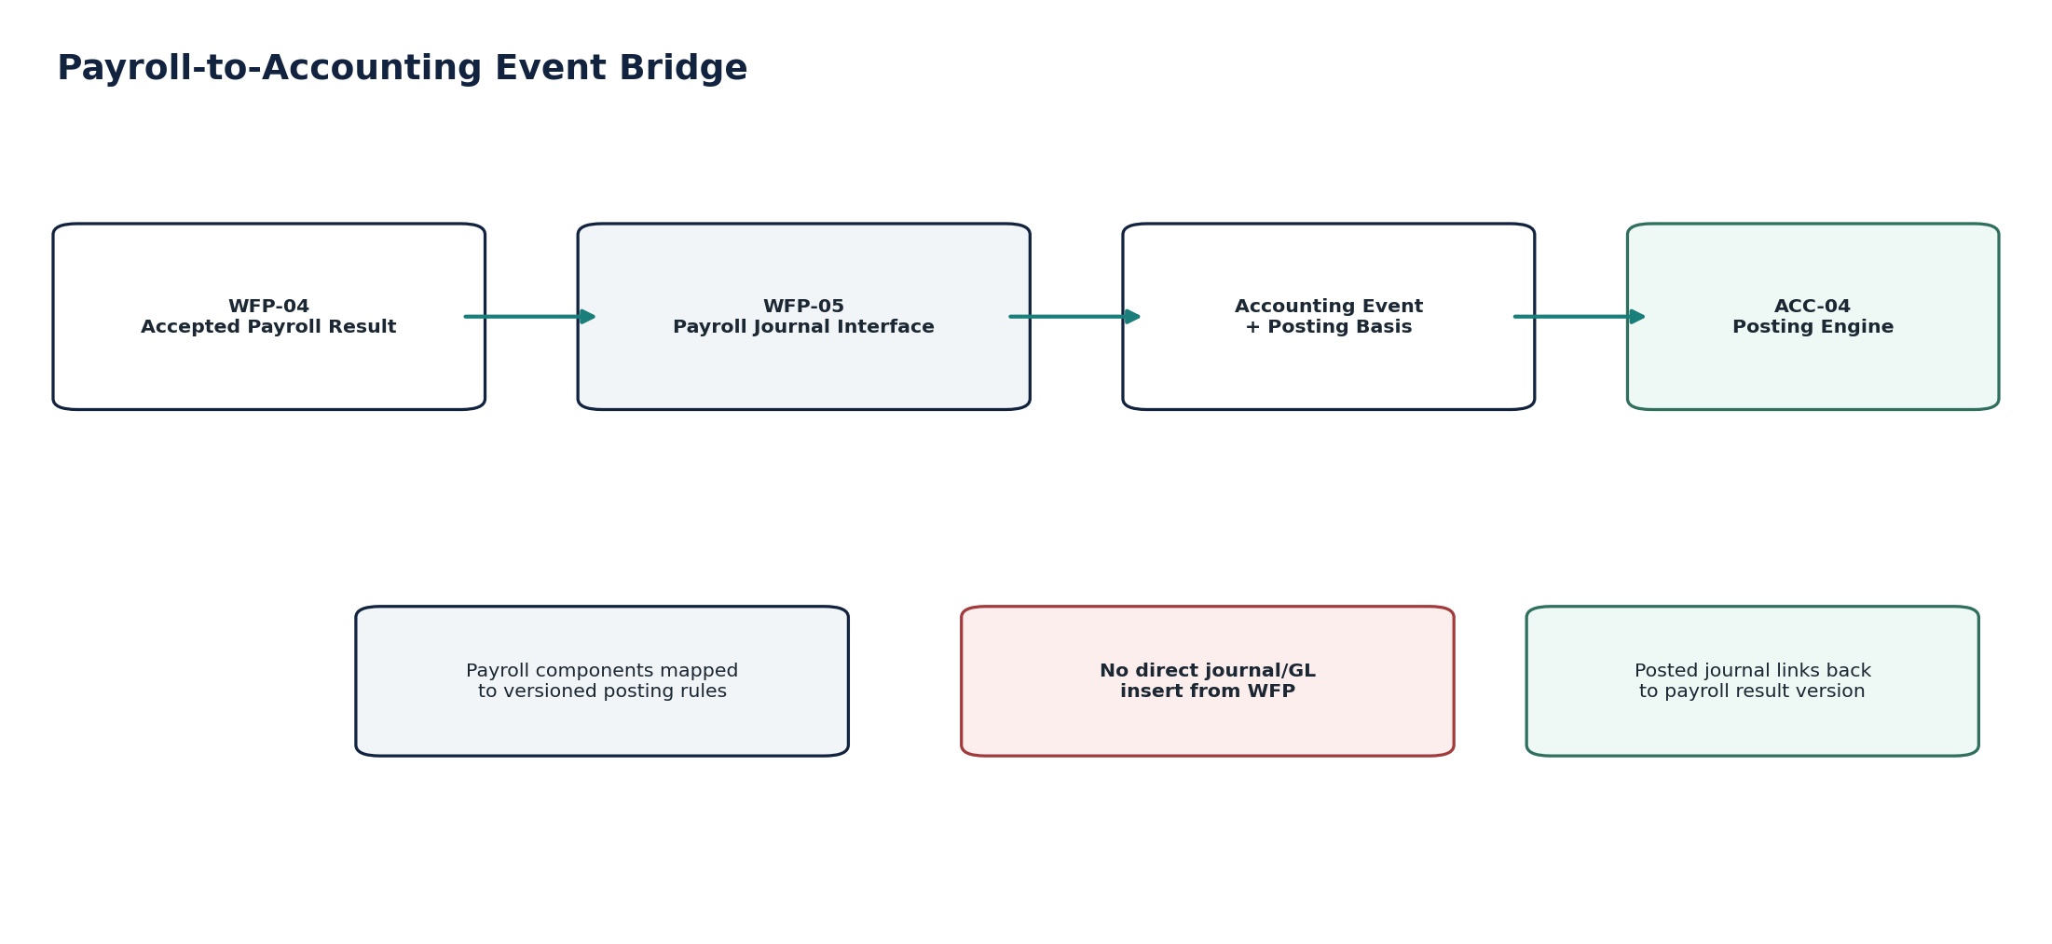
Figure 9 — Payroll Journal Interface engineering flow.

9. WFP-06 — Payroll Liability Interface
Track payroll tax, social insurance, pension, benefit, garnishment and other payroll-derived liabilities through due, payment and reconciliation states.

Contract area | Build-ready requirement
Purpose / outcome | Track payroll tax, social insurance, pension, benefit, garnishment and other payroll-derived liabilities through due, payment and reconciliation states.
Authoritative ownership | PayrollLiability financial tracking record, due-date/rule linkage, allocation to authority/beneficiary and settlement/reconciliation status.
Must not own | Statutory law, payroll calculation, authority filing result, Banking settlement or GL posting.
Required source inputs | Accepted payroll result components; liability class; authority/beneficiary; employee/employer amounts; currency; due date basis; jurisdiction/rule reference; payroll period.
Server-resolved context | Jurisdiction obligation calendar; authority/beneficiary master; accounting liability account mapping; Banking settlement references; filing/return references where applicable.
Named commands | RecognizePayrollLiability; SchedulePayrollLiability; LinkSettlement; AdjustPayrollLiability; MarkDisputed; ReconcilePayrollLiability.
Queries | GetPayrollLiability; ListDueLiabilities; GetAuthorityBalance; GetLiabilityReconciliation.
State / workflow | Recognized → Due → Scheduled/Submitted → Paid/Settled → Reconciled; Disputed/Adjusted are orthogonal exception/correction paths.
Authorization / SoD | Liability adjustment/waiver requires delegated finance/tax authority; payment initiation is separate.
Events | payroll_liability_recognized; payroll_liability_due; payroll_liability_settled; payroll_liability_adjusted; payroll_liability_reconciliation_failed.
Idempotency / concurrency | Liability identity binds result component + authority/beneficiary + liability type + period; settlement links idempotent by authoritative bank/authority ref.
Failure semantics | Missing authority, ambiguous due date, unsupported rule, payment attempt without settlement or filing mismatch = ReviewRequired/Blocked; never mark paid from intent alone.
Evidence / lineage | Payroll result component, rule manifest, due-date source, authority/beneficiary, accounting ref, banking/filing settlement evidence.
NFR / recovery | C0/C1 for legal-timing liabilities; deadline observability and non-dismissible escalation required.
Minimum acceptance tests | Duplicate liability; due-date rule change; payment pending unknown; partial settlement; authority refund; liability correction; filing/GL mismatch; legal hold.
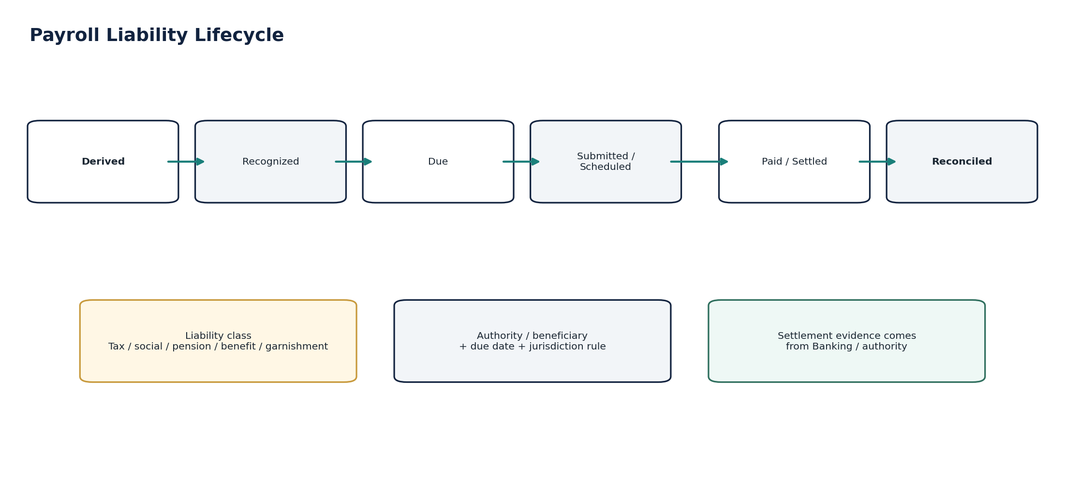
Figure 10 — Payroll Liability Interface engineering flow.

10. WFP-07 — Payroll Payment Interface
Create approved net-pay and approved payroll beneficiary payment instructions for Banking without executing or finalizing the payment.

Contract area | Build-ready requirement
Purpose / outcome | Create approved net-pay and approved payroll beneficiary payment instructions for Banking without executing or finalizing the payment.
Authoritative ownership | PayrollPaymentInstruction subject, protected approval fingerprint, source result links and Banking handoff references.
Must not own | Beneficiary bank master, Banking provider message, payment execution, settlement/finality or payroll calculation.
Required source inputs | Accepted PayrollResult/worker result; net pay or authorized beneficiary amount; currency; pay date/value date; payee master reference/version; paying bank account policy; payment method; purpose/reference.
Server-resolved context | Payee identity from ORG-10; paying account from Banking policy; payment rail/profile; signer limits; approval/quorum; cutoff calendar; Banking idempotency contract.
Named commands | CreatePayrollPaymentInstruction; ValidatePayrollPaymentInstruction; ApprovePayrollPaymentInstruction; InvalidatePaymentApproval; SubmitToBanking; CancelUnsubmittedInstruction; SupersedeInstruction.
Queries | GetPayrollPaymentInstruction; GetApprovalFingerprint; GetBankingHandoffStatus; ListPendingPayrollPayments.
State / workflow | Draft → Validated → Approved → SubmittedToBanking → HandedOff / Cancelled / Superseded. Bank settlement state is separately consumed from Banking.
Authorization / SoD | Maker-checker and signing authority; payroll preparer cannot self-authorize protected payment where policy forbids; payee changes force reapproval.
Events | payroll_payment_instruction_created; payroll_payment_instruction_approved; payroll_payment_instruction_invalidated; payroll_payment_submitted_to_banking.
Idempotency / concurrency | Instruction fingerprint binds payroll result, payee version, amount, currency, date and paying-account context. Retry reuses same subject.
Failure semantics | Missing/changed payee, stale approval, unavailable rail or Banking timeout = Blocked/Pending; resolve original Banking attempt before any new instruction that could duplicate payment.
Evidence / lineage | Payroll result → payee identity version → approval fingerprint → Banking attempt → finality/return/reversal → reconciliation.
NFR / recovery | C0 irreversible-money-movement boundary; zero duplicate instruction with same protected subject; strong observability and runbook ownership.
Minimum acceptance tests | Payee changed after approval; duplicate submit; timeout unknown; returned payment; partial run; wrong entity bank account; self-approval; reused authorization; payroll result superseded before handoff.
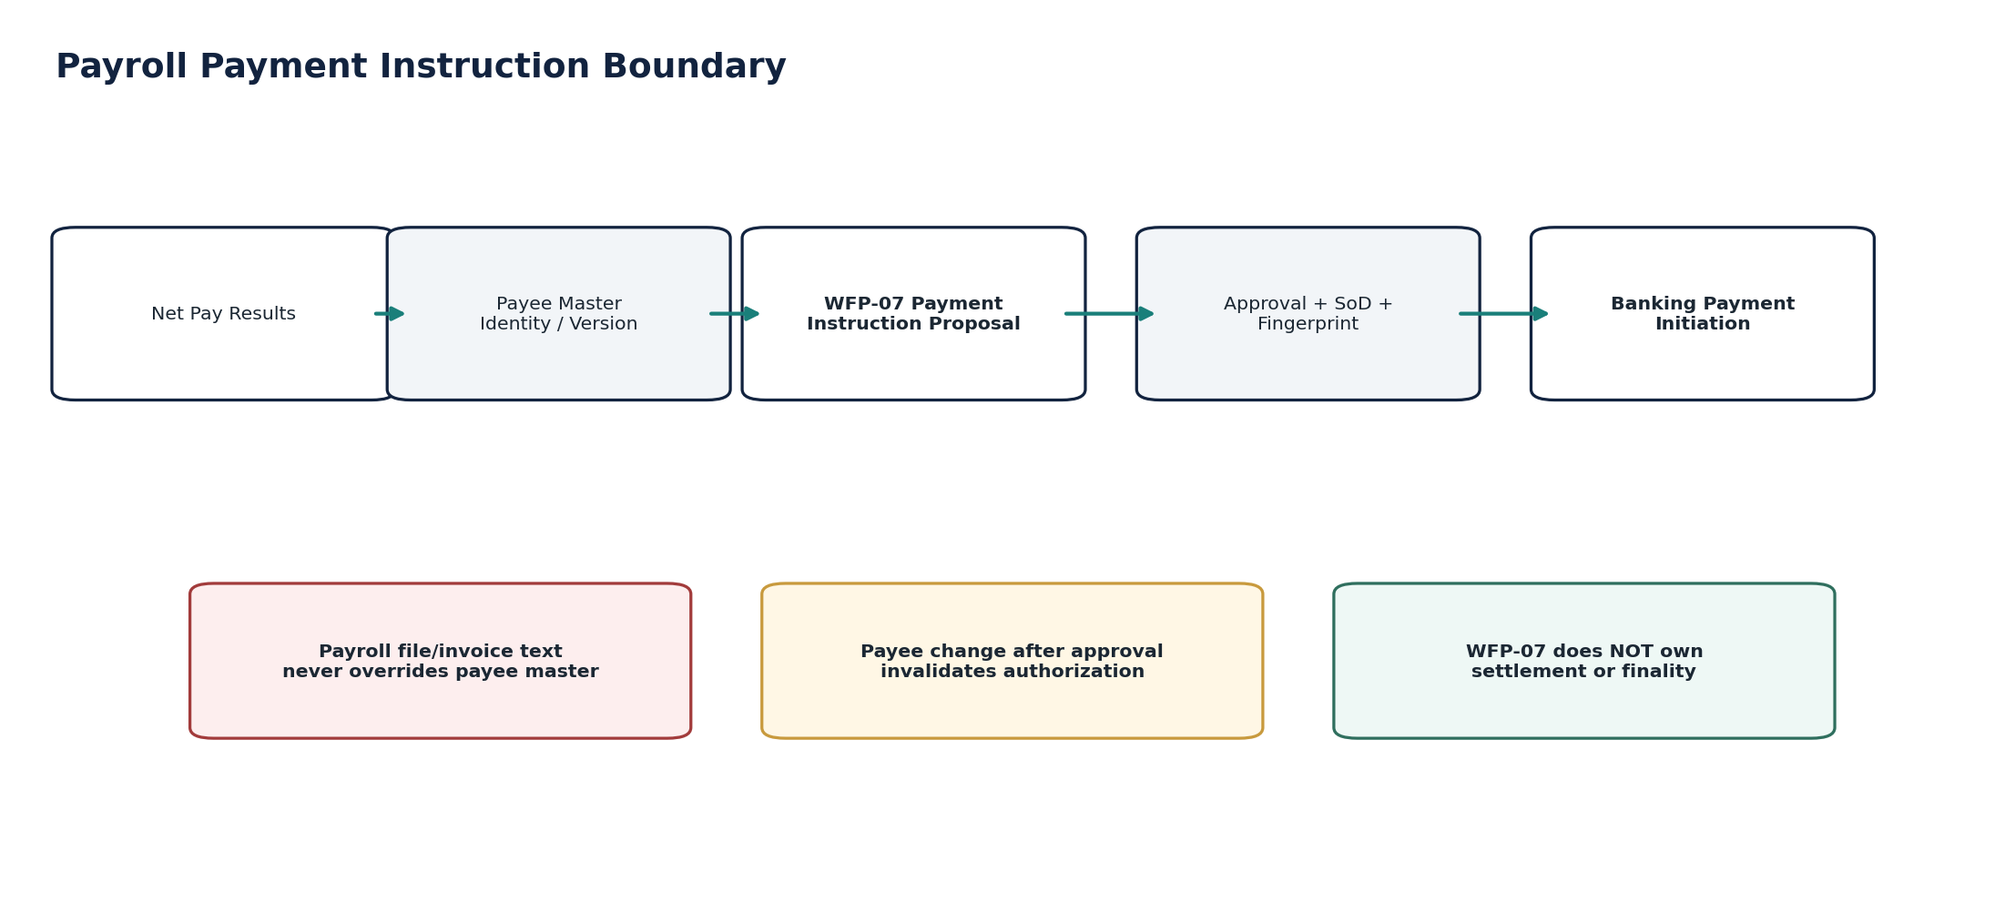
Figure 11 — Payroll Payment Interface engineering flow.

11. Correction, Reversal & Retroactive Payroll Doctrine
Approved payroll results are immutable evidence of what the payroll engine determined at that time. A correction does not rewrite that history. The source payroll engine produces a corrected/retro result with its own rule manifest and version. ZoikoSuite links it to the original, creates the accounting reversal/adjustment path, adjusts liabilities explicitly, and resolves any original Banking attempt before issuing additional money movement.
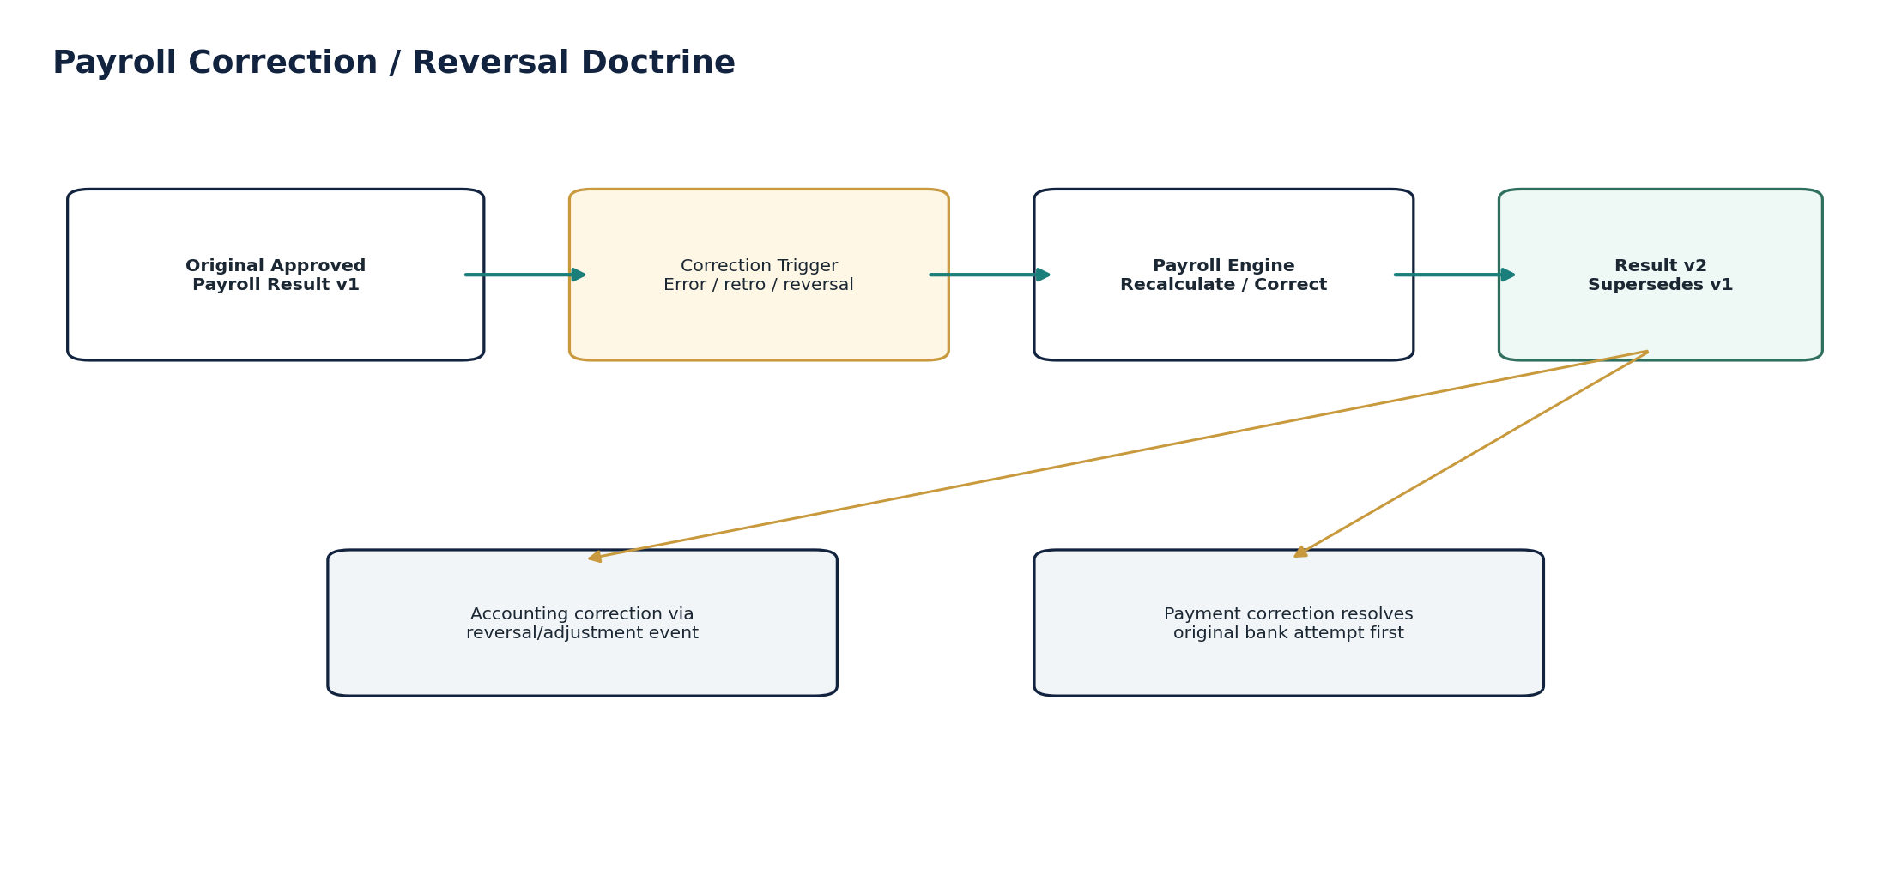
Figure 12 — Payroll correction and reversal doctrine.
Situation | Required treatment | Prohibited treatment
Payroll input corrected before run final | Supersede input; recompute in payroll engine; new result version if needed. | Editing accepted result in WFP.
Approved payroll result error | Source payroll correction/retro run; WFP result v2 supersedes v1. | Changing v1 component amounts.
Accounting already posted | Controlled reversal/adjustment accounting event via ACC-04. | Deleting/replacing posted journal.
Net pay not yet submitted | Invalidate/supersede instruction and regenerate from corrected result. | Editing approved instruction in place.
Banking outcome unknown | Resolve original attempt first; then decide correction/recovery. | Assume failed and resend.
Overpayment settled | Record recovery/offset under policy and employee/legal process; accounting follows controlled correction. | Silent negative payroll entry without basis/evidence.
Underpayment | Create approved off-cycle/correction run and separate payment subject. | Ad hoc manual bank payment disconnected from payroll evidence.

12. Payroll Reconciliation & Financial Control Framework
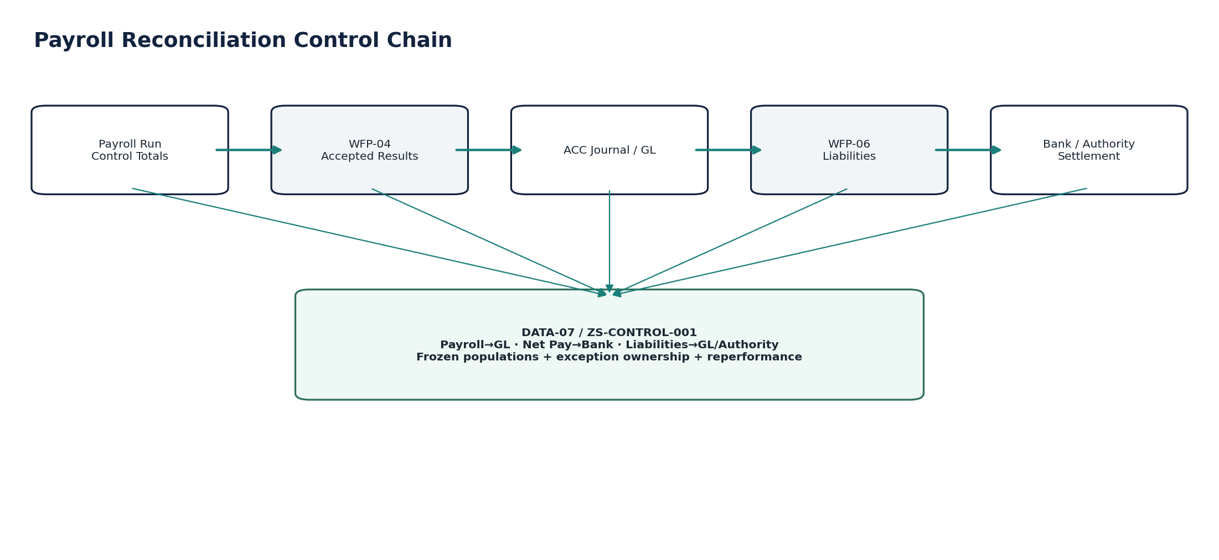
Figure 13 — Payroll reconciliation control chain.
Control | Assertion
WFP-02 source → imported time/leave | Approved units/counts/amount-bearing elements reconcile to accepted batch and quarantined exceptions.
WFP-03 inputs → payroll engine | Frozen input population/hash/control totals match source engine intake.
Payroll engine → WFP-04 | Run-level gross, deduction, employer cost/liability and net totals match accepted result population.
WFP-04 → WFP-05 / GL | Accepted payroll result totals reconcile to payroll accounting events and posted journals by entity/book/period.
WFP-04 → WFP-06 | Employee/employer tax/social/benefit liabilities reconcile to recognized liability population.
WFP-04 → WFP-07 → Banking | Net-pay population reconciles to approved instructions, Banking attempts, settled/returned/unknown items.
Liability → authority/payment | Liability amount reconciles to filing/authority status and Banking settlement/refund where applicable.
Payroll source → signed reporting | Source-to-report lineage traces payroll facts through journal, control run and signed financial snapshot.

13. Jurisdiction Rule Provenance & Regulatory Change
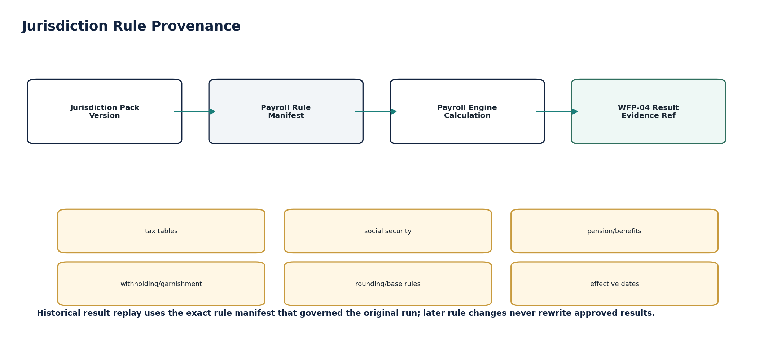
Figure 14 — Jurisdiction/payroll rule provenance.
- Payroll statutory numerics are determined by the source payroll engine using a certified effective-dated jurisdiction/rule pack; WFP stores and validates the rule manifest reference rather than duplicating all statutory logic.
- Rule changes may be future-effective, retroactive or correcting. Each release requires effective dates, source authority, test evidence, approval and historical-replay support.
- Unsupported or missing rule provenance blocks result acceptance for regulated payroll components. “Use current rules” is never an acceptable fallback for a historical payroll run.
- Jurisdiction-specific filing or employer reporting protocols remain adapters outside WFP unless the relevant canonical service explicitly owns them; WFP-06 links liabilities to those filing/authority references.
- Legal employment-status, tax residency and worker-classification determinations require the owning HR/legal/tax workflow and jurisdiction validation; WFP consumes the approved classification.
Current-market evidence reinforces the versioned-rule architecture: HMRC publishes 2026–27 RTI technical specifications for payroll submissions, while the IRS publishes annual 2026 employer withholding guidance/tables. ZoikoSuite therefore must bind each payroll result to the exact jurisdiction/rule version used rather than hardcode “current” payroll logic.

14. Security, Privacy, Residency & Sensitive Payroll Data
Area | Requirement
Data class | Payroll results, tax/social identifiers, garnishments, benefits and bank/payee references are Restricted/Highly Restricted under ZS-SEC-001 classification.
Minimization | WFP interfaces carry only fields necessary for the financial purpose; unrelated HR/medical/disciplinary data is prohibited.
Banking details | Prefer controlled payee-master references/tokens; raw bank details are not repeated across WFP records or logs.
Logging | No full bank account, government identifier, sensitive deduction detail or secret in application/security logs.
Residency | Payroll data, backups, events, analytics, support access and AI processing inherit tenant/legal-entity residency policy.
Support | JIT/purpose-bound support sessions; sensitive payroll views masked unless explicitly required and authorized.
Retention / legal hold | Retention and disposition resolved by record class/jurisdiction/hold. Payroll financial evidence required for accounting/tax/audit is not deleted solely because a worker leaves.
AI | No raw payroll data to unapproved models/regions; no model training; high-risk payroll explanation requires source-governed controls.

15. Canonical Operational Runbooks
Runbook | Trigger | Required response
WFP-RB-01 | Source worker mapping failure | Quarantine affected records; do not default entity/jurisdiction/payee.
WFP-RB-02 | Time/leave batch mismatch | Freeze source watermark; compare counts/units; resolve duplicates/late records.
WFP-RB-03 | Payroll input batch rejected | Isolate code/provenance/mapping failures; no manual bypass without evidence.
WFP-RB-04 | Payroll result control-total failure | Reject/quarantine full affected run; investigate source payroll output.
WFP-RB-05 | Payroll posting rejected | Preserve accepted payroll result; resolve Accounting Kernel reason; retry idempotently.
WFP-RB-06 | Payroll liability deadline risk | Escalate legal-timing clock; validate filing/payment state; no silent dismissal.
WFP-RB-07 | Payee details changed after approval | Invalidate instruction; reverify payee; obtain new approval fingerprint.
WFP-RB-08 | Banking payment Pending/Unknown | Resolve original Banking attempt; suppress duplicate payroll payment.
WFP-RB-09 | Payroll correction after posting/payment | Execute source correction, accounting reversal/adjustment, liability/payment recovery chain.
WFP-RB-10 | Payroll-to-GL or net-pay reconciliation break | Contain close/release as required; identify frozen populations; remediate and reperform control.

16. Canonical Control Catalogue
Control ID | Control | Minimum assertion
WFP-CTRL-001 | Worker/entity mapping validity | Block invalid or cross-entity worker financial context.
WFP-CTRL-002 | Effective-date consistency | No overlapping contradictory worker financial profiles.
WFP-CTRL-003 | Approved time/leave only | Unapproved source units cannot enter payroll/costing.
WFP-CTRL-004 | Time/leave duplicate detection | Source line replay does not double units.
WFP-CTRL-005 | Payroll input provenance | Every material input has source/reason/approval.
WFP-CTRL-006 | Frozen payroll input population | Calculation uses versioned frozen inputs.
WFP-CTRL-007 | Payroll run finality | Only approved/final source runs accepted.
WFP-CTRL-008 | Rule manifest required | Regulated result blocked without rule/calculation provenance.
WFP-CTRL-009 | Gross-to-net control totals | Worker/run totals mathematically reconcile.
WFP-CTRL-010 | Accepted result immutability | Corrections supersede; no in-place edit.
WFP-CTRL-011 | Payroll-to-accounting event only | No direct GL write.
WFP-CTRL-012 | Posting idempotency | Same result/book cannot create duplicate journal.
WFP-CTRL-013 | Payroll-to-GL reconciliation | Accepted result ties to posted accounting consequence.
WFP-CTRL-014 | Liability completeness | All configured statutory/benefit liabilities represented.
WFP-CTRL-015 | Liability due-date provenance | Due date ties to jurisdiction/rule/calendar.
WFP-CTRL-016 | Liability settlement evidence | Paid state requires authoritative settlement/authority evidence.
WFP-CTRL-017 | Payee-master binding | Payment instruction references controlled payee identity/version.
WFP-CTRL-018 | Payment approval fingerprint | Protected fields bound to approval.
WFP-CTRL-019 | Approval invalidation | Payee/amount/date/currency/paying-account change invalidates approval.
WFP-CTRL-020 | Payment handoff idempotency | Banking handoff cannot duplicate same protected subject.
WFP-CTRL-021 | Pending/Unknown suppression | Unknown external outcome blocks blind retry.
WFP-CTRL-022 | Net pay → settlement reconciliation | Worker/run net pay ties to Banking settled/returned population.
WFP-CTRL-023 | Payroll liability → GL reconciliation | Liability records tie to liability accounts.
WFP-CTRL-024 | Correction chain completeness | Original, superseding result, accounting and payment effects linked.
WFP-CTRL-025 | Source-to-report lineage | Payroll result traces to signed financial snapshot/report.
WFP-CTRL-026 | Tenant/residency isolation | No cross-tenant/region leakage across payroll stores/events/backups.
WFP-CTRL-027 | Sensitive logging prohibition | No raw bank/government/sensitive deduction data in logs.
WFP-CTRL-028 | Legal hold/retention preservation | Disposition respects accounting/tax/audit retention and holds.
WFP-CTRL-029 | AI authority boundary | AI cannot create authoritative payroll numerics/approval/payment/posting.
WFP-CTRL-030 | Close gate | Material unresolved payroll reconciliation may block financial close.

17. Negative-Path Engineering Certification Scenarios
ID | Scenario | Required result
WFP-NP-001 | Forged tenant/entity context on worker profile | Reject; derive tenant/entity server-side; security evidence.
WFP-NP-002 | Out-of-order worker profile version | Reject stale version; preserve current state.
WFP-NP-003 | Worker payee ref points to another entity | Block cross-entity payment context.
WFP-NP-004 | Unapproved time record imported | Reject/quarantine; no payroll/costing effect.
WFP-NP-005 | Duplicate time source line replay | Idempotent; no duplicate units.
WFP-NP-006 | Late time record after frozen payroll input | Create controlled delta/correction; no silent mutation.
WFP-NP-007 | Payroll input missing source provenance | Block/quarantine.
WFP-NP-008 | Duplicate bonus input with different source IDs but same business subject | Flag duplicate candidate; policy-driven review.
WFP-NP-009 | Manual payroll adjustment self-approved | SoD denies.
WFP-NP-010 | Payroll input code mapping changed after batch frozen | Existing frozen batch retains old mapping version.
WFP-NP-011 | Payroll result arrives before source run final | Reject/hold; cannot accept.
WFP-NP-012 | Payroll result lacks rule manifest | Block regulated result acceptance.
WFP-NP-013 | Payroll result gross-to-net totals do not reconcile | Reject/quarantine whole affected scope.
WFP-NP-014 | Worker result mapped to wrong legal entity | Reject affected result; no posting/payment.
WFP-NP-015 | Same source run ID arrives with changed result fingerprint | Require new source version/supersession; reject conflicting replay.
WFP-NP-016 | Generic GL layer attempts to recompute payroll tax | Blocked by architecture/test; source payroll engine remains authority.
WFP-NP-017 | WFP-05 attempts direct ledger insert | Denied; only ACC-04 path permitted.
WFP-NP-018 | Duplicate payroll accounting-event retry | Same idempotency subject; one posting effect.
WFP-NP-019 | Accounting period hard closed | ACC-04 rejects; payroll result remains accepted and unchanged.
WFP-NP-020 | Payroll account mapping missing | Posting blocked; explicit exception/runbook.
WFP-NP-021 | Corrected payroll result after original journal posted | Create controlled reversal/adjustment; no journal deletion.
WFP-NP-022 | Liability due date lacks rule source | Block certification/scheduling.
WFP-NP-023 | Liability payment initiated but provider outcome unknown | Keep liability unpaid/pending; resolve authoritative settlement.
WFP-NP-024 | Partial statutory liability payment | Preserve residual amount; do not mark fully settled.
WFP-NP-025 | Authority refund received | Create explicit refund/adjustment link; reconcile liability/GL.
WFP-NP-026 | Payroll file contains new bank account differing from payee master | Do not adopt automatically; block/reverify payee.
WFP-NP-027 | Payee bank identity changes after payment approval | Invalidate approval fingerprint.
WFP-NP-028 | Payroll preparer attempts to self-authorize payment | SoD denies where maker-checker required.
WFP-NP-029 | Duplicate payment handoff retry | Same protected subject; no second Banking attempt.
WFP-NP-030 | Banking timeout after receiving payment | Pending/Unknown; resolve original attempt before retry.
WFP-NP-031 | Bank returns employee payment after original settlement | Consume return event; reopen payment/reconciliation state; no deletion.
WFP-NP-032 | Payroll result superseded after payment instruction approved but before handoff | Invalidate/supersede instruction; regenerate from latest approved result.
WFP-NP-033 | Payroll result superseded after payment settled | Correction/recovery/off-cycle flow; no raw rollback.
WFP-NP-034 | Net pay control total differs from settled Banking population | Create reconciliation exception; may block close.
WFP-NP-035 | Payroll liabilities differ from GL liability accounts | Create reconciliation exception; no forced plug.
WFP-NP-036 | Payroll result population differs from source run count/hash | Reject certification; investigate source/ingest completeness.
WFP-NP-037 | Jurisdiction rule retroactively changes | New payroll correction/retro result; historical original remains replayable.
WFP-NP-038 | Future-effective rule pack used before effective date | Block source-result certification.
WFP-NP-039 | Cross-tenant payroll event injected on bus | Consumer rejects; security incident evidence.
WFP-NP-040 | Payroll log contains full bank account / government identifier | Security test fails release; redaction/remediation required.
WFP-NP-041 | Legal hold active during worker deletion request | Preserve held payroll evidence; restrict/minimize per policy rather than delete.
WFP-NP-042 | Backup restored into wrong residency region | Block/incident; restore must honor tenant residency.
WFP-NP-043 | AI proposes corrected statutory payroll amount | Suggestion may be explanatory only; cannot become authoritative numeric result.
WFP-NP-044 | Close attempted with material unreconciled payroll exception | Close gate blocks or requires formally authorized exception under ZS-CONTROL-001.
WFP-NP-045 | Payroll evidence package missing source rule manifest or banking finality refs | Certification fails; no “complete” status.

18. Definition of Ready & Definition of Done

18.1 Service Definition of Ready
- Canonical service ID/owner and source-system authority are approved.
- Worker/entity/payroll-period/jurisdiction context and effective-dating rules are defined.
- Source payload schemas, code mappings and provenance fields are registered.
- Payroll rule-manifest contract and source-engine finality semantics are agreed.
- Accounting posting mappings/control accounts are approved for WFP-05.
- Liability classes, due-date sources and authority/beneficiary mappings are configured.
- Payee-master, Banking handoff and approval fingerprint contract are implemented for WFP-07.
- Privacy/residency/retention classification is approved.
- Negative-path tests, runbooks, SLOs and reconciliation controls are defined.

18.2 Service Definition of Done
- OpenAPI/event contracts pass schema, idempotency, concurrency and backward-compatibility tests.
- Golden payroll source/result fixtures pass full worker/run control totals.
- Duplicate/replay, correction/retro and out-of-order tests pass.
- Payroll-to-GL, liability-to-GL and net-pay-to-Banking reconciliations are automated and evidenced.
- No direct GL or Banking-settlement bypass path exists.
- Payee-change/approval invalidation and Pending/Unknown provider behavior pass zero-tolerance tests.
- Tenant isolation, residency, sensitive logging and legal-hold tests pass.
- Operational runbooks and monitoring are proven in staging/production-like exercises.
- Release evidence is accepted under ZS-QA-001 and operational ownership is assigned.

19. Implementation Sequence
Wave | Scope
Wave 1 | Shared worker/run identity, source trust profiles, event schemas and canonical data model.
Wave 2 | WFP-01 worker financial context and WFP-02 approved time/leave import.
Wave 3 | WFP-03 payroll input batching, provenance and freeze controls.
Wave 4 | WFP-04 payroll result acceptance, fingerprints, rule-manifest evidence and correction versioning.
Wave 5 | WFP-05 Accounting Kernel bridge and payroll-to-GL controls.
Wave 6 | WFP-06 liability registry, due-date/authority linkage and liability reconciliation.
Wave 7 | WFP-07 payee-master/payment-instruction control and Banking handoff.
Wave 8 | End-to-end reconciliation, close gates, incident runbooks, migration and historical replay.
Wave 9 | Jurisdiction expansion, external payroll provider certification, volume/resilience hardening and production sign-off.

20. Controlled Pre-Production Decisions
Decision | Open decision | Approver / owner
WFP-D-01 | Source payroll engine trust/certification profile for Zoiko Payroll and each external provider. | Payroll Product + Finance + Tax + QA
WFP-D-02 | Authoritative worker/assignment source and effective-dating semantics per integration. | HR Product + Payroll Architecture
WFP-D-03 | Payroll input code taxonomy and mapping ownership. | Payroll Product + Finance
WFP-D-04 | Payroll rule-manifest schema and required evidence by jurisdiction. | Payroll Tax + Jurisdiction Governance
WFP-D-05 | Posting-rule mapping, books and payroll control accounts. | Controller + Accounting Architecture
WFP-D-06 | Liability classes, authority/beneficiary registry and legal-timing escalation rules. | Payroll Tax + Treasury + Compliance
WFP-D-07 | Payee identity verification, change-control and signing limits. | Treasury + Security + Payroll Operations
WFP-D-08 | Provider/Banking finality mappings and returned-payment handling. | Banking Product + Treasury
WFP-D-09 | Retention/legal-hold schedules for payroll financial evidence per launch jurisdiction. | Legal/Privacy + Data Governance
WFP-D-10 | Production SLOs, batch volumes, close windows and recovery objectives. | SRE + Payroll Operations + Finance

21. Prohibited Workforce / Payroll Anti-Patterns
Anti-pattern | Why prohibited
Recompute gross-to-net in the GL or reporting layer | Creates divergent statutory numerics and destroys payroll-engine authority.
Store one mutable payroll status | Conflates calculation finality, accounting, liabilities, payment and exception state.
Direct payroll journal insert | Bypasses posting rules, period control, SoD and Accounting Kernel evidence.
Trust bank details from payroll source text | Creates beneficiary-diversion/fraud risk; must use controlled payee identity.
Mark payment complete from file export/submission | Submission is not settlement/finality.
Blind retry after payment/provider timeout | May duplicate irreversible money movement.
Overwrite corrected payroll result | Destroys historical evidence; corrections must supersede.
Use “current” payroll rules for historical replay | Produces non-reproducible historical payroll.
Delete payroll evidence on termination | May conflict with accounting, tax, audit, legal-hold and statutory retention.
Allow AI to create payroll numerics or approvals | Violates deterministic calculation and professional-control boundaries.
Force reconciliation with suspense/plugs | Masks source, posting, liability or payment differences.
Treat a successful API response as compliance certification | Regulatory/payroll compliance requires authoritative rule and filing evidence.

22. Current External Standards & Regulatory Design Anchors
Anchor | Engineering relevance | Official source
HMRC Real Time Information 2026–27 technical specifications | HMRC publishes software-developer RTI RIM artefacts for the 2026–27 tax year. This supports versioned payroll filing/technical profiles rather than hardcoded generic submission logic. | https://www.gov.uk/government/publications/real-time-information-internet-submissions-2026-to-2027-technical-specifications
IRS Publication 15 / 15-T (2026) | The IRS publishes annual employer/withholding guidance and 2026 federal income-tax withholding methods/tables. This reinforces effective-dated payroll rule manifests and annual certification. | https://www.irs.gov/publications/p15t
HMRC benefits-in-kind reporting change from April 2027 | HMRC announced phased mandatory real-time payrolling/reporting of benefits in kind beginning April 2027. The architecture must support future-effective rule/schema changes without rewriting earlier payroll results. | https://www.gov.uk/government/publications/changes-to-reporting-of-benefits-in-kind-from-april-2027
ISO 20022 current edition (April 2026) | The ISO 20022 Registration Authority states the current edition comprises nine parts published in April 2026. WFP-07 therefore hands payment intent to Banking, which owns rail/provider message implementation. | https://www.iso20022.org/about-iso-20022

Scope boundary — this engineering standard is not legal, employment or payroll-tax advice and does not certify payroll compliance in any jurisdiction. Country/state/province/local rules, worker-status determinations, filing obligations and payroll-engine rule packs require current authoritative validation before production use.

23. Final Build Doctrine
ZS-SVC-L-001 is build-ready only when ZoikoSuite can ingest approved workforce/payroll financial facts without taking ownership of HR or payroll-calculation authority; preserve exact source and rule provenance; freeze and version payroll inputs/results; route accounting through ACC-04; track liabilities independently from filing/payment state; build payment instructions from controlled payee identity with maker-checker controls; resolve external ambiguity without blind retry; reconcile payroll to GL, liabilities and Banking; preserve correction/reversal chains; enforce tenant/residency/privacy rules; and certify every material result from source through financial statements without guessing which worker profile, payroll run, rule manifest, posting rule, payee identity, payment attempt or control run governed the outcome.
Final acceptance statement — Product, Payroll, Finance, Tax, HR, Banking, Security, Data Governance, QA and Operations should be able to implement WFP-01 through WFP-07 from this specification without inventing authority boundaries, state semantics, idempotency keys, correction behavior, payee controls, posting paths, liability evidence, reconciliation assertions or external-UNKNOWN handling.

