COMSATS University Islamabad
CYC386 – Secure Software Design and Development
Midterm Lab Exam – 1-Week DevSecOps Security Sprint (Fall 2026)
Threat Model
DFD · STRIDE · Attack Trees · CVSS v3.1
Field | Detail
Project | MedVault – Secure Diagnostic Lab Report Portal
Team | MedVault
Member(s) | Zojaja Naveed (Fa23-bct-047)  Tayyeba Usman (Fa23-bct-053)
Instructor | Engr. Muhammad Ahmad Nawaz
Repository | https://github.com/Zojaja-Naveed/MedicalVault.git
Date | 30 October 2026

1. Scope and Assumptions
- In scope: the Flask web app, native C parser, SQLite database, file store, and the data flows between them.
- The server runs in a container; the operating system is assumed patched.
- Exploitation was performed only in the team's own lab environment.
- Jira epic: MV-2 (Threat Modeling & Risk). Method: DFD + STRIDE + Attack Trees + CVSS v3.1.

2. Context Diagram (Level 0)
The context diagram shows MedVault as a single process and the external entities that exchange data with it.
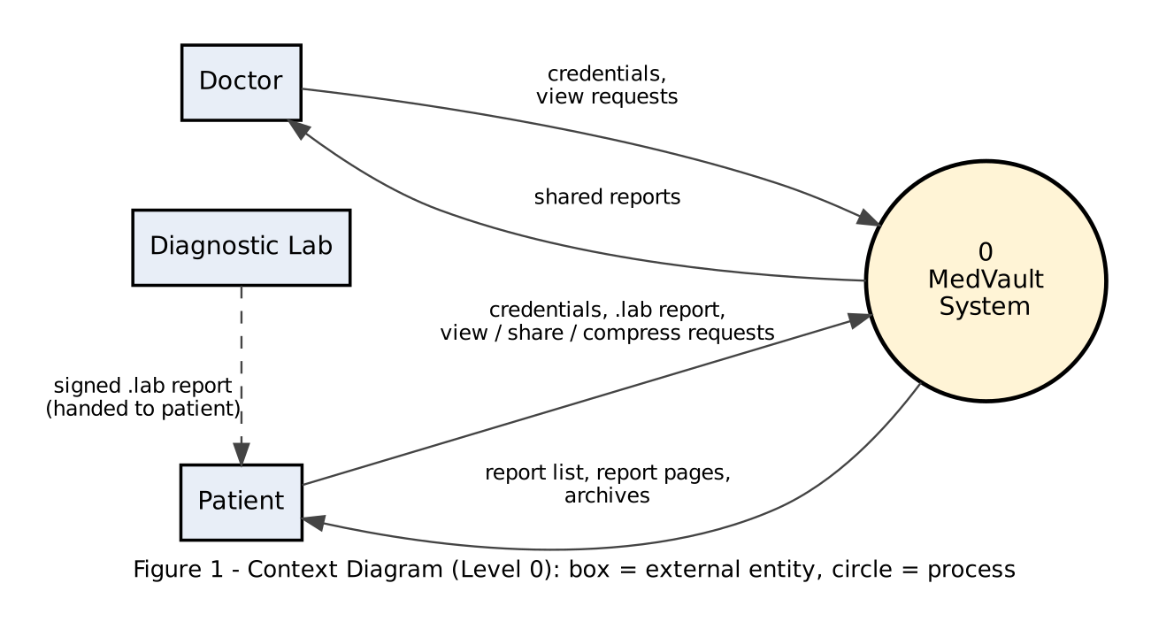

3. Level-1 Data Flow Diagram
The Level-1 DFD breaks MedVault into five processes, the native parser, and three data stores. The red dashed trust boundary separates untrusted browser input from the server; every flow that crosses it must be validated and authorized.
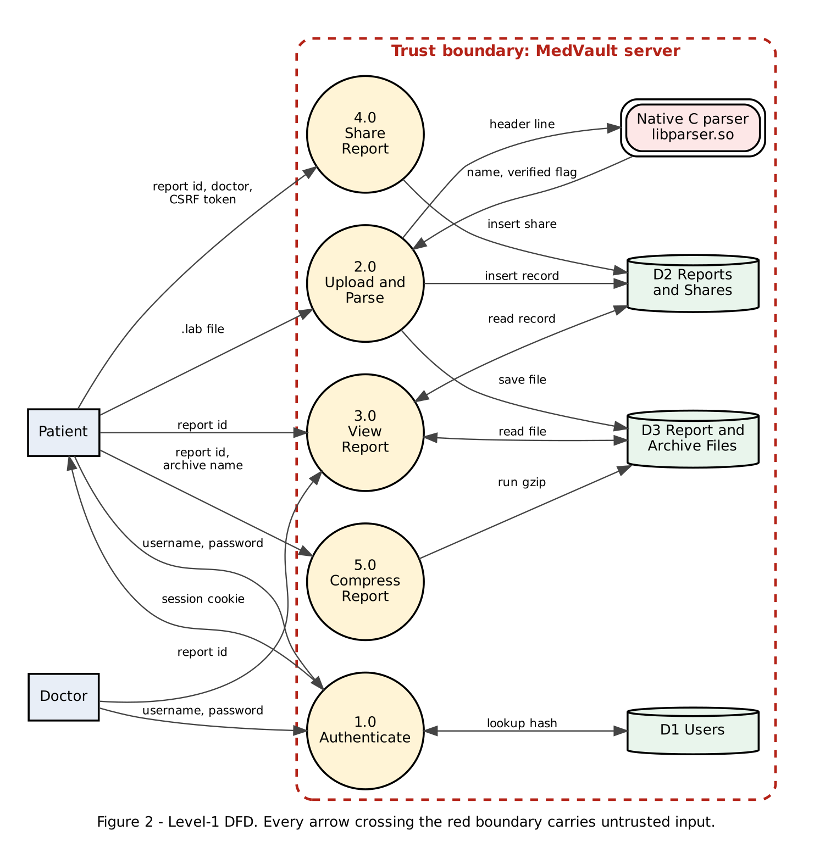

4. STRIDE Analysis
STRIDE was applied to every DFD element. Threats in bold are the five mandatory vulnerability classes.
Element | S – Spoofing | T – Tampering | R – Repudiation | I – Info Disclosure | D – Denial of Service | E – Elevation of Privilege
Patient / Doctor (external) | Stolen or forged session cookie (T-06) | – | User denies sharing a report (T-08) | – | – | –
P1 Authenticate | Password guessing; session forgery via hard-coded key (T-06) | – | No login audit (T-08) | Debug pages leak internals (T-07) | Login brute-force load | Debug console gives code execution (T-07)
P2 Upload and Parse | – | Forged verified stamp via overflow (T-01) | Uploads not logged (T-08) | – | Oversize header crashes parser (T-01) | Memory corruption → control-flow hijack (T-01)
Native C parser | – | Adjacent memory overwritten (T-01) | – | – | Segfault / abort (T-01) | Code execution if mitigations absent (T-01)
P3 View Report | – | – | – | Read others' reports by changing ID (T-03) | – | Horizontal privilege escalation (T-03)
P4 Share Report | Forged cross-site share (T-04); UI redress click (T-05) | Share list changed without consent (T-04) | Shares not logged (T-08) | Report shared to attacker (T-04, T-05) | – | –
P5 Compress Report | – | Files modified via injected commands (T-02) | – | Arbitrary file read (T-02) | Injected commands kill/flood server (T-02) | Remote code execution (T-02)
D1 Users | – | – | – | Password hash disclosure via T-02 | – | –
D2 Reports and Shares | – | Direct edits via T-02 | – | Metadata disclosure via T-03 | – | –
D3 File store | – | Report files altered via T-02 | – | Files read via T-02 / T-03 | Disk filled with archives | –
Data flows (browser ↔ server) | – | Request forged cross-site (T-04) | – | Cookie theft over plain HTTP (residual) | – | –

4.1 Threat List
ID | Threat | STRIDE | Protection Need
T-01 | Buffer overflow in native report-header parser | T, D, E | PN-02, PN-06
T-02 | OS command injection in Compress Report | T, I, D, E | PN-03
T-03 | IDOR on /report/<id> | I, E | PN-01
T-04 | CSRF on Share Report | S, T, I | PN-04
T-05 | Clickjacking of dashboard / share UI | S, I | PN-05
T-06 | Hard-coded Flask secret key → session forgery | S | PN-07
T-07 | Flask debug mode enabled | I, E | PN-07
T-08 | Missing audit logging | R | PN-08

5. Attack Trees

5.1 Attack Tree 1 – Remote command execution
Root is an OR node: any one branch reaches the goal. Each branch is an AND node: all its leaves must succeed. The easiest path before fixes is 1.1 → 1.3 → 1.4, which needs only a free account and one form field, so T-02 is the top priority.
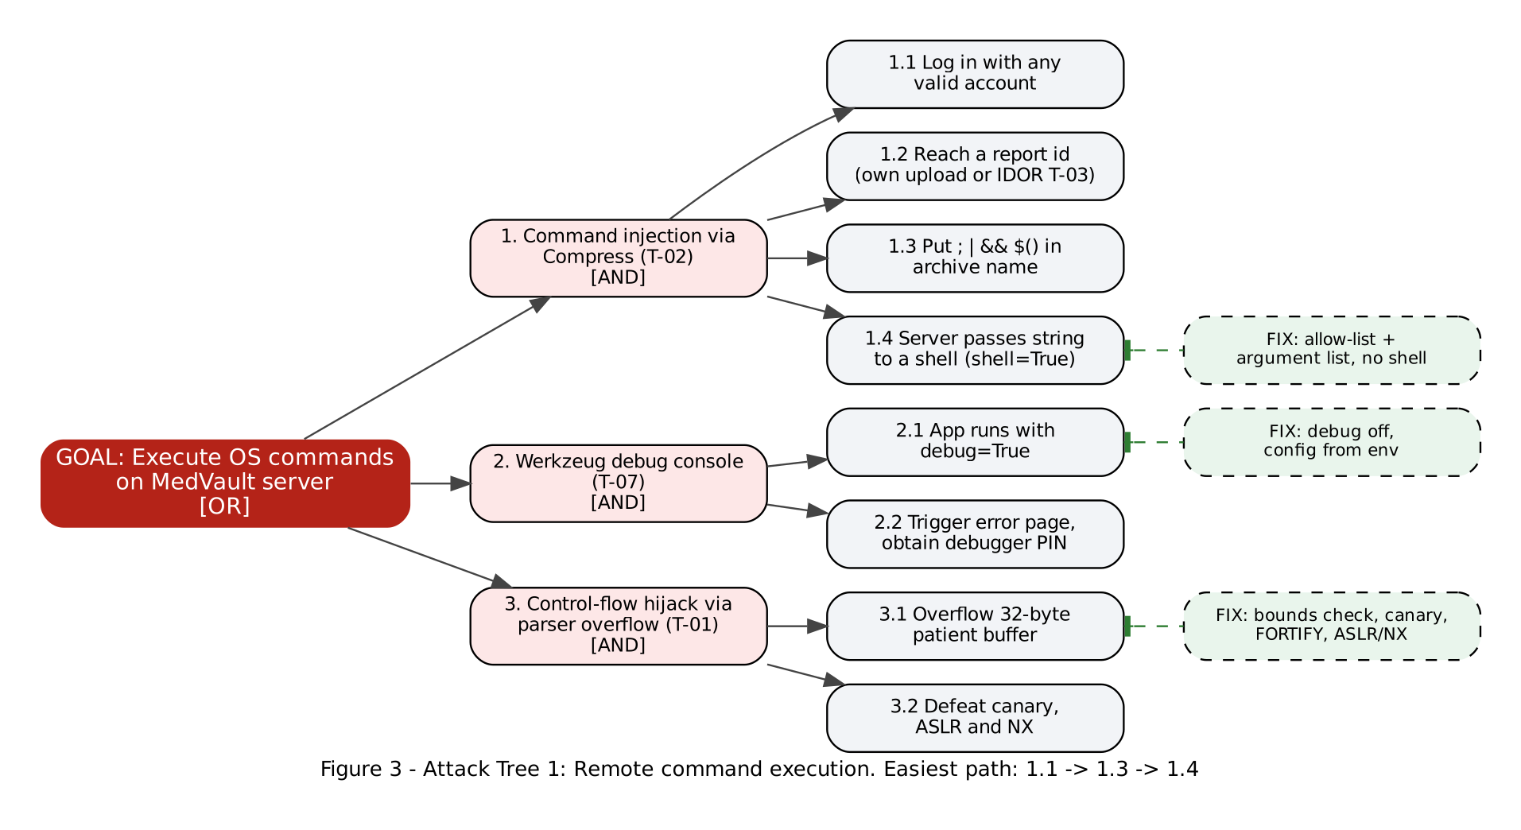

5.2 Attack Tree 2 – Forged "verified" medical report
Branch 1 is the buffer overflow demonstrated in the lab. Branch 3 remains a residual risk because the lab signature is a static marker rather than a cryptographic signature.
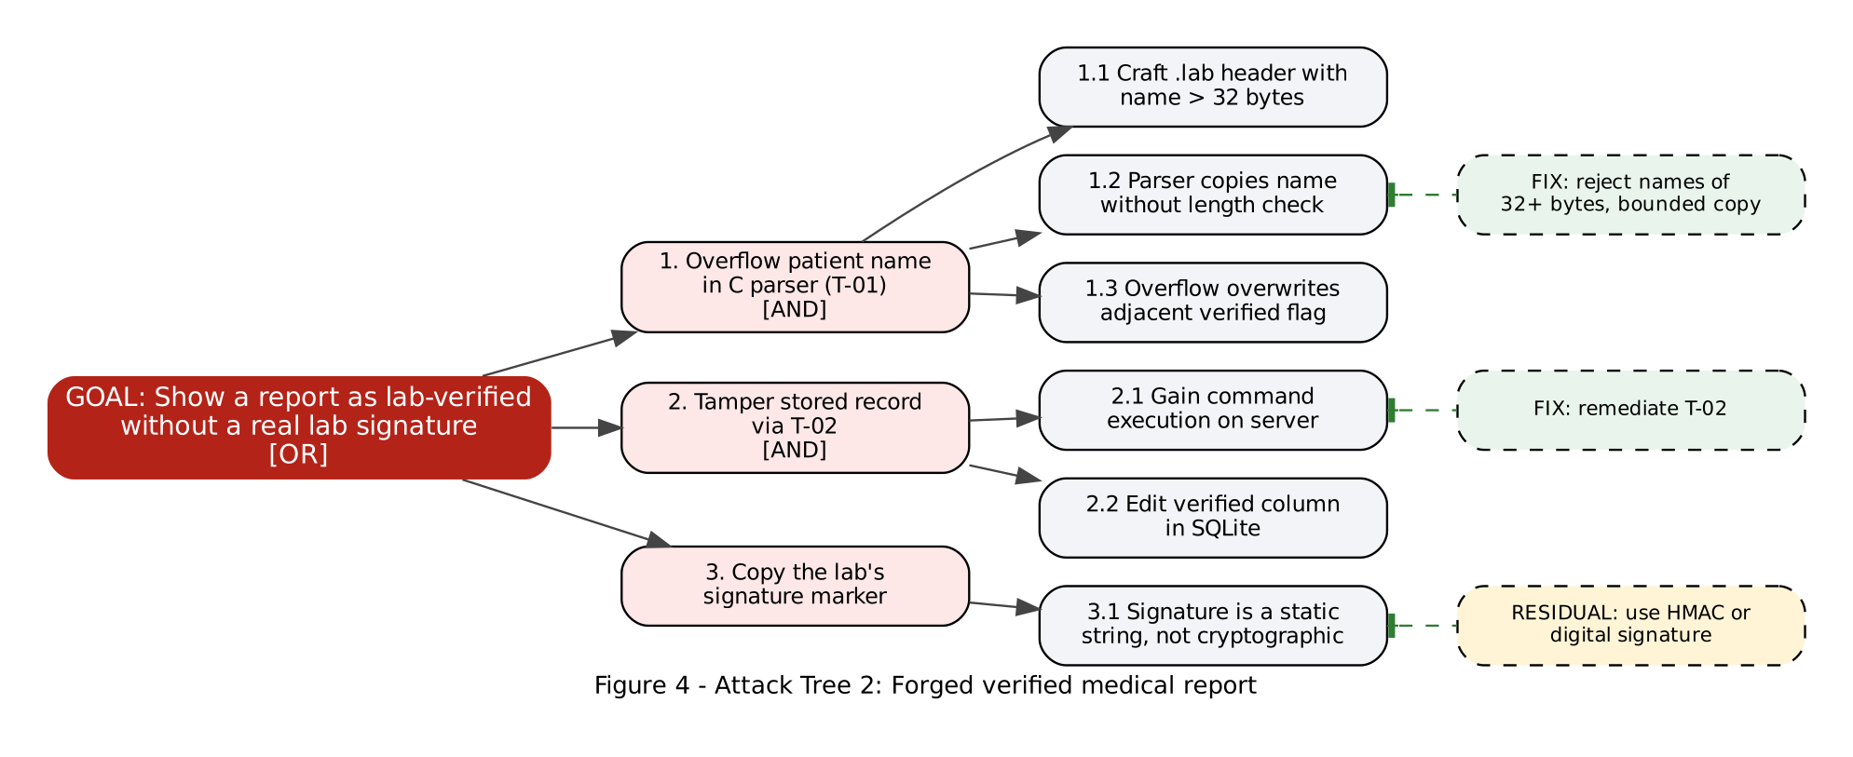

6. CVSS v3.1 Scoring
ID | Threat | Vector | Base | Severity | Justification
T-02 | Command injection | AV:N/AC:L/PR:L/UI:N/S:U/C:H/I:H/A:H | 8.8 | High | Reachable over the network with any account; no user interaction; full read/write/kill on the server
T-01 | Buffer overflow | AV:N/AC:L/PR:L/UI:N/S:U/C:N/I:H/A:H | 8.1 | High | Crafted upload forges the verified flag (integrity) or crashes the parser (availability); no data read
T-07 | Debug mode | AV:N/AC:H/PR:N/UI:N/S:U/C:H/I:H/A:H | 8.1 | High | Debugger console gives code execution, but obtaining the PIN raises attack complexity
T-06 | Hard-coded secret key | AV:N/AC:H/PR:N/UI:N/S:U/C:H/I:H/A:N | 7.4 | High | Anyone who reads the source can forge any user's session; the key must be found first
T-04 | CSRF on share | AV:N/AC:L/PR:N/UI:R/S:U/C:H/I:L/A:N | 7.1 | High | Victim only has to visit a page; report disclosed to attacker and share list altered
T-03 | IDOR | AV:N/AC:L/PR:L/UI:N/S:U/C:H/I:N/A:N | 6.5 | Medium | Any logged-in user reads any report by changing the ID
T-05 | Clickjacking | AV:N/AC:L/PR:N/UI:R/S:U/C:N/I:L/A:N | 4.3 | Medium | Requires the victim to click on a crafted page; limited integrity impact
T-08 | No audit log | – | – | Low | Not directly exploitable; weakens incident response

Environmental adjustment: medical data requires high confidentiality (CR:H). With CR:H, T-03 (IDOR) rises from 6.5 to 8.3 (High), so it is treated as High priority.

7. Prioritized Risk Register
PR numbers are filled in as each fix is merged.
Priority | ID | Threat | CVSS | Jira | Fix PR | Status | Residual Risk
1 | T-02 | Command injection | 8.8 | MV-15 | #__ | Open | Low
2 | T-03 | IDOR (environmental 8.3) | 6.5 / 8.3 | MV-16 | #__ | Open | Low
3 | T-01 | Buffer overflow | 8.1 | MV-14 | #__ | Open | Low
4 | T-07 | Debug mode | 8.1 | MV-13 | #__ | Open | Low
5 | T-06 | Hard-coded secret key | 7.4 | MV-13 | #__ | Open | Low
6 | T-04 | CSRF | 7.1 | MV-17 | #__ | Open | Low
7 | T-05 | Clickjacking | 4.3 | MV-18 | #__ | Open | Very low
8 | T-08 | No audit log | – | MV-13 | #__ | Open | Medium

8. Residual Risk Statement
After all fixes, the following risks remain and are accepted for this sprint:
Risk | CIA | Reason accepted / future work
Lab signature is a static marker, not cryptographic | I | Replace with an HMAC or digital signature from the lab
No HTTPS in the local lab setup | C | Use TLS (reverse proxy + certificate) on the EC2 deployment
No login rate limiting or MFA | C, I | Add rate limiting (e.g. Flask-Limiter) and MFA
SQLite data not encrypted at rest | C | Use disk or database encryption in production
C parser is memory-unsafe by language | I, A | Isolated behind strict length checks and compiler hardening; could be rewritten in Rust

