DocReminder
Complete App Tour Guide — Login Flow & Feature Walkthrough
Flutter Mobile Application • June 29, 2026

Sections: 1. Login │ 2. Users │ 3. Doc Types │ 4. Documents │ 5. Reminders │ 6. Roles │ 7. Permissions │ 8. Logs │ 9. Profile

SECTION 1 — Login Flow

Step 1 › App Launch & Login Screen
When the app starts, a blue splash screen is displayed with the DocReminder logo and a loading indicator. In the background, the app checks SharedPreferences for a saved auth token. If no token is found, the user is taken to the Login screen.

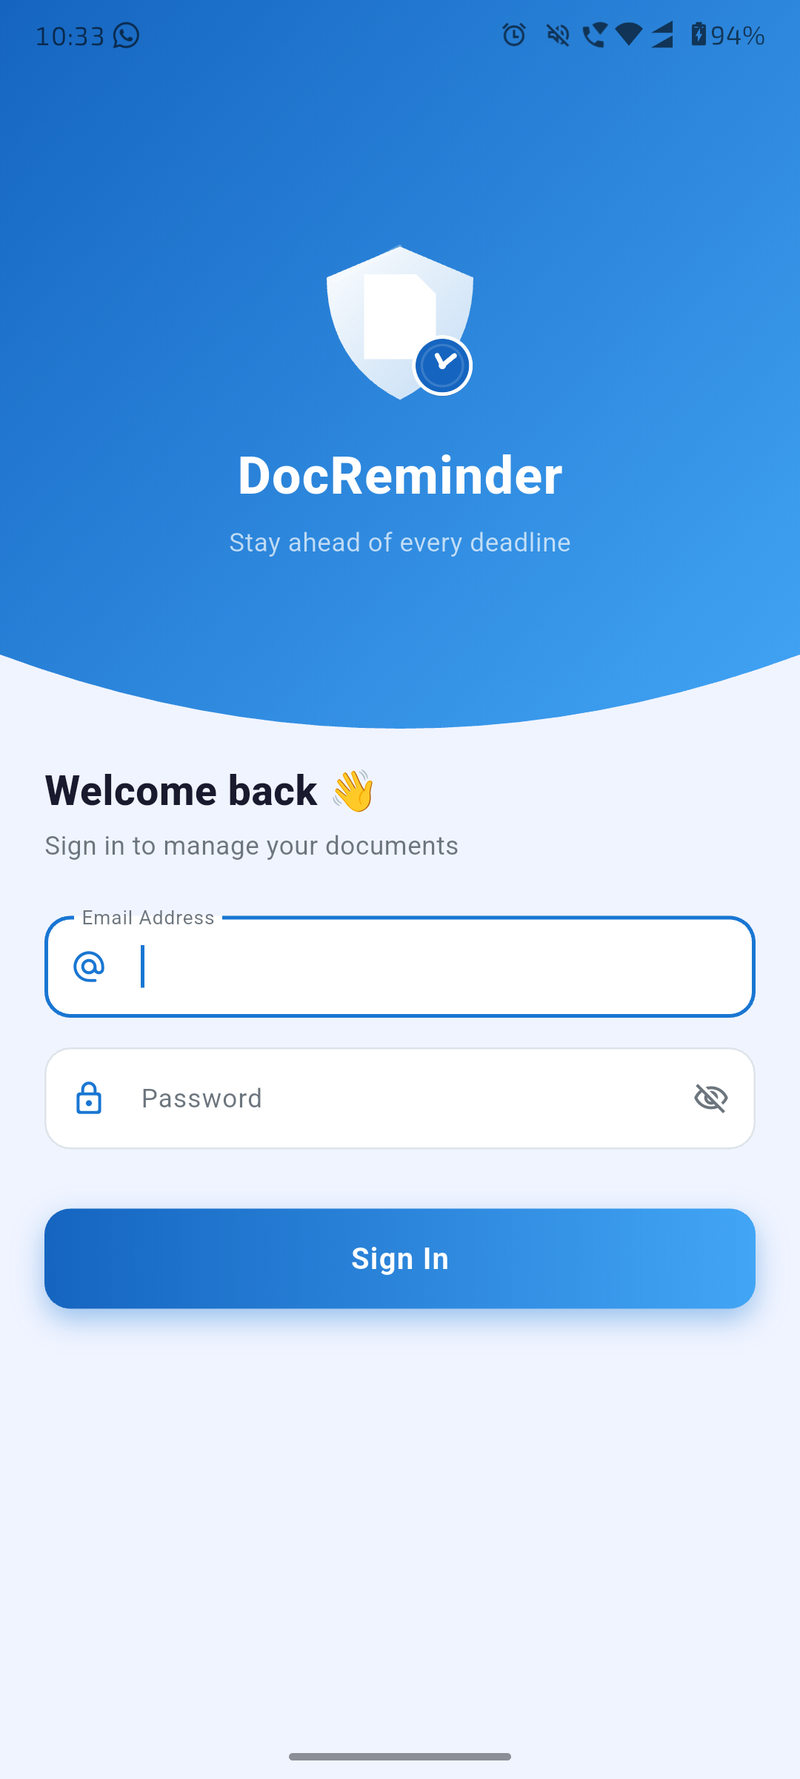
Fig 1 — Login Screen (DocReminder)
What you see on the Login screen
- Curved blue gradient header with the DocReminder shield logo
- "Welcome back 👋 — Sign in to manage your documents" greeting
- Email Address field with @ icon
- Password field with eye-toggle for visibility
- Blue gradient "Sign In" button

Step 2 › Enter Credentials & Validate
The user types their email and password. Before making any network call, the form validates: Email must be non-empty and contain "@". Password must be non-empty. Inline error messages appear on failed validation.

Step 3 › API Call — POST /auth/login
On valid input, AuthService.login() sends a JSON POST request to the server:
- Endpoint: POST {baseUrl}/auth/login
- Body: { "email": "...", "password": "..." }
- A full-screen loading overlay blocks interaction during the request

Step 4 › Success → Token Saved, Permissions Loaded
- Server returns { success: true, data: { token, user } }
- Token stored in SharedPreferences under key "auth_token"
- User JSON stored under key "user_data"
- PermissionNotifier.load(roleId) fetches role permissions from API
- App navigates to Home screen (Login is removed from back-stack)

Step 5 › Failure → Error Snackbar
- Server returns { success: false, message: "..." }
- A red snackbar shows the error message (e.g., "Wrong password")
- Form stays on screen — user can correct and retry
- Network errors caught → "Connection error: ..." message shown

SECTION 2 — Users Management

2.1 › Users List
After login, admins can navigate to the Users tab in the bottom navigation bar. This screen lists all registered users with their name, email, role badge, and active/inactive status. A search bar at the top filters by name or email. Quick-filter buttons for "Active" and "Admin" users are provided.

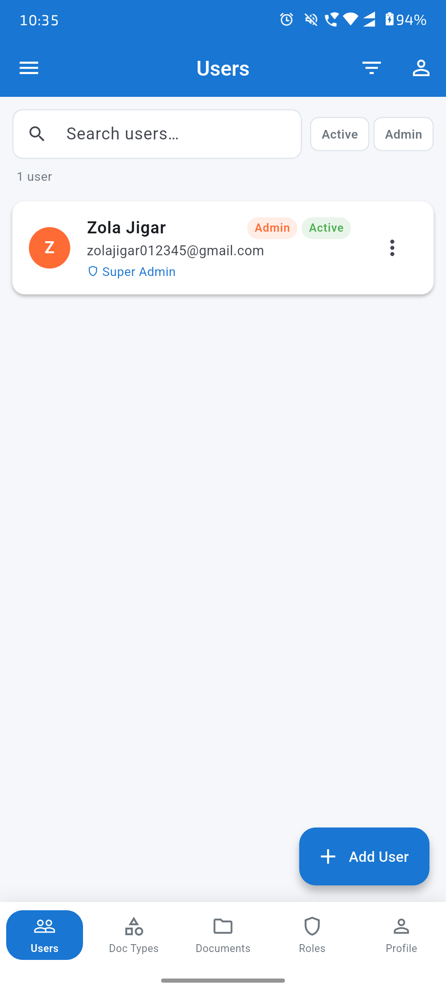  Fig 2 — Users List | 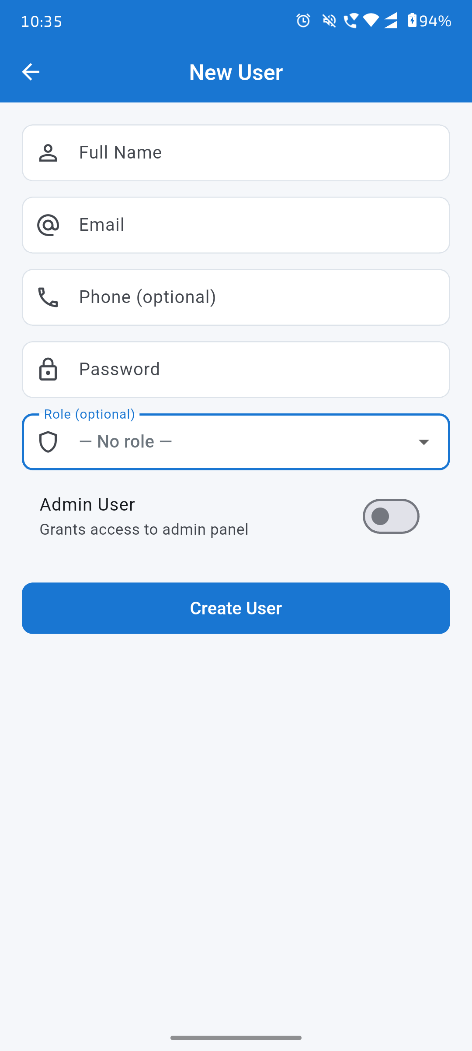  Fig 3 — New User Form

2.2 › Creating a New User
- Tap "+ Add User" floating button
- Fill in: Full Name (required), Email (required), Phone (optional), Password (required)
- Optionally assign a Role from the dropdown
- "Admin User" toggle — grants access to the admin panel
- Tap "Create User" to submit

SECTION 3 — Document Types

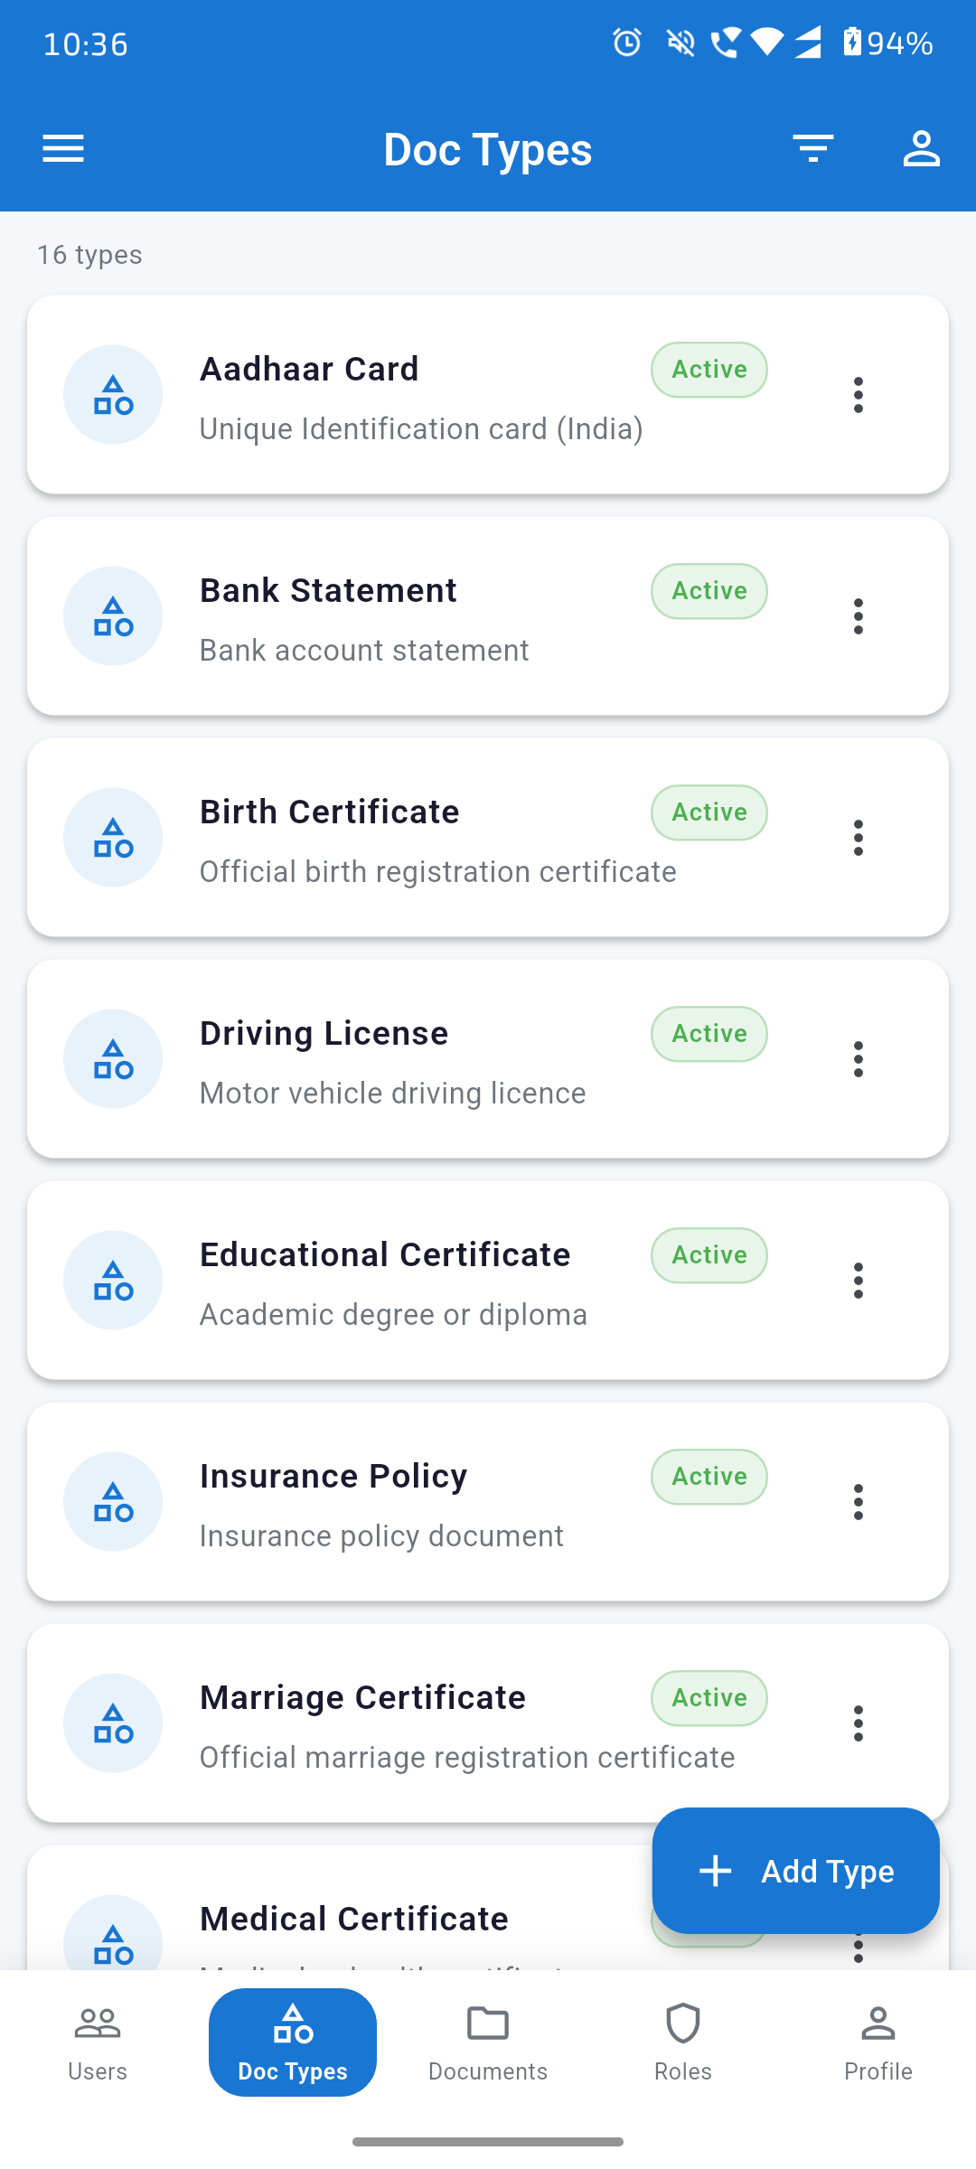  Fig 4 — Document Types List | 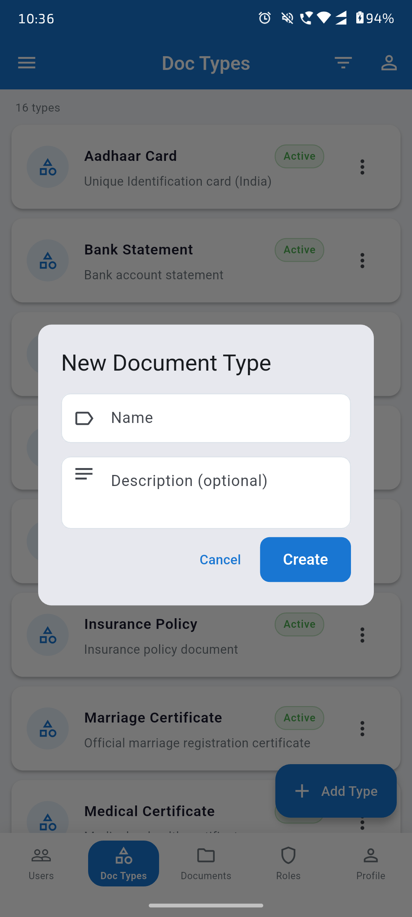  Fig 5 — New Document Type Dialog

3.1 › Document Types List
The Doc Types tab shows all configured document categories (e.g. Aadhaar Card, Bank Statement, Driving License, Insurance Policy, etc.). Each type shows its name, description, and Active status badge. The three-dot menu allows Edit/Delete.
- 16 types shown by default (seeded by admin)
- Search bar at top filters in real time
- Each entry has an icon, name, description, Active badge, and context menu

3.2 › Adding a New Document Type
- Tap "+ Add Type" floating button
- Enter Name (required) and Description (optional)
- Tap "Create" — type appears immediately in the list

SECTION 4 — Documents

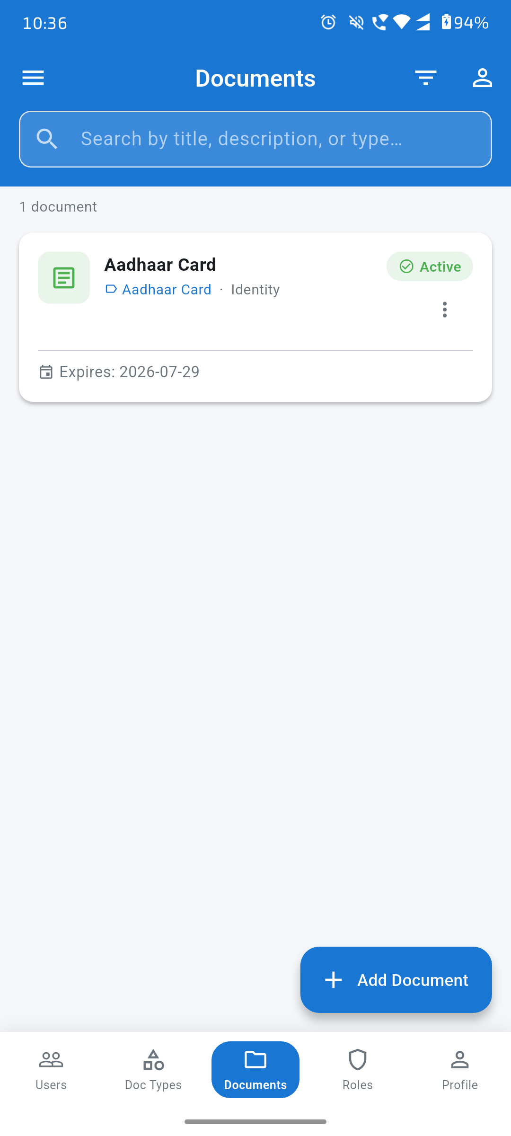  Fig 6 — Documents List | 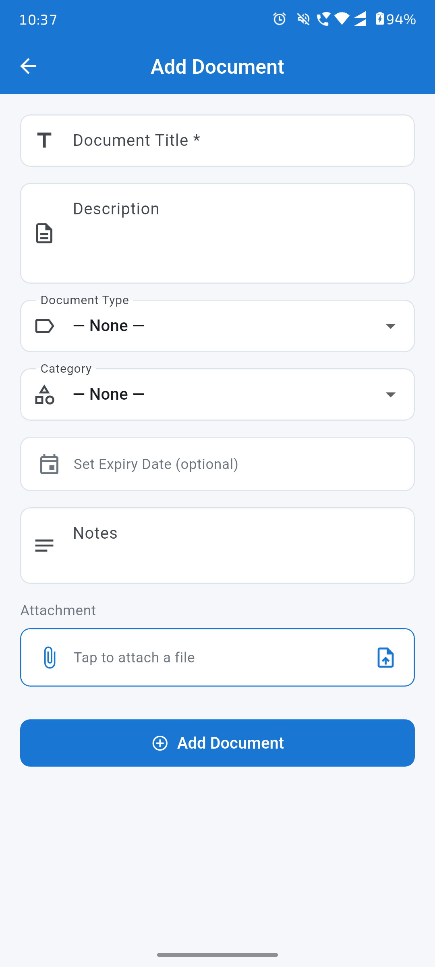  Fig 7 — Document Detail | 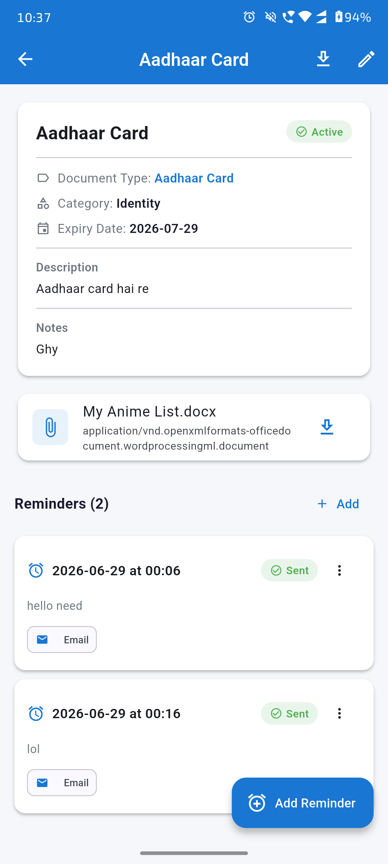  Fig 8 — Add Document Form

4.1 › Documents List
The Documents tab is the core of the app. It lists all documents owned by the user. Each card shows the document name, type, category, expiry date, and Active/Expired status. A search bar filters by title, description, or type.
- Tap any document card to open the detail view
- Three-dot context menu for Edit / Delete
- "+ Add Document" button at bottom right

4.2 › Document Detail
The detail screen shows the full document info: title, type, category, expiry date, description, notes, and any attached file. Attached files can be downloaded with the download icon.
- Reminders section shows all scheduled reminders for this document
- Each reminder shows date, time, status (Sent/Pending), message, and channel
- "+ Add" button opens the Add Reminder flow
- Download icon (top right) downloads the attached file
- Edit icon (top right) opens the edit form

4.3 › Adding a New Document
- Tap "+ Add Document"
- Fill in: Document Title (required), Description, Document Type, Category
- Optionally set an Expiry Date
- Add Notes for extra context
- Tap "Tap to attach a file" to upload a PDF, DOCX, image, etc.
- Tap "+ Add Document" button to save

SECTION 5 — Reminders & Email Notifications

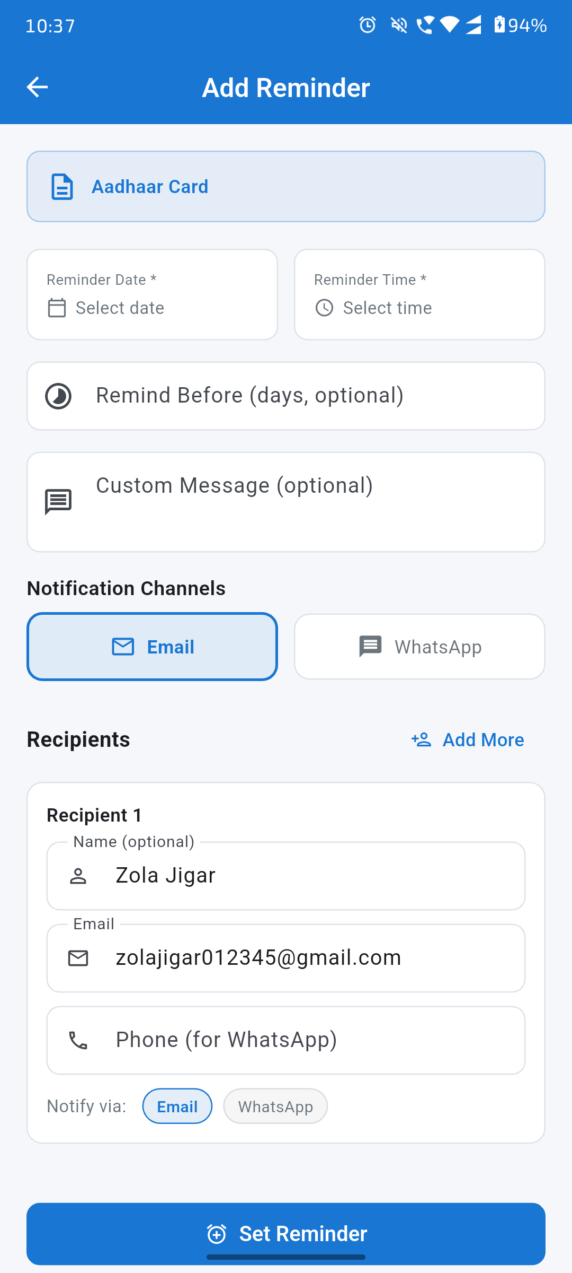  Fig 9 — Add Reminder Form | 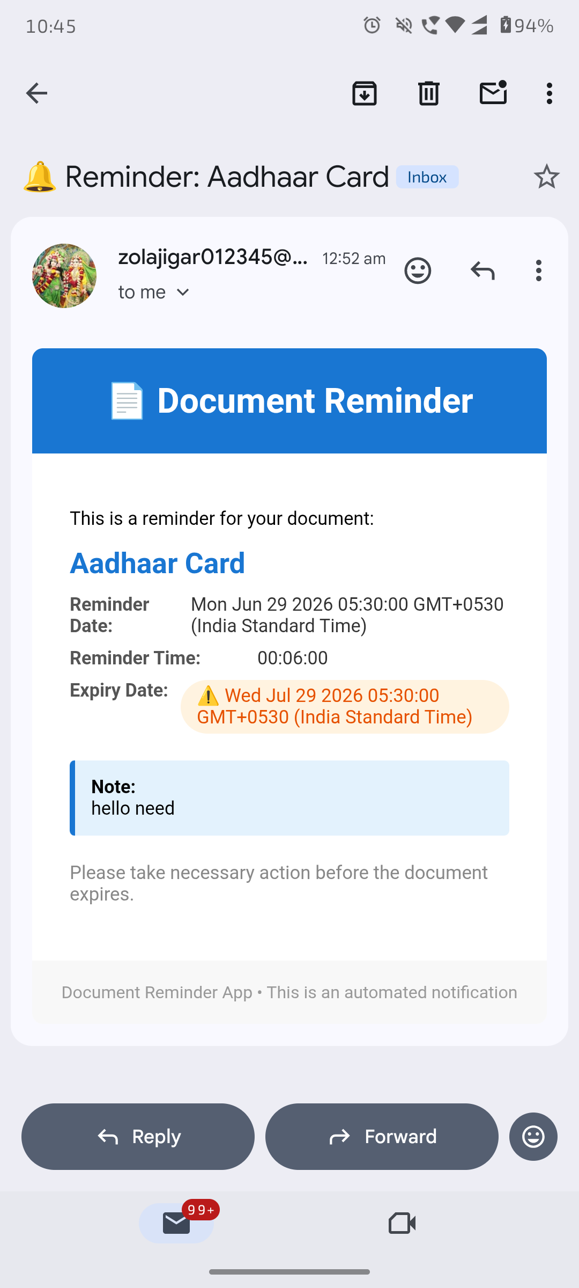  Fig 18 — Reminder Email Received in Gmail

5.1 › Setting a Reminder
From a document's detail screen, tap "+ Add" in the Reminders section. The Add Reminder form is pre-filled with the document name.
- Reminder Date * — date picker (required)
- Reminder Time * — time picker (required)
- "Remind Before (days, optional)" — trigger reminder N days in advance
- "Custom Message (optional)" — personal note included in the notification
- Notification Channels — select Email and/or WhatsApp
- Recipients — add multiple recipients (name, email, phone)
- Tap "Set Reminder" to schedule

5.2 › Reminder Email
At the scheduled time, the server sends an automated email to all recipients. The email includes the document name, reminder date/time, expiry date (highlighted in yellow if expiring soon), and the custom note.
- Subject: "🔔 Reminder: <Document Name>"
- Sender: DocReminder automated system
- Expiry date shown with ⚠️ warning highlight if near expiry
- Footer: "Document Reminder App • This is an automated notification"

SECTION 6 — Roles

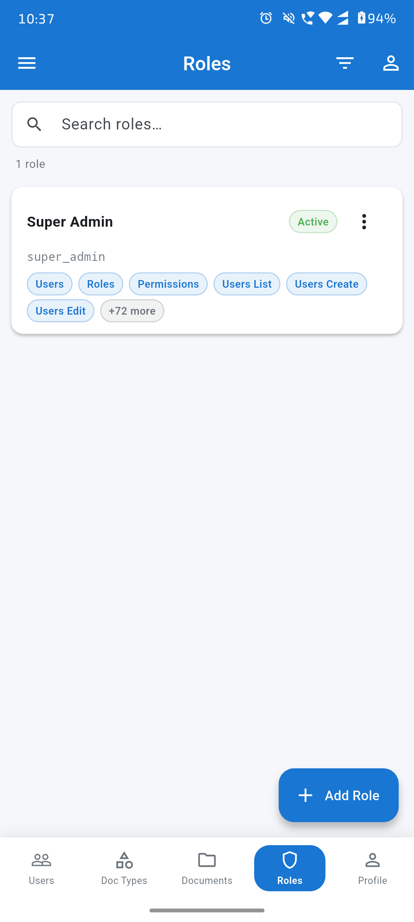  Fig 10 — Roles List | 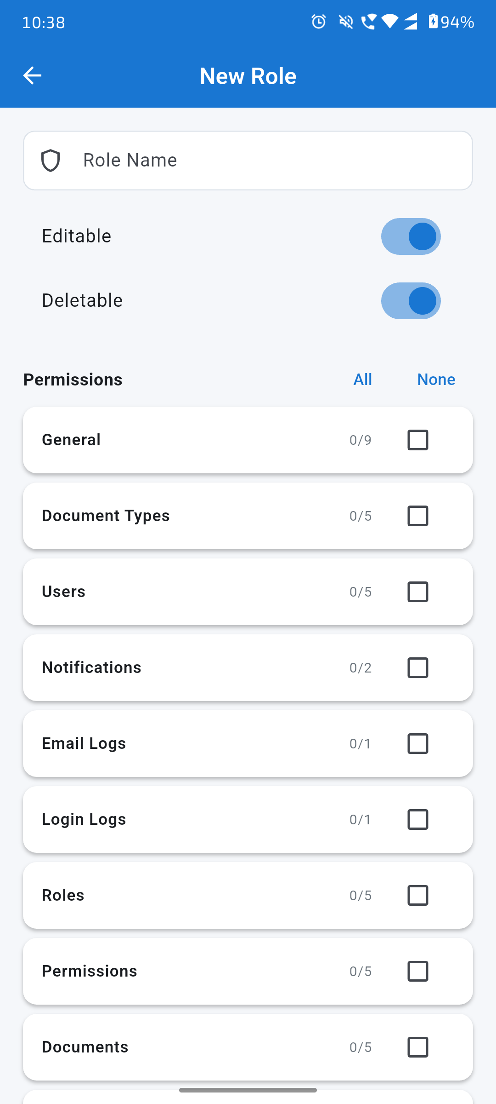  Fig 11 — New Role (Collapsed) | 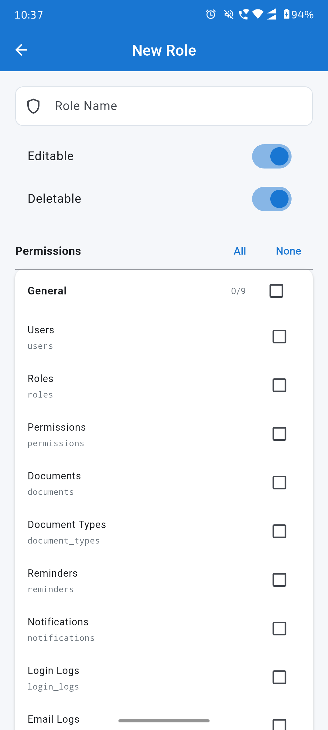  Fig 12 — New Role (Expanded)

6.1 › Roles List
The Roles tab (under admin navigation) shows all defined roles. Each role card displays the role name, slug, Active status, and a chip-preview of assigned permissions (e.g. Users, Roles, Permissions … +72 more).
- Search roles by name
- Three-dot menu: Edit / Delete
- "+ Add Role" floating button

6.2 › Creating a New Role
The New Role screen lets you define a role name and its permission set.
- Enter Role Name in the text field
- "Editable" toggle — allows this role to be modified later
- "Deletable" toggle — allows this role to be removed
- Permissions section lists all permission groups (General, Document Types, Users, etc.)
- "All" / "None" shortcuts to select/deselect all at once
- Tap a group to expand and see individual permissions with checkboxes
- Each permission shows its name and slug (e.g. users, roles, documents)

SECTION 7 — Permissions

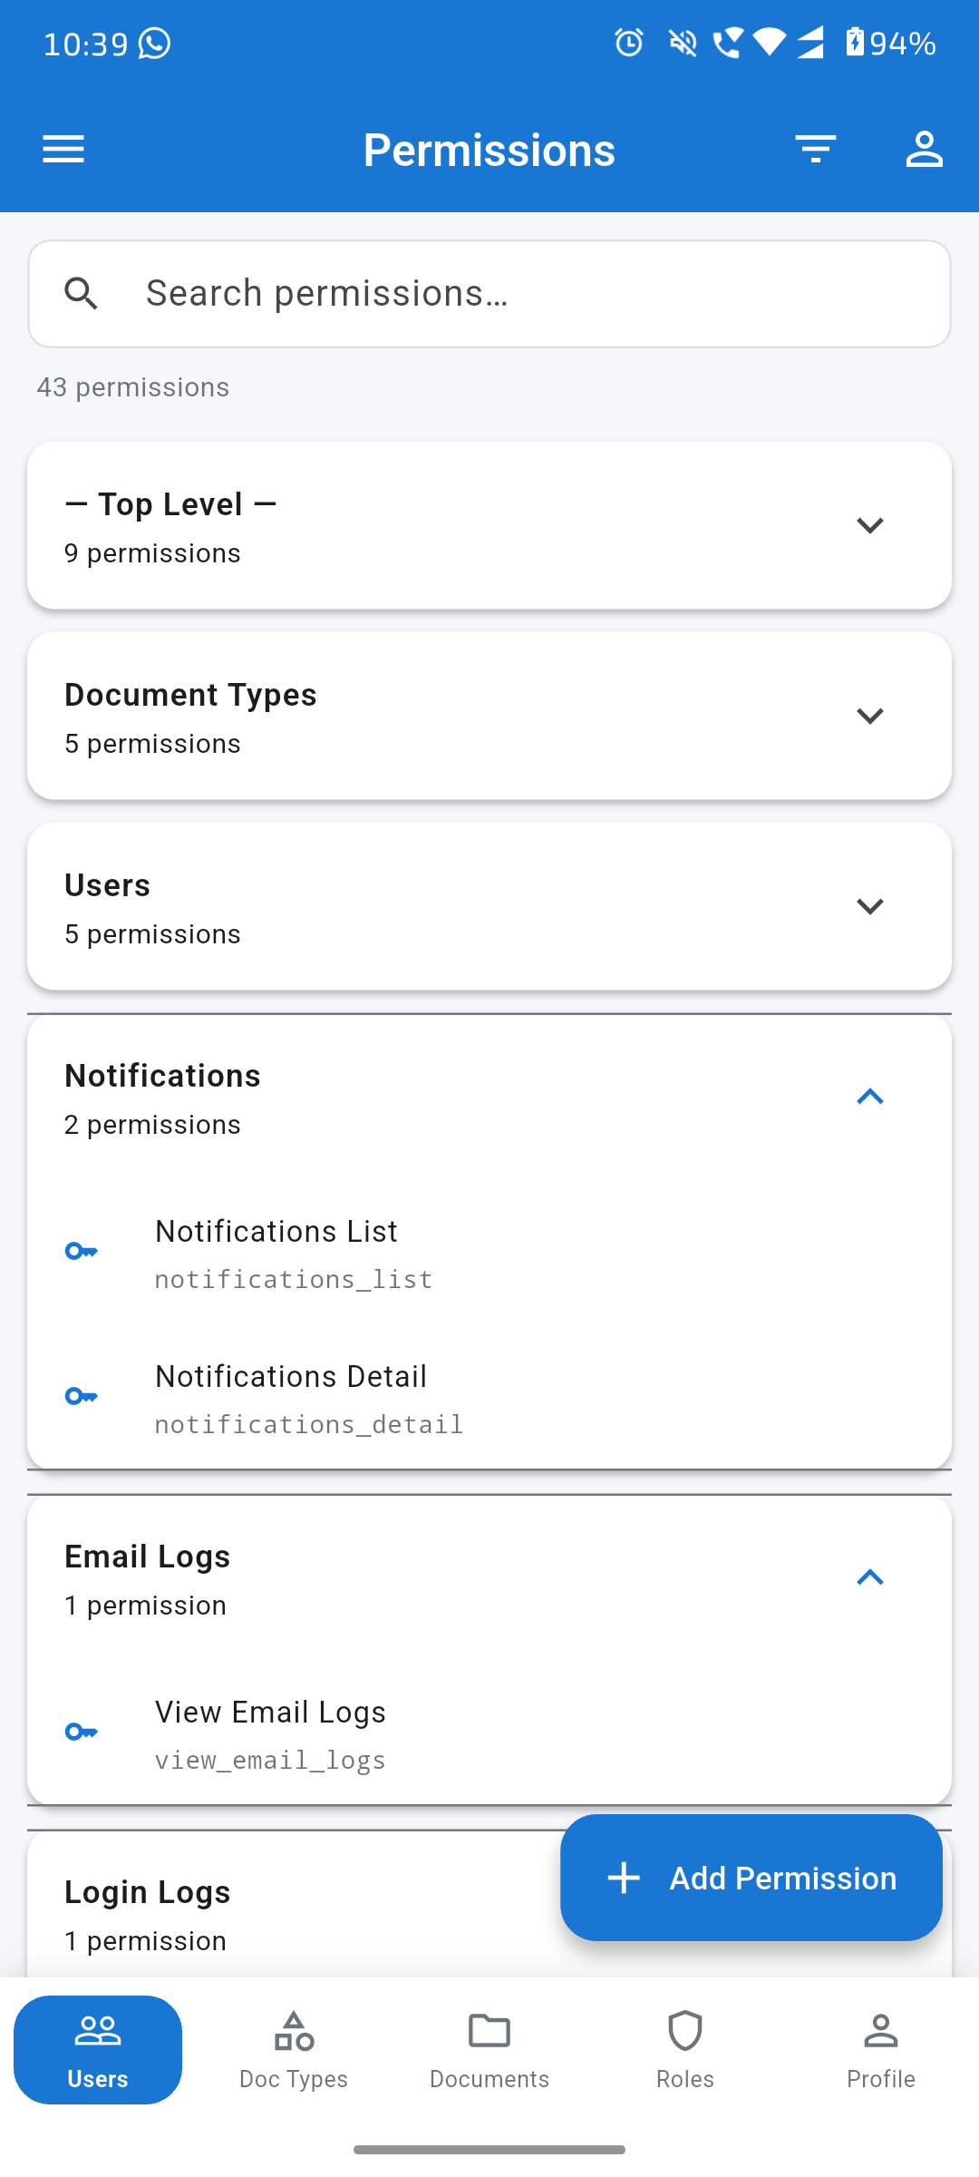  Fig 13 — Permissions List | 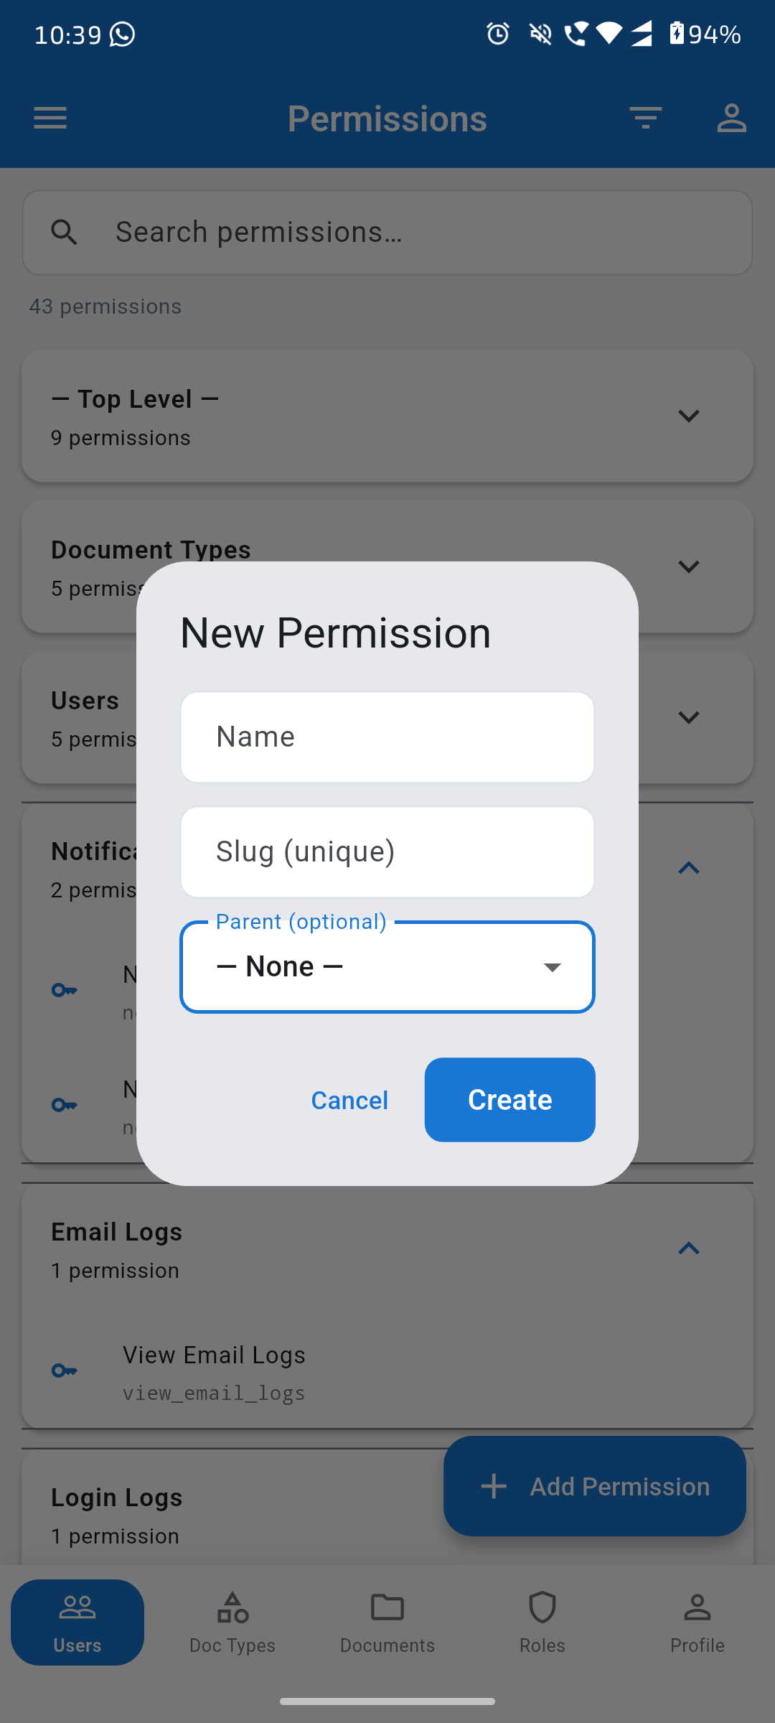  Fig 14 — New Permission Dialog

7.1 › Permissions List
The Permissions screen lists all 43 permissions organized into groups: Top Level, Document Types, Users, Notifications, Email Logs, Login Logs, etc. Each group is collapsible. Individual permissions show their name and slug.
- Search bar filters permissions by name or slug
- Groups can be expanded/collapsed with the chevron arrow
- Key icon (🔑) shown next to each permission slug
- "+ Add Permission" floating button

7.2 › Adding a New Permission
- Tap "+ Add Permission"
- Enter Name — human-readable label (e.g. "View Email Logs")
- Enter Slug — unique machine key (e.g. "view_email_logs")
- Parent (optional) — nest under an existing permission group
- Tap "Create" — permission appears in the relevant group immediately

SECTION 8 — Logs (Email & Login)

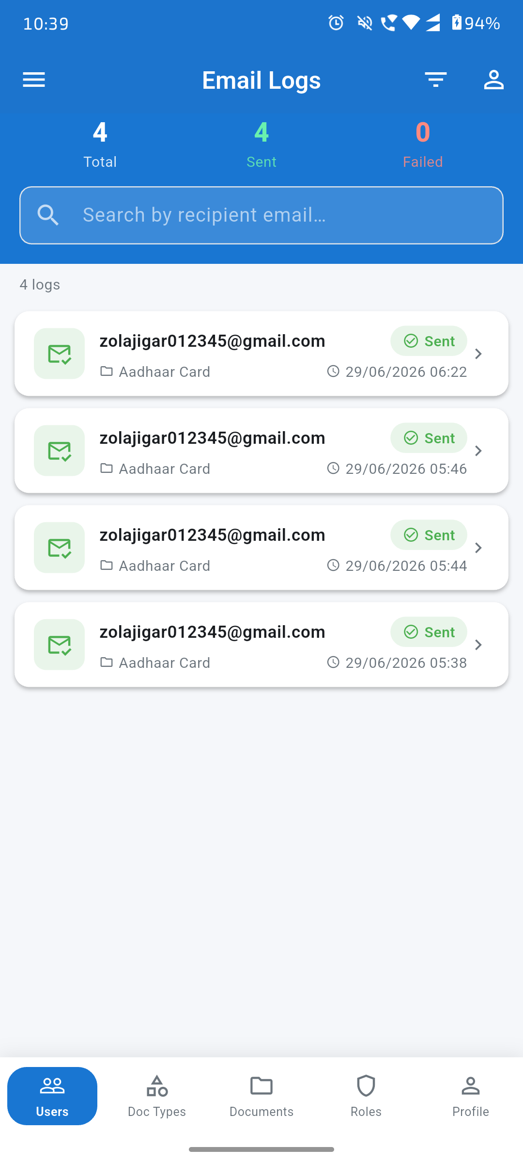  Fig 15 — Email Logs | 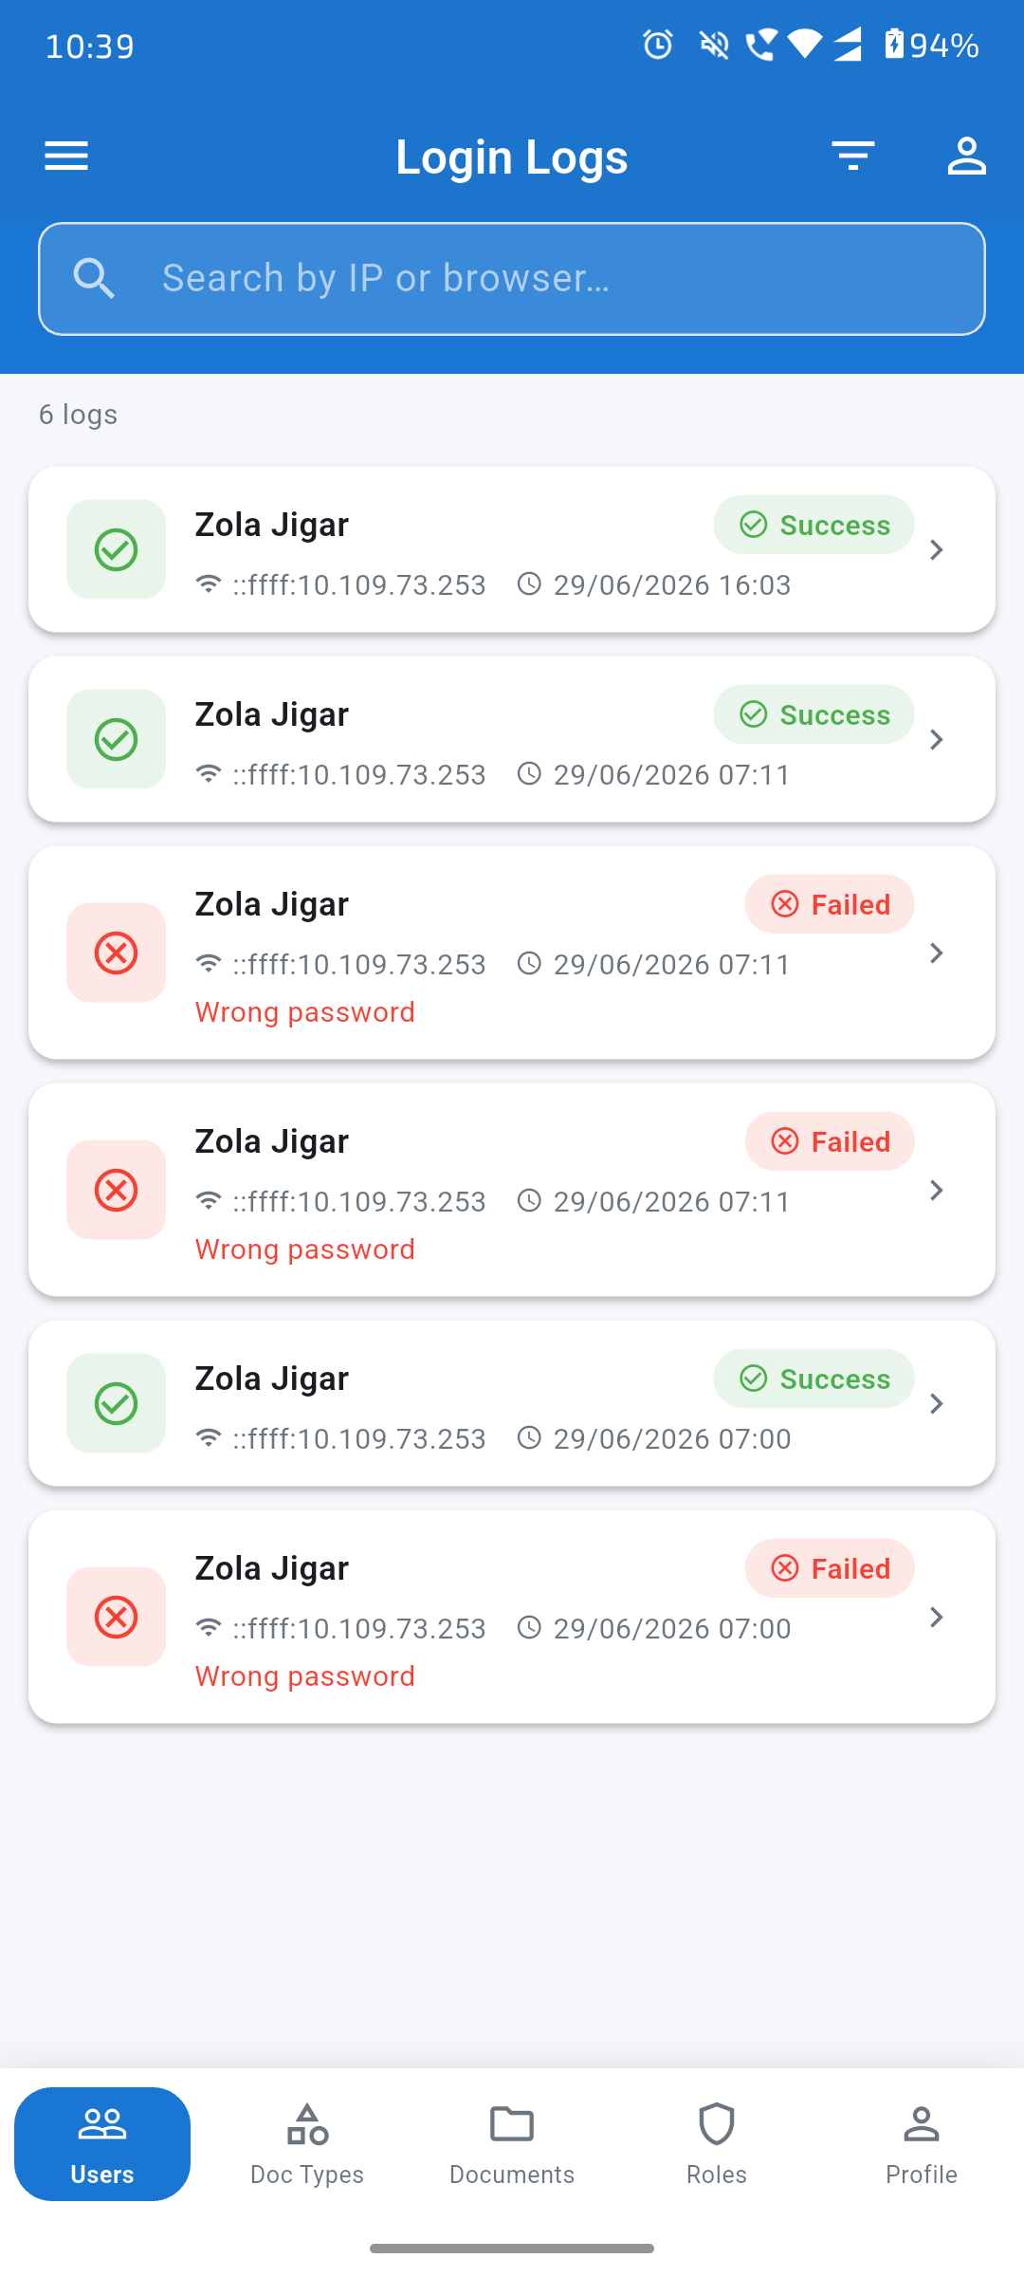  Fig 16 — Login Logs

8.1 › Email Logs
The Email Logs screen shows all notification emails sent by the system. A summary bar at the top shows Total / Sent (green) / Failed (red) counts.
- Each log entry shows: recipient email, document name, sent timestamp
- "✅ Sent" green badge — email delivered successfully
- "❌ Failed" red badge — delivery failed
- Search by recipient email address
- Tap any entry for full details

8.2 › Login Logs
The Login Logs screen is an audit trail of all login attempts to the app. Admins can see who logged in, when, from which IP, and whether it succeeded.
- "✅ Success" green badge — login was successful
- "❌ Failed" red badge — login attempt failed
- "Wrong password" shown in red under failed entries
- Each entry: user name, IP address, timestamp
- Search by IP address or browser
- Tap any entry for complete details including browser info

SECTION 9 — Profile & Logout

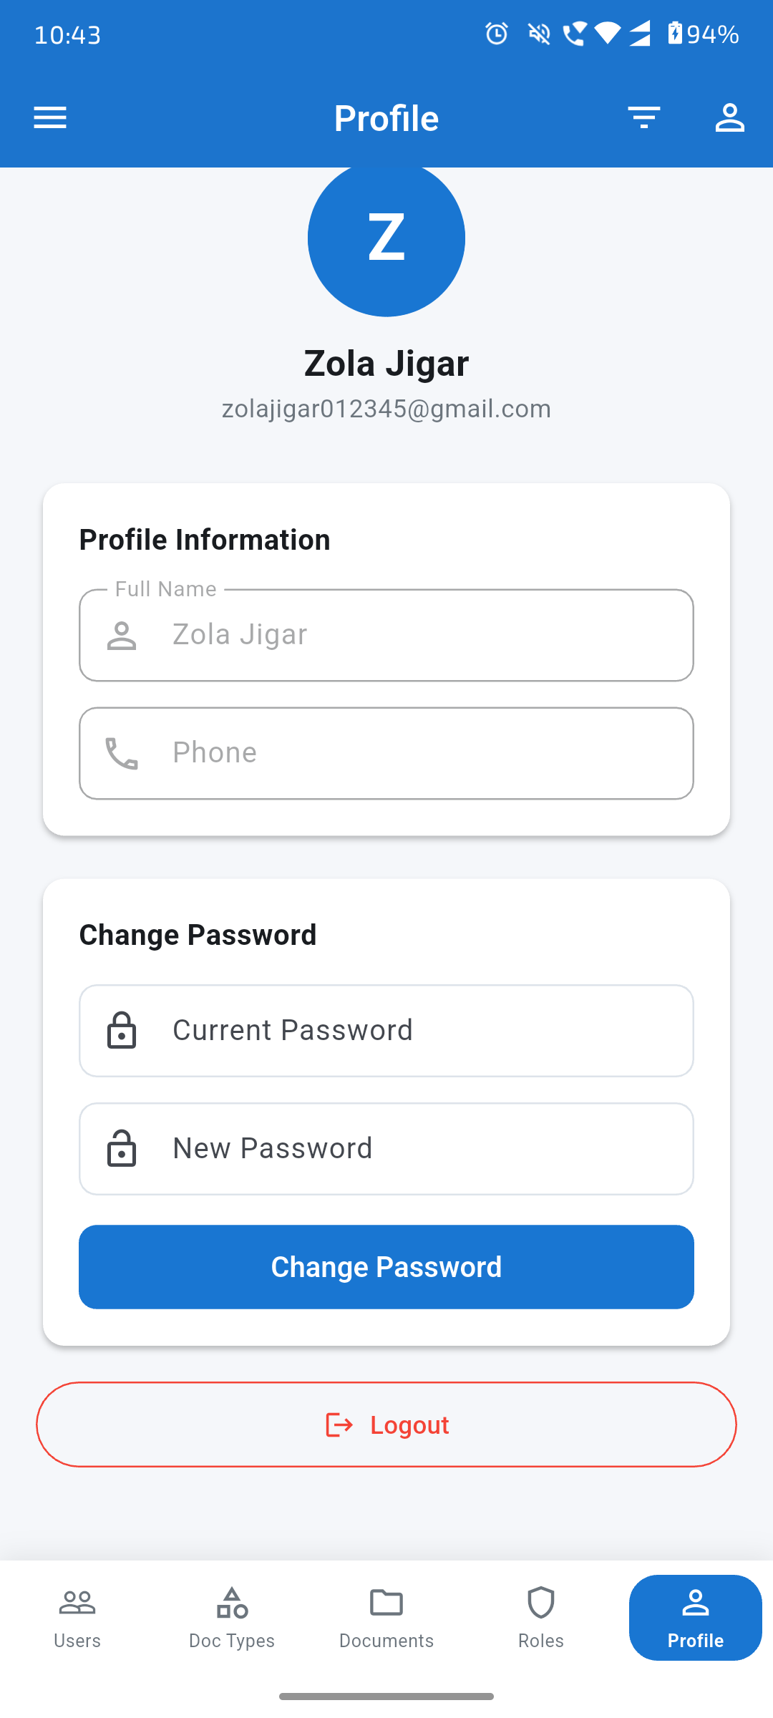
Fig 17 — Profile Screen
9.1 › Profile Screen
The Profile tab shows the logged-in user's avatar (initial letter), full name, and email address.
- Profile Information card — edit Full Name and Phone number
- Change Password card — enter Current Password and New Password, tap "Change Password"
- "Logout" button (red outline) — clears the session and returns to Login screen

9.2 › Logout Flow
- Tap the red "Logout" button
- AuthService.logout() clears "auth_token" and "user_data" from SharedPreferences
- _currentUser is set to null
- PermissionNotifier.clear() resets all role permissions
- App navigates to LoginScreen, removing the full navigation stack

SECTION 10 — Complete Login Flow Summary

# | Step | File / Method | Description
1 | App Launch | main.dart / _SplashRouter | PermissionNotifier provider created. Blue splash screen shown. SharedPreferences checked for "auth_token".
2 | Session Found? | AuthService.isLoggedIn() | YES → loadUser() rehydrates user + permissions → HomeScreen.  NO → LoginScreen shown.
3 | Login Screen | login_screen.dart | Animated form (fade + slide-up). Email + Password fields. Sign In button.
4 | Validation | _formKey.validate() | Email: required + contains "@". Password: required. Inline errors on fail.
5 | API Request | POST /auth/login | JSON body: { email, password }. LoadingOverlay shown. No auth header needed.
6 | Success Response | AuthService → SharedPrefs | Token saved as "auth_token". User JSON as "user_data". PermissionNotifier.load(roleId) fetches role permissions.
7 | Navigate Home | Navigator.pushReplacement | Login screen removed from stack. HomeScreen rendered with permissions loaded.
8 | Failure Response | showSnack() | Red snackbar shows error message. Form stays visible for retry.
9 | Auth Requests | ApiService.getHeaders() | "Authorization: Bearer <token>" injected on every subsequent API call.
10 | Logout | AuthService.logout() | SharedPrefs cleared. _currentUser = null. PermissionNotifier.clear(). Navigate to LoginScreen.

DocReminder Flutter App • Complete Tour Guide • June 29, 2026 • All screenshots from live device

