*// Name: Ho Nhat Tien*

*// Class: DIT/FT/1B/1B04*

*// Admission Number: P2205894*

**Additional APIs/ Features**

|  |  |  |  |
| --- | --- | --- | --- |
| |  | | --- | | **POST** | | /film | |
|  | Add a new customer to the database (note: customer’s email address is unique) | |
|  | | |
| **Parameters** | | |
| Name | Type | Description |
| object | body | Example Value: |
|  | | |
| **Responses** | Content Type: application.json | |
| Code | Description | |
| 200 | Record was created successfully  Example Value: | |
| 400 | Missing information from body object.  Example Value: | |
| 500 | Example Value: | |

**Modifications:**1. Added Admin Table (For Login Purposes):

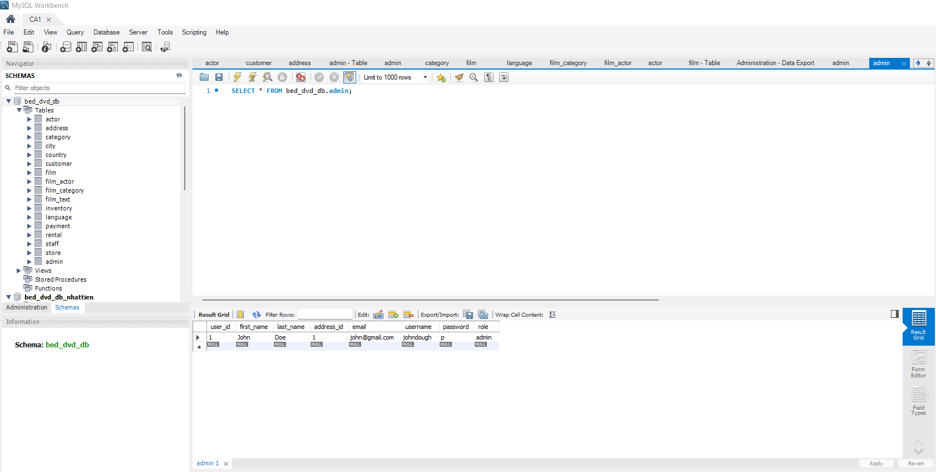

2. Added Image Column to the Film Table:

