**Class exercise 3**

**Junior Moraba & Simamkele Nongwe**

1. **Scoping diagram for international and local procurement at Zambikes**

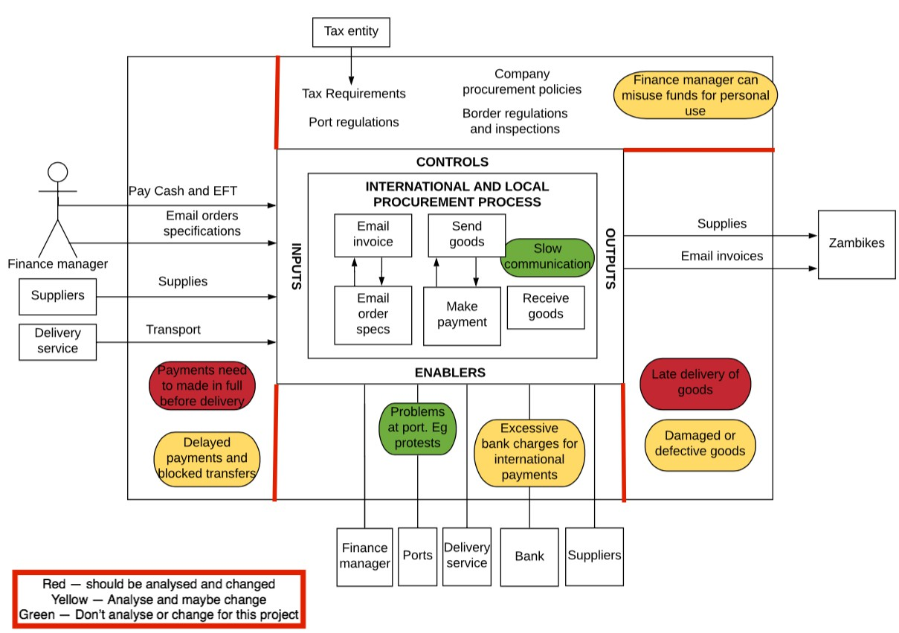

**2. 5 whys for the Damaged or defective goods problem**

• Damaged or defective goods == why

• Used gravel road == why

• Avoiding traﬃc oﬃcers on Tar road == why

• License expired == why

• Been to busy to go renew == why

Solution ==> Take leave and go renew license and drive on Tar road