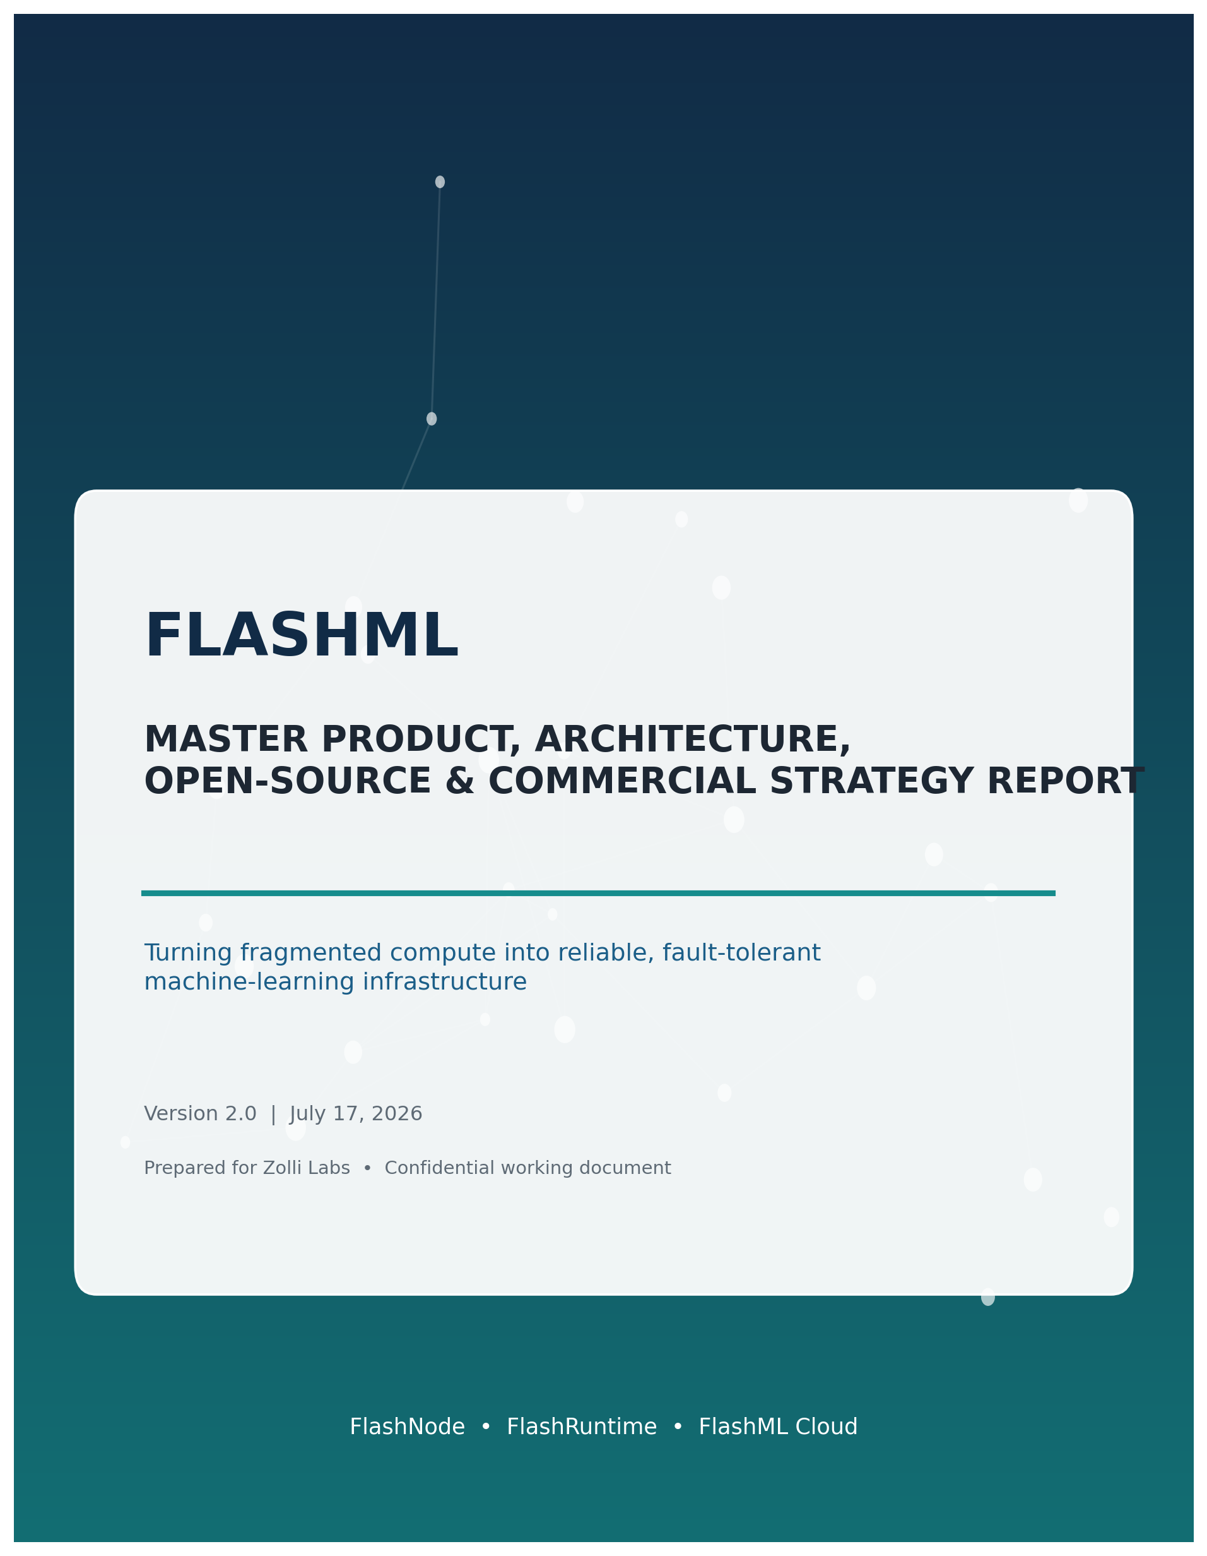

How to use this document
This report is the consolidated source of truth for the FlashML project discussed across the uploaded Vision Report, the Master Strategy and Moat Report, and the subsequent product-design conversations. It deliberately corrects the earlier over-narrow framing of FlashML as only a GPU-reliability overlay and preserves the larger three-part company idea: an open host agent, an open distributed runtime, and a closed managed application that joins supply, execution and monetization.
The report separates three horizons that must not be confused: the hackathon demonstration, the first real product used by design partners, and the long-term platform. A feature can be strategically attractive and still be wrong for the current horizon. This document therefore marks what should be built now, what belongs after validation, and what should remain a research direction.
Decision rule
A new feature belongs in FlashML only when it increases usable supply, improves completed useful work under failure, lowers cost per completed workload, raises host utilization, or increases trust. If it merely adds another way to list a machine, launch a container or display a GPU price, it is probably outside the core wedge.

Document status
Item | Current decision
Company / umbrella | Zolli Labs
Product system | FlashML
Open-source repository 1 | flashnode - host agent and local executor
Open-source repository 2 | flashruntime - distributed execution, protocol, checkpointing and recovery
Private repository | flashml-cloud - hosted control plane, marketplace, billing and proprietary intelligence
Initial compute scope | Supported Linux CPU hosts for the hackathon; controlled NVIDIA GPU and external-provider paths next
Initial workload | Independent distributed ML tasks such as hyperparameter search or sharded K-means; controlled LoRA recovery as a follow-on
Core success measure | Completed useful work per dollar and per host-hour

Contents
- 1. Executive summary
- 2. Origin and corrected product definition
- 3. Problem, opportunity and industry structure
- 4. Final product thesis and strategic boundaries
- 5. The three-product system
- 6. End-to-end architecture and control planes
- 7. Workload model and scope
- 8. Distributed execution and fault tolerance
- 9. Scheduling, benchmarking and useful-work economics
- 10. Security, trust and data governance
- 11. Platform and open-source ecosystem integration
- 12. Competitive landscape and differentiation
- 13. Repository, licensing and contribution strategy
- 14. Technical stack, protocol and data model
- 15. Hackathon MVP and demonstration plan
- 16. Real-user acquisition and validation
- 17. Business model and monetization
- 18. Metrics and proof of value
- 19. Roadmap and engineering execution
- 20. Risks, invalidation tests and guardrails
- 21. Final company narrative
- Appendices: example job spec, API surface, repository trees, glossary and references

1. Executive summary
FlashML should become the open execution and reliability layer that converts fragmented devices and mixed compute supply into predictable machine-learning capacity.
FlashML is a three-part product system. FlashNode is open-source software installed by resource contributors. FlashRuntime is the open-source workload protocol and execution layer that divides work, leases tasks, tracks progress, checkpoints state and recovers from node loss. FlashML Cloud is the private managed service that authenticates users and hosts, matches workloads to capacity, applies trust and economic policy, records contribution, and handles billing, credits, payouts and enterprise controls. This architecture preserves transparency where trust is required and concentrates defensibility where network data and operational complexity accumulate. [I1][I2]
The strongest positioning is not “another GPU marketplace.” Marketplaces and clouds already expose capacity, while orchestrators already launch jobs. FlashML should own the complete path from a workload request to verified completed work across unreliable and heterogeneous infrastructure. The key objects are not merely machines and prices; they are task attempts, job progress, checkpoint lineage, node reliability, placement constraints, recovery actions, result validity and the economic cost of failure.
The hackathon version should begin with CPU-friendly, naturally parallel workloads across two or three real devices. Distributed hyperparameter search, cross-validation, sharded preprocessing and K-means are more credible on ordinary internet-connected hosts than synchronous gradient training. The demonstration should intentionally terminate one host, automatically reassign its task, complete the job and display a recovery timeline plus host credits. This shows all three components without pretending that random laptops can efficiently run tightly synchronized PyTorch training.
The first post-hackathon product should add supported Linux/NVIDIA hosts, signed containers, object-store artifacts, workload-specific benchmarks, trust tiers and one controlled training-recovery path. A two-node PyTorch LoRA run on a single provider or low-latency pool is the right reliability demonstration: FlashML detects the loss, selects a viable checkpoint, replaces capacity, restarts the worker group and reports lost steps and avoided waste. PyTorch Elastic restarts all workers after membership changes, so the first product must promise controlled restart with bounded lost work rather than zero-downtime rank repair. [S6][S7]
The durable moat is the data and policy system that improves with volume: a distributed job-state model, workload-specific node scores, a cross-provider reliability graph, an auditable recovery-policy engine and deep integrations that make FlashML the system of record for what failed, what action was taken, and how much useful work was preserved. The open-source components make the runtime inspectable and adoptable; the private cloud compounds reliability data, marketplace density, billing operations, fraud controls and enterprise policy.
3  Product components | 2  Public repositories | 1  Private managed platform | 1  Core metric: useful work

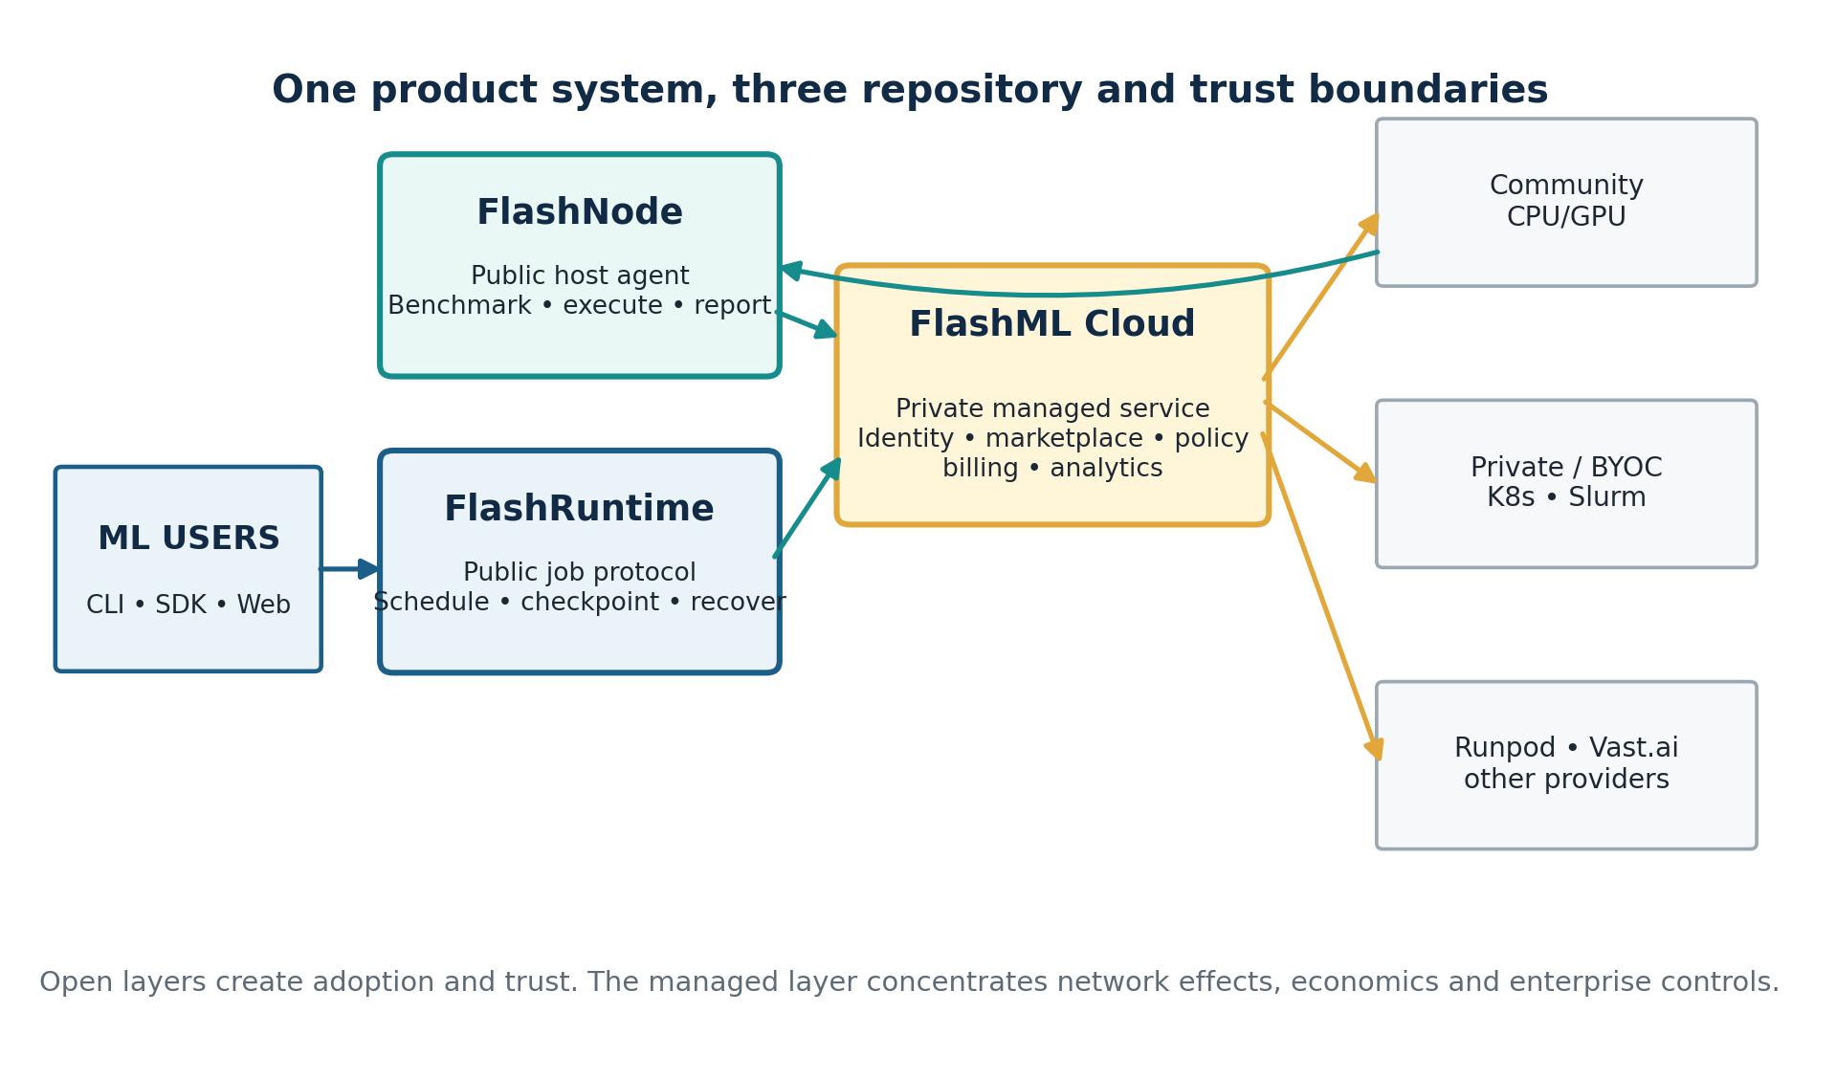
Figure 1. FlashML combines two open-source layers with a private managed control plane.
Final recommendation
Build the smallest complete loop: a host joins, a user submits a real ML job, FlashRuntime distributes it, a node fails, the work is recovered, the result is committed, and FlashML Cloud shows both user value and host contribution. Do not expand into a broad marketplace or arbitrary internet-wide synchronous training until this loop produces repeat usage and willingness to pay.

2. Origin and corrected product definition
The current company is an evolution of the Runpod hackathon prototype, not the unrelated Spark/Hadoop project that also used the FlashML name.

2.1 From visual distributed ML to a platform
The original FlashML hackathon project made distributed machine learning visible through modes such as distributed K-means, gradient synchronization and parallel hyperparameter search. A FastAPI coordinator and Next.js interface demonstrated that work could be split across remote workers and visualized in real time. Winning the Runpod Flash Hack Day Grand Prize validated the founder’s ability to build and explain distributed systems quickly, but the visualization itself is not a durable company wedge. [I2]
The product now answers a larger question: how can underused machines, private clusters and third-party compute providers be turned into a reliable ML execution network that finishes jobs despite failures? This broadens the supply idea beyond rented GPUs while retaining reliability as the intelligence layer connecting every component.
Stage | Product | Value proved | Remaining limitation
Hackathon origin | Visual distributed-ML playground | Remote orchestration and understandable distributed execution | Primarily educational and demo-oriented
New hackathon MVP | Community CPU pool + fault-tolerant independent tasks | Three-sided loop: host, user and managed application | Small trusted host set and narrow workloads
First product | Open node agent + open runtime + managed control plane | Repeatable jobs, recovery and contribution accounting | Security, demand density and provider diversity
Long-term platform | Reliability and economic OS for heterogeneous compute | Cross-environment useful-work optimization | Must avoid becoming an unfocused cloud marketplace

2.2 Naming and brand caution
“FlashML” is not an empty namespace. An older 247.ai artifact used the name for a Spark-based machine-learning framework, and a separate FlashML organization now publishes FlashLib for fast classical ML operators. This does not determine trademark rights, but it creates search, repository and messaging confusion. Public materials should therefore lead with the distinctive product names FlashNode, FlashRuntime and FlashML Cloud under the Zolli Labs umbrella, and a formal trademark/domain review should occur before a major launch. [S22][S23]
Identity statement
This report uses FlashML exclusively for Zolli Labs’ fragmented-compute platform. It is not Apache Spark, Hadoop, Hive, the old 247.ai framework, or FlashLib.

3. Problem, opportunity and industry structure
Compute is abundant but fragmented; completed, trustworthy ML work remains scarce.

3.1 The supply fragmentation problem
Useful compute exists in many forms: idle student desktops, gaming PCs, university workstations, underutilized office servers, private Kubernetes and Slurm clusters, spot instances, regional GPU operators and self-serve platforms such as Runpod and Vast.ai. These resources differ in operating system, CPU and accelerator type, memory, storage, network quality, uptime, trust, price and operational support. A nominal core-hour or GPU-hour is therefore not a uniform product.
Existing marketplaces prove that owners will expose capacity, but supply alone does not create value. A host that registers and never receives work will leave. A cheap node that repeatedly fails may cost more per completed result than an expensive stable node. A fast node may still be inappropriate for sensitive data. The product must therefore convert raw resource availability into workload-specific, policy-governed capacity.

3.2 The failure chain
1. A node, process, network path, provider or container becomes unavailable or unhealthy.
2. The runtime observes a missed heartbeat, process exit, GPU error, timeout, corrupted artifact or degraded throughput.
3. The system determines whether the problem is task-local, node-fatal, correlated, transient or caused by the application.
4. For restartable work, the latest valid checkpoint or intermediate artifact is selected.
5. A replacement node must satisfy capability, trust, locality, image, cost and deadline requirements.
6. The task or worker group is reconstructed and resumed without duplicating committed output.
7. The platform records useful work, lost work, downtime, host contribution and user cost.

3.3 Where FlashML fits in the stack
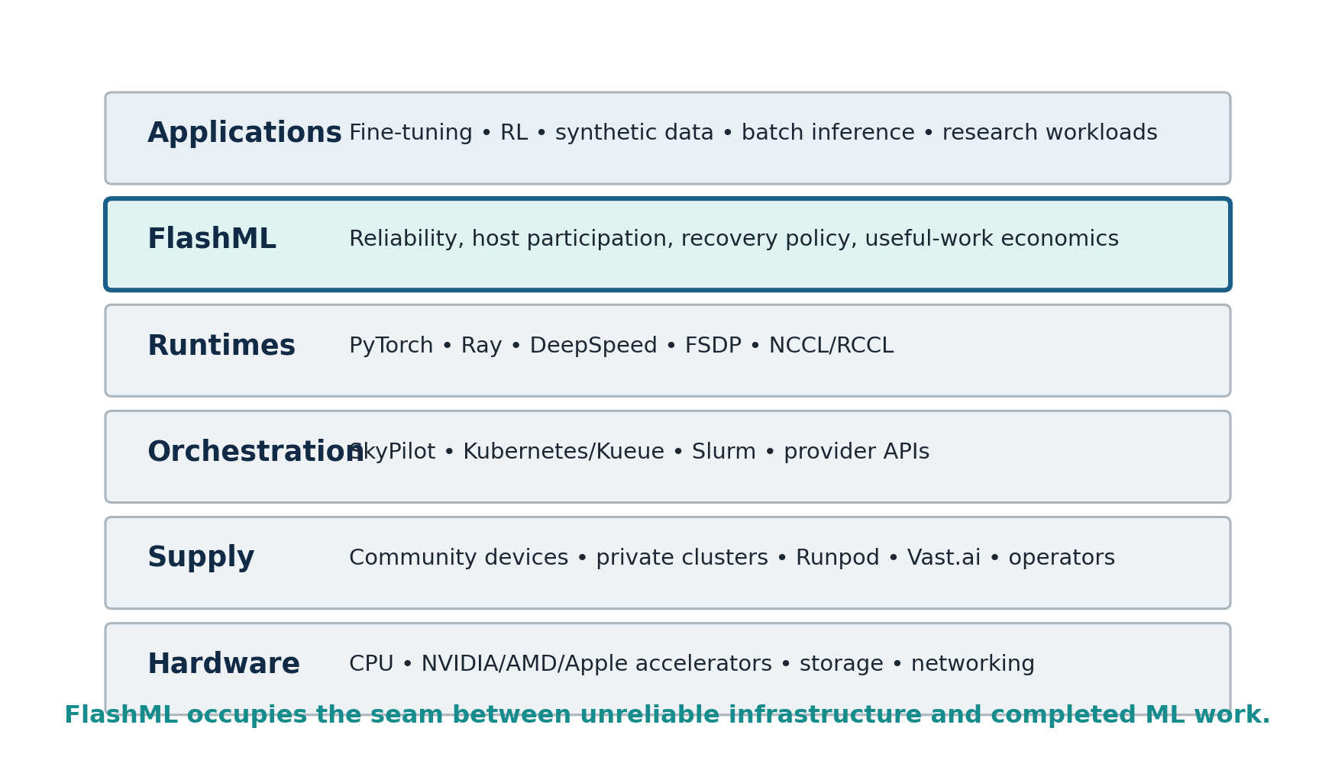
Figure 2. FlashML sits between compute supply, orchestrators and application runtimes.
Hardware vendors build processors and accelerators. Clouds and operators sell capacity. Marketplaces expose heterogeneous supply. Orchestrators provision and queue jobs. Training runtimes execute synchronized computation. Applications create business or research outcomes. FlashML should integrate with each layer but own the seam where infrastructure unreliability becomes lost application progress and wasted money. [I2]

3.4 Why this is a credible market
The underlying market evidence is directional rather than a substitute for customer validation. Runpod exposes programmable Pods, Serverless endpoints and APIs for compute resources; Vast.ai qualifies hosts through self-tests and automated verification; Golem and Akash demonstrate provider participation and compensation; Salad abstracts healthy-node routing and automatic retry for discrete jobs; SkyPilot automatically recovers managed jobs from preemptions, GPU errors and node crashes. These systems independently validate supply aggregation, queueing, host qualification and recovery as real infrastructure needs. [S1][S2][S3][S4][S5][S10][S11][S12]
The remaining question is not whether distributed compute can exist. It is whether FlashML can attract a dense enough workload segment and deliver a meaningfully better ratio of completed work to cost and operator effort. The first user interviews and pilots must measure this directly.

4. Final product thesis and strategic boundaries
FlashML is an open execution network with a managed reliability and economic control plane.

4.1 One-sentence definition
Product definition
FlashML lets people contribute idle compute through an open node agent, lets developers run fault-tolerant distributed ML jobs through an open runtime, and provides the managed cloud that schedules work, measures reliability, and monetizes the network.

4.2 What FlashML sells
Users do not ultimately buy “access to a machine.” They buy a completed experiment, processed dataset, trained adapter, evaluated model or generated artifact. Hosts do not ultimately want a node status badge. They want utilization, transparent eligibility and credible compensation. FlashML Cloud should align both sides around verified useful work.
- For developers: portable job submission, reliable completion, visible recovery and a clear cost record.
- For hosts: safe participation, understandable workload eligibility, utilization and contribution accounting.
- For private clusters and operators: a standard node agent, workload policy, failure telemetry and higher-quality capacity.
- For enterprise teams: BYOC controls, auditability, regional placement and consistent reliability policy across environments.

4.3 What FlashML must not become
Do not lead with | Why it is weak | Better framing
Generic GPU marketplace | Crowded category with fraud, payout, support and demand-density burdens | Open node network plus workload-aware execution and reliability
Universal “any device” promise | Devices differ sharply in architecture, security and network quality | Published supported host classes and workload envelopes
OpenRouter for GPUs | Short stateless requests differ from long-running stateful work | Completed-work routing for ML tasks and training
Generic multi-cloud launcher | SkyPilot, Kubernetes and Slurm already provision and schedule broadly | Reliability and economic layer that can use them as substrates
Autonomous AI infrastructure agent | A chatbot is not the moat and creates unauditable risk | Typed, deterministic recovery actions with logged policy
Internet-wide all-reduce training on day one | Communication and trust assumptions are unrealistic | Independent jobs first; controlled low-latency training next

4.4 Strategic synthesis of the two source reports
The Vision Report correctly identifies the three-part open/open/closed structure and the importance of benchmarking, trust, scheduling and managed operations. The Master Strategy report correctly narrows the differentiated intelligence toward workload state, checkpoints, recovery and completed-work economics. The final direction combines both: the company is broader than a reliability overlay, but reliability is the control intelligence that prevents the three components from becoming an undifferentiated marketplace. [I1][I2]

5. The three-product system
Each component has a distinct user, trust boundary, repository and economic role.

5.1 FlashNode - open host agent
FlashNode is installed by individuals, labs, companies and compute operators. Because it runs on someone else’s machine and executes third-party workloads, it must be inspectable, minimal and explicit about permissions. Open sourcing the agent is therefore both a distribution strategy and a trust requirement.
Capability | Initial behavior | Longer-term behavior
Identity | Generate node keypair; register signed node ID | Hardware-backed identity or attestation for premium pools
Discovery | Report CPU, RAM, disk, OS, architecture and optional GPU | Rich topology, accelerator, network and storage inventory
Benchmarking | Short CPU, disk, memory and network probes | Workload-specific benchmark profiles and thermal stability
Execution | Pull allowlisted container; apply CPU/RAM/time limits | Rootless OCI, gVisor or microVM tier based on trust policy
Telemetry | Heartbeats, state, task progress, logs and resource use | GPU health, XID/NVML events, thermal and failure fingerprints
Artifacts | Download inputs; upload outputs and checkpoint pieces | Local caching, encrypted staging and content-addressed artifacts
Contribution | Track accepted work units and online time | Verified useful-work credits, pricing and payout eligibility

For the hackathon, support a deliberately narrow host class: x86-64 Linux, Python, Docker or Podman, at least four CPU cores, eight gigabytes of memory and stable outbound internet. No inbound public port should be required. FlashNode maintains an outbound authenticated WebSocket or gRPC connection, which avoids router and firewall configuration for student and consumer hosts.
Golem shows the appeal of a one-command provider installation, but its documented provider path still requires Linux x86-64 and nested virtualization. Akash has simplified its provider setup, yet it remains fundamentally a provider/Kubernetes operating model. FlashNode should compete on a lower-friction installation experience for narrow, safe ML tasks. [S10][S11]

5.2 FlashRuntime - open distributed execution and recovery
FlashRuntime defines what a job is, how it becomes tasks, how tasks are leased, how progress is reported, how artifacts are committed and how recovery occurs. The runtime should be self-hostable so developers can run it on their own machines or private clusters without using FlashML Cloud. This makes the protocol credible and creates an integration surface for contributors and infrastructure partners.
- Job specification and schema validation.
- Task graph or shard creation.
- Capability and policy matching interfaces.
- Leases, heartbeats, retries and idempotent attempts.
- Checkpoint manifests and artifact commit protocol.
- Failure taxonomy and deterministic recovery state machine.
- Provider and orchestrator adapter interfaces.
- CLI, Python SDK and reproducible examples.
- Local coordinator for self-hosted or development use.
FlashRuntime should reuse mature mechanisms rather than reimplement training science. Ray can provide task-level retries and batch execution; PyTorch Elastic can manage distributed worker groups; PyTorch Distributed Checkpoint can save across ranks and reshard during load; SkyPilot can provision and relaunch infrastructure; Kubernetes/Kueue and Slurm can provide queueing and cluster resource management. FlashRuntime’s value is the consistent job-state and recovery contract spanning these mechanisms. [S5][S6][S7][S8][S15][S16]

5.3 FlashML Cloud - private managed application
FlashML Cloud is the commercial product. It provides the low-friction experience that most users and hosts will choose instead of self-hosting the runtime. It is also where the compounding advantages live: marketplace density, cross-node reliability history, fraud and abuse signals, advanced scheduling, pricing, billing, payouts, support and enterprise policy.
Surface | Primary functions
Developer experience | Projects, API keys, job submission, templates, live progress, logs, artifacts, recovery timeline and spend
Host experience | Node onboarding, diagnostics, eligible workloads, availability, tasks, credits, reliability and earnings
Control plane | Job and node state, queue, scheduler, failure classifier, checkpoint catalog, event ledger and policy
Commercial operations | Usage metering, credits, invoices, host settlement, payout status, KYC/tax workflow and disputes
Trust and security | Image allowlists, trust tiers, secrets policy, regional routing, access control and audit history
Enterprise | Organizations, SSO/RBAC, private pools, BYOC deployment, policy packs, support and SLA reporting

Boundary principle
The open runtime must be genuinely useful without the cloud. The cloud wins by operating the network better, not by deliberately crippling the public repositories.

6. End-to-end architecture and control planes
FlashML should separate user intent, durable control state, replaceable execution and customer-owned artifacts.

Figure 3. The three products connect users to community, BYOC and external-provider capacity.

6.1 Logical planes
Plane | Components | Responsibility
Interface | CLI, Python SDK, web dashboard, REST API | Submit jobs and policies; inspect progress, recovery, cost and contribution
Managed control | Identity, registry, queue, scheduler, policy engine, event ledger | Validate, match, observe, decide, meter and audit
Runtime control | Job graph, leases, heartbeats, checkpoint catalog, recovery state | Guarantee consistent execution semantics across environments
Adapter | Community pool, Runpod, Vast, SkyPilot, Kubernetes/Kueue, Slurm, Ray | Provision or select capacity and translate provider events
Execution | FlashNode and runtime integration inside workers | Execute signed tasks, stage artifacts and emit telemetry
Storage | Customer S3-compatible storage, managed artifact store, local cache | Preserve inputs, outputs and checkpoints independently of node lifetime

6.2 Normal job lifecycle
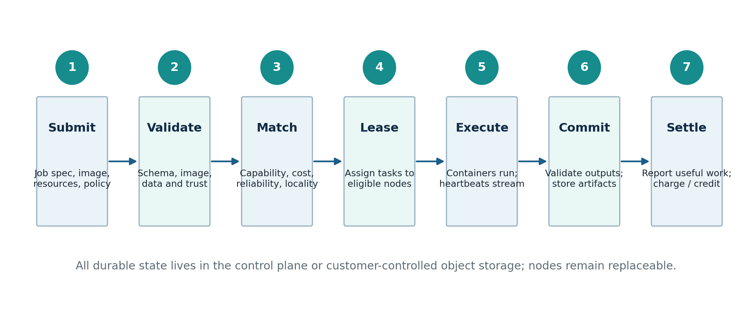
Figure 4. Normal jobs progress through validation, matching, leases, execution, commit and settlement.
A user submits a declarative job specification that identifies the container image, command, input data, expected outputs, resource envelope, workload mode, failure policy and trust requirements. The control plane validates the request and creates a job attempt. FlashRuntime expands the attempt into tasks or a coordinated worker group. The scheduler selects eligible capacity. FlashNode or a provider adapter creates execution attempts, which report heartbeats and progress until outputs are committed.
The platform should distinguish attempted work from accepted work. A host earns contribution only for verified task execution or clearly defined reserved capacity, not merely for claiming resources. Results must be committed through an idempotent protocol so that retries do not double-count output or compensation.

6.3 Durable state model
Nodes should be disposable; state should not be. Durable objects include User, Organization, Node, NodeCapabilitySnapshot, Job, JobAttempt, Task, TaskAttempt, Lease, Heartbeat, CheckpointManifest, Artifact, FailureEvent, RecoveryAction, UsageRecord, ContributionRecord and Settlement. The event ledger records every state transition and automated decision.
Design invariant
Any node should be replaceable without losing the control plane’s understanding of the job. Any cloud adapter should be replaceable without changing the public job model.

7. Workload model and scope
Fragmented compute is valuable when the workload can tolerate weak coupling, retries and heterogeneous performance.

7.1 Execution mode A: fragmented independent work
This is the correct hackathon and early community-network mode. Work is decomposed into independent tasks that need little or no communication while running. A slow node affects only its task. A disappearing node causes a lease to expire and the task to be reassigned. Heterogeneous CPUs and GPUs can participate because the scheduler can size and route tasks based on capability.
- Hyperparameter search and experiment sweeps.
- Cross-validation folds and ablation studies.
- Dataset preprocessing, feature extraction and media transformation.
- Offline batch inference and evaluation.
- Synthetic-data generation with independent seeds or prompts.
- Sharded K-means, map-reduce style statistics and Monte Carlo workloads.
- Independent LoRA jobs or model-evaluation runs, where each trial uses one node.

7.2 Execution mode B: coordinated training
Synchronous DDP, FSDP and DeepSpeed jobs require a controlled environment with compatible accelerators and acceptable network topology. PyTorch torchrun supports fault-tolerant and elastic worker groups, but when workers fail or membership changes, all surviving workers are stopped and restarted. Checkpoint frequency therefore determines lost work. FlashML can coordinate replacement and checkpoint selection, but it cannot erase the communication assumptions of the training framework. [S6]
The initial coordinated-training envelope should be one provider, one data center, one private cluster or another known low-latency pool. Cross-provider synchronous training should remain a later research track. Kueue’s topology-aware scheduling explicitly exists because pod placement and network hierarchy affect AI/ML workload execution time and cost. [S13][S14]

7.3 Workload fit matrix
Workload | Community fragmented pool | Controlled cluster/provider | Reason
Hyperparameter search | Excellent | Excellent | Independent trials, easy retries and clear aggregation
Cross-validation / evaluation | Excellent | Excellent | Natural task boundaries and deterministic outputs
Data preprocessing | Excellent | Excellent | Parallel shards; artifact validation is straightforward
Offline batch inference | Excellent | Excellent | Throughput matters more than single-request latency
Synthetic data generation | Excellent | Excellent | Prompt/seed units are independent; outputs can be validated
Single-node LoRA jobs | Good with trusted data policy | Excellent | Checkpointable and lower memory than full fine-tuning
Same-cluster multi-GPU training | Poor | Good | Requires coordinated network and homogeneous local world size
Internet-wide all-reduce training | Poor | Conditional research | Communication and failure coordination dominate
Low-latency interactive inference | Poor initially | Good with dedicated pools | Cold starts and node variance become user-visible
Sensitive enterprise data | Not allowed initially | Good in private/trusted pools | Host and legal trust must match data sensitivity

7.4 Why CPU-first is useful but not the entire company
CPU hosts are easy to recruit and ideal for proving node onboarding, distributed task execution, retries, contribution accounting and the user/host application loop. They are not automatically the highest-value commercial supply for modern AI. The roadmap should treat CPU-first as a validation and distribution wedge, then extend the same protocol to supported GPUs, BYOC clusters and external provider APIs. The architecture must avoid hard-coding CPU assumptions into the public job or node model.

8. Distributed execution and fault tolerance
Recovery must be designed by workload class and expressed as a transparent state machine.

8.1 Leases and heartbeats for independent tasks
A task lease grants one node the right to execute a task attempt for a bounded period. The node renews the lease through heartbeats. If heartbeats stop beyond the policy threshold, the attempt becomes suspect, then expired. FlashRuntime creates a new attempt on another node. Only one attempt may commit the final artifact; late duplicate attempts are rejected or treated as speculative execution results.
Ray demonstrates the basic pattern: tasks can be retried after worker or machine failure, with configurable retry limits. Salad’s job queues similarly distribute discrete jobs to healthy nodes and retry transient failures. FlashRuntime should expose the same concept without coupling the public protocol to either implementation. [S8][S12]

8.2 Failure taxonomy
Failure class | Signals | Default action
Application error | Known exception, deterministic non-zero exit | Fail or retry only if policy explicitly classifies it as transient
Worker process crash | Lost process, worker exit, runtime error | Restart task attempt; preserve node if health remains good
Node loss | Heartbeat timeout, unreachable agent, host shutdown | Expire leases, cordon node and reassign tasks
Accelerator failure | NVML/XID signal, CUDA error, ECC or driver fault | Cordon accelerator or node; choose replacement
Network degradation | High latency, repeated object-store timeouts, rendezvous failure | Retry transfer, move task, or restart coordinated group
Artifact corruption | Hash mismatch, invalid schema or failed validation | Reject commit; retry on different node; lower reliability score
Capacity loss / preemption | Provider termination or spot event | Acquire replacement and restore from durable state
Correlated incident | Multiple simultaneous nodes or control-plane dependency fails | Stop automation or move pool; escalate according to policy

8.3 Checkpoint and artifact model
A checkpoint is not simply a path. FlashRuntime should maintain a manifest containing job ID, attempt ID, workload mode, framework and version, training step or completed shards, world size, rank files, optimizer and scheduler presence, dataset cursor or sampler state, object hashes, creation time, storage location and validation status. The control plane chooses only checkpoints marked complete and compatible with the intended recovery topology.
PyTorch Distributed Checkpoint supports parallel save/load and load-time resharding, which is important when topology changes. PyTorch Elastic still requires the training program to load the checkpoint after restart. FlashML should catalog and score checkpoints, orchestrate storage and replacement, and report recovery economics rather than reimplement serialization. [S6][S7]

8.4 Recovery state machine
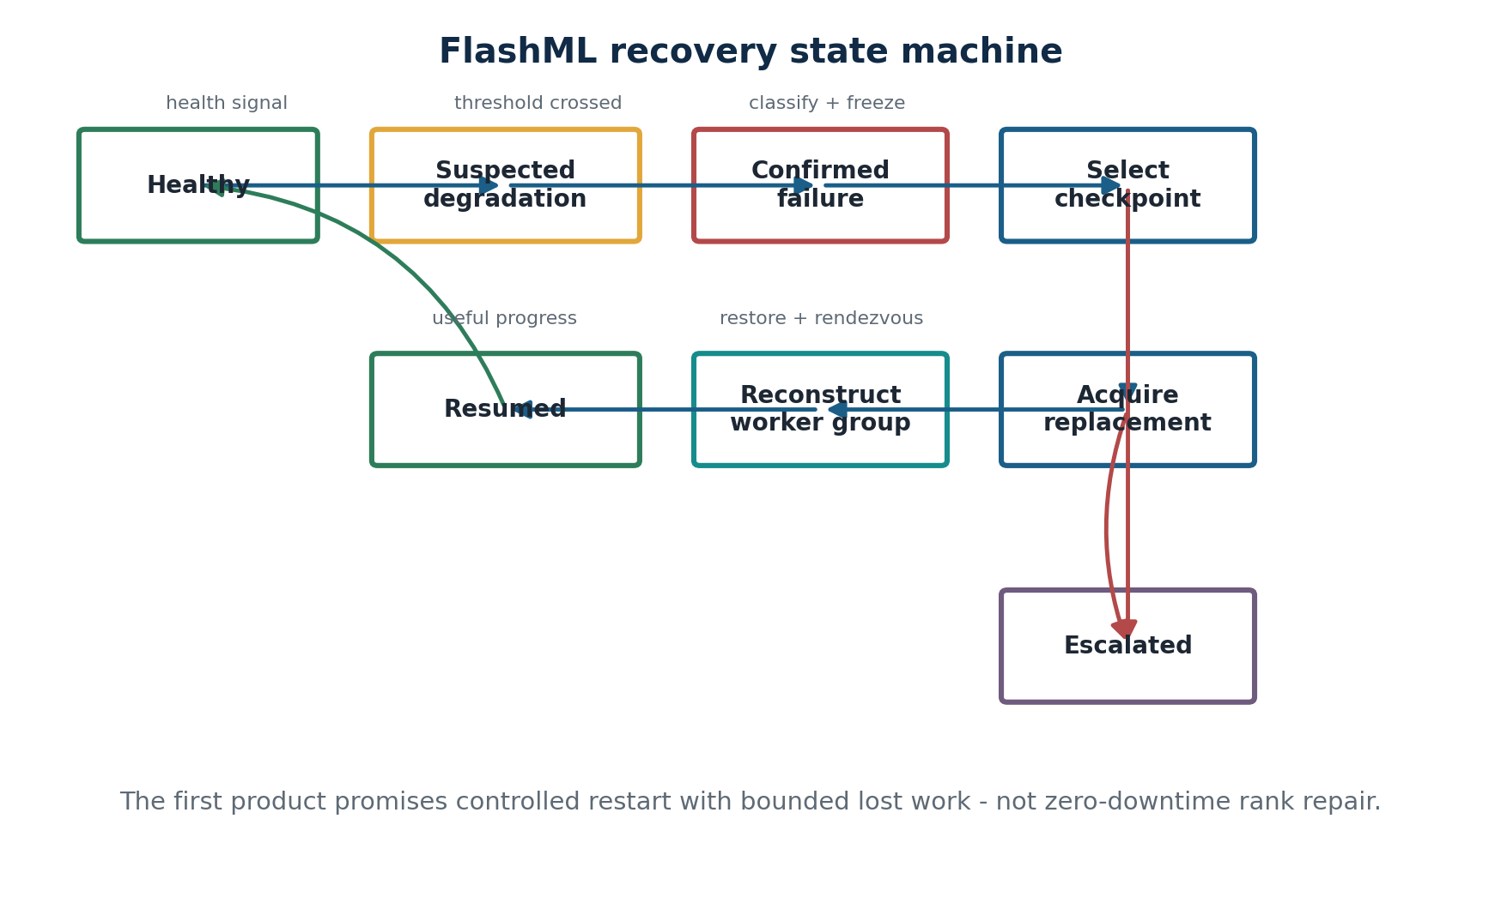
Figure 5. The first product uses controlled restart and explicit escalation.
The policy begins deterministically. It may retry a process, reassign a task, replace a node, restart a coordinated worker group, reduce parallelism if allowed, move to another supply pool, wait for capacity, or stop automation. Machine learning should not select high-impact recovery actions until FlashML has enough labeled events to evaluate policy quality. Early decisions must remain inspectable and reproducible.

8.5 Result validation and correctness
Fault tolerance that returns incorrect work is worse than failure. Independent tasks should publish output through temporary object keys, include content hashes and pass workload-specific validators before commit. Coordinated training should validate checkpoint completeness, restored step monotonicity, data-sampler state and final metric continuity. The platform must explicitly escalate when it cannot prove that recovery is safe.

9. Scheduling, benchmarking and useful-work economics
FlashML should optimize expected cost per accepted result, not nominal price per CPU- or GPU-hour.

9.1 Three independent node assessments
Assessment | Question | Inputs
Capability score | Can this node run the workload? | Architecture, cores, RAM, accelerator, VRAM, drivers, container support, storage and bandwidth
Reliability score | How likely is it to finish correctly? | Successful attempts, lease loss, restart rate, artifact validity, uptime, thermals and recovery history
Trust tier | What data and actions may be placed here? | Identity, ownership, verification, attestation, location, policy compliance and contractual status

These scores must remain separate. A powerful machine can be unreliable. A reliable consumer host can still be inappropriate for proprietary data. A data-center host can be trustworthy but uneconomical for a low-priority batch job. Vast.ai’s self-test and automated verification show that host qualification requires driver, network, ports, PCIe, VRAM, CPU/RAM and workload checks rather than a self-reported GPU model. [S3][S4]

9.2 Workload-specific benchmarks
Benchmarks should measure the bottlenecks that affect the target workload: model or container cold start, input transfer, sustained throughput, checkpoint upload, local cache hit, output validation and failure recovery. A single synthetic score should never replace the raw measurements. Scheduling policy can compute workload-specific suitability from a shared benchmark profile.

9.3 Economic objective
expected_cost_per_completed_job =
compute_price
+ cold_start_and_model_load
+ data_transfer_and_storage
+ checkpoint_overhead
+ expected_failure_loss
+ retry_and_recovery_cost
+ platform_fee

The scheduler may minimize cost, completion time or deadline miss probability subject to trust and capability constraints. A user-facing policy can expose presets such as Cheapest, Balanced, Fastest and Trusted. Internally, the decision should account for node throughput, queue depth, cache locality, failure probability, recovery time, data location and the user’s maximum cost or deadline.

9.4 Contribution accounting
The hackathon can use non-cash credits, but the accounting model should already distinguish reserved time, attempted compute, accepted useful work, failed work caused by the host, failed work caused by the workload and platform-directed cancellation. Payout policy must not reward nodes for repeatedly failing or producing unverifiable output. Hosts need a transparent explanation of why they were eligible, why they received or did not receive work, and how to improve their score.

9.5 Moat flywheel
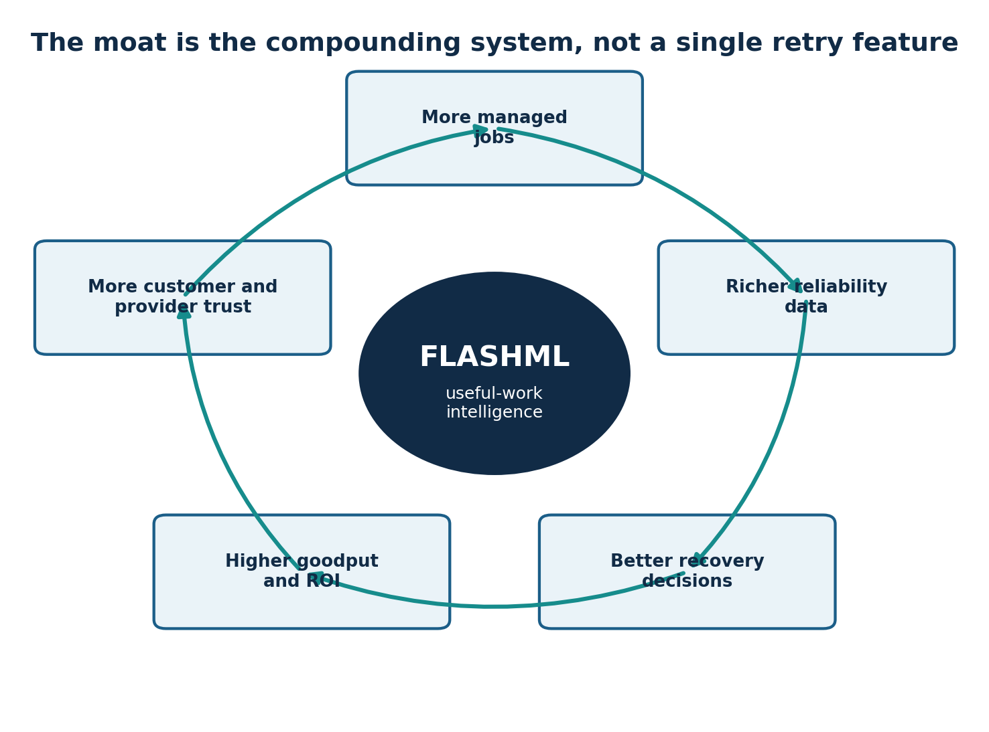
Figure 6. More jobs improve the data used to route and recover later jobs.

10. Security, trust and data governance
Community compute requires both containment and explicit limits on what the platform promises.

10.1 Threat model
FlashML must protect the host from an untrusted workload, protect the workload and its data from an untrusted host, protect the control plane from malicious nodes and users, and protect the marketplace from fraud. No single sandbox solves all four. A malicious host owner with full machine control can often inspect local memory, storage or devices even when the guest workload is containerized. Community pools must therefore begin with non-sensitive data and disposable tasks.

10.2 Staged isolation model
Tier | Runtime | Use | Limit
Hackathon / baseline | Docker or rootless OCI, cgroups, seccomp/AppArmor, allowlisted images | Trusted participants and public datasets | Shared host kernel; not a complete boundary against a malicious host or kernel escape
Hardened community | Rootless OCI plus stronger policy and optional gVisor | Broader untrusted code with reduced host-kernel attack surface | gVisor improves containment but does not make the host confidential
Professional pool | Kata Containers or microVM-backed execution | Higher-value multi-tenant workloads on qualified hosts | GPU and virtualization operations are more complex
Confidential enterprise | Confidential containers, attestation and customer-controlled secrets | Sensitive workloads on supported hardware only | Hardware availability, operational overhead and topology constraints

gVisor intercepts application system calls in a per-sandbox userspace kernel to reduce exposure to the host kernel. Firecracker provides KVM-based microVMs with a deliberately small device model. NVIDIA supports GPU containers through the NVIDIA Container Toolkit and documents a constrained path for Kata Containers. Confidential Containers uses attestation services to conditionally release secrets. These technologies support a staged roadmap, not an excuse to claim complete trustlessness. [S17][S18][S19][S20][S21]
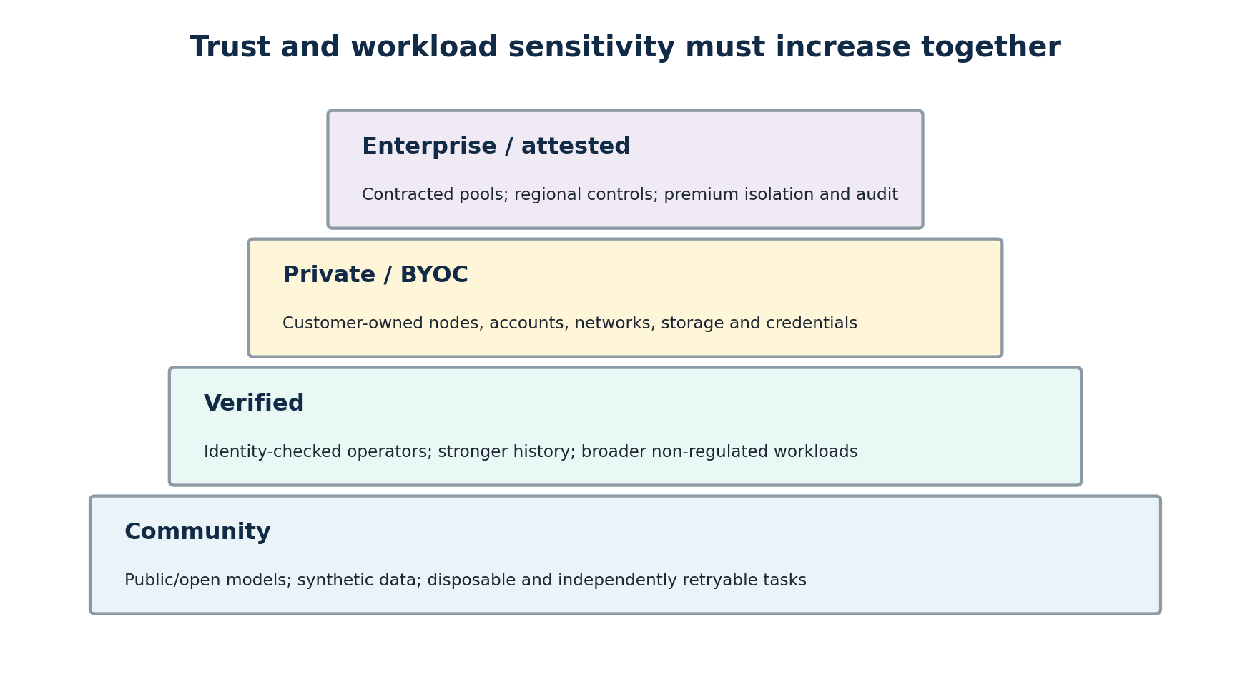
Figure 7. More sensitive workloads require stronger host identity, policy and isolation.

10.3 Security requirements for FlashNode
- Outbound-only control connection by default; no inbound SSH requirement for community hosts.
- Signed node identity and short-lived session credentials.
- Allowlisted or signed workload images for the first product.
- Non-root execution and explicit CPU, memory, disk, time and network limits.
- Read-only root filesystem where feasible and narrowly mounted work directories.
- No host Docker socket, arbitrary device access or unrestricted privileged mode.
- Secrets delivered only to workloads and nodes allowed by trust policy, preferably with short lifetimes.
- Complete event logging for task assignment, image digest, permissions, network policy and artifact commit.

10.4 Data policy
Community nodes should initially process only public datasets, synthetic data, open models or tasks whose exposure is acceptable. Verified operators may receive broader workloads with explicit user consent. Private/BYOC deployments keep data, credentials and storage in the customer environment. Enterprise pools add contracts, regional routing, audit and potentially attestation. The cloud should store operational metadata whenever possible rather than customer training data.

10.5 Payout and compliance surface
A real marketplace creates identity, tax, sanctions, payment, dispute, privacy and processor/subprocessor obligations. The first commercial product should avoid becoming merchant of record for arbitrary global hosts until demand and reliability are validated. Credits or controlled pilots can demonstrate the economic loop before full payouts. This is an operational sequencing decision, not a claim that compliance can be ignored.

11. Platform and open-source ecosystem integration
FlashML should integrate where mature systems are strong and differentiate where they stop.

11.1 Runpod
Runpod provides Pods, Serverless endpoints, APIs and high-performance cluster products. For FlashML, Runpod is managed supply and a deployment environment, not something to replace. A provider adapter can create Pods, attach storage, launch a FlashNode-compatible worker image and collect billing metadata. Controlled multi-node training can use Runpod’s clustered environment while FlashRuntime owns checkpoint catalog, recovery events and useful-work reporting. [S1][S2]

11.2 Vast.ai
Vast.ai is a useful low-cost provider integration and a model for host qualification. Its self-test checks drivers, network stability, ports, PCIe, VRAM, CPU/RAM and workload performance; automated verification changes with machine health and reliability. FlashML should borrow the principle, not the exact marketplace: hosts must earn eligibility through measurements, and placement should consider the expected cost of successful completion. [S3][S4]

11.3 SkyPilot
SkyPilot is the closest orchestration substrate. Managed Jobs provision temporary clusters, recover from preemption, GPU error and node crash, and can restart in another region or cloud. By default, however, a recovered job restarts from scratch unless application checkpointing is implemented. FlashML should avoid rebuilding SkyPilot’s provider catalog and instead add deeper application-state awareness, checkpoint viability, node participation and recovery economics. [S5]

11.4 Kubernetes and Kueue
Kubernetes is appropriate for professional host pools and enterprise BYOC. Kueue provides workload admission, queues, quota sharing, preemption, elastic workload support, multi-cluster dispatch and topology-aware scheduling. FlashRuntime can map its public job model onto Kubernetes custom resources or supported job controllers while preserving the same external state and recovery semantics. [S13][S14]

11.5 Slurm
Slurm remains important for universities, research labs and private HPC environments. It allocates cluster resources, starts and monitors parallel jobs, and manages queues and priorities. A Slurm adapter would allow FlashML to instrument existing research workloads without asking labs to replace their scheduler. [S15]

11.6 Ray
Ray is a strong execution backend for independent tasks, data processing, batch inference and certain training workloads. Ray retries worker or machine task failures, supports actors and checkpoints, and autoscaling responds to queued logical resource demand. FlashRuntime should be able to compile compatible job graphs into Ray while retaining provider-neutral identity, contribution and event records. [S8][S9]

11.7 Golem, Akash and Salad
Golem demonstrates an installable provider agent and compensation model for unused resources. Akash demonstrates competitive provider bidding, attributes, leases and audited providers, but its provider model is closer to operating a small cloud than installing a lightweight consumer agent. Salad demonstrates queueing discrete jobs across healthy interruptible nodes with automatic retry. FlashML combines these lessons around ML-specific task structure, open runtime semantics and a managed economic layer. [S10][S11][S12]

11.8 Bacalhau, exo, Gensyn and Prime Intellect
Bacalhau is a particularly relevant architectural reference: a job is submitted to an orchestrator, scheduled to compute nodes, executed in isolated environments and published to storage. Its emphasis is compute near data rather than a two-sided ML marketplace. exo proves that heterogeneous devices can be discovered and topology-aware model placement can unify local hardware, but its current focus is local inference. Gensyn’s RL Swarm and Prime Intellect’s published protocol illustrate permissionless or decentralized ML coordination; the archived Prime protocol included workers, validators, discovery and orchestration. FlashML should learn from these projects without inheriting blockchain complexity before a simpler managed network is validated. [S24][S25][S26][S27]

12. Competitive landscape and differentiation
Every component has substitutes; the integration and accumulated execution data create the opportunity.
Category / system | Primary strength | Where FlashML must differ
Runpod / Vast.ai | Accessible compute supply, APIs and marketplace economics | Open host/runtime layer, cross-supply policy, useful-work and recovery record
Golem / Akash | Open provider participation and economic coordination | Simpler ML-focused onboarding, workload semantics and managed user experience
SaladCloud | Distributed consumer GPU supply and healthy-node job queues | Open runtime, BYOC/provider neutrality and deeper checkpoint-aware jobs
SkyPilot | Broad provisioning, multi-cloud portability and managed-job recovery | Host participation, application-state recovery and cross-environment economics
Ray / Anyscale | Distributed Python runtime, retries, data and training ecosystem | Neutral public protocol and managed marketplace across non-Ray environments
Kubernetes/Kueue / Slurm | Mature cluster admission, quota, topology and scheduling | Cross-environment job state, recovery policy and user/host economic layer
PyTorch / DeepSpeed | Training execution, elasticity and checkpoint mechanisms | Managed infrastructure replacement, checkpoint catalog and incident economics
Bacalhau | Simple distributed compute orchestration and compute-over-data | ML-specific runtime, contribution accounting and hosted marketplace
exo | Automatic heterogeneous device discovery and model partitioning | Wide-area task network, fault-tolerant jobs and monetization
Gensyn / Prime Intellect | Decentralized training and worker/validator protocols | Practical managed adoption, broader workload modes and enterprise/BYOC bridge

12.1 Honest differentiation
Defensible claim
FlashML is not the only system with retries, nodes, queues or checkpoints. It is the product that treats resource contribution, workload structure, node reliability, checkpoint viability, recovery action, accepted output and completed-work economics as one end-to-end control problem.

12.2 The four compounding assets
1. Distributed job-state model: canonical representation of tasks, ranks, shards, checkpoints, artifacts, attempts and recovery constraints.
2. Cross-environment reliability graph: observed relationships among hardware, node, provider, workload, failure, checkpoint and successful remediation.
3. Recovery and placement policy: deterministic rules first, then learned estimates for success, cost and recovery time as data accumulates.
4. Integration and system-of-record position: adapters and incident history embedded in how teams run and audit expensive jobs.

12.3 Moat test
A useful feature is not automatically defensible. The test is whether the feature improves because FlashML has observed more hosts, workloads, failures and recoveries. A CLI command that launches a container is useful but does not compound. A workload-specific estimate that a particular node class will finish a video batch with lower expected retry cost can compound.

13. Repository, licensing and contribution strategy
Three repositories are justified because the open-source and private trust boundaries are real.
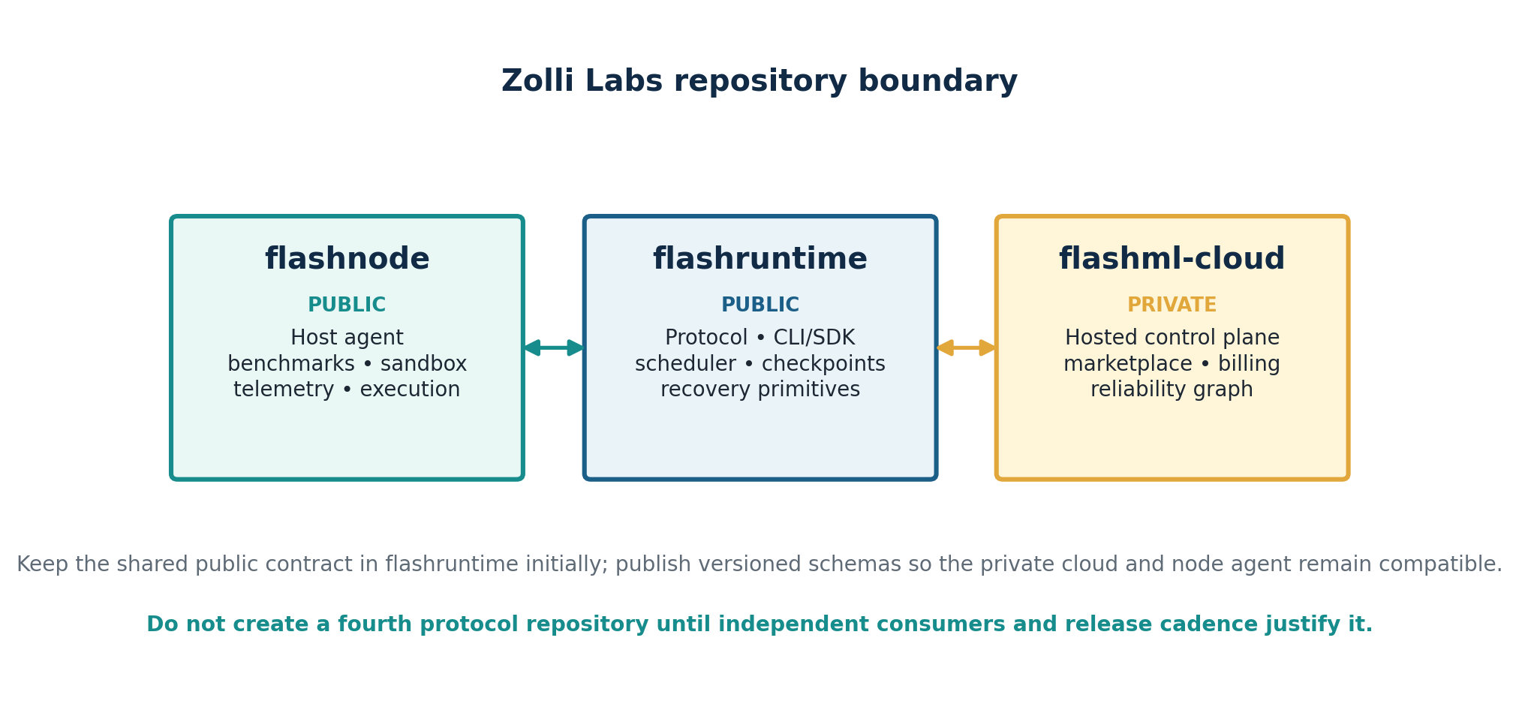
Figure 8. The recommended Zolli Labs repository boundary.

13.1 Repository decisions
Repository | Visibility | Purpose | Initial language
flashnode | Public | Installable agent, benchmark suite, sandbox executor, telemetry and local artifact handling | Python for hackathon; migrate performance-sensitive agent core to Go when justified
flashruntime | Public | Job schema, task graph, leases, checkpoint protocol, recovery state machine, CLI, SDK and adapters | Python with Pydantic/FastAPI-compatible models
flashml-cloud | Private | Web application, hosted API, identity, marketplace, advanced scheduler, billing, reliability graph and enterprise features | TypeScript/Next.js plus Python services

13.2 Dependency direction
flashruntime owns the public protocol package and versioned schemas. flashnode imports that package to register, receive leases and report events. flashml-cloud imports the same package to validate API requests and control messages. The private repository may add internal fields or services, but public-node compatibility cannot depend on private code.
flashml-cloud ───────┐
├── uses versioned flashruntime protocol
flashnode ──────┘
flashruntime does not import either application repository.

13.3 Why not a monorepo
A monorepo would simplify the hackathon technically, but it would blur licensing, access and contribution boundaries. Because two components are intentionally public and the commercial application is intentionally private, separate repositories reduce accidental source leakage and let each project have its own release cadence, issue tracker and contributor community. Shared contracts remain in flashruntime until independent adoption justifies a fourth protocol repository.

13.4 Licensing
Apache License 2.0 is the working recommendation for flashnode and flashruntime because it is commercially permissive and includes an explicit patent grant. This is a product recommendation rather than legal advice. Contributor License Agreements should be avoided initially unless counsel identifies a clear need; a Developer Certificate of Origin and signed-off commits may provide a lighter contribution process.

13.5 Public contribution strategy
- Maintain a public roadmap focused on node support, adapters, workload examples and reliability primitives.
- Create reproducible “kill a node” examples as the signature contribution experience.
- Use stable interfaces and semantic versioning for job schemas and node protocol.
- Publish architecture decision records for security- and compatibility-sensitive choices.
- Keep host telemetry collection explicit, documented and configurable.
- Accept provider adapters through well-defined conformance tests rather than ad hoc cloud logic.

14. Technical stack, protocol and data model
Optimize the first implementation for speed, auditability and replaceable components.

14.1 Recommended stack by repository
Area | Hackathon / first version | Later optimization
FlashNode | Python 3.12, asyncio, psutil, Docker SDK, WebSocket client, Ed25519 identity | Go agent, containerd/Podman support, gVisor/Kata integrations, auto-update channels
FlashRuntime | Python, Pydantic schemas, FastAPI local coordinator, Redis leases, SQLAlchemy/Postgres state | Event-driven services, durable workflow engine, pluggable scheduler and protocol SDKs
FlashML Cloud web | Next.js, TypeScript, Tailwind, React Query, Recharts/React Flow | Design system, streaming observability, enterprise administration
Managed API | FastAPI, Postgres, Redis, background workers, WebSocket/SSE | Service decomposition only after load and team size justify it
Storage | S3-compatible object storage and content hashes | Regional stores, local NVMe cache, lifecycle policy and customer-managed storage
Observability | Structured JSON logs, OpenTelemetry, Prometheus-compatible metrics | Failure fingerprinting, anomaly detection and reliability analytics
Identity / payments | Supabase/Clerk for user auth; internal non-cash credits first | Organization SSO/RBAC, Stripe billing, payout provider, KYC/tax workflows

14.2 Public job specification
apiVersion: flashml.dev/v1alpha1
kind: Job
metadata:
name: churn-hyperparameter-search
spec:
image: ghcr.io/example/churn-search:sha256-...
mode: distributed_tasks
command: ["python", "worker.py"]
resources:
workers: 3
cpu: 4
memory: 8Gi
data:
input: s3://team-public/churn/
output: s3://team-results/run-42/
faultTolerance:
maxAttempts: 3
heartbeatTimeoutSeconds: 15
checkpointIntervalSeconds: 60
placement:
trustTier: community
maxCostUsd: 5.00

14.3 Minimal managed API
POST /v1/nodes/register
POST /v1/nodes/{id}/heartbeat
POST /v1/jobs
GET /v1/jobs/{id}
POST /v1/jobs/{id}/cancel
POST /v1/leases/{id}/accept
POST /v1/attempts/{id}/progress
POST /v1/attempts/{id}/checkpoint
POST /v1/attempts/{id}/complete
POST /v1/attempts/{id}/fail
GET /v1/hosts/me/contributions

14.4 Core data entities
Entity | Key fields
Node | node_id, owner, public_key, status, trust_tier, current_capability_snapshot, labels
NodeCapabilitySnapshot | CPU/GPU/VRAM/RAM, architecture, OS, drivers, storage, bandwidth, benchmark results
Job | user, spec_digest, state, priority, trust policy, budget, deadline, artifact locations
Task | job, shard or trial definition, dependencies, commit key and validator
TaskAttempt | node, lease, start/end, exit class, metrics, output hashes and accepted flag
CheckpointManifest | job attempt, step, world size, rank objects, hashes, compatibility and validation
FailureEvent | signal source, category, affected scope, evidence and timestamp
RecoveryAction | selected action, policy version, inputs, outcome and avoided-work estimate
ContributionRecord | accepted compute, workload class, quality adjustment, credits and settlement state

14.5 Versioning and compatibility
Every job specification, node message and checkpoint manifest must include a schema version. The cloud should support at least one previous minor protocol version during rolling upgrades. Nodes advertise supported executors and feature flags during registration. Unknown fields should be ignored only when the schema explicitly permits forward compatibility; security-relevant fields must fail closed.

15. Hackathon MVP and demonstration plan
The MVP should prove the entire network loop with real machines, real ML work and an intentional failure.

15.1 MVP promise
Judge-facing promise
Three ordinary machines join FlashML. A developer launches a distributed hyperparameter-search or sharded K-means job. One machine is terminated during execution. FlashML detects the lost heartbeat, reassigns unfinished work, completes the job, and shows the recovery plus each host’s accepted contribution.

15.2 Scope
Include | Defer
Two or three supported Linux hosts | Global public host marketplace
Python FlashNode agent with outbound WebSocket | Production-grade gVisor/Kata/microVM isolation
CPU benchmark and capability registration | Arbitrary GPU and operating-system support
One job mode: distributed independent tasks | Internet-wide synchronous training
Redis-backed leases, heartbeats and requeue | Learned scheduler and complex economic optimization
Public dataset and allowlisted container | Sensitive or proprietary customer data
User dashboard, host dashboard and credits | Real-money payouts, KYC and tax processing
Failure timeline and accepted result commit | In-place rank repair or zero-downtime claims

15.3 Recommended workload
Distributed hyperparameter search is the strongest default. Each task trains or evaluates a model with a different parameter set on a public dataset. Trials are naturally independent, easy to retry, easy to validate and easy for judges to understand. The output is a ranked comparison and a best-model artifact. Sharded K-means is an excellent visual secondary mode because it connects directly to the original winning prototype.

15.4 Demo sequence
1. Host A, B and C install FlashNode and join using a one-time code.
2. The host dashboard displays capability, benchmark and availability.
3. The developer submits a 12-trial ML job through the web app or CLI.
4. FlashRuntime creates trials and leases them across the three nodes.
5. The live view displays each task, node, progress and accepted results.
6. One host process is killed or disconnected while it owns active work.
7. The heartbeat expires, the lease is invalidated and the task moves to another node.
8. The job completes with no permanently lost task.
9. The result page compares baseline local execution with FlashML completion and shows recovery time.
10. Each host receives credits only for accepted work.

15.5 Acceptance criteria
Criterion | Pass condition
Onboarding | A new host joins without inbound port configuration
Remote execution | A submitted containerized task runs on another physical machine
Distribution | At least two hosts execute different task attempts concurrently
Detection | A killed host is marked unavailable within the configured interval
Recovery | Its unfinished task is automatically requeued and accepted from another node
Correctness | The final aggregate contains each required task exactly once
Transparency | The UI reports attempts, node, failure, reassignment and completion
Economics | The UI calculates user compute usage and host credits from accepted work

15.6 Hackathon narrative
The presentation should begin with waste: machines sit idle while developers wait or pay for compute. Then show the open-source host install, the open runtime distributing a real ML workload, and the private application coordinating the network. The dramatic moment is not a chart; it is killing a machine and watching the job continue. The closing message is that the same protocol can later bridge community CPUs, private clusters, Runpod, Vast.ai and trusted GPU operators.

16. Real-user acquisition and validation
Demand density is harder than host registration; acquire workloads before chasing a large supply count.

16.1 Initial customer hypotheses
Segment | Immediate pain | First offer
AI students and researchers | Limited compute, repeated experiments and manual coordination | Run sweeps or evaluation across contributed machines for free during pilot
Hackathon teams | Bursty preprocessing and model experiments under deadline | One-click distributed task template and failure-safe completion
Small AI startups | Batch inference, data processing and expensive reruns | Instrument one real job and compare baseline completion cost
University labs | Idle workstations plus scarce shared clusters | Private pool with node inventory, queues and reproducible job history
Small GPU operators | Underused hardware and weak reliability software | Install FlashNode, expose a qualified pool and receive workload/incident analytics

16.2 The first 10 interviews
Interview teams that have actually run sweeps, batch jobs, fine-tuning or distributed workloads. Do not ask whether the idea sounds useful. Ask for the most recent incident, the environment, duration, cost, failure mode, steps lost, time to restore, who intervened and what existing tool failed to solve. A design partner should have a quantified workload and agree to run it through the product.
- What job took long enough that failure or manual distribution mattered?
- How is the job split today, and what state must survive?
- Which machines or providers are already available?
- What data can legally and practically leave the current environment?
- What is the baseline completion time, spend and human effort?
- What would make the team repeat the job through FlashML next week?
- What would they pay to avoid a rerun or to use cheaper supply safely?

16.3 First-month targets
10  Problem interviews | 5  Active hosts | 3  External workloads | 2  Repeat users | 1  Payment signal

A signup is not validation. The strongest evidence is repeat execution of a real workload, followed by a customer asking to keep the service or agreeing to a paid or structured pilot. Host count matters only when hosts receive useful work and remain active.

16.4 Distribution channels
- Open-source launch with a reproducible kill-node benchmark.
- WPI students, research labs and hackathon communities as the first trusted network.
- Technical posts comparing local sequential, manual distributed and FlashML-recovered execution.
- Provider and operator conversations positioned as reliability and utilization software, not a competing cloud.
- Examples and templates for hyperparameter search, batch inference, preprocessing and LoRA jobs.
- Founder-led outreach to teams already using Runpod, Vast.ai, spot instances or mixed private fleets.

17. Business model and monetization
Monetize coordination, trust and reliability before taking on the full burden of a global compute marketplace.

17.1 Revenue models
Model | Customer pays for | When to introduce
BYOC platform subscription | Scheduling, recovery, observability and policy across customer-owned machines or accounts | First commercial pilots
Managed usage fee | Jobs, useful compute hours, artifacts and reliability services on FlashML-managed pools | After repeat workloads exist
Marketplace take rate | Matching users to community or operator capacity, settlement and support | After supply quality and demand density are proven
Verified / SLA premium | Trusted nodes, regional controls, stronger isolation, support and guarantees | With professional operators and enterprise demand
Operator software | Per-node or cluster fee for validation, telemetry and reliability controls | When operators request private or white-label deployment
Outcome-aligned pilot | Fixed implementation plus optional share of verified avoided waste | Enterprise-like design partners

17.2 Recommended sequence
1. Use internal credits in the hackathon to prove contribution accounting.
2. Sell BYOC or managed pilot software before acting as merchant of record for arbitrary hosts.
3. Add controlled paid pools with known operators and clear support boundaries.
4. Introduce broader marketplace payouts only after the platform can measure quality, handle disputes and keep hosts utilized.
5. Charge higher margins for trust, reliability, policy and support rather than hiding a large markup in raw compute.

17.3 Unit economics
The governing unit is gross margin per completed workload, not markup per listed compute hour. Revenue must cover compute or host payment, storage, data transfer, failed attempts, support, payment costs and platform operation. A workload that appears cheap but has high cold-start, retry or egress cost may be unprofitable. FlashML’s scheduler and pricing model should use the same expected-completion economics.

17.4 Host economics
Host retention depends on utilization and predictability. The host dashboard should show eligible workload classes, recent assignments, accepted compute, failure deductions, score changes and expected earnings ranges. FlashML should not promise immediate passive income; it should show how demand, pricing, availability and reliability affect assignment probability.

18. Metrics and proof of value
Measure completed useful work, recovery quality and network health - not vanity supply.
Metric | Definition | Why it matters
Job success rate | Share of submitted eligible jobs that reach accepted completion | Core user trust
Useful-work ratio / goodput | Accepted progress divided by paid wall-clock resource time | Combines queue, initialization, failure and checkpoint losses
Cost per completed job | All compute, storage, transfer, retry and platform cost per accepted result | True economic comparison
MTTD | Time from incident to reliable detection | Measures wasted survivor time and detection quality
MTTR | Time from detection to resumed accepted progress | Core recovery speed
Recovery success rate | Eligible incidents returning automatically to useful progress | Automation trustworthiness
Lost work per incident | Progress after latest valid checkpoint or incomplete task work | Checkpoint and retry effectiveness
Output validation pass rate | Attempt outputs accepted without corruption or policy failure | Protects correctness
P50 / P95 completion time | Median and tail time by workload class | Reveals heterogeneous-node variance
Host utilization | Accepted busy time divided by available time | Supply retention and network efficiency
Host churn | Nodes leaving or going inactive over time | Tests economic attractiveness
Repeat workload rate | Users running a second meaningful job | Best early product validation
Human intervention rate | Incidents requiring manual operator action | Measures operational burden removed
Trusted-pool share | Revenue or jobs on verified/private/enterprise pools | Shows monetizable quality progression

18.1 Hackathon dashboard metrics
- Connected hosts and their capability profiles.
- Running, queued, recovered and completed tasks.
- Heartbeat age and lease status.
- Failure detection and reassignment time.
- Accepted work units and host credits.
- Total job completion time compared with a local baseline.

18.2 Pilot proof
A paid pilot should establish a baseline without FlashML, run controlled failure tests, shadow a real production-like workload and quantify completion rate, recovery time, lost progress, engineer intervention and avoided compute. The incident report should be a product artifact suitable for both an ML engineer and a budget owner.

19. Roadmap and engineering execution
Sequence the company by evidence, not by the number of integrations.
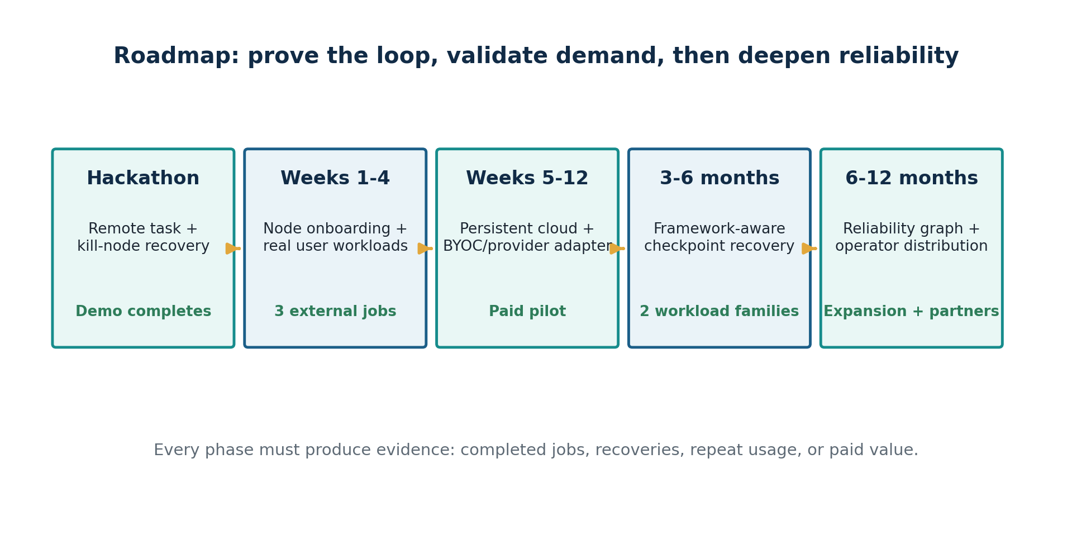
Figure 9. Each phase has a concrete proof threshold.

19.1 Hackathon
- FlashNode registration, benchmark and outbound connection.
- Job submission and independent task decomposition.
- Redis leases, heartbeat loss and automatic requeue.
- Allowlisted Docker execution on two or three machines.
- User and host dashboards with contribution credits.
- Public demo repository and recorded kill-node sequence.

19.2 Weeks 1-4: real-user pilot foundation
- Persistent Postgres state and event ledger.
- Cleaner CLI and job specification.
- Artifact store, content hashes and idempotent commit.
- Node capability snapshots and basic reliability score.
- Three external workloads and five active hosts.
- Baseline comparison and one written case study.

19.3 Weeks 5-12: usable platform
- Organization and project model, authentication and API keys.
- Runpod, Vast.ai or Kubernetes adapter in addition to community nodes.
- Configurable trust tiers, placement presets and recovery policy.
- Usage metering, invoices or pilot credits, and operator reporting.
- One controlled PyTorch LoRA recovery path with object-store checkpointing.
- One customer willing to pay or sign a structured pilot.

19.4 Months 3-6: framework-aware reliability
- PyTorch Distributed Checkpoint manifests and restore validation.
- FSDP/DeepSpeed or Ray Train certified workload envelope.
- Checkpoint scoring, topology compatibility and recovery economics.
- SkyPilot, Kubernetes/Kueue or Slurm adapter based on customer demand.
- Private/BYOC deployment mode and stronger security controls.

19.5 Months 6-12: data and distribution moat
- Workload-specific reliability graph across nodes and providers.
- Professional operator pool and improved FlashNode distribution.
- Repeatable public failure benchmark suite.
- Enterprise policy, SSO/RBAC, audit and private control-plane option.
- Customer expansion across workloads, teams or environments.
- Partner integrations where providers expose FlashML as their reliability layer.

19.6 Founder priorities
1. Build and film the complete hackathon loop before expanding product surface.
2. Recruit real workloads and quantify their current failure or distribution pain.
3. Keep one supported host envelope and one job mode until the system is reliable.
4. Instrument every attempt, lease, failure, recovery and output decision from day one.
5. Publish a benchmark that compares local/manual execution with FlashML recovery.
6. Use existing runtimes and orchestrators as substrates whenever they already solve the lower layer well.

20. Risks, invalidation tests and strategic guardrails
The largest risk is building an impressive infrastructure system before proving that users value the completed-work improvement.
Risk | What could invalidate the thesis | Test / mitigation
Demand is too weak | Users have cheap enough compute and tolerate manual reruns | Require three external workloads and repeat use before broad supply expansion
Host supply is low quality | Consumer devices disconnect, throttle or produce inconsistent output | Narrow supported class, admission benchmark, leases, validation and score-based promotion
Security blocks participation | Hosts fear workloads; users fear hosts | Open agent, allowlisted tasks, public data first, BYOC and staged isolation
Marketplace distraction | Payments, fraud and disputes consume the team | Use credits and BYOC pilots before global cash payouts
SkyPilot/providers close reliability gap | Managed jobs become checkpoint- and framework-aware | Integrate where useful; own node participation, neutral data and useful-work economics
Framework complexity | Correct recovery across FSDP/DeepSpeed is too brittle | Start with independent tasks and controlled whole-group restart
No data moat | Customers refuse telemetry or volume is too small | Collect privacy-preserving operational events; ensure immediate local value without network data
Provider heterogeneity overwhelms team | Every cloud needs custom networking, storage and images | One adapter first, strict interface contract and partner leverage
Host economics fail | Contributors earn too little or receive no work | Acquire demand first; show eligibility and utilization transparently
Name confusion | Other FlashML projects dominate search or create legal risk | Lead with Zolli Labs and component brands; complete trademark review

20.1 Strategic guardrails
- Do not market “any device” until support classes and conformance tests exist.
- Do not route proprietary or regulated data to unknown community hosts.
- Do not promise zero-downtime or in-place distributed rank repair before it is demonstrated correctly.
- Do not build a blockchain or token because adjacent decentralized networks use one; prove the workload and accounting loop first.
- Do not make an LLM agent the center of recovery. Automated actions must be typed, authorized and logged.
- Do not hide checkpoints or customer data in proprietary formats to manufacture lock-in.
- Do not measure success by registered nodes, GitHub stars or top-down market size alone.
- Do not add providers faster than the team can support and benchmark them.

20.2 Kill criteria and pivots
The project should reconsider the open marketplace direction if real users repeatedly prefer BYOC only, if host security prevents meaningful workloads, or if community-host economics cannot attract stable supply. That would not invalidate FlashRuntime: the open runtime and reliability control plane could still become valuable software for private fleets, research labs and GPU operators. Conversely, if independent tasks gain traction but coordinated training remains too complex, FlashML can lead with fault-tolerant batch ML rather than forcing a training-first narrative.

21. Final company narrative
Use consistent language with developers, hosts, customers, partners and investors.

21.1 Problem statement
Problem
Compute is fragmented across idle devices, private clusters and cloud providers, but machine-learning workloads still require manual setup and fail expensively. A listed core or GPU does not guarantee a completed result.

21.2 Solution statement
Solution
FlashML connects an open host agent, an open fault-tolerant runtime and a managed cloud. It qualifies machines, distributes ML work, detects failure, retries or restores the workload, validates outputs and records both user cost and host contribution.

21.3 Why different
Clouds sell compute, marketplaces list supply, schedulers launch jobs and frameworks provide execution primitives. FlashML connects those layers around a common measure: accepted completed work. It creates one protocol across contributed devices, BYOC clusters and provider APIs, while its managed service learns which capacity and recovery actions work for each workload.

21.4 Thirty-second pitch
Pitch
FlashML turns fragmented computers into one fault-tolerant machine-learning platform. Hosts install our open-source node agent, developers submit distributed jobs through our open runtime, and our managed cloud schedules the work, recovers when machines disappear, and tracks both the value delivered to users and the contribution of every host.

21.5 Investor-quality wedge
We begin with one undeniable demonstration: multiple ordinary machines execute a real ML job, one machine is killed, and the workload still completes without manual reassignment. That loop produces the execution and reliability events needed to build a workload-aware network. We then extend the same protocol to GPUs, private clusters and existing providers, turning low-cost fragmented capacity into reliable completed work.

21.6 Long-term vision
FlashML becomes the reliability and economic operating layer for heterogeneous AI compute: the neutral system that knows which capacity can be trusted, which workload can run there, which checkpoint can resume, which recovery action will work, and how much useful work each infrastructure dollar and contributed host-hour produced.

21.7 Recommended terminology
Use | Avoid | Reason
Fragmented compute network | Any-device cloud | Accurate without overpromising universal compatibility
Open host agent | Mining software | Describes transparent useful computation rather than token speculation
Fault-tolerant distributed runtime | Retry script | Communicates durable job, lease, artifact and checkpoint semantics
Completed useful work / goodput | Raw uptime | Connects infrastructure behavior to user outcome
Controlled restart with bounded lost work | Zero-downtime recovery | Accurate for the first training product
Managed control plane | New cloud provider | Preserves integrations and BYOC positioning
Recovery policy engine | Autonomous infrastructure agent | Signals deterministic, auditable decisions
Reliability graph | Provider leaderboard | Captures workload, failure, checkpoint and remediation context

Appendix A. Example host and job experience
Illustrative interfaces for the hackathon and first product.

A.1 Host installation
pip install flashnode
flashnode join --code HACKATHON-2026
flashnode status

Expected status: node identity, CPU and memory, benchmark results, available state, active lease, accepted tasks and contribution credits. The agent must show exactly which limits and permissions apply to a workload before execution.

A.2 User submission
pip install flashruntime
flashml login
flashml run examples/hyperparameter-search/job.yaml
flashml jobs watch <job-id>

A.3 Example incident report
Field | Illustrative display
Failure detected | 12.4 seconds after missed heartbeat threshold
Affected node | node_7f31 - 8 CPU cores, community tier
Affected task | trial-09, random_seed=41
Completed progress | 72% before lease loss
Recovery action | New attempt assigned to node_b210
Reassignment time | 1.8 seconds after lease expiration
Final commit | Accepted from replacement attempt; late original commit rejected
Job outcome | 12/12 trials completed
User impact | No manual intervention; 1 task retried
Host accounting | Original accepted work: 0.72 task units; replacement accepted remainder according to policy

Appendix B. Repository trees
Recommended initial structure; details should evolve with implementation evidence.

B.1 flashnode
flashnode/
├── flashnode/
│ ├── agent/ # control connection and lifecycle
│ ├── identity/ # node keys and registration
│ ├── inventory/ # CPU/GPU/memory/storage discovery
│ ├── benchmark/ # admission and workload probes
│ ├── executor/ # Docker/rootless execution
│ ├── telemetry/ # heartbeats, metrics and logs
│ ├── artifacts/ # input/output/checkpoint staging
│ └── config/ # local policy and limits
├── tests/
├── scripts/
├── docs/
└── README.md

B.2 flashruntime
flashruntime/
├── flashruntime/
│ ├── protocol/ # versioned public schemas
│ ├── jobs/ # job graph and task expansion
│ ├── leases/ # assignment and expiration semantics
│ ├── scheduler/ # pluggable placement interfaces
│ ├── checkpoint/ # manifests and compatibility
│ ├── recovery/ # failure taxonomy and state machine
│ ├── adapters/ # local, Ray, provider and cluster backends
│ ├── cli/
│ └── sdk/
├── examples/
├── conformance/
├── tests/
├── docs/
└── README.md

B.3 flashml-cloud
flashml-cloud/
├── apps/
│ ├── web/ # user and host dashboard
│ └── api/ # managed external API
├── services/
│ ├── control-plane/
│ ├── scheduler/
│ ├── node-registry/
│ ├── marketplace/
│ ├── metering-billing/
│ ├── reliability-graph/
│ └── notifications/
├── packages/
│ ├── ui/
│ └── internal-contracts/
├── infrastructure/
├── migrations/
├── tests/
└── docs/

Appendix C. Glossary
Common terms used throughout the FlashML product system.
Term | Definition
Accepted work | An attempt whose output passed validation and successfully committed.
Artifact | Durable input, output, model, log bundle or other job file.
Capability score | Assessment of whether a node can execute a particular workload.
Checkpoint manifest | Metadata proving the completeness, contents and compatibility of a saved workload state.
Community node | A contributed host without professional or enterprise trust guarantees.
Completed useful work | Verified application progress or accepted output, rather than merely allocated compute time.
Control plane | The durable system that records state, applies policy and coordinates execution.
FlashNode | The public host agent and local executor.
FlashRuntime | The public job, execution, lease, checkpoint and recovery layer.
FlashML Cloud | The private managed application connecting users, hosts, policy and monetization.
Goodput | Share of paid wall-clock resource time producing valid forward progress.
Job attempt | One end-to-end execution of a job, potentially containing multiple task attempts and recoveries.
Lease | Time-bounded right for a node to execute a task attempt.
Reliability graph | Accumulated relationships among workload, node, provider, failure, checkpoint and remediation outcomes.
Task attempt | One execution try for an independent task or shard.
Trust tier | Policy classification governing which data and workloads may be placed on a node or pool.
BYOC | Bring your own cloud or cluster; the customer controls infrastructure credentials and data.

Appendix D. Research method, sources and cautions
The report combines internal strategy documents with a July 2026 review of official documentation and primary project materials.
Internal sources I1 and I2 are the user-provided reports. External sources were selected primarily from official product documentation, official project repositories and primary technical documentation. Company capabilities, project status, pricing and market participation can change; re-verify current claims before publishing externally or using this report in legal, investor or procurement materials.

D.1 Internal source documents
[I1] FlashML Vision Report, user-provided PDF, July 2026.
[I2] FlashML Master Strategy, Differentiation & Moat Report, user-provided PDF, July 2026.

D.2 External references
[S1] Runpod Documentation - Pods Overview. https://docs.runpod.io/pods/overview
[S2] Runpod Documentation - API Overview. https://docs.runpod.io/api-reference/overview
[S3] Vast.ai Documentation - How to Self-Test. https://docs.vast.ai/host/how-to-self-test
[S4] Vast.ai Documentation - Verification Stages. https://docs.vast.ai/host/verification-stages
[S5] SkyPilot Documentation - Managed Jobs. https://docs.skypilot.co/en/latest/examples/spot-jobs.html
[S6] PyTorch Documentation - torchrun (Elastic Launch). https://docs.pytorch.org/docs/main/elastic/run.html
[S7] PyTorch Documentation - Distributed Checkpoint. https://docs.pytorch.org/docs/stable/distributed.checkpoint.html
[S8] Ray Documentation - Task Fault Tolerance. https://docs.ray.io/en/latest/ray-core/fault_tolerance/tasks.html
[S9] Ray Documentation - Offline Batch Inference. https://docs.ray.io/en/latest/data/batch_inference.html
[S10] Golem Documentation - Provider Installation. https://docs.golem.network/docs/providers/provider-installation
[S11] Akash Documentation - Providers and Leases. https://akash.network/docs/learn/core-concepts/providers-leases/
[S12] SaladCloud Documentation - Job Queues. https://docs.salad.com/container-engine/explanation/job-processing/job-queues
[S13] Kueue Documentation - Concepts. https://kueue.sigs.k8s.io/docs/concepts/
[S14] Kueue Documentation - Topology-Aware Scheduling. https://kueue.sigs.k8s.io/docs/concepts/topology_aware_scheduling/
[S15] Slurm Workload Manager - Overview. https://slurm.schedmd.com/overview.html
[S16] PyTorch Documentation - Elastic Agent. https://docs.pytorch.org/docs/main/elastic/agent.html
[S17] gVisor - Security Model. https://gvisor.dev/docs/architecture_guide/security/
[S18] Firecracker - Secure and Fast microVMs. https://firecracker-microvm.github.io/
[S19] NVIDIA Container Toolkit - Overview. https://docs.nvidia.com/datacenter/cloud-native/container-toolkit/overview.html
[S20] NVIDIA GPU Operator - GPU Operator with Kata Containers. https://docs.nvidia.com/datacenter/cloud-native/gpu-operator/25.3.0/gpu-operator-kata.html
[S21] Confidential Containers - Attestation with Trustee. https://confidentialcontainers.org/docs/attestation/
[S22] Maven Repository - com.github.247-ai FlashML versions. https://mvnrepository.com/artifact/com.github.247-ai/FlashML/versions
[S23] FlashML-org / FlashLib. https://flashml-org.github.io/
[S24] Bacalhau - Architecture. https://bacalhau.org/docs/overview/architecture
[S25] exo - official GitHub repository. https://github.com/exo-explore/exo
[S26] Gensyn RL Swarm - official GitHub repository. https://github.com/gensyn-ai/rl-swarm
[S27] Prime Intellect Protocol - archived official GitHub repository. https://github.com/PrimeIntellect-ai/protocol
Publication caution
This is a product and engineering strategy document, not legal, tax, securities, privacy or security certification advice. Trademark, licensing, payout, data-processing and enterprise-contract decisions require qualified review before production launch.

END OF REPORT

