Putting In Memory

A fun minigolf game. Including Buffer Overflow and ROP Chains
Difficulty: Probably Too Hard
Ben Poulton
Abertay HackSoc Term 1 CTF 2025/26

Introduction
The User is presented with a minigame style golf game. This is played by inputting a memory address in hex, and the resulting function located at that address is revealed. The function used to read the user’s input utilises gets(), an insecure function that allows for buffer overflow. As this is a 64 bit binary with stack protection enabled, for the user to exploit this buffer overflow they also need to use ROP Chaining, specifically on functions found within LIBC, as these are leakable using the memory reading the “minigame” provides.

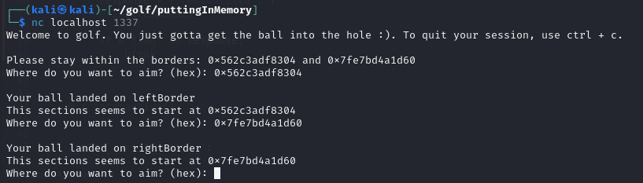

Solution
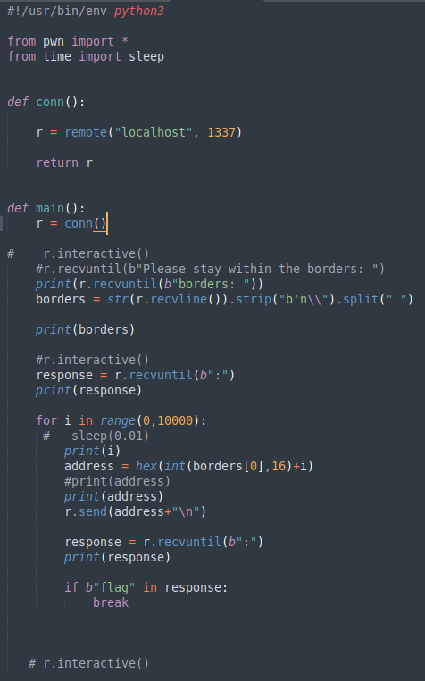
A simple pwntools script can be used to scout out the program. The location of the borders in use can be read into the program and used to define a starting point for the memory checking, and each location can be check sequentially.
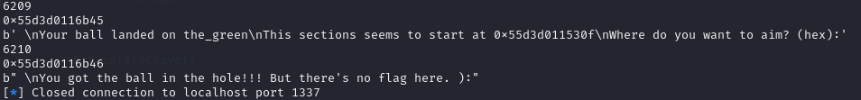
Initially, using the left border as the starting point will eventually get the user to the “hole”, but this is actually useless.

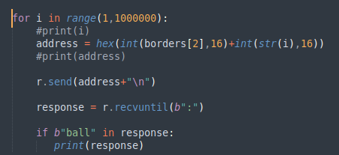
Changing the script to instead start at the location given for the right border, allows for the user to leak the starting addresses of the LIBC functions. These can then be put into a LIBC calculator to find the version being used.
Minor change for leaking the LIBC function addresses.

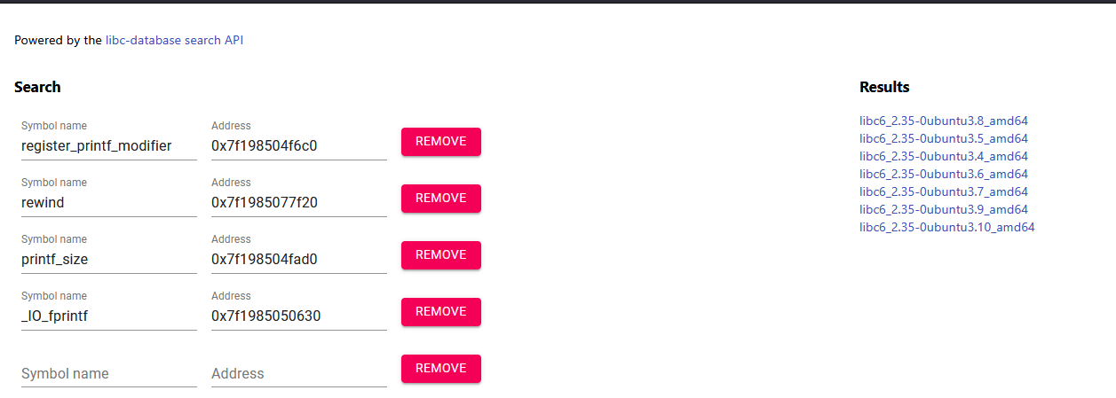
The LIBC versions found are all 2.35, though for differing versions of ubuntu. For the needs of this challenge, it seems as though any of these version will work, except for ubuntu 3.4 (Other versions may have varying levels of success).
Once the version of LIBC has been found, pwntools can be used to easily build a payload using ROP.
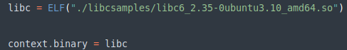
The leaked _IO_printf address is used to properly align the location of the LIBC binary in memory, meaning any calls to function within this library will be at the correct memory location.
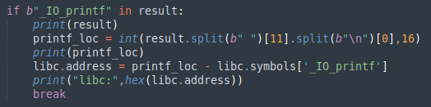

The payload is build using a set of gadgets, and a system call to /bin/sh. Pwntools makes this a relatively simple process.
This works due to how 64 bit executables handle buffer overflows, having them put on a separate part of the stack, which is then used for the return address.
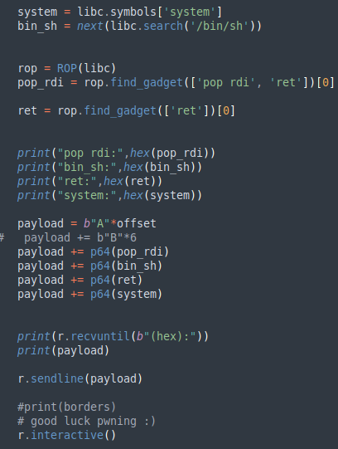
Finding the buffer overflow offset would require some brute force. The program crashes at an overflow of 33 bytes (As the char set being overflowed hold 32 bytes.), but for rbp to be overwritten correctly and offset of 40 is required.
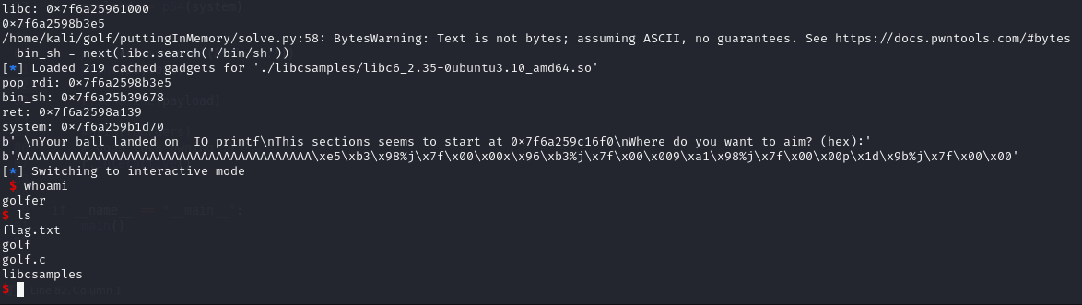

Running a python script with the correct payload and offset will give the user access to the docker container, including the flag file.

