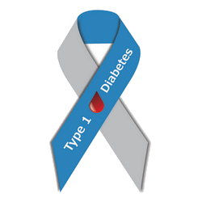
HBC Diabetes Diary
v20.2 Type 1 Diabetes APP
User manual and installation guide

For people living with insulin-treated diabetes, their relatives and their treating physicians.
August 2026

Table of contents
Table of contents 2
1. Introduction: what this application is and who it is for 4
2. What is new in v20 5
3. Glossary: the terms used in this manual 17
4. The application view by view 20
4.0 Screenshots: what the application looks like 20
4.1 Overview (Dashboard) 23
4.2 Charts 23
4.3 Entries 23
4.4 Statistics 24
4.5 Foods 25
4.6 Sync 25
4.7 Settings 26
4.8 New entry 31
4.9 Quick reference: buttons, icons, indicators 32
5. A typical day with the application — a practical example 33
6. The phases of installation 34
6.1 First phase: publishing on GitHub Pages 34
6.2 Installing on an Android phone 36
6.3 Installing on an iPhone 36
6.4 Installing on a Windows or Mac computer 36
6.5 Taking over the data of an earlier (v6, v7 or v8) diary 36
6.6 First settings, together with the treating physician 37
6.7 Updates in the future 37
7. Google Drive sync: the follower sees the values live 38
7.1 How it works 38
7.2 One-time Google setup (about 20 minutes, free) 38
7.3 Setting up the owner (owner mode) 41
7.4 Sharing the folder and setting up the follower (follower mode) 41
7.5 Backup in practice: the monthly routine 42
8. Loading CGM data (for sensor users) 42
9. Publishing in the Google Play store 43
9.1 Creating a developer account 43
9.2 Building the Android package 43
9.3 Upload and store listing 43
10. Troubleshooting: frequent questions 44
11. Medical and privacy notes 45
11.1 From a specialist’s point of view 45
11.2 Where the data is 45
11.3 Summary 46
12. The SOS emergency feature 46
12.1 Setting it up 46
12.2 Opening the SOS page 46
12.3 Automatic alert on a low reading 47
12.4 Important limitations and advice 47

1. Introduction: what this application is and who it is for
The HBC Diabetes Diary is a personal health diary for people with insulin-treated diabetes. It runs on phones, tablets, laptops and desktop computers, works without an internet connection, and all data remains on the user’s own device. The diary records blood glucose readings, the carbohydrate content of meals and the insulin administered, then turns them into clear charts and statistics.
The application provides five key services that a paper diary cannot. First: it performs calculations for the user — for example, it suggests a pre-meal insulin dose based on values agreed with the treating physician. Second: it gives immediate feedback — for example, it issues a warning when a low blood glucose value is recorded. Third: it can be shared, so a designated follower — a relative or the treating physician — can view fresh readings live on their own phone. Fourth: it is bilingual (Hungarian and English), and the blood glucose unit can be switched as well. Fifth — new in v9.0 —: it produces a printable medical report for any freely chosen date range, which can be taken to an appointment as a PDF.

What the application does not do
The application is not a medical device and does not replace medical advice. All of its calculations — including the insulin dose suggestion and the estimated HbA1c and GMI values — are for information only. Dose decisions must in every case follow the guidance of the treating physician. The application displays this warning in the appropriate places as well.
Important medical warning
In case of feeling unwell, first measure blood glucose and act according to the learned protocol; attend to logging only afterwards. Example: at a reading of 3.2 mmol/l, first take 15 grams of fast-acting carbohydrate (3 glucose tablets or 150 ml of fruit juice), re-check after 15 minutes, and record the value only after that.

2. What is new in v20
This chapter briefly summarises the changes compared to v19. The temperature lookup can be switched on/off individually in Settings; the other new features are automatic and available to every user.
- Automatic temperature lookup (v20.1): when the Activity/heat profile block appears, the temperature is now looked up automatically by default, based on the device’s location; it can be turned off with a checkbox in Settings, which keeps the previous, manual “📍 Look up” button behaviour. If the lookup fails or is denied, the value can still be entered manually. (4.7, 4.8)
- Foods in the entry — amount and carbs/100g rethought (v20.1–v20.2): the input fields for selected foods are now: Time | Mode (g/ml/pcs) | Amount | Carbs/100g (or carbs/100ml) | Delete. The item’s final carbohydrate content is a calculated, displayed value from these. The app now detects whether a food is weight-based (g), liquid-based (ml, e.g. “1 dl” = 100 ml) or piece/serving-based (pcs — e.g. “1 pcs”, “1 serving”, “1 tablespoon”, where no meaningful “per 100 g/ml” ratio exists); the detected Mode can always be overridden manually with a dropdown. In “pcs” mode the Amount field is the piece count — taking over the role of the old ×1/×2/×3 quick-add multiplier (which was temporarily broken for piece-based foods in v20.1, fixed in v20.2). (4.5, 4.8)
- Activity picker — collapsed by default (v20.1): the searchable “Activity (choose from earlier ones)” list now appears collapsed by default and opens on tap — taking up less space on the form. (4.8)
- Active basal insulin — Lantus and similar (v20.1): a new, purely informational estimate of the active amount of basal insulin (Lantus/Abasaglar/Semglee/Toujeo/Tresiba/Levemir/Insulatard/Humulin N), based on the manufacturers’ official duration-of-action data. A separate stat card and a combined line chart with the rapid (bolus) insulin appear on the Overview and Statistics pages, plus a summary in the medical report — it is NOT subtracted from the bolus suggestion. (4.1, 4.4)
- Dawn phenomenon / Somogyi effect detection (v20.1, new, informational): the diary automatically detects notable morning blood-glucose rises that occur without carb intake or rapid insulin during the dawn window (3:00–8:00 by default, adjustable in Settings), and distinguishes a dawn-phenomenon-like pattern from a Somogyi-effect-like one (the latter preceded by a low blood glucose reading). Shown on the Statistics page and summarised in the medical report — pattern detection only, not a diagnosis and not an automatic dosing suggestion. (4.4)
- Responsiveness review — mobile and desktop view (v20.2): following a thorough review, fixed the mobile layout of the “Foods in the entry” fields, the appearance of the desktop top navigation bar, and the screen-docking of the mobile bottom navigation and menu.

Earlier version (v19) features (in brief)
This chapter briefly summarises the changes compared to v17. Every new feature can be switched on/off separately on the Settings → New features (v19) card; all of them are enabled by default. Every feature is described in detail in the later chapters.
-  Measurement time-shift bug fixed (v20.0): if a Meal entry’s main timestamp automatically shifted to the earliest food item’s time (e.g. blood glucose measured at 7:30, then breakfast started at 8:00, so the entry time moved to 8:00), the original moment of the blood glucose measurement (and insulin administration) used to get lost — it now always stays recorded and visible on Entry cards, the detail view, the PDF medical report and the CSV export.
- Private entry for every entry type (v20.0): the "Private entry" toggle, previously available only for "Other activity", can now be set for Meal, Check and Lantus entries too — the Follower never sees these either.
- Searchable activity picker (v20.0): the plain dropdown for "Choose a previous activity…" has been replaced with a search box plus a live filtered, clickable list — much faster when you have many previous activities.
-  Custom grams/carbs per food line (v20.0): instead of the previous 1–10 whole-number multiplier, every food line in an entry now has freely editable actual grams (g) AND carbs (g CH) — both when adding the entry and in later edits.
-  Activity/heat profile is now editable afterwards (v20.0): the profile and temperature chosen when adding an entry can now also be changed later, from the entry’s edit screen.
- Statistics — confirmed (v20.0): Statistics always uses the current, corrected entry data; CGM import (if you use such a device) remains in a fully separate data store, untouched by manual corrections.
-  Activity/heat profiles (v19.0): a freely editable preset list (Settings → Activity/heat profiles) — e.g. “Garden work – mildly/extremely hot” — each with its own morning/midday/evening bolus % reduction plus a free-text “suggested extra carbs” reminder. Optionally selectable on the New entry bolus calculator, with a temperature field (location + free weather lookup, or manual entry) — the suggested dose is adjusted for the time of day, and the value applied at save time is recorded on the entry. On the Statistics page, an adjustable-period, informational retrospective analysis helps fine-tune the percentages — a suggestion only, not a substitute for medical consultation. (4.4, 4.7, 4.8)
-  "View" mode for the Owner too (v19.1): on the Overview "Today's entries" cards and on the Entries page list, the Owner (not only the Follower) now also gets a  button on every entry — opening the same read-only detail view the Follower has always seen. The  edit button remains separately available, unchanged. (4.1, 4.3)
-  Pure "Other activity" entry date line (v19.2): if an entry contains only an activity (no blood glucose, no insulin), the date+time line on the Overview and Entries pages shows the activity’s full "-to-" duration range instead of a single timestamp; the activity tile itself then shows only the total duration (e.g., "4 h"), without repeating the range. (4.1, 4.3)
-  Calibratable retrospective analysis (v19.3): the analysis period of the Activity/heat profiles retrospective analysis can now be reduced to as little as 1 day; the app shows how many readings and what period the result is based on, and flags how reliable it is. The "after entry" time window (how long after the entry a reading still counts for that profile) can be set from a quick preset list or fully customized. (4.4)
-  Weight field (v19.3): a new, optional body-weight field on the New entry form and when editing an entry afterwards. The most recently recorded value appears on the Overview's "Today's logging ring" tile (below the bar on desktop, in the label row on the right on mobile). (4.1, 4.3, 4.8)
-  "Open" button on New features (v19.3): in the Settings "New features (v19)" list, every feature now has a button that jumps straight to its own screen — the on/off switch itself stays right there. (4.7)
-  Icons in the manual (v19.3): instead of emoji characters that used to show up as a boxed question mark on some systems, the manual now uses its own crisp image icons everywhere it gives visual guidance — these render identically in every version of Word and every PDF viewer.
-  Profile photo (v19.3): next to the "Nickname" field in Settings you can now take a spontaneous selfie with the camera, or pick any photo from your gallery/computer — the photo is stored only on the device, and also appears in the header. (4.7)
-  Whole-number mmol/l values shown in full (v19.4, fix): on the Overview and Entries page cards, mmol/l blood glucose values now always show one decimal place (e.g. "8.0") — previously whole-number readings were shown truncated, without the decimal (e.g. "8"). (4.1, 4.3)
-  Dark mode — Activity/heat profiles contrast fix (v19.4, fix): the text on profile-related cards (Settings, Statistics) is now readable in dark mode as well — previously dark green text appeared on a greyish background. (4.4, 4.7)
-  Blood glucose measurement time no longer shifts (v19.5, fix): if you later edit the main timestamp of an entry that already has a recorded blood glucose value (e.g. moving a meal’s time later), the original measurement moment now always stays separate, as if you had explicitly used the "Measurement time differs?" option. (7.2, 7.3)
-  Profile photo size and responsiveness fixed (v19.6, fix): the header profile photo is now exactly twice the size of the HBC logo, responsive on every device — previously it appeared at its native, unrealistically large size and also pushed the Settings page's "Choose photo"/"Delete" buttons out of place. (7.4, 7.5)

Earlier version (v18) features (in brief)
v18 introduced the following features compared to v17; they remain available in v19.
- “Entries” page — unified layout with the Overview (v18.9): the v18.8 "Today's entries" layout (Type on top, then on its own left-aligned row the date/time, then the other data badges, then the note, with larger/stronger-contrast text) is now used on the Entries page list as well — on both mobile and desktop. (4.3)
- “Today's entries” — simplified layout (v18.8): the v18.7 desktop-only two-column layout is replaced by a single, unified vertical layout on both mobile and desktop: Type, then (on its own left-aligned row) date/time, then the other data badges (glucose, carbs, insulin, activity), then the note. Takes more vertical space, but is more readable.
- Insulin dose time — now firmly anchored behind the meal time (v18.8): refines the v18.7 “Meal entry time follows the earliest food item” behaviour: previously only the glucose measurement time stayed fixed when the main time later shifted; the insulin (Humalog/Lantus) dose time did not. Now entering an insulin dose (or accepting the bolus suggestion) also fixes its own time at that moment, independent of any later shift of the main time — e.g. glucose measured and insulin given at 6:30, then a meal started at 7:30 moves the entry's time to 7:30, but the measurement and injection time (6:30) does not.
- Editing an entry — wrapping of the food-item row (v18.7): the row of foods added to an entry used to break apart with a long food name in mobile portrait view, and the delete () button could stick out of the card. The row now wraps as needed, and its controls (time, multiplier, delete) never overflow — the same fix applies to the New entry form.
- “Latest glucose” large tile — full decimal digit (v18.7): a round mmol/l value (e.g. 7.0) used to appear truncated (“7”) on this one tile; it now always shows the full, one-decimal form. The mg/dl display (whole number) is unchanged.
- Built-in carb table now in the entry editor too (v18.7): the 205-item, category- and search-browsable built-in Hungarian carb table was previously available only on the New entry form; it can now also be used when editing an already-saved entry.
- “Foods” page — collapsible lists (v18.7): the All foods list and the built-in carb table (205 items) are now collapsible cards, collapsed by default — on both desktop and mobile — for a quicker overview.
- “Today's entries” — desktop layout and stronger contrast (v18.7): in desktop view, the date/time block now sits on the left and the Type plus measurement data (glucose, carbs, insulin, activity) on the right (mobile layout is unchanged). Text size and contrast increased in both Light and Dark mode, on desktop and mobile alike.
- Type-based default time + separate glucose measurement time (v18.7): for a Meal, the entry's main time now automatically follows the earliest food-item time (e.g. glucose measured at 6:30, then a meal started at 7:30 moves the entry's time to 7:30). The glucose reading's own measurement time is kept separately and unchanged, and is shown wherever it differs from the entry's main time (e.g. “ 6.2 mmol/l ·  6:30”): on the Today's entries card, in the entry detail/edit views, in the CSV export, and in the medical report. For Control, Lantus and Other activity, the main time remains whatever the user entered (measurement / injection / start time); an added Activity does not override it.
- Activity “start–end” time counted backwards (v18.6): the Activity (Other activity / Control) duration slider now counts backwards from the entry (logging) time, because the activity is logged afterwards, once it is finished. The “Set exact start/end” button lets you fine-tune the Start and End clocks separately — e.g. if the entry was logged later than the activity actually ended. The Overview and the entry detail view now also show the start–end time range.
- Logo = dark/light toggle (v18.5): tapping the TypeOneDiab logo at the top left of the header instantly switches between dark and light view without any confirmation — in both desktop and mobile view; the choice is saved immediately. (4.1, 4.7)
- Per-item carb times (v18): every food of a meal can get its own consumption time with the clock field — by default the entry time applies. A prolonged meal (e.g. lunch at 12:45 + cappuccino at 16:10) thus appears with its real timing on the carb chart, and the post-meal reminder counts from the time of the last item. (4.8)
- Built-in Hungarian carb table: hundreds of Hungarian foods (bakery, sides, soups, mains, fruits, dairy, sweets, drinks) with typical portions and carb values, fully offline. It can be browsed with category buttons and searched in the quick picker of the New entry form, and the full 205-item list is also available on the Foods page. (4.5, 4.8)
- AGP view in Statistics: an international-standard percentile chart — hourly median with bands showing the middle 50% and 90% of readings; fingerstick and CGM data are combined. (4.4)
- Fatty/protein-rich meal flag: a toggle on the meal entry; it warns about a delayed, prolonged glucose rise and recommends a control measurement in 2–3 hours. Information, not dosing advice. (4.8)
- Bluetooth glucose meter connection: the BT button reads the last measurement from a standard Bluetooth meter (e.g. Accu-Chek, Dcont smart meters). Important limitation: works only on Android phones in Chrome — not supported on iPhone (Safari), where manual input remains. (4.8)
- Predicted low alert: based on the CGM trend, the follower is alerted before the value drops below the configured limit (about 20 minutes ahead). (chapter 7)
- Post-meal measurement reminder: after a configurable time (default: 100 minutes; recommended 90–120) the Overview signals that it is time for a control measurement. (4.1)
- Diary search: free-text search on the Entries page (e.g. “pizza”) — the search runs across the whole diary. (4.3)
- Large font mode: a switchable larger font size across the whole application. (4.7)
- Weekly summary for the follower: once a week a short digest card (TIR, average, number of hypos) on the follower device. (4.1)
- Editable motivational messages: the texts shown after saving an entry can be edited in Settings, and the display duration can be set between 1 and 10 seconds. (4.7)
- Editable Streak card texts: the texts of the Streak card of the Overview can be rephrased in Settings; the new defaults have a positive, uplifting tone. (4.7)
- Minor fixes: the labels of the activity duration slider now match the 4-hour scale; carb values are shown with one decimal (e.g. 7.0 g) on every surface of the application; the insulin-on-board (IOB) progress bar is now visible on the Overview as well; an old (pre-v15) bug that occasionally re-inserted a stale, automatic note text has been permanently fixed (v18.6).

Earlier version (v17) features (in brief)
v17 introduced the following features compared to v16; they remain available in v18.
- Configurable basal insulin reminder: the purple reminder banner of the Overview (“You have not logged basal insulin today”) can now be customised on the Insulin settings card of the Settings page. You can set the basal injection time (default: 22:00) and how much earlier the reminder should appear (0–120 minutes, default: 60 minutes); the reminder can also be switched off entirely. The banner also shows the configured injection time and stays until the day’s basal dose is logged. Previously the banner appeared from a fixed 18:00 — the distracting early-afternoon signal is gone.
- The reminder never appears for the Follower: the basal insulin reminder is shown exclusively on the Owner’s devices; it never appears on the Follower’s Overview.
- Simplified Meal entry: the Meal entry form — both when adding and when editing — now contains only the rapid insulin field (e.g. Humalog); the basal (Lantus) field has been removed, since basal insulin is recorded with the Lantus entry type. Basal values stored in older Meal entries are kept and still count in the statistics.
- Activity duration slider: the from–to duration slider now goes up to 4 hours (240 minutes) instead of the previous 12 hours — making typical durations much easier to set precisely.

Earlier version (v16) features (in brief)
v16 introduced the following features compared to v15; they remain available in v18.
- Medical report as a PDF attachment: the e-mail of the report-sending feature now contains the formal cover letter (the patient’s name, phone number and e-mail address), while the report itself arrives as an attached, printable PDF file. The PDF mirrors the report layout — header with logo, key metrics, charts, detailed log — and opens in any desktop, mobile or web PDF viewer; it can be downloaded and archived. The former report preview shown in the message body has been removed: all essential information is in the letter header and in the attachment.
- Light splash screen: the background of the splash screen stays light even in dark mode, so the HBC logo is always clearly visible.

Earlier version (v15) features (in brief)
v15 introduced the following features compared to v14; they remain available in v18.
- Note on the Latest blood glucose card — now saved into the diary: the note written on the Latest blood glucose card of the Overview page is no longer a separate, stand-alone text: it is saved directly into the Notes field of the latest blood-glucose entry. It therefore appears immediately in the Today’s entries list, can be edited further in the entry editor, is synchronised, and the Follower sees it too. By default only the Note button is shown; the input field opens when the button is pressed. In follower mode the note is read-only — no button or input field appears.
- Sending the medical report by e-mail: the Create report button on the Statistics page now opens a panel. The doctor’s e-mail address can be typed in — or picked with one tap from the saved address list — and the report is sent with a single button press from the user’s own Gmail account. The message is formal: its subject is “(Name)’s diabetes report – (period from – to)”, the body contains the patient’s name, phone number and e-mail address, followed by the full formatted report with the charts; the report also arrives as an attached, archivable file. The addresses used are saved without limit, and the list can be edited and any address deleted. Before the first send, Google asks for a one-time new permission (sending mail from your own account). The PDF / Print option remains available from the same panel.
- Splash screen on cold start: when the application is freshly launched, the HBC logo, the application name and the always-current version number are shown for 3 seconds — on mobile and desktop alike — while the data is being refreshed. The version number comes directly from the central version constant of the application code, so an outdated number can never get stuck. When the app merely returns from the background, the splash screen does not appear.
- Alert button label in follower mode: the alert screen is the same in follower mode as on the owner’s devices, but the closing button reads “OK — dismiss alert” for the follower (for the owner it remains “I AM OK — dismiss alert”).

Earlier version (v14) features (in brief)
v14 introduced the following features compared to v12.3; they remain available in v18.
- Automatic Google sign-in: on the Sync page you can enter the e-mail address of the Google account used for signing in — in both owner and follower mode. Once set, the Google account picker list no longer appears: the app always signs in with this account, on mobile and desktop alike. The first authorisation is done manually once per device; every later sign-in is automatic. In an emergency an unfamiliar helper no longer has to pick the right account from a long list.
- Unified header text in follower mode: the header text (the version line in the “— Nickname’s diary” form) in follower mode now exactly matches the setting of the followed person — the Owner. The colour theme, the custom background and the light/dark mode remain the Follower’s own settings. The purple “Follower mode” bar still shows that you are viewing someone else’s diary.
- Eye icon for the follower: in follower mode an eye icon replaces the pencil on the entry cards. Tapping it opens a read-only detail view with every recorded item — foods with multipliers, insulins with injection times, activity, duration, physical activity level, notes — and nothing can be modified; there is no delete button either.
- Private entries: the Owner can mark Other activity entries — and only those — as private, with the “Private entry” switch that appears on the new-entry and edit forms for this type. On other types (Meal, Check, Basal) the switch is not available. A private entry is completely hidden from the follower — it appears in no list, statistic or alert, as if it did not exist; it is visible only with the owner sign-in, marked with a “Private” label on its card.
- Type-specific forms: on Check entries the Extra carbs block with the full food quick picker (and the New food option) now comes BEFORE the rapid insulin (correction) field — so carbs taken for low blood glucose can be recorded precisely. On Basal entries the superfluous rapid-insulin field has been removed. On Other activity entries activity fields replace the rapid-insulin field; the full activity block (quick picker, from–to duration, physical activity) is also available on Check entries. Editing an existing entry now shows EXACTLY the same fields per type as the new-entry form.
- Smarter activities: a dropdown quick picker lists previously recorded activity names; a new name can be typed freely and joins the picker automatically after saving. Activities can have a from–to duration in 5-minute steps up to 4 hours (from v17), plus a 1–5 Physical activity indicator — the level names can be renamed in Settings. The “Other activity” filter on the Entries page can now also be narrowed to a specific activity name.
- Mobile view fixes: with many fields filled in, the form no longer “sticks out” of the screen: the editor and every pop-up window scroll from the top over their full length, the input font size prevents the mobile browser from zooming in automatically (this caused the un-scrollable overflow), and content can no longer overflow horizontally.
- Notification for every new entry (optional): in the Alert settings box the Follower can switch on “Notification for every new entry”. From then on the phone shows a notification not only at low/high values but whenever ANY new entry arrives — naturally not for private entries. The notification arrives with at most the refresh-interval delay and only while the app is open or in the background; switching it on does not trigger a retroactive flood for old entries.

Earlier version (v12.3) features (in brief)
v12.3 introduced the following features compared to v12.2; they remain available in v18.
- Separate insulin injection time: in the new-entry and edit forms an “Injection time differs?” button appears under each dose field, letting you set a separate injection time for the rapid and the basal insulin — by default the entry time applies, and the  button resets to it. A post-meal bolus delayed because of low blood glucose can thus be logged with its real time: IOB (insulin on board), the Last insulin card, the insulin chart, the daily totals, the medical report and the CSV export all follow the actual injection time. A differing time is shown on the entry badge with a mark.
- Header with the nickname: in owner mode the version line reads “v19 Type 1 Diabetes APP  — Nickname’s diary”, in follower mode the title reads “HBC Diabetes Diary – Nickname’s notes” — the nickname without quotation marks, and only when it is set.
- Dark mode fix: the small badges on the entry cards (blood glucose, carbs, insulin, activity) now keep their familiar, well-readable light-mode colours in dark mode too — in both desktop and mobile view.

Earlier version (v12.2) features (in brief)
V12.2 introduced the following features compared to v11.1; they are all available in v18.
- SOS emergency feature: a new red SOS button in the mobile hamburger menu (and in the desktop header) opens a full-screen helper page for unknown helpers and paramedics: first-aid steps, a 112 emergency call button, one-tap calling of the contacts to notify, the home address and the freely worded "How to communicate with me" note. Described in detail in chapter 12.
- Automatic SOS alert: if the most recent reading of the day (manual or CGM) falls below the configured low threshold, the SOS page appears automatically with the measured value and a notification is sent. It is dismissed with the "I AM OK — dismiss alert" button (in follower mode the button reads "OK — dismiss alert"); each reading alerts only once.
- Medical report with official personal data: the full name and phone number entered in Settings appear in the header of the Medical report, and the report version number now always follows the current application version automatically.
- Free number entry on phones: any value can now be typed into the numeric fields of Settings (ICR, sensitivity, thresholds etc.) on mobile; fields no longer snap back to their default value while typing.
- Durable follower access (v12.1): follower mode requests read-only Google Drive access, so the selected diary file is no longer "lost" after the Google sign-in expires. Even with this permission the app cannot write to or modify anything on Drive.
- SOS page fixes (v12.2): the page now always appears above the header and menu bars, with identical, highly readable colours in both light and dark themes; tiles can be re-arranged by dragging the ⠿ handle (the order is remembered on the device); the Contacts to notify tile sits above the 112 button by default; the note title shows the configured nickname. Timed sync is now popup-free: a Google window may flash at most once, when the app is opened.

Earlier version (v11.1) features (in brief)
Version v11.1 introduced the following features compared to v10.0; all of them remain available in v18.
- Editing foods after saving: the foods belonging to an already recorded meal can now be added to or removed afterwards in the entry’s edit window (pencil icon); the carbohydrate total is recalculated automatically.
- More precise sync error messages: when the Sync now button is triggered manually, the application now reports the exact cause of a failure (expired login, missing permission, deleted file, no internet connection, invalid Client ID); the scheduled, automatic sync keeps retrying silently in the background.
- App name on the home screen: the installed app icon now shows the label “HBC Diab Napló” underneath.
- Public Google access: Google authorisation for Drive sync is now open to anyone, without a test-user list (see chapter 7.2 for details).

Earlier version (v10.0) features (in brief)
v10.0 introduced the following new features compared to v9.0; these remain available in v18.
- Larger desktop button bar: the top page-selector buttons now share the content width of the app evenly (not the full monitor width), with larger text and icons — easier to tap, and they resize proportionally when the window is resized.
- Improved hamburger menu: the mobile menu panel now always opens BELOW the header and never covers it; the panel scrolls when it contains many items.
- Custom background color: next to Settings → Appearance, a background color can be chosen from a pop-up color palette; it appears as a soft gradient throughout the application — in both light and dark mode — while card contrast is preserved; it can be cleared at any time with the Reset button.

Earlier version (v9.0) features (in brief)
v9.0 introduced the following new features compared to v8.0; these remain available in v10.0 and later versions.
- Restored program files: several files of the v8.0 package were saved in a damaged, truncated state, so the application started incorrectly or not at all. v9.0 contains complete, verified code.
- Mobile hamburger menu: the  button in the top right corner of the header makes every page reachable (Overview, Charts, Entries, Statistics, Foods, Sync, Settings, New entry). The quick bar with the five most-used pages remains at the bottom of the screen — so the patient, the family member and the physician can all navigate easily, for example during a demonstration or when reviewing statistics.
- Desktop top bar: every page-selector and settings button is visible on every page in the bar under the header — in the well-proven way known from v7.
- Larger, adaptive logo: the TypeOneDiab logo is 20% larger in desktop view and scales automatically with the window width; on mobile its maximum size adapts to the space available in the header.
- Insulins from drop-down lists: in Settings the rapid (bolus) insulins available in Hungary (Humalog, NovoRapid, Fiasp, Apidra, Lyumjev, Actrapid…) and the basal insulins (Lantus, Abasaglar, Toujeo, Levemir, Tresiba, Semglee…) can be chosen from a list; a custom name can still be entered.
- Custom color picker: in addition to the Light / Dark / Automatic appearance, the accent color of the application can now be chosen freely from a pop-up color palette (Settings → Color theme → Custom color).
- Alerts only for same-day values: the family-member alert fires only for the latest measurement taken on the current day; back-dated, older values never trigger an alert. The shared data package also includes the CGM readings, so the alert always reflects the current state.
- Language completeness: every label on every page appears in both Hungarian and English, according to the selected language.

Earlier v8.0 features (in brief)
v9.0 contains every v8.0 feature. The main v8.0 additions compared to v7.0 were the following; diary data remains untouched after every update.
- Refreshed appearance: the Type 1 Diabetes ribbon logo appears in the header and in the application icons, and the emoji icons have been replaced by a consistent, drawn (SVG) icon set.
- Bottom navigation bar on phones: the tabs are located in a thumb-friendly bar at the bottom of the screen. On desktop computers the familiar top tab row remains.
- Medical report (PDF): from the Statistics tab, a one-page printable summary is generated for any freely chosen from–to period — TIR, estimated HbA1c, GMI, variability measures, charts, daily pattern and the detailed log.
- GMI in Statistics: alongside the estimated HbA1c, the internationally used Glucose Management Indicator is displayed as well.
- Daily pattern chart: hourly average, minimum and maximum values for the selected period — it clearly reveals, for example, early-morning rises.
- Configurable time-of-day boundaries: the hour limits for the default meal type (Breakfast…Late-night snack) and for the bolus calculator’s time periods can be adjusted to the user’s daily routine in Settings.
- Typo protection: before saving an unusual blood glucose value (below 2.0 mmol/l or above 25.0 mmol/l), the application requests confirmation.
- Larger touch targets, better dark-mode contrast and keyboard focus indication — more comfortable and more accessible operation on every device.
- Bug fixes: a rare crash of the weekly TIR tile has been eliminated, and entry cards now display the insulin names configured in Settings.

3. Glossary: the terms used in this manual
The table explains every term that appears in this manual or in the application. When encountering an unfamiliar word, its meaning can be looked up here quickly.
Term | Plain-language meaning
Blood glucose (BG) | The sugar level of the blood. In Hungary it is measured in mmol/l, e.g. 5.6 mmol/l. In the American unit, mg/dl, the same value is 101 mg/dl.
mmol/l and mg/dl | Two units for the same value. Conversion: 1 mmol/l = 18 mg/dl. It can be switched on the Settings tab.
Carbs (CH) | The blood-glucose-raising component of food, measured in grams. Example: a bread roll is about 30 grams of carbs.
Bolus | The rapid-acting insulin taken with a meal, e.g. Humalog. It covers the carbohydrate content of the food.
Basal | The once-daily long-acting insulin, e.g. Lantus. It works steadily in the background all day.
ICR (carb-to-insulin ratio)  Insulin-to-Carbohydrate Ratio (ICR) | Indicates how many grams of carbohydrate 1 unit of rapid insulin covers. Example: with an ICR of 10, a lunch containing 60 grams of carbs requires 6 units of insulin. The value may differ by time of day.
Sensitivity (ISF)  Insulin Sensitivity Factor | Indicates how much 1 unit of rapid insulin lowers blood glucose. Example: with a sensitivity of 2.5 mmol/l, a reading of 9.0 mmol/l is expected to drop to 6.5 mmol/l after 1 unit.
IOB (insulin on board)  Insulin On Board | The amount of previously injected insulin still active. Example: 2 hours after injecting 4 units, about 2.3 units are still working. The application subtracts this from the next suggestion, protecting against stacked doses.
TIR (time in range)  Time in Range | The percentage of readings that fell within the target band (by default between 3.9 and 10.0 mmol/l). Example: 78% TIR means almost eight out of ten readings were in range. Medical guidance generally considers above 70% good.
HbA1c | The proportion of sugar bound to red blood cells, reflecting the average blood glucose of the past 2–3 months. The application computes an estimate from the readings; the precise value comes only from a laboratory test.
GMI  Glucose Management Indicator | Glucose Management Indicator: an HbA1c-like percentage computed from average glucose with an international formula. GMI shows how your sugar metabolism has been over the past few days (usually requires at least 14 days of CGM data)  A common reference number in the CGM world — also an estimate, not a laboratory result.
SD and CV  SD - Standard Deviation | Variability measures in the medical report. SD (standard deviation) shows how far readings scatter around the average; CV is the same as a percentage — below 36% is generally considered stable.
CGM  Continuous Glucose Monitoring | Continuous glucose monitor sensor (e.g. FreeStyle Libre or Dexcom) measuring every minute or every 5 minutes. The sensor’s factory export file can be imported into the application.
PWA  Progressive Web App (PWA) | Progressive web application: a website that can be installed on phones and computers like an app, with an icon, full screen and offline operation.
Google Drive | Google’s free cloud storage (15 GB with every Google account). The application saves a copy of the diary there when sync is enabled.
Sync | Automatic reconciliation of data between two devices. Here: uploading the diary to Drive and downloading fresh values to the follower’s phone.
Owner and Follower | The two roles of sharing. The Owner is the user keeping the diary; the Follower is the person — a relative or the treating physician — who can view the shared diary live, in read-only mode.
Hypoglycaemia (hypo) | Blood glucose lower than normal — in the application, a value below the configured lower limit (3.9 mmol/l by default). Symptoms may include trembling, sweating, weakness. Action: 15 grams of fast carbs, re-check after 15 minutes.
Hyperglycaemia (hyper) | Blood glucose higher than normal — in the application, a value above the upper limit (10.0 mmol/l by default). The application marks it red on the charts and adds a correction to the bolus suggestion.
JSON and CSV | Two file formats. JSON is the complete, restorable backup of the diary. CSV is a table that Excel opens, for medical review or personal analysis.
Active basal insulin (basal IOB) | An estimate of how much of the previously injected long-acting (basal) insulin is still active, based on the manufacturer’s official duration-of-action data. Unlike rapid-insulin IOB, this is purely informational — it is not subtracted from the bolus suggestion.
Dawn phenomenon | A morning blood-glucose rise, typically without carb intake or rapid insulin, caused by the body’s early-morning hormonal processes. The diary detects and flags this automatically — for information only, not a diagnosis.
Somogyi effect | A morning blood-glucose rise similar to the dawn phenomenon, but preceded by a low blood glucose (hypoglycaemia) overnight — the body’s rebound response. The diary flags this separately from the dawn phenomenon.
Carbs/100g and carbs/100ml | The carbohydrate content of a food or liquid per 100 grams or per 100 millilitres — typically how it appears on a product’s nutrition label. The diary uses this together with the amount actually consumed to calculate the item’s final carb (g) value.

4. The application view by view
On a phone, a quick bar at the bottom of the screen holds the five most-used pages (Overview, Charts, New entry, Entries, Statistics), while the  hamburger menu in the top right corner of the header reaches every page — including Foods, Sync and Settings. On desktop computers and tablets all seven tabs are visible in a row under the header on every page, and the new-entry button sits in the top right corner of the header. This chapter introduces each view: its purpose, its contents, and its recommended use.

4.0 Screenshots: what the application looks like
The following screenshots show the key elements using the application's real colors, logo and labels, so that using it feels familiar from the very first moment.
a) Desktop header + top button bar (v10 — larger, evenly split)
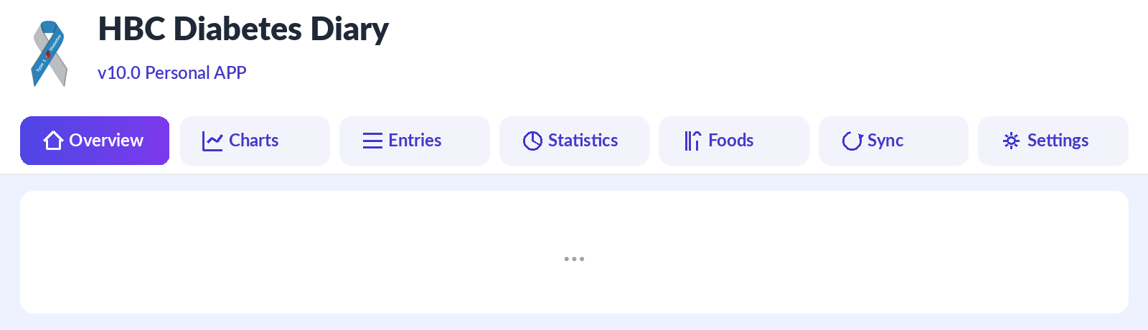

b) Mobile bottom bar + hamburger button
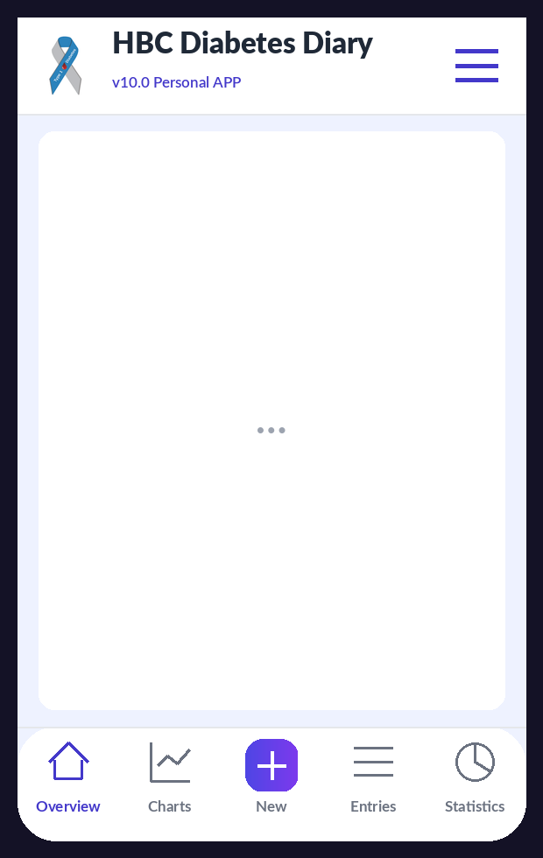

c) Opened hamburger menu (v10 — opens BELOW the header)
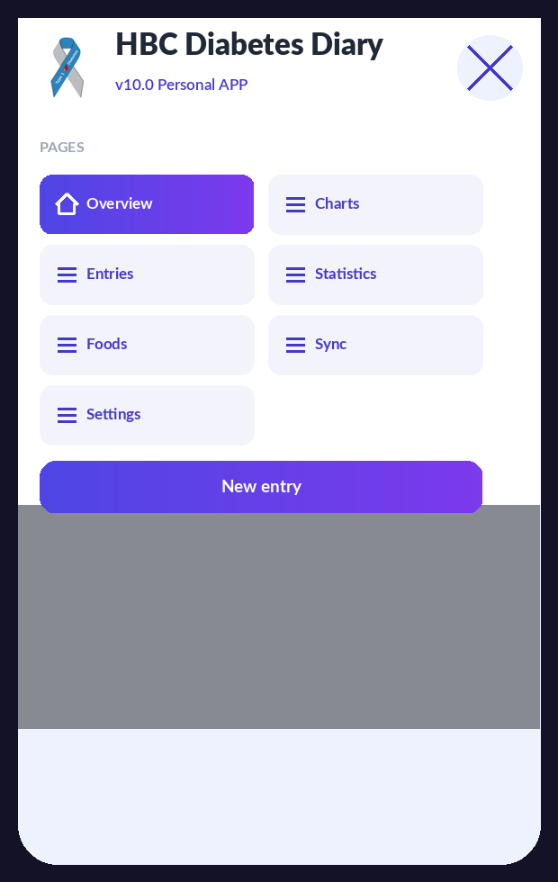

d) Appearance / Color theme setting — custom background color picker
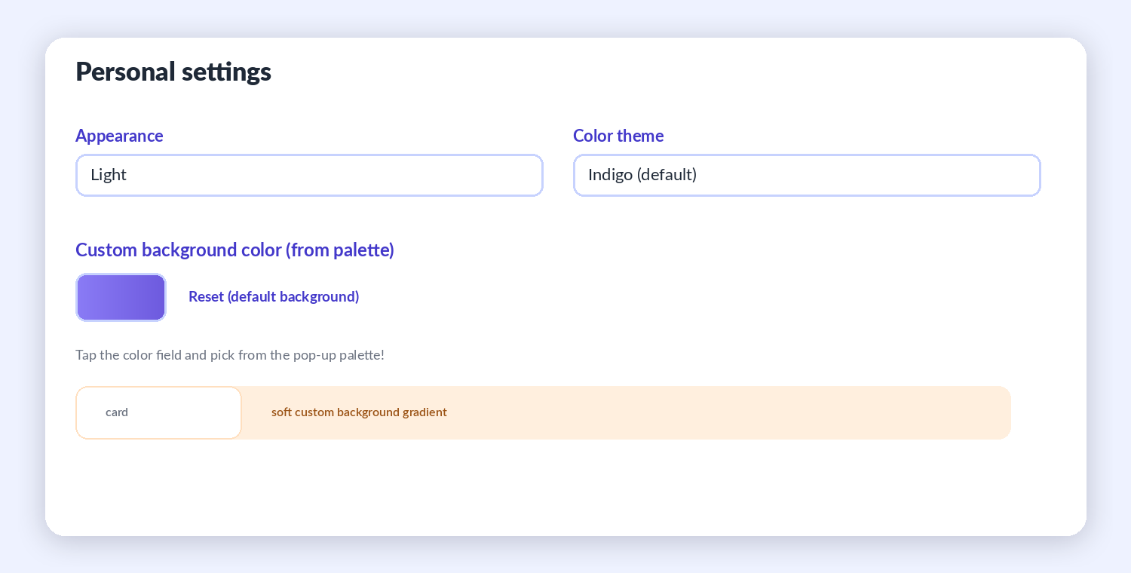

e) New entry form (date / time field)
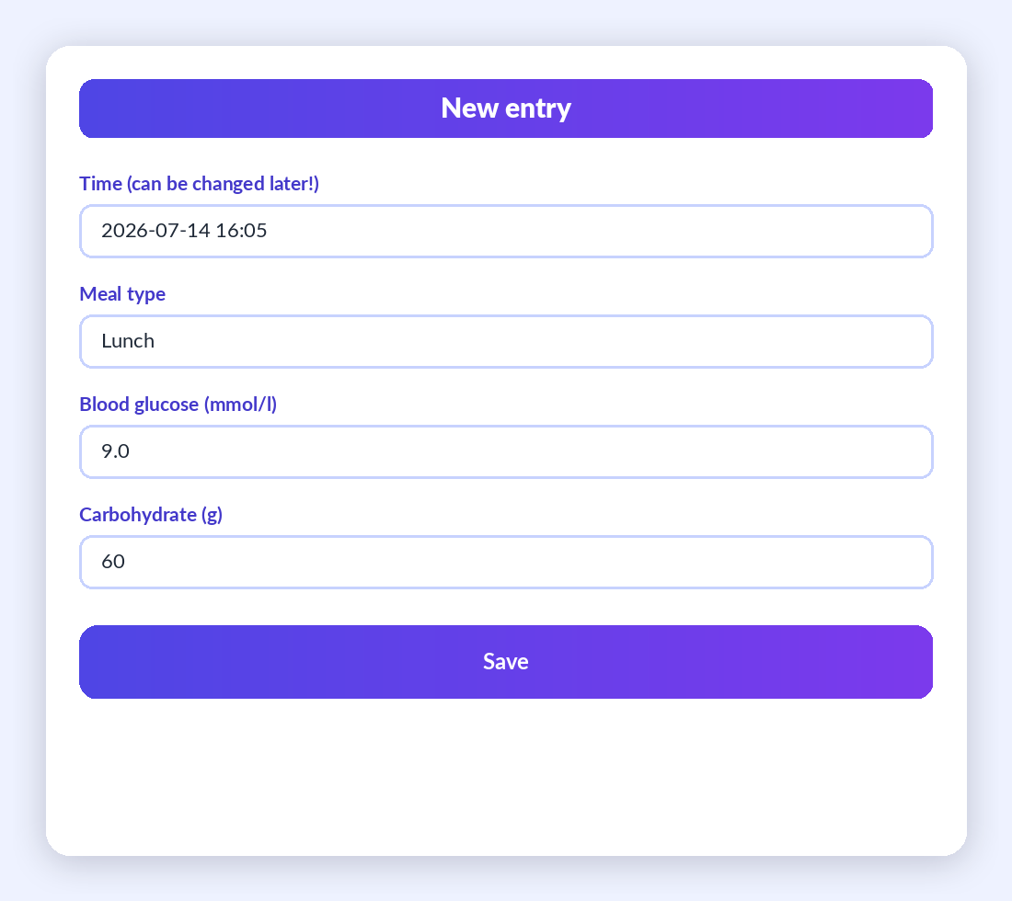
f) Entry cards with indicator colors (green / amber / red)
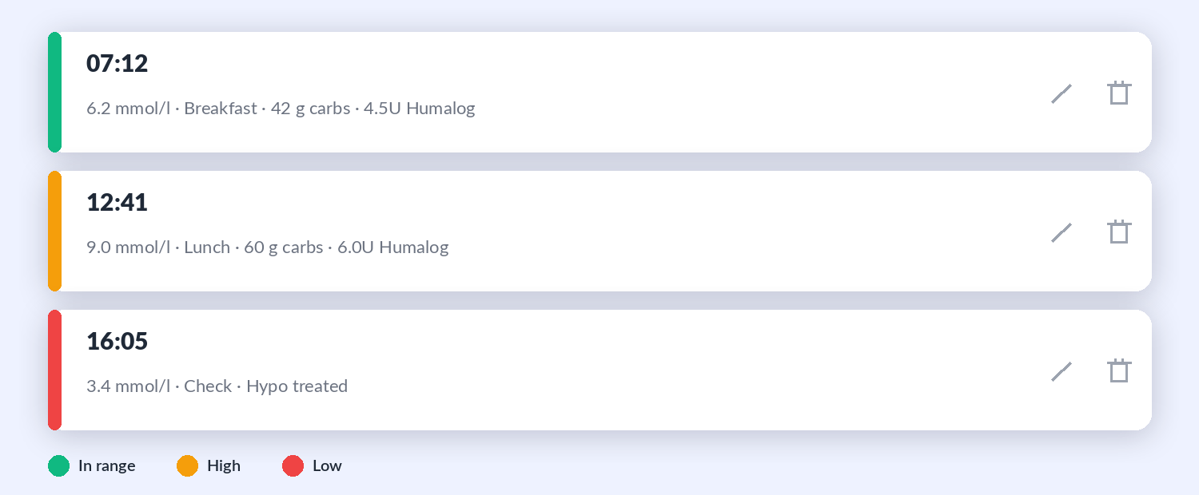

4.1 Overview (Dashboard)
This is the home screen, the summary of the day. At the top there are three motivation tiles: Streak counts how many days the diary has been kept complete (e.g. 12 days of complete logging), Today’s logging circle shows how many of the 4 daily entries are done (e.g. 2/4), and the Weekly TIR goal shows time in range against the 70% target. Below them are three coloured summary tiles: insulin taken today, the 7-day glucose average and today’s carbs. The largest card shows the latest blood glucose value: green if in range, amber if low, red if high. A short note for the physician can also be added here, for example: woke at 3 am, sweating. In the evening the application indicates if no basal insulin has been logged that day.
New in v18: a progress bar below the insulin-on-board (IOB) figure now also shows the active amount; the post-meal measurement reminder signals in a green banner after the configured time (default: 100 minutes) that it is time for a control measurement — acknowledge it with the “OK” button; in follower mode a short weekly summary card (TIR, average, number of hypos) appears once a week.
New in v18.5: tapping the logo at the top left of the header (or Tab + Enter/space on keyboard) instantly switches between dark and light view with no confirmation prompt; the setting also updates the Settings → Appearance field and is saved immediately.
New in v20.1: the estimated active amount of basal insulin (Lantus and similar) now appears on its own stat card, and also on a combined line chart with the rapid insulin — purely informational, not subtracted from the bolus suggestion.

4.2 Charts
Three charts show the recent period: blood glucose (line chart), carbohydrate and insulin (bar charts). The range is switched with buttons: Day, Week, Month, or a Custom period where the start and end dates can be set freely (from–to). On the glucose curve a green band marks the target range, and the colour of each point grades the reading: green in range, amber low, red high. Imported CGM data appears on a separate chart. A practical example: before an appointment, set the range to Month and review the behaviour of the early-morning hours together with the physician.

4.3 Entries
The list of all records in chronological order, filtered by day or by any from–to period, and also by type (Meal, Check, Basal, Other activity). Every card shows the time, blood glucose, carbs, insulin and note. With the pencil icon any entry can be corrected later; the bin icon deletes it. Example: if it turns out in the evening that 54 grams were recorded at lunch instead of 45, it can be corrected here with two taps.
New in v14: the entry card shows the duration next to the activity name and the physical activity level (1–5) on its own label; private entries carry a “Private” label (visible to the Owner only). Selecting the “Other activity” filter reveals a second dropdown that narrows the list to a specific activity name. In follower mode an eye icon replaces the pencil and the bin: tapping it opens every detail of the entry in a read-only view.
New in v18: free-text search — type for example “pizza” and the search brings up similar earlier entries from the whole diary (regardless of the date filter), with their dates.

4.4 Statistics
A numeric summary for the chosen period, set with buttons (1, 7, 30, 90 days) or with a custom from–to date range: average glucose, TIR percentage, estimated HbA1c, GMI, and the distribution of readings (low, normal, high). A separate card shows the currently active insulin (IOB) and the actual carb-to-insulin ratio computed from the diary. Next to the estimated HbA1c and the GMI the application notes: this number is an estimate, not a laboratory result. An example of interpretation: a 90-day TIR of 82% with an estimated HbA1c of 6.8% indicates good balance, to be confirmed by the next laboratory test.
New in v9.0 is the Daily pattern chart: it groups the readings of the selected period by hour of day and shows the hourly average together with the band of the lowest and highest values. At a glance it reveals in which parts of the day blood glucose tends to rise or fall — for example the dawn phenomenon or a regularly under-estimated dinner.
New in v18: AGP view (percentile bands) — the international-standard chart: the thick line is the hourly median, the darker band is the middle 50% of readings (25th–75th percentile), the lighter one the middle 90% (5th–95th percentile). Fingerstick readings and loaded CGM data are combined. The view can be switched in Settings.

Creating the medical report (PDF)
The Medical report card is located at the bottom of the Statistics tab. Set the start and end dates (from–to), then press Create report. A print-ready summary opens on a new page: the nickname (if configured) and the period in the header, followed by the key figures (number of readings, average, SD/CV, TIR, estimated HbA1c, GMI, low and high events, daily average insulin and carbs), the glucose curve of the whole period, the daily pattern, and finally the detailed log table. Use the Print button on the opened page to print on paper, or choose Save as PDF in the print dialog to create a file that can be sent by e-mail. The report is generated in the application’s language and with the configured unit.
New in v15/v16: the Create report button opens a panel from which the report can also be sent directly by e-mail to your doctor from your own Gmail account. The recipient can be picked from the saved address list; the list is unlimited and editable. The message contains the formal cover letter (the patient’s name, phone number and e-mail address), while the report itself arrives as an attached, printable PDF file that opens in any PDF viewer. The familiar PDF / Print option is available via the PDF / Print button of the panel.
New in v20.1: the estimated active basal insulin appears on a combined line chart with the rapid insulin; a new “Dawn phenomenon / Somogyi effect” summary shows if the diary detects a notable morning blood-glucose rise without carb intake — both purely informational, and both are included in the medical report.

4.5 Foods
The user’s own food database. It starts with 22 foods and their carb values, for example: a 1 cm slice of sourdough loaf is 15 grams of carbs, a medium apple is 15 grams. It can be extended at any time by entering a name, carb value and unit (e.g. cottage-cheese pancake, 25 grams, 1 pc). Foods added here appear in the quick picker of the New entry screen, so at mealtime they can be added with a single tap.
New in v18: built-in Hungarian carb table — the food search of the New entry form also searches a built-in list of hundreds of Hungarian foods (typical portion + carbs) in addition to your own foods; on the Foods page the full 205-item list can be browsed by category, and any item can be copied into your own foods with the  button. The values are average, rounded figures; exact carbs may differ by product.
New in v20.1–v20.2: the food input fields switched to Amount (g) + Carbs/100g (or, for liquids, Amount (ml) + Carbs/100ml). The app detects whether an item is weight-, liquid- or piece/serving-based; this can always be overridden with the Mode dropdown. For piece/serving-based foods (e.g. “1 pcs”, “1 serving”, “1 tablespoon”) the Amount field is the piece count, and behaves just like the earlier ×1/×2/×3 quick-add multiplier.

4.6 Sync
All data backup and sharing features are located here: setting up Google Drive sync (details in chapter 7), importing a CGM file (chapter 8), full backup to a JSON file, CSV download for Excel or for the physician, and text copy-paste between two devices. JSON is the complete, restorable copy of the diary; CSV is a tabular format that Excel opens. Recommendation: once a month press JSON Export and store the file — that is the backup. If the latest backup is older than 7 days, the Overview screen issues a warning.
New in v14: the Google Drive sync settings now include an “Automatic sign-in — Google account (e-mail)” field (in owner and follower mode alike). With the account set, the app signs in by itself, WITHOUT the account picker list — after a one-time manual authorisation per device. This matters most in an emergency: an unfamiliar helper does not have to pick the right account from the long list of Google accounts on the device.

4.7 Settings
The personal settings come in four groups. The first group is appearance: language (Hungarian or English), blood glucose unit (mmol/l or mg/dl), nickname, colour theme (indigo, teal, rose — and from v9.0 also a custom color chosen from a pop-up color palette), light, dark or automatic mode, and the switch for motivation features. The second group is the blood glucose thresholds: low limit, high limit and target value. The third group — new in v9.0 — is the time-of-day boundaries: here it can be set until what hour Breakfast, Mid-morning snack, Lunch, Afternoon snack and Dinner last (this drives the automatic meal-type suggestion), and until when the bolus calculator uses the morning and the midday ICR. The fourth group is insulin: the names of the rapid (bolus) and basal insulin — selectable from v9.0 in a drop-down list of the products available in Hungary, with a custom name still possible —, the action time in hours, the sensitivity, and the carb-to-insulin ratio (ICR) by time of day. The table in chapter 6.6 assists in completing the values together with the treating physician. From v10.0 a custom background color can also be chosen from a pop-up color palette: the selected color appears as a soft background gradient throughout the application, in both light and dark mode, while card contrast is preserved; it can be cleared at any time with the Reset button.

New in v18: Motivational messages card — the texts shown after saving an entry can be freely edited and extended, and the display duration can be set between 1 and 10 seconds; the texts of the Streak card can be rephrased; every new feature can be switched on/off on the New features (v19) card (enabled by default); a large font mode can be switched on for older or visually impaired users.
Below, EVERY card and field of the Settings page is described in detail, card by card — together with the default values. The “Save settings” button at the bottom of the cards stores every change.

 Personal settings card
Personalises the language and appearance of the application.
- Nyelv / Language: Hungarian or English interface with a single tap. Stored data is language-independent — nothing is lost when switching, and you can switch back at any time.
- Blood glucose unit: mmol/l (Hungarian custom) or mg/dl. The app always stores values in mmol/l internally, so switching units is safe and reversible; every chart and statistic converts instantly.
- Nickname: appears in the header (“v19 Type 1 Diabetes APP  — Nickname’s diary”), and the Follower sees it too — so the relative always knows whose data they are looking at.
- Colour theme + custom accent colour: choose from preset themes, or pick your own accent colour on the pop-up palette (colour of buttons, bars, active elements).
- Appearance:  Light, Dark or Automatic — the latter follows the phone’s system setting (e.g. switches to dark in the evening by itself).
- Quick switch with the header logo (v18.5): besides the Appearance dropdown above, tapping the logo at the top left of the header also instantly switches between dark and light view, without confirmation — handy when you just need a quick switch (e.g. for evening reading). Starting from Automatic mode, the tap switches to the opposite of the current view, and from then on it lives on as a manual setting until you set the dropdown back to Automatic.
- Custom background colour: the colour picked from the palette appears as a soft gradient across the whole app, in light and dark mode alike; the “ Reset” button removes it.
- Motivational elements (toggle): switches the Streak / Daily logging circle / Weekly TIR goal cards of the Overview and the positive feedback after saving on or off. Enabled by default.

Motivational messages card (v18)
Full customisation of the positive messages that pop up after saving an entry.
- Message list: one message per line; edit, delete or extend them freely. When an in-range value is saved, the app picks one at random. If you delete every line, the factory defaults are used.
-  Restore default messages: brings back the six factory messages with one tap.
- Display duration: adjustable with a slider between 1 and 10 seconds so it can be read comfortably. Default: 3 s.

Streak card texts (v18)
The three texts of the Streak card of the Overview can be rephrased to your own taste.
- Card title: default “Streak”.
- Text after the number: default “days the energy of balance has been flowing with you”.
- Encouraging message (3+ days): appears from a 3-day streak; default “ Wonderful! The universe is with you — guard this beautiful flow!”.
-  Restore default texts: you can return to the factory texts at any time.

New features (v19) card
Every new v19 feature can be switched here separately; all are enabled by default (the only exception is large font mode). Enabled features are marked with a green frame.
- Built-in Hungarian carb table: 205 Hungarian foods with category buttons and search, in the quick picker of the New entry form and on the Foods page, fully offline.
- AGP view (percentile bands): the international-standard chart on the Statistics page — hourly median + 50% and 90% bands.
- Fatty/protein-rich meal flag: a toggle on the meal entry + warning about a delayed glucose rise.
- Bluetooth glucose meter connection: reads the last measurement from a standard Bluetooth meter. Requires Android + Chrome; not supported on iPhone.
- Predicted low alert: the Follower is alerted before the CGM value drops below the limit (trend-based, about 20 minutes ahead).
- Post-meal measurement reminder + “Remind after meal” field: adjustable between 30 and 240 minutes (default: 100; recommended 90–120); the Overview signals this long after a meal.
- Diary search: free-text search on the Entries page — across the whole diary, regardless of the date filter.
- Weekly summary for the follower: once a week a short digest card (TIR, average, number of hypos) on the Follower device.
- Large font mode: about 15% larger font size across the whole app, for older or visually impaired users. A display option, therefore OFF by default.
Good to know
The toggles travel to the Follower as part of the shared diary package: if the Owner switches off, for example, the predicted low alert, it will not sound on the Follower’s phone either. Display settings (language, colours, large font), however, may differ per device.

Emergency (SOS) card
The data of the help page that opens when the red SOS button in the menu is tapped. Everything entered here is stored only on your device.
- Full name and own phone number: shown on the SOS page AND in the header of the medical report.
- Home address: for helpers and paramedics.
- Contacts to notify: several people can be added (name, relation, phone number); they get one-tap call buttons on the SOS page.
- “How to communicate with me” note: freely editable text for unknown helpers (e.g. “I have diabetes. If I act confused, give me a sugary drink…”).

Blood glucose limits card
The limits behind alerts, colour feedback and statistics (TIR) — enter the values agreed with your doctor!
-  Low limit: below this a value counts as low (alert, amber colour, hypo counter). Default: 3.9 mmol/l.
- High limit: above this a value counts as high (red colour). Default: 10.0 mmol/l.
- Target glucose: the target of the correction calculation of the bolus calculator. Default: 6.0 mmol/l.

Insulin settings card
Every parameter of the bolus calculator and the IOB calculation.
- Rapid (bolus) insulin: dropdown with the rapid insulins available in Hungary (Humalog, NovoRapid, Fiasp, Apidra, Lyumjev…); a custom name can also be typed. This name appears on the forms and in the report.
- Basal insulin: likewise from a dropdown (Lantus, Abasaglar, Toujeo, Levemir, Tresiba…), custom name possible.
- Insulin action time (DIA): adjustable between 2 and 8 hours, default 4 hours. This is the basis of the insulin-on-board (IOB) calculation — Humalog is typically ~4 hours.
- Basal injection time: default 22:00 — the basal insulin reminder aligns to this.
- Remind this much earlier: how long before the injection time the purple reminder banner should appear (default: 60 minutes).
- Reminder on the Overview (toggle): switches the basal reminder on/off entirely. The reminder NEVER appears for the Follower.
- Insulin sensitivity (ISF): 1 unit of rapid insulin lowers glucose by this much. Default: 2.5 mmol/l.
- Carb/insulin ratio (ICR) by time of day: separate values for Morning / Noon / Evening — how many grams of carbs need 1 unit of rapid insulin. Default: 10 g/U in all three periods.
Important medical warning
The ICR, the insulin sensitivity (ISF), the target glucose and the insulin action time (DIA) must only be used with values agreed with your treating physician! The bolus calculator computes from these — a wrong value gives a wrong suggestion. Decide about every dose according to your doctor’s guidance!

Time-of-day boundaries card
Two independent hour schedules can be set.
- Meal default boundaries: five times decide which meal type the app offers for a new entry (until Breakfast, until Morning snack, until Lunch, until Afternoon snack, until Dinner — afterwards Late snack). Defaults: 9 / 11 / 14 / 17 / 21 h.
- Bolus-ICR boundaries: two times decide whether the calculator uses the Morning / Noon / Evening ICR. Defaults: Morning until 10 h, Noon until 16 h, Evening afterwards.

 Physical activity levels card
The names of the 1–5 scale can be rewritten (defaults: Very light, Light, Moderate, Strenuous, Very strenuous). Your own names appear on the entry form, on the cards and in the report.

Saving and sync
The “Save settings” button stores every change. With Google Drive sync the settings are synchronised between your devices, so the phone and the computer behave the same. In follower mode the Follower may use their own display settings on their own device — this does not affect the Owner’s data.
New in v20.1: when the Activity/heat profile block appears, the temperature is now looked up automatically by default (can be turned off in Settings); the “Activity (choose from earlier ones)” list now appears collapsed by default.
New in v20.1–v20.2: the food row fields switched to Time | Mode (g/ml/pcs) | Amount | Carbs/100g (or carbs/100ml) | Delete; the Mode can be overridden with the dropdown, and for piece/serving-based foods the Amount field is the piece count (behaving just like the old ×1/×2/×3 multiplier button).

4.8 New entry
Reached with the plus button in the header. The date and time default to the current moment but can be changed freely, so a forgotten morning reading can still be logged in the afternoon with its real time. The type can be Meal, Check (measurement only), Basal (Lantus) or Other activity (e.g. a walk). For meals the application pre-selects the meal type by time of day — based on the boundaries configured in Settings, for example Lunch at noon. Foods are added from the quick picker with one tap and the carbs add up. When a blood glucose value is entered, the application calculates an insulin suggestion (details in chapter 5), which can be accepted with the Apply suggestion button, or a different dose can be entered manually.
Separate injection time (v12.3): if the insulin was not injected at the entry’s time — for example the bolus was delayed until after the meal because of low blood glucose — the “ Injection time differs?” button under the dose field lets you set a separate time for the rapid and the basal insulin. The  button resets it to the entry time. IOB and every insulin-related statistic, chart and report follow the actual injection time.
Type-specific fields (v14): the fields adapt to the selected type. On Check entries the Extra carbs block (with the full food quick picker) sits before the rapid-insulin correction field — for recording carbs taken at a low reading. On Basal entries only the basal dose (and its injection time) can be entered. On Other activity entries — and on Check entries too — an activity quick picker (from earlier names), a freely typed new name, a from–to duration adjustable in 5-minute steps up to 4 hours and a 1–5 Physical activity indicator are available. Since the activity is typically logged afterwards, once it is finished, the duration slider counts the start backwards from the entry (logging) time (v18.6). The “Set exact start/end” button lets you fine-tune the Start and End clocks independently — e.g. if the entry was logged later than the activity actually ended; the Overview and the entry detail view then also show the start–end time range. On Other activity entries — and only there — the “Private entry” switch can be turned on; such an entry is completely invisible to the follower. Exactly the same fields appear when editing existing entries.
Typo protection (v9.0): if the entered blood glucose value falls outside the plausible range — below 2.0 mmol/l or above 25.0 mmol/l — the application asks before saving whether the value is really correct. This way an accidental 65 instead of 6.5 does not distort the statistics and the report. Answering Yes still saves the unusual value, because rare but real extreme readings do occur.

New in v18: the BT button reads the last measurement from a Bluetooth glucose meter (Android + Chrome only; not supported on iPhone, where manual input remains); when the “Fatty, protein-rich meal” toggle is ticked, the app warns about a prolonged glucose rise and recommends a control measurement in 2–3 hours; the food search also looks in the built-in Hungarian carb table — with category buttons or by typing at least 2 letters.
New in v18 — per-item carb times: a clock field appears in the rows of the foods added to an entry, showing the entry time by default. If you ate an item later (or earlier), set the actual time — the modified item is marked with a green frame, after saving it appears with a mark in the entry details, it is shown as a separate bar at its own time on the carb chart, and the post-meal measurement reminder counts from the time of the last carb item. It can be edited the same way afterwards (pencil icon). The “Other/Extra carbs” counts with the entry time.

4.9 Quick reference: buttons, icons, indicators
The table summarises the recurring elements of the screens to support confident use even in the first days. In v9.0 the icons follow a consistent drawn style.
Element | Where it is found | What it does
Plus button (New) | Header, top right | Records a new entry from any tab.
Bottom navigation bar | On phones, at the bottom of the screen | Switches between the seven tabs; the active tab is coloured.
Pencil icon | On entry cards | Edits the entry afterwards, including its time.
Bin icon | On entry cards | Deletes, after a confirmation question.
Green, amber, red colours | On cards and charts | In-range, low, and high blood glucose values.
Pulsing IOB label | Overview, insulin tile | Insulin is currently active in the body; the amount is shown in units.
Purple bar under the header | In follower mode | The follower’s view: the time of the last sync and the Sync now button.
Apply suggestion button | New entry, purple box | Moves the calculated insulin dose into the field, after confirmation.
Create report button | Bottom of the Statistics tab | Report panel for the given from–to period: send it by e-mail to your doctor (with a saved address list), or PDF / print.
Sync now button | Sync tab and follower bar | Immediate manual upload or refresh through Drive.

5. A typical day with the application — a practical example
This chapter walks through an ordinary weekday from morning to evening through the eyes of an example user, to show where the diary fits into everyday life. The numeric values are illustrations; personal parameters must always be agreed with the treating physician.

7:00 am — waking measurement and breakfast
The user measures their blood glucose: 6.2 mmol/l. They press the plus button. The type is Meal and the meal type already says Breakfast. They enter 6.2, then pick from the quick picker: 2 slices of wholemeal toast (24 g carbs) and a medium apple (15 g carbs), 39 grams in total. The application calculates with the morning ICR (10 g/U in this example): 3.9 units; the deviation from target is small so the correction is negligible, there is no active insulin, and the suggestion is 4.0 units of rapid insulin. The user accepts the suggestion, injects the insulin, then Save. The Overview shows: 1/4 entries today, the streak continues.

12:30 pm — lunch with higher glucose
Reading: 9.0 mmol/l; lunch: chicken with rice, about 60 grams of carbs. The calculation has three parts. Carb part: 60 / 10 = 6.0 units. Correction: (9.0 measured minus 6.0 target) / 2.5 sensitivity = 1.2 units. Active insulin: nothing remains from the morning dose, so 0. The suggestion: 6.0 + 1.2 = 7.2, rounded to half units: 7.0 units. The application also displays the details, so the follower can see afterwards exactly how the dose was composed.

4:00 pm — treating hypoglycaemia
The user feels weak and measures: 3.4 mmol/l. They act first: 15 grams of glucose, 15 minutes of waiting, re-check: 4.6 mmol/l. Then they record the 3.4 value with the Check type. On saving, the application confirms the protocol in a pop-up (15 grams of fast carbs, re-check in 15 minutes), the value appears as an amber dot on the chart, and the follower’s phone receives an alert if it has been enabled.

9:30 pm — basal insulin and closing the day
The Overview signals in a purple bar: no basal insulin logged today. The user injects their usual basal dose and records it as a Basal-type entry. The daily circle turns 4/4, the weekly TIR tile shows 81%, and the day ends with a green confirmation.

Weekend example: exercise and a restaurant
On Saturday morning the user cycles for an hour and a half. Before setting off they measure 7.8 mmol/l, and because exercise lowers blood glucose, they eat 20 grams of carbohydrate without insulin according to the protocol agreed with the physician. They record this as an Other activity entry with the note: before 90 min cycling. In the evening they eat out. The exact carb content is an estimate in such cases: the user takes 70 grams as the basis of the bolus for the pasta dish, based on experience. After saving they write in the note: restaurant estimate, carbonara. Two hours later they log a check reading, 9.6 mmol/l. When the application calculates the next suggestion, it automatically subtracts the insulin still on board (IOB), reducing the danger of stacked doses. Days annotated like this are especially valuable at the clinic: the treating physician can see exactly which situations cause the swings.

Before the quarterly check-up: a report in two taps
On the evening before the appointment, the user opens the Medical report card on the Statistics tab, sets the past 90 days, presses Create report and saves the summary as a PDF. The next day the physician sees the TIR, the estimated HbA1c and GMI, the variability measures, the daily pattern and the full log on a single page — so the consultation can focus on decisions.

6. The phases of installation
Installation has two big steps: first the application must be published once on the internet (it is sufficient for a single person to do this), then everyone installs it on their own device from a browser. The reason for publishing: for security reasons, installability and Drive sync only work on an encrypted, so-called HTTPS address — not when the file is opened directly from the computer.

6.1 First phase: publishing on GitHub Pages
GitHub is the world’s largest free code host, and its Pages service provides a free web address. No bank card is needed and the whole process takes about 15 minutes. Based on practical experience, the steps below highlight the two most common pitfalls: the exact repository name and the correct way of uploading the files.
- Open github.com and sign up (an e-mail address and a password are required).
- In the top right corner click the plus sign, then New repository.
- The repository name must be exactly the full web address: YOURUSERNAME.github.io — including the .github.io ending! As an example, using a fictional username naplopelda: correctly, the repository name is naplopelda.github.io, and the application will be available at the full address https://naplopelda.github.io. Incorrect examples: just naplopelda (without the .github.io ending), or any other name that does not exactly match the username (e.g. naplopelda-site) — with these the Pages service will not start at the main address.
- Set it to Public, then click Create repository.
- Verification: in the repository's Settings → General section the name (in the example above: naplopelda.github.io), and on the Settings → Pages screen the web address, must both appear in the full https://naplopelda.github.io form — together with the .github.io part. If the ending is missing in either place, the name given in step 2 is wrong and the repository must be renamed (Settings → General → Repository name).
- Click the “uploading an existing file” link.
- When uploading, drag in ALL files and subfolders that are INSIDE the HBC_App_v12 folder — but NOT the folder itself! Correctly: open the HBC_App_v12 folder on your computer, select everything in it (Ctrl+A) and drag this selection into the browser window: the index.html, manifest.json and sw.js files and the css, js, lib, fonts, icons and store folders. Incorrectly: if you drag in the HBC_App_v12 folder as a whole, the application ends up under the …/HBC_App_v12/ sub-address and will not start at the main https://YOURUSERNAME.github.io address.

k) GitHub — Settings → Pages: the “Your site is live at…” confirmation
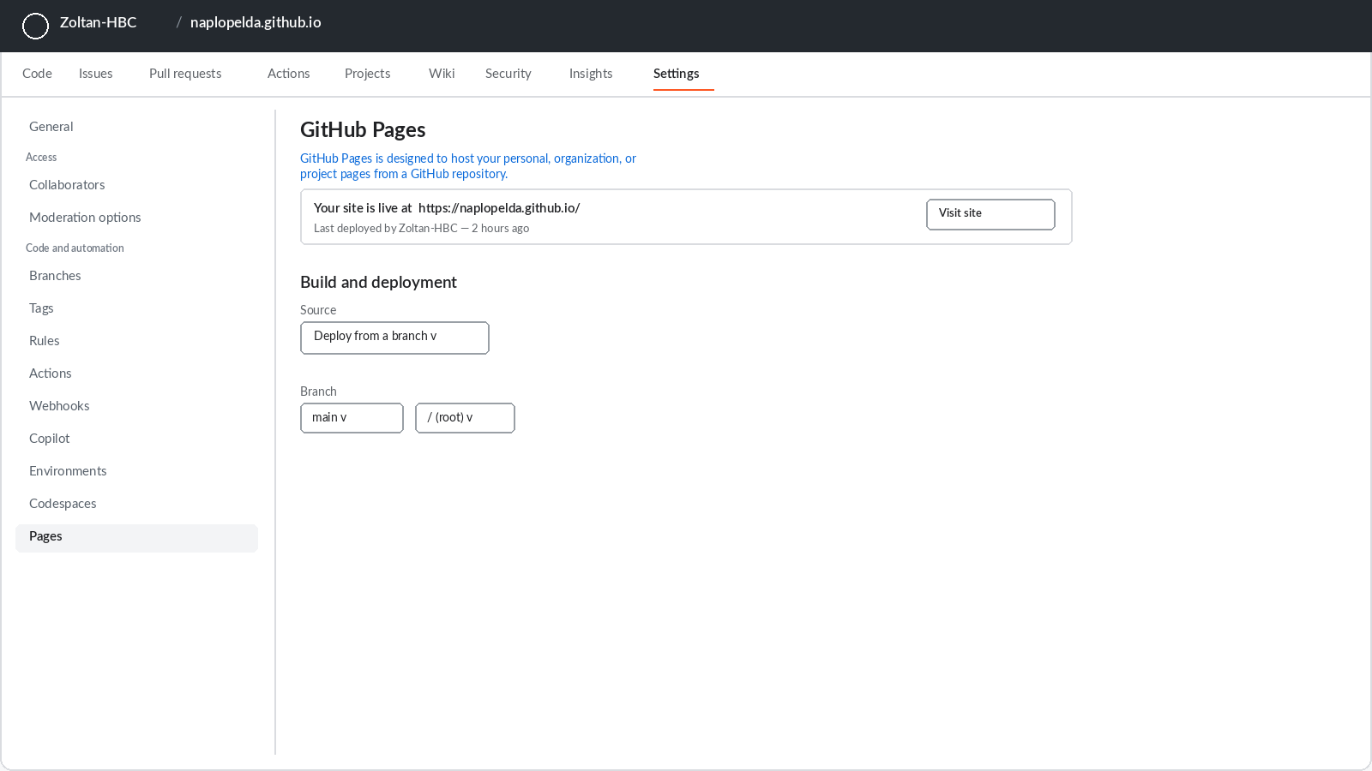

l) GitHub — Settings → General: the exact repository name can be checked here
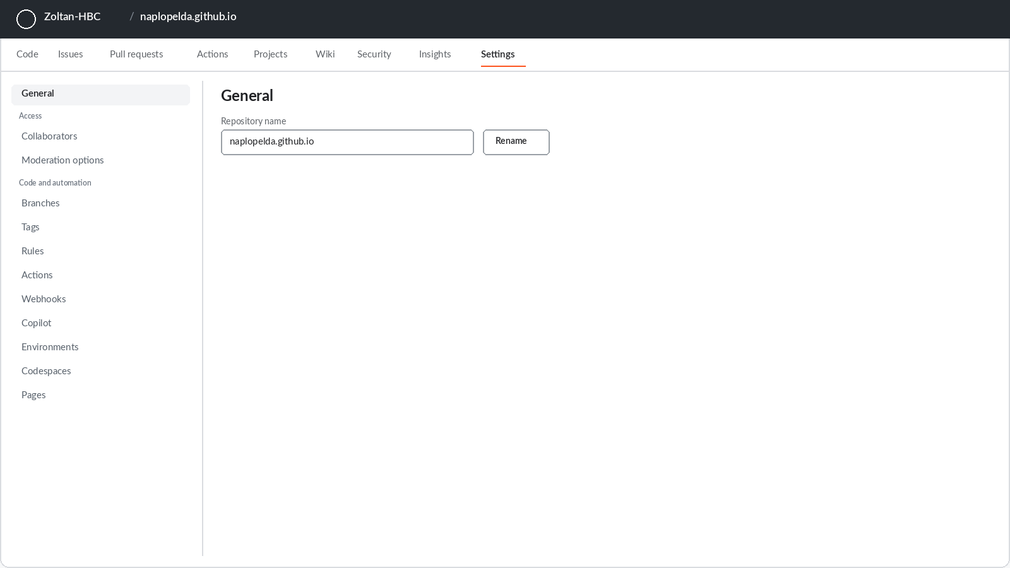
- Click Commit changes and wait 2–3 minutes.
- Open the full address https://YOURUSERNAME.github.io in a browser. If the application loads, publishing is complete.
Good to know
The public repository contains only the application’s program files, not the diary data. The data is always stored on the individual phones and in the user’s own Google Drive.

6.2 Installing on an Android phone
- Open https://YOURNAME.github.io in the Chrome browser.
- An Install offer pops up at the bottom of the screen. If not, tap the three dots in the top right, then Install app.
- Tap Install. The icon (the blue-grey ribbon logo) is placed on the home screen.
- Open it from the icon: the application runs full-screen and from then on works without internet as well.

6.3 Installing on an iPhone
- Open https://YOURNAME.github.io in the Safari browser.
- Tap the Share button at the bottom (a square with an upward arrow).
- Scroll down, choose Add to Home Screen, then tap Add.
- The icon appears on the home screen; started from there it runs full-screen, even without internet.

6.4 Installing on a Windows or Mac computer
- Open https://YOURNAME.github.io in the Chrome or Edge browser.
- A small install icon appears at the right edge of the address bar (a monitor with a downward arrow). Click it.
- Click Install. The application runs in its own window and is added to the Start menu or the Dock.

6.5 Taking over the data of an earlier (v6, v7 or v8) diary
There are two cases. If the new application is opened in the same browser in which the v6, v7 or v8 diary was used so far, the data appears by itself — nothing needs to be done. When starting on another device or browser: in the old diary open the Sync tab, press JSON Export, send the file to yourself (for example by e-mail), then on the Sync tab of the new application load it with the JSON/CSV Import button. The import is intelligent: it does not duplicate entries that already exist.

6.6 First settings, together with the treating physician
After installation open the Settings tab and complete the table below. The values in the left column are approved by the treating physician, because the insulin suggestions are calculated from them.
Setting | What it means | Example value (to agree with the physician)
Low blood glucose limit | The hypo warning sounds below this | 3.9 mmol/l
High blood glucose limit | Values above this count as high | 10.0 mmol/l
Target glucose | The target of the correction calculation | 6.0 mmol/l
Sensitivity | The glucose-lowering effect of 1 unit of insulin | 2.5 mmol/l
ICR morning  Insulin-to-Carbohydrate Ratio (ICR) | How many grams of carbs 1 unit covers in the morning | 10 g
ICR midday  Insulin-to-Carbohydrate Ratio (ICR) | How many grams of carbs 1 unit covers at midday | 12 g
ICR evening  Insulin-to-Carbohydrate Ratio (ICR) | How many grams of carbs 1 unit covers in the evening | 10 g
Time-of-day boundaries | The hour limits of meal types and ICR periods | Breakfast until 9, Lunch until 14, Dinner until 21; ICR: morning until 10, midday until 16
Insulin action time | How long injected rapid insulin counts as active | 4 hours
Insulin names | The names of the preparations used | e.g. Humalog and Lantus
Custom background color (v10.0) | A background color choosable from a pop-up palette next to Settings → Appearance | e.g. #EEF2FF (clear anytime with Reset)

6.7 Updates in the future
When a new version of the application is ready, updating is simple: the changed files are uploaded to the GitHub repository the same way as in chapter 6.1. The copies installed on phones and computers notice the new version by themselves: they download it the next time they are opened with an internet connection, and the version after that restart is already the new one. Diary data remains untouched during the update, because it lives not in the program files but in the device’s own storage. Example: files uploaded on Tuesday evening are downloaded by the follower’s phone when opened on Wednesday morning, and the second opening that morning already runs the new version.
“App update available” notice: on an installed application the browser (Chrome/Edge) may show its own built-in notice at the top of the screen when it detects a new version. This is not a message from the application and not an error: the diary is typically already running the new version when the notice appears, and clicking it merely refreshes the browser’s own records. The notice can safely be clicked away; it cannot be switched off because it is a browser feature, but it causes no harm and does not touch the data.

7. Google Drive sync: the follower sees the values live

7.1 How it works
Sync is built on two roles. The owner’s application automatically uploads the diary as a single file to a chosen folder of their own Google Drive after every save. The follower’s — a relative’s or the treating physician’s — application connects to this shared file: it downloads fresh data on opening and at a configurable interval (5 minutes by default), and shows it on the same screens as the owner’s — just read-only. Alerts can be requested too: when a fresh low or high value arrives, the follower’s phone shows a notification; from v14 a notification can optionally be requested for every new entry as well. Alerts arrive while the application is open or in the background; with the application fully closed they do not — that would require a central server, which may be a future extension.
The application uses Google’s strictly limited permission called drive.file: it can access only its own diary file and cannot even see the other files stored on the Drive.

7.2 One-time Google setup (about 20 minutes, free)
Google requires every such application to have a so-called Client ID. It must be created once, without a bank card.
- Open console.cloud.google.com and sign in with your Google account.
- At the top, in the project selector, click New project, name it HBC Naplo, then Create.
- In the left menu: APIs & Services, then Library. Find and enable (Enable) the Google Drive API, then the Google Picker API the same way.
- On first entry the Google Auth Platform setup wizard appears (Overview tab, Get started button). Enter the app name (e.g. HBC Diabetes Diary) and your email address (User support email); on the next step choose the External audience type, enter your email again as the contact, and accept the terms (Finish, Continue).
- In the left-hand Clients menu click + Create client. Set the type to Web application; any name is fine (e.g. Web client 1). In the Authorized JavaScript origins field enter your own address: https://YOURNAME.github.io, then Create.
- Click the created client to reveal the Client ID (a long string ending in .apps.googleusercontent.com) — copy it, it will be needed in step 7.3.
- In the left-hand Audience menu scroll to Test users and use + Add users to add your own email address and the follower's email address. In Testing publishing status up to 100 test users can be added, no verification required.

g) Google Auth Platform — Branding (app name, contact email)
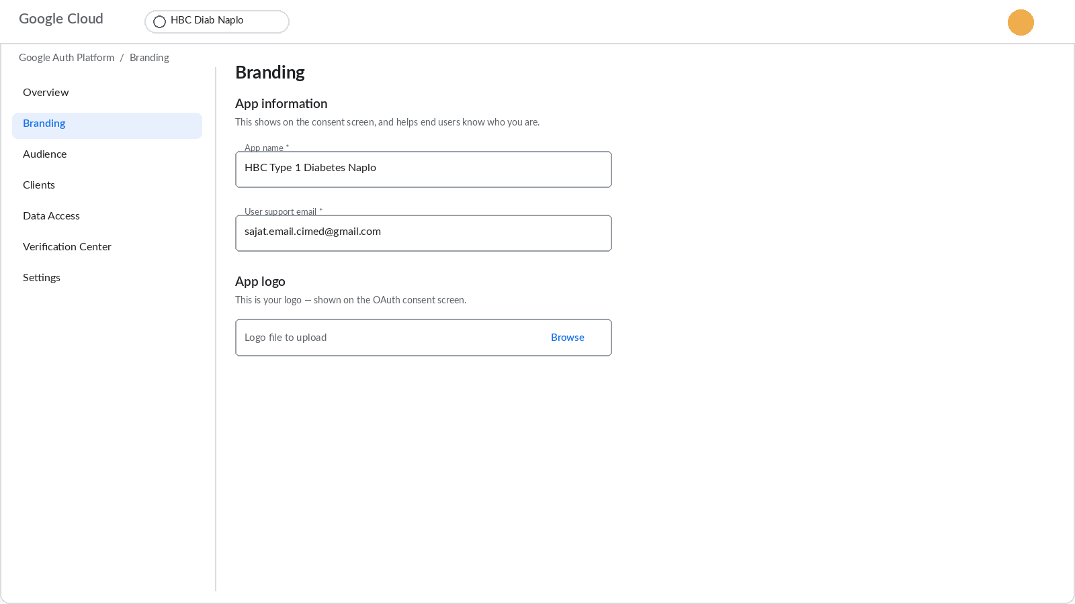
h) Google Auth Platform — Audience (Testing status, test users)
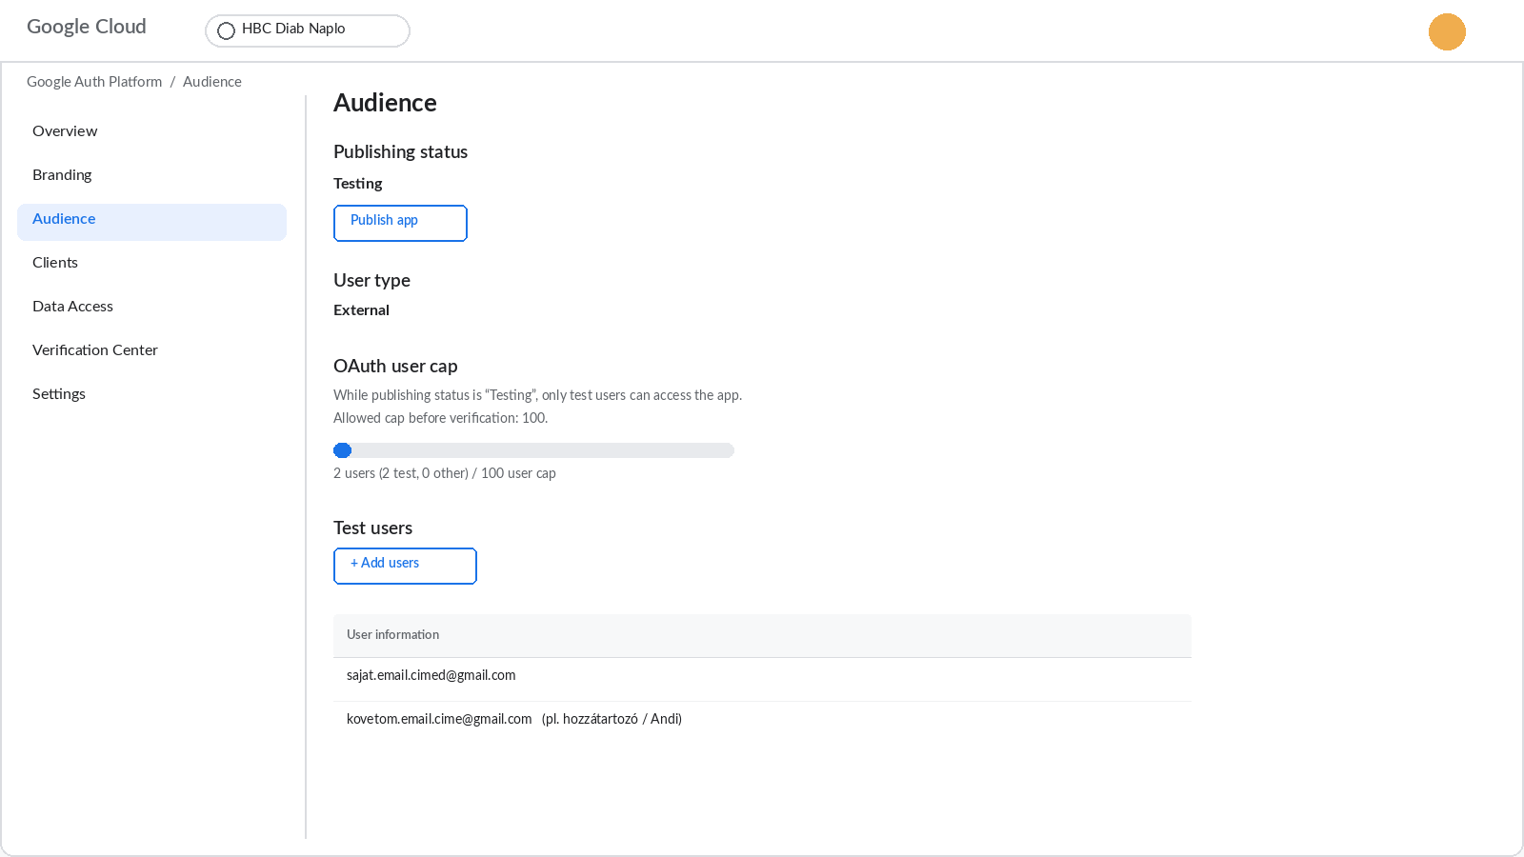

i) Google Auth Platform — Clients (the created OAuth client)
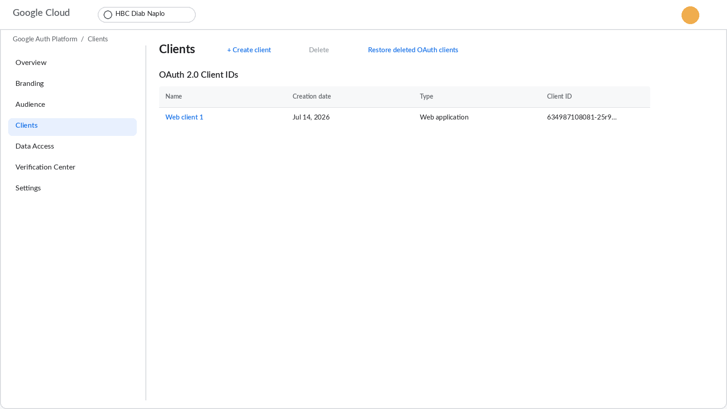
j) Client details — Authorized JavaScript origins and the Client ID
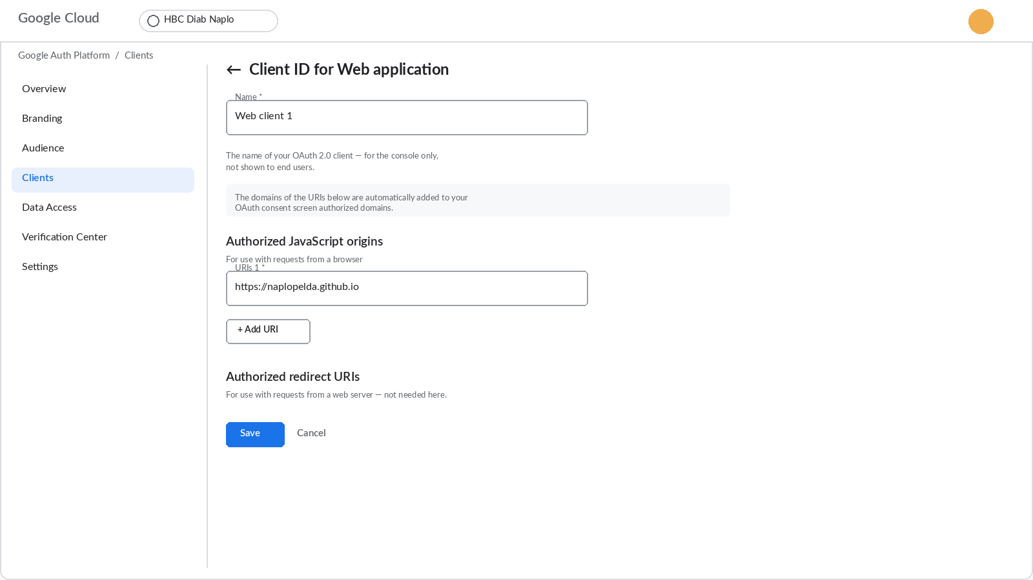

7.3 Setting up the owner (owner mode)
- In the HBC Diabetes Diary application itself — NOT in Google Cloud, in the diary app — open the Sync tab, and on the Google Drive sync card choose the Owner mode button.
- Paste the Client ID into field 1.
- Press button 2, Connect with Google account, and allow access. If the Google Cloud project is still in Testing status, Google may show an “unverified app” screen: proceed with Continue, because only the registered test users have access. In production status this screen does not appear.
- Press button 3, Choose folder, and select the diary folder on the Drive (worth creating in advance, for example named HBC Naplo).
- Done: from then on the file on Drive refreshes a few seconds after every save. It can also be triggered manually with Sync now.

7.4 Sharing the folder and setting up the follower (follower mode)
- On drive.google.com right-click the diary folder, choose Share, enter the follower’s e-mail address with the Viewer role, and send it.
- The follower installs the application on their own phone the same way (chapter 6.2 or 6.3).
- On the Sync tab the follower chooses the Follower mode button, pastes the same Client ID, and connects with their own Google account.
- Tapping the Choose shared diary button, they select the HBC_Diabetesz_Naplo.json file from the Shared with me section of the picker.
Important (v12.1): at the Connect with Google account button, Google now asks for the "See your Google Drive files" (read-only) permission. This is needed so that the selected diary file is not "lost" after the Google sign-in expires — even with this permission the app cannot write to or modify anything on Drive. Tip: if Google keeps showing the full consent screen every week, set the project from "Testing" to "In production" (Publish app) on the Google Cloud Console "OAuth consent screen" page — after that the consent is durable.
- In the Alert settings box they enable notifications, switch on the low-value alert, and set the refresh interval (for example 5 minutes). If desired, they also switch on “Notification for every new entry” (v14) — then every new entry triggers a notification, private entries never do.
- Done: the purple bar under the header shows the time of the last sync, and the Sync now button requests an immediate refresh.
An everyday example
The owner records a 3.4 mmol/l value at 16:05. The diary is uploaded to Drive at 16:05. The follower’s phone downloads it at the next refresh, by 16:10 at the latest, and since the value is below the 3.9 limit, it shows an alert: HBC Diary, low value alert, 3.4 mmol/l.
Important (v9.0): the alert fires only for the latest measurement taken on the current day. A back-dated value entered for an earlier day never triggers an alert, so there is no false night-time wake-up because of a past record being filled in. The shared data package also includes the CGM sensor readings, so the alert always reflects the real, current state.

7.5 Backup in practice: the monthly routine
Drive sync gives continuous protection, but it is worth adding a simple monthly routine, because a manual backup is independent even of the Google account. The suggested procedure on the first Sunday of every month: on the Sync tab press JSON Export; the downloaded file name automatically contains the date (for example HBC_v9_backup_2026-08-02.json); copy it to a USB stick or send it to yourself by e-mail. If everything ever needs restoring (new phone, lost device, cleaned browser), the latest such file can be loaded back within minutes with the JSON/CSV Import button, and the import does not duplicate existing entries. The Overview screen warns when the latest backup or sync is older than 7 days, so skipping the routine does not go unnoticed.

8. Loading CGM data (for sensor users)
When using a continuous glucose sensor (for example FreeStyle Libre or Dexcom), the measurement file downloadable from the manufacturer’s system can be loaded into the application and appears as a separate curve on the Charts tab. There is currently no live, direct connection to the sensor, because the manufacturers do not open this to third-party applications, but the application is prepared for it, so a later extension can add it.

LibreView example
- Sign in at libreview.com and save the CSV file with the Download glucose data button.
- On the application’s Sync tab press the Choose CGM CSV file button and select the downloaded file.
- The confirmation shows the number of imported readings, for example: CGM: 1340 readings imported.
- The CGM sensor curve appears on the Charts tab, with the target-range band.

Dexcom Clarity example
At clarity.dexcom.eu a CSV file can be requested with the Export button; loading works the same way. The application recognises the file’s unit: values saved in mg/dl are converted to mmol/l automatically, so the data is stored consistently.

9. Publishing in the Google Play store
The application can also be uploaded to the Play store, so anyone can install it from the store by searching. This is not a requirement for use (installation as in chapter 6 is fully featured); it is rather the path of an official release for a wider audience. The materials needed for the process are ready in the HBC_App_v12/store folder: store texts in Hungarian and English, a privacy statement, and a packaging configuration file.

9.1 Creating a developer account
- Open play.google.com/console/signup and sign in with a Google account.
- Choose the Personal account type and pay the one-time 25 dollar registration fee by bank card.
- Complete the identity verification (a photo of an ID card). Approval usually takes a few days.

9.2 Building the Android package
A packaged Android file (AAB) is uploaded to the Play store; it is produced from the published application by the free tool Bubblewrap. This requires Node.js on the computer (nodejs.org, LTS version).
- In a command prompt run: npm install -g @bubblewrap/cli
- Then: bubblewrap init --manifest=https://YOURNAME.github.io/manifest.json. For the questions, the values in the store folder’s twa-manifest.json are authoritative.
- The process creates a signing key: write down and keep its passwords, they will be needed for every future update.
- Run: bubblewrap build. The result is the app-release-bundle.aab file.
- Bubblewrap prints content named assetlinks.json: upload it to the website into the .well-known folder. Without it a browser bar would show inside the app.

9.3 Upload and store listing
- In the Play Console click Create app; the name is HBC Diabétesz Napló, the language Hungarian.
- In the Internal testing track create a release and upload the AAB file. This gives an immediately installable link for trying it out before the public release.
- Copy the texts of store/STORE_ANYAGOK.md to the store listing (short and long description in Hungarian and English), upload the 512-pixel icon and the screenshots.
- On the data safety form declare: the application does not collect and does not share data with third parties. Provide the web address of the privacy statement.
- In the health declaration state that the application is not a medical device.
- After successful testing create the production release and submit it for review. Assessment typically takes 1–7 days.
Apple App Store note: for iPhones, installation as in chapter 6.3 is the recommended route. An App Store release requires an Apple developer account (99 dollars per year) and a Mac computer, so it warrants a separate decision.

10. Troubleshooting: frequent questions
Symptom | Cause and solution
The Install button does not appear on the phone. | On Android only Chrome offers it, on iPhone only Safari. Check that the address is https://YOURNAME.github.io and the file was not opened directly.
The application does not update to the new version. | Close the application completely, then open it again with an internet connection. The update activates on the second opening.
The medical report does not open. | The report opens on a new page: allow pop-ups for this address in the browser settings, then press Create report again.
The application questions the value when saving. | This is the typo protection: it asks for confirmation before values below 2.0 mmol/l or above 25.0 mmol/l. A real extreme value can be saved with Yes.
An “unverified app” screen appears at the Drive connection. | This only appears if the Google Cloud project is still in Testing status — in that case proceed with Continue, but only registered test users have access. In production status (see chapter 7.2) this screen does not appear.
The follower cannot find the shared file in the picker. | Check that the folder on Drive is shared with the follower’s exact e-mail address and that the owner’s application has synced at least once (that is when the file is created).
No alert arrives on the follower’s phone. | In the Alert settings the Enable notifications button must be green, and the application must be open or running in the background. With the application fully closed the alert does not arrive.
Drive asks to sign in again every hour. | By Google’s security rule, access renews roughly every hour. This usually happens by itself, without a pop-up window.
The CGM file import reports an error. | Check that the original, unmodified CSV file from LibreView or Clarity is being loaded. A file opened and re-saved in Excel may have a changed structure.
Data disappeared after cleaning the browser. | The application’s dual storage (backup database) usually restores it automatically on restart. If not, everything can be reloaded from the latest JSON backup with the Import button.
A few Hungarian words remain in English mode. | Manually entered data (food names, notes, insulin names) intentionally stays exactly as recorded — that is the user’s personal data.
The Sync now button shows an error message (for example “Login expired”, “No permission”, “File not found”, “No internet connection”). | This precise error message (introduced in v11.1) helps pinpoint the problem: for an expired login, sign in again with Connect with Google account; for a missing permission, check that the folder is shared; for a deleted file, choose the folder again; without an internet connection, the data syncs on the next successful attempt. The scheduled, automatic sync retries silently in this case, without showing an error.

11. Medical and privacy notes

11.1 From a specialist’s point of view
The application’s dose suggestion follows the internationally common three-part formula: the carbohydrate coverage (total carbs divided by the ICR) plus the correction (the difference of the measured and target values divided by the sensitivity) minus the insulin on board (IOB). The ICR can be set separately by time of day — and in v9.0 the hour boundaries of these periods can be adapted to the patient’s routine —, the action-curve length is adjustable, and the result is rounded to half units. Every parameter is to be entered on the Settings tab under medical supervision. The estimated HbA1c is computed from the average glucose of the selected period with the common conversion formula; alongside it, v9.0 also calculates the GMI (Glucose Management Indicator) with the international formula. The application consistently marks both as estimates. The medical report provides a summary of any period that can be printed or forwarded as a PDF, with SD/CV variability measures. Follower mode is read-only: the treating physician sees the patient’s data but cannot modify it.

What to review during the appointment: a checklist
The following list gives a fast, factual overview from the application at the quarterly check-up, illustrated with examples.
- Medical report for a 90-day period: every key figure and the detailed log on a single printable page — the fastest starting point.
- Statistics tab, 90-day range: TIR, average, estimated HbA1c and GMI together. Example: with 76% TIR and 7.1% estimated HbA1c the direction of therapy is good; details can be refined on the charts.
- Daily pattern chart: the hourly averages. Example: if the 3–6 am band is repeatedly low, lowering the basal dose may come up — a decision for the specialist.
- Measurement summary: the ratio of low, normal and high readings. Example: 3 low, 41 normal, 9 high indicates that the excursions tend upward.
- Carb/insulin ratio card: the actual ratio computed from the diary against the configured ICR. Example: if the configured morning ICR is 10 but the diary shows 1 unit covering only 8 grams, adjusting the ratio may be justified.
- Entries tab with the notes: the context of restaurant, sport and stressful days, as in the examples of chapter 5.

11.2 Where the data is
Every entry is stored on the given device, with dual storage: besides the fast primary store, a backup database also keeps it, so it recovers even after an accidental browser clean-up. The application sends no data whatsoever to the developer or any third party, and contains no advertising or tracking code. With Drive sync enabled, a copy of the diary also exists on the user’s own Google Drive, and only those with whom the user themselves shared the folder can access it. Sharing can be revoked at any time on the Drive interface, and sync can be switched off with the Disconnect button. The medical report is generated locally, on the device — its content reaches anyone only if the user prints or sends it themselves.

11.3 Summary
The HBC Diabetes Diary v19 Type 1 Diabetes APP is an installable, offline-capable, bilingual diary that turns logging into calculation, feedback and sharing: it suggests insulin doses based on values agreed with the physician, warns at low and unusual values, shows the trends on charts, statistics and the daily pattern, produces a printable medical report for any period, and can be followed live on the designated follower’s phone. Installation consists of a one-time publication and a few taps per device; Drive sync works by itself after a one-time Google setup. The chapters of this document walk through every phase from everyday use to the store release, and chapter 10 resolves the most frequent difficulties.

12. The SOS emergency feature
New in v12.0. During severe hypoglycaemia an insulin-treated person may become confused or lose consciousness — and then every minute counts for unknown helpers and paramedics. The SOS page shows the essentials in large letters with a single tap: what happened, what to do and whom to call.

12.1 Setting it up
Open Settings → Emergency (SOS) and fill in the following. All data is stored only on your device.
- Full name and own phone number: these also appear in the header of the Medical report, making it an official, identifiable document.
- Home address: to inform helpers and paramedics.
- Contacts to notify: any number of people can be added with the + (add) button (name, relation, phone number); the first person in the list is the primary contact. Any entry can be removed with the bin icon.
- "How to communicate with me" note: a fully, freely editable text. Based on your own experience, describe what you are like during hypoglycaemia (calm? confused? dismissive? — often as if you were drunk) and how helpers should treat you while you are still conscious. Helpers will see this text word for word.

12.2 Opening the SOS page
- On a phone: with the red SOS button at the bottom of the  hamburger menu in the header.
- On a desktop computer: with the small button on the right of the header (mainly useful for checking the settings).
The page appears in the configured language (Hungarian or English) and contains: the warning title ("INSULIN-TREATED DIABETIC"), step-by-step first-aid instructions, the 112 emergency call button, one-tap call buttons for the contacts, the home address and the communication note.
From v12.2 the tiles can be freely re-arranged by dragging the ⠿ handle in their top right corner — the order is remembered on the device. In the default order the Contacts to notify tile sits above the 112 button. The note title also shows the nickname configured in Settings ("How to communicate with me — my name is …"), and the page keeps the same, highly readable colours in dark mode too.

12.3 Automatic alert on a low reading
If the most recent reading of the day — a manual entry or an imported CGM value — falls below the configured low blood-glucose threshold, the SOS page appears automatically with the measured value, and (if notifications are enabled) a system notification is also sent. It is dismissed with the "I AM OK — dismiss alert" button (in follower mode the button reads "OK — dismiss alert"); the application alerts only once per reading, and an older (retrospectively recorded) value never triggers an alert.

12.4 Important limitations and advice
- It cannot appear on a locked screen: a web application cannot draw over the lock screen of a phone and cannot unlock the phone — this is a system-level restriction that applies to every application.
- Also set up the system-level emergency data: the "Medical ID" of the Health app on iPhone, or "Emergency information" on Android — these are available WITHOUT unlocking, from the lock screen, and paramedics look there first. The SOS page complements them; it does not replace them.
- Keep the app on the home screen: after unlocking the phone the helper finds it immediately and can open the SOS page from the menu with a single tap.
- Not a medical device: the SOS page is an informational aid; in the case of severe illness always call an ambulance.

