Admin

Commands Tab opens the following form:

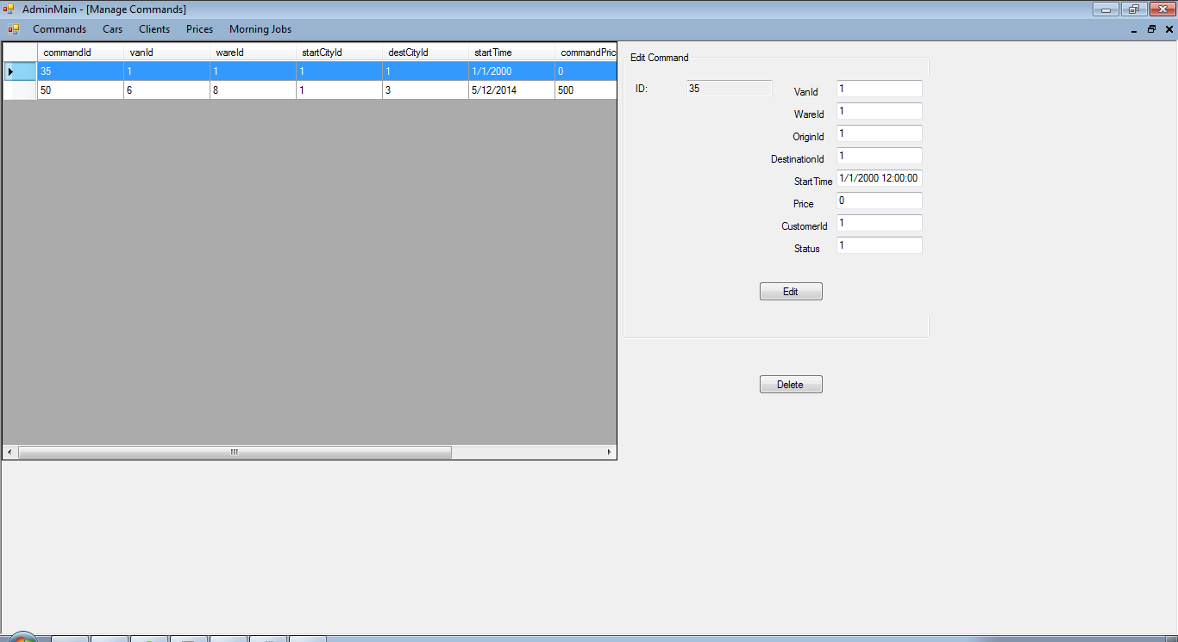

First we populate the datagridview with data from database:

InitializeComponent();

adminController = adminC;

DataTable dt = adminC.viewCommands();

dataGridView1.DataSource = dt;

For populating the textboxes we use the selectionChanged method :

private void dataGridView1_SelectionChanged(object sender, EventArgs e)

{

foreach (DataGridViewRow row in dataGridView1.SelectedRows)

{

tb_id.Text = row.Cells["commandId"].Value.ToString();

tb_vanid.Text = row.Cells["vanId"].Value.ToString();

tb_wareid.Text = row.Cells["wareId"].Value.ToString();

tb_originid.Text = row.Cells["startCityId"].Value.ToString();

tb_destinationid.Text = row.Cells["destCityId"].Value.ToString();

tb_time.Text = row.Cells["startTime"].Value.ToString();

tb_priceid.Text = row.Cells["commandPrice"].Value.ToString();

tb_customerid.Text = row.Cells["customerID"].Value.ToString();

tb_status.Text = row.Cells["commandStatus"].Value.ToString();

}

}

For edit button we first check if all the fields are filled, if not we show an error message, otherwise we update the data to database:

private void btnEdit_Click(object sender, EventArgs e)

{

if (tb_id.Text.Equals("") && tb_vanid.Text.Equals("") && tb_wareid.Text.Equals("") && tb_originid.Text.Equals("") && tb_destinationid.Text.Equals("") && tb_time.Text.Equals("") && tb_customerid.Text.Equals("") && tb_status.Text.Equals(""))

{

MessageBox.Show("All fields Must be completed");

}

else

{

Command toEdit = new Command();

toEdit.CommandId = Convert.ToInt32(tb_id.Text);

toEdit.VanId = Convert.ToInt32(tb_vanid.Text);

toEdit.WareId = Convert.ToInt32(tb_wareid.Text);

toEdit.StartCityId = Convert.ToInt32(tb_originid.Text);

toEdit.DestCityId = Convert.ToInt32(tb_destinationid.Text);

toEdit.StartTime = Convert.ToDateTime(tb_time.Text);

toEdit.UserId = Convert.ToInt32(tb_customerid.Text);

toEdit.CommandStatus = Convert.ToInt32(tb_status.Text);

command.updateCommandInDb(toEdit);

MessageBox.Show("Updated successful");

}

}

The admin has the possibility to delete a command (e.g. A customer calls and wants to cancel the command) using the delete button:

private void btnDelete_Click(object sender, EventArgs e)

{

int i;

i = dataGridView1.SelectedCells[0].RowIndex;

if (dataGridView1.Rows.Count > 1 && i != dataGridView1.Rows.Count - 1)

{

int id = int.Parse(dataGridView1.Rows[i].Cells["commandId"].Value.ToString());

adminController.deleteCommand(id);

dataGridView1.Rows.RemoveAt(dataGridView1.Rows[i].Index);

MessageBox.Show("Row Deleted");

}

}

Prices tab opens the following form:

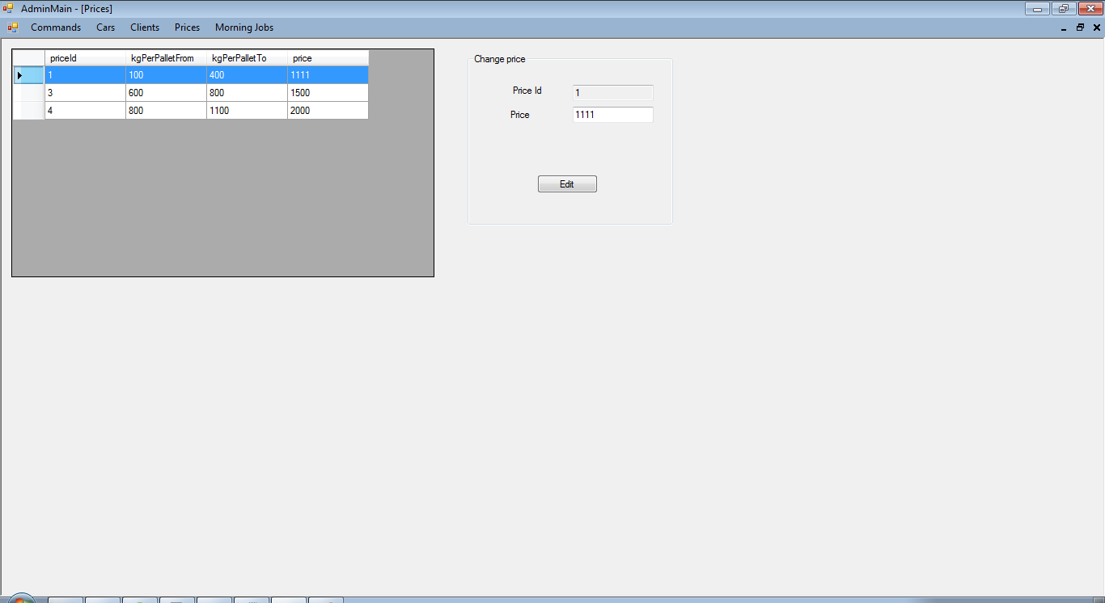

For populating the datagridview and the textboxes we used similar methods to those presented for manage commands.

The admin can only update the price using the edit button using similar validations:

private void btnEdit_Click(object sender, EventArgs e)

{

if (tb_id.Text.Equals("") && tb_price.Text.Equals(""))

{

MessageBox.Show("All fields Must be completed");

}

else

{

int id = Convert.ToInt32(tb_id.Text);

int price = Convert.ToInt32(tb_price.Text);

adminController.updatePrice(id, price);

MessageBox.Show("Updated successful");

}

}

Clients

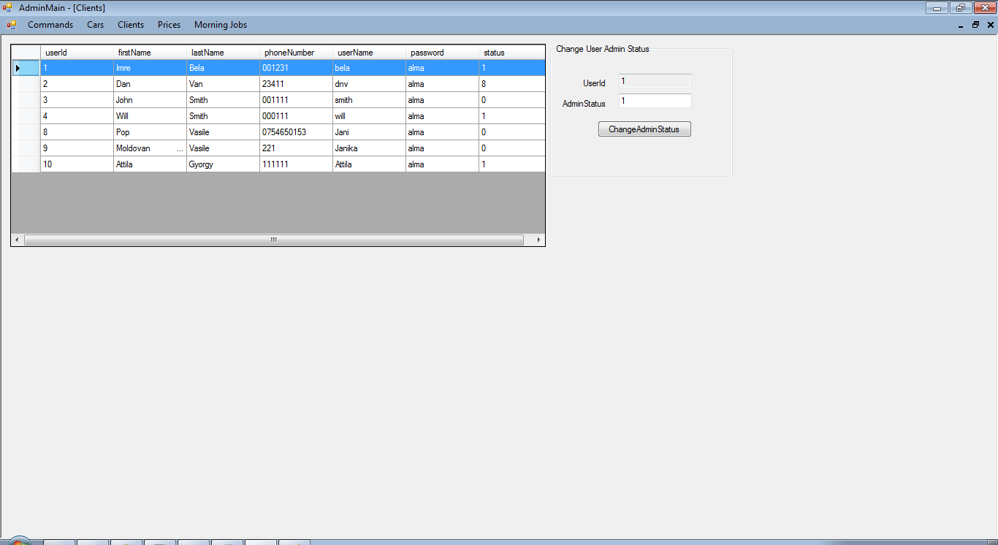

For populating the datagridview and the textboxes we used similar methods to those presented for manage commands.

The only thing that the admin can change about a client is his admin status(set / unset; 0 for customer/1for admin), we use similar validations for the textbox fields and another one in order to be sure that the status is 0/1:

private void btn_edit_Click(object sender, EventArgs e)

{

if (tb_id.Text.Equals("") && tb_adminstatus.Text.Equals("") )

{

MessageBox.Show("All fields Must be completed");

}

else if (tb_adminstatus.Text.Equals("0") || tb_adminstatus.Text.Equals("1"))

{

int id = Convert.ToInt32(tb_id.Text);

int adminStatus = Convert.ToInt32(tb_adminstatus.Text);

adminController.updateClientStatus(id, adminStatus);

MessageBox.Show("Updated successful");

}

else{

MessageBox.Show("Status must be 0-Client 1-Admin");

}

}