Project of Industrial Informatics

Transport Logistics

Members:
Project manager: Nagy Zoltán
Programmers: Dolha Raul Marcel, Stoica Andrei
Database: Ţibre Marius Andrei
Tester: Simon Zsolt
III. year, Automation and Computer Science
I. Introduction
The idea of this project is to make an easily understandable transport program for both administrators and clients. The name of the program comes from the initials of the programmers. In this project the Windows Form was used with an SQL Server Express for the database. Also to divide the work and make easier the communication the Github was used. Where each member could work parallel on the project.
II. Utilization
The program starts with a small window with the login part, where the user can log in or can make a new user by clicking on the Register button(fig II.1). If there is a new user than by clicking on the Register button the Register Form appears.
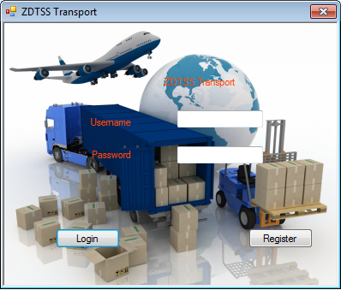
Fig. II.1- Login Form
There are two type of users, by clicking on the Login button the program scans the username and the password and decide which form has to be opened the client or the administrator form. When a new user is created its status will be 0 which means that it is a client. Only an administrator can change the status of a client to an administrator.
- Client user
The client user main activity is to create a new command. First he has to select the cities from where and to where he want to transport, and also some other details like when he want this transport, and a short description about the ware. After that he can go further by clicking on the next button and once again he can see his command and the price of the command. If he is agreed with this than he can accept or if not decline. After he accepted he cannot modify, it will be saved in the database, only the administrator can modify it.
He can also view his previous commands and their status, he can modify his personal data and if he need some help there is also a help menu, where he can find some information and phone numbers if something is not clear enough.
This part contains all the necessary information for a client user, to make his command as simple as possible. The functionality of the client user is visible for on the use case diagram(fig II.2.1).
- Admin user
The admin user has the purpose to correct errors, change data in the database, add new components like vans and the most important is to view see the works what the drivers need to do. When an administrator is logged in he can view the morning jobs, which is separated for each region and for each van in the region.
Only the administrator can change a status of a command, from “goods in transport” to “goods arrived”. He can change the prices of the transport, he can make a client to a user, and also delete users. All the functionality of an administrator can be seen on the use case diagram(fig 2).
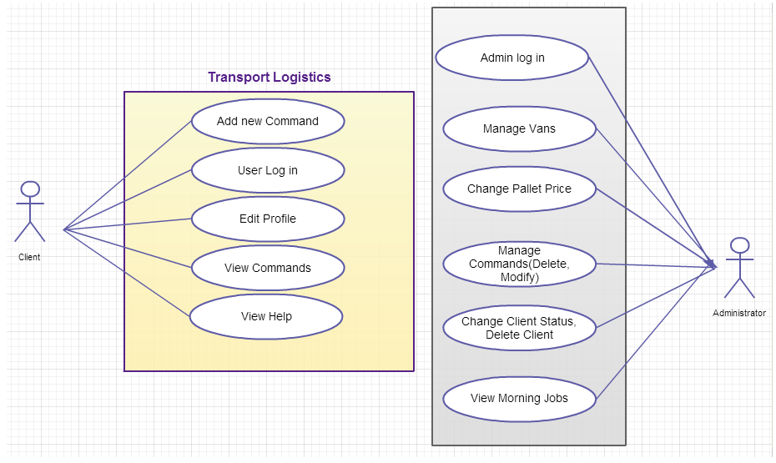
Fig II.2.1 Use Case Diagram

III. Programming
- Interface
In this project the Windows Form features were used. There are more than 10 forms, each of them with its own functionality. The first form is for the log in, it’s a small one, because it contains just a few information(fig. 1). Another form is for registering for new users. The user can do the registering by simply clicking on the Register button on the log in form and by giving some personal data he can create a new client user. To put everything in a common place MDI (Multiple Document Interface) was used, in parent-child relationship. There are 2 different type of forms one for the client and the other one for the administrator. The Main interface (MDI parent) for the client user contains all the forms which refers to this part, respectively does the AdminMain interface for administrators.
From a menu strip the user can select the activity what he want to do. For instance if an administrator wants to see all the commands, he can do this by clicking on the command menu and there will appear all the commands in a table. To represent a data table the DataGridView class was used.
  - Interface detailed – Client user

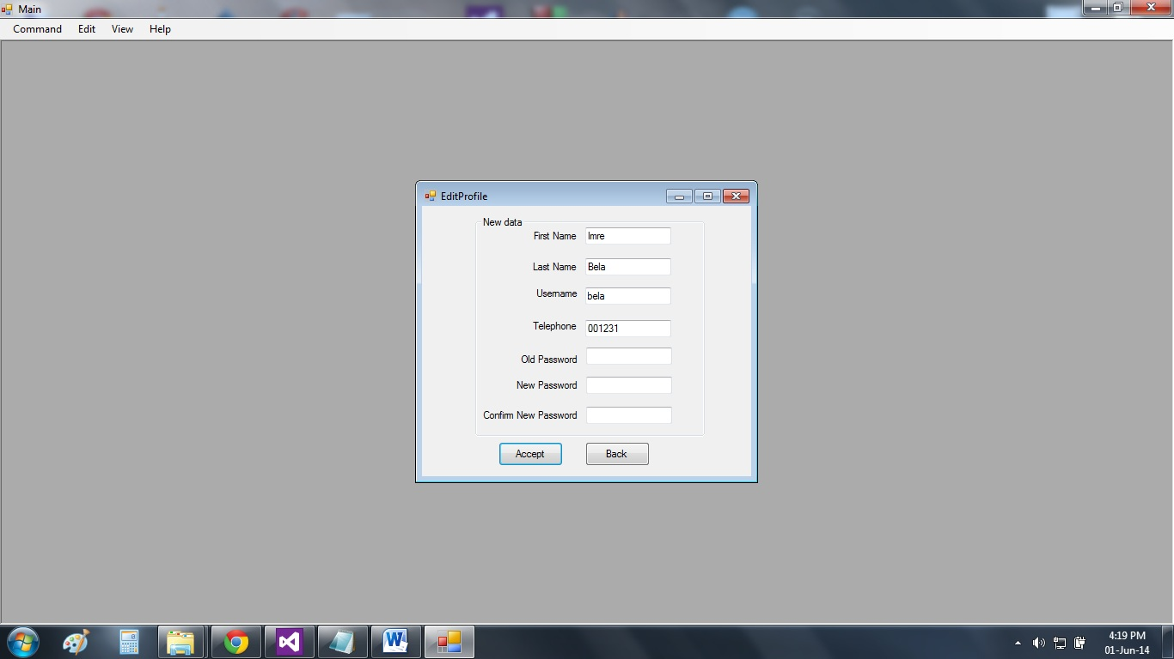
Figure III.1.1.1 Edit Profile
The editProfile Window has the role to UPDATE the given data(textbox) in the database. The update is accomplished with the updateUserInDb( ) method from the User class.
Code:
SqlCommand cmd = new SqlCommand("UPDATE users SET firstName=@firstName, lastName=@lastName, phoneNumber=@phoneNumber ,userName=@userName, password=@password WHERE userId=@userId", Database.sqlCon);
There is a .pdf document that has the role of being the guidebook of the application for the casual user.
Code to open Help.pdf:
Process.Start(@"location");
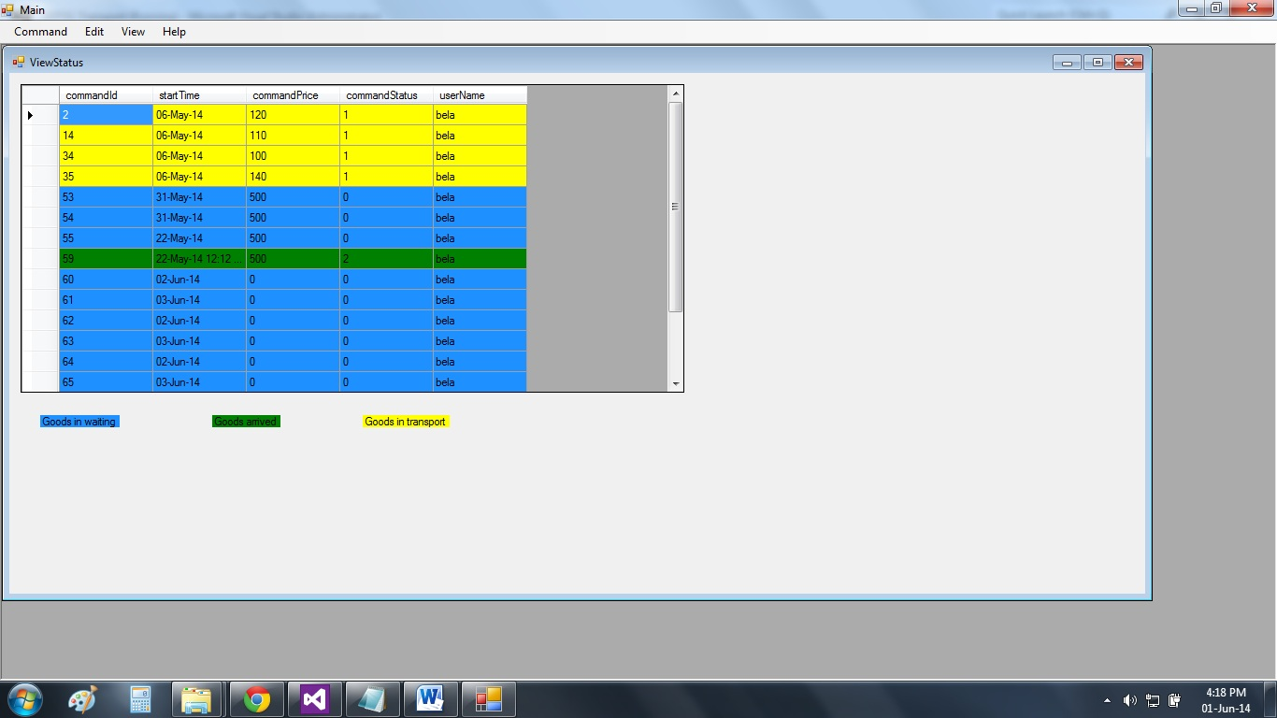
Figure III.1.1.2 Command Status

This window will show information about the command ,the user has made. It shows commands in 3 steps :
1.Waiting to be collected from warehouse goods
2.Goods in transport to the client location
3.Finished commands
Works as a history for the client to see his past orders from the application.The controller of View Status is in User class, the method we use is viewStatus(User,int)

Code:
SqlDataAdapter sda = new SqlDataAdapter("SELECT commandId,startTime,commandPrice,commandStatus,users.userName FROM commands JOIN users ON commands.customerId=users.userId WHERE commands.customerId=users.userId", Database.sqlCon);
SqlCommand sqc = new SqlCommand("SELECT commandId,startTime,commandPrice,commandStatus,users.userName FROM commands JOIN users ON commands.customerId=users.userId WHERE customerId=@userId", Database.sqlCon);
try
{
sqc.Parameters.Add("@userId", SqlDbType.Int).Value = userId;
}
catch (Exception ex)
{
MessageBox.Show(ex.ToString());
}
sda.SelectCommand = sqc;
sda.Fill(dt);

  - Interface detailed – Admin user
Commands Tab opens the following form:
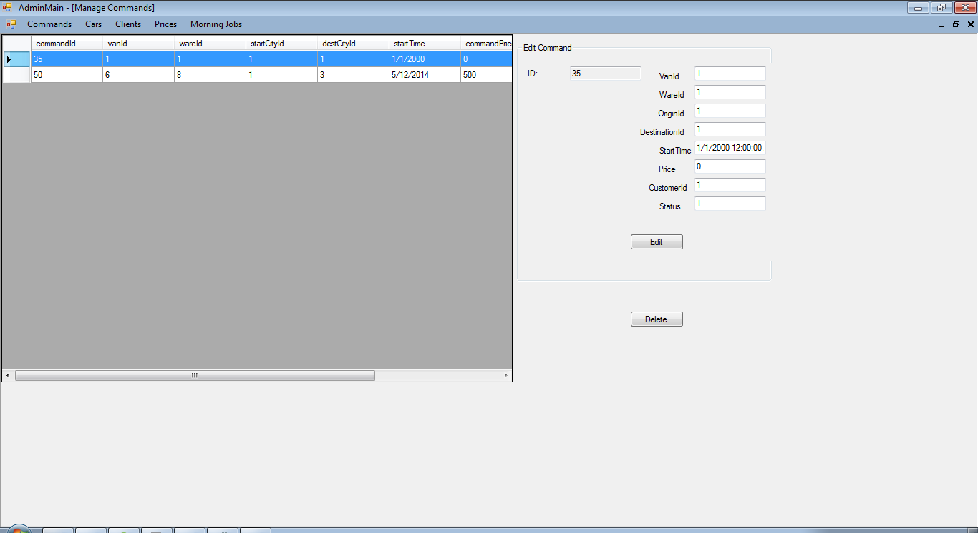
Figure III 1.2.1 Commands

First we populate the datagridview with data from database:
InitializeComponent();
adminController = adminC;
DataTable dt = adminC.viewCommands();
dataGridView1.DataSource = dt;

For populating the textboxes we use the selectionChanged method :
private void dataGridView1_SelectionChanged(object sender, EventArgs e)
{
foreach (DataGridViewRow row in dataGridView1.SelectedRows)
{
tb_id.Text = row.Cells["commandId"].Value.ToString();
tb_vanid.Text = row.Cells["vanId"].Value.ToString();
tb_wareid.Text = row.Cells["wareId"].Value.ToString();
tb_originid.Text = row.Cells["startCityId"].Value.ToString();
tb_destinationid.Text = row.Cells["destCityId"].Value.ToString();
tb_time.Text = row.Cells["startTime"].Value.ToString();
tb_priceid.Text = row.Cells["commandPrice"].Value.ToString();
tb_customerid.Text = row.Cells["customerID"].Value.ToString();
tb_status.Text = row.Cells["commandStatus"].Value.ToString();
}
}
For edit button we first check if all the fields are filled, if not we show an error message, otherwise we update the data to database:
private void btnEdit_Click(object sender, EventArgs e)
{
if (tb_id.Text.Equals("") && tb_vanid.Text.Equals("") && tb_wareid.Text.Equals("") && tb_originid.Text.Equals("") && tb_destinationid.Text.Equals("") && tb_time.Text.Equals("") && tb_customerid.Text.Equals("") && tb_status.Text.Equals(""))
{
MessageBox.Show("All fields Must be completed");
}
else
{
Command toEdit = new Command();
toEdit.CommandId = Convert.ToInt32(tb_id.Text);
toEdit.VanId = Convert.ToInt32(tb_vanid.Text);
toEdit.WareId = Convert.ToInt32(tb_wareid.Text);
toEdit.StartCityId = Convert.ToInt32(tb_originid.Text);
toEdit.DestCityId = Convert.ToInt32(tb_destinationid.Text);
toEdit.StartTime = Convert.ToDateTime(tb_time.Text);
toEdit.UserId = Convert.ToInt32(tb_customerid.Text);
toEdit.CommandStatus = Convert.ToInt32(tb_status.Text);
command.updateCommandInDb(toEdit);
MessageBox.Show("Updated successful");
}
}
The admin has the possibility to delete a command (e.g. A customer calls and wants to cancel the command) using the delete button:

private void btnDelete_Click(object sender, EventArgs e)
{
int i;
i = dataGridView1.SelectedCells[0].RowIndex;
if (dataGridView1.Rows.Count > 1 && i != dataGridView1.Rows.Count - 1)
{
int id = int.Parse(dataGridView1.Rows[i].Cells["commandId"].Value.ToString());
adminController.deleteCommand(id);
dataGridView1.Rows.RemoveAt(dataGridView1.Rows[i].Index);
MessageBox.Show("Row Deleted");
}
}

Prices tab opens the following form:
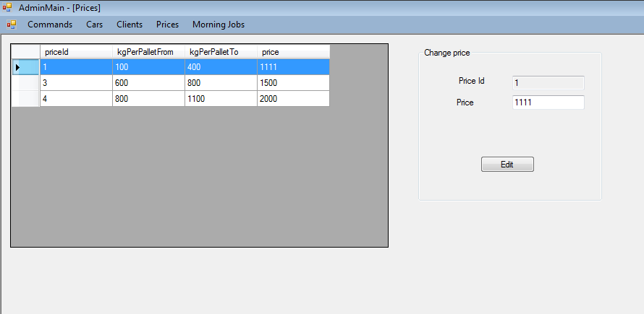
Figure III. 1.2.2 Prices
For populating the datagridview and the textboxes we used similar methods to those presented for manage commands. The admin can only update the price using the edit button using similar validations:
private void btnEdit_Click(object sender, EventArgs e)
{
if (tb_id.Text.Equals("") && tb_price.Text.Equals(""))
{
MessageBox.Show("All fields Must be completed");
}
else
{
int id = Convert.ToInt32(tb_id.Text);
int price = Convert.ToInt32(tb_price.Text);
adminController.updatePrice(id, price);
MessageBox.Show("Updated successful");
}
}

Clients
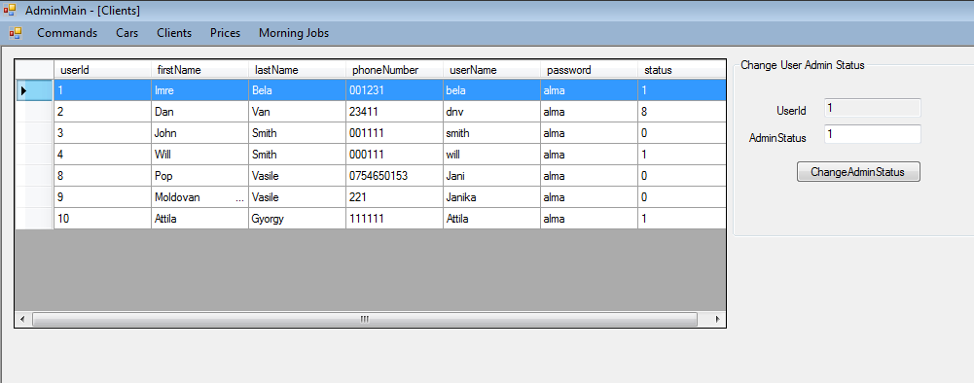
Figure III.1.2.3 Clients
For populating the datagridview and the textboxes we used similar methods to those presented for manage commands.
The only thing that the admin can change about a client is his admin status(set / unset; 0 for customer/1for admin), we use similar validations for the textbox fields and another one in order to be sure that the status is 0/1:
private void btn_edit_Click(object sender, EventArgs e)
{
if (tb_id.Text.Equals("") && tb_adminstatus.Text.Equals("") )
{
MessageBox.Show("All fields Must be completed");
}
else if (tb_adminstatus.Text.Equals("0") || tb_adminstatus.Text.Equals("1"))
{
int id = Convert.ToInt32(tb_id.Text);
int adminStatus = Convert.ToInt32(tb_adminstatus.Text);
adminController.updateClientStatus(id, adminStatus);
MessageBox.Show("Updated successful");
}
else{
MessageBox.Show("Status must be 0-Client 1-Admin");
}
}

  - Interfaces detailed – Morning Jobs

This part is useful for the administrator, because it splits the commands for regions and in each region will show all the commands referring to that region. The admin can add the wares to the vans by simply clicking on the “Add vans” button. For each van will appear a color, to make it easier to differentiate from the others. The commands which still do not have vans has white color. And also the vans are ordering by a ratio between the load capacity in kg and the load capacity in volume.
From the listboxes one can select which region want to see and also see the external commands.

The external commands are on the same van – the 100 because this is a very big van and it handles all the external commands at each day. In a similar solution can be used as it is in the case of the regions, but this is for further development.

On the figure x it can be seen that the commands are split and put for each region separately. The regions can be selected from the listbox, and it can be decided which part to show up(intern collect or inter divide).

On the figure y the results can be seen after adding vans to the commands(It actually happens vice-versa but that is how it is seen there).

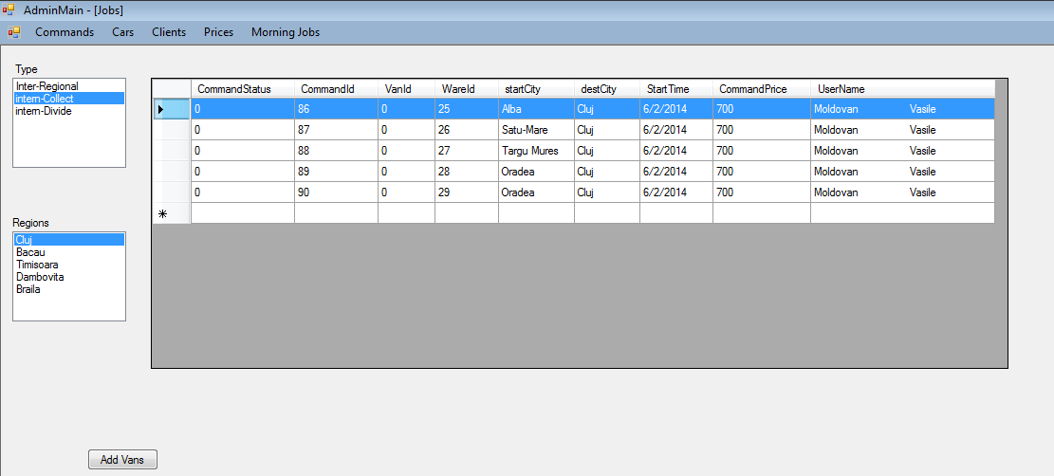
Figure III.1.3.1 MorningJobs split

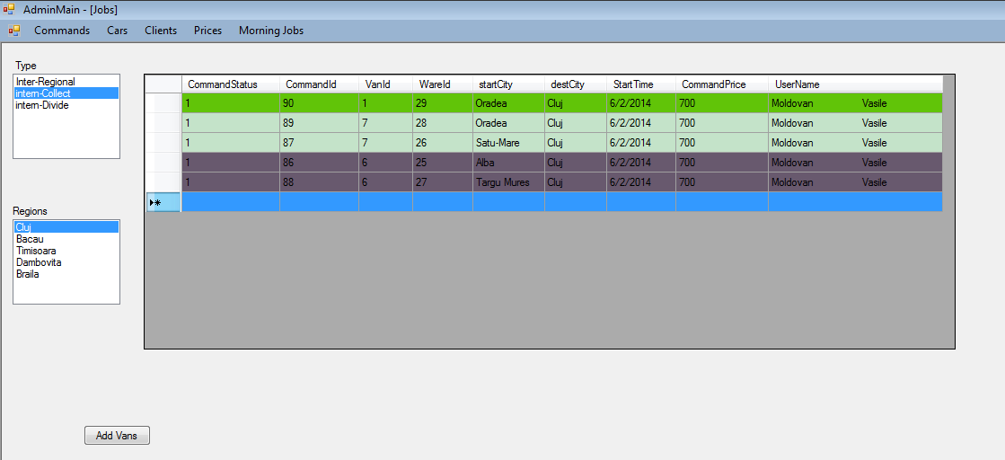
Figure III.1.3.2 Adding Vans to the commands
About the code. A couple of internal functions were used, to get and set information at the database and also to provide the algorithm.

First part of code is dealing with the split of the commands. At each command will be verified and if the case than will be split into more divisional commands:

if (startRegion == destRegion)
{
//split into 2
if ((command.DestCityId!=destRegionId)&&(command.StartCityId!=startRegionId))
{
//update the commands- start -> center
updateCommandInDb(command, startRegionId);
//creating new command center -> destionation
insertCommandIntoDb(command, startRegionId, command.DestCityId, 1);
}
}
else
{
//split into 3
if (command.StartCityId != startRegionId)
{
//update the commands- start -> center
updateCommandInDb(command, startRegionId);
}
//command -- center to center
if ((command.StartCityId != startRegionId) || (command.DestCityId != destRegionId))
{
insertCommandIntoDb(command, startRegionId, destRegionId, 1);
}
if (destRegionId != command.DestCityId)//if the destination is not the regionCenter
{
//command -- center -> destionation
insertCommandIntoDb(command, destRegionId, command.DestCityId, 2);
}
}

When this is done than the next step is to add vans to the commands, first step is to order decreasingly all the commands by using the commands capacity in Kg and the commands capacity in volume.

foreach (Command command in commandList)
{
//getting each command and adding to a van
// till the van is full
int commandCapacity =command.Ware.NrOfPallets;
int commandTotalKg=command.Ware.WeightPerPallet * command.Ware.NrOfPallets;
long vanKg = vanList[i].LoadCapKg;
int vanPallets = vanList[i].LoadCapPallet;
//firstly we got the total kg than the "weight" of the ware
//if ((filled + commandCapacity) < maxVanCapacity)
if ((maxCapKg+commandTotalKg<=vanKg)&&(maxCapP+commandCapacity<=vanPallets))
{
maxCapKg += commandTotalKg;
maxCapP += command.Ware.NrOfPallets;
//filling also the database and the list
fillCommandsVanChangeStatus(vanList[i].VanId, command.CommandId);
command.VanId = vanList[i].VanId;
command.CommandStatus = 1;
}
else
{
if (i < vanList.Count - 1)
{
i++;

maxCapKg = 0;
maxCapP = 0;
maxCapKg += commandTotalKg;
maxCapP += command.Ware.NrOfPallets;
//filling the database and also the list
fillCommandsVanChangeStatus(vanList[i].VanId, command.CommandId);
command.VanId = vanList[i].VanId;
command.CommandStatus = 1;
}
else
{
break;
//if it arrives here== there is no more van
//it needs to be checked if the other commands can be put into here or other
}
}
}

Software Architecture
From the software point of view there was used a model-view control architecture. The user can only see the interfaces but in the background there are classes which do the hard work.
There are three type of classes, form classes which are responsible to make everything user friendly and easily understandable; there are classes which is used to load a row from a table like Command class-it contains all the fields from the database “commands” table, and it is used just to save data, and to work with them inside the program; the third type of classes are the controllers, which does the actual work, they are responsible for making everything.
There are 4 Controller class: Authentication controller, Client controller, Admin controller, Job controller and Database class.
The Authentication controller is responsible for the login and register part. It verifies all the entries inside the fields and gives an error message if something is wrong. And also here is the decision part, it decide from the user status which form has to be opened next the client or the admin.
The Client controller deals with all the functionalities of a client. Creating a new command, changing some personal data and viewing all the commands of the client.
The Admin controller works with the admin related functions which are visible on the use case diagram(fig. 2).
The Job controller is actually a part of the admin controller, because it is also admin functionality, but it deals just with calculation of an optimal solution for the vans’ capacity per kg problem. It is put separately to make the code cleaner.
The Database class is also some kind of a controller, it deals with the connection of the database. It is a static class with static methods, to make it accessible from everywhere inside the program.
- Algorithm
There are mostly database related methods, reading, updating, adding or deleting from a database. In this part there is no difficulty from the algorithm point of view.
To calculate a better solution from the trivial one, a divide and conquer idea was used. Which means that the possible places where the vans can go were collected into regions. There are 5 regions and in each region there are 5 cities (More cities can be add by the administrator). The communication between regions can be done only by going through the capitals of the regions.
There are three type of transport: intern collect command(fig. 3), intern distribute (fig. 4) and extern commands(fig. 5). The intern collect transport collects all the ware inside the region and transports it to the center of the region, the intern distribute type transports from the center to the cities inside of that region and the extern is actually an inter-regional transportation, transports between regions.
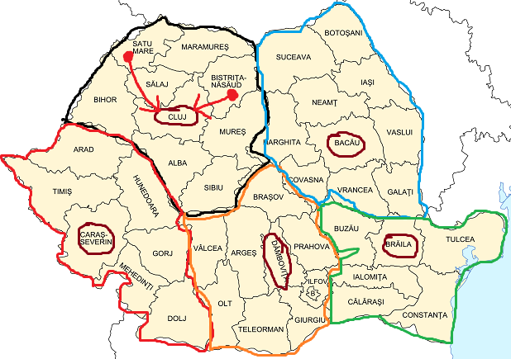
Fig. 3 intern collect transport
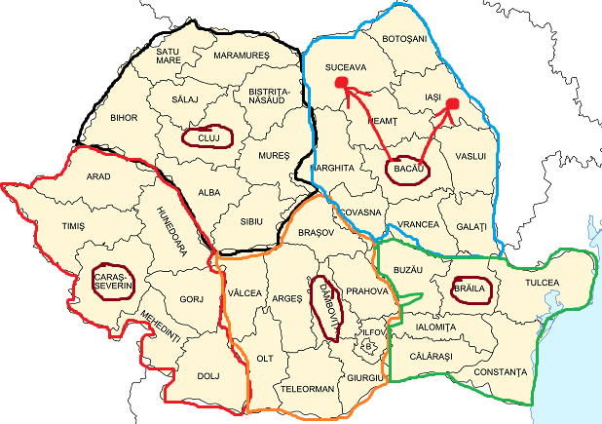
Fig. 4 intern distribute transport
Fig. 5 inter regional transport
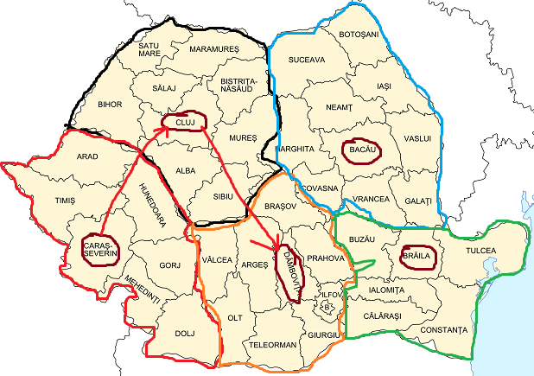
Because of this algorithm the commands need to be divide into 3 or 2 parts. If it is a regional command which means that the start and the destination city are in the same region it is split into 2 part: start city→center, center→ destination city (fig. 6). If it is an inter-regional transport which means that the start and the destination city are not in the same region, will be split into 3 parts: start city→ center1, center1→center2, center2→destination city(fig 7).
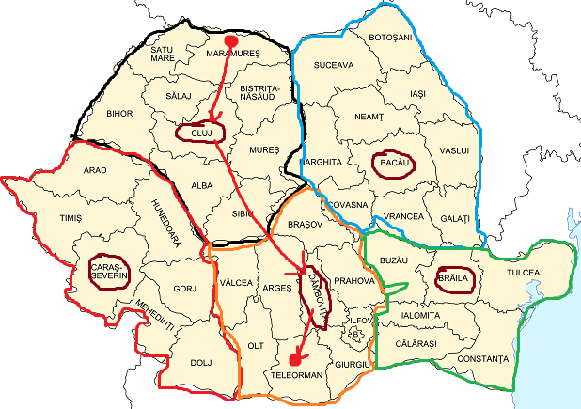
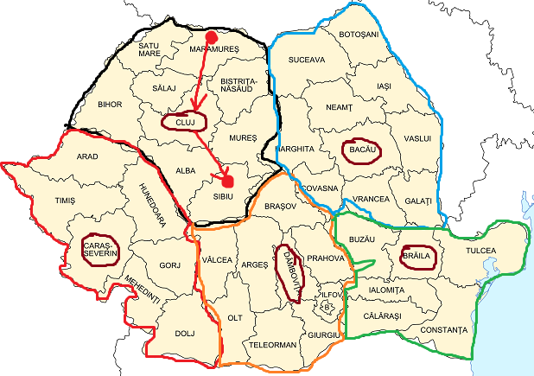
Fig 6. Regional transport

Fig 7. Inter-regional transport

This split is visible also in the database. The initial command will be updated with the start to center command, and one or two new commands will appear. These new commands has almost the same fields as the first one except that the start time will be changed with plus one or two days from the current date and also the price will be 0.
When the splitting is done the only problem which remains is how to fill the vans to get an almost optimal solution. This is a multiple knapsack problem, which means that the best solution is if we try all the possibilities and chose the best, however it is a really time consuming solution so in this project a greedy algorithm was used.
In each region the wares were ordered decreasingly by a weight. This weight was given by the product of the total weight and the number of pallets. As it comes in the order will be put into the van. If a van is full than starts the other van in the region. If there is no more available van than the command will stay there till one of the vans will be emptied. This is not the best solution but, it provides a better one than the trivial solution.
Summarizing the idea: first all the commands will be split into 2 or 3 parts, after that in each region there is two type of transport: collect and divide for each type an optimal filling method will be calculated. The vans will be filled and their statuses will be changed. The are 2 big vans which deals with the inter-regional transportation and they transport each inter-regional ware to the right destiny.
- Class diagram
At the first glance this project looks like a simple one, because it contains just a couple of tables in a database, and with some simple controller methods adding and deleting can be done. However it looks simple it is not so easy, there are a lot of classes, first of all the necessary classes to start a c# project are the main Program, Settings and Resources. Also, there are a lot of interface classes which are derived from the Form class( fig. 8). On the other hand there are the classes which deals with the adding and withdrawal of the data from the database(fig. 8). And there are classes which deal with the manipulation of all of these elements(fig. 9). It is really hard to put all the relations in the same class diagram, so it will be represented separately, for each part. The first part is the Program class and the classes which interacts with this(fig. 10). The other classes are the client user related classes(fig. 11) and finally the administrator classes(fig. 11).

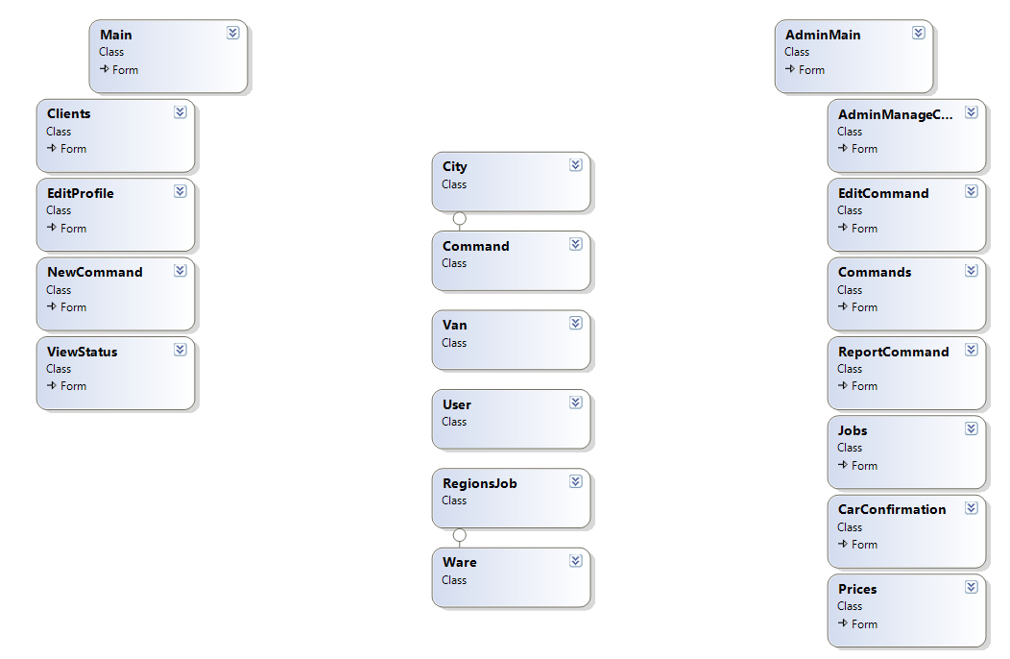
Fig. 8 classes for client and admin
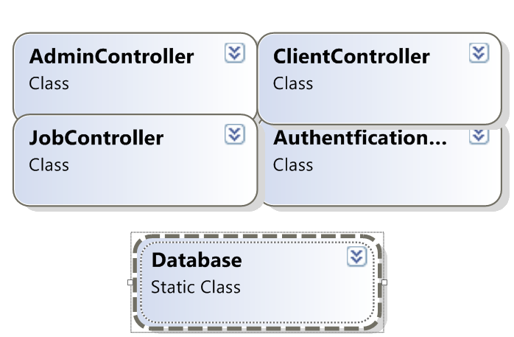
Fig. 9 Controllers

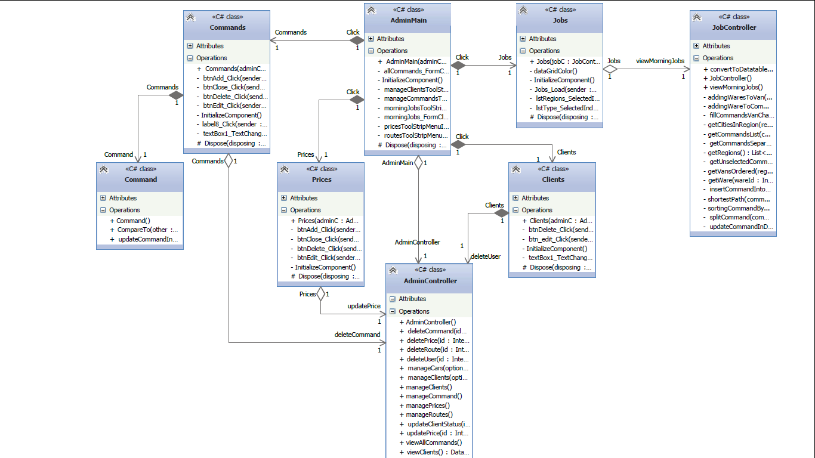
  - Class Diagrams detailed
Figure 9.1 class diagram Admin

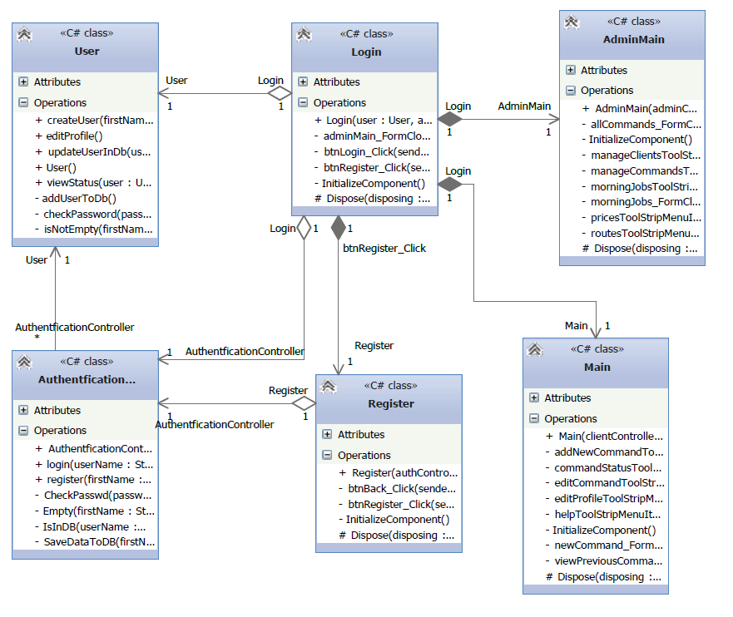
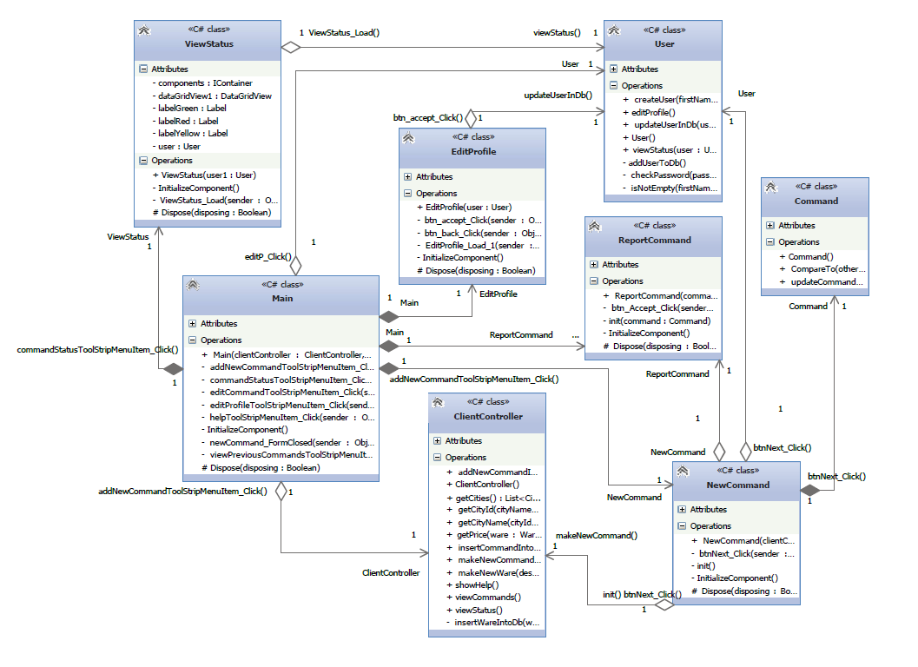
Figure 9.2 class diagram Client
Figure 9.3 class diagram Login

- Databases
Environment/ Software used to create and manage the Database: SQL Server Management Studio 2012. Based on Data Analysis (establishing the nature of data) and Functional Analysis (establishing the use of data), our Database, named 'ZDTSS_TRANSPORT' contains 8 tables:

*Cities
*Commands
*Prices
*Users
*Vans
*Wares

The image below shows the SQL Server database Diagram and the relationships between database tables, which are shown among them through bars/pipes by default.
However if it is required to also display the name of the relationship key among tables in a text form, then choose "Show Relationship Labels". It will display names of all present relationships among the tables. Relationships we used here come in the following three flavors:
*One-to-many: relationships represent connections between a single primary key value (the "one" side) and multiple instances of the same value in the foreign key field (the "many" side)
*One-to-one: relationships connect primary key values in two tables. By using these relational rules, we established the connections between our tables.
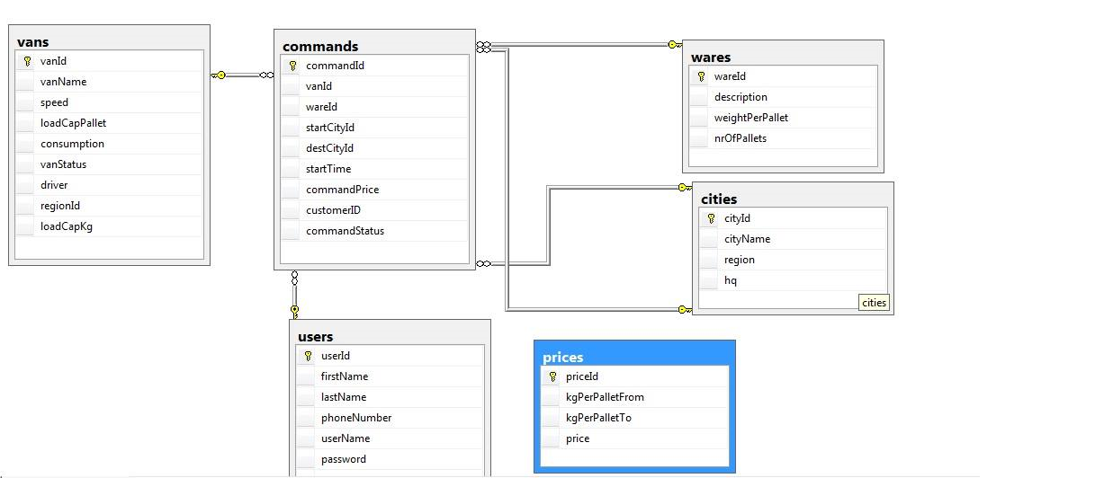
Fig. 12 Relations in the database
With the big rise of transporting the goods in our country, we want to make an easy use of this software. We want to provide an easily understandable platform also on the database point of view.
Concerning this, we created some tables ('Users' ) for the curious users who show interest in transporting the goods, and also for those who are too busy to go center. In order to do this, users must follow a training program and pass some requirements.
'Users' table contains fields filled with personal information about each user, and contact datas ('firstName', 'lastName', 'phoneNumber', 'userName', 'password', 'status') and an identification number 'userId', unique for each user, set as Primary Key(a special relational database table column (or combination of columns) designated to uniquely identify all table records; Without primary key and closely-related foreign key concepts, relational databases would not work.) These information correspond to the users which made an account, but didn't subscribed yet.
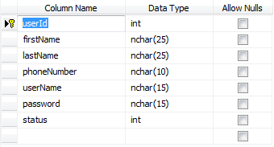
Fig. 13 Users table
'Commands' table contains the fields :'commandId', 'vanId', 'driverId', 'wareId', 'startCityId', 'destinationCityId' set as Foreign Key related to 'Van' table, 'Driver', 'Ware'. In the table Commands a <client/user> can command something to transport and <admin> can modify the commands and all the tables that invole it.
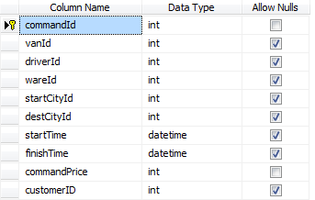
Figure 3. Command Table

'Wares' table contains the fields: 'wareId', 'description', 'weightPerPallet', 'nrOfPallets' . In this table we store information about each client and what he want to transport.
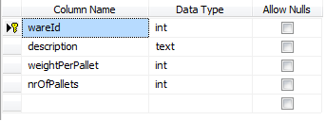
Figure 5.Wares Table

'Cities' table contains the fields: 'cityId', 'cityName', 'region', 'hq' . In this table we have information about cities . Four or five cities determine a region.We can not transport with one car from a region to another. We must compact the stuff in one van and transport after.

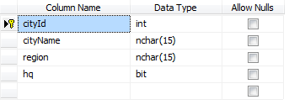
Figure 6. Cities Table

'Vans' table contains the fields: 'vanId', 'vanName', 'speed', 'loadCapKg', 'loadCapPallet', 'consumption', 'vanStatus'.In this table we have information about each van. Each user want’s to transport a different capacity of stuff. Because of this situation we have different type of vans with different capacacity.

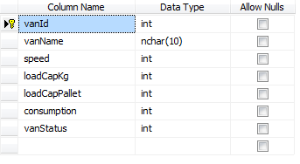
Figure 8. Vans Table

The last table in our project is 'Price' table which contains the fields: 'p_id', 'capacitykg', 'capacitypallet', 'price'. This table is an independent one in which we have general prices and only admin can modify that.
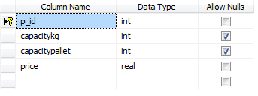
Figure 9. Price Table

IV. Further Development
From the point of view of further development there are a couple of idea, how to make more efficient from the optimization and user friendliness point of view.
To get a more optimized solution also the routes needs to take into consideration. By calculating the shortest path in each region can provide a more efficient solution, but this is a Travelling Sales Man problem which also a NP-complete (Non-deterministic Polynomial time) problem, which means that the best solution can be find by trying all the possibilities, which takes a lot of time when there are too much information. But in this case in each region are just a couple of cities which means that the time won’t be a problem.
To make a more user friendly solution, a color coding can be used underline certain character of a field. For clients to make a new command might be easier to click on a map rather to select it from a drop down list.
V. Conclusion
As a conclusion this project was really useful to develop object oriented programming skills and to see how can work in a group where everybody has his duty. Also it was useful to see how can does a project, how to work with use case- and class diagrams.
On the other hand, it can be summarized that it is not easy to work together in a group, and it is also hard to split the works equally, correct the errors, and to get finally a coherent solution.

