# **Q1:** Revenue streams are the various sources from which a business earns money from the sale of goods or the provision of services. The types of revenue that a business records on its accounts depend on the types of activities carried out by the business. Generally speaking, the revenue accounts of retail businesses are more diverse, as compared to businesses that provide services.

# **Q2:**

**Q3:** A business partnership is when companies (commercial entities) form an alliance, which is either exclusive or loose. Loose relationships mean that both parties can still partner with further entities, whilst exclusivity limits to either company to that that one relationship.

Most partnership relationships are for the simple reason that most businesses want to have a spread of other businesses to reduce risk and provide opportunities for growth.

When considering a partnership there are several factors that need to be considered.

1. Link to Value Proposition.
2. Selection criteria.
3. Partnership agreements.
4. Defining terms and service levels.
5. Development of a win-win relationship.

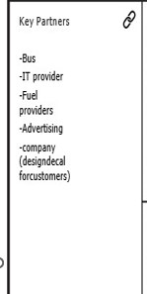a