Lpush cust:0206186 jd

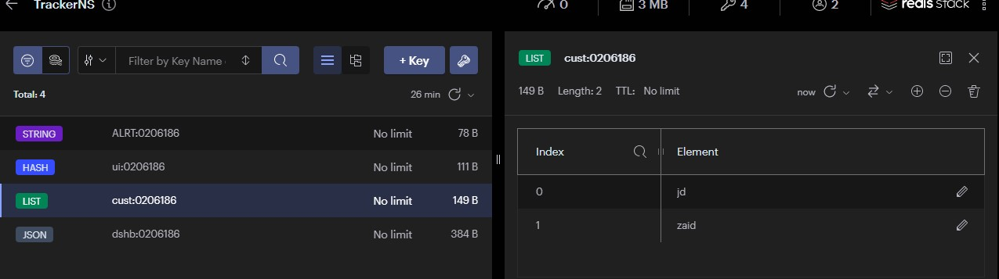

Lpush cust:0206186 zaid

SET alrt:0206186 zyd0206186@ju.edu.jo

HSET ui:0206186 font-type Arial font-size 13 color red

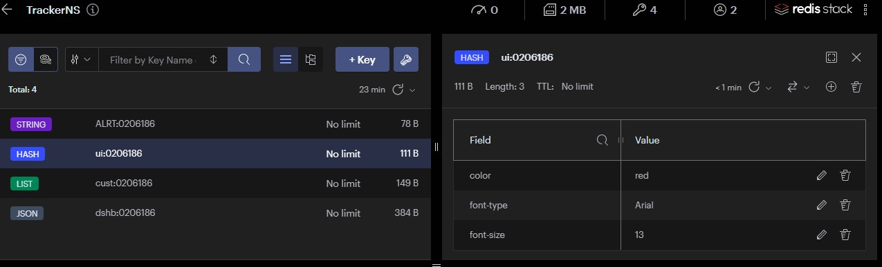

JSON.set dshb:0206186 $ ‘{“shpComp”: “My company”, “shpWght”:“20kg”,”shpCountry”:”Jordan”,”shpCity”:”Amman”,”shpDelivDate”:”20/6”,”shpCnt”:”5”}’