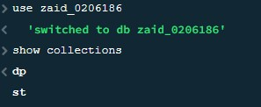

**Find all students in st collection .**

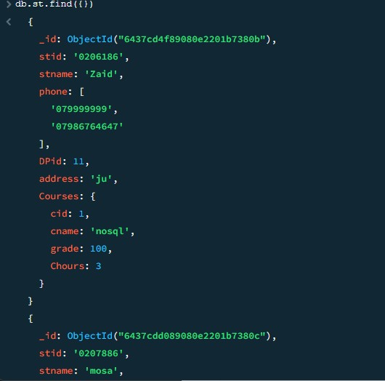

**Find all students in department 11.**

**Del all students in department 11**

