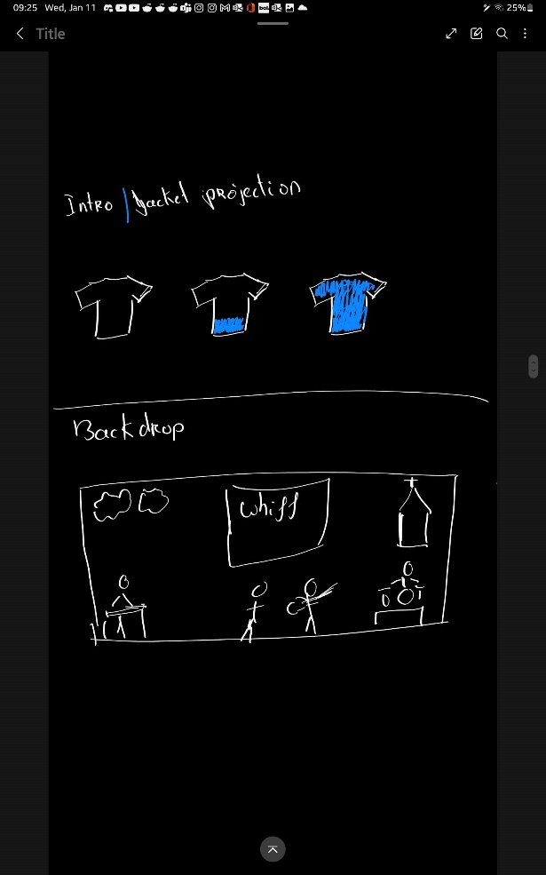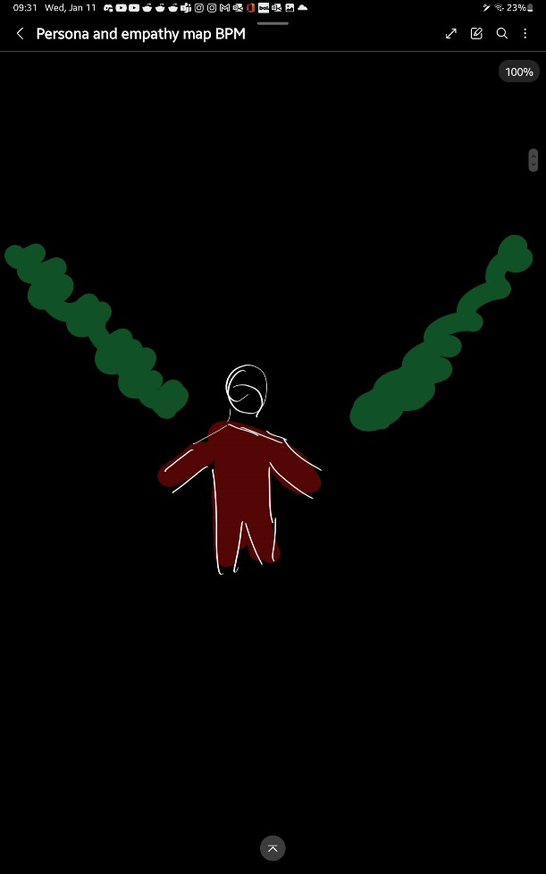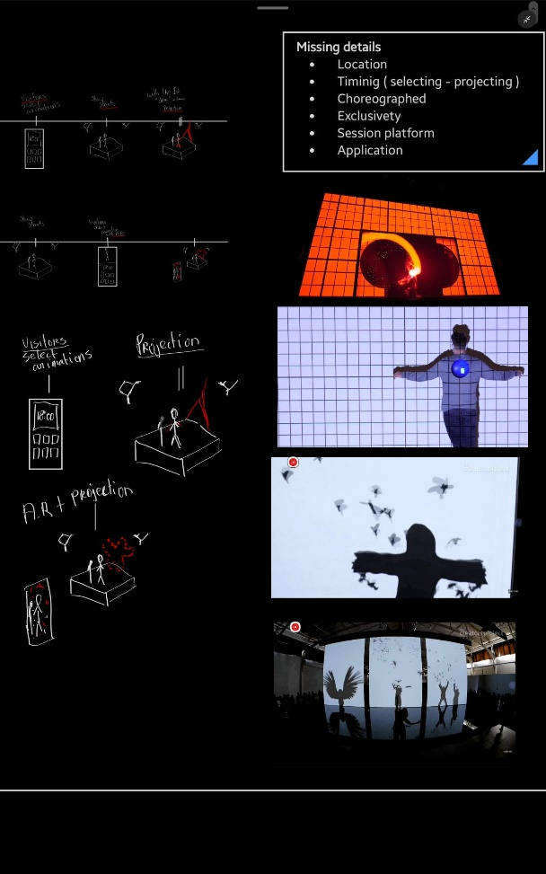  
These are the sketches for the different types of interactions for the body projection mapping

The image on the left is a sketch for the body projections for Whiff and the Wet Socks.  
They wanted a projection on top of a specific jacket and the projections would change the color of the jacket.   
At the bottom of the image you can see where the back drop projections would take place on the stage.

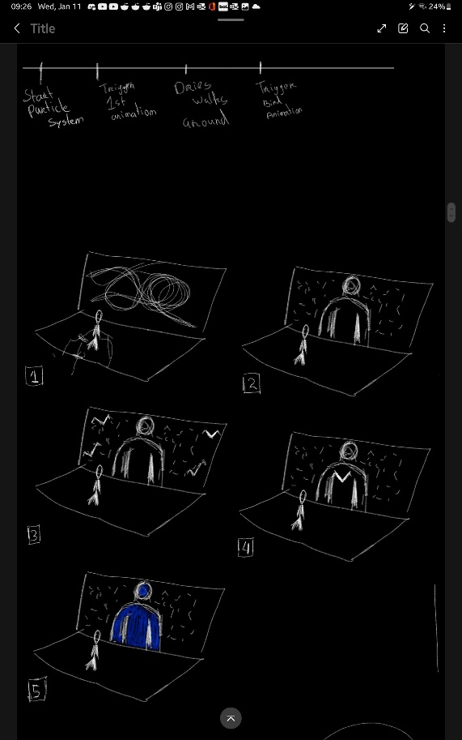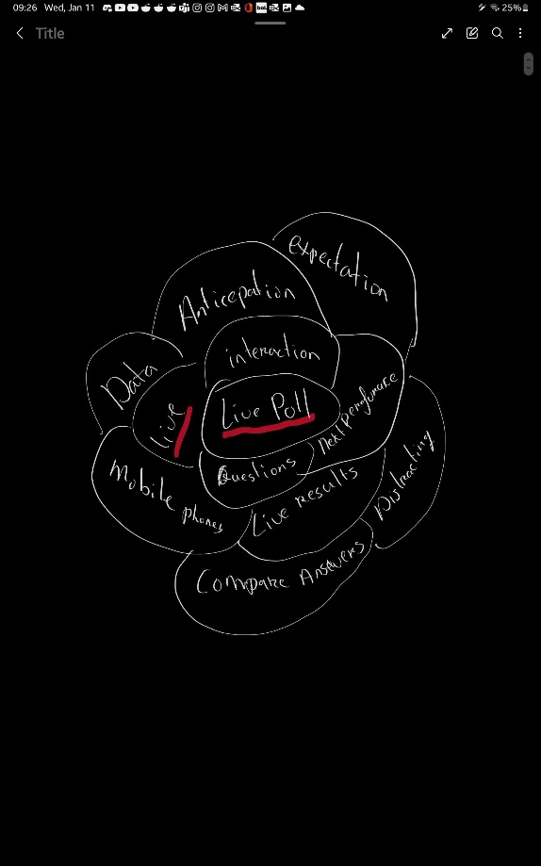In order for me to come up with new interactions for the body projection mapping, I created a flower brainstorm. You can see here that I started with the Live Poll and wrote down all of the capabilities and limitations that come with it.

This is the timeline for the projections for Whiff and the Wet Socks. The top of the image is the timeline and the bottom is a storyboard that corolates with the timeline.