<ah yes I very much have a game name, trust me> Feature Design Document Inventory

Student Name: Zebedee Chalcroft Dilworth

# Executive Summary/Elevator Pitch

I’ll be adding a point style inventory to my game. The point of the inventory system will be to carry around Health packs for the player to use in the game.

# Gameplay

When the player finds a health pack u will pick it up and it will go into point style inventory. when u pick health kits up, the score in the corner of the screen will go up and vice versa when using a health kit. You will gain 25 health.

# Mechanics

I started with making a number global variable called HealthKit starting at 0. Once the player is over the HealthKit, they press E and the HealthKit will delete itself while changing the global variable to add 1 to the point style inventory. When the player presses and release q, the game will check to see if the HealthKit global variable is equal or greater than 1, if so the player will gain 25 health and the HealthKit number will go down by 1.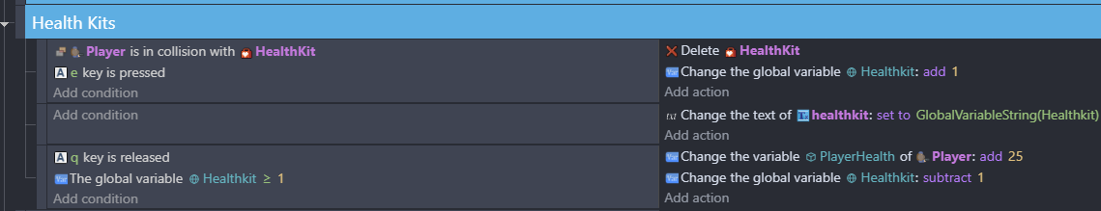

# Assets

|  |  |  |
| --- | --- | --- |
| Asset Name | Short Description | Source |
| HealthKit | When the player is on top of the healthkit, they can pick it up | <add link to file or a screenshot if you created the asset yourself> |
| Healthkit | When they collect the HealthKit, it will change the globe variable by 1, in the top left corner | … |
| PlayerHealth | When they use the HealthKit, the player will get 25 health points | … |