INITIAL CONCEPTUAL DESIGN OF A SPACEPLANE

Team A
Christopher Cabrera
Luis Mendoza
Gabe Silva
Laura Gilford

TABLE OF CONTENTS

Abstract . . . . 3
Introduction . . . . 4
List of symbols . . . . 8
PART I
Initial Sizing . . . . 12
PART II
Wing Design and Aerodynamics . . . 20
PART III
Propellant and Motor Design . . . 31
Drawing of Grain and Motor Layout . . 44
PART IV
Ballistics . . . . 52
PART V
Final Drawings . . . . 56
Summary . . . . 58
References . . . . 61
Appendix . . . . 62

ABSTRACT
In this analysis of a spaceplane’s preliminary design, we confine the varying elements of a rocket plane into the needs of our specific mission. Our mission must ultimately meet the attainable requirements of the Anasari X Prize for a spacecraft that is not constructed, and hence our preliminary design is molded to fit the requirements of a piloted spaceplane that must reach the Karman line and carry two passengers. Our report details the design of a spaceplane that combines the characteristics of SpaceShipOne, the winner of the Anasari X Prize, and the Skylon Spaceplane, an orbital spaceplane built by Reaction Engines Limited. During the first stage of design, we create our preliminary conceptual drawings, perform initial sizing calculations, determine the advantages and disadvantages of our chosen design, and calculate the characteristics of our chosen propellant. During the second stage of our preliminary design of a spaceplane, we refine the design of our wing and propellant. We calculated the dimensional characteristics of our wing and estimated the lift and drag of the wing. The lift and drag were primarily calculated using empirical graphs for the particular dimensions of our wing. We refined the details of our propellant grain and designed our nozzle. We predicted the burn time and chamber pressure evolution, and performed a ballistics analysis that allowed us to estimate thrust evolution. We completed more refined drawings of the spacecraft and its interior layout. During the third and final stage of the preliminary design, the solid rocket motor components were designed and inboard profile drawings were finalized. The solid rocket motor was designed and sized in terms of the motor case, igniter, motor case insulation, thrust skirt, polar boss and nozzle. The final inboard profile drawing consists of the finalized spacecraft including rocket motor, fuel tanks, and payload.

INTRODUCTION
In this design concept, we will attempt to combine elements of SpaceShipOne and the Skylon Spaceplane to accomplish the mission requirements of a modified set of Anasari X Prize Rules. Here we identify our mission requirements and the characteristics of these two rocket planes. Table 1 summarizes the dimensions and characteristics of the two spaceplanes in study.
MISSION REQUIREMENTS
The design of our spaceplane must meet an adjusted set of Anasari X Prize Rules (for the task of designing a spaceplane, but not for manufacturing and flight testing), as follows.
The spacecraft must:
- Reach a suborbital altitude of 100 kilometers
- Carry three people (or one pilot plus the weight of two passengers)
- Return safely to earth
- Be launched from an airplane (we assume we have the use of the White Knight, SpaceShipOne’s mothership)
- Use a solid propellant rocket
SPACESHIPONE
SpaceShipOne is a small suborbital spaceplane built by Burt Rutan and Scaled Composites that won the Anasari X Prize at the Mojave Air and Spaceport in 2004, becoming the first privately funded manned spacecraft. SpaceShipOne is a rocket plane that was dropped from a mothership plane called White Knight at an altitude of 50,000 feet. Thereafter the rocket plane boosts itself up supersonically to the Karman line at 100 kilometers and coasts to its apogee. After spending four minutes in space, SpaceShipOne freefalls from its apogee and then uses a tail feathering mechanism in which its wings are deployed to maximize drag and minimize heating to re-enter the atmosphere (also supersonically). Finally, the spacecraft acts as a glider plane at beginning at 80,000 feet, lingers via circular flight path loops to lower its speed and then lands horizontally on a runway. The horizontal displacement between takeoff and landing are 35 nautical miles. SpaceShipOne was built similarly to a kit-plane, in which aircraft components of common materials were screwed together.
THE SKYLON SPACEPLANE
The Skylon Spaceplane is a giant orbital spaceplane designed by Reaction Engines Limited in the United Kingdom. This spaceplane is reusable for a few hundred space flights, unlike SpaceShipOne, which flew into space only three times. The Skylon is an air-breathing spaceplane with dual Sabre engines. The Skylon Spaceplane reaches orbit without a mothership plane like SpaceShipOne and is meant to be un-piloted, but can carry passengers. The Skylon lands and takes off like a horizontal plane and uses a specialized hot aeroshell skin to accommodate re-entry conditions. The Skylon spaceplane is unlike SpaceShipOne aerodynamically because the Skylon (which never reaches v = 0 in flight) will be slowed down by its reentry into earth’s atmosphere, whereas SpaceShipOne reaches its apogee and hovers at zero velocity and on its downfall back to earth reaches huge speed which requires a structural design to slow it down. The Skylon can potentially take over 10 tons of cargo to the International Space Station. The Skylon Spaceplane is made of carbon fiber, foil thermal insulation, and a ceramic skin. The Skylon Spaceplane has not yet been built, but flight tests are planned for 2019. See Appendix A for a diagram of the Skylon.

Table 1: Comparison of SpaceShipOne and Skylon
 | SpaceShipOne | The Skylon Spaceplane
Length | 8.5 meters | 83.0 meters
Wing span | 5.0 meters | 25 meters
Height | 2.7 meters | 6.25 meters
Gross Weight | 3,600 kilograms | 275,000 kilograms
Rocket type | Hybrid | Dual air-breathing hybrid
Speed | Mach 3.09 | Mach 5.5
Re-entry method | Tail feathering | Hot aeroshell

WING, PROPELLANT, AND LAYOUT
In the aerodynamic part of our analysis, we prepared detailed sizing and wing geometry in order to make calculations on the lift and drag of our wing. In our uncambered wing, the minimum drag is when the lift is zero. The lift curve slope is nearly constant for typical swept wings. The lift curve slope times the angle of attack yields the lift coefficient for below the stall angle of the aircraft (Raymer 309). The extraction of the lift curve slope is found by using empirical graphs. The supersonic parasite drag coefficient, which results from zero lift drag that includes separation pressure drag and skin friction drag, is a component of the total drag coefficient that allows calculation of the drag force. The drag divergence Mach number is the Mach number where drag increases greatly as Mach number continues to rise.
Expanding on the analysis did in Task 1, the grain design and ballistics analysis sections of this report prove that the grain design and propellant mass are sufficient to propel the spacecraft to an altitude of 100 km. After choosing a grain design that produces a neutral burn, instead of progressive as in Task 1, the Steady State Lumped Parameter method was used to compute the chamber pressure, burn rate, and total burn time of the rocket motor. The propellant fuel and oxidizer mixture was kept the same as in the previous task. With the chamber pressure evolution known, it was then possible to use the Thermodynamic equations for 1-D steady isentropic flow to solve for the exit Mach number and ultimately exit pressure. Using these values it was then possible to calculate the thrust using the rocket thrust equation. An estimate of the thrust history of the motor versus time could then be established and plotted.
The integration of major structural components is shown on the spacecraft layout drawing on page 32. The center console is where all necessary flight controls and avionics will be located. Instead of making multiple consoles for controls, one slightly larger console was implemented. This was chosen with the purpose of decreasing structural complexities as well as decreasing the workload of the pilot during all flight phases. The single seat in the middle of the aircraft has sufficient room for up to 3 people, a pilot, co-pilot and a passenger. The spacecraft also has a large cargo bay in the back with resulting from a significant reduction in size of the booster. The cargo bay has sufficient space for any necessary cargo needed on the flight. Said cargo bay can also be replaced with additional seats to take more passengers as long as weight limit is not exceeded.

LIST OF SYMBOLS
$I_{sp}$ = specific impulse [s]
$m_{0}$= gross weight or total weight [kg]
$m_{p}$= propellant weight [kg]
$m_{s}$= structural weight [kg]
$m_{b}$= mass at burnout [kg]

$m_{L}$= payload weight [kg]
z = m_0/m_s + m_L [unitless]
$u_{e}$= exhaust velocity [m/s]
g = gravitational acceleration = 9.8 [m/s^2]
Δv = characteristic velocity of the maneuver = 1700 [m/s]
ε = structural coefficient = m_s /(m_s + m_p) = 0.4 [unitless]
λ = payload ratio [unitless]
T = thrust [kg]
ρ = density [g/cm^3]
b = burn rate of propellant [kg/s]
M = Mach number
λ = taper
$Ʌ_{LE}$ = sweep of the wing’s leading edge
AR = aspect ratio
b = wingspan [m]
$M_{DD}$ = Mach divergence drag number
u = upsweep angle
$C_{L, α}$= lift curve slope
$c_{MAC}$ = mean aerodynamic chord [m]
${\left(C_{D_{0}}\right)}_{subsonic}$= subsonic drag coefficient
$C_{fc}$ = flat-plate skin-friction drag coefficient
$R$ = Reynold’s number
${FF}_{w}$ = wing “form factor”
${FF}_{f}$ = fuselage “form factor”
${\left(x/c\right)}_{m}$ = chordwise location of the airfoil maximum thickness point
$\left(\frac{t}{c}\right)$ = mean thickness ratio
$Λ_{m}$ =sweep of the maximum-thickness line
$l$ = characteristic length
$A_{max}$ = maximum cross-sectional area of the fuselage [$m^{2}$]
Q = interference factor
$S_{{wet}_{c}}$ = planform area wetted [$m^{2}$]
$S_{ref}$ = planform area [$m^{2}$]
$C_{D_{misc }}$ = miscellaneous drag
$C_{D_{L\&P}}$ = leakage and protuberance drag
${\left(C_{D_{0}}\right)}_{supersonic}$ = supersonic drag coefficient
$C_{D_{wave}}$ = wave drag coefficient
$E_{WD}$ = empirical wave-drag efficiency factor
a = Progression rate coefficient
A_{b} = Instantaneous burn area [$m^{2}$]
A_{e} = Nozzle Exit Area [$m^{2}$]
A_{t} = Nozzle throat Area [$m^{2}$]
A_{w} =Surface area of motor case exposed to gases [$m^{2}$]
c*= Characteristic Velocity $\left[\frac{m}{s}\right]$
D = Motor Casing Diameter $\left[m\right]$
F = Force (Thrust) $\left[N\right]$
g₀ = Gravity on Earth’s surface $\left[9.81 \frac{m}{s^{2}}\right]$
I_{spv} = Vacuum Theoretical Specific Impulse $\left[s\right]$
L = Length of rocket motor case $\left[m\right]$
L_{sub} = submerged length parameter
M_{e} = Mach number at nozzle exit
m_{insul} = Mass of insulation $\left[kg\right]$
$\dot{m_{out}}$ = Mass flow rate out of control volume$\left[\frac{kg}{s}\right]$
n = Propellant regression parameter
p = Static pressure at point with known Mach number $\left[Pa\right]$
p_{amb} = ambient air pressure at certain altitude $\left[Pa\right]$
P_{c} = Chamber Pressure $\left[Pa\right]$
p_{e} = nozzle exit pressure $\left[Pa\right]$
p_{o} = Stagnation pressure $\left[Pa\right]$
r_{b} = Instantaneous burn rate $\left[\frac{cm}{s}\right]$
R_{i} = Propellant inner radius $\left[m\right]$
R_{o} = Propellant outer radius $\left[m\right]$
s = Speed of sound (dependent on temperature) $\left[\frac{m}{s}\right]$
t_{b} = Propellant burn time $\left[s\right]$
V_{e} = Velocity at nozzle exit $\left[\frac{m}{s}\right]$
V_{p} = Volume of propellant $\left[m^{3}\right]$
X = Nozzle submerged length $\left[m\right]$
γ = Ratio of specific heats
ε = Nozzle Expansion Ratio
ρ_{i} = Insulation density $\left[\frac{kg}{m^{3}}\right]$
ρ_{p} = Propellant density $\left[\frac{kg}{m^{3}}\right]$

PART I
INITIAL SIZING
The initial sizing of our aircraft primarily includes determining the dimensions, takeoff weight, and fuel weight in order for our spacecraft to succeed in performing its mission (Raymer 111). Since our concept is similar to SpaceShipOne, our initial sizing and weights are aimed to be similar to SpaceShipOne, but with modifications to account for the characteristics of the Skylon Spaceplane used in our design. Our design uses the materials, wings, and canards of the Skylon at a slightly elongated dimensional scale of SpaceShipOne where we will use a height of 2 meters and a length of 10 meters. We will not stray far from the dimensions and mass of SpaceShipOne because we want to minimize the weight and structure of our design and SpaceShipOne is the smallest successful suborbital rocket craft. Table 2 at the end of this section summarizes our initial sizing calculations.
SpaceShipOne is made mostly of epoxy (plastics) and the Skylon is made of carbon fiber and ceramic matrix composite (CMC). The graphite epoxy of SpaceShipOne has a density of 1.3g/cm^3 and CMC has a density of 2.1g/cm^3, so we estimate that our design will be heavier due to the heavier materials. Approximating the shape of the spaceship as a cylinder, the area of our more slender design is near in surface area to the surface area of SpaceShipOne, thus we must account for added mass for the change in materials. Our total gross weight equals the sum of all the structure, propellant, and payload (Raymer 12):
$m_{0}=m_{s}+ m_{p}+ m_{L }$[1]
The mass of our payload, $m_{L },$(including the passengers and any necessary equipment) will remain the same as SpaceShipOne (570 kilograms), but our propellant mass will probably increase from SpaceShipOne’s weight due to the use of the heavier solid propellant. We estimate that our design will be heavier than SpaceShipOne and we will maintain a structural similarity to SpaceShipOne. To determine if this rocket design is possible, we must ultimately have z (ratio of total mass to mass at burnout) > 1 and ε (structural coefficient) < 1 and λ (payload ratio) > 0 (Crispin 11) , where λ, z, and ε are
$$λ=\frac{m_{L}}{m_{s}+ m_{p}} z=\frac{m_{0}}{m_{s}+ m_{L}}=e^{\frac{Δv}{u_{e}}} ε=\frac{m_{s}}{(m_{s} + m_{p})} [2]$$
To calculate a possible mass for our design, we begin with the mission requirements of a characteristic velocity of SpaceShipOne, Δv , of 1700 m/s and a specific impulse of 270 seconds (as determined by our propellant type), and a structural coefficient of 0.4, which means we will match the structural coefficient of SpaceShipOne. Thus our exhaust velocity, $u_{e}$, will be approximately 2700 m/s, which is calculated as follows (Crispin 5):
$$u_{e}= I_{sp} g = 2714\frac{m}{s} [3]$$
We can now use the exponential z relation in Equation 2 and our calculated $u_{e}$ to find λ as follows:
$$λ=\frac{1- εz }{z-1} [4]$$
Since our ε = 0.4, our z = 1.9, and our λ = 0.267, we know that our rocket plane design is feasible because these values meet the inequality criteria of z > 1 and ε < 1 and λ > 0 (Crispin 11). To solve for our mass, we solve for the combined mass of our propellant and structure by rearranging the $λ$ relation in Equation 2 as follows:
$$\frac{m_{L}}{λ}=m_{s}+ m_{p}=2135 kg [5]$$
Our structural weight, $m_{s}$, can now be solved for by using our $ε$relation in Equation 2. This yields a structural weight of 854 kilograms. Using Equation 5 again, we can solve for our propellant mass by inserting our calculated structural mass, which yields a propellant mass of 1281 kilograms. Adding our propellant, payload, and structural mass together, we get a total weight of 2705 kilograms. We find that our design will be lighter than SpaceShipOne, which has a gross mass of 3600 kilograms.
Specific impulse (I_{sp}), or the ratio of the rocket’s impulse (FΔt) to its burned propellant weight, will help us determine the aerodynamics of our spaceship and its trajectory. Since we are using a solid rocket, instead of a hybrid rocket like SpaceShipOne, we know that the specific impulse of our rocket craft will be higher than that of SpaceShipOne. Since SpaceShipOne used a solid and liquid (hybrid) rocket, we analyze the characteristics of the solid component of their propellant to estimate our specific impulse. SpaceShipOne used tire rubber, hydroxyl-terminated polybutadiene (HTPB), as the solid component of their rocket (Linehan 76). The specific impulse of this solid fuel is near 270 seconds (Humble 714). With our estimate of our I_{sp}, we can determine the complexity of our trajectory. One important part of determining our trajectory is to determine how many stages our rocket plane will need to reach the desired altitude. A single-stage rocket simply needs to expend propellant to reach the desired altitude, whereas a multi-stage rocket requires the expenditure of hardware. SpaceShipOne and Skylon are single-stage rocket planes and hence the ideal concept for this task will be as well, but to
ensure that we have a single-stage design, we must have this inequality hold (Crispin 11):
$$I_{sp}>\frac{Δv}{\ln{(1/ε)}} [6]$$
where Δv is the characteristic velocity, or the velocity change of the rocket plane during its maneuver (assuming the use of SpaceShipOne’s Δv = 1700 m/s) and ε is the structural coefficient (a ratio of the structural and propellant masses, where we have chose to use the same masses as SpaceShipOne). This equation yields a specific impulse of 189 seconds, making an I_{sp} of 270 seconds feasible for a single-stage rocket maneuver.
The propellant for our design must burn for 80 seconds (like SpaceShipOne) and with a propellant mass of 1281 kilograms, this yields a burn rate b of 16.01 kg/s:
$b=\frac{m_{p}}{t_{b}} [7]$
$$b=\frac{1281 kg}{80 s}$$
$$b=16.01\frac{kg}{s}$$
With this information, we can estimate the thrust of our rocket plane by taking the burn rate times the exhaust velocity. Exhaust velocity can be found by
$u_{e}= I_{sp} g = 2714\frac{m}{s} [8]$
(Crispin 5). Then our thrust is
$T = b u_{e} = 43,424 N = 4428 kg [9]$
The majority of launch vehicles have a thrust to weight ratio of 1.5 (Humble 18). Our thrust to weight ratio is 1.6, which matches the 1.6 thrust to weight ratio of SpaceShipOne. Our lift and drag calculations will depend on our wing design which will be detailed in our later analysis.

Table 2: Summary of Sizing Configurations
Feature | Dimension/Size
Length | 10 meters
Height | 2 meters
Structural weight | 854 kilograms
Propellant weight | 1281 kilograms
Total weight | 2705 kilograms
Thrust to weight ratio | 1.6

CONFIGURATION ADVANTAGES AND DISADVANTAGES
The advantages of our chosen design include its small, lightweight design like SpaceShipOne and its air-braking system. One large disadvantage is the use of the solid propellant, which will make our rocket plane difficult to control and maneuver, which is a crucial part of the success of this piloted mission and hence will require a more skilled pilot. There are also some advantages and disadvantages to our configuration of delta wings and canards (Raymer 69). Overall, the configuration of these aerodynamic limbs will help add controllability to the plane.
One advantage of our chosen configuration is the use of the hot aeroshell and thermal insulation foils of the Skylon Spaceplane which will protect the ship from any reentry heating. While the heating of SpaceShipOne will not be as great as the heating of the Skylon Spaceplane, overheating of our design is still a factor to consider. This configuration ensures a high likelihood of a safe re-entry maneuver and will help ensure the safe return of our craft and our passengers, which is one of the most important tasks of our mission. The technology of the Skylon Spaceplane is expensive, but since cost is not a factor for this design task, we chose the advanced aerospace materials of the Skylon. This configuration choice should be seen as especially advantageous in the wake of the catastrophe of SpaceShipTwo. SpaceShipTwo had an emergency failure, resulting in the loss of the spacecraft and the loss a pilot in October 2014, reportedly due to a misuse of the tail-feathering mechanism used for re-entry. Our design will not rely on this flawed mechanism, which is a great advantage of our design.
Canards
Canards with forward placement before the wing have many benefits on the spacecraft. These canards increase the controllability of the spacecraft due to their placement in front of the main wing in undistributed air versus a horizontal tail stabilizer so the spacecraft reacts faster to maneuvers. The forward canards also act as a lift surface that contributes to the overall lift of the spacecraft. This means the dimensions of the spacecraft, such as wingspan and weight, can be decreased with this increase in lift. Another benefit of the canards is stall prevention for the spacecraft. The forward canards will stall causing the nose of the spacecraft to pitch downwards because of its placement forward of the center of gravity. This would happen prior to the wing stalling and therefore prevent the stall of the wing. The only noticeable disadvantage of the canards is the downwash and trailing vortices that limit the effective angle of attack and therefore attainable lift. Thus, canards are a good choice for a solid rocket (which is hard to maneuver) because of their added controllability.
Delta Wings
For most aircraft, delta wings are not practical. However, they have been used for the space shuttle and fighter jets. They perform best at supersonic speeds and shock waves form after the lead edge of the wing. For a delta wing, the coefficient of lift increases gradually with respect to the Mach number. The stall angle is higher due to the wing vortex produced by the wing that stayed attached to the upper surface of the wing. The disadvantage of delta wings is the lack of control. When they are combined with the canards, this control issue is counteracted. Therefore, for our purpose of a spacecraft, delta wings match our criteria.
Drag Inducing Devices
After close revaluation of our spaceships design, an airbrake/speed brake system placed around the rear of the fuselage as well as dive brakes on the airfoils and the tail and if necessary even a drogue parachute. These were determined to be the best and safest options for increasing drag upon re-entry and maintaining the ship at a safe and stable speed when approaching the runway. These devices will replace the drag-inducing tail-feathering mechanism of SpaceShipOne.
SOLID AND LIQUID ROCKET MOTORS
There are three main forms of rocket engine: solid, liquid, and hybrid rockets, each of which consist of an oxidizer and a fuel. The difference between these three lies in the state of matter of the fuel and oxidizer. The solid rocket motor and propellant has a solid oxidizer and a solid fuel, unlike the hybrid and liquid, which have liquid components. While solid rocket motors are simple, low-cost, and can be densely packed, they are hard to build, maintain, maneuver, and have relatively low performance compared to liquid rocket motors. Liquid motors have the greatest performance and controllability. Solid rocket motors yield a very high thrust level and hence are why they are an excellent choice for a single stage rocket launch vehicle.
Solid Rocket Motors and Propellants
A solid rocket engine consists primarily of an oxidizer and fuel combination, a combustion chamber, and a nozzle. In the solid rocket propellant used for our design concept, both the oxidizer and the fuel are solid materials. For a solid rocket propulsion system, the propellant grain for a solid rocket engine consists of a “granular fuel and oxidizer in a ‘rubber’ matrix binder.” The port or “bore” of the solid rocket is the shape of the propellant grain that affects the burn rate of the rocket. The igniter is used to produce the energy need to begin the combustion process. An internal insulation is used to protect the motor case from the temperatures of the combustion process and dissipate the heat. All of this is housed in the motor case, where the combustion pressure is contained. It is usually made of titanium, high-strength steels or wound fiber. The motor case is attach to the rocket structure with a thrust skirt. The polar boss connects the nozzle to the motor case.
There are multiple advantages and disadvantages to the solid rocket propellants and motors. The advantages of the solid rocket motors include high compactness, low volume, long storage life, instant ignition, and high reliability. The primary disadvantages include high mass, low performance, low maneuverability once ignited, and have to be filled at the factory where they are manufactured, making them difficult to transport. Also, solid rockets can have catastrophic results in the case of a system failure.
Liquid Rocket Motors and Propellants
Liquid rocket prolusion systems consist of a pressurant tank, oxidizer and fuel tanks, pumps, and trust chamber. The advantages of liquid rocket propellants are that they produce the highest specific impulse and are easy to maneuver (the potential for on and off, the ability to restart, and the ability to control throttle). There are a number of disadvantages in using liquid propulsion. Liquid fuels have a lower density, therefore a larger volume of liquid propellant is needed versus solid propellant. The propulsion systems of liquid propellants are more complex than solid rocket propellants due to the gages, regulators, and valves that are needed to monitor the liquids. Liquid propellants are more hazardous (toxic/corrosive) than solid propellant and need to be stored at specific conditions.
PART II
WING DESIGN AND AERODYNAMICS
The wing of our rocketplane is a complex cropped delta wing, which is a nearly triangular wing with the tips of the wing cut off or cropped and slight trailing edge sweep. The sweep of our delta wing is 45 degrees on the leading edge$, Ʌ_{LE}=45$degrees, and our trailing edge sweep is 11 degrees. The taper, λ, or the ratio of the wing tip to the wing root is 0.25 (where the tip chord is 1 meter and the root chord is 4 meters). The wing is placed midway on the fuselage of the ship due to the placement of the frontal canards. The area of the cropped delta can be approximated by manipulating the wing surface into simpler triangles. Thus we can add the cropped triangle to the right triangle using $A=\frac{1}{2}bh$, which yields a wing area of 6.25 m^2 per wing. We must also add the area of the canards to our total lift area, which act like smaller wings that also add to our total lift. The canards, which are swept back in a manner that mirrors the cropped delta, have an area that is also estimated in a similar manner to the wings, yielding an area of 0.75 m^2 per canard.
The wing loading of our spacecraft is the ratio of the gross weight of our design to the area of the wing. Since our final calculated gross mass is 3308 kilograms, and the area of both of our wings is 12.5 m^2, our wing loading is
$$\frac{W}{S}= \frac{3308*g }{14 m^{2}} =\frac{1}{2}ρ{V_{s}}^{2}C_{L, max}=2315$$
Where S is the area of the wing and can be calculated by geometry or the following relation (with $c_{r}$ is the root chord and b is the wingspan):
S = $\frac{b}{2} c_{r}(1+λ)$

This loading is equal to the above relation relating the air density (using sea level at 1.23kg/m^3), the stall speed, $V_{s}$, and the maximum lift coefficient, $C_{L, max}$. The maximum lift coefficient can be calculated as follows (Raymer 316):
$C_{L, max}=0.9C_{L, max,airfoil}*cosɅ_{c/4}$ = 0.896
Where $C_{L, max,airfoil}$ for a similar airfoil as ours is about 1.3 and our quarter chord sweep is 40 degrees. From our wing loading, we can estimate our stall speed (64.8 m/s) and consequently our landing speed with the following relation:
$${{V_{landing}=1.15V}_{s}= 74.5 m/s}^{}$$
This is a reasonable approach speed and will ensure that our spacecraft lands safely and our
mission requirement of returning our pilot and our passengers safely to earth is ensured.
Since aspect ratio is defined as a ratio of the wingspan b (the wingspan of our wings is 6.5 meters where our fuselage is 1.5 meter thick in diameter) to the area of the wings (12.5 m^2 total):
$$A=\frac{b^{2}}{S}=3.4$$

The aspect ratio of our canards is (where the fuselage is thinner at 1 meter and the span of each canard is 1.2 meters):
$$A_{canards}=\frac{b^{2}}{S}=6.0$$

The MAC (mean aerodynamic chord) is calculated as follows, where C is the root chord (Raymer 53):
$$c_{MAC}=\frac{2}{3}C\frac{1+λ+λ^2 }{1+ λ}= 2.8$$

AIRFOIL
In this section, we will check our drag divergence Mach number and our sweep angle. The drag divergence Mach number is the Mach number where drag increases greatly as Mach number continues to rise. The steep increase in drag is created by the formation of a shock wave on the top of the airfoil. The sweep angle is 45 degrees and our airfoil has an airfoil thickness of 0.04, which is 4 percent of the chord length. It is a straight, symmetric wing with no camber, making it a NACA 0004 type wing.
We need to ensure that our spaceplane can endure the supersonic speeds of SpaceShipOne (SpaceShipOne reaches a max speed of Mach 3.09). For a supersonic wing we must have the following relation (Raymer 312) where M = 3.09 has been used:
$$C_{L, α}=\frac{4}{\sqrt{M^{2}-1}}=\frac{4}{β} =1.37$$
M must be greater than the leading edge sweep,$Ʌ_{LE},$which is 45 degrees:
$$M>\frac{1}{\cos{Ʌ_{LE}}}= 1.414$$
In order to find the drag divergence Mach number $M_{DD}$, we can make use of some empirical graphs (Raymer 342-343, see Appendix B) and the following relation:
$M_{DD}= M_{DD, L=0 }{LF}_{DD}– 0.05 C_{L, design }$
where $M_{DD, L=0 }$is the Mach divergence drag number at a coefficient of lift at zero and ${LF}_{DD}$ is found using the Figure 12.29 in Raymer (343). $C_{L, design }$ is the coefficient of lift of our particular design, calculated as 1.37. $C_{L, design }$ times 0.05 gives 0.0685. Using Figure 12.28 and using the following relation for the angle of sweep at the quarter chord, $Ʌ_{c/4}$,
$${A*tanɅ}_{c/4}= {A*tanɅ}_{LE} – 4n\frac{(1-λ)}{(1+ λ) }$$
where A is the aspect ratio, n is chord fraction (0.25 in this case) and λ , the taper ratio. This yields $Ʌ_{c/4}$ of 40 degrees. Figure 12.28 uses a group of airfoil thickness lines specific to a particular design, and we have chosen our airfoil thickness to be 0.04. Connecting this particular airfoil thickness ratio to our quarter chord angle, we find a $M_{DD, L=0 }$= 0.90. Now with this value, we can use Figure 12.29 and our calculated $0.05 C_{L, design }$ to get our ${LF}_{DD}$ value, which is nearly unity. Finally, we can solve the above drag divergence equation to acquire our $M_{DD}$, which yields $M_{DD}$ = 0.8315.
We can estimate the upsweep, u, which is the angle at which the fuselage is pointed upward from the fuselage centerline. We can estimate our upsweep with the following relation (Raymer 333):
$$\frac{D}{q_{sweep}}=3.83u^{2.5}A_{max}$$
Where $A_{max}$ is the maximum cross sectional area of the fuselage, which is 1.76 m^2. $\frac{D}{q_{sweep}}$ is
the drag area, which has a range of 0 to 2.5 ft^2, according to Raymer (333-334). Using an aver
-age drag area from Raymer’s plot (1 ft = 0.093 square meters), our upsweep is about 10 de
grees. The upsweep angle is primarily important for longer aircraft that need the rear fuselage to
be turned upward so that it doesn’t hit the ground upon takeoff rotation.

WING DRAWING

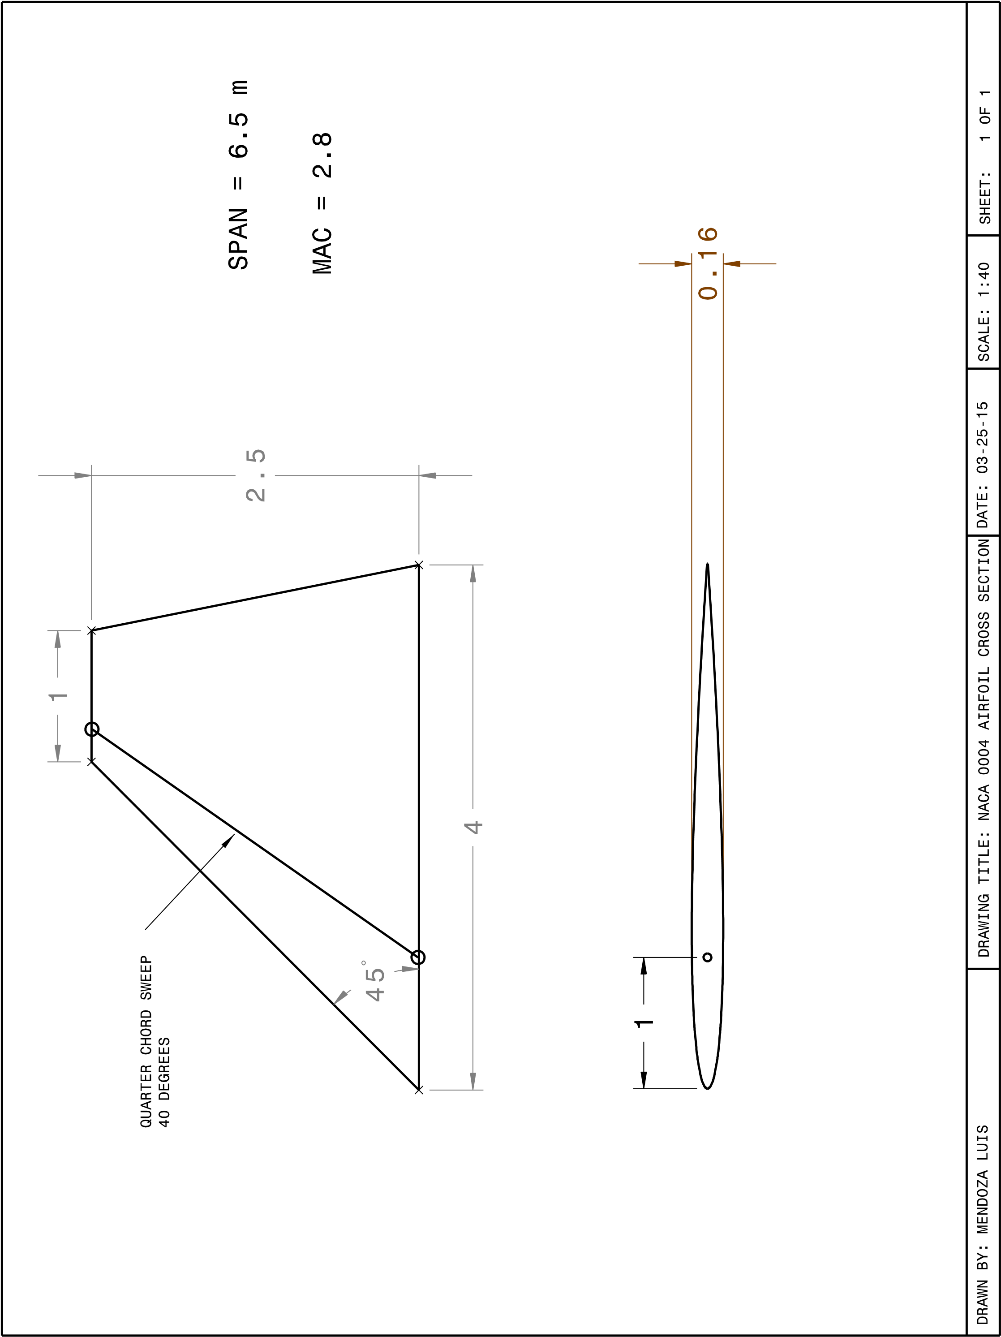

LIFT CURVE SLOPE
To estimate the lift curve slope of our wing, we make use of empirical graphs that relate the specified aspect ratio and taper of the wing to the lift curve slope, as in Figure 1 (Raymer 269). Since our sweep angle is 45 degrees, our $\tan{Ʌ_{LE}}$ = 1. For Mach < 1, β = $\sqrt{{1- M}^{2}}$ and for Mach > 1, β = $\sqrt{M^{2}-1}$. Using Figure 1, we choose a few Mach values relevant to our design for each of the subsonic (M<1), transonic (~0.85 – 1.2 for swept wings) and supersonic (M>1). Since our design will reach similar speeds to SpaceShipOne, our maximum Mach value is 3.09. We now calculate β from our chosen Mach values and then calculate $β^{-1}$ (since $\tan{Ʌ_{LE}}$ = 1) for our Mach values above 1. Since our aspect ratio, A, is near 3, we use the $A\tan{Ʌ_{LE}}$ = 3 on Figure one to acquire values for β*$C_{L, α}$ and $C_{L, α}*\tan{Ʌ_{LE}}$ on the y-axis for Mach values above 1 and below 1 respectively. Now we can solve for $C_{L, α}$ values and plot points of $C_{L, α}$that correlate to Mach values, allowing us to acquire plot of lift curve versus Mach number. To acquire values for the transonic lift curve, we have to extrapolate the data between the subsonic and supersonic values (Raymer 313). To do this, the use of the Matlab command ‘interpl’ and ‘spline’ were used (see Appendix A-1). Our maximum lift curve nears 4. Figure 2 illustrates the result of these calculations, which agrees with Rayer’s plot of the lift curve for swept wings (Raymer 311). The lift curve does not include the effects of the canards since the Raymer method for calculating lift is specific to wings and their particular qualities, so we need to plot a separate lift curve to estimate the lift of the canards. In Figure 3, we repeat the above process to get an estimate of our canard lift, which is high because of the high aspect ratio of the canards, A = 6. Therefore, we can estimate that our total lift curve might be slightly higher than what was calculated.

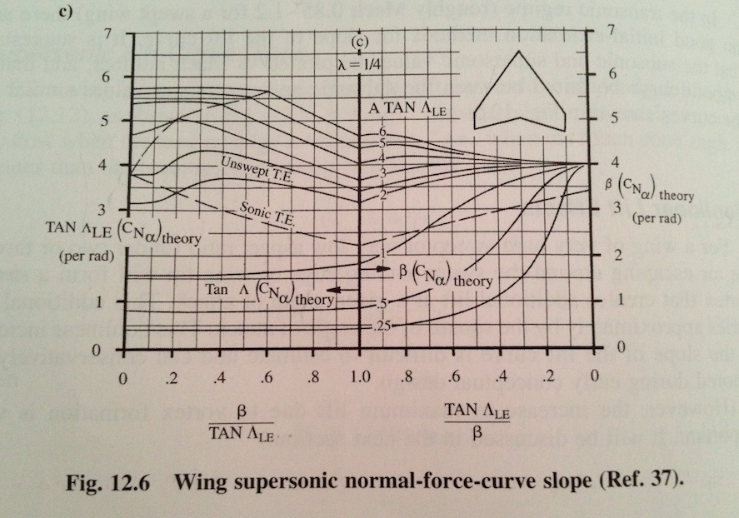
Figure 1

Table 1: Points acquired from Figure 1
Mach number, M | Lift curve slope, $C_{L, α}$
3.09 | 1.38
1.50 | 3.39
0.50 | 3.80
0.25 | 3.7

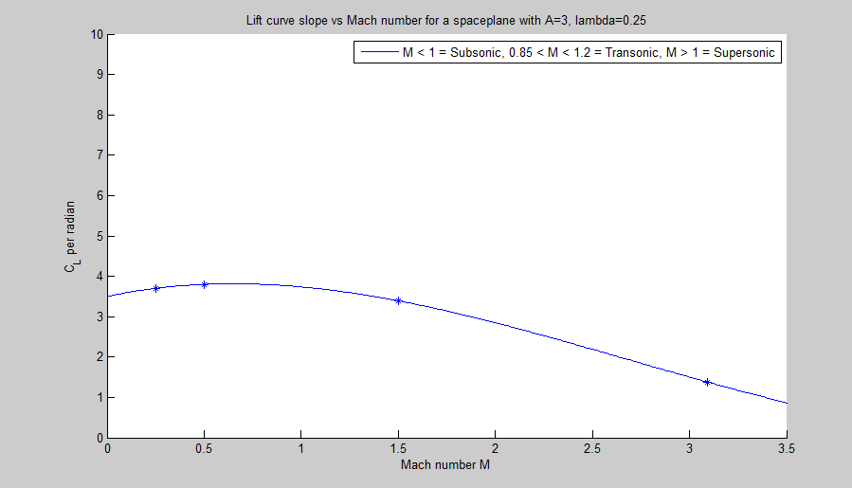

Figure 2

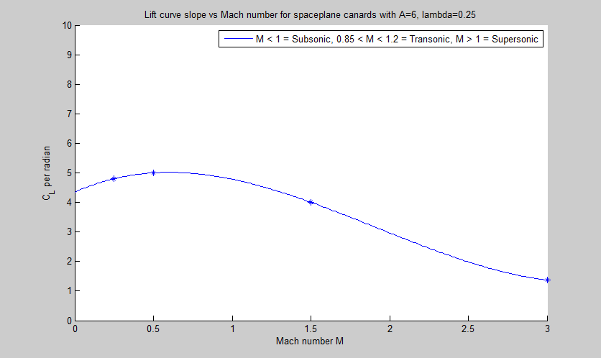

Figure 3

DRAG ESTIMATIONS
We used the component build up method to estimate the drag coefficient in plot form (Figure 3). The drag coefficient is determined in three parts (subsonic, transonic, and supersonic). For the subsonic drag coefficient, ${\left(C_{D_{0}}\right)}_{subsonic} (Raymer 281)$, the sum of products of the flat-plate skin-friction drag coefficient, components of “form factor”, interference factor, and planform areas of each component (wing, canard, and fuselage) are added to the other drag coefficients.
$${\left(C_{D_{0}}\right)}_{subsonic}=\frac{\sum{\left(C_{fc}{FF}_{c}Q_{c}S_{{wet}_{c}}\right)}}{S_{ref}}+C_{D_{misc}}+C_{D_{L\&P}}$$
The flat-plate skin-friction drag coefficient, $C_{fc} (Raymer 282)$, is determined from the Reynolds and Mach number:
$$C_{fc}=\frac{0.455}{{\left(\log_{10}R\right)}^{2.58}{\left(1+0.144M^{2}\right)}^{0.65}}$$
The sum of the components of “form factor”, ${FF}_{c}$, estimates the pressure drag due to viscous separation. The wing and canards both use the ${FF}_{w}$ equation (Raymer 283) while the fuselage uses the ${FF}_{f}$equation (Raymer 283):
$${FF}_{w}=\left[1+\frac{0.6}{{\left(x/c\right)}_{m}}\left(\frac{t}{c}\right)+100{\left(\frac{t}{c}\right)}^{4}\right]\left[1.34M^{0.18}{(cosΛ_{m})}^{0.28}\right]$$
${FF}_{f}=\left(1+\frac{60}{f^{3}}+\frac{f}{400}\right)$ , where $f=\frac{l}{d}=\frac{l}{\sqrt{\left(\frac{4}{π}\right)A_{max}}}$
The interference factor, Q, is approximated to 1 for the fuselage, wing, and canards. The miscellaneous drags, $C_{D_{misc}}$, are assumed to be zero in our case due to the simple design. The Leakage and Protuberance Drag, $C_{D_{L\&P}}$, can be estimated to be 5-10 percent of the parasite drag for the spaceplane based on the shape of the new-design fighter aircraft. The average was used (7.5 percent).
The transonic parasite drag was estimated using Raymer’s simplified method (293). The critical Mach number, $M_{cr}$, which is approximately 0.8 corresponds to a drag coefficient of 0. The drag divergence Mach number, $M_{DD}$, (and was determined earlier to be 0.8315) corresponds to a drag coefficient of 0.002. The drag coefficient at Mach 1.2 is estimated to be the same as that of Mach 1.05. The drag coefficient at Mach 1.05 is estimated to be half of that at Mach 1.0. These four points are used to estimate the drag coefficient plot for the transonic region of the plot.
The supersonic drag coefficient, ${\left(C_{D_{0}}\right)}_{supersonic} (Raymer 290)$, was calculated similar to the subsonic drag coefficient. In the supersonic case, the skin-friction drag is simplified and wave drag, $C_{D_{wave}}$ (Raymer 292), is taken into consideration. Wave drag is the drag that results from the formation of shock from supersonic and high subsonic speed (Raymer 307).
$${\left(C_{D_{0}}\right)}_{supersonic}=\frac{\sum{\left(C_{fc}S_{{wet}_{c}}\right)}}{S_{ref}}+C_{D_{misc}}+C_{D_{L\&P}}+C_{D_{wave}}$$
$$C_{D_{wave}}= \frac{E_{WD}\left[1-0.386{\left(M-1.2\right)}^{0.57}\left(1-\frac{π*{Λ_{LE}}^{0.77}}{100}\right)\right]\left[\frac{9π}{2}{\left(\frac{A_{max}}{l}\right)}^{2}\right]}{S_{ref}}$$

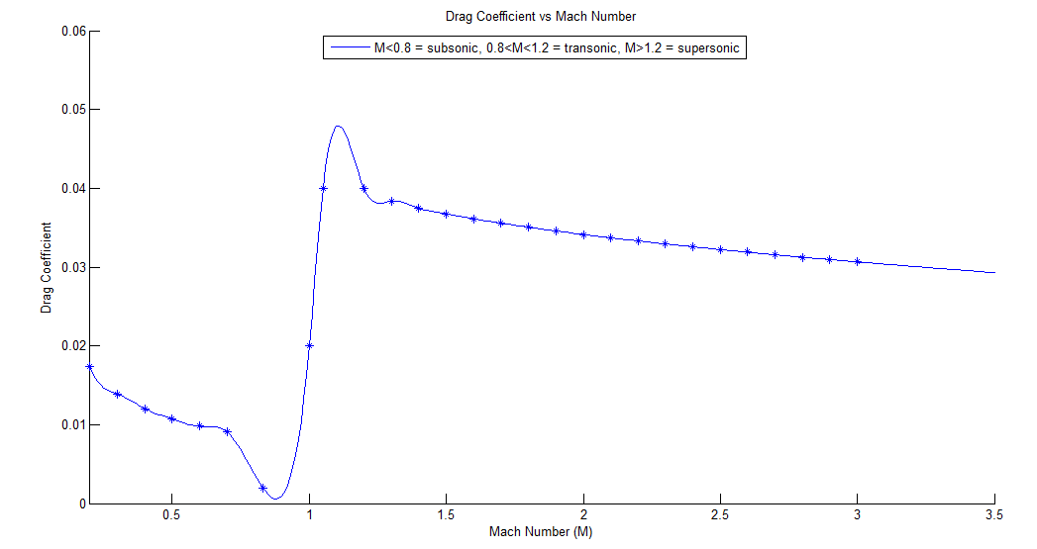
Figure 3

PART III
PROPELLANT DESIGN
INITIAL CONSIDERATIONS
We chose our propellant as a modification of the solid component of SpaceShipOne’s hybrid rocket. SpaceShipOne used tire rubber as the fuel of their propellant and nitrous oxide as the oxidizer of their propellant. Since our mission requires that we use entirely solid propellant, we chose a common solid oxidizer that works in conjunction with the tire rubber fuel, ammonium. Our propellant design will be a combination of the propellants used for the Space Shuttle and SpaceShipOne. We will use ammonium as our oxidizer and tire rubber and aluminum for our fuel. Table 3 and 4 summarize our propellant design.
The first step to designing the shape and size of the propellant is to determine the volume of propellant needed so that it can be verified it fits in the spacecraft. The fuel and oxidizer combination Hydroxyl-terminated polybutadiene (HTPB) and Aluminum along with Ammonium Perchlorate (NH4ClO4 or AP) has an I_{sp} of 277s and was chosen because it commercially available and is not military grade. This lowers the cost of the propellant, and ensures it is easier to obtain than other types of propellant. The combination uses similar compounds as the SpaceShipOne propellant, however this is entirely a solid rocket design. The density of the rocket fuel is then calculated using a weighted average displayed in Equation 10, and the density equation is used to solve for the volume of the propellant as shown below in Equation 11.
$ρ=AP\left(Percentage\right)+HTPB\left(Percentage\right)+Al\left(Percentage\right)$ [10]
$$ρ=1.95\frac{g}{{cm}^{3}}\left(0.68\right)+0.9\frac{g}{{cm}^{3}}\left(0.14\right)+2.7\frac{g}{{cm}^{3}}\left(0.18\right)$$
$$ρ=1.938\frac{g}{{cm}^{3}}=1938\frac{kg}{m^{3}}$$
The results from Equation 10 are then used in Equation 11 to solve for the volume of propellant.
$V=\frac{m_{p}}{ρ}$ [11]
$V=\frac{1281 kg}{1938 \frac{kg}{m^{3}}}$
$V=0.7 m^{3 }$ ~ $1 m^{3}$
Since our spaceplane has a width of 2 meters and if we approximate it as a cylinder of length L with a 1 meter radius R, the volume of a cylinder = πR^2*L. This means we have about three cubic meters of space for our propellant within 1 meter of length. Thus, the above calculation verifies that the 0.7 cubic meter propellant will fit in our design.
The next steps involve the use of the mass flow rate equation. With a requirement that the rocket must burn for 80 seconds, the burn time (t_{b}) is known as well as the mass of propellant (m_{p}). The previously calculated mass flow rate or burn rate (b) of propellant (Equation [7]) is also valid for Equation [12] (Humble 332) where A_{b} is the instantaneous burn area, $ρ$ is the density of propellant, and r_{b} is the burn rate of the propellant.
$b=A_{b}*ρ*r_{b}$ [12]
In order to solve for A_{b}, the burn rate (r_{b}) must be calculated. An average burn rate based on the values for similar propellants was calculated as the values necessary to calculate the burn rate for the chosen propellant mixture were not available. Equation 13 (Humble 327) is used to calculate the average burn rate where a and n are constants, and (P_{c})_{av} is the chamber pressure in MPa.
${{(r}_{b)}}_{av}=a({{{(P}_{C})}_{av})}^{n}$ [13]
(P_{c})_{av} was taken to be the average chamber pressure via the highest and lowest values for the propellants which came out to be 5 MPa. The constants a and n were estimated to be 0.4 and 0.3 respectively based on the values for the similar rocket fuels. The values were taken from Table 6.9 (330) in the book Space Propulsion Analysis and Design by Ronald Humble.
$${{(r}_{b)}}_{av}=0.4({5)}^{0.3}$$
$${{(r}_{b)}}_{av}=0.6483\frac{cm}{s}$$
With the average burn rate of the propellant known, the web of the propellant (the thickness of the tube of the propellant grain in this case) can be solved for using Equation [14] (Humble 335).
$w_{f}={{(r}_{b})}_{av}*t_{b}$ [14]

$$w_{f}=0.6483\frac{cm}{s}*80s$$

$$w_{f}=51.864 cm=0.51864 m$$

Where $w_{f}$ is the web of propellant, ${{(r}_{b})}_{av}$ is the average burn rate, and $t_{b}$ is the burn time.

Also using the answer from Equation [13], Equation [12] can be solved for the average burn area and rewritten as Equation [15].
$b=A_{b}*ρ*r_{b}$ [12]
$A_{b}=\frac{b}{ρ*r_{b}}$ [15]
$$A_{b}=\frac{16.01\frac{kg}{s}}{1938\frac{kg}{m^{3}}*0.006483\frac{m}{s}}$$
$${{(A}_{b})}_{av}=1.27 m^{2}$$
Once all of this information is obtained, a type of cross section for the propellant grain must be chosen. Different web designs will result in varying performance of the same mass and volume of propellant. An internal burning tube was selected for the preliminary design for simplicity. The internal burning tube has a progressive burn to it, which means that its thrust will increase as time progresses, and then drop off sharply at the end when there is no more propellant to burn.
Due to the geometry of the internal burning tube, the average burn area is the surface area on the inside of the propellant. Since this an average, the average radius of the propellant must be used in the surface area cylinder calculation (Equation [16]).
${{(A}_{b})}_{av}=\left(2πr_{av}\right)L$ [16]
Where $r_{av}$ is the average radius, L is the length of propellant, and ${{(A}_{b})}_{av}$ is the average burn area. Equation [16] can be rearranged to solve for $r_{av}$ as shown below.
$$r_{av}=\frac{{{(A}_{b})}_{av}}{2πL}$$
$$r_{av}=\frac{1.38 m^{2}}{2πL}$$
The average radius can also be equated to the outer radius of the tube, R, and the internal radius of the tube, $r_{i}$.
$r_{av}=\frac{R+r_{i}}{2}$ [17]
The final independent equation is derived from the volume of a cylinder. The volume of propellant needed is known, and with the geometry of the grain chosen, the volume can be determined.
$V= πL\left(R^{2}-r_{i}^{2}\right)$ [18]
Manipulating the variables to solve for $R^{2}-r_{i}^{2}$ while inputting the known value for the volume yields:
$$R^{2}-r_{i}^{2}=\frac{1.00m^{3}}{πL}$$
There are, however, four variables and only three equations. To counter this problem, an iterative process was setup with L as a parameter, and then the other three variables were solved for. Table 3 displays different values for L and the resulting radii.
Table 3: Propellant Length and Radii
Length (m) | Outer Radius (m) | Inner Radius (m)
1.25 | 0.5062868222 | -0.01226987884
1 | 0.5680389401 | 0.04948223908
0.75 | 0.6709591365 | 0.1524024355
0.65 | 0.7342946420 | 0.2157379411
0.5 | 0.8767995297 | 0.3582428287

The parameter, L, was chosen to be 1 meter in length. This resulted in an outer radius of 0.57 m and an inner radius of 0.049 meters (the following results were rounded up from Table 3). This can be verified as an acceptable result by using Equation [19]. Subtracting the inner radius from the outer radius will leave only the propellant web remaining.
$w_{f}=R-r_{i}$ [19]
$$w_{f}=0.57m-0.049m$$
$$w_{f}=0.52 m$$
Comparing the result with the required $w_{f}$ obtained in Equation [14], it can be shown that this configuration is acceptable.

 |  | Table 4: Propellant Design
Fuel | Oxidizer | Mixture | Volume | Shape | I_{sp}
Hydroxyl-terminated polybutadiene (HTPB) and Aluminum | Ammonium Perchlorate | 2.12 | 0.7 m^3 | Internal burning tube (progressive burn) | 277 seconds

PROPELLANT GRAIN DESIGN
ADVANCED CONSIDERATIONS
The first step of the design process was to choose a geometry for the grain cross section. It was decided not to go with the internal burning tube that had been initially used in Task 1. The internal burning tube produces a progressive thrust curve, which produces increasing thrust over the course of its burn. The spacecraft becomes lighter later on in the burn due to propellant being burned. The lighter spacecraft then faces increased acceleration which has the potential to cause structural problems. A neutral burn is much more favorable as it produces an almost constant thrust curve over time. Keeping this in mind, the internal-external burning tube grain design was selected as it produces a neutral burn, and is relatively simple to work with compared to much more complex grain geometries. The nozzle expansion ratio, ε, was decided by taking an average of the nozzle expansion ratios presented in Table 6.3 (Humble 304). Taking an average of those values resulted in an ε= 40.
The fuel and oxidizer combination that was chosen was Hydroxyl terminated polybutadiene (HTPB) and Aluminum as the fuel and Ammonium Perchlorate (NH4ClO4 or AP) as the oxidizer in a 2.12 mixture. This mixture yields an I_{sp} of 277s. The HTBP, Aluminum, and AP mixture is the same propellant combination used in Task 1 as the fuel is commercially available which lowers cost while also having a relatively high I_{sp}. The density calculation for this propellant is repeated below for convenience:
$ρ_{p}=AP\left(Percentage\right)+HTPB\left(Percentage\right)+Al\left(Percentage\right)$
$$ρ_{p}=1.95\frac{g}{{cm}^{3}}\left(0.68\right)+0.9\frac{g}{{cm}^{3}}\left(0.14\right)+2.7\frac{g}{{cm}^{3}}\left(0.18\right)$$
$$ρ_{p}=1.938\frac{g}{{cm}^{3}}=1938\frac{kg}{m^{3}}$$
The Steady State Lumped Parameter method was used to determine the chamber pressure evolution versus time as well as the burn area versus time. This method assumes a steady state operation of the rocket which means that there will be no mass accumulation in the control volume. In other words, the mass flow rate in is equal to the mass flow rate out. Setting the mass flow rate in and the mass flow rate out equal to one another results in Equation 6.28 (Humble 335) which can then be rearranged to the equation shown below to solve for the chamber pressure.
$$P_{c}={\left(\frac{aρ_{p}A_{b}c^{*}}{A_{t}}\right)}^{\frac{1}{1-n}}$$
Where P_{c} is the chamber pressure (Pa), a is the progression rate coefficient (estimated to be 0.4 by taking the average of Table 6.9 (Humble 330)), n is the propellant regression parameter (also estimated from Table 6.9), $ρ$ is the propellant density (kg/m^3), $A_{b}$ is the instantaneous burn surface area (m^2), $c^{*}$ is the characteristic velocity which was given to be 1550 m/s, and finally $A_{t}$ is the throat area of the nozzle (m^2).
The burn area is dependent upon time and geometry, however it can be constrained to be constant if the geometry is correct. This is the case with the current internal-external burning tube design. As the outer radius burns it shrinks as a circle, and thus reduces the burn area. While the inner radius is burning, it too burns as a circle, but the burn area increases as it burns. This causes the net change in the burn area to be zero, and gives a constant burn area, burn rate, and chamber pressure as shown in the graphs. The burn area equation for this geometry is shown below for reference.
$$A_{b(i)}=2πL\left(\left(R_{i}+w\left(i\right)\right)+\left(R_{o}-w\left(i\right)\right)\right)$$
Where A_{b(i)} is the burn area at a given instant, L is the propellant length, R_{i} is the initial inner propellant radius, R_{o} is the initial outer propellant radius, and w(i) is the instanteous burn rate.

Since the process for solving for pressure, burn rate, and burn area requires many iterations, a MATLab program for an internal burning tube provided by Dr. Crispin was modified to work with the grain geometry selected. A copy of the MATLab program can be viewed in the appendices to this paper. Using the program, the burn rate, burn area, and chamber pressure wereproduced as functions of time shown below.
The final burn time, t_{b}, was 82.5 seconds which is slightly over the 80 seconds required. A percent error calculation results in a 3.125 % error. The parameters entered to obtain this result are a throat area (A_{t}) of 0.025m^2, a length (L) of 1.25m, an outer radius (R_{o}) of 0.5m, and an inner radius (R_{i}) of 0.05m which easily fits into the spacecraft as shown by the drawings below. The burn rate (r_{b}) is 0.55 cm/s. Using the density equation, the mass of the propellant can then be determined.
$$ρ_{p}=\frac{m_{p}}{V_{p}}$$
Having already solved for the density of the propellant, the volume must be obtained in order to find the mass. Based solely off the grain geometry the volume equation is as follows:
$$V_{p}=πL(R_{o}^{2}-R_{i}^{2})$$
$$V_{p}=π\left(1.25\right)*({0.5}^{2}-{0.05}^{2})$$
$$V_{p}=0.972 m^{3}$$
Then solving for the propellant mass,
$$m_{p}=V_{p}*ρ_{p}$$
$$m_{p}=0.972 m^{3}*1938 \frac{kg}{m^{3}}$$
$$m_{p}=1883.6 kg$$
Due to the grain geometry chosen, insulation is required on the outer combustion chamber otherwise the hot gases would melt the motor casing. Equation 6.16 (Humble 315) is used to determine the mass of the insulation needed. The type of insulation being used is EPDM insulation with a density, ρ_{i}, of 1108 kg/m^3.
$$m_{insul}=1.788*{10}^{-9}m_{p}^{-1.33}t_{b}^{0.965}{\left(\frac{L}{D}\right)}^{0.144}L_{sub}^{0.058}A_{w}^{2.69}$$
Where m_{insul} is the mass of the insulation, m_{p} is the propellant mass, t_{b} is the burn time, L is the length of the motor case, D is the diameter of the motor case, L_{sub} is nozzle submergence parameter defined below, and A_{w} is the surface area of the wall motor case exposed to gases.
$$L_{sub}=\frac{100X}{L}$$
Where X is the nozzle submerged length in meters (decided to be 0.2m), and L is the length of the case.
$$L_{sub}=\frac{100*0.2m}{1.25 m}$$
$$L_{sub}=16$$
Setting the outer case radius to be 0.55m, the value of A_{w} is equal to 35,342.92 cm^2 through the surface area calculation of a cylinder. Substituting all of the parameters into the above equation results in,
$$m_{insul}=1.788*{10}^{-9}*{1883.6 kg}^{-1.33}*{82.5s}_{}^{0.965}{\left(\frac{1.25m}{0.55m}\right)}^{0.144}{16}_{}^{0.058}*{35342.92}_{}^{2.69}$$
$$m_{insul}=12.651 kg$$
Once the mass of the insulation is known, the average thickness can be determined by using Equation 6.82 (Humble 356).
$$t=\frac{m_{insul}}{ρ_{i}A_{w}}$$
$$t=\frac{12.651 kg}{1108\frac{kg}{m^{3}}\left({3.534292 m}^{2}\right)}*\frac{100 cm}{1 m}$$
$$t=0.32 cm$$
Therefore the required thickness of insulation to be put on the casing is 0.32 cm.
The propellant mass flow rate was determined by using Equation 6.26 (Humble 334).
$$\dot{m_{out}}=\frac{P_{c}A_{t}}{c^{*}}$$
$$\dot{m_{out}}=\frac{2.8394*{10}^{6} Pa*(0.025 m^{2})}{1550\frac{m}{s}}$$
$$\dot{m_{out}}=45.797 \frac{kg}{s}$$
With the throat area set as a parameter and the nozzle expansion ratio known, the exhaust nozzle exit area can easily be determined using the expansion ratio equation.
$$ε=\frac{A_{e}}{A_{t}}$$
Rearranging, to solve for the exhaust nozzle exit area results in:
$$A_{e}=ε*A_{t}$$
$$A_{e}=40*0.025 m^{2}$$
$$A_{e}=1 m^{2}$$
The expansion ratio can also be used to solve for the exhaust speed Mach number. Under the assumption of choked flow, and that the Mach number is 1 at the nozzle throat Equation 3.100 (Humble 102) can be used.
$$ε=\frac{1}{M_{e}}\sqrt{{\left(\frac{2}{γ+1}\left[1+\frac{γ-1}{2}M_{e}^{2}\right]\right)}^{\frac{γ+1}{γ-1}}}$$
Where M_{e} is the Mach number at the nozzle exit, gamma is the ratio of specific heats for the propellant (estimated to 1.3 based on HTPB propellants), and $ε$ is the nozzle expansion ratio.
$$40=\frac{1}{M_{e}}\sqrt{{\left(\frac{2}{1.3+1}\left[1+\frac{1.3-1}{2}M_{e}^{2}\right]\right)}^{\frac{1.3+1}{1.3-1}}}$$
As this is a quadratic equation, Wolfram Alpha equation solver was used to easily solve the above equation (a PDF of the Wolfram Alpha calculation can be found in the appendix). The resulting exit Mach number was 4.4181 Mach. The exhaust velocity changes with altitude as the speed of sound varies altitude according to $s=\sqrt{γRT}$. Where a is the speed of sound, gamma is the ratio of specific heats (1.4 for air), R is the universal gas constant, and T is the absolute temperature. The Mach number is related to velocity by the following equation:
$$Ma=\frac{V}{s}$$
Using this equation, the speed of sound is calculated at varying altitudes from the initial altitude of 10,000m to the final altitude required of 100,000m with 5,000m increments. A graph of the exhaust velocity plotted against the altitude of the spacecraft is displayed below.

PROPELLANT GRAIN LAYOUT
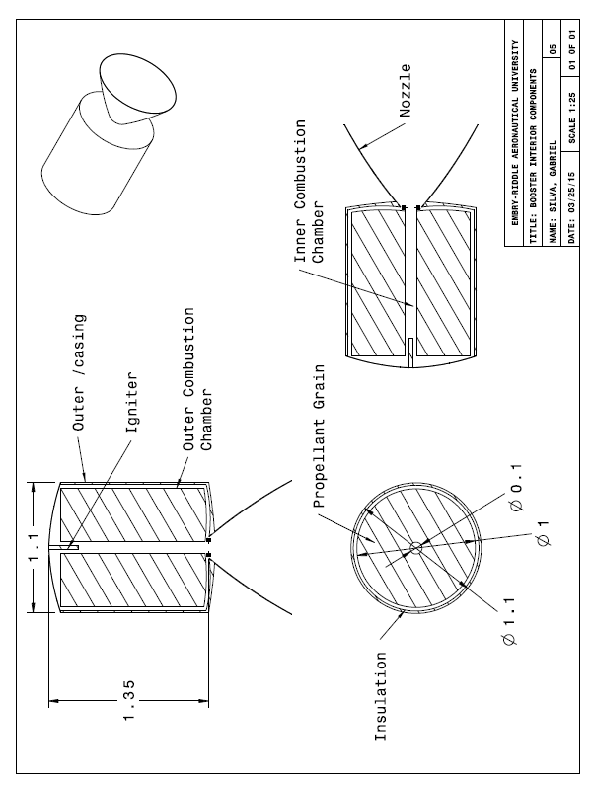
SOLID ROCKET MOTOR DESIGN

The first component being considered is the motor case, which must contain the chamber pressure from the propellant being burned. The burst pressure for the motor case factors in a safety factor to the maximum expected operating pressure.
$$P_{b}=f_{s}\left(MEOP\right)$$
$$P_{b}=1.4\left(2.8394 MPa\right)$$
$$P_{b}=3.975 MPa$$
Where f_{s} is the factor of safety (usually 1.4 for manned vehicles), P_{b} is the burst pressure, and MEOP is the maximum expected operating pressure. The next step is to determine the motor case thickness so that the burst pressure will not be exceeded. Using the ultimate tensile strength of a material and the equation below the motor case thickness can be solved for. Multiple different materials were considered, and a sample calculation for AMS 4904 Ti-6Al-4V Titanium is shown below. The ultimate tensile strength for this material, as well as the other materials considered, were taken from MMPDS-07 as shown in the appendices and converted to SI units.
$$t_{cs}=\frac{P_{b}r_{cs}}{F_{tu}}$$
$$t_{cs}=\frac{3.975 MPa (0.55 m)}{{1.1032*10}^{9} GPa}$$
$$t_{cs}=0.00198 m=1.98 mm$$
Where t_{cs} is the case thickness, r_{cs} is the case radius, F_{tu} is the ultimate tensile strength of the material, and P_{b} is the burst pressure. With a known thickness and volume of material for the case as well as having the material density for the metal chosen, the mass can be calculated.
$$m=ρ*V$$
$$m=4428.78\frac{kg}{m^{3}}*\left(πh({0.55198}^{2}-{0.55}^{2}\right)$$
$$m=37.95 kg$$
The next thing to be designed is the thrust skirt and polar boss. The main purpose of the thrust skirt is to securely attach the motor case to the fuselage of the spacecraft, and the purpose of the polar boss is to attach the rocket nozzle to the motor casing. According to Humble, for preliminary design purposes the thrust skirt can be estimated to be made from the same material as the motor casing, which is what was done here. Likewise the polar boss is usually made from aluminum so 7075-T6 was chosen as it is commonly used for aircraft skin. It also has a higher F_{tu} than 2024-T3 aluminum at 0.52 GPa compared with 0.44 GPa respectively.
The next component is the igniter, which is essentially a miniature rocket motor designed to get hot gasses flowing throughout the combustion chamber in order to ignite the propellant. The design that was chosen, was a BKNO3 (Boron- Potassium Nitrate) pyrogen igniter, which is commonly used by NASA. It contains a 25% mixture of Boron and a 75% mixture of potassium nitrate by weight. Some of the alluring characteristics of this type of igniter include that it is thermally stable. Also its burn rate is independent of pressure, so it will perform the same at various altitudes. It burns hotter than black powder, but does leave more residue which is a drawback for multi-use systems. Another drawback is that it is relatively expensive, however seeing as it has such a lower mass compared to the propellant this was deemed to be acceptable. The mass of the igniter needed was calculated by the empirical equation from Humble’s book presented below.
$$m_{ig}=0.138V_{port}^{0.571}$$
Where m_{ig} is the mass of the igniter and V_{port} is the volume of the port of the propellant.
$$V_{port}=V_{prop}\left(\frac{1}{η_{v}}-1\right)$$
Where V_{prop} is the propellant volume and $η_{v}$ is the thrust efficiency factor given below.
$$η_{v}=\frac{V_{prop}}{V_{cs}}$$
Where V_{cs} is the motor case volume. Due to the geometry, this becomes the equation below, which can then be easily solved.
$$η_{v}=\frac{Lπ\left(R_{o}^{2}-R_{i}^{2}\right)}{LπR_{cs}^{2}}$$
$$η_{v}=\frac{1.25π\left({0.5}_{}^{2}-{0.05}_{}^{2}\right)}{1.25π{(0.55}_{}^{2})}$$
$$η_{v}=0.82$$
Substituting this result into the port volume equation yields,
$$V_{port}=Lπ\left(R_{o}^{2}-R_{i}^{2}\right)\left(\frac{1}{0.82}-1\right)$$
$$V_{port}=0.2134 m^{3}$$
In order for the empirical equation for the mass of the igniter to work, the port volume must be converted to cm³.
$$m_{ig}=0.0138{\left(213400\right)}^{0.517}$$
$$m_{ig}=7.85 kg$$
With a gap between the propellant and the motor case wall, the motor case is exposed to the hot gases of the combustion chamber. Insulation is needed to prevent the motor case from being damaged by the hot gases and maintain its structural integrity. The insulation chosen was the same EPDM insulation mentioned in the book. The main reason for this is it has a very low density at 1108 kg/m^3. The one drawback to this insulation is that it has a relatively high erosion rate of 0.16 mm/s. The thickness of the insulation required, and subsequently the mass required is calculated below.
$$t_{i}=t_{exp}\dot{e}f_{s}$$
Where t_{i} is the insulation thickness, t_{exp} is the time exposed to hot gasses, e dot is the erosion rate, and f_{s} is the factor of safety.
$$t_{i}=82.5 s*\left(0.16\frac{mm}{s}\right)*1.4$$
$$t_{i}=18.48 mm$$
$$m_{i}=ρV$$
$$m_{i}=1108 \frac{kg}{m^{3}}\left(0.08117 m^{3}\right)$$
$$m_{i}=89.9 kg$$
The final component needed is the rocket nozzle. In his book, Humble provided a way to empirically estimate the mass of a nozzle, but noted that even this was insufficient for preliminary design as up to a 20% error can be incurred in the calculation. This equation was however used as a starting point to compare the actual results to. For simplicity, the basic shape of a conical nozzle was chosen. From there, the equation reproduced below was used to provide a rough estimate of what the mass of the nozzle should be.
$$m_{noz}=0.256*{10}^{-4}{\left[\frac{{\left(m_{prop}\left(c^{*}\right)\right)}^{1.2}ε^{0.3}}{P_{c}^{0.8}t_{b}^{0.6}{\left(tanθ_{cn}\right)}^{0.4}}\right]}^{0.917}$$
Where m_{prop} is the propellant mass, c* is the characteristic velocity, $ε$ is the nozzle expansion ratio, P_{c} is maximum chamber pressure, t_{b} is the burn time, and theta cn is the nozzle half-angle, which determines the efficiency of the nozzle. A nozzle with a half angle of 0 has a 100% percent efficient rating, but it is also infinitely long and therefore unrealistic. A portion of Table 3.2 (Humble 120) has been provided to show the different half angles and their corresponding efficiencies.

Nozzle Half Angle | Efficiency
12 | 0.989
16 | 0.981
20 | 0.97
24 | 0.957

Decreasing the half-angle of a nozzle will, in turn, increase the efficiency, but it will also increase the length and therefore the weight of the nozzle. Therefore an optimum design balances the two, and maximizes efficiency while also keeping the weight low. A half-angle of 20 degrees was chosen as it met both of those criteria.
$$m_{noz}=0.256*{10}^{-4}{\left[\frac{{\left(1883.6 kg\left(1550\frac{m}{s}\right)\right)}^{1.2}{40}^{0.3}}{{2.3894 MPa}_{}^{0.8}{82.5}_{}^{0.6}{\left(tan20\right)}^{0.4}}\right]}^{0.917}$$
$$m_{noz}=29.427 kg$$
As this is just an estimate, it was determined the most feasible, and thus the best, way to calculate the mass of the nozzle was to determine the mass of its individual components via volume and density, and then simply add them up. The nozzle is essentially a hollow truncated cone so that was the volume formula used. As the nozzle is not prone to much structural loading, it can be composed of mostly insulation with a metallic backing (usually aluminum).
The insulation calculation used for the motor case was used again to determine the amount of insulation needed for the nozzle. This time a carbon phenolic insulation was chosen due to it having a high ultimate tensile strength of 72.4 MPa. The advantage to this is that it will help carry some of the minimal loading on the nozzle, and the metal portion of the nozzle can be made thinner reducing the weight as the metal is almost twice as heavy as the insulation. A disadvantage of carbon phenolic is that it has a high erosion rate of 0.18 mm/s.
$$t_{i}=t_{exp}\dot{e}f_{s}$$
$$t_{inoz}=82.5 s\left(0.18 \frac{mm}{s}\right)1.4$$
$$t_{inoz}=20.79 mm$$
The thickness of the metal portion of the nozzle was estimated to be 0.040” (0.001016 m) thick as this is an average skin thickness for commercial aircraft under pressurization loads. From here the volume of a truncated cone was calculated for the inner dimension and then subtracted from the outer dimension to obtain the volume of material present (i.e. the thickness of the material).
$$V=\frac{1}{3}π\left(r_{1}^{2}+r_{1}r_{2}+r_{2}^{2}\right)L$$
Where r₁ is the radius of the base or near the nozzle exit, r₂ is the radius by the throat, and L is the Length.
A simple way to determine the length of the nozzle is given by Equation 5.41 (Humble 224), which is as follows.
$$L_{noz}=\frac{D_{e}-D_{t}}{2tan⁡(θ_{cn})}$$
Where D_{e} is the exit diameter, D_{t} is the throat diameter, and theta cn is the half-angle.
$$L_{noz}=\frac{1.1284m-0.17842m}{2tan⁡(20)}$$
$$L_{noz}=1.305 m$$

The volume of the insulation was determined to be 0.05746 m^3 and the volume of the metal was determined to be 0.002724 m^3. The carbon phenolic has a density of 1400 kg/m^3 and the aluminum chosen (2024-T3) has a density of 2678 kg/m^3. This resulted in masses of 29.106 kg and 7.54 kg for the insulation and aluminum respectively with an overall weight of 36.65 kg. This process was repeated for other nozzle half-angles with the same materials, and this result maximized the efficiency while keeping the mass of the nozzle low.

PART IV
BALLISTICS ANALYSIS
In order to determine the thrust history of the rocket motor, the rocket thrust equation is used.
$$F=\dot{m}v_{e}+A_{e}\left(p_{e}-p_{amb}\right)$$
Where $\dot{m}$ is the mass flow rate (kg/s), v_{e} is the exit velocity (m/s), A_{e} is the exit area (m^2), p_{e} is the exit pressure (Pa), and p_{amb} is the ambient pressure of the atmosphere at that given moment. As the spacecraft ascends, some of these values change due to the change in pressure in temperature at higher altitudes. The exit velocity is based upon the exit Mach number, however the speed of sound varies with altitude so the exit velocity must account for this. Likewise atmospheric pressure decreases with altitude and must also be accounted for.
With the values for $\dot{m}$, v_{e}, and A_{e} known, the exit pressure and ambient pressure must be solved for in order to determine the thrust at various points in flight. First, the ambient pressure of the air can be taken from charts. Again, increments of 5,000m were used from 10,000 to 100,000m. Next, using isentropic relations, the exit pressure can be calculated using Equation 3.95 (Humble 101).
$$\frac{p_{o}}{p}={\left(1+\frac{γ-1}{2}M^{2}\right)}^{\frac{γ}{γ-1}}$$
Where p_{o} is the stagnation pressure, p is the pressure at a point with a known Mach number, gamma is the ratio of specific heats for the propellant, and M is the Mach number.
Having previously calculated the nozzle exit Mach number that value is known along with the specific heat ratio. The stagnation pressure is also known as this is the chamber pressure. Due to grain geometry, the chamber pressure remains constant throughout the burn as shown previously. Knowing the Mach number at the exit of the nozzle allows the picking of the exit as the point to determine the static pressure. Solving this results in the exit pressure of the rocket motor.
$$\frac{2.8394*{10}^{6} Pa}{p_{e}}={\left(1+\frac{1.3-1}{2}{\left(4.4181\right)}^{2}\right)}^{\frac{1.3}{1.3-1}}$$
$$p_{e}=7560.2 Pa$$
With these values it is then possible to solve the rocket thrust equation at various altitudes and times in order to produce an estimate of the thrust history of the rocket motor. A sample calculation for the initial altitude of 10,000m where the spacecraft detaches from the plane is shown below.
$$F=\dot{m}v_{e}+A_{e}\left(p_{e}-p_{amb}\right)$$
$$F=45.797 \frac{kg}{s}*1323.057\frac{m}{s}+1m^{2}\left(7560.2 Pa-26436.3 Pa\right)$$
$$F=41715.96 N$$
Repeating this equation at various time increments and altitudes produces thrust values that can be plotted against the burn time to result in an estimate of the thrust history of the rocket motor.
Finally, the theoretical specific impulse in a vacuum can be solved for by using Equation 6.65 (Humble 351).
$$I_{spv}=\frac{1}{g_{0}m_{p}}\int_{0}^{t_{b}}{\left(F+p_{e}A_{e}\right)dt}$$
Where g₀ is 9.81 m/s^2, m_{p} is the mass of propellant, F is the time varying thrust magnitude, p_{e} is the exit pressure, A_{e} is the exit area, and t_{b} is the burn time.
Adding the exit pressure multiplied by the area to the time varying thrust and integrating over the burn time (82.5 seconds) yields:
$$I_{spv}=\frac{1}{9.81 \frac{m}{s^{2}}*1883.6 kg}\left(5972195.578\right)$$
$$I_{spv}=323.2037 s$$
As the propellant configuration presented above works to get our desired burn time, it is more mass than originally estimated in the Task 1 design. As such, our Task one values need to be updated. Recalling the equations for lambda, epsilon, and z as follows, and then substituting our new propellant values in we obtain the results below.
$$λ=\frac{m_{L}}{m_{s}+m_{p}}$$
$$λ=\frac{570 kg}{854 kg+1883.6 kg}$$
$$λ=0.208$$
$$z=\frac{m_{o}}{m_{s}+m_{L}}=e^{\frac{ΔV}{g*Isp}}$$
$$z=\frac{3307.6 kg}{854 kg+570kg}$$
$$z=2.32$$
$$ε=\frac{m_{s}}{m_{s}+m_{p}}$$
$$ε=\frac{854 kg}{854 kg+1883.6 kg}$$
$$ε=0.31$$
The only thing that was changed was the propellant mass; the structural mass and payload mass were kept the same. To prove our design works, the second half of the z equation is used to calculate our delta v of the current configuration. The Isp, gravity, and z values are known so solving for the delta v term yields:
$$z=e^{\frac{ΔV}{g*Isp}}$$
$$2.32=e^{\frac{ΔV}{(9.81*277)}}$$
$$ΔV=2286.8 m/s$$
This proves that our spacecraft is more than capable of meeting its required goal of 100 km which would require a delta v of 1700 m/s. As our delta v is greater than the required delta v, it can be stated that our spacecraft will indeed reach its intended altitude.

FINAL LAYOUT DRAWINGS
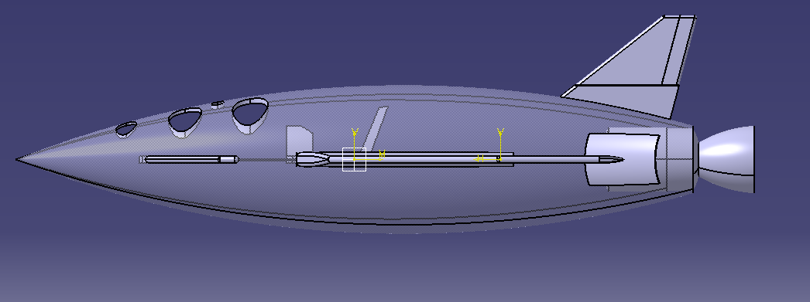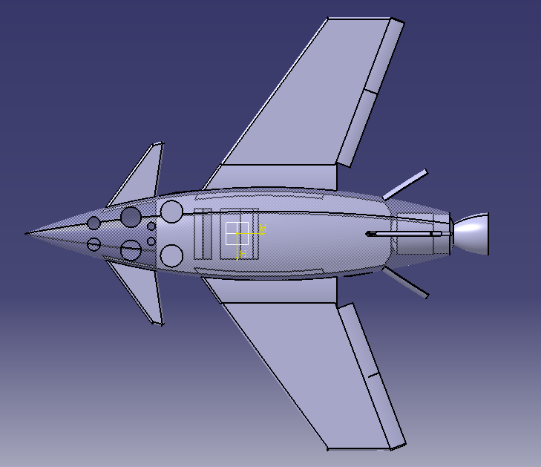
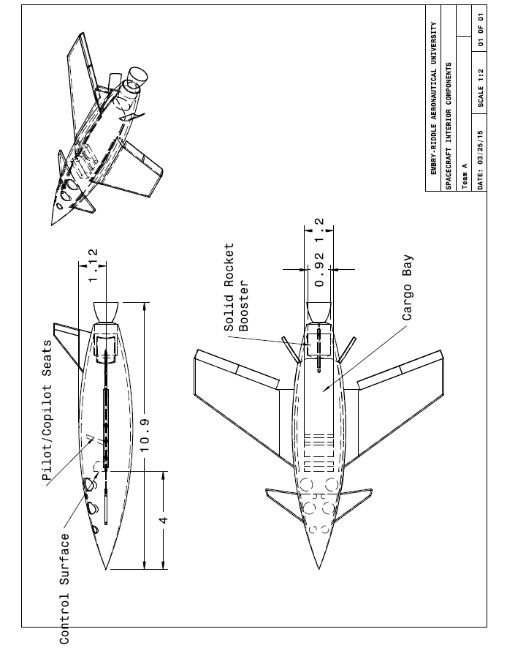

SUMMARY, CONCLUSIONS, AND RECOMMENDATIONS
In this preliminary analysis and design of a spaceplane, we defined the dimensions, mass, aerodynamics, propellant, and ballistics of our rocket plane. We chose a design with similar dimensions and mass to SpaceShipOne, but with aerodynamic structure and materials similar to the Skylon Spaceplane. We have found that our combination of these two spaceplanes is a feasible and potentially successful design for a single-stage suborbital manned rocket craft.
In our initial sizing process, we calculated the mass of our rocketplane based on the characteristic velocity and structural coefficient of SpaceShipOne and the specific impulse of our solid propellant type. We changed our propellant mass by adding 600 kilograms. This was due to the change in geometry, and the requirement to have an 80 second burn time. We met the minimum characteristic velocity stated in the mission requirements to reach 100km. Our final design is a slightly elongated, lighter SpaceShipOne. We found that our aerodynamic configuration and materials will be highly beneficial to our design. We chose a propellant combination similar to SpaceShipOne with all solid components (tire rubber, aluminum powder, and Ammonium Perchlorate). The associated specific impulse of this propellant combination allowed us to confirm the feasibility of our design and thus proved that a single-stage rocket was sufficient for this mission. We verified that the volume of our propellant generously fits inside our design. The quantitative details of the dimensions, masses, and propellant of our spaceplane are summarized in the tables below.
During the analysis of the wing, propellant, and ballistics of our spaceplane design, we refined and calculated features and dynamics of our spacecraft. A wing similar to a delta type wing was chosen for its efficiency for supersonic speeds. The drag and lift of the particular wing were found to be acceptable according to the equivalent plots found in Raymer’s Conceptual Approach to Aircraft Design. The landing speed of the spacecraft was determined to be slow enough to safely return our passengers to earth. The propellant grain was selected as the internal-external burning tube grain design since it produces a neutral burn. The Steady State Lumped Parameter method was used to determine the chamber pressure evolution versus time as well as the burn area versus time. The nozzle area, exit area, and exhaust speed were calculated and consequently, the exhaust speed allowed us to confirm that our spacecraft would reach an altitude of the Karman line. Our ballistics analysis allowed us to show that our thrust evolution would remain relatively constant over time. Details of our propellant and rocket motor design, such as use of a safety factor and a low pressure chamber exponent, allowed us to ensure the stability of our rocket motor and thus confirm the possibility for success for our rocketplane mission.

Summary of Sizing Configurations
Feature | Dimension/Size
Length | 10 meters
Height | 2 meters
Structural weight | 854 kilograms
Propellant weight | 1883.6 kg
Total weight | 3307.6 kg
Thrust to weight ratio | 1.76

 |  | Propellant Design
Fuel | Oxidizer | Mixture | Volume | Shape | I_{sp}
Hydroxyl-terminated polybutadiene (HTPB) and Aluminum | Ammonium Perchlorate | 2.12 | $0.972 m^{3}$ | Internal External Burning Tube (Neutral Burn) | 277 seconds

Motor Design Summary
Major Motor Components | Mass (kg) | Materials
Case | 37.95 | Ti-6Al-4V Titanium
Igniter | $$7.85$$ | BKNO3 Pyrogen Igniter
Insulation | 89.9 | EPDM Insulation
Nozzle | 36.65 | Carbon Phenolic and 2024-T3
Propellant | 1883.6 | HTPB and AP

REFERENCES
Crispin, Y. J., Supersonic Lift notes, AE 434, Embry-Riddle, 2015.
Crispin, Y. J., Rocket Vehicle Dynamics Notes, AE 434, Embry-Riddle, 2015.
Humble, R., Henry, G., and Wiley, L. Space Propulsion Analysis and Design. New York:
McGraw Hill Companies, Inc., 1995.
Raymer, Daniel. Aircraft Design: A Conceptual Approach. Reston, Virginia: American Institute
of Aeronautics and Astronautics., Inc., 2006.
Linehan, Dan. SpaceShipOne: An Illustrated History. Minneapolis: Zenith Press, 2008.
Encyclopedia Astronautica on rocket motor types: http://www.astronautix.com/fuels/solid.htm
Skylon Spaceplane statistics: www.reactionengines.co.uk/space_skylon_tech.html
Skylon diagram: http://www.aerospaceweb.org/question/spacecraft/q0202.shtml
Solid rocket propellant statistics: http://www.braeunig.us/space/propel.htm#solid
Canard features: http://seit.unsw.adfa.edu.au/ojs/index.php/juer/article/viewFile/250/152

http://www.dept.aoe.vt.edu/~mason/Mason_f/canardsS03.pdf

http://ntrs.nasa.gov/archive/nasa/casi.ntrs.nasa.gov/19870013196.pdf

Delta wings: http://www.456fis.org/THE_DELTA_WING.htm

http://aerostudents.com/files/advancedAircraftDesign/AdvancedAircraftDesign2Summary.pdf
AirBrakes: http://science.ksc.nasa.gov/shuttle/technology/sts-newsref/sts_coord.html#verticaltail

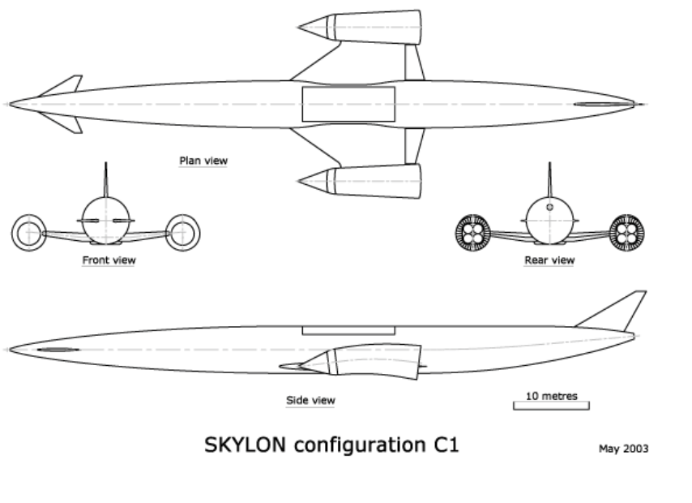
APPENDIX A

APPENDIX B
MATLAB CODES
- Code for the generation of the lift curve (Figure 2):
x=[0.25 0.5 3.09 1.5];

y=[3.7 3.8 1.38 3.39];

figure
hold on;

xi=0:0.01:4;
yi=interp1(x,y,xi,'spline');

plot(xi,yi);

plot(x,y,'*');

axis([0, 3.5, 0, 10])

ylabel('C_L per radian')
xlabel('Mach number M')
title('Lift curve slope vs Mach number for a spaceplane with A=3, lambda=0.25')
legend('M < 1 = Subsonic, 0.85 < M < 1.2 = Transonic, M > 1 = Supersonic')

- Code for the variation of the burn area and burn duration

%Internal External Tube Grain
%File Steady1.m
%Please see word document in dropbox for explanation of dimensions and
%grain design cross section

clear; clc;
%Ri= inner radius of propellant
%R0= outer radius of propellant
%L= Length
%eps= Ae/At= nozzle expansion ratio
%rp= aPc^n= propellant burn rate in cm/sec
%rop= propellant density in kg/m^3
%cstar= characteristic velocity in m/s
%As= area of outer circular cross section
%Ai= area of inner circular cross section
%Ae= nozzle exit area
%At= nozzle throat area
%Ab= burn surface area
%all areas in m^2
%all lengths and radii in meters

Ri=0.1; R0=1.25; L=1;
eps=40; a=0.4; n=0.3; rop=1938; cstar=1550;
A0=pi*R0*R0;
Ai=pi*Ri*Ri;
At=0.025;
Ae=eps*At;

t(1)=0; w(1)=0; dw=0; dt=0.5;
i=1;

%W=(R0-Ri)*100; %cm
%start integration loop
while w(i)<=(R0-Ri)*0.5
%grain geometry as function of time shown below
Ab(i)=2*pi*L*((Ri+w(i))+(R0-w(i)));
%convert a from (cm/s)/[MPa^0.3}] to m/s....
ams=a/100;
%Pc_one_minus_n= Pc^(1-n)
%divide by 1e6 to convert from Pa to MPa
Pc_one_minus_n= (ams*rop*Ab(i)*cstar/At)/1e6;
Pc(i)= Pc_one_minus_n^(1/(1-n));
rb(i)=ams*Pc(i)^n;
dw=rb(i)*dt;

w(i+1)=w(i)+dw;
t(i+1)=t(i)+dt;
Pc(i+1)=Pc(i); Ab(i+1)=Ab(i); rb(i+1)=rb(i);
i=i+1;
end

subplot(221); plot(t,100*rb); xlabel('t sec');
ylabel('Burn Rate rb (cm/s)');
grid on;
title('Internal External Burning Tube')
subplot(222); plot(t,100*w); xlabel('t sec');
ylabel('Web Length w (cm)');
grid on;
subplot(223); plot(t,Ab); xlabel('t sec');
ylabel('Burn Area Ab (m^2)');
grid on;
subplot(224); plot (t, Pc); xlabel('t sec');
ylabel('Pressure Pc (MPa)');
grid on;

- Code for the generation of the drag coefficient

clc;
clear;
M=[0:0.1:0.75];
R=(M/sqrt(1.4*287*288.15))*1.225*2.8/(1.7894*10^-5);
Cfw=0.455./((log10(R)).^2.58);
fM=1-0.08.*(M.^1.45);
xoverc_m=0.25;
toverc=0.04;
maxsweep= 45;
S=12;
Ftcw=(1+((2.7*toverc)+100*(toverc^4)));
Swetw=2*(1+(0.5*toverc*S));
Cd_0sub=1.07*Cfw.*Ftcw.*fM.*(Swetw./S);
Minf=[1.2:0.1:3.09];
Rinf= (Minf./sqrt(1.4*287*288.15))*1.225*2.8/(1.7894*10^-5);
Cfw=0.455./((log10(Rinf)).^2.58);
D_qwave=1.2.*(1-0.386*(Minf-1.2).^0.57.*(1-(pi*maxsweep^0.77)/100)).*((9*pi/2)*(S/Swetw)^2)/1000;
Cdwave=(1.07*( Cfw.*Swetw/S))+((1/S)*D_qwave);
x=[0:0.1:0.75 0.8315 1 1.05 1.2:0.1:3.09];
y=[Cd_0sub 0.002 0.0399713766814579/2 0.0399713766814579 Cdwave];
xi=0:0.01:4;
yi=interp1(x,y,xi,'spline');
figure
hold on;
plot(xi,yi);
plot(x,y,'*');
axis([0.2,3.5,0,0.06]);
xlabel('Mach Number (M)')
ylabel('Drag Coefficient')
title('Drag Coefficient vs Mach Number')
legend('M<0.8 = subsonic, 0.8<M<1.2 = transonic, M>1.2 = supersonic')

APPENDIX C
RAYMER’S PLOTS FOR MACH DRAG DIVERGENCE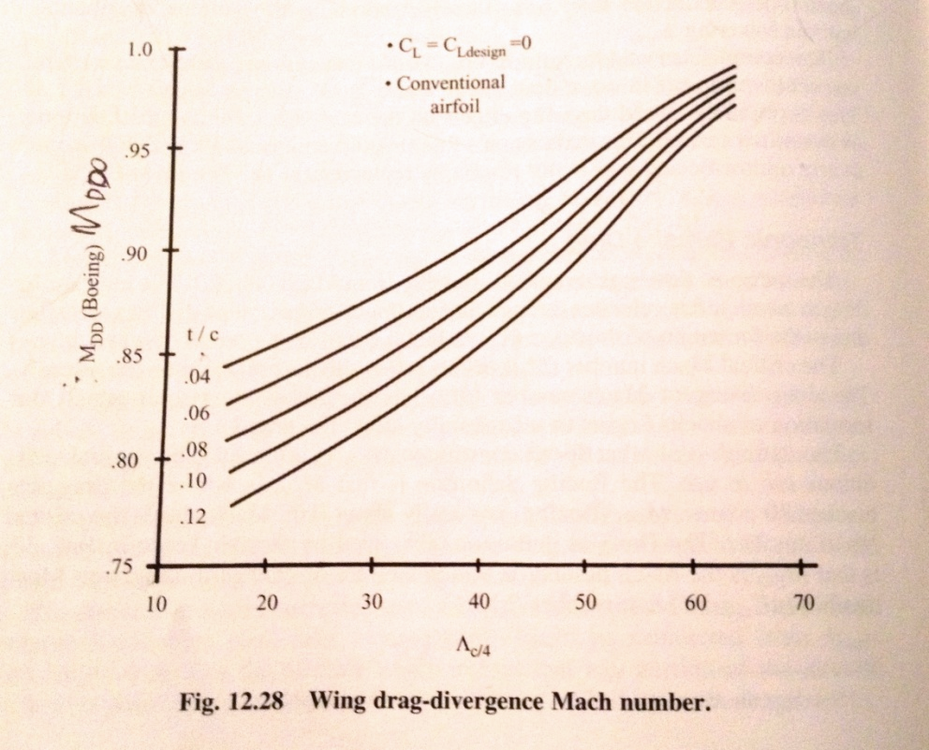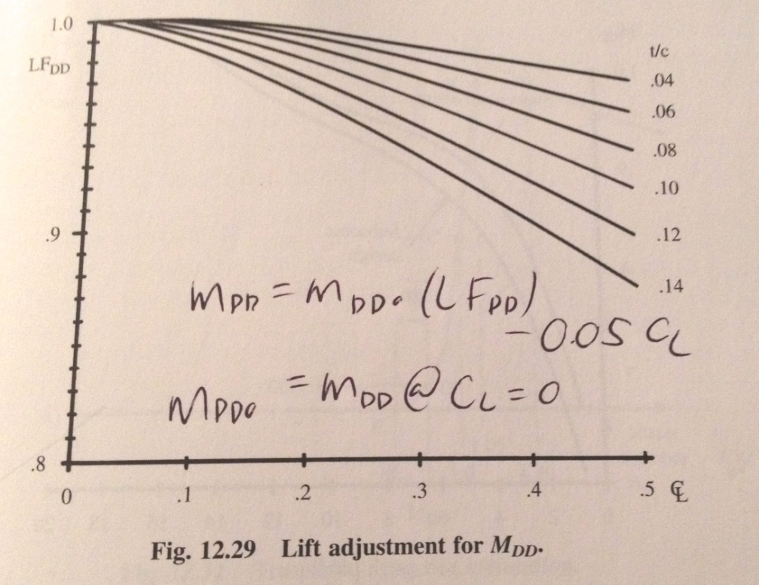

APPENDIX D
Computerized calculation for the Mach number at the nozzle exit
Generated by Wolfram|Alpha (www.wolframalpha.com) on March 25, 2015 from Champaign, IL.
40

1

x

0.86957

1

0.15
x
^
2
☹
^
7.6667
☹
^
0.5
Input
interpretation
:
40

1
x
0.86957

1

0.15
x
2

7.6667
Result
:
40

0.932507

0.15
x
2

1

7.6667
x
Numerical
solutions
:
More
digits
x

0.0233199750011293
…
x

4.41810208307632
…
APPENDIX E
TABLES FOR ROCKET MOTOR SIZING
TA

