Spacecraft’s Heat Shield Improvements

*A Causal Analysis*

For

Aerospace Engineers Board,

Chairman

By

Christopher Cabrera

**Letter of Transmittal**

600 South Clyde Morris Boulevard,

Daytona Beach, FL 32114

February 17, 2018

Chairman of NASA

Florida 32899

Space Coast, USA

Dear Board of Aerospace Engineering

Attached is my causal analysis of the different ways heat shields on spacecraft can be improved to better handle the inferno of the atmosphere’s temperatures on reentry. Heat shields are the only protection spacecraft have to protect themselves on reentry. The price to pay for a spacecraft with astronauts onboard and/or precious research data collected is priceless.

This report analyzes how various improvements to heat shields compare to the current heat shields being used now. Data will be collected from the improved heat shields versus the current heat shield and will see how each improvement varies from the current heat shield. It is evident that the heat shield being use on spacecraft currently can be improve to provide better protection when reentering earth’s atmosphere.

If you have any questions or would like more information regarding this report, please feel free to contact me via e-mail at cabrerc5@my.erau.edu. Thank you for your time.

Sincerely,

Christopher Cabrera

Enclosure

**Table of Contents**

Letter of Transmittal……………………………………………………………............ ii

List of Figures and Tables………………………………………………………………iv

Audience Scenario……………………………………………………………………… v

Abstract…………………………………………………………………………………vi

Introduction……………..……………………………………………………………… 1

Background and Purpose……..……………………………………………….…….. 1

Sources of Data…………………………………………………………………….... 1

Limitations to the Report……..…………………………………………………..…. 1

Working Definitions…………………………………………………………..….…. 1

Supplements to the Analysis……………………………….……………….….……. 1

Conclusion………………………………...………………………………….…..…. 1

Scope of Analysis……………………………………………………….……..….… 1

**List of Figures and Tables**

Figure 1.

**Audience Scenario**

The primary audience of this report is Aerospace engineers who work to design and create heat shield for spacecraft for their space agencies. The engineers as the primary audience will be able to make the necessary changes to their own heat shields to better the efficiently against the heat of the atmosphere during reentry. The second audience for this report is the engineers outside of aerosphere who deals with other versions of heat shields, for example, the heat shield in the engine of a car. The other types of engineers would be able to benefit and come up with ideas that they could implement on their heat shields.

**Abstract**

**Introduction**

**Background and Purpose**

Every time a spacecraft reenters earth’s atmosphere, the atmosphere extorts high temperature heat onto the spacecraft outer layer. A heat shield is used on of the outer layer to help prevent the layer from burn up. Heat shields are a honeycomb design that contains gel like substances that help absorb and/or reflect the heat around it. Just like a car’s tires that loses trend when it’s driven around, a heat shield also gets “used” up. However unlike a car’s tires that are replaced after many miles, a heat shield needs to be repair or even replaced after a single mission trip. The purpose of this report to analyze different ways that a heat shield could be improved to increase the efficiently of the heat protection it offers.

**Sources of Data**

This report contains patents of aerospace engineers who have worked at NASA as engineers. The engineers’ knowledge of working at one of the best space agency and being exposed to heat shields often, adds a higher level of expertise which would make this analysis more creditable. An interview with an aerospace engineer who teaches at Embry Riddle will also be a source of data, as he will be give his input of how a heat shield could be improve on.

**Limitations to the Report**

All information given by NASA of their current heat shields used on spacecraft will be used. All prototypes, unpublished versions of heat shields will not be counted for in this analysis. Current NASA information will be only used in this report, all This analysis will compare improvements on heat shield versus the current heat shield used by NASA.

**Working Definitions**

Boundary Layer:

**Supplements to the Analysis**

Appendices regarding material, construction and cost information can be found pages:

**Conclusion**

Given the improvements on the current heat shield used about NASA, it can be seen that indeed that improvements are more efficiently at remove/relocating the heat that the shield receives.

**Scope of the Analysis**

This casual analysis will cover the following topics:

* Two Alternatives for Better Heat Shield Efficiently
* Cost
* Reusability
* Design
* Profession option
* Overall Efficiency

**Collected Data**

**Two Alternatives for Better Heat Shield Efficiently**

Figure 1. (Shows the two different alternatives for a better heat shield efficiency).

**Low-density material (PICA-X)**

**­**

Ever since the first missions to reach outer space, we have been using heat shields to protect our spacecraft. One way that we have been improving our heat shield is using better material for the heat shield. Having a material with a low density ablative, would it increasing its durability, and has better resistance against heat when reentering the atmosphere. A newer low-density material would be a lightweight ceramic ablator, a reusable phenolic impregnated carbon ablator (PICA-X)­­­. In the figure below shows the current use of the PICA- X material on one of the spacecraft called Dragon owned by Space-X.

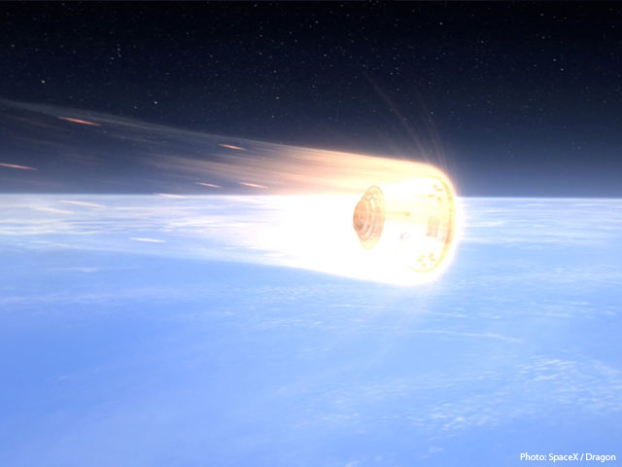

Figure 2. (Space X’s Dragon reentering Earth’s Atmosphere. The heat shield used on dragon is the PICA-X, protecting the spacecraft from 2,000 degrees C)

**Cost**

Although no public records exist for the price per tile for the PICA-X, Space-X has come out and said that the cost of PICA-X tile is a fraction of the cost of the normal PICA variant. One PICA tile costs about 3,000 dollars to buy. On the Mars Science Laboratory spacecraft mission to mars, over 30,000 tiles are used. Total cost for a heat shield for the Mars spacecraft is roughly $90,000,000. For the space shuttle program, according to the tiles' manufacturer, Lockheed Martin, the baked silica squares originally cost NASA about $10,000 per square foot installed. Typically, tiles measure about a quarter of that, or 6 by 6 inches (15.2 by 15.2 cm). More than 20,000 tiles are installed on each space shuttle. Roughly the total cost is 100,000,000. The new material PICA-X would save millions on cost alone.

**Reusability**

According to the Space X article the new PICA-X can potentially be used hundreds of times for Earth orbit reentry with only minor degradation each time — as proven on this flight — and can even withstand the much higher heat of a moon or Mars velocity reentry. Every time the space shuttle left earth for a mission, and came back, repairs to the heat shield would have been made, either a new tile replacement or a completely repair of the tile. For a new material to be used hundreds of times with minor fixes is a feat that will save billions to NASA each time they launch a spacecraft to orbit.

**Design**

Not only is the PICA-X cost and reusability efficient, but also it is design efficiently as well. The tiles are about 3 in (8 cm) thick, and weigh about 2 lbs (1 kg). The heat shield on the Dragon is only three inches thick. The shield is robust enough that only about half an inch, less than 1 centimeter, burns off during reentry allowing a comfortable safety emargin for both cargo and astronauts. To offer an example, the space shuttle program’s heat shield Varied in thickness from one inch (2.54 cm) to five inches (12.7 cm) depending on the heating they will be subjected to. The tiles collectively protect the orbiter from temperatures as high as 2,300 degrees Fahrenheit during its reentry into the Earth's atmosphere. To the everyday joe, shaving off two inches is nothing, however in the world of aerospace engineering, those two inches, going from five inches to three inches is about saving millions of dollars on cost and weight to the spacecraft. The figure below shows the PICA-X material thickness vs. the PICA material used in the shuttle program.

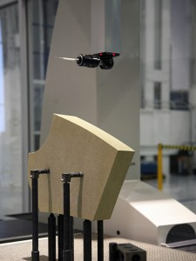

Figure 3(Shows actual PICA-X material tile before placement on the test heat shield by SPACE-X)

**Overall Efficiently**

The overall efficiently of the new material, PICA-X, is largely greater than current day use. Although the old material, PICA, development was a technologic advancement for it’s time, the newer material PICA-X offers a huge lower cost compare to its predecessor as a fraction to the cost. As far as reusability goes, the newer tiles are able to be used hundreds of times for earth orbit

**Heat Shield Link:**

[**http://arc.aiaa.org/doi/pdf/10.2514/2.3293**](http://arc.aiaa.org/doi/pdf/10.2514/2.3293)

**http://arc.aiaa.org/doi/pdf/10.2514/1.12403**