Data

In order to solve the problem proposed, I need several types of data. First, the specific Starbucks stores located within a radius of 50km of New York city. More specifically, I need each stores’ latitude, longitude, and store ID. This is done via a Foursquare venue search. (Due the limitation of the Foursquare data, I was only able to gather 50 stores located in New York city.) Next, with each store ID, I fetched more specific rating information of each store. (I also want to find sales record, but those data were not available to me.) I have attached processed. screenshots of the Starbucks location map as well as latitude, longitude, and 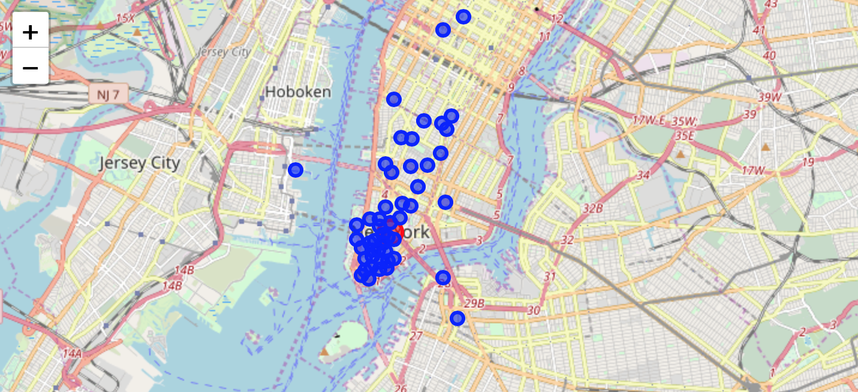rating data.