**Trigger**

1. **Students can borrow up to 5 books and staff can borrow up to 10 books**

CREATE OR REPLACE TRIGGER Stu_Five

BEFORE INSERT ON Borrow

FOR EACH ROW

DECLARE

number1 int;

number2 number(4);

BEGIN

SELECT MemberID INTO number2 FROM Memb WHERE :NEW.MemberID=MemberID ;

SELECT COUNT(*) INTO number1 FROM Borrow WHERE Borrow.MemberID = :NEW.MemberID AND Borrow.BStatus = 'Borrowing';

IF number2=:NEW.MemberID and number1=5 then

raise_application_error (-20004,'The maximum number of loan has been reached for a student!');

END IF;

END;

**Test Data**

SELECT * FROM Borrow;

INSERT INTO Borrow VALUES(1004,1112,'Borrowing', TO_DATE('20221209','yyyymmdd'), NULL);



CREATE OR REPLACE TRIGGER Sta_Ten

BEFORE INSERT ON Borrow

FOR EACH ROW

DECLARE

number3 int;

number4 number(4);

BEGIN

SELECT MemberID INTO number4 FROM Memb WHERE :NEW.MemberID=MemberID;

SELECT COUNT(*) INTO number3 FROM Borrow WHERE Borrow.memberID = :NEW.MemberID AND Borrow.BStatus = 'Borrowing';

IF number4=:NEW.MemberID and number3=10 then

raise_application_error (-20004,'The maximum number of loan has been reached for a staff!');

END IF;

END;

**Test Data**

SELECT * FROM Borrow;

INSERT INTO Borrow VALUES(2001,1112,'Borrowing', TO_DATE('20221209','yyyymmdd'), NULL);



1. **Judge whether the amount of resource is enough. If it is not enough, report an error and lend it out when it is enough**

CREATE OR REPLACE TRIGGER Lend_Resource

BEFORE INSERT ON Borrow

FOR EACH ROW

DECLARE amount int;

BEGIN

SELECT amount INTO amount FROM Reso WHERE :NEW.ResourceID=ResourceID;

IF amount=0 then

raise_application_error (-20003,'No inventory!');

ELSIF amount > 0 then

UPDATE Reso SET amount = amount - 1 WHERE :New.ResourceID = ResourceID;

END IF;

END;

**Test Data**

SELECT * FROM Reso;

SELECT * FROM Borrow;

INSERT INTO Borrow VALUES(2002,1112,'Borrowing', TO_DATE('20221209','yyyymmdd'), NULL);

**Befor Insert**

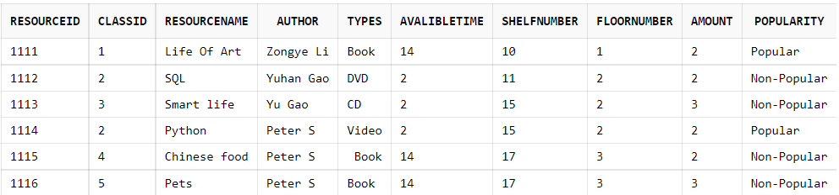

**After Insert**

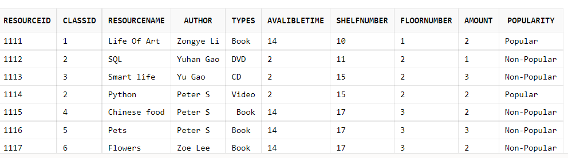

1. **Update the penalty for each person who borrows a resource**

CREATE OR REPLACE TRIGGER Update_Penalty

AFTER UPDATE OF ReturnDate ON Borrow

FOR EACH ROW

DECLARE

a_time int;

BEGIN

SELECT AvalibleTime INTO a_time FROM Reso WHERE ResourceID=:NEW.ResourceID;

IF TRUNC(:NEW.ReturnDate) - TRUNC(:NEW.StartDate)>a_time Then

UPDATE Loan set LAmount=(TRUNC(:NEW.ReturnDate) - TRUNC(:NEW.StartDate))-a_time WHERE :NEW.MemberID=MemberID AND :NEW.ResourceID=ResourceID AND LStatus='Unpaid';

UPDATE Loan set LStatus='Paid' WHERE :NEW.MemberID=MemberID AND :NEW.ResourceID=ResourceID and LStatus='Unpaid';

END IF;

END;

**Test Data**

SELECT * FROM Loan;

SELECT * FROM Borrow;

UPDATE Borrow SET ReturnDate = TO_DATE('20221226','yyyymmdd') WHERE MemberID = 1003 AND ResourceID = 1115;

**Before**

**Loan**

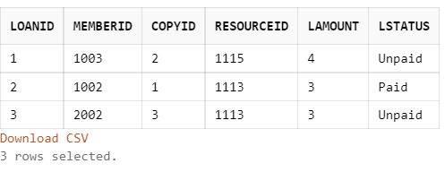

**Borrow**

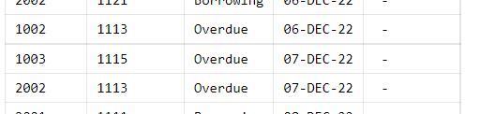

**Resource**

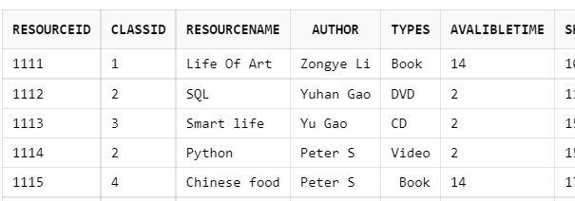

**After**

**Loan**

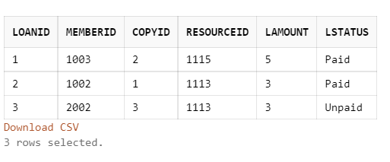

1. **The blacklist (all the resources a person has not paid back, add up to a total of 10 pounds in arrears)**

**You can keep borrowing books after you pay the fine**

CREATE OR REPLACE TRIGGER Not_Allowed

BEFORE INSERT ON Borrow

FOR EACH ROW

DECLARE

total int;

BEGIN

SELECT SUM(LAmount) INTO total FROM Loan WHERE :NEW.MemberID=MemberID AND LStatus='Unpaid';

IF total>=10 THEN

raise_application_error (-20100,'You are not allowed to borrow books. Please pay the fine as soon as possible!');

END IF;

END;

**Test Data**

INSERT INTO Borrow VALUES(2002,1111,'Borrowing',TO_DATE('20221204','yyyymmdd'),NULL);



1. **When the user returns the book, the amount of the resource that can be borrowed +1**

CREATE OR REPLACE TRIGGER update_Reso

AFTER UPDATE ON Borrow

FOR EACH ROW

DECLARE amount INT;

BEGIN

SELECT amount INTO amount FROM Reso WHERE :NEW.ResourceID = ResourceID;

CASE

WHEN UPDATING THEN

UPDATE Reso SET amount = amount + 1 WHERE :NEW.BStatus = 'Returned' AND :NEW.ResourceID = ResourceID;

END CASE;

END;

**Test Data**

UPDATE Borrow SET BStatus = 'Returned', ReturnDate = TO_DATE('20221207','yyyymmdd') WHERE MemberID = 2002 AND ResourceID = 1121 AND StartDate = TO_DATE('20221206','yyyymmdd');

**Before**

Resource

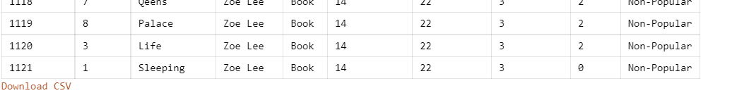

Borrow

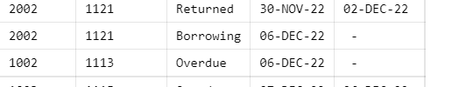

**After**

Resource

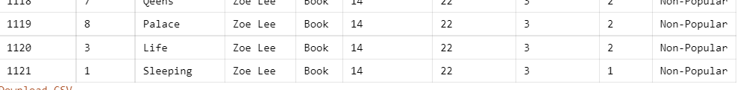

Borrow

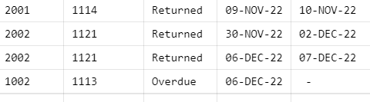

**6.**

CREATE OR REPLACE TRIGGER update_popularity

BEFORE INSERT ON Borrow

FOR EACH ROW

DECLARE Amount_Borrow INT;

BEGIN

SELECT COUNT(*) INTO Amount_Borrow FROM Borrow WHERE :NEW.ResourceID = ResourceID;

IF Amount_Borrow >= 4 THEN

UPDATE Reso SET Popularity = 'Popular' WHERE :NEW.ResourceID = ResourceID;

END IF;

END;

**Test Data**

INSERT INTO Borrow VALUES(1005,1113,'Borrowing', TO_DATE('20221212','yyyymmdd'),NULL)

**Before**

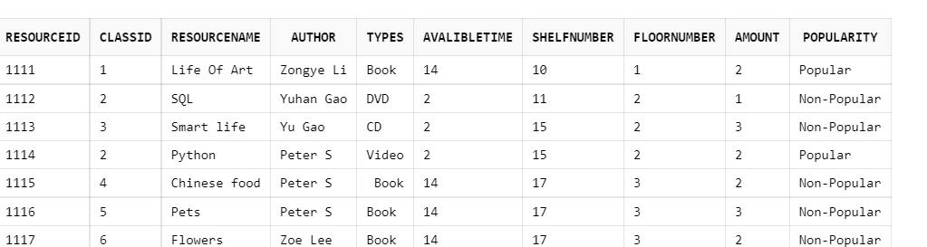

**After**

