**Neutron noise benchmark on a simplified UOX fuel assembly**

This document presents the calculations performed using the time-domain code FEMFFUSION developed at Universitat Politècnica de València, for the neutron noise benchmark on a simplified UOX fuel assembly. This code uses the neutron diffusion approximation with two energy groups. Their results must be similar to CORESIM+ developed by Chalmers University of Technology. The specifications of the benchmark are provided by CEA-Saclay.

# Computational mesh

The spatial mesh was defined by the benchmark using 138x138 cells. Results calculated FEMFFUSION use a 2nd degree polynomial in the finite element method. Also, the time step was set to 0.001 s simulating a total of 3 seconds (3 complete cycles).

# Critical calculation

The results of the static calculations are summarized in Table I.

Table I Values of keff .

|  |  |  |
| --- | --- | --- |
| Code | $$k_{eff}$$ | Relative difference |
| TRIPOLI-4® | 0.99912 ± 8 pcm | reference |
| CORE SIM+ | 1.01309 | 1398 pcm |
| FEMFFUSION | 1.01367 | 1456 pcm |

There is a mean relative difference between CORESIM+ and FMUFFUSION of 0.01 % for the fast flux and 0.13 % for the thermal flux.

# Neutron noise induced by a generic vibrating absorber

This section represents the results for the case 3 of the benchmark. Following the benchmark specifications, the change of the cross section is sowhn in Table II.

Table II: Amplitude of the cross-section change.

|  |  |
| --- | --- |
| Cross Section | Value |
| δD1 | 3.622567e-02 |
| δΣa1 | 1.546450e-02 |
| δΣf1 | 3.137549e-04 |
| δΣf12 | 2.940014e-05 |
| δD2 | 2.486140e-02 |
| δΣa2 | 2.257624e-02 |
| δΣf2 | 5.778823e-03 |

Only the noise at the perturbation frequency (1 Hz) are show. The amplitude of the neutron noise is normalized by the value of the neutron noise in the computational cell with index (1,1). The mean relative differences between FEMFFUSION of CORE SIM+ is of 1.03 % for the noise of the fast flux and 2.59 % for the thermal flux noise and the noise of the thermal flux. This difference can be seen at Figure 1.

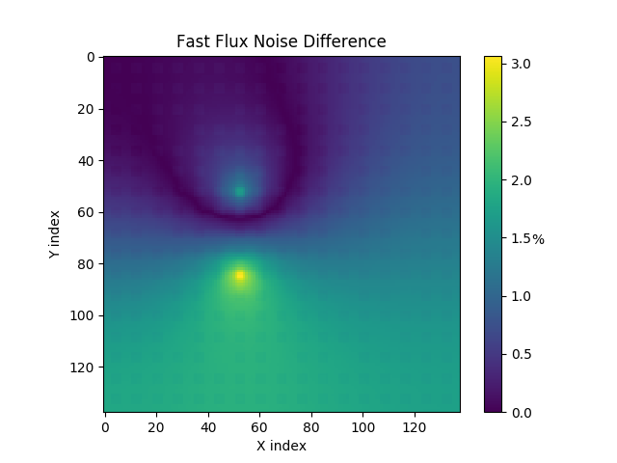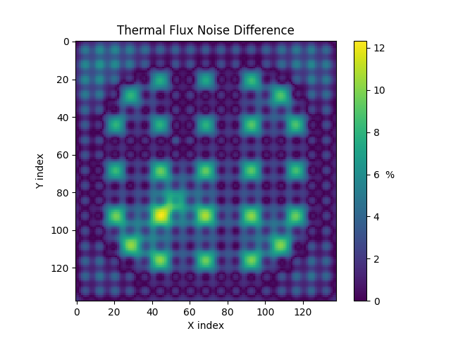

*Figure 1 Relative difference between FEMFFUSION and CORESIM+ noise amplitudes, for the fast flux noise amplitude (left) and for the thermal flux noise amplitude (right).*

The phase difference is smaller of only 0.71 % for both the fast and thermal flux noises.