Introduction to Structural Organisation in Animals
The animal kingdom shows a vast diversity of organisms, ranging from unicellular organisms to highly complex multicellular animals. In unicellular organisms, all essential life processes such as digestion, respiration, and reproduction are carried out by a single cell. In contrast, multicellular animals have different groups of cells specialized to perform different functions.
A simple multicellular organism such as Hydra consists of different types of cells, while the human body is made up of billions of cells that work together in coordination.
To make this coordination possible, similar cells, along with the intercellular substances surrounding them, are organized into groups called tissues. In complex animals, tissues are organized in specific patterns and proportions to form organs, such as the heart, lungs, stomach, and kidneys.
When two or more organs work together to perform a particular function, they form an organ system, such as the digestive system or respiratory system. Thus, multicellular animals show a well-organized hierarchy
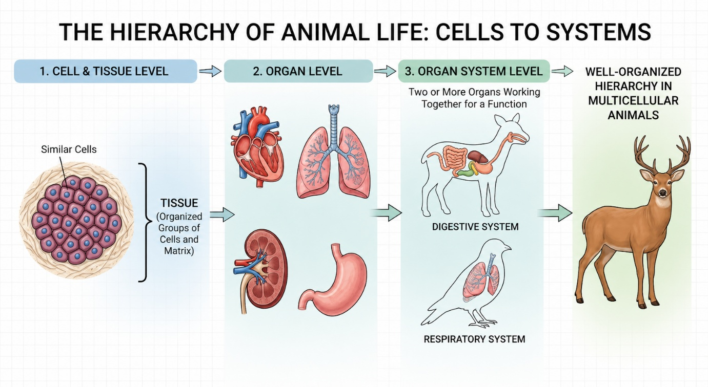
Img: The Hierarchy of Animal life:Cells to Systems

This organization allows different parts of the body to perform specialized functions through an efficient division of labour, ensuring the proper functioning and survival of the organism.

Animal Tissues
In complex animals, cells are specialized to perform different functions. Groups of cells with similar structure and specialized functions are organized into different types of animal tissues. Each tissue has structural features that are closely related to the function it performs.
In complex animals, animal tissues are broadly classified into four basic types:
- Epithelial tissue
- Connective tissue
- Muscular tissue
- Neural tissue
Each type has its own characteristic structure and performs specific functions in the body.

