# **Automatically Add Dynamic Email Signatures with Office 365 using Exchange Transport Rules**

With office 365 and the Exchange Admin Center, adding dynamic email signatures is easier than you might think.

Check out the walk through guide below for step by step instructions on how to set this up today.

**To start, we are going to want to head over to** [**http://portal.office.com**](http://portal.office.com/) **and log into Office 365**

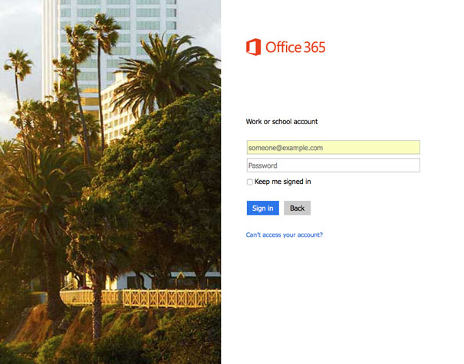

**Once logged in, in the admin center at the bottom of the left sidebar menu, click “Admin centers”**

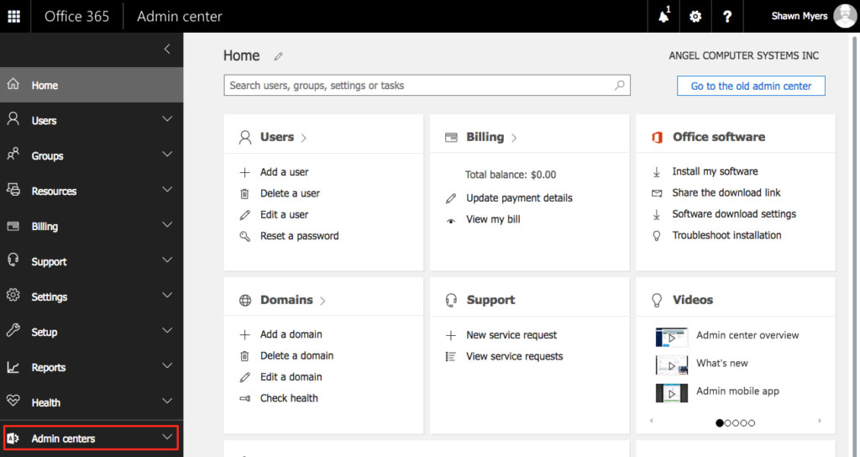

**In the expanded sub menu, click “Exchange”**

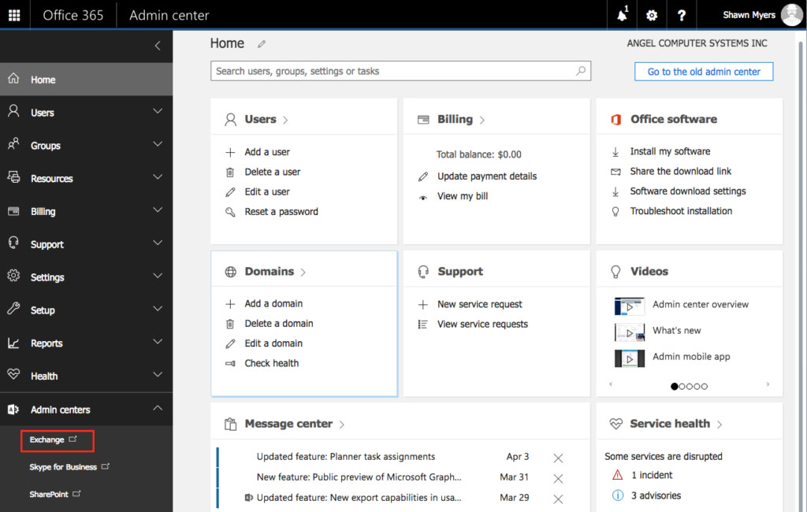

**Once inside the Exchange Admin Center, select “Mail Flow” from the left sidebar menu.**

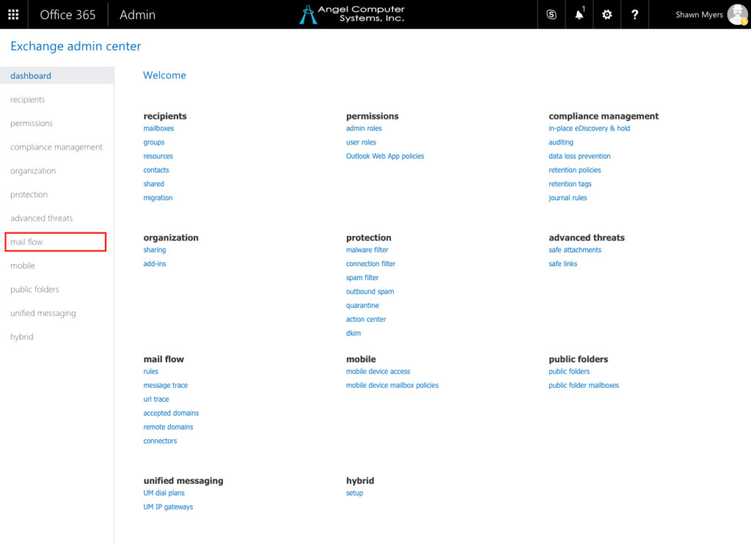

**Once inside the mail flow category, make sure you are in the “Rules” section in the top menu.**

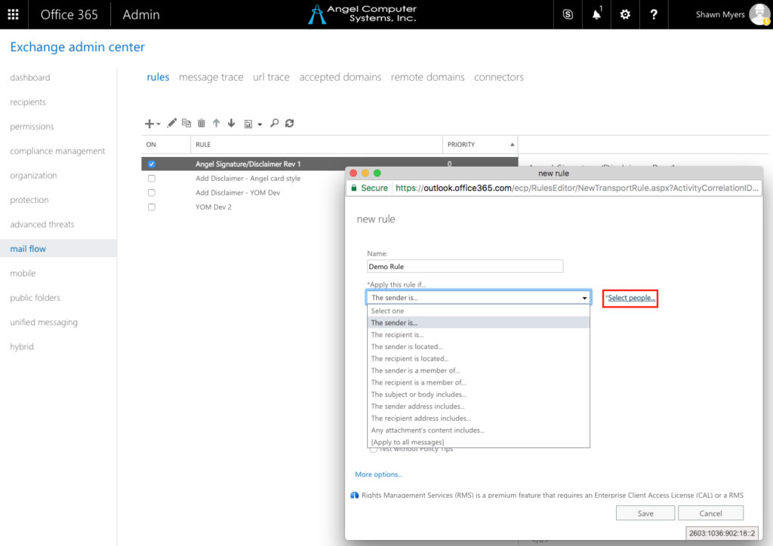

**Click on the “+” and then select “Create a new rule”**

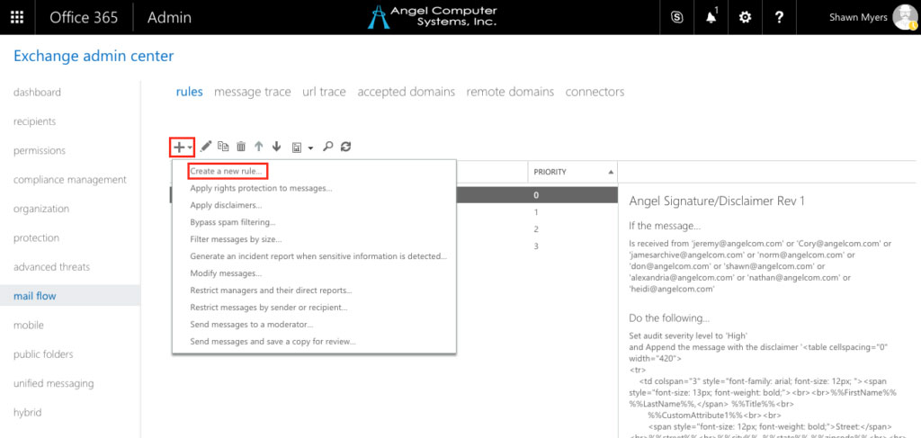

**Give your new rule a name**

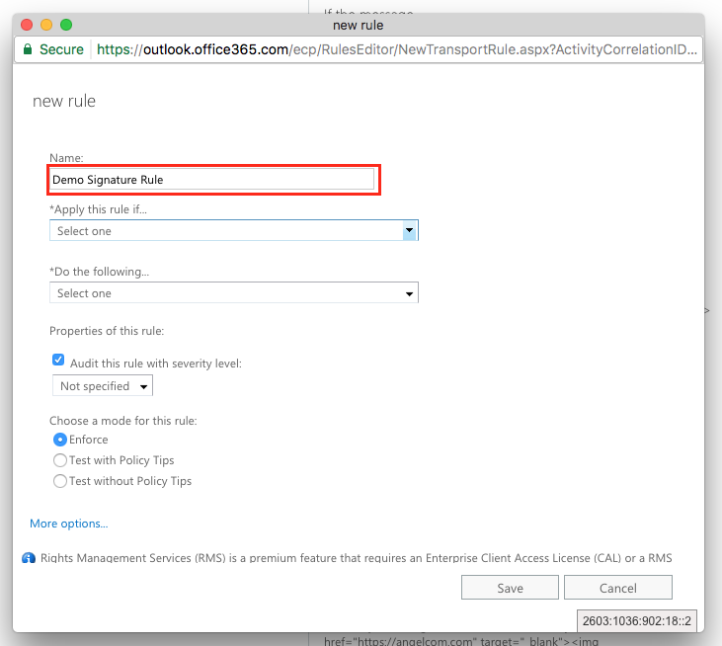

**Under “Apply this rule if…”, select “The sender is…”**

F,{fdfcf673-3900-4003-9fc8-7fafc81dd582}{41},13,9.1875

**If a pop up window asking you to select members does not pop up automatically, you will need to click the “*Select people…” link.**

F,{fdfcf673-3900-4003-9fc8-7fafc81dd582}{70},13,9.1875

**From this window, you can select everyone that you want to be included in the rule. Anyone that you want to have a signature. You can use the “Ctrl” key to select multiple senders.**

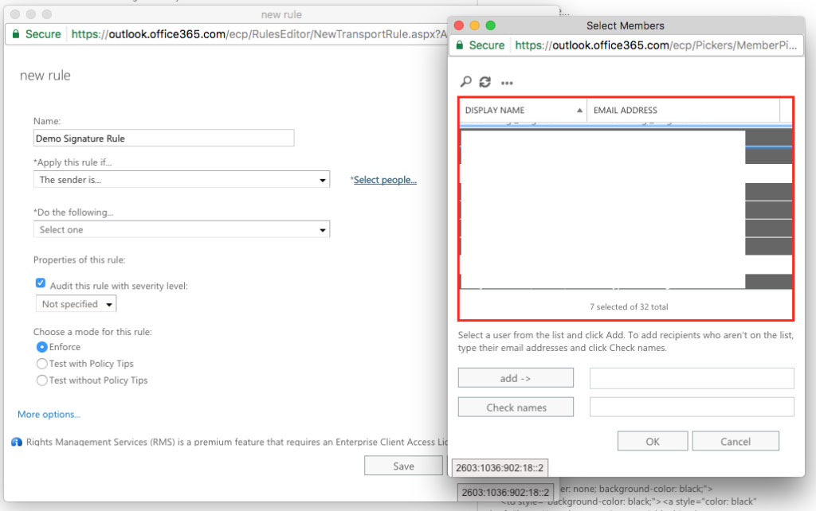

**Click the “add – >” button to add the selected senders, then click “OK” to save and close the window.**

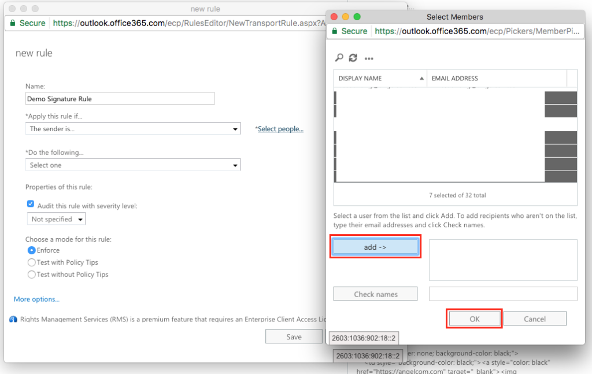

**Now, we are going to skip down to add an exception to the rule. This exception will allow us to tell our rule that we only want it to run once. Otherwise, after emailing & responding back and forth with a co-worker a few times you’ll notice that you get a nice stack of signatures at the bottom of the email conversation.**

**Scroll down to the bottom of your rule and click on “More options”, scroll down and click on the “add exception” button.**

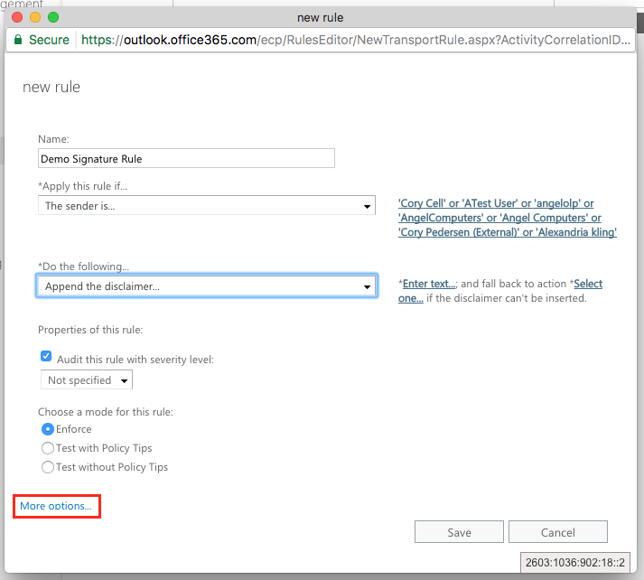

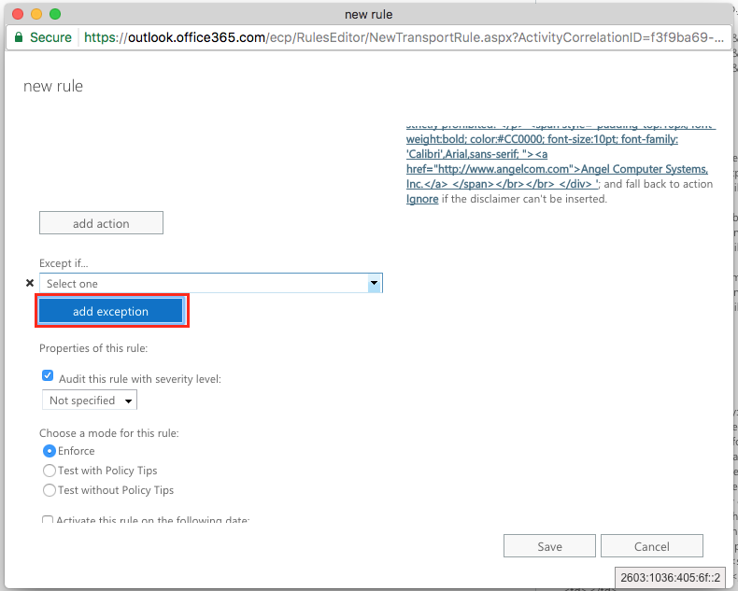

**From the drop down menu, select “The subject or body…”, then select “subject or body includes any of these words”**

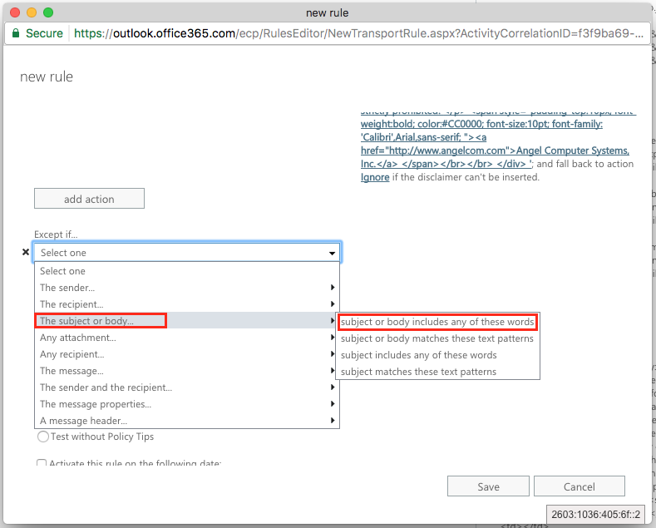

**We are going to want to choose a unique mix of letters and symbols. Something that wouldn’t normally be included in an email. This rule exception looks for this key and will not add the signature to your email if it finds it. Eliminating the stack of email signatures at the bottom of the conversation.**

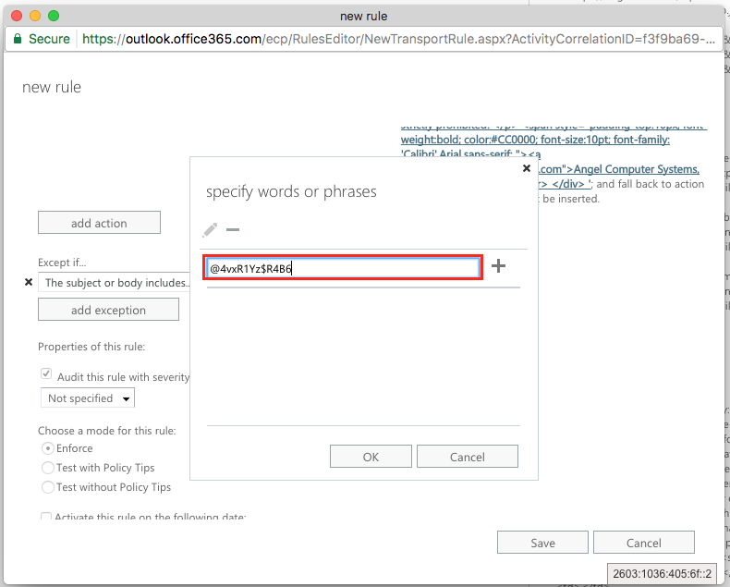

**Once you come up with your unique phrase, enter it in the field and click the “+” button. Click the “OK” button to save.**

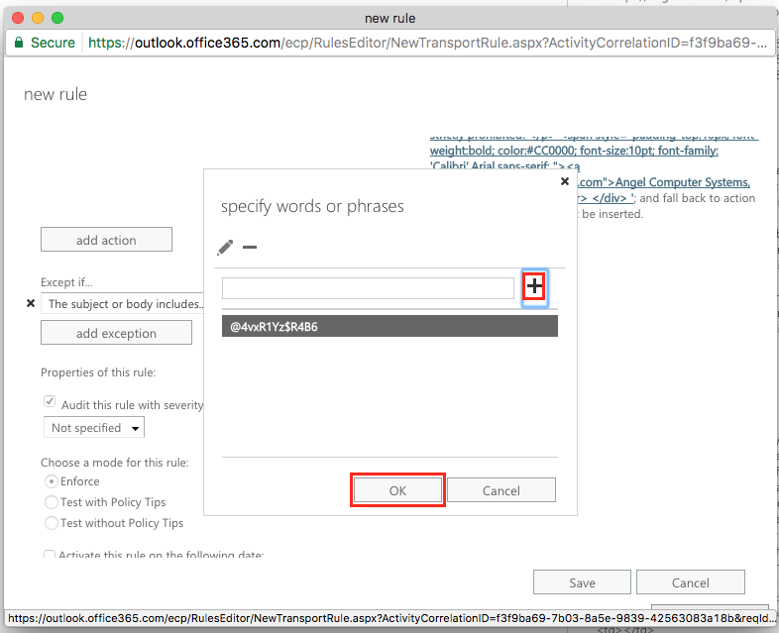

**In the next step, we need to scroll back up and give our rule an action. Under “*Do the following…”, select” Append the disclaimer…”**

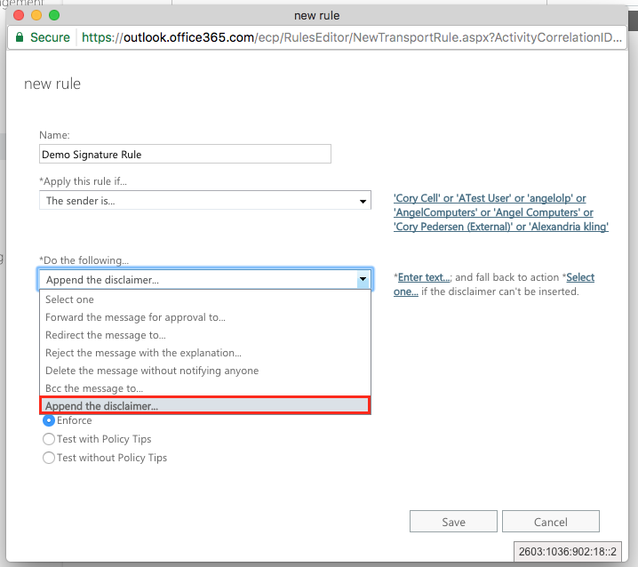

**To the right, click on”*Enter text…” to add the text of your signature.**

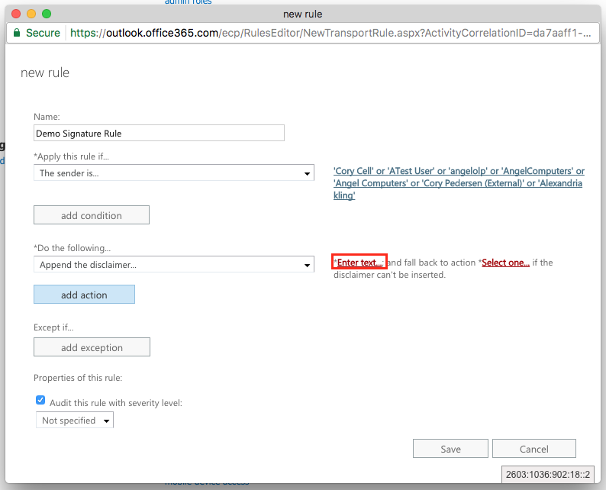

**You can use HTML, CSS and make the signature dynamic (one rule for all company signatures) using tokens to add attributes from each senders Active Directory account. For a full list of attributes that can be used in your signature, check out Microsoft’s,** [**Mail flow rule conditions and exceptions (predicates) in Exchange 2016**](https://technet.microsoft.com/en-us/library/dd638183(v=exchg.160).aspx)**.**

**Make sure to include the unique phrase we created in the above step. You can add a little inline CSS to the signature to hide the unique phrase. The example below assumes that your signature has a white background and changes the color of the unique phrase text to white to hide it.**

<span style=”color: #fff;”>@4vxR1Yz$R4B6</span>

**Here’s an example of an HTML signature that includes unique user attributes along with an IMG tag and in-line CSS:**

<div style=”font-size: 9pt; font-family: ‘Century Gothic’,sans-serif;”>%%displayname%%  
%%title%%  
%%company%%  
%%street%%  
%%city%%, %%state%% %%zipcode%%</div>  
&nbsp;  
<div style=”background-color: #d5eaff; border: 1px dotted #003333; padding: .8em;”>  
<div><img style=”margin-bottom: 10px; max-width: 200px;” src=”https://angelcom.com/wp-content/uploads/2015/05/angel_logo.jpg” alt=”Angel Logo” /></div>  
<span style=”font-size: 12pt; font-family: ‘Cambria’,’times new roman’,’garamond’,serif; color: #ff0000;”>HTML Disclaimer Title</span>  
<p style=”font-size: 8pt; line-height: 10pt; font-family: ‘Cambria’,’times roman’,serif;”>This message contains confidential information and is intended only for the individual(s) addressed in the message. If you are not the named addressee, you should not disseminate, distribute, or copy this e-mail. If you are not the intended recipient, you are notified that disclosing, distributing, or copying this e-mail is strictly prohibited.</p>  
<span style=”padding-top: 10px; font-weight: bold; color: #cc0000; font-size: 10pt; font-family: ‘Calibri’,Arial,sans-serif;”><a href=”http://www.angelcom.com”>Angel Computer Systems, Inc.</a>  
</span>  
<span style=”color: #fff;”>@4vxR1Yz$R4B6</span>  
</div>

**Once the signature text is in place, go ahead and click “OK”**

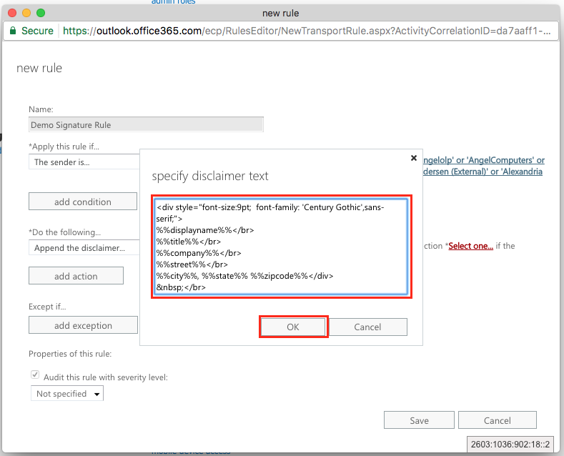

**Next, create a fall back to action by clicking on “*Select one…”**

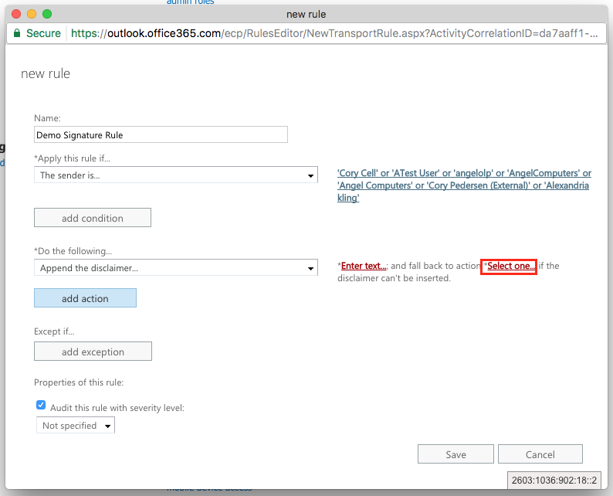

**Select “Ignore” from the list of fallback actions and click “OK” to save.**

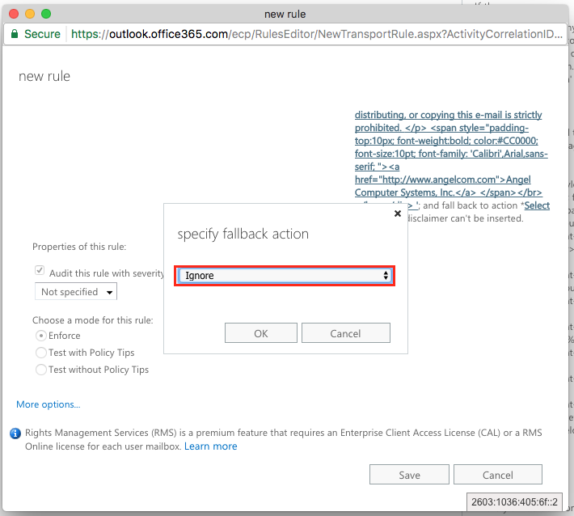

**Next, scroll down to the checkbox “Audit this rule with severity level:”, make sure the box is checked and choose “High” from the list.**

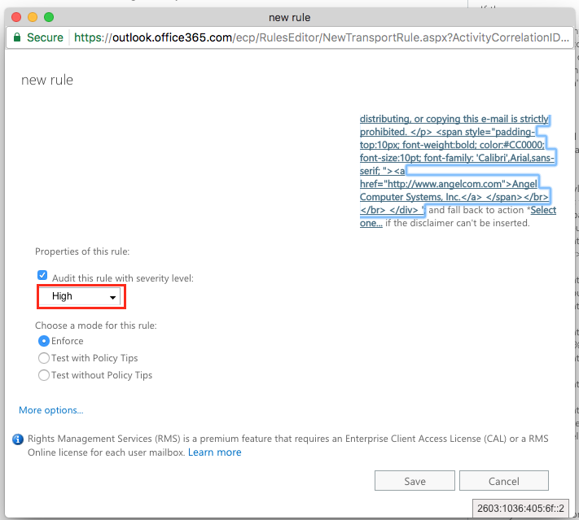

**The rest of the options will keep their default setting. Click “Save” to save your new rule.**

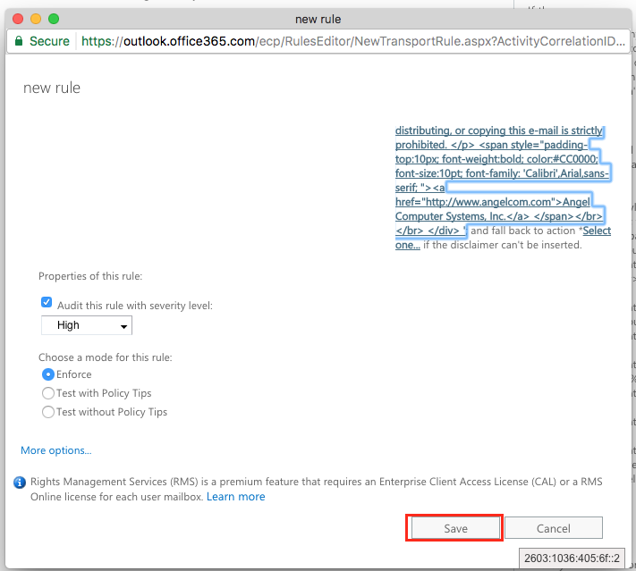

**Now that your rule is in place, the selected senders will have their signature automatically appended to each outgoing email.**

**Send yourself a test email to verify that the new rule is working properly. If everything works like you want it to, you are done!**