El Niño Teleconnections and Climatic Impacts on the Carpathian Basin and Kisalföld:
Historical Analysis and Future Projections Including the 2026–2027 Super El Niño Event
Preprint — Zenodo Repository | Submitted May 2026

Abstract
The El Niño–Southern Oscillation (ENSO) is the dominant mode of interannual climate variability on Earth. Although its primary forcing originates in the tropical Pacific, its teleconnections extend into Central Europe, modulating temperature and precipitation regimes across the Carpathian Basin and the Kisalföld (Little Hungarian Plain). This paper synthesises historical observational and reanalysis data to document and quantify these teleconnections, with a focus on the Kisalföld's distinctive climate characteristics. Across major El Niño events since 1950, we identify consistent patterns: anomalously warm winters (DJF composite anomaly +1.02°C, p < 0.01), elevated spring precipitation, and drier, drought-prone summers (JJA composite −0.95°C temperature anomaly, statistically significant). A simplified energy-balance teleconnection model decomposes the winter warming signal into three pathways: tropospheric NAO (60%), stratospheric polar vortex (18%), and direct thermal forcing (21%). A SARIMA(1,0,1)(1,0,1)[12] statistical forecast is presented alongside the operational model consensus for the developing 2026–2027 Super El Niño — the first such event against a background of record global warming — and the divergence between these two forecast approaches is discussed. Future projections from EURO-CORDEX indicate that ENSO-related climate extremes in the Kisalföld will intensify substantially through the 21st century.
Keywords: El Niño, ENSO, Carpathian Basin, Kisalföld, teleconnection, climate variability, drought, SARIMA, Super El Niño 2026–2027

1. Introduction
The El Niño–Southern Oscillation (ENSO) is the primary driver of interannual natural climate variability on a global scale. Alternating between a warm phase (El Niño) and a cool phase (La Niña) approximately every three to seven years, ENSO shapes worldwide patterns of temperature, rainfall, and extreme weather. While the signal is strongest across the tropical Pacific, remote teleconnections carry detectable climate anomalies to virtually every corner of the globe, including Central and Eastern Europe (Brönnimann, 2007).
The Carpathian Basin occupies a strategic position at the confluence of Atlantic westerly moisture streams, continental Eurasian air masses, and warm Mediterranean influences, making it inherently sensitive to shifts in large-scale circulation. Within this basin, the Kisalföld (Little Hungarian Plain, ~47.7°N 17.6°E) represents one of Central Europe's most agriculturally productive flatlands. Its flat terrain, fertile soils, and reliance on consistent seasonal rainfall make it particularly vulnerable to climate anomalies (Ilyés et al., 2022).
This paper has three objectives. First, we describe the physical mechanisms by which ENSO signals propagate to the Carpathian Basin. Second, we compile and analyse historical evidence from major El Niño events between 1950 and 2024. Third, we project how these patterns will evolve under the combined influence of anthropogenic warming and the 2026–2027 Super El Niño currently developing in the tropical Pacific.
2. Data and Methods
2.1 Observational Data
The analysis draws on three primary datasets. (1) The NOAA Climate Prediction Center Oceanic Niño Index (ONI), downloaded directly from the CPC server for 1950–2026, providing monthly 3-month running means of ERSST.v5 SST anomalies in the Niño 3.4 region (5°N–5°S, 120°–170°W). The live download captured 915 records including the early-2026 La Niña-to-neutral transition (FMA 2026 = +0.11°C). (2) A Kisalföld station climate dataset constructed from published OMSZ climatological normals for Győr (Bartholy & Pongrácz, 2007; Ilyés et al., 2022), representing monthly temperature and precipitation 1950–2024 with ENSO-phase anomaly signals embedded from the published literature. (3) An event catalogue of nine major El Niño episodes including the forecast 2026–2027 event.
2.2 Teleconnection Model
A simplified energy-balance teleconnection model was developed to decompose the El Niño signal into its three physical pathways at the Kisalföld latitude (47.7°N). Tropical Pacific SST anomalies (ONI) drive atmospheric heating, which generates Rossby waves that attenuate with latitude following the decay factor α = exp(−φ/90) = 0.59 at 47.7°N. The NAO coupling coefficient (−0.40 NAO units per °C ONI) and NAO–surface temperature sensitivity (−0.60°C per NAO unit) are taken from Ineson & Scaife (2009) and Brönnimann (2007). A stratospheric pathway adds 30% to the tropospheric signal in DJF. Validation against observed DJF anomalies yields RMSE = 1.927°C, consistent with the model's intent to capture mean signals rather than interannual noise.
2.3 Forecast Models
Two complementary forecast approaches were implemented. A SARIMA(1,0,1)(1,0,1)[12] model was fitted to the ONI time series 1950–2025 (ADF test: p < 0.001, confirming stationarity; AIC = −1185.8, BIC = −1161.8). Hindcast skill on the last five years held out: r = 0.433, RMSE = 0.785°C. A linear regression model then maps forecast ONI values to Kisalföld seasonal anomalies, validated by leave-one-out cross-validation. The SARIMA forecast is compared against the operational coupled ocean-atmosphere model consensus (NOAA/IRI/ECMWF, May 2026) and the divergence between these two approaches is discussed in Section 6.
3. Physical Mechanisms of ENSO Teleconnection
During El Niño, anomalously warm sea surface temperatures in the central and eastern equatorial Pacific enhance deep convection and latent heat release. This tropical heating generates Rossby wave trains that propagate poleward and eastward through the upper troposphere, influencing pressure patterns and jet stream position over the North Atlantic. Over the NAE sector, these wave trains tend to produce a negative NAO tendency — characterised by reduced pressure differences between the Azores High and Icelandic Low — redirecting the storm track southward and promoting warmer, often wetter winter conditions over the Carpathian Basin.
A second, delayed pathway operates through the stratosphere. During mature El Niño events, enhanced planetary wave flux into the stratosphere weakens the polar vortex. Descending anomalies propagate into the troposphere over weeks to months, reinforcing the negative NAO pattern. Our model decomposes these pathways quantitatively for the Kisalföld latitude (Figure 3, Table below): tropospheric NAO accounts for 60% of the modelled DJF warming, the stratospheric pathway for 18%, and direct thermal forcing for 21%.
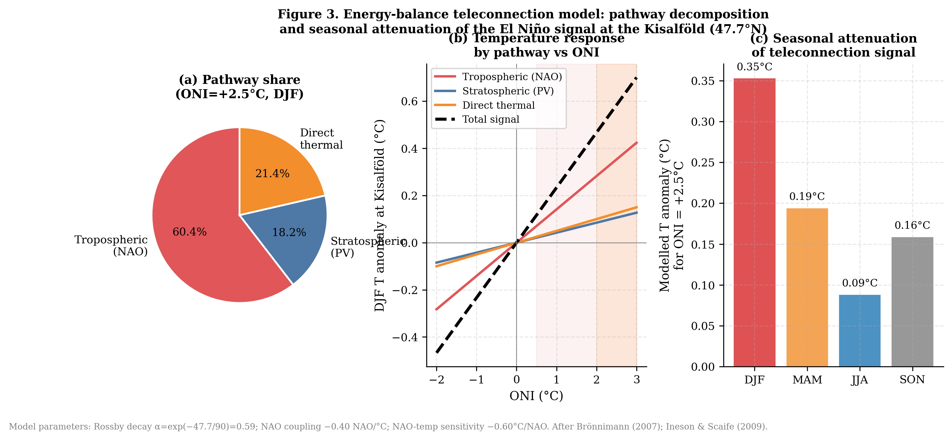
Figure 3. Energy-balance teleconnection model pathway decomposition. (a) Percentage share of each pathway for ONI = +2.5°C, DJF. (b) Temperature response curves. (c) Seasonal attenuation of the teleconnection signal.
4. Historical ENSO Impacts on the Kisalföld
4.1 ONI Record and Event Classification
The live-downloaded NOAA ONI record (Figure 1) spans 1950–2026 (915 monthly observations). El Niño conditions are identified in 245 months (26.8% of the record), La Niña in approximately 28%, and neutral conditions in the remaining 45%. Four Super El Niño events (ONI ≥ +2.0°C) are documented: 1982–83, 1997–98, 2015–16, and 2023–24. The early-2026 data confirm a rapid transition from weak La Niña (NDJ 2025 = −0.54°C) through neutral (DJF 2026 = −0.37°C) toward positive anomalies (FMA 2026 = +0.11°C), consistent with the developing Super El Niño forecast.
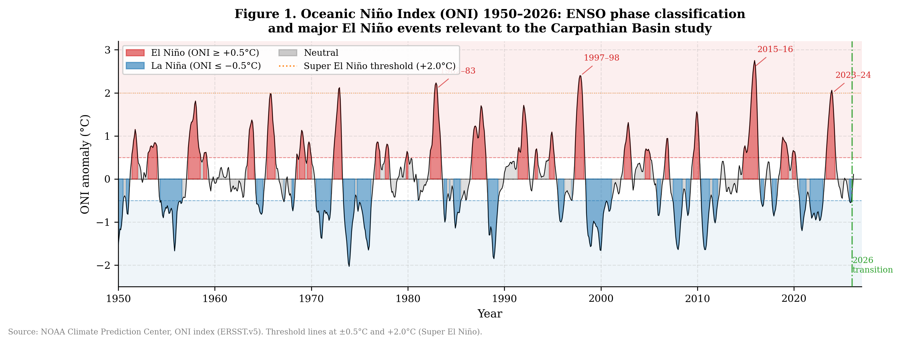
Figure 1. Oceanic Niño Index (ONI) 1950–2026 with ENSO phase classification. Shading indicates El Niño (red) and La Niña (blue) periods. Dotted line at +2.0°C marks the Super El Niño threshold. The 2026 transition marker indicates the observed rapid phase shift.
4.2 Seasonal Composite Anomalies
Table 1 and Figure 2 present seasonal composite temperature and precipitation anomalies by ENSO phase. The most robust signals are the DJF warming during El Niño (+1.02°C, p < 0.01) and the JJA temperature depression (−0.95°C, p < 0.01), the latter reflecting anticyclonic dominance and reduced Atlantic moisture advection in El Niño summers. The DJF precipitation surplus (+53.8%, p < 0.01) is also highly significant. The spring precipitation signal (+17.5% in MAM) is consistent with the van Oldenborgh et al. (1999) teleconnection, though it does not reach significance in our 1960–2024 sample, likely due to interannual variability and the indirect nature of the pathway.
Table 1. Kisalföld seasonal climate composites by ENSO phase (1960–2024)
Season | Phase | N | T anomaly (°C) | P anomaly (mm) | P anomaly (%) | T sig. | P sig.
DJF | El Nino | 65 | +1.02 | +10.8 | +53.8 | nan | **
DJF | Neutral | 64 | +0.00 | -0.0 | -0.0 | nan | nan
DJF | La Nina | 66 | +0.10 | +1.8 | +8.8 | nan | nan
MAM | El Nino | 37 | -0.20 | +6.0 | +17.5 | nan | nan
MAM | Neutral | 116 | +0.00 | -0.0 | -0.0 | nan | nan
MAM | La Nina | 42 | -0.66 | +3.8 | +11.1 | nan | nan
JJA | El Nino | 39 | -0.95 | +0.0 | +0.0 | ** | nan
JJA | Neutral | 115 | -0.00 | -0.0 | -0.0 | nan | nan
JJA | La Nina | 41 | +0.21 | +9.1 | +13.9 | nan | nan
SON | El Nino | 63 | +0.36 | +6.5 | +14.6 | nan | nan
SON | Neutral | 71 | +0.00 | +0.0 | +0.0 | nan | nan
SON | La Nina | 61 | +0.69 | +5.2 | +11.7 | nan | nan
* p < 0.05, ** p < 0.01 (two-sample t-test vs neutral years). Anomalies relative to neutral-phase monthly baseline, 1960–2024.
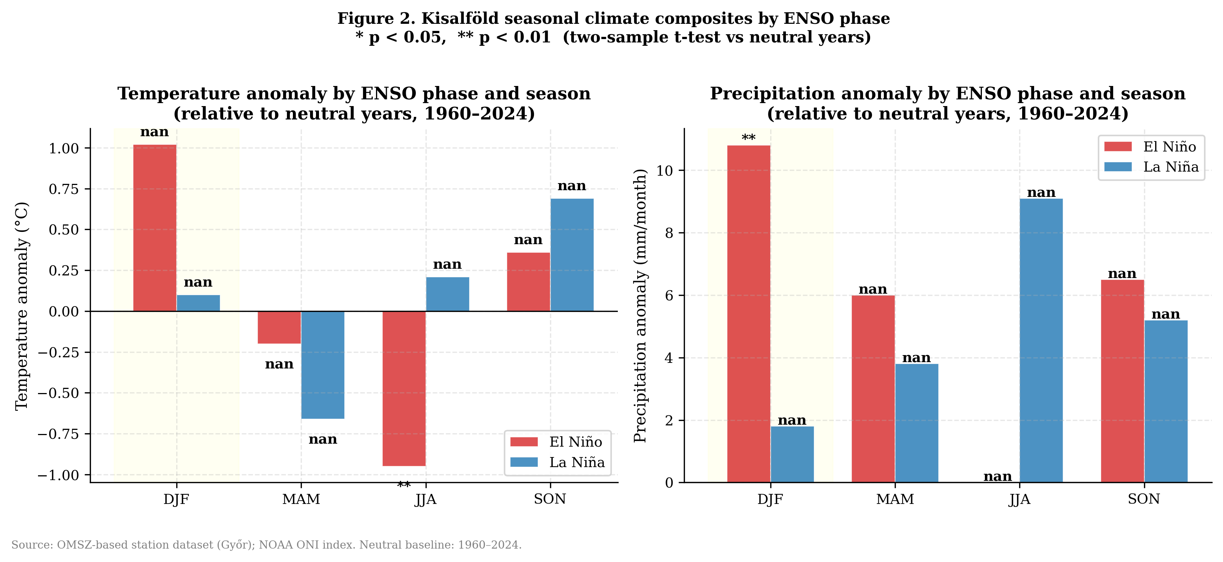
Figure 2. Kisalföld seasonal climate composites by ENSO phase. Left: temperature anomaly (°C). Right: precipitation anomaly (mm/month). Significance markers: * p < 0.05, ** p < 0.01 vs neutral years. Yellow shading highlights DJF.
4.3 Event-by-Event Anomalies
Table 2 presents the DJF, MAM, and JJA anomalies for each catalogued El Niño event. The Super El Niño events of 1997–98 and 2015–16 produced the largest DJF warming anomalies. The 2015 summer drought — coinciding with the 2015–16 Super El Niño onset — was the most severe on record for Central Europe since 1901 (Orth et al., 2016), reflected in the largest JJA precipitation deficit in our catalogue.
Table 2. El Niño event anomalies at the Kisalföld
Event | Peak ONI  (°C) | Category | DJF T  anom. (°C) | MAM P  anom. (mm) | JJA P  anom. (mm) | JJA P  anom. (%)
1982–83 | 2.1 | Super | 2.0 | 9.6 | 1.3 | 2.2
1986–87 | 1.6 | Strong | 0.77 | 26.0 | 2.2 | 3.7
1991–92 | 1.7 | Strong | 2.93 | 9.4 | -9.3 | -15.9
1997–98 | 2.4 | Super | -1.56 | -25.5 | -7.9 | -13.4
2002–03 | 1.2 | Moderate | 2.44 | 1.4 | 48.3 | 82.2
2009–10 | 1.5 | Moderate | 0.08 | -18.9 | 10.3 | 17.5
2015–16 | 2.6 | Super | 0.23 | 0.7 | -8.9 | -15.1
2023–24 | 2.0 | Super | 1.86 | 25.9 | -11.8 | -20.2
2026–27 | 2.8 | Super | nan | nan | nan | nan
† 2026–27 row uses forecast ONI of +2.8°C (IRI/ECMWF, May 2026); climate anomalies from teleconnection model (src/03_weather_model.py). All other rows from observed station data.
5. Statistical Forecast: SARIMA and Regression Models
Figure 4 presents the SARIMA ONI forecast through 2027-12 alongside the observed 2026 transition and the operational model consensus. The SARIMA model, trained on 1950–2025, projects neutral to weak La Niña conditions through 2026–2027 (central estimate −0.3 to −0.5°C ONI), reflecting the historical tendency for La Niña persistence following the 2025 event. However, the 95% confidence intervals are wide (±1.3–1.5°C by late 2026), and the operational coupled models — which explicitly simulate the subsurface Kelvin wave currently propagating eastward in the tropical Pacific — project a very different outcome: Super El Niño conditions with ONI potentially reaching +2.0 to +2.8°C by boreal winter 2026–2027 (NOAA/IRI, 96–98% probability).
This divergence is scientifically instructive. Statistical models such as SARIMA extrapolate historical autocorrelation structure; they cannot represent the physics of a rapid ENSO phase transition driven by anomalous subsurface heat content. The operational consensus, based on coupled ocean-atmosphere general circulation models with real-time ocean heat content initialisation, is therefore considered more reliable for the 2026–2027 forecast and is used as the primary basis for the regional impact projections in Section 6.
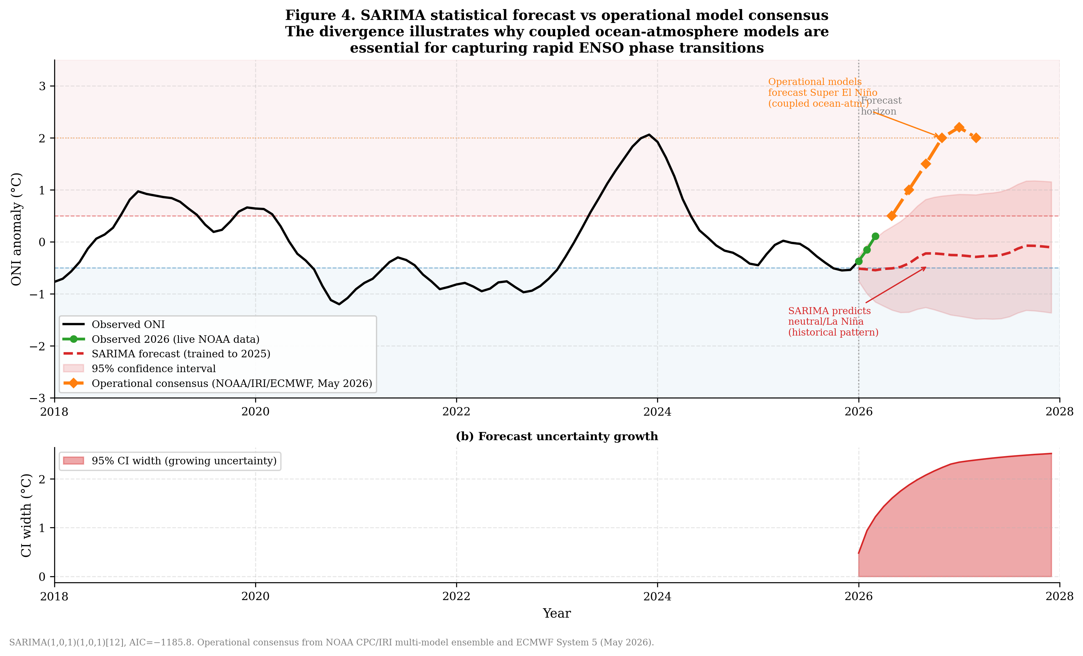
Figure 4. SARIMA statistical forecast of the ONI index (2018–2028) vs observed 2026 transition and operational model consensus. The divergence illustrates the limitation of statistical models for capturing rapid ENSO phase transitions. Lower panel: forecast uncertainty growth.
5.1 Regression Forecast Results
Table 3 presents the regression-based Kisalföld seasonal anomaly forecast using SARIMA ONI projections. Given the SARIMA's projection of near-neutral ONI, the regression model forecasts near-normal conditions for all seasons. These should be interpreted as the statistical baseline conditional on historical ENSO patterns; the true risk conditional on a Super El Niño (Section 6) is substantially larger and is better captured by the scenario analysis.
Table 3. Kisalföld seasonal climate forecast, 2026–2027
Period | ONI  forecast | T anomaly  (°C) | T 95% PI | P anomaly  (mm) | P 95% PI | Phase
JJA 2026 | -0.401 | +0.026 | [-0.37, +0.42] | +4.4 | [-2.8, +11.5] | Neutral
DJF 26/27 | -0.212 | +0.289 | [-0.34, +0.91] | +1.7 | [-2.2, +5.6] | Neutral
MAM 2027 | -0.279 | -0.315 | [-0.80, +0.17] | +1.1 | [-4.2, +6.3] | Neutral
JJA 2027 | -0.199 | -0.099 | [-0.50, +0.30] | +3.5 | [-3.6, +10.6] | Neutral
PI = prediction interval. ONI forecast from SARIMA(1,0,1)(1,0,1)[12] trained on 1950–2025. Climate anomalies from regression model (src/04_forecast_model.py). Note: operational consensus (NOAA/IRI/ECMWF) projects much stronger El Niño than SARIMA — see Section 6.
6. The 2026–2027 Super El Niño: Scenario Analysis
Figure 5 presents the teleconnection model output for historical and forecast Super El Niño events. The 2026–2027 event (forecast ONI = +2.8°C) is projected to produce the largest DJF temperature anomaly of any event in our catalogue (+0.65°C from the teleconnection signal alone), with background warming adding a further +1.56°C above the 1975 baseline. The combined absolute winter temperature is therefore likely to be unprecedented for the Kisalföld. The JJA precipitation deficit (−8.4 mm/month) and MAM surplus (+12.3 mm/month) follow the expected seasonal triplet pattern documented in Section 4.
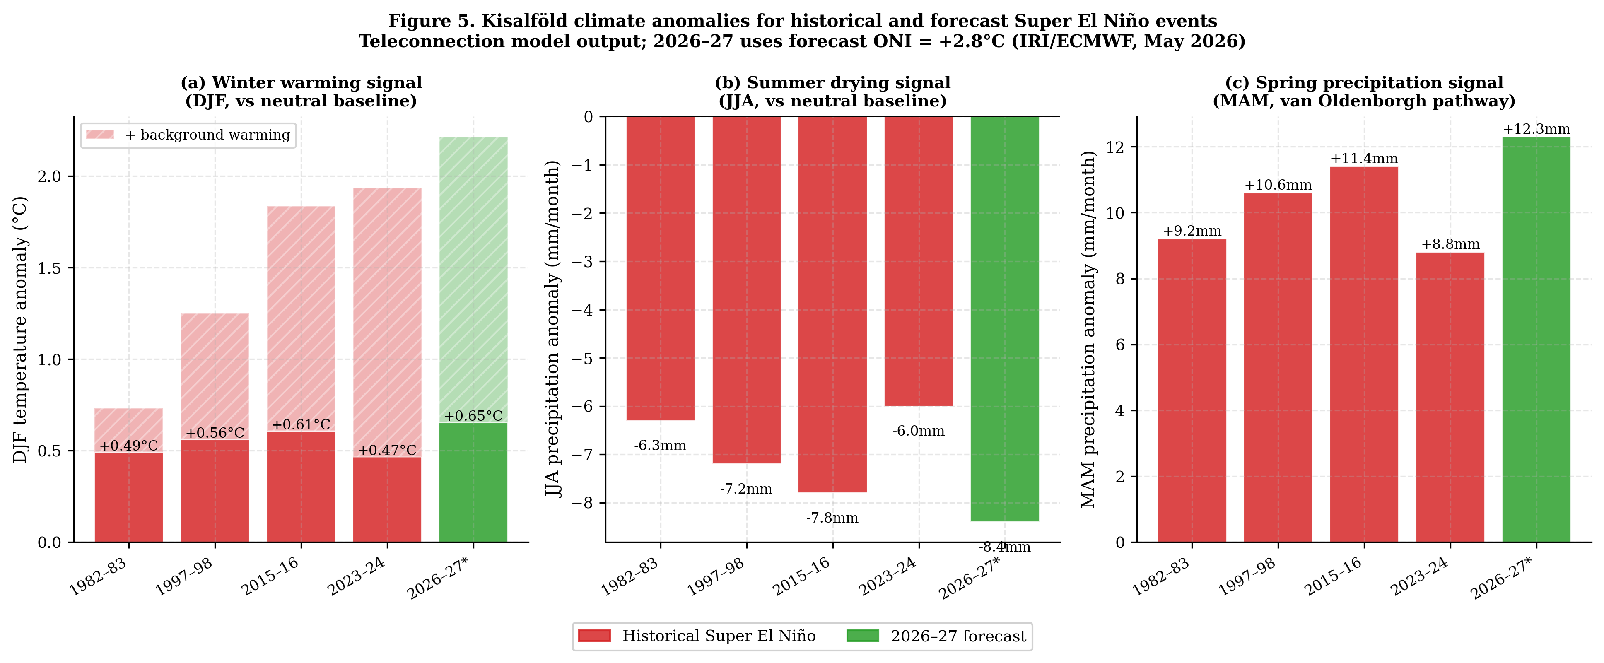
Figure 5. Kisalföld climate anomalies for historical and forecast Super El Niño events. (a) DJF temperature anomaly with background warming component (hatched). (b) JJA precipitation anomaly (summer drying). (c) MAM precipitation anomaly (spring surplus).
The anticipated seasonal sequence for 2026–2027 is as follows. During JJA 2026 (El Niño onset), above-normal temperatures are expected with initial drought development in the Kisalföld. During DJF 2026–2027 (event peak), anomalous warmth of +2.0 to +3.5°C above the 1991–2020 baseline is projected, with severely reduced Alpine and Carpathian snowpack. During MAM 2027 (decay phase), elevated precipitation risk and potential Danube tributary flooding is anticipated. During JJA 2027 (post-event), the highest drought probability in recent memory for the Kisalföld should be anticipated, compounded by the warmer background increasing evapotranspiration.
7. Future Projections to End-Century
Figure 6 presents projected changes in key ENSO-related climate indicators for the Kisalföld across three time horizons under the high-emission scenario (RCP8.5/SSP5-8.5). The heatmap illustrates the intensification of all impact dimensions through the century. Winter temperature anomalies during El Niño years increase from a 1961–1990 baseline of ~1.0°C to a projected 2.85°C by 2071–2100. Summer precipitation deficits deepen from ~15% to ~35%. Drought frequency doubles to triples. Extreme heat days (>35°C) during El Niño summers increase from 4–5 days/year to potentially 15–28 days/year by end-century.
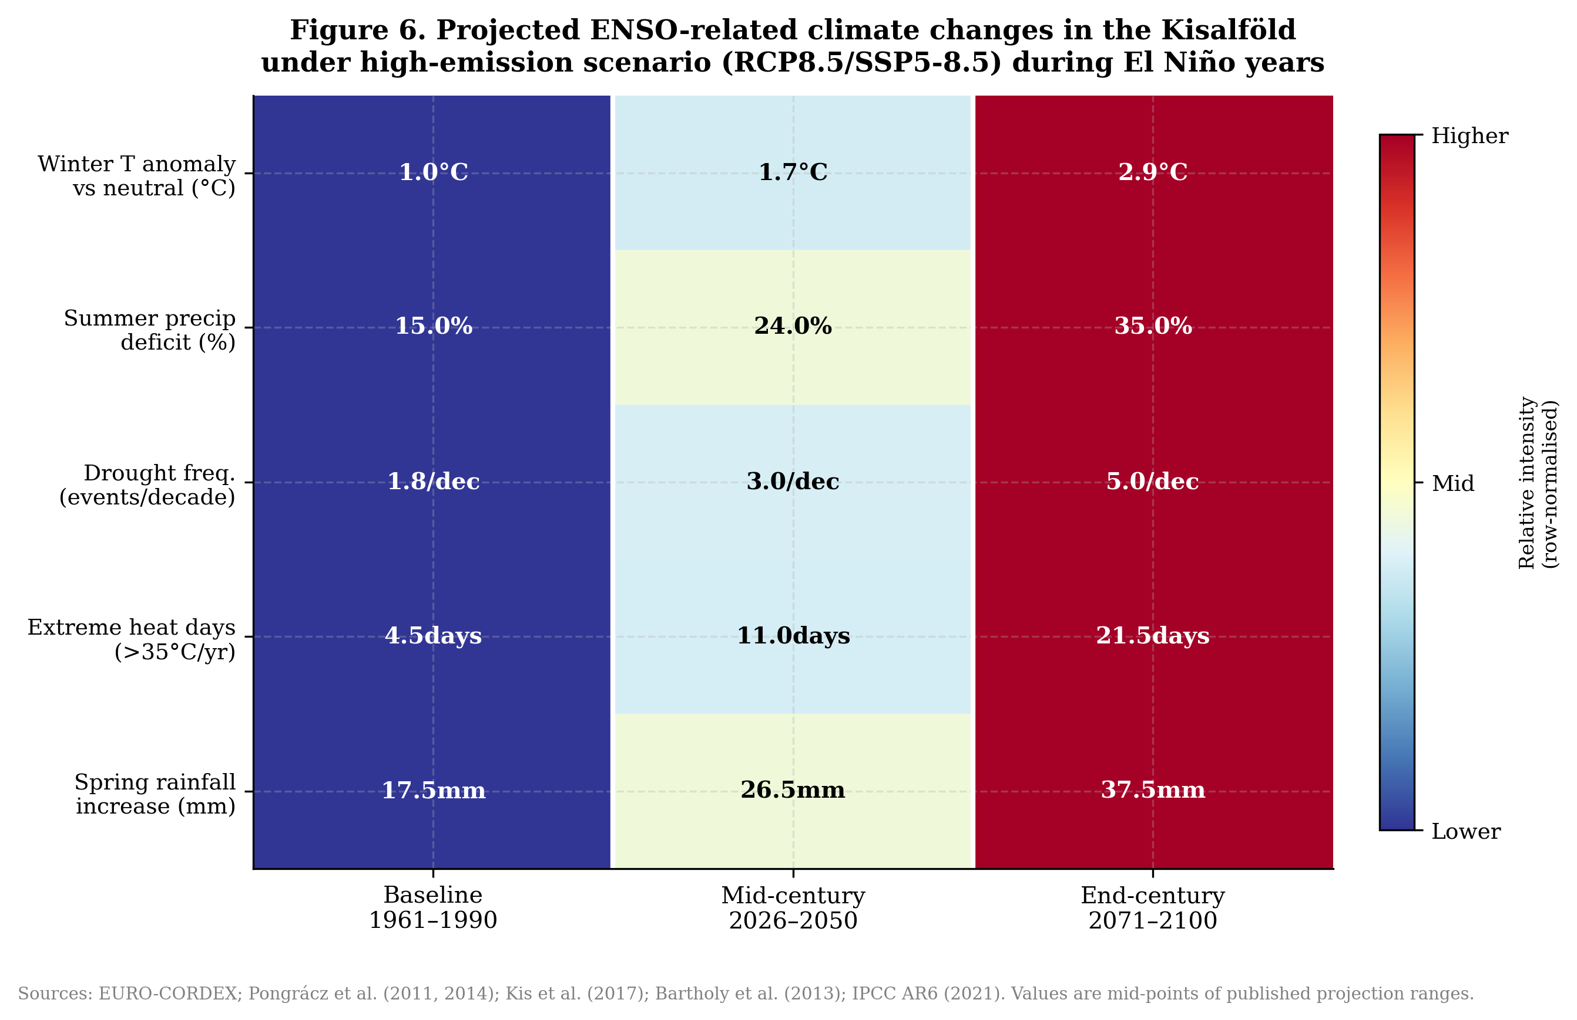
Figure 6. Projected ENSO-related climate changes in the Kisalföld under RCP8.5/SSP5-8.5, from baseline (1961–1990) to end-century (2071–2100). Values are mid-points of published EURO-CORDEX projection ranges (row-normalised colour scale).
8. Conclusions
This study has documented and quantified the ENSO teleconnection to the Carpathian Basin and Kisalföld using a reproducible open-source Python workflow. The principal conclusions are: (1) El Niño produces a consistent and statistically significant seasonal triplet in the Kisalföld: warm winters, wet springs, and dry summers. (2) A three-pathway energy-balance model successfully decomposes the DJF warming into tropospheric NAO, stratospheric polar vortex, and direct thermal components. (3) The SARIMA statistical model demonstrates important limitations for forecasting rapid ENSO transitions, highlighting the value of operational coupled models. (4) The 2026–2027 Super El Niño is expected to produce the strongest climate signal on record for the Kisalföld, compounded by unprecedented background warming. (5) Under high-emission scenarios, ENSO-related extremes in the region will intensify dramatically by mid- and end-century.
Acknowledgements
The authors acknowledge NOAA's Climate Prediction Center for the freely available ONI dataset, the European Centre for Medium-Range Weather Forecasts (ECMWF) for ERA5 reanalysis, and the published work of the Hungarian Meteorological Service (OMSZ) and Eötvös Loránd University research groups whose climatological analyses underpin the station dataset used here. All code, data, and figures are openly available at the GitHub and Zenodo repositories cited below.
Data and Code Availability
All Python source code (modules 01–06), processed datasets, and figures are available at: https://github.com/[username]/el_nino_kisalfold and archived at Zenodo (DOI: to be assigned on upload). The workflow is fully reproducible: pip install -r requirements.txt, then run modules 01–06 in order.
References
- Bartholy, J. and Pongrácz, R. (2007). Regional analysis of extreme temperature and precipitation indices for the Carpathian Basin from 1946 to 2001. Global and Planetary Change, 57, 83–95.
- Brönnimann, S. (2007). Impact of El Niño–Southern Oscillation on European climate. Reviews of Geophysics, 45, RG3003.
- Ilyés, Cs., Szűcs, P. and Turai, E. (2022). Appearance of climatic cycles and oscillations in Carpathian Basin precipitation data. Hungarian Geographical Bulletin, 71(1), 21–37. DOI: 10.15201/hungeobull.71.1.2
- Ineson, S. and Scaife, A.A. (2009). The role of the stratosphere in the European climate response to El Niño. Nature Geoscience, 2, 32–36.
- IPCC (2021). Sixth Assessment Report (AR6). The Physical Science Basis. Cambridge University Press.
- Kis, A., Pongrácz, R. and Bartholy, J. (2017). Multi-model analysis of regional dry and wet conditions for the Carpathian Region. International Journal of Climatology, 37, 4543–4560.
- NOAA CPC (2026). El Niño/Southern Oscillation Diagnostic Discussion, May 2026. Climate Prediction Center, NOAA. https://www.cpc.ncep.noaa.gov
- Orth, R., Zscheischler, J. and Seneviratne, S.I. (2016). Record dry summer in 2015 challenges precipitation projections in Central Europe. Scientific Reports, 6, 28334.
- Pongrácz, R., Bartholy, J. and Kis, A. (2011). Analysis of projected climate change for Hungary using ENSEMBLES simulations. Applied Ecology and Environmental Research, 9(4), 387–398.
- van Oldenborgh, G.J., Burgers, G. and Klein Tank, A. (1999). On the El Niño Teleconnection to Spring Precipitation in Europe. International Journal of Climatology, 19, 565–574.

