⚽ Wroughton Youth FC - Summer Tournament App

This is a full-stack web application to manage teams, fixtures, match results, and display a dynamic league table for the Wroughton Youth FC summer tournament.

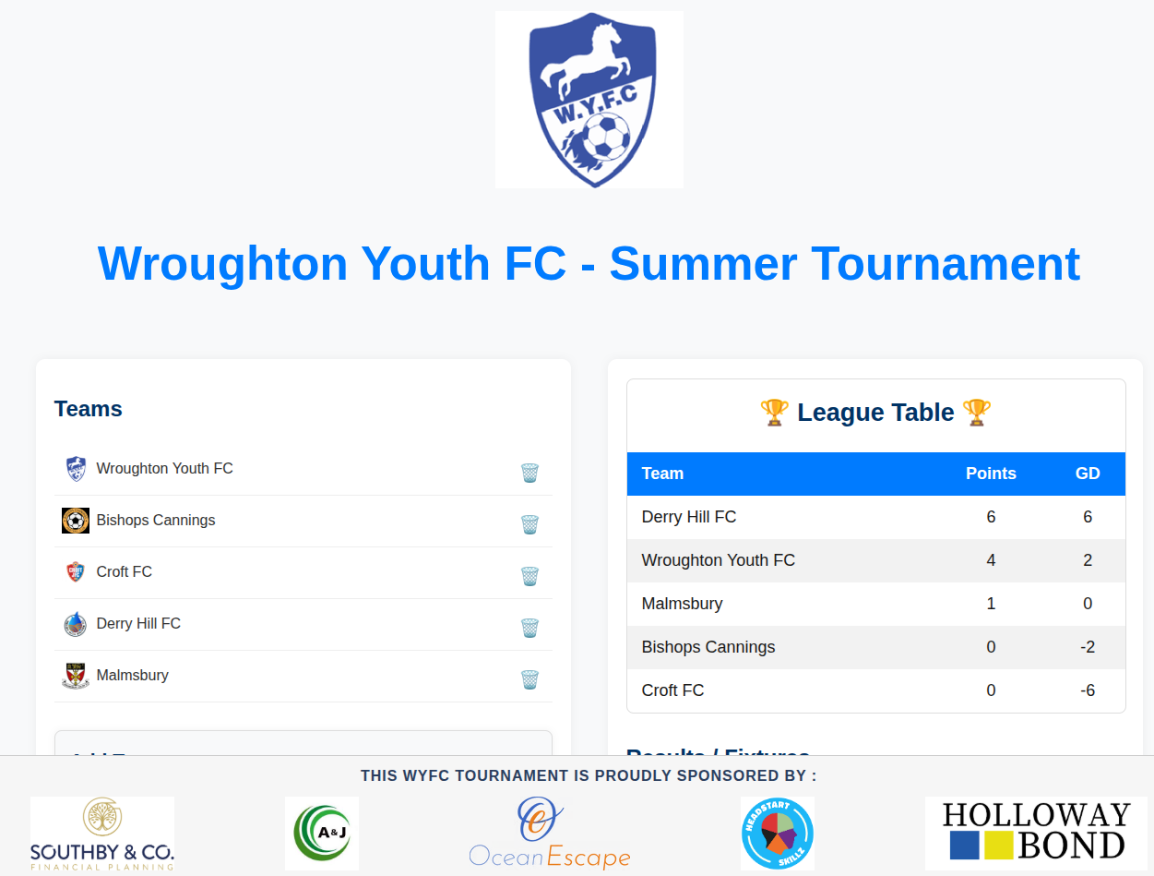

📦 Features

- ✅ Add / delete teams with logos
- ✅ Manage fixtures (add, delete, enter results)
- ✅ Automatically updating league table with points & goal difference
- ✅ Fixture list with real-time result submissions
- ✅ Sponsor section with sticky footer
- ✅ Responsive, polished two-panel layout

---

🛠️ Tech Stack

- **Frontend**: React (Vite), HTML/CSS
- **Backend**: Node.js, Express
- **Database**: PostgreSQL
- **Icons & Styling**: Pure CSS + Emoji icons

---

🚀 Getting Started

1. Clone the repo

```bash
git clone https://github.com/yourusername/wroughton-youth-fc.git
cd wroughton-youth-fc

2. Set up the backend

cd server
npm install

3. Set up the Frontend

cd ../client
npm install
npm run dev

🧪 Database Setup
Create a PostgreSQL database with the following tables:

CREATE TABLE teams (
id SERIAL PRIMARY KEY,
team VARCHAR(255) UNIQUE NOT NULL,
logo TEXT
);

CREATE TABLE matches (
id SERIAL PRIMARY KEY,
home_team_id INTEGER REFERENCES teams(id) ON DELETE CASCADE,
away_team_id INTEGER REFERENCES teams(id) ON DELETE CASCADE,
home_score INTEGER,
away_score INTEGER,
played BOOLEAN DEFAULT FALSE
);

🌐 Deployment
You can deploy this app on platforms like:
- Render (backend + PostgreSQL)
- Vercel / Netlify (frontend)

🤝 Sponsors
Displayed in the sticky footer — update /public/sponsors/ with your sponsor logos.

📁 Project Structure

- [`/client`](./client) — Frontend (React + Vite)
- [`/server`](./server) — Backend (Node.js + Express)
- [`/public`](./client/public) — Logos and assets

simple-node-app/
├── client/ # React Frontend (Vite)
├── server/ # Node.js Backend (Express)
├── README.md

🧑‍💻 Quick Start
``bash
Clone the repo
git clone https://github.com/yourusername/wroughton-youth-fc.git
cd wroughton-youth-fc

Setup backend
cd server
npm install
node app.js

Setup frontend
cd ../client
npm install
npm run dev

---

✅ `/client/README.md`

🎨 Frontend - Wroughton Youth FC

This is the **React (Vite)** frontend for the Wroughton Youth FC tournament app.

---

🚀 Start Dev Server

```bash
npm install
npm run dev

Visit: http://localhost:5173

🔧 Features
- Manage teams and logos
- Add/delete fixtures
- Submit results
- Live-updating league table
- Sponsor footer section
- Responsive layout

📁 Structure
- src/App.jsx — Main layout and components
- src/components/ — Teams, LeagueTable, Fixtures, etc.
- public/sponsors/ — Sponsor logos
- assets/ — Team logo images

🔗 API Endpoint
Make sure the backend is running at:
http://localhost:3000/api

configured via vite.config.js
---
✅ `/server/README.md`

🛠️ Backend - Wroughton Youth FC

This is the **Node.js + Express** backend for the tournament app. It connects to a PostgreSQL database and serves API endpoints.

---

▶️ Start Server

```bash
npm install
node app.js

default port : http:localhost/3000

📦 Features
- RESTful API for:
  - Teams
  - Fixtures
  - Match results
  - League standings
- PostgreSQL database connection
- CORS + JSON middleware

🗃️ PostgreSQL Schema

CREATE TABLE teams (
id SERIAL PRIMARY KEY,
team VARCHAR(255) UNIQUE NOT NULL,
logo TEXT
);

CREATE TABLE matches (
id SERIAL PRIMARY KEY,
home_team_id INTEGER REFERENCES teams(id) ON DELETE CASCADE,
away_team_id INTEGER REFERENCES teams(id) ON DELETE CASCADE,
home_score INTEGER,
away_score INTEGER,
played BOOLEAN DEFAULT FALSE
);

🔗 API Routes
- GET /api/teams
- POST /api/teams
- DELETE /api/teams/:id
- GET /api/matches
- POST /api/matches
- POST /api/matches/:id/result
- DELETE /api/matches/:id
- GET /api/league

🔐 Environment Config
You can use .env or directly edit db.js with PostgreSQL credentials.

🧪 Test Connection
Use test-db.js (if available) to verify DB connection and list tables.

Node test-db.js

