**COMP.5210 Assignment 1, Semester 1, 2021**

Tutor: Bruce Tuhakaraina

Student Name: Zach Coley. Student ID: 30036594

Table of Contents

Introduction 1

SDLC Methodology 1

Design Choices 2

Responsiveness 2

Browser testing 3

Screen size testing 4

Validation 6

HTML Validation 6

CSS validation 9

# Introduction

Link to my project repository on GitHub: <https://github.com/zachcoley/SCP-HTML>

Link to the live website hosted via CPanel: <https://30036594.2021.labnet.nz/Zach_Coley_30036594_COMP5210_Assign1_Website/index.html>

This site is about the SCP Foundation, an organisation responsible for finding and contain objects or creatures that violate natural law.

I originally built this website from scratch using purely my own HTML and CSS skills, but I decided to remake it using the Bootstrap 5 CSS framework because bootstrap is mobile responsive by default and scales properly on all devices and my website needs to be mobile responsive as it would need to be used on the go by SCP agents for example.

# SDLC Methodology

The Software Development Life Cycle (SDLC) I have used is Rapid Application Development (RAD) because it allowed me to quickly tinker, plan and try new ideas as I developed the site until I had a fully finished site. I quickly developed each page of the site and fixed errors as they arose. One issue I had was getting my background gradient to go behind my container div classes, especially on the SCP Catalogue page. I solved this by adding the background gradient to the body element of each page in my main.css document. Another issue was getting the warning message on the index.html page positioned in the centre of the screen as I had to make the height of the container div 100% and use the d-flex align-items-center justify-content-center bootstrap classes.

One issue I have not managed to solve is where when moving from scp_002.html to any other page the Navbar and container will change scale and sort of jump, but this issue does not occur when running my website on the Microsoft Edge browser, it’s not serious but it annoys me.

# Design Choices

I added a logo of the SCP Foundation to the sites Navbar to make the site feel more formal and professional, the Navbar also contains a login form for SCP Agents or Overseers to login to the site.

The index.html page has a warning message as the foundation is a top-secret organisation so I figured adding a warning message to the home page was fitting and would deter any unwanted visitors.

I use bootstrap cards for listing and displaying each SCP subject because they show a good glimpse at what the SCP is without having to click on the SCP first.

I added the description for each SCP and their Object Classes to each card as well to provide more info about each SCP.

For the HTML page structure of each SCP subject file, I decided to go for a grid approach dividing parts of the SCP subject file contents into their own grid column making it easy to read by keeping all sections in mostly the same place across all HTML pages, the text wraps around the subject image when the pages minimum width is 768 pixels wide.

The reddish brown and black colour theme really works for the site giving it a creepy and interesting vibe.

# Responsiveness

By using the Bootstrap CSS framework all my pages are responsive on both mobile and desktop screens, bootstraps Navbar automatically shows a hamburger button when the screen size hits a certain value and my content inside bootstraps grid system also scales.

## Browser testing

I have tested my site on both the Google Chrome and Microsoft Edge web browsers.

Google Chrome:

Microsoft Edge:

## Screen size testing

I have tested my website on different screen sizes such as Desktop (1920x1080), iPhone X and an iPad Pro.

Desktop:

iPhone X:

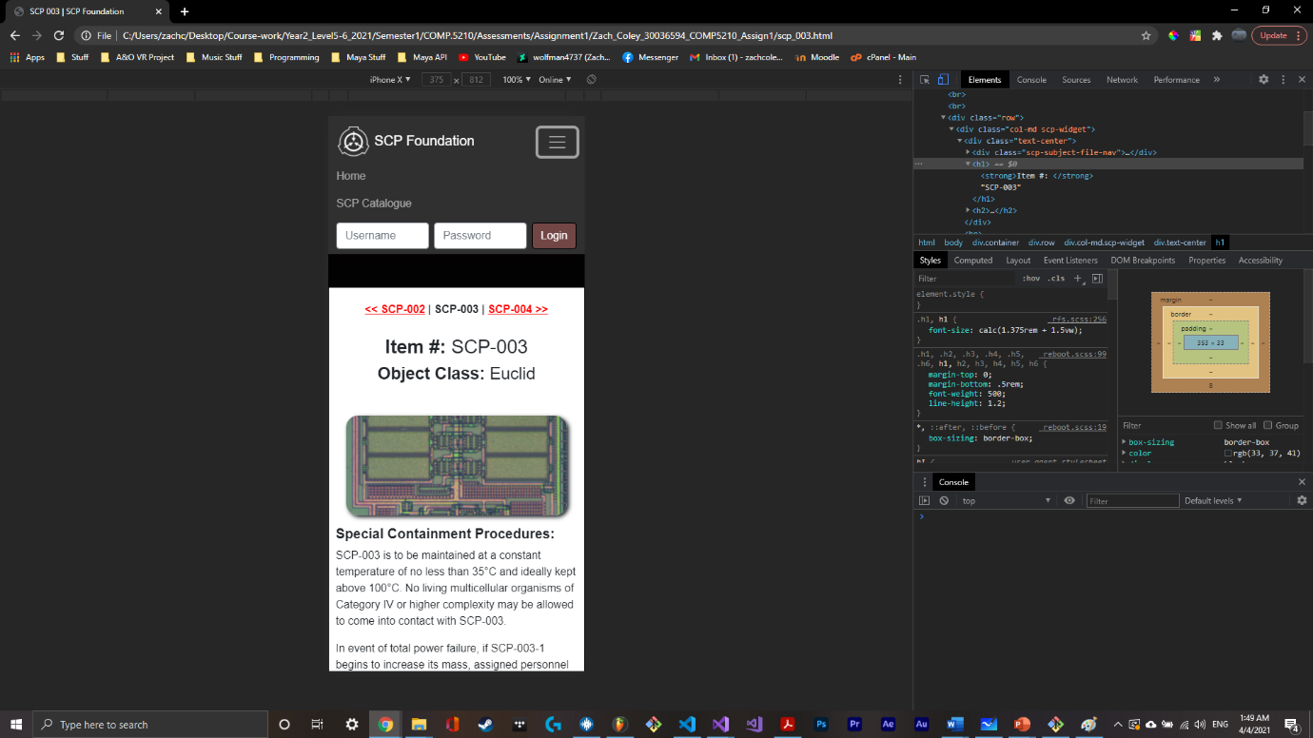

iPad Pro:

# Validation

I have performed both HTML and CSS code validation on my site to ensure it adheres to current HTML 5 and CSS standards.

## HTML Validation

index.html:

scp_catalogue.html:

scp_002.html:

scp_003.html:

scp_004.html:

scp_005.html:

scp_006.html:

## CSS validation

When validating my CSS code (using CSS 2.1) I got a bunch of errors, I changed the validation to CSS 3 and got less errors. I searched online and found that these errors can be ignored as the validator is out of date and so my CSS is indeed valid.

main.css:

