MPA-MLF Final Project Report
Classification of Room Occupancy from 60 GHz Radar Signals
Victor Germain & Angélique Vallon
ISEP Paris Erasmus exchange at VUT Brno
Machine Learning Fundamentals (MPA-MLF)
April 2026
Code: github.com/Zoomma1/MPA-MLF-Final-project-GERMAIN-VALLON
Best Kaggle public score : 0.97819

Contents
Contents 2
List of figures 2
1. Introduction 3
2. Problem description 3
3. Methodology 4
3.1 Data pipeline 4
3.2 Baseline architecture 4
3.3 Class imbalance 4
3.4 Iterative improvement strategy 4
4. Experiments and results 5
4.1 Baseline CNN 5
4.2 Data augmentation 5
4.3 Regularization 5
4.4 Transfer learning 5
4.5 Hyperparameter tuning 5
4.6 Label smoothing and ensemble 5
4.7 Techniques that degraded performance 6
5. Conclusions 7

List of figures
Figure 1 Class distribution in the training set
Figure 2 Representative examples per class (4 samples each)
Figure 3 Baseline CNN training curves
Figure 4 Best model training curves (Deeper CNN, label smoothing ε=0.05)
Figure 5 Confusion matrix on the validation set (label smoothing model)

1. Introduction
This report presents our final project for the MPA-MLF (Machine Learning Fundamentals) course at VUT Brno, completed as part of an Erasmus exchange from ISEP Paris. The project was carried out in pairs.
The task is to classify the number of persons present in a room (0, 1, 2, or 3) from 60 GHz radar snapshots in the delay-Doppler domain. Each snapshot is a 45×51 pixel PNG image representing target reflections at various distances and velocities from the receiver.
We treated this as a supervised image classification problem. Starting from a simple CNN baseline, we improved performance step by step through regularization, architecture search, label smoothing, and ensemble methods. All experiments were evaluated on a Kaggle competition leaderboard. The source code is available at the GitHub link on the cover page.

2. Problem description
The dataset consists of 9,770 training images and a separate test set, all PNG format. Each image is a 45×51 pixel snapshot in the delay-Doppler domain, captured with a 60 GHz radar. The x-axis encodes delay (proportional to distance) and the y-axis encodes Doppler shift (proportional to velocity). In clean recordings, each person appears as a distinct bright spot; in practice, noise, reflections, and missed targets make many samples harder to read.
The task has four classes: 0 persons (machine noise only), 1 person, 2 persons, and 3 persons. As shown in Figure 1, the dataset is heavily imbalanced: class 3 has only 282 samples out of 9,770, roughly 17 times fewer than class 1. Figure 2 shows representative examples from each class.
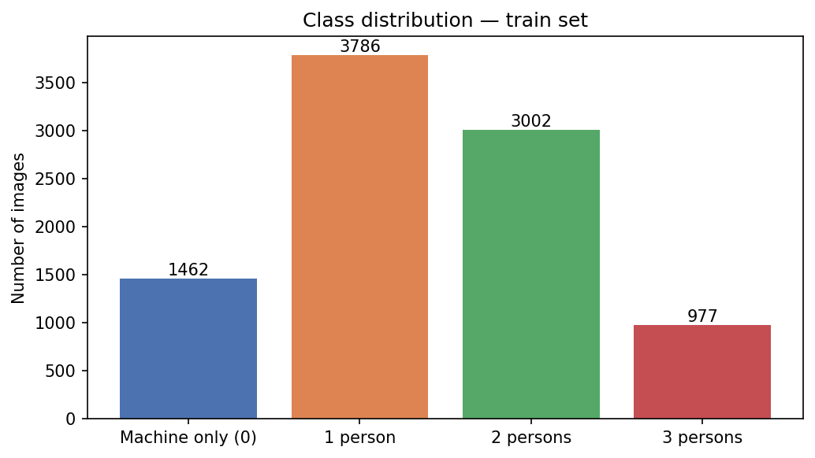
Figure 1 Class distribution in the training set
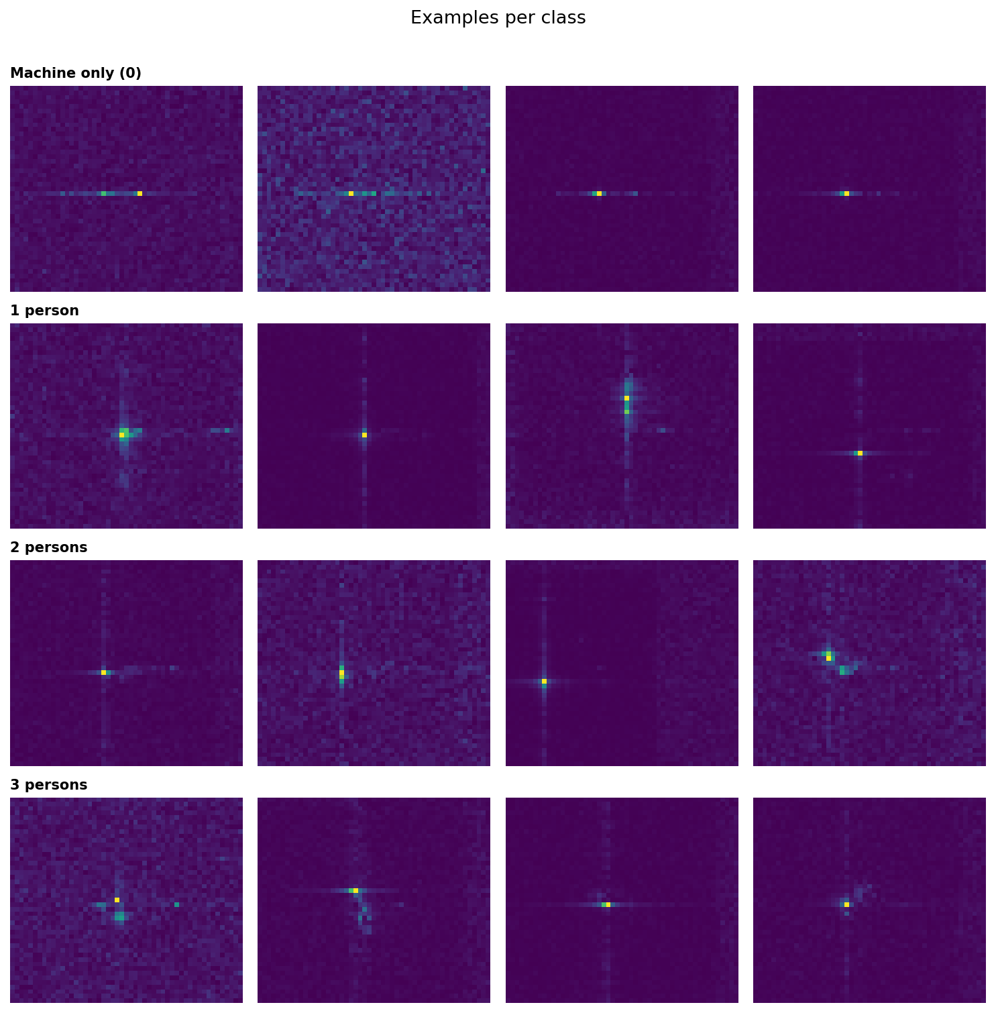
Figure 2 Representative examples per class (4 samples each)

3. Methodology

3.1 Data pipeline
Each sample is loaded as a PNG and normalized to [0, 1]. A critical issue was identified early: input images are numbered from 1 while the CSV labels are 0-indexed. Misaligning these offsets mislabels the entire training set. A corrected y_train.csv was provided by the instructor on April 9th; all results in this paper use the corrected dataset. Images missing from disk are filtered out before training.
The data is split 80/20 using a stratified split, yielding 7,816 training and 1,954 validation samples.

3.2 Baseline architecture
Our baseline CNN has three convolutional blocks (32→64→128 filters, 3×3 kernel, same padding, ReLU), each followed by MaxPooling2D (2×2). This feeds into a Flatten layer, a Dense(128, ReLU) layer, and a Dense(4, softmax) output. The model uses Adam (lr=1e–3) and sparse categorical crossentropy. Training stops early on validation accuracy (patience=5, restore_best_weights=True).

3.3 Class imbalance
Class 3 represents 2.9% of the dataset. We tested class weights from scikit-learn (weight 6.93 for class 3), which caused gradient amplification and training instability loss stuck at log(4) ≈ 1.386, accuracy oscillating between 4% and 44%. Class weights were dropped for all subsequent experiments.

3.4 Iterative improvement strategy
Starting from the baseline (Kaggle: 0.951), we worked through data augmentation, batch normalization, transfer learning with ImageNet backbones, then a more intensive tuning phase. Each technique is evaluated in Section 4.

4. Experiments and results
All experiments use the same 80/20 stratified split. Kaggle scores refer to the public leaderboard (50% of the test set). Table 1 summarizes all results.

4.1 Baseline CNN
The baseline trained for 5 epochs before EarlyStopping triggered. Figure 3 shows training accuracy continuing to rise while validation accuracy plateaued classic overfitting. First Kaggle submission: 0.951.
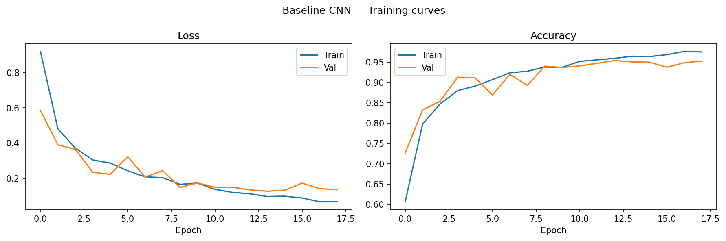
Figure 3 Baseline CNN training curves

4.2 Data augmentation
Horizontal flip, rotation (±15°), and Gaussian noise were tested individually and combined. None improved validation accuracy. Without first addressing the overfitting, augmentation cannot help.

4.3 Regularization
Adding Batch Normalization and class weights reached 0.953 validation accuracy marginally below the unregularized baseline. Batch normalization alone did not provide a significant benefit at this dataset size.

4.4 Transfer learning
We fine-tuned EfficientNetB0 and MobileNetV2 (pre-trained on ImageNet, inputs resized to 96×96). Both were outperformed by the custom CNN: 0.819 and 0.814 validation accuracy respectively, against 0.964 for the baseline. The domain gap between ImageNet textures and radar heatmaps, combined with information loss from upscaling 45×51 images, likely explains this gap.

4.5 Hyperparameter tuning
We searched over filter counts, optimizers, and learning rates. The best configuration filters (32, 64, 128, 256), Nadam optimizer, lr=0.002 scored 0.971 on Kaggle. This deeper architecture became the base for all subsequent experiments.

4.6 Label smoothing and ensemble
Label smoothing (ε=0.05) on the deeper architecture reached 0.977 on Kaggle. Figure 4 shows clean convergence with no sign of overfitting. A multi-architecture ensemble combining this model with a wider variant (64→128→256 filters) achieved the best result: 0.978 on the public leaderboard.
Figure 5 shows the confusion matrix of the label smoothing model on the validation set.
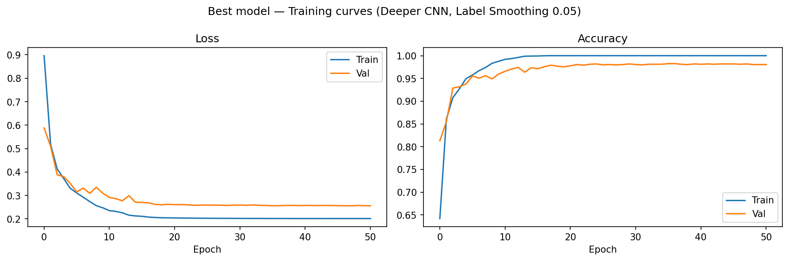
Figure 4 Best model training curves (Deeper CNN, label smoothing ε=0.05)
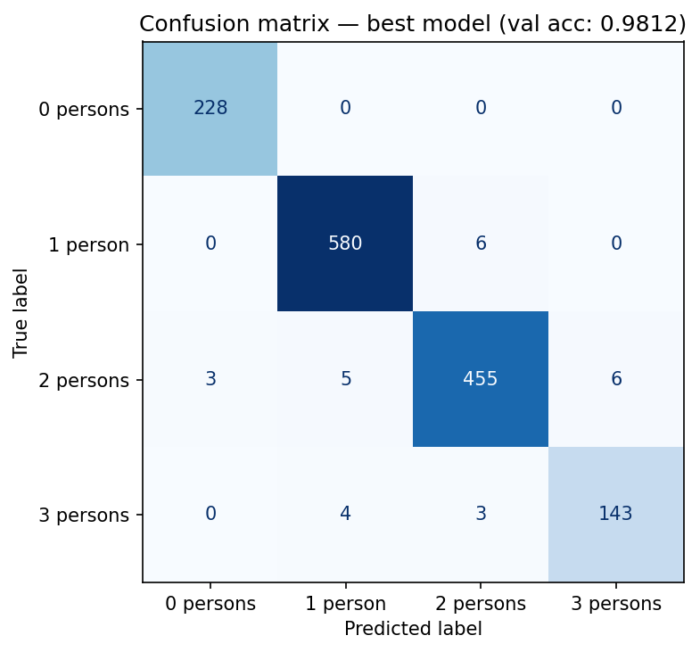
Figure 5 Confusion matrix on the validation set (label smoothing model)

4.7 Techniques that degraded performance
Several approaches consistently hurt performance: pseudo-labeling (0.969), test-time augmentation (0.83–0.88), focal loss (0.967), mixup (0.963), and learning rate scheduling variants. The base model with label smoothing outperformed all of them, suggesting it had already extracted most of the available signal from this dataset.
Table 1 Experiment summary (Kaggle public leaderboard; = no submission for that run)
Experiment | Val accuracy | Kaggle public
Baseline CNN | 0.964 | 0.951
+ Data augmentation | 0.964
+ Batch norm + class weights | 0.953
Transfer learning (EfficientNetB0) | 0.819
Transfer learning (MobileNetV2) | 0.814
Hyperparameter tuning (deeper, Nadam) |  | 0.971
Label smoothing ε=0.05 | 0.983 | 0.977
Multi-architecture ensemble (LS=0.05) |  | 0.978
Private leaderboard (to be added) |  | TBD

5. Conclusions
We built a CNN classifier for radar occupancy detection that reached 0.978 on the public Kaggle leaderboard. The most impactful changes were deeper architecture, switching to the Nadam optimizer, and label smoothing (ε=0.05). Transfer learning from ImageNet hurt performance due to the domain gap with radar data. More complex techniques pseudo-labeling, TTA, focal loss consistently degraded results.
The main lesson is that data quality matters more than model complexity. A corrupted label file produced weeks of misleading results; once corrected, a simple custom CNN outperformed all ImageNet backbones. Collecting more samples for class 3 currently 282 out of 9,770 would likely have the most impact on further improvement.

