SELECT

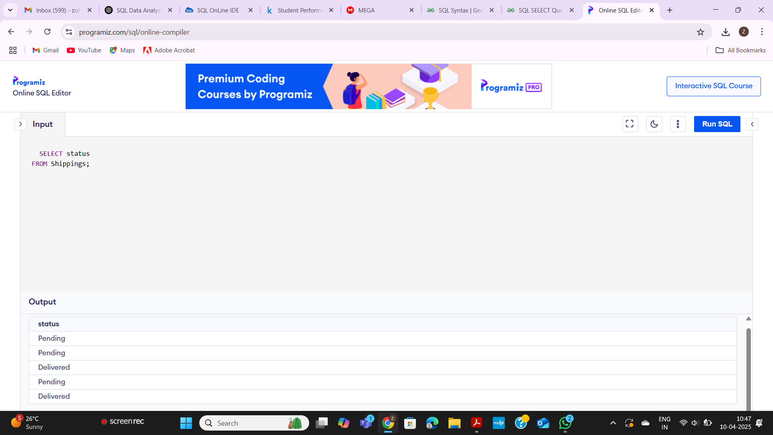

Data set

| shipping_id | status | customer |
| --- | --- | --- |
| 1 | Pending | 2 |
| 2 | Pending | 4 |
| 3 | Delivered | 3 |
| 4 | Pending | 5 |
| 5 | Delivered | 1 |

ORDER BY

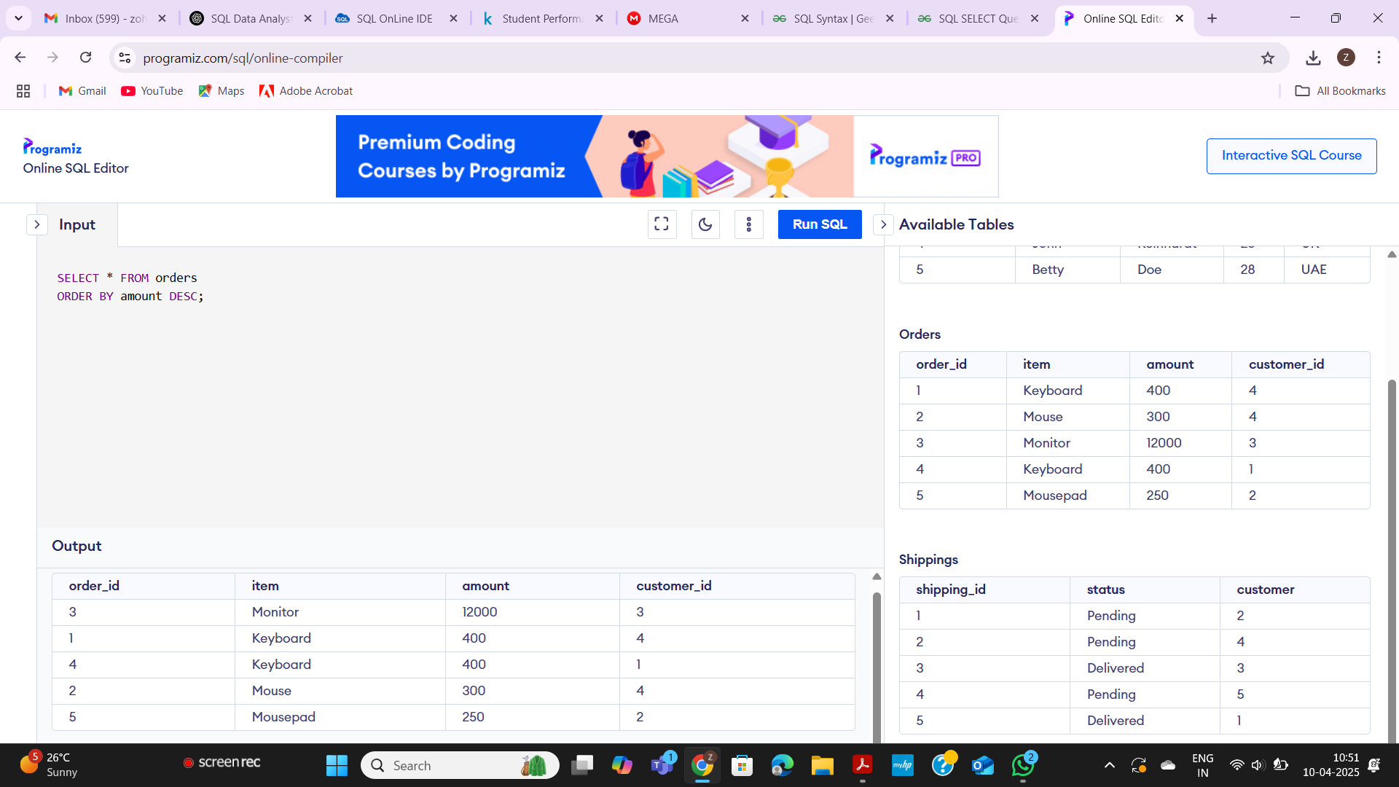

DATASET

| order_id | item | amount | customer_id |
| --- | --- | --- | --- |
| 1 | Keyboard | 400 | 4 |
| 2 | Mouse | 300 | 4 |
| 3 | Monitor | 12000 | 3 |
| 4 | Keyboard | 400 | 1 |
| 5 | Mousepad | 250 | 2 |

SELECT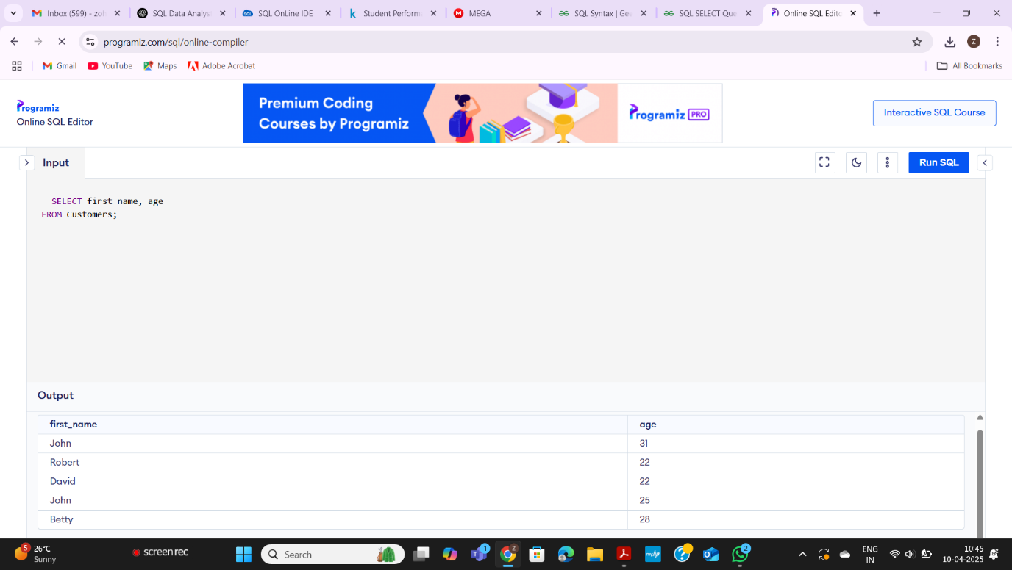

DATASET

| customer_id | first_name | last_name | age | country |
| --- | --- | --- | --- | --- |
| 1 | John | Doe | 31 | USA |
| 2 | Robert | Luna | 22 | USA |
| 3 | David | Robinson | 22 | UK |
| 4 | John | Reinhardt | 25 | UK |
| 5 | Betty | Doe | 28 | UAE |

AVG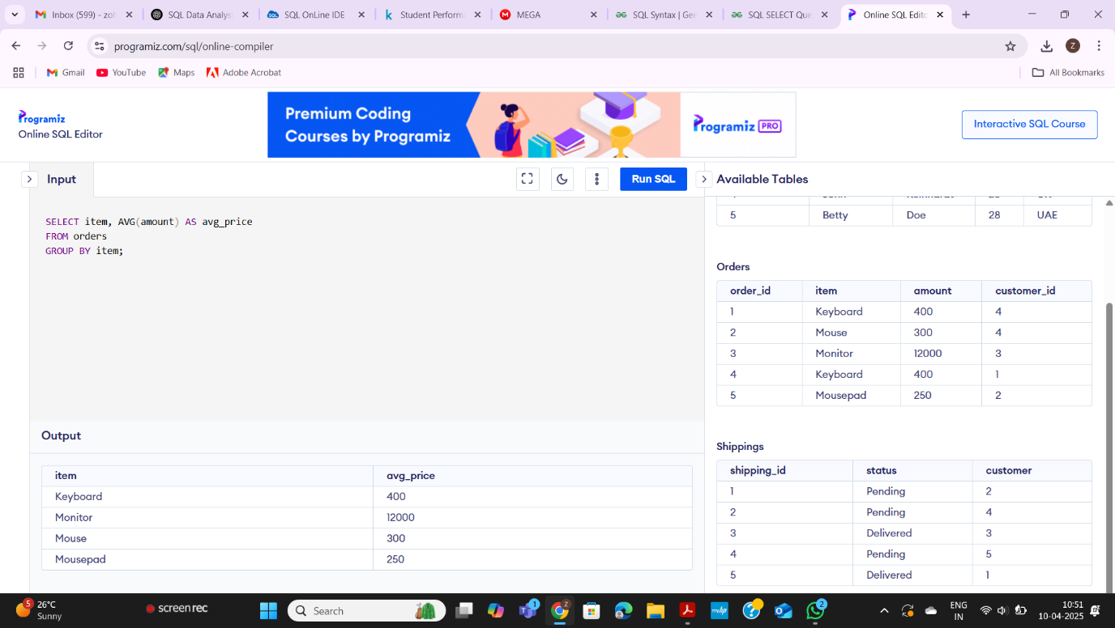

ORDERBY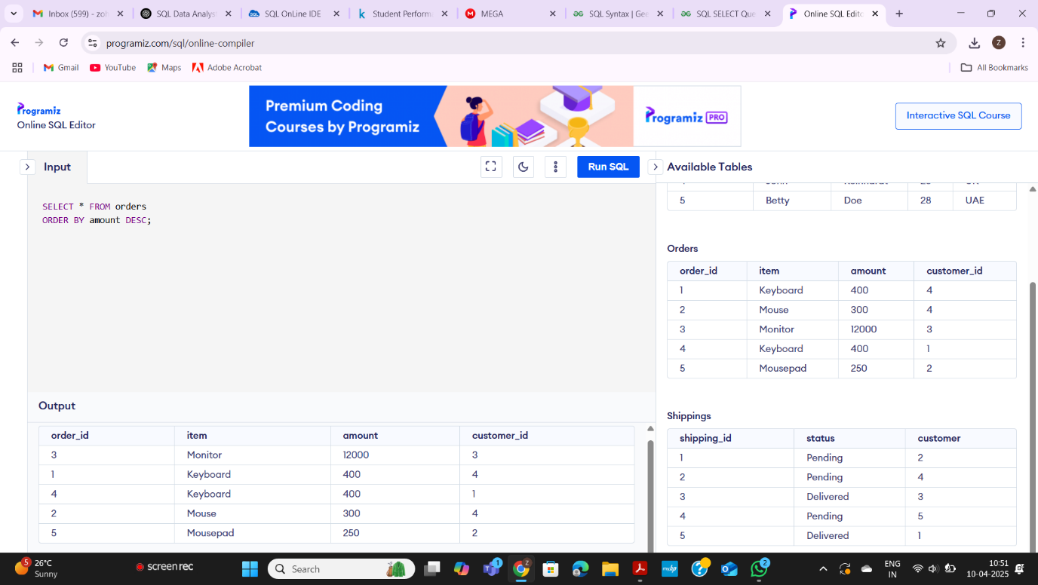

GROUPBY