Title: Seasonally variable thermal performance curves prevent adverse effects of heatwaves

**Authors:** Matthew Sasaki, Michael Finiguerra, Hans G. Dam

**Abstract** - The increasing frequency and intensity of heatwaves may represent a significant challenge for organisms in a warming ocean. The direct impacts of heatwaves on populations depend on the relative position of environmental temperatures to the thermal performance curve optima. The effects of heatwaves may therefore vary seasonally along the annual temperature cycle. However, this seasonal variation in the effects of heatwaves may be dampened by corresponding variation in thermal performance curves. In organisms with relatively short generation times, these changes may be driven by phenotypic plasticity as well as genetic differentiation. We investigate the effects of seasonal timing and duration on the impacts of heatwaves in the ecologically important copepod *Acartia tonsa*. We show that thermal performance curves are seasonally variable in the field, and that this variation buffers against negative effects of simulated heatwaves. Further, the offspring of individuals that experienced the simulated heatwaves were raised in the laboratory to examine trans-generational effects of heatwaves on body size and reproductive output. The lack of a clear pattern in the trans-generational effects may indicate that seasonal variation in thermal performance curves also buffers against indirect effects of heat waves by reducing the effects of parental stress on the offspring. Our results show that seasonal variation in thermal performance curves has the potential to limit the adverse effects of heatwaves on populations of short-lived organisms.

# Introduction

Heatwaves are increasing in frequency and intensity in aquatic ecosystems (Frölicher and Laufkötter 2018; Oliver et al. 2018; Tassone et al. 2022). These periods of anomalously high temperatures present severe challenges to marine biota (Smale et al. 2019). The effects of these events on communities will be strongly dependent on the relative vulnerabilities of the different component taxa to increased temperatures. Understandably, much attention has been focused on macro-organisms like coral, kelp, and fish, on which heatwaves have had significant, highly visible effects (Smith et al. 2023). Planktonic taxa, however, have received far less attention, despite their importance in aquatic communities and unique life histories. Characterizing the thermal sensitivity (and seasonal variation in thermal sensitivity) of planktonic taxa is crucial for predicting the effects of marine heatwaves on food webs and ecosystem functioning.

The direct effects of increased temperature on organisms and population dynamics are well known (Deutsch et al. 2022; Arroyo et al. 2022; Hochachka and Somero 2002; Angilletta 2009). Shaped by resulting changes in metabolism, reproduction, competitive ability, and survival, increased temperature during a heatwave may have profound effects on planktonic community dynamics and the distribution of organisms (McKinstry, Campbell, and Holderied 2022; Evans et al. 2020; Maazouzi et al. 2008). The effects of heatwaves on populations may also be propagated by mechanisms like trans-generational plasticity and maternal effects, which can have important effects on offspring performance (Truong et al. 2022; Dinh et al. 2021). Given the generally short generation times of many planktonic taxa, there is also the potential for genetic differentiation to produce variation in thermal performance curves over seasonal timescales (Sasaki and Dam 2020; Rudman et al. 2022).

Vulnerability to adverse effects of heatwaves is often assumed to be largest during the warmest seasons, although there can be important exceptions to this, driven by seasonal variation in thermal performance (Tran and Johansen 2023). In planktonic taxa, this seasonal variation may be driven by direct physiological effects, acclimatization within generations, and transgenerational effects across generations, along with seasonal genetic differentiation. Regardless of mechanism, this variation may play an important role in determining the effects of heatwaves on a population (Figure 1). Much of the past work on the effects of heatwaves assumes performance curves are fixed (i.e. - there is no seasonal variation in TPCs). In this case, the effect of heatwaves would be predicted to vary seasonally as the relative position of environmental temperatures to TPC optimum temperature and lethal thermal limits varies. Alternatively, variation in TPCs over seasonal timescales may act as a buffer against negative effects of heatwaves if optimum temperatures maintain a fixed position relative to environmental temperatures, limiting exposure to temperatures in excess of thermal optima. Differences in the magnitude of seasonal variation in TPCs between taxa may therefore play a key role in shaping patterns in relative vulnerability of community members.

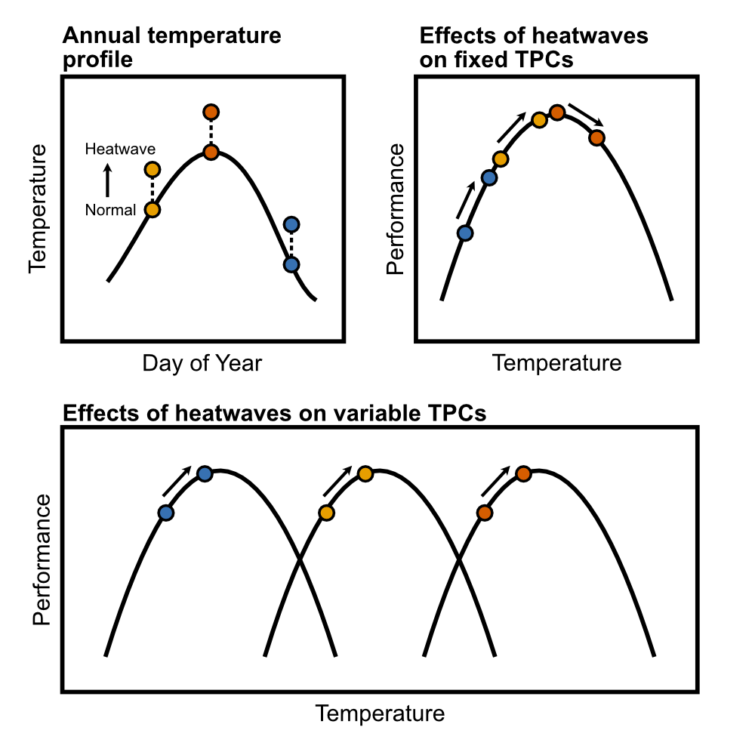

Schematic illustrating the effects of heatwaves on performance. A) Heatwaves may occur at various times throughout the year, resulting in acute increases in temperature against a seasonally-variable baseline. B) Static thermal performance curves result in seasonally-variable effects of heatwaves on performance. Heatwaves that occur when temperatures are low relative to the optimum would be expected to increase performance (a beneficial effect). Heatwaves that occur when temperatures are near or past the thermal optimum may decrease performance (a detrimental effect). C) Variable thermal performance curves reduce seasonal variation in the effects of heatwaves on performance, when thermal optima are positively correlated with environmental temperatures. An increase in temperature would then be expected to increase performance, regardless of the seasonal timing of the heatwave.

Given their short generations times, abundance, and ecological importance in marine systems, copepods are an ideal model system to examine the interplay between seasonal variation in thermal performance curves and the direct and indirect effects of heatwaves. Here we characterize how seasonal variation in thermal performance curves for key fitness related traits (egg production, hatching success, and survivorship) of the ecologically important copepod species *Acartia hudsonica* and *A. tonsa* shapes vulnerability to heatwaves. We also quantified both direct and trans-generational effects of heatwaves on one of the species (*A. tonsa*) in the laboratory using a series of simulated heatwave experiments. We test two hypotheses: 1) there is seasonal variation in the thermal performance curves of *A. hudsonica* and *A. tonsa*; and 2) that seasonal variation in TPCs will limit the variation in transgenerational effects of heatwaves.

# Methods

## Generating Field TPCs **[Note - Will need input from others to finish the methods section]**

Copepods were collected from Long Island Sound, near the University of Connecticut, Avery Point Campus at several times throughout the year using surface tows of a [FILL IN] um mesh plankton net (Table 1). Mature *Acartia hudsonica* or *Acartia tonsa* females were isolated from the contents of the plankton tow and placed individually in petri dishes for egg production and hatching success assays. During these assays, females were fed [FILL IN]. Females produced eggs for [THREE?] days, after which the female was removed. Eggs were given [THREE?] additional days to hatch. Egg production (the total number of eggs produced per female per day), the hatching success (percentage of eggs produced that hatched), and the total production (the number of nauplii produced per female per day) were measured for each individual. These assays were performed across a range of temperatures (10-30°C for *A. tonsa* and 4-24°C for *A. hudsonica*). Thermal performance curves (TPCs) for egg production, hatching success, and production were modeled using a Gaussian equation (Padfield, O’Sullivan, and Pawar 2021). TPC parameters (maximum trait values and thermal optima) were extracted from these model fits. All analyses were performed in R version 4.1.3.

Thermal survivorship curves were also determined for each of these collections by exposing individual females to an acute 24 hour heat shock across a range of temperatures. Individual females were placed in a 2.5 ml microfuge tube with 0.2 um filtered seawater, and moved to 15-well drybaths (USA Scientific). Each drybath was set to a single temperature, ranging from 17-28°C for *A. hudsonica* and 16-36°C for *A. tonsa*. After 24 hours each female was checked for survivorship. Survivorship was modeled using a logistic regression of individual survivorship against stress temperature. These survivorship curves were then used to estimate thermal tolerance (as LD50, the temperature of 50% mortality).

To determine whether TPC parameter variation tracked seasonal temperature changes, we regressed the TPC parameters against the temperature at the time of collection. A significant, positive relationship between collection temperature and TPC parameters (esp. thermal optimum and thermal tolerance) would indicate that TPCs varied in relation to the seasonal temperature cycle.

Details for the field TPC collections. The date and water temperature at the time of collection is provided for each group, along with which species was collected. The exact date for the June 2015 collection of Acartia hudsonica was not available.

| Month | Date | Temperature | Species |
| --- | --- | --- | --- |
| January | January 21st 2015 | 2.1 | *Acartia hudsonica* |
| February | February 21st 2015 | -0.4 | *Acartia hudsonica* |
| March | March 16 2015 | 4.0 | *Acartia hudsonica* |
| April | April 21st 2015 | 9.2 | *Acartia hudsonica* |
| May | May 14th 2015 | 12.0 | *Acartia hudsonica* |
| June | June __ 2015 | 18.6 | *Acartia hudsonica* |
| July | July 29th 2014 | 20.0 | *Acartia tonsa* |
| August | August 13th 2014 | 18.0 | *Acartia tonsa* |
| September | September 11th 2014 | 18.0 | *Acartia tonsa* |
| October | October 22nd 2014 | 16.0 | *Acartia tonsa* |
| November 1 | November 4th 2014 | 14.5 | *Acartia tonsa* |
| November 2 | November 19th 2014 | 11.0 | *Acartia tonsa* |

## 

## Simulated Heat Waves

To test our second hypothesis (that varying thermal performance curve parameters reduce vulnerability to heatwaves) we collected *Acartia tonsa* from the same site again in 2015 for use in laboratory simulated heatwave experiments. In order to test the effects of a heatwave against the seasonally shifting baseline of ambient temperature, three collections were made before, during, and after peak environmental temperatures, corresponding to late June, late July, and early December (Table 2). These experiments examined both direct and transgenerational effects of heatwaves. To examine the direct effects, egg production rate, hatching success, and production were measured for around 60 females per collection, split into two groups (control and heatwave). These assays were performed as described in the Field TPC section, with females isolated in individual petri dishes and provided with food *ad libitum*. The control group remained at a temperature near the current ambient temperature in Long Island Sound while the Heatwave group experienced temperatures 5°C above the ambient temperature (Table 2). During the simulated heatwave, traits were measured over two periods to examine the effects of short and long heatwave events - Days 1-3 and Days 5-7. Females were moved into petri dishes with fresh food solution on Days 3 and 5. Eggs produced during the intervening period were not examined.

We used effect sizes (Hedge’s g) to examine how heatwaves and the duration of exposure affected copepod performance (Gardner and Altman 1986; Ho et al. 2019; Berner and Amrhein 2022). Two sets of effect sizes were estimated within each collection: the effect of duration within treatments (long control vs. short control and long heatwave vs. short heatwave), and the effect of treatment (short heatwave vs. short control and long heatwave vs. long control). A negative effect size represents a reduction in egg production, hatching success, etc. as either 1) duration increases, or 2) when copepods were exposed to heatwave conditions. Each effect size estimate also included a 95% Confidence Interval (CI), estimated by non-parametric bootstrapping (Ho et al. 2019). Hedge’s g was used instead of mean or median difference to account for the drastic seasonal differences in the magnitude and variation of egg production and hatching success observed between collections.

Details for the simulated heatwave collections. The date and water temperature at the time A. tonsa individuals were collected from the field is provided for each group, along with the temperatures used for the control and heatwave exposures.

| Period | Date | Field Temp. | Control Temp. | Heatwave Temp. |
| --- | --- | --- | --- | --- |
| Early | June 27th 2015 | 17.8 | 17 | 22 |
| Mid | July 29th 2015 | 22.4 | 22 | 27 |
| Late | December 1st 2015 | 12.0 | 12 | 17 |

## 

## Transgenerational Effects

In addition to the direct effects of heatwaves, we also examined the effects of parental exposure to increased temperature on offspring performance (i.e. - transgenerational effects). From the same collections described above, several hundred adult copepods were placed into each of eight 4L buckets of filtered seawater, which were split between the control and heatwave temperatures for that collection. Cultures were provided with food ad libitum and kept oxygenated using a small aquarium pump. Eggs were collected from each bucket following the same schedule as the direct effect experiments (on day 3 and day 7 for the short and long heatwave exposures, respectively). Eggs were discarded on day 5 to ensure all individuals reflected the correct exposure periods. For each collection, we therefore had four groups of offspring, those with parents exposed to control and heatwave temperatures for either 3 or 7 days.

These four groups of eggs were then further split into three groups which developed at either 12, 17, or 22°C. These rearing temperatures were used for all three collections. During development, individuals were maintained in 4L buckets of filtered seawater and fed ad libitum. After these individuals matured, body size and the three reproductive traits (egg production, hatching success, and production) were measured at the respective rearing temperature.

As for the F0 generation, we used effect size estimates (Hedge’s g) to examine how parental conditions affected offspring traits. For each seasonal collection we examined the effect of treatment within each developmental temperature (short heatwave vs. short control and long heatwave vs. long control). As offspring of the different batches of parents developed under identical conditions within each temperature, an effect of treatment in these comparisons indicates a transgenerational effect of parental exposure to heatwave conditions. As before, a negative effect size indicates a trait reduction when parents were exposed to heatwave conditions.

# Results

## Seasonal Variation in Field TPCs

There was abundant variation in TPCs for egg production, hatching success, and production for copepods collected throughout the year. *Acartia hudsonica* EPR TPCs tended to have lower optima and were less variable than *A. tonsa* EPR TPCs (Figure 2). Within *A. tonsa*, EPR optimum temperatures tended to be higher in warmer months (Figure 3). Hatching success TPCs for *A. hudsonica* were also less variable than those of *A. tonsa*. TPCs for hatching success were also considerably wider in *A. tonsa* than in *A. hudsonica*. Hatching success was higher for *A. tonsa* in warmer months than cooler months, regardless of incubation temperature. This is especially evident for the second November collection of *A. tonsa*, which exhibited very low hatching success at all but the highest temperatures used in the assays. When combined, the variation in EPR and HS TPCs yielded production curves that were highly variable in *Acartia tonsa*. Collections from warmer months generally had slightly higher optimum temperatures as well as higher maximum production values, although the narrow hatching success TPC of the second November collection produces a production TPC strongly skewed towards warmer temperatures, going against this trend.

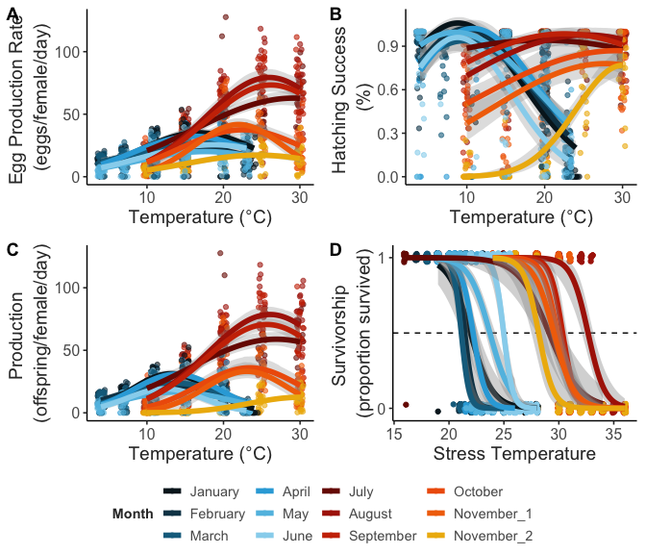

Thermal performance curves for each of the collections, each shown in a different color. Panels A-C show points for each individual measurement along with the estimated Gaussian regression line. Panel D shows individual survivorship measurements following a 24-hour acute heat stress. Survivorship curves are estimated as logistic regressions. Note that the x-axis ranges differ between the two sets of curves.

Thermal optima of the individual production TPCs were related to collection temperature for *A. tonsa* but not *A. hudsonica* (Figure 3)*.* The values from the second November collection of *A. tonsa*, which had the highest production thermal optimum despite being collected at the lowest temperature, were excluded from this analysis. These copepods were collected at 11°C. This is around the threshold for resting egg production in *A. tonsa* (Holste and Peck 2006). The extremely high estimated optimum temperature for production in this collection may therefore reflect the difference in hatching requirements between resting and subitaneous eggs. Thermal survivorship curves were variable in both species, with a range of LD50 values around 5°C in both species. As observed in previous studies, *A. tonsa* had higher thermal tolerance than *A. hudsonica* (Sasaki & Dam, 2020). Thermal tolerance increased with collection temperature in both species.

Vulnerability to heatwaves was estimated using two metrics: thermal safety margins for production (the difference between thermal optimum and collection temperature) and warming tolerance for survivorship (difference between thermal tolerance, LD50, and environmental temperature) (C. A. Deutsch et al. 2008). Thermal safety margins of the two species responded differently to changes in collection temperature (Table 3; Supp. Fig. 1). The invariant thermal optima for *A. hudsonica* production results in a strong decline in thermal safety margins as water temperatures increase (Figure 3; Supp. Fig. 1). Indeed, the warmest collection of *A. hudsonica*, occurring ~19°C, appears to have been above the population’s thermal optimum. By contrast, the seasonally variable *A. tonsa* production TPCs resulted in relatively stable thermal safety margins (Figure 3; Supp. Fig. 1). Throughout its season of occurrence, *A. tonsa* maintained a safety margin of at least 5°C. In both species, warming tolerance responded in a similar manner to changes in collection temperature (Table 4; Supp. Fig. 1). Decreases in warming tolerance with increasing water temperature indicated imperfect compensation of thermal limits via either acclimatization or adaptation (Figure 3; Supp. Fig. 1). While collection temperatures never exceeded thermal tolerance for either species, the lower thermal tolerance of *A. hudsonica* translated to reduced warming tolerance relative to *A. tonsa*, again suggesting that the seasonal occurrence of this species may be delimited at least in part by direct effects of temperature.

ANOVA results for a linear regression examining the relationship between thermal safety margin and collection temperature for the two Acartiid species examined. The model included collection temperature and species as factors, along with their interaction.

|  | Sum Sq | Df | F value | Pr(>F) |
| --- | --- | --- | --- | --- |
| (Intercept) | 451.696 | 1 | 1017.230 | 0.000 |
| temperature | 256.400 | 1 | 577.418 | 0.000 |
| species | 0.023 | 1 | 0.052 | 0.826 |
| temperature:species | 10.034 | 1 | 22.596 | 0.002 |
| Residuals | 3.108 | 7 | NA | NA |

ANOVA results for a linear regression examining the relationship between warming tolerance and collection temperature for the two Acartiid species examined. The model included collection temperature and species as factors, along with their interaction.

|  | Sum Sq | Df | F value | Pr(>F) |
| --- | --- | --- | --- | --- |
| (Intercept) | 1121.518 | 1 | 885.457 | 0.000 |
| temperature | 162.123 | 1 | 127.999 | 0.000 |
| species | 4.554 | 1 | 3.596 | 0.095 |
| temperature:species | 0.082 | 1 | 0.065 | 0.805 |
| Residuals | 10.133 | 8 | NA | NA |
|  |  |  |  |  |

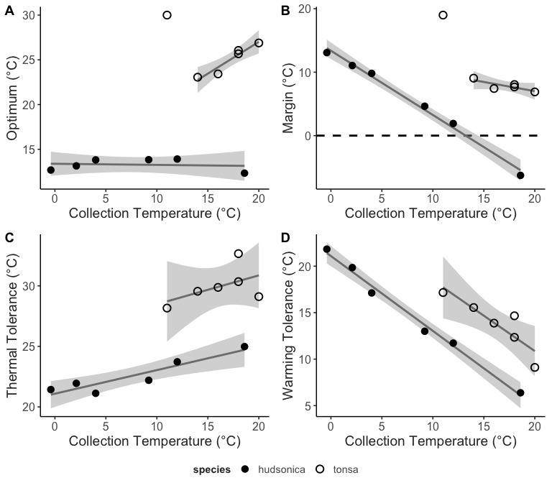

Relationships between (A) thermal optimum, estimated from the production thermal performance curves, and collection temperature; (B) the thermal safety margin (calculated as the difference between thermal optimum and collection temperature) and collection temperature; (C) thermal tolerance, measured as LD50, and collection temperature; and (D) warming tolerance (calculated as the difference between thermal tolerance and collection temperature) and collection temperature. The two Acartiid species are shown with different symbols. Linear regressions with confidence intervals are included.

## Effects of Simulated Heatwaves

The second component of this project examined the effects of heatwaves across generations in seasonal collections of *Acartia tonsa*. This began by assessing the impact of a simulated warming event on field collected (F0) individuals. We examined the effects of warming for 1-3 days (short duration) and 5-7 days (long duration) on EPR, HS, and production (Supp. Fig. 2a). The impact of these warming events was assessed using an effect size estimate (Hedge’s g), comparing the warming to the control treatment.

Results were highly variable across collection and duration, but effect sizes tended to be fairly small (Hedge’s g between -1 and 1). For the June collection, there was a small increase in EPR in response to acute warming, and a small decrease in HS in response to the longer duration event. Production, integrating both EPR and HS, exhibited only a small decrease in the longer duration warming treatment. In the August copepods, there was a small increase in EPR and a small decrease in HS during both short and longer events. The increase in EPR was large enough, however, to result in a small increase in production during both short and long events. In November, warming resulted in a large increase in EPR regardless of the duration of the event (Hedge’s g > 1). There was no effect of warming on HS, however, limiting the increase in production.

We also examined the effect of warming duration (the comparison between long and short events within treatment) on the three traits. Here, we observed similar effects of duration on production in both control and warming groups, in all three months (Supp. Fig. 3); in all cases there were slight decreases in production over time for the June and August collections and an increase in production for the November collection. The similarities in the effect of duration between the control and heatwave treatments suggests that seasonal variation in the effects of warming may be more consequential than differences between short and long events (at least at the daily to weekly timescales examined here).

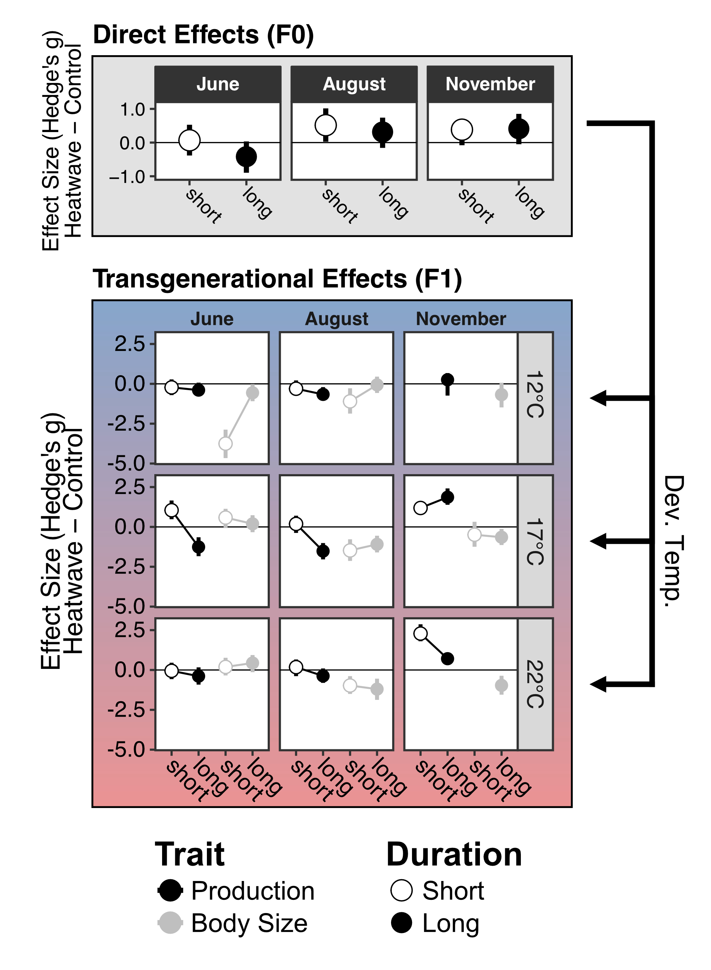

The effects of simulated heatwaves on production and body size. A) The direct effects of elevated temperature (field-caught F0 individuals), estimated as the effect size (Hedge’s g) calculated for the comparison between production by copepods exposed to heatwave and control treatments. A negative effect size indicates exposure to elevated temperature decreased production. The two different durations, short and long events, are shown with different symbols. B) The indirect, transgenerational effects of parental exposure to elevated temperature were also estimated as an effect size using Hedge’s g. Each panel shows data for one month and one developmental temperature. The different durations are again represented with different symbols, while offspring body size and production are shown in different colors. Here, a negative effect size indicates that parental exposure to elevated temperature decreased production or body size relative to individuals whos parents did not experience elevated temperatures.

## Transgenerational Effects of Simulated Heatwaves

For the transgenerational experiments, comparing between control and heatwave treatments now examines not the direct effects of increased temperature, but the indirect effect of parental exposure to heatwaves on offspring performance. Results were again highly variable across developmental temperatures, parental exposure duration, and monthly collections. For the June and August collections, effect sizes were often similar across all three reproductive traits (Supp. Fig. 2b; see June copepods at 17°C and 22°C, and August copepods at 12 °C). When effect sizes differed between traits, EPR tended to be most strongly affected by parental exposure to warming (see June copepods at 18°C and August copepods at 17°C and 22°C). Differences in the effects of parental exposure to heatwaves on EPR and HS often ameliorated the effects on production, which was generally least affected by parental exposure to warming. There were, however, significant decreases in production driven by parental exposure to longer duration warming in offspring developed at 17°C for both June and August collections. A small increase in production resulted from parental exposure to short duration warming in the June copepods reared at 17°C. This was the only observation of a positive effect of parental exposure to warming on production for the June and August copepods.

Effects of parental exposure to elevated temperature on November copepods were drastically different from those observed in June and August copepods. Instead of primarily affecting EPR, parental exposure to warming generally had large effects on HS in the November copepods (Supp. Fig. 2b). Additionally, unlike in June and August, there were no negative effects of parental exposure to warming on production values (Figure 3). However, nauplii in the 12°C developmental temperature group produced by parents exposed to short heatwaves did not successfully reach adulthood, potentially indicating strong lethal effects of parental exposure on offspring survival.

In all three collection, parental exposure to warming generally (but not always) reduced offspring body size. The effects of parental exposure to warming on production and body size were not correlated (Supp. Fig. 4). Offspring body size generally decreased with developmental temperature (Supp. Fig. 5). However, there were, at times, substantial differences in the observed temperature sensitivity of offspring body size between the two treatments; in June, parental exposure to heatwaves slightly decreased the temperature sensitivity of offspring body size, while a long heatwave during August increased the temperature sensitivity.

# Discussion

The rapid, intense warming associated with heatwaves and other extreme events may have dire consequences for ecological dynamics in aquatic systems. Responses to these acute events are determined by the position of thermal optima and limits relative to environmental temperatures. In taxa with short generation times, however, phenotypic plasticity and genetic differentiation may promote TPC parameter variation that tracks ambient temperatures, maintaining a buffer against detrimental effects of heatwaves. Further, exposure to elevated temperatures during heatwaves may have indirect, transgenerational effects on offspring that are important to account for. By integrating experiments with field-collected and lab-reared organisms, we show that TPCs of *A. tonsa* but not *A. hudsonica* vary across seasons and that this variation allows the *A. tonsa* population to maintain a relatively constant margin between optimum temperatures and ambient environmental temperatures. The mechanisms that produce seasonally variable TPCs, whether genetic or plastic, reduced the potential for heatwaves to adversely affect population dynamics and thus increase resilience in the face of climate change. We also used a series of simulated heatwave experiments to compare the transgenerational effects of short and long duration events throughout the year in *Acartia tonsa*. The observed variation in the transgenerational effects of heatwaves between collections reinforces that seasonal variation in temperature sensitivity may lead to unpredictable seasonal effects of heatwaves on population dynamics.

Differing seasonal patterns in variation of thermal performance curves between taxa may play an important role in determining community responses to heatwaves. We observed strong seasonal variation in the vulnerability of *A. hudsonica* to heatwaves; as ambient temperatures increase, it approaches the population’s relatively static thermal optimum. Indeed, late in the season of occurrence, ambient water temperatures actually exceed the thermal optimum. A heatwave at this point would be expected to strongly decrease population performance. By contrast, the variable TPC of *Acartia tonsa* produces relatively stable thermal safety margins, regardless of season. As a result, we’d predict that mild warming would increase production by pushing environmental temperatures closer to the thermal optimum of this population. Importantly, this is a deviation from the generally accepted notion that *A. tonsa* constitutes a “generalist” species, and illustrates the importance of considering seasonal variation in TPCs; as we have observed, the broad range of temperatures this population withstands is determined not only by a fairly broad TPC (relative to its congener), but by rapid shifts of the TPC. By focusing on short time scales, this and other studies highlight that variation in the TPC is fundamental to shaping temporal occurrence in planktonic taxa (Sasaki and Dam 2020; Anderson and Rynearson 2020), and will likely play an important role in determining the response of taxa to climate change.

Regardless of the mechanism, the contrasting levels of variation in TPCs of the two species of *Acartia* suggest different levels of vulnerability to future change. The increasing incidence of heatwaves may reduce the seasonal occurrence of the cold-water dominant *A. hudsonica* as the thermal optimum is exceeded more frequently. *Acartia tonsa* performance, on the other hand, would be expected to increase as heatwaves shift the population towards its thermal optimum. [Impacts of this switch? Are hudsonica and tonsa ecologically interchangeable? Can this be generalized for other taxa? Tropicalization of temperate communities - if cold/hot specialist TPCs are also less seasonally variable, this would intensify the vulnerability of these taxa relative to their temperate counter parts]

Trans-generational effects of heatwaves were highly variable. Not only did the effect of duration differ across offspring developmental temperature, the pattern of this variation across developmental temperatures varied across seasonal collection. Against this background variation however, there were general similarities between June and August production effect sizes, with strong differences between these and the November copepods. Past work has shown that seasonal variation in thermal performance has a genetic basis in *A. tonsa* (Sasaki and Dam 2020). This highlights the importance of considering not only seasonal variation in TPCs, but the mechanistic underpinnings of the variation. In scenarios where seasonal variation is entirely due to plasticity, we would expect broad similarities in the transgenerational effects of heatwaves regardless of offspring developmental temperature. However, where variation in TPCs is produced by genetic variation, transgenerational effects may also differ, reflecting interplay between parental stress, developmental effects, and differing genetic backgrounds (REFS ON GENETIC BASIS). This context dependence is a crucial, largely unexplored dimension of the response of marine taxa to heatwaves, reinforcing that caution is warranted when extrapolating the results of both acute warming and short heatwave events from laboratory experiments to the response of natural populations.

[Future directions; multi-stressor interactions; recurring heatwaves (do transgenerational effects alter offspring sensitivity to heatwaves); etc.] In these experiments, animals were fed *ad libitum* and may have been able to maintain the energetic demands of a robust stress response via increased consumption. In the absence of high food quality or quantity, populations may be more strongly affected by heatwaves.

**References**

Anderson, Stephanie I., and Tatiana A. Rynearson. 2020. “Variability Approaching the Thermal Limits Can Drive Diatom Community Dynamics.” *Limnology and Oceanography* 65 (9): 1961–73. <https://doi.org/10.1002/lno.11430>.

Angilletta, Michael J. 2009. *Thermal Adaptation: A Theoretical and Empirical Synthesis*. Oxford Biology. Oxford ; New York: Oxford University Press.

Arroyo, José Ignacio, Beatriz Díez, Christopher P. Kempes, Geoffrey B. West, and Pablo A. Marquet. 2022. “A General Theory for Temperature Dependence in Biology.” *Proceedings of the National Academy of Sciences* 119 (30): e2119872119. <https://doi.org/10.1073/pnas.2119872119>.

Berner, Daniel, and Valentin Amrhein. 2022. “Why and How We Should Join the Shift from Significance Testing to Estimation.” *Journal of Evolutionary Biology* 35 (6): 777–87. <https://doi.org/10.1111/jeb.14009>.

Deutsch, Curtis A., Joshua J. Tewksbury, Raymond B. Huey, Kimberly S. Sheldon, Cameron K. Ghalambor, David C. Haak, and Paul R. Martin. 2008. “Impacts of Climate Warming on Terrestrial Ectotherms Across Latitude.” *Proceedings of the National Academy of Sciences* 105 (18): 6668–72. <https://doi.org/10.1073/pnas.0709472105>.

Deutsch, Curtis, Justin L. Penn, Wilco C. E. P. Verberk, Keisuke Inomura, Martin-Georg Endress, and Jonathan L. Payne. 2022. “Impact of Warming on Aquatic Body Sizes Explained by Metabolic Scaling from Microbes to Macrofauna.” *Proceedings of the National Academy of Sciences* 119 (28): e2201345119. <https://doi.org/10.1073/pnas.2201345119>.

Dinh, Khuong V., Kha L. U. Doan, Nam X. Doan, Hung Q. Pham, Thi Hoang Oanh Le, Minh-Hoang Le, Minh T. T. Vu, Hans-Uwe Dahms, and Kiem N. Truong. 2021. “Parental Exposures Increase the Vulnerability of Copepod Offspring to Copper and a Simulated Marine Heatwave.” *Environmental Pollution* 287 (October): 117603. <https://doi.org/10.1016/j.envpol.2021.117603>.

Evans, R., M.-A. Lea, M. A. Hindell, and K. M. Swadling. 2020. “Significant Shifts in Coastal Zooplankton Populations Through the 2015/16 Tasman Sea Marine Heatwave.” *Estuarine, Coastal and Shelf Science* 235 (April): 106538. <https://doi.org/10.1016/j.ecss.2019.106538>.

Frölicher, Thomas L., and Charlotte Laufkötter. 2018. “Emerging Risks from Marine Heat Waves.” *Nature Communications* 9 (1): 650. <https://doi.org/10.1038/s41467-018-03163-6>.

Gardner, M J, and D G Altman. 1986. “Confidence Intervals Rather Than P Values: Estimation Rather Than Hypothesis Testing.” *BMJ* 292 (6522): 746–50. <https://doi.org/10.1136/bmj.292.6522.746>.

Ho, Joses, Tayfun Tumkaya, Sameer Aryal, Hyungwon Choi, and Adam Claridge-Chang. 2019. “Moving Beyond P Values: Data Analysis with Estimation Graphics.” *Nature Methods* 16 (7): 565–66. <https://doi.org/10.1038/s41592-019-0470-3>.

Hochachka, Peter W., and George N. Somero. 2002. *Biochemical Adaptation: Mechanism and Process in Physiological Evolution*. New York: Oxford University Press.

Holste, Linda, and Myron A. Peck. 2006. “The Effects of Temperature and Salinity on Egg Production and Hatching Success of Baltic Acartia Tonsa (Copepoda: Calanoida): A Laboratory Investigation.” *Marine Biology* 148 (5): 1061–70. <https://doi.org/10.1007/s00227-005-0132-0>.

Maazouzi, Chafik, Gérard Masson, Maria Soledad Izquierdo, and Jean-Claude Pihan. 2008. “Midsummer Heat Wave Effects on Lacustrine Plankton: Variation of Assemblage Structure and Fatty Acid Composition.” *Journal of Thermal Biology* 33 (5): 287–96. <https://doi.org/10.1016/j.jtherbio.2008.03.002>.

McKinstry, Caitlin A. E., Rob W. Campbell, and Kris Holderied. 2022. “Influence of the 20142016 Marine Heatwave on Seasonal Zooplankton Community Structure and Abundance in the Lower Cook Inlet, Alaska.” *Deep Sea Research Part II: Topical Studies in Oceanography* 195 (January): 105012. <https://doi.org/10.1016/j.dsr2.2021.105012>.

Oliver, Eric C. J., Markus G. Donat, Michael T. Burrows, Pippa J. Moore, Dan A. Smale, Lisa V. Alexander, Jessica A. Benthuysen, et al. 2018. “Longer and More Frequent Marine Heatwaves over the Past Century.” *Nature Communications* 9 (1): 1324. <https://doi.org/10.1038/s41467-018-03732-9>.

Padfield, Daniel, Hannah O’Sullivan, and Samraat Pawar. 2021. “rTPC and Nls.multstart: A New Pipeline to Fit Thermal Performance Curves in r.” *Methods in Ecology and Evolution* 12 (6): 1138–43. <https://doi.org/10.1111/2041-210X.13585>.

Rudman, Seth M., Sharon I. Greenblum, Subhash Rajpurohit, Nicolas J. Betancourt, Jinjoo Hanna, Susanne Tilk, Tuya Yokoyama, Dmitri A. Petrov, and Paul Schmidt. 2022. “Direct Observation of Adaptive Tracking on Ecological Time Scales in *Drosophila*.” *Science* 375 (6586): eabj7484. <https://doi.org/10.1126/science.abj7484>.

Sasaki, Matthew C., and Hans G. Dam. 2020. “Genetic Differentiation Underlies Seasonal Variation in Thermal Tolerance, Body Size, and Plasticity in a Short-Lived Copepod.” *Ecology and Evolution* 10 (21): 12200–12210. <https://doi.org/10.1002/ece3.6851>.

Smale, Dan A., Thomas Wernberg, Eric C. J. Oliver, Mads Thomsen, Ben P. Harvey, Sandra C. Straub, Michael T. Burrows, et al. 2019. “Marine Heatwaves Threaten Global Biodiversity and the Provision of Ecosystem Services.” *Nature Climate Change* 9 (4): 306–12. <https://doi.org/10.1038/s41558-019-0412-1>.

Smith, Kathryn E., Michael T. Burrows, Alistair J. Hobday, Nathan G. King, Pippa J. Moore, Alex Sen Gupta, Mads S. Thomsen, Thomas Wernberg, and Dan A. Smale. 2023. “Biological Impacts of Marine Heatwaves.” *Annual Review of Marine Science* 15 (1). <https://doi.org/10.1146/annurev-marine-032122-121437>.

Tassone, Spencer J., Alice F. Besterman, Cal D. Buelo, Dat T. Ha, Jonathan A. Walter, and Michael L. Pace. 2022. “Increasing Heatwave Frequency in Streams and Rivers of the United States.” *Limnology and Oceanography Letters* n/a (n/a). <https://doi.org/10.1002/lol2.10284>.

Tran, Leon L., and Jacob L. Johansen. 2023. “Seasonal Variability in Resilience of a Coral Reef Fish to Marine Heatwaves and Hypoxia.” *Global Change Biology*, February. <https://doi.org/10.1111/gcb.16624>.

Truong, Kiem N., Ngoc-Anh Vu, Nam X. Doan, Canh V. Bui, Minh-Hoang Le, Minh T. T. Vu, and Khuong V. Dinh. 2022. “Transgenerational Exposure to Marine Heatwaves Ameliorates the Lethal Effect on Tropical Copepods Regardless of Predation Stress.” *Ecology and Evolution* 12 (8): e9149. <https://doi.org/10.1002/ece3.9149>.

# Supplementary Material

# Supplementary Figures

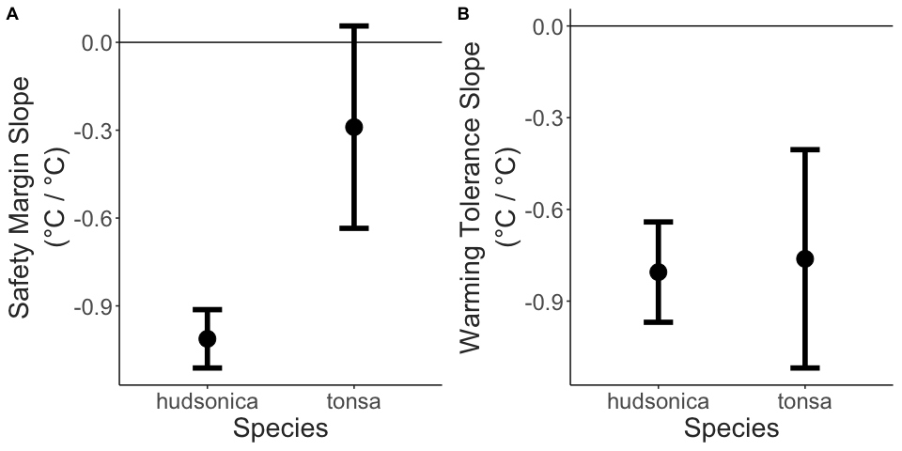

Comparison of the A) safety margin vs. collection temperature slopes and B) warming tolerance vs. collection temperature slopes for the two Acartia species, +/- 95 percent confidence intervals. Slopes represent the change in metric per °C change in collection temperature.

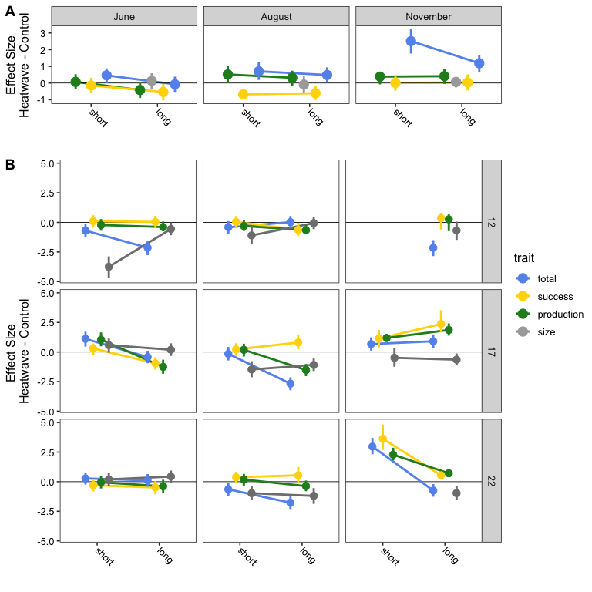

The effects of simulated heatwaves on all four measured traits: body size, production, hatching success, and egg production rate. A) The direct effects of elevated temperature (field-caught F0 individuals), estimated as the effect size (Hedge’s g) calculated for the trait comparisons between copepods exposed to heatwave and control treatments. A negative effect size indicates exposure to elevated temperature led to trait decreases. B) The indirect, transgenerational effects of parental exposure to elevated temperature were also estimated as an effect size using Hedge’s g. Each panel shows data for one month and one developmental temperature. Here, a negative effect size indicates that parental exposure to elevated temperature decreased production or body size relative to individuals whos parents did not experience elevated temperatures. In all cases, each of the four traits are shown in different colors.

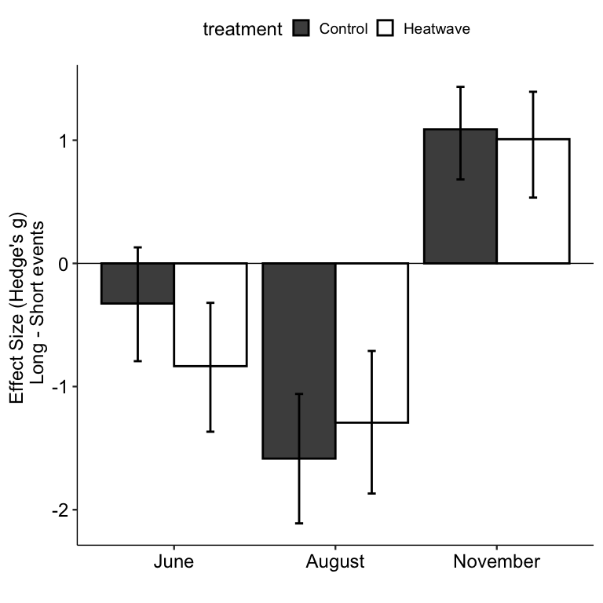

Effect size comparisons between short and long duration events for each collection, along with 95% confidence intervals. The different treatments, control and heatwave, are shown with different colors. A negative effect size indicates that the observed production value within a treatment decreased over time.

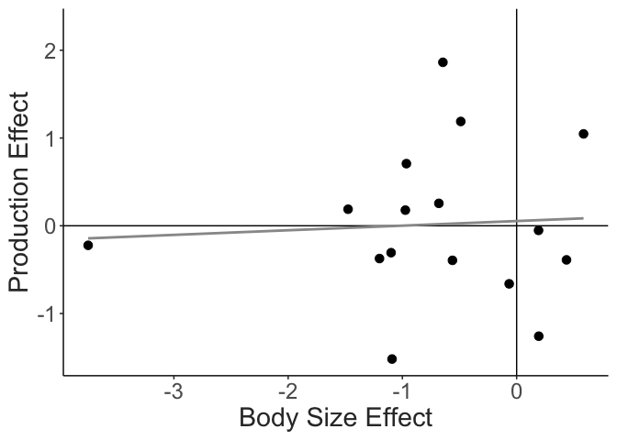

The relationship between the effects of parental exposure to warming on offspring body size and production. No significant relationship is observed.

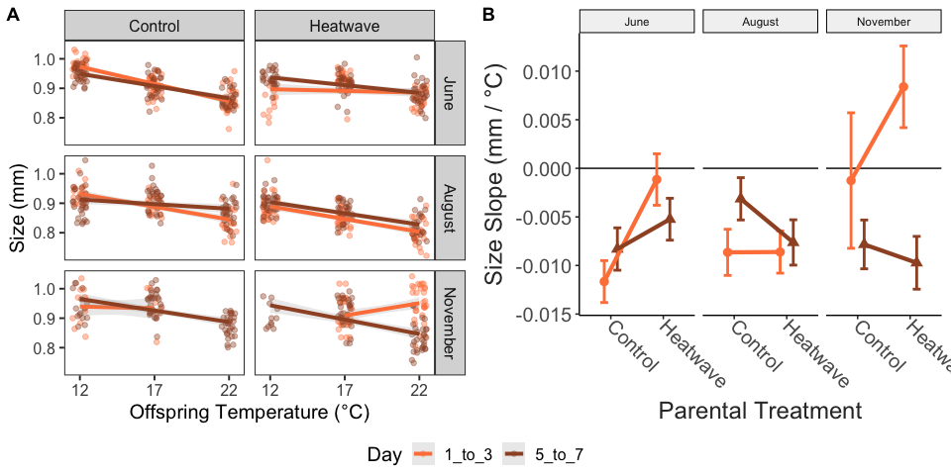

A) The relationship between offspring developmental temperature and adult body size. Each panel includes individual measurements for one treatment within a collection. Data for offspring of parents exposed to different duration events are shown in different colors. B) The slopes of body size vs. temperature shown in the panel A. A negative slope indicates that body size decreases with increasing temperature. The different durations are again shown with different colors.