Phenotypic and genomic variation diverge across space and season in a coastal copepod
Matthew Sasaki University of Massachusetts Lowell
Melissa Pespeni University of Vermont
Correspondence: Matthew_Sasaki@uml.edu
Code: https://github.com/ZoopEcoEvo/spatiotemp_genomics
This draft is current as of November 1, 2026
Abstract
ABSTRACT HERE. (Draft once Results are settled: question - design - four cryptic clades differ heritably in CTmax and turn over through the season - CTmax tracks seasonal temperature plastically, but differs among sites more than acclimation predicts - genomes are structured by site, with no seasonal evolution beyond drift and no seasonal echo of spatial temperature associations - a single CTmax misplaces vulnerability; forecasts should be built on clades, plasticity and turnover.)
Keywords: thermal tolerance, cryptic species, phenotypic plasticity, seasonal evolution, low-coverage whole-genome sequencing, Acartia tonsa

Introduction
Organising question: at what scale does thermal tolerance vary in a widespread coastal “species”, and does variation across space predict change through time?
- among cryptic clades: clades shift ranges or replace one another;
- among cryptic lineages: lineages shift ranges;
- among populations: local adaptation, so populations adapt in place;
- across seasons: rapid evolution tracks warming quickly;
- within individuals: plasticity buffers warming.
- Space-for-time substitution. Forecasts often assume spatial gradients (latitude, site temperature) predict responses through time. This assumption can hold for phenotypes and fail for genomes, or the reverse, and it is rarely tested on the same organisms.
- Seasonal evolution has been shown in Drosophila (Bergland et al. 2014; Machado et al. 2021), with seasonal allele-frequency change that parallels latitudinal clines. Short-lived marine plankton with many generations per season should be an even better candidate.
- Acartia tonsa is a dominant coastal copepod and a standard model for thermal physiology. It has short generations (several per season) and large populations. It is also a complex of deeply divergent cryptic clades, which is usually ignored in physiological work.
- The gap: no field study has separated the clade, population, seasonal and individual levels for the same animals, or tested space-for-time substitution at both the phenotypic and genomic levels.
- Hypotheses (from the phenotype draft): thermal limits vary strongly across both space and season; accounting for clade differences and acclimation raises estimated vulnerability at high latitudes and lowers it at low latitudes.
- Why it matters for forecasts: vulnerability is usually summarised as warming tolerance (CTmax minus habitat temperature) from a single CTmax per species. If tolerance differs among clades and shifts with acclimation, a single value misplaces where and when populations are at risk.
- This study: eight sites from 27.5°N (Florida) to 47°N (Gulf of St. Lawrence), sampled two or three times between July and December 2023. Each individual’s CTmax was measured on the day of collection, and the same individual was sequenced at low coverage (about 400 individuals). Pairing individual phenotypes and genomes across space and season is the methodological hook.

Methods

Field collections and site temperatures
Copepods were collected by surface plankton tow from eight sites along the western Atlantic and Gulf of Mexico coasts, from Florida to the Gulf of St. Lawrence, at two or three times between July and December 2023 (Table 1). Water temperature and salinity were measured at the time of collection with a handheld thermometer and an optical refractometer, respectively. Collections were timed to bracket the warm season: in general, the first sample from each site was collected just after the site reached its warmest period, and the final sample after temperatures had cooled in the autumn. The exception is the two Florida sites, where only two collections (peak and late season) were obtained, the first after an extended period of high temperatures.
To place the collections in a longer-term seasonal context, we used daily sea surface temperature from the Multi-scale Ultra-high Resolution (MUR) analysis (JPL MUR SST v4.1, 0.01°; 2014–2023) [REF]. For each site we averaged the water pixels within 5 km of the collection point (the nearest water pixel where none fell within that radius), which also reflects the scale over which planktonic copepods are advected. MUR temperatures were checked against continuous records from nearby monitoring stations (USGS, Chesapeake Bay Program, NOAA CO-OPS and Fisheries and Oceans Canada). Biases were within ±0.5 °C at all stations except the upper Chesapeake, where the Ganey’s Wharf series was corrected month by month against station ET5.1; no station was available to verify the Ritchie Wharf series. From these records we calculated each site’s long-term mean temperature, seasonal range and generation-averaged temperatures (Figure 25).
Table 1: Locations of the collection sites.
Site | Region | Lat | Long
Manatee River | Florida | 27.51 | -82.57
Ft. Hamer | Florida | 27.52 | -82.43
Tyler Cove | Maryland | 38.35 | -76.23
Ganey’s Wharf | Maryland | 38.81 | -75.91
Esker Point | Connecticut | 41.32 | -72.00
Sawyer Park | Maine | 43.91 | -69.87
St. Thomas de Kent Wharf | New Brunswick | 46.45 | -64.64
Ritchie Wharf | New Brunswick | 47.00 | -65.56

Thermal tolerance
Plankton samples were held in an insulated flask to maintain them at the collection temperature. Within three hours of collection, mature Acartia tonsa females were sorted from the tow into a mixture of equal parts 63-µm filtered seawater and artificial seawater (bottled spring water adjusted to the collection salinity with Instant Ocean), to acclimate animals to the artificial seawater before the thermal limit assays.
Critical thermal maximum (CTmax) was measured for individual copepods using a custom setup [REF], comprising a reservoir with a heating element and water pump, a clear plexiglass water bath holding thirteen 50-ml flat-bottom glass shell vials, and an Arduino temperature logger. During the assay the heating element warms water in the reservoir, which is pumped through the water bath and back. Copepods were placed individually into ten of the vials, observed through the sides of the bath; the remaining three vials held temperature sensors that recorded water temperature every five seconds.
To start an assay, vials with 10 ml of the artificial seawater were placed in the water bath, adjusted to the collection temperature, and copepods were transferred individually into the vials. Control individuals were held in vials at ambient temperature throughout each assay; none showed changes in behaviour or mortality. After a brief rest, the heating element was turned on. Ramping rates started at about 0.3 °C per minute and slowed to about 0.1 °C per minute (Figure 20), typical for CTmax assays with copepods and other small invertebrates [REF]. Copepods were monitored continuously until they no longer responded to gentle stimulus (water movement from slowly turning the vial), and the temperature at that point was taken from the continuous record as the individual’s CTmax. This endpoint differs from lethal temperature: all individuals recovered after the assay.
After the assay, each individual was photographed with a handheld microscope camera (Em1 600) and prosome length measured in Fiji [REF] against an image of a 1-mm scale bar. Body size is reported (Figure 21) but not used as a covariate in the analyses. Each copepod was then preserved individually in 95% ethanol, kept at room temperature for several days in the field and stored at -20 °C in the laboratory. Generally about 20 individuals were measured per collection (two assays of ten). The late-season tow in Maine was dominated by the congener Acartia hudsonica; all A. tonsa recovered were assayed, but sample sizes at that time point were reduced.

DNA extraction, library preparation and sequencing
DNA was extracted from each individual copepod with a modified magnetic-bead protocol (Ali et al., 2015). Individual copepods were soaked in molecular-grade water for 1 hour at room temperature and then added, on ice, to the wells of a 96-well plate containing 100 µl of digestion buffer (90.5 µl Lifton’s buffer, 7 µl of 20 mg/ml Proteinase K and 2.5 µl of 1 M DTT), making sure each copepod was fully submerged before the wells were sealed. Plates were incubated overnight at 55 °C. After incubation, 80 µl of hybridization buffer (2.5 M NaCl, 20% PEG 8000, 0.025 M DTT) and 20 µl of resuspended AMPure XP beads were added to each well; plates were briefly vortexed and incubated for five minutes at room temperature. Plates were placed on a magnetic rack, the supernatant was discarded, and the beads were washed three times with 150 µl of freshly prepared 80% ethanol. After the final wash the beads were air-dried for 11 minutes, resuspended in 20 µl low TE, incubated for five minutes at room temperature and returned to the magnetic rack, and the supernatant containing the purified DNA was transferred to a new plate.
Low-coverage whole-genome libraries were prepared with Twist Bioscience 96-plex library preparation kits following the manufacturer’s instructions, and sequenced by Novogene (Sacramento, CA, USA) on two lanes of an Illumina NovaSeq X Plus 25B flow cell (150-bp paired-end; 436 libraries).

Read processing, mapping and site filtering
- Demultiplexing (fqtk) and read cleaning (fastp) [REF]; mapping to GCF_053477335.1 plus clade mitogenome contigs. Repeat, NUMT and paralog masks; per-clade depth bounds. [report §3]
- Exclusions: A. hudsonica, unassigned libraries, MR_peak_2_04 and MR_peak_2_05.

Clade and lineage assignment
Acartia tonsa comprises several deeply divergent cryptic clades, distinguished by mitochondrial COI sequence (Figueroa et al., 2020). Mitogenome contigs were assembled for each clade (MEGAHIT and NOVOPlasty [REF]) from individuals whose COI matched published clade haplotypes, and added to the nuclear reference so that mitochondrial reads map to their own clade’s contig rather than to nuclear copies (NUMTs). Each individual was assigned to the clade whose contig received at least 90% of its reads in the COI region (at least 20 reads); libraries below this majority, which contained DNA from two individuals of different clades, were left unassigned (Figure 24). Clade calls agreed with genome-wide structure (PCAngsd and NGSadmix [REF]) in every retained individual. Genome-wide structure further split clade F into four geographically separated lineages (F-N, F-NE, F-FH and F-MR); relationships among lineages were estimated from the COI maximum-likelihood tree (IQ-TREE [REF]) and from genome-wide distances (neighbour-joining on net distances between lineages from the PCAngsd covariance) (Figure 27). Previous genetic and physiological work treats F as a single clade [REF], and we do the same: clade is the analysis unit throughout, and the F lineages are considered in the Discussion as a direction for future work. The exception is the within-clade association scan, which was run within lineages so that population structure within F did not confound genotype–CTmax associations.

Population genetics within clades
- Diversity, Tajima’s D, FST, LD decay, relatedness and inbreeding (ANGSD, ngsRelate, ngsLD); local PCA. [report §3]

Seasonal allele-frequency change
- Split-half calibration of low-coverage sampling noise (c $≈$ 0.58–0.70); calibrated temporal Fc and Ne. [report §3, “Seasonal allele-frequency change”]
- Per-SNP binomial GLMs against time in season and against generation-averaged temperature; exact within-site permutations. [same]
- Allele-frequency variance partition, spatial vs seasonal, with per-population sampling variance; chromosome jackknife. [report §3, “Spatial vs. seasonal genetic variation”]
- Space-for-time concordance: per-SNP spatial (site-mean MUR temperature) and seasonal temperature slopes; seasonal and spatial nulls. [report §3, “Does space substitute for time?”]

Statistical analysis of CTmax
Thermal limits were analysed for individuals verified as adult A. tonsa females with a clade assignment. 32 phenotyped individuals were excluded: 5 were identified after the assay as late-stage juveniles, 23 could not be assigned because their sequencing libraries failed, 2 were A. hudsonica, and 2 libraries contained DNA from two individuals of different clades. The analysis set comprised 395 individuals in four clades (X 118, F 151, S 71, IV 55).
CTmax was analysed with linear mixed-effects models (lme4 [REF]). The first model included clade, collection temperature (centred) and their interaction as fixed effects, with random intercepts for site (non-thermal variation among sites), collection (site × season), assay replicate (time between collection and assay) and vial position in the water bath (“tube”). Collection temperature varies only between collections, so the collection term prevents individuals from acting as independent replicates of temperature. Model fit was checked visually with the performance package [REF], and clade marginal means (at the mean collection temperature, 22 °C) and temperature slopes (acclimation responses) were extracted with emmeans [REF].
To compare the response of CTmax to seasonal and to spatial temperature variation, each collection’s temperature was split into a seasonal component, the mean collection temperature of that season (early, peak or late) across all sites, and a spatial component, the collection’s deviation from that season mean, i.e. how much warmer or cooler the site was than the other sites at the same point in the season. Both components were fitted together, with clade and the random effects above, first with common slopes and then with clade-specific slopes; the difference between the spatial and seasonal slopes and its standard error were taken from the model’s covariance matrix. Seasons were defined by the seasonal temperature cycle at each site rather than by calendar date, and the Florida sites were not sampled in the early season. As a sensitivity analysis we used the standard within/between-site decomposition [van de Pol & Wright 2009, REF]: each site’s mean collection temperature (spatial) and each collection’s deviation from it (seasonal). Variance in CTmax was partitioned among clade, spatial and seasonal temperature (the variance of each fitted fixed effect), other site and collection differences, the assay and individuals [Nakagawa & Schielzeth 2013, REF], with 95% intervals from 200 parametric bootstraps. Finally, collections containing two or more clades ($≥$ 3 individuals each) served as natural common gardens: animals collected together share recent conditions, so clade differences estimated with collection as a fixed effect cannot reflect acclimation.
Seasonal changes in clade composition were tested at each site with Fisher’s exact test (clade × season, simulated p) and across sites with the sum of per-site chi-square statistics against 10,000 permutations of season labels within sites. The CTmax expected from composition alone (the mean of each collection’s clade effects, temperature-adjusted, from the model with seasonal and spatial temperature) was regressed, weighted by the number of individuals, on the seasonal and spatial components of collection temperature. These composition slopes add to the within-clade slopes; their sum is the slope of the community’s CTmax. 95% intervals come from 2,000 bootstraps that resampled individuals within collections and drew clade effects from their sampling distribution. Each slope was tested against 10,000 permutations of clade labels: among seasons within sites for the seasonal slope, and among sites within seasons for the spatial slope.

Genetic basis of CTmax
Within each lineage (clades X, S and IV, and the F lineages F-N and F-FH) with at least 30 phenotyped and sequenced individuals (collections with at least 8 individuals of the lineage), CTmax was regressed on genotype dosage (the expected number of minor alleles from ANGSD genotype posteriors [REF]) at every SNP, with collection and log mean sequencing depth as covariates, so individuals were compared only with others collected at the same time and place. A genome-wide null came from 100 replicates with CTmax shuffled among individuals of the same collection. Power was estimated by simulation on each lineage’s own data: for 2,000 SNPs sampled across the genome, true genotypes were drawn from each individual’s genotype posterior, a causal effect of 0.25–3 °C per allele was added to within-collection-shuffled CTmax, and the scan’s test was repeated against a genome-wide 5% threshold (the 5th percentile of the smallest p across SNPs in each permutation). Between clades, mitochondrial protein-coding sequences were compared among clade consensus sequences [report §4, “Candidate genes”].
For nuclear genes, a consensus sequence was called for each clade from all of its individuals’ reads (ANGSD -doFasta 2 [REF], at least three reads, within the final site list and the clade’s depth bounds). For the longest protein of every RefSeq gene, codons called in at least three of the four clades were compared, and a nucleotide difference carried by one clade while the other called clades shared the base was assigned to that clade’s branch as nonsynonymous (N) or synonymous (S). Requiring all four clades would have excluded many genes, because reads from S and IV, the clades most divergent from the reference, map less often in coding sequence. Genes were annotated with GO terms and KEGG pathways by eggNOG-mapper v2.1.12 (DIAMOND, more-sensitive mode; eggNOG 5.0 [REF]), with GO terms propagated to their ancestors. For each GO term and KEGG pathway with at least 10 genes and 20 substitutions, we tested (i) amino-acid divergence (N per codon compared, summed over branches) and (ii) N/(N + S) on each clade’s branch, against genes annotated in the same ontology, using the sampling variance of a ratio estimator for random gene sets of the same size; p values were adjusted by Benjamini–Hochberg within each test, and significant terms were checked against 2,000 random gene sets. Branch-specific acceleration of single genes was tested by comparing N/(N + S) on one branch with the same gene’s other branches (one-sided Fisher test).
Fifteen transcripts that responded to selection in experimental evolution of A. tonsa [REF] were placed on the reference genome with megablast and assigned to the RefSeq genes they overlap (18 genes). SNPs in these genes (± 2 kb) were compared with SNPs in 1,000 random sets of the same number of other genes for the spatial temperature association, seasonal change, sign agreement of seasonal and spatial slopes, and the within-lineage CTmax association; clade-specific amino-acid substitutions in the genes were compared with random background gene sets.

Additional analyses
Parasites and epibionts were detected from reads that did not map to the A. tonsa reference, by screening for small-subunit rRNA (phyloFlash [REF], SILVA 138.1 [REF]); an organism group was called present at ≥ 5 read pairs and ≥ 2 per million library pairs. Their effect on CTmax was estimated within collections with both carriers and non-carriers (CTmax ~ status + clade + (1 | collection)). To test for phenotypic signatures of seasonal selection, the spread of CTmax within clades (absolute deviation from the collection median; Brown–Forsythe) was compared among seasons within each clade × site with a mixed model (|deviation| ~ season + (1 | clade × site)). Long-term effective size was estimated from nucleotide diversity (π = 4N_{e}µ) for mutation rates of 10⁻⁹–10⁻⁸ per site per generation, and compared with temporal N_{e}.

Power of the seasonal tests
The power of the seasonal tests was estimated by injecting selection into the observed allele frequencies (unlinked SNPs) and rerunning each test exactly as in the analysis, so that drift, sampling noise and the sampling design were those of the real data. For the seasonal GLM and temporal Fc, a random fraction of SNPs (0.1–10%) had their logit frequency shifted by a fixed amount between each site’s first and last sample, in the same direction at every site. For the concordance test, the most temperature-associated SNPs across sites (top 1–100% by spatial z) were given a seasonal temperature response equal to a fraction (0.05–1) of their spatial slope. Detection meant ranking above every within-site permutation (seasonal GLM, concordance) or an added excess Fc larger than the observed excess plus 1.96 standard errors (inverse-variance pooled over sites); ten replicates per scenario.

Warming tolerance scenarios
To illustrate how clade differences and acclimation change estimates of vulnerability, we calculated daily warming tolerance (CTmax minus habitat temperature [REF]) at each site from the bias-corrected MUR temperatures for August–September 2014–2023 (the warmest months and the period of peak abundance), and pooled nearby sites into six regions (Florida: MR and FH; Chesapeake: MD and GW; Connecticut; Maine; Shediac: TK; Miramichi: RW), weighting sites equally after applying each site’s own composition and temperature terms. We compared three scenarios. Scenario 1 assumes a single CTmax for the species, the mean of all peak-season individuals, so variation in warming tolerance comes only from temperature. Scenario 2 uses each clade’s peak-season mean CTmax (its mean across all collections when it had fewer than five peak-season individuals), weighted by the clade make-up of the site’s peak-season collection. Scenario 3 adds acclimation: CTmax was predicted for each clade on each day from the within/between-site model (fixed effects only), with the day’s temperature as the within-site term. To avoid extrapolating acclimation beyond the data, daily temperatures were clamped to the range of collection temperatures at which each clade was sampled. As a sensitivity analysis, scenario 3 was repeated with each site’s clade make-up across all collections instead of the peak collection.
For each region and scenario we summarised the mean warming tolerance of the peak-season population, and the warming tolerance on the warmest August–September day of each year (averaged over years) for the least tolerant clade making up at least 10% of the peak collection. Intervals are 95% ranges from 1,000 bootstrap resamples of individuals (scenarios 1 and 2) or 1,000 draws of the model’s fixed effects (scenario 3). All scenarios were repeated with 4 °C of warming applied uniformly. These are illustrations rather than forecasts: they assume no change in clade composition and no evolutionary response, and only scenario 3 allows CTmax to respond to warming (through acclimation, up to the sampled limit).

Results

1. Thermal limits vary across space and through the season
Collection temperatures ranged from 10 °C to 36 °C, with strong seasonal variation at all eight sites (Figure 1; Figure 22). Thermal limits varied substantially among collections. CTmax generally declined through the season, highest in the early or peak collections and markedly lower in the late collections, and was higher at the southern sites than the northern ones in every season (Figure 1 C). Body size varied less consistently: it increased through the season at several sites but peaked in an earlier collection at others (Figure 21).
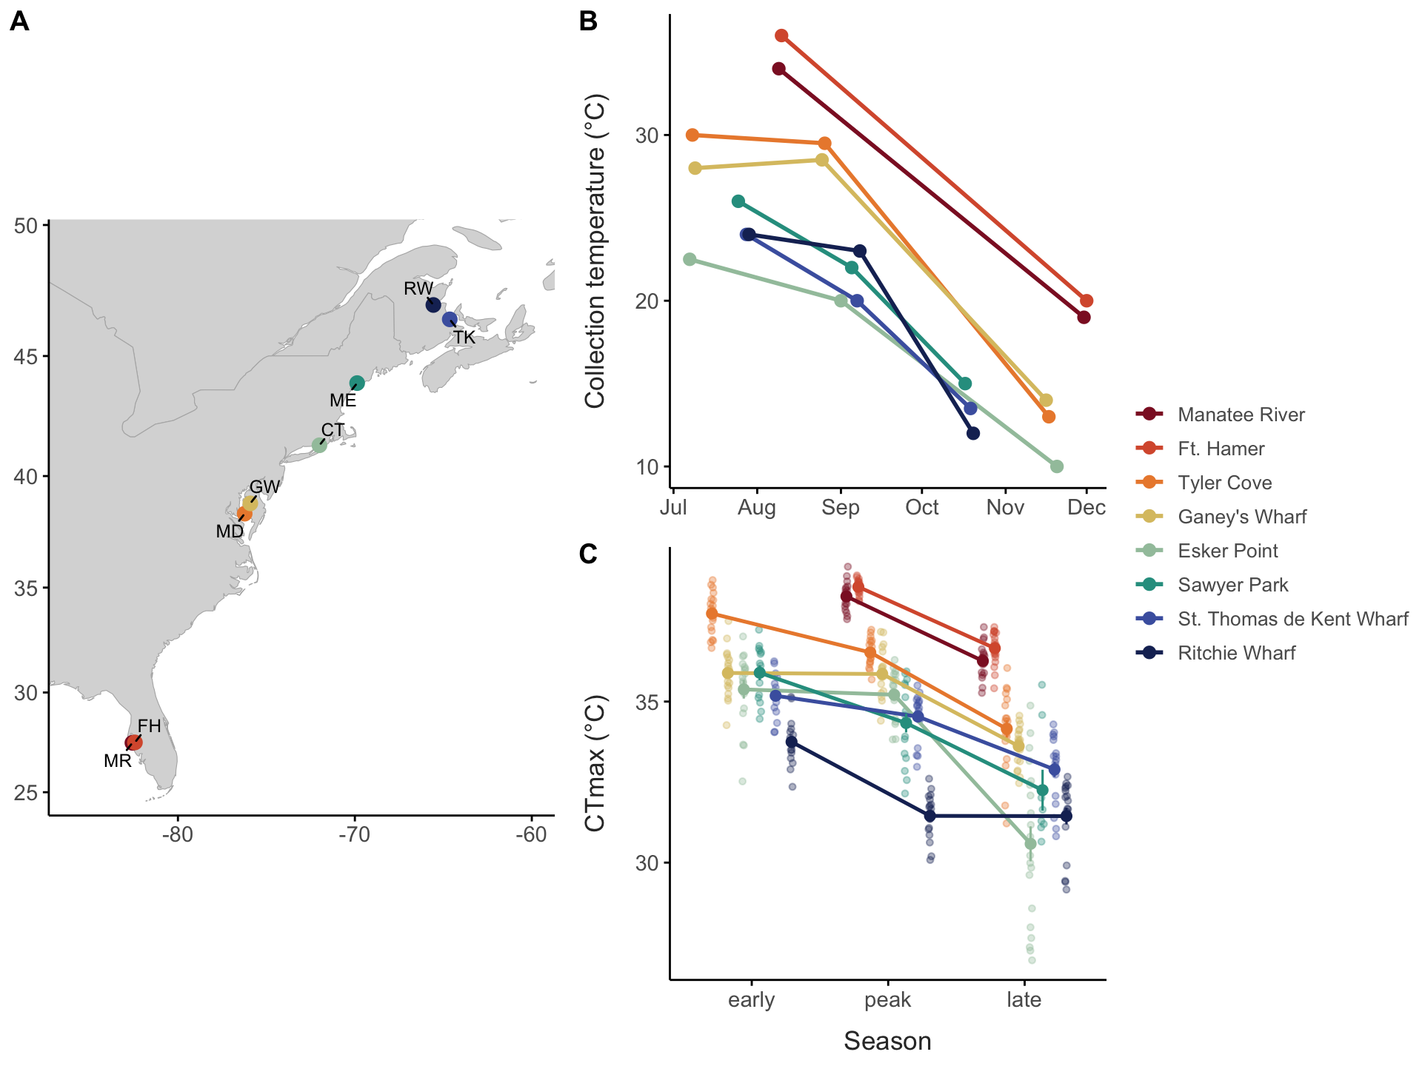
Figure 1: Collection sites and thermal limits. (A) Collection sites. (B) Water temperature at each collection. (C) CTmax of individuals (small points) and collection means ± SE (large points, connected within sites) by season. Colours: sites, south (red) to north (blue).

2. Cryptic clades are structured by site and turn over through the season
Genome-wide PCA separated the four clades completely (Figure 2 A). Within clades, individuals clustered by site rather than by season (Figure 2 B; Figure 26): F separated Florida (FH, MR) from the Chesapeake (MD, GW) and Connecticut, S separated the Chesapeake from Florida and Connecticut, X separated the Gulf of St. Lawrence (TK, RW) from Connecticut and Maine, and IV showed a similar north–south split. In F, this structure corresponds to four geographically separated lineages whose mitochondrial and nuclear trees agree (Figure 27).
Clade composition varied strongly across both space and time (Figure 2 C). The low-latitude sites were dominated by F and S, and the northern sites by X and IV. Composition changed through the season at six of the seven sites with more than one clade (combined permutation test, p < 10⁻⁴; RW, p = 0.11; Figure 7). In Connecticut the early collection contained all four clades, the peak collection was mostly S and the late collection mostly IV; at TK, X made up the early and peak collections and IV the entire late collection; in the Chesapeake, F dominated the early collections and S increased at the peak (MD) or late (GW). These seasonal shifts mirror the spatial pattern: clades common at warm sites dominate warm collections, and IV, a northern clade, dominates the cold late-season collections (Figure 23). Because the clades differ in CTmax (Result 5), these shifts change the thermal tolerance of the community as a whole (Result 3).
- Caveat: about 20 individuals per collection, one year of sampling.
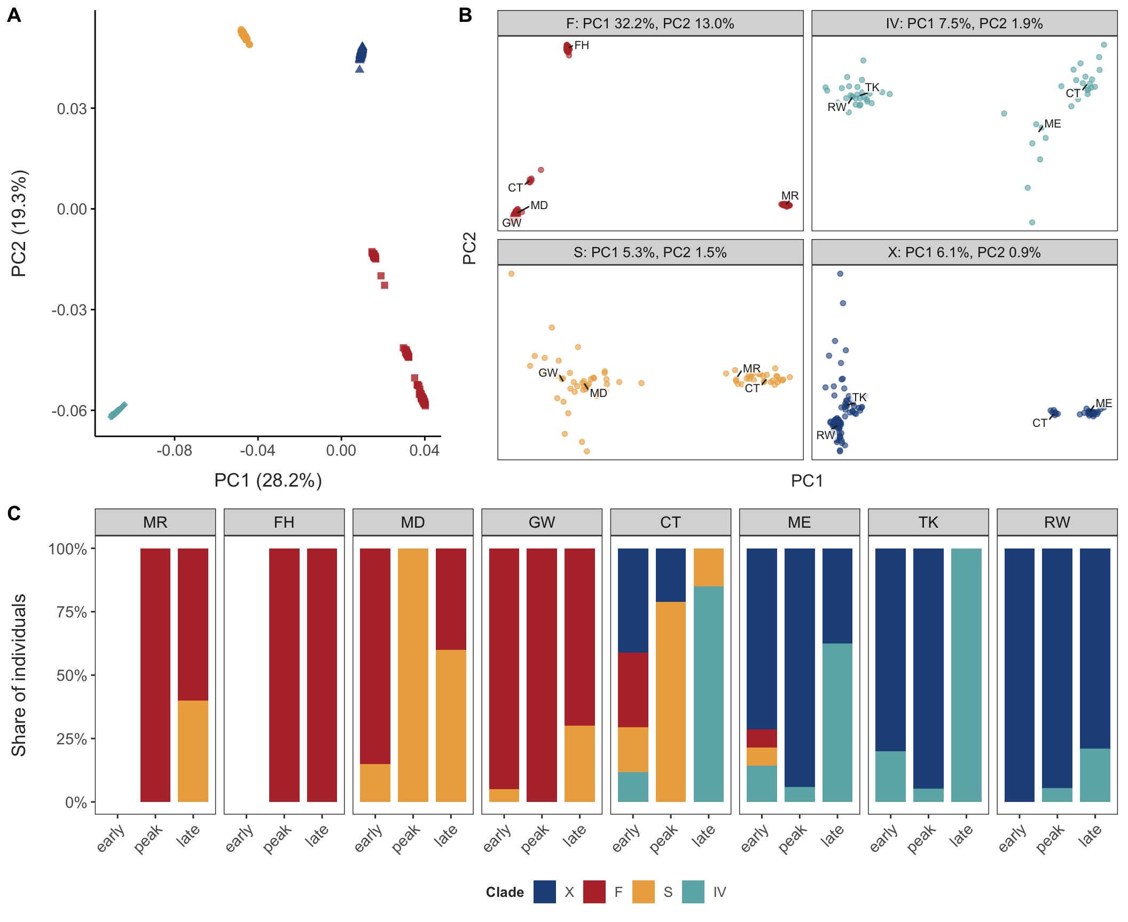
Figure 2: Genomic structure and clade composition. (A) PCA of all individuals (PCAngsd), coloured by clade. (B) PCAs within each clade; labels mark the median position of each site’s individuals (sites with at least three individuals). (C) Clade composition of each collection by site and season.

3. Thermal tolerance differs more across space than through the season
Collection temperature was split into its seasonal component (the season’s mean across sites) and its spatial component (how much warmer or cooler a site was than the other sites in the same season). CTmax rose with both, but more steeply with spatial temperature: 0.25 °C per °C (SE 0.06) against 0.13 °C per °C (SE 0.02) for seasonal temperature, a difference of 0.12 °C per °C (95% CI −0.00 to 0.24, p = 0.054; Figure 3 A). The spatial slope was the steeper of the two in every clade, and clearly so in X (difference 0.22, 95% CI 0.05–0.39) and S (0.18, 0.01–0.35); the intervals for F (0.13, −0.06 to 0.31) and IV (0.16, −0.08 to 0.39) were wider. The conventional within/between-site decomposition, which compares eight site means instead of collections within seasons, gave the same direction but could not resolve the difference (0.11, −0.10 to 0.32; Table 4). Sites therefore differ in CTmax by more than seasonal acclimation to their temperatures predicts, consistent with the heritable differences in thermal tolerance among populations found in laboratory common-garden experiments [REF].
Clade composition adds to both responses. Because the clades differ in CTmax (Result 5), the CTmax expected from composition alone, with each individual given its clade’s temperature-adjusted mean, rose by 0.05 °C per °C of seasonal temperature (95% CI 0.03–0.06; permutation p < 0.001) and by 0.12 °C per °C of spatial temperature (0.08–0.16; p < 0.001; Figure 3 B). Composition therefore favours tolerant clades in warm water in both directions and, like plasticity, more strongly across sites than through the season (difference 0.07, 0.03–0.11). The seasonal shift came mostly from IV dominating the cold late-season collections at CT, TK and ME. For the community as a whole, CTmax rose by 0.18 °C per °C through the season and by 0.37 °C per °C across sites (difference 0.19, 0.06–0.32): turnover adds about a third to the seasonal and about half to the spatial response of plasticity within clades.
Clade, temperature and site together structured most of the variation in CTmax (Figure 3 C). Without temperature terms, collection (32%), clade (35%) and site (19%) were the largest components, with 13% among individuals within a collection. With the temperature terms, spatial temperature explained 22% (95% CI 7–42%) and seasonal temperature 10% (5–22%) of CTmax variance; they absorbed most of the collection component (6% remaining), leaving 14% to other site differences. Clade accounted for 34%, with a wide interval (2–64%) because there are only four clades.
- Infection does not explain CTmax variation: within collections, individuals carrying parasites (Paradinium, trematodes) or epibiotic ciliates, detected from unmapped reads, did not differ in CTmax from non-carriers (Table 6; Figure 15). [in hand]
- Note: in summer, collection-day temperatures at northern sites run 2–6 °C warmer than MUR, which matters for interpreting acclimation. [TO CHECK]
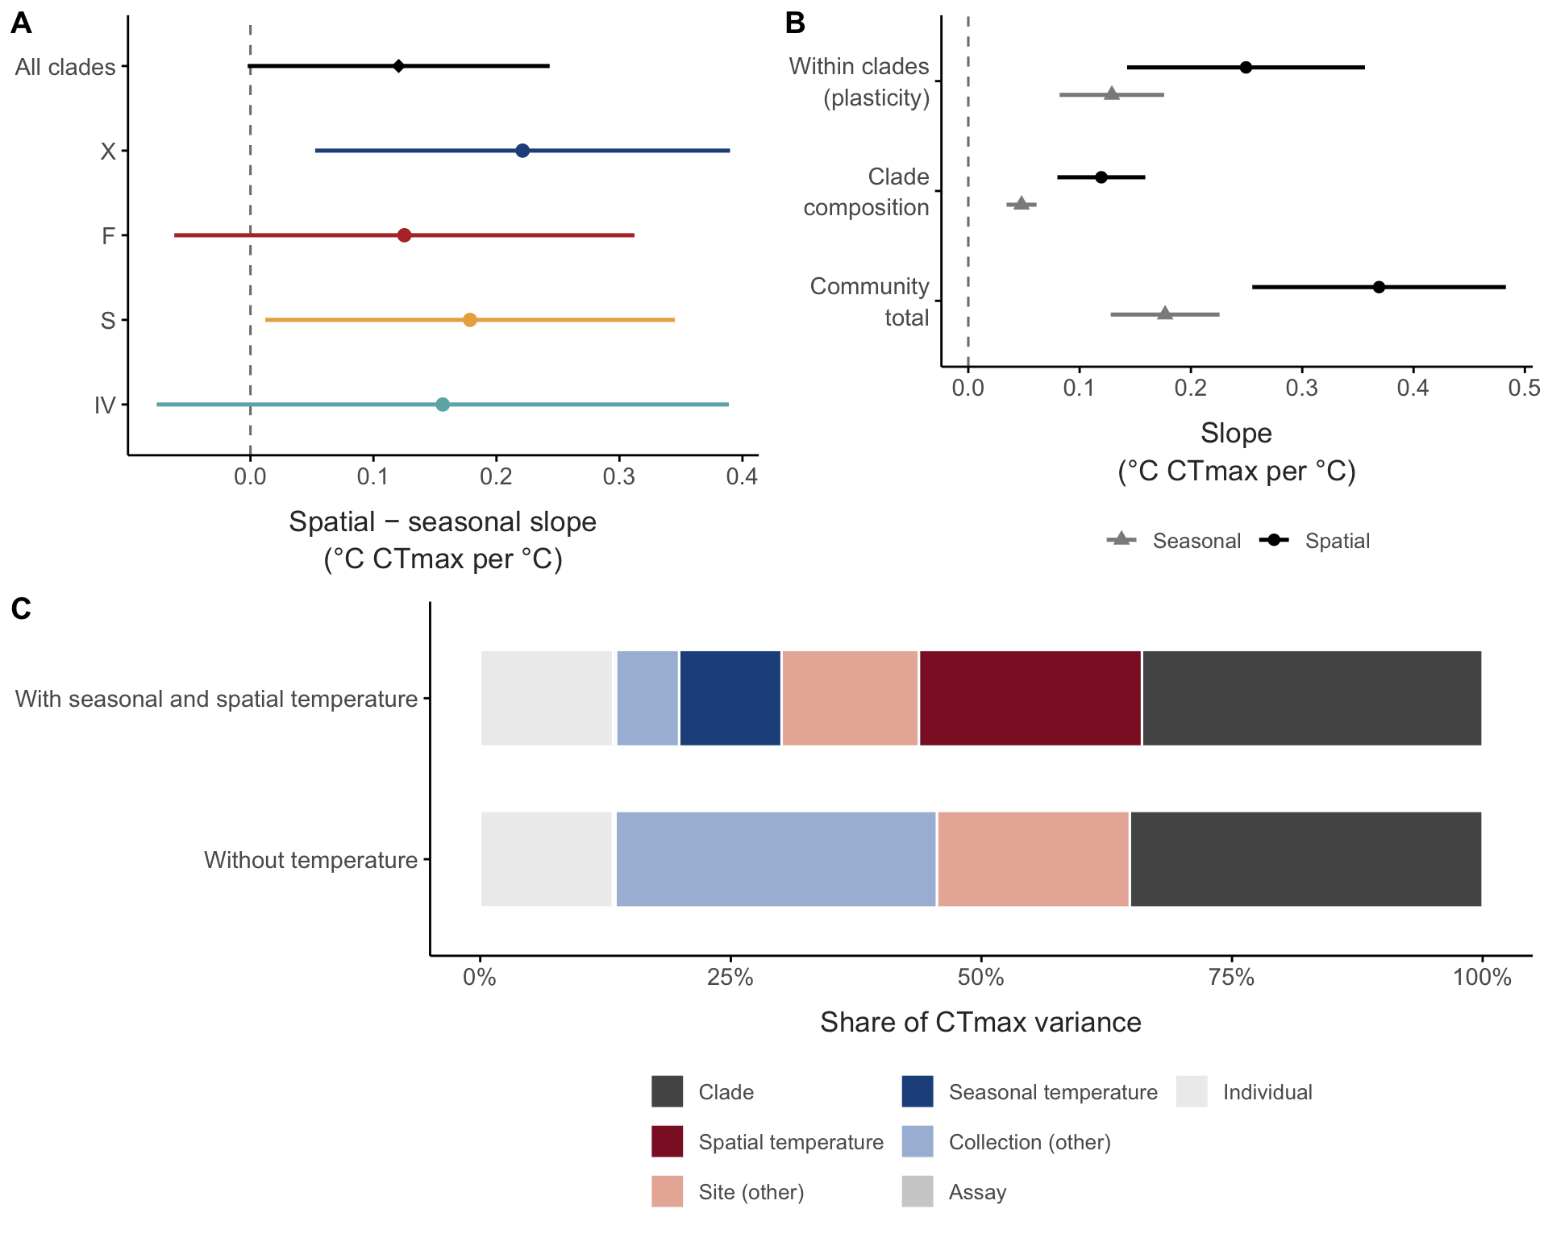
Figure 3: Thermal tolerance responds more strongly to spatial than to seasonal temperature, within clades and through clade composition. (A) Difference between the spatial and seasonal CTmax slopes (°C CTmax per °C; 95% CI), for all clades together and for each clade. Collection temperature was split into the season’s mean across sites (seasonal) and each collection’s deviation from that mean (spatial). (B) Seasonal (grey) and spatial (black) CTmax slopes within clades (plasticity), from clade composition alone (turnover), and their sum for the community as a whole (95% CI). (C) Share of CTmax variance explained by clade, spatial and seasonal temperature, other site and collection differences, the assay and individuals, without and with the temperature terms.

4. Genomic variation is spatial, and seasonal change does not echo spatial temperature associations
- Allele-frequency variance between sites far exceeds that between seasons within sites (Figure 4 A): about 13 times in X (0.030 vs 0.002, scaled by $\overset{‾}{p}(1−\overset{‾}{p})$), and the seasonal component is indistinguishable from zero in S. In F, between-site variance (0.41) includes the divergence between Florida and Chesapeake populations. IV had no site sampled in two seasons. [in hand]
- After calibrating low-coverage sampling noise, seasonal change is about what drift predicts (calibrated excess Fc 0.000–0.011; Figure 28, Figure 11, Figure 12). No genome-wide excess of seasonal association in X or F, against time in season or against temperature; chr6 makes no difference; S uninformative. [in hand]
- Concordance: alleles associated with warmer sites did not rise after warm periods. Among the 1% of SNPs with the strongest spatial temperature association, the sign of the seasonal slope matched the spatial slope in 55% (X) and 49% (F), within the range of the permutations (Figure 4 B; Figure 13). [in hand]
- Power is built into Figure 4 B: had these SNPs responded to seasonal temperature at only 5–10% of their spatial slope (seasonal changes of 4–14 percentage points), sign agreement would have exceeded every permutation. In F the spatial associations mostly reflect the Florida–Chesapeake split, so X is the cleaner test. [in hand]
- Seasonal GLM power (Figure 16): ≥ 80% power for changes of about 18 percentage points at ≥ 5% of SNPs or 23 points at ≥ 1% (s ≈ 0.04–0.06 per generation in F, 0.13–0.18 in X, which has fewer generations between samples); temporal Fc is less sensitive (23 points at ≥ 5% of SNPs). With 12 (X) or 24 (F) permutations, the smallest attainable p is 0.083 and 0.042. Strong seasonal selection, and any seasonal echo of the spatial temperature associations, is excluded; weak, polygenic seasonal change is not. [in hand]
- Temporal Ne (about 200–5,400) is 23–214 times smaller than long-term Ne from nucleotide diversity, even at a high mutation rate of 10⁻⁸ (Table 5): within a season, local allele frequencies change far more than closed populations of the long-term size would allow, consistent with sites open to immigration and mixing of water masses. [in hand; Discussion]
- High diversity and large long-term Ne in every clade; no close kin (Figure 10). [in hand]
- Phenotypic check: CTmax spread within clades did not narrow through the season, as strong selection removing intolerant individuals would cause (mean absolute deviation +0.02 °C at peak, +0.05 °C late vs early; CIs span zero; Figure 14). [in hand]
- chr6 structural polymorphism in northern X. [TO DECIDE: main text or supplement]
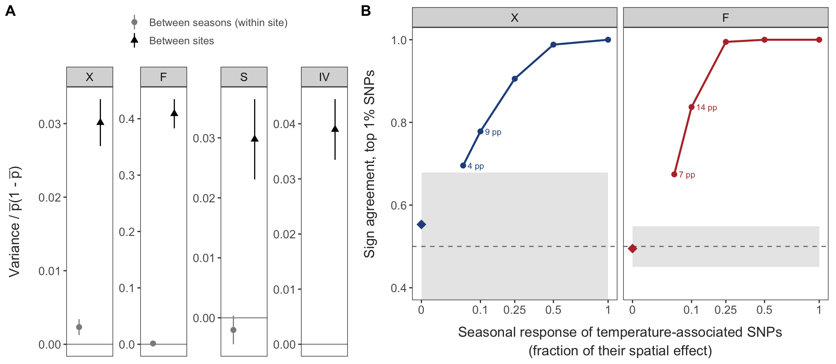
Figure 4: Genomic variation is spatial, and seasonal allele-frequency change does not echo spatial temperature associations. (A) Allele-frequency variance between sites and between seasons within sites, scaled by $\overset{‾}{p}(1−\overset{‾}{p})$, after removing sampling noise (unlinked SNPs; 95% CI from a chromosome jackknife); each clade on its own scale; IV had no site sampled in two seasons. (B) Agreement in sign between seasonal and spatial temperature slopes for the 1% of SNPs with the strongest spatial association, in X and F. Diamonds: observed; grey band: range under permutations of temperature among each site’s collections; lines: power simulations in which these SNPs respond to seasonal temperature at a fraction of their spatial slope (square-root scale), labelled with the implied seasonal change in allele frequency (percentage points).

5. Clades differ heritably in thermal tolerance, and IV acclimates most
The clades differed strongly in thermal tolerance (Figure 5). At the mean collection temperature (22 °C), marginal mean CTmax was 35.9 °C in F (95% CI 35.0–36.8), 35.2 °C in S, 34.8 °C in X and 33.4 °C in IV; F exceeded S and X by 0.7–1.1 °C, IV was 1.5–2.5 °C below every other clade, and S and X did not differ (0.35 °C, p = 0.57). CTmax rose with collection temperature in every clade, at 0.13–0.15 °C per °C in F, S and X and about twice that in IV (0.27 °C per °C; IV vs others p = 0.01–0.02). A single regression ignoring clade gives a steeper slope (0.24 °C per °C) than any clade except IV, because the more tolerant clades were collected in warmer water.
Because clades occupy different sites and seasons, these comparisons could partly reflect the conditions each was collected in. Collections containing two or more clades resolve this (Figure 9): IV was 2.5 °C less tolerant than X (three shared collections) and 2.8 °C less tolerant than S (one), and F was 0.6 °C more tolerant than S (five) and 1.0 °C more tolerant than X (one). The S–X difference was small and not significant within shared collections (0.4 °C, two collections), as in the model. Clade differences in CTmax are therefore not explained by recent conditions.
- Caveat: “heritable” here means not explained by shared recent conditions; it could include developmental or maternal effects.
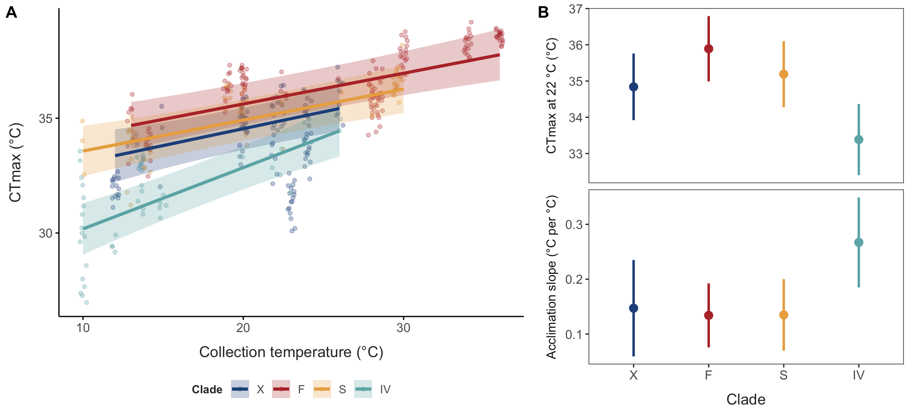
Figure 5: Clade differences in thermal tolerance. (A) CTmax against collection temperature (points: individuals; lines and bands: fitted values and 95% CI from the mixed model with clade × temperature, over each clade’s sampled range). (B) Marginal mean CTmax at the mean collection temperature (22 °C; top) and acclimation slope (bottom) for each clade, with 95% CI.

6. Genetic basis of thermal tolerance
- Within lineages (exploratory): no SNP was associated with CTmax beyond what within-collection permutations produced (Figure 17), but the scan could detect only loci of roughly 2–3 °C per allele in the two largest groups (X, F-N; 50% power at minor-allele frequency 0.3–0.5) and essentially none in S, F-FH and IV (Table 12). Genotype accuracy at < 1x coverage was r² = 0.39–0.47. The scan therefore does not constrain the polygenic basis of within-clade variation. Detecting a locus explaining 5% of within-collection variance would need roughly 2,000 individuals per group at this coverage. [in hand]
- Between clades, mitochondrial: COX1 nearly invariant; 29 substitutions unique to IV, the least tolerant clade (7 COX1, 14 CYTB, 8 in a third ORF) (Table 7, Table 8). [in hand; X and IV contigs cover only ~a third of the mitogenome]
- Candidate genes from experimental evolution: 15 transcripts that responded to selection in the laboratory [REF] map to 18 genes, including a mitochondrial HSP90 (Trap1), an HSP90 co-chaperone (AHSA1), complex I and III genes and vitellogenin. In the field these genes showed no excess spatial, seasonal or CTmax-associated SNP variation (17 tests, p = 0.17–0.84; Table 9), and no clade had an excess of amino-acid substitutions in the 12 with enough coverage (Table 10). The core thermal candidates had too few codons called across clades to compare. [in hand]
- Genome-wide, protein divergence among clades followed functional class in the same way on every branch: fast in ribosome biogenesis and mitochondrial translation, slow in neuronal and developmental genes (Table 11). Genes annotated to heat response, protein folding and oxidative phosphorylation showed no excess of amino-acid change in any clade, and heat-shock genes were strongly conserved (N/(N + S) 0.05–0.11 vs 0.18–0.21 genome-wide). The only clade-specific signal was an excess in nuclear-encoded mitochondrial ribosomal proteins in S (q = 0.001), as expected from mitonuclear coevolution [REF: Tigriopus]. Branch-specific acceleration of single genes was no more common than chance. Heritable clade differences in CTmax therefore cannot be traced to protein change in thermal-function genes with these data, pointing to regulatory or polygenic differences. [in hand]
- Summary of the scales of variation: Table 2.
Table 2: Summary of the scales of variation in thermal tolerance (draft).
Scale | CTmax varies? | Genomic signal? | Interpretation
Clade | Yes, up to ~2.5 °C at a common temperature | Deep divergence | Heritable; range shifts and seasonal turnover
Site within clade | Yes, more than seasonal acclimation predicts | Strong differentiation among sites | Plasticity plus a persistent site-level component
Season within site | Yes, through acclimation and clade turnover | Drift only; no seasonal echo of spatial associations | No detectable seasonal evolution
Individual | Yes | Not resolvable at this sample size and coverage | Genetic basis unknown

7. Accounting for clades, acclimation and turnover changes where A. tonsa is vulnerable
With clade-specific CTmax and acclimation, daily warming tolerance over the sampled season was lowest in Florida and the Chesapeake, where the warmest days came within a few degrees of zero under 4 °C of warming, and highest in Maine and the Gulf of St. Lawrence (Figure 6 A). The scenarios differed most on the warmest days (Figure 6 B; Figure 18, Figure 19). With a single CTmax for the species, peak-season warming tolerance ranged 13 °C across regions, from 5.8 °C in Florida to 18.8 °C in Maine. Clade-specific CTmax narrowed this range by 31% (Table 3), raising warming tolerance in Florida by 1.9 °C and in the Chesapeake by 1.1 °C (F and S are the most tolerant clades) and lowering it in Maine and the Gulf of St. Lawrence by about 2 °C (X and IV are less tolerant than the species average). Adding acclimation left the range 30% narrower than with a single CTmax; the warmest-day metric gave similar reductions (29–30%). With 4 °C of warming, the single-CTmax scenario brought warming tolerance on Florida’s warmest days to zero (−0.2 °C), whereas clade-specific CTmax kept it 1.7 °C above, and 2.6 °C with acclimation. Using each site’s clade make-up across all collections, instead of the peak-season collection, lowered the warmest-day margin by about 2 °C in Connecticut, Maine and Shediac, because IV, the least tolerant clade, is common there only in autumn.
- Caveat: MUR summer temperatures run below in-situ collection temperatures at the northern sites; the acclimation model was fitted to in-situ temperatures.
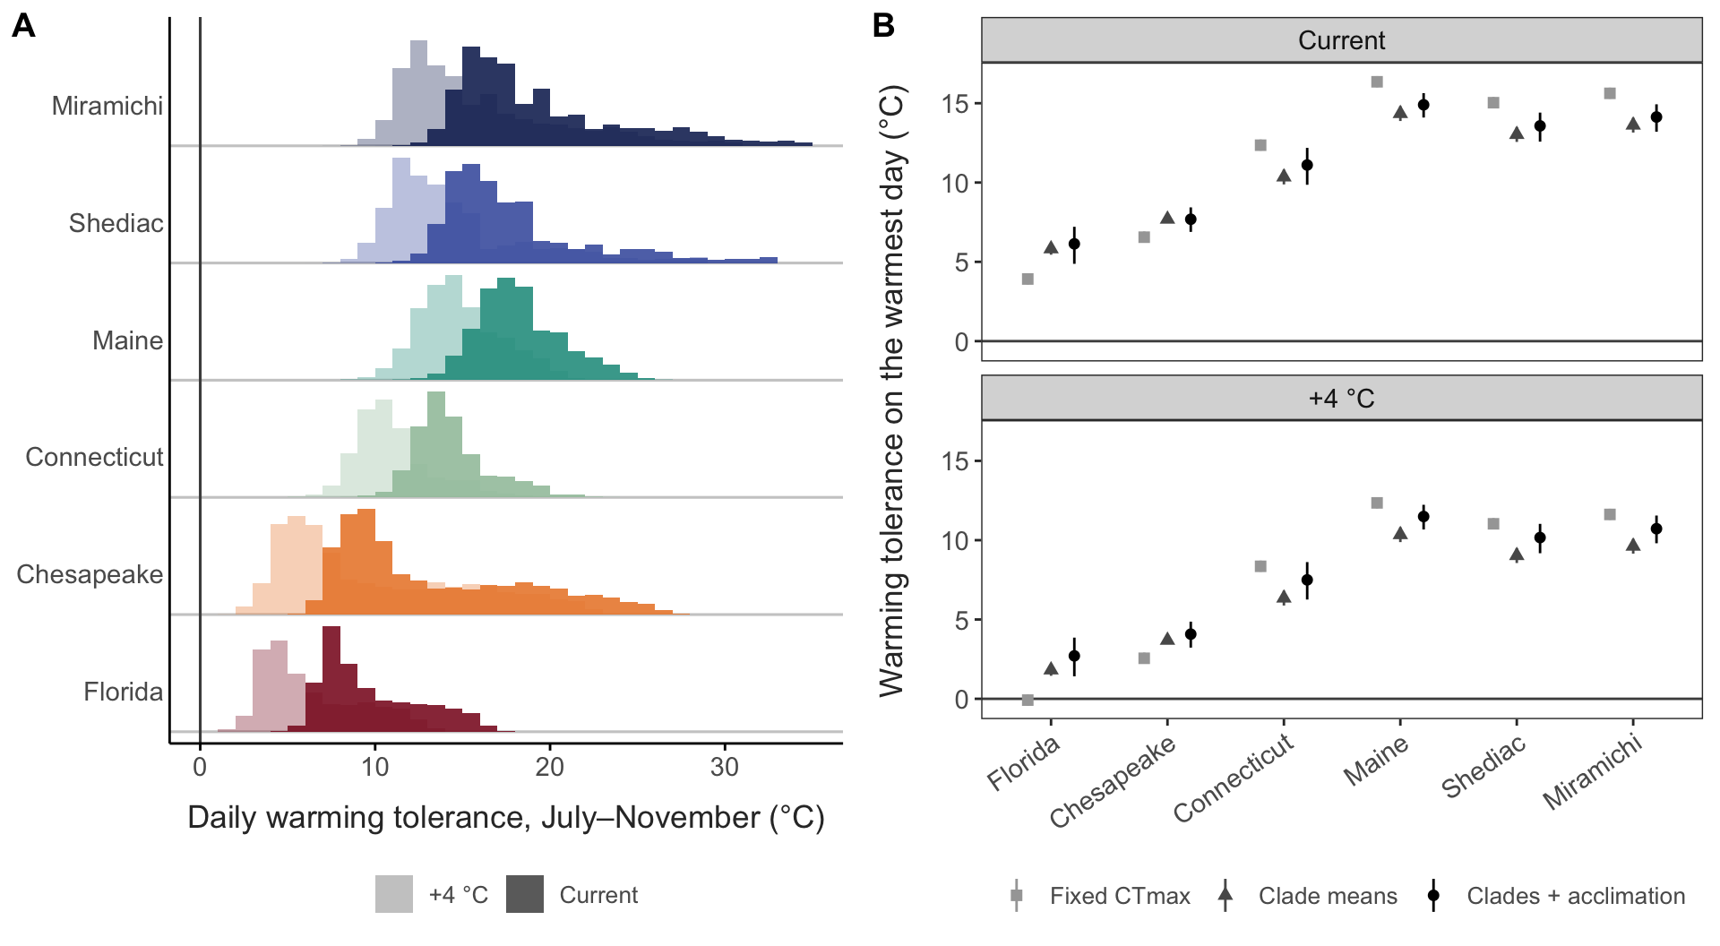
Figure 6: Warming tolerance (CTmax − habitat temperature). (A) Distribution of daily warming tolerance in each region over the sampled season (July–November, MUR SST 2014–2023) with clade-specific CTmax and acclimation; days weighted by the clade make-up of the matching collection. Dark: current conditions; pale: +4 °C uniform warming. (B) Warming tolerance on the warmest August–September day (mean over years) for the least tolerant clade making up at least 10% of the peak collection, under a single fixed CTmax, clade means, and clades with acclimation; 95% intervals.
Table 3: Spread of warming tolerance among regions under current conditions, and its change relative to a fixed CTmax. The last scenario uses annual instead of peak-season clade make-up.
Scenario | Metric | Range among regions (°C) | Change vs fixed (%)
Fixed CTmax | Aug–Sep mean | 13.3 | –
Clade means | Aug–Sep mean | 9.3 | -30
Clades + acclimation | Aug–Sep mean | 9.4 | -29
Clades + acclimation (annual make-up) | Aug–Sep mean | 9.2 | -31
Fixed CTmax | Warmest day, least tolerant common clade | 12.4 | –
Clade means | Warmest day, least tolerant common clade | 8.5 | -31
Clades + acclimation | Warmest day, least tolerant common clade | 8.8 | -30
Clades + acclimation (annual make-up) | Warmest day, least tolerant common clade | 8.4 | -32

Discussion
- Main message: thermal tolerance in this “species” is structured by cryptic clades (heritable), by plasticity, and by persistent differences among sites, not by seasonal evolution. Phenotype and genome agree that sites differ, but diverge through the season: CTmax changes plastically and through clade turnover, while allele frequencies change only by drift.
- Space vs season in the phenotype. CTmax rises about twice as steeply with spatial as with seasonal temperature. The spatial component beyond acclimation is consistent with heritable population differences shown in common-garden experiments [REF], though developmental plasticity and longer-term acclimatisation may contribute. Spatial gradients in CTmax therefore overstate the short-term plastic response to warming within a site.
- Why no strong seasonal evolution, despite short generations?
  - Open populations: advection and mixing reset local allele frequencies; the gap between long-term and temporal Ne.
  - Overlapping generations and egg banks slow the response to selection within a season.
  - Plasticity absorbs seasonal temperature change, weakening selection on tolerance.
  - Contrast with Drosophila (Bergland et al. 2014; Machado et al. 2021).
- Clade turnover as the seasonal response. Composition shifts with temperature and adds about a third to the seasonal CTmax change from acclimation, and about half to the spatial change. The community responds to season through sorting of heritably different clades (cf. seasonal species succession in plankton), not through allele-frequency change within them. Where do clades go between seasons: resting eggs, advection from offshore or other estuaries?
- Implications for forecasting: model clades separately, account for acclimation and turnover, and do not expect within-season evolutionary rescue. A single species-level CTmax overstates vulnerability in warm regions and understates it in cool ones (Result 7); seasonal turnover means peak-season composition, not annual composition, sets exposure.
- Implications for lab studies: experiments that treat “A. tonsa” as one unit can mix clades that differ by up to ~2.5 °C in CTmax.
- Space-for-time predictions and ecological acclimation: relate the composition result to community-level ‘ecological acclimation’ through species turnover (Stemkovski et al. [REF]); here the turnover happens among cryptic clades within a single nominal species.
- Future directions: structure within clade F. F comprises four geographically separated lineages with concordant mitochondrial and nuclear trees (Figure 27), and the Florida lineages had the highest CTmax in the dataset. Whether these are locally adapted populations or incipient cryptic species, and whether they differ in thermal physiology under common-garden conditions, is an open question; here they were analysed together, as in previous work.
- Caveats: the seasonal tests detect only strong selection (roughly 10–20 percentage-point seasonal changes), and few sites and seasons cap the permutation p values (0.083 for X); the spatial–seasonal slope difference rests on three phenological seasons and is marginal overall (p = 0.054), though consistent across clades; the within-clade genetic basis of CTmax was beyond reach at this sample size and coverage (the association scan is reported for completeness, with its power); CTmax as one measure of tolerance; collection-day temperature vs MUR; partial mitogenomes for X and IV; clade consensus sequences at < 1x coverage against a single reference under-call S and IV in coding sequence, which limits the protein comparisons.

References
Ali, O.A., O’Rourke, S.M., Amish, S.J., Meek, M.H., Luikart, G., Jeffres, C., et al. (2015) RAD capture (rapture): Flexible and efficient sequence-based genotyping. Genetics, 202, 389–400.
Figueroa, N.J., Figueroa, D.F. & Hicks, D. (2020) Phylogeography of acartia tonsa dana, 1849 (calanoida: Copepoda) and phylogenetic reconstruction of the genus acartia dana, 1846. Marine Biodiversity, 50, 23.

Supplementary Material
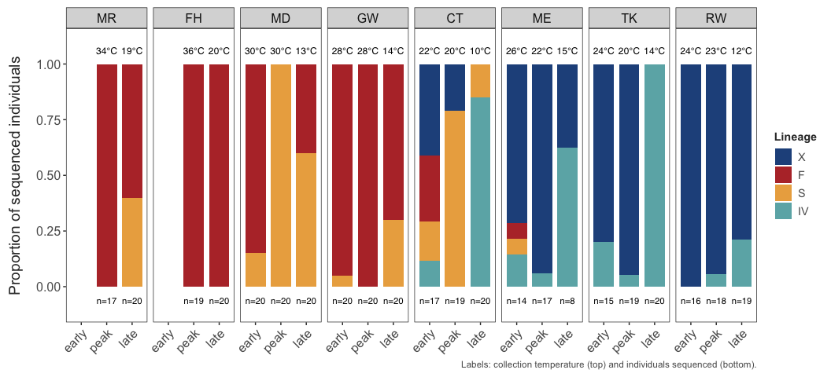
Figure 7: Clade composition of each collection, with collection temperature (top) and individuals sequenced (bottom).
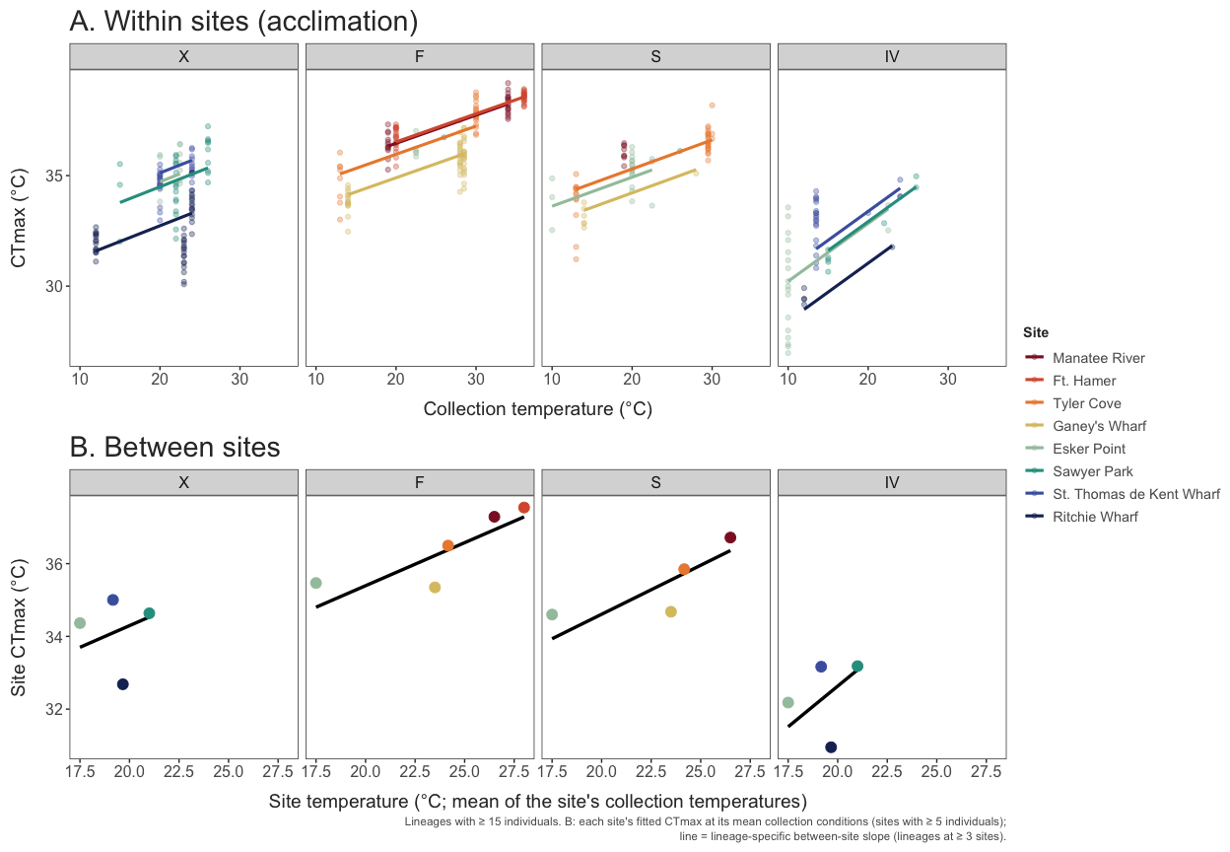
Figure 8: Sensitivity analysis: CTmax against the within-site (seasonal) and between-site (spatial) components of collection temperature from the site-mean decomposition, by clade.
Table 4: Seasonal and spatial CTmax slopes (°C per °C, ± SE) and their difference under two decompositions of collection temperature. Season-mean split (main text): seasonal = the season’s mean collection temperature across sites; spatial = a collection’s deviation from it. Site-mean split: spatial = the site’s mean collection temperature; seasonal = a collection’s deviation from it. All models include clade and random intercepts for site, collection, assay replicate and tube.
Decomposition | Group | Seasonal slope | Spatial slope | Spatial − seasonal (95% CI) | p
Season-mean split | All clades | 0.13 ± 0.02 | 0.25 ± 0.05 | 0.12 (-0.00, 0.24) | 0.054
Season-mean split | X | 0.13 ± 0.04 | 0.35 ± 0.09 | 0.22 (0.05, 0.39) | 0.010
Season-mean split | F | 0.10 ± 0.04 | 0.23 ± 0.07 | 0.13 (-0.06, 0.31) | 0.190
Season-mean split | S | 0.10 ± 0.04 | 0.28 ± 0.07 | 0.18 (0.01, 0.35) | 0.036
Season-mean split | IV | 0.26 ± 0.04 | 0.41 ± 0.12 | 0.16 (-0.08, 0.39) | 0.190
Site-mean split | All clades | 0.15 ± 0.02 | 0.26 ± 0.11 | 0.11 (-0.10, 0.32) | 0.300
Site-mean split | X | 0.14 ± 0.05 | 0.24 ± 0.23 | 0.10 (-0.37, 0.56) | 0.690
Site-mean split | F | 0.13 ± 0.03 | 0.24 ± 0.12 | 0.11 (-0.13, 0.35) | 0.370
Site-mean split | S | 0.13 ± 0.03 | 0.27 ± 0.12 | 0.14 (-0.10, 0.38) | 0.260
Site-mean split | IV | 0.26 ± 0.04 | 0.45 ± 0.27 | 0.19 (-0.36, 0.73) | 0.510

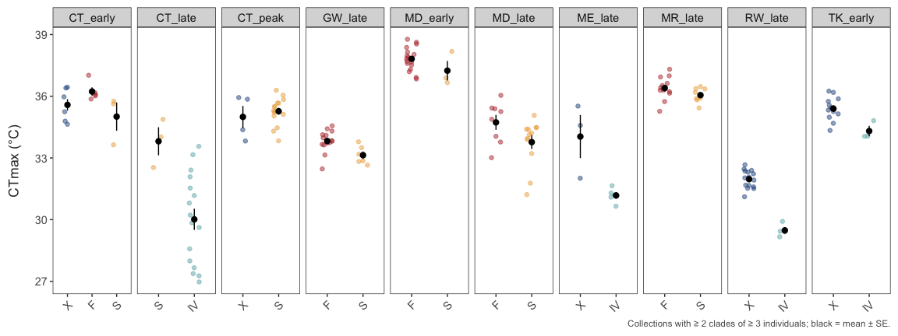
Figure 9: Natural common gardens: CTmax of clades collected together at the same place and time (collections with at least two clades of at least three individuals). Points are individuals; black is the mean ± SE.
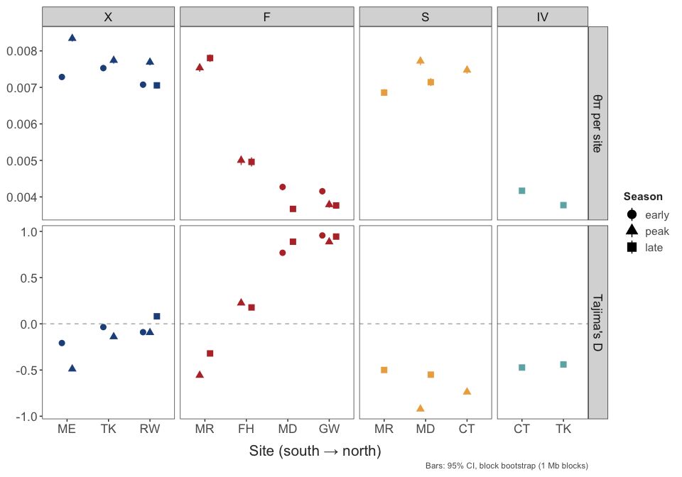
Figure 10: Genetic diversity within populations of each clade (F shown by lineage).
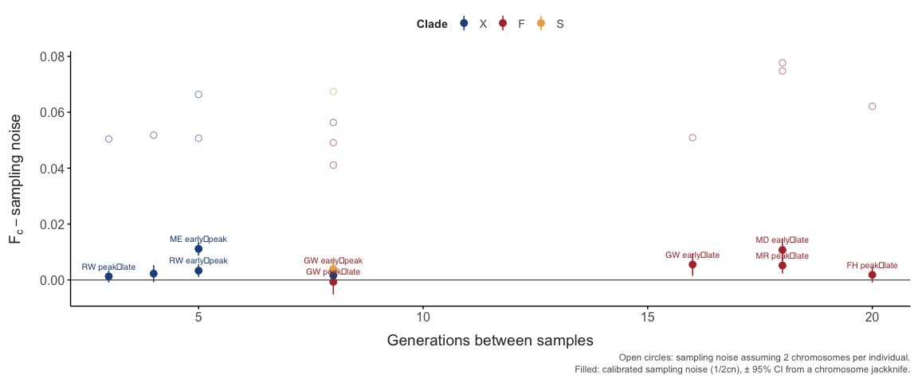
Figure 11: Seasonal allele-frequency change within sites against the drift expectation after calibrating sampling noise.
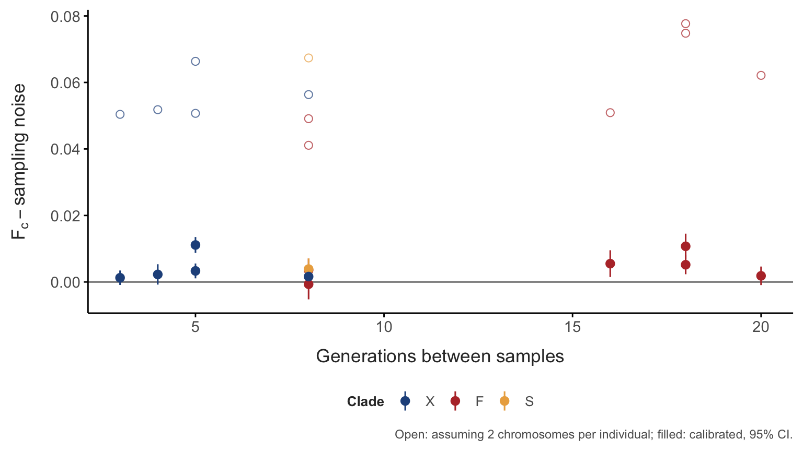
Figure 12: Temporal F_{c} between each site’s first and last sample, minus sampling noise, against the number of generations between samples. Open: assuming two chromosomes sampled per individual; filled: calibrated from split halves, with 95% CI.
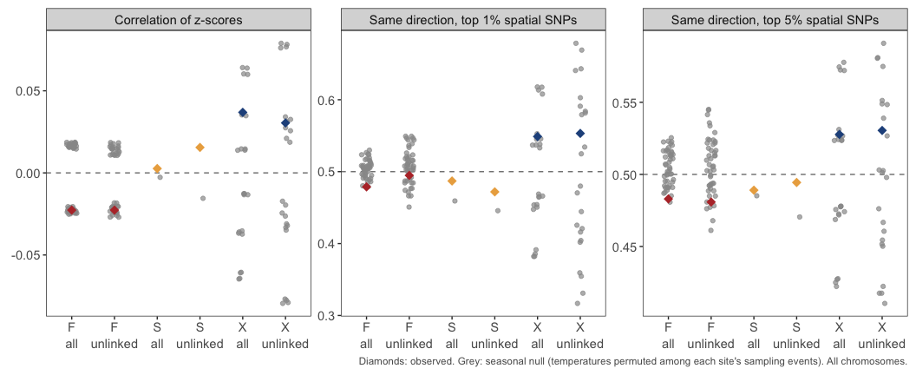
Figure 13: Concordance of spatial and seasonal temperature associations against seasonal and spatial nulls.
Table 5: Long-term effective size from nucleotide diversity (π = 4Neµ; µ = 10⁻⁸ to 10⁻⁹ per site per generation) against the temporal (within-season) Ne estimated from calibrated F_{c}.
Group | π (median) | Long-term Ne | Temporal Ne, median (range) | Ratio (µ = 10⁻⁸)
F-FH | 0.0050 | 120,000 – 1,200,000 | 5,398 (5,398 – 5,398) | 23×
F-MR | 0.0077 | 190,000 – 1,900,000 | 1,735 (1,735 – 1,735) | 111×
F-N | 0.0038 | 95,000 – 950,000 | 1,113 (838 – 1,450) | 85×
S | 0.0073 | 180,000 – 1,800,000 | 1,029 (1,029 – 1,029) | 178×
X | 0.0075 | 190,000 – 1,900,000 | 880 (225 – 2,459) | 214×

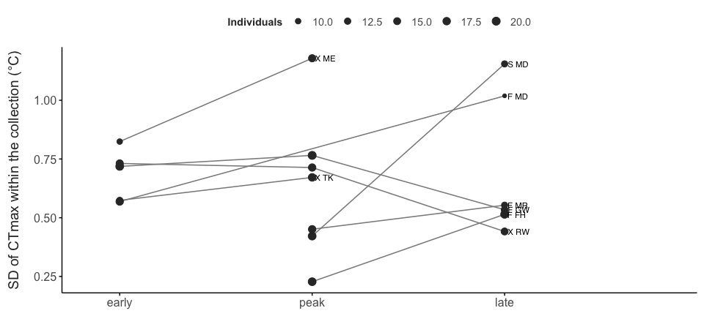
Figure 14: Spread of CTmax within clades through the season: standard deviation of CTmax in each collection, for each clade at each site sampled in two or more seasons (collections with at least five individuals of the clade).
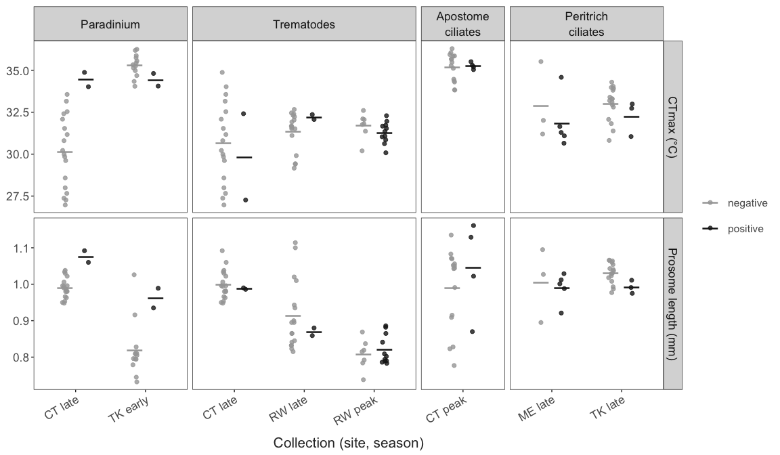
Figure 15: CTmax and body size of individuals carrying parasites or epibionts (positive) and non-carriers (negative) within the same collections (collections with at least two of each).
Table 6: Effect of carrying a parasite or epibiont on CTmax and body size within collections (trait ~ status + clade + (1 | collection)).
Carrier of | Trait | Collections | Carriers | Effect | SE
Parasite | CTmax (°C) | 6 | 23 | 0.361 | 0.304
Parasite | Prosome length (mm) | 6 | 23 | 0.009 | 0.012
Epibiont | CTmax (°C) | 4 | 13 | -0.233 | 0.312
Epibiont | Prosome length (mm) | 4 | 13 | -0.013 | 0.023

Table 7: Amino-acid differences between clade consensus proteins (differences / aligned positions) in the three mitochondrial genes covered by all four clade contigs.
Clade pair | COX1 | CYTB | ORF (LQDA)
F – S | 5 / 495 | 26 / 366 | 17 / 205
F – X | 2 / 495 | 15 / 364 | 13 / 207
F – IV | 10 / 495 | 31 / 366 | 22 / 204
S – X | 5 / 495 | 30 / 364 | 13 / 205
S – IV | 11 / 495 | 39 / 367 | 18 / 202
X – IV | 8 / 495 | 32 / 364 | 18 / 206

Table 8: Mitochondrial amino-acid substitutions unique to IV, the least tolerant clade (IV differs; F, S and X share the state). Positions are in the F protein.
Gene | Position | F, S, X | IV | Context (F)
COX1 | 176 | M | L | LRSFGMVLDLM
COX1 | 415 | G | A | LKAQFGMMFLG
COX1 | 416 | M | T | KAQFGMMFLGV
COX1 | 467 | Y | F | VISIMYFLFIL
COX1 | 495 | Y | F | SSLEXYHSFPP
COX1 | 512 | I | S | SIPVVISK
COX1 | 514 | K | S | PVVISK
CYTB | 7 | I | V | KQLKXISPVTK
CYTB | 20 | E | D | FGSVVELPTPS
CYTB | 105 | G | S | RGLYYGSYYFS
CYTB | 110 | S | T | GSYYFSHTWLV
CYTB | 159 | D | E | PYLGGDLVLWM
CYTB | 184 | L | F | FSLHFLIPFVV
CYTB | 188 | V | I | FLIPFVVAAMS
CYTB | 192 | M | L | FVVAAMSAVHL
CYTB | 324 | M | T | PLSKMMFWIQI
CYTB | 334 | L | M | IXIVILLTWIG
CYTB | 353 | I | T | IVIGQILSVVY
CYTB | 360 | S | L | SVVYFSYYFFQ
CYTB | 364 | F | I | FSYYFFQPLMM
CYTB | 368 | M | L | FFQPLMMMFWD
ORF_LQDA | 66 | V | I | ACPSLVLLYLM
ORF_LQDA | 99 | A | P | YXDMIAGHQFP
ORF_LQDA | 103 | F | S | IAGHQFPFEFD
ORF_LQDA | 132 | T | I | VDXRTTLPLHV
ORF_LQDA | 135 | L | M | RTTLPLHVKIR
ORF_LQDA | 181 | F | Y | DRPGLFFGQCS
ORF_LQDA | 202 | I | V | PIVVEIVXVET
ORF_LQDA | 209 | Y | F | XVETFYAYILS

Table 9: SNP-level signals in genes that responded to selection in experimental evolution [REF] against random sets of the same number of other genes (one-sided p for a larger value in the candidates). Statistics are the mean squared z (or t) over SNPs in the genes, or the share of SNPs whose seasonal and spatial slopes have the same sign.
Test | Group | Genes | SNPs | Candidates | Other genes | p
Seasonal change (time) | F | 18 | 657 | 0.964 | 0.946 | 0.39
Seasonal change (time) | S | 16 | 400 | 0.559 | 0.595 | 0.63
Seasonal change (time) | X | 18 | 2371 | 1.000 | 0.994 | 0.41
Seasonal change (temperature) | F | 18 | 657 | 0.933 | 0.930 | 0.47
Seasonal change (temperature) | S | 16 | 400 | 0.559 | 0.595 | 0.65
Seasonal change (temperature) | X | 18 | 2371 | 1.035 | 0.988 | 0.17
Spatial temperature association | F | 18 | 657 | 7.590 | 7.633 | 0.48
Seasonal–spatial sign agreement | F | 18 | 657 | 0.480 | 0.473 | 0.41
Spatial temperature association | S | 16 | 368 | 1.217 | 1.149 | 0.28
Seasonal–spatial sign agreement | S | 16 | 368 | 0.489 | 0.498 | 0.59
Spatial temperature association | X | 18 | 2371 | 1.604 | 1.806 | 0.84
Seasonal–spatial sign agreement | X | 18 | 2371 | 0.515 | 0.510 | 0.39
CTmax association | F-FH | 17 | 303 | 0.992 | 1.035 | 0.58
CTmax association | F-N | 17 | 516 | 0.868 | 0.991 | 0.83
CTmax association | IV | 12 | 91 | 1.298 | 1.231 | 0.38
CTmax association | S | 16 | 345 | 1.131 | 1.028 | 0.19
CTmax association | X | 18 | 2623 | 1.036 | 0.991 | 0.18

Table 10: Clade-specific amino-acid substitutions (N, nonsynonymous; S, synonymous) in the experimental-evolution genes and in heat-shock and nuclear OXPHOS genes (selected by product name), against random background gene sets of the same size (two-sided permutation p). Genes with at least 50 codons called in at least three clades.
Set | Genes | Clade | N | S | N/(N+S) | Background | p
Heat shock | 41 | F | 5 | 106 | 0.05 | 0.20 | 0.002
Heat shock | 41 | S | 7 | 99 | 0.07 | 0.18 | 0.008
Heat shock | 41 | X | 9 | 70 | 0.11 | 0.19 | 0.096
Heat shock | 41 | IV | 18 | 147 | 0.11 | 0.21 | 0.004
Nuclear OXPHOS | 13 | F | 8 | 15 | 0.35 | 0.20 | 0.100
Nuclear OXPHOS | 13 | S | 7 | 15 | 0.32 | 0.18 | 0.120
Nuclear OXPHOS | 13 | X | 5 | 17 | 0.23 | 0.19 | 0.670
Nuclear OXPHOS | 13 | IV | 6 | 20 | 0.23 | 0.21 | 0.810
Experimental evolution | 12 | F | 16 | 39 | 0.29 | 0.20 | 0.300
Experimental evolution | 12 | S | 12 | 31 | 0.28 | 0.18 | 0.340
Experimental evolution | 12 | X | 3 | 47 | 0.06 | 0.19 | 0.130
Experimental evolution | 12 | IV | 17 | 61 | 0.22 | 0.21 | 0.960

Table 11: Nonsynonymous fraction N/(N + S) on each clade’s branch for selected GO terms and KEGG pathways, with q values in parentheses, against genes annotated in the same ontology (bottom row). The full results are in the report (function_enrichment.csv).
Group | Term | Source | X | F | S | IV
Fast on all branches | ribosome biogenesis | GO:BP | 0.26 (<0.001) | 0.30 (<0.001) | 0.23 (0.022) | 0.26 (0.026)
Fast on all branches | nucleolus | GO:CC | 0.19 (0.0042) | 0.22 (<0.001) | 0.18 (0.032) | 0.22 (<0.001)
Fast on all branches | mitochondrial gene expression | GO:BP | 0.25 (0.14) | 0.29 (0.0067) | 0.30 (0.012) | 0.28 (0.058)
Conserved on all branches | neuron projection | GO:CC | 0.11 (0.017) | 0.12 (0.0065) | 0.10 (0.0045) | 0.13 (<0.001)
Conserved on all branches | cellular anatomical entity morphogenesis | GO:BP | 0.10 (<0.001) | 0.12 (0.0015) | 0.11 (0.063) | 0.15 (0.058)
Thermal function | response to heat | GO:BP | 0.12 (0.59) | 0.11 (0.32) | 0.10 (0.53) | 0.15 (0.63)
Thermal function | protein folding | GO:BP | 0.13 (0.83) | 0.09 (0.17) | 0.09 (0.51) | 0.14 (0.48)
Thermal function | heat shock protein binding | GO:MF | 0.14 (0.99) | 0.14 (0.85) | 0.13 (0.93) | 0.17 (0.93)
Thermal function | Oxidative phosphorylation | KEGG | 0.13 (0.99) | 0.14 (0.98) | 0.18 (0.84) | 0.21 (0.7)
Thermal function | respiratory chain complex | GO:CC | 0.21 (0.54) | 0.24 (0.36) | 0.24 (0.25) | 0.25 (0.38)
Clade-specific (S) | mitochondrial large ribosomal subunit | GO:CC | 0.36 (0.032) | 0.29 (0.16) | 0.43 (0.0011) | 0.27 (0.3)
Clade-specific (S) | mitochondrial protein-containing complex | GO:CC | 0.17 (0.68) | 0.20 (0.3) | 0.27 (<0.001) | 0.20 (0.58)
 | Background (annotated genes, GO:BP) |  | 0.15 | 0.16 | 0.14 | 0.18

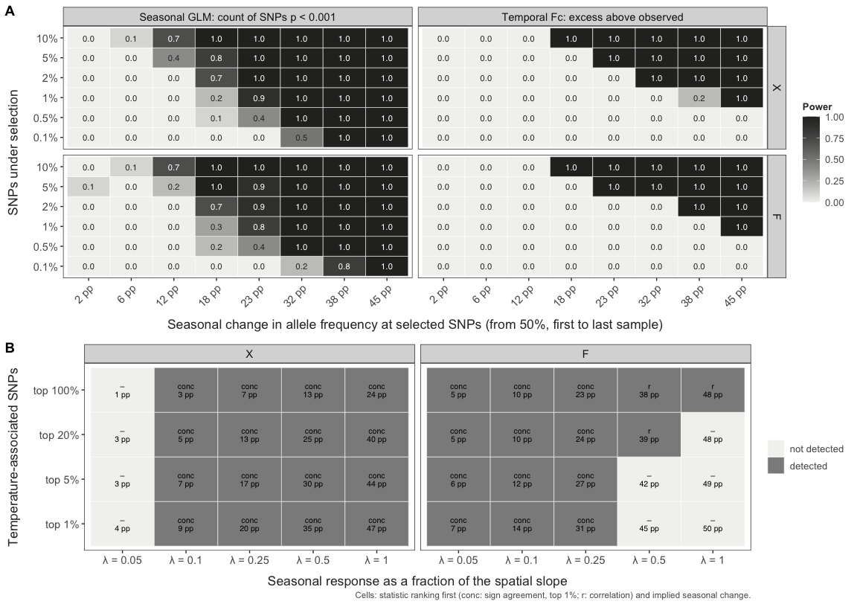
Figure 16: Power of the seasonal tests, from selection injected into the observed allele frequencies. (A) Share of replicates detected by the seasonal GLM and the temporal Fc test, by the fraction of SNPs under selection and their change in allele frequency between first and last samples (from 50%). (B) Concordance test: detection when the most temperature-associated SNPs respond to seasonal temperature at a fraction λ of their spatial slope, with the implied seasonal change.
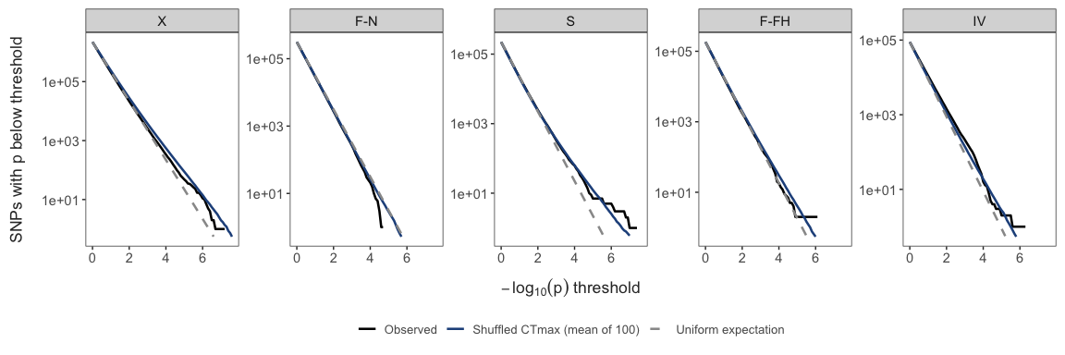
Figure 17: CTmax association within lineages (clades X, S and IV, and the F lineages F-N and F-FH): SNPs below each p-value threshold, observed vs the mean of 100 within-collection shuffles of CTmax and the uniform expectation.
Table 12: Power of the within-lineage CTmax association scan: share of simulated causal SNPs detected at the genome-wide 5% threshold, by effect size (°C per allele) and minor-allele frequency 0.3–0.5. Numbers in parentheses: mean share of within-collection CTmax variance explained by the causal locus. r²: squared correlation between expected dosage and true genotype.
Lineage | r² | 0.25 °C | 0.5 °C | 0.75 °C | 1 °C | 1.5 °C | 2 °C | 3 °C
X | 0.40 | 0.00 (5%) | 0.00 (17%) | 0.01 (31%) | 0.07 (44%) | 0.26 (64%) | 0.45 (76%) | 0.62 (88%)
F-N | 0.44 | 0.00 (6%) | 0.00 (19%) | 0.04 (35%) | 0.16 (48%) | 0.45 (68%) | 0.64 (79%) | 0.77 (89%)
S | 0.43 | 0.00 (6%) | 0.00 (19%) | 0.00 (35%) | 0.00 (48%) | 0.03 (68%) | 0.09 (79%) | 0.16 (89%)
F-FH | 0.39 | 0.00 (16%) | 0.00 (42%) | 0.00 (62%) | 0.01 (74%) | 0.04 (87%) | 0.05 (92%) | 0.06 (96%)
IV | 0.44 | 0.00 (1%) | 0.00 (4%) | 0.00 (9%) | 0.00 (15%) | 0.00 (28%) | 0.00 (41%) | 0.01 (61%)

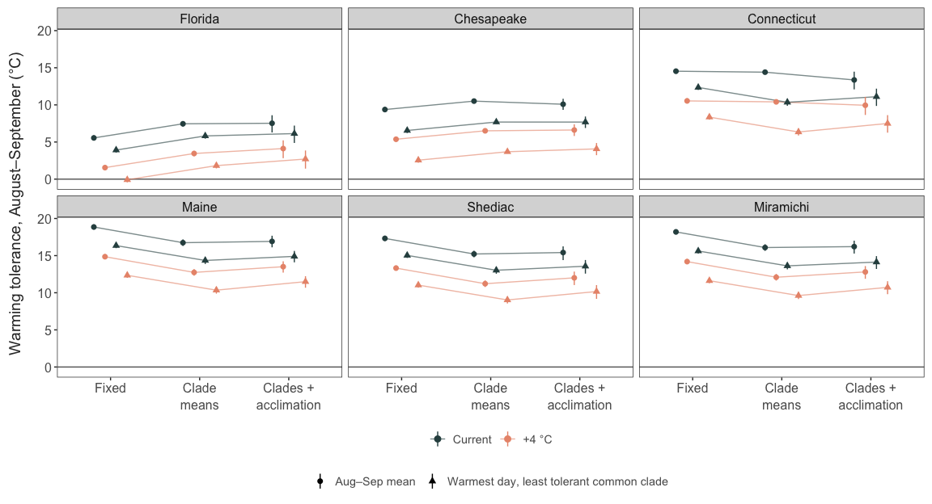
Figure 18: Warming tolerance in August–September in each region under the three scenarios: peak-season mean (circles) and warmest day for the least tolerant common clade (triangles); current conditions and +4 °C; 95% intervals.
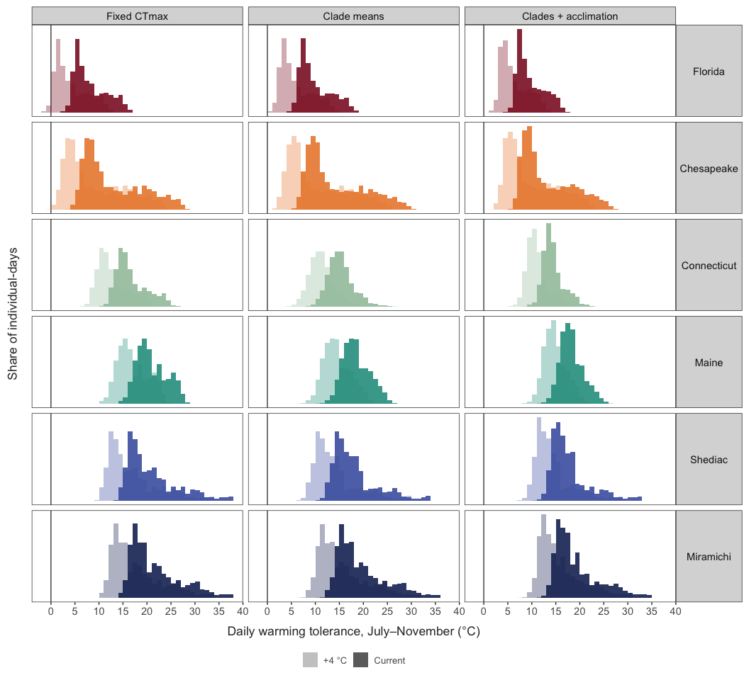
Figure 19: Distributions of daily warming tolerance in each region (July–November) under all three scenarios. Dark: current conditions; pale: +4 °C.
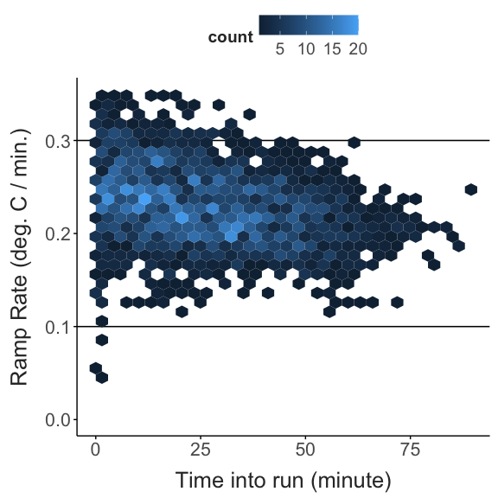
Figure 20: Recorded heating rates during the CTmax assays.
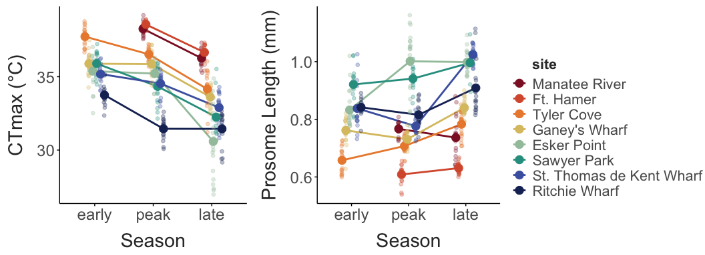
Figure 21: CTmax (A) and body size (prosome length; B) by season at each site.
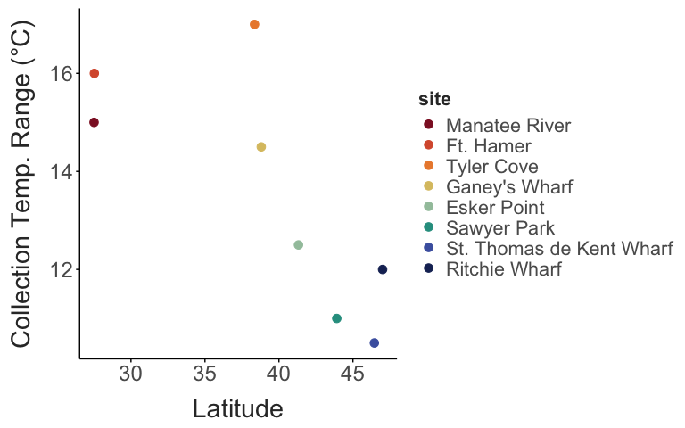
Figure 22: Seasonal range of collection temperatures against latitude.
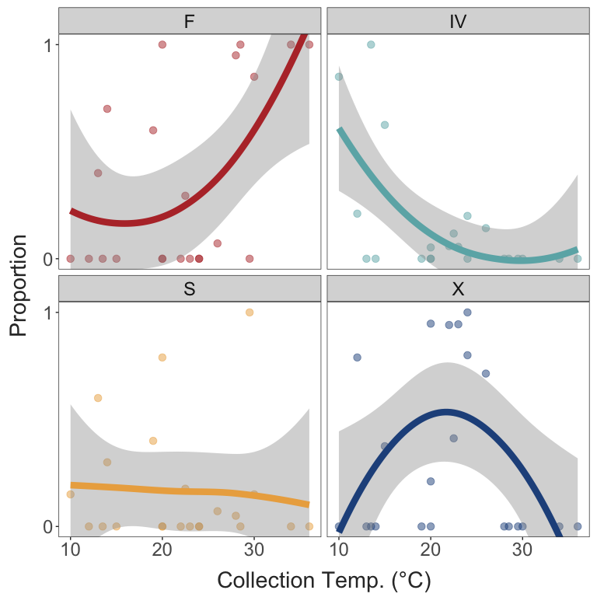
Figure 23: Proportion of each clade in a collection against collection temperature.
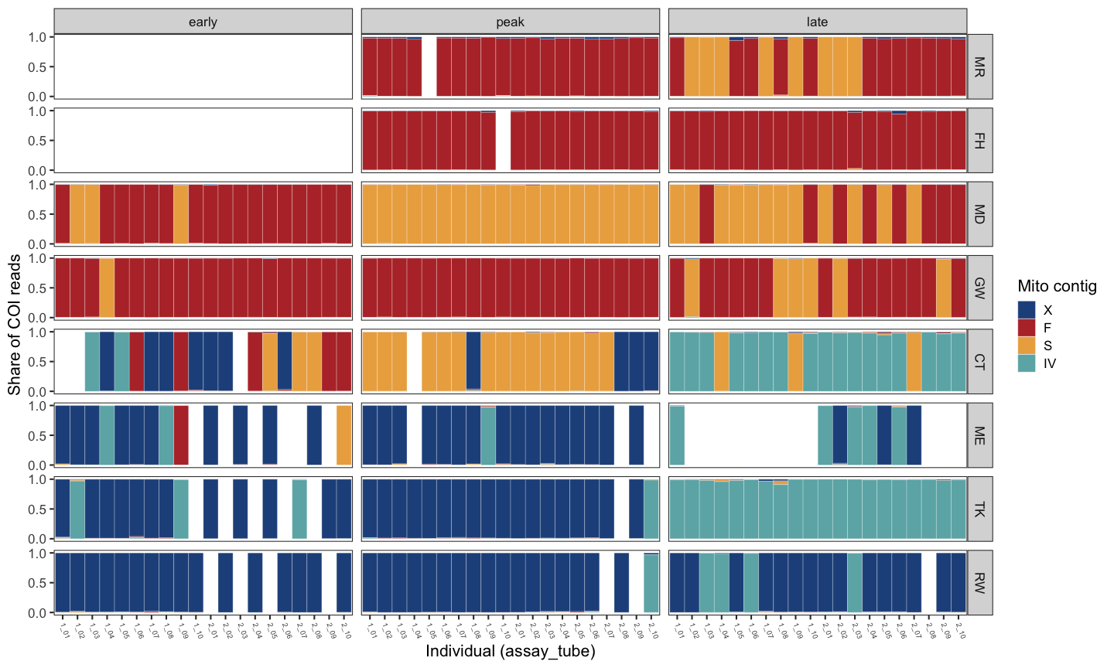
Figure 24: Share of each individual’s COI-region reads mapping to each clade’s mitogenome contig, used for clade assignment.
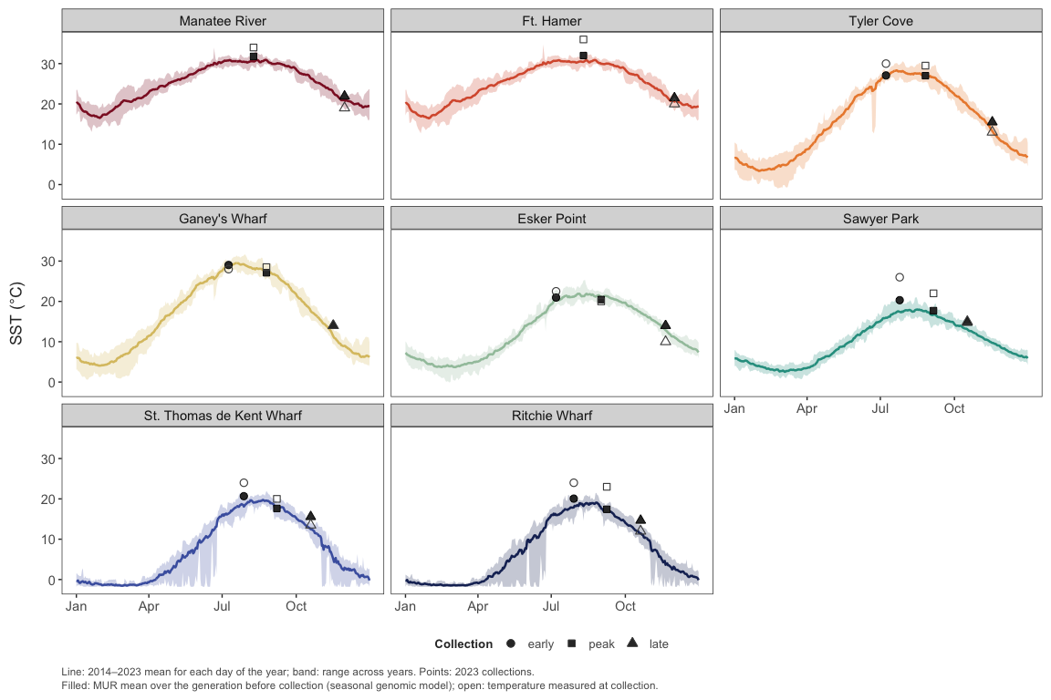
Figure 25: Long-term (MUR SST 2014–2023) temperature cycles at each site.
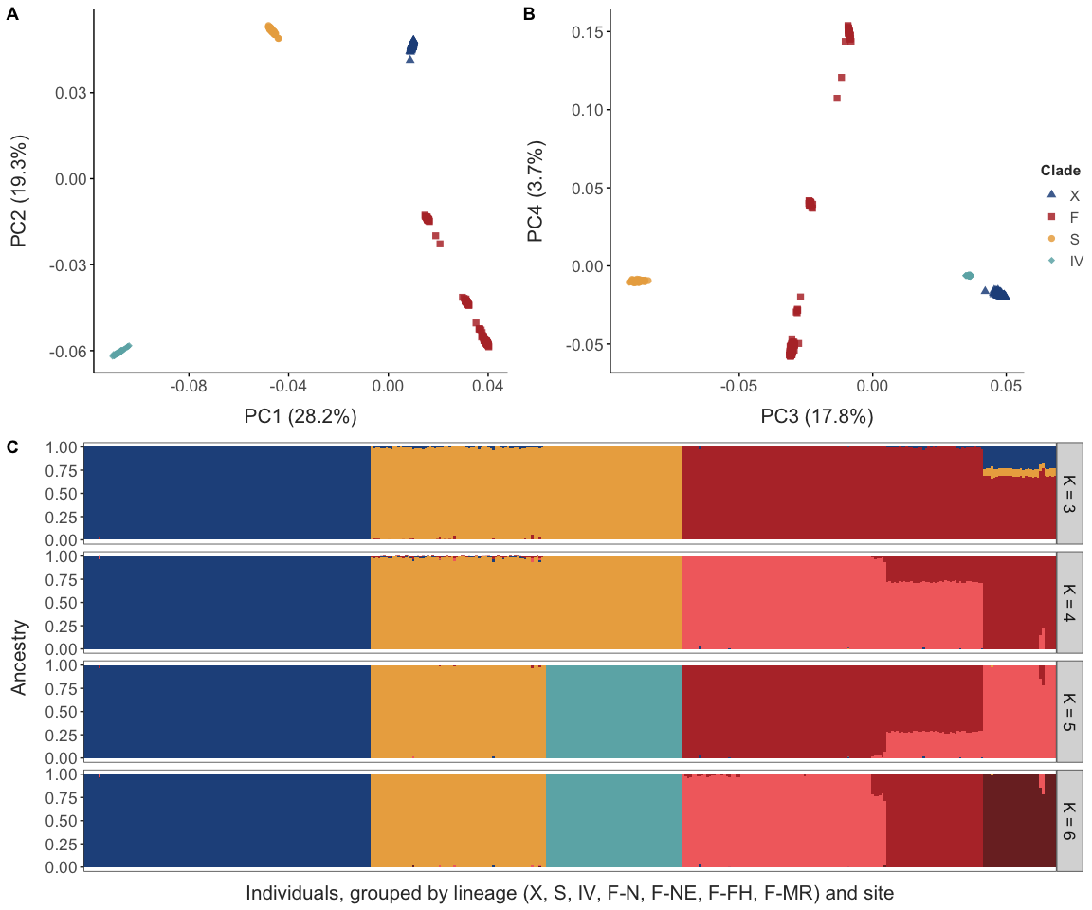
Figure 26: Genome-wide structure and mitochondrial clades.
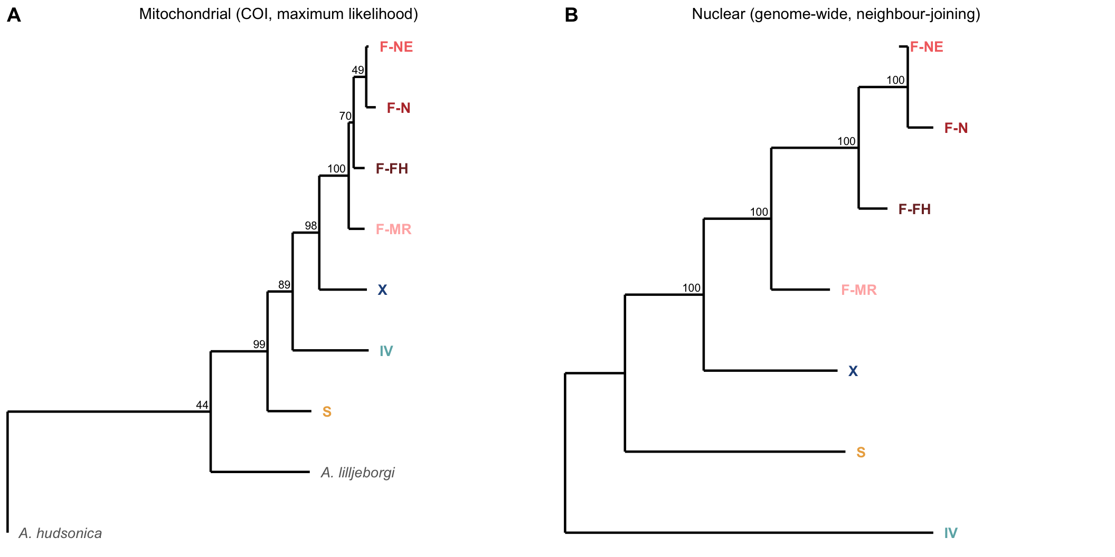
Figure 27: Relationships among clades and the lineages within F. (A) Mitochondrial (COI, maximum likelihood, rooted on A. hudsonica) and (B) nuclear (genome-wide net distances, neighbour-joining, midpoint-rooted) trees; numbers are bootstrap support. Both trees separate {S, IV} from {X, F}, place X as sister to F, and order the four F lineages identically (F-MR, F-FH, then F-N with F-NE).
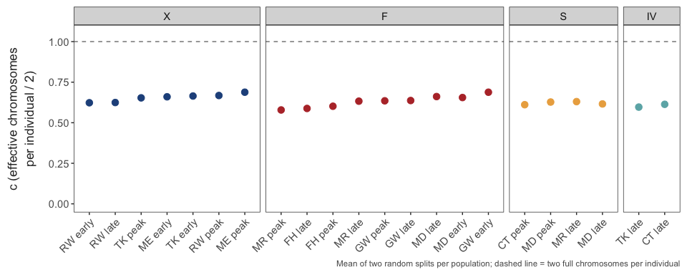
Figure 28: Calibration of low-coverage sampling noise from random split halves of each population.

