Space does not substitute for time: cryptic lineages and plasticity, not rapid evolution, structure thermal tolerance in a coastal copepod
Matthew Sasaki University of Massachusetts Lowell
Melissa Pespeni University of Vermont
Correspondence: Matthew_Sasaki@uml.edu
Code: https://github.com/ZoopEcoEvo/spatiotemp_genomics
This draft is current as of October 30, 2026
Abstract
ABSTRACT HERE. (Draft once Results 1-7 are settled: question - design - lineages differ heritably - within-lineage CTmax tracks temperature plastically, same across space and season - no seasonal evolution beyond drift, no concordance with spatial patterns - a single CTmax misplaces vulnerability; forecasts should be built on lineages and plasticity.)
Keywords: thermal tolerance, cryptic lineages, phenotypic plasticity, seasonal evolution, low-coverage whole-genome sequencing, Acartia tonsa

Introduction
Organising question: at what scale does thermal tolerance vary in a widespread coastal “species”, and does variation across space predict change through time?
- Thermal tolerance can vary at four levels, each implying a different response to warming:
  - among cryptic lineages: lineages shift ranges;
  - among populations: local adaptation, so populations adapt in place;
  - across seasons: rapid evolution tracks warming quickly;
  - within individuals: plasticity buffers warming.
- Space-for-time substitution. Forecasts often assume spatial gradients (latitude, site temperature) predict responses through time. This assumption can hold for phenotypes and fail for genomes, or the reverse, and it is rarely tested on the same organisms.
- Seasonal evolution has been shown in Drosophila (Bergland et al. 2014; Machado et al. 2021), with seasonal allele-frequency change that parallels latitudinal clines. Short-lived marine plankton with many generations per season should be an even better candidate.
- Acartia tonsa is a dominant coastal copepod and a standard model for thermal physiology. It has short generations (several per season) and large populations. It is also a complex of deeply divergent cryptic lineages, which is usually ignored in physiological work.
- The gap: no field study has separated the lineage, population, seasonal and individual levels for the same animals, or tested space-for-time substitution at both the phenotypic and genomic levels.
- Hypotheses (from the phenotype draft): thermal limits vary strongly across both space and season; accounting for lineage differences and acclimation raises estimated vulnerability at high latitudes and lowers it at low latitudes.
- Why it matters for forecasts: vulnerability is usually summarised as warming tolerance (CTmax minus habitat temperature) from a single CTmax per species. If tolerance differs among lineages and shifts with acclimation, a single value misplaces where and when populations are at risk.
- This study: eight sites from 27.5°N (Florida) to 47°N (Gulf of St. Lawrence), sampled two or three times between July and December 2023. Each individual’s CTmax was measured on the day of collection, and the same individual was sequenced at low coverage (about 400 individuals). Pairing individual phenotypes and genomes across space and season is the methodological hook.

Methods

Field collections and site temperatures
Copepods were collected by surface plankton tow from eight sites along the western Atlantic and Gulf of Mexico coasts, from Florida to the Gulf of St. Lawrence, at two or three times between July and December 2023 (Table 1). Water temperature and salinity were measured at the time of collection with a handheld thermometer and an optical refractometer, respectively. Collections were timed to bracket the warm season: in general, the first sample from each site was collected just after the site reached its warmest period, and the final sample after temperatures had cooled in the autumn. The exception is the two Florida sites, where only two collections (peak and late season) were obtained, the first after an extended period of high temperatures.
To place the collections in a longer-term seasonal context, we used daily sea surface temperature from the Multi-scale Ultra-high Resolution (MUR) analysis (JPL MUR SST v4.1, 0.01°; 2014–2023) [REF]. For each site we averaged the water pixels within 5 km of the collection point (the nearest water pixel where none fell within that radius), which also reflects the scale over which planktonic copepods are advected. MUR temperatures were checked against continuous records from nearby monitoring stations (USGS, Chesapeake Bay Program, NOAA CO-OPS and Fisheries and Oceans Canada). Biases were within ±0.5 °C at all stations except the upper Chesapeake, where the Ganey’s Wharf series was corrected month by month against station ET5.1; no station was available to verify the Ritchie Wharf series. From these records we calculated each site’s long-term mean temperature, seasonal range and generation-averaged temperatures (Figure 16).
Table 1: Locations of the collection sites.
Site | Region | Lat | Long
Manatee River | Florida | 27.51 | -82.57
Ft. Hamer | Florida | 27.52 | -82.43
Tyler Cove | Maryland | 38.35 | -76.23
Ganey’s Wharf | Maryland | 38.81 | -75.91
Esker Point | Connecticut | 41.32 | -72.00
Sawyer Park | Maine | 43.91 | -69.87
St. Thomas de Kent Wharf | New Brunswick | 46.45 | -64.64
Ritchie Wharf | New Brunswick | 47.00 | -65.56

Thermal tolerance
Plankton samples were held in an insulated flask to maintain them at the collection temperature. Within three hours of collection, mature Acartia tonsa females were sorted from the tow into a mixture of equal parts 63-µm filtered seawater and artificial seawater (bottled spring water adjusted to the collection salinity with Instant Ocean), to acclimate animals to the artificial seawater before the thermal limit assays.
Critical thermal maximum (CTmax) was measured for individual copepods using a custom setup [REF], comprising a reservoir with a heating element and water pump, a clear plexiglass water bath holding thirteen 50-ml flat-bottom glass shell vials, and an Arduino temperature logger. During the assay the heating element warms water in the reservoir, which is pumped through the water bath and back. Copepods were placed individually into ten of the vials, observed through the sides of the bath; the remaining three vials held temperature sensors that recorded water temperature every five seconds.
To start an assay, vials with 10 ml of the artificial seawater were placed in the water bath, adjusted to the collection temperature, and copepods were transferred individually into the vials. Control individuals were held in vials at ambient temperature throughout each assay; none showed changes in behaviour or mortality. After a brief rest, the heating element was turned on. Ramping rates started at about 0.3 °C per minute and slowed to about 0.1 °C per minute (Figure 11), typical for CTmax assays with copepods and other small invertebrates [REF]. Copepods were monitored continuously until they no longer responded to gentle stimulus (water movement from slowly turning the vial), and the temperature at that point was taken from the continuous record as the individual’s CTmax. This endpoint differs from lethal temperature: all individuals recovered after the assay.
After the assay, each individual was photographed with a handheld microscope camera (Em1 600) and prosome length measured in Fiji [REF] against an image of a 1-mm scale bar. Body size is reported (Figure 12) but not used as a covariate in the analyses. Each copepod was then preserved individually in 95% ethanol, kept at room temperature for several days in the field and stored at -20 °C in the laboratory. Generally about 20 individuals were measured per collection (two assays of ten). The late-season tow in Maine was dominated by the congener Acartia hudsonica; all A. tonsa recovered were assayed, but sample sizes at that time point were reduced.

DNA extraction, library preparation and sequencing
DNA was extracted from each individual copepod with a modified magnetic-bead protocol (Ali et al., 2015). Individual copepods were soaked in molecular-grade water for 1 hour at room temperature and then added, on ice, to the wells of a 96-well plate containing 100 µl of digestion buffer (90.5 µl Lifton’s buffer, 7 µl of 20 mg/ml Proteinase K and 2.5 µl of 1 M DTT), making sure each copepod was fully submerged before the wells were sealed. Plates were incubated overnight at 55 °C. After incubation, 80 µl of hybridization buffer (2.5 M NaCl, 20% PEG 8000, 0.025 M DTT) and 20 µl of resuspended AMPure XP beads were added to each well; plates were briefly vortexed and incubated for five minutes at room temperature. Plates were placed on a magnetic rack, the supernatant was discarded, and the beads were washed three times with 150 µl of freshly prepared 80% ethanol. After the final wash the beads were air-dried for 11 minutes, resuspended in 20 µl low TE, incubated for five minutes at room temperature and returned to the magnetic rack, and the supernatant containing the purified DNA was transferred to a new plate.
Low-coverage whole-genome libraries were prepared with Twist Bioscience 96-plex library preparation kits following the manufacturer’s instructions, and sequenced by Novogene (Sacramento, CA, USA) on two lanes of an Illumina NovaSeq X Plus 25B flow cell (150-bp paired-end; 436 libraries).

Read processing, mapping and site filtering
- Demultiplexing (fqtk) and read cleaning (fastp) [REF]; mapping to GCF_053477335.1 plus clade mitogenome contigs. Repeat, NUMT and paralog masks; per-clade depth bounds. [report §3]
- Exclusions: A. hudsonica, unassigned libraries, MR_peak_2_04 and MR_peak_2_05.

Clade and lineage assignment
Acartia tonsa comprises several deeply divergent cryptic clades, distinguished by mitochondrial COI sequence (Figueroa et al., 2020). Mitogenome contigs were assembled for each clade (MEGAHIT and NOVOPlasty [REF]) from individuals whose COI matched published clade haplotypes, and added to the nuclear reference so that mitochondrial reads map to their own clade’s contig rather than to nuclear copies (NUMTs). Each individual was assigned to the clade whose contig received at least 90% of its reads in the COI region (at least 20 reads); libraries below this majority, which contained DNA from two individuals of different clades, were left unassigned. Clade calls agreed with genome-wide structure (PCAngsd and NGSadmix [REF]) in every retained individual, and genome-wide structure further split clade F into four lineages (F-N, F-NE, F-FH and F-MR). Relationships among lineages were estimated from the COI maximum-likelihood tree (IQ-TREE [REF]) and from genome-wide distances (neighbour-joining on net distances between lineages from the PCAngsd covariance). Lineage is the analysis unit throughout.

Population genetics within lineages
- Diversity, Tajima’s D, FST, LD decay, relatedness and inbreeding (ANGSD, ngsRelate, ngsLD); local PCA. [report §3]

Seasonal allele-frequency change
- Split-half calibration of low-coverage sampling noise (c $≈$ 0.58–0.70); calibrated temporal Fc and Ne. [report §3, “Seasonal allele-frequency change”]
- Per-SNP binomial GLMs against time in season and against generation-averaged temperature; exact within-site permutations. [same]
- Allele-frequency variance partition, spatial vs seasonal, with per-population sampling variance; chromosome jackknife. [report §3, “Spatial vs. seasonal genetic variation”]
- Space-for-time concordance: per-SNP spatial (site-mean MUR temperature) and seasonal temperature slopes; seasonal and spatial nulls. [report §3, “Does space substitute for time?”]

Statistical analysis of CTmax
Thermal limits were analysed for individuals verified as adult A. tonsa females with a lineage assignment. 32 phenotyped individuals were excluded: 5 were identified after the assay as late-stage juveniles, 23 could not be assigned because their sequencing libraries failed, 2 were A. hudsonica, and 2 libraries contained DNA from two individuals of different clades. The analysis set comprised 395 individuals in seven lineages (F-FH 39, F-MR 28, F-N 78, F-NE 6, IV 55, S 71, X 118).
CTmax was analysed with linear mixed-effects models (lme4 [REF]). The first model included lineage, collection temperature (centred) and their interaction as fixed effects, with random intercepts for site (non-thermal variation among sites), assay replicate (time between collection and assay) and vial position in the water bath (“tube”). Model fit was checked visually with the performance package [REF], and lineage marginal means and temperature slopes (acclimation response) were extracted with emmeans [REF]. To separate seasonal from spatial temperature effects, collection temperature was decomposed into a within-site component (collection temperature minus the site’s mean collection temperature) and a between-site component (the site’s long-term MUR mean minus the mean across sites) (van de Pol & Wright 2009 [REF]); lineage-specific slopes were estimated where a lineage was sampled across enough temperatures (within: $≥$ 15 individuals with seasonal variation; between: $≥$ 3 sites). Variance in CTmax was partitioned among lineage, site temperature, other site differences, acclimation (within-site temperature), other collection differences and individuals (Nakagawa & Schielzeth 2013 [REF]), with intervals from parametric bootstrap. Finally, collections containing two or more lineages ($≥$ 3 individuals each) served as natural common gardens: animals collected together share recent conditions, so lineage differences estimated with collection as a fixed effect cannot reflect acclimation.
Seasonal changes in lineage composition were tested at each site with Fisher’s exact test (lineage × season, simulated p) and across sites with the sum of per-site chi-square statistics against 10,000 permutations of season labels within sites. The CTmax expected from composition alone (composition-weighted mean of temperature-adjusted lineage effects) was regressed on collection temperature within sites, against 10,000 permutations of lineage labels among seasons within sites.

Genetic basis of CTmax
- Within lineages: dosage regression on genotype posteriors, collection and log depth as covariates, within-collection permutation null. [report §4, “Genetic basis of CTmax within collections”]
- Between lineages: mitochondrial ORF comparisons; nuclear clade consensus and clade-specific amino-acid substitutions in candidate gene sets. [report §4, “Candidate genes”; nuclear part running]

Warming tolerance scenarios
To illustrate how lineage differences and acclimation change estimates of vulnerability, we calculated daily warming tolerance (CTmax minus habitat temperature [REF]) at each site from the bias-corrected MUR temperatures for August–September 2014–2023, and pooled nearby sites into six regions (Florida: MR and FH; Chesapeake: MD and GW; Connecticut; Maine; Shediac: TK; Miramichi: RW), weighting sites equally after applying each site’s own composition and temperature terms, the warmest months and the period of peak abundance, under three scenarios. Scenario 1 assumes a single CTmax for the species, the mean of all peak-season individuals, so variation in warming tolerance comes only from temperature. Scenario 2 uses each lineage’s peak-season mean CTmax (its mean across all collections when it had fewer than five peak-season individuals), weighted by the lineage make-up of the site’s peak-season collection. Scenario 3 adds acclimation: CTmax was predicted for each lineage on each day from the within/between model (fixed effects only), with the day’s temperature as the within-site term. To avoid extrapolating acclimation beyond the data, daily temperatures were clamped to the range of collection temperatures at which each lineage was sampled. As a sensitivity analysis, scenario 3 was repeated with each site’s lineage make-up across all collections instead of the peak collection.
For each region and scenario we summarised the mean warming tolerance of the peak-season population, and the warming tolerance on the warmest August–September day of each year (averaged over years) for the least tolerant lineage making up at least 10% of the peak collection. Intervals are 95% ranges from 1,000 bootstrap resamples of individuals (scenarios 1 and 2) or 1,000 draws of the model’s fixed effects (scenario 3). All scenarios were repeated with 4 °C of warming applied uniformly. These are illustrations rather than forecasts: they assume no change in lineage composition and no evolutionary response, and only scenario 3 allows CTmax to respond to warming (through acclimation, up to the sampled limit).

Results

Collection conditions and seasonal thermal limits
Collection temperatures ranged from 10 °C to 36 °C, with strong seasonal variation at all eight sites (Figure 1). Thermal limits varied substantially among collections. CTmax generally declined through the season, highest in the early or peak collections and markedly lower in the late collections (Figure 2). Body size varied less consistently: it increased through the season at several sites but peaked in an earlier collection at others (Figure 12).
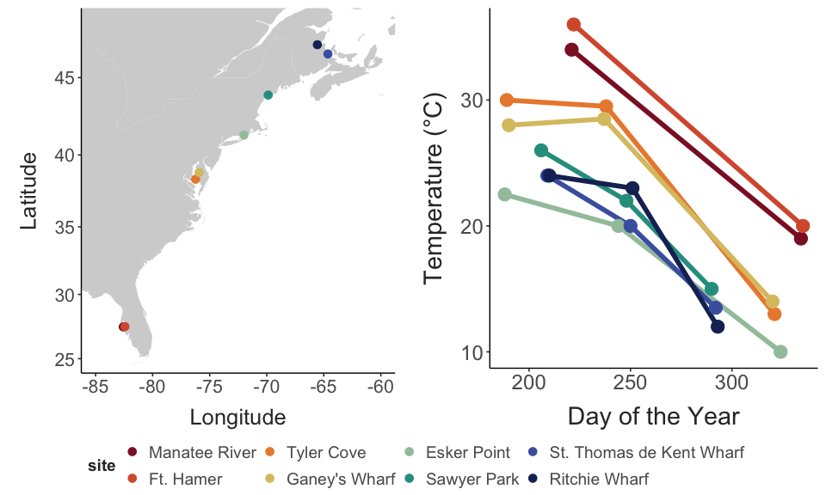
Figure 1: Map of the collection sites (A) and the temperature at each collection (B).
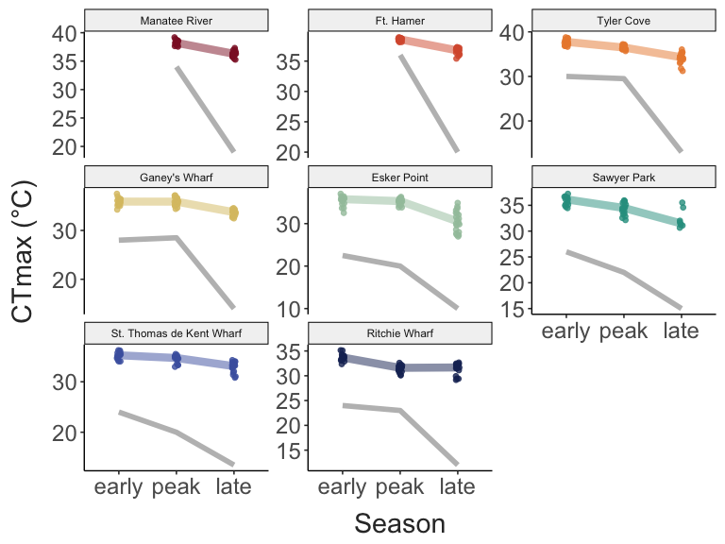
Figure 2: CTmax of individuals in each collection by season and site.

1. A. tonsa is a complex of cryptic lineages that turn over along the coast and through the season
- Four deeply divergent clades (F, S, X, IV); F splits into lineages (F-N, F-NE, F-FH, F-MR). [in hand]
- Mitochondrial (COI) and nuclear trees agree at every level: {S, IV} vs {X, F}, X sister to F, and the same order of F lineages. The lineages are separate genetic units, not mitochondrial types on a shared nuclear background. [in hand; report “Lineage phylogeny”]
- Lineages replace each other along the coast but co-occur at several sites and in single collections.
- Lineage composition changes through the season at 6 of 7 sites with more than one lineage (combined permutation p < 10⁻⁴). Late-season (October–November, 10–15 °C) collections shift toward IV at CT, TK and ME, and toward S at MD and GW; S dominates the warm peak at MD and CT. [in hand; report “Seasonal turnover of lineages”]
- Turnover tracks temperature: the composition-expected CTmax rises 0.04 °C per °C of collection temperature within sites (p < 0.001), about a quarter of the acclimation slope. Warm water holds more tolerant lineages, cool water more IV. Seasonal change in tolerance has a heritable component, through sorting of lineages rather than evolution within them. [in hand; report “Does lineage turnover change seasonal thermal tolerance?” - may sit better in Result 2 or 3]
- Caveat: about 20 individuals per collection, one year of sampling.
Lineage composition varied strongly across both space and time (Figure 3). The low-latitude sites were dominated by S and the F lineages (F-FH and F-MR in Florida, F-N in the Chesapeake), and the northern sites by X and IV. Composition changed through the season at six of the seven sites with more than one lineage (combined permutation test, p < 10⁻⁴; RW, p = 0.12). The clearest shifts were in Connecticut, Maine and New Brunswick. In Connecticut the early collection contained four lineages, the peak collection was mostly S and the late collection mostly IV; at TK, X made up the early and peak collections and IV the entire late collection. In the Chesapeake, F-N dominated the early collections and S increased at the peak (MD) or late (GW). These seasonal shifts mirror the spatial pattern: lineages common at warm sites dominate warm collections, and IV, the northern lineage, dominates the cold late-season collections (Figure 14).
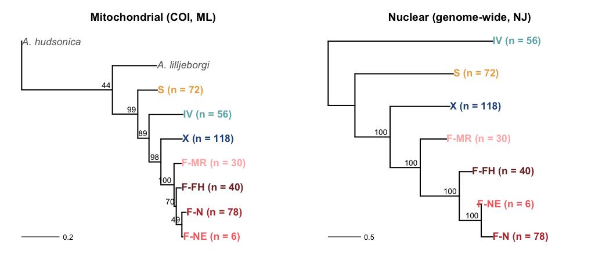
(a) Mitochondrial and nuclear lineage trees

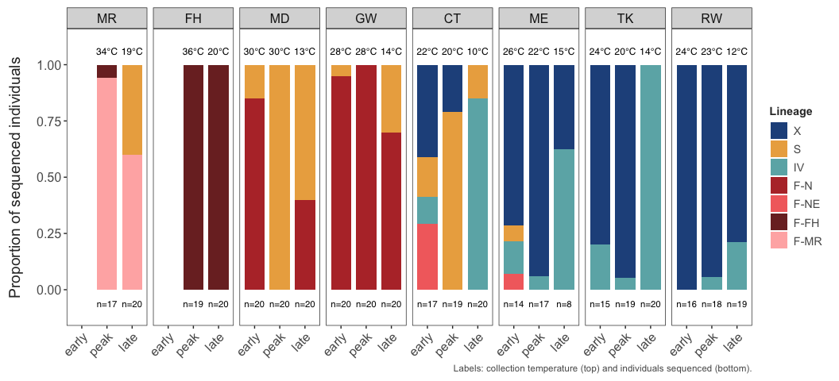
(b) Lineage composition by collection

Figure 3: Cryptic lineages of Acartia tonsa. (A) Mitochondrial (COI, maximum likelihood) and nuclear (genome-wide, neighbour-joining) trees of the lineages. (B) Lineage composition of each collection, with collection temperature. (Planned: add a site map.)

2. Lineages differ heritably in thermal tolerance
- Lineage explains about a quarter of CTmax variance. [in hand]
- Natural common garden: IV is 2.5–2.9 °C less tolerant than co-occurring X or S, and F-N is 0.8 °C more tolerant than S across three Chesapeake collections. These differences cannot be acclimation. [in hand]
- S–X shrinks from 1.0 °C across all collections to 0.4 °C (not significant) where they co-occur, so part of it reflects where each lineage was sampled.
- Caveat: “heritable” here means not explained by shared recent conditions; it could include developmental or maternal effects.
As might be expected from their distributions, the lineages differed strongly in thermal tolerance. The S and F lineages had higher CTmax than X and IV regardless of collection temperature (raw means: F-FH 37.6 °C, F-MR 37.5 °C, F-NE 36.3 °C, F-N 35.8 °C, S 35.3 °C, X 33.9 °C, IV 31.7 °C), and these differences persisted in the temperature-adjusted marginal means from the mixed model. Because lineages occupy different sites, these comparisons could partly reflect the conditions each was collected in. Collections containing two or more lineages resolve this (Figure 4): IV was 2.5–2.9 °C less tolerant than X or S collected with it, and F-N 0.8 °C more tolerant than S in the three Chesapeake collections where both occurred. [CHECK: the phenotype draft noted a slightly steeper acclimation slope in IV; confirm against the lineage-specific within-site slopes.]
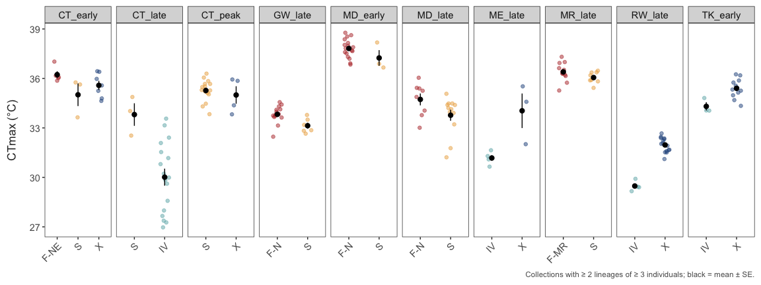
Figure 4: CTmax of lineages collected together at the same place and time. Points are individuals, black is the mean ± SE.

3. Within lineages, CTmax tracks temperature through plasticity, equally across space and season
- Within-site (seasonal) slope 0.15 °C per °C; between-site slope 0.12; difference -0.02 (-0.15 to 0.11). The spatial gradient in CTmax is what acclimation predicts: for the phenotype, space substitutes for time. [in hand]
- Variance partition: lineage 24%, site temperature 20%, other site 16%, acclimation 18%, other collection 8%, individual 14%. [in hand]
- Cannot exclude modest local adaptation (upper CI ~0.1 °C per °C).
- Note: in summer, collection-day temperatures at northern sites run 2–6 °C warmer than MUR, which matters for interpreting acclimation. [TO CHECK]
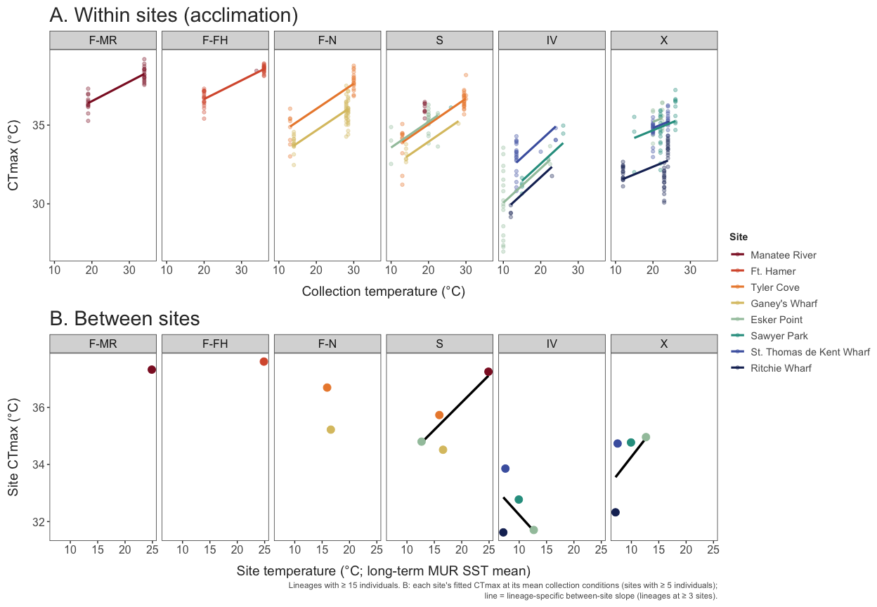
(a) Within- and between-site temperature

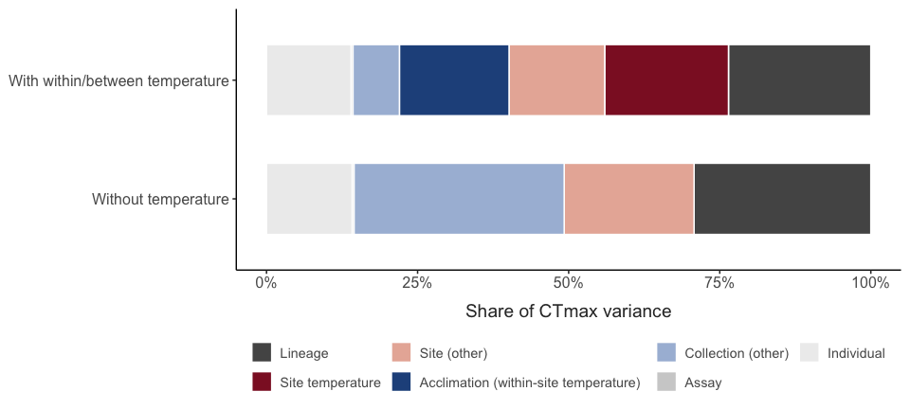
(b) Variance partition

Figure 5: CTmax against within-site (seasonal) and between-site (spatial) temperature, and the partition of CTmax variance.

4. Genomic variation within lineages is structured in space, not time
- High diversity and a large long-term Ne in every lineage; no close kin. Lineage-specific histories: expansion in F, large stable S and IV, high diversity in northern X despite its seasonal presence. [in hand]
- Temporal Ne is much smaller (about 750–5,400). The contrast with long-term Ne suggests sites are open: advection and mixing of water masses inflate apparent drift within a season. [in hand; interpretation for Discussion]
- Allele-frequency variance between sites is about 13 times that between seasons in X, and about 6 times in F-N. [in hand]
- chr6 structural polymorphism in northern X. [TO DECIDE: main text or supplement]
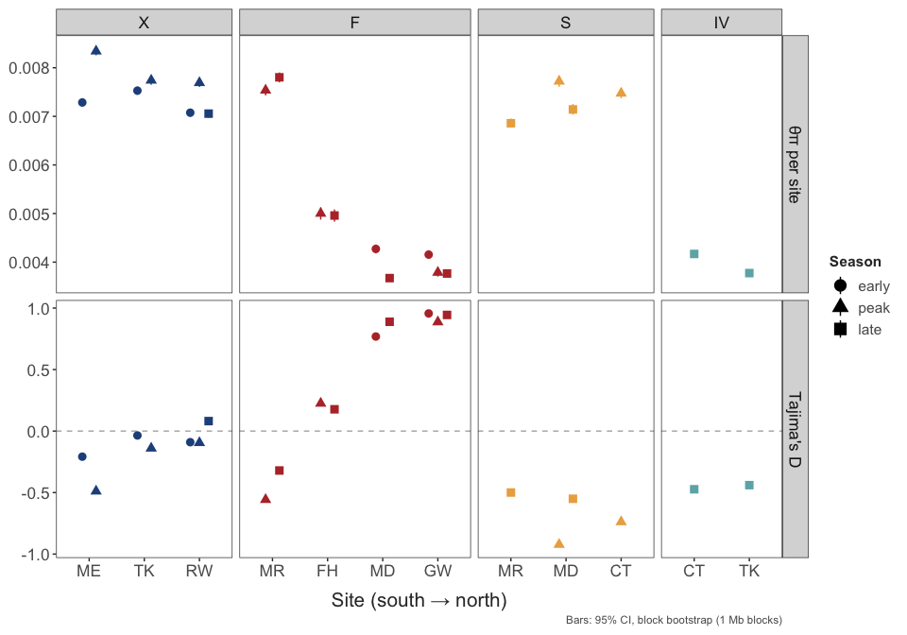
(a) Diversity within lineages

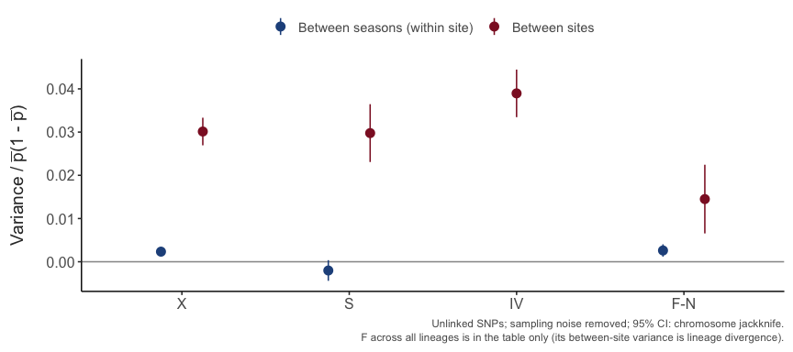
(b) Spatial vs seasonal allele-frequency variance

Figure 6: Genetic diversity within lineages and the partition of allele-frequency variance into spatial and seasonal components.

5. No rapid seasonal evolution, and no concordance between space and time
- After calibrating low-coverage sampling noise, seasonal change is about what drift predicts (calibrated excess Fc 0.000–0.011). [in hand]
- No genome-wide excess of seasonal association in X or F, against time in season or against temperature; chr6 makes no difference; S uninformative. [in hand]
- Concordance: alleles associated with warm sites do not rise after warm periods (X: r $≈$ 0.04, rank 5–6 of 24 under the null). For the genome, space does not substitute for time. [in hand]
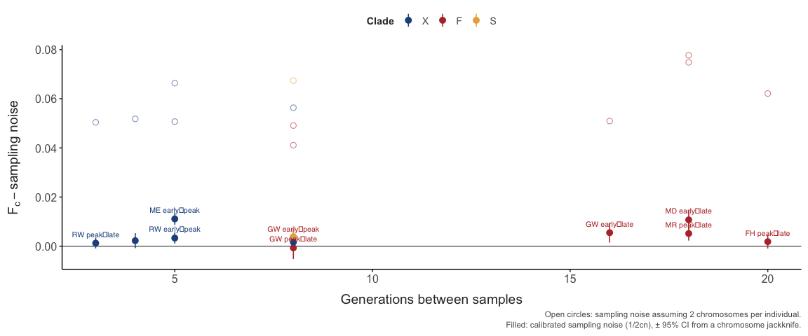
(a) Seasonal change vs drift

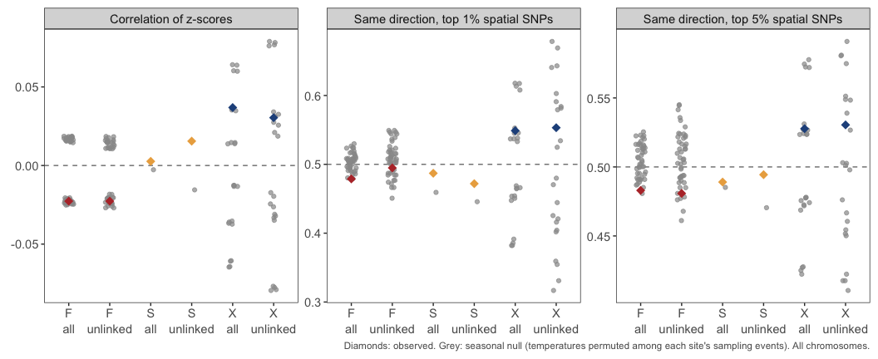
(b) Spatial-seasonal concordance

Figure 7: Seasonal allele-frequency change against the drift expectation, per-SNP seasonal tests against their permutation null, and spatial–seasonal concordance.

6. The genetic basis of tolerance lies between lineages, not within them
- Within lineages: no SNP associates with CTmax beyond what within-collection shuffles produce, once sequencing depth is controlled. [in hand; TO DO: power statement, i.e. the per-SNP effect detectable in each lineage]
- Between lineages, mitochondrial: COX1 nearly invariant; 29 substitutions unique to IV (7 COX1, 14 CYTB, 8 in a third ORF). Large mitochondrial divergence within F does not track CTmax. [in hand; X and IV contigs cover only ~a third of the mitogenome]
- Between lineages, nuclear: clade-specific amino-acid substitutions in heat-shock, nuclear OXPHOS and lipid genes against the genome background. [running]
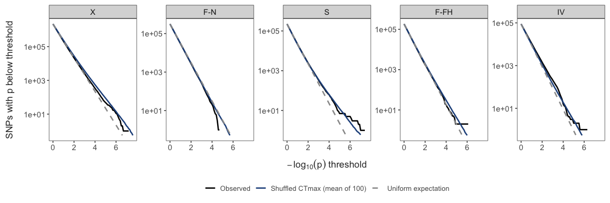
Figure 8: CTmax association within lineages against within-collection shuffles. (Planned: add the candidate-gene summary and a summary diagram of the scales of variation.)
Table 2: Summary of the scales of variation in thermal tolerance (draft).
Scale | CTmax varies? | Genomic signal? | Interpretation
Lineage | Yes, up to ~3 °C | Deep divergence; candidates under test | Heritable; range shifts
Site within lineage | Yes, as acclimation predicts | Strong differentiation, not linked to CTmax | Mostly plasticity
Season within site | Yes, through acclimation | Change about equal to drift; no concordance | No rapid evolution
Individual | Yes | No within-lineage associations | Plasticity / small effects

7. Accounting for lineages, acclimation and turnover changes where A. tonsa is vulnerable
- A single CTmax makes Florida look most vulnerable and the north least. Lineage means raise Florida’s margin by about 3 °C (F-FH, F-MR are the most tolerant lineages) and lower the northern sites’ by about 2 °C (X, IV); Chesapeake and Connecticut peak-season means barely change. Nearby sites pooled into six regions. [in hand; report §5]
- The spread of warming tolerance among regions shrinks by about a third (33–38% depending on scenario and metric).
- With +4 °C, the fixed CTmax puts Florida’s warmest days at zero warming tolerance; lineage-specific CTmax keeps them about 2.5 °C above.
- Acclimation changes little at the peak (peak means already include it) and adds about 1 °C under warming in the Chesapeake; it is the least certain scenario.
- Seasonal turnover matters: annual instead of peak-season make-up lowers the warmest-day margin by ~2 °C in Connecticut, Maine and Shediac, because IV is common there only in autumn. Links Result 7 to Result 1.
- Ties the paper together: lineages (Results 1–2) and plasticity (Result 3) are what matter for forecasts; rapid evolution (Result 5) adds nothing detectable.
- Caveat: MUR summer temperatures run below in-situ collection temperatures at the northern sites; the acclimation model was fitted to in-situ temperatures.
Warming tolerance followed a strong latitudinal gradient under all three scenarios (Figure 9, Figure 10). With a single CTmax for the species, peak-season warming tolerance ranged 13 °C across regions, from about 6 °C in Florida to 19 °C in Maine. Lineage-specific CTmax narrowed this range by 38% (Table 3), raising warming tolerance in Florida by about 3 °C (the Florida lineages F-FH and F-MR are the most tolerant) and lowering it in the northern regions by about 2 °C (X and IV are less tolerant than the species average). Adding acclimation left the range 34% narrower than with a single CTmax; the warmest-day metric gave similar reductions (33–35%). With 4 °C of warming, the single-CTmax scenario brought warming tolerance on the warmest days in Florida to zero, whereas lineage-specific CTmax, with or without acclimation, kept it about 2.5 °C above. Using each site’s lineage make-up across all collections, instead of the peak-season collection, lowered the warmest-day margin by about 2 °C in Connecticut, Maine and Shediac, because IV, the least tolerant lineage, is common there only in autumn.
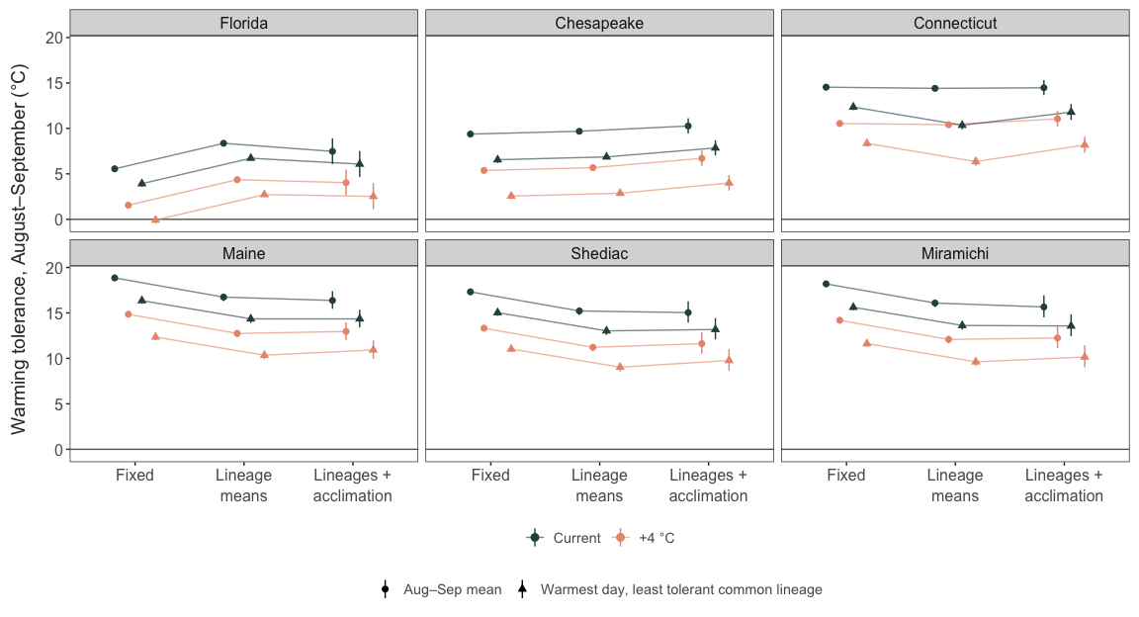
Figure 9: Warming tolerance (CTmax - habitat temperature) in August–September in each region under three scenarios: a single fixed CTmax, lineage-specific mean CTmax weighted by peak-season lineage make-up, and lineage-specific CTmax with acclimation. Circles: peak-season mean; triangles: warmest day, least tolerant common lineage. Current conditions and +4 °C uniform warming; bars are 95% intervals.
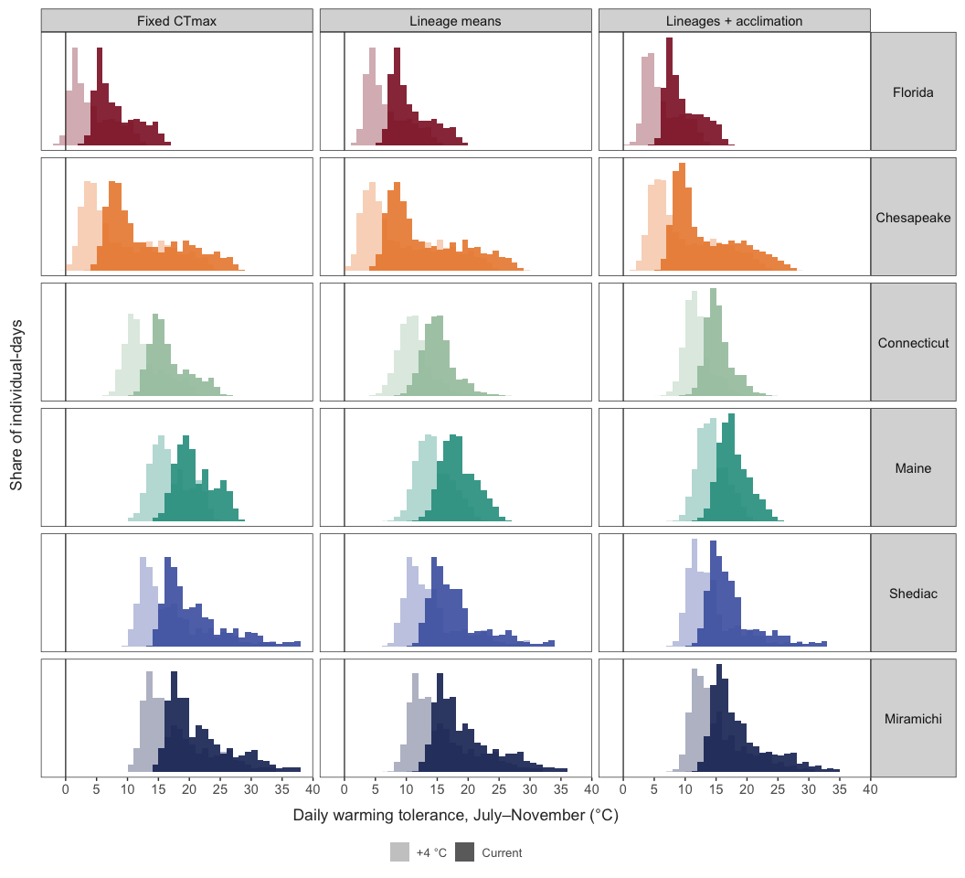
Figure 10: Distributions of daily warming tolerance in each region over the sampled season (July–November, MUR SST 2014–2023) under the three scenarios. Days are weighted by the lineage make-up of the matching collection (July: early; August–September: peak; October–November: late). Dark bars: current conditions; pale bars: +4 °C uniform warming. The vertical line marks zero warming tolerance.
Table 3: Spread of warming tolerance among regions under current conditions, and its change relative to a fixed CTmax. The last scenario uses annual instead of peak-season lineage make-up.
Scenario | Metric | Range among regions (°C) | Change vs fixed (%)
Fixed CTmax | Aug–Sep mean | 13.3 | –
Lineage means | Aug–Sep mean | 8.4 | -37
Lineages + acclimation | Aug–Sep mean | 8.9 | -33
Lineages + acclimation (annual make-up) | Aug–Sep mean | 8.8 | -34
Fixed CTmax | Warmest day, least tolerant common lineage | 12.4 | –
Lineage means | Warmest day, least tolerant common lineage | 7.6 | -39
Lineages + acclimation | Warmest day, least tolerant common lineage | 8.3 | -33
Lineages + acclimation (annual make-up) | Warmest day, least tolerant common lineage | 7.7 | -38

Discussion
- Main message: thermal tolerance in this “species” is structured by cryptic lineages (heritable) and plasticity (within lineages), not by rapid evolution. Space substitutes for time in phenotype but not in genome.
- Why no rapid seasonal evolution, despite short generations?
  - Open populations: advection and mixing reset local allele frequencies; the gap between long-term and temporal Ne.
  - Overlapping generations and egg banks slow the response to selection within a season.
  - Plasticity absorbs seasonal temperature change, weakening selection on tolerance.
  - Contrast with Drosophila (Bergland et al. 2014; Machado et al. 2021).
- Lineage turnover as the seasonal response. Composition shifts with temperature and adds about a quarter to the seasonal CTmax change from acclimation. The community responds to season through sorting of heritably different lineages (cf. seasonal species succession in plankton), not through allele-frequency change within them. Where do lineages go between seasons: resting eggs, advection from offshore or other estuaries?
- Implications for forecasting: model lineages separately, treat within-lineage spatial variation as plastic, and do not expect within-season evolutionary rescue. A single species-level CTmax overstates vulnerability in warm regions and understates it in cool ones (Result 7); seasonal lineage turnover means peak-season composition, not annual composition, sets exposure.
- Implications for lab studies: experiments that treat “A. tonsa” as one unit can mix lineages that differ by ~3 °C in CTmax.
- Space-for-time predictions and ecological acclimation: relate the composition result to community-level ‘ecological acclimation’ through species turnover (Stemkovski et al. [REF]); here the turnover happens among cryptic lineages within a single nominal species.
- Caveats: low-coverage power for small-effect loci; CTmax as one measure of tolerance; collection-day temperature vs MUR; partial mitogenomes for X and IV; F consensus pools four lineages.

References
Ali, O.A., O’Rourke, S.M., Amish, S.J., Meek, M.H., Luikart, G., Jeffres, C., et al. (2015) RAD capture (rapture): Flexible and efficient sequence-based genotyping. Genetics, 202, 389–400.
Figueroa, N.J., Figueroa, D.F. & Hicks, D. (2020) Phylogeography of acartia tonsa dana, 1849 (calanoida: Copepoda) and phylogenetic reconstruction of the genus acartia dana, 1846. Marine Biodiversity, 50, 23.

Supplementary Material
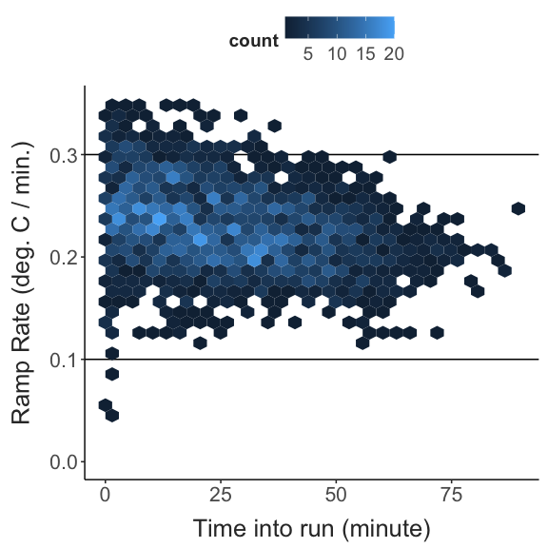
Figure 11: Recorded heating rates during the CTmax assays.
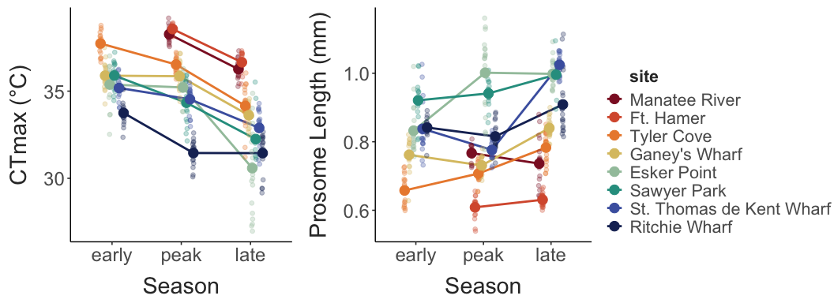
Figure 12: CTmax (A) and body size (prosome length; B) by season at each site.
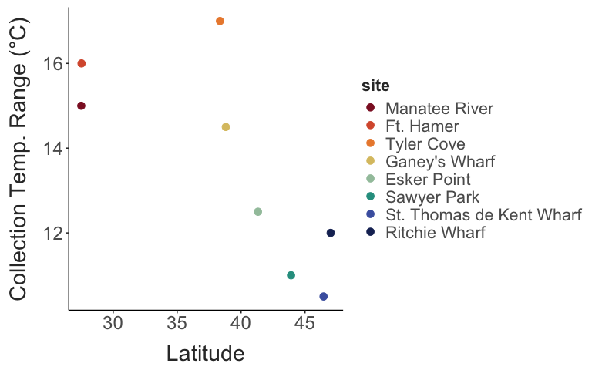
Figure 13: Seasonal range of collection temperatures against latitude.
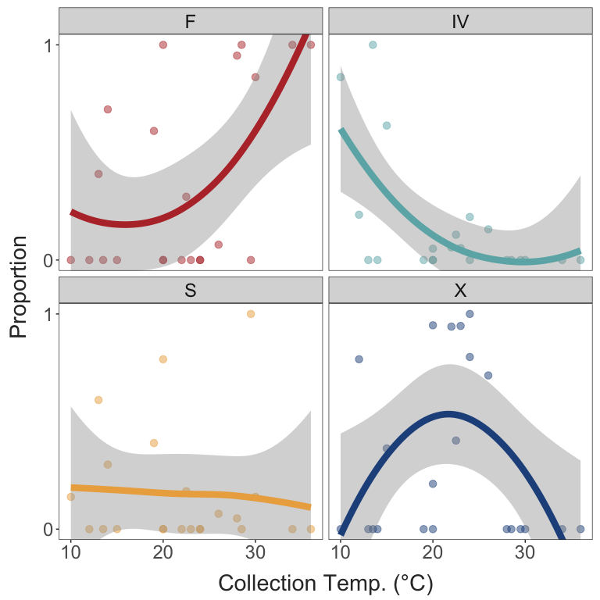
Figure 14: Proportion of each clade in a collection against collection temperature.
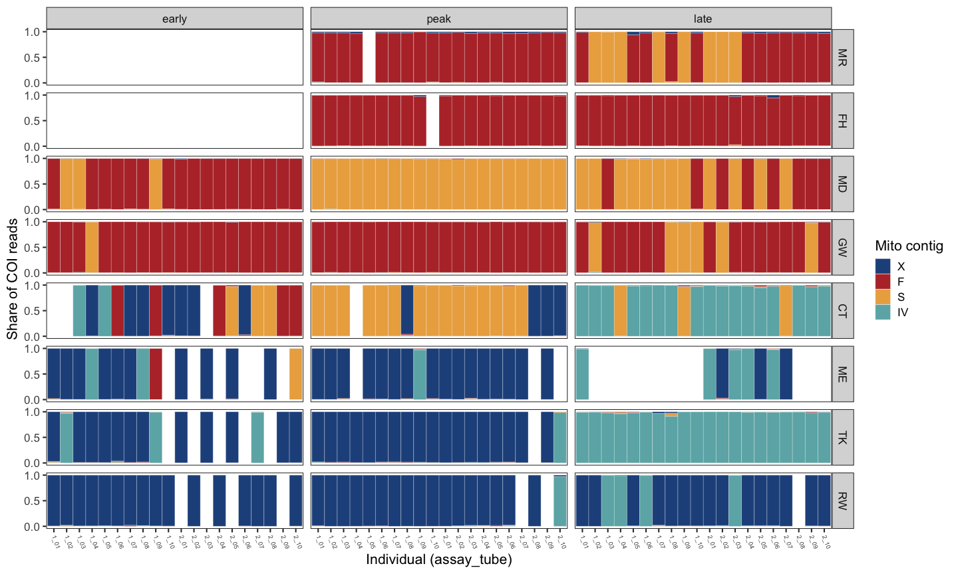
Figure 15: Share of each individual’s COI-region reads mapping to each clade’s mitogenome contig, used for clade assignment.
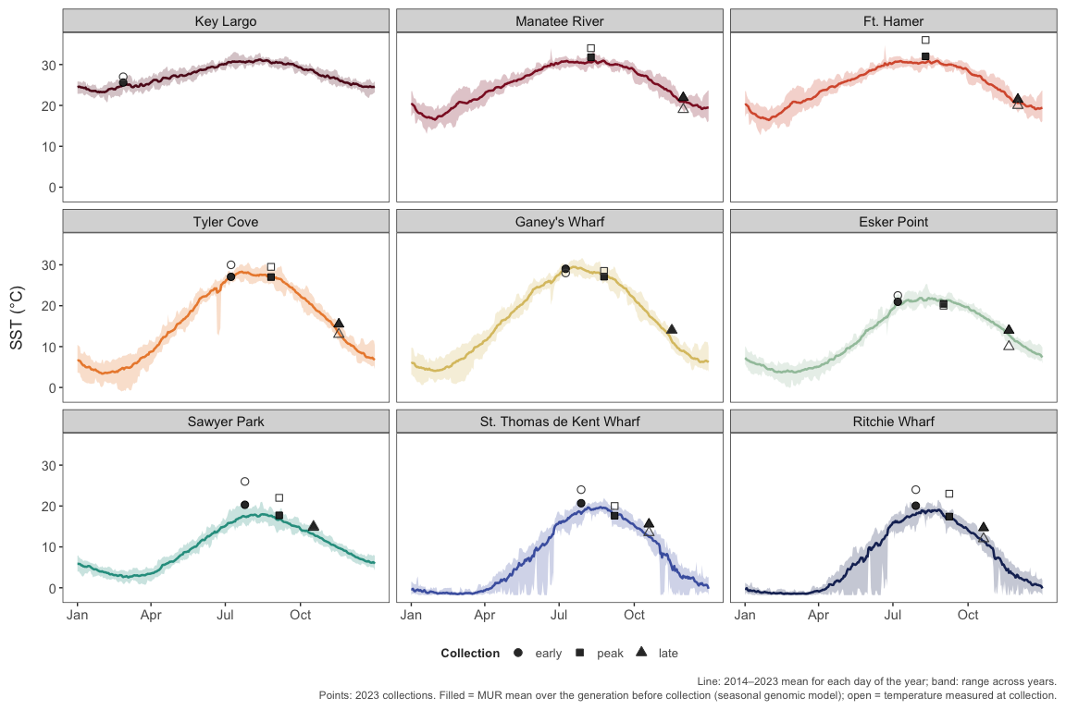
Figure 16: Long-term (MUR SST 2014–2023) temperature cycles at each site.
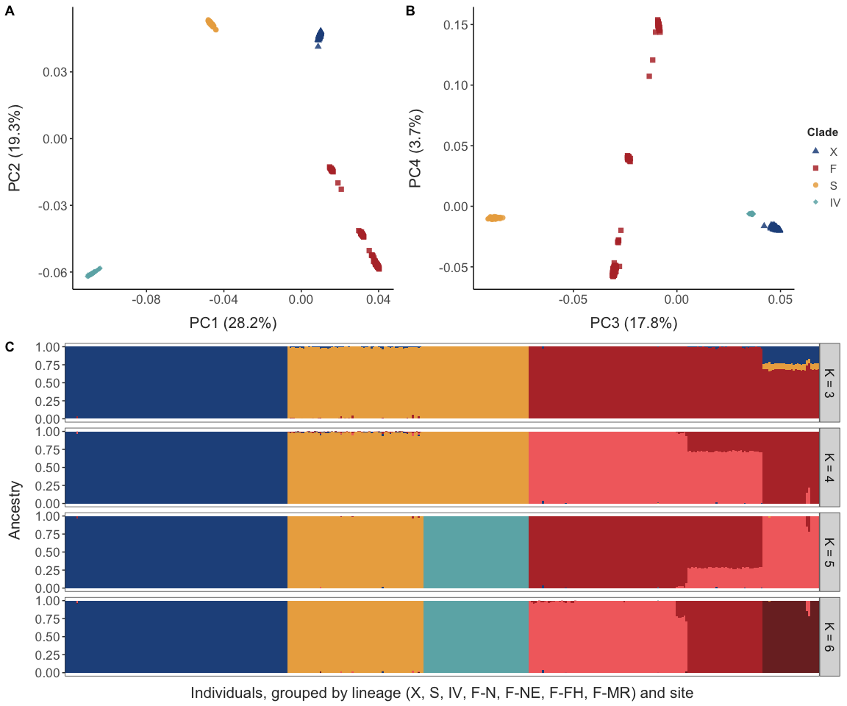
Figure 17: Genome-wide structure and mitochondrial clades.
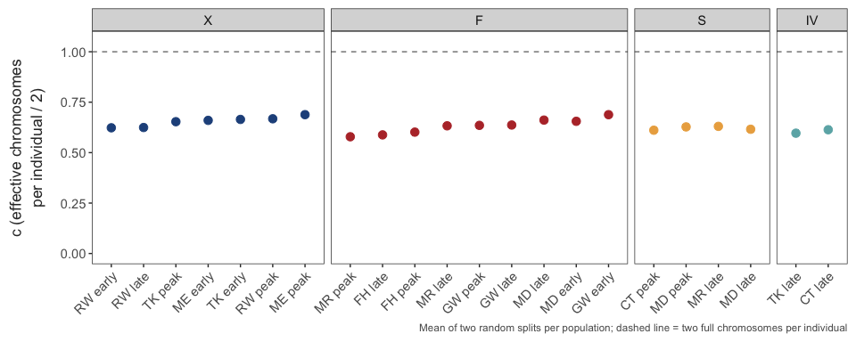
Figure 18: Calibration of low-coverage sampling noise from random split halves of each population.

